Evaluating the Psychological and Social Nature of Actual and Perceived Liking Gaps
Table of Contents
Overview of the Hypothesized Possibilities 2
The Distributions of Liking and Felt Liking Judgments 3
Variance Decomposition Results for Study 1 Using the Social Relations Model 4
Analyses of the Second Interaction in Study 2 5
Perceiver Reported Interaction Experiences 8
Analyses with Personality Traits 10
Analyses with Close Other Ratings in Study 1 12
Analyses Comparing the Linear Model Against the Polynomial Model for All Primary Variables 14

Overview of the Hypothesized Possibilities
Figure S1
Plotted Regression Surfaces Illustrating The Hypothesized Possibilities
- Liking gaps are maladaptive | - Felt liking only
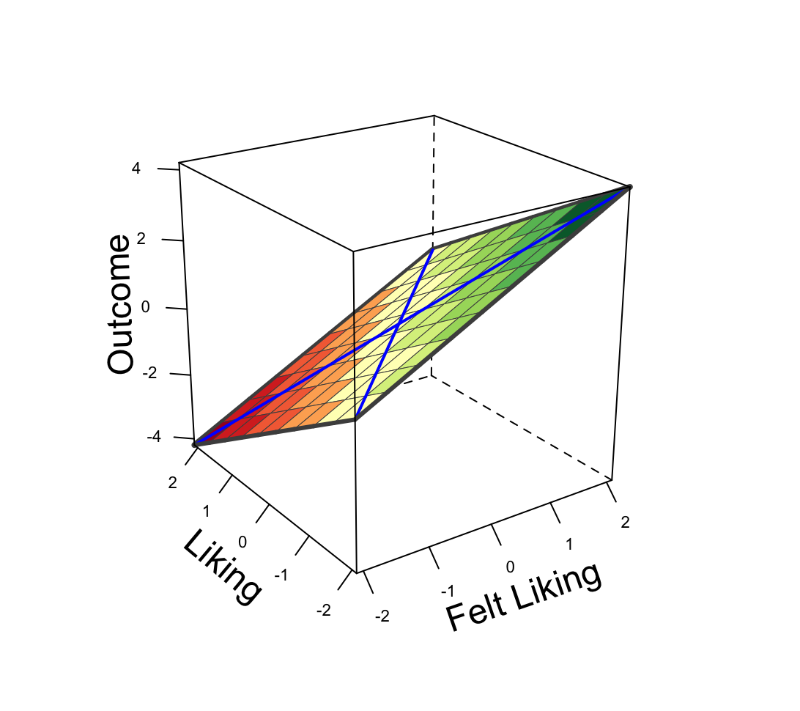 | 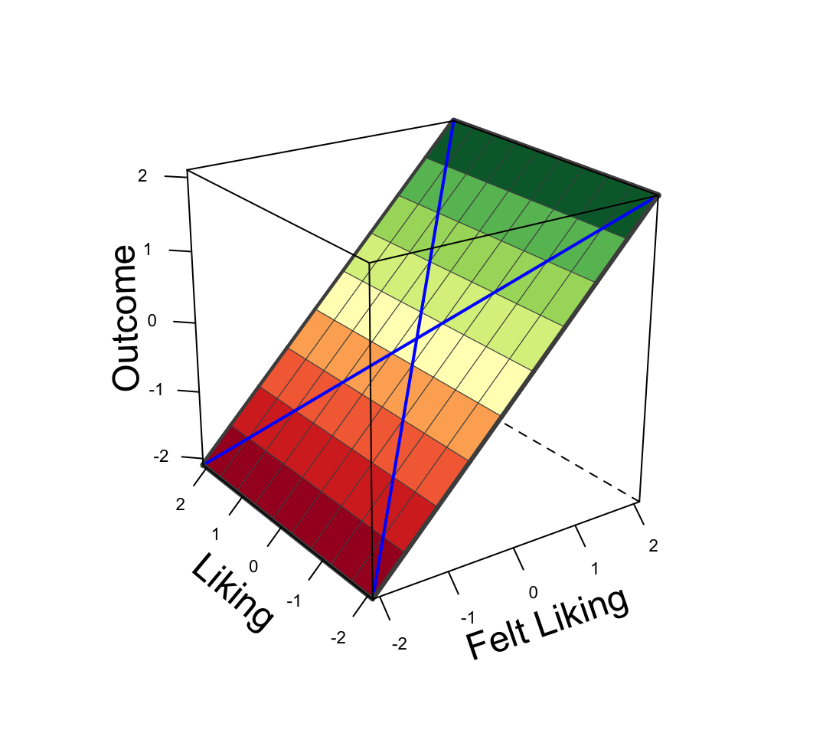
- Liking only | - Joint effect
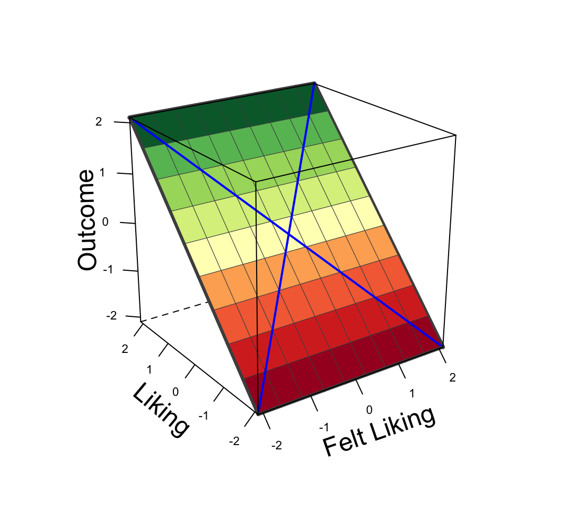 | 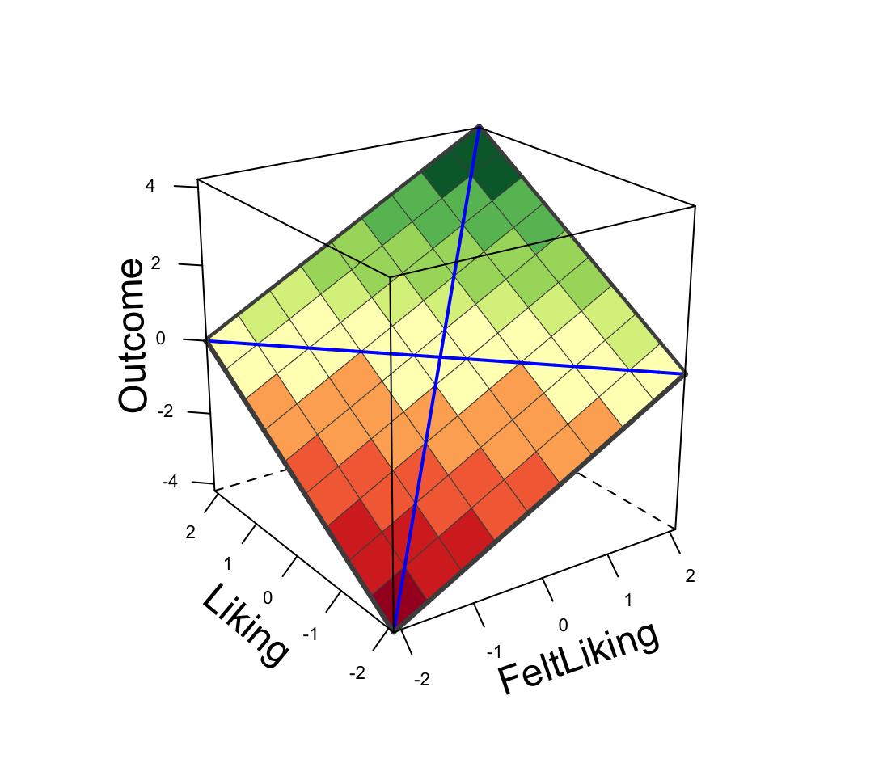
Note. These graphs are based on the regression model $Outcome{= c}_{0}+c_{1}FeltLiking+c_{2}Liking+ε$. Each panel depicts a different constellation of the coefficients $c_{1}$ and $c_{2}$. Panel (a) illustrates the liking gaps are maladaptive hypothesis ($c_{1}$ > 0 and $c_{2}$ < 0), where the highest liking gaps are related to the lowest outcome. Panel (b) reflects the feeling liked only hypothesis ($c_{1}$ > 0 and $c_{2}$ = 0), where the outcome is only dependent on the levels of felt liking. Panel (c) reflects the liking only hypothesis ($c_{1}$ = 0 and $c_{2}$ > 0), where the outcome is only dependent on the levels of liking. Panel (c) depicts the idea that both felt liking and liking matter ($c_{1}$ > 0 and $c_{2}$ > 0), and the outcome is highest when both liking and felt liking are high.

The Distributions of Liking and Felt Liking Judgments

Figure S2

Density Plots of Felt Liking and Liking

- Study 1  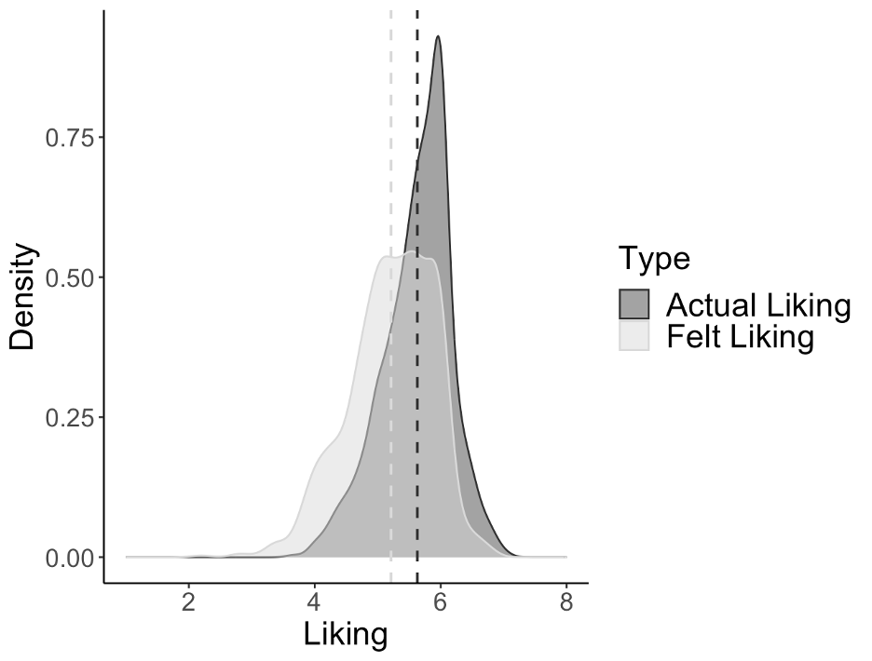 | - Study 2  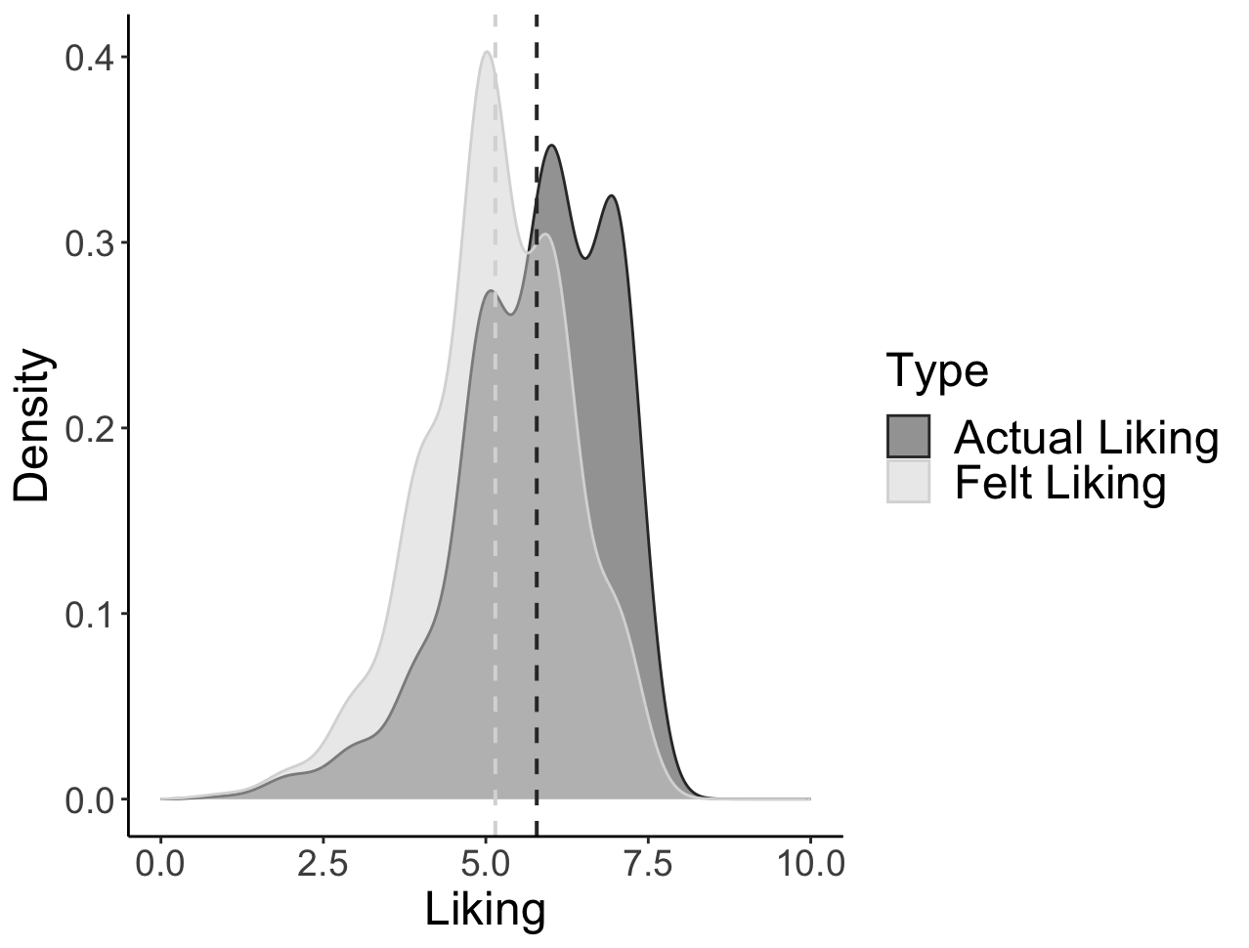
- Study 3
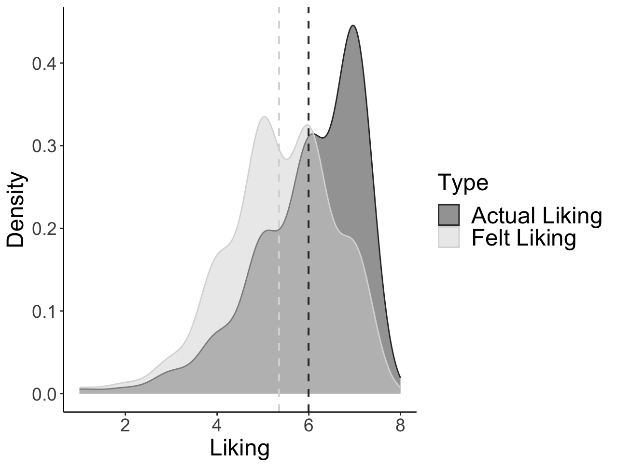

Note. All ratings of liking were single-items rated on a 7-point Likert scale. The dashed lines depict the sample means.

Variance Decomposition Results for Study 1 Using the Social Relations Model

Table S1

Variance Partitioning for the Dyadic Items in Study 1

Variable of Interest |  | Variance
 |  | Target | Perceiver | Error
Liking | Estimate | .13** | .25** | .62
 | Reliability | .52 | .67 | -
Felt Liking | Estimate | .09** | .43** | .48
 | Reliability | .48 | .82 | -
Engagement and Interest | Estimate | .21** | .19** | .60
 | Reliability | .65 | .62 | -
Closeness | Estimate | .11** | .32** | .56
 | Reliability | .50 | .74 | -
Conversation Flow | Estimate | .20** | .15** | .66
 | Reliability | .61 | .53 | -
Interaction Enjoyment | Estimate | .15** | .18** | .67
 | Reliability | .53 | .58 | -
Note. All variances reported here are standardized. The target is the person being rated. The perceiver is the person providing the rating. Notably, our single-item indices were relatively reliable. ** p < .001.

Analyses of the Second Interaction in Study 2
In Study 2, participants completed 2 interactions with two separate interaction partners. The analyses reported in the primary manuscript reflect the results from the first interaction. Below, we report on the results from the second interaction.
Firstly, people again displayed a liking gap at the sample level, revealing that people are pessimistic about how much they feel liked by others as compared to how much people liked others, b = -0.59, d = -1.04, CI_{95%} [-1.25, -0.82], t = -10.11, p < .001. Secondly, we examined the adaptiveness of the liking gaps by examining their correlates (see Table S2 and S3 below). Overall, we closely replicate the results from the first interaction, as reported in the main manuscript. That is, self-esteem, our adjustment indicator from Study 2, was unrelated to an actual gap, but it was related to a perceived gap, independently of felt liking and liking. Larger perceived gaps were experienced by those with lower self-esteem, supporting the idea that a perceived gap might reflect a social insecurity. Further, interaction experiences were unrelated to an actual liking gap or a perceived liking gap with one exception: People reported greater willingness to talk to someone new when the perceived liking gap was larger. Besides this finding, people’s decisions about subsequent interactions appeared to depend on a joint effect of both felt liking and liking of the partner. In sum, all findings from the second interaction are consistent with those from the first interaction, as reported in the main manuscript.
Table S2
Summary of Results Illustrating the Links Between Actual Liking Gaps, Their Components
Correlate | Main Effect of Felt Liking  (c1)  [CI_{95%}] | Main Effect of Being Liked  (c2)  [CI_{95%}] | Joint Effect  c1 + c2  [CI_{95%}] | Difference of Main Effects  c1 – c2  [CI_{95%}] | Effect of the Gap  (abs)  [CI_{95%}] | Pattern/  Hypothesis
Adjustment indicator
Self-Esteem | 0.36**  [0.24, 0.48] | 0.04  [-0.07, 0.16] | 0.40**  [0.26, 0.55] | 0.32**  [0.14, 0.50] | -0.09  [-0.31, 0.14] | Feeling Liked
Decisions about subsequent interactions
Desire to meet again | 0.67**  [0.57, 0.78] | 0.27**  [0.17, 0.37] | 0.94**  [0.82, 1.06] | 0.40**  [0.23, 0.57] | -0.54  [-0.74, -0.34] | Joint effect
Desire to meet someone new | -0.04  [-0.16, 0.08] | -0.02  [-0.14, 0.09] | -0.06  [-0.21, 0.08] | -0.02  [-0.20, 0.16] | -0.04  [-0.27, 0.19] | None
Note. The coefficients were based on a linear regression: Outcome = c₀ + c₁FeltLiking + c₂Liking + e. abs=|c₁- c₂|-| c₁+ c₂|. The significance of the abs value was based on a one-tailed p-value, examining whether abs > 0, whereas the significance of all other coefficient were based on two-tailed p-values. **p<.01, *p<.05, † p<.10. Bolded values remained significant (p<.05) after applying the False Discover Rate correction.

Table S3
Summary of Results Illustrating the Links Between Perceived Liking Gaps, Their Components
Correlate | Main Effect of Felt Liking  (c1)  [CI_{95%}] | Main Effect of Being Liked  (c2)  [CI_{95%}] | Joint Effect  c1 + c2  [CI_{95%}] | Difference of Main Effects  c1 – c2  [CI_{95%}] | Effect of the Gap  (abs)  [CI_{95%}] | Pattern/  Hypothesis
Adjustment indicator
Self-Esteem | 0.59**  [0.44, 0.73] | -0.32**  [-0.46, -0.19] | 0.26**  [0.14, 0.38] | 0.91**  [0.66, 1.16] | 0.65**  [0.37, 0.92] | Perceived Gap
Decisions about subsequent interactions
Desire to meet again | 0.18**  [0.08, 0.28] | 0.85**  [0.76, 0.95] | 1.03**  [0.94, 1.11] | -0.68**  [-0.85, -0.50] | -0.35  [-0.55, -0.15] | Joint effect
Desire to meet someone new | 0.16*  [0.02, 0.31] | -0.32**  [-0.46, -0.18] | -0.15*  [-0.28, -0.03] | 0.48**  [0.23, 0.74] | 0.33*  [0.04, 0.62] | Perceived Gap
Note. The coefficients were based on a linear regression: Outcome = c₀ + c₁FeltLiking + c₂Liking + e. abs=|c₁- c₂|-| c₁+ c₂|. The significance of the abs value was based on a one-tailed p-value, examining whether abs > 0, whereas the significance of all other coefficient were based on two-tailed p-values. **p<.01, *p<.05, † p<.10. Bolded values remained significant (p<.05) after applying the False Discover Rate correction.

Perceiver Reported Interaction Experiences
Table S4
Summary of Results Illustrating the Links Between Actual Liking Gaps, Their Components and Perceivers’ Interaction Experiences
Interaction Experience | Study | Main Effect of Felt Liking  (c1)  [CI_{95%}] | Main Effect of Being Liked  (c2)  [CI_{95%}] | Joint Effect  c1 + c2  [CI_{95%}] | Difference of Main Effects  c1 – c2  [CI_{95%}] | Effect of the Gap  (abs)  [CI_{95%}] | Pattern/  Hypothesis
Impressions of the interaction partner
Engagement and Interest | 1 | 0.02  [-0.02, 0.07] | 0.97**  [0.91, 1.03] | 1.00**  [0.94, 1.06] | -0.95**  [-1.03, -0.86] | -0.05  [-0.13, 0.04] | Joint effect
Closeness | 1 | 0.12**  [0.06, 0.18] | 1.06**  [0.97, 1.14] | 1.18**  [1.09, 1.26] | -0.94**  [-1.06, -0.82] | -0.24  [-0.35, -0.12] | Joint effect
 | 3 | 0.05  [-0.01, 0.11] | 0.92**  [0.86, 0.98] | 0.97**  [0.90, 1.05] | -0.87**  [-0.96, -0.78] | -0.10  [-0.22, 0.02] | Joint effect
Desire to be Friends | 3 | 0.04†  [-0.01, 0.11] | 0.94**  [0.88, 1.00] | 0.99**  [0.92, 1.07] | -0.89**  [-0.98, -0.80] | -0.10  [-0.22, 0.01] | Joint effect
Impressions of the interaction
Conversation Flow | 1 | 0.05†  [0.00, 0.11] | 0.98**  [0.90, 1.05] | 1.03**  [0.95, 1.11] | -0.92**  [-1.03, -0.82] | -0.10  [-0.21, 0.00] | Joint effect
Enjoyment | 1 | 0.02  [-0.01, 0.05] | 0.94**  [0.89, 0.98] | 0.96**  [0.91, 1.00] | -0.92**  [-0.98, -0.86] | -0.04  [-0.10, 0.02] | Liking
 | 3 | 0.04**  [0.02, 0.07] | 1.11**  [1.09, 1.14] | 1.16**  [1.12, 1.19] | -1.07**  [-1.11, -1.03] | -0.09  [-0.14, -0.04] | Joint effect
Shared Reality | 3 | 0.03†  [0.00, 0.06] | 0.53**  [0.50, 0.56] | 0.56**  [0.52, 0.60] | -0.50**  [-0.55, -0.46] | -0.06  [-0.12, 0.00] | Joint effect
Decisions about subsequent interactions
Desire to meet again | 2 | 0.13*  [0.03, 0.24] | 0.67**  [0.56, 0.77] | 0.80**  [0.67, 0.93] | -0.53**  [-0.69, -0.37] | -0.27  [-0.47, -0.06] | Joint effect
 | 3 | 0.08*  [0.02, 0.14] | 1.02**  [0.95, 1.08] | 1.09**  [1.01, 1.17] | -0.94**  [-1.03, -0.84] | -0.15  [-0.28, -0.03] | Joint effect
Desire to meet someone new | 2 | -0.05  [-0.18, 0.08] | -0.14*  [-0.28, -0.01] | -0.19*  [-0.36, -0.02] | 0.10  [-0.11, 0.30] | -0.10  [-0.36, 0.17] | Liking
Note. The coefficients were based on a linear regression: Outcome = c₀ + c₁FeltLiking + c₂Liking + e. abs=|c₁- c₂|-| c₁+ c₂|. The significance of the abs value was based on a one-tailed p-value, examining whether abs > 0, whereas the significance of all other coefficients were based on two-tailed p-values. **p<.01, *p<.05. Bolded values remained significant (p<.05) after applying the False Discover Rate correction.
Table S5
Summary of Results Illustrating the Links Between Perceived Liking Gaps, Their Components and Perceivers’ Interaction Experiences
Interaction Experience | Study | Main Effect of Felt Liking  (c1)  [CI_{95%}] | Main Effect of Being Liked  (c2)  [CI_{95%}] | Joint Effect  c1 + c2  [CI_{95%}] | Difference of Main Effects  c1 – c2  [CI_{95%}] | Effect of the Gap  (abs)  [CI_{95%}] | Pattern/  Hypothesis
Impressions of the interaction partner
Engagement and Interest | 1 | 0.15**  [0.07, 0.22] | 0.22**  [0.13, 0.31] | 0.37**  [0.29, 0.44] | -0.08  [-0.23, 0.08] | -0.29  [-0.44, -0.14] | Joint effect
Closeness | 1 | 0.23**  [0.14, 0.32] | 0.28**  [0.16, 0.40] | 0.51**  [0.42, 0.60] | -0.05  [-0.24, 0.14] | -0.46  [-0.64, -0.28] | Joint effect
 | 3 | 0.23**  [0.13, 0.33] | 0.51**  [0.41, 0.61] | 0.74**  [0.66, 0.82] | -0.28**  [-0.46, -0.10] | -0.46  [-0.66, -0.26] | Joint effect
Desire to be Friends | 3 | 0.12*  [0.01, 0.22] | 0.59**  [0.48, 0.69] | 0.70**  [0.62, 0.78] | -0.47**  [-0.66, -0.28] | -0.23  [-0.44, -0.03] | Joint effect
Impressions of the interaction
Conversation Flow | 1 | 0.18**  [0.10, 0.27] | 0.20**  [0.09, 0.31] | 0.39**  [0.30, 0.47] | -0.02  [-0.19, 0.16] | -0.37  [-0.54, -0.20] | Joint effect
Enjoyment | 1 | 0.12**  [0.05, 0.18] | 0.25**  [0.17, 0.33] | 0.37**  [0.31, 0.43] | -0.14*  [-0.27, -0.01] | -0.23  [-0.36, -0.10] | Joint effect
 | 3 | 0.29**  [0.25, 0.34] | 0.75**  [0.70, 0.79] | 1.04**  [1.01, 1.07] | -0.46**  [-0.54, -0.37] | -0.59  [-0.67, -0.50] | Joint effect
Shared Reality | 3 | 0.09**  [0.04, 0.14] | 0.04  [-0.01, 0.09] | 0.13**  [0.09, 0.17] | 0.05  [-0.04, 0.14] | -0.08  [-0.18, 0.01] | Feeling Liked
Decisions about subsequent interactions
Desire to meet again | 2 | 0.23**  [0.09, 0.37] | 0.16*  [0.01, 0.31] | 0.39**  [0.25, 0.52] | 0.07  [-0.19, 0.33] | -0.32  [-0.61, -0.02] | Joint effect
 | 3 | 0.21**  [0.12, 0.31] | 0.16**  [0.06, 0.25] | 0.37**  [0.29, 0.44] | 0.06  [-0.12, 0.23] | -0.31  [-0.51, -0.12] | Joint effect
Desire to meet someone new | 2 | -0.06  [-0.22, 0.09] | -0.01  [-0.18, 0.15] | -0.08  [-0.23, 0.07] | -0.05  [-0.33, 0.23] | -0.03  [-0.35, 0.29] | None
Note. The coefficients were based on a linear regression: Outcome = c₀ + c₁FeltLiking + c₂Liking + e. abs=|c₁- c₂|-| c₁+ c₂|. The significance of the abs value was based on a one-tailed p-value, examining whether abs > 0, whereas the significance of all other coefficients were based on two-tailed p-values. **p<.01, *p<.05. Bolded values remained significant (p<.05) after applying the False Discover Rate correction.

Analyses with Personality Traits
Table S6
Summary of Results Illustrating the Links Between Personality Traits, the Actual Gap, and Their Components
Personality Trait | Study | Main Effect of Felt Liking  (c1)  [CI_{95%}] | Main Effect of Being Liked  (c2)  [CI_{95%}] | Joint Effect  c1 + c2  [CI_{95%}] | Difference of Main Effects  c1 – c2  [CI_{95%}] | Effect of the Gap  (abs)  [CI_{95%}] | Pattern/  Hypothesis
Agreeableness | 1 | 0.40**  [0.32, 0.48] | 0.10†  [-0.02, 0.21] | 0.50**  [0.38, 0.61] | 0.30**  [0.15, 0.46] | -0.19  [-0.42, 0.03] | Feeling Liked
 | 3 | 0.13**  [0.11, 0.15] | 0.02  [0.00, 0.04] | 0.15**  [0.12, 0.18] | 0.11**  [0.08, 0.15] | -0.04  [-0.09, 0.01] | Feeling Liked
Extraversion | 1 | 0.45**  [0.34, 0.55] | 0.31**  [0.16, 0.46] | 0.75**  [0.60, 0.90] | 0.14  [-0.07, 0.35] | -0.61  [-0.91, -0.31] | Joint effect
 | 3 | 0.15**  [0.12, 0.18] | -0.01  [-0.04, 0.02] | 0.14**  [0.10, 0.18] | 0.16**  [0.11, 0.20] | 0.02  [-0.04 0.07] | Feeling Liked
Conscientiousness | 1 | 0.33**  [0.24, 0.41] | 0.03  [-0.10, 0.15] | 0.35**  [0.23, 0.48] | 0.30**  [0.12, 0.47] | -0.06  [-0.31, 0.20] | Feeling Liked
 | 3 | 0.08**  [0.05, 0.11] | 0.00  [-0.03, 0.03] | 0.08**  [0.04, 0.12] | 0.08**  [0.03, 0.12] | 0.00  [-0.06, 0.06] | Feeling Liked
Openness | 1 | 0.17**  [0.07, 0.26] | -0.08  [-0.21, 0.05] | 0.08  [-0.05, 0.21] | 0.25**  [0.06, 0.43] | 0.17  [-0.10, 0.43] | Feeling Liked
 | 3 | 0.06**  [0.04, 0.09] | 0.03*  [0.00, 0.05] | 0.09**  [0.06, 0.12] | 0.04  [0.00, 0.07] | -0.05  [-0.10, 0.00] | Joint effect
Note. Neuroticism does not appear here because it is reported in the main manuscript. The coefficients were based on a linear regression: Outcome = c₀ + c₁FeltLiking + c₂Liking + e. abs=|c₁- c₂|-| c₁+ c₂|. The significance of the abs value was based on a one-tailed p-value, examining whether abs > 0, whereas the significance of all other coefficient were based on two-tailed p-values. **p<.01, *p<.05, † p<.10. Bolded values remained significant (p<.05) after applying the False Discover Rate correction.
Table S7
Summary of Results Illustrating the Links Between Personality Traits, the Perceived Gap, and Their Components
Personality Trait | Study | Main Effect of Felt Liking  (c1)  [CI_{95%}] | Main Effect of Being Liked  (c2)  [CI_{95%}] | Joint Effect  c1 + c2  [CI_{95%}] | Difference of Main Effects  c1 – c2  [CI_{95%}] | Effect of the Gap  (abs)  [CI_{95%}] | Pattern/  Hypothesis
Agreeableness | 1 | 0.31**  [0.21, 0.40] | 0.23**  [0.11, 0.35] | 0.54**  [0.44, 0.63] | 0.08  [-0.12, 0.27] | -0.46  [-0.70, -0.22] | Joint Effect
 | 3 | 0.12**  [0.08, 0.15] | 0.03†  [0.00, 0.06] | 0.14**  [0.12, 0.17] | 0.09**  [0.03, 0.15] | -0.06  [-0.12, 0.01] | Feeling Liked
Extraversion | 1 | 0.69**  [0.56, 0.82] | -0.33**  [-0.49, -0.17] | 0.36**  [0.23, 0.48] | 1.02**  [0.76, 1.28] | 0.66**  [0.35, 0.98] | Perceived Gap
 | 3 | 0.24**  [0.20, 0.28] | -0.14**  [-0.18, -0.10] | 0.10**  [0.07, 0.13] | 0.39**  [0.31, 0.46] | 0.29**  [0.21, 0.36] | Perceived Gap
Conscientiousness | 1 | 0.42**  [0.31, 0.53] | -0.17*  [-0.31, -0.04] | 0.25**  [0.14, 0.35] | 0.59**  [0.38, 0.81] | 0.35**  [0.08, 0.61] | Perceived Gap
 | 3 | 0.11**  [0.07, 0.15] | -0.05*  [-0.09, -0.01] | 0.06**  [0.03, 0.09] | 0.17**  [0.09, 0.24] | 0.10**  [0.02, 0.18] | Perceived Gap
Openness | 1 | 0.21**  [0.10, 0.32] | -0.12†  [-0.26, 0.02] | 0.09  [-0.02, 0.19] | 0.33**  [0.11, 0.56] | 0.25*  [-0.03, 0.53] | Perceived Gap
 | 3 | 0.02  [-0.01, 0.05] | 0.07**  [0.04, 0.10] | 0.09**  [0.07, 0.12] | -0.05  [-0.11, 0.01] | -0.36  [-0.11, 0.02] | Liking
Note. Neuroticism does not appear here because it is reported in the main manuscript. The coefficients were based on a linear regression: Outcome = c₀ + c₁FeltLiking + c₂Liking + e. abs=|c₁- c₂|-| c₁+ c₂|. The significance of the abs value was based on a one-tailed p-value, examining whether abs > 0, whereas the significance of all other coefficient were based on two-tailed p-values. **p<.01, *p<.05, † p<.10. Bolded values remained significant (p<.05) after applying the False Discover Rate correction.

Analyses with Close Other Ratings in Study 1
Table S8
Summary of Results Illustrating the Links Between Actual Liking Gaps, Their Components and Adjustment
Adjustment Indicator | Main Effect of Felt Liking  (c1)  [CI_{95%}] | Main Effect of Being Liked  (c2)  [CI_{95%}] | Joint Effect  c1 + c2  [CI_{95%}] | Difference of Main Effects  c1 – c2  [CI_{95%}] | Effect of the Gap  (abs)  [CI_{95%}] | Pattern/  Hypothesis
Self-Esteem | 0.48**  [0.31, 0.64] | 0.09  [-0.14, 0.33] | 0.57**  [0.33, 0.81] | 0.38*  [0.05, 0.71] | -0.19  [-0.66, 0.29] | Feeling Liked
Neuroticism | -0.28**  [-0.42, -0.15] | -0.02  [-0.22, 0.17] | -0.31**  [-0.50, -0.11] | -0.26*  [-0.53, 0.01] | -0.05  [-0.43, 0.33] | Feeling Liked
Agreeableness | 0.20**  [0.10, 0.30] | 0.12  [-0.02, 0.26] | 0.32**  [0.17, 0.47] | 0.08  [-0.12, 0.28] | -0.24  [-0.53, 0.05] | Feeling Liked
Extraversion | 0.20**  [0.09, 0.32] | 0.30**  [0.13, 0.47] | 0.50**  [0.33, 0.67] | -0.09  [-0.33, 0.14] | -0.41  [-0.65, -0.17] | Joint Effect
Conscientiousness | 0.21**  [0.09, 0.32] | -0.01  [-0.17, 0.15] | 0.20*  [0.04, 0.36] | 0.21  [-0.01, 0.43] | 0.01  [-0.31, 0.33] | Feeling Liked
Openness | 0.01  [-0.08, 0.11] | -0.04  [-0.18, 0.10] | -0.02  [-0.16, 0.12] | 0.05  [-0.14, 0.25] | 0.03  [-0.17, 0.23] | None
Positive Relations with Others (SR) | 0.63**  [0.51, 0.74] | 0.14†  [-0.02, 0.31] | 0.77**  [0.61, 0.93] | 0.48**  [0.26, 0.71] | -0.29  [-0.61, 0.03] | Feeling Liked
Note. We report on the self-reports (SR) for the positive relations with others here but see the main manuscript for results with close other informant-reports (IR). The coefficients were based on a linear regression: Outcome = c₀ + c₁FeltLiking + c₂Liking + e. abs=|c₁- c₂|-| c₁+ c₂|. The significance of the abs value was based on a one-tailed p-value, examining whether abs > 0, whereas the significance of all other coefficient were based on two-tailed p-values. **p<.01, *p<.05, † p<.10. Bolded values remained significant (p<.05) after applying the False Discover Rate correction.
Table S9
Summary of Results Illustrating the Links Between Perceived Liking Gaps, Their Components and Adjustment
Adjustment Indicator | Main Effect of Felt Liking  (c1)  [CI_{95%}] | Main Effect of Being Liked  (c2)  [CI_{95%}] | Joint Effect  c1 + c2  [CI_{95%}] | Difference of Main Effects  c1 – c2  [CI_{95%}] | Effect of the Gap  (abs)  [CI_{95%}] | Pattern/  Hypothesis
Self-Esteem | 0.76**  [0.56, 0.97] | -0.51**  [-0.76, -0.26] | 0.25*  [0.06, 0.45] | 1.27**  [0.86, 1.68] | 1.02**  [0.52, 1.51] | Perceived Gap
Neuroticism | -0.40**  [-0.56, -0.23] | 0.21*  [0.01, 0.41] | -0.19*  [-0.35, -0.03] | -0.61**  [-0.94, -0.27] | 0.42*  [0.01, 0.82] | Perceived Gap
Agreeableness | 0.08  [-0.04, 0.21] | 0.28**  [0.13, 0.43] | 0.36**  [0.24, 0.48] | -0.20  [-0.45, 0.05] | -0.16  [-0.41, 0.08] | Liking
Extraversion | 0.46**  [0.32, 0.61] | -0.36**  [-0.54, -0.18] | 0.10  [-0.04, 0.24] | 0.82**  [0.53, 1.12] | 0.73**  [0.37, 1.08] | Perceived Gap
Conscientiousness | 0.16*  [0.02, 0.30] | 0.09  [-0.08, 0.26] | 0.25**  [0.11, 0.38] | 0.07  [-0.21, 0.35] | -0.18  [-0.52, 0.16] | Feeling Liked
Openness | -0.03  [-0.15, 0.09] | 0.07  [-0.08, 0.22] | 0.04  [-0.08, 0.16] | -0.10  [-0.35, 0.14] | 0.06  [-0.18, 0.31] | None
Positive Relations with Others (SR) | 0.63**  [0.49, 0.77] | 0.07  [-0.11, 0.24] | 0.69**  [0.56, 0.83] | 0.56**  [0.28, 0.84] | -0.13  [-0.48, 0.21] | Feeling Liked
Note. We report on the self-reports (SR) for the positive relations with others here but see the main manuscript for results with close other informant-reports (IR). The coefficients were based on a linear regression: Outcome = c₀ + c₁FeltLiking + c₂Liking + e. abs=|c₁- c₂|-| c₁+ c₂|. The significance of the abs value was based on a one-tailed p-value, examining whether abs > 0, whereas the significance of all other coefficient were based on two-tailed p-values. **p<.01, *p<.05, † p<.10. Bolded values remained significant (p<.05) after applying the False Discover Rate correction.

Analyses Comparing the Linear Model Against the Polynomial Model for All Primary Variables
Table S10
Summary of Results for the Model Comparison
Variable | Study | Actual Gap |  | Perceived Gap
 |  | Chi Square or F-value | p-value | Chi Square or F-value | p-value
Self-Esteem | 1 | 4.94 | .002 | 3.87 | .009
 | 2 | 0.58 | .901 | 0.66 | .884
Social Anxiety | 1 | 0.60 | .617 | 0.43 | .734
Neuroticism | 1 | 1.55 | .200 | 2.03 | .109
 | 3 | 13.56 | .004 | 3.48 | .324
Loneliness | 1 | 1.73 | .160 | 1.24 | .296
 | 3 | 5.36 | .148 | 1.83 | .608
Life Satisfaction | 1 | 1.15 | .329 | 0.97 | .406
Positive Relations with Others (IR) | 1 | 1.73 | .161 | 2.19 | .088
Engagement and Interest | 1 | 5.91 | .001 | 0.78 | .504
Closeness | 1 | 2.42 | .065 | 1.79 | .147
 | 3 | 0.69 | .877 | 0.19 | .979
Desire to be Friends | 3 | 0.93 | .819 | 0.37 | .947
Conversation Flow | 1 | 4.91 | .002 | 1.33 | .263
Enjoyment | 1 | 7.61 | <.001 | 1.23 | .298
 | 3 | 41.14 | <.001 | 10.12 | .018
Shared Reality | 3 | 14.65 | .002 | 6.44 | .092
Desire to meet again | 2 | 3.45 | .327 | 5.01 | .171
 | 3 | 10.36 | .016 | 48.15 | <.001
Desire to meet someone new | 2 | 1.54 | .673 | 1.46 | .692
Note. For Study 1, we report the F-Value and for Studies 2 & 3, we report the chi-square value. This is because studies 2 & 3 were modelled using multilevel modelling. Bolded values were significant at the level of p < .05. A significant p-value here suggests that the second-order polynomial model is a better fit for the data.

