Supplemental Material for

Automatic Implicit Motives Codings are at Least as Accurate as Humans’ and 99% Faster

Table S1
Intraclass Correlation Coefficients in the Implicit Motive Literature
 | Achievement | Affiliation | Power | Average over motives
Paper | Single random rater ICC (1,1)
Spengler et al., 2020 | - | - | .81 | -
Spengler (Dzionsko) et al., 2020 | .84 | - | .74 | -
Rawolle et al., 2013 | .77 | .87 | .65 | -
Spengler et al., 2019 | - | .77 | .81 | -
Average | .81 | .82 | .75 | .79
Our models (table 2) | .90 (.88–.91) | .88 (.86–.90) | .92 (.91–.94)
 | Average raters absolute ICC (3,1)
Schie, 2020 | .90 | .89 | .89 | -
Pang & Ring, 2020  UD1 | .90 | .96 | .83 | -
UD2 | .85 | .78 | .84 | -
Schäpers et al., 2023  condition 1 | - | - | - | .89¹
condition 2 | - | - | - | .90¹
Raihala, 2018  study 2 | - | - | .86 | -
study 3 | - | - | .79 | -
Dufner et al., 2015  wave 1 | - | .92 |  | -
wave 2 | - | .93 | - | -
Average | 89 | 90 | 86 | 88
Our models | .95 (.94–.96) | .94 (.92–.95) | .96 (.95–.97)
 | Unclear ICC
Schüler et al., 2015 | .80 | .89 | .87 | -
Pang & Schultheiss 2005 | .83 | .85 | .73 | -
Hagemeyer et al., 2016 | - | .93 | - | -
Schüler et al., 2013 | .80 | - | - | -
Strick 2017 | - | .87 | .71 | -
Strick & Bijlebeld, 2021 | .83 - .97² | .90 - .97 | .75 - .97 | -
Stockert et al., 2015  Study 1 | .89 | .95 | .69 | -
Study 2 | .85 | .95 | .84 | -
Schoel et al., 2014 | - | .98 | - | -
Average | 86 | 92 | 80 | 86
Note: ¹= These studies only reported an ICC averaged over motives. We thus used this average for all three implicit motives in our calculations of the overall ICC averages. ² = numbers are from three studies. We used the minimum, maximum, and average as separate values when calculating averages. Search prompt on Google Scholar: "Picture story exercise," "intraclass correlation," "implicit motives," limiting results between 2005 and 2023.
Table S2
Summary of Implicit Motive Model Performance on Holdout Data using no word count correction.
Data |  |  | Power |  | Achievement |  | Affiliation
 |  | N | r | ICC | r | ICC | r | ICC
Expert coders’ reference |  |  |  | .75 |  | .81 |  | .82
Holdout
 | Schönbrodt  2010-2020¹ | 551 | .86  (.84 - .88) | .85  (.82 - .87) | .80  (.77 - .83) | .80  (.77 - .83) | .90  (.88 - .91) | .90  (.88 - .91)
External holdout
 | McClelland  1949 | 111 | - | - | .85  (.79 - .89) | .82  (.74 - .87) | - | -
 | Schultheiss  2004 | 30 | .73  (.50 - .86) | .43²  (.09 - .68) | - | - | .94  (.87 - .97) | .57³  (.28 - .77)
Note. ¹ = The paper and the database were published in 2021, but the data is from 2010-2020.
² and ³ had considerably higher ICC in terms of consistency. For ², ICC(3,1) = .70, for ³, ICC (3,1) = .86.
All p < .01.
Benchmark regarded as excellent ICC = .75 (Cicchetti, 1994).
This table should mainly be compared against Table 2 in the main manuscript, where word count correction is the only difference.

Table S3
Summary of Implicit Motive Model Performance on Cross-Validation and Holdout Data Using RoBERTa off the Shelf Compared to Fine-Tuned RoBERTa
Data |  |  | Power |  | Achievement |  | Affiliation
 |  | N | r | ICC | r | ICC | r | ICC
Expert coders’ reference |  |  |  | .75 |  | .81 |  | .82
Training (CV)
 | Schönbrodt  2010-2020¹ | 2,202 | .78  (.77 - .80) | .86  (.85 - .87) | .74  (.72 - .76) | .83  (.81 - .84) | .80  (.78 - .81) | .88  (.87 - .89)
Test sets
 | Schönbrodt  2010-2020¹ | 551 | .78  (.75 - .81) | .87  (.84 - .89) | .76  (.73 - .80) | .85  (.82 - .87) | .82  (.79 - .85) | .89  (.88 - .91)
 | Fine-tuned RoBERTa | 551 | .83  (.80 - .85) | .90  (.88 - .91) | .80  (.77 - .83) | .88  (.86 - .90) | .86  (.84 - .88) | .92  (.91 - .94)
 | McClelland  1949 | 111 | - | - | .78  (.70 - .85) | .87  (.81 - .91) | - | -
 | Fine-tuned RoBERTa | 111 | - | - | .79  (.71 - .85) | .87  (.82 - .91) | - | -
 | Schultheiss  2004 | 30 | .68  (.43 - .84) | .78  (.59 - .89) | - | - | .82  (.66 - .91) | .90  (.80 - .95)
 | Fine-tuned RoBERTa | 30 | .74  (.52 - .87) | .84  (.69 - .92) | - | - | .89  (.77 - .95) | .94  (.88 - .97)
Note. ¹ = The paper and the database were published in 2021, but the data is from 2010-2020.
Confidence Intervals in (). All p < .001.
Benchmark regarded as excellent ICC = .75 (Cicchetti, 1994).
Training Implicit Motive Models with RoBERTa off the shelf
We trained three implicit models, one per motive, to assess implicit motives at the sentence level before aggregating these assessments to the person level. We used cross-validated binary logistic ridge regression (one model per motive) to assess motives from sentence RoBERTa embeddings as classification tasks. We used 10-fold nested cross-validation to avoid overfitting and decide penalties (as described in Kjell et al., 2023). To do so, the data was initially split into ten random folds stratified for age and gender while ensuring all sentences from the same participant ended up in the same fold. With this stratified training data, we computed the logistic regression models with ridge penalties that ranged 10^{seq(1, -3)}, i.e., an element among 10, 1, 0.1, 0.01, 0.001, and 0.0001. The final models had penalties of 0.01, 0.001, and 0.01 for power, achievement, and affiliation, respectively. Since achievement had a penalty at the end of its range (i.e., 0.001), we tested increasing the range to a minimum of both 0.0001 and 0.00001, and the penalty remained at the original 0.001. Given the convex nature of objective function, this hyperparameter would be the optimal choice. We chose a relatively small number of penalties, within a relatively high range, to increase the probability of generalization (when models have many penalties to choose from within a small range, they easily overfit). Each model used 90% of the data/folds and was evaluated on the remaining 10% (i.e., the last holdouttest fold). This procedure was repeated ten times to estimate out-of-sample sentence probabilities, meaning each sentence got a probability from a model that did not include the sentence. The final implicit motive models were trained on all data using the hyperparameter that produced the highest balanced accuracy (i.e., the mean of the sensitivity and specificity) across the 10 cross-validated folds. We evaluated these three final implicit motive models on holdout data sets, and they were uploaded as open-source. The overall best-performing model became the final model.
Table S4
Summary of Implicit Motive Model Performance on the Holdout Data Using Fine-tuned HaRT
Data |  |  | Power |  | Achievement |  | Affiliation
 |  | N | r | ICC | r | ICC | r | ICC
Holdout
 | Schönbrodt  2010-2020¹ | 549 | .81  (.78 - .84) | .89  (.87 - .90) | .80  (.77 - .83) | .88  (.86 - .90) | .81  (.78 - .84) | .89  (.87 - .91)
External holdout
 | McClelland  1949 | 111 | - | - | .73  (.63 - .80) | .82  (.74 - .87) | - | -
 | Schultheiss  2004 | 30 | .72  (.48 - .86) | .80  (.63 - .90) | - | - | .82  (.65 - .91) | .90  (.79 - .95)
Expert coders’ reference |  |  |  | .75 |  | .81 |  | .82
Note. ¹ = The paper and the database were published in 2021, but the data is from 2010-2020. The HaRT models were not cross-validated but trained on the entire training set from the Schönbrodt dataset. Confidence Intervals in ().
All p < .001.
Benchmark regarded as excellent ICC = .75 (Cicchetti, 1994).
This table (fine-tuned HaRT) should mainly be compared against Table 2 (fine-tuned RoBERTa large) in the main manuscript, where the LLM is the main difference, apart from HaRT considering the previous language of a person.

HaRT-based Model Development. We also tested fine-tuning the pre-trained HaRT model (Soni et al., 2022) to classify each Implicit Motive individually (Power, Achievement, and Affiliation) using the Schönbrodt train set. We evaluated the fine-tuned models on the three holdout sets. All sentences (from all stories) written by a single participant were processed together to provide the models with the context derived latently from each participant’s language. We used the embedding (768 dimensions) derived from each sentence’s last token (i.e., word) to classify the respective motives.
We then applied each of the three (one per motive) fine-tuned HaRT models on the holdout sets to create the sentence embeddings. We then summed these sentence probabilities to the person level while correcting for word count, just like in the RoBERTa-based models. When creating these HaRT embeddings, all sentences (from all stories) written by a single participant were processed together to provide the models with the context derived latently from each participant’s language. The main difference between the HaRT- and RoBERTa-based models was that the former took into account the full context of each participant, whereas RoBERTa considered each sentence independently.

Table S5
Summary of Implicit Motive Model Performance on Cross-Validation and Holdout Data with the Model Taking the Previous Sentence into Account Using RoBERTa of the shelf
Data |  |  | Power |  | Achievement |  | Affiliation
 |  | N | r | ICC | r | ICC | r | ICC
Cross-validation
 | Schönbrodt  2010-2020¹ | 2,202 | .78  (.76 - .80) | .86  (.85 - .87) | .74  (.72 - .75) | .82  (.81 - .84) | .79  (.79 - .81) | .87  (.86 - .88)
Holdout
 | Schönbrodt  2010-2020¹ | 551 | .79  (.75 - .82) | .87  (.85 - .89) | .76  (.72 - .79) | .84  (.82 - .87) | .81  (.78 - .84) | .89  (.87 - .90)
External holdout
 | McClelland  1949 | 111 | - | - | .78  (.70 - .85) | .87  (.81 - .91) | - | -
 | Schultheiss  2004 | 30 | .67  (.42 - .83) | .77  (.58 - .88) | - | - | .84  (.69 - .92) | .92  (.83 - .96)
Expert coders’ reference |  |  |  | .75 |  | .81 |  | .82
Note. ¹ = The paper and the database were published in 2021, but the data is from 2010-2020. CV=cross-validated. Confidence Intervals in (). All p < .001.
Benchmark regarded as excellent ICC = .75 (Cicchetti, 1994).
This table should mainly be compared against Table S3, where consideration of the previous sentence is the only difference.

Table S6
Summary of Implicit Motive Model Performance on Cross-Validation and Holdout Data using German BERT on the original German data.
Data |  |  | Power |  | Achievement |  | Affiliation
 |  | N | r | ICC | r | ICC | r | ICC
Cross-validation
 | Schönbrodt  2010-2020¹ | 2,202 | .75  (.73 - .77) | .84  (.82 - .85) | .72  (.70 - .74) | .80  (.79 - .82) | .76  (.75 - .78) | .85  (.84 - .86)
Holdout
 | Schönbrodt  2010-2020¹ | 551 | .77  (.73 - .80) | .85  (.83 - .87) | .72  (.68 - .76) | .81  (.78 - .84) | .77  (.74 - .81) | .86  (.83 - .88)
Expert coders’ reference |  |  |  | .75 |  | .81 |  | .82
Note. ¹ = The paper and the database were published in 2021, but the data is from 2010-2020. CV=cross-validated. Confidence Intervals in (). All p < .001.
Benchmark regarded as excellent ICC = .75 (Cicchetti, 1994).
This table should mainly be compared against Table S3, where the LLM and translation are the only differences (original German with German BERT vs translation to English and RoBERTa).

Table S7
Summary of Implicit Motive Model Performance on the Holdout Data Using Classifications With Fine-Tuned RoBERTa
Data |  |  | Power |  | Achievement |  | Affiliation
 |  | N | r | ICC | r | ICC | r | ICC
Holdout
 | Schönbrodt  2010-2020¹ | 551 | .78  (.75 - .81) | .86  (.84 - .88) | .76  (.72 - .79) | .84  (.82 - .86) | .83  (.81 - .86) | .90  (.89 - .92)
Expert coders’ reference |  |  |  | .75 |  | .81 |  | .82
Note. ¹ = The paper and the database were published in 2021, but the data is from 2010-2020. CV=cross-validated. Confidence Intervals in (). All p < .001.
Benchmark regarded as excellent ICC = .75 (Cicchetti, 1994).
This table should mainly be compared against Table 2 in the main manuscript, where the use of probabilities vs classifications is the only difference.

Table S8
Summary of Implicit Motive Model Performance on Holdout Data Using Sentence Level Using Fine-Tuned RoBERTa
Data |  |  | Power |  | Achievement |  | Affiliation
 |  | N | r | ICC | r | ICC | r | ICC
Holdout
 | Schönbrodt  2010-2020¹ | 20,744 | .67  (.66 - .67) | .65  (.64 - .66) | .70  (.70 - .71) | .70  (.69 - .70) | .74  (.74 - .75) | .74  (.73 - .74)
Expert coders’ reference |  |  |  | .75 |  | .81 |  | .82
Note. ¹ = The paper and the database were published in 2021, but the data is from 2010-2020. CV=cross-validated. Confidence Intervals in (). All p < .001.
Benchmark regarded as excellent ICC = .75 (Cicchetti, 1994).
This table should mainly be compared against Table S2, where the aggregation to the person level is the only difference.

Table S9
Summary of Implicit Motive Model Performance Based on Different Pictures Using RoBERTa of the Shelf.
Data |  |  | Power |  | Achievement |  | Affiliation
 |  | N | r | ICC | r | ICC | r | ICC
Cross-validation
 | Schönbrodt  2010-2020 | 2,202 | .70  (.68 - .72) | .79  (.77 - .80) | .65  (.63 - .68) | .74  (.72 - .75) | .75  (.73 - .77) | .83  (.82 - .85)
 | Average  (min - max) |  | .58  (.48 - .69) | .64  (.48 - .78) | .62  (.32 - .77) | .66  (.19 - .86) | .69  (.62 - .77) | .77  (.69 - .85)
 | Applause⁽⁴⁾ | 852 | .62  (.58 - .66) | .70  (.66 - .73) | .77  (.74 - .80) | .86  (.84 - .87) | .73  (.69 - .76) | .81  (.79 - .84)
 | Architect at desk⁽²⁾ | 168 | .52  (.68 - .72) | .56  (.44 - .65) | .64  (.54 - .72) | .72  (.64 - .79) | .77  (.70 - .82) | .85  (.81 - .89)
 | Boxer⁽¹⁰⁾ | 1,127 | .54  (.50 - .58) | .59  (.55 - .62) | .74  (.71 - .77) | .83  (.81 - .84) | .67  (.63 - .70) | .75  (.72 - .77)
 | Couple by river⁽¹¹⁾ | 1,220 | .48  (.44 - .53) | .48  (.44 - .53) | .32  (.27 - .37) | .19  (.14 - .24) | .71  (.68 - .74) | .80  (.78 - .82)
 | Newpic 1⁽²⁾ | 150 | .57  (.47 - .67) | .62  (.51 - .71) | .58  (.46 - .67) | .63  (.53 - .72) | .65  (.55 - .73) | .73  (.65 - .80)
 | Newpic 9⁽²⁾ | 149 | .58  (.46 - .67) | .64  (.53 - .72) | .61  (.50 - .70) | .68  (.59 - .76) | .70  (.61 - .78) | .79  (.72 - .84)
 | Newpic 10⁽²⁾ | 145 | .69  (.59 - .76) | .78  (.70 - .83) | .76  (.68 - .82) | .85  (.79 - .89) | .68  (.59 - .76) | .77  (.70 - .83)
 | Newpic 12⁽²⁾ | 148 | .58  (.46 - .68) | .64  (.54 - .73) | .74  (.65 - .80) | .83  (.77 - .87) | .66  (.55 - .74) | .74  (.66 - .80)
 | Newpic 22⁽²⁾ | 149 | .61  (.49 - .70) | .68  (.58 - .76) | .76  (.68 - .82) | .84  (.79 - .88) | .72  (.64 - .79) | .81  (.75 - .86)
 | Nightclub scene⁽¹³⁾ | 1,425 | .60  (.57 - .64) | .67  (.64 - .70) | .33  (.28 - .37) | .20  (.15 - .25) | .66  (.62 - .68) | .74  (.71 - .76)
 | Ship captain⁽¹²⁾ | 1,633 | .63  (.60 - .66) | .71  (.68 - .73) | .52  (.48 - .56) | .55  (.51 - .58) | .64  (.61 - .67) | .72  (.69 - .74)
 | Trapeze artists⁽¹³⁾ | 1,432 | .57  (.53 - .60) | .62  (.59 - .65) | .63  (.59 - .65) | .70  (.67 - .73) | .70  (.67 - .72) | .78  (.76 - .80)
 | Woman in laboratory⁽¹⁰⁾ | 1,554 | .61  (.58 - .64) | .68  (.65 - .71) | .67  (.65 - .70) | .76  (.74 - .78) | .62  (.58 - .65) | .69  (.66 - .71)
Expert coders’ reference |  |  |  | .75 |  | .81 |  | .82
Note. CV=cross-validated. Confidence Intervals in (). All p < .001. The number next to each picture id indicates how many studies these picture cues were included in out of 16.
Benchmark regarded as excellent ICC = .75 (Cicchetti, 1994).
This table should mainly be compared against Table S3, which has the same numbers, but here, they are split between picture id:s. We used the cross-validated training data with RoBERTa of the shelf to get more statistical power than if we used fine-tuned RoBERTa.

Table S10
Summary of Implicit Motive Model Performance on Based on Different Studies Using RoBERTa of the Shelf.
Data |  |  | Power |  | Achievement |  | Affiliation
 |  | N | r | ICC | r | ICC | r | ICC
Training (CV)
 | Schönbrodt  2010-2020¹ | 2,202 | .70  (.68 - .72) | .79  (.77 - .80) | .65  (.63 - .68) | .74  (.72 - .75) | .75  (.73 - .77) | .83  (.82 - .85)
 | Average  (min - max) |  | .69  (.52 - .87) | .77  (.56 - .88) | .72  (.58 - .88) | .80  (.65 - .94) | .77  (.62 - .89) | .85  (.69 - .94)
 | BS | 103 | .72  (.61 - .80) | .81  (.73 - .87) | .58  (.74 - .80) | .65  (.52 - .75) | .84  (.77 - .89) | .91  (.87 - .94)
 | CZ | 100 | .72  (.61 - .80) | .81  (.73 - .87) | .72  (.61 - .80) | .81  (.73 - .87) | .78  (.69 - .85) | .86  (.80 - .91)
 | FS ErlSem | 28 | .65  (.37 - .82) | .75  (.52 - .87) | .83  (.67 - .92) | .91  (.81 - .96) | .72  (.47 - .86) | .82  (.64 - .91)
 | FS MOCO | 107 | .79  (.71 - .86) | .88  (.82 - .91) | .59  (.45 - .70) | .66  (.53 - .75) | .78  (.69 - .84) | .86  (.81 - .90)
 | FS newpic | 42 | .67  (.46 - .81) | .76  (.60 - .86) | .74  (.57 - .85) | .84  (.72 - .91) | .80  (.65 - .87) | .88  (.79 - .93)
 | JP | 567 | .76  (.72 - .79) | .84  (.82 - .87) | .73  (.69 - .77) | .82  (.79 - .85) | .77  (.74 - .80) | .86  (.83 - .88)
 | KJ | 78 | .63  (.47 - .74) | .71  (.57 - .80) | .80  (.70 - .87) | .88  (.82 - .92) | .68  (.59 - .76) | .77  (.70 - .83)
 | LI | 143 | .68  (.58 - .76) | .76  (.69 - .82) | .80  (.74 - .85) | .88  (.84 - .91) | .80  (.74 - .86) | .88  (.84 - .91)
 | LS | 394 | .58  (.51 - .65) | .64  (.58 - .70) | .64  (.58 - .70) | .72  (.67 - .77) | .70  (.64 - .74) | .78  (.74 - .82)
 | MK2 | 73 | .74  (.61 - .83) | .83  (.74 - .89) | .76  (.64 - .84) | .85  (.77 - .90) | .87  (.79 - .91) | .93  (.89 - .95)
 | MK3 | 72 | .52  (.33 - .67) | .56  (.38 - .70) | .62  (.46 - .75) | .71  (.57 - .81) | .77  (.66 - .85) | .86  (.78 - .91)
 | MOJ | 18 | .87  (.68 - .95) | .93  (.83 - .97) | .88  (.70 - .96) | .94  (.85 - .98) | .72  (.58 - .83) | .82  (.71 - .89)
 | MQ | 61 | .55  (.35 - .70) | .60  (.42 - .74) | .58  (.38 - .73) | .65  (.48 - .77) | .62  (.58 - .65) | .69  (.66 - .71)
 | OCS_Bp | 59 | .77  (.64 - .86) | .86  (.77 - .91) | .76  (.63 - .85) | .85  (.76 - .91) | .89  (.81 - .93) | .94  (.90 - .96)
 | OCS_smofee8 | 102 | .72  (.61 - .80) | .81  (.73 - .87) | .77  (.67 - .84) | .85  (.79 - .90) | .82  (.74 - .87) | .89  (.85 - .93)
 | PMK | 255 | .72  (.66 - .78) | .81  (.77 - .85) | .76  (.71 - .81) | .85  (.81 - .88) | .75  (.69 - .80) | .84  (.80 - .87)
Expert coders’ reference |  |  |  | .75 |  | .81 |  | .82
Note. ¹ = The paper and the database were published in 2021, but the data is from 2010-2020. CV=cross-validated. Confidence Intervals in (). All p < .001. The number next to each picture id indicates how many studies these picture cues were included in out of 16.
Benchmark regarded as excellent ICC = .75 (Cicchetti, 1994).
This table should mainly be compared against Table S3, which has the same numbers, but here, they are split between studies. We used the cross-validated training data with RoBERTa of the shelf to get more statistical power than if we used fine-tuned RoBERTa.
Table S11
Summary of Implicit Motive Model Performance on the Training and Holdout Data with the Model Taking the Picture into Account using RoBERTa of the Shelf
Data |  |  | Power |  | Achievement |  | Affiliation
 |  | N | r | ICC | r | ICC | r | ICC
Cross-validation
 | Schönbrodt  2010-2020¹  Controlled for pic id | 2,202 | .81  (.80 - .83) | .89  (.88 - .90) | .75  (.73 - .77) | .84  (.83 - .85) | .81  (.79 - .82) | .88  (.87 - .89)
 | Original |  | .78  (.77 - .80) | .86  (.85 - .87) | .74  (.72 - .76) | .83  (.81 - .84) | .80  (.78 - .81) | .88  (.87 - .89)
Expert coders’ reference |  |  |  | .75 |  | .81 |  | .82
Note. ¹ = The paper and the database were published in 2021, but the data is from 2010-2020. CV=cross-validated. Confidence Intervals in (). All p < .001.
Benchmark regarded as excellent ICC = .75 (Cicchetti, 1994). Pictures were added as one hot encoded dimensions next to the word embeddings.

Table S12
Sentences Where New Rater 1 Disagreed With the two Other new Coders, the old Coders and the Achievement Model
Sentences
- It's election time again in the USA and at the moment there is a duel between the two top candidates.
- John F. Kennedy and his rival for the presidency of the United States are currently engaged in an oratorical duel.
Note. New Rater 1 coded both these sentences as power motive, which New Rater 3 also did in addition to Achievement. The power model gave sentence 1 a 5% probability and sentence 2 a 1% probability of being a power motive.
Figure S1
Distributions of Motive Imagery
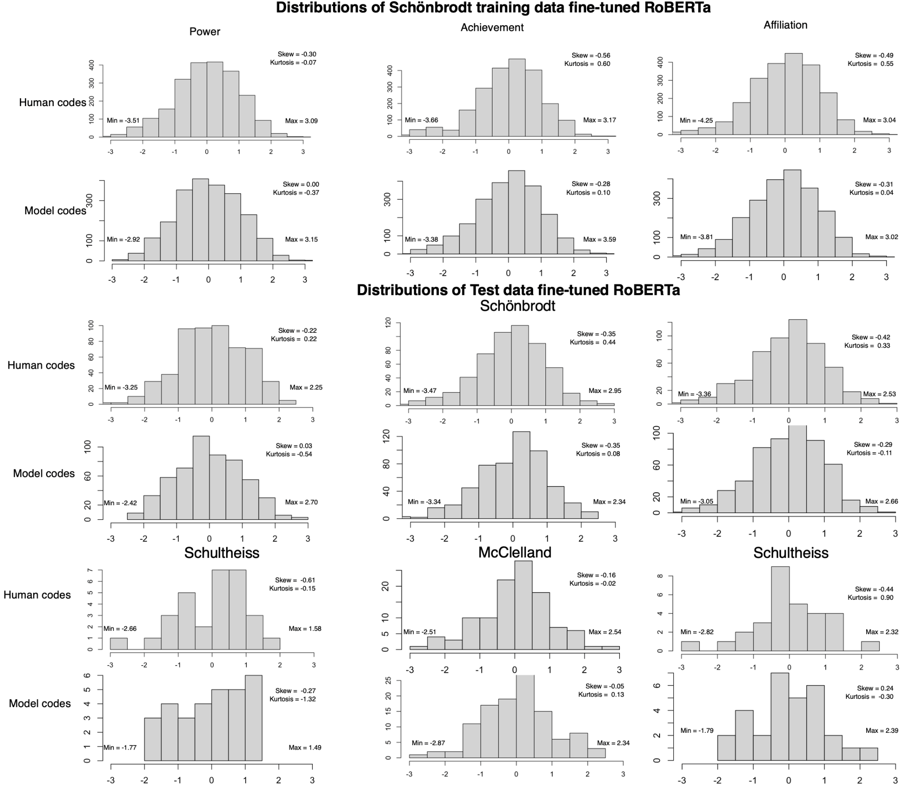
Figure S2
Distributions of Motive Imagery Using and not Using Word Count Correction
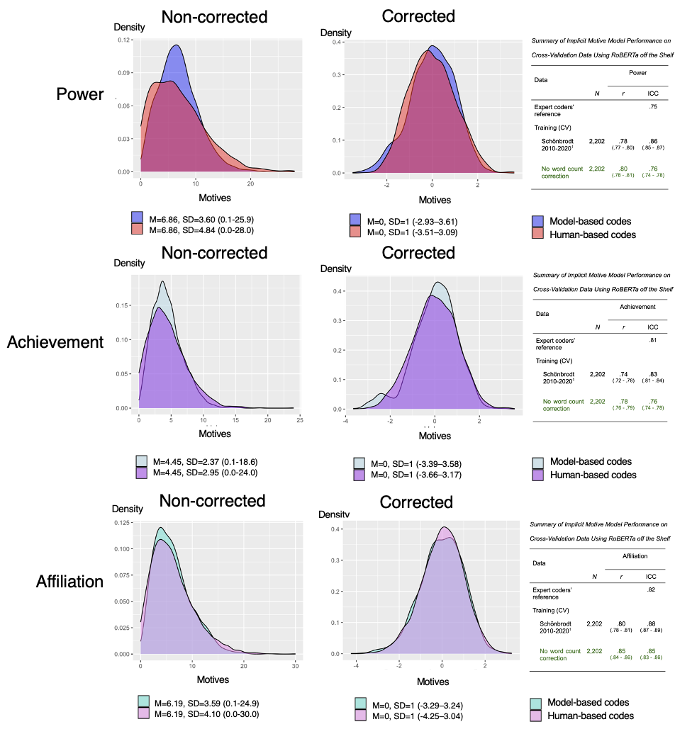Note. The level of difference in distribution between distribution corrected and non-corrected for word count is approximately equivalent to the difference in ICC score between corrected and non-corrected scores.
Supplemental Material References
Dufner, M., Arslan, R. C., Hagemeyer, B., Schönbrodt, F. D., & Denissen, J. J. A. (2015). Affective
contingencies in the affiliative domain: Physiological assessment, associations with
the affiliation motive, and prediction of behavior. Journal of Personality and Social
Psychology, 109, 662–676. https://doi.org/ 10.1037/pspp0000025.
Hagemeyer, B., Dufner, M., and Denissen, J. J. A. (2016). Double dissociation between implicit and
explicit affiliative motives: a closer look at socializing behavior in dyadic interactions. J. Res.
Pers. 65, 89–93. https://doi.org/10.1016/j.jrp.2016.08.003.
Pang, J. S., & Ring, H. (2020). Automated coding of implicit motives: A machine-learning approach.
Motivation and Emotion, 44(4), 549–566. https://doi.org/10.1007/s11031-020-09832-8
Pang, J. S., & Schultheiss, O. (2005). Assessing implicit motives in U.S. college students: Effects of
picture type and position, gender and ethnicity, and cross-cultural comparisons. Journal of
Personality Assessment, 85, 280–294. https://doi.org/10.1207/s15327752jpa8503_04.
Raihala, C. (2018). Behavioral and Affective Correlates of the Implicit Power Motive in Children.
University of Trier.
Rawolle, M., Schultheiss, M., & Schultheiss, O. (2013). Relationships between implicit motives,
self-attributed motives, and personal goal commitment. Frontiers in Psychology, 4, Article
923. https://doi.org/10.3389/fpsyg.2013.00923.
Schie, P. (2020). A study examining the relationship between the implicit power motive and humor
production ability. Utrecht University.
Schoel, C., Zimmer, K., & Stahlberg, D. (2015). The Spatial Power Motivation Scale: A semi-implicit
measure of situational power motivation. Journal of Personality Assessment, 97, 66–80.
https://doi.org/10.1080/00223891.2014.914524
Schüler, J., Brandstätter, V., & Sheldon, K. M. (2013). Do implicit motives and basic psychological
needs interact to predict well-being and flow? Testing a universal hypothesis and a matching
hypothesis. Motivation and Emotion, 37, 480–495. http://dx.doi.org/10.1007/s11031-012-
9317-2
Schüler, J., Brandstäter, V., & Wegner, M. (2015). Testing the convergent and discriminant validity of
three implicit motive measures: PSE, OMT, and MMG. Motivation and Emotion, 39, 839–857.
https://doi.org/10.1007/s11031-015-9502-1
Schäpers, P., Krumm, S., Lievens, F. and Stenzel, N. (2021), “Arousing motives or eliciting stories?
On the role of pictures in a picture–story exercise”, Assessment, Vol. 30 No. 3, p.
107319112110361, https://doi.org/10.1177/10731911211036191.
Spengler, B., Hofer, J., Busch H. (2019). A video game-based investigation of power stress
moderators in children. Motivation and Emotion 44(3):345-355
Spengler, B., Hofer, J., Busch H. (2020). Somebody hit the button! The implicit power motive and the
frequency of verbal persuasion behavior in children. Motivation and Emotion, (44), 695-703
Spengler, B., Hofer, J., Busch, H., Dzionsko, I., & Emslander, V. (2020). Implicit motives and children’s
salivary cortisol reactivity to an adapted version of the Trier Social stress test for children
(TSST-C). Personality and Individual Differences, 162, 110010.
https://doi.org/10.1016/j.paid.2020.110010.
Soni, N., Matero, M., Balasubramanian, Niranjan., and Schwartz, H, A. (2022). Human language
modeling. In Findings of the Association for Computational Linguistics: ACL 2022, pages
622–636, Dublin, Ireland. Association for Computational Linguistics.
Stoeckart, P. F., Strick, M., Bijleveld, E., & Aarts, H. (2018). The implicit power motive predicts
decisions in line with perceived instrumentality. Motivation and Emotion, 42(3), 309–320.
https://doi.org/10.1007/s11031-018-9687-1
Strick, M., Bijleveld, E. (2021). People Prefer Politicians with Matching Implicit Motives: A Study on
the Achievement and Affiliation Motives. psyarxiv pre-print.
https://doi.org/10.31234/osf.io/vpehf
Strick, M., & Papies, E. K. (2017). A brief mindfulness exercise promotes the correspondence
between the implicit affiliation motive and goal setting. Personality and Social Psychology
Bulletin, 43, 623–637. http://dx.doi.org/10.1177/0146167217693611

