Supplemental Material

Supplemental Table S1

Personality Terms Associated Consistently with Either of Two Dimensions in a Majority of Eleven Languages

Term/Concept | CHN | FIL | GRK | HUN | KHO | KOR | MAA | MLY | POL | SEN | TUR
Communion/SSR
good/good-natured (8) | 1 | 1 | 2 |  | 1 | 1 | 1 |  |  | 1 | 2
kind/kindhearted (7) | 1 | 1 | 2 | 1 | 1 | 1 |  | 2
respectful (7) |  | 1 |  | 1 | 1 |  | 1 | 1 |  | 1 | 2
calm (6) |  |  | 2 | 1 | 2 |  | 1 | 2 |  |  | 2
diligent (6) | 1 | 1 |  | 1 | 1 |  |  | 2 | 1
gentle (6) |  |  |  | 1 | 2 | 1 |  |  | 1 | 1 | 2
honest (6) | 1 |  | 2 |  | 1 |  |  |  | 1 | 1 | 2
generous (5) | 1 | 1 |  |  |  | 1 | 1 |  |  | 1
hardworking (5) |  |  | 2 |  | 1 |  | 2 | 2 |  |  | 2
humane (5) |  | 1 |  | 1 | 1 |  |  | 2 |  | 1
obedient/dis- (5) | 1 |  | 2 | 1 | 1 |  |  |  | 1
polite/courteous (5) |  |  | 2 | 1 |  | 1 |  | 1 |  |  | 2
benevolent (4) | 1 |  |  | 1 | 1 | 1
faithful (4) |  |  | 2 | 1 |  |  |  | 1 |  |  | 2
friendly (4) |  | 2 |  | 1 |  | 1 |  | 2
industrious (4) |  | 1 | 2 | 1 | 1
modest (4) |  | 2 |  |  |  | 1 |  | 2 |  |  | 2
naïve (4) | 1 |  |  |  | 2 | 1 |  |  | 2
peaceful (4) |  |  | 2 | 1 |  |  |  | 2 |  | 2
conscientious (3) | 1 |  |  | 1 |  |  |  |  | 1
dutiful (3) |  | 1 |  | 1 |  |  |  |  | 1
responsible (3) |  |  | 2 | 1 |  |  |  |  |  |  | 2
gossipy (5) |  | 1 |  |  | 1 |  | 1 | 1 |  | 1
aggressive (4) |  |  | 2 |  | 2 | 1 |  |  |  |  | 2
hot-headed/tempered (3) |  | 1 |  |  |  |  | 1 |  | 1
selfish (3) | 1 | 1 |  |  |  | 1
Agency/Dynamism
active (7) | 2 | 2 | 1 |  |  | 2 |  | 2 |  | 2 | 1
brave (6) |  |  | 1 |  |  | 2 | 2 |  | 2 | 2 | 1
clever (6) | 2 |  | 1 | 2 | 1 |  |  | 2 |  | 2
lively (6) | 2 | 2 |  | 2 | 2 | 2 |  |  | 2
bold (5) | 2 |  | 1 |  | 2 |  |  |  | 2 |  | 1
cheerful (5) | 2 | 2 | 1 |  |  | 2 |  | 1
energetic (5) |  |  | 1 | 2 |  | 2 |  | 2 |  |  | 1
happy (5) | 2 | 2 |  |  | 1 |  | 2 |  |  | 2
daring (4) | 2 |  | 1 |  |  | 2 | 2
courageous (4) |  |  | 1 |  |  |  | 2 | 2 | 2
determined (4) |  |  | 1 | 2 | 1 | 2
dynamic (4) | 2 |  | 1 | 2 |  |  |  |  |  |  | 1
enterprising (3) |  |  |  |  |  | 2 |  |  | 2 |  | 1
extraverted (3) | 2 |  |  |  |  | 2 |  |  |  |  | 1
joyful (3) | 2 |  |  |  |  |  | 2 |  |  | 1
optimistic (3) | 2 |  | 1 | 2
sociable (3) |  |  | 1 | 2 |  |  |  |  |  |  | 1
vigorous (3) |  |  |  |  |  | 2 |  |  | 2 |  | 1
quiet (6) | 2 | 2 | 2 | 2 | 2 |  |  |  | 2
timid (6) | 2 | 2 |  |  |  | 2 | 2 |  | 2 |  | 1
bashful (5) | 2 |  | 2 | 2 |  |  |  |  | 2 |  | 1
loner (5) | 2 | 2 | 1 |  |  |  | 1 | 1
sad/unhappy (5) |  | 2 | 1 |  |  |  |  | 1 |  | 2 | 1
silent (5) |  | 2 | 1 | 2 | 2 |  |  |  |  |  | 1
coward (4) |  |  | 1 | 2 |  |  | 1 |  | 2
pessimistic (4) | 2 |  | 1 | 2 |  |  |  |  |  |  | 1
shy (4) | 2 | 2 |  | 2 |  | 2
boring (3) | 2 |  | 1 | 2
depressed (3) | 2 |  | 1 |  |  |  | 2
fearful (3) |  |  | 1 |  |  |  |  |  |  | 2 | 1
weak (3) |  | 2 | 1 |  |  |  |  |  |  |  | 2
Note. CHN = Chinese, FIL = Filipino, GRK = Greek, HUN = Hungarian, KHO = Khoekhoe, KOR = Korean, MAA = Maasai, MLY = Malay, POL = Polish, SEN = Senufo, TUR = Turkish;1 = appeared on the first extracted factor; 2 = appeared on the second factor. Italic items are coded negatively for the respective scale.

Supplemental Table S2

Items Rated as Unknown Words by the ALLS Participants, by Country Sample

Item | Kenya (n = 739) |  |  | Namibia (n = 891) |  |  | South Africa (n = 836)
Item | Number | % |  | Number | % |  | Number | %
benevolent | 251 | 33.33 |  | 497 | 55.41 |  | 234 | 27.66
bashful | 182 | 24.17 |  | 413 | 46.04 |  | 123 | 14.54
pessimistic | 120 | 15.94 |  | 412 | 45.93 |  | 148 | 17.49
timid | 149 | 19.79 |  | 364 | 40.58 |  | 149 | 17.61
industrious | 75 | 9.96 |  | 364 | 40.58 |  | 196 | 23.17
courteous | 63 | 8.37 |  | 326 | 36.34 |  | 120 | 14.18
dynamic | 175 | 23.24 |  | 246 | 27.42 |  | 76 | 8.98
hotheaded | 116 | 15.41 |  | 266 | 29.65 |  | 31 | 3.66
modest | 119 | 15.80 |  | 242 | 26.98 |  | 49 | 5.79
diligent | 63 | 8.37 |  | 238 | 26.53 |  | 83 | 9.81
naive | 102 | 13.55 |  | 217 | 24.19 |  | 28 | 3.31
compassionate | 40 | 5.31 |  | 223 | 24.86 |  | 21 | 2.48
daring | 69 | 9.16 |  | 148 | 16.50 |  | 55 | 6.50
bold | 47 | 6.24 |  | 195 | 21.74 |  | 16 | 1.89
loner | 72 | 9.56 |  | 171 | 19.06 |  | 12 | 1.42
humane | 65 | 8.63 |  | 153 | 17.06 |  | 31 | 3.66
inhumane | 51 | 6.77 |  | 157 | 17.50 |  | 41 | 4.85
hot-tempered | 19 | 2.52 |  | 144 | 16.05 |  | 9 | 1.06
arrogant | 26 | 3.45 |  | 126 | 14.05 |  | 16 | 1.89
disobedient | 7 | 0.93 |  | 141 | 15.72 |  | 19 | 2.25
obedient | 2 | 0.27 |  | 138 | 15.38 |  | 23 | 2.72
cowardly | 56 | 7.44 |  | 72 | 8.03 |  | 13 | 1.54
courageous | 3 | 0.40 |  | 122 | 13.60 |  | 8 | 0.95
good-natured | 18 | 2.39 |  | 88 | 9.81 |  | 9 | 1.06
aggressive | 64 | 8.50 |  | 38 | 4.24 |  | 6 | 0.71
generous | 2 | 0.27 |  | 88 | 9.81 |  | 9 | 1.06
determined | 6 | 0.80 |  | 73 | 8.14 |  | 10 | 1.18
lively | 20 | 2.66 |  | 57 | 6.35 |  | 10 | 1.18
gossipy | 25 | 3.32 |  | 34 | 3.79 |  | 7 | 0.83
energetic | 11 | 1.46 |  | 49 | 5.46 |  | 6 | 0.71
cheerful | 11 | 1.46 |  | 48 | 5.35 |  | 5 | 0.59
kindhearted | 15 | 1.99 |  | 39 | 4.35 |  | 5 | 0.59
gentle | 18 | 2.39 |  | 27 | 3.01 |  | 6 | 0.71
polite | 3 | 0.40 |  | 35 | 3.90 |  | 8 | 0.95
bad | 8 | 1.06 |  | 29 | 3.23 |  | 5 | 0.59
unhappy | 8 | 1.06 |  | 21 | 2.34 |  | 4 | 0.47
calm | 9 | 1.20 |  | 18 | 2.01 |  | 4 | 0.47
clever | 9 | 1.20 |  | 18 | 2.01 |  | 2 | 0.24
self-confident | 2 | 0.27 |  | 21 | 2.34 |  | 5 | 0.59
weak | 7 | 0.93 |  | 17 | 1.90 |  | 4 | 0.47
quiet | 5 | 0.66 |  | 17 | 1.90 |  | 4 | 0.47
active | 4 | 0.53 |  | 17 | 1.90 |  | 4 | 0.47
friendly | 2 | 0.27 |  | 13 | 1.45 |  | 8 | 0.95
shy | 5 | 0.66 |  | 14 | 1.56 |  | 3 | 0.35
faithful | 1 | 0.13 |  | 15 | 1.67 |  | 6 | 0.71
silent | 4 | 0.53 |  | 14 | 1.56 |  | 3 | 0.35
happy | 1 | 0.13 |  | 8 | 0.89 |  | 11 | 1.30
confident | 1 | 0.13 |  | 16 | 1.78 |  | 3 | 0.35
sad | 8 | 1.06 |  | 8 | 0.89 |  | 2 | 0.24
respectful | 0 | 0.00 |  | 12 | 1.34 |  | 5 | 0.59
honest | 0 | 0.00 |  | 13 | 1.45 |  | 4 | 0.47
hardworking | 0 | 0.00 |  | 10 | 1.11 |  | 5 | 0.59
kind | 0 | 0.00 |  | 9 | 1.00 |  | 6 | 0.71
brave | 1 | 0.13 |  | 12 | 1.34 |  | 2 | 0.24
peaceful | 0 | 0.00 |  | 10 | 1.11 |  | 4 | 0.47
Note. The amount and percentage of times the answer option "I do not know this word." was selected in the ALLS data set, for each item and all countries. The items are ordered from greatest to smallest frequency of this answer option on average frequency across countries (see Table 2).

Supplemental Table S3

EFA Factor Loadings ALLS Combined Samples

Item | Subscale | Ipsatized Data |  |  |  | Raw Data
Item | Subscale | Primary Factor | C/SSR loading | A/D  loading | Loading Ratio | Primary Factor | C/SSR loading | A/D  loading | Loading Ratio
bad | C/SSR | C/SSR | -.68 | -.04 | 15.5 | A/D | -.24 | .47 | 1.92
disobedient | C/SSR | C/SSR | -.66 | -.04 | 17.82 | A/D | -.19 | .49 | 2.51
kind | C/SSR | C/SSR | .64 | -.08 | 7.71 | C/SSR | .75 | .06 | 11.67
inhumane | C/SSR | C/SSR | -.62 | 0 | 427.56 | A/D | -.21 | .38 | 1.8
arrogant | C/SSR | C/SSR | -.61 | -.01 | 54.04 | A/D | -.13 | .44 | 3.39
respectful | C/SSR | C/SSR | .58 | -.06 | 9.66 | C/SSR | .71 | .05 | 15.41
friendly | C/SSR | C/SSR | .53 | -.01 | 74.76 | C/SSR | .71 | .04 | 16.38
faithful | C/SSR | C/SSR | .53 | -.03 | 16.61 | C/SSR | .68 | .03 | 20.55
generous | C/SSR | C/SSR | .52 | .02 | 23.39 | C/SSR | .72 | .04 | 17.33
polite | C/SSR | C/SSR | .52 | -.08 | 6.75 | C/SSR | .63 | .03 | 24.63
good-natured | C/SSR | C/SSR | .51 | 0 | 108.13 | C/SSR | .68 | .02 | 34.4
honest | C/SSR | C/SSR | .51 | .01 | 52.05 | C/SSR | .66 | -.01 | 47.09
hotheaded | C/SSR | C/SSR | -.50 | -.12 | 4.09 | A/D | -.04 | .53 | 12.43
gossipy | C/SSR | C/SSR | -.49 | -.11 | 4.46 | A/D | -.18 | .38 | 2.07
gentle | C/SSR | C/SSR | .48 | -.01 | 4.46 | C/SSR | .68 | .06 | 10.7
kindhearted | C/SSR | C/SSR | .48 | -.01 | 79.11 | C/SSR | .66 | .05 | 14.19
peaceful | C/SSR | C/SSR | .48 | -.01 | 86.57 | C/SSR | .63 | -.01 | 89.17
hot-tempered | C/SSR | C/SSR | -.46 | -.12 | 3.69 | A/D | -.03 | .48 | 14.69
aggressive | C/SSR | C/SSR | -.46 | .19 | 2.38 | A/D | -.07 | .12 | 1.8
hardworking | C/SSR | C/SSR | .45 | .15 | 2.99 | C/SSR | .71 | -.01 | 52.06
obedient | C/SSR | C/SSR | .44 | .08 | 5.42 | C/SSR | .62 | -.04 | 14.37
calm | C/SSR | C/SSR | .42 | -.12 | 3.45 | C/SSR | .58 | .12 | 4.71
humane | C/SSR | C/SSR | .41 | 0 | 1452.99 | C/SSR | .59 | .02 | 25.7
compassionate | C/SSR | C/SSR | .33 | .04 | 7.91 | C/SSR | .59 | .06 | 9.19
cowardly* | A/D | C/SSR | -.33 | -.32 | 1.02 | A/D | -.11 | .48 | 4.31
diligent | C/SSR | C/SSR | .29 | .13 | 2.2 | C/SSR | .58 | 0 | 366.56
naive | C/SSR | C/SSR | -.26 | -.17 | 1.53 | A/D | .02 | .37 | 20.86
bashful* | A/D | C/SSR | -.26 | -.06 | 4.5 | A/D | .09 | .29 | 3.27
courteous | C/SSR | C/SSR | .25 | .07 | 3.36 | C/SSR | .48 | -.01 | 57.24
modest | C/SSR | C/SSR | .13 | .07 | 1.84 | C/SSR | .45 | .09 | 5.14
benevolent | C/SSR | C/SSR | .06 | -.05 | 1.16 | C/SSR | .33 | .18 | 1.87
weak | A/D | A/D | -.33 | -.34 | 1.04 | A/D | -.08 | .54 | 7.12
unhappy | A/D | A/D | -.29 | -.42 | 1.45 | A/D | -.08 | .58 | 7.76
determined | A/D | A/D | .21 | .33 | 1.58 | C/SSR | .60 | -.07 | 8.51
sad | A/D | A/D | -.21 | -.48 | 2.28 | A/D | -.01 | .60 | 46.28
timid | A/D | A/D | -.21 | -.34 | 1.6 | A/D | .07 | .51 | 7.52
pessimistic | A/D | A/D | -.21 | -.26 | 1.21 | A/D | .04 | .43 | 9.97
clever | A/D | A/D | .20 | .30 | 1.53 | C/SSR | .62 | -.01 | 45.38
happy | A/D | A/D | .19 | .39 | 2.01 | C/SSR | .61 | -.11 | 5.48
silent | A/D | A/D | .15 | -.56 | 3.84 | A/D | .23 | .49 | 2.11
quiet | A/D | A/D | .15 | -.51 | 3.36 | A/D | .24 | .45 | 1.88
daring | A/D | A/D | -.15 | .41 | 2.67 | C/SSR | .38 | 0 | 205.5
bold | A/D | A/D | -.13 | .44 | 3.4 | C/SSR | .39 | -.05 | 7.33
industrious* | C/SSR | A/D | .12 | .25 | 1.99 | C/SSR | .48 | -.04 | 11.56
cheerful | A/D | A/D | .08 | .41 | 4.92 | C/SSR | .55 | -.09 | 6.21
courageous | A/D | A/D | .07 | .51 | 7.34 | C/SSR | .59 | -.10 | 5.79
shy | A/D | A/D | .07 | -.55 | 7.83 | A/D | .16 | .51 | 3.22
active | A/D | A/D | .06 | .47 | 7.96 | C/SSR | .55 | -.10 | 5.49
energetic | A/D | A/D | -.06 | .53 | 9.15 | C/SSR | .51 | -.09 | 5.42
loner | A/D | A/D | -.06 | -.52 | 9.19 | A/D | .08 | .55 | 6.65
self-confident | A/D | A/D | .05 | .53 | 10.64 | C/SSR | .55 | -.16 | 3.56
lively | A/D | A/D | .04 | .49 | 11.78 | C/SSR | .57 | -.09 | 6.69
confident | A/D | A/D | .03 | .59 | 20.67 | C/SSR | .57 | -.17 | 3.36
brave | A/D | A/D | .02 | .47 | 23.02 | C/SSR | .56 | -.06 | 8.88
dynamic | A/D | A/D | -.01 | .30 | 47.39 | C/SSR | .44 | .01 | 59.74
Note. C/SSR = Communion/Social Self-Regulation, A/D = Agency/Dynamism. Factor loadings are in descending order of absolute loading on the primary factor of the ipsatized data. Items marked with * had their primary loading on the unintended factor.

Supplemental Table S4

Zero-Order Correlations between CCB2I and External Scales in ALLS

 | Communion/SSR |  |  |  | Agency/ Dynamism
 | K | N | SA |  | K | N | SA
Gender = male | -.07 | -.12* | -.08 |  | -.06 | -.07 | .14**
General Self-Reported Health | -.05 | -.03 | -.06 |  | -.10* | -.02 | -.39***
IMHA scales
Internalizing | -.24*** | -.14** | -.21*** |  | -.23*** | -.06 | -.45***
Depression | -.27*** | -.11* | -.23*** |  | -.27*** | -.07 | -.53***
Anxiety | -.16*** | -.13* | -.17*** |  | -.18*** | -.05 | -.34***
Post-Traumatic Stress | -.23*** | -.15** | -.17*** |  | -.16*** | -.04 | -.34***
Attention Deficit/Hyperactivity¹ | -.22*** | -.08 | -.21*** |  | -.24*** | .00 | -.30***
Externalizing | -.36*** | -.21*** | -.30*** |  | -.27*** | -.07 | -.19***
Substance Abuse | -.35*** | -.35*** | -.24*** |  | -.20*** | -.11 | .05
Anger | -.33*** | -.15** | -.25*** |  | -.20*** | -.07 | -.03
Duke Religion Index
Intrinsic Religiosity | .25*** | .29*** | .27*** |  | .19*** | .24*** | .19***
Religiosity Activity | .23*** | .06 | .16*** |  | .22*** | .08 | .22***
Note. K = Kenya, N = Namibia, SA = South Africa; N_{Kenya} = 739, N_{Namibia} = 891, N_{SouthAfrica} = 836; * p < .05, ** p < .01, *** p < .001.
¹ included on both Internalizing and Externalizing scales.

Supplemental Table S5

Partial Correlations between CCB2I and External Scales in ALLS

 | Communion/SSR |  |  |  | Agency/ Dynamism
 | K | N | SA |  | K | N | SA
Gender = male | -.05 | -.10 | -.15** |  | -.02 | .01 | .20***
General Self-Reported Health | .01 | -.02 | .12* |  | -.09 | .00 | -.41***
IMHA scales
Internalizing | -.17** | -.13* | -.04 |  | -.11* | .04 | -.41***
Depression | -.17** | -.08 | -.02 |  | -.14** | -.01 | -.49***
Anxiety | -.10* | -.13 | -.04 |  | -.09 | .05 | -.30***
Post-Traumatic Stress | -.18*** | -.15* | -.04* |  | -.04 | .07 | -.30***
Attention Deficit / Hyperactivity¹ | -.13** | -.10 | -.10* |  | -.14** | .06 | -.24***
Externalizing | -.28*** | -.22** | -.25*** |  | -.10* | .09 | -.08
Substance Abuse | -.28*** | -.36*** | -.29*** |  | -.03 | .15* | .17***
Anger | -.27*** | -.13 | -.26*** |  | -.04 | .03 | .08
Intrinsic Religiosity | .17*** | .17** | .21*** |  | .07 | .09 | .08
Religiosity Activity | .13** | .01 | .09 |  | .11* | .06 | .17***
Note. K = Kenya, N = Namibia, SA = South Africa; N_{Kenya} = 739, N_{Namibia} = 891, N_{SouthAfrica} = 739; * p < .05, ** p < .01, *** p < 0.001.
¹ included on both Internalizing and Externalizing scales.

Supplemental Table S6
Partial Correlations between CCB2I and External Scales, SAPA data
Trait | Communion/SSR | Agency/Dynamism
Other Two-Factor Scales
IPIP Dynamism | .10 [.06, .14] | .48 [.44, .51]
IPIP SSR | .33 [.30, .37] | .01 [-.04, .05]
QB6 Dynamism | .07 [.03, .11] | .39 [.36, .42]
QB6 SSR | .31 [.28, .35] | .08 [.04, .12]
Plasticity | .08 [.04, .12] | .43 [.39, .46]
Stability | .23 [.19, .26] | .23 [.19, .27]
Big Five
Agreeableness | .33 [.30, .37] | .07 [.03, .12]
Conscientiousness | .26 [.22, .30] | .21 [.17, .25]
Extraversion | -.06 [-.10,-.01] | .38 [.35, .42]
Neuroticism | -.11 [-.15,-.07] | -.31 [-.35,-.28]
Openness | .13 [.09, .17] | .24 [.20, .28]
SPI Traits
Compassion | .31 [.27, .35] | .02 [-.03, .06]
Irritability | -.26 [-.3,-.23] | -.14 [-.18,-.10]
Sociability | 0 [-.04, .04] | .32 [.28, .36]
Well Being | .21 [.17, .25] | .45 [.42, .48]
Sensation Seeking | -.12 [-.16,-.08] | .26 [.23, .30]
Anxiety | 0 [-.04, .04] | -.31 [-.34,-.27]
Honesty | .30 [.26, .33] | .07 [.03, .11]
Industry | .22 [.18, .26] | .28 [.25, .32]
Intellect | .13 [.09, .17] | .28 [.24, .32]
Creativity | .12 [.08, .16] | .27 [.24, .31]
Impulsivity | -.26 [-.30,-.22] | -.03 [-.07, .01]
Attention Seeking | -.17 [-.20,-.12] | .21 [.17, .25]
Order | .17 [.13, .21] | .10 [.06, .14]
Authoritarianism | .30 [.26, .34] | -.03 [-.07, .01]
Charisma | .05 [.01, .09] | .46 [.42, .49]
Trust | .16 [.12, .20] | .07 [.03, .11]
Humor | .05 [.01, .09] | .30 [.26, .34]
Emotional Expressiveness | .03 [-.01, .07] | .29 [.25, .32]
Art Appreciation | .11 [.07, .15] | .07 [.03, .11]
Introspection | .16 [.12, .20] | .07 [.03, .11]
Perfectionism | .12 [.08, .16] | .07 [.03, .11]
Self Control | .20 [.16, .24] | .09 [.05, .13]
Conformity | .09 [.05, .13] | -.19 [-.23,-.15]
Adaptability | .10 [.06, .14] | .28 [.24, .32]
Easy Goingness | .04 [-.01, .08] | -.10 [-.14,-.06]
Emotional Stability | .03 [-.01, .07] | .19 [.15, .23]
Conservatism | .08 [.04, .12] | .04 [0, .08]
Socio-Demographic Variables
Age | .10 [.05, .14] | .09 [.05, .13]
Sex = female | 0 [-.04, .04] | -.07 [-.11,-.03]
Self-reported health | .12 [.08, .16] | .25 [.21, .29]
Parent 1 education | -.02 [-.06, .02] | 0 [-.04, .04]
Parent 2 education | -.04 [-.08, 0] | 0 [-.04, .04]
Education | .04 [0, .08] | .05 [.01, .09]
Occupational prestige | .01 [-.03, .05] | .04 [0, .08]
BMI | .04 [0, .08] | 0 [-.04, .04]
Exercise frequency | .07 [.03, .11] | .23 [.19, .26]
Smoking frequency | -.09 [-.13,-.05] | .03 [-.01, .07]
Sleep quality | .10 [.05, .14] | .22 [.19, .26]
Caffeine consumption | -.02 [-.06, .03] | .03 [-.01, .07]
Volunteering frequency | .13 [.09, .17] | .22 [.18, .26]
Religious frequency | .09 [.05, .13] | .10 [.06, .14]
Credit score | .05 [.01, .09] | .11 [.07, .15]
Twitter usage | -.03 [-.07, .01] | 0 [-.04, .05]
Note. 95% confidence intervals are shown.
Supplemental Table S7

Intercorrelations of CCB2I-Related Scales in Published Studies
Model | Sample | Reference | r
Agency and Communion life goals (self-report) | 272 American students | Trapnell and Paulhus (2012) | .10
Agency and Communion traits (self-report) | 1,808 students from Germany, France, Poland, Australia, the USA, and China | Abele et al. (2016) | .33
Agency and Communion traits (rating others) | 83 Polish employees rating supervisors | Wojciszke et al. (2009) | .58
Agency and Communion behavior (self-report) | 317 Americans | Buchanan & Bardi (2015) | .58
Agency and Communion traits (rating others) | 162 Polish employees rating supervisors | Wojciszke and Abele (2008) | .61
Note. Values are sorted from lowest to highest magnitude. Many reports of two-factor models did not report their correlations of the two factors (e.g., Digman, 1997; Gebauer et al., 2013; Saucier et al., 2014; Thalmayer & Saucier, 2014; Wiggins, 1979; Zeldow et al., 1988).

Supplemental Figure S1

Correlations Between CCB2I and External Scales, ALLS Combined
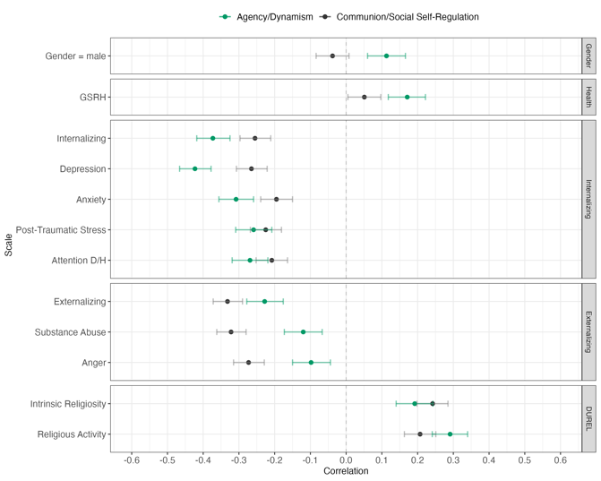
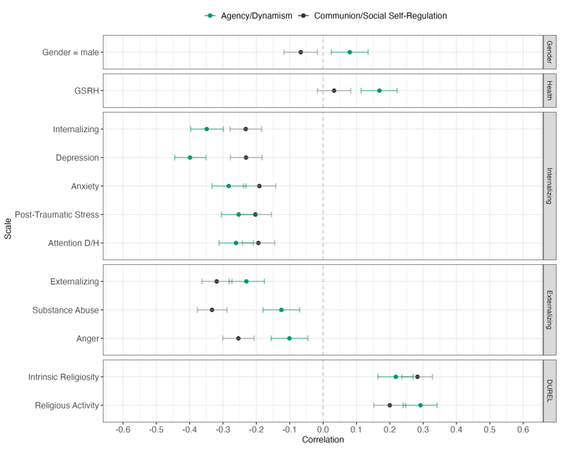
(a) Original Scale, Zero-Order (b) Balanced-Key, Zero-Order

(c) Original Scale, Partial Correlations
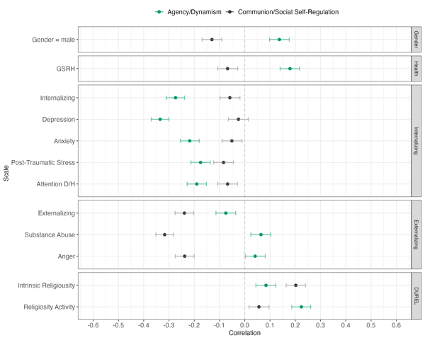

Supplemental Figure S2
Partial Correlations Between CCB2I and External Scales, SAPA Data
(a) Personality Scales
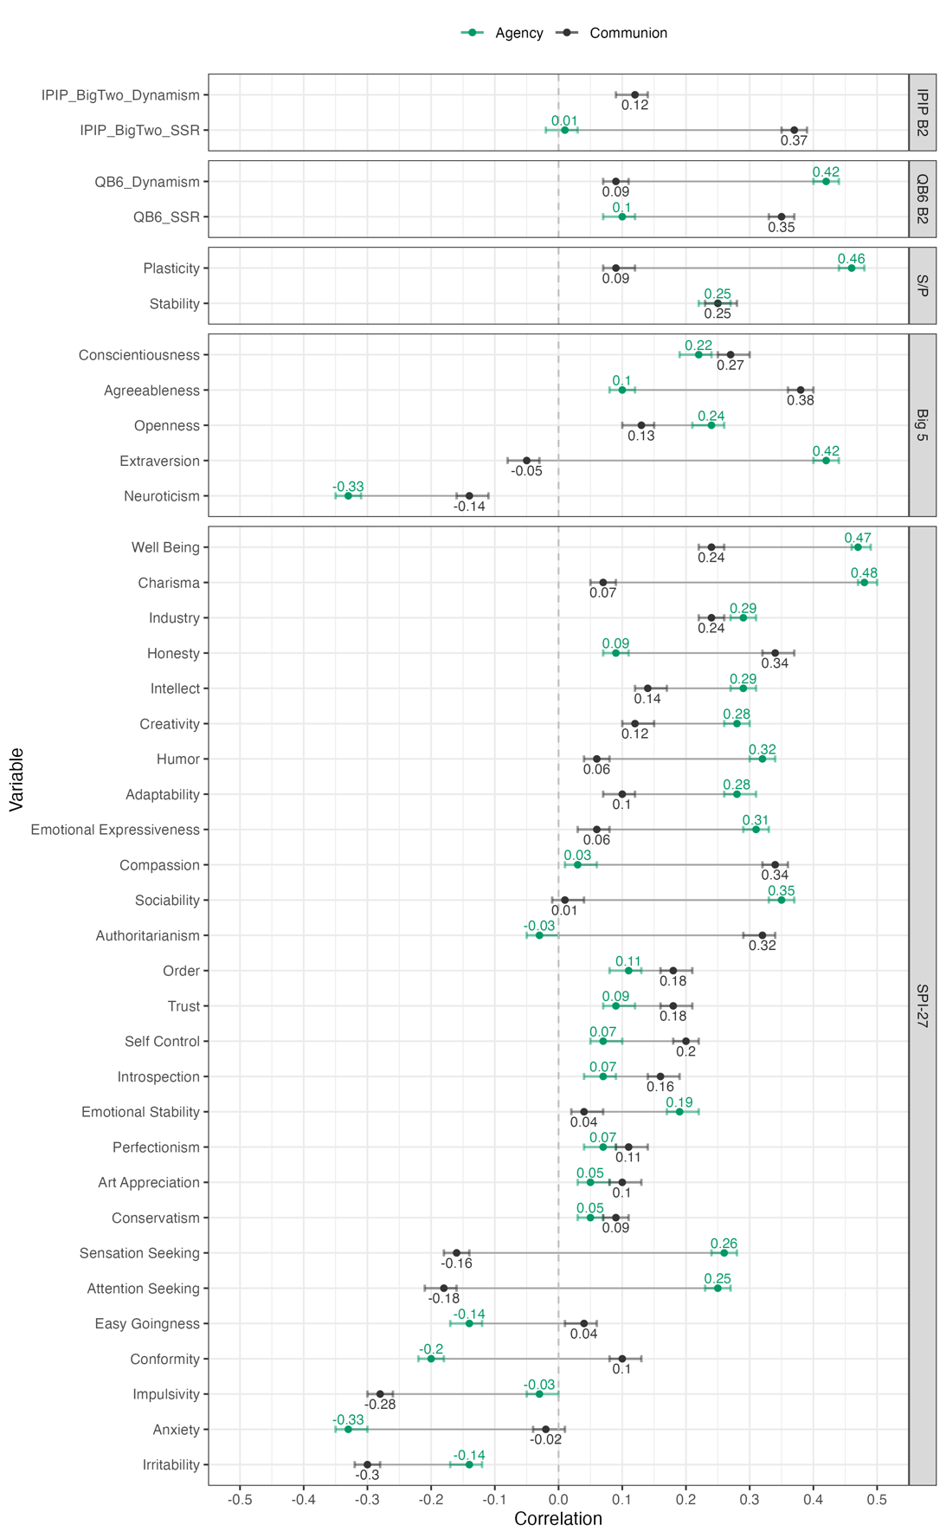

(b) Socio-Demographic Variables
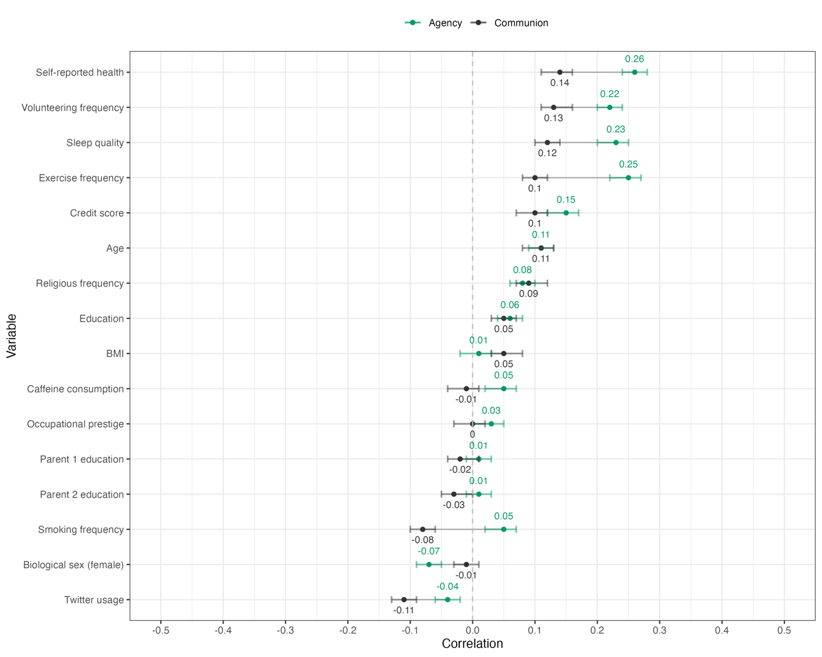
References

Abele, A. E., Hauke, N., Peters, K., Louvet, E., Szymkow, A., & Duan, Y. (2016). Facets of the Fundamental Content Dimensions: Agency with Competence and Assertiveness—Communion with Warmth and Morality. Frontiers in Psychology, 7. https://doi.org/10.3389/fpsyg.2016.01810
Buchanan, K., & Bardi, A. (2015). The Roles of Values, Behavior, and Value-Behavior Fit in the Relation of Agency and Communion to Well-Being: Agency, Communion, and Well-Being. Journal of Personality, 83(3), 320–333. https://doi.org/10.1111/jopy.12106
DeYoung, C. G. (2006). Higher-order factors of the Big Five in a multi-informant sample. Journal of Personality and Social Psychology, 91(6), 1138–1151. https://doi.org/10.1037/0022-3514.91.6.1138
Digman, J. M. (1997). Higher-order factors of the Big Five. Journal of Personality and Social Psychology, 73(6), 1246–1256. https://doi.org/10.1037/0022-3514.73.6.1246
Gebauer, J. E., Paulhus, D. L., & Neberich, W. (2013). Big Two Personality and Religiosity Across Cultures: Communals as Religious Conformists and Agentics as Religious Contrarians. Social Psychological and Personality Science, 4(1), 21–30. https://doi.org/10.1177/1948550612442553
Saucier, G., Thalmayer, A. G., Payne, D. L., Carlson, R., Sanogo, L., Ole-Kotikash, L., Church, A. T., Katigbak, M. S., Somer, O., Szarota, P., Szirmák, Z., & Zhou, X. (2014). A Basic Bivariate Structure of Personality Attributes Evident Across Nine Languages: Basic Bivariate Personality Structure. Journal of Personality, 82(1), 1–14. https://doi.org/10.1111/jopy.12028
Thalmayer, A. G., & Saucier, G. (2014). The Questionnaire Big Six in 26 Nations: Developing Cross–Culturally Applicable Big Six, Big Five and Big Two Inventories. European Journal of Personality, 28(5), 482–496. https://doi.org/10.1002/per.1969
Trapnell, P. D., & Paulhus, D. L. (2012). Agentic and Communal Values: Their Scope and Measurement. Journal of Personality Assessment, 94(1), 39–52. https://doi.org/10.1080/00223891.2011.627968
Wiggins, J. S. (1979). A psychological taxonomy of trait-descriptive terms: The interpersonal domain. Journal of Personality and Social Psychology, 37(3), 395–412. https://doi.org/10.1037/0022-3514.37.3.395
Wojciszke, B., & Abele, A. E. (2008). The primacy of communion over agency and its reversals in evaluations. European Journal of Social Psychology, 38(7), 1139–1147. https://doi.org/10.1002/ejsp.549
Wojciszke, B., Abele, A. E., & Baryla, W. (2009). Two dimensions of interpersonal attitudes: Liking depends on communion, respect depends on agency. European Journal of Social Psychology, 39(6), 973–990. https://doi.org/10.1002/ejsp.595
Zeldow, P. B., Daugherty, S. R., & McADAMS, D. P. (1988). Intimacy, Power, and Psychological Weil-Being in Medical Students: The Journal of Nervous and Mental Disease, 176(3), 182–187. https://doi.org/10.1097/00005053-198803000-00007

