My Partner Really Gets Me: Affective Reactivity to Partner Stress Predicts Greater Relationship Quality in New Couples

Online Supplemental Material

Dyadic Model Equations
All dyadic models were constructed following the approach recommended by Kenny and Kashy (2011). In all models, e = residual. In models with repeated outcome assessments, i = person; j = time; u₀ = random intercept; u₁ = random slope.
Computing Affective Reactivity in Studies 1-3
Affective Reactivity to Partner Stress
own negative affect_{ij} = γ₀₀ + γ₁₀ gender + γ₂₀ partner external stressor exposure_{ij} + (female) u₀ + (male) u₀ + (female) (partner external stressor exposure) u₁ + (male) (partner external stressor exposure) u₁ + (female) e_{ij} + (male) e_{ij}. (1)
Affective Reactivity to Own Stress
own negative affect_{ij} = γ₀₀ + γ₁₀ gender + γ₂₀ own external stressor exposure_{ij} + (female) u₀ + (male) u₀ + (female) (own external stressor exposure) u₁ + (male) (own external stressor exposure) u₁ +(female) e_{ij} + (male) e_{ij}. (2)
To compute affective reactivity to partner stress and affective reactivity to own stress, we derived empirical Bayes estimates of the randomly varying Level 1 slopes for each participant—denoted by the “(partner external stressor exposure) u₁” term in Equation 1 and “(own external stressor exposure) u₁” term in Equation 2, respectively.

Testing the Research Questions in Study 1
Estimating Partner’s Relationship Quality from Reactivity to Partner Stress
Unadjusted Model.
partner relationship quality_{ij} = γ₀₀ + γ₁₀ gender + γ₂₀ reactivity to partner stress + (female) u₀ + (male) u₀ + (female) e_{ij} + (male) e_{ij}. (3)
Adjusted Model.
partner relationship quality_{ij} = γ₀₀ + γ₁₀ gender + γ₂₀ reactivity to partner stress + γ₃₀ reactivity to own stress + γ₄₀ negative affect similarity + (female) u₀ + (male) u₀ + (female) e_{ij} + (male) e_{ij}. (4)
The Mediating Role of Partner’s Perceived Responsiveness
Unadjusted models.
partner’s perceived responsiveness_{ij} = γ₀₀ + γ₁₀ gender + γ₂₀ reactivity to partner stress + (female) u₀ + (male) u₀ + (female) e_{ij} + (male) e_{ij}. (5)
partner relationship quality_{ij} = γ₀₀ + γ₁₀ gender + γ₂₀ reactivity to partner stress + γ₃₀ gmc partner’s perceived responsiveness + γ₄₀ gm partner’s perceived responsiveness + (female) u₀ + (male) u₀ + (female) e_{ij} + (male) e_{ij}. (6)
Note that because affective reactivity to partner stress was a person-level variable, the indirect association could explain only between-person differences. Thus, following Zhang et al., (2009), we separated partner’s perceived responsiveness into its within- and between-person components in Equation 6. This involved group-mean centering perceived responsiveness (denoted above as “gmc partner’s perceived responsiveness”) and re-introducing the group mean to the model as a separate predictor (denoted above as “gm partner’s perceived responsiveness”).
The indirect effect was computed as γ_{20(Equation 5)} × γ_{40(Equation 6)}.

Adjusted models.
partner’s perceived responsiveness_{ij} = γ₀₀ + γ₁₀ gender + γ₂₀ reactivity to partner stress + γ₃₀ reactivity to own stress + γ₄₀ negative affect similarity + (female) u₀ + (male)u₀ + (female) e_{ij} + (male) e_{ij}. (7)
partner relationship quality_{ij} = γ₀₀ + γ₁₀ gender + γ₂₀ reactivity to partner stress + γ₃₀ gmc partner’s perceived responsiveness + γ₄₀ gm partner’s perceived responsiveness + γ₅₀ reactivity to own stress + γ₆₀ negative affect similarity + (female) u₀ + (male) u₀ + (female) e_{ij} + (male) e_{ij}. (8)
The indirect effect was computed as γ_{20(Equation 7)} × γ_{40(Equation 8)}
The Buffering Role of Reactivity to Partner Stress in the Trajectory of Relationship Quality
Unadjusted model.
partner relationship quality_{ij} = γ₀₀ + γ₁₀ gender + γ₂₀ time_{ij} + γ₃₀ reactivity to partner stress + γ₄₀ (reactivity to partner stress) (time) + (female) u₀ + (male) u₀ + (female) (time) u₁ + (male) (time) u₁ + (female) e_{ij} + (male) e_{ij}. (9)
Adjusted model.
partner relationship quality_{ij} = γ₀₀ + γ₁₀ gender + γ₂₀ time_{ij} + γ₃₀ reactivity to partner stress + γ₄₀ reactivity to own stress + γ₅₀ negative affect similarity + γ₆₀ (reactivity to partner stress) (time) + γ₇₀ (reactivity to own stress) (time) + γ₈₀ (negative affect similarity) (time) + (female) u₀ + (male) u₀ + (female) (time) u₁ + (male) (time) u₁ + (female) e_{ij} + (male) e_{ij}. (10)
Testing the Research Questions in Study 2
To model nonindependence in distinguishable dyadic data where dyad members are assessed only once, Kenny and Kashy (2011) recommended treating the dyad members as repeated measures where each member has an error and the errors are correlated. Models 11 through 16 were constructed following this recommendation.

Estimating Partner’s Relationship Quality from Reactivity to Partner Stress
Unadjusted Model.
post-diary partner relationship quality = γ₀₀ + γ₁₀ gender + γ₂₀ pre-diary partner relationship quality + γ₃₀ reactivity to partner stress + (female) e + (male) e. (11)
Adjusted Model.
post-diary partner relationship quality = γ₀₀ + γ₁₀ gender + γ₂₀ pre-diary partner relationship quality + γ₃₀ reactivity to partner stress + γ₄₀ reactivity to own stress + γ₅₀ negative affect similarity + (female) e + (male) e. (12)
The Mediating Role of Partner’s Perceived Responsiveness
Unadjusted models.
partner’s perceived responsiveness = γ₀₀ + γ₁₀ gender + γ₂₀ pre-diary partner relationship quality + γ₃₀ reactivity to partner stress + (female) e + (male) e. (13)
post-diary partner relationship quality = γ₀₀ + γ₁₀ gender + γ₂₀ pre-diary partner relationship quality + γ₃₀ reactivity to partner stress + γ₄₀ partner’s perceived responsiveness + (female) e + (male) e. (14)
The indirect effect was computed as γ_{30(Equation 13)} × γ_{40(Equation 14)}
Adjusted models.
partner’s perceived responsiveness = γ₀₀ + γ₁₀ gender + γ₂₀ pre-diary partner relationship quality + γ₃₀ reactivity to partner stress + γ₄₀ reactivity to own stress + γ₅₀ negative affect similarity + (female) e + (male) e. (15)
post-diary relationship quality = γ₀₀ + γ₁₀ gender + γ₂₀ pre-diary partner relationship quality + γ₃₀ reactivity to partner stress + γ₄₀ partner’s perceived responsiveness + γ₅₀ reactivity to own stress + γ₆₀ negative affect similarity + (female) e_{ij} + (male) e_{ij}. (16)
The indirect effect was computed as γ_{30(Equation 15)} × γ_{40(Equation 16)}

The Buffering Role of Reactivity to Partner Stress in the Trajectory of Relationship Quality
Please see Equations 9 and 10.
Testing the Research Questions in Study 3
Please see Equation 11 (the association between reactivity to partner stress and partner relationship quality), Equation 13 (the association between reactivity to partner stress and partner’s perceived responsiveness), and Equation 9 (the interaction between reactivity to partner stress and time in predicting partner’s relationship quality). Because no evidence for the effects of interest were found in unadjusted models, we did not proceed to the adjusted models.
Testing the Research Questions in Study 4
Please see Equation 3 (the association between reactivity to partner stress and partner relationship quality), Equation 5-8 (the indirect association through partner’s perceived responsiveness), and Equation 9 (the interaction between reactivity to partner stress and time in predicting partner’s relationship quality). Because no evidence was found in the unadjusted models for the direct association between reactivity to partner stress and partner relationship quality or for the moderating role of reactivity to partner stress in the trajectory of partner relationship quality, we did not proceed to the adjusted models.

Response Surface Analyses
In Studies 1 and 2 where we observed a significant association between reactivity to partner stress and partner relationship quality in fledgling couples, we further explored whether the congruence in partners’ affective reactivity predicted relationship quality. According to the congruence idea, the observed benefits for one’s relationship quality might be due to the similarity between an individual’s reactivity to their own external stressors and their partner’s reactivity to those stressors. In other words, the congruence account identifies a possible qualifier of the effects we observed in Studies 1 and 2 by suggesting that having a partner who shows high affective reactivity to your external stress promotes your relationship quality particularly when you also show high affective reactivity to those stressors.
We used response surface analyses (RSAs; Schönbrodt, 2016) to explore possible congruence effects in Studies 1 and 2. We tested whether the congruence between the actor’s and the partner’s affective reactivity to the actor’s external stress predicted actor relationship quality and perceived responsiveness. The RSAs involved estimating the polynomial regression model below where X corresponded to actor affective reactivity to own external stressors, Y corresponded to partner affective reactivity to the actor’s external stressors, and Z corresponded to the actor’s outcomes (i.e., relationship quality and perceived partner responsiveness). The predictors were standardized for the analyses.
Z = b₀ + b₁X + b₂Y + b₃X² + b₄XY + b₅Y² (17)
We then used the R package RSA (Schönbrodt & Humberg, 2018) to obtain point estimates, significance tests, and graphs for all surface parameters. We nested the partners within couples in these analyses in order to account for non-independent data. RSA provides four point estimates for this model:
a₁ = b₁ + b₂
a₂ = b₃ + b₄ + b₅
a₃ = b₁ - b₂
a₄ = b₃ - b₄ + b₅
Lastly, RSA also tests whether the position of the first principal axis to the line in the XY plane that contains all congruent predictor combinations Y = X, which is reflected in the a₅ = b3 - b5 estimate (see proof for the a₅ parameter in Appendix A of Nestler et al., 2019).
In order for a congruence effect to be present in this model, (1) a₅ must not be significantly different from zero, (2) a₄ must be significantly negative, and (3) a₃ must not be significantly different from zero. Further details can be found in the published guidelines for RSA (Humberg et al., 2019).
Study 1
We first controlled for gender (Model 1a) and if we found a significant effect, we controlled for gender, negative affect similarity and the partner’s reactivity to their own stress (Model 1b). The congruence between the actor’s and the partner’s affective reactivity to the actor’s external stress predicted actor’s relationship quality. The estimates are presented below.

Table S1. RSA estimates for relationship quality in Study 1.
 | Estimate | SE | p-value
Model 1a
a₁ | .269 | .066 | .000
a₂ | -.018 | .051 | .718
a₃ | -.012 | .084 | .888
a₄ | -.184 | .068 | .007
a₅ | .031 | .046 | .490
Model 1b
a₁ | .207 | .064 | .001
a₂ | -.031 | .049 | .526
a₃ | -.008 | .079 | .918
a₄ | -.159 | .067 | .017
a₅ | .039 | .044 | .376

However, we did not find evidence for a congruence effect in predicting the actor’s perceived responsiveness. The estimates are presented below.

Table S2. RSA estimates for perceived partner responsiveness in Study 1.
 | Estimate | SE | p-value
Model 1a
a₁ | .557 | .071 | .000
a₂ | .115 | .054 | .035
a₃ | -.131 | .085 | .125
a₄ | -.112 | .070 | .107
a₅ | -.060 | .047 | .199
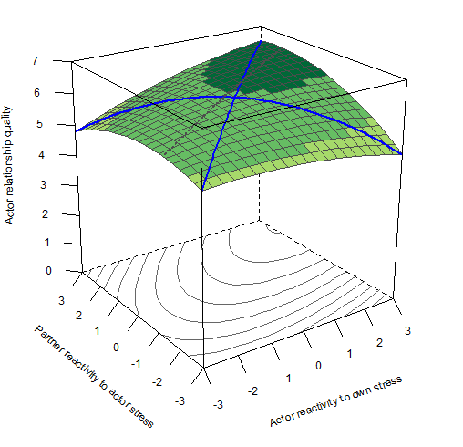
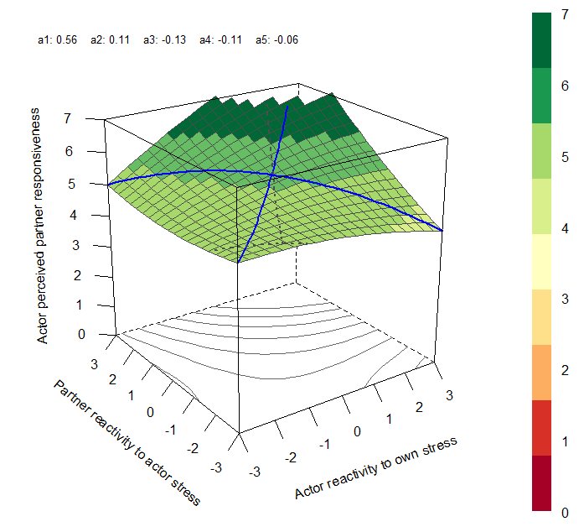

A
B

Figure S1. RSA results in Study 1.

Study 2
We controlled for gender and actor relationship quality at baseline. We did not find a congruence effect predicting either actor relationship quality or actor perceived responsiveness. The estimates are presented in Tables S3 and S4. Because we did not observe any effects, we did not perform the models with the covariates.

Table S3. RSA estimates for relationship quality in Study 2.
 | Estimate | SE | p-value
a₁ | .183 | .183 | .183
a₂ | .083 | .083 | .083
a₃ | .027 | .027 | .027
a₄ | .096 | .096 | .096
a₅ | .066 | .066 | .066

Table S4. RSA estimates for perceived partner responsiveness in Study 2.
 | Estimate | SE | p-value
a₁ | .289 | .083 | .001
a₂ | -.013 | .067 | .844
a₃ | -.033 | .065 | .610
a₄ | .053 | .051 | .302
a₅ | .040 | .051 | .432

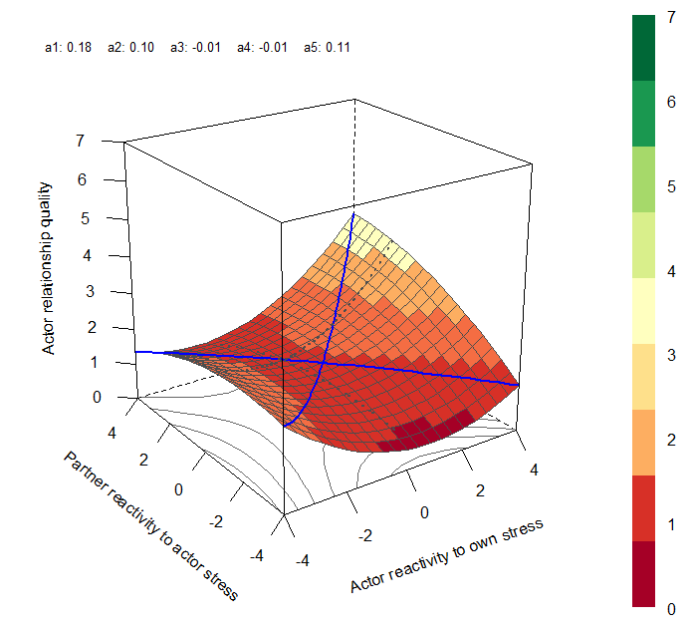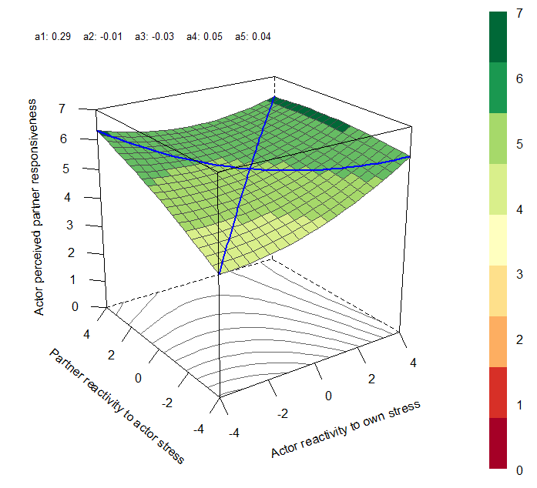

A
B
Figure S2. RSA results in Study 2.
Summary
The RSAs did not reveal a consistent pattern. Of the four analyses, only one revealed a congruence effect. The congruence between the actor’s and the partner’s affective reactivity to the actor’s own external stressors was associated with actor relationship quality in Study 1. However, we failed to replicate this effect in Study 2. We did not find congruence effects in predicting the actor’s perceived responsiveness in either study. In sum, while the idea that congruence in affective reactivity might play a role in relationship quality is plausible, the effect does not seem to consistently emerge in the current samples of fledgling couples. Furthermore, if congruence in affective reactivity does play a role in relationship quality, it likely follows a different mechanism than perceived responsiveness.
References
Fletcher, G. J., Simpson, J. A., & Thomas, G. (2000). The measurement of perceived relationship quality components: A confirmatory factor analytic approach. Personality and Social Psychology Bulletin, 26(3), 340-354. https://doi.org/10.1177/0146167200265007
Humberg, S., Nestler, S., & Back, M. D. (2019). Response surface analysis in personality and social psychology: Checklist and clarifications for the case of congruence hypotheses. Social Psychological and Personality Science, 10(3), 409-419. https://doi.org/10.1177/1948550618757600
Kenny, D. A., & Kashy, D. A. (2011). Dyadic data analysis using multilevel modeling. In J. Hox & J. K. Roberts (Eds.), Handbook of advanced multilevel analysis (pp. 335–370). Routledge/Taylor & Francis Group.
Nestler, S., Humberg, S., & Schönbrodt, F. D. (2019). Response surface analysis with multilevel data: Illustration for the case of congruence hypotheses. Psychological Methods, 24(3), 291–308. https://doi.org/10.1037/met0000199
Schönbrodt, F. D. (2016). Testing fit patterns with polynomial regression models. https://doi.org/10.31219/osf.io/ndggf
Schönbrodt, F. D., & Humberg, S. (2018). RSA: An R package for response surface analysis (version 0.9.12). https://CRAN.R-project.org/package=RSA
Zhang, Z., Zyphur, M. J., & Preacher, K. J. (2009). Testing multilevel mediation using hierarchical linear models: Problems and solutions. Organizational Research Methods, 12(4), 695-719. doi: 10.1177/1094428108327450

