S1. Measures of well-being or well-being synonyms that were included as indicators of well-being in the meta-analysis

General Well-being | Need Satisfaction | Positive Affect | Life Satisfaction | Self-esteem | Purpose and Meaning in Life
Ryff (1989) Scales of Well-being | General Needs Satisfaction Scale (Gagné, 2003) | Happiness Measure (Fordyce, 1988) | Satisfaction With Life Scale (Diener et al., 1985) | Rosenberg Self-esteem Scale (Rosenberg, 1979) | Meaning in life (Rahe & Tolles, 2002)
Keyes (2006) Well-being scales | Basic Needs Satisfaction in General Scale (Johnston & Finney, 2010) | Positive Affect Scale (Watson et al., 1988) | Engaged Living Scale (Trompetter et al., 2013) | Multi-dimensional Self-esteem Inventory (O'Brien & Epstein, 1988) | Life Meaning Subscale from the Brief Stress and Coping Inventory (Konkolÿ Thege et al., 2008)
World Health Organization (ten) Well-being Index (Bech et al., 1996) | Basic Psychological Need Satisfaction Scale (Chen et al., 2015) | Time happy (Fordyce, 1988) | Multidimensional Students’ Life Satisfaction Scale (Huebner & Gilman, 2002) |  | Meaning in Life Questionnaire (Steger et al., 2006)
Index of Self-Actualization (Jones & Crandall, 1986) | Basic Needs Satisfaction in General (Deci et al., 2001) | Positive Affect (Emmons, 1991) | Temporal Satisfaction With Life Scale (Pavot et al., 1998) |  | Purpose in Life Test (Crumbaugh & Maholick, 1981)
Oxford Happiness Inventory (Argyle et al., 1989) | Balanced Measure of Psychological Needs Scale (Sheldon & Hilpert, 2012) | Affect Valence (Diener & Emmons, 1984)
Subjective General Well-being (Gombás, 2015) | General Need Satisfaction Scale (Ilardi et al., 1993) | Positive Affect (Diener & Emmons, 1984)
Subjective Vitality Scale (Ryan & Frederick, 1997) |  | Scale of Positive Experiences (Diener et al., 2010)
Berne Subjective Well-being Questionnaire (Grob, 1995) |  | International Positive Affect Schedule Short Form (Thompson, 2007)
Short Depression-Happiness Scale (Joseph et al., 2004)
Subjective Well-being Inventory (Nagpal & Sell, 1992)
Subjective Happiness Scale (Lyubomirsky & Lepper, 1999)
Eudaimonic Well-being Questionnaire (Waterman et al., 2010)
Index of Well-being (Mei et al., 2015)

S2. Measures of ill-being or ill-being synonyms that were included as indicators of ill-being in the meta-analysis
Need Frustration | Depression and Anxiety | Negative Affect
Basic Psychological Need Frustration Scale (Chen et al., 2015) | Beck Depression Inventory (Beck et al., 1996) | Negative Affect Scale (Watson et al., 1988)
Balanced Measure of Psychological Needs Scale (Sheldon & Hilpert, 2012) | Hopkins Symptoms Checklist (Derogatis et al., 1974) | Time unhappy (Fordyce, 1988)
 | State Trait Anxiety Scale (Spielberger et al., 1983) | Negative Affect (Emmons, 1991)
 | Center for Epidemiological Studies Depression Scale (Radloff, 1977) | Negative Affect (Diener & Emmons, 1984)
 | Self-rating Anxiety Scale (Zung, 1971) | Scale of Negative Experiences (Diener et al., 2010)
 | Multidimensional Anxiety Scale for Children (Yen et al., 2010) | International Negative Affect Schedule Short Form (Thompson, 2007)
 | Brief Measure of Generalized Anxiety (Spitzer et al., 2006)
 | General Health Questionnaire (Goldberg et al., 1997)

S3. A summary of the studies includes in the meta-analyses, and their effects, divided according to the univariate meta-analyses
Authors | Year | Title | Study | n | Female (%) | Effects | r
Intrinsic Aspirations & Wellbeing

Ahn & Reeve | 2020 | Developmental pathways of preadolescents’ intrinsic and extrinsic values: The role of basic psychological needs satisfaction | 1 | 241 | 55.60 | 9 | 0.35 to 0.49
Allan & Duffy | 2014 | Calling, goals, and life satisfaction: A moderated mediation model | 1 | 230 | 54.35 | 1 | -0.20
Anic et al. | 2013 | Orientations to happiness, subjective well-being and life goals | 1 | 769 | 62.94 | 2 | 0.21 to 0.37
Berg-Poppe | 2015 | An examination of goal contents, motivation, need satisfaction, and well-being among practicing health professionals | 1 | 280 | 75.36 | 4 | 0.25 to 0.43
Berki & Piko | 2017 | Hungarian adaptation and psychological correlates of source of enjoyment in youth sport questionnaire among high school students | 1 | 526 | 52.28 | 4 | 0.09 to 0.70
Berki et al. | 2020 | Sport commitment profiles of adolescent athletes: Relation between health and psychological behaviour | 1 | 526 | 47.72 | 1 | 0.42
Bradshaw et al. | 2021 | A configural approach to aspirations: The social breadth of aspiration profiles predicts well-being over and above the intrinsic and extrinsic aspirations that comprise the profiles | 2 | 1632 | 50.98 | 16 | 0.15 to 0.40
Bradshaw et al. | 2021 | A configural approach to aspirations: The social breadth of aspiration profiles predicts well-being over and above the intrinsic and extrinsic aspirations that comprise the profiles | 3 | 6063 | 17.80 | 28 | 0.09 to 0.40
Brdar & Anic | 2010 | Životni ciljevi, orijentacije prema sreci i psihološke potrebe adolescenata: Koji je najbolji put do srece? [Adolescent’s life goals, orientations to happiness and psychological needs: Which is the best path to happiness?] | 1 | 218 | 66.97 | 3 | 0.27 to 0.43
Brown & Kasser | 2005 | Are psychological and ecological well-being compatible? The role of values, mindfulness, and lifestyle | 1 | 200 | 65.50 | 2 | 0.31 to 0.37
Brown et al. | 2009 | When what one has is enough: Mindfulness, financial desire discrepancy, and subjective well-being | 1 | 200 | 65.50 | 24 | -0.03 to 0.36
Carver & Baird | 1998 | The American dream revisited: Is it what you want or why you want it that matters? | 1 | 246 | NA | 1 | 0.24
Chan & Joseph | 2000 | Dimensions of personality, domains of aspiration, and subjective well-being | 1 | 107 | 62.62 | 18 | 0.12 to 0.58
Costa et al. | 2020 | Validation of a Portuguese version of the Aspiration Index for adolescents (AI) | 1 | 1359 | 55.85 | 1 | 0.14
Davids et al. | 2017 | Adolescent goals and aspirations in search of psychological well-being: from the perspective of self-determination theory | 1 | 457 | 53.17 | 1 | 0.16
Frost | 1998 | A cross-cultural study of major life aspirations and, psychological well-being | 1 | 217 | 49.50 | 24 | 0.01 to 0.39
Frost & Frost | 2000 | Romanian and American life aspirations in relation to psychological well-being | 1 | 217 | 49.50 | 12 | -0.10 to 0.19
Galand et al. | 2012 | Buts personnels, orientations motivationnelles et bien-eˆtre subjectif : Effets inde ́pendants ou me ́diatise ́s [Personal goals, motivational orientations, and subjective well-being: Independent or mediated effects] | 1 | 333 | 57.96 | 2 | 0.20 to 0.23
Gámez Armas et al. | 2014 | Relaciones entre el autoconcepto relacional, la elección de metas y la satisfacción de necesidades psicológicas en estudiantes universitarios. [Relations between the relational self-construal, the choice of goals and psychological need satisfaction of university students] | 1 | 605 | 40.99 | 5 | 0.16 to 0.26
Gombas | 2015 | Materialistic thinking and its mental-hygienic implications among students of Budapest business school | 1 | 198 | 76.77 | 1 | 0.27
Grumet | 2021 | Prosocial and self-serving values: An investigation of their structure and the role of cultivating gratitude in promoting positive changes | 1 | 376 | 60.90 | 2 | 0.13 to 0.36
Guillen-Royo & Kasser | 2015 | Personal goals, socio-economic context and happiness: Studying a diverse sample in Peru | 1 | 500 | NA | 1 | 0.11
Hakimi & Talepasand | 2020 | Predictors of subjective wellbeing in students of medical sciences: The role of orientation to happiness and life goals | 1 | 285 | 57.19 | 8 | 0.00 to 0.32
Henderson-King & Mitchell | 2011 | Do materialism, intrinsic aspirations, and meaning in life predict students’ meanings of education? | 1 | 232 | 74.57 | 2 | 0.09 to 0.24
Hope et al. | 2014 | Self-growth in the college years: Increased importance of intrinsic values predicts resolution of identity and intimacy stages | 1 | 196 | NA | 4 | 0.25 to 0.50
Hope et al. | 2018 | The path from intrinsic aspirations to subjective well-being is mediated by changes in basic psychological need satisfaction and autonomous motivation: A large prospective test | 1 | 1468 | 78.00 | 2 | 0.15 to 0.17
Humphrey & Vari | 2021 | Meaning matters: Self-perceived meaning in life, its predictors and psychological stressors sssociated with the COVID-19 pandemic | 1 | 260 | 85.77 | 1 | 0.27
Ilhan & Ozbay | 2010 | The predictive role of life goals and psychological need satisfaction on subjective well-being | 1 | 1474 | 47.29 | 1 | 0.32
Janke & Dickhauser | 2018 | A situated process model of vocational achievement goal striving within members of the academic staff at university | 1 | 113 | 66.37 | 2 | 0.08 to 0.19
Kasser | 1996 | Aspirations and well-being in a prison setting | 1 | 66 | 0.00 | 16 | -0.51 to 0.45
Kasser & Ahuvia | 2002 | Materialistic values and well-being in business students | 1 | 92 | 71.74 | 4 | 0.18 to 0.29
Kasser & Ryan | 1993 | A dark side of the American dream: Correlates of financial success as a central life aspiration | 1 | 118 | 64.41 | 24 | -0.10 to 0.52
Kasser & Ryan | 1993 | A dark side of the American dream: Correlates of financial success as a central life aspiration | 2 | 198 | 67.17 | 24 | -0.04 to 0.56
Kasser & Ryan | 1996 | Further examining the American dream: Differential correlates of intrinsic and extrinsic goals | 1 | 100 | 76.00 | 4 | 0.44 to 0.68
Kasser & Ryan | 1996 | Further examining the American dream: Differential correlates of intrinsic and extrinsic goals | 2 | 192 | 55.73 | 6 | 0.29 to 0.74
Kasser & Ryan | 2001 | Further examining the American dream: Differential correlates of intrinsic and extrinsic goals | 1 | 120 | 49.17 | 6 | 0.18 to 0.49
Kasser & Ryan | 2001 | Further examining the American dream: Differential correlates of intrinsic and extrinsic goals | 2 | 261 | 58.62 | 3 | 0.13 to 0.22
Kim et al. | 2003 | Self-Concept, aspirations, and well-being in South Korea and the United States | 1 | 322 | 55.24 | 6 | -0.06 to 0.36
Konkolÿ Thege et al. | 2008 | A rövidített stressz és megküzdés kérdoív élet értelmességét méro alskálájának (BSCI-LM) pszichometriai jellemzoi. [Psychometric properties of the Life Meaning Subscale from the Brief Stress and Coping Inventory (BSCI-IM)] | 1 | 4524 | 60.19 | 2 | 0.34 to 0.42
Lekes et al. | 2010 | Parental autonomy-support, intrinsic life goals, and well-being among adolescents in China and North America | 1 | 567 | 52.22 | 2 | 0.19 to 0.26
Lekes et al. | 2012 | Influencing value priorities and increasing well- being: The effects of reflecting on intrinsic values | 1 | 113 | 76.99 | 2 | 0.09 to 0.34
Lekes et al. | 2016 | The role of intrinsic values for self-growth and community contribution at different life stages: Differentially predicting the vitality of university students and teachers over one year | 1 | 660 | 72.63 | 6 | 0.09 to 0.27
Li & Feng | 2018 | Goal content, well-being, and psychological needs satisfaction in Chinese adolescents | 1 | 493 | 48.48 | 2 | 0.25 to 0.27
Mackenzie et al. | 2017 | Lifespan differences in a self determination theory model of eudaimonia: A cross-sectional survey of younger, middle-aged, and older adults | 1 | 66 | 81.82 | 9 | -0.09 to 0.30
Margitics & Pauwlik | 2007 | Egyéni aspirációk és depresszió. [Individual aspirations and depression] | 1 | 712 | 76.54 | 3 | 0.16 to 0.46
Martela et al. | 2019 | Expanding the map of intrinsic and extrinsic aspirations using network analysis and multidimensional scaling: Examining four new aspirations | 1 | 196 | 46.94 | 12 | 0.21 to 0.42
Martela et al. | 2019 | Expanding the map of intrinsic and extrinsic aspirations using network analysis and multidimensional scaling: Examining four new aspirations | 2 | 341 | 49.85 | 12 | 0.21 to 0.37
Martos | 2013 | Életcélok összefüggése a lelki egészséggel és a párkapcsolatokról alkotott vélekedésekkel. [Life goals’ associations with mental health and attitudes toward close relationship] | 1 | 2000 | 53.45 | 3 | 0.33 to 0.42
Martos & Konkolÿ Thege | 2012 | Aki keres, és aki talál – az élet értelmessége keresésének és megélésének mérése az Élet Értelme Kérdoív magyar változatával. [Those who search and those who find – Assessing the presence of and search for the meaning in life with the Hungarian version of the Meaning in Life Questionnaire] | 1 | 219 | 70.32 | 2 | 0.25 to 0.33
Martos & Kopp | 2012 | Life goals and well-being: Does financial status matter? Evidence from a representative Hungarian sample | 1 | 4841 | 58.83 | 2 | 0.34 to 0.44
Martos et al. | 2006 | Az aspirációs index rövidített változatának pszichometriai jellemzoi hazai mintán. [Psychometric Characteristics of the Shortened Aspiration Index in Hungarian Sample] | 1 | 512 | 64.84 | 6 | 0.02 to 0.23
Martos et al. | 2006 | Az aspirációs index rövidített változatának pszichometriai jellemzoi hazai mintán. [Psychometric Characteristics of the Shortened Aspiration Index in Hungarian Sample] | 2 | 343 | 51.90 | 2 | 0.29 to 0.40
Merkaš et al. | 2011 | The relation of intrinsic and extrinsic aspirations to adolescent life satisfaction | 1 | 468 | 55.34 | 16 | 0.05 to 0.28
Murphy | 2007 | Individual and relational dynamics of ambition in careers | 1 | 223 | 32.74 | 3 | 0.10 to 0.24
Narayanan | 2015 | Predictors of resilience among adolescents of low socio-economic status in India | 1 | 1451 | 49.48 | 1 | -0.12 to -0.12
Niemiec et al. | 2009 | The path taken: Consequences of attaining intrinsic and extrinsic aspirations in post-college life | 1 | 164 | 69.79 | 48 | -0.01 to 0.62
Nishimura & Suzuki | 2016 | Aspirations and life satisfaction in Japan: The big five personality makes clear | 1 | 474 | 38.82 | 5 | 0.06 to 0.11
Nishimura et al. | 2021 | Satisfaction of basic psychological needs in an interdependence model of fathers’ own aspirations and those of their adolescent children | 1 | 310 | 0.00 | 2 | 0.10 to 0.25
Nishimura et al. | 2021 | Satisfaction of basic psychological needs in an interdependence model of fathers’ own aspirations and those of their adolescent children | 2 | 310 | 50.00 | 2 | 0.11 to 0.45
Olčar et al. | 2019 | Primary school teachers’ life satisfaction: The role of life goals, basic psychological needs and flow at work | 1 | 480 | 100.00 | 4 | 0.10 to 0.19
Oriol et al. | 2020 | Self-transcendent aspirations and life satisfaction: The moderated mediation role of gratitude considering conditional effects of affective and cognitive empathy | 1 | 1356 | 42.18 | 1 | 0.19
Pauwlik & Margitics | 2008 | Személyes törekvések kapcsolata a szubjektív jólléttel foiskolai hallgatóknál. [Correlation between subjective well-being and the personal strivings in the case of college students] | 1 | 712 | 76.54 | 60 | -0.01 to 0.56
Piko et al. | 2006 | Physical activity, psychosocial health and life goals among youth | 1 | 1109 | 60.14 | 5 | 0.00 to 0.04
Proctor et al. | 2016 | The Rogerian fully functioning person: A positive psychology perspective | 1 | 329 | 70.82 | 10 | 0.18 to 0.56
Proctor et al. | 2016 | The Rogerian fully functioning person: A positive psychology perspective | 2 | 307 | 77.52 | 10 | 0.00 to 0.44
Raj & Chettiar | 2012 | Need satisfaction, goal content and subjective well-being | 1 | 100 | 48.00 | 16 | 0.01 to 0.29
Rijavec et al. | 2011 | Aspirations and well-being: Extrinsic vs. intrinsic life goals | 1 | 129 | 93.02 | 1 | 0.23
Rodriguez et al. | 2021 | What do you really want? Change in goals and life satisfaction during emerging adulthood in Brazil | 1 | 970 | 56.80 | 5 | 0.08 to 0.20
Roman et al. | 2015 | Parenting styles and psychological needs influences on adolescent life goals and aspirations in a South African setting | 1 | 853 | 56.98 | 2 | 0.18 to 0.30
Romero et al. | 2012 | Life aspirations, personality traits and subjective well-being in a Spanish sample | 1 | 583 | 71.36 | 6 | 0.22 to 0.47
Ryan et al. | 1999 | The American dream in Russia: Extrinsic aspirations and well-being in two cultures | 1 | 103 | 100.00 | 24 | 0.03 to 0.56
SabzehAra et al. | 2014 | An investigation of the associations between contingent self-worth and aspirations among Iranian university students | 1 | 502 | 66.53 | 3 | 0.15 to 0.32
Schmuck et al. | 2000 | Intrinsic and extrinsic goals: Their structure and relationship to well-being in German and US college students | 1 | 83 | 61.45 | 4 | 0.01 to 0.35
Sheldon | 2005 | Positive value change during college: Normative trends and individual differences | 1 | 109 | 83.49 | 2 | 0.07 to 0.43
Sheldon & Krieger | 2014 | Walking the talk: Value importance, value enactment, and well-being | 2 | 2975 | 41.51 | 1 | 0.09
Sheldon & Krieger | 2014 | Service job lawyers are happier than money job lawyers, despite their lower income | 1 | 5974 | 38.08 | 2 | 0.04 to 0.08
Sheldon et al. | 2018 | Feeling interpersonally controlled while pursuing materialistic goals: A problematic combination for moral behavior | 1 | 109 | 75.23 | 1 | 0.10
Spasovski | 2013 | The relation of basic psychological needs, intrinsic and extrinsic life goals, and collectivism with subjective well-being: A case in Macedonia | 1 | 242 | 62.40 | 2 | 0.42 to 0.52
Steffen | 2014 | Perfectionism and life aspirations in intrinsically and extrinsically religious individuals | 1 | 540 | 63.05 | 2 | 0.22 to 0.25
Stevens et al. | 2011 | Aspirations and wellbeing in Romanian and US undergraduates | 1 | 69 | 54.88 | 12 | -0.16 to 0.41
Tao et al. | 2018 | The cultural shaping of career aspirations: Acculturation and Chinese biculturals’ career identity styles | 1 | 194 | 60.31 | 1 | 0.52
Tessier et al. | 2021 | Adolescents “walking the talk”: How value importance and enactment relate to well‐being and risk‐taking | 1 | 647 | 55.95 | 4 | 0.15 to 0.19
Tóth et al. | 2018 | The impact of goal attainment and goal importance on satisfaction with life-–A polynomial regression and response surface analysis | 1 | 149 | 75.17 | 2 | 0.24 to 0.49
Tuicomepee & Romano | 2005 | Psychological well-being of Thai drug users: Implications for prevention | 1 | 163 | 12.27 | 4 | 0.26 to 0.40
Unanue et al. | 2014 | Materialism and well-being in the UK and Chile: Basic need satisfaction and basic need frustration as underlying psychological processes | 1 | 958 | 58.98 | 4 | 0.13 to 0.26
Unanue et al. | 2014 | Materialism and well-being in the UK and Chile: Basic need satisfaction and basic need frustration as underlying psychological processes | 2 | 257 | 52.92 | 4 | 0.09 to 0.25
Van Hiel & Vansteenkiste | 2009 | Ambitions fulfilled? The effects of intrinsic and extrinsic goal attainment on older adults’ ego-integrity and death attitudes | 1 | 202 | 50.99 | 1 | 0.46
Van Hiel & Vansteenkiste | 2009 | Ambitions fulfilled? The effects of intrinsic and extrinsic goal attainment on older adults’ ego-integrity and death attitudes | 2 | 213 | NA | 1 | 0.47
Vansteenkiste et al. | 2006 | Materialistic values and well-being among business students: Further evidence of their detrimental effect | 1 | 119 | 54.62 | 3 | 0.19 to 0.27
Visser & Pozzebon | 2013 | Who are you and what do you want? Life aspirations, personality, and well-being | 1 | 166 | 69.88 | 5 | -0.11 to 0.07
Werner et al. | 2019 | Do narcissists benefit from materialistic pursuits? Examining the relation between narcissistic tendencies, extrinsic goals, and well-being | 1 | 642 | NA | 9 | 0.03 to 0.45
Yamaguchi & Halberstadt | 2012 | Goals and well-being in New Zealand | 1 | 97 | 88.66 | 4 | 0.02 to 0.53
Zemojtel-Piotrowska et al. | 2015 | Materialism, subjective well-being and psychological entitlement: Interplay between materialism and social functioning | 1 | 153 | 51.63 | 16 | 0.03 to 0.41
Zhang et al. | 2019 | Personal aspirations, person-environment fit, meaning in work, and meaning in life: A moderated mediation model | 1 | 655 | 38.99 | 4 | 0.05 to 0.39
Extrinsic Aspirations & Wellbeing

Allan & Duffy | 2014 | Calling, goals, and life satisfaction: A moderated mediation model | 1 | 230 | 54.35 | 1 | 0.08
Anic et al. | 2013 | Orientations to happiness, subjective well-being and life goals | 1 | 769 | 62.94 | 2 | 0.08 to 0.13
Berg-Poppe | 2015 | An examination of goal contents, motivation, need satisfaction, and well-being among practicing health professionals | 1 | 280 | 75.36 | 2 | -0.06 to 0.03
Berki & Piko | 2017 | Hungarian adaptation and psychological correlates of source of enjoyment in youth sport questionnaire among high school students | 1 | 526 | 52.28 | 3 | 0.04 to 0.67
Berki et al. | 2020 | Sport commitment profiles of adolescent athletes: Relation between health and psychological behaviour | 1 | 526 | 47.72 | 1 | 0.34
Bradshaw et al. | 2021 | A configural approach to aspirations: The social breadth of aspiration profiles predicts well-being over and above the intrinsic and extrinsic aspirations that comprise the profiles | 2 | 1632 | 50.98 | 12 | 0.02 to 0.15
Bradshaw et al. | 2021 | A configural approach to aspirations: The social breadth of aspiration profiles predicts well-being over and above the intrinsic and extrinsic aspirations that comprise the profiles | 3 | 6063 | 17.80 | 21 | 0.02 to 0.34
Brdar & Anic | 2010 | Životni ciljevi, orijentacije prema sreci i psihološke potrebe adolescenata: Koji je najbolji put do srece? [Adolescent’s life goals, orientations to happiness and psychological needs: Which is the best path to happiness?] | 1 | 218 | 66.97 | 3 | -0.08 to 0.12
Brown et al. | 2009 | When what one has is enough: Mindfulness, financial desire discrepancy, and subjective well-being | 1 | 200 | 65.50 | 18 | -0.36 to -0.02
Carver & Baird | 1998 | The American dream revisited: Is it what you want or why you want it that matters? | 1 | 246 | NA | 1 | -0.30
Chan & Joseph | 2000 | Dimensions of personality, domains of aspiration, and subjective well-being | 1 | 107 | 62.62 | 6 | -0.21 to 0.34
Costa et al. | 2020 | Validation of a Portuguese version of the Aspiration Index for adolescents (AI) | 1 | 1359 | 55.85 | 1 | 0.11
Davids et al. | 2017 | Adolescent goals and aspirations in search of psychological well-being: from the perspective of self-determination theory | 1 | 457 | 53.17 | 1 | 0.10
Frost | 1998 | A cross-cultural study of major life aspirations and, psychological well-being | 1 | 217 | 49.50 | 8 | -0.23 to 0.21
Frost & Frost | 2000 | Romanian and American life aspirations in relation to psychological well-being | 1 | 217 | 49.50 | 4 | -0.22 to -0.03
Galand et al. | 2012 | Buts personnels, orientations motivationnelles et bien-eˆtre subjectif : Effets inde ́pendants ou me ́diatise ́s [Personal goals, motivational orientations, and subjective well-being: Independent or mediated effects | 1 | 333 | 57.96 | 2 | -0.07 to 0.02
Gámez Armas et al. | 2014 | Relaciones entre el autoconcepto relacional, la elección de metas y la satisfacción de necesidades psicológicas en estudiantes universitarios. [Relations between the relational self-construal, the choice of goals and psychological need satisfaction of university students] | 1 | 605 | 40.99 | 5 | 0.16 to 0.26
Gombas | 2015 | Materialistic thinking and its mental-hygienic implications among students of Budapest business school | 1 | 198 | 76.77 | 1 | 0.15
Grumet | 2021 | Prosocial and self-serving values: An investigation of their structure and the role of cultivating gratitude in promoting positive changes | 1 | 376 | 60.90 | 2 | -0.10 to 0.15
Guillen-Royo & Kasser | 2015 | Personal goals, socio-economic context and happiness: Studying a diverse sample in Peru | 1 | 500 | NA | 1 | -0.03
Górnik-Durose & Pyszkowska | 2020 | Personality matters – Explaining the link between materialism and well-being in young adults | 1 | 415 | 16.87 | 2 | 0.28 to 0.35
Hakimi & Talepasand | 2020 | Predictors of subjective wellbeing in students of medical sciences: The role of orientation to happiness and life goals | 1 | 285 | 57.19 | 6 | -0.01 to 0.16
Henderson-King & Mitchell | 2011 | Do materialism, intrinsic aspirations, and meaning in life predict students’ meanings of education? | 1 | 232 | 74.57 | 2 | -0.11 to 0.08
Humphrey & Vari | 2021 | Meaning matters: Self-perceived meaning in life, its predictors and psychological stressors associated with the COVID-19 pandemic | 1 | 260 | 85.77 | 1 | -0.07
Ilhan & Ozbay | 2010 | The predictive role of life goals and psychological need satisfaction on subjective well-being | 1 | 1747 | 39.90 | 1 | -0.07
Janke & Dickhauser | 2018 | A situated process model of vocational achievement goal striving within members of the academic staff at university | 1 | 113 | 66.37 | 3 | -0.03 to 0.06
Kasser | 1996 | Aspirations and well-being in a prison setting | 1 | 66 | 0.00 | 4 | -0.21 to -0.03
Kasser & Ahuvia | 2002 | Materialistic values and well-being in business students | 1 | 92 | 71.74 | 4 | -0.26 to -0.08
Kasser & Ryan | 1993 | A dark side of the American dream: Correlates of financial success as a central life aspiration | 1 | 118 | 64.41 | 8 | -0.46 to 0.12
Kasser & Ryan | 1993 | A dark side of the American dream: Correlates of financial success as a central life aspiration | 2 | 198 | 67.17 | 8 | -0.32 to 0.21
Kasser & Ryan | 1996 | Further examining the American dream: Differential correlates of intrinsic and extrinsic goals | 1 | 100 | 76.00 | 4 | -0.61 to -0.51
Kasser & Ryan | 1996 | Further examining the American dream: Differential correlates of intrinsic and extrinsic goals | 2 | 192 | 55.73 | 6 | -0.88 to -0.33
Kasser et al. | 2014 | Changes in materialism, changes in psychological well-being: Evidence from three longitudinal studies and an intervention | 1 | 251 | 62.15 | 4 | -0.24 to 0.01
Lekes et al. | 2010 | Parental autonomy-support, intrinsic life goals, and well-being among adolescents in China and North America | 1 | 567 | 52.22 | 2 | -0.05 to 0.13
Li & Feng | 2018 | Goal content, well-being, and psychological needs satisfaction in Chinese adolescents | 1 | 493 | 48.48 | 2 | -0.05 to -0.02
Margitics & Pauwlik | 2007 | Egyéni aspirációk és depresszió. [Individual aspirations and depression] | 1 | 712 | 76.54 | 3 | 0.06 to 0.38
Martela et al. | 2019 | Expanding the map of intrinsic and extrinsic aspirations using network analysis and multidimensional scaling: Examining four new aspirations | 1 | 196 | 46.94 | 12 | 0.06 to 0.24
Martela et al. | 2019 | Expanding the map of intrinsic and extrinsic aspirations using network analysis and multidimensional scaling: Examining four new aspirations | 2 | 341 | 49.85 | 12 | 0.04 to 0.25
Martos | 2013 | Életcélok összefüggése a lelki egészséggel és a párkapcsolatokról alkotott vélekedésekkel. [Life goals’ associations with mental health and attitudes toward close relationship] | 1 | 2000 | 53.45 | 3 | 0.19 to 0.27
Martos & Konkolÿ Thege | 2012 | Aki keres, és aki talál – az élet értelmessége keresésének és megélésének mérése az Élet Értelme Kérdoív magyar változatával. [Those who search and those who find – Assessing the presence of and search for the meaning in life with the Hungarian version of the Meaning in Life Questionnaire] | 1 | 219 | 70.32 | 2 | 0.07 to 0.12
Martos & Kopp | 2012 | Life goals and well-being: Does financial status matter? Evidence from a representative Hungarian sample | 1 | 4841 | 58.83 | 2 | 0.21 to 0.29
Martos et al. | 2006 | Az aspirációs index rövidített változatának pszichometriai jellemzoi hazai mintán. [Psychometric Characteristics of the Shortened Aspiration Index in Hungarian Sample] | 1 | 512 | 64.84 | 3 | -0.08 to 0.06
Martos et al. | 2006 | Az aspirációs index rövidített változatának pszichometriai jellemzoi hazai mintán. [Psychometric Characteristics of the Shortened Aspiration Index in Hungarian Sample] | 2 | 343 | 51.90 | 1 | -0.02
Merkaš et al. | 2011 | The relation of intrinsic and extrinsic aspirations to adolescent life satisfaction | 1 | 468 | 55.34 | 16 | -0.19 to 0.16
Murphy | 2007 | Individual and relational dynamics of ambition in careers | 1 | 223 | 32.74 | 2 | -0.09 to -0.04
Narayanan | 2015 | Predictors of resilience among adolescents of low socio-economic status in India | 1 | 1451 | 49.48 | 1 | -0.16
Niemiec et al. | 2009 | The path taken: Consequences of attaining intrinsic and extrinsic aspirations in post-college life | 1 | 164 | 69.79 | 36 | -0.11 to 0.36
Nishimura & Suzuki | 2016 | Aspirations and life satisfaction in Japan: The big five personality makes clear | 1 | 474 | 38.82 | 4 | -0.11 to 0.01
Nishimura et al. | 2021 | Satisfaction of basic psychological needs in an interdependence model of fathers’ own aspirations and those of their adolescent children | 1 | 310 | NA | 1 | 0.13
Nishimura et al. | 2021 | Satisfaction of basic psychological needs in an interdependence model of fathers’ own aspirations and those of their adolescent children | 2 | 310 | 50.00 | 1 | 0.32
Olčar et al. | 2019 | Primary school teachers’ life satisfaction: The role of life goals, basic psychological needs and flow at work | 1 | 480 | 100.00 | 3 | -0.01 to 0.08
Pauwlik & Margitics | 2008 | Személyes törekvések kapcsolata a szubjektív jólléttel foiskolai hallgatóknál. [Correlation between subjective well-being and the personal strivings in the case of college students] | 1 | 712 | 76.54 | 48 | -0.34 to 0.38
Piko et al. | 2006 | Physical activity, psychosocial health and life goals among youth | 1 | 1109 | 60.14 | 4 | 0.00 to 0.01
Raj & Chettiar | 2012 | Need satisfaction, goal content and subjective well-being | 1 | 100 | 48.00 | 12 | -0.26 to 0.04
Rijavec et al. | 2011 | Aspirations and well-being: Extrinsic vs. intrinsic life goals | 1 | 129 | 93.02 | 1 | 0.07
Rodriguez et al. | 2021 | What do you really want? Change in goals and life satisfaction during emerging adulthood in Brazil | 1 | 970 | 56.80 | 4 | -0.07 to -0.02
Roman et al. | 2015 | Parenting styles and psychological needs influences on adolescent life goals and aspirations in a South African setting | 1 | 853 | 56.98 | 2 | 0.03 to 0.25
Romero et al. | 2012 | Life aspirations, personality traits and subjective well-being in a Spanish sample | 1 | 583 | 71.36 | 6 | -0.03 to 0.17
Rothman | 2009 | Affluent adolescents: Attachment, entitlement, and subjective well-being | 1 | 95 | 40.00 | 4 | 0.01 to 0.07
SabzehAra et al. | 2014 | An investigation of the associations between contingent self-worth and aspirations among Iranian university students | 1 | 502 | 66.53 | 3 | -0.06 to 0.19
Sheldon et al. | 2018 | Feeling interpersonally controlled while pursuing materialistic goals: A problematic combination for moral behavior | 1 | 109 | 75.23 | 1 | 0.01
Spasovski | 2013 | The relation of basic psychological needs, intrinsic and extrinsic life goals, and collectivism with subjective well-being: A case in Macedonia | 1 | 242 | 62.40 | 2 | 0.29 to 0.31
Steffen | 2014 | Perfectionism and life aspirations in intrinsically and extrinsically religious individuals | 1 | 540 | 63.05 | 2 | -0.24 to -0.08
Stevens et al. | 2011 | Aspirations and wellbeing in Romanian and US undergraduates | 1 | 69 | 54.88 | 12 | -0.24 to 0.23
Tao et al | 2018 | The cultural shaping of career aspirations: Acculturation and Chinese biculturals’ career identity styles | 1 | 194 | 60.31 | 1 | 0.04
Tessier et al. | 2021 | Adolescents “walking the talk”: How value importance and enactment relate to well‐being and risk‐taking | 1 | 647 | 55.95 | 4 | -0.07 to 0.13
Tóth et al | 2018 | The impact of goal attainment and goal importance on satisfaction with life-–A polynomial regression and response surface analysis | 1 | 149 | 75.17 | 2 | 0.06 to 0.41
Unanue et al. | 2014 | Materialism and well-being in the UK and Chile: Basic need satisfaction and basic need frustration as underlying psychological processes | 1 | 958 | 58.98 | 4 | -0.10 to -0.09
Unanue et al. | 2014 | Materialism and well-being in the UK and Chile: Basic need satisfaction and basic need frustration as underlying psychological processes | 2 | 257 | 52.92 | 4 | -0.16 to 0.02
Van Hiel & Vansteenkiste | 2009 | Ambitions fulfilled? The effects of intrinsic and extrinsic goal attainment on older adults’ ego-integrity and death attitudes. | 1 | 202 | 50.99 | 1 | 0.33
Van Hiel & Vansteenkiste | 2009 | Ambitions fulfilled? The effects of intrinsic and extrinsic goal attainment on older adults’ ego-integrity and death attitudes. | 2 | 213 | NA | 1 | 0.33
Vansteenkiste et al. | 2006 | Materialistic values and well-being among business students: Further evidence of their detrimental effect | 1 | 119 | 54.62 | 3 | -0.22 to -0.15
Visser & Pozzebon | 2013 | Who are you and what do you want? Life aspirations, personality, and well-being | 1 | 166 | 69.88 | 4 | -0.07 to 0.02
Wasser | 2011 | Materialism and well-being: Examining the strength of the negative relationship using multiple materialism measures and controlling for important variables | 1 | 71 | 74.65 | 6 | -0.38 to -0.01
Werner et al. | 2019 | Do narcissists benefit from materialistic pursuits? Examining the relation between narcissistic tendencies, extrinsic goals, and well-being | 1 | 642 | NA | 9 | -0.19 to 0.16
Yamaguchi & Halberstadt | 2012 | Goals and well-being in New Zealand | 1 | 97 | 88.66 | 4 | -0.06 to 0.26
Zemojtel-Piotrowska et al. | 2015 | Materialism, subjective well-being and psychological entitlement: Interplay between materialism and social functioning | 1 | 153 | 51.63 | 12 | -0.04 to 0.38
Zhang et al | 2019 | Personal aspirations, person-environment fit, meaning in work, and meaning in life: A moderated mediation model | 1 | 655 | 38.99 | 4 | -0.11 to 0.20
Intrinsic Aspirations & Ill-being

Anic et al. | 2013 | Orientations to happiness, subjective well-being and life goals | 1 | 769 | 62.94 | 1 | -0.07
Bradshaw et al. | 2021 | A configural approach to aspirations: The social breadth of aspiration profiles predicts well-being over and above the intrinsic and extrinsic aspirations that comprise the profiles | 1 | 3370 | 77.45 | 4 | -0.05 to 0.04
Bradshaw et al. | 2021 | A configural approach to aspirations: The social breadth of aspiration profiles predicts well-being over and above the intrinsic and extrinsic aspirations that comprise the profiles | 2 | 1632 | 50.98 | 4 | -0.11 to -0.01
Bradshaw et al. | 2021 | A configural approach to aspirations: The social breadth of aspiration profiles predicts well-being over and above the intrinsic and extrinsic aspirations that comprise the profiles | 3 | 6063 | 17.80 | 12 | -0.14 to 0.04
Brdar & Anic | 2010 | Životni ciljevi, orijentacije prema sreci i psihološke potrebe adolescenata: Koji je najbolji put do srece? [Adolescent’s life goals, orientations to happiness and psychological needs: Which is the best path to happiness?] | 1 | 218 | 66.97 | 1 | -0.17
Brown et al. | 2009 | When what one has is enough: Mindfulness, financial desire discrepancy, and subjective well-being | 1 | 200 | 65.50 | 8 | -0.21 to -0.04
Davids et al. | 2017 | Adolescent goals and aspirations in search of psychological well-being: from the perspective of self-determination theory | 1 | 457 | 53.17 | 1 | 0.04
Gámez Armas et al. | 2014 | Relaciones entre el autoconcepto relacional, la elección de metas y la satisfacción de necesidades psicológicas en estudiantes universitarios. [Relations between the relational self-construal, the choice of goals and psychological need satisfaction of university students] | 1 | 605 | 40.99 | 1 | -0.31
Grumet | 2021 | Prosocial and self-serving values: An investigation of their structure and the role of cultivating gratitude in promoting positive changes | 1 | 376 | 60.90 | 1 | -0.03
Hakimi & Talepasand | 2020 | Predictors of subjective wellbeing in students of medical sciences: The role of orientation to happiness and life goals | 1 | 285 | 57.19 | 4 | -0.01 to 0.09
Kasser | 1996 | Aspirations and well-being in a prison setting | 1 | 66 | 0.00 | 16 | -0.51 to 0.41
Kasser & Ahuvia | 2002 | Materialistic values and well-being in business students | 1 | 92 | 71.74 | 1 | -0.27
Kasser & Ryan | 1993 | A dark side of the American dream: Correlates of financial success as a central life aspiration | 2 | 198 | 67.17 | 24 | -0.50 to 0.22
Kasser & Ryan | 1996 | Further examining the American dream: Differential correlates of intrinsic and extrinsic goals | 1 | 100 | 76.00 | 4 | -0.44 to -0.19
Kasser & Ryan | 1996 | Further examining the American dream: Differential correlates of intrinsic and extrinsic goals | 2 | 192 | 55.73 | 6 | -0.32 to -0.04
Kim et al. | 2003 | Self-Concept, aspirations, and well-being in South Korea and the United States | 1 | 322 | 55.24 | 4 | -0.12 to 0.01
Komlósi et al. | 2006 | Az aspirációs index hazai alkalmazásával szerzett tapasztalatok. [Experience gained in the domestic application of the aspiration index] | 1 | 261 | NA | 1 | -0.15
Margitics & Pauwlik | 2007 | Egyéni aspirációk és depresszió. [Individual aspirations and depression] | 1 | 712 | 76.54 | 2 | -0.38 to -0.34
Martela et al. | 2019 | Expanding the map of intrinsic and extrinsic aspirations using network analysis and multidimensional scaling: Examining four new aspirations | 1 | 196 | 46.94 | 6 | -0.30 to -0.15
Martela et al. | 2019 | Expanding the map of intrinsic and extrinsic aspirations using network analysis and multidimensional scaling: Examining four new aspirations | 2 | 341 | 49.85 | 6 | -0.18 to -0.06
Martos et al. | 2006 | Az aspirációs index rövidített változatának pszichometriai jellemzoi hazai mintán. [Psychometric Characteristics of the Shortened Aspiration Index in Hungarian Sample] | 1 | 512 | 64.84 | 4 | -0.08 to -0.03
Martos et al. | 2006 | Az aspirációs index rövidített változatának pszichometriai jellemzoi hazai mintán. [Psychometric Characteristics of the Shortened Aspiration Index in Hungarian Sample] | 2 | 343 | 51.90 | 2 | -0.31 to -0.24
Niemiec et al. | 2009 | The path taken: Consequences of attaining intrinsic and extrinsic aspirations in post-college life | 1 | 164 | 69.79 | 16 | -0.34 to 0.12
Pauwlik & Margitics | 2008 | Személyes törekvések kapcsolata a szubjektív jólléttel foiskolai hallgatóknál. [Correlation between subjective well-being and the personal strivings in the case of college students] | 1 | 712 | 76.54 | 15 | -0.46 to 0.14
Proctor et al. | 2016 | The Rogerian fully functioning person: A positive psychology perspective | 1 | 329 | 70.82 | 2 | -0.30 to 0.10
Proctor et al. | 2016 | The Rogerian fully functioning person: A positive psychology perspective | 2 | 307 | 77.52 | 2 | -0.24 to 0.01
Roman et al. | 2015 | Parenting styles and psychological needs influences on adolescent life goals and aspirations in a South African setting | 1 | 853 | 56.98 | 2 | 0.07 to 0.19
Romero et al. | 2012 | Life aspirations, personality traits and subjective well-being in a Spanish sample | 1 | 583 | 71.36 | 3 | -0.18 to -0.02
Ryan et al. | 1999 | The American dream in Russia: Extrinsic aspirations and well-being in two cultures | 1 | 103 | 100.00 | 8 | -0.34 to 0.03
Schmuck et al. | 2000 | Intrinsic and extrinsic goals: Their structure and relationship to well-being in German and US college students | 1 | 83 | 61.45 | 4 | -0.28 to -0.11
Sheldon & Krieger | 2014 | Walking the talk: Value importance, value enactment, and well-being | 1 | 1992 | 58.43 | 2 | -0.08 to -0.05
Sheldon & Krieger | 2014 | Walking the talk: Value importance, value enactment, and well-being | 2 | 2975 | 41.51 | 1 | -0.03
Sheldon & Krieger | 2014 | Service job lawyers are happier than money job lawyers, despite their lower income | 1 | 5974 | 38.08 | 1 | -0.08
Steffen | 2014 | Perfectionism and life aspirations in intrinsically and extrinsically religious individuals | 1 | 540 | 63.05 | 4 | -0.17 to -0.13
Unanue et al. | 2014 | Materialism and well-being in the UK and Chile: Basic need satisfaction and basic need frustration as underlying psychological processes | 1 | 958 | 58.98 | 4 | -0.05 to 0.04
Unanue et al. | 2014 | Materialism and well-being in the UK and Chile: Basic need satisfaction and basic need frustration as underlying psychological processes | 2 | 257 | 52.92 | 4 | -0.09 to -0.02
Van Hiel & Vansteenkiste | 2009 | Ambitions fulfilled? The effects of intrinsic and extrinsic goal attainment on older adults’ ego-integrity and death attitudes. | 1 | 202 | 50.99 | 1 | -0.06
Van Hiel & Vansteenkiste | 2009 | Ambitions fulfilled? The effects of intrinsic and extrinsic goal attainment on older adults’ ego-integrity and death attitudes. | 2 | 213 | NA | 2 | -0.25 to -0.20
Vansteenkiste et al. | 2006 | Materialistic values and well-being among business students: Further evidence of their detrimental effect | 1 | 119 | 54.62 | 3 | -0.14 to -0.07
Werner et al. | 2019 | Do narcissists benefit from materialistic pursuits? Examining the relation between narcissistic tendencies, extrinsic goals, and well-being | 1 | 642 | NA | 6 | -0.10 to -0.01
Xie et al. | 2011 | Mediating effect of social support in relationship between materialism and anxiety | 1 | 443 | 58.01 | 4 | -0.16 to -0.02
Yamaguchi & Halberstadt | 2012 | Goals and well being in New Zealand | 1 | 97 | 88.66 | 4 | -0.19 to 0.10
Zemojtel-Piotrowska et al. | 2015 | Materialism, subjective well-being and psychological entitlement: Interplay between materialism and social functioning | 1 | 153 | 51.63 | 8 | -0.15 to 0.07
Extrinsic Aspirations & Ill-being

Ahn & Reeve | 2020 | Developmental pathways of preadolescents’ intrinsic and extrinsic values: The role of basic psychological needs satisfaction | 1 | 241 | 55.60 | 9 | -0.05 to 0.18
Anic et al. | 2013 | Orientations to happiness, subjective well-being and life goals | 1 | 769 | 62.94 | 1 | 0.12
Bradshaw et al | 2021 | A configural approach to aspirations: The social breadth of aspiration profiles predicts well-being over and above the intrinsic and extrinsic aspirations that comprise the profiles | 1 | 3370 | 77.45 | 3 | -0.01 to 0.07
Bradshaw et al | 2021 | A configural approach to aspirations: The social breadth of aspiration profiles predicts well-being over and above the intrinsic and extrinsic aspirations that comprise the profiles | 2 | 1632 | 50.98 | 3 | 0.00 to 0.06
Bradshaw et al | 2021 | A configural approach to aspirations: The social breadth of aspiration profiles predicts well-being over and above the intrinsic and extrinsic aspirations that comprise the profiles | 3 | 6063 | 17.80 | 9 | 0.15 to 0.26
Brdar & Anic | 2010 | Životni ciljevi, orijentacije prema sreci i psihološke potrebe adolescenata: Koji je najbolji put do srece? [Adolescent’s life goals, orientations to happiness and psychological needs: Which is the best path to happiness?] | 1 | 218 | 66.97 | 1 | 0.20
Brown et al. | 2009 | When what one has is enough: Mindfulness, financial desire discrepancy, and subjective well-being | 1 | 200 | 65.50 | 6 | 0.01 to 0.21
Davids et al. | 2017 | Adolescent goals and aspirations in search of psychological well-being: from the perspective of self-determination theory | 1 | 457 | 53.17 | 1 | -0.04
Grumet | 2021 | Prosocial and self-serving values: An investigation of their structure and the role of cultivating gratitude in promoting positive changes | 1 | 376 | 60.90 | 1 | 0.24
Hakimi & Talepasand | 2020 | Predictors of subjective wellbeing in students of medical sciences: The role of orientation to happiness and life goals | 1 | 285 | 57.19 | 3 | 0.15 to 0.17
Kasser | 1996 | Aspirations and well-being in a prison setting | 1 | 66 | 0.00 | 4 | 0.15 to 0.22
Kasser & Ahuvia | 2002 | Materialistic values and well-being in business students | 1 | 92 | 71.74 | 4 | 0.16 to 0.22
Kasser & Ryan | 1993 | A dark side of the American dream: Correlates of financial success as a central life aspiration | 2 | 198 | 67.17 | 8 | -0.11 to 0.36
Kasser & Ryan | 1996 | Further examining the American dream: Differential correlates of intrinsic and extrinsic goals | 1 | 100 | 76.00 | 4 | 0.28 to 0.48
Kasser & Ryan | 1996 | Further examining the American dream: Differential correlates of intrinsic and extrinsic goals | 2 | 192 | 55.73 | 6 | 0.10 to 0.52
Kasser et al. | 2014 | Changes in materialism, changes in psychological well-being: Evidence from three longitudinal studies and an intervention | 1 | 118 | NA | 2 | 0.16 to 0.19
Komlósi et al. | 2006 | Az aspirációs index hazai alkalmazásával szerzett tapasztalatok. [Experience gained in the domestic application of the aspiration index] | 1 | 261 | NA | 1 | 0.14
Ling | 2016 | Intrinsic and extrinsic goals as moderators of stress and depressive symptoms in Chinese undergraduate students: A multi-wave longitudinal study | 1 | 462 | 46.10 | 1 | 0.10 to 0.10
Margitics & Pauwlik | 2007 | Egyéni aspirációk és depresszió. [Individual aspirations and depression] | 1 | 712 | 76.54 | 2 | -0.23 to -0.21
Martela et al. | 2019 | Expanding the map of intrinsic and extrinsic aspirations using network analysis and multidimensional scaling: Examining four new aspirations | 1 | 196 | 46.94 | 6 | -0.11 to 0.09
Martela et al. | 2019 | Expanding the map of intrinsic and extrinsic aspirations using network analysis and multidimensional scaling: Examining four new aspirations | 2 | 341 | 49.85 | 6 | -0.07 to 0.05
Martos et al. | 2006 | Az aspirációs index rövidített változatának pszichometriai jellemzoi hazai mintán. [Psychometric Characteristics of the Shortened Aspiration Index in Hungarian Sample] | 1 | 512 | 64.84 | 2 | 0.02 to 0.06
Martos et al. | 2006 | Az aspirációs index rövidített változatának pszichometriai jellemzoi hazai mintán. [Psychometric Characteristics of the Shortened Aspiration Index in Hungarian Sample] | 2 | 343 | 51.90 | 1 | 0.04
Niemiec et al. | 2009 | The path taken: Consequences of attaining intrinsic and extrinsic aspirations in post-college life | 1 | 164 | 69.79 | 12 | -0.12 to 0.22
Pauwlik & Margitics | 2008 | Személyes törekvések kapcsolata a szubjektív jólléttel foiskolai hallgatóknál. [Correlation between subjective well-being and the personal strivings in the case of college students] | 1 | 712 | 76.54 | 12 | -0.21 to 0.13
Roman et al. | 2015 | Parenting styles and psychological needs influences on adolescent life goals and aspirations in a South African setting | 1 | 853 | 56.98 | 2 | 0.05 to 0.14
Romero et al. | 2012 | Life aspirations, personality traits and subjective well-being in a Spanish sample | 1 | 583 | 71.36 | 3 | -0.07 to 0.12
Steffen | 2014 | Perfectionism and life aspirations in intrinsically and extrinsically religious individuals | 1 | 540 | 63.05 | 4 | 0.11 to 0.24
Unanue et al. | 2014 | Materialism and well-being in the UK and Chile: Basic need satisfaction and basic need frustration as underlying psychological processes | 1 | 958 | 58.98 | 4 | 0.14 to 0.20
Unanue et al. | 2014 | Materialism and well-being in the UK and Chile: Basic need satisfaction and basic need frustration as underlying psychological processes | 2 | 257 | 52.92 | 4 | 0.16 to 0.30
Van Hiel & Vansteenkiste | 2009 | Ambitions fulfilled? The effects of intrinsic and extrinsic goal attainment on older adults’ ego-integrity and death attitudes. | 1 | 202 | 50.99 | 1 | 0.13
Van Hiel & Vansteenkiste | 2009 | Ambitions fulfilled? The effects of intrinsic and extrinsic goal attainment on older adults’ ego-integrity and death attitudes. | 2 | 213 | NA | 2 | -0.11 to 0.01
Vansteenkiste et al. | 2006 | Materialistic values and well-being among business students: Further evidence of their detrimental effect | 1 | 119 | 54.62 | 3 | 0.10 to 0.13
Werner et al. | 2019 | Do narcissists benefit from materialistic pursuits? Examining the relation between narcissistic tendencies, extrinsic goals, and well-being | 1 | 642 | NA | 6 | 0.04 to 0.10
Xie et al. | 2011 | Mediating effect of social support in relationship between materialism and anxiety | 1 | 443 | 58.01 | 3 | 0.02 to 0.12
Yamaguchi & Halberstadt | 2012 | Goals and well being in New Zealand | 1 | 97 | 88.66 | 4 | -0.01 to 0.23
Zemojtel-Piotrowska et al. | 2015 | Materialism, subjective well-being and psychological entitlement: Interplay between materialism and social functioning | 1 | 153 | 51.63 | 6 | 0.06 to 0.16
Intrinsic & Extrinsic Aspirations

Allan & Duffy | 2014 | Calling, goals, and life satisfaction: A moderated mediation model | 1 | 230 | 54.35 | 1 | -0.77
Anic et al. | 2013 | Orientations to happiness, subjective well-being and life goals | 1 | 769 | 62.94 | 1 | 0.13
Berg-Poppe | 2015 | An examination of goal contents, motivation, need satisfaction, and well-being among practicing health professionals | 1 | 280 | 75.36 | 1 | 0.12
Berki & Piko | 2017 | Hungarian adaptation and psychological correlates of source of enjoyment in youth sport questionnaire among high school students | 1 | 526 | 52.28 | 12 | 0.02 to 0.52
Bradshaw et al. | 2021 | A configural approach to aspirations: The social breadth of aspiration profiles predicts well-being over and above the intrinsic and extrinsic aspirations that comprise the profiles | 1 | 3370 | 77.45 | 12 | -0.05 to 0.32
Bradshaw et al. | 2021 | A configural approach to aspirations: The social breadth of aspiration profiles predicts well-being over and above the intrinsic and extrinsic aspirations that comprise the profiles | 2 | 1632 | 50.98 | 12 | 0.07 to 0.29
Bradshaw et al. | 2021 | A configural approach to aspirations: The social breadth of aspiration profiles predicts well-being over and above the intrinsic and extrinsic aspirations that comprise the profiles | 3 | 6063 | 17.80 | 12 | 0.08 to 0.36
Brdar & Anic | 2010 | Životni ciljevi, orijentacije prema sreci i psihološke potrebe adolescenata: Koji je najbolji put do srece? [Adolescent’s life goals, orientations to happiness and psychological needs: Which is the best path to happiness?] | 1 | 218 | 66.97 | 1 | 0.15
Chan & Joseph | 2000 | Dimensions of personality, domains of aspiration, and subjective well-being | 1 | 107 | 62.62 | 6 | 0.31 to 0.53
Costa et al. | 2020 | Validation of a Portuguese version of the Aspiration Index for adolescents (AI) | 1 | 1359 | 55.85 | 1 | 0.40
Davids et al. | 2017 | Adolescent goals and aspirations in search of psychological well-being: from the perspective of self-determination theory | 1 | 457 | 53.17 | 1 | 0.72
Galand et al. | 2012 | Buts personnels, orientations motivationnelles et bien-eˆtre subjectif : Effets inde ́pendants ou me ́diatise ́s [Personal goals, motivational orientations, and subjective well-being: Independent or mediated effects] | 1 | 333 | 57.96 | 1 | 0.03
Gámez Armas et al. | 2014 | Relaciones entre el autoconcepto relacional, la elección de metas y la satisfacción de necesidades psicológicas en estudiantes universitarios. [Relations between the relational self-construal, the choice of goals and psychological need satisfaction of university students] | 1 | 605 | 40.99 | 1 | 0.21
Gombas | 2015 | Materialistic thinking and its mental-hygienic implications among students of Budapest business school | 1 | 198 | 76.77 | 1 | 0.27
Grumet | 2021 | Prosocial and self-serving values: An investigation of their structure and the role of cultivating gratitude in promoting positive changes | 1 | 376 | 60.90 | 1 | 0.05
Guillen-Royo & Kasser | 2015 | Personal goals, socio-economic context and happiness: Studying a diverse sample in Peru | 1 | 500 | NA | 1 | 0.31 to 0.31
Hakimi & Talepasand | 2020 | Predictors of subjective wellbeing in students of medical sciences: The role of orientation to happiness and life goals | 1 | 285 | 57.19 | 12 | 0.14 to 0.37
Henderson-King & Mitchell | 2011 | Do materialism, intrinsic aspirations, and meaning in life predict students’ meanings of education? | 1 | 232 | 74.57 | 1 | -0.05
Humphrey & Vari | 2021 | Meaning matters: Self-perceived meaning in life, its predictors and psychological stressors sssociated with the COVID-19 pandemic | 1 | 260 | 85.77 | 1 | 0.28
Janke & Dickhauser | 2018 | A situated process model of vocational achievement goal striving within members of the academic staff at university | 1 | 113 | 66.37 | 1 | -0.12
Kasser & Ryan | 1993 | A dark side of the American dream: Correlates of financial success as a central life aspiration | 1 | 118 | 64.41 | 2 | -0.22 to 0.21
Kasser & Ryan | 1993 | A dark side of the American dream: Correlates of financial success as a central life aspiration | 2 | 198 | 67.17 | 2 | 0.08 to 0.22
Kasser & Ryan | 1996 | Further examining the American dream: Differential correlates of intrinsic and extrinsic goals | 2 | 192 | 55.73 | 2 | 0.28 to 0.58
Lekes et al | 2010 | Parental autonomy-support, intrinsic life goals, and well-being among adolescents in China and North America | 1 | 567 | 52.22 | 2 | 0.21 to 0.52
Li & Feng | 2018 | Goal content, well-being, and psychological needs satisfaction in Chinese adolescents | 1 | 493 | 48.48 | 1 | 0.18
Ling | 2016 | Intrinsic and extrinsic goals as moderators of stress and depressive symptoms in Chinese undergraduate students: A multi-wave longitudinal study | 1 | 970 | 56.04 | 14 | 0.01 to 0.49
Martos & Kopp | 2012 | Life goals and well-being: Does financial status matter? Evidence from a representative Hungarian sample | 1 | 4841 | 58.83 | 1 | 0.65
Merkaš et al. | 2011 | The relation of intrinsic and extrinsic aspirations to adolescent life satisfaction | 1 | 468 | 55.34 | 10 | -0.03 to 0.33
Murphy | 2007 | Individual and relational dynamics of ambition in careers | 1 | 223 | 32.74 | 6 | 0.04 to 0.18
Narayanan | 2015 | Predictors of resilience among adolescents of low socio-economic status in India | 1 | 1451 | 49.48 | 1 | 0.62
Niemiec et al. | 2009 | The path taken: Consequences of attaining intrinsic and extrinsic aspirations in post-college life | 1 | 164 | 69.76 | 48 | -0.06 to 0.52
Nishimura & Suzuki | 2016 | Aspirations and life satisfaction in Japan: The big five personality makes clear | 1 | 474 | 38.82 | 1 | 0.40
Nishimura et al. | 2021 | Satisfaction of basic psychological needs in an interdependence model of fathers’ own aspirations and those of their adolescent children | 1 | 310 | NA | 2 | -0.55 to 0.35
Nishimura et al. | 2021 | Satisfaction of basic psychological needs in an interdependence model of fathers’ own aspirations and those of their adolescent children | 2 | 310 | 50.00 | 2 | -0.51 to 0.65
Olčar et al. | 2019 | Primary school teachers’ life satisfaction: The role of life goals, basic psychological needs and flow at work | 1 | 480 | 100.00 | 12 | -0.02 to 0.25
Piko et al. | 2006 | Physical activity, psychosocial health and life goals among youth | 1 | 1109 | 60.14 | 13 | -0.02 to 0.86
Raj & Chettiar | 2012 | Need satisfaction, goal content and subjective well-being | 1 | 100 | 48.00 | 3 | 0.47 to 0.68
Rijavec et al. | 2011 | Aspirations and well-being: Extrinsic vs. intrinsic life goals | 1 | 129 | 93.02 | 1 | 0.10
Roman et al. | 2015 | Parenting styles and psychological needs influences on adolescent life goals and aspirations in a South African setting | 1 | 853 | 56.98 | 1 | 0.20
Romero et al. | 2012 | Life aspirations, personality traits and subjective well-being in a Spanish sample | 1 | 583 | 71.36 | 3 | 0.17 to 0.52
Rothman | 2009 | Affluent adolescents: Attachment, entitlement, and subjective well-being | 1 | 95 | 40.00 | 1 | 0.08
SabzehAra et al. | 2014 | An investigation of the associations between contingent self-worth and aspirations among Iranian university students | 1 | 502 | 66.53 | 3 | 0.29 to 0.57
Sheldon | 2005 | Positive value change during college: Normative trends and individual differences | 1 | 109 | 83.49 | 4 | -0.14 to 0.08
Sheldon et al. | 2018 | Feeling interpersonally controlled while pursuing materialistic goals: A problematic combination for moral behavior | 1 | 109 | 75.23 | 1 | 0.10
Spasovski | 2013 | The relation of basic psychological needs, intrinsic and extrinsic life goals, and collectivism with subjective well-being: A case in Macedonia | 1 | 242 | 62.40 | 1 | 0.49
Steffen | 2014 | Perfectionism and life aspirations in intrinsically and extrinsically religious individuals | 1 | 540 | 63.05 | 2 | -0.04 to 0.07
Stevens et al. | 2011 | Aspirations and wellbeing in Romanian and US undergraduates | 1 | 69 | 54.88 | 4 | 0.25 to 0.62
Tao et al. | 2018 | The cultural shaping of career aspirations: Acculturation and Chinese biculturals’ career identity styles | 1 | 194 | 60.31 | 1 | 0.27
Tessier et al. | 2021 | Adolescents “walking the talk”: How value importance and enactment relate to well‐being and risk‐taking | 1 | 647 | 55.95 | 1 | 0.01
Tóth et al. | 2018 | The impact of goal attainment and goal importance on satisfaction with life-–A polynomial regression and response surface analysis | 1 | 149 | 75.17 | 2 | 0.28 to 0.55
Unanue et al | 2014 | Materialism and well-being in the UK and Chile: Basic need satisfaction and basic need frustration as underlying psychological processes | 1 | 958 | 58.98 | 1 | -0.05
Van Hiel & Vansteenkiste | 2009 | Ambitions fulfilled? The effects of intrinsic and extrinsic goal attainment on older adults’ ego-integrity and death attitudes. | 1 | 202 | 50.99 | 1 | 0.56
Van Hiel & Vansteenkiste | 2009 | Ambitions fulfilled? The effects of intrinsic and extrinsic goal attainment on older adults’ ego-integrity and death attitudes. | 2 | 213 | NA | 1 | 0.61
Werner et al. | 2019 | Do narcissists benefit from materialistic pursuits? Examining the relation between narcissistic tendencies, extrinsic goals, and well-being | 1 | 642 | NA | 9 | -0.06 to 0.16
Xie et al. | 2011 | Mediating effect of social support in relationship between materialism and anxiety | 1 | 443 | 58.01 | 12 | 0.19 to 0.34
Zemojtel-Piotrowska et al | 2015 | Materialism, subjective well-being and psychological entitlement: Interplay between materialism and social functioning | 1 | 153 | 51.63 | 24 | 0.01 to 0.40
Zhang et al. | 2019 | Personal aspirations, person-environment fit, meaning in work, and meaning in life: A moderated mediation model | 1 | 655 | 53.59 | 1 | 0.49
Well-being and Ill-being

Anic et al. | 2013 | Orientations to happiness, subjective well-being and life goals | 1 | 769 | 62.94 | 2 | -0.39 to -0.38
Bradshaw et al. | 2021 | A configural approach to aspirations: The social breadth of aspiration profiles predicts well-being over and above the intrinsic and extrinsic aspirations that comprise the profiles | 2 | 1632 | 50.98 | 4 | -0.61 to -0.38
Bradshaw et al. | 2021 | A configural approach to aspirations: The social breadth of aspiration profiles predicts well-being over and above the intrinsic and extrinsic aspirations that comprise the profiles | 3 | 6063 | 17.80 | 21 | -0.32 to 0.07
Brdar & Anic | 2010 | Životni ciljevi, orijentacije prema sreci i psihološke potrebe adolescenata: Koji je najbolji put do srece? [Adolescent’s life goals, orientations to happiness and psychological needs: Which is the best path to happiness?] | 1 | 218 | 66.97 | 3 | -0.57 to -0.17
Davids et al. | 2017 | Adolescent goals and aspirations in search of psychological well-being: from the perspective of self-determination theory | 1 | 457 | 53.17 | 1 | 0.43
Gámez Armas et al. | 2014 | Relaciones entre el autoconcepto relacional, la elección de metas y la satisfacción de necesidades psicológicas en estudiantes universitarios. [Relations between the relational self-construal, the choice of goals and psychological need satisfaction of university students] | 1 | 605 | 40.99 | 4 | -0.25 to 0.43
Grumet | 2021 | Prosocial and self-serving values: An investigation of their structure and the role of cultivating gratitude in promoting positive changes | 1 | 376 | 60.90 | 2 | -0.35 to -0.13
Hakimi & Talepasand | 2020 | Predictors of subjective wellbeing in students of medical sciences: The role of orientation to happiness and life goals | 1 | 285 | 57.19 | 2 | -0.14 to 0.57
Niemiec et al. | 2009 | The path taken: Consequences of attaining intrinsic and extrinsic aspirations in post-college life | 1 | 164 | 69.51 | 6 | -0.53 to -0.22
Proctor et al. | 2016 | The Rogerian fully functioning person: A positive psychology perspective | 1 | 329 | 70.82 | 5 | -0.53 to 0.33
Proctor et al. | 2016 | The Rogerian fully functioning person: A positive psychology perspective | 2 | 307 | 77.52 | 5 | -0.54 to 0.24
Roman et al. | 2015 | Parenting styles and psychological needs influences on adolescent life goals and aspirations in a South African setting | 1 | 853 | 56.98 | 4 | -0.13 to -0.07
Romero et al. | 2012 | Life aspirations, personality traits and subjective well-being in a Spanish sample | 1 | 583 | 71.36 | 2 | -0.14 to 0.27
Sheldon & Krieger | 2014 | Service job lawyers are happier than money job lawyers, despite their lower income | 1 | 5974 | 38.08 | 1 | -0.43
Unanue et al. | 2014 | Materialism and well-being in the UK and Chile: Basic need satisfaction and basic need frustration as underlying psychological processes | 1 | 958 | 58.98 | 16 | -0.65 to -0.31
Unanue et al. | 2014 | Materialism and well-being in the UK and Chile: Basic need satisfaction and basic need frustration as underlying psychological processes | 2 | 257 | 52.92 | 16 | -0.66 to -0.17
Van Hiel & Vansteenkiste | 2009 | Ambitions fulfilled? The effects of intrinsic and extrinsic goal attainment on older adults’ ego-integrity and death attitudes. | 1 | 202 | 50.99 | 1 | -0.29
Van Hiel & Vansteenkiste | 2009 | Ambitions fulfilled? The effects of intrinsic and extrinsic goal attainment on older adults’ ego-integrity and death attitudes. | 2 | 213 | NA | 2 | -0.54 to -0.27
Werner et al. | 2019 | Do narcissists benefit from materialistic pursuits? Examining the relation between narcissistic tendencies, extrinsic goals, and well-being | 1 | 642 | NA | 6 | -0.46 to -0.24
Zemojtel-Piotrowska et al. | 2015 | Materialism, subjective well-being and psychological entitlement: Interplay between materialism and social functioning | 1 | 153 | 51.63 | 2 | -0.26 to -0.15

S4. Funnel plot for the association between intrinsic aspirations and well-being. Data were first aggregated to the cluster level using fixed-effects meta-analysis.
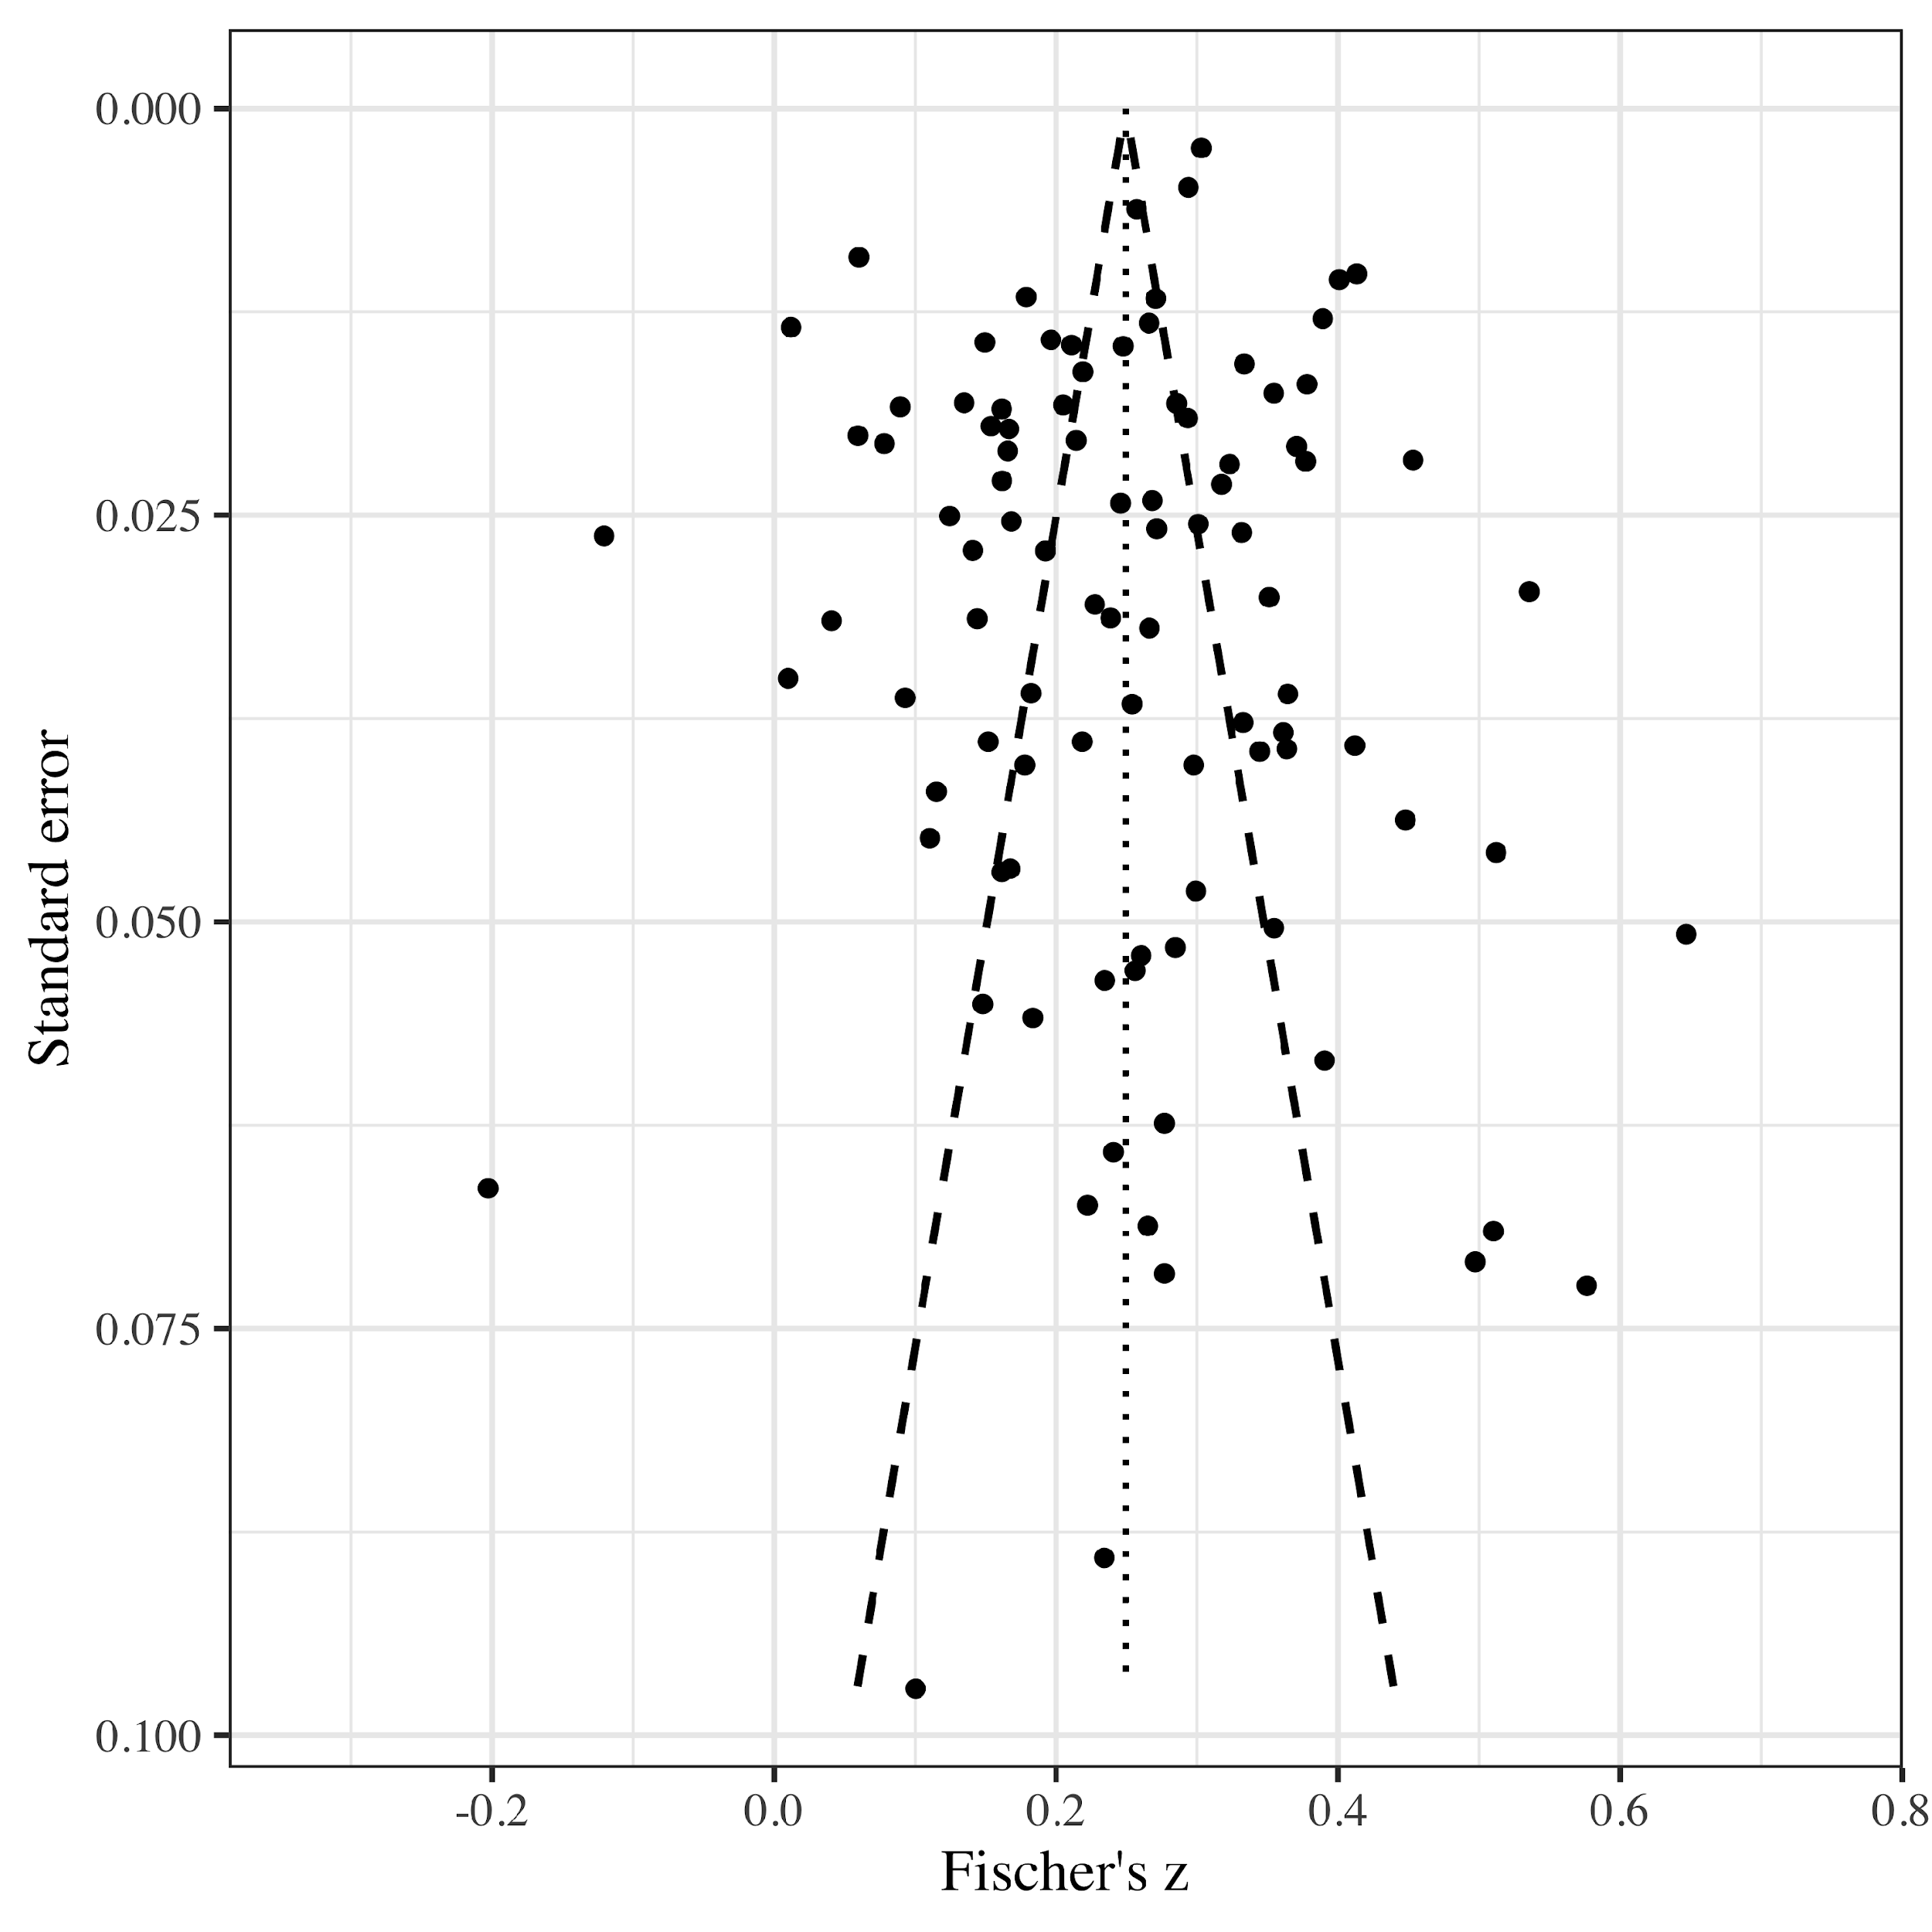

S5. Funnel plot for the association between extrinsic aspiration simple scores and well-being. Data were first aggregated to the cluster level using fixed-effects meta-analysis.
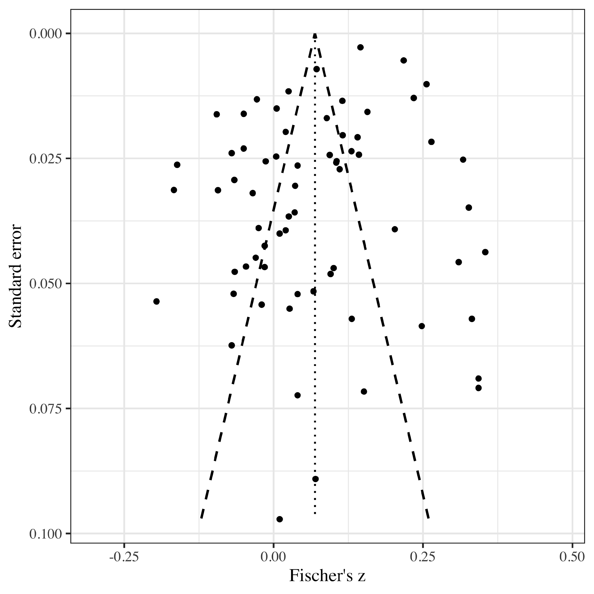

S6. Funnel plot for the association between extrinsic aspiration relative centrality scores and well-being. Data were first aggregated to the cluster level using fixed-effects meta-analysis.
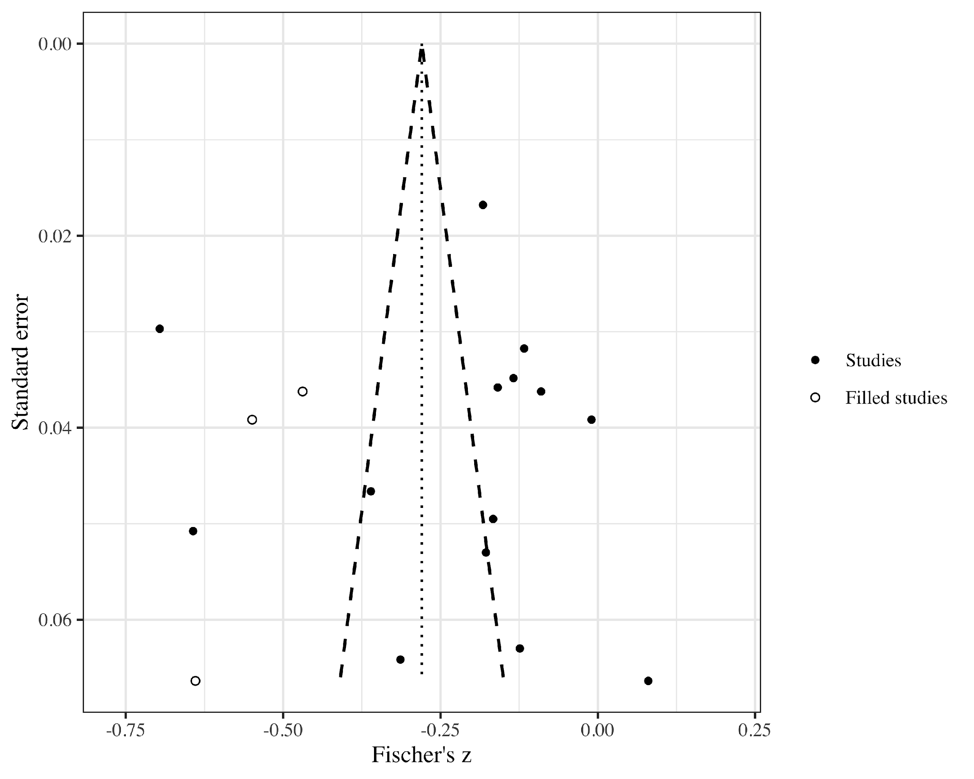
S7. Funnel plot for the association between intrinsic aspirations and ill-being. Data were first aggregated to the cluster level using fixed-effects meta-analysis.
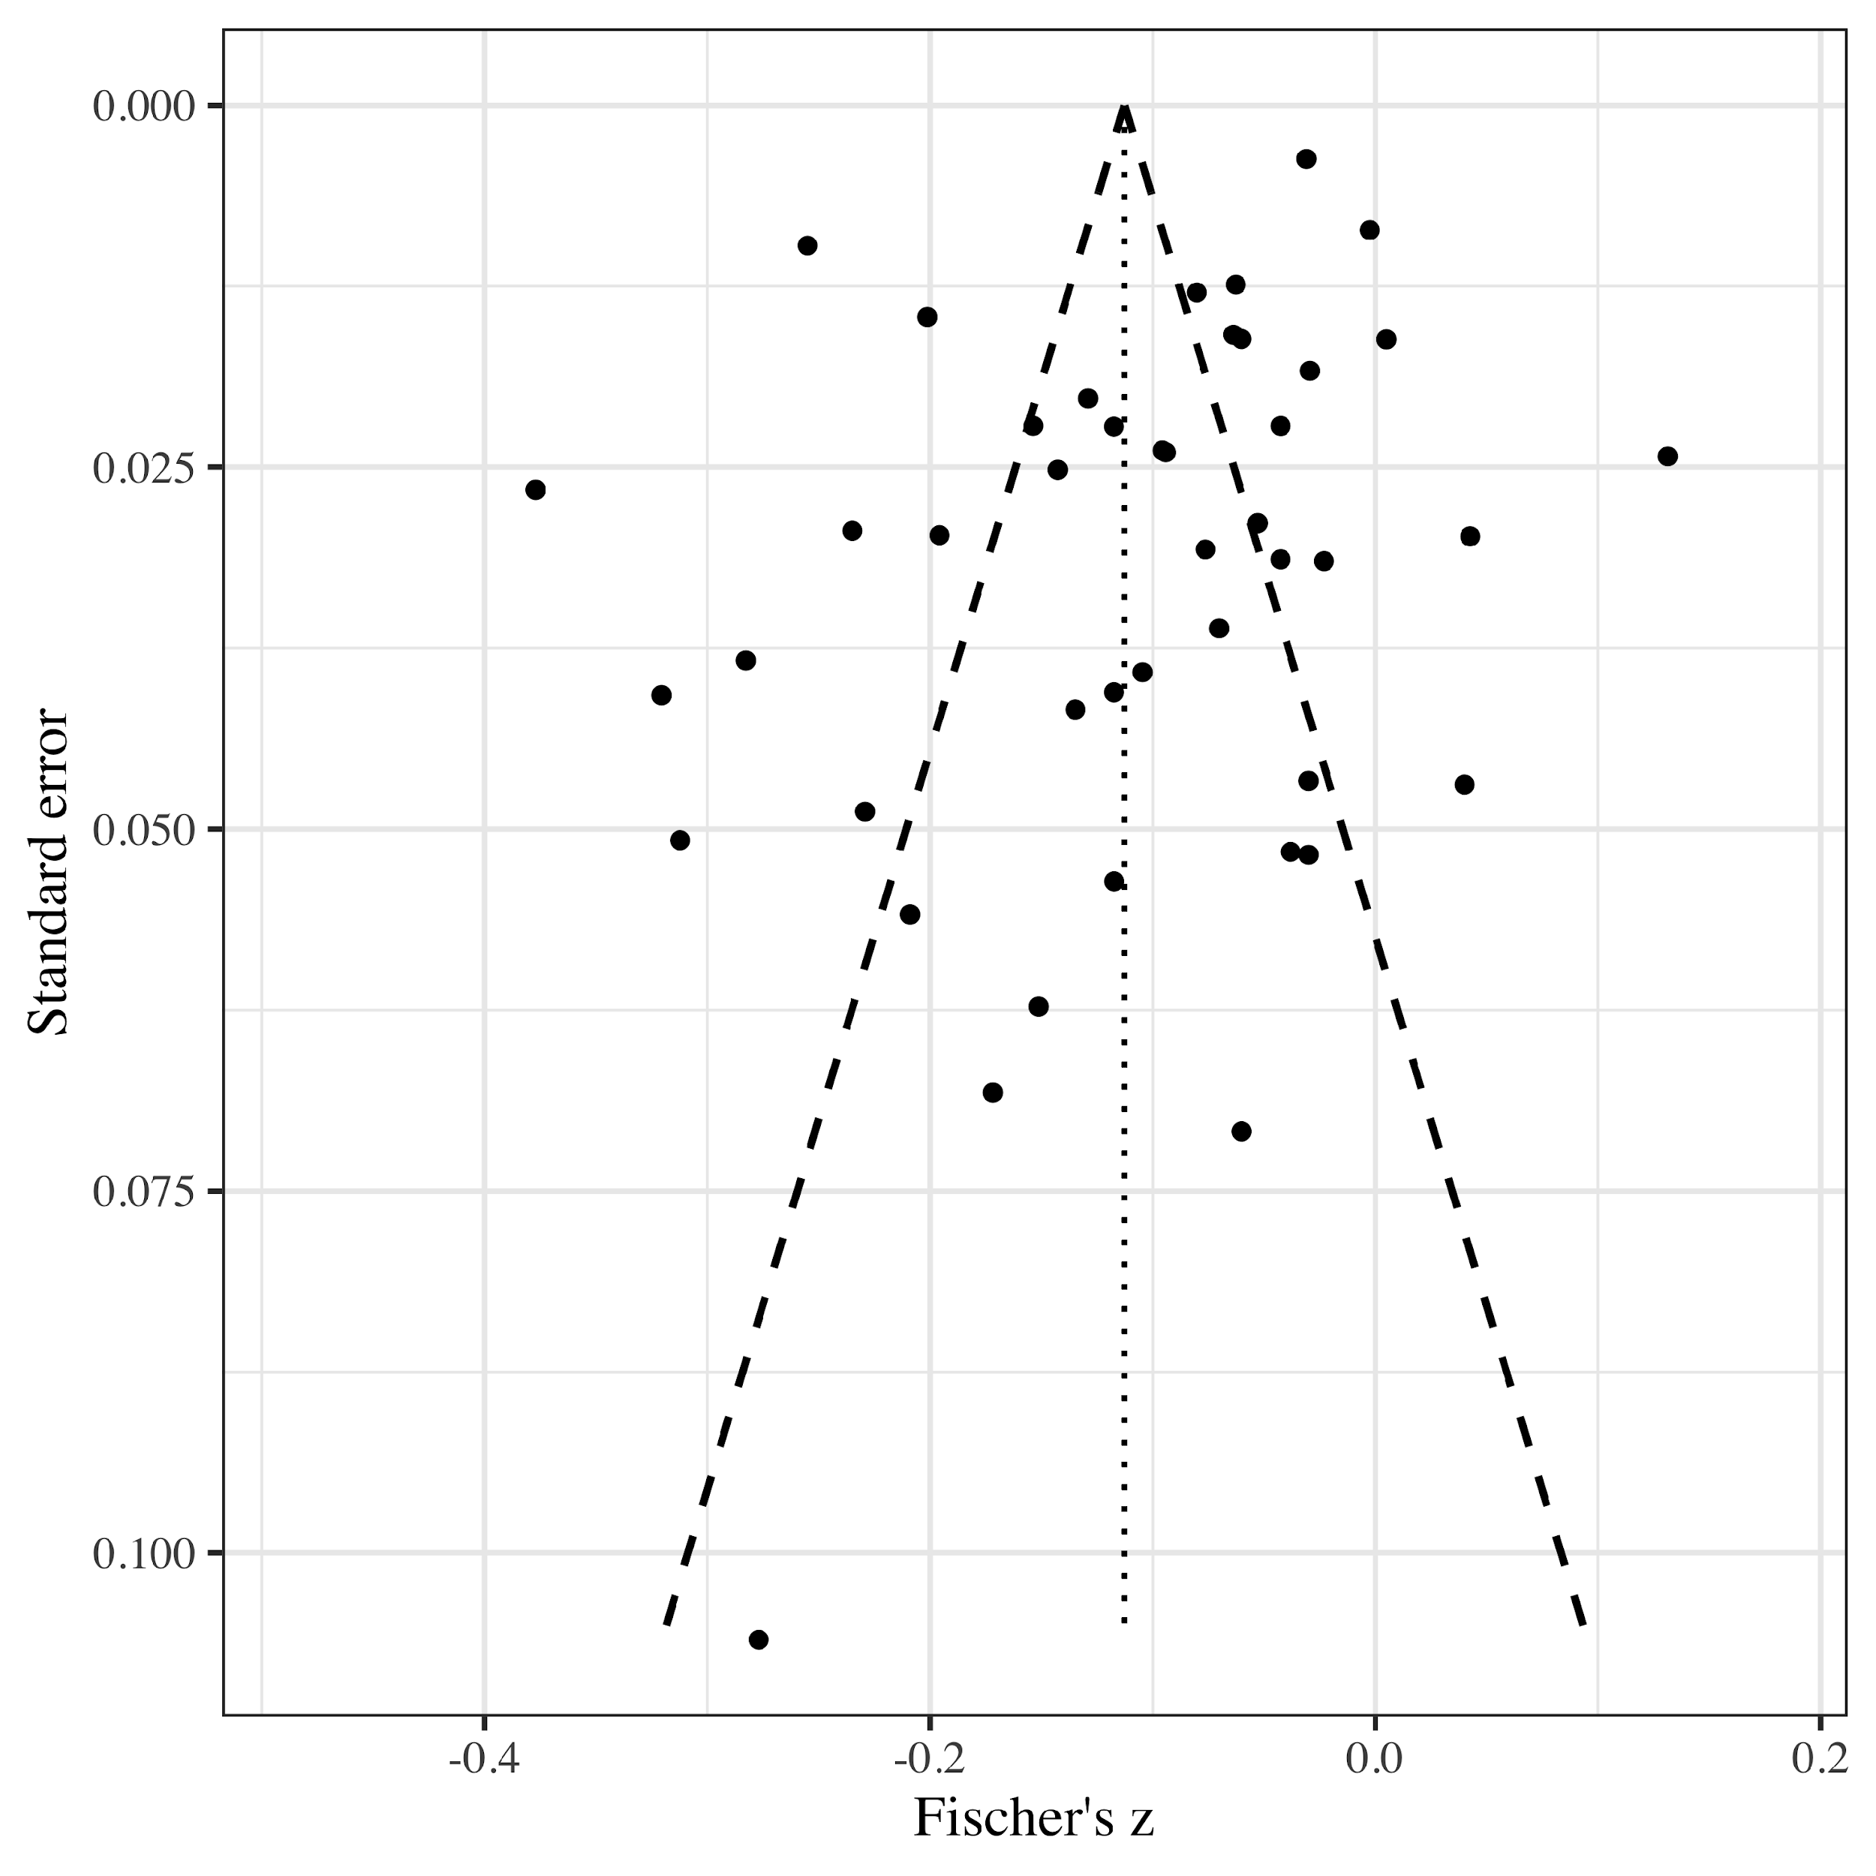
S8. Funnel plot for the association between extrinsic aspiration simple scores and ill-being. Data were first aggregated to the cluster level using fixed-effects meta-analysis.
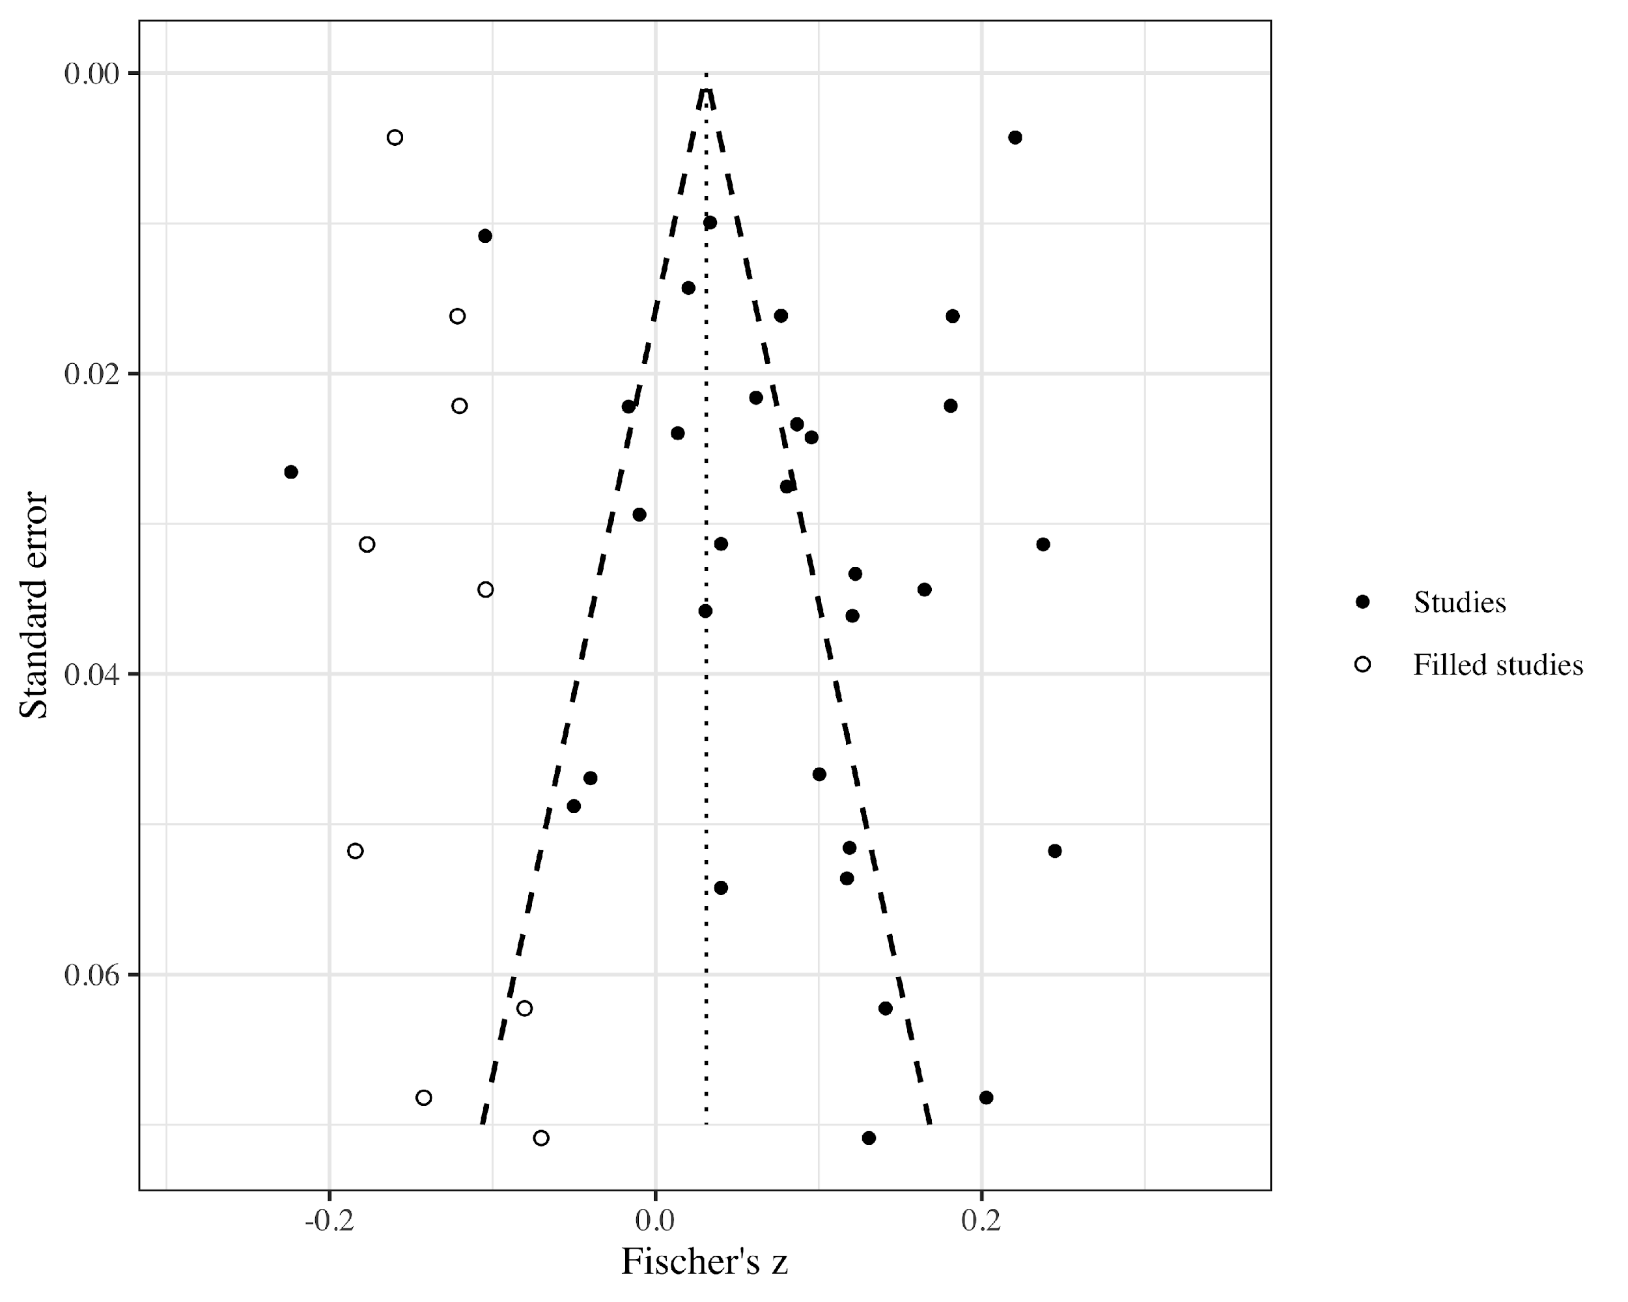
S9. Funnel plot for the association between intrinsic and extrinsic aspirations. Data were first aggregated to the cluster level using fixed-effects meta-analysis.
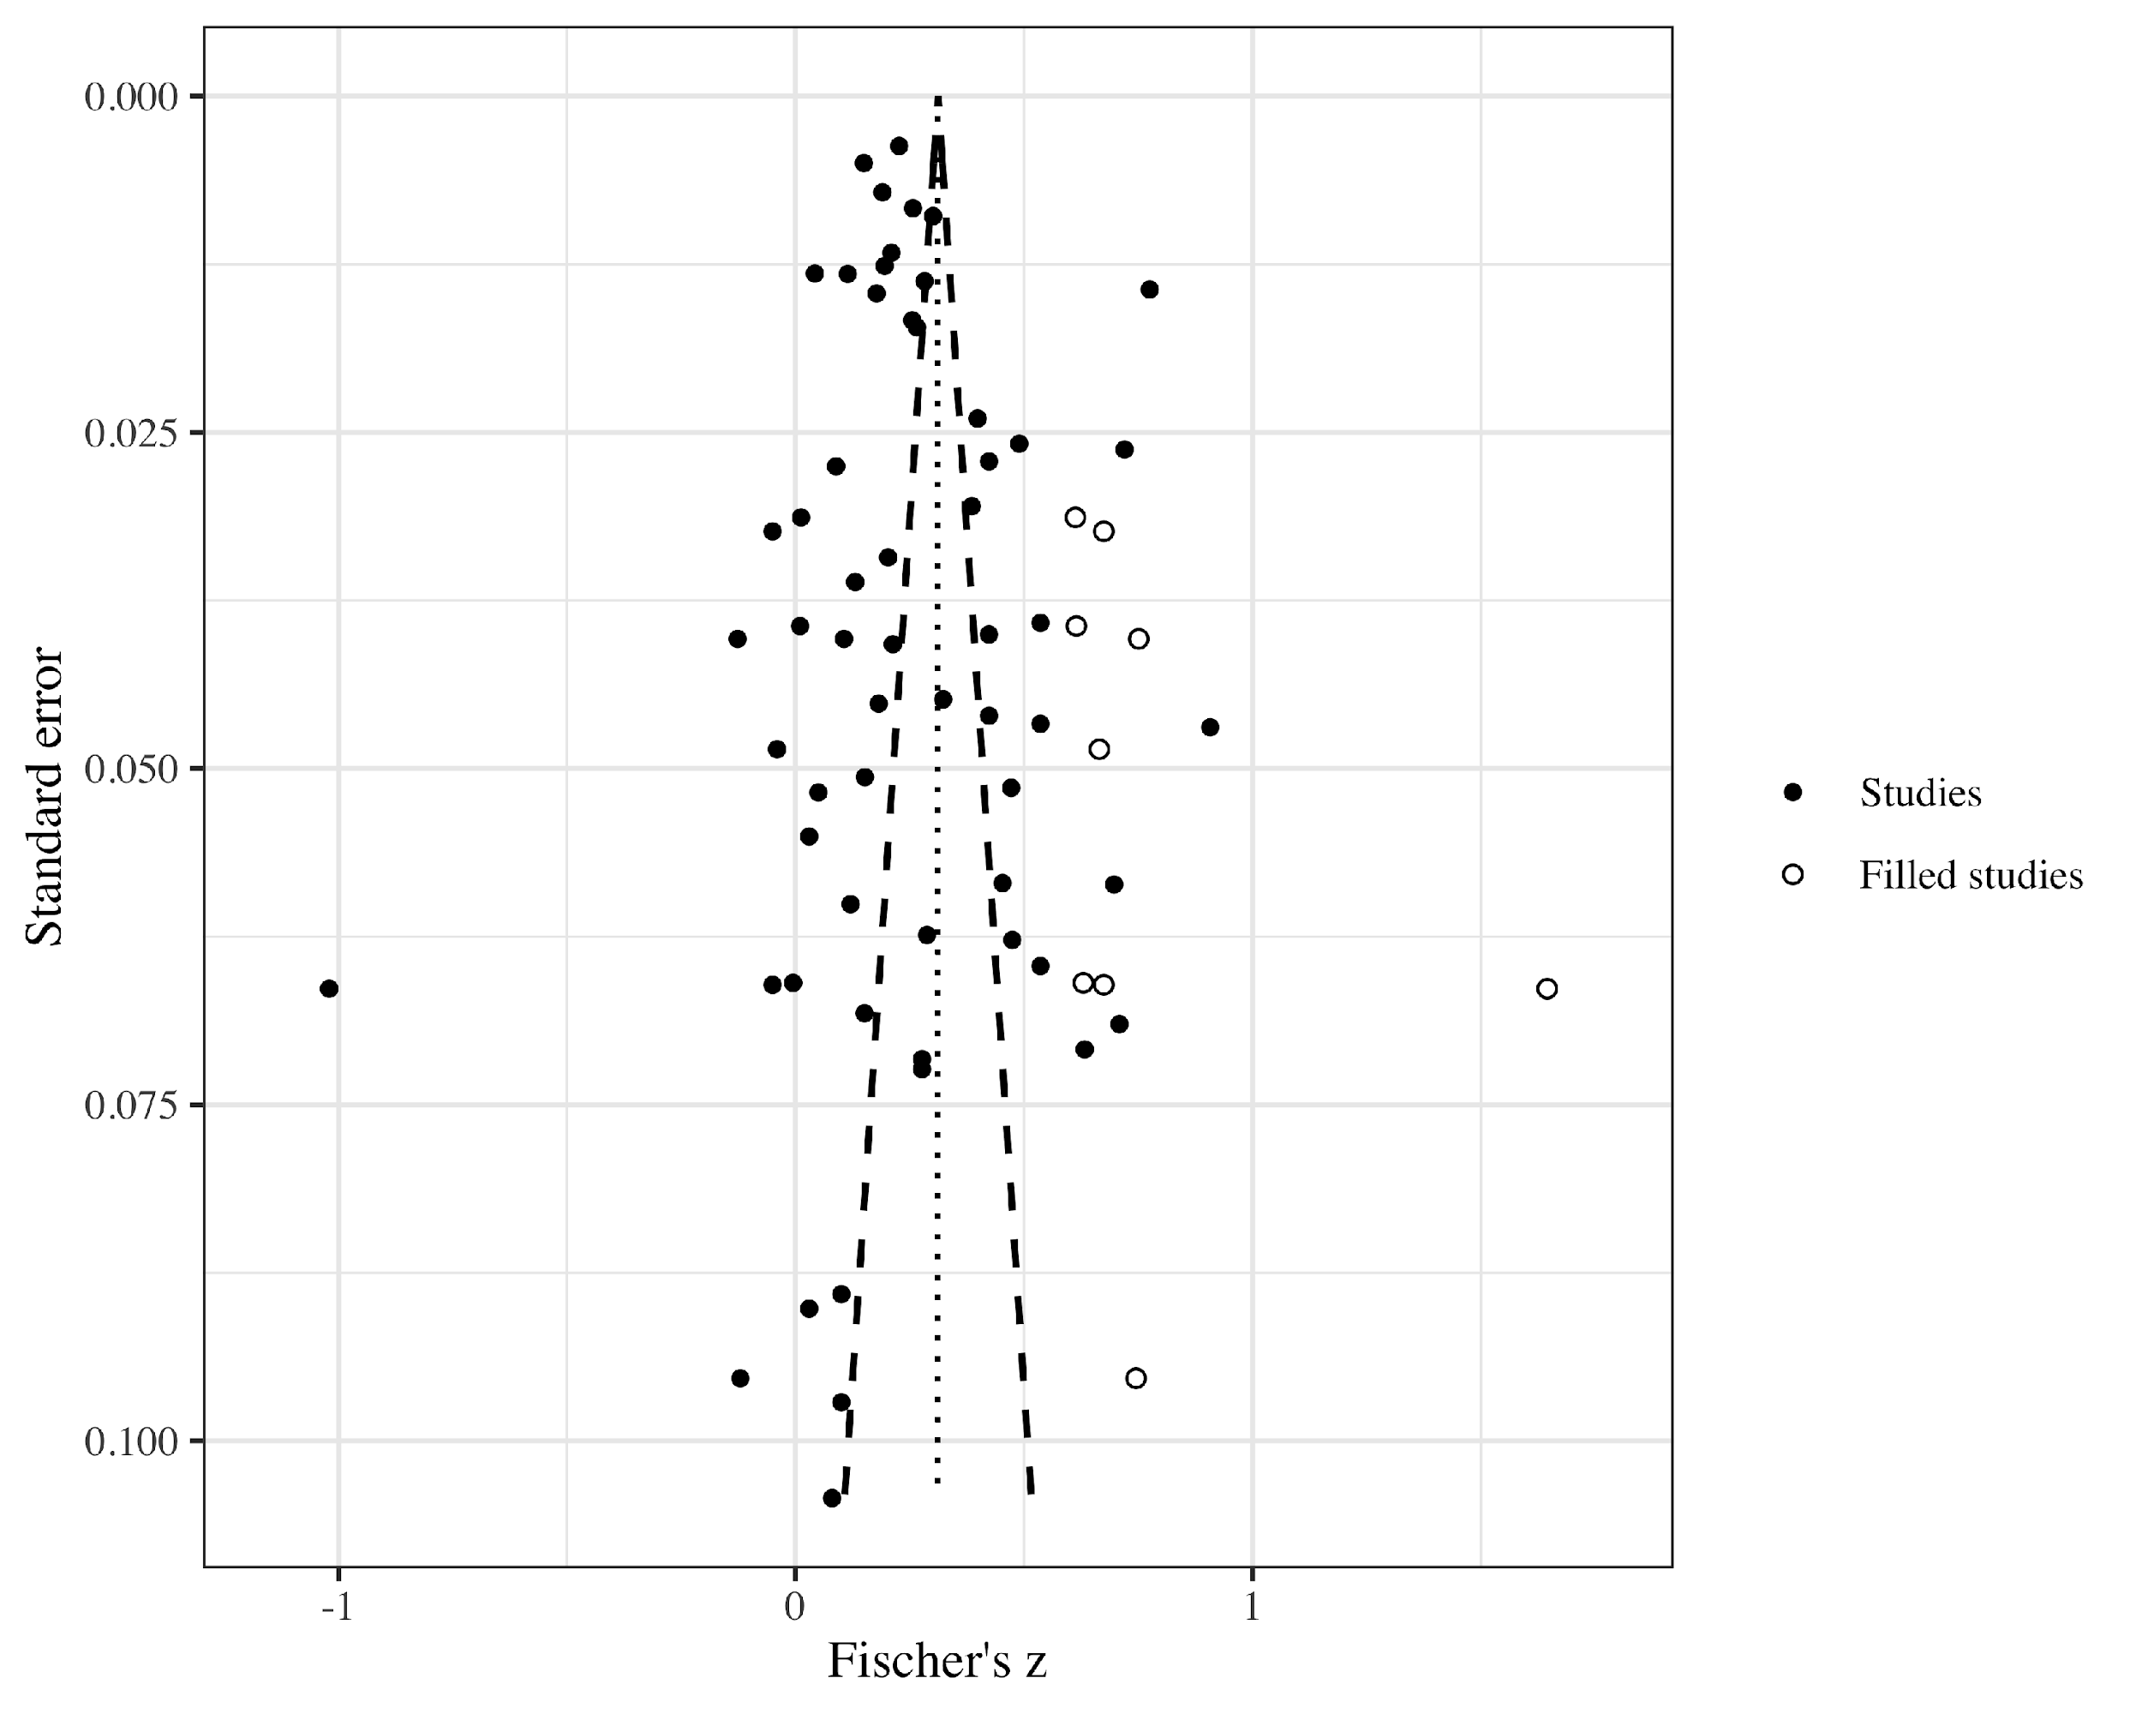
S10. Funnel plot for the association between well-being and ill-being. Data were first aggregated to the cluster level using fixed-effects meta-analysis.
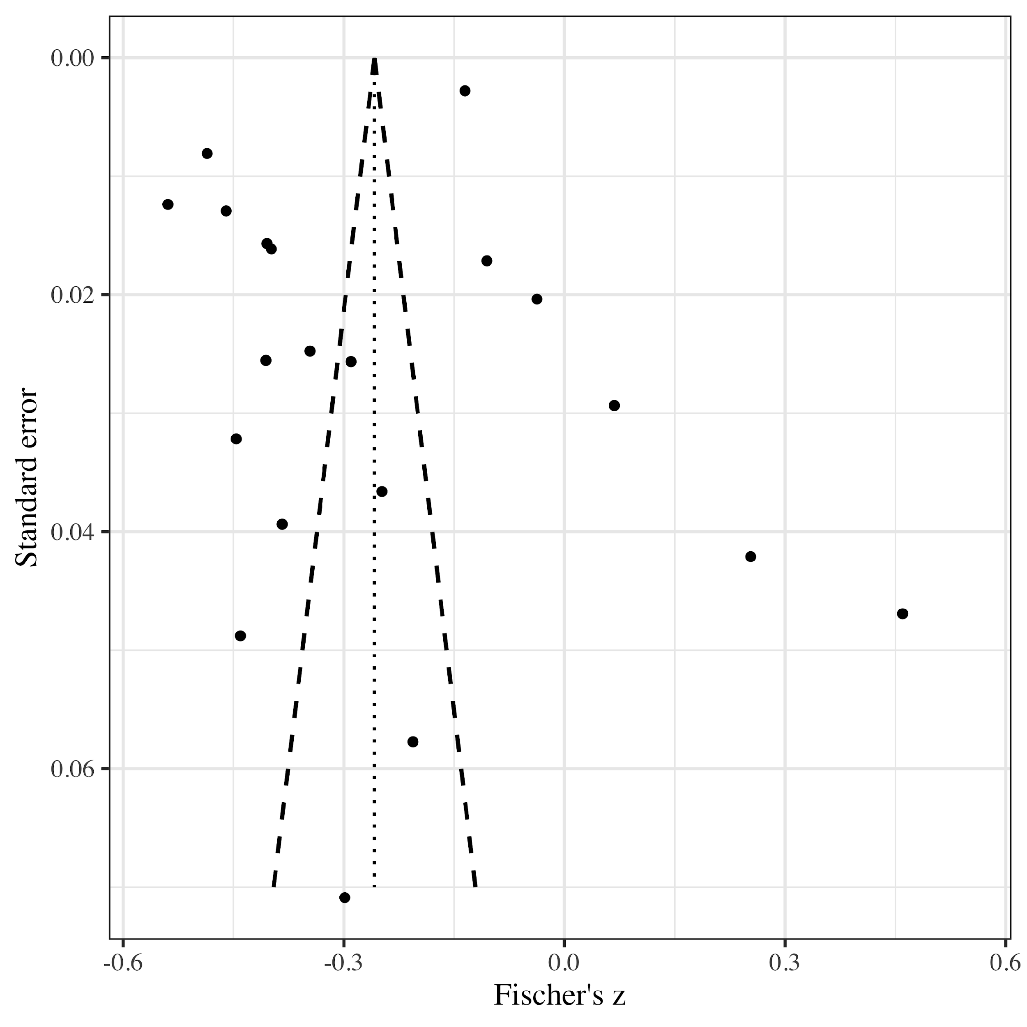
References
Argyle, M., Martin, M., & Crossland, J. (1989). Happiness as a function of personality and social encounters. In J. P. Forgas & J. M. Innes (Eds.), Recent advances in social psychology: An international perspective (pp. 189-203). Elsevier.
Bech, P., Gudex, C., & Johansen, K. S. (1996). The WHO (Ten) well-being index: Validation in diabetes. Psychotherapy and Psychosomatics, 65(4), 183-190. https://doi.org/10.1159/000289073
Beck, A. T., Steer, R. A., & Brown, G. K. (1996). Beck depression inventory-II. The Psychological Corporation.
Chen, B., Vansteenkiste, M., Beyers, W., Boone, L., Deci, E. L., Van der Kaap-Deeder, J., Duriez, B., Lens, W., Matos, L., & Mouratidis, A. (2015). Basic psychological need satisfaction, need frustration, and need strength across four cultures. Motivation and Emotion, 39(2), 216-236. https://doi.org/https://doi.org/10.1007/s11031-014-9450-1
Crumbaugh, J. C., & Maholick, M D. (1981). The manual of instructions for the Purpose in Life Test. Psychometric Affiliates.
Deci, E. L., Ryan, R. M., Gagné, M., Leone, D. R., Usunov, J., & Kornazheva, B. P. (2001). Need satisfaction, motivation, and well-being in the work organizations of a former eastern bloc country: A cross-cultural study of self-determination. Personality and Social Psychology Bulletin, 27(8), 930-942. https://doi.org/10.1177/0146167201278002
Derogatis, L. R., Lipman, R. S., Rickels, K., Uhlenhuth, E. H., & Covi, L. (1974). The Hopkins Symptom Checklist (HSCL): A self‐report symptom inventory. Behavioral Science, 19(1), 1-15. https://doi.org/10.1002/bs.3830190102
Diener, E., & Emmons, R. A. (1984). The independence of positive and negative affect. Journal of Personality and Social Psychology, 47(5), 1105-1117. https://doi.org/10.1037/0022-3514.47.5.1105
Diener, E., Emmons, R. A., Larsen, R. J., & Griffin, S. (1985). The satisfaction with life scale. Journal of Personality Assessment, 49(1), 71-75. https://doi.org/https://doi.org/10.1207/s15327752jpa4901_13
Diener, E., Wirtz, D., Tov, W., Kim-Prieto, C., Choi, D.-w., Oishi, S., & Biswas-Diener, R. (2010). New well-being measures: Short scales to assess flourishing and positive and negative feelings. Social Indicators Research, 97(2), 143-156. https://doi.org/10.1007/s11205-009-9493-y
Emmons, R. A. (1991). Personal strivings, daily life events, and psychological and physical well‐being. Journal of Personality, 59(3), 453-472. https://doi.org/10.1111/j.1467-6494.1991.tb00256.x
Fordyce, M. W. (1988). A review of research on the happiness measures: A sixty second index of happiness and mental health. Social Indicators Research, 20(4), 355-381. https://doi.org/10.1007/BF00302333
Gagné, M. (2003). The role of autonomy support and autonomy orientation in prosocial behavior engagement. Motivation and Emotion, 27(3), 199-223. https://doi.org/10.1023/A:1025007614869
Goldberg, D. P., Gater, R., Sartorius, N., Ustun, T. B., Piccinelli, M., Gureje, O., & Rutter, C. (1997). The validity of two versions of the GHQ in the WHO study of mental illness in general health care. Psychological Medicine, 27(1), 191-197. https://doi.org/https://doi.org/10.1017/S0033291796004242
Gombás, J. (2015). Materialistic thinking and its mental-hygienic implications among students of Budapest business school. Practice and Theory in Systems of Education, 10(2), 194-208. https://doi.org/10.1515/ptse-2015-0019
Grob, A. (1995). Berne questionnaire of subjective well-being (youth form). University of Bern.
Huebner, E. S., & Gilman, R. (2002). An introduction to the multidimensional students' life satisfaction scale. Social Indicators Research, 60(1-3), 115-122. https://doi.org/10.1007/978-94-015-9970-2_5
Ilardi, B. C., Leone, D., Kasser, T., & Ryan, R. M. (1993). Employee and supervisor ratings of motivation: Main effects and discrepancies associated with job satisfaction and adjustment in a factory setting. Journal of Applied Social Psychology, 23(21), 1789-1805. https://doi.org/10.1111/j.1559-1816.1993.tb01066.x
Johnston, M. M., & Finney, S. J. (2010). Measuring basic needs satisfaction: Evaluating previous research and conducting new psychometric evaluations of the Basic Needs Satisfaction in General Scale. Contemporary Educational Psychology, 35(4), 280-296. https://doi.org/10.1016/j.cedpsych.2010.04.003
Jones, A., & Crandall, R. (1986). Validation of a short index of self-actualization. Personality and Social Psychology Bulletin, 12(1), 63-73. https://doi.org/10.1177/0146167286121007
Joseph, S., Linley, P. A., Harwood, J., Lewis, C. A., & McCollam, P. (2004). Rapid assessment of well‐being: The short depression‐happiness scale (SDHS). Psychology and psychotherapy: Theory, research and practice, 77(4), 463-478. https://doi.org/10.1348/1476083042555406
Keyes, C. L. (2006). Mental health in adolescence: Is America's youth flourishing? American Journal of Orthopsychiatry, 76(3), 395-402. https://doi.org/https://doi.org/10.1037/0002-9432.76.3.395
Konkolÿ Thege, B., Martos, T., Skrabski, Á., & Kopp, M. (2008). A rövidített stressz és megküzdés kérdőív élet értelmességét mérő alskálájának (BSCI-LM) pszichometriai jellemzői. [Psychometric properties of the Life Meaning Subscale from the Brief Stress and Coping Inventory (BSCI-IM)]. Mentálhigiéné és Pszichoszomatika, 9(3), 243-261. https://doi.org/10.1556/Mental.9.2008.3.4
Lyubomirsky, S., & Lepper, H. S. (1999). A measure of subjective happiness: Preliminary reliability and construct validation. Social Indicators Research, 46(2), 137-155. https://doi.org/10.1023/A:1006824100041
Mei, S., Chai, J., & Guo, J. (2015). Subjective well-being and Internet addiction of adolescents: Mediating roles of self-esteem and self-control. Psychological Development and Education, 31(5), 603-609.
Nagpal, R., & Sell, H. (1992). Assessment of subjective well-being: The subjective well-being inventory. Regional Office for South-East Asia, World Health Organization.
O'Brien, E., & Epstein, S. (1988). MSEI: The multidimensional self-esteem inventory: Professional manual. Psychological Assessment Resources.
Pavot, W., Diener, E., & Suh, E. (1998). The temporal satisfaction with life scale. Journal of Personality Assessment, 70(2), 340-354. https://doi.org/10.1207/s15327752jpa7002_11
Radloff, L. S. (1977). The CES-D scale: A self-report depression scale for research in the general population. Applied Psychological Measurement, 1(3), 385-401. https://doi.org/10.1177/014662167700100306
Rahe, R. H., & Tolles, R. L. (2002). The brief stress and coping inventory: A useful stress management instrument. International Journal of Stress Management, 9(2), 61-70. https://doi.org/10.1023/A:1014950618756
Rosenberg, M. (1979). Conceiving the self. Basic Books.
Ryan, R. M., & Frederick, C. (1997). On energy, personality, and health: Subjective vitality as a dynamic reflection of well‐being. Journal of Personality, 65(3), 529-565. https://doi.org/10.1111/j.1467-6494.1997.tb00326.x
Ryff, C. D. (1989). Happiness is everything, or is it? Explorations on the meaning of psychological well-being. Journal of Personality and Social Psychology, 57(6), 1069-1081. https://doi.org/10.1037/0022-3514.57.6.1069
Sheldon, K. M., & Hilpert, J. C. (2012). The balanced measure of psychological needs (BMPN) scale: An alternative domain general measure of need satisfaction. Motivation and Emotion, 36(4), 439-451. https://doi.org/10.1007/s11031-012-9279-4
Spielberger, C., Gorsuch, R., Lushene, R., Vagg, P., & Jacobs, G. (1983). Manual for the state-trait anxiety inventory. Consulting Psychologists Press.
Spitzer, R. L., Kroenke, K., Williams, J. B., & Löwe, B. (2006). A brief measure for assessing generalized anxiety disorder: The GAD-7. Archives of Internal Medicine, 166(10), 1092-1097. https://doi.org/10.1001/archinte.166.10.1092
Steger, M. F., Frazier, P., Oishi, S., & Kaler, M. (2006). The meaning in life questionnaire: Assessing the presence of and search for meaning in life. Journal of Counseling Psychology, 53(1), 80-93. https://doi.org/https://www.doi.org/10.1037/0022-0167.53.1.80
Thompson, E. R. (2007). Development and validation of an internationally reliable short-form of the positive and negative affect schedule (PANAS). Journal of Cross-Cultural Psychology, 38(2), 227-242. https://doi.org/10.1177/0022022106297301
Trompetter, H. R., ten Klooster, P. M., Schreurs, K. M., Fledderus, M., Westerhof, G. J., & Bohlmeijer, E. T. (2013). Measuring values and committed action with the Engaged Living Scale (ELS): Psychometric evaluation in a nonclinical sample and a chronic pain sample. Psychological Assessment, 25(4), 1235-1246. https://doi.org/https://doi.org/10.1037/a0033813
Waterman, A. S., Schwartz, S. J., Zamboanga, B. L., Ravert, R. D., Williams, M. K., Bede Agocha, V., Yeong Kim, S., & Brent Donnellan, M. (2010). The questionnaire for eudaimonic well-Being: Psychometric properties, demographic comparisons, and evidence of validity. The Journal of Positive Psychology, 5(1), 41-61. https://doi.org/10.1080/17439760903435208
Watson, D., Clark, L. A., & Tellegen, A. (1988). Development and validation of brief measures of positive and negative affect: the PANAS scales. Journal of Personality and Social Psychology, 54(6), 1063-1070. https://doi.org/10.1037/0022-3514.54.6.1063
Yen, C.-F., Yang, P., Wu, Y.-Y., Hsu, F.-C., & Cheng, C.-P. (2010). Factor structure, reliability and validity of the Taiwanese version of the Multidimensional Anxiety Scale for Children. Child Psychiatry & Human Development, 41(3), 342-352. https://doi.org/10.1007/s10578-010-0172-7
Zung, W. W. (1971). A rating instrument for anxiety disorders. Psychosomatics: Journal of Consultation and Liaison Psychiatry, 12(6), 371-379. https://doi.org/10.1016/S0033-3182(71)71479-0

