Supplemental Materials
Agentic Narcissism, Communal Narcissism, and Prosociality
by A. D. Nehrlich et al., 2018, Journal of Personality and Social Psychology
http://dx.doi.org/10.1037/pspp0000190

S1. Study 1 also included the following measures that we did not analyze: Rosenberg Self-Esteem Scale (Rosenberg, 1965), Contingent Self-Esteem Scale (Kernis & Goldman, 2006), Two-Dimensional Self-Esteem Scale (designed for this data collection), Global Psychological Adjustment Scale (Gebauer, 2016), Anxiety subscale from the IPIP 16PF (Goldberg, 1999), Death Anxiety Scale (Templer, 1970), Center for Epidemiologic Studies Depression Scale (Lewinsohn, Seeley, Roberts, & Allen, 1997), Agency-Communion Scale (Gebauer, Paulhus, & Neberich, 2013), Tendency to Forgive Scale (Brown, 2003), Transgression-Related Interpersonal Disposition Inventory (Hoyt, Fincham, McCullough, Maio, & Davila, 2005), Empathic Concern subscale of Multidimensional Individual Difference Measure of Empathy (Davis, 1980), Pleasure and Pressure Based Prosocial Motivation Scale (Gebauer, Riketta, Broemer, & Maio, 2008; revised and extended version), Volunteering in an Online Study Paradigm (adapted from Coke, Batson, & McDavis, 1978), Trust Game (Berg, Dickhaut, & McCabe, 1995), Political-Engagement Scale (adapted from Costa & Kahn, 2003), Belief in the Existence of True Altruism Scale (Gebauer, Sedikides, Leary, & Asendorpf, 2015a; as cited in Gebauer, Sedikides, Leary, & Asendorpf, 2015b), Dehumanization Scale (designed for this data collection), Balanced Inventory of Socially Desirable Responding (Paulhus, 1991), Agentic and Communal Overclaiming Scale (adapted from Gebauer, Sedikides, Verplanken, & Maio, 2012), Agency-Communion Better-Than-Average Scale (Gebauer, Sedikides, & Schrade, 2017), Global Religiosity Scale (Gebauer & Maio, 2012), Intrinsic Religiosity Scale (Zwingmann, Hellmeister, & Ochsmann, 1994), Christian Better-Than-Average Scale (designed for this data collection), Christian Overclaiming Scale (Gebauer et al., 2017), Amount and Conditionality of Belongingness Scale (Gebauer, Riketta, Maio, & Haddock, 2018), Inclusion of Others in the Self Scale (Aron, Aron, & Smollan, 1992), Parental Attachment History Prototypes (Birgegard & Granqvist, 2002), Two-Dimensional Ideal-Versus-Actual Partnership Quality Scale (designed for this data collection). Although we did not analyze any of these measures, two appear relevant: The Volunteering in an Online Study Paradigm and the Trust Game. However, there is an important difference between these two additional measures and the objective prosociality measures reported in the main text. The two additional measures evidenced insufficient temporal stability to qualify as trait indicators of objective prosociality (volunteering: r_{tt} = [r₁₂ × r₂₃] / r₁₃ = [.290 × .395] / .465 = .25; trust game: r_{tt} = [r₁₂ × r₂₃] / r₁₃ = [.279 × .301] / .458 = .42). We thus decided against using these two measures. This decision is consistent with Gebauer et al. (2015a; as cited in Gebauer et al., 2015b), who used the same data set.
S2. Study 2 also included the following measures that we did not analyze. Self-report assessment: Rosenberg Self-Esteem Scale (Rosenberg, 1965), Global Psychological Adjustment Scale (Gebauer, 2016), Big Five Inventory (Lang, Lüdtke, & Asendorpf, 2001), Agency-Communion Scale (Gebauer et al., 2013), Balanced Inventory of Socially Desirable Responding (version 6; Paulhus, 1991), and a variant of the Overclaiming Questionnaire, concerning six psychological subfields (adapted from Paulhus, Harms, Bruce, & Lysy, 2003). Round-robin assessments: Agency Scale (adapted from Gebauer et al., 2013), Agentic Behavior Scale (adapted from Moskowitz, 1994; see also Dufner, Leising, & Gebauer, 2016); Big Five Inventory Short-Form (Rammstedt & John, 2007); Liking Scale (Back, Schmuckle, & Egloff, 2011), Meta-Perceptions of Being Liked Scale (Back et al., 2011), Study Course Knowledge Scale (designed for this data collection), Influence on Group Decisions Scale (designed for this data collection).
Supplement References
Aron, A., Aron, E. N., & Smollan, D. (1992). Inclusion of Other in the Self Scale and the structure of interpersonal closeness. Journal of Personality and Social Psychology, 63, 596–612.
Back, M. D., Schmukle, S. C., & Egloff, B. (2011). A closer look at first sight: Social relations lens model analysis of personality and interpersonal attraction at zero acquaintance. European Journal of Personality, 25, 225–238.
Berg, J., Dickhaut, J., & McCabe, K. (1995). Trust, reciprocity, and social history. Games and Economic Behavior, 10, 122–142.
Birgegard, A., & Granqvist, P. (2004). The correspondence between attachment to parents and God: Three experiments using subliminal separation cues. Personality and Social Psychology Bulletin, 30, 1122–1135.
Brown, R. P. (2003). Measuring individual differences in the tendency to forgive: Construct validity and links with depression. Personality and Social Psychology Bulletin, 29, 759–771.
Coke, J. S., Batson, C. D., & McDavis, K. (1978). Empathic mediation of helping: A two-stage model. Journal of Personality and Social Psychology, 36, 752–766.
Costa, D. L., & Kahn, M. E. (2003). Civic engagement and community heterogeneity: An economist's perspective. Perspectives on Politics, 1, 103–111.
Davis, M. H. (1980). A multidimensional approach to individual differences in empathy. JSAS: Catalog of Selected Documents in Psychology, 10, 85.
Dufner, M., Leising, D., & Gebauer, J. E. (2016). Which basic rules underlie social judgments? Agency follows a zero-sum principle and communion follows a non-zero-sum principle. Personality and Social Psychology Bulletin, 42, 677–687.
Gebauer, J. E. (2016, December). On the discriminant validity of the Rosenberg Self-Esteem Scale: Do lay people distinguish between global self-esteem and psychological adjustment? Talk presented at the 2nd GESIS Expert Meeting on Advances in Scale Development in the Social Sciences, Mannheim, Germany.
Gebauer, J. E., & Maio, G. R. (2012). The need to belong can motivate belief in God. Journal of Personality, 80, 465–501.
Gebauer, J. E., Paulhus, D. L., & Neberich, W. (2013). Big Two personality and religiosity across cultures: Communals as religious conformists and agentics as religious contrarians. Social Psychological and Personality Science, 4, 21–30.
Gebauer, J. E., Riketta, M., Broemer, P., & Maio, G. R. (2008). Pleasure and pressure based prosocial motivation: Divergent relations to subjective well-being. Journal of Research in Personality, 42, 399-420.
Gebauer, J. E., Riketta, M., Maio, G. R., & Haddock, G. (2018). There’s more to belongingness than whether it’s high or low: An unconditional belongingness model of anxiety and depression. Unpublished manuscript, University of Mannheim, Germany.
Gebauer, J. E., Sedikides, C., Leary, M. R., & Asendorpf, J. B. (2015a). Lay belief in the existence of true altruism. Manuscript in preparation, University of Mannheim, Germany.
Gebauer, J. E., Sedikides, C., Leary, M. R., & Asendorpf, J. B. (2015b). Lay beliefs in true altruism versus universal egoism. In C. B. Miller, R. M. Furr, A. Knobel, & W. Fleeson (Eds.), Character: New directions from philosophy, psychology, and theology (pp. 75–99). Oxford, UK: Oxford Press.
Gebauer, J. E., Sedikides, C., & Schrade, A. (2017). Christian self-enhancement. Journal of Personality and Social Psychology, 113, 786-809.
Gebauer, J. E., Sedikides, C., Verplanken, B., & Maio, G. R. (2012). Communal narcissism. Journal of Personality and Social Psychology, 103, 854-878.
Goldberg, L. R. (1999). A broad-bandwidth, public-domain, personality inventory measuring the lower-level facets of several five-factor models. In I. Mervielde, I. J. Deary, F. De Fruyt, & F. Ostendorf (Eds.), Personality psychology in Europe (Vol. 7, pp. 7–28). Tilburg, The Netherlands: Tilburg University Press.
Hoyt, W. T., Fincham, F. D., McCullough, M. E., Maio, G., & Davila, J. (2005). Responses to interpersonal transgressions in families: Forgivingness, forgivability, and relationship-specific effects. Journal of Personality and Social Psychology, 89, 375–394.
Kernis, M. H., & Goldman, B. M. (2006). A multicomponent conceptualization of authenticity: Theory and research. Advances in Experimental Social Psychology, 38, 283–357.
Lang, F. R., Lüdtke, O., & Asendorpf, J. B. (2001). Testgüte und psychometrische Äquivalenz der deutschen Version des Big Five Inventory (BFI) bei jungen, mittelalten und alten Erwachsenen. [Validity and psychometric equivalence of the German version of the Big Five Inventory in young, middle-aged and old adults]. Diagnostica, 47, 111–121.
Lewinsohn, P. M., Seeley, J. R., Roberts, R. E., & Allen, N. B. (1997). Center for Epidemiologic Studies Depression Scale (CES-D) as a screening instrument for depression among community-residing older adults. Psychology and Aging, 12, 277–287.
Moskowitz, D. S. (1994). Cross-situational generality and the interpersonal circumplex. Journal of Personality and Social Psychology, 66, 921–933.
Paulhus, D. L. (1991). Measurement and control of response bias. In J. P. Robinson, P. R. Shaver, & L. S. Wrightsman (Eds.). Measures of personality and social psychological attitudes (Vol. 1, pp. 17–59). San Diego, CA: Academic Press.
Paulhus, D. L., Harms, P. D., Bruce, M. N., & Lysy, D. C. (2003). The over-claiming technique: measuring self-enhancement independent of ability. Journal of Personality and Social Psychology, 84, 890–904.
Rammstedt, B., & John, O. P. (2007). Measuring personality in one minute or less: A 10-item short version of the Big Five Inventory in English and German. Journal of Research in Personality, 41, 203–212.
Rosenberg, M. (1965). Society and the adolescent self-image. Princeton, NJ: Princeton University Press.
Templer, D. I. (1970). The construction and validation of a death anxiety scale. Journal of General Psychology, 82, 165–177.
Zwingmann, C., Hellmeister, G., & Ochsmann, R. (1994). Intrinsische und extrinsische Orientierung: Fragebogenskalen zum Einsatz in der empirisch-religionspsychologischen Forschung [Intrinsic and extrinsic religious orientation: Questionnaire scales in use for psychological studies of religion]. Zeitschrift für Differentielle und Diagnostische Psychologie, 15, 131–139.

Figure S1. Additional Results of Study 2: Relations Between the Grandiose Facets of The Npi (Leadership-Authority and Grandiose Exhibitionism), Communal Narcissism, And Prosociality (Objective and Subjective)

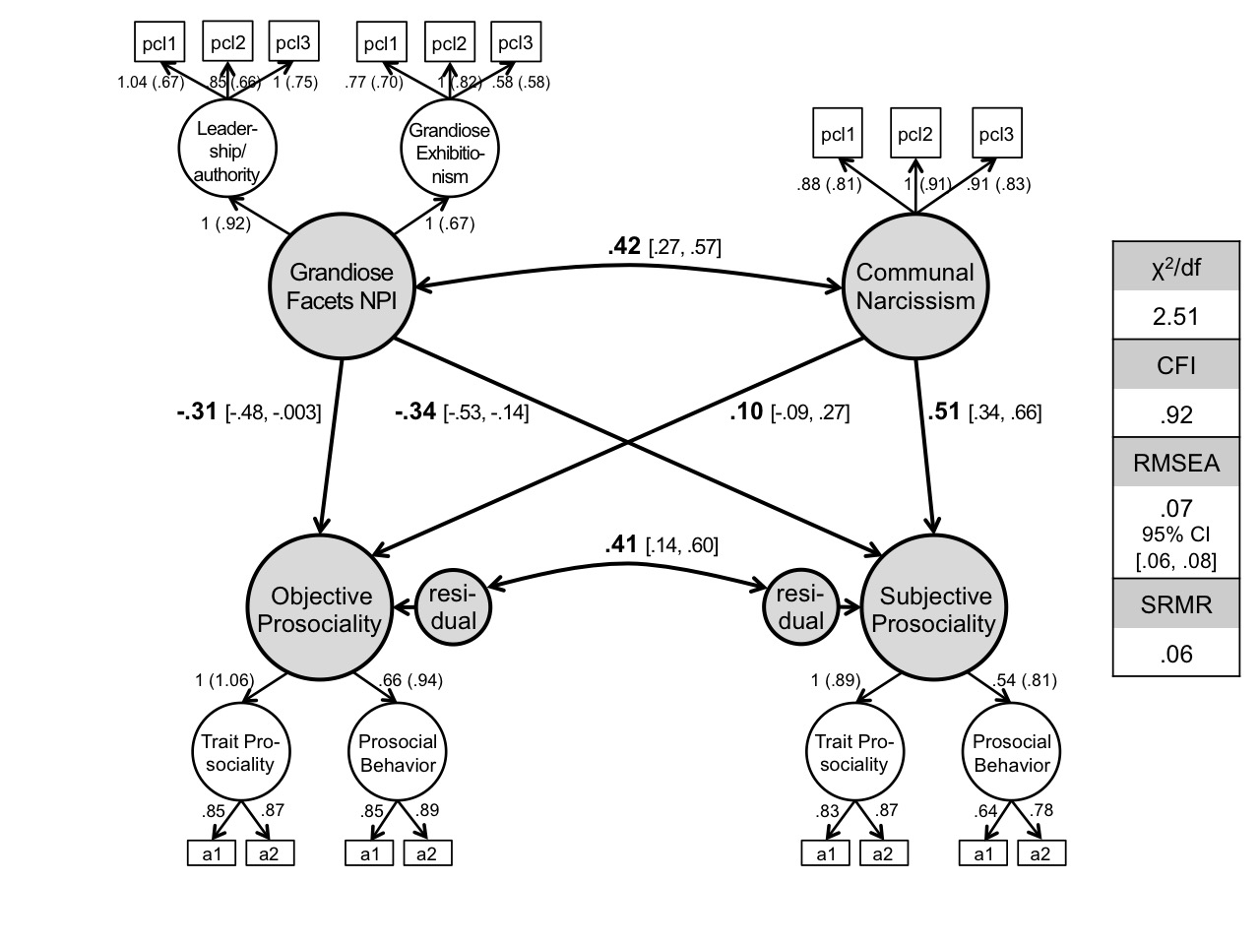

Note. pcl1–pcl3 = parcels 1–3; a1–a2 = round-robin assessments 1–2.

Figure S2. Additional Results of Study 2: Relations Between the Leadership-Authority Facet of The Npi, Communal Narcissism, And Prosociality (Objective and Subjective)

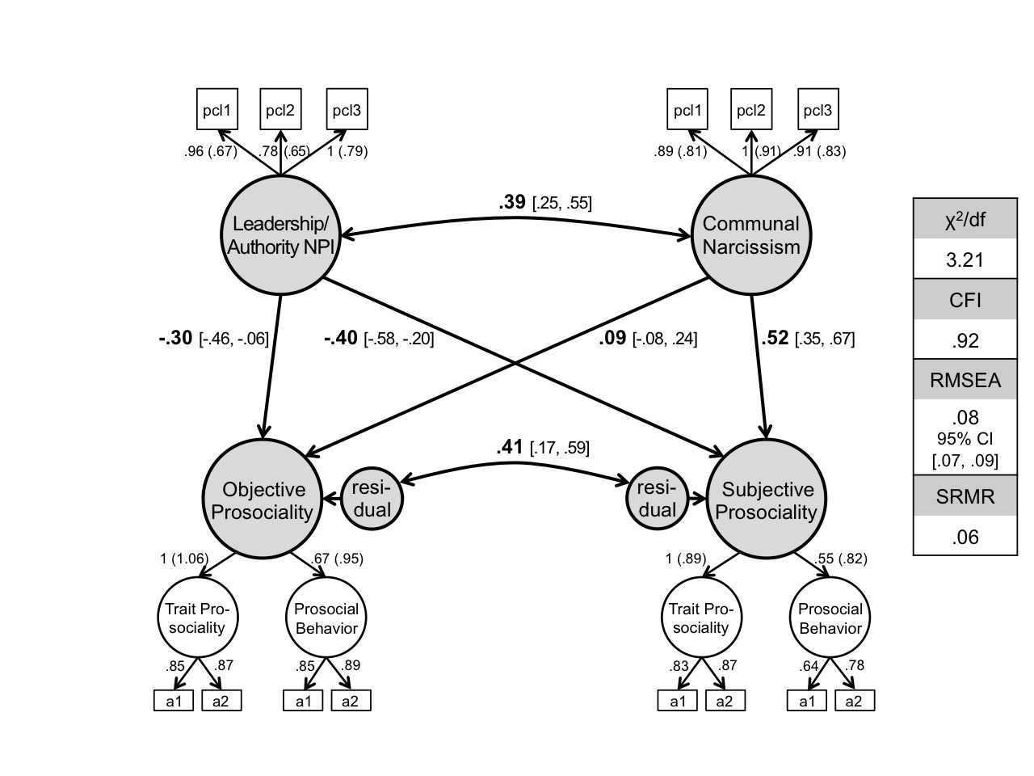

Note. pcl1–pcl3 = parcels 1–3; a1–a2 = round-robin assessments 1–2.

Figure S3. Additional Results of Study 2: Relations Between the Grandiose-Exhibitionism Facet of The Npi, Communal Narcissism, And Prosociality (Objective and Subjective)

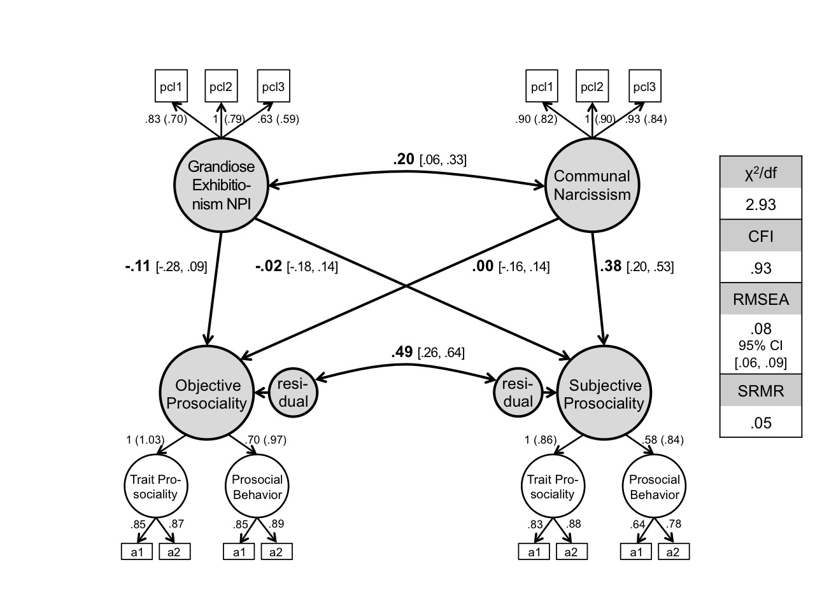

Note. pcl1–pcl3 = parcels 1–3; a1–a2 = round-robin assessments 1–2.

Figure S4. Additional Results of Study 2: Relations Between the Entitlement-Exploitativeness Facet of The Npi, Communal Narcissism, And Prosociality (Objective and Subjective)

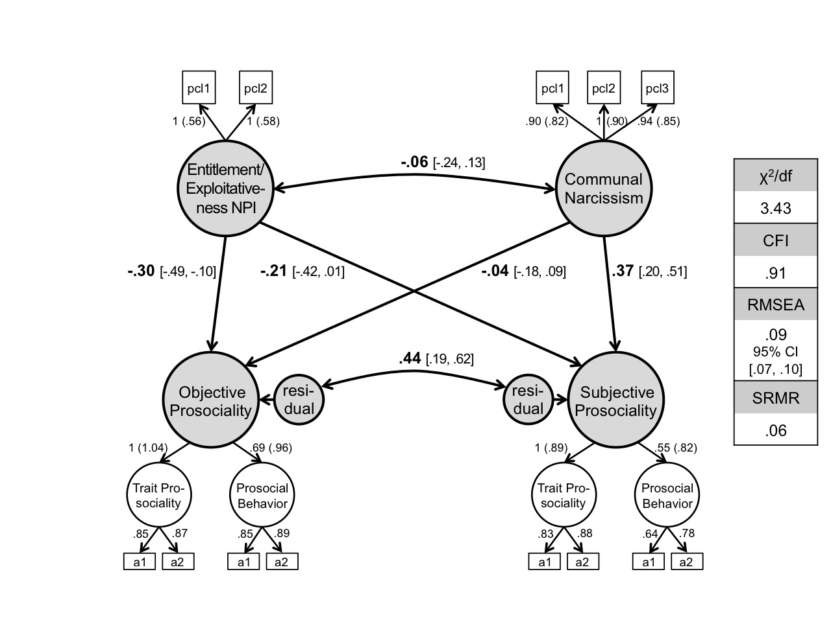

Note. pcl1–pcl3 = parcels 1–3; a1–a2 = round-robin assessments 1–2.

