**Supplemental Materials**

**How Distinctive are Morningness and Eveningness from the Big Five-Factors of Personality? A Meta-Analytic Investigation**

**by A. A. Lipnevich et al., 2016, *Journal of Personality and Social Psychology***

**http://dx.doi.org/10.1037/pspp0000099**

**Moderator analyses**

*Analytic strategy*. Because the meta-analytic results of the relationship between Big Five traits and morningness and eveningness – particularly the wide credibility intervals – suggested the presence of some unexamined moderators, we explored whether or not any of the coded study characteristics might explain the variation in observed effect sizes across studies. This approach is in line with prior research that has suggested that study characteristics such as publication type (published versus unpublished) can moderate the size of the observed effects (e.g., Rosenthal & Rubin, 1978; Smith & Glass, 1977). To do so, the observed effect size for each relationship was regressed onto the following study characteristics: publication type (published=1, not published=0), study design (longitudinal=1, concurrent=0), sample source (USA=1, non-USA=0), year of publication, and the mean age and gender composition of the sample. Rather than rely on Ordinary-Least-Squares regression for this analysis we relied on a weighted least-squares (WLS) multiple regression approach because this allows us to give greater weight to studies with larger sample sizes (Hunter & Schmidt, 2004). Using a multiple regression approach is preferred to an approach, in which separate meta-analyses are calculated for each categorical moderator because of the confounding of many of these potential moderators and the moderate number of overall studies for this meta-analysis.

*Results*. Only for the relations of eveningness with conscientiousness and extraversion, the proportion of the variation in observed effect sizes that could be explained by variations in study artifacts (% Var) exceeded the critical value of 75%. For all other relations, moderators were likely to be present. In order to explore the possibility that study characteristics may have moderated the observed relations between chronotype and Big Five personality traits we regressed the observed effect sizes onto the six coded-for study characteristics mentioned in the Method, for which complete data was available using WLS. Values for these study characteristics were as follows: publication status (18 published studies, 18 unpublished studies); year of publication (*M* = 2006.92, *SD* = 4.69); whether the data was collected in the USA (ten USA samples, 26 non-USA samples); the proportion of the sample that was male (*M* = .39, *SD* = .22), the mean age of the sample (*M* = 22.74, *SD* = 5.98); and the research design (2 longitudinal designs, 34 concurrent designs). Results for these ten analyses are presented in Table 1 of the Supplemental Materials. Although these analyses did detect statistically significant moderators of the relations these moderators were not consistent across relationships. For example, year of publication was a significant moderator of both the morningness-agreeableness and eveningness-neuroticism relations but the effect did not replicate with the other eight examined relations. Similar inconsistencies were observed for all other examined study characteristics. Publication status, proportion of men in the sample, and mean age were significant moderators of only one relation, and whether or not the study design was longitudinal moderated three relations. These inconsistent results are likely to be a function, at least in part, of the relatively low number of studies used for this analysis (i.e., the sample size for the regression analysis is the number of studies and not the number of individuals in those studies). Together, the six examined study characteristics explained between 1% and 72% of the variance in observed effect sizes (*M* = .28, *SD* = 20). The largest amount of effect size variance could be explained for the eveningness–neuroticism relationship. More recent estimates of this relationship appear to be significantly smaller while longitudinal designs have exhibited significantly stronger average effects. Because these moderator effects were not observed for most other relationships, we speculate that sampling error due to the relatively small number of studies included in this analyses can account for these findings.

**Funnel plots of the relationship among study variables.**

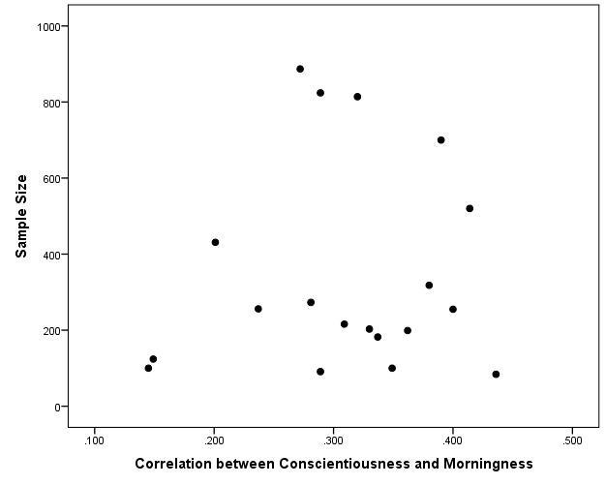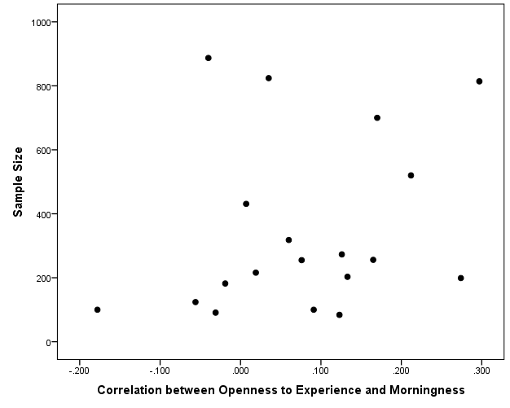

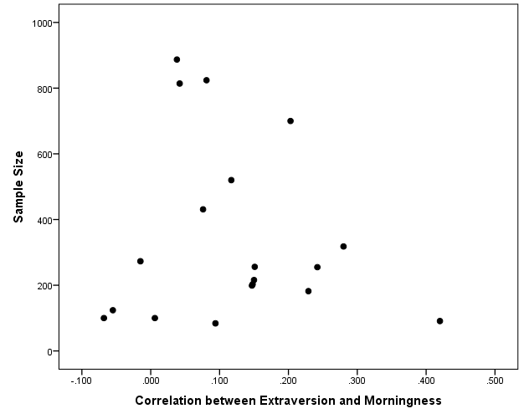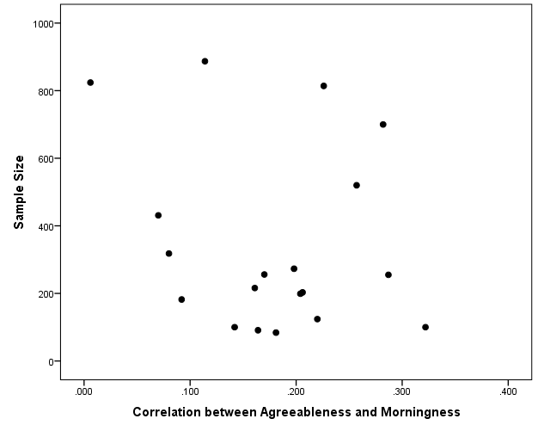

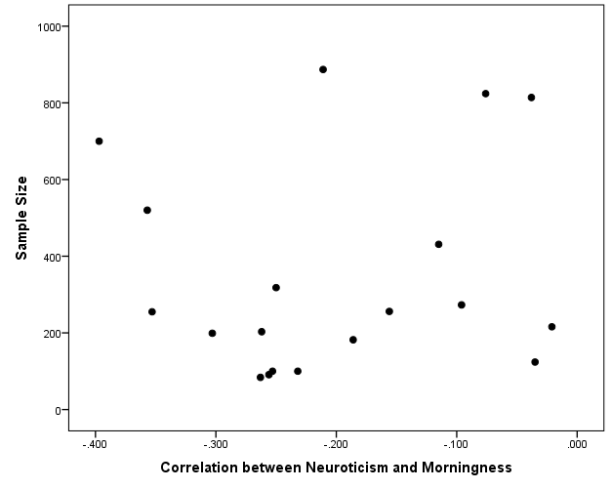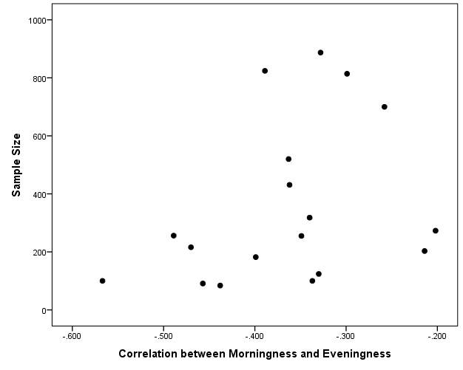

*Figure 1*. Funnel plots of the relationships between morningness and Big Five traits and of the relationship between morningness and eveningness.

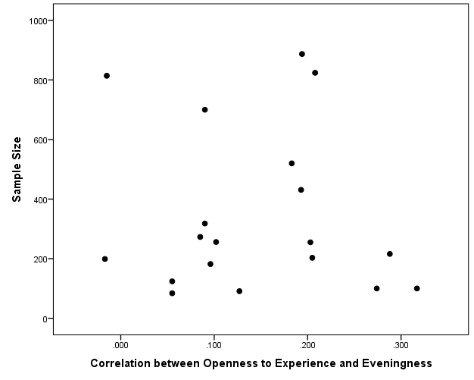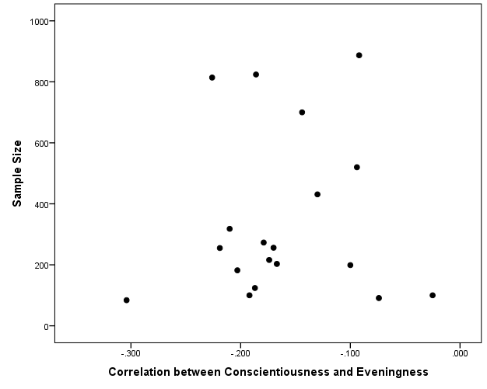

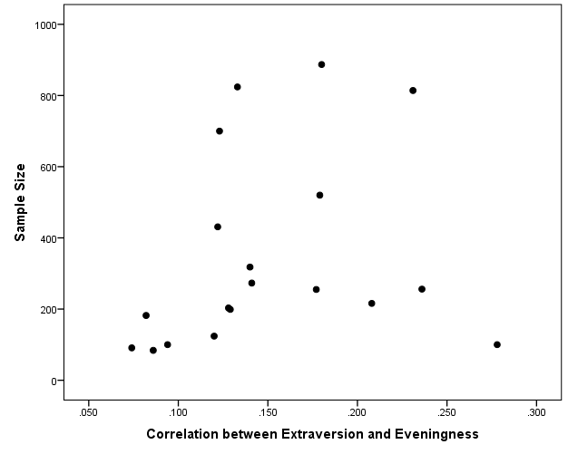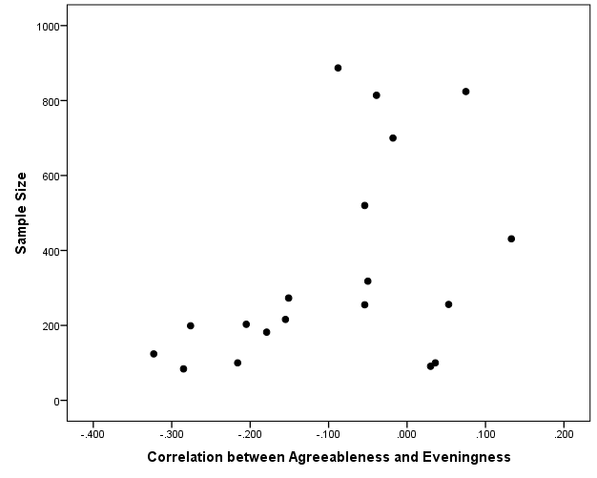

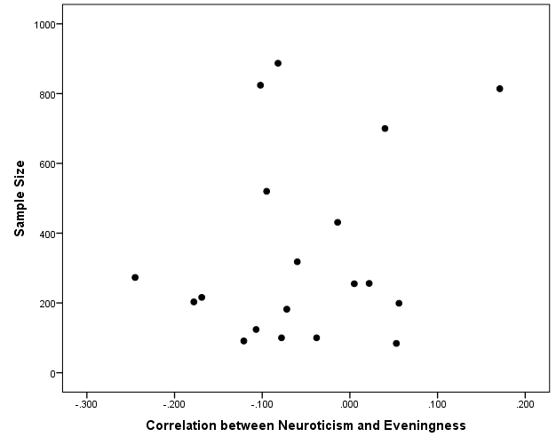

*Figure 2.* Funnel plots of the relationships between eveningness and Big Five traits.

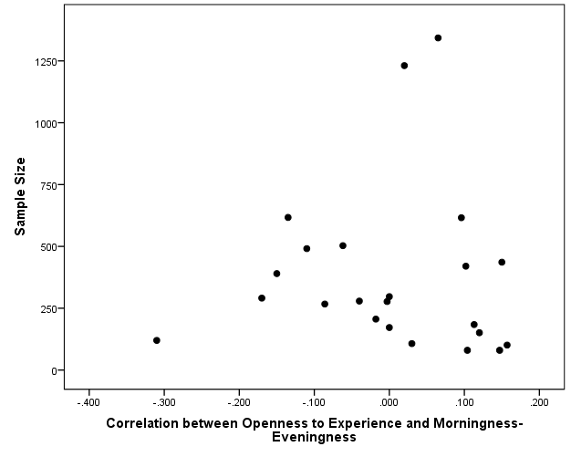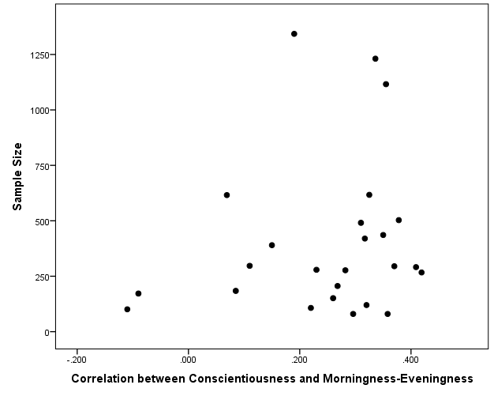

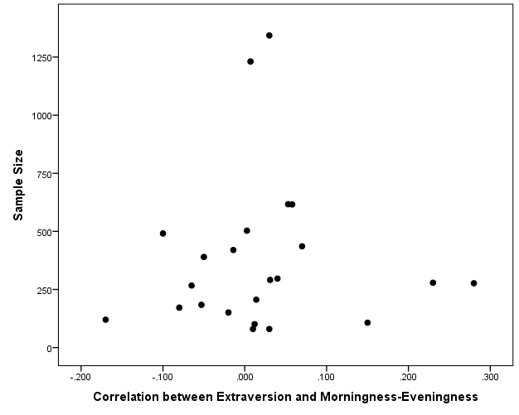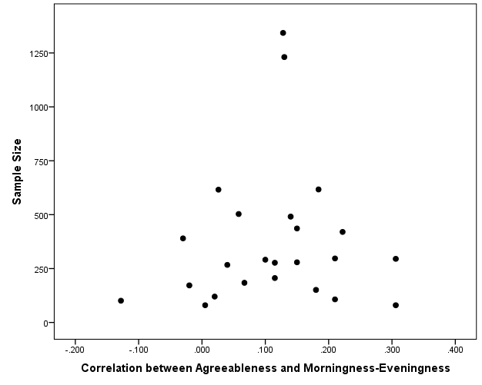

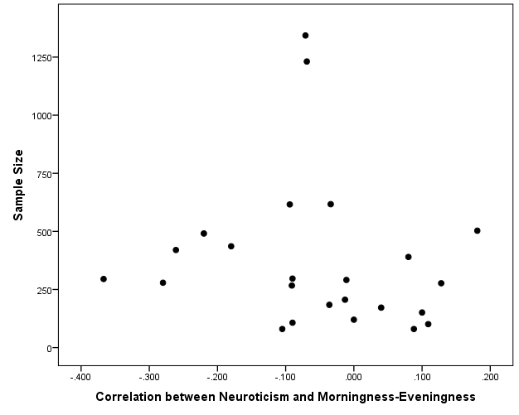

*Figure 3.* Funnel plots of the relationships between morningness–eveningness and Big Five traits.

Table 1

*Results from WLS Regression of Effect Sizes onto Six Study Characteristics*

|  |  |  |  |  |  |  |  |  |
| --- | --- | --- | --- | --- | --- | --- | --- | --- |
| Morningness–Eveningness | Big Five Trait | Published?  (1=Yes, 0=No) | Year of Publication | USA Sample? (1=Yes, 0=No) | % Male | Mean Age | Longitudinal Design?  (1=Yes 0=No) | Adj. *R2* |
| Morningness | Openness | .34* | -.30 | -.08 | .15 | -.20 | .63** | 0.67 |
|  |  | (.30) | (-.22) | (-.05) | (.11) | (-.14) | (.47) |  |
| Morningness | Conscientiousness | .32 | -.14 | -.22 | .51 | .00 | .13 | 0.08 |
|  |  | (.27) | (-.10) | (-.15) | (.38) | (.00) | (.10) |  |
| Morningness | Extraversion | -.13 | .15 | -.22 | .23 | -.51 | -.49 | 0.00 |
|  |  | (-.11) | (.11) | (-.15) | (.17) | (-.36) | (-.36) |  |
| Morningness | Agreeableness | .12 | -.76** | -.91** | .65** | .11 | .64** | 0.77 |
|  |  | (.10) | (-.56) | (-.61) | (.48) | (.08) | (.48) |  |
| Morningness | Neuroticism | -.21 | .50 | .40 | -.53* | -.35 | .15 | 0.48 |
|  |  | (-.18) | (.37) | (.27) | (-.39) | (-.24) | (.11) |  |
| Eveningness | Openness | -.29 | .27 | .22 | .07 | .08 | -.77** | 0.37 |
|  |  | (-.25) | (.20) | (.14) | (.05) | (.06) | (-.57) |  |
| Eveningness | Conscientiousness | .29 | -.35 | .04 | .18 | .82** | -.06 | 0.38 |
|  |  | (.25) | (-.26) | (.03) | (.13) | (.57) | (-.05) |  |
| Eveningness | Extraversion | .15 | -.19 | -.17 | -.11 | .31 | .84* | 0.17 |
|  |  | (.13) | (-.14) | (-.12) | (-.08) | (.22) | (.62) |  |
| Eveningness | Agreeableness | -.17 | .10 | .97** | -.36 | -.09 | -.34 | 0.34 |
|  |  | (-.15) | (.07) | (.65) | (-.26) | (-.01) | (-.25) |  |
| Eveningness | Neuroticism | -.02 | -.45 | .11 | -.238 | .18 | .82** | 0.57 |
|  |  | (-.02) | (-.33) | (.08) | (-.18) | (.13) | (.61) |  |
| ME Continuum | Openness | -.07 | .32 | .23 | .23 | -.55* |  | 0.07 |
|  |  | (-.07) | (.27) | (.18) | (.17) | (-.48) |  |  |
| ME Continuum | Conscientiousness | .02 | -.16 | .24 | -.06 | -.28 |  | 0.00 |
|  |  | (.02) | (-.15) | (.19) | (-.05) | (-.26) |  |  |
| ME Continuum | Extraversion | -.03 | .09 | .39 | -.47 | -.20 |  | 0.00 |
|  |  | (-.03) | (.07) | (.30) | (-.35) | (-.17) |  |  |
| ME Continuum | Agreeableness | -.15 | -.26 | .21 | .07 | .08 |  | 0.00 |
|  |  | (-.15) | (-.22) | (.17) | (.06) | (.07) |  |  |
| ME Continuum | Neuroticism | -.08 | -.16 | -.45 | -.23 | -.03 |  | 0.18 |
|  |  | (-.08) | (-.14) | (-.36) | (-.18) | (-.03) |  |  |

*Notes.* *N* = 19 for studies involving morningness and eveningness and *N* = 25 for studies involving the morningness–eveningness continuum; ME Continuum = Morningness–Eveningness continuum. Values outside of parenthesis are standardized regression coefficients and values in parentheses are semi-partial correlations. Two studies involving the ME continuum did not report the mean age of the sample and for these the average mean age of other studies involving the ME continuum (24.42 years) were imputed for these analyses. The research design variable was excluded from the analysis involving morningness–eveningness because all studies for this analysis employed a concurrent design. * *p* < .05. ** *p* < .01.

Table 2

*Correlations among Examined Study Moderators*

|  |  |  |  |  |  |  |  |  |
| --- | --- | --- | --- | --- | --- | --- | --- | --- |
|  |  | Mean | *SD* | 1 | 2 | 3 | 4 | 5 |
| 1 | Published? (es = 1, 0 = No) | 0.61 | 0.49 |  |  |  |  |  |
| 2 | Year of publication | 2008.52 | 5.24 | 0.49 |  |  |  |  |
| 3 | USA sample? (Yes = 1, No = 0) | 0.27 | 0.45 | -0.04 | -0.19 |  |  |  |
| 4 | % male | 0.41 | 0.23 | 0.11 | 0.00 | 0.54 |  |  |
| 5 | Mean age | 23.37 | 6.62 | 0.08 | 0.32 | -0.09 | 0.02 |  |
| 6 | Longitudinal design? (Yes = 1, No = 0) | 0.05 | 0.21 | -0.28 | -0.04 | 0.11 | 0.06 | -0.27 |

*Note*. *N* = 44, except for correlations involving mean age (*N* = 42).