Supplemental Material for The Uniquely Powerful Impact of Explicit, Blatant Dehumanization on Support for Intergroup Violence

Author Note. The elements in this Supplemental Material are organized in the order they were mentioned in the main text, beginning with the deviations from our preregistered analyses and then proceeding through the Meta-Analysis, Cross-Cultural Studies, Experiment, and General Discussion sections. Specific elements can be found using the Table of Contents, below.

Table of Contents
Deviations from Preregistration 4
Meta-Analysis 4
Cross-Cultural Studies 4
Experiment 5
Supplemental Material for the Meta-Analysis 5
Table S1 5
Figure S1 7
Meta-Analysis: Supplemental Procedure 7
Search Procedure 7
Figure S2 8
Extraction of Effect Sizes 11
Coding of Moderators 12
Contacting Authors 16
Meta-Analysis: Supplemental Results 16
Analysis Plan 16
Sensitivity Analyses 17
Table S3 19
Table S4 20
Table S5 20
Moderator Analyses 20
Table S6 21
Table S7 22
Table S8 23
First stage of the Meta-Analytic Structural Equation Model (Without Covariates) 24
Table S9 24
Table S10 24
Dehumanization’s Unique Relationship with Support for Violence is Robust to Covariates 24
Covariate: Trait Aggression 26
Covariate: Social Dominance Orientation 28
Covariate: Right-Wing Authoritarianism 30
Covariate: Ideological Conservatism 31
Covariate: Hostile (or “Dark”) Personality Traits 32
Supplemental Material for the Cross-Cultural Studies 33
Cross-Cultural Studies: Supplemental Method 33
Palestinian Sample 33
Preregistered Exclusions 36
Tables S12-S18: Demographic Information for Each Sample 42
Detailed Measures 49
Table S19 51
Detailed Procedure 53
Cross-Cultural Studies: Supplemental Results 53
Table S20 54
Figures S13-S25: Density Plots Depicting Variable Distributions 56
Figures S26-S32: Heatmaps Depicting Variable Intercorrelations 69
Pooled Analysis 77
Tables S21-S28: Output of Multiple Linear Regression Models 77
Robustness Tests 85
Cross-Cultural Studies: Comparing Dehumanization to Other Predictors 85
Table S30 88
Supplemental Material for the Experiment 89
Table S31 89
Figure S33 90
Figure S34 91
Table S32 92
Experiment: Comparing Dehumanization to Other Predictors 92
Figures S35-S40: Effect of Intervention on Each Dependent Variable 93
Table S33 100
Figure S41 101
Supplemental Material for the General Discussion 102
Moderation Analyses 102
Linguistic Analyses 105
References 111

Deviations from Preregistration

Meta-Analysis

Preregistration: https://osf.io/k28zq/?view_only=59028fa03ddc474995674180e13c953e

In the section of the preregistration on Overlapping authorships, we wrote that “individuals involved in this review are co-authors of studies likely to be included in our review. These individuals will not be involved in…quality assessment of those studies.” However, the lead author (who is an author of studies included in the review) was involved in the risk of bias assessment. As described in the “Risk of Bias Assessment” section of the Supplemental Material for the Meta-Analysis, two research assistants jointly evaluated each study on six criteria indicating risk of bias. To ensure reliability, the first author also evaluated each study on these criteria. He also solely evaluated each study on three additional criteria (which concerned the primary aim the study, whether it was published or unpublished, and how the effects were calculated) due to his familiarity with each of the studies and how the data was extracted from them.
In the Screening reliability section, we wrote that “two reviewers will independently screen all published articles (i.e., those identified in the PsycINFO, Scopus, and Embase databases), while the other two reviewers will independently screen all unpublished articles (those identified in the PsyArXiv database, as well as any articles sent to us via our listserv call for unpublished data).” In actuality, two independent reviewers screened all the articles. This was simply a matter of expedience—out of the initial four reviewers, two left the project shortly after the screening began.
In the section Quality assessment, we said we would use the Joanna Briggs Institute Critical Appraisal Checklist for Analytical Cross-Sectional Studies to perform the risk of bias assessment. However, as our meta-analysis focused on evaluating correlations between dehumanization/dislike and support for violence, many of the studies were surveys. Therefore, we instead used Nudelman and Otto's (2020) Risk of Bias Utilized for Surveys Tool (ROBUST), which was “designed specifically to be relevant and accessible to researchers performing meta-analyses of surveys” (p. 280), as opposed to the Joanna Briggs Institute tool, which was designed primarily for experimental studies. Likewise, we consulted Siddaway et al.'s (2019) guidelines because they specifically focused on meta-analyses in psychology.
Finally, although not a deviation, note that we updated this protocol on April 10, 2024. We did so to indicate that we would extract data from a single, large dataset with several thousand effect sizes meeting our inclusion criteria. To determine the robustness of our effects, we said we would conduct the meta-analysis with and without this dataset included. We did so and the substantive results were unchanged when removing this dataset (see the “Leave-One-Out Analyses” in this Supplemental Material on p. 19).

Cross-Cultural Studies

All preregistrations can be found at the OSF repository associated with this project: https://osf.io/2r4cu/?view_only=760f7226c1024fd598e53133066190c8.
Russian and Ukrainian Samples
We preregistered that we would merge these samples and perform a multilevel model that treated “sample” as a random factor. For consistency with the other studies, we instead report the results of a simultaneous linear regression within each sample separately. However, the substantive results remain unchanged in the aforementioned multilevel model.
Israeli Sample
We preregistered an intended final sample size of 500 Israelis. However, the survey company made an initial error in matching the sample to regional demographics. Thus, they had to continue recruiting subjects to approximate the regional distribution of Israel’s population, leading to a final sample of 900. No data was analyzed until all responses were collected.
Hindu and Muslim Samples
In these studies, we preregistered that we would exclude respondents who completed the survey in three standard deviations above or below the median time. However, after feedback from colleagues, we instead excluded participants who completed the survey in three median absolute deviations above or below the median time, as the median absolute deviation is robust to outliers and does not assume normality (see Leys et al., 2013).

Experiment

The preregistration for this study can be found at our OSF repository: https://osf.io/2r4cu/?view_only=760f7226c1024fd598e53133066190c8.
We preregistered that 689 participants would be required to detect a small effect (d = 0.2) with 80% power. This value corresponds to a one-tailed test. In hindsight (and as reported in the main text), we deemed the appropriate power analysis to be carried out with a two-tailed test, which results in 788 participants required for a small effect. Thus, our final sample of 753 participants is sensitive to detect an effect of d = 0.21.

Supplemental Material for the Meta-Analysis

Table S1

An Overview of the Dehumanization Measures Included in our Meta-Analysis
Measure | Description | Example Items | % of Total Dehumanization- Support for Violence Effects in Meta-Analysis | Seminal citation
Ascent of Man | Participants rate how “evolved” the target is on slider scale corresponding to folk notions of human evolutionary progress. | See Figure S1, below. | 44% alone  29% as a composite measure combined with animalistic traits (see row below) | (Kteily et al., 2015)
Animalistic traits | Participants rate how well animalistic traits characterize the target, derived from Haslam's (2006) dual model. | Savage, barbaric, lacking self-restraint, unsophisticated | 5% alone  29% as a composite measure combined with Ascent of Man (see row above) | (Bastian & Haslam, 2010)
Mechanistic traits | Participants rate how well mechanistic traits characterize the target, derived from Haslam's (2006) dual model. | Mechanical and cold, like robots, superficial, lacking depth | 5% | (Bastian & Haslam, 2010)
Ipsative measure | Participants are given 20 words, half related to humans and half related to animals. From this list, they select 10 they think best characterize the target (with higher numbers of animal-related words indicating greater dehumanization). | Animal-related words: creature, mongrel, wild  Human-related words: Person, citizen, man | 2% | (Viki et al., 2006)
Normative dehumanization | Participants rate how much of a “true” human the target is. | "There is a sense in which [target] is human, but ultimately, if you think about what it really means to be human, you’d have to say that there is a deeper sense in which [target] is not a true human after all.” | 3% | (Phillips, 2022)
Other dehumanizing sentiments | Other statements that explicitly and blatantly deny the target’s humanity. | “Many [target] lack the traits to be considered fully human—they behave like animals.” | 12% | (Kalmoe & Mason, 2022)

Figure S1

The Ascent of Man scale (Kteily et al., 2015)

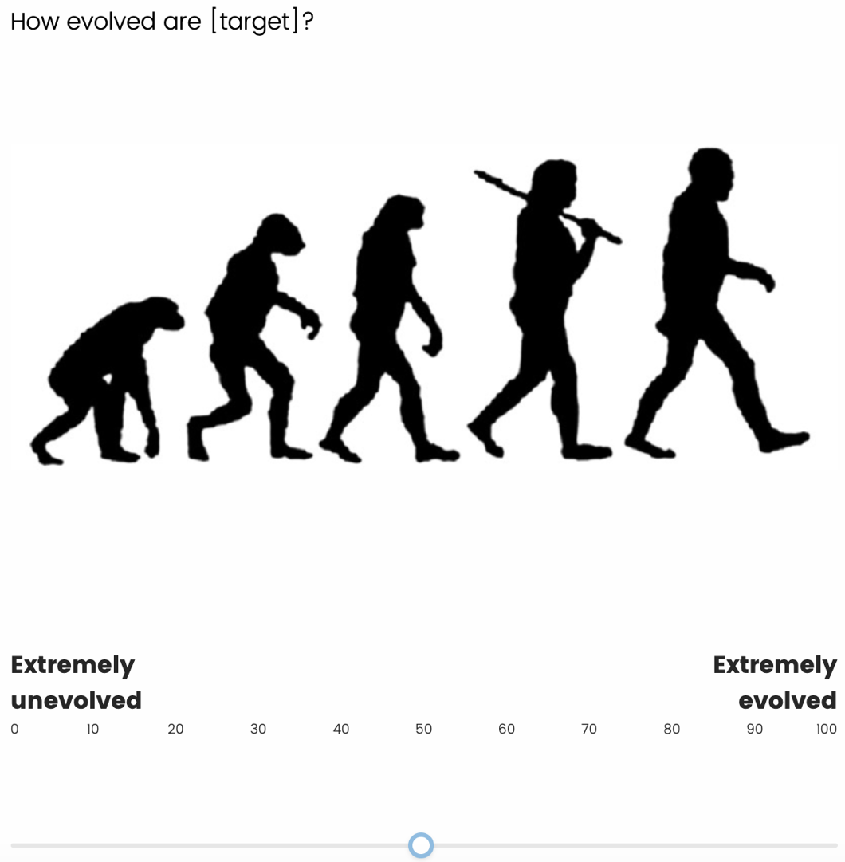
Note. In the studies reported in the main text, we adapted this measure to be even more face valid, asking “How human are [target]?” with the scale anchors ranging from Not at all human to Completely human.

Meta-Analysis: Supplemental Procedure

Search Procedure

Records eligible for inclusion must have employed a correlational or experimental design among a non-clinical sample of human subjects, and measured (a) dehumanization and support for violence, (b) dislike and support for violence, or (c) all three constructs. Along with published and unpublished journal articles, eligible records could have been reported in books, book chapters, conference proceedings, or as raw data not associated with any text.

We identified eligible records through five sources: article database and register searches, backward searches of the eligible records from these searches, author outreach, publicly available data, and datasets from previous studies conducted by our research team. Specifically, on October 30, 2023, we queried the PsycINFO, Embase, and Scopus databases, as well as the PsyArXiv register, for potentially eligible articles. We then searched the reference lists of the eligible articles from these searches to identify additional eligible articles. Moreover, on two separate occasions (October 25, 2023, and January 29, 2024), we disseminated calls for unpublished data to the listservs of the Society for Personality and Social Psychology, the European Association of Social Psychology, and the International Society of Political Psychology. We also contacted authors doing relevant work on dehumanization or intergroup violence directly with this inquiry. Then, on September 3, 2024, we downloaded all data collected to that point from America’s Political Pulse (Iyengar et al., 2023), an ongoing longitudinal survey assessing (among other things) political partisans’ dislike and support for violence against members of the other party. Throughout this search process, we simultaneously extracted data from 41 (mostly unpublished) studies conducted by members of our own research team that met our inclusion criteria (for details on these studies, see the subfolder “Data From Our Prior Research” in the meta-analysis folder on our OSF repository: https://osf.io/2r4cu/?view_only=760f7226c1024fd598e53133066190c8).

A PRISMA chart depicting our search and screening process is presented in Figure S2, and a descriptive table of all records in the meta-analysis can be found at our OSF repository.

Figure S2
Study Search and Screening Process According to PRISMA
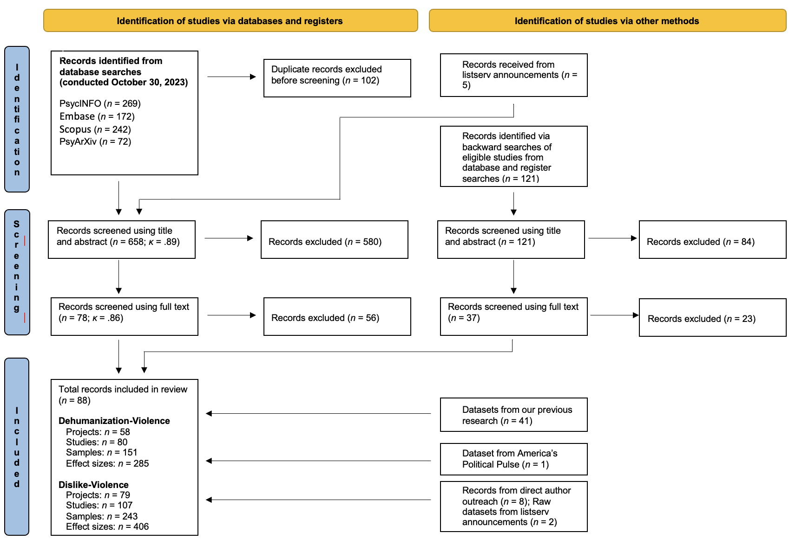
Note. Adapted from Page et al. (2021). PRISMA = Preferred Reporting Items for Systematic Reviews and Meta-Analyses.

Database and Register Searches. We derived search terms from our construct definitions. Regarding dehumanization, we used the terms dehuman* and infrahuman* (the asterisk allows for alternative spelling, tenses, and parts of speech). Regarding dislike, we used the terms dislik*, prejud*, affective polarization, negative affect, and animosity. Regarding violence, we used the terms violen*, aggress*, kill*, tortur*, bomb*, attack*, execut*, and murder*. Each term within the dehumanization, dislike, and violence search strings was separated by the Boolean operator OR. Moreover, the string of dehumanization terms and the string of dislike terms were separated by the OR operator, and these two strings were themselves linked to the violence string by an AND operator, as follows: ([dehumanization terms] OR [dislike terms]) AND [violence terms]
For the PsycINFO, Embase, and Scopus databases, we searched article titles for the dehumanization and dislike terms, while we searched article titles, abstracts, keywords, and full text for the violence terms. For PsyArXiv, we searched the title, abstract, keywords, and full text for all terms.

Article Screening. Our database and register searches returned a total of 755 articles, and an additional five were received from authors following our listserv announcements. After removing duplicate entries (n = 102), two independent coders screened the title and abstract of these articles against our inclusion criteria. To do so, they were provided instructions that gave clear conceptual definitions of each construct, several example measures of each construct, and inclusion/exclusion criteria through the Population, Intervention, Comparison, Outcomes, and Study design (PICOS) framework (Amir-Behghadami & Janati, 2020). See the document titled “Construct Definitions and Inclusion Criteria” on our OSF repository for these instructions.
After title and abstract screening, the coders evaluated the full text of remaining articles using the same PICOS framework and construct definitions. Interrater reliability was high during both stages of screening (title/abstract: Cohen’s κ = .89; full text: Cohen’s κ = .86). When disagreements did occur, the first author made the final decision on whether the article should be included or excluded.

At the title and abstract screening stage, 580 articles were excluded because they did not measure dehumanization or dislike (n = 30) or support for violence (n = 165), were not a correlational or experimental study (n = 26), were a review paper, meta-analysis, or secondary data analysis (n = 17), employed clinical or non-human subjects (n = 3), or for multiple of these reasons (n = 339). At the full-text screening stage, 56 articles were excluded because they did not measure dehumanization or dislike (n = 14) or support for violence (n = 23), were not a correlational or experimental study (n = 1), lacked necessary data which could not be obtained from the authors (n = 13), or for multiple of these reasons (n = 5).

Backward Searches. After identifying all eligible articles from the database searches and author outreach (n = 28), as well as articles associated with datasets from our research team (n = 3), the first author reviewed the reference lists of these articles and identified studies potentially meeting our inclusion criteria (n = 121). He then read these articles’ titles and abstracts, and if necessary, the method section of each study reported in them, to determine whether they met our inclusion criteria. Fourteen additional articles were identified in this way (Figure S2).
The remaining 107 articles were excluded because they did not measure dehumanization or dislike (n = 35) or support for violence (n = 21), were not a correlational or experimental study (n = 6), were a review paper or meta-analysis (n = 8), reported data that overlapped with another study already included in our analysis (n = 3), lacked necessary data that could not be obtained from the authors (n = 14), or for multiple of these reasons (n = 20).

Extraction of Effect Sizes

In each study, we extracted the zero-order Pearson’s r correlation coefficients between our constructs of interest (dehumanization, dislike, support for violence, and the covariates) and the corresponding sample sizes. If the study design was correlational, then we extracted the effect(s) for the entire sample. If the design was experimental (i.e., there was some type of manipulation prior to the measures of interest), then we extracted the effect(s) for each condition separately. Also, in some studies, participants evaluated multiple target groups and/or completed multiple measures of our constructs of interest. In these cases, we extracted data at the lowest level possible (e.g., if participants evaluated eight targets, we extracted the effects for each specific target rather than aggregating across all targets). As described below, we account for the dependence in the data with a multilevel model.

We extracted the effect(s) directly from the text of eligible articles if these were reported. If not, but the data was publicly available (e.g., on the Open Science Framework), we attempted to calculate the effect(s) ourselves. If the data was not publicly available or we were unable to calculate the effect(s) (e.g., because we had questions about how variables were scored), we attempted to contact the corresponding author (see the “Contacting Authors” section, below). The exceptions to this were the effects from the America’s Political Pulse dataset and our own team’s unpublished datasets, both of which we necessarily extracted ourselves. Datasets we obtained from publicly available sources (including the America’s Political Pulse dataset), from authors directly, and those from our own prior studies, along with the analysis code used to extract the effects from them, can be accessed at our OSF repository.

To ensure data quality, after all effects were entered into the data sheet, two members of the research team jointly reviewed all the extracted effect and sample sizes to identify and correct any errors. Five values (0.12%) were corrected before conducting the meta-analysis.

Coding of Moderators

Risk of Bias Assessment. We evaluated all studies that had a manuscript associated with them (k = 76) on nine risk of bias criteria. Five criteria were specified in Siddaway et al.'s (2019) guidelines for systematic reviews in psychology and Nudelman and Otto's (2020) Risk of Bias Utilized for Surveys Tool: whether basic demographic information was provided, whether the sample was representative of the population being studied, whether the exclusion rate of participants was acceptable, whether the sample size was appropriate for answering our research questions, and whether the measures used were sufficiently reliable. A sixth criterion was whether the study was preregistered or not. Two coders jointly evaluated each study on these six criteria. Then, the first author independently evaluated each study on these criteria. Agreement was high (97%) and in the few instances where there was a discrepancy (n = 13), the final decision was made by the first author.
We considered three additional criteria that may also indicate risk of bias. First, we assessed whether the study was unpublished or published. We assumed that manuscripts that had passed peer review may be subject to less risk of bias than those that had not. Second, we coded whether or not the study was conducted with the aim of testing the relationship between dehumanization/dislike and support for violence. We assumed that studies conducted for some other reason (e.g., to test the effects of various interventions on anti-democratic norms; Voelkel et al., 2023) are less likely to have reported results inflating these relationships. Finally, for each study, we coded whether the effects were extracted directly from the manuscript (or supplemental material associated with it) or if any of the effects were derived from second-hand calculations—either by us (using researchers’ raw data posted to an open-access repository) or by the researchers themselves (who then provided us with these effects via email). We assumed that effects derived from second-hand calculations may be more susceptible to bias. The first author solely evaluated the studies on these three criteria, due to his familiarity with each of the studies and how the data was extracted from them.

In our analyses, we assessed whether these criteria moderated the relationships between (a) dehumanization and support for violence and (b) dislike and support for violence, both individually and when summed to create an overall risk of bias composite (see Table S2).

All nine criteria are listed below, and the full risk of bias assessment sheet can be found in the “Meta-Analysis” folder on our OSF repository: https://osf.io/2r4cu/?view_only=760f7226c1024fd598e53133066190c8.

Criterion 1. Is the study published?
- YES = The study is published in a peer-reviewed academic journal or book.
- NO = The study is not published in a peer-reviewed academic journal or book.

Criterion 2. Was the study conducted to test something other than the relationship between dehumanization/dislike and support for violence?
- YES = The primary aim of the study was not to test the relationship(s) between measures of dehumanization/dislike and support for violence (e.g., a study testing the impact of an intervention on these measures).
- NO = The primary aim of the study was to test the relationship(s) between measures of dehumanization/dislike and support for violence (e.g., a correlational study where measures of dehumanization/dislike were included as predictors of support for violence.)

Criterion 3. Were effects extracted directly from manuscript?
- YES = All effects entered into the meta-analysis sheet were taken directly from the manuscript (or supplemental text associated with the manuscript).
- NO = At least one effect (dehumanization-support for violence or dislike-support for violence) was either calculated by the research team or provided by the authors via email.

Criterion 4. Were sample demographics reported in sufficient detail?
- YES = At least age and gender were both reported.
- NO = Age and/or gender were not reported.

Criterion 5. Is the sample largely representative of the studied population?
- YES = The sample approximates the studied population on key demographics (e.g., age, race, gender).
- NO = The sample does not approximate the studied population (i.e., it is a non-representative or “convenience” sample).

Criterion 6. Is the exclusion rate of participants acceptable?
- YES = 10% or less of participants who met the initial demographic eligibility criteria were excluded (e.g., participants who were excluded due to failing attention checks or providing insufficient data, but not participants who were excluded for being homosexual in a study specifically targeting heterosexuals).
- NO = Over 10% of participants who met the initial demographic eligibility criteria were excluded.

Criterion 7. Is the final sample size sufficient for our research questions? (Assuming correlations stabilize around 250 observations; Schönbrodt & Perugini, 2013.)
- YES = The final sample consisted of 250 participants or more (for experimental studies, this applies to each condition separately).
- NO = The final sample consisted of less than 250 participants.

Criterion 8. Are the measures of dehumanization, dislike, and support for violence reliable?
- YES = All multi-item measures have reliability of α at or above 0.7.
- NO = At least one measure has reliability of α less than 0.7, or all measures are just a single item.

Criterion 9. Was the study preregistered?
- YES = Authors clearly state that the study was preregistered somewhere in the paper.
- NO = Authors do not state the study was preregistered in the paper.

Additional Moderators. Along with risk of bias, we assessed seven additional factors that may moderate the relationship(s) between dehumanization, dislike, and support for violence. As described in the main text, we coded the type of dehumanization measure, the type of dislike measure, and the extremity of the support for violence measure. We also coded the concreteness of the support for violence measure, the target of evaluation, the study design, and the type of sample. We describe how each of these variables were coded as follows.
Type of Dehumanization Measure. Kteily et al. (2015) pioneered the study of explicit, blatant dehumanization by developing the “Ascent of Man” scale (see Figure S1). This has become the most common measure of the construct, either in isolation or in combination with blatantly dehumanizing animalistic traits (e.g., savage, like animals; e.g., Kteily et al., 2016, Study 1b). Therefore, we coded as 1 effects that used the Ascent of Man scale (either in isolation or as a composite) and all other effects as 0.
Effects coded as 0 included those that measured animalistic traits in isolation (i.e., without the Ascent of Man scale; e.g., Bevens & Loughnan, 2019), mechanistic traits (e.g., mechanical and cold, like robots; Zlobina & Andujar, 2021), Viki et al.'s (2006) ipsative measure of blatant dehumanization (Viki et al., 2012, 2013), normative dehumanization (Phillips, 2023), and other blatantly dehumanizing sentiments (e.g., “[target] are cockroaches”; Rousseau et al., 2023). See Table S1 for an overview of the dehumanization measures included in this meta-analysis.
Type of Dislike Measure. We coded as 0 effects that measured general negative affect, through the feeling thermometer or general evaluative sentiments (e.g., “To what extent do you dislike Black people?”; Cooley et al., 2019). We coded as 1 effects that measured intense negative emotions, such as hatred, contempt, anger, and disgust (e.g., Bruneau & Kteily, 2017; Molho et al., 2017; Rousseau et al., 2023). We coded as 2 effects that measured prejudicial attitudes, including homophobia (e.g., with the Attitudes Toward Gay Men and Lesbians Scale; Daboin et al., 2015), ethnic prejudice (e.g., with an adaptation of the Attitudes Toward Blacks scale; Kteily et al., 2015), and sexism (e.g., with the hostile sexism subscale of the Ambivalent Sexism Inventory; Bevens & Loughnan, 2019).
Extremity of Support for Violence. We coded as 0 measures in which we could not determine the extremity of support for violence because the items were too general for us to reliably infer how participants interpreted them (e.g., wanting to “attack” the target; Phillips, 2023). We coded as 1 measures of minor physical harm, such as hitting or kicking (e.g., “Which schoolmates do you sometimes hit or kick?”; Wittek et al., 2020). We coded as 2 measures of severe physical harm, such as assault with a deadly weapon, torture, and rape (e.g., Rudman & Mescher, 2012; Viki et al., 2013; Westwood et al., 2022). We coded as 3 measures of support for killing the target (e.g., Landry et al., 2024; Rousseau et al., 2023). However, some measures fell into multiple categories. In these cases, we categorized the measure in the most extreme category (e.g., we categorized the support for violence measure from Landry et al., 2024, which included items both about torture and killing, as 3).
Concreteness of Support for Violence. We also considered another aspect of the support for violence measures: how concrete they were. We did so because less concrete measures asking about “violence” in general can generate inflated correlations with predictors than precisely worded items about specific, concrete acts of violence (Westwood et al., 2022). Therefore, we coded as 0 measures that relied on self-reported support for general violence (e.g., “How much do you feel it is justified for [ingroup] to use violence in advancing their political goals these days?”; Kalmoe & Mason, 2022). We coded as 1 measures that assessed self-reported support for specific violent acts or policies, such as with a detailed vignette describing a politically motivated shooting (Westwood et al., 2022). We coded as 2 measures that assessed actual violent behavior, either by asking participants to report whether they had previously engaged in specific violent actions (Daboin et al., 2015) or by measuring behavioral aggression in the lab (e.g., by administering bogus electric shocks to a confederate; Parrott & Zeichner, 2005). However, some measures included items falling into multiple categories. In these cases, we categorized the measure in the most concrete category (e.g., Kteily et al.’s, 2015, measure of militaristic counterterrorism included general support for making terrorists suffer along with support for specific acts of aggression, so it was categorized as 1).
Target of Evaluation. Effects were coded as 1 if the target was one’s political opponents (e.g., Democrats’ and Republicans’ evaluations of one another; Kalmoe & Mason, 2022). Effects were coded as 2 if the target was an enemy during wartime (e.g., Israelis’ evaluations of Palestinians during the 2014 Gaza War; Bruneau & Kteily, 2017) or a national group with which one has a history of conflictual relations (e.g., Americans’ evaluations of Iranians; Kteily et al., 2016). Effects were coded as 3 if the target was a group that had been historically disadvantaged in the respondent’s society, including certain racial, ethnic, or religious minorities (Cooley et al., 2019; Viki et al., 2013), homosexuals (Daboin et al., 2015), and women (Rudman & Mescher, 2012). Effects were coded as 4 if the target was an extreme violator of moral norms (e.g., pedophiles; Viki et al., 2012). Finally, effects were coded as 5 if the target could not otherwise be categorized.
Study Design. Effects were coded as 0 if they came from a correlational study and 1 if they came from an experiment.
Sample Source. Effects were coded as 1 if they came from an online sample, 2 if they came from an in-person sample, and 3 if they came from a study that used a mixed online and in-person sample.

Contacting Authors

We contacted authors for necessary information at two time points: when screening articles and when extracting data from them. During screening, we contacted the corresponding author if an English version of the full text was not available or if insufficient information was provided to determine a study’s eligibility. During data extraction, we contacted the corresponding author if an eligible study did not report the necessary effect(s) and we were unable to calculate this ourselves. If we did not receive a reply after two weeks, we attempted to contact the corresponding author a second time and also contacted any co-authors we could obtain contact information for. If, after another two weeks, we still did not receive a reply, we sent out a final inquiry to all authors we had contact information for. If we did not receive a reply to this final inquiry, we did not include the study.

Meta-Analysis: Supplemental Results

Analysis Plan

Research Questions 1 and 2. To answer the first research question (What are the Zero-Order Relationships Between Dehumanization, Dislike, and Support for Violence?), separate meta-analyses were performed for the correlations between (a) dehumanization and support for violence, (b) dislike and support for violence, and (c) dehumanization and dislike. We made use of a multilevel meta-analytic model (Van den Noortgate et al., 2013), because of our data’s nested structure: multiple effects can come from the same sample, multiple samples can come from the same study, and multiple studies can come from the same project. Whereas a traditional random effects meta-analysis distinguishes between two sources of variance (sampling variance of observed effect sizes around the true effect sizes and variance between studies), we distinguish between five sources of variance: sampling variance (level 1), variance between effects within samples (level 2), variance between samples within studies (level 3), variance between studies within the same project (level 4), and variance between projects (level 5). Correlations were first transformed to Fisher’s z values before being combined in the meta-analysis. Robust variance estimation was used to obtain sandwich standard errors that are robust to possible misspecifications of the data structure (Pustejovsky & Tipton, 2022). Afterwards, mean effect estimates and confidence intervals were back-transformed to the correlation scale.

To answer the second research question (Are the Relationships Between Dehumanization, Dislike, and Support for Violence Moderated by how the Constructs were Measured?), the moderators were introduced individually in the multilevel meta-analytic model and their significance was evaluated via Wald tests with robust standard errors and Satterthwaite approximated degrees of freedom.

Research Questions 3 and 4. For the third research question (Does Dehumanization and/or Dislike Explain Unique Variance in Support for Violence?), we used meta-analytic structural equation modelling (Cheung, 2015). In a first stage, a multivariate meta-analysis was performed to obtain an estimate of the correlation and variance-covariance matrices for dehumanization, dislike, and support for violence (presented in Tables S9-S10). These analyses were done directly on the correlations, again accounting for the five sources of variance and using robust variance estimation to obtain a robust variance-covariance matrix. Moreover, this multivariate meta-analysis also accounts for the grouping of estimates of different types of correlations within studies. In a second stage, we regressed support for violence on dehumanization and dislike simultaneously (within the SEM framework). Predictors were allowed to covary, and 95% confidence intervals were constructed for the regression coefficients to evaluate their significance.

For the fourth research question (Does Dehumanization Continue to Explain Unique Variance in Support for Violence After Accounting for Dislike and the Personality Covariates?), we used meta-analytic structural equation modelling in the same manner as for RQ3, but now also included one of the five covariates: trait aggression, the “dark” personality traits, social dominance orientation, right-wing authoritarianism, and conservatism. (Because only one study measured all these covariates, we entered each individually in five separate models.)

Sensitivity Analyses

As mentioned in the main text, we performed five sets of sensitivity analyses: risk of bias, publication bias, leave-one-out analyses, replicating our results with an alternative meta-analytic model, and replicating our results when leaving out data from our own research team’s unpublished studies. We describe each below.

Risk of Bias Assessment. We tested whether the effects were influenced by studies’ risk of bias by including these scores as predictors in the multilevel meta-analytic model (for details on how we assessed risk of bias, see the “Coding of Moderators” section above). Risk of bias did not influence the effects—both when all criteria were aggregated together and, with few exceptions, when using each individual criterion. The results are presented below in Table S2.

Table S2

Effects of the Risk of Bias Indicators on the Meta-Analytic Correlations Between Dehumanization, Dislike, and Support for Violence
Risk of Bias  Criteria | Dehumanization –  Support for Violence |  |  | Dislike –  Support for Violence |  |  | Dehumanization –  Dislike
 | β | 95% CI | p | β | 95% CI | p | β | 95% CI | p
Publication Status | .002 | [-.09, .09] | .97 | .08 | [-.03, .19] | .16 | .02 | [-.08, .12] | .74
Study Purpose | -.04 | [-.15, .08] | .42 | -.17 | [-.32, -.01] | .04 | -.07 | [-.18, .04] | .16
Extraction Method | .08 | [-.05, .22] | .15 | .25 | [.07, .42] | .008 | .11 | [-.01, .23] | .06
Demo Details | .00 | [-.46, .47] | .99 | .02 | [-.09, .13] | .65 | .14 | [-.14, .43] | .24
Representative | -.16 | [-.32, .01] | .05 | -.24 | [-.33, -.14] | <.001 | .01 | [-.56, .58] | .93
Exclusion rate | .12 | [.01, .23] | .04 | .23 | [.12, .33] | <.001 | .03 | [-.15, .21] | .70
Sufficient N | -.04 | [-.19, .10] | .47 | -.12 | [-.23, .00] | .04 | .07 | [-.10, .24] | .40
Reliable Measures | .11 | [-.02, .23] | .09 | .08 | [-.09, .26] | .32 | .07 | [-.10, .24] | .36
Preregistered | -.05 | [-.26, .16] | .59 | -.17 | [-.31, -.02] | .03 | .02 | [-.13, .16] | .83
Overall Risk of Bias | .01 | [-.06, .08] | .77 | -.01 | [-.06, .04] | .59 | .04 | [-.03, .11] | .25
Note. The coefficients for each individual risk of bias criterion refer to its effect on the mean Fisher’s z estimate when it is “good” (i.e., low risk of bias, scored as 1) versus not (i.e., high risk of bias, scored as 0). The overall risk of bias is the sum of the 9 individual criteria. Its coefficient refers to the effect on the mean Fisher’s z when the overall risk of bias increases with 1 (i.e., when one additional criterion is “good”).

Publication Bias. We tested for publication bias in the data, in the sense that non-significant and unexpected findings are less likely to be published. Because one would expect a positive association between dehumanization/dislike and support for violence, this kind of publication bias would mean that for smaller studies (for which the observed effect sizes are expected to fluctuate more) only the largest positive effect sizes are reported, resulting in a positive association between the observed effect sizes and the standard error. We tested for this association in three ways: (1) by observing a funnel plot and by including (2) the standard error and (3) studies’ publication status (published vs. unpublished) as predictors in the multilevel model.

Figure S3 shows the funnel plots for the three correlations: dehumanization-support for violence, dislike-support for violence, and dehumanization-dislike. For all three correlations, the pattern appears relatively symmetric, especially for dehumanization-support for violence and dehumanization-dislike, showing little evidence for publication bias. This is confirmed by means of multilevel meta-analyses including the standard error as a predictor variable. The regression weight estimate of the SE for the dehumanization-support for violence correlation is 0.75 (p = .20), for dislike-support for violence it is 1.31 (p = .02), and for dehumanization-dislike it is 0.47 (p = .44). Although the relationship with the standard error is statistically significant for dislike-support for violence, the proportion of variance explained is rather small (R² = .05). Finally, as depicted above in the top row of Table S2, for all three effects, there was no significant difference between published and unpublished studies.
Figure S3
Funnel Plots for the Meta-Analytic Correlations Between Dehumanization, Dislike, and Support for Violence
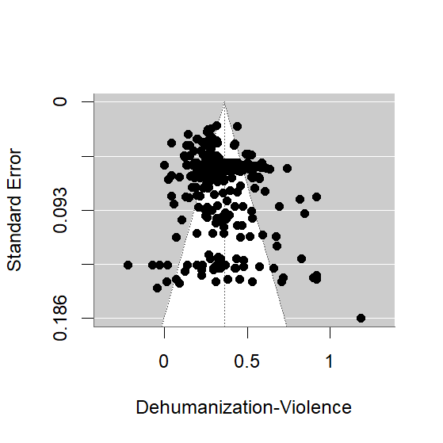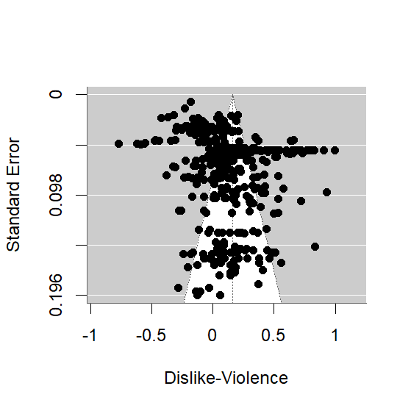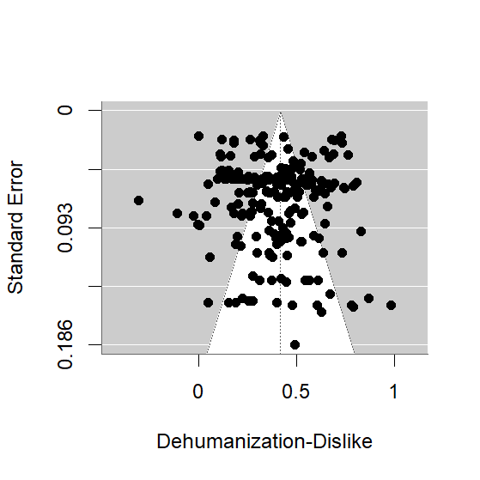
Leave-One-Out Analyses. We left out one project, study, sample, and effect size at a time and reran the analyses. Table S3 shows the ranges of the mean effect size estimates, as well as of the p-value. For all three effects, the estimates are not largely affected by individual units and all remained p < .001, regardless of what unit was left out.

Table S3
Range of Mean Correlation Estimates and p-values, When Leaving Out One Unit

 | Dehumanization – Support for Violence |  | Dislike - Support for Violence |  | Dehumanization - Dislike
 | Correlation | p-value | Correlation | p-value | Correlation | p-value
Projects | [.350, .366] | < .001 | [.150, .168] | < .001 | [.415, .429] | < .001
Studies | [.350, .364] | < .001 | [.151, .169] | < .001 | [.415, .429] | < .001
Samples | [.354, .363] | < .001 | [.151, .164] | < .001 | [.415, .425] | < .001
Effects | [.354, .363] | < .001 | [.151, .164] | < .001 | [.415, .425] | < .001

Replicating Results with Correlated-and-Hierarchical Effects Model and Leaving Out Our Team’s Unpublished Effects. As another sensitivity analysis, we used an alternative meta-analytic model, the correlated-and-hierarchical effects model (CHE; Pustejovsky & Tipton, 2022), which explicitly accounts for the correlation between effect sizes from the same sample. Table S4 shows that this hardly changes the results.
Finally, because a large part of the data in this meta-analysis consists of unpublished datasets from other projects led by members of our research team, we ran the analyses again (using the hierarchical model) without these datasets to determine whether the substantive results held. Indeed, this was the case—the estimated overall correlation between dehumanization-support for violence and dehumanization-dislike hardly changes, whereas the overall correlation between dislike-support for violence increased slightly. Although the 95% confidence intervals became larger (due to ignoring a considerable part of the data), all effects remain p < .001. See the bottom row of Table S4.

Table S4
Mean Correlation Estimates and p-values for the Main (Hierarchical) and CHE Model, and for the Main Model Without Our Team’s Unpublished Data

 | Dehumanization – Support for Violence |  |  | Dislike –  Support for Violence |  |  | Dehumanization - Dislike
 | r | 95% CI | p | r | 95% CI | p | r | 95% CI | p
Main Model | .35 | [.31, .38] | < .001 | .16 | [.10, .21] | < .001 | .40 | [.36, .44] | < .001
CHE Model | .34 | [.31, .37] | < .001 | .16 | [.10, .21] | < .001 | .40 | [.36, .44] | < .001
Without Our Data | .36 | [.27, .44] | < .001 | .22 | [.11, .32] | < .001 | .39 | [.29, .49] | < .001

Table S5

Distribution of the Variance (in Fisher’s z) Across the Five levels of Analysis

Variance Component | Dehumanization- Support for Violence | Dislike- Support for Violence | Dehumanization-Dislike
Between projects | 0.0147 (50%) | 0.0467 (65%) | 0.0203 (48%)
Between studies | 0.0022 (7%) | 0.0133 (19%) | 0.0000 (0%)
Between samples | 0.0036 (12%) | 0.0000 (0%) | 0.0000 (0%)
Between effects | 0.0052 (19%) | 0.0080 (11%) | 0.0184 (44%)
Median sampling variance | 0.0034 (12%) | 0.0036 (5%) | 0.003 (8%)

Moderator Analyses

As described in the “Coding of Moderators” section of this Supplemental Material, along with the risk of bias criteria, we coded seven additional factors that may moderate the relationship(s) between dehumanization, dislike, and support for violence: the type of dehumanization measure, the type of dislike measure, the extremity of support for violence, the concreteness of support for violence, the target of evaluation, the study design, and the source of the sample.
Tables S6-S7 report the results of the models introducing one moderator at a time. Table S8 reports the results of the model introducing all moderators together.

Table S6
Omnibus Tests for Significance in Models Introducing One Moderator at a Time
 | Dehumanization – Support for Violence |  |  |  |  |  | Dislike – Support for Violence
Moderator | F | df |  |  |  | p | F | df |  |  | p
Dehumanization Measure | 0.28 |  | 1, 7.42 |  | .61 |  | 0.43 |  |  | 1, 4.02 |  | .55
Dislike Measure | 0.88 |  | 2, 3.19 |  | .50 |  | 95.10 |  |  | 2, 3.28 |  | .001
Extremity of Support for Violence | 3.13 |  | 3, 3.66 |  | .21 |  | 1.75 |  |  | 3, 7.08 |  | .24
Concreteness of Support for Violence | 4.80 |  | 2, 1.79 |  | .19 |  | 2.43 |  |  | 2, 3.46 |  | .22
Target of Evaluation | 12.2 |  | 4, 10.2 |  | < .001 |  | 5.91 |  |  | 4, 6.97 |  | .02
Study Design | 0.31 |  | 1, 19 |  | .58 |  | 6.49 |  |  | 1, 25.6 |  | .02
Sample Source | 0.28 |  | 1, 8.59 | .61 |  |  | 30.3 |  | 2, 3.34 |  |  | .007

Table S7
Effects for Each Moderator Category in Models Introducing One Moderator at a Time
 | Dehumanization – Support for Violence |  |  |  |  | Dislike – Support for Violence
Moderator | r | 95% CI |  |  | p | r | 95% CI |  | p
Dehumanization Measure
Ascent of Man (possibly +  animalistic traits) | .34 |  | [.30, .38] | < .001 |  | .22 |  | [.01, .41] |  | .04
Anything else | .37 |  | [.26, .47] | < .001 |  | .15 |  | [.06, .24] |  | .002
Dislike Measure
General negative affect | .34 |  | [.30, .38] | < .001 |  | .09 |  | [.04, .15] |  | .003
Intense negative emotions | .37 |  | [.12, .58] | .02 |  | .25 |  | [.12, .37] |  | .004
Prejudicial attitudes | .29 |  | [.15, .41] | .008 |  | .33 |  | [.28, .38] |  | < .001
Violence: Extremity
Cannot determine | .33 |  | [.29, .37] | < .001 |  | .12 |  | [.05, .19] |  | .002
Minor physical harm | .13 |  | [-.39, .58] | .24 |  | .22 |  | [-.01, .43] |  | .06
Severe physical harm | .35 |  | [.29, .41] | < .001 |  | .29 |  | [.17, .40] |  | < .001
Killing | .37 |  | [.32, .41] | < .001 |  | .13 |  | [.05, .20] |  | .002
Violence: Concreteness
Support for general  violence | .34 |  | [.30, .38] | < .001 |  | .13 |  | [.06, .20] |  | < .001
Support for specific violent  acts/policies | .36 |  | [.32, .40] | < .001 |  | .15 |  | [.08, .22] |  | < .001
Behavioral aggression or  prior acts of violence | .13 |  | [-.49, .67] | .26 |  | .32 |  | [.14, .48] |  | .07
Target of Evaluation
Political opponents | .26 |  | [22, .30] | < .001 |  | .01 |  | [-.07, .08] |  | .87
Wartime enemies, national  enemies | .43 |  | [.38, .48] | < .001 |  | .25 |  | [.15, .34] |  | < .001
Disadvantaged/stigmatized  groups | .27 |  | [.20, .34] | < .001 |  | .24 |  | [.16, .31] |  | < .001
Extreme moral norm  violators | .37 |  | [.31, .43] | < .001 |  | .21 |  | [.12, .29] |  | < .001
Other target | .36 |  | [.29, .44] | < .001 |  | .22 |  | [.09, .33] |  | .003
Study Design
Correlational | .35 |  | [.31, .40] | < .001 |  | .23 |  | [.15, .30] |  | < .001
Experimental | .34 |  | [.29, .38] | < .001 |  | .08 |  | [.01, .16] |  | .03
Sample Source
Online | .35 | [.31, .38] |  |  | < .001 | .11 | [.05, .17] |  | < .001
In-person | .31 | [.14, .47] |  |  | .01 | .32 | [.25, .38] |  | < .001
Combination | -- | -- |  |  | -- | .47 | [-.06, .79] |  | .06
Note. For each moderator, coefficient estimates refer to the mean correlation in the respective categories.

Table S8
Effects for Each Moderator Category Based on Model Introducing All Moderators Together
 | Dehumanization – Support for Violence |  |  |  |  |  | Dislike – Support for Violence
Moderator | r | 95% CI |  |  |  | p | r |  | 95% CI |  |  | p
Intercept | .32 |  |  | [.10, .54] | .01 |  | .10 | [-.12, .32] |  |  | .34
Dehumanization Measure
Ascent of Man (possibly + animalistic traits) | -.06 |  | [-.30, .18] |  | .56 |  | -.03 |  |  | [-.24, .19] |  |  | .74
Dislike Measure | F(2, 3.49) = 0.093, p = .91 |  |  |  |  |  | F(2, 2.13) = 18.6, p = .04
Intense negative emotions | .03 |  | [-.19, .25] |  | .73 |  | .23 |  |  | [.02, .44] |  |  | .04
Prejudicial attitudes | -.02 |  | [-.31, .27] |  | .83 |  | .28 |  |  | [.06, .50] |  |  | .03
Violence: Extremity | F(2, 4.57) = 0.18, p = .84 |  |  |  |  |  | F(2, 3.99) = 0.248, p = .79
Severe physical harm | .03 |  | [-.19, .25] |  | .67 |  | .05 |  |  | [-.33, .43] |  |  | .70
Killing | .05 |  | [-.20, .29] |  | .57 |  | .01 |  |  | [-.38, .41] |  |  | .91
Violence: Concreteness | F(2, 4.67) = 0.757, p = .52 |  |  |  |  |  | F(2, 2.8) = 5.72, p = .10
Support for specific violent acts/policies | -.05 |  | [-.30, .20] |  | .54 |  | -.04 |  |  | [-.43, .36] |  |  | .77
Behavioral aggression or prior acts of violence | -.15 |  | [-.47, .18] |  | .33 |  | -.40 |  |  | [-.75, -.06] |  |  | .03
Target of Evaluation | F(4, 7.66) = 19.8, p < .001 |  |  |  |  |  | F(4, 5.28) = 1.97, p =.23
Wartime enemies, national enemies | .21 |  | [.13, .30] |  | <.001 |  | .19 |  |  | [.03, .35] |  |  | .02
Disadvantaged/stigmatized groups | .02 |  | [-.05, .09] |  | .62 |  | .09 |  |  | [-.09, .27] |  |  | .28
Extreme moral norm violators | .13 |  | [.06, .20] |  | .002 |  | .09 |  |  | [-.07, .26] |  |  | .22
Other | .12 |  | [.04, .21] |  | .01 |  | .10 |  |  | [-.09, .27] |  |  | .26
Study Design
Experimental | -.01 |  | [-.08, .06] |  | .69 |  | -.08 |  |  | [-.26, .09] |  |  | .28
Sample Source
In-person | -.06 | [-.25, .13] |  |  |  | .46 | .02 |  | [-.20, .24] |  |  | .84
Note. For each moderator, coefficient estimates and corresponding p-values refer to contrasts against a reference category. Estimates are on the Fisher’s z scale. In addition, for categorical moderators with more than two categories, an F-test is done to test that all contrasts are zero (i.e., that the effect is the same in all categories).

First stage of the Meta-Analytic Structural Equation Model (Without Covariates)

We tested whether dehumanization and/or dislike explained unique variance in support for violence with a two-stage MA-SEM. In the first stage, we estimated the correlation matrix and corresponding sampling covariance matrix by means of a multivariate meta-analyses. Table S9 shows the correlation matrix and Table S10 shows the variance-covariance matrix.

Table S9
Estimated Correlation Matrix Based on Multivariate Meta-Analysis
 | Dehumanization | Dislike | Support for Violence
Dehumanization | 1.00 | .38 | .32
Dislike | .38 | 1.00 | .15
Violence | .32 | .15 | 1.00

Table S10
Variance-Covariance Matrix of Estimated Correlations
 | Dehumanization - Support for Violence | Dislike -  Support for Violence | Dehumanization - Dislike
Dehumanization - Support for Violence | 0.00110 | -0.00057 | 0.00112
Dislike - Support for Violence | -0.00057 | 0.00140 | -0.00071
Dehumanization - Dislike | 0.00112 | -0.00071 | 0.00140
Note. The correlations here are not exactly the same as those in the analysis reported in the main text because in this first stage of the MA-SEM approach correlation coefficients are combined directly, rather than Fisher’s z transformations.

Dehumanization’s Unique Relationship with Support for Violence is Robust to Covariates

Finally, we tested whether dehumanization’s unique relationship with support for violence, over and above dislike, held after accounting for five personality traits that also covary with support for violence: trait aggression, social dominance orientation, right-wing authoritarianism, ideological conservatism, and hostile (or “dark”) personality traits. To do so, we used meta-analytic structural equation modelling (Cheung, 2015). In a first stage, a multivariate meta-analysis was performed to obtain an estimate of the correlation and variance-covariance matrices for the variables of interest: dehumanization, dislike, support for violence, and each of the five covariates. In a second stage, we fitted five multiple regression models (within the SEM framework) with support for violence as the outcome, and dehumanization, dislike, and one of the five covariates as predictors.
In each regression, dehumanization continued to explain unique variance in support for violence (dislike, on the other hand, never explained unique variance in these models).
The results for each of these models are given below, with tables for the correlation coefficients and corresponding covariance matrix resulting from the multivariate meta-analysis (stage 1), a table with the SEM parameter estimates and corresponding 95% CIs (stage 2), and a visualization of the stage 2 model.

Covariate: Trait Aggression
Pooled correlation matrix (stage 1):
Violence Dislike Dehuman Aggression
Violence 1.0000000 0.1550736 0.3232980 0.3217062
Dislike 0.1550736 1.0000000 0.3833555 0.1104906
Dehuman 0.3232980 0.3833555 1.0000000 0.2123673
Aggression 0.3217062 0.1104906 0.2123673 1.0000000

Corresponding variance-covariance matrix (stage 1):

Dis_Vio Deh_Vio Agg_Vio Deh_Dis Agg_Dis Agg_Deh
Dis_Vio 1.441016e-03 -5.646098e-04 6.391701e-04 -0.0007094507 1.301259e-04 -4.180501e-05
Deh_Vio -5.646098e-04 1.036239e-03 3.662264e-05 0.0010546321 4.565736e-04 5.770208e-04
Agg_Vio 6.391701e-04 3.662264e-05 1.881755e-03 -0.0002351289 7.852154e-05 -2.051387e-04
Deh_Dis -7.094507e-04 1.054632e-03 -2.351289e-04 0.0013481778 5.113999e-04 7.117981e-04
Agg_Dis 1.301259e-04 4.565736e-04 7.852154e-05 0.0005113999 3.723431e-04 4.288435e-04
Agg_Deh -4.180501e-05 5.770208e-04 -2.051387e-04 0.0007117981 4.288435e-04 5.664793e-04

Parameter estimates of regression model (stage 2):

Estimate lbound ubound
beta_agg 0.26416244 0.17087087 0.3550714
Beta_deh 0.25665821 0.16796115 0.3703175
Beta_dis 0.02749485 -0.10066416 0.1372619
r_DehAgg 0.21236729 0.16568977 0.2590268
r_DisAgg 0.11049057 0.07266785 0.1485531
r_DisDeh 0.38335550 0.31122332 0.4556507
Violence_with_Violence 0.82777651 0.76720042 0.8767897

Visualization of regression model (stage 2):

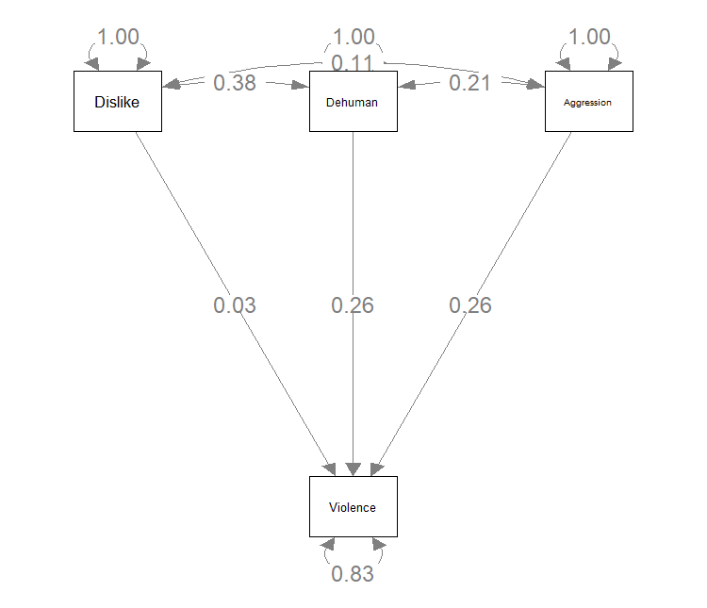

Covariate: Social Dominance Orientation
Pooled correlation matrix (stage 1):
Violence Dislike Dehuman SDO
Violence 1.0000000 0.15636754 0.3225943 0.30283192
Dislike 0.1563675 1.00000000 0.3818363 0.01367578
Dehuman 0.3225943 0.38183626 1.0000000 0.18187311
SDO 0.3028319 0.01367578 0.1818731 1.00000000

Corresponding variance-covariance matrix (stage 1):

Dis_Vio Deh_Vio SDO_Vio Deh_Dis SDO_Dis SDO_Deh
Dis_Vio 0.0014459941 -5.544117e-04 -0.0003104344 -0.0007309704 2.734471e-04 -0.0002860290
Deh_Vio -0.0005544117 1.104431e-03 0.0004921892 0.0011090290 6.413526e-05 0.0004151811
SDO_Vio -0.0003104344 4.921892e-04 0.0015174961 0.0008891323 1.341064e-03 0.0018812214
Deh_Dis -0.0007309704 1.109029e-03 0.0008891323 0.0013603968 4.841963e-04 0.0009394020
SDO_Dis 0.0002734471 6.413526e-05 0.0013410639 0.0004841963 3.171859e-03 0.0023489411
SDO_Deh -0.0002860290 4.151811e-04 0.0018812214 0.0009394020 2.348941e-03 0.0028672937

Parameter estimates of regression model (stage 2):

Estimate lbound ubound
Beta_deh 0.25487531 0.16793004 0.3606272
Beta_dis 0.05554978 -0.07012382 0.1641566
beta_SDO 0.25571727 0.20676162 0.3105608
r_DisDeh 0.38183626 0.30943215 0.4541360
r_DehSDO 0.18187311 0.07653385 0.2868373
r_DisSDO 0.01367578 -0.09731391 0.1240941
Violence_with_Violence 0.83165314 0.77716062 0.8725118

Visualization of regression model (stage 2):

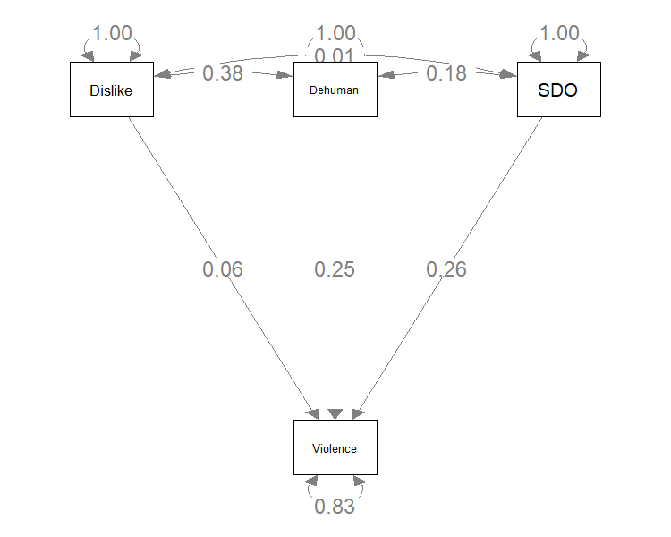

Covariate: Right-Wing Authoritarianism
Pooled correlation matrix (stage 1):

Violence Dislike Dehuman RWA
Violence 1.0000000 0.15593983 0.3222722 0.26622494
Dislike 0.1559398 1.00000000 0.3829832 0.02188682
Dehuman 0.3222722 0.38298325 1.0000000 0.18116571
RWA 0.2662249 0.02188682 0.1811657 1.00000000

Corresponding variance-covariance matrix (stage 1):

Dis_Vio Deh_Vio RWA_Vio Deh_Dis RWA_Dis RWA_Deh
Dis_Vio 1.427246e-03 -5.533967e-04 0.0002134096 -0.0007005514 5.331841e-04 4.982264e-05
Deh_Vio -5.533967e-04 1.046848e-03 0.0005988534 0.0010641266 5.005155e-05 5.869732e-04
RWA_Vio 2.134096e-04 5.988534e-04 0.0020249551 0.0003719812 -1.486208e-04 9.509395e-04
Deh_Dis -7.005514e-04 1.064127e-03 0.0003719812 0.0013428791 4.359528e-04 4.559100e-04
RWA_Dis 5.331841e-04 5.005155e-05 -0.0001486208 0.0004359528 2.964983e-03 -1.556460e-04
RWA_Deh 4.982264e-05 5.869732e-04 0.0009509395 0.0004559100 -1.556460e-04 8.318976e-04

Parameter estimates of regression model (stage 2):

Estimate lbound ubound
Beta_deh 0.26366766 0.17955815 0.3712698
Beta_dis 0.05020225 -0.07764924 0.1595305
beta_RWA 0.21735863 0.13804366 0.3003938
r_DisDeh 0.38298325 0.31115063 0.4549947
r_DehRWA 0.18116571 0.12447605 0.2377842
r_DisRWA 0.02188682 -0.08509312 0.1287553
Violence_with_Violence 0.84933242 0.78979445 0.8968930

Visualization of regression model (stage 2):

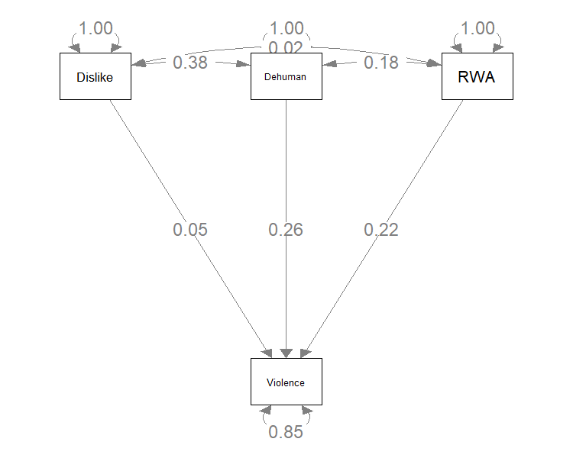

Covariate: Ideological Conservatism
Pooled correlation matrix (stage 1):
Violence Dislike Dehuman Conservatism
Violence 1.0000000 0.1371001 0.3508179 0.1728836
Dislike 0.1371001 1.0000000 0.4158321 0.1207562
Dehuman 0.3508179 0.4158321 1.0000000 0.1516658
Conservatism 0.1728836 0.1207562 0.1516658 1.0000000

Corresponding variance-covariance matrix (stage 1):

Dis_Vio Deh_Vio Con_Vio Deh_Dis Con_Dis Con_Deh
Dis_Vio 1.526988e-03 -0.0002207739 -9.758007e-05 -2.981702e-04 -0.0004266549 -0.0004136361
Deh_Vio -2.207739e-04 0.0005807278 1.422763e-04 5.458076e-04 0.0001258122 0.0006121664
Con_Vio -9.758007e-05 0.0001422763 1.647549e-03 -9.469268e-05 0.0007887627 -0.0003368833
Deh_Dis -2.981702e-04 0.0005458076 -9.469268e-05 7.771158e-04 0.0001824726 0.0008328273
Con_Dis -4.266549e-04 0.0001258122 7.887627e-04 1.824726e-04 0.0017476793 0.0003109819
Con_Deh -4.136361e-04 0.0006121664 -3.368833e-04 8.328273e-04 0.0003109819 0.0014765672

Parameter estimates of regression model (stage 2):

Estimate lbound ubound
beta_Con 0.12363025 0.03036386 0.21565062
Beta_deh 0.34006812 0.26779736 0.42865295
Beta_dis -0.01924024 -0.13937445 0.09156565
r_DehCon 0.15166577 0.07613512 0.22698603
r_DisCon 0.12075616 0.03863308 0.20269812
r_DisDeh 0.41583211 0.36104120 0.47062607
Violence_with_Violence 0.86196222 0.81513378 0.89590574

Visualization of regression model (stage 2):
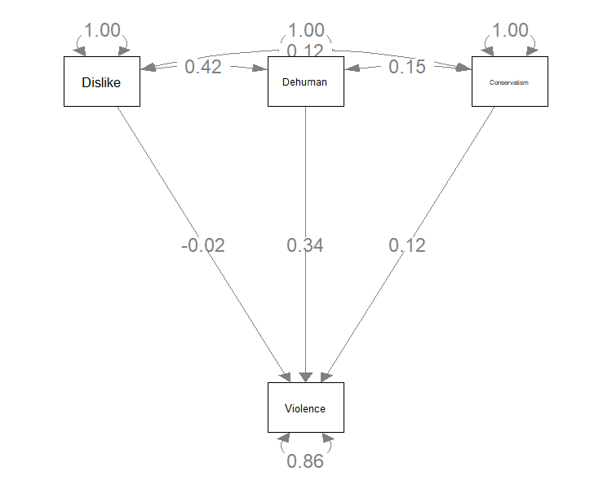

Covariate: Hostile (or “Dark”) Personality Traits
Pooled correlation matrix (stage 1):
Violence Dislike Dehuman Hostile
Violence 1.0000000 0.15239723 0.3180501 0.27585604
Dislike 0.1523972 1.00000000 0.3790054 0.05497743
Dehuman 0.3180501 0.37900540 1.0000000 0.17053299
Hostile 0.2758560 0.05497743 0.1705330 1.00000000

Corresponding variance-covariance matrix (stage 1):

Dis_Vio Deh_Vio Hos_Vio Deh_Dis Hos_Dis Hos_Deh
Dis_Vio 0.0014561994 -0.0005418479 -0.0011999434 -0.0006964239 0.0003473942 -0.0006268965
Deh_Vio -0.0005418479 0.0010490427 -0.0001624083 0.0010540075 0.0004539554 0.0002473684
Hos_Vio -0.0011999434 -0.0001624083 0.0485480139 0.0004543131 0.0032187985 0.0262123965
Deh_Dis -0.0006964239 0.0010540075 0.0004543131 0.0013153847 0.0006030561 0.0006262199
Hos_Dis 0.0003473942 0.0004539554 0.0032187985 0.0006030561 0.0037377884 0.0028566303
Hos_Deh -0.0006268965 0.0002473684 0.0262123965 0.0006262199 0.0028566303 0.0148410189

Parameter estimates of regression model (stage 2):

Estimate lbound ubound
Beta_deh 0.26398217 0.01252951 0.3976936
Beta_dis 0.03977588 -0.08927134 0.1518559
beta_Hos 0.22865159 -0.14069857 0.6905800
r_DisDeh 0.37900540 0.30786918 0.4501604
r_DehHos 0.17053299 -0.06867470 0.4098119
r_Dishos 0.05497743 -0.06525145 0.1753126
Violence_with_Violence 0.84690379 0.49734381 0.9202033

Visualization of regression model (stage 2):
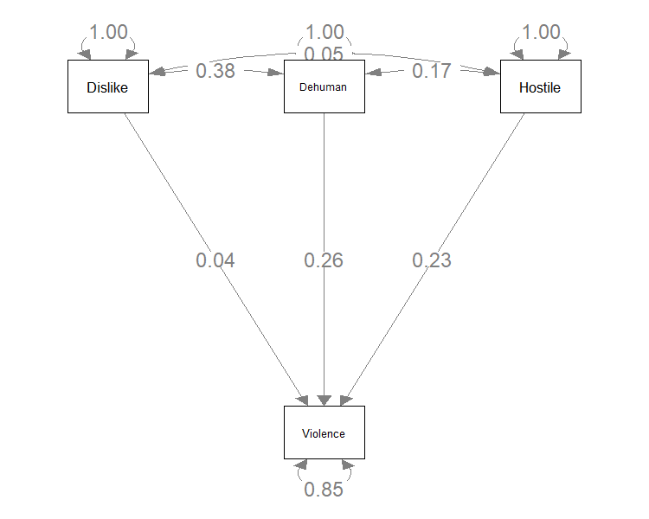

Supplemental Material for the Cross-Cultural Studies

Cross-Cultural Studies: Supplemental Method

Palestinian Sample

To recruit the Palestinian sample, we partnered with the Arab-European Center, a research center that focuses on providing in-depth analysis of conflict-prone regions in the Middle East (see https://centreeuroarabe.org/home). The sample was recruited by members who are highly active within the Palestinian community who used various online platforms, including dedicated forums, social media groups, and community networks, to reach a large sample of Palestinians.
The majority of the sample hailed from Jordan (n = 266; 66%), Palestine (n = 48; 12%), Egypt (n = 30; 7%), Lebanon (n = 13; 3%), Saudi Arabia (n = 13; 3%), and Kuwait (n = 13; 3%). Remaining participants were from the United States (n = 5), Spain (n = 4), the United Arab Emirates (n = 5), Iraq (n = 3), Syria (n = 3), Libya (n = 2), Greece (n = 1), Hungary (n = 1), Italy (n = 1), and Malaysia (n = 1). See Figure S4.

Figure S4
Frequency Table of Palestinian Sample’s Countries of Origin
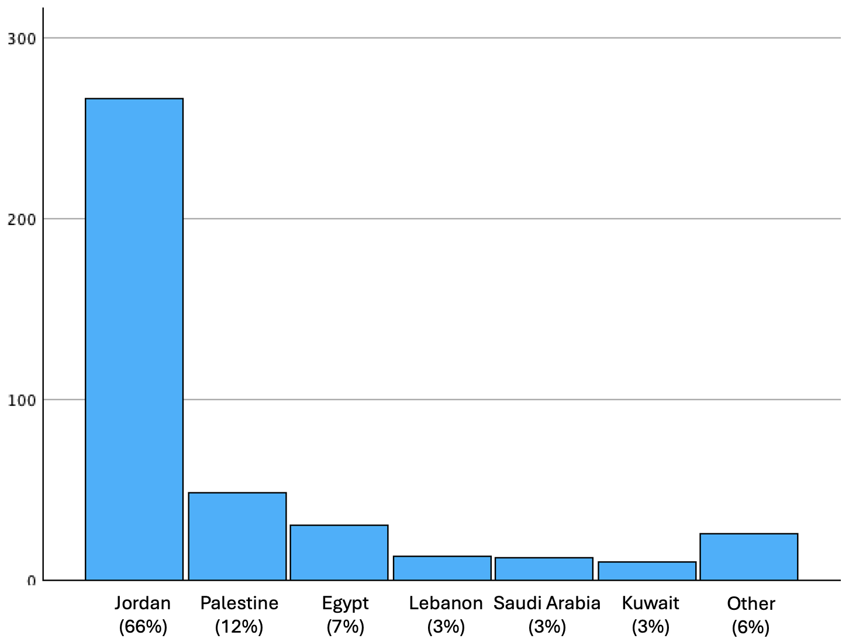
At the time of the study, most of the sample was living in Jordan (n = 298; 73%), Egypt (n = 62; 15%), or Lebanon (n = 14; 3%). Some participants also reported living in the Palestinian territories (n = 7; 2%), the United Arab Emirates (n = 7; 2%), and Saudi Arabia (n = 4; 1%). Other participants were living in Armenia, Cyprus, Germany, Holand, Ireland, Libya, Russia, Syria, Tunisia, and the United States (all n = 1; 0.2%).
Thirty-three respondents (8%) reported having had lived in Gaza themselves. These respondents lived in Gaza for an average of 11.18 years (SD = 11.07) and left Gaza, on average, in 2014 (SD = 6.69). Moreover, the majority of respondents (n = 306; 72%) had connections with people living in Gaza at the time of the survey—which was approximately three weeks after Israel began large-scale bombing of the region. Of these participants, 47 (15%) reported having close family in Gaza, 218 (71%) reported having close friends in Gaza, 106 (35%) reported having distant family in Gaza, and 36 (12%) reported having connections to other people in Gaza (see Figure S5). For more information on the demographics of the Palestinian sample, see Table S16.
Figure S5
Frequency Table of Palestinian Sample’s Connections to People Living in Gaza
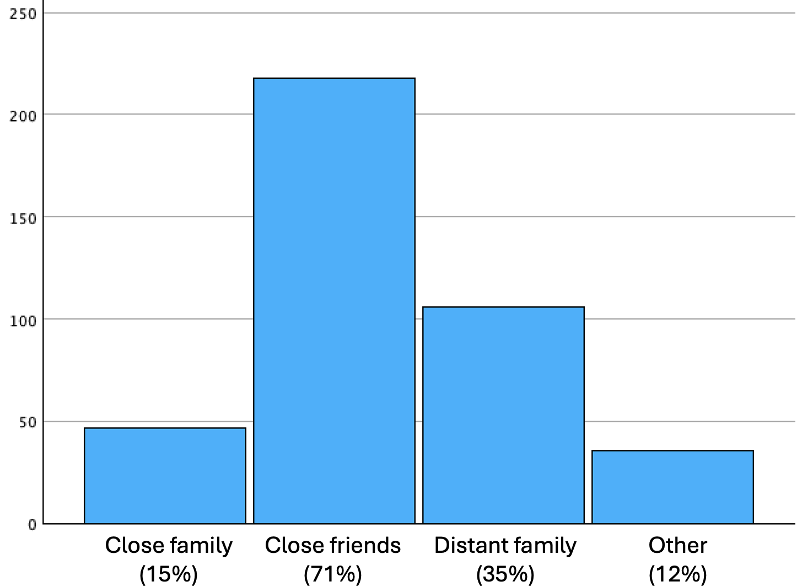
Note. Percentages on the x-axis are in relation to the 306 respondents indicating they knew people living in Gaza at the time of the study. These respondents could select as many options that applied (e.g., participants could indicate they had both close family and close friends living in Gaza), so the percentages do not sum to 100%.
Differential Attrition Tests
Given the high levels of attrition we observed in this sample (83%), we tested for differential attrition based on key demographic factors. Using the full dataset (i.e., containing all 2,437 responses from both the 426 comprising our final sample and the other 2,011 respondents), we created a binary indicator variable (0 = retained, 1 = attritted) and performed a logistic regression in which we regressed this indicator on respondents’ age, gender (0 = female, 1 = male), income, education (six levels ranging from “no degree” to “advanced degree,” where higher scores mean more educated), whether they had ever lived in Gaza (0 = no, 1 = yes), and whether they knew anyone currently living in Gaza (0 = no, 1 = yes). We observed no evidence for differential attrition based on any of these demographic factors (see Table S11). However, it should be noted that a substantial proportion of respondents left the survey even before completing these demographic items (n = 1,319; see Figure S10).
Table S11
Logistic Regression Predicting Attrition Status (0 = Retained, 1 = Attritted) Based on Demographic Factors in the Palestinian Sample
Predictor | b | Standard Error | z value | p value
Age | 0.00 | 0.00 | -0.56 | .574
Gender | -0.10 | 0.14 | -0.68 | .496
Education | -0.08 | 0.05 | -1.63 | .103
Income | -0.07 | 0.05 | -1.28 | .202
Ever Live in Gaza? | 0.04 | 0.26 | .171 | .864
Know Anyone in Gaza? | 0.01 | 0.15 | 0.06 | .954

We speculate that two other factors contributed to the high attrition rate. For one, although we took measures to ensure participants understood the sensitive nature of the survey before beginning (see the Procedure in the main text), this study took place during the very first weeks of the bombing of Gaza. Thus, many Palestinians may have experienced heightened emotional distress while taking the survey, making it challenging for them to complete it. Second, the involvement of US universities in conducting this research may have undermined trust, as some participants might have been wary of the researchers’ intentions. This mistrust, coupled with the charged emotional context, likely contributed to the high attrition rate.

Preregistered Exclusions

In each sample, we included two attention checks (e.g., a “catch” item asking respondents to select a specific option). The exception was the US sample, which was substantially longer than the others (see Procedure), so here we included three checks. Respondents who failed any attention checks were excluded from analyses. Moreover, in the Israeli, Palestinian, Hindu, and Muslim samples, at the beginning of the study, we asked respondents whether they identified as a member of that group (e.g., “Are you a Jewish Israeli?”) and immediately redirected those who were not to the end of the survey. Finally, in the Hindu and Muslim samples, we implemented three additional measures to ensure data quality, based on recommendations from our survey partner. First, participants were presented with a short mock vignette (i.e., a paragraph with content unrelated to the rest of the study) and asked an attention check question about it. Those who answered incorrectly were immediately redirected to the end of the study. Second, we excluded respondents who completed the survey in three absolute deviations above or below the median time (Rindskopf & Shiyko, 2010). Third, we excluded those who provided a response to open-ended questions (described in the Procedure section below) that was nonsensical or bore no relation to the question prompt (e.g., "good survey", "nice"). Figures S6-S12, below, depict respondent attrition for each sample.

Figure S6

Attrition in the US Sample

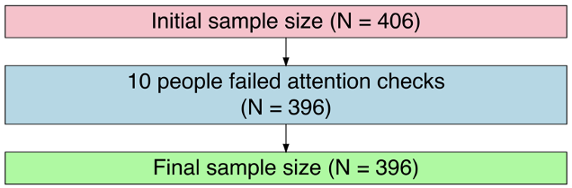

Figure S7

Attrition in the Russian Sample

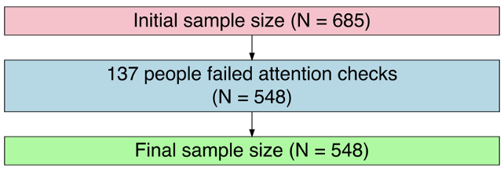

Figure S8

Attrition in the Ukrainian Sample

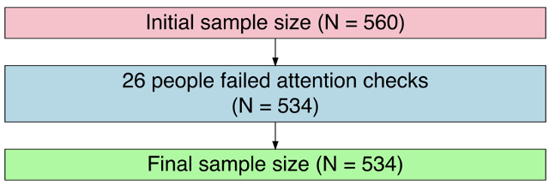

Figure S9

Attrition in the Israeli Sample

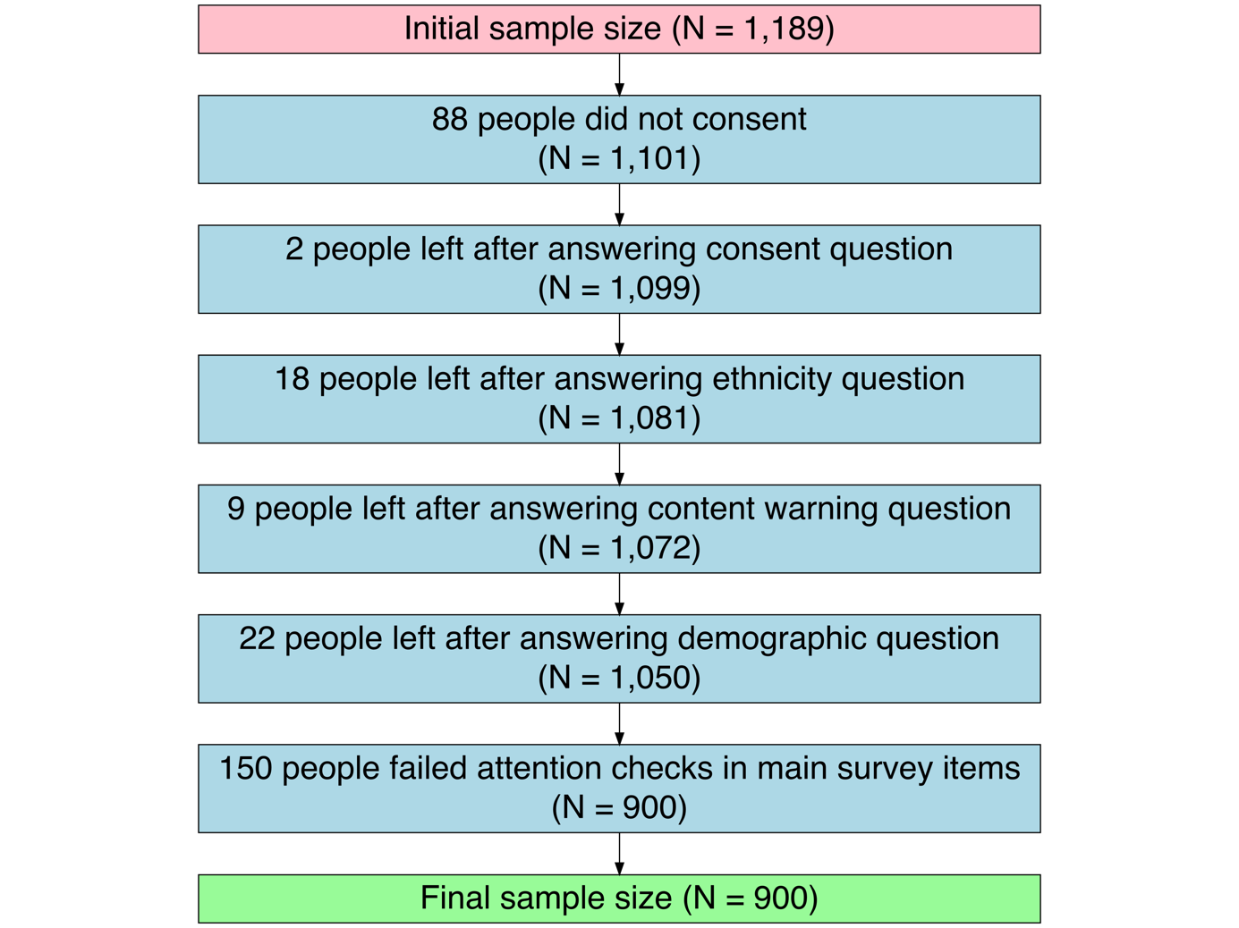

Figure S10

Attrition in the Palestinian Sample

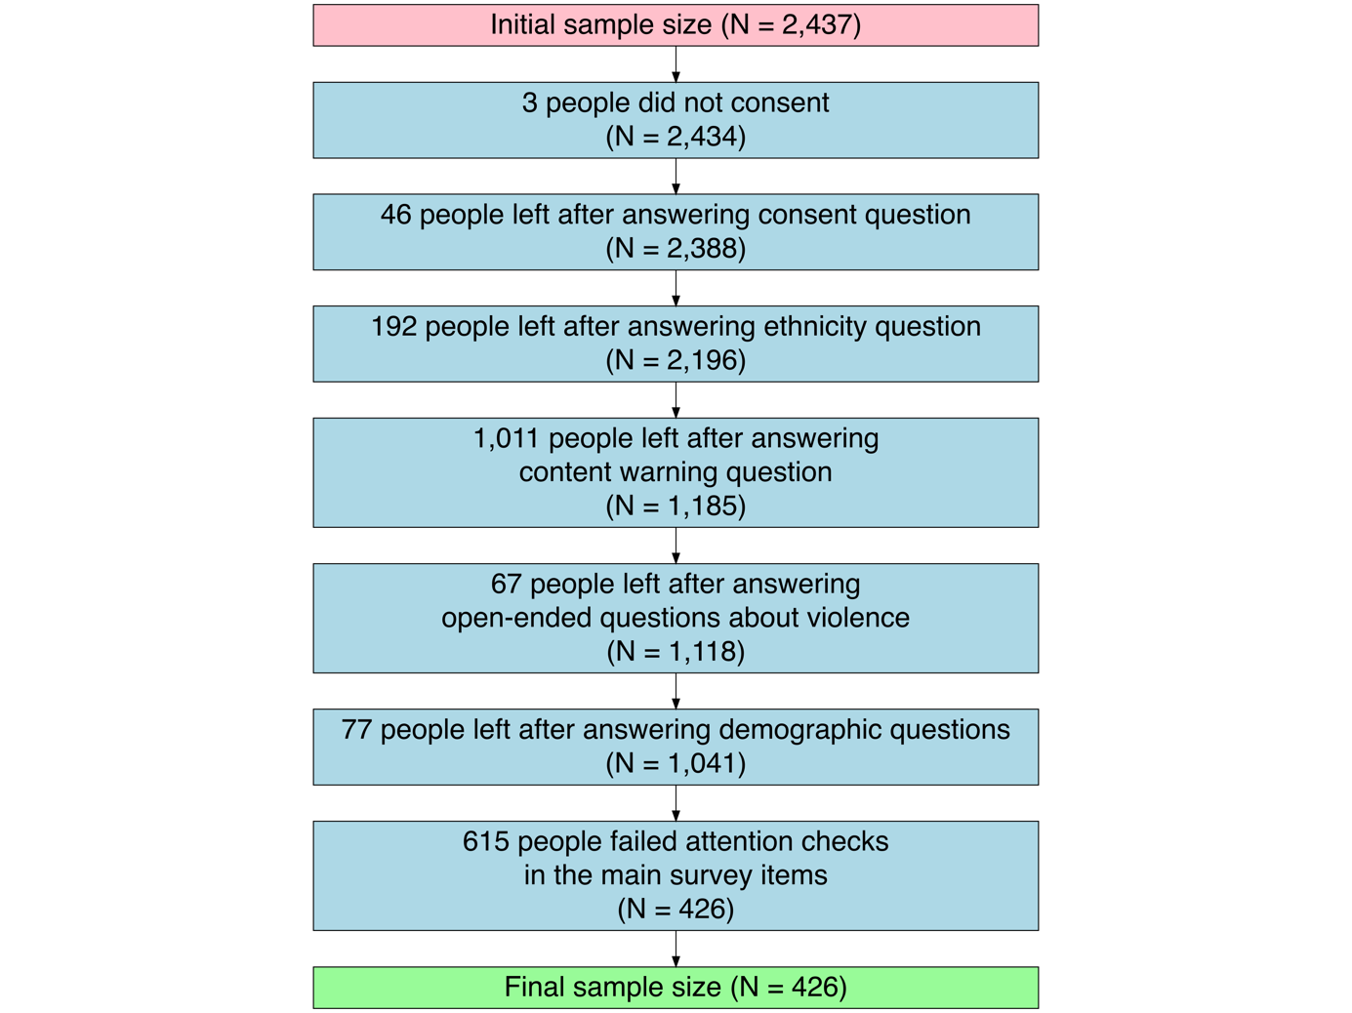

Figure S11

Attrition in the Hindu Sample

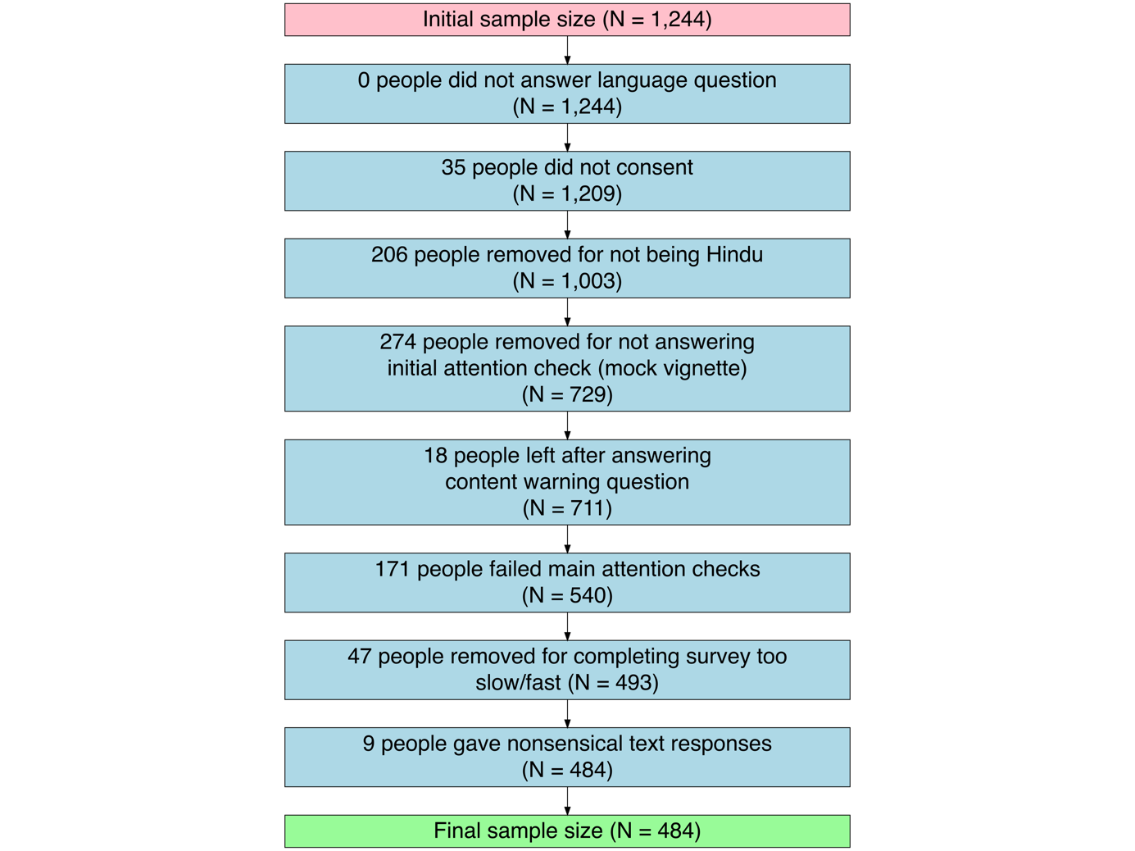

Figure S12

Attrition in the Muslim Sample

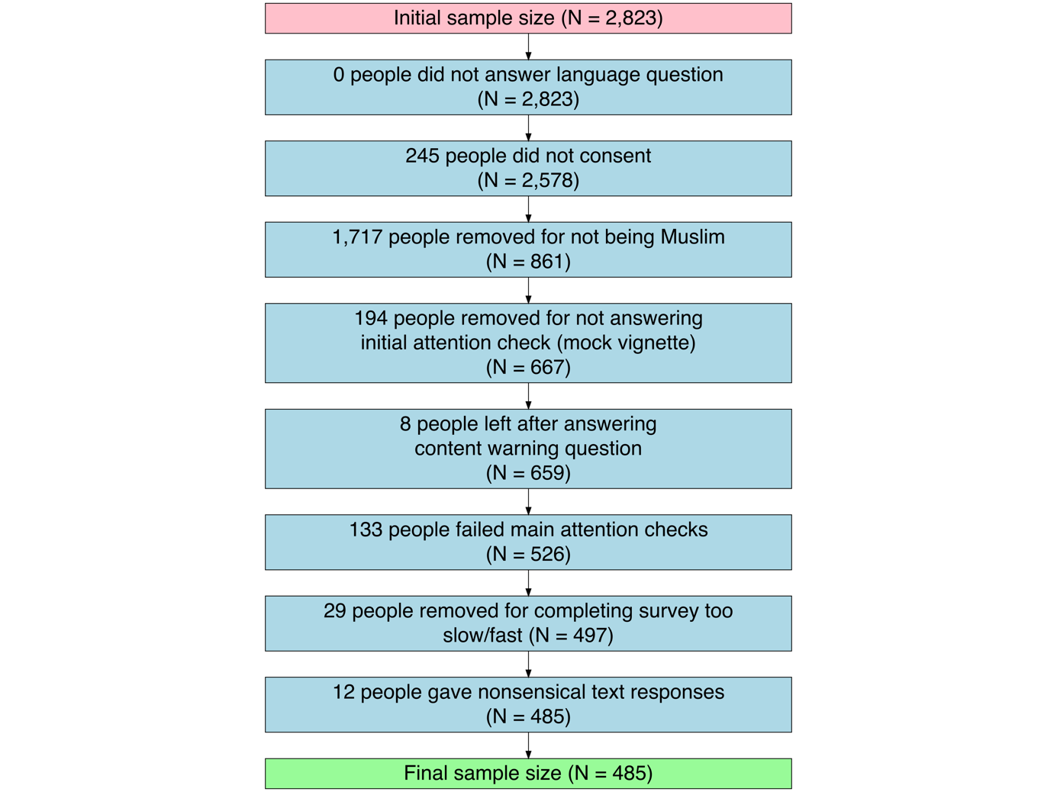

Tables S12-S18: Demographic Information for Each Sample

Table S12
Demographic Composition of the US Sample

Age | n | % | Annual Income | n | %
18-24 | 26 | 6.6% | Less than $30,000 | 83 | 21%
25-34 | 144 | 36.4% | $30,000-$60,000 | 108 | 27.3%
35-44 | 112 | 28.3% | $60,001-$80,000 | 80 | 20.2%
45-54 | 57 | 14.4% | $80,001-$120,000 | 64 | 16.2%
55-64 | 34 | 8.6% | $120,001-$200,000 | 39 | 9.8%
65+ | 19 | 4.8% | Over $200,000 | 18 | 4.5%
No response | 4 | 1% | No response | 4 | 1%
Gender | n | %
Male | 224 | 56.6%
Female | 168 | 42.4%
No response | 4 | 1%
Race | n | % | Education | n | %
White | 259 | 65.4% | High school or less | 49 | 12.4%
Black | 45 | 11.4% | Some college | 81 | 20.5%
Asian | 40 | 10.1% | Associate’s degree | 45 | 11.4%
Hispanic | 39 | 9.8% | Bachelor’s degree | 165 | 41.7%
Other | 9 | 2.3% | Advanced degree | 52 | 13.1%
No response | 4 | 1% | No response | 4 | 1%
Note. This was a convenience sample recruited via CloudResearch’s Connect platform on October 2, 2023 (Hartman et al., 2023).

Table S13

Demographic Composition of the Russian Sample (Matched to Russian Population on Age, Gender, and Region)

 | Sample |  | Population |  | Sample
Age | n | % | % | Education | n | %
18-25 | 55 | 10% | 10% | General secondary or less | 38 | 6.9%
26-35 | 93 | 17.1% | 17.1% | Vocational secondary | 157 | 28.6%
36-45 | 112 | 20.4% | 20.4% | Non-complete higher | 32 | 5.8%
46-55 | 90 | 16.5% | 16.5% | Higher | 321 | 58.6%
56+ | 197 | 36% | 36%
Gender | n | % | % | Employment | n | %
Male | 248 | 45.2% | 45.2% | Work full-time | 344 | 62.8%
Female | 300 | 54.8% | 54.8% | Work part-time | 63 | 11.5%
 |  |  |  | Don’t work | 114 | 20.8%
 |  |  |  | Student | 19 | 3.4%
 |  |  |  | Other/no response | 7 | 1.4%
Region | n | % | % | Socioeconomic Status | n | %
Far Eastern | 29 | 5.3% | 5.3% | Lack basic necessities (e.g., food, clothing) | 37 | 6.7%
Volga | 108 | 19.6% | 19.6% | Lack basic household appliances | 176 | 32%
Northwestern | 53 | 9.8% | 9.8% | Lack luxury items (e.g., car) | 279 | 51%
Southern and North  Caucasus | 98 | 17.9% | 17.9% | Can afford luxury items | 43 | 7.9%
Siberian | 61 | 11.1% | 11.1% | No response | 13 | 2.4%
Ural | 45 | 8.2% | 8.2%
Central | 155 | 28.2% | 28.2%

Note. This sample was recruited by Info Sapiens (https://www.sapiens.com.ua/en/index) from November 6 to December 4, 2023. Data is weighted to the Russian population’s age, gender, and regional demographics (as determined by the 2023 census of the Federal Service of State Statistics of Russian Federation).

Table S14

Demographic Composition of the Ukrainian Sample (Matched to Ukrainian Population on Age, Gender, Region, and Settlement Size)
 | Sample |  | Population |  | Sample
Age | n | % | % | Post-Invasion Residence | n | %
18-25 | 59 | 11.1% | 11.1% | Live in the same settlement | 442 | 82.9%
26-35 | 109 | 20.5% | 20.5% | Moved to another settlement | 66 | 12.5%
36-45 | 121 | 22.7% | 22.8% | Moved abroad | 21 | 3.9%
46-55 | 103 | 19.3% | 19.2% | None of the above | 4 | 0.7%
56+ | 141 | 26.4% | 26.4%
Gender | n | % | % | Employment | n | %
Male | 253 | 47.4% | 47.4% | Military | 5 | 0.9%
Female | 281 | 52.6% | 52.6% | Work full-time | 213 | 39.8%
 |  |  |  | Work part-time | 60 | 11.3%
 |  |  |  | Don’t work | 217 | 40.7%
 |  |  |  | Student | 21 | 4%
 |  |  |  | Other/no response | 17 | 3.2%
Region | n | % | % | Socioeconomic Status | n | %
Kyiv | 45 | 8.5% | 8.5% | Lack basic necessities (e.g., food, clothing) | 200 | 37.5%
North | 76 | 14.3% | 14.3% | Lack basic household appliances | 195 | 36.6%
West | 139 | 26.1% | 26.1% | Lack luxury items (e.g., car) | 89 | 16.8%
Center | 143 | 26.7% | 26.7% | Can afford luxury items | 15 | 2.8%
South | 74 | 13.9% | 13.9% | No response/hard to say | 34 | 6.4%
East | 56 | 10.4% | 10.4%
Settlement Size | n | % | % | Education | n | %
Village | 170 | 31.9% | 32% | General secondary or less | 47 | 9.3%
City less than  50,000 | 117 | 21.9% | 21.8% | Vocational secondary | 160 | 30.1%
City 50,000-  100,000 | 29 | 5.5% | 5.5% | Non-complete higher | 37 | 6.9%
City 100,000-  500,000 | 86 | 16.1% | 16.1% | Higher | 285 | 53.4%
City over 500,000 | 131 | 24.5% | 24.5% | No response | 2 | 0.4%

Note. This sample was recruited by Info Sapiens (https://www.sapiens.com.ua/en/index) from November 6 to December 4, 2023. Data is weighted to the pre-invasion Ukrainian population’s age, gender, regional, and settlement size demographics (as determined by the 2022 census of the State Statistics Service of Ukraine). Note that 17% of our sample had been displaced following the invasion.

Table S15

Demographic Composition of the Israeli Sample (Matched to Jewish Israeli Population on Age, Gender, Region, and Religiosity)

 | Sample |  | Population |  | Sample
Age | n | % | % | Israeli Military Service | n | %
18-24 | 217 | 24.1% | 16% | Never served | 325 | 36.1%
25-34 | 248 | 27.6% | 22% | Veteran | 516 | 57.3%
35-44 | 131 | 14.6% | 21% | Currently serving | 59 | 6.6%
45-54 | 113 | 12.6% | 17%
55-64 | 108 | 12% | 13%
65+ | 71 | 7.9% | 11%
No response | 12 | 1.3%
Gender | n | % | % | Israeli Military Role | n | %
Male | 464 | 51.6% | 49% | Combat unit | 111 | 12.3%
Female | 436 | 48.4% | 51% | Combat support unit | 180 | 20%
 |  |  |  | Special forces unit | 10 | 1.1%
 |  |  |  | Non-combat unit | 291 | 32.3%
Region | n | % | % | Socioeconomic Status | n | %
Jerusalem | 97 | 10.8% | 9% | Much less than average income | 235 | 26.1%
North | 123 | 13.7% | 10% | Just less than average income | 180 | 20%
Haifa | 95 | 10.6% | 12% | About average income | 236 | 26.2%
Center | 266 | 29.6% | 28% | More than average income | 173 | 19.2%
Tel Aviv | 152 | 16.9% | 22% | Much more than average income | 75 | 8.3%
South | 106 | 11.8% | 15% | No response | 1 | 0.1%
Judea and Samaria | 61 | 6.8% | 5%
Religiosity | n | % | % | Education | n | %
Secular | 318 | 35.3% | 43% | No high school diploma | 124 | 13.8%
Traditional | 266 | 29.6% | 36% | High school diploma | 198 | 22%
Religious | 140 | 15.6% | 11% | Some college, no degree | 206 | 22.9%
Ultra-orthodox | 175 | 19.4% | 10% | Bachelor’s degree | 258 | 28.7%
No response | 1 | 0.1% |  | Advanced degree | 114 | 12.7%
Note. This sample was recruited by iPanel (https://www.ipanel.co.il/en/) from November 5-14, 2023, and was quota-matched to approximate the Jewish Israeli population’s age, gender, regional, and religiosity demographics (as determined by the 2022 census of Israel’s Central Bureau of Statistics). The demographic variable “Israeli Military Role” refers to what type of unit(s) those who had served or were serving in the IDF occupied (respondents could select multiple types). The percentage reflects the percent of respondents out of the entire sample who occupied that type of unit.

Table S16

Demographic Composition of the Palestinian Sample

Gender | n | % | Know Anyone in Gaza? | n | %
Male | 149 | 35% | Yes | 306 | 71.8%
Female | 275 | 64.6% | No | 119 | 27.9%
No response | 2 | 0.4% | No response | 1 | 0.2%
Age | n | % | Who Do You Know in Gaza? | n | %
18-24 | 163 | 38.3% | Close family | 47 | 11%
25-34 | 134 | 31.5% | Friends | 218 | 51.2%
35-44 | 62 | 14.6% | Distant family | 106 | 24.9%
45-54 | 14 | 3.3% | Other | 36 | 8.5%
55-61 | 8 | 1.9%
No response | 45 | 10.6%
Annual Income | n | % | Religion | n | %
$10,000 or less | 185 | 43.4% | Muslim | 392 | 92%
$10,001-$24,000 | 114 | 26.8% | Christian | 7 | 1.6%
$24,001-$45,000 | 51 | 12% | Non-religious | 21 | 4.9%
$45,001-$80,000 | 28 | 6.6% | Other/no response | 6 | 1.4%
Over $80,000 | 22 | 5.1%
No response | 26 | 6.1%
Note. This was a convenience sample recruited by Centre Euro Arabe (https://centreeuroarabe.org/home) from November 9-19, 2023. The demographic variable “Who Do You Know in Gaza?” refers to what social tie(s) respondents had to individuals living in Gaza at the time of the study (respondents could select multiple options). The percentage reflects the percent of respondents out of the entire sample who had that social tie.

Table S17

Demographic Composition of the Indian Hindu Sample (Matched to the Indian Hindu Population on Age, Gender, and Region)

 | Sample |  | Population |  | Sample
Age | n | % | % | Income | n | %
18-24 | 92 | 19% | 21% | Rs 0-3 lakh | 68 | 14%
25-34 | 148 | 30.6% | 25% | Rs 3-6 lakh | 86 | 17.8%
35-44 | 105 | 21.7% | 20% | Rs 6-9 lakh | 86 | 17.8%
45-54 | 69 | 14.3% | 14% | Rs 9-12 lakh | 91 | 18.8%
55-64 | 35 | 7.2% | 10% | Rs 12-15 lakh | 67 | 13.8%
65+ | 25 | 5.2% | 9% | Above Rs 15 lakh | 81 | 16.7%
No response | 10 | 2.1% |  | No response | 5 | 1%
Gender | n | % | % | Education | n | %
Male | 261 | 53.9% | 52% | Secondary school or less | 293 | 60.5%
Female | 217 | 44.8% | 48% | Some college, no degree | 186 | 38.4%
No response | 6 | 1.2% |  | No response | 5 | 1%
Region | n | % | % | Caste | n | %
Central | 38 | 7.9% | 9% | Upper caste | 325 | 67.1%
East | 71 | 14.7% | 22% | Scheduled Castes and Scheduled Tribes | 34 | 7%
North | 134 | 27.7% | 30% | Other Backward Classes | 100 | 20.7%
Northeast | 13 | 2.7% | 3% | Any other castes | 19 | 3.9%
South | 123 | 25.4% | 22% | No response | 6 | 1.2%
West | 100 | 20.7% | 15%
No response | 5 | 1%

Note. This sample was recruited by CloudResearch’s Prime Panels (Chandler et al., 2019) from March 5-29, 2024, and was quota-matched to approximate the Indian Hindu population’s age, gender, and regional demographics (as determined by the 2011 census of the Government of India).

Table S18

Demographic Composition of the Indian Muslim Sample (Matched to the Indian Muslim Population on Age, Gender, and Region)

 | Sample |  | Population |  | Sample
Age | n | % | % | Income | n | %
18-24 | 86 | 17.7% | 21% | Rs 0-3 lakh | 36 | 7.4%
25-34 | 148 | 30.5% | 25% | Rs 3-6 lakh | 80 | 16.5%
35-44 | 101 | 20.8% | 20% | Rs 6-9 lakh | 117 | 24.1%
45-54 | 105 | 21.6% | 14% | Rs 9-12 lakh | 105 | 21.6%
55-64 | 27 | 5.6% | 10% | Rs 12-15 lakh | 68 | 14%
65+ | 8 | 1.6% | 9% | Above Rs 15 lakh | 71 | 14.6%
No response | 10 | 2.1% |  | No response | 8 | 1.6%
Gender | n | % | % | Education | n | %
Male | 250 | 51.5% | 52% | Secondary school or less | 318 | 65.5%
Female | 227 | 46.8% | 48% | Some college, no degree | 157 | 32.4%
No response | 8 | 1.6% |  | No response | 10 | 2.1%
Region | n | % | % | Caste | n | %
Central | 25 | 5.2% | 3% | Upper caste | 218 | 44.9%
East | 63 | 13% | 28% | Scheduled Castes and Scheduled Tribes | 23 | 4.7%
North | 123 | 25.4% | 34% | Other Backward Classes | 168 | 34.6%
Northeast | 30 | 6.2% | 7% | Any other castes | 68 | 14%
South | 112 | 23.1% | 17% | No response | 8 | 1.6%
West | 124 | 25.6% | 11%
No response | 8 | 1.6%

Note. This sample was recruited by CloudResearch’s Prime Panels (Chandler et al., 2019) from March 5-29, 2024, and was quota-matched to approximate the Indian Muslim population’s age, gender, and regional demographics (as determined by the 2011 census of the Government of India).

Detailed Measures

Translation of Survey Materials. For the Russian, Ukrainian, and Israeli samples, a native-speaking member of the survey company we partnered with first translated the survey materials to the native language. Then, another native-speaking partner back-translated the materials to English so we could ensure the original meaning was retained. This same procedure was also done for the Hindu and Muslim samples, except the survey materials were translated to Hindi, and then back-translated to English, by a professional translation service (Rush Translate, 2023). Finally, the translation for the Palestinian sample was performed by a member of our research team who is a native Arabic speaker. All translated survey materials can be found on our OSF repository.

Intense Negative Emotions. We measured the negative moral emotions—contempt, anger, and disgust—and hatred (Halperin, 2011; Rozin et al., 1999). In the US sample, participants were asked “How much of the following do you feel toward [target]?” and were presented with the following eight items (two for each emotion): contempt, disrespect, fury, rage, disgust, sick to my stomach, hatred, and loathing. They rated the degree to which they felt each using a 7-point Likert scale (1 = Not at all, 7 = Extremely). We did the same for the Hindu and Muslim samples, except we only used four items (contempt, fury, disgust, and hatred). For the Russian, Ukrainian, Israeli, and Palestinian samples, we measured the three moral emotions (contempt, fury, and disgust) as described previously, and asked about hatred in a separate block. Here, participants rated their agreement with the statement “I hate [target]” using a 7-point Likert scale (1 = I don’t hate [target] at all, 7 = I have a fierce hatred for [target]). In each sample, we averaged all items into a single measure of intense negative emotions (ω > .84).

Attributions of Immorality. In the US, Hindu, and Muslim samples, participants were asked “How well do the following traits describe [target]?” and were presented with the following three traits: immoral, evil, and cruel. They rated how well each trait described the target group using a 7-point Likert scale (1 = Not at all well, 7 = Extremely well). To measure attributions of immorality in the Russian, Ukrainian, Israeli, and Palestinian samples, participants were asked to evaluate the following three statements, each measured with 7-point Likert scales that had unique scale anchors: “[target] are immoral” (1 = There is nothing immoral about [target], 7 = [target] are completely immoral), “[target] are evil” (1 = [target] are not evil in any way, 7 = [target] are evil in every way), and “[target] lack integrity” (1 = [target] do not lack integrity, 7 = [target] lack any shred of integrity). In each sample, we averaged all items into a single measure of attributions of immorality (ω > .84).

Psychological Distance. This measure was only administered to the Russian, Ukrainian, Israeli, and Palestinian samples. Participants evaluated the following three statements, each measured with 7-point Likert scales that had unique scale anchors: “I am different from [target]” (1 = There are no ways in which I am different from [target], 7 = I am as different from [target] as can be), “I feel distant from [target]” (1 = I don’t feel distant from [target], 7 = I feel as if [target] and I are on separate planets), and “No matter how hard I try, I can’t see the world the way [target] do” (1 = I don’t have any difficulty seeing the world the way [target] do, 7 = It’s impossible for me to see the world the way [target] do). We averaged all items into a single measure of psychological distance (ω > .59).

Trait Aggression. This measure was only administered to the US, Israeli, Palestinian, Hindu, and Muslim samples. Participants responded to the Physical Aggression subscale of the Brief Aggression Questionnaire (Webster et al., 2014), which consists of the following three items: “Given enough provocation, I may hit another person”, “There are people who pushed me so far that we came to blows”, and “If I have to resort to violence to protect my rights, I will.” Participants evaluated each of these statements using a 7-point Likert scale (1 = Strongly disagree, 7 = Strongly agree). We averaged these items together into a single measure of trait aggression (ω > .61).

Social Dominance Orientation. This measure was only administered to the US, Israeli, Palestinian, Hindu, and Muslim samples. Participants responded to the following four items from the SDO₇ scale (Ho et al., 2015): “Group equality should not be our primary goal”, “It is unjust to try to make groups equal”, “An ideal society requires some groups to be on top and others to be on the bottom”, and “Some groups of people are simply inferior to other groups.” Participants evaluated each of these statements using a 7-point Likert scale (1 = Strongly disagree, 7 = Strongly agree). We averaged these items together into a single measure of social dominance orientation (ω > .58).

Right-Wing Authoritarianism. This measure was only administered to the US, Israeli, Palestinian, Hindu, and Muslim samples. Participants completed the Very Short Authoritarianism scale (Bizumic & Duckitt, 2018), which consists of the following three items: “What our country needs most is discipline, with everyone following our leaders in unity”, “Our society needs tougher government and stricter laws”, and “The facts on crime and the recent public disorders show we have to crack down harder on troublemakers if we are going to preserve law and order.” Participants evaluated each of these statements using a 7-point Likert scale (1 = Strongly disagree, 7 = Strongly agree). We averaged these items together into a single measure of right-wing authoritarianism (ω > .63).

Additional Measures. We included several additional measures that are not of relevance to the current study but are mentioned here for transparency. In all samples, participants who responded with strong agreement (i.e., a 7 out of 7) to any of the items in the support for violence measure (described in the main text) were asked to elaborate on their response in an open-ended text box. In all samples except for the US, we included measures of meta-dehumanization and meta-dislike (i.e., participants’ perception of how much the target group dehumanizes and dislikes their own group; Kteily et al., 2016). In the Israeli sample, we included a donation task where respondents could choose to contribute or take away money to aid Palestinians in Gaza. In the Palestinian sample, we included a measure of general tendencies to support intergroup violence (as opposed to support for violence against a specific outgroup; Abou-Ismail et al., 2023) and also asked a series of five open-ended questions regarding their perceptions of the Israeli-Palestinian conflict (e.g., what acceptable solutions may look like). And in the Hindu and Muslim samples, we included an additional, vignette-based measure of support for violence against the target group. See Table S19 for an overview of all measures administered to each sample.

Table S19
Overview of All Measures Administered to Each Sample in the Cross-Cultural Studies

Measure | United States | Russia | Ukraine | Israel | Palestine | Hindus | Muslims
Dehumanization
General Negative Affect
Intense Negative Emotions
Immorality
Unintelligence
Global Derogation
Psychological Distance
Trait Aggression
Social Dominance Orientation
Right-Wing Authoritarianism
Support for Violence
Dehumanization Follow-Up
Meta-Dehumanization
Meta-Dislike
Violence Vignette
Collective Violence Scale
Violence Follow-Up
Donation
Open-ended Questions About Israeli-Palestinian Conflict

Note. Green cells indicate the measure was administered to that sample, red cells indicate the measure was not administered to that sample. Italicized measures are not considered in the present research. All study materials can be found on our OSF repository: https://osf.io/2r4cu/?view_only=760f7226c1024fd598e53133066190c8

Detailed Procedure

Given the gravity of these conflicts, we first made participants aware of the nature of the study and their rights. Specifically, after consenting to participate, participants were presented with a content warning that reiterated the survey questions are highly sensitive and may make them uncomfortable, they can skip any question they wish to, they can discontinue their participation at any time, and their responses are confidential. Participants had to indicate they understood this information before continuing to the survey.

Then, Israelis, Palestinians, Hindus, and Muslims completed the item to determine whether they identified with the relevant group, and Hindus and Muslims then completed the mock vignette attention check (see “Preregistered Exclusions”, above). Eligible participants then advanced to the main study, which consisted of three blocks of measures. Unless otherwise specified, measures were randomized within each block, and items were randomized within each measure.

The first block consisted of the personality covariates: trait aggression, SDO, and RWA (administered only to the US, Israeli, Palestinian, Hindu, and Muslim samples). The next block consisted of the measures of dehumanization, general negative affect, intense negative emotions, attributions of immorality, attributions of unintelligence, global trait derogation, and psychological distance (with the final two measures administered only to the Russian, Ukrainian, Israeli, and Palestinian samples). In the Russian, Ukrainian, Israeli, and Palestinian samples, one item from the intense negative emotions measure (hatred), as well as the items comprising the attributions of immorality, global trait derogation, and psychological distance measures, were administered together (in randomized order) on a single survey page. The third block consisted of the support for violence measure. After completing these blocks (except for Palestinians), the dehumanization follow-up was administered to respondents who rated the target group at 70 or less on the Ascent of Man scale.

Finally, at the conclusion of the study, all participants were provided with contact information for mental health services in case the survey caused distress, as well as the contact information for the lead investigator should they want more information about the study or how their responses would be used.

Cross-Cultural Studies: Supplemental Results

Table S20

Descriptive Statistics and Reliabilities for Measures in the Cross-Cultural Studies
Measure | Americans |  |  | Russians |  |  | Ukrainians |  |  | Israelis |  |  | Palestinians |  |  | Indian Hindus |  |  |  | Indian Muslims
 | M | SD | r/ω | M | SD | r/ω | M | SD | r/ω | M | SD | r/ω | M | SD | r/ω | M | SD | r/ω | M |  | SD | r/ω
Dehumanization | 0.00 | 0.96 | .84 | -0.04 | 0.89 | .73 | -0.06 | 0.95 | .71 | 0.00 | 0.97 | .87 | 0.00 | 0.96 | .85 | 0.00 | 0.93 | .72 | 2.00 |  | 1.40 | .88
General Negative Affect | 0.00 | 0.96 | .83 | 0.01 | 0.95 | .80 | -0.01 | 0.91 | .63 | 0.00 | 0.93 | .73 | 91.92 | 18.42 |  | 2.75 | 1.56 | .81 | 2.39 |  | 1.41 | .74
Intense Negative Emotions | 4.95 | 1.87 | .97 | 2.49 | 1.72 | .94 | 5.96 | 1.39 | .91 | 5.21 | 1.60 | .88 | 6.13 | 1.36 | .84 | 2.73 | 1.65 | .93 | 2.44 |  | 1.49 | .92
Attributions of Immorality | 5.54 | 1.77 | .95 | 3.47 | 1.83 | .92 | 6.18 | 1.19 | .92 | 5.72 | 1.39 | .93 | 6.50 | 1.04 | .84 | 3.03 | 1.83 | .92 | 2.39 |  | 1.46 | .87
Attributions of Unintelligence | 3.84 | 2.01 | .97 | 3.04 | 1.97 | .96 | 5.76 | 1.66 | .93 | 4.31 | 1.98 | .93 | 4.78 | 2.09 | .91 | 2.56 | 1.69 | .91 | 2.26 |  | 1.52 | .91
Global Derogation |  |  |  | 3.93 | 1.74 |  | 6.22 | 1.17 |  | 5.66 | 1.41 |  | 6.38 | 1.17
Psychological Distance |  |  |  | 3.88 | 2.00 | .86 | 6.36 | 1.21 | .86 | 6.18 | 1.10 | .79 | 6.38 | 1.07 | .59
Trait Aggression | 3.08 | 1.76 | .85 |  |  |  |  |  |  | 2.39 | 1.46 | .82 | 3.55 | 1.51 | .61 | 3.60 | 1.62 | .72 | 3.63 |  | 1.64 | .73
Social Dominance Orientation | 2.35 | 1.68 | .93 |  |  |  |  |  |  | 3.24 | 1.39 | .73 | 2.13 | 1.30 | .58 | 3.26 | 1.64 | .79 | 3.22 |  | 1.56 | .76
Right-Wing Authoritarianism | 3.49 | 1.71 | .88 |  |  |  |  |  |  | 4.79 | 1.46 | .75 | 3.48 | 1.73 | .63 | 5.74 | 1.26 | .78 | 5.39 |  | 1.43 | .76
Support for Violence | 3.78 | 2.08 | .93 | 2.04 | 1.15 | .87 | 3.66 | 1.57 | .89 | 4.48 | 1.67 | .91 | 3.16 | 2.08 | .92 | 3.34 | 1.97 | .89 | 2.36 |  | 1.63 | .89

Note. Gray boxes indicate the measure was not administered in that sample or a reliability was not computed because the measure was a single item. For the dehumanization measure, the reliability is the zero-order correlation (r) between the Ascent of Man scale and the dehumanizing sentiments, which were standardized and combined into a single composite. The exception was the Muslim sample, where we used only the dehumanizing sentiments in our primary analyses, so the reliability is the McDonald’s Omega (ω) for the three dehumanizing sentiments items. For the general negative affect measure, in the US, Russian, Ukrainian, and Israeli samples, the reliability is the zero-order correlation (r) between the feeling thermometer and the disliking sentiments, which were standardized and combined into a single composite. For the Palestinian sample, we used only the single-item feeling thermometer in our primary analyses, so no reliability is given. For the Hindu and Muslim samples, we used only the disliking sentiments in our primary analyses, so the reliability is the McDonald’s Omega (ω) for the three disliking sentiments items. For all other measures, the reliability is the McDonald’s Omega (ω) for the items comprising them (except for global derogation, which is just a single item). Also, the data for the Russian and Ukrainian samples are weighted to their respective countries’ age, gender, region, and for Ukrainians, settlement size demographics.

Figures S13-S25: Density Plots Depicting Variable Distributions

Figure S13

Density Plot Depicting Distributions of Ascent of Man Scores

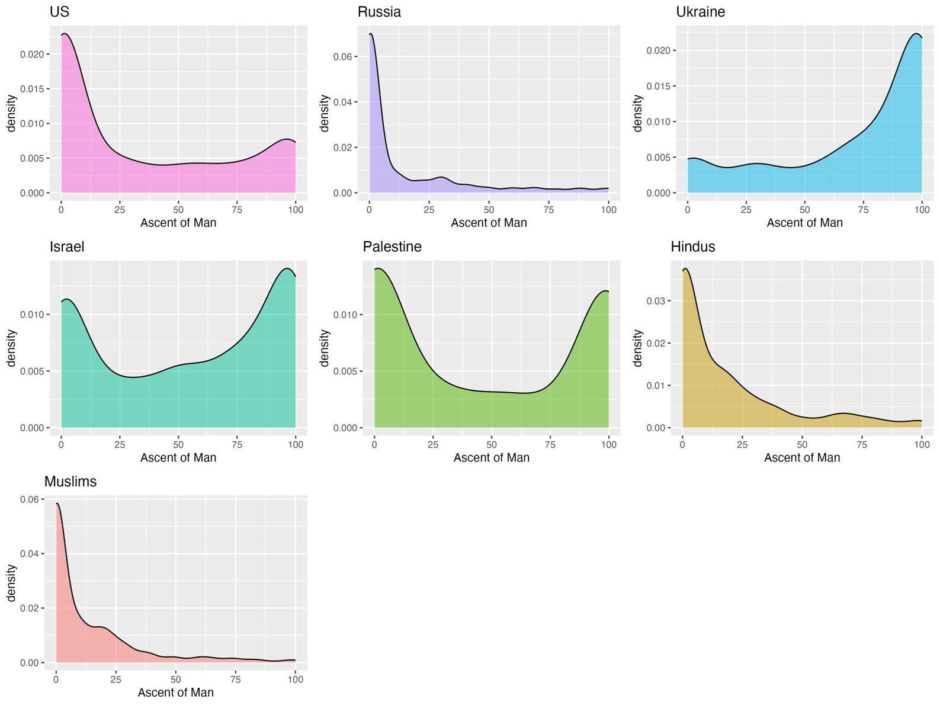

Figure S14

Density Plot Depicting Distributions of Dehumanizing Sentiments Scores

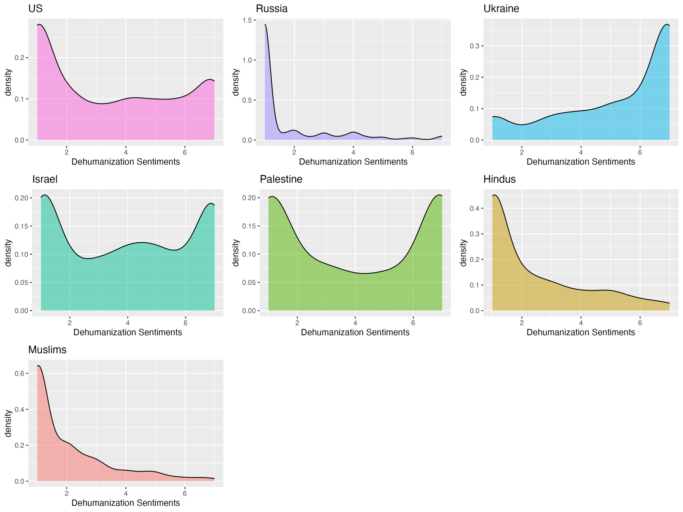

Figure S15

Density Plot Depicting Distributions of Feeling Thermometer Scores

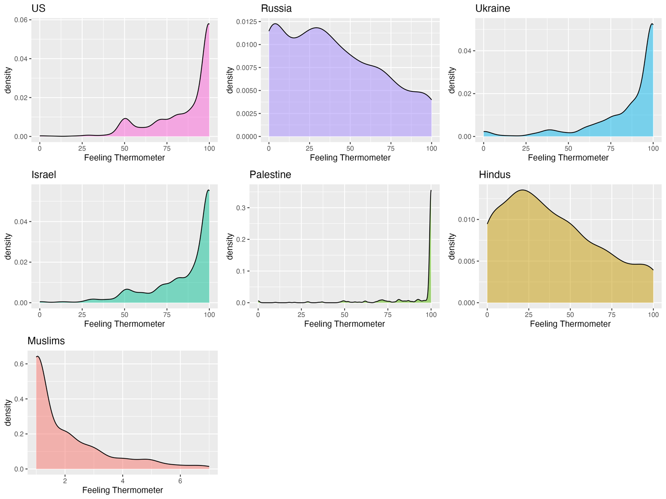

Figure S16

Density Plot Depicting Distributions of Disliking Sentiments Scores

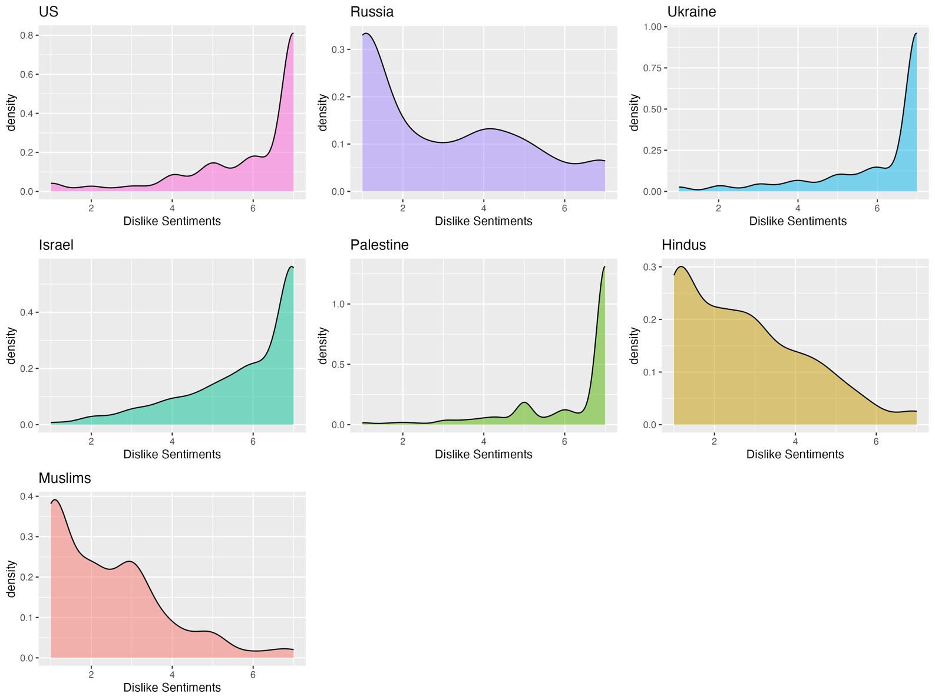

Figure S17

Density Plot Depicting Distributions of Intense Negative Emotions Scores

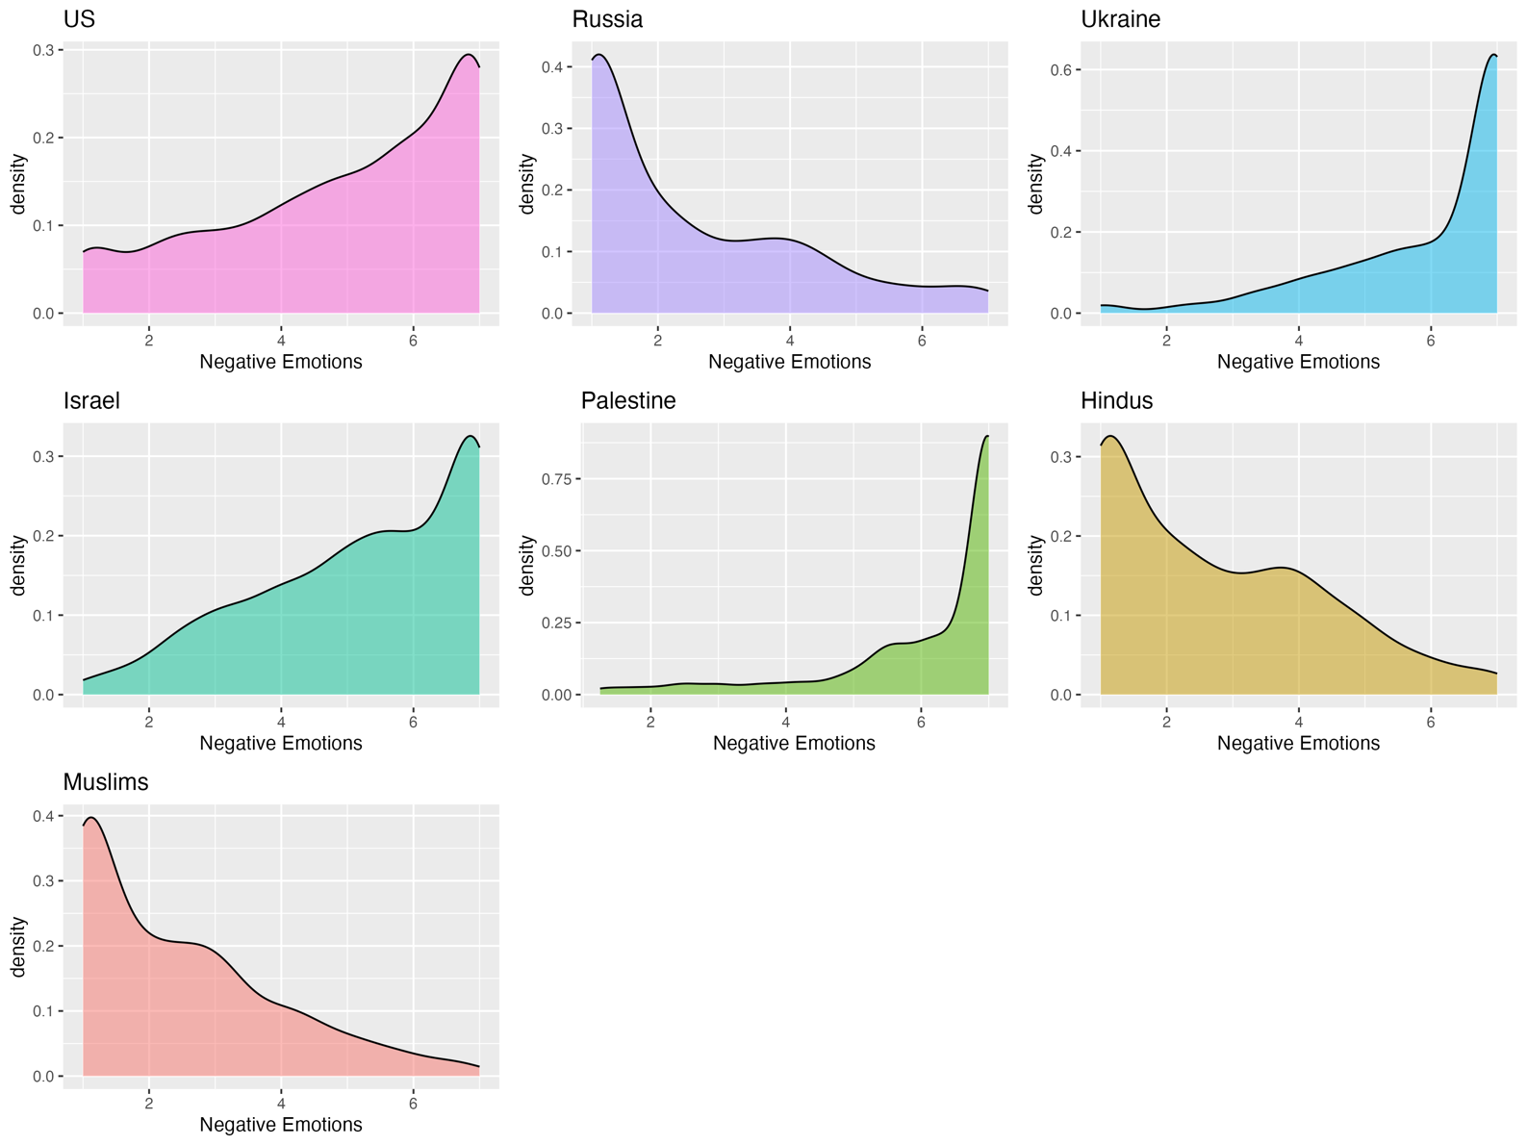

Figure S18

Density Plot Depicting Distributions of Attributions of Immorality Scores

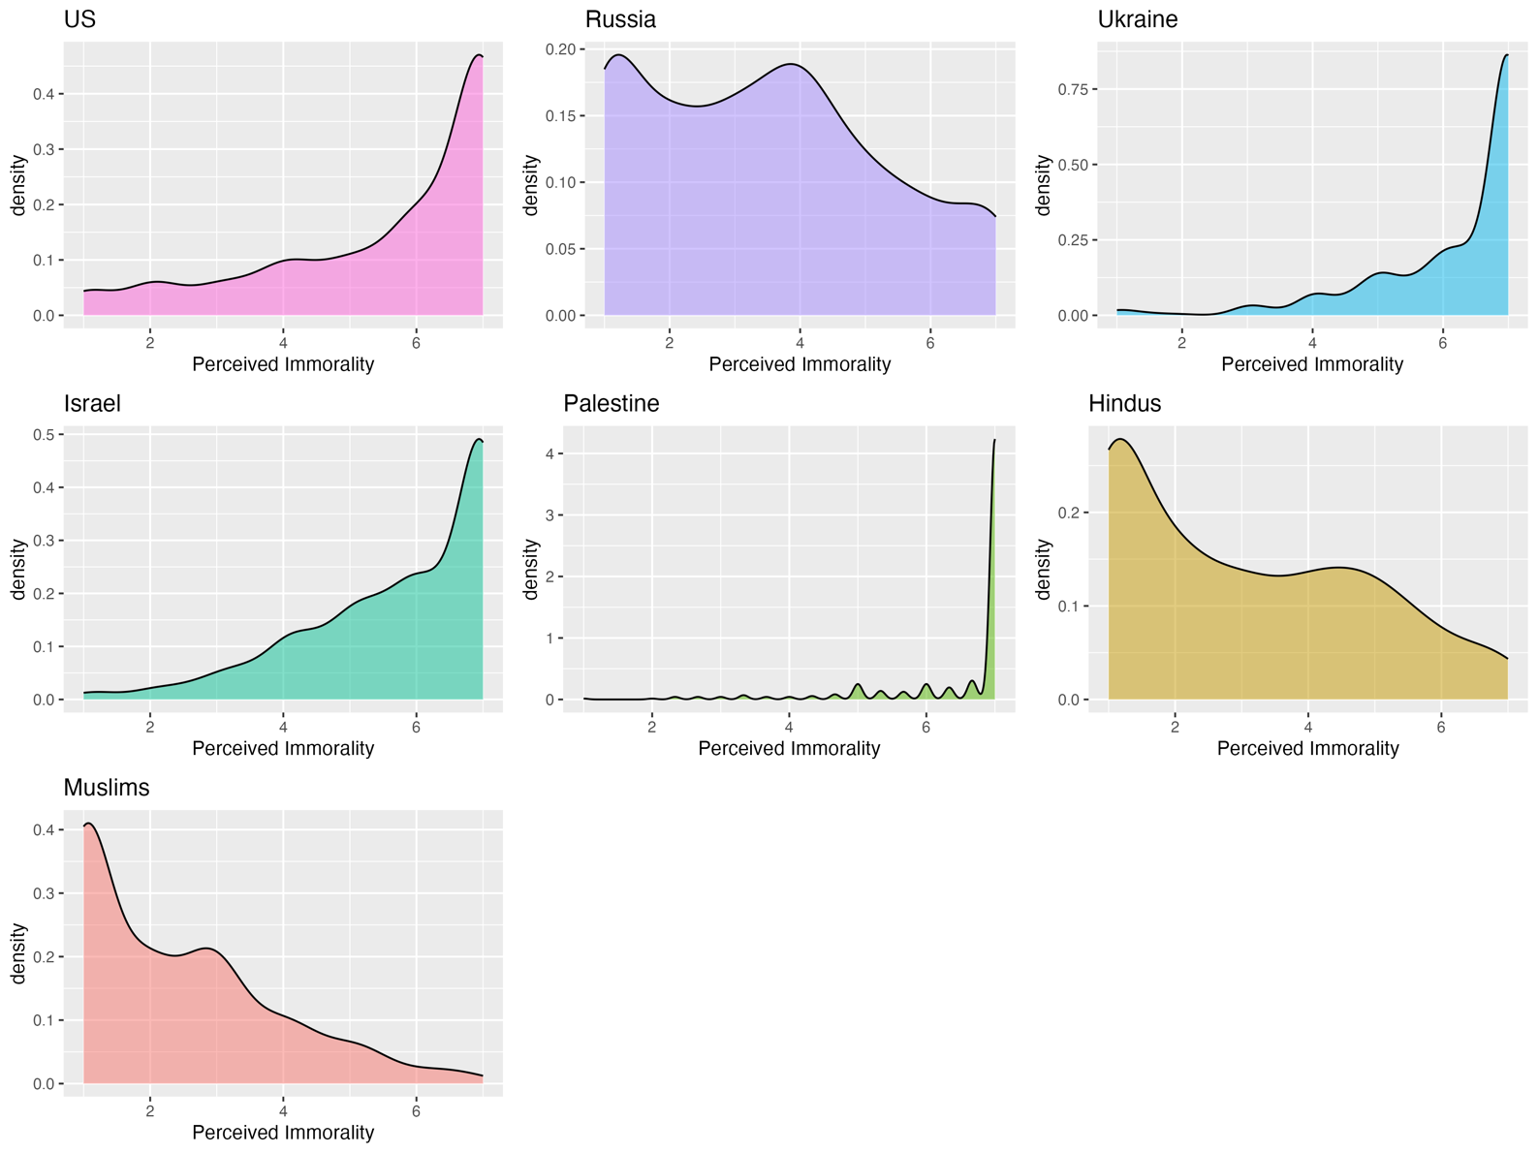

Figure S19

Density Plot Depicting Distributions of Attributions of Unintelligence Scores

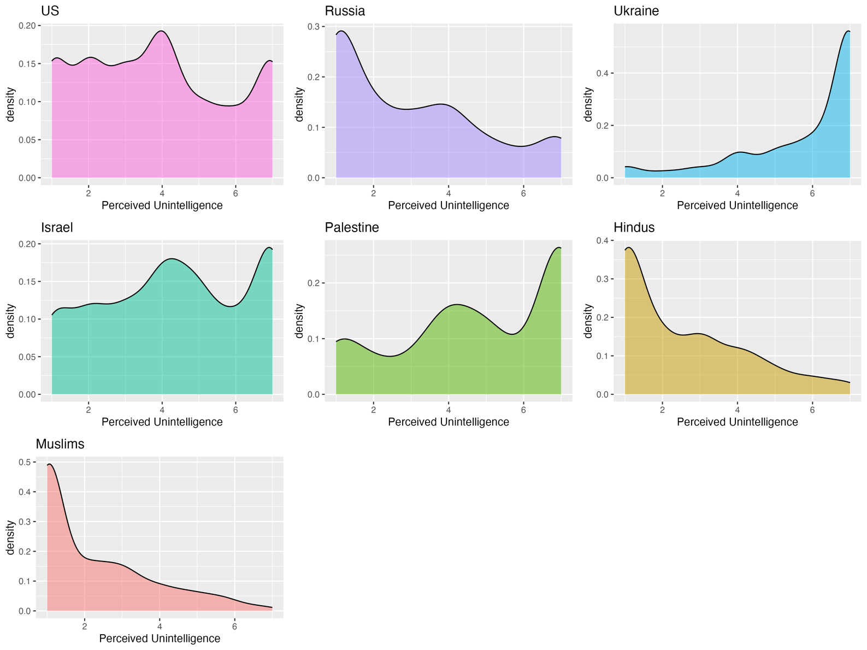

Figure S20

Density Plot Depicting Distributions of Global Derogation Scores

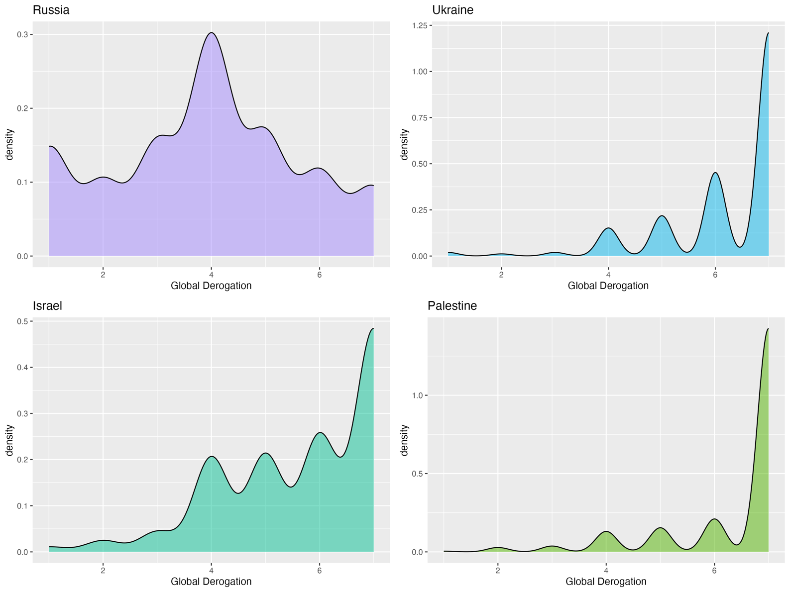

Figure S21

Density Plot Depicting Distributions of Psychological Distance Scores

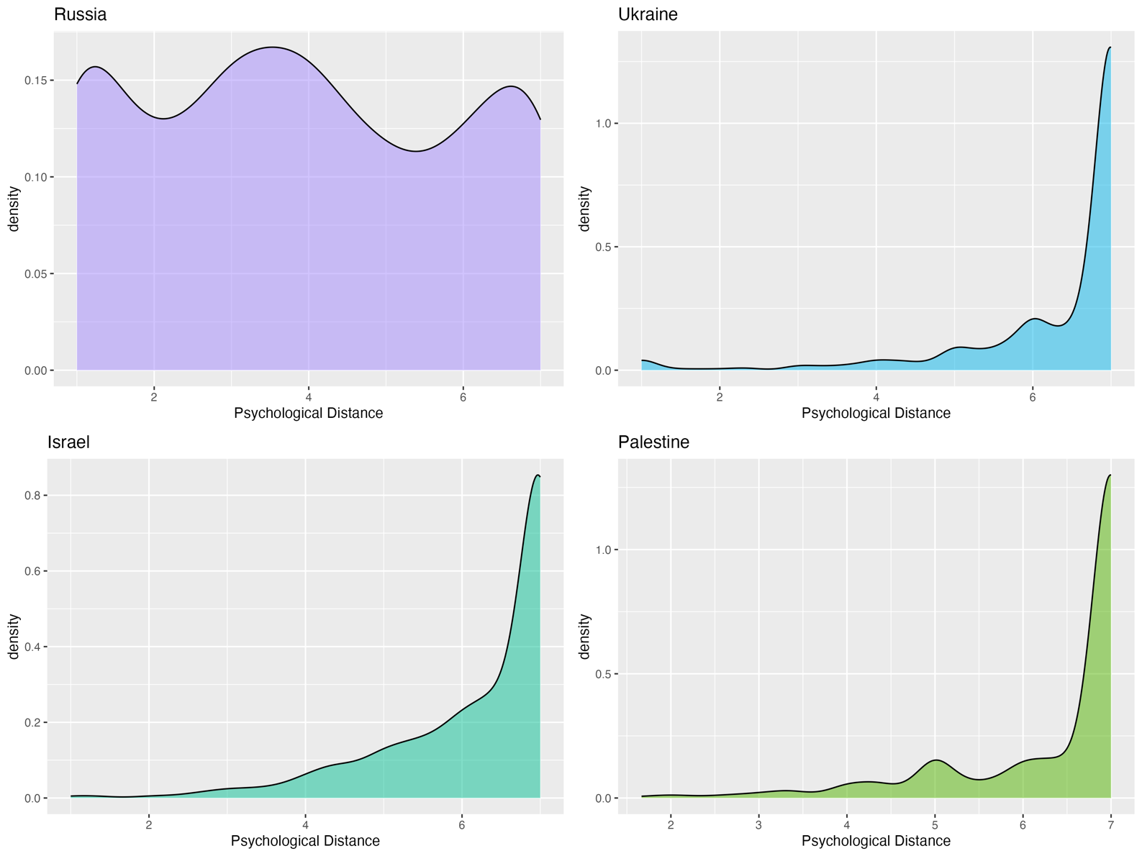

Figure S22

Density Plot Depicting Distributions of Trait Aggression Scores

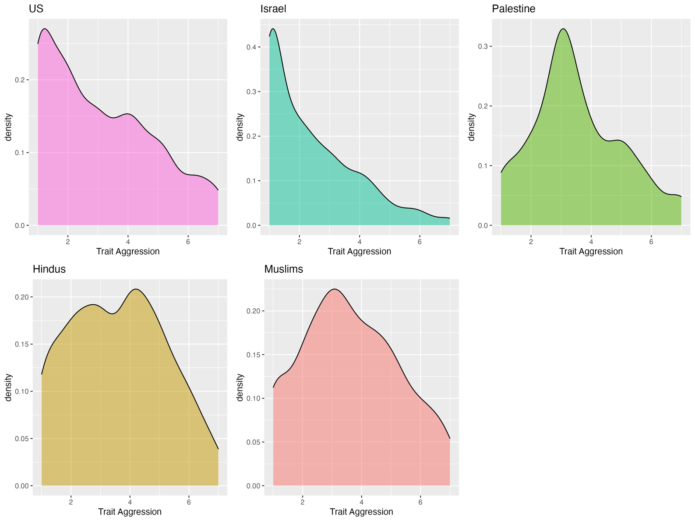

Figure S23

Density Plot Depicting Distributions of Social Dominance Orientation Scores

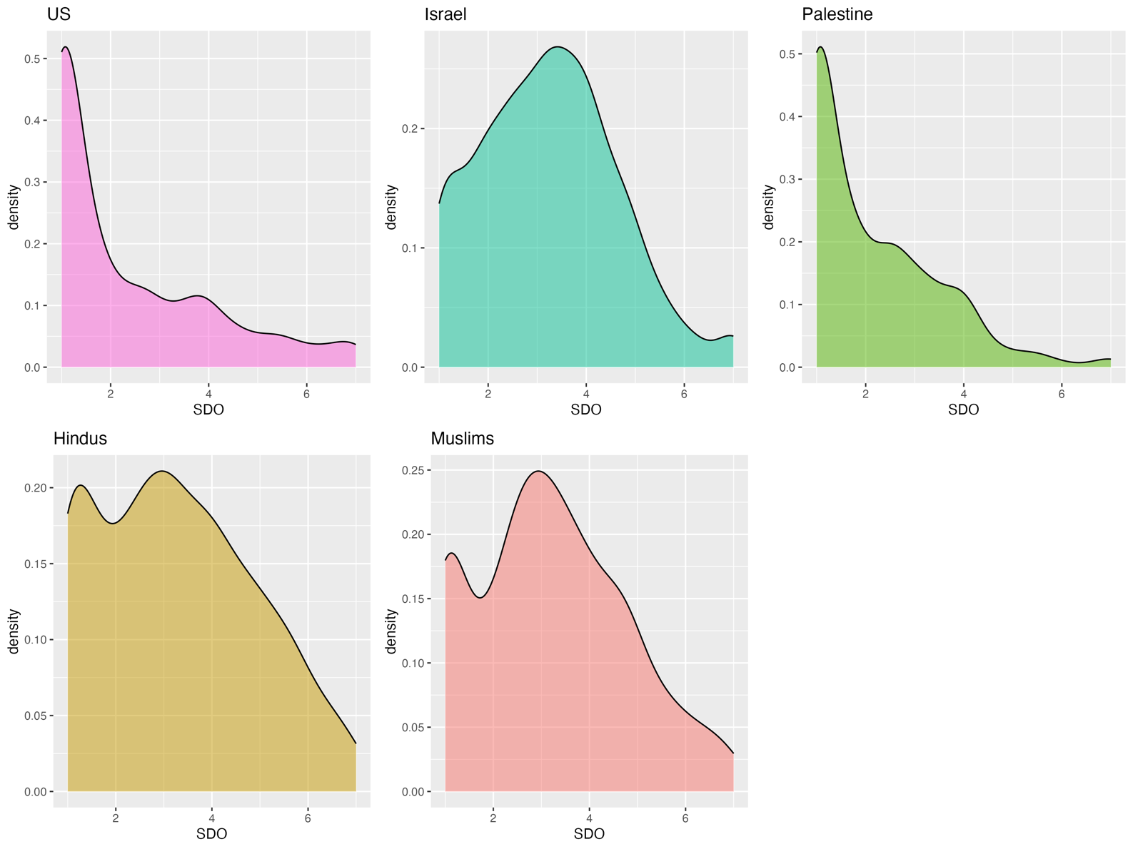

Figure S24

Density Plot Depicting Distributions of Right-Wing Authoritarianism Scores

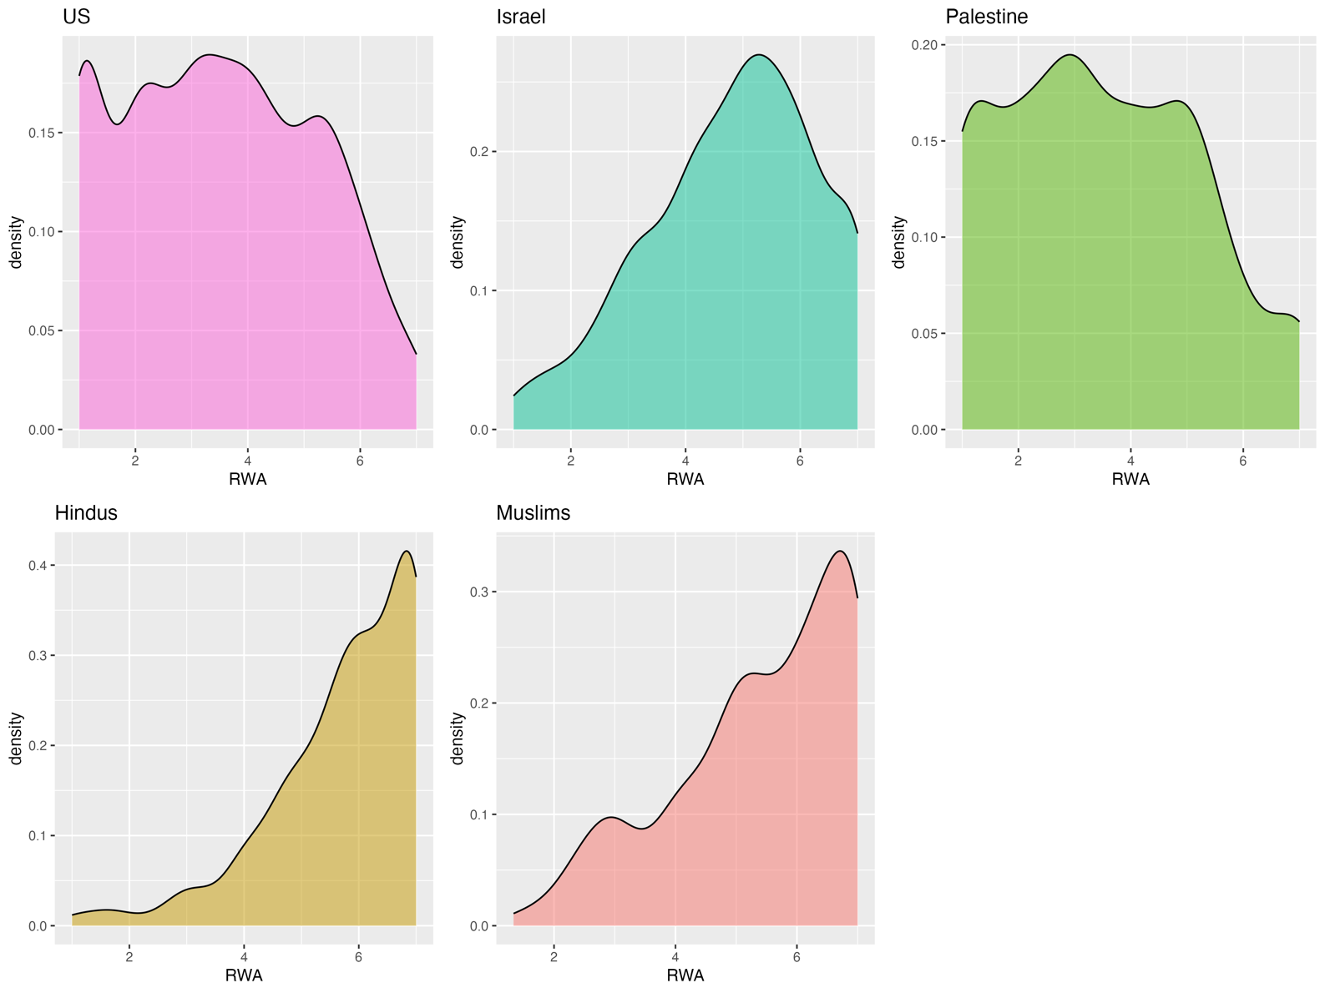

Figure S25

Density Plot Depicting Distributions of Support for Violence Scores

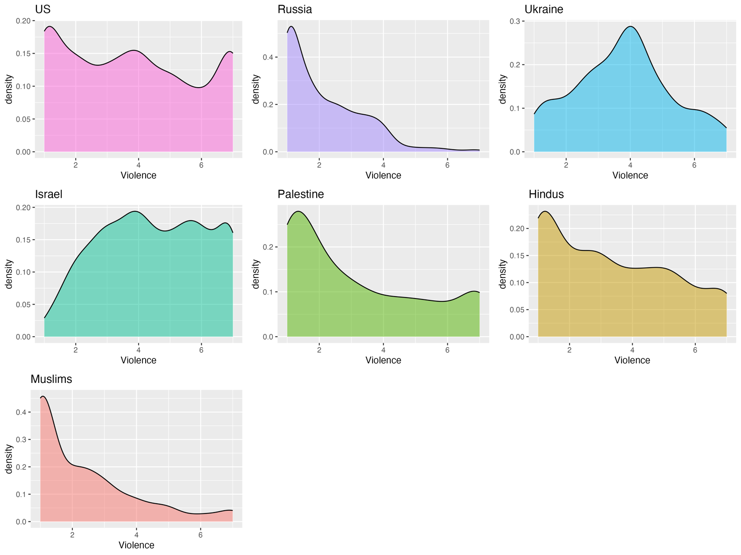

Figures S26-S32: Heatmaps Depicting Variable Intercorrelations

Figure S26

US Sample: Heatmap Depicting Variable Intercorrelations

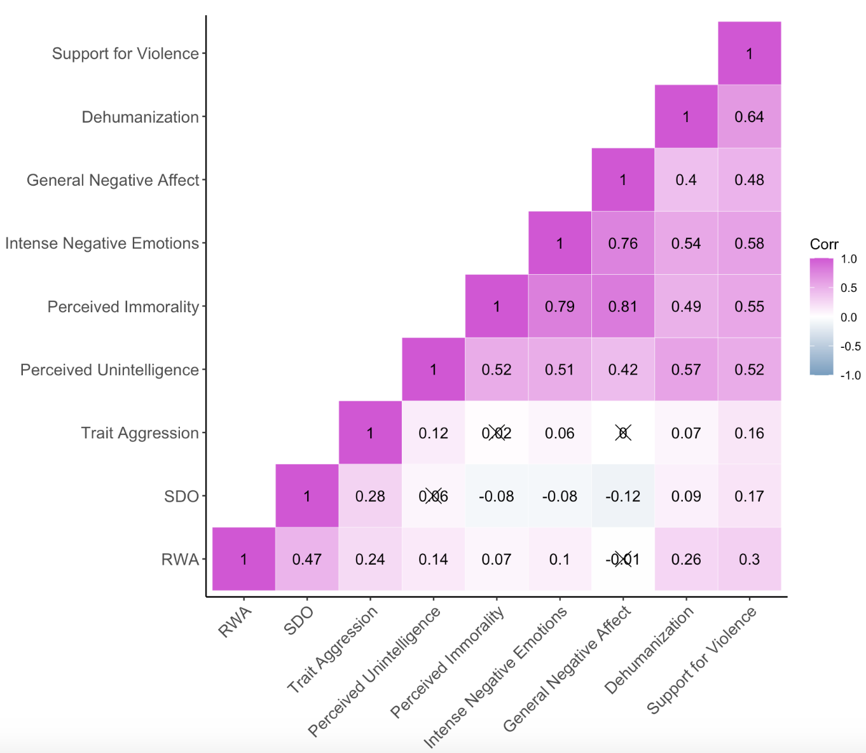

Figure S27

Russian Sample: Heatmap Depicting Variable Intercorrelations

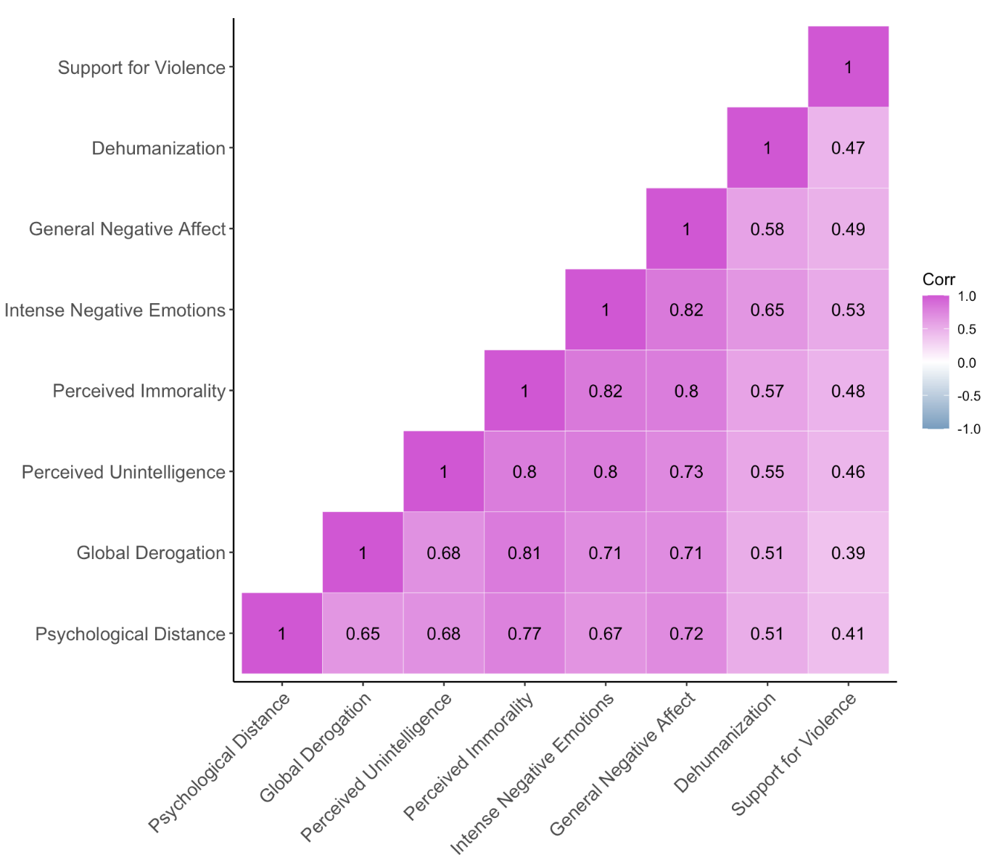

Figure S28

Ukrainian Sample: Heatmap Depicting Variable Intercorrelations

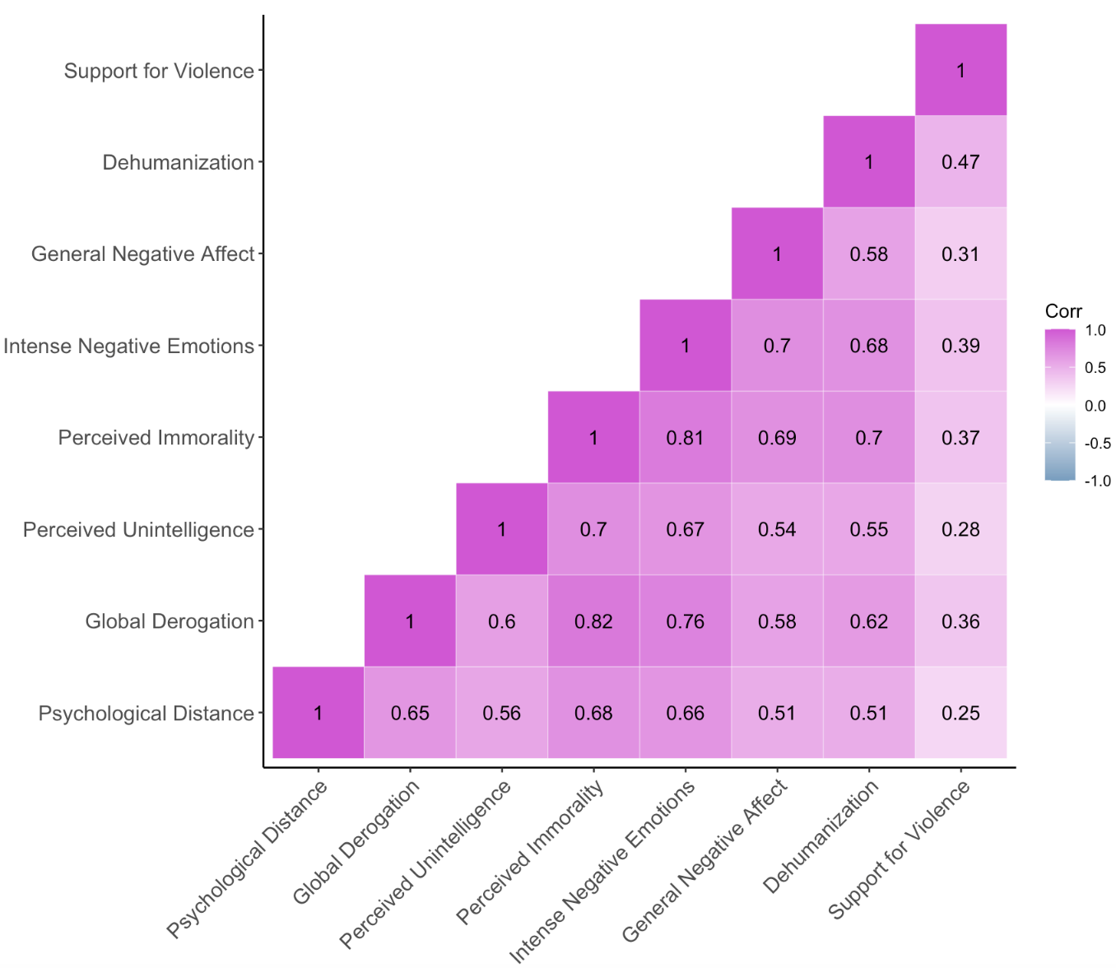

Figure S29

Israeli Sample: Heatmap Depicting Variable Intercorrelations

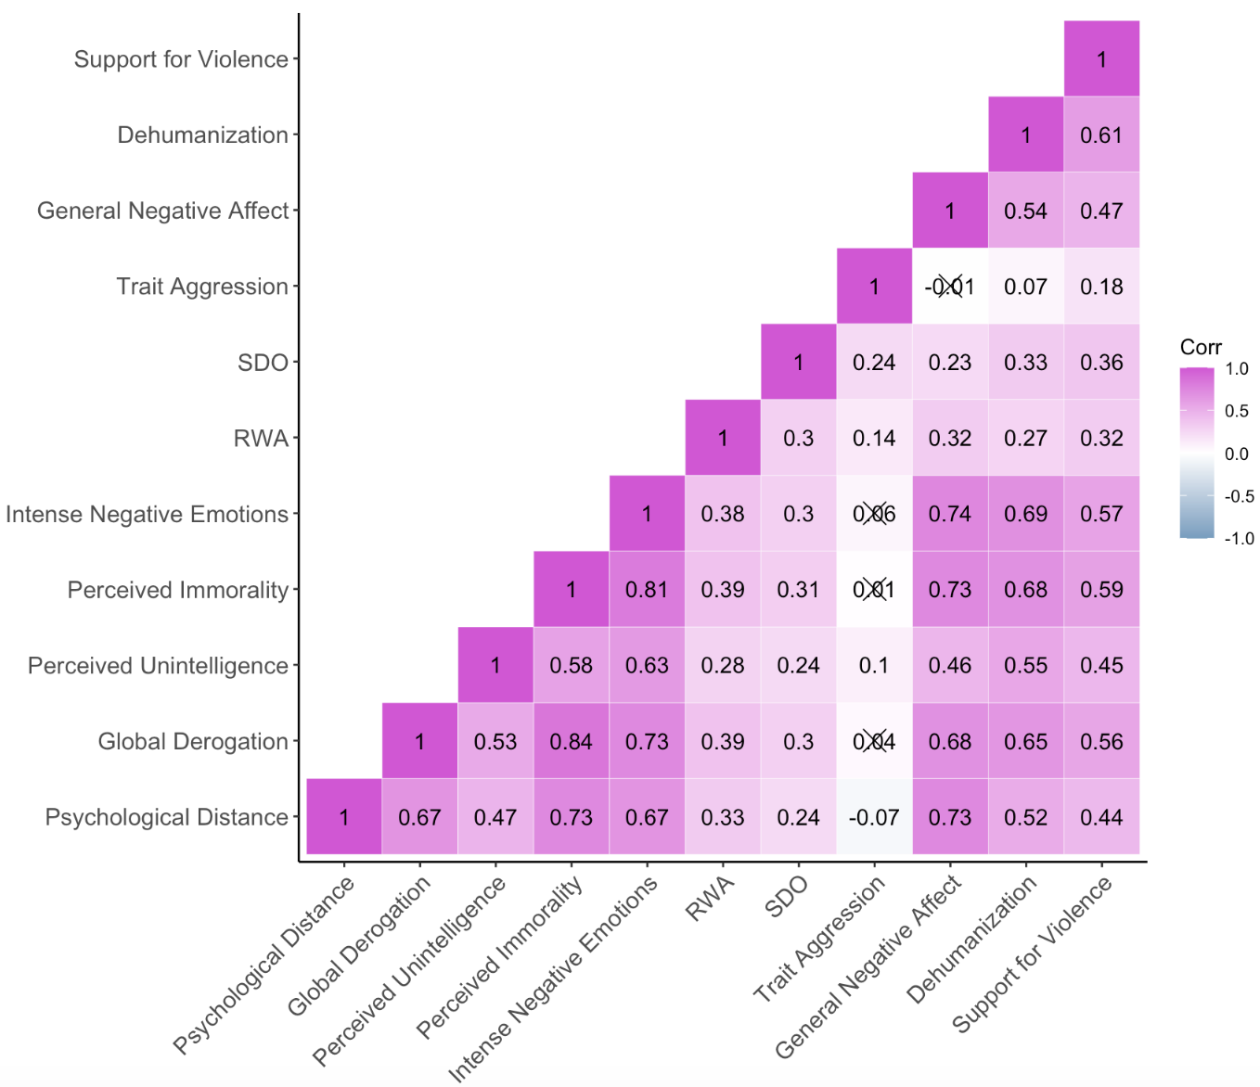

Figure S30

Palestinian Sample: Heatmap Depicting Variable Intercorrelations

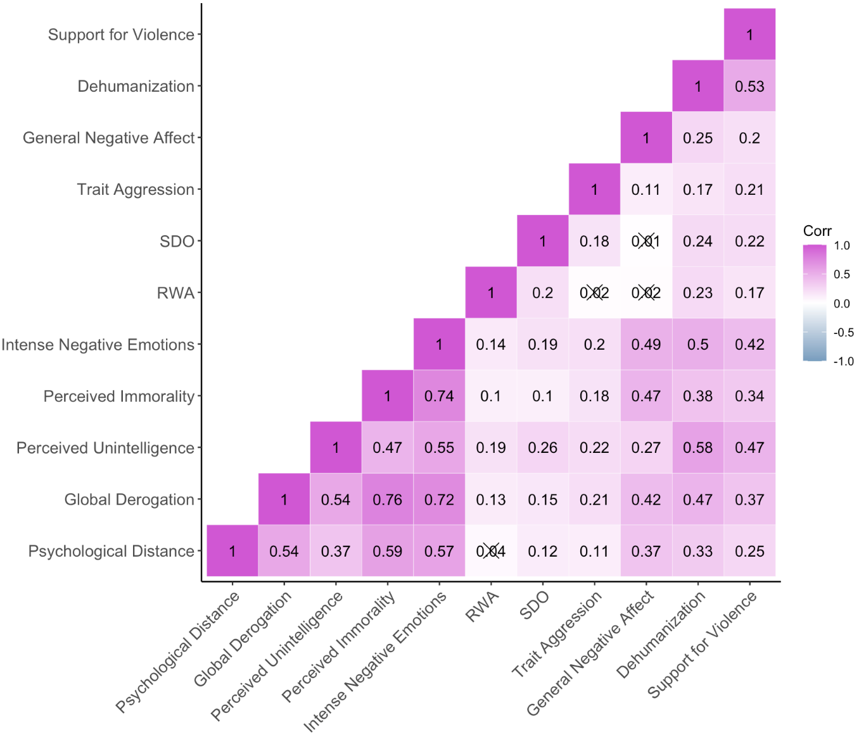

Figure S31

Hindu Sample: Heatmap Depicting Variable Intercorrelations

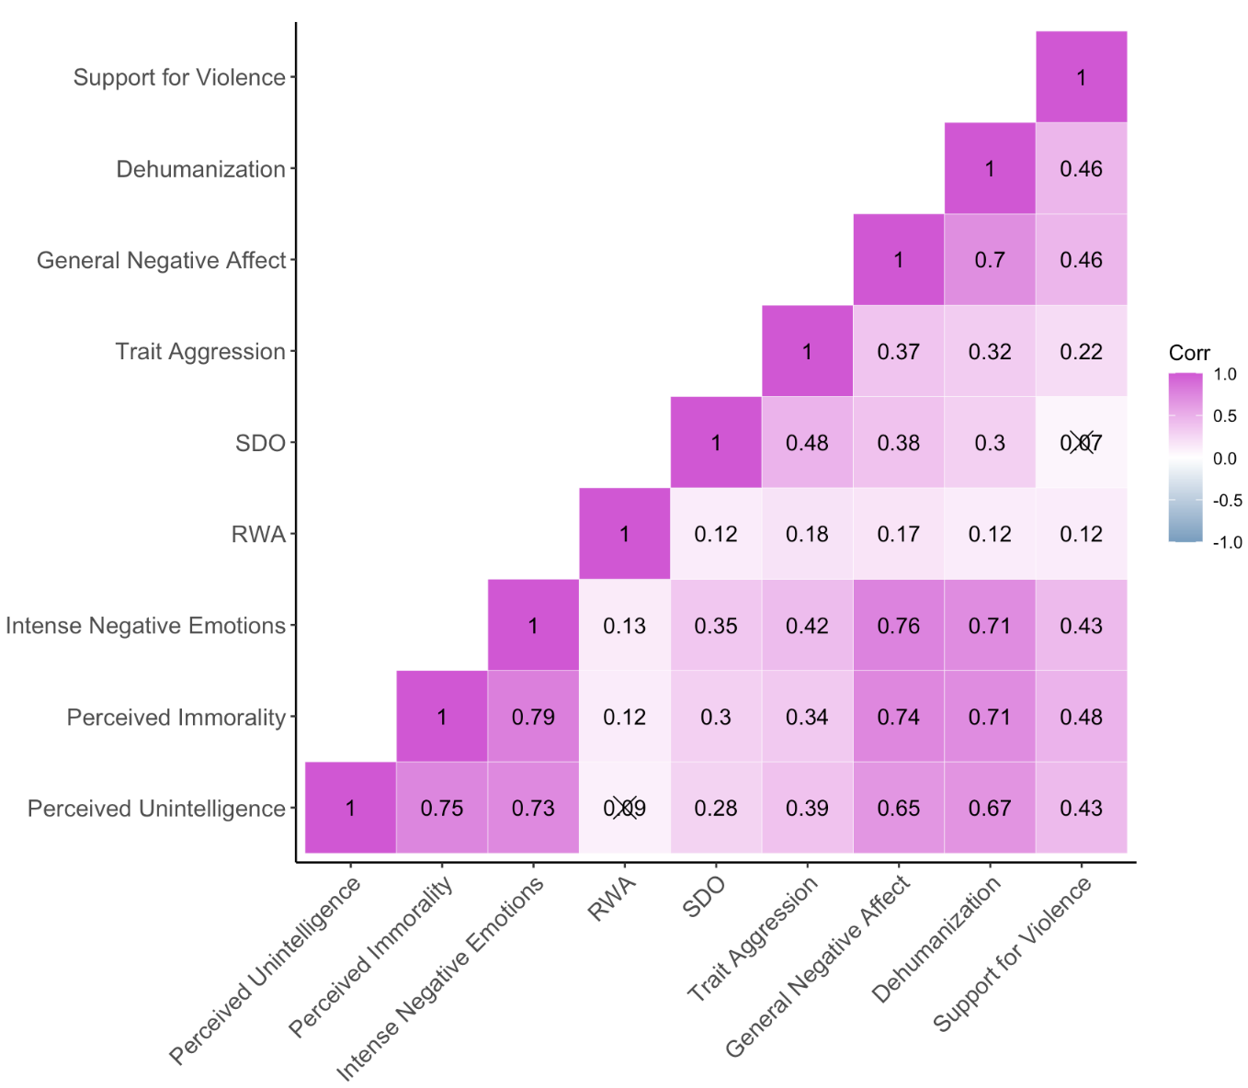

Figure S32

Muslim Sample: Heatmap Depicting Variable Intercorrelations

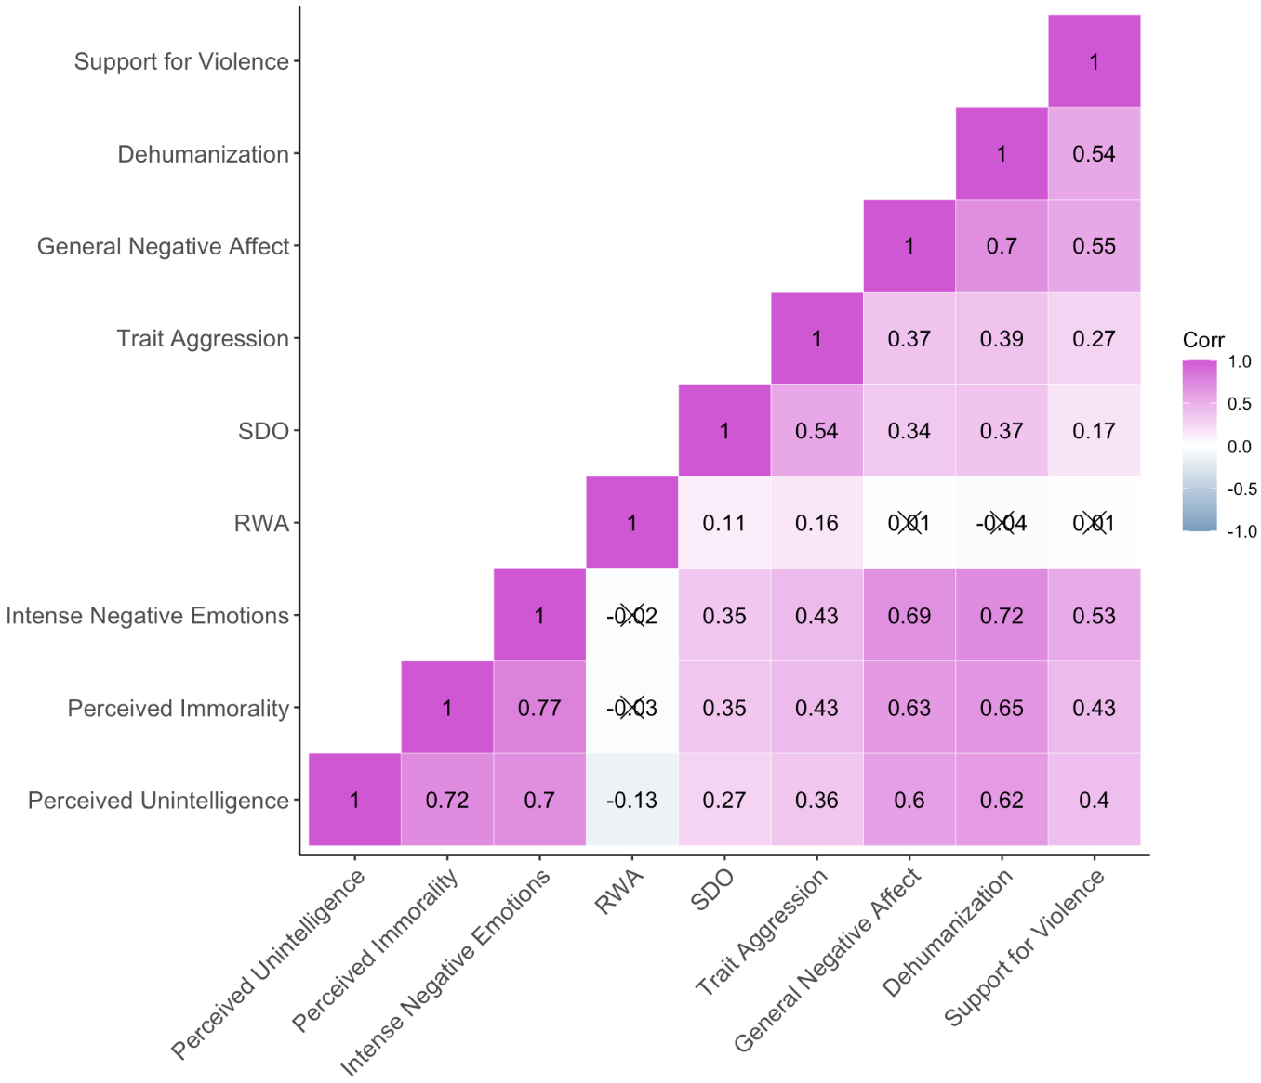

Pooled Analysis

We pooled all seven samples together and regressed support for violence on the predictors common to all samples: dehumanization, general negative affect, intense negative emotions, attributions of immorality, and attributions of unintelligence. We also included several demographic covariates common to all the samples: age, gender, and education. We did so with a multilevel model that specified random intercepts for both target group (because the US sample evaluated multiple target groups) and sample, and nested target group within sample. In this model, dehumanization emerged as a significant predictor of support for violence: β = .31 [.28, .34], p < 001. See Figure 3 in the main text for point estimates and Table S28, below, for the full output.

Tables S21-S28: Output of Multiple Linear Regression Models

Table S21
Preregistered Regression Model Output: US Sample
Predictor | b/β [95% CI] | SE | t | p | VIF
Dehumanization | .36 [.30, .41] | 0.03 | 12.51 | < .001 | 1.56
General Negative Affect | .08 [.01, .15] | 0.04 | 2.24 | .025 | 2.51
Intense Negative Emotions | .21 [.14, .28] | 0.04 | 5.68 | < .001 | 2.57
Attributions of Immorality | .08 [.01, .16] | 0.04 | 2.29 | .022 | 2.76
Attributions of Unintelligence | .11 [.06, .16] | 0.03 | 4.47 | < .001 | 1.53
Trait Aggression | .07 [.02, .13] | 0.03 | 2.56 | .010 | 1.31
Social Dominance Orientation | .10 [.04, .16] | 0.03 | 3.25 | .001 | 1.50
Right-Wing Authoritarianism | .11 [.05, .17] | 0.03 | 3.53 | < .001 | 1.46
Age | 0.00 [0.00, 0.01] | 0.00 | 1.85 | .065 | 1.18
Income | 0.02 [-0.02, 0.06] | 0.02 | 0.95 | .341 | 1.20
Gender | -0.13 [-0.24, -0.02] | 0.05 | -2.38 | .018 | 1.13
Black | 0.04 [-0.13, 0.20] | 0.09 | 0.46 | .646 | 1.16
Asian | 0.09 [-0.08, 0.26] | 0.09 | 1.00 | .320 | 1.13
Hispanic | 0.11 [-0.06, 0.28] | 0.09 | 1.22 | .222 | 1.10
Other | 0.16 [-0.17, 0.50] | 0.17 | 0.94 | .349 | 1.07
Some college | -0.13 [-0.25, -0.02] | 0.06 | -2.27 | .024 | 1.33
Advanced degree | -0.12 [-0.29, 0.05] | 0.09 | -1.38 | .170 | 1.42
Note. This was a multilevel model with random intercepts specified for participant and target group. Preregistered demographic covariates are italicized and reported in terms of unstandardized b (all other predictors are reported in terms of standardized β). Age and income are continuous, gender is coded such that 0 is “female” or “other” and 1 is “male”, race is dummy coded with “White” as the reference category, and education is dummy coded with “no college” as the reference category. Degrees of freedom for the t-value of each main predictor are as follows: dehumanization = 1,012; general negative affect = 1,144; intense negative emotions = 1,150; attributions of immorality = 1,129; attributions of unintelligence = 1,157; trait aggression = 380; social dominance orientation = 390; right-wing authoritarianism = 395.
Table S22
Preregistered Regression Model Output: Russian Sample
Predictor | β [95% CI] | SE | t(540) | p | VIF
Dehumanization | .25 [.16, .34] | 0.05 | 5.53 | < .001 | 1.63
General Negative Affect | .09 [-.04, .23] | 0.07 | 1.34 | .180 | 4.05
Intense Negative Emotions | .20 [.05, .35] | 0.08 | 2.66 | .008 | 4.98
Attributions of Immorality | .05 [-.11, .22] | 0.08 | 0.65 | .516 | 5.95
Attributions of Unintelligence | .06 [-.06, .19] | 0.06 | 1.01 | .312 | 3.45
Global Derogation | -.09 [-.21, .03] | 0.06 | -1.53 | .126 | 3.03
Psychological Distance | .05 [-.06, .16] | 0.06 | 0.83 | .405 | 2.68
Note. Data is weighted to the Russian population’s age, gender, and regional demographics (as determined by the 2023 census of the Federal Service of State Statistics of Russian Federation). Also, because of the high variance inflation factors for some measures of dislike (see the last column), we ran an additional model that reduced the VIFs to a more acceptable level. To do so, we combined the measures of general negative affect, intense negative emotions, attributions of immorality, attributions of unintelligence, and global derogation into a single composite. We then regressed support for violence on dehumanization, this composite, and psychological distance. Dehumanization continued to predict support for violence (β = .28, p < .001). For detailed results, see Section 3.10.1 of “Cross-Cultural Analyses.html” on our OSF repository: https://osf.io/2r4cu/?view_only=760f7226c1024fd598e53133066190c8.

Table S23
Preregistered Regression Model Output: Ukrainian Sample
Predictor | β [95% CI] | SE | t(526) | p | VIF
Dehumanization | .40 [.29, .50] | 0.05 | 7.40 | <.001 | 2.01
General Negative Affect | .00 [-.11, .11] | 0.05 | -0.01 | .990 | 2.04
Intense Negative Emotions | .23 [.08, .38] | 0.08 | 3.01 | .003 | 3.90
Attributions of Immorality | -.14 [-.30, .02] | 0.08 | -1.70 | .090 | 4.54
Attributions of Unintelligence | -.04 [-.14, .07] | 0.05 | -0.70 | .482 | 1.92
Global Derogation | .12 [-.02, .25] | 0.07 | 1.73 | .084 | 3.25
Psychological Distance | -.05 [-.16, .05] | 0.05 | -0.97 | .333 | 1.97
Note. Data is weighted to the Ukrainian population’s age, gender, regional, and settlement size demographics (as determined by the 2022 census of the State Statistics Service of Ukraine).

Table S24
Preregistered Regression Model Output: Israeli Sample
Predictor | b/β [95% CI] | SE | t(866) | p | VIF
Dehumanization | .31 [.24, .39] | 0.04 | 8.54 | < .001 | 2.27
General Negative Affect | .01 [-.07, .10] | 0.04 | 0.32 | .751 | 3.06
Intense Negative Emotions | .04 [-.06, .14] | 0.05 | 0.73 | .469 | 4.27
Attributions of Immorality | .20 [.09, .31] | 0.06 | 3.56 | < .001 | 5.41
Attributions of Unintelligence | .04 [-.02, .11] | 0.03 | 1.35 | .177 | 1.85
Global Derogation | .08 [-.01, .17] | 0.05 | 1.68 | .093 | 3.81
Psychological Distance | -.02 [-.10, .06] | 0.04 | -0.41 | .681 | 2.75
Trait Aggression | .13 [.08, .19] | 0.03 | 4.70 | < .001 | 1.30
Social Dominance Orientation | .12 [.06, .17] | 0.03 | 4.25 | < .001 | 1.30
Right-Wing Authoritarianism | .04 [-.01, .10] | 0.03 | 1.49 | .137 | 1.33
Age | 0.00 [0.00, 0.00] | 0.00 | -0.36 | .718 | 1.31
Gender | -0.10 [-0.20, 0.01] | 0.05 | -1.80 | .073 | 1.19
Jerusalem | -0.11 [-0.35, 0.13] | 0.12 | -0.92 | .357 | 2.40
North | -0.16 [-0.38, 0.07] | 0.12 | -1.36 | .173 | 2.67
Haifa | -0.01 [-0.25, 0.23] | 0.12 | -0.05 | .959 | 2.38
Center | -0.17 [-0.37, 0.04] | 0.11 | -1.58 | .115 | 3.88
Tel Aviv | 0.00 [-0.23, 0.22] | 0.12 | -0.04 | .970 | 3.12
South | -0.01 [-0.25, 0.23] | 0.12 | -0.09 | .926 | 2.55
Secular | -0.03 [-0.19, 0.13] | 0.08 | -0.41 | .682 | 2.53
Traditional | 0.02 [-0.13, 0.17] | 0.08 | 0.30 | .768 | 2.02
Religious | -0.01 [-0.18, 0.16] | 0.09 | -0.15 | .885 | 1.67
Note. Preregistered demographic covariates are italicized and reported in terms of unstandardized b (all other predictors are reported in terms of standardized β). Age is continuous, gender is coded such that 0 is “female” or “other” and 1 is “male”, region is dummy coded with “Judea and Samaria” as the reference category, and religiosity is dummy coded with “ultra-orthodox” as the reference category. Also, because of the high variance inflation factors for some measures of dislike (see the last column), we ran an additional model that reduced the VIFs to a more acceptable level. To do so, we combined the measures of general negative affect, intense negative emotions, attributions of immorality, global derogation, and psychological distance into a single composite. We then regressed support for violence on dehumanization, this composite, attributions of unintelligence, trait aggression, SDO, RWA, and the demographic covariates. Dehumanization continued to predict support for violence (β = .34, p < .001). For detailed results, see Section 3.10.2 of “Cross-Cultural Analyses.html” on our OSF repository.

Table S25
Preregistered Regression Model Output: Palestinian Sample
Predictor | β [95% CI] | SE | t(415) | p | VIF
Dehumanization | .35 [.24, .45] | 0.05 | 6.71 | < .001 | 1.69
General Negative Affect | .00 [-.09, .09] | 0.05 | -0.05 | .798 | 1.38
Intense Negative Emotions | .12 [-.02, .25] | 0.07 | 1.67 | .084 | 3.05
Attributions of Immorality | .06 [-.08, .20] | 0.07 | 0.81 | .442 | 3.19
Attributions of Unintelligence | .16 [.06, .27] | 0.05 | 3.04 | .008 | 1.88
Global Derogation | -.02 [-.15, .11] | 0.07 | -0.31 | .963 | 2.95
Psychological Distance | -.02 [-.13, .08] | 0.05 | -0.49 | .580 | 1.68
Trait Aggression | .08 [.00, .16] | 0.04 | 2.01 | .022 | 1.09
Social Dominance Orientation | .06 [-.03, .14] | 0.04 | 1.30 | .292 | 1.15
Right-Wing Authoritarianism | .03 [-.06, .11] | 0.04 | 0.62 | .486 | 1.09

Table S26
Preregistered Regression Model Output: Indian Hindu Sample
Predictor | b/β [95% CI] | SE | t(504) | p | VIF
Dehumanization | .14 [.03, .26] | 0.06 | 2.42 | .016 | 2.59
General Negative Affect | .24 [.11, .36] | 0.06 | 3.70 | < .001 | 3.04
Intense Negative Emotions | -.07 [-.21, .06] | 0.07 | -1.05 | .293 | 3.74
Attributions of Immorality | .24 [.10, .38] | 0.07 | 3.32 | .001 | 3.80
Attributions of Unintelligence | .07 [-.05, .19] | 0.06 | 1.11 | .268 | 2.82
Trait Aggression | .09 [.00, .18] | 0.05 | 1.98 | .049 | 1.54
Social Dominance Orientation | -.19 [-.28, -.11] | 0.04 | -4.44 | < .001 | 1.39
Right-Wing Authoritarianism | .04 [-.03, .12] | 0.04 | 1.06 | .288 | 1.06
Age | 0.01 [0.01, 0.02] | 0.00 | 3.91 | < .001 | 1.06
Gender | -0.36 [-0.51, -0.21] | 0.08 | -4.78 | < .001 | 1.06
North | 0.10 [-0.37, 0.58] | 0.24 | 0.42 | .674 | 8.80
South | 0.38 [-0.10, 0.86] | 0.24 | 1.56 | .118 | 8.49
East | 0.28 [-0.21, 0.77] | 0.25 | 1.12 | .264 | 5.92
West | 0.40 [-0.08, 0.88] | 0.25 | 1.62 | .105 | 7.53
Central | -0.25 [-0.78, 0.27] | 0.27 | -0.96 | .339 | 3.90
Note. Preregistered demographic covariates are italicized and reported in terms of unstandardized b (all other predictors are reported in terms of standardized β). Age is continuous, gender is coded such that 0 is “female” or “other” and 1 is “male”, and region is dummy coded with “Northeast” as the reference category. Also note the high VIFs for the regional demographics, which can occur when dummy variables are not independent from one another (Murray et al., 2012). Regardless, when the demographic covariates are removed, dehumanization remains a significant predictor of support for violence (β = .18, p = .004; see Section 3.5.3 of “Cross-Cultural Analyses.html” on our OSF repository for detailed results).

Table S27
Preregistered Regression Model Output: Indian Muslim Sample
Predictor | b/β [95% CI] | SE | t(487) | p | VIF
Dehumanization | .25 [.14, .37] | 0.06 | 4.36 | < .001 | 2.60
General Negative Affect | .24 [.13, .36] | 0.06 | 4.11 | < .001 | 2.66
Intense Negative Emotions | .27 [.13, .41] | 0.07 | 3.91 | < .001 | 3.66
Attributions of Immorality | -.02 [-.15, .11] | 0.06 | -0.31 | .754 | 3.14
Attributions of Unintelligence | -.07 [-.19, .04] | 0.06 | -1.25 | .213 | 2.58
Trait Aggression | .07 [-.02, .17] | 0.05 | 1.55 | .122 | 1.68
Social Dominance Orientation | -.11 [-.20, -.02] | 0.04 | -2.51 | .012 | 1.51
Right-Wing Authoritarianism | .01 [-.07, .09] | 0.04 | 0.29 | .774 | 1.19
Age | 0.01 [0.00, 0.02] | 0.00 | 2.92 | .004 | 1.12
Gender | -0.14 [-0.30, 0.01] | 0.08 | -1.89 | .059 | 1.13
North | -0.02 [-0.34, 0.30] | 0.16 | -0.12 | .908 | 3.84
South | -0.01 [-0.34, 0.31] | 0.16 | -0.08 | .935 | 3.78
East | -0.15 [-0.50, 0.20] | 0.18 | -0.86 | .391 | 2.78
West | -0.11 [-0.43, 0.21] | 0.16 | -0.67 | .504 | 3.92
Central | -0.21 [-0.63, 0.21] | 0.21 | -0.97 | .332 | 1.78
Note. Preregistered demographic covariates are italicized and reported in terms of unstandardized b (all other predictors are reported in terms of standardized β). Age is continuous, gender is coded such that 0 is “female” or “other” and 1 is “male”, and region is dummy coded with “Northeast” as the reference category.

Table S28
Output for Regression Model in Pooled Analysis
Predictor | b/β [95% CI] | SE | t | p | VIF
Dehumanization | .31 [.28, .34] | 0.01 | 21.38 | < .001 | 1.80
General Negative Affect | .03 [.00, .06] | 0.02 | 1.78 | .075 | 2.29
Intense Negative Emotions | .19 [.14, .24] | 0.03 | 7.08 | < .001 | 3.31
Attributions of Immorality | .08 [.03, .13] | 0.03 | 3.01 | .003 | 3.07
Attributions of Unintelligence | .09 [.06, .12] | 0.02 | 5.19 | < .001 | 1.90
Age | 0.00 [0.00, 0.00] | 0.00 | 1.50 | .134 | 1.04
Gender | 0.05 [0.01, 0.09] | 0.02 | 2.22 | .027 | 1.00
Some college | -0.08 [-0.13, -0.02] | 0.03 | -2.84 | .005 | 1.18
Advanced degree | -0.14 [-0.23, -0.05] | 0.04 | -3.16 | .002 | 1.19
Note. This was a multilevel model with random intercepts specified for sample and target group (with target group nested within sample). Demographic covariates are italicized and reported in terms of unstandardized b (all other predictors are reported in terms of standardized β). Age is continuous, gender is coded such that 0 is “female” or “other” and 1 is “male”, and education is dummy coded with “no college” as the reference category. Degrees of freedom for the t-value of the main predictors are as follows: dehumanization = 4,434; general negative affect = 4,173; intense negative emotions = 4,386; attributions of immorality = 4,331; attributions of unintelligence = 4,463.

Robustness Tests

These effects replicated when using the un-imputed data and two alternative imputation methods (median imputation and k-nearest neighbors; Fix & Hodges, 1951). They also replicated when we did not apply preregistered data exclusions, removed preregistered demographic covariates (in the US, Israeli, and Muslim samples), used unweighted data (in the Russian and Ukrainian samples), included several demographic covariates (in the Palestinian sample), and used each measure of dehumanization separately. For detailed results of these robustness tests, see Section 3 of “Cross-Cultural Analyses.html” on our OSF repository: https://osf.io/2r4cu/?view_only=760f7226c1024fd598e53133066190c8.

Also, in the Russian and Israeli samples, we observed high variance inflation factors (VIFs) among some of the dislike measures, suggesting multicollinearity (Thompson et al., 2017). Therefore, we also ran additional models in these samples combining the dislike measures with high VIFs. This reduced the VIFs to an acceptable level, and dehumanization continued to strongly predict support for violence (see Section 3.10 of “Cross-Cultural Analyses.html”).

Cross-Cultural Studies: Comparing Dehumanization to Other Predictors

As described in the main text, in each individual sample and in all samples pooled together, we regressed support for violence on dehumanization, each of the dislike measures, and (in applicable samples) the personality covariates and preregistered demographic covariates. For each of these regressions, we compared the strength of dehumanization’s effect on support for violence with those of the other predictors using nested model comparisons.
For each sample and all samples pooled together, we began with a baseline model: the regression model described in the main text. From this baseline model, we created a series of otherwise-identical models where the effect of dehumanization was constrained to be equal to one of the other predictors. For instance, in the US sample, along with the baseline model, we created seven additional models, each of which constrained the effect of dehumanization to be equal to one of the other seven predictors in that study. We then compared how much variance in support for violence each of these constrained models explained, relative to the baseline model, using F-tests for multiple regression models and likelihood ratio tests for multilevel models. In cases where dehumanization has a larger coefficient than the other predictor, a significant difference indicates that dehumanization’s effect on support for violence is stronger than that of the predictor it is being compared to.
Table S29 reports the results of these tests. Each cell contains the standardized point estimates in the baseline model for dehumanization and the relevant predictor. Green cells indicate that dehumanization’s effect is significantly greater than the other predictor and white cells indicate the effects do not differ (gray cells indicate that comparison was not performed because the relevant predictor was not measured in that sample). Note that, for the comparisons between dehumanization and each predictor, we applied Bonferroni corrections to the criterion for statistical significance.
To summarize the findings, dehumanization had a significantly stronger effect on support for violence than the other predictor in 38 comparisons (69%), and there was no significant difference in the other 17 comparisons.
For detailed results, see Sections 2 (for each individual sample) and 4.3 (for all samples pooled together) in “Cross-Cultural Analyses.html” on our OSF repository: https://osf.io/2r4cu/?view_only=760f7226c1024fd598e53133066190c8.

Table S29
Nested Model Comparisons of Dehumanization to the Other Predictors in the Cross-Cultural Studies
Sample | vs General Negative Affect | vs Intense Negative Emotions | vs Perceived Immorality | vs Perceived Unintelligence | vs Global Derogation | vs Psychological Distance | vs Trait Aggression | vs Social Dominance Orientation | vs Right-Wing Authoritarianism
US | .36 vs .08 | .36 vs .21 | .36 vs .08 | .36 vs .11 | -- | -- | .36 vs .07 | .36 vs .10 | .36 vs .11
Russia | .25 vs .09 | .25 vs .20 | .25 vs .05 | .25 vs .06 | .25 vs -.09 | .25 vs .05 | -- | -- | --
Ukraine | .40 vs .00 | .40 vs .23 | .40 vs -.14 | .40 vs -.04 | .40 vs .12 | .40 vs -.05 | -- | -- | --
Israel | .31 vs .01 | .31 vs .04 | .31 vs .20 | .31 vs .04 | .31 vs .08 | .31 vs -.02 | .31 vs .13 | .31 vs .12 | .31 vs .04
Palestine | .35 vs .00 | .35 vs .12 | .35 vs .06 | .35 vs .16 | .35 vs -.02 | .35 vs -.02 | .35 vs .08 | .35 vs .06 | .35 vs .03
Hindus | .14 vs .24 | .14 vs -.07 | .14 vs .24 | .14 vs .07 | -- | -- | .14 vs .09 | .14 vs -.19 | .14 vs .04
Muslims | .25 vs .24 | .25 vs .27 | .25 vs -.02 | .25 vs -.07 | -- | -- | .25 vs .07 | .25 vs -.11 | .25 vs .01
All samples combined | .31 vs .03 | .31 vs .19 | .31 vs .08 | .31 vs .09 | -- | -- | -- | -- | --
Note. Values in cells refer to the standardized point estimate of dehumanization and the relevant predictor in the baseline regression model (i.e., the regression model reported in the main text), while the color of the cell indicates the results of the nested model comparison. Green cells indicate that dehumanization’s effect is significantly greater than the other predictor and white cells indicate the effects do not differ (gray cells indicate that comparison was not performed because the relevant predictor was not measured in that sample). Note that, for the comparisons between dehumanization and each predictor, we applied Bonferroni corrections to the criterion for statistical significance.

Table S30

“Metaphorical vs Literal” Dehumanization Regression Model Output
Predictor | b/β [95% CI] | SE | t | p | VIF
Metaphorical (0) vs literal (1) | 0.41 [0.24, 0.59] | 0.09 | 4.68 | < .001 | 1.12
(Quantitative) dehumanization | .56 [.41, .72] | 0.08 | 7.14 | < .001 | 2.01
General Negative Affect | .16 [.01, .31] | 0.07 | 2.19 | .029 | 2.23
Intense Negative Emotions | .42 [.20, .64] | 0.11 | 3.72 | < .001 | 2.57
Attributions of Immorality | .17 [-.09, .43] | 0.13 | 1.27 | .204 | 2.49
Attributions of Unintelligence | .11 [-.02, .24] | 0.07 | 1.65 | .100 | 1.51
Note. This was a multilevel model with random intercepts specified for sample. The binary indicator variable denoting whether a respondent was a “metaphorical” (0) or “literal” (1) dehumanizer is reported in terms of unstandardized b for interpretability, as this value simply represents the increase in support for violence associated with moving from “metaphorical” to “literal.” The estimates for all the other predictors are reported in terms of standardized β. Degrees of freedom for the t-value of each predictor are as follows: metaphorical vs literal indicator = 1,170; (quantitative) dehumanization = 1,121; general negative affect = 1,097; intense negative emotions = 1,161; attributions of immorality = 1,052; attributions of unintelligence = 1,171.

Supplemental Material for the Experiment

Table S31

Descriptive Statistics and Reliabilities for Continuous Variables in the Experiment
Condition | Dehumanization |  |  | General Affect |  |  | Intense Negative Emotions |  |  | Immorality |  |  | Unintelligence |  |  | Support for War Crimes
 | M | SD | r | M | SD | r | M | SD | ω | M | SD | ω | M | SD | ω | M | SD | ω
Control | 0.20 | 1.07 | .78 | 0.40 | 0.80 | .75 | 4.10 | 1.81 | .93 | 4.55 | 1.82 | .95 | 3.17 | 1.79 | .98 | 2.44 | 1.61 | .92
Intervention | -0.24 | 0.70 | .75 | -0.48 | 0.88 | .75 | 2.77 | 1.58 | .95 | 2.85 | 1.61 | .96 | 2.75 | 1.64 | .98 | 1.85 | 1.30 | .94
Note. For dehumanization, r refers to the zero-order correlation between the Ascent of Man scale and the dehumanizing sentiments (these were standardized and combined into a single dehumanization composite). For general negative affect, r refers to the zero-order correlation between the feeling thermometer and the disliking sentiments (these were standardized and combined into a single dislike composite). For all other measures, ω refers to the McDonald’s Omega reliability for the items comprising them.

Figure S33

Zero-Order Correlations Among Continuous Variables for Participants in the Control Condition (n = 412)
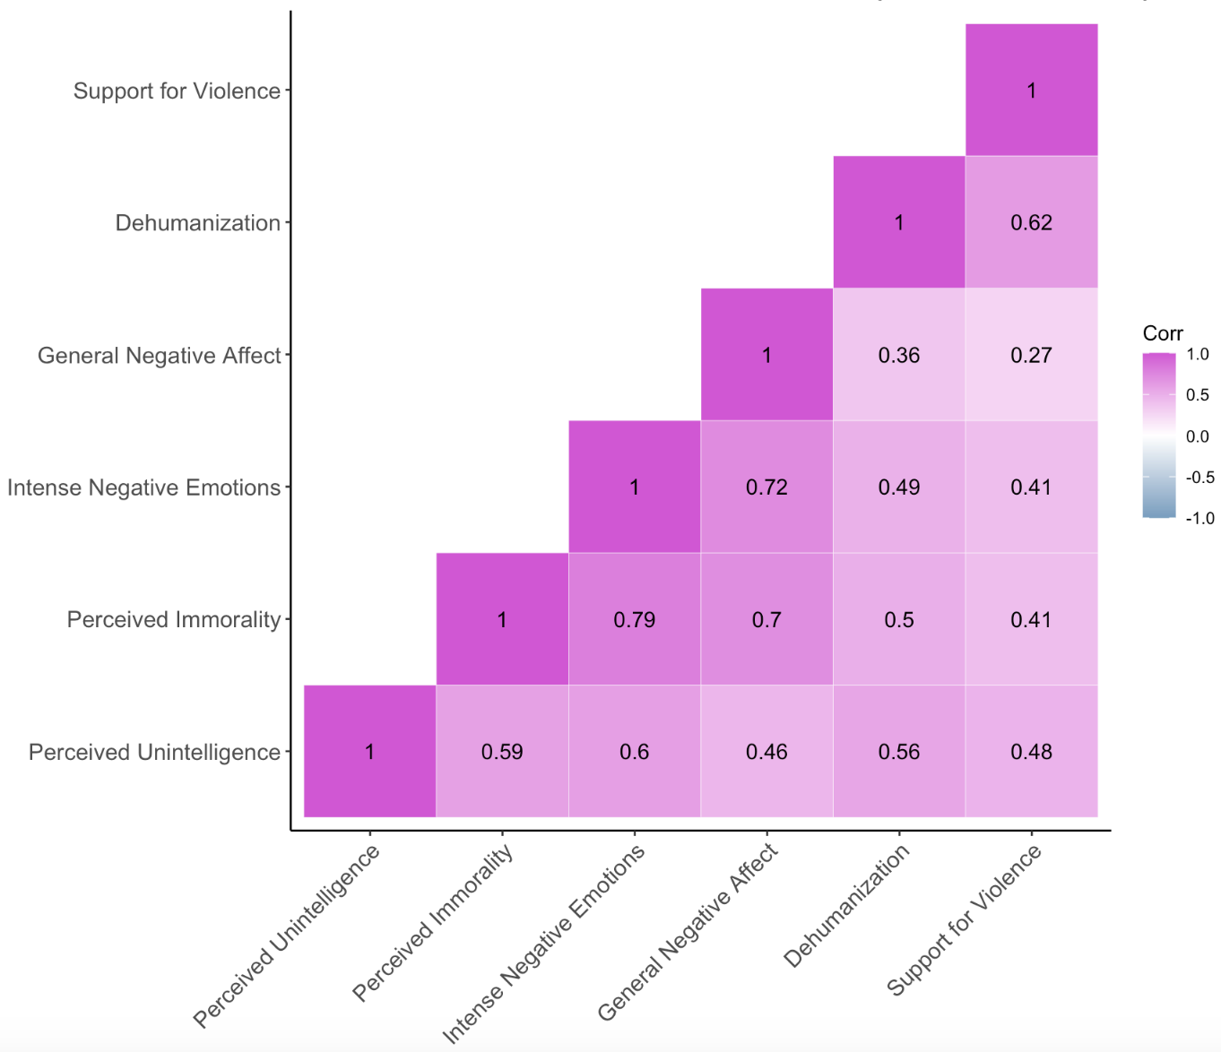

Figure S34

Zero-Order Correlations Among Continuous Variables for Participants in the Intervention Condition (n = 341)
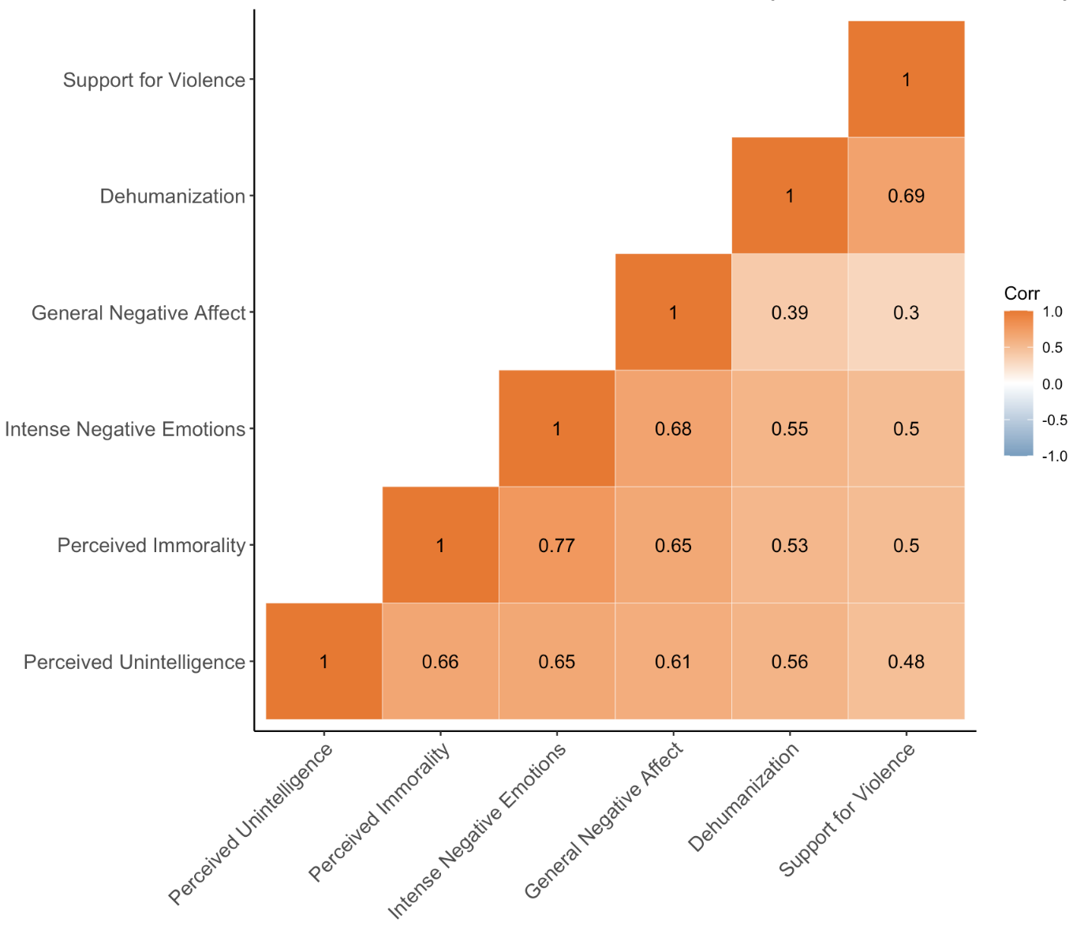

Table S32

Output for Model Regressing Support for War Crimes on all Continuous Mediators in Experiment

Predictor | β [95% CI] | SE | t(742) | p | VIF
Dehumanization | .51 [.44, .57] | 0.03 | 14.74 | < .001 | 1.65
General Negative Affect | -.11 [-.19, -.02] | 0.04 | -2.46 | .014 | 2.57
Intense Negative Emotions | .12 [.02, .22] | 0.05 | 2.37 | .018 | 3.68
Attributions of Immorality | .11 [.01, .21] | 0.05 | 2.08 | .038 | 3.61
Attributions of Unintelligence | .11 [.04, .19] | 0.04 | 3.10 | .002 | 1.90

Experiment: Comparing Dehumanization to Other Predictors

As described in the main text, we regressed support for war crimes on dehumanization and the four dislike measures (general negative affect, intense negative emotions, attributions of immorality, and attributions of unintelligence) in a simultaneous linear regression. We then compared the strength of dehumanization’s effect on war crime support with that of each dislike measure. Specifically, from the baseline regression model described in the main text, we created four otherwise-identical models where the effect of dehumanization was constrained to be equal to one of the dislike measures. We used F-tests to compare how much variance in war crime support each of these constrained models explain, relative to the baseline model.
In each case, the baseline model explained significantly more variance than the constrained model. Because the effect of dehumanization was numerically greater than all measures of dislike (see Table S32, above), we can conclude that dehumanization was a significantly stronger predictor of support for war crimes than any of the dislike measures.
For the full results, see Section 2.3 of “Experiment Analyses.html” on our OSF repository: https://osf.io/2r4cu/?view_only=760f7226c1024fd598e53133066190c8

Figures S35-S40: Effect of Intervention on Each Dependent Variable

Figure S35
Effect of the Intervention on Reduced Dehumanization
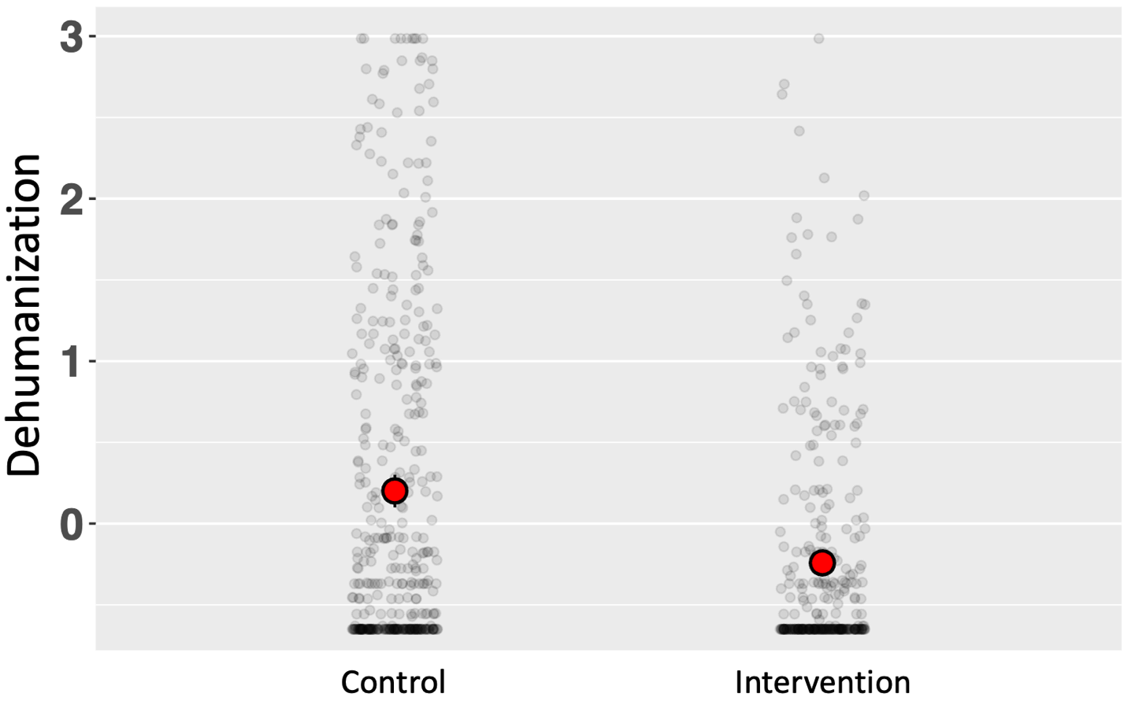
Note. Scores ranged from -0.65 to 2.99, as this variable was the standardized (z-scored composite) of the Ascent of Man scale and dehumanizing sentiments. M_{diff} = 0.44 [0.32, 0.57], SE_{diff} = 0.06, t(712) = 6.83, d = 0.48, p < .001.

Figure S36
Effect of the Intervention on Reduced Support for War Crimes
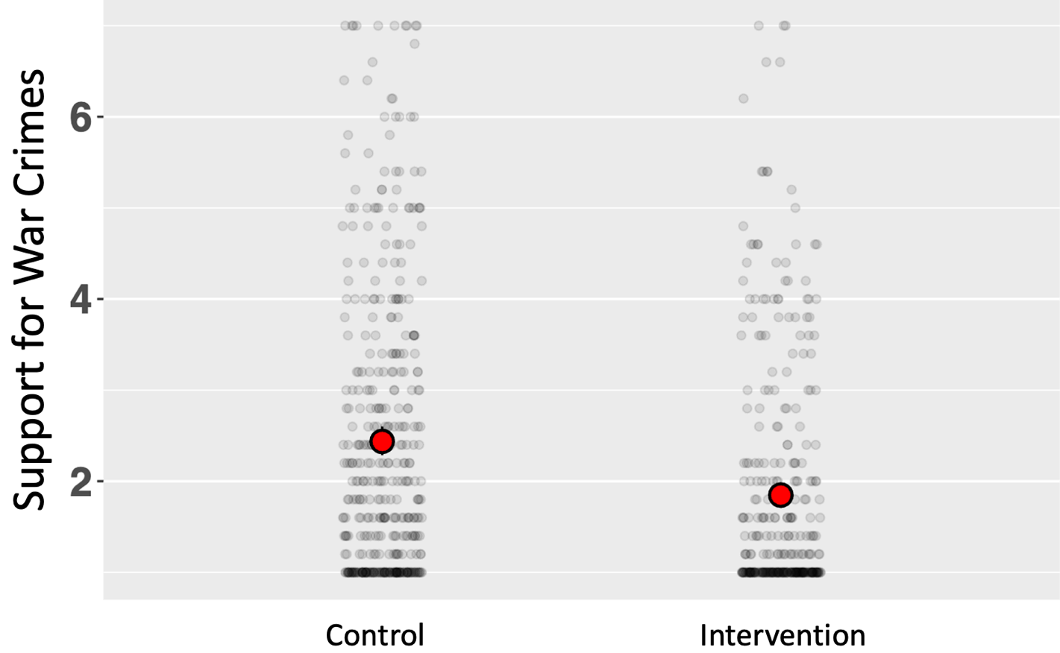
Note. Scores ranged from 1 to 7. M_{diff} = 0.59 [0.38, 0.80], SE_{diff} = 0.11, t(746) = 5.54, d = 0.40, p < .001.

Figure S37
Effect of the Intervention on Reduced General Negative Affect
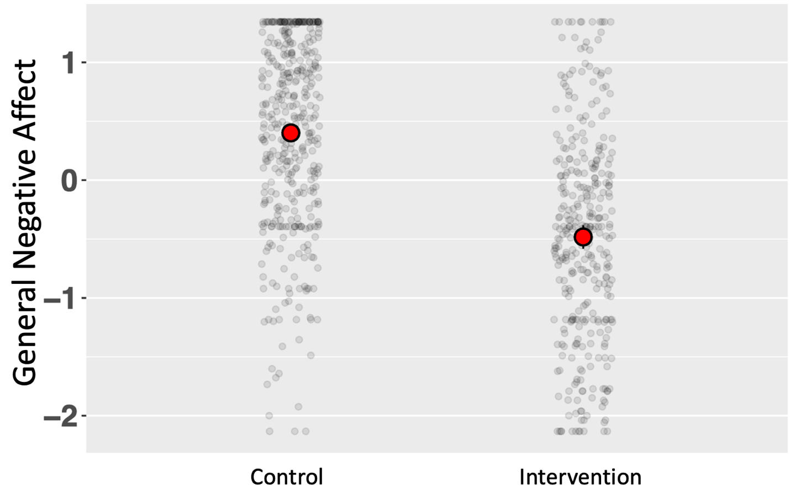
Note. Scores ranged from -2.13 to 1.34, as this variable was the standardized (z-scored composite) of the feeling thermometer and disliking sentiments. M_{diff} = 0.88 [0.76, 1.00], SE_{diff} = 0.06, t(747) = 14.34, d = 1.05, p < .001.

Figure S38
Effect of the Intervention on Reduced Intense Negative Emotions
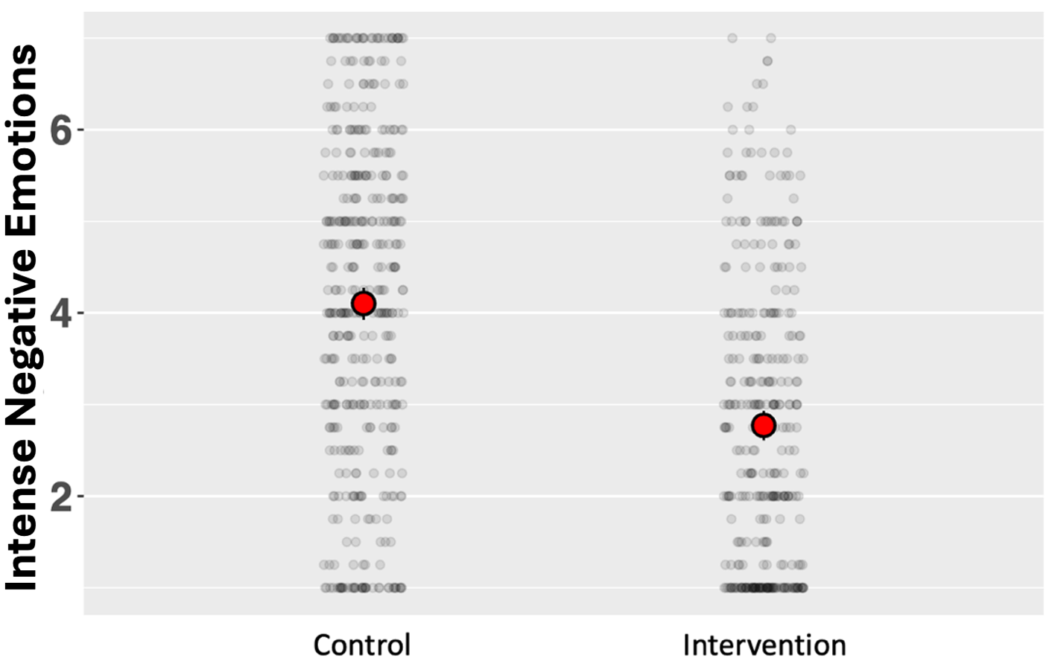
Note. Scores ranged from 1 to 7. M_{diff} = 1.33 [1.09, 1.57], SE_{diff} = 0.12, t(745) = 10.77, d = 0.78, p < .001.

Figure S39
Effect of the Intervention on Reduced Attributions of Immorality
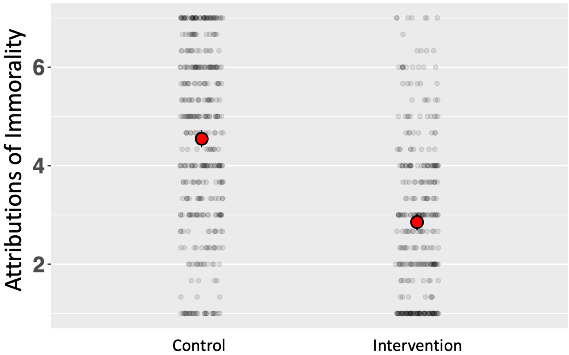
Note. Scores ranged from 1 to 7. M_{diff} = 1.69 [1.45, 1.94], SE_{diff} = 0.13, t(744) = 13.49, d = 0.98, p < .001.

Figure S40
Effect of the Intervention on Reduced Attributions of Unintelligence
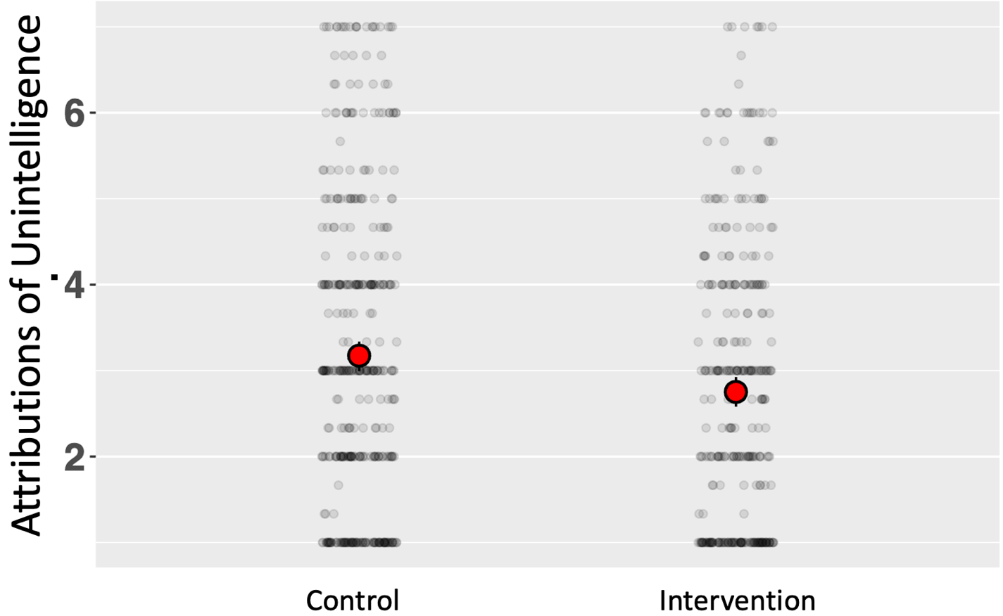
Note. Scores ranged from 1 to 7. M_{diff} = 0.42 [0.17, 0.67], SE_{diff} = 0.13, t(748) = 3.33, d = 0.25, p < .001.

Table S33

Pattern Matrix Depicting Item Loadings from Exploratory Factor Analysis
Item | Factor 1 | Factor 2 | Factor 3
Dislike_3 (I feel negatively toward [target]) | .977 | -.106 | -.044
Dislike_1 (I feel cold toward [target]) | .960 | -.123 | -.010
Dislike_2 (I dislike [target]) | .927 | -.065 | .003
FT (Feeling thermometer) | .890 | -.113 | -.064
Neg_Emo_3 (Disgust) | .858 | .034 | .024
Immoral_3 (Cruel) | .840 | .077 | -.018
Immoral_2 (Immoral) | .813 | .074 | .032
Neg_Emo_1 (Contempt) | .788 | -.018 | .062
Neg_Emo_2 (Fury) | .738 | .124 | .037
Immoral_1 (Evil) | .682 | .197 | .067
Neg_Emo_4 (Hatred) | .646 | .238 | .060
Dhmz_2 ([target] are less than fully human) | -.037 | 1.000 | -.023
Dhmz_3 ([target] don't fit my definition of "human") | -.006 | .981 | -.026
Dhmz_1 ([target] don't seem truly human) | .010 | .965 | -.022
Ascent (Ascent of Man scale) | -.053 | .783 | .069
Stupid_3 (Dumb) | -.003 | -.003 | .985
Stupid_2 (Stupid) | .003 | .007 | .977
Stupid_1 (Unintelligent) | .029 | .003 | .926

Note. Pattern matrix based on a principal axis EFA using Promax rotation. Factor 1-Factor 2 correlation: r = .58, Factor 1-Factor 3 correlation: r = .64, Factor 2-Factor 3 correlation: r = .61.

Figure S41

Indirect Effects of the Intervention on Reduced War Crime Support, Mediated by the Dehumanization, Unintelligence, and General Affect-Negative Emotions-Immorality Factors
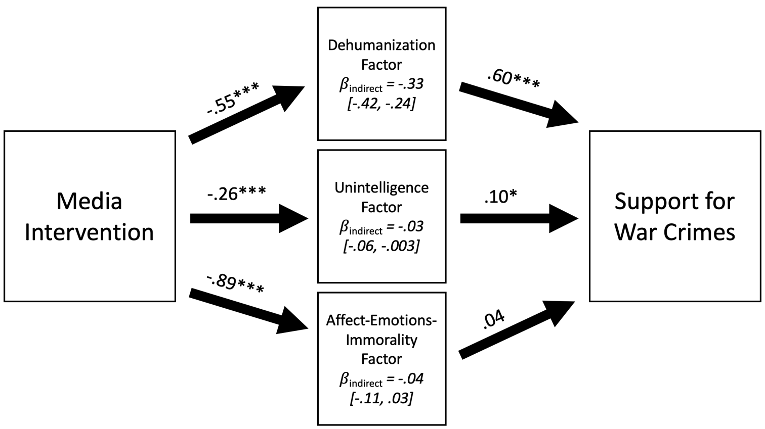
Note. Mediation performed with 5,000 bootstrapped resamples. Total effect: β = -.39 [-.49, -.29], SE = .05. Direct effect: β = .00, p = .978. Values reflect standardized beta coefficients. ***p < .001, *p = .011.

Supplemental Material for the General Discussion

Moderation Analyses

In our cross-cultural studies, for each of the regression analyses reported in the main text, we also tested whether dehumanization’s relationship with support for violence was moderated by any of the other predictors.
For each sample (as well as all samples pooled together), we began with a baseline model: the regression model described in the main text. From this baseline model, we created a series of otherwise-identical models where an interactive, rather than an additive, term was specified for dehumanization and one of the other predictors. For instance, in the US sample, along with the baseline model, we created seven additional models, each of which interacted dehumanization with one of the other seven predictors in that study.
Table S34 reports the results of these tests. Each cell contains the point estimate for the interaction term between dehumanization and the relevant predictor (in unstandardized b). The shading of the cell indicates whether the effect is significant, with green cells indicating a significant moderation and red cells indicating a non-significant moderation (gray cells indicate the moderation was not performed because the relevant predictor was not measured in that sample). Note that, for the interaction of dehumanization with each predictor, we applied Bonferroni corrections to the criterion for statistical significance.
In short, none of the predictors consistently moderated dehumanization’s relationship with support for violence. Namely, we observed significant moderations in only 9 of the 55 tests (16%).
For the full output of these regression models, see Section 6.2 of “Cross-Cultural Analyses.html” on our OSF repository: https://osf.io/2r4cu/?view_only=760f7226c1024fd598e53133066190c8.

Table S34
Results of Moderation Analyses in the Cross-Cultural Studies
Sample | vs General Negative Affect | vs Intense Negative Emotions | vs Perceived Immorality | vs Perceived Unintelligence | vs Global Trait Derogation | vs Psychological Distance | vs Trait Aggression | vs Social Dominance Orientation | vs Right-Wing Authoritarianism
US | 0.12 | 0.16 | 0.15 | 0.06 | -- | -- | 0.04 | 0.01 | 0.05
Russia | 0.00 | 0.02 | -0.03 | 0.01 | -0.03 | -0.05 | -- | -- | --
Ukraine | 0.09 | 0.10 | 0.08 | 0.08 | 0.13 | 0.05 | -- | -- | --
Israel | -0.02 | -0.03 | 0.00 | 0.02 | 0.02 | 0.02 | 0.00 | 0.02 | -0.01
Palestine | -0.05 | 0.30 | 0.16 | 0.08 | 0.37 | 0.09 | 0.04 | 0.09 | 0.08
Hindus | -0.01 | 0.03 | 0.00 | -0.01 | -- | -- | 0.03 | 0.11 | 0.03
Muslims | 0.06 | 0.03 | 0.01 | 0.01 | -- | -- | 0.06 | 0.04 | 0.06
Pooled samples | -0.01 | 0.07 | 0.06 | -0.01 | -- | -- | -- | -- | --
Note. Each cell contains the point estimate for the interaction term between dehumanization and the other relevant predictor, in terms of unstandardized b. The shading of the cell indicates whether the effect is significant, with green cells indicating a significant moderation and red cells indicating a non-significant moderation (gray cells indicate the moderation was not performed because the relevant predictor was not measured in that sample). Note that, for the interaction of dehumanization with each predictor, we applied Bonferroni corrections to the criterion for statistical significance.

Linguistic Analyses

In this research, we conceptualized dehumanization as the explicit and blatant denial of a target’s humanity. This refers to the outward manifestation of an underlying psychological process, rather than the psychological process itself (Rai et al., 2018). Thus, it is imperative to ask: why do people deny others’ humanity? A related question concerns what distinguishes “literal” from “metaphorical” dehumanization—when does the denial of another’s humanity reflect a genuine conviction they are less than human, and when is it “just talk” (Smith, 2021)? We sought insight into these two questions by asking participants to elaborate on their reasons for dehumanizing the target group (either metaphorically or literally) in an open-ended text response. Specifically, for those who indicated metaphorically dehumanizing the target, we asked them to “elaborate on why you said [target] are less than human, even though you don’t actually believe this”, while we asked those who indicated literally dehumanizing the target to “describe, as clearly as you can, what about [target] makes them seem less than human.” In total, we collected 802 literal and 556 metaphorical responses (N_{Total} = 1,358).
Why Do People (Literally) Dehumanize Others?
To address the first question of what gives rise to dehumanization, we analyzed the responses from literal dehumanizers for attributes about the target group that made them seem less than human. We first read through the responses ourselves and identified prominent attributes. We then used the Generative Pre-Trained Transformer 4o (GPT), a large language model capable of human-like information processing (OpenAI, 2024), to refine these key attributes and probe for additional ones. To do so, we provided GPT with a description of this research and detailed instructions to “extract common features of the target group that participants provided for literally believing they are less than human.” The model initially identified several key attributes of dehumanized groups which, encouragingly, were similar to those we had identified. After clarifying and refining these attributes, we derived seven key attributes (or lack thereof) respondents cited as making the target group seem literally less than human. A description of each attribute, illustrative quotes from participants, and relevant literature is presented in Table S35. The instructions we provided GPT and a transcript of the conversation that helped us derive the attributes can be found in the “Linguistic Analyses” subfolder of the Cross-Cultural Studies folder on our OSF repository: https://osf.io/2r4cu/?view_only=760f7226c1024fd598e53133066190c8
Table S35
Attributes of (Literally) Dehumanized Groups Identified in Analysis of Open-Ended Responses
Attribute | Description | Illustrative Quotes | Relevant Literature
Extreme Abnormality and Incomprehensibility | The perception of the target group as exhibiting thoughts or behavior that are profoundly aberrant and unnatural. Respondents see the group as fundamentally different, unrelatable, and incomprehensible to the respondent, and are unable to view them as fellow human beings. | “Because it is hard to comprehend how a human can harm a child like that.”  “It is impossible to understand why they have the kind of values and views that contradict the image of a real person”  “They don't act like human beings. Doing things that the sane mind cannot contain.”
Lack of Self-Restraint and Cultural Refinement | The perception of the target group as impulsive and uncivilized; subject to primitive urges and lacking “uniquely human” capacities for cultural refinement and self-restraint. | “The thought of being sexual with an underage is the height of indiscipline and brain problems. It is something only common amongst lower animals, so if you behave like that you are less human.”  “Muslims are just a tribe as was in the pre-historic times. They still live by the rules which are defunct in modern societies.” | (Haslam, 2006)
Unintelligence and Irrationality | The perception of the target group as lacking the intelligence and rationality that distinguish humans from “lower” animals. | “They don't have the ability to reason like a human instead they think like a primate.”  “They demonstrate human stupidity and cannot adequately evaluate the circumstances”  “They think like animals and how to survive without thinking about the consequences.” | (Haslam, 2006)
Lack of Empathy and Emotionality | The perception of the target group as emotionless and cold-hearted; lacking the empathic responsiveness and interpersonal warmth deemed essential aspects of “human nature.” | “They don't feel emotions that other normal humans feel and are trained and groomed to become ruthless.”  “A person is not only a physical body, but also a conscience, morality, kindness, and empathy. They have none of this.”  “There are no human emotions in them, they have the feelings of murder machines” | (Haslam, 2006)
Lack of Agentic Mental Capacities | The perception of the target group as unthinkingly conforming to a collective mindset without exercising individual judgment. Respondents see the target group as lacking fundamentally human capacities for mental agency. | “they are controlled by a regime, which makes them not think for themselves, therefore being less human.”  “They've lost the ability to think, to analyze information…They're completely brainwashed.”  “The majority are sheep, who don't understand anything but instructions from above” | (Harris & Fiske, 2011; Waytz et al., 2010)
Intrinsic Malevolence | The perception of the target group as fundamentally evil and lacking an essentially human moral compass. | “they are way too evil to be a part of our species.”  “I believe that that [sic] are truly evil, and they are the Devil, and they walk this Earth, as a Human form of the Devil”  “Nazis in their hearts”  “They are Inhumanly cruel” | (Brandt & Reyna, 2011; Phillips, 2022; Schwartz & Struch, 1989)
Threat | The perception of the target group as extremely threatening to the respondent or broader society. | “Bloodthirsty killers are not humans but dangerous animals”  “They are incited by hatred of Jews and want to throw me to the sea”  “Because they are extremist and they kill people in the name of god and make the society inpeaceful to live”  “They resort to violence very quickly and put others also in danger.” | (Bar-Tal, 1989; da Costa Silva et al., 2019; Esses et al., 2013; Pavetich & Stathi, 2021)

It is noteworthy that many of these attributes accord with prominent psychological models of dehumanization. For instance, Lack of Self-Restraint and Cultural Refinement and Unintelligence and Irrationality are key components of animalistic dehumanization within Haslam’s dual model, while Lack of Empathy and Emotionality is a prominent feature of mechanistic dehumanization within this model. The attribute Lack of Agentic Mental Capacities accords with theories of dehumanization as the denial of mind (Harris & Fiske, 2011; Waytz et al., 2010). The attribute of Intrinsic Malevolence squares with work pointing to the centrality of morality in perceptions of humanity (Strohminger & Nichols, 2014) and that the denial of an essentially human moral compass can produce dehumanization (Brandt & Reyna, 2011; Phillips, 2022; Schwartz & Struch, 1989). Finally, seminal theories and empirical evidence suggest that perceptions of Threat can catalyze dehumanization (Bar-Tal, 1989; da Costa Silva et al., 2019; Esses et al., 2013; Pavetich & Stathi, 2021).
What Distinguishes Literal Dehumanization from Mere Metaphor?
To address the second question of how literal dehumanization is distinct from metaphorical dehumanization, we first asked GPT to “compare the responses from two types of participants”, asking it to perform “an in-depth analysis of the underlying themes…with an eye to differentiating the two types of responses from one another.” We provided it with the metaphorical and literal dehumanization responses (in separate columns), and simply referred to them as “Type 1” and “Type 2.” For robustness, we did this exact same procedure three times. Each time, GPT characterized the literal responses as more definitive and categorical, tending to essentialize the target group as inherently deficient, fundamentally immoral, or an implacable threat. Metaphorical responses, on the other hand, tended to include more nuanced moral evaluations and contextual explanations. These responses also expressed greater uncertainty and ambivalence, as well as a tendency to rationalize dehumanization based on specific actions or contexts. GPT interpreted this as a potential struggle with cognitive dissonance, as respondents attempted to reconcile behaviors they consider extremely heinous or threatening with a recognition of the target’s humanity. The full transcripts of these three conversations, as well as a document highlighting GPT’s consistent conclusions, can be found in the “Linguistic Analyses” subfolder of the Cross-Cultural Studies folder on our OSF repository: https://osf.io/2r4cu/?view_only=760f7226c1024fd598e53133066190c8.
We then sought to quantify differences in psycholinguistic properties of the responses using a battery of specialized dictionaries for the Linguistic Inquiry and Word Count software (Boyd et al., 2022). Consistent with our finding that literal dehumanizers reported greater support for violence, literal responses contained more words related to violence (e.g., bloodshed, fight; M_{Diff} = 1.81 [0.81, 2.82], SE_{Diff} = 0.51, d = 0.20, t(1354) = 3.54, p = < .001) and murder (e.g., kill, stab; M_{Diff} = 1.75 [0.72, 2.78], SE_{Diff} = 0.52, d = 0.19, t(1354) = 3.35, p < .001), as measured by a psycholinguistic dictionary specialized for violence threat assessment (the Grievance Dictionary; van der Vegt et al., 2021). Further results are in line with the attributes of literally dehumanized groups identified in the open-ended responses above. Consistent with the attribute of Intrinsic Malevolence, literal responses contained more expressions of moral disgust (e.g., cruel, destructive; M_{Diff} = 1.40 [0.56, 2.24], SE_{Diff} = 0.43, d = 0.18, t(1354) = 3.26, p = .001), as measured by the extended Moral Foundations Dictionary (Hopp et al., 2021). Consistent with the attribute of Threat, literal responses contained more words related to threat (e.g., danger, unsafe), as measured with both the Threat Dictionary (Choi et al., 2022; M_{Diff} = 1.25 [0.32, 2.19], SE_{Diff} = 0.48, d = 0.15, t(1354) = 2.62, p = .009) and the Grievance Dictionary (M_{Diff} = 1.12 [0.44, 1.79], SE_{Diff} = 0.34, d = 0.18, t(1354) = 3.25, p = .001). And consistent with the attribute Lack of Agentic Mental Capacities, literal responses contained fewer words related to agency (e.g., autonomous, competent; M_{Diff} = 0.85 [0.11, 1.59], SE_{Diff} = 0.38, d = 0.12, t(1354) = 2.25, p = .025), as measured by the Agency dictionary (Pietraszkiewicz et al., 2019).
These analyses were exploratory and provisional, so we encourage future work to build on them with more systematic tests of the mechanisms underlying literal dehumanization and what makes such dehumanization more than mere metaphor. For instance, researchers may leverage advances in natural language processing (see Mendelsohn et al., 2020) to identify what drives explicit and blatant dehumanization, and develop machine learning classifiers to determine when these utterances are intended literally.

References
Abou-Ismail, R., Phillips, J. B., & Sengupta, N. (2023). Conceptualising and Measuring Support for Collective Violence. OSF. https://doi.org/10.31234/osf.io/5qrgt
Amir-Behghadami, M., & Janati, A. (2020). Population, Intervention, Comparison, Outcomes and Study (PICOS) design as a framework to formulate eligibility criteria in systematic reviews. Emergency Medicine Journal. https://doi.org/10.1136/emermed-2020-209567
Bandura, A., Underwood, B., & Fromson, M. E. (1975). Disinhibition of aggression through diffusion of responsibility and dehumanization of victims. Journal of Research in Personality, 9(4), 253–269. https://doi.org/10.1016/0092-6566(75)90001-X
Bar-Tal, D. (1989). Delegitimization: The Extreme Case of Stereotyping and Prejudice. In D. Bar-Tal, C. F. Graumann, A. W. Kruglanski, & W. Stroebe (Eds.), Stereotyping and Prejudice: Changing Conceptions (pp. 169–182). Springer. https://doi.org/10.1007/978-1-4612-3582-8_8
Bastian, B., & Haslam, N. (2010). Excluded from humanity: The dehumanizing effects of social ostracism. Journal of Experimental Social Psychology, 46(1), 107–113. https://doi.org/10.1016/j.jesp.2009.06.022
Bevens, C. L., & Loughnan, S. (2019). Insights into Men’s Sexual Aggression Toward Women: Dehumanization and Objectification. Sex Roles, 81(11), 713–730. https://doi.org/10.1007/s11199-019-01024-0
Bizumic, B., & Duckitt, J. (2018). Investigating Right Wing Authoritarianism With a Very Short Authoritarianism Scale. Journal of Social and Political Psychology, 6(1), Article 1. https://doi.org/10.5964/jspp.v6i1.835
Boyd, R., Ashokkumar, A., Seraj, S., & Pennebaker, J. (2022). The Development and Psychometric Properties of LIWC-22. University of Texas at Austin. https://doi.org/10.13140/RG.2.2.23890.43205
Brandt, M. J., & Reyna, C. (2011). The Chain of Being: A Hierarchy of Morality. Perspectives on Psychological Science, 6(5), 428–446. https://doi.org/10.1177/1745691611414587
Bruneau, E., & Kteily, N. (2017). The enemy as animal: Symmetric dehumanization during asymmetric warfare. PLOS ONE, 12(7), e0181422. https://doi.org/10.1371/journal.pone.0181422
Chandler, J., Rosenzweig, C., Moss, A. J., Robinson, J., & Litman, L. (2019). Online panels in social science research: Expanding sampling methods beyond Mechanical Turk. Behavior Research Methods, 51(5), 2022–2038. https://doi.org/10.3758/s13428-019-01273-7
Cheung, M. W.-L. (2015). metaSEM: An R package for meta-analysis using structural equation modeling. Frontiers in Psychology, 5. https://doi.org/10.3389/fpsyg.2014.01521
Choi, V. K., Shrestha, S., Pan, X., & Gelfand, M. J. (2022). When danger strikes: A linguistic tool for tracking America’s collective response to threats. Proceedings of the National Academy of Sciences, 119(4), e2113891119. https://doi.org/10.1073/pnas.2113891119
Cooley, E., Lei, R., Brown-Iannuzzi, J., & Ellerkamp, T. (2019). Personal Prejudice, Other Guilt: Explicit Prejudice Toward Black People Predicts Guilty Verdicts for White Officers Who Kill Black Men. Personality and Social Psychology Bulletin, 45(5), 754–766. https://doi.org/10.1177/0146167218796787
da Costa Silva, K., Álvaro, J. L., Torres, A. R. R., & Garrido, A. (2019). Terrorist threat, dehumanization, and right-wing authoritarianism as predictors of discrimination. Scandinavian Journal of Psychology, 60(6), 616–627. https://doi.org/10.1111/sjop.12574
Daboin, I., Peterson, J. L., & Parrott, D. J. (2015). Racial differences in sexual prejudice and its correlates among heterosexual men. Cultural Diversity & Ethnic Minority Psychology, 21(2), 258–267. https://doi.org/10.1037/a0038444
Dambrun, M. (2007). Understanding the Relationship Between Racial Prejudice and Support for the Death Penalty: The Racist Punitive Bias Hypothesis. Social Justice Research, 20(2), 228–249. https://doi.org/10.1007/s11211-007-0040-1
Esses, V. M., Medianu, S., & Lawson, A. S. (2013). Uncertainty, Threat, and the Role of the Media in Promoting the Dehumanization of Immigrants and Refugees. Journal of Social Issues, 69(3), 518–536. https://doi.org/10.1111/josi.12027
Finkel, E., Bail, C. A., Cikara, M., Ditto, P. H., Iyengar, S., Klar, S., Mason, L., McGrath, M. C., Nyhan, B., Rand, D. G., Skitka, L. J., Tucker, J. A., Van Bavel, J. J., Wang, C. S., & Druckman, J. N. (2020). Political sectarianism in America. Science, 370(6516), 533–536. https://doi.org/10.1126/science.abe1715
Finkel, E., Landry, A., Hoyle, R., Druckman, J., & Van Bavel, J. J. (2024). Partisan Antipathy and the Erosion of Democratic Norm. https://doi.org/10.31234/osf.io/ahgy6
Fix, E., & Hodges, J. L. (1951). Discriminatory Analysis, Nonparametric Discrimination: Consistency Properties. (Technical Report 4). USAF School of Aviation Medicine.
Halperin, E. (2011). The emotional roots of intergroup aggression: The distinct roles of anger and hatred. In Human aggression and violence: Causes, manifestations, and consequences (pp. 315–331). American Psychological Association. https://doi.org/10.1037/12346-017
Harris, L. T., & Fiske, S. T. (2011). Dehumanized Perception: A Psychological Means to Facilitate Atrocities, Torture, and Genocide? Zeitschrift Fur Psychologie, 219(3), 175–181. https://doi.org/10.1027/2151-2604/a000065
Hartman, R., Moss, A. J., Jaffe, S. N., Rosenzweig, C., LItman, L., & Robinson, J. (2023). Introducing Connect by CloudResearch: Advancing Online Participant Recruitment in the Digital Age. OSF. https://doi.org/10.31234/osf.io/ksgyr
Haslam, N. (2006). Dehumanization: An Integrative Review. Personality and Social Psychology Review, 10(3), 252–264. https://doi.org/10.1207/s15327957pspr1003_4
Ho, A. K., Sidanius, J., Kteily, N., Sheehy-Skeffington, J., Pratto, F., Henkel, K. E., Foels, R., & Stewart, A. L. (2015). The nature of social dominance orientation: Theorizing and measuring preferences for intergroup inequality using the new SDO₇ scale. Journal of Personality and Social Psychology, 109(6), 1003–1028. https://doi.org/10.1037/pspi0000033
Hopp, F. R., Fisher, J. T., Cornell, D., Huskey, R., & Weber, R. (2021). The extended Moral Foundations Dictionary (eMFD): Development and applications of a crowd-sourced approach to extracting moral intuitions from text. Behavior Research Methods, 53(1), 232–246. https://doi.org/10.3758/s13428-020-01433-0
Iyengar, S., Lelkes, Y., & Westwood, S. (2023). America’s Political Pulse [Dataset]. https://polarizationresearchlab.org/americas-political-pulse/
Kalmoe, N. P., & Mason, L. (2022). Radical American Partisanship: Mapping Violent Hostility, Its Causes, and the Consequences for Democracy. University of Chicago Press.
Kteily, N., Bruneau, E., Waytz, A., & Cotterill, S. (2015). The ascent of man: Theoretical and empirical evidence for blatant dehumanization. Journal of Personality and Social Psychology, 109(5), 901–931. https://doi.org/10.1037/pspp0000048
Kteily, N., Hodson, G., & Bruneau, E. (2016). They see us as less than human: Metadehumanization predicts intergroup conflict via reciprocal dehumanization. Journal of Personality and Social Psychology, 110(3), 343–370. https://doi.org/10.1037/pspa0000044
Landry, A. P., Fincher, K., Barr, N., Brosowsky, N. P., Protzko, J., Ariely, D., & Seli, P. (2024). Harnessing dehumanization theory, modern media, and an intervention tournament to reduce support for retributive war crimes. Journal of Experimental Social Psychology, 111, 104567. https://doi.org/10.1016/j.jesp.2023.104567
Leyens, J.-P., Demoulin, S., Vaes, J., Gaunt, R., & Paladino, M. P. (2007). Infra-humanization: The Wall of Group Differences. Social Issues and Policy Review, 1(1), 139–172. https://doi.org/10.1111/j.1751-2409.2007.00006.x
Leys, C., Ley, C., Klein, O., Bernard, P., & Licata, L. (2013). Detecting outliers: Do not use standard deviation around the mean, use absolute deviation around the median. Journal of Experimental Social Psychology, 49(4), 764–766. https://doi.org/10.1016/j.jesp.2013.03.013
Međedović, J., & Petrović, B. (2015). The Dark Tetrad. Journal of Individual Differences, 36(4), 228–236. https://doi.org/10.1027/1614-0001/a000179
Mendelsohn, J., Tsvetkov, Y., & Jurafsky, D. (2020). A Framework for the Computational Linguistic Analysis of Dehumanization. Frontiers in Artifical Intelligence, 3(55). https://doi.org/10.3389/frai.2020.00055
Molho, C., Tybur, J. M., Güler, E., Balliet, D., & Hofmann, W. (2017). Disgust and Anger Relate to Different Aggressive Responses to Moral Violations. Psychological Science, 28(5), 609–619. https://doi.org/10.1177/0956797617692000
Murray, L., Nguyen, H., Lee, Y.-F., Remmenga, M. D., & Smith, D. W. (2012). Variance inflation factors in regression models with dummy variables. Conference on Applied Statistics in Agriculture. https://doi.org/10.4148/2475-7772.1034
Nudelman, G., & Otto, K. (2020). The Development of a New Generic Risk-of-Bias Measure for Systematic Reviews of Surveys. Methodology, 16(4), Article 4. https://doi.org/10.5964/meth.4329
OpenAI. (2024). ChatGPT (Version 4) [Computer software]. https://chatgpt.com/
Page, M. J., McKenzie, J. E., Bossuyt, P. M., Boutron, I., Hoffmann, T. C., Mulrow, C. D., Shamseer, L., Tetzlaff, J. M., Akl, E. A., Brennan, S. E., Chou, R., Glanville, J., Grimshaw, J. M., Hróbjartsson, A., Lalu, M. M., Li, T., Loder, E. W., Mayo-Wilson, E., McDonald, S., … Moher, D. (2021). The PRISMA 2020 statement: An updated guideline for reporting systematic reviews. BMJ, 372, n71. https://doi.org/10.1136/bmj.n71
Parrott, D. J., & Zeichner, A. (2005). Effects of Sexual Prejudice and Anger on Physical Aggression Toward Gay and Heterosexual Men. Psychology of Men & Masculinity, 6(1), 3–17. https://doi.org/10.1037/1524-9220.6.1.3
Pavetich, M., & Stathi, S. (2021). Investigating antecedents of Islamophobia: The role of perceived control over terrorism, threat, meta-dehumanization, and dehumanization. Journal of Community & Applied Social Psychology, 31(4), 369–382. https://doi.org/10.1002/casp.2512
Phillips, B. (2022). “They’re Not True Humans:” Beliefs about Moral Character Drive Denials of Humanity. Cognitive Science, 46(2), e13089. https://doi.org/10.1111/cogs.13089
Phillips, B. (2023). Normative dehumanization and the ordinary concept of a true human. Current Research in Ecological and Social Psychology, 5, 100155. https://doi.org/10.1016/j.cresp.2023.100155
Pietraszkiewicz, A., Formanowicz, M., Gustafsson Sendén, M., Boyd, R. L., Sikström, S., & Sczesny, S. (2019). The big two dictionaries: Capturing agency and communion in natural language. European Journal of Social Psychology, 49(5), 871–887. https://doi.org/10.1002/ejsp.2561
Pustejovsky, J. E., & Tipton, E. (2022). Meta-analysis with Robust Variance Estimation: Expanding the Range of Working Models. Prevention Science, 23(3), 425–438. https://doi.org/10.1007/s11121-021-01246-3
Rai, T. S., Valdesolo, P., & Graham, J. (2018). Reply to Fincher et al.: Conceptual specificity in dehumanization research is a feature, not a bug. Proceedings of the National Academy of Sciences, 115(15), E3331–E3332. https://doi.org/10.1073/pnas.1802004115
Rindskopf, D., & Shiyko, M. (2010). Measures of Dispersion, Skewness and Kurtosis. In P. Peterson, E. Baker, & B. McGaw (Eds.), International Encyclopedia of Education (Third Edition) (pp. 267–273). Elsevier. https://doi.org/10.1016/B978-0-08-044894-7.01344-0
Rodríguez-Pérez, A., & Betancor, V. (2023). Infrahumanization: A restrospective on 20 years of empirical research. Current Opinion in Behavioral Sciences, 50, 101258. https://doi.org/10.1016/j.cobeha.2023.101258
Rousseau, D. L., Gorman, B., & Baranik, L. E. (2023). Crossing the Line: Disgust, Dehumanization, and Human Rights Violations. Socius, 9, 23780231231157686. https://doi.org/10.1177/23780231231157686
Rozin, P., Lowery, L., Haidt, J., & Imada, S. (1999). The CAD Triad Hypothesis: A Mapping Between Three Moral Emotions (Contempt, Anger, Disgust) and Three Moral Codes (Community, Autonomy, Divinity). Journal of Personality and Social Psychology, 76(4), 574–586.
Rudman, L. A., & Mescher, K. (2012). Of Animals and Objects: Men’s Implicit Dehumanization of Women and Likelihood of Sexual Aggression. Personality and Social Psychology Bulletin, 38(6), 734–746. https://doi.org/10.1177/0146167212436401
Rush Translate. (2023). RushTranslate. https://rushtranslate.com
Schönbrodt, F. D., & Perugini, M. (2013). At what sample size do correlations stabilize? Journal of Research in Personality, 47(5), 609–612. https://doi.org/10.1016/j.jrp.2013.05.009
Schwartz, S. H., & Struch, N. (1989). Values, Stereotypes, and Intergroup Antagonism. In D. Bar-Tal, C. F. Graumann, A. W. Kruglanski, & W. Stroebe (Eds.), Stereotyping and Prejudice: Changing Conceptions (pp. 151–167). Springer. https://doi.org/10.1007/978-1-4612-3582-8_7
Siddaway, A. P., Wood, A. M., & Hedges, L. V. (2019). How to Do a Systematic Review: A Best Practice Guide for Conducting and Reporting Narrative Reviews, Meta-Analyses, and Meta-Syntheses. Annual Review of Psychology, 70(Volume 70, 2019), 747–770. https://doi.org/10.1146/annurev-psych-010418-102803
Smith, D. L. (2021). Challenge 8: A Response to Over (2021). Perspectives on Psychological Science, 16(1), 22–23. https://doi.org/10.1177/1745691620917351
Strohminger, N., & Nichols, S. (2014). The essential moral self. Cognition, 131(1), 159–171. https://doi.org/10.1016/j.cognition.2013.12.005
Thompson, C. G., Kim, R. S., Aloe, A. M., & Becker, B. J. (2017). Extracting the Variance Inflation Factor and Other Multicollinearity Diagnostics from Typical Regression Results. Basic and Applied Social Psychology, 39(2), 81–90. https://doi.org/10.1080/01973533.2016.1277529
Van den Noortgate, W., López-López, J. A., Marín-Martínez, F., & Sánchez-Meca, J. (2013). Three-level meta-analysis of dependent effect sizes. Behavior Research Methods, 45(2), 576–594. https://doi.org/10.3758/s13428-012-0261-6
van der Vegt, I., Mozes, M., Kleinberg, B., & Gill, P. (2021). The Grievance Dictionary: Understanding threatening language use. Behavior Research Methods, 53(5), 2105–2119. https://doi.org/10.3758/s13428-021-01536-2
Viki, G. T., Fullerton, I., Raggett, H., Tait, F., & Wiltshire, S. (2012). The Role of Dehumanization in Attitudes Toward the Social Exclusion and Rehabilitation of Sex Offenders. Journal of Applied Social Psychology, 42(10), 2349–2367. https://doi.org/10.1111/j.1559-1816.2012.00944.x
Viki, G. T., Osgood, D., & Phillips, S. (2013). Dehumanization and self-reported proclivity to torture prisoners of war. Journal of Experimental Social Psychology, 49(3), 325–328. https://doi.org/10.1016/j.jesp.2012.11.006
Viki, G. T., Winchester, L., Titshall, L., Chisango, T., Pina, A., & Russell, R. (2006). Beyond Secondary Emotions: The Infrahumanization of Outgroups Using Human–Related and Animal–Related Words. Social Cognition, 24(6), 753–775. https://doi.org/10.1521/soco.2006.24.6.753
Voelkel, J. G., Stagnaro, M., Chu, J., Pink, S., Mernyk, J., Redekopp, C., Cashman, M., Qualifying StrengtheningDemocracy Challenge Submitters, Druckman, J. N., Rand, D., & Willer, R. (2023). Megastudy identifying successful interventions to strengthen Americans’ democratic attitudes. Https://Www.Strengtheningdemocracychallenge.Org/Paper.
Wai, M., & Tiliopoulos, N. (2012). The affective and cognitive empathic nature of the dark triad of personality. Personality and Individual Differences, 52(7), 794–799. https://doi.org/10.1016/j.paid.2012.01.008
Waytz, A., Epley, N., & Cacioppo, J. T. (2010). Social Cognition Unbound: Insights Into Anthropomorphism and Dehumanization. Current Directions in Psychological Science, 19(1), 58–62. https://doi.org/10.1177/0963721409359302
Webster, G. D., DeWall, C. N., Pond Jr., R. S., Deckman, T., Jonason, P. K., Le, B. M., Nichols, A. L., Schember, T. O., Crysel, L. C., Crosier, B. S., Smith, C. V., Paddock, E. L., Nezlek, J. B., Kirkpatrick, L. A., Bryan, A. D., & Bator, R. J. (2014). The brief aggression questionnaire: Psychometric and behavioral evidence for an efficient measure of trait aggression. Aggressive Behavior, 40(2), 120–139. https://doi.org/10.1002/ab.21507
Westwood, S. J., Grimmer, J., Tyler, M., & Nall, C. (2022). Current research overstates American support for political violence. Proceedings of the National Academy of Sciences, 119(12), e2116870119. https://doi.org/10.1073/pnas.2116870119
Wittek, M., Kroneberg, C., & Lämmermann, K. (2020). Who is fighting with whom? How ethnic origin shapes friendship, dislike, and physical violence relations in German secondary schools. Social Networks, 60, 34–47. https://doi.org/10.1016/j.socnet.2019.04.004
Zlobina, A., & Andujar, R. (2021). Police violence during citizens’ protests: Dehumanization processes, legitimation of violence, and hostility. Peace and Conflict: Journal of Peace Psychology, 27(4), 534–541. https://doi.org/10.1037/pac0000550

We received five articles from our listserv announcements, which were screened along with the articles identified in the database and register searches. We also received two unpublished datasets from the listserv announcements, which we extracted data from after a detailed discussion with the researcher who led the study to confirm it met our inclusion criteria. Finally, we received eight records (six published articles and two raw datasets) from researchers doing relevant work on dehumanization or intergroup violence whom we contacted directly (again confirming these records met our inclusion criteria through a detailed discussion). See Figure S2.
Our precise search strings differed slightly across databases/registers, but we used the same key terms and Boolean operators for each. The exact search strings can be found in the Search Strategy section of our preregistration: https://osf.io/k28zq/?view_only=59028fa03ddc474995674180e13c953e.
“Infrahumanization” is not typically used to refer to the explicit and blatant denial of another’s humanity. Still, it has a rich research tradition within the broader dehumanization literature (reviewed by Leyens et al., 2007; Rodríguez-Pérez & Betancor, 2023), so we included it for the sake of comprehensiveness.
Ultimately, we sought to balance thoroughness with practicality in our database searches. As noted in our preregistration, we piloted various combinations of search terms in each database until a reasonable number of articles were identified. For instance, we initially opened the dehumanization and dislike search terms to the title, abstract, and keywords of texts. However, doing so resulted in an unwieldy number of articles (~4,000) so we then restricted the dehumanization and dislike search terms to the title only, which returned a more manageable number of articles (ranging from 56-340 across the databases).
In the PsycINFO, Embase, and Scopus databases, we also restricted our search to English-language empirical articles using human subjects. Further, in Embase and Scopus, we limited the earliest year of publication to 1974-75 (to our knowledge, the first empirical article on dehumanization was published in 1975; Bandura et al., 1975) and restricted the research domain to the psychological or social sciences.
The exceptions were one study (Wittek et al., 2020) where variables were dichotomous, and hence odds ratio’s and corresponding standard errors were extracted and then converted to correlation coefficients, and another (Dambrun, 2007) reporting Spearman’s ρ correlations due to the non-normal distribution of the data.
Dehumanization’s relationship with support for violence was not moderated by study design (Table S6).
Dehumanization’s relationship with support for violence was not moderated by extraction method (Table S2) and held when excluding our own team’s unpublished datasets (Table S4).
We also ran a model that introduced all moderators together, see Table S8.
To be as comprehensive as possible, we also included antisocial traits that are not explicitly part of the “dark tetrad” (i.e., psychopathy, narcissism, sadism, and Machiavellianism; Međedović & Petrović, 2015), but are tightly related to them (e.g., low empathy; Wai & Tiliopoulos, 2012). Thus, we refer to this covariate as hostile traits to reflect this expansion.
Because only one study measured all these covariates, we tested them one-by-one in five separate analyses.
Hindu and Muslim respondents were given the option to take the survey in either English or Hindi. The vast majority (91% of Hindus and 93% of Muslims) chose to take the survey in English.
Because US participants evaluated three target groups, they completed all measures in the second and third blocks for a specific target group before proceeding to the next. Presentation of the three target groups was randomized.
The reason being that these items all belonged to a scale being developed for another stream of research (see Finkel et al., 2020, 2024).
If US participants rated more than one group at 70 or less, they were randomly assigned to answer the dehumanization follow-up in reference to one of these groups.
We also ran simple pairwise models with just the interaction between dehumanization and the relevant predictor (excluding all other predictors). We observed similarly inconsistent results in these models (see Section 6.3 of “Cross-Cultural Analyses.html”).

