ONLINE SUPPLEMENT

Extended AI Aversion: People Deny Humanness to AI Users

STIMULUS MATERIALS 2
Study 1 2
Study 2 3
Study S1 4
Study 3 4
Study S2 5
Study S3 6
Study 4 8
Study 5 9
SUPPLEMENTARY ANALYSIS IN STUDY 1 12
SUPPLEMENTARY ANALYSIS IN STUDY 2 14
DESCRIPTIONS OF STUDY S1 15
DESCRIPTIONS OF STUDY S2 19
DESCRIPTIONS OF STUDY S3 22

STIMULUS MATERIALS

Study 1
Advice Seeker Manipulation
Participants in the AI-advice seeker scenario read the following:
A company is turning to recorded video interviews to screen job applicants. Candidates answer questions in front of a camera, record a video, and send it to the company. James, the manager of the company, uses an algorithm to review the video and evaluates the candidate.
Participants in the human-advice seeker scenario read the following:
A company is turning to recorded video interviews to screen job applicants. Candidates answer questions in front of a camera, record a video, and send it to the company. James, the manager of the company, invites a HR specialist to review the video and evaluates the candidate.

Humanness Attribution (Crawford et al., 2013; Haslam et al., 2005)
Human nature: friendly, sociable, trusting, impatient (reverse-scored), impulsive (reverse-scored), and jealous (reverse-scored)
Human uniqueness: open-minded, rational, mature, impolite (reverse-scored), rude (reverse-scored), and shallow (reverse-scored)

Word Use (Pietraszkiewicz et al., 2019; Schweitzer & Waytz, 2021)
On the following page we would like you to write a brief essay about James in terms of his plan to recruit job applicants. Please write a brief essay (at least 250 characters) about James in terms of his plan to use an algorithm [invite a HR specialist] to evaluate the candidates. Take a moment to think about him: What does James think about? What sorts of emotions does he feel? When writing about James, we want you to focus only on his mental states. How would you describe his thoughts, feelings, and intentions?

Study 2
Advice Seeker Manipulation
Participants in the AI-advice seeker scenario read the following:
Zhang is planning to buy a gift for a friend, who is about to get married, and thus needs advices regarding what gift is appropriate for a wedding. Zhang turns to ChatGPT, which has been trained with a massive dataset of text regarding wedding rituals, for advice regarding buying gifts.

Participants in the human-advice seeker scenario read the following:
Zhang is planning to buy a gift for a friend, who is about to get married, and thus needs advices regarding what gift is appropriate for a wedding. Zhang turns to an expert who has expertise in wedding rituals.

Perceived Similarity with Advice Seeker
1. How similar do you think is this protagonist to you? (1 = not at all, 7 = very much)
2. We will present participants with seven diagrams, each depicting two circles (one representing yourself, the other representing the protagonist) with varying degrees of overlap. Participants chose the diagram that best represented their relationship with the protagonist; the greater the overlap between the two circles, the higher the similarity.
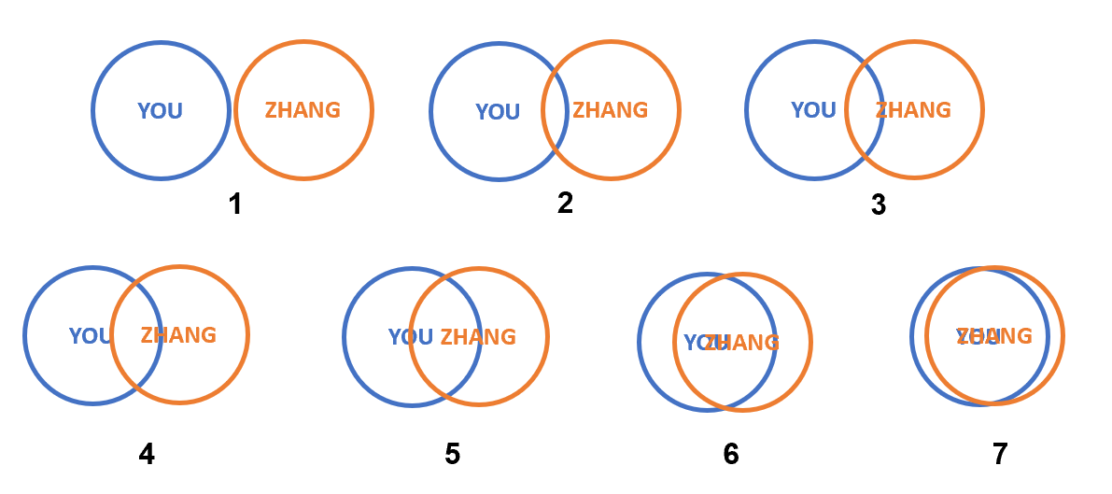
Attituded Toward AI
Generally speaking, do you have a positive or negative view of artificial intelligence? (1 = very negative, 7 = very positive)

Study S1
Perceived Similarity with Advice Seeker
1. When you need to choose a wedding gift for a friend, to what extent will the way you seek advice be similar to the way the protagonist takes? (1 = not at all, 7 = very much)
2. When you need to choose a wedding gift for a friend, to what extent are you likely to seek advice in a similar way to the protagonist? (1 = not at all, 7 = very much)

Study 3
Advice Seeker Manipulation
Participants in the AI-advice seeker scenario read the following:
Zhang is a college student taking a course called World Art History. The instructor assigned an assignment: to summarize the characteristics of primitive art in prehistoric times. In order to complete this assignment, Zhang needed to read some reference materials. Zhang sought for recommended materials by using ChatGPT, and completed the assignment after reading these materials.
Participants in the human-advice seeker scenario read the following:
Zhang is a college student taking a course called World Art History. The instructor assigned an assignment: to summarize the characteristics of primitive art in prehistoric times. In order to complete this assignment, Zhang needed to read some reference materials. Zhang sought for recommended materials by sending an email to a professor in the field, and completed the assignment after reading these materials.

Behavioral Support
All participants to read the following instructions:
Zhang plans to enhance the quality of his essay for potential publication as an academic paper. To achieve this, Zhang intends to gather feedback from the public on artworks through 6 surveys. Each survey will take 2-3 minutes. Participation in these surveys is voluntary and no compensation will be provided. How many (0-6) surveys will you participate in? If you decide to participate, please write down your name, email address, and mobile phone number. Zhang will then contact you to arrange your involvement in the surveys.

How many surveys will you participate in?
--0 survey
--1 survey
--2 surveys
--3 surveys
--4 surveys
--5 surveys
--6 surveys

Study S2
Advice Seeker Manipulation
Participants in the AI-advice seeker scenario read the following:
Please image such a scenario. You are a college student taking a course called World Art History. The instructor assigned an assignment: to summarize the characteristics of primitive art in prehistoric times. In order to complete this assignment, all students needed to read some reference books. Your classmate, Zhang, sought for recommended materials by using ChatGPT. Zhang completed the assignment after reading these materials.

Participants in the human-advice seeker scenario read the following:
Please image such a scenario. You are a college student taking a course called World Art History. The instructor assigned an assignment: to summarize the characteristics of primitive art in prehistoric times. In order to complete this assignment, all students needed to read some reference books. Your classmate, Zhang, sought for recommended materials by sending an email to a professor in the field. Zhang completed the assignment after reading these materials.

Helping Intention
1. Zhang would like to publish the essay in an academic journal. To what extent are you willing to help Xiao Zhang prepare the manuscript? (1 = not at all, 7 = very much)
2. Zhang would like to present the essay at an academic forum. To what extent are you willing to help Zhang prepare the presentation? (1 = not at all, 7 = very much)
3. Zhang would like to apply for a research fund based on the essay. To what extent are you willing to help Zhang prepare a proposal? (1 = not at all, 7 = very much)

Study S3
Advice Seeker Manipulation
Participants in the AI-advice seeker scenario read the following:
With the development of modern medical technology, more and more artificial intelligence algorithms are applied in the medical field. During the medical treatment process, patients first go to relevant departments for examination based on their symptoms, and then the medical artificial intelligence algorithm identifies the examination results. The artificial intelligence algorithm diagnoses the patient’s examination results based on deep learning of a large number of clinical case information and provides patients with diagnosis and treatment suggestions.

Zhang felt unwell recently. He went to the hospital in time and used artificial intelligence algorithms to identify and diagnose the symptoms. Zhang’s skin was red, swollen and dry, he underwent a routine blood test. Then, AI medical algorithms diagnosed whether Zhang’s symptoms were skin inflammation based on the test results. Zhang felt pain in his knees when walking. He went for an MRI test, and then AI algorithms used the test results to diagnose whether Zhang’s symptoms were caused by the wear of cartilage tissue.

Participants in the human-advice seeker scenario read the following:
With the development of modern medical technology, the disease diagnosis skills mastered by doctors are also constantly improving. During the medical treatment process, patients first go to relevant departments for examination based on their symptoms, and then professional doctors identify the examination results. Professional doctors diagnose patients’ examination results based on a large number of clinical case experiences and provide patients with diagnosis and treatment suggestions.

Zhang felt unwell recently. He went to the hospital promptly and asked doctors from relevant departments to identify and diagnose the symptoms. Zhang’s skin was red, swollen and dry, he underwent a routine blood test. Then, a doctor used the test results to diagnose whether Zhang’s symptoms were skin inflammation. Zhang felt pain in his knees when walking, so he went for an MRI test. A doctor then used the test results to diagnose whether Zhang’s symptoms were caused by the wear of cartilage tissue.

Helping Intention
1. If you were a staff who handles medical insurance reimbursement at Zhang’s company, to what extent are you willing to reimburse Zhang for examination and diagnosis fees at the highest rate? (1 = not at all, 7 = very much)
2. If you are a staff responsible for selecting patients who will be provided with free follow-up medical services at the hospital, to what extent are you willing to add Zhang to the follow-up list? (1 = not at all, 7 = very much)
3. If you were a staff responsible for selecting residents who will be provided with medical assistance (e.g., professional treatment and recovery plans) at the community, to what extent are you willing to include Zhang as a recipient of the medical assistance? (1 = not at all, 7 = very much)

Study 4
Advice Seeker Manipulation
Participants in the human-advice seeker scenario read the following:
Zhang is planning to buy a gift for a friend, who is about to get married, and thus needs advices regarding what gift is appropriate for a wedding. Zhang turns to an expert who has expertise in wedding rituals.

Participants in the anthropomorphic-AI-advice seeker scenario read the following:
Zhang is planning to buy a gift for a friend, who is about to get married, and thus needs advices regarding what gift is appropriate for a wedding. Zhang turns to ChatGPT for advice regarding buying gifts. A recent study revealed that ChatGPT’s emotional understanding ability has reached human level and can understand complex emotions in social situations. For example, the researchers asked ChatGPT to imagine that A secretly prepared a beautiful necklace for B. ChatGPT was capable to infer not only that B was happy when receiving the necklace but also that B would be pleasantly surprised by A’s actions.

Participants in the nonanthropomorphic-AI-advice seeker scenario read the following:
Zhang is planning to buy a gift for a friend, who is about to get married, and thus needs advices regarding what gift is appropriate for a wedding. Zhang turns to ChatGPT for advice regarding buying gifts. A recent study revealed that ChatGPT’s emotional understanding ability has not reached human level and cannot fully understand complex emotions in social situations. For example, the researchers asked ChatGPT to imagine that A secretly prepared a beautiful necklace for B. ChatGPT was only capable to infer that B was happy when receiving the necklace, but it failed infer that B would be surprised by A’s actions.

Please indicate how capable you believe ChatGPT is of… (1 = not at all, 7 = very much)
-having a mind of its own
-having consciousness
-experiencing emotions
-expressing emotions
[Only participants in the anthropomorphic-AI-advice seeker condition and the nonanthropomorphic-AI-advice seeker condition completed these two items.]

Study 5
Advice Seeker Manipulation
Participants in the human-advice seeker condition read the following:
Zhang turns to an education expert who has extensive knowledge about the development pattern of children’s reading ability. The expert asks Zhang (1) the reading content that students have learned, (2) the reading content that students will learn, and (3) the current distribution of students’ reading performance. By sorting through the information, the expert forms a detailed evaluation of students’ reading abilities. In addition, the expert identifies Zhang’s teaching style by interacting with him. Subsequently, the expert recommends reading materials based on students’ reading ability and Zhang’s teaching style.

In the generative-AI-advice seeker condition, participants read the following:
Zhang turns to an AI-powered learning management system, which was trained using a massive dataset of text regarding the development pattern of children’s reading ability. The system interacts in a conversational way and asks (1) the reading content that students have learned, (2) the reading content that students will learn, and (3) the current distribution of students’ reading performance. By synthesizing the information, the system forms a detailed evaluation of students’ reading abilities. In addition, the system identifies Zhang’s teaching style by interacting with him. Subsequently, the system recommends reading materials based on students’ reading ability and Zhang’s teaching style.

In the traditional-AI-advice seeker condition, participants read the following:
Zhang turns to an AI-powered learning management system, which was trained using a small dataset of text regarding the development pattern of children’s reading ability. The system requires Zhang to upload information about (1) the reading content that students have learned, (2) the reading content that students will learn, and (3) the current distribution of students’ reading performance. By computing the information, the system forms a rough evaluation of students’ reading abilities. The system cannot identify Zhang’s teaching style based on the information uploaded. Therefore, the system recommends reading materials by calculating the similarity between students’ current reading performance and the dataset it was trained on.

Please indicate the extent to which the learning system… (1 = not at all, 7 = very much)
-behaves like a human being,
-has a human-like mind.
[Only participants in the generative-AI-advice seeker condition and the traditional-AI-advice seeker condition completed these two items.]

SUPPLEMENTARY ANALYSIS IN STUDY 1

Experience and agency not only bear conceptual comparison to human nature and human uniqueness (Haslam, 2006), but also correspond to warmth and competence judgments (Fiske et al., 2007). Warmth pertains to one’s striving to form social bonds with others while competence pertains to striving to achieve goals (Fiske et al., 2007). Therefore, for explorative purposes, we also measured linguistic use of warmth and competence words.
Participants wrote a brief essay about James in terms of his plan to recruit job applicants. Using Schweitzer and Waytz’s (2021) instructions, we asked participants to focus on James’ mental states, specifically, what James thinks about, the emotions he feels, and his intentions. Using R package quanteda and the “Big Two” dictionaries (Pietraszkiewicz et al., 2019), we quantified the frequency of warmth words (e.g., “help” and “justice”) and competence words (e.g., “able” and “confident”) participants used to describe the protagonist.
To compare the use of warmth/competence word in describing James across two condition, we conducted a 2 (Target: AI-advice seeker, human-advice seeker) × 2 (Word: warmth, competence) mixed ANOVA. Participants used warmth and competence words less frequently when describing the AI-advice seeker (M = 2.41, SD = 1.18) than when describing the human-advice seeker (M = 3.05, SD = 1.65), F(1, 198) = 9.85, p = .002, η² = .047, 90% CI [0.011, 0.103]. Participants used competence words (M = 4.48, SD = 2.60) more frequently than warmth words (M = 0.98, SD = 1.22) across conditions, F(1, 198) = 316.57, p < .001, η² = .615, 90% CI [0.548, 0.666]. The Target × Dimension interaction was significant, F(1, 198) = 5.57, p = .019, η² = .027, 90% CI [0.002, 0.075]. Simple effect analyses (see Figure S1) revealed that participants used equal numbers of warmth words to describe the AI-advice seeker (M = 0.89, SD = 1.07) and the human-advice seeker (M = 1.06, SD = 1.34), F(1, 198) = 0.98, p = .325, η² = .005, 90% CI [0.000, 0.034]; however, they used fewer competence words to describe the AI-advice seeker (M = 3.93, SD = 2.16) than the human-advice seeker (M = 5.03, SD = 2.89), F(1, 198) = 9.32, p = .003, η² = .045, 90% CI [0.010, 0.100]. Thus, participants dehumanized the AI-advice seeker on the dimension of competence but not warmth.

Figure S1
Warmth and Competence Words Use in Descriptions in Study 1
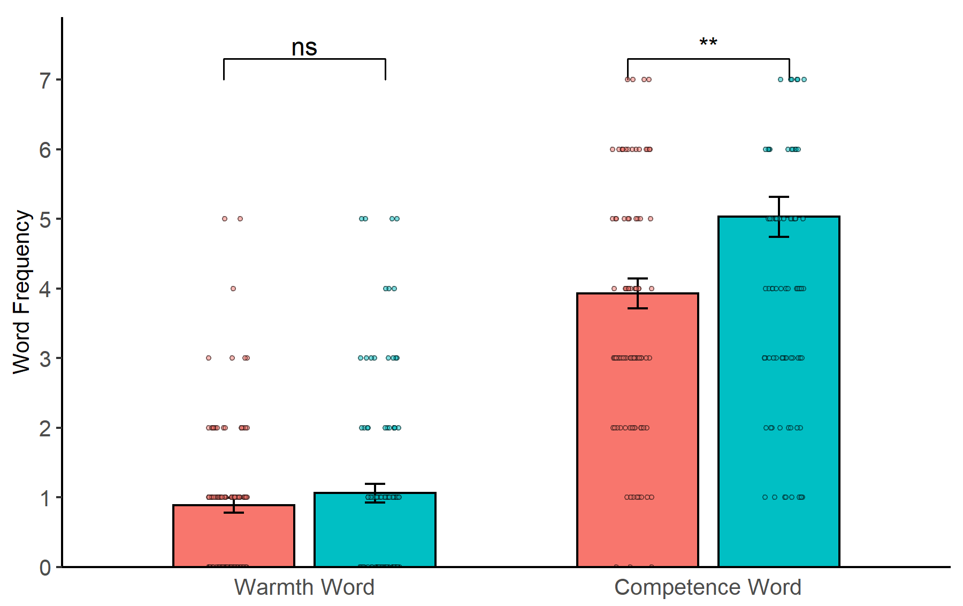
Note. Error bars depict ± 1 standard error. Dots depict jittered individual data points. **p < .01. ns = non-significant.

Echoing the complex relationship between measures found in past work (Formanowicz et al., 2023; Schweitzer & Waytz, 2021), correlation analyses in Study 1 revealed that ratings on humanness traits were not correlated with any word use (ps > .105). Experience word use was positively associated with both warmth word use (r = .25, p < .001) and competence word use (r = .24, p = .001), while agency word use was positively associated with only competence word use (r = .32, p < .001) but not warmth word use (r = .01, p = .847).

SUPPLEMENTARY ANALYSIS IN STUDY 2

To test an alternative explanation that people dehumanize AI users because they think it is not appropriate to use AI for tasks requiring human capacities, we measured participants’ perceived appropriateness of AI use. Participants indicated the extent to which they think the way that the protagonist use to select a gift is appropriate (i.e., “How appropriate do you think is the way that this protagonist use to select a gift?”; 1 = not at all, 7 = very much).
To explore the potential role of perceived appropriateness of AI use, we tested a mediation model using Mplus 8.0. The model include perceived similarity with advice seekers and perceived appropriateness of AI use as two correlated mediators, target as the independent variable, and human nature and human uniqueness as the correlated dependent variables. Based on 5,000 bootstrap samples, perceived appropriateness of AI use mediated the denial of humanness to the AI-advice seeker (vs. advice-seeker) in terms of human nature (b = –0.14, 95% CI [–0.19, –0.10], SE = .03) and human uniqueness (b = –0.17, 95% CI [–0.23, –0.12], SE = .03). Importantly, after controlling for perceived appropriateness of AI use, the mediating role of similarity remained significant (b = –0.11, 95% CI [–0.17, –0.07], SE = .03 for human nature; b = –0.13, 95% CI [–0.20, –0.08], SE = .03 for human uniqueness).
Note that although perceived similarity is a significant mediator even when accounting for perceived appropriateness of AI use, the results suggest that perceived appropriateness of AI use also might contribute to the dehumanization of AI users. We will return to this point in the General Discussion section.

DESCRIPTIONS OF STUDY S1

Method
Participants
The focus of interest in Study 1 was the mediating role of perceived similarity with advice seekers. Therefore, we used a web-based Monte Carlo power analysis app (Schoemann et al., 2017) to compute the required sample size. We specified medium relations between the target and perceived similarity (r = –.30) and between perceived similarity and humanness attribution (r = .30). Relying on the smaller effect of the target on human nature and human uniqueness obtained in Study 1 (r = –.45), an N of 230 would provide 80% of the power to detect an indirect effect. We recruited 251 participants via Credamo; one participant failed the attention check and was excluded. The final sample included 250 participants (95 men and 155 women; M_{age} = 30.37, SD = 7.54), with each paid 3 CNY. They were randomly assigned to either the AI-advice seeker (n =125) or the human-advice seeker (n = 125) condition.
Materials and Procedure
Advice Seeker Manipulation. We presented participants with a social scenario wherein the protagonist needed advice on purchasing gifts for a friend who was getting married. Participants then read that the protagonist had sought advice in two ways. In the AI-advice seeker condition, the protagonist turned to ChatGPT for advice, whereas in the human-advice seeker condition, the protagonist sought advice from experts with expertise in wedding etiquette.
Perceived Similarity with Advice Seeker. We assessed participants’ perceived similarity with the protagonist using two items (i.e., “To what extent would you seek advice in a similar way to the protagonist when choosing a gift?” and “To what extent would you choose a gift in a similar way to the protagonist?” 1 = not at all, 7 = very much). We averaged both items together to create a perceived similarity index (α = .91).
Humanness Attribution. Participants rated the protagonist on human nature (α = .82) and human uniqueness (α = .86) traits as in Study 1.
AI Aversion. We assessed participants’ overall attitudes toward AI with a single item from Eurobarometer 87.1 (2017; i.e., “Generally speaking, do you have a positive or negative view of artificial intelligence?” 1 = very negative, 7 = very positive). We reverse-coded this item, with a higher score indicating a higher level of AI aversion.
Covariates. We assessed participants’ experience with (i.e., “Please indicate how often you come into contact with AI tools in your daily life;” 1 = never, 7 = very often) and knowledge of (i.e., “Please indicate the extent to which you have heard, read, or seen anything about AI”; 1 = very little, 7 = very much) AI tools.
Transparency and Openness
We have made data for this study public at http://tinyurl.com/yc7k3dty (Dang, 2024). It was preregistered at http://tinyurl.com/26yccuym. Stimulus materials are provided in the SM.
Results
Humanness Attribution to Advice Seekers
We conducted a 2 (Target) × 2 (Dimension) mixed ANOVA. The main effect of Target was significant, F(1, 248) = 41.74, p < .001, η² = .144, 90% CI [0.083, 0.211], with participants attributing less humanness to the AI-advice seeker (M = 5.39, SD = 1.00) than to the human-advice seeker (M = 6.03, SD = 0.46). Moreover, participants attributed greater human uniqueness (M = 5.77, SD = 0.87) than human nature (M = 5.65, SD = 0.89) to advice seekers, F(1, 248) = 12.65, p < .001, η² = .049, 90% CI [0.014, 0.098]. The two-way interaction was significant, F(1, 248) = 20.52, p < .001, η² = .076, 90% CI [0.031, 0.133]. Simple effect analyses (Figure 1c) revealed that participants attributed less human nature to the AI-advice seeker (M = 5.26, SD = 1.01) than to the human-advice seeker (M = 6.05, SD = 0.53), F(1, 248) = 58.88, p < .001, η² = .192, 90% CI [0.123, 0.261], and they also attributed less human uniqueness to the AI-advice seeker (M = 5.52, SD = 1.06) than to the human-advice seeker (M = 6.01, SD = 0.51), F(1, 248) = 22.04, p < .001, η² = .082, 90% CI [0.035, 0.140]. The difference between humanness attributed to both advice seekers was larger for human nature than for human uniqueness. We conducted the analysis again after controlling for experience and knowledge of AI and produced similar results. Experience with and knowledge of AI did not interact with other variables to influence human attribution (ps > .218) and the above results remained unchanged.
Perceived Similarity as a Mediator
Using Mplus 8.0, we tested a mediation model with human nature and human uniqueness as the correlated dependent variables. Participants perceived less similarity with the AI-advice seeker than with the human-advice seeker (b = –0.73, 95% CI [–0.90, –0.56], SE = .09, p < .001, b* = –.47). Perceived similarity positively predicted human nature (b = 0.29, 95% CI [0.23, 0.35], SE = .03, p < .001, b* = .51) and human uniqueness (B = 0.30, 95% CI [0.23, 0.36], SE = .03, p < .001, b* = .53) ratings. Human nature and uniqueness were positively correlated (b = 0.38, 95% CI [0.31, 0.46], SE = .04, p < .001, b* = .76). After controlling for perceived similarity, the direct effect of Target on human nature was significant (b = –0.18, 95% CI [–0.28, –0.08], SE = .05, p < .001, b* = –.20), whereas that on human uniqueness was not (b = –0.03, 95% CI [–0.13, 0.07], SE = .05, p = .543, b* = –.04). Based on 5,000 bootstrap samples, perceived similarity mediated the denial of humanness by the AI-advice seeker (vs. advice-seeker) in terms of human nature (b = –0.21, 95% CI [–0.31, –0.14], SE = .05) and human uniqueness (b = –0.22, 95% CI [–0.32, –0.13], SE = .05).
Moderating Role of AI Aversion
We used Mplus 8.0 to test a first-stage moderated mediation model with AI aversion as a moderator of the effect of Target on perceived similarity. The moderating role of AI aversion was significant, b = –0.38, 95% CI [–0.51, –0.26], SE = .06, p < .001, b* = –.30, which supported Hypothesis 2. Simple slope analyses (Figure S2) revealed that the effect of perceiving less similarity with the AI-advice seeker (versus human-advice seeker) was stronger for participants with high AI aversion (+1 SD from the mean; b = –1.27, 95% CI [–1.49, –1.05], SE = .11, p < .001) than for those with low AI aversion (–1 SD from the mean; b = –0.32, 95% CI [–0.54, –0.10], SE = .11, p = .004). Therefore, as expected, the mediating role of perceived similarity was stronger in participants with high AI aversion (b = –0.37, 95% CI [–0.51, –0.24], SE = .07 for human nature; b = –0.37, 95% CI [–0.53, –0.23], SE = .08 for human uniqueness) than in participants with low AI aversion (b = –0.09, 95% CI [–017, –0.03], SE = .03 for human nature; b = –0.09, 95% CI [–0.17, –0.04], SE = .03 for human uniqueness).

Figure S2
Effect of the Target on Perceived Similarity as a Function of AI Aversion
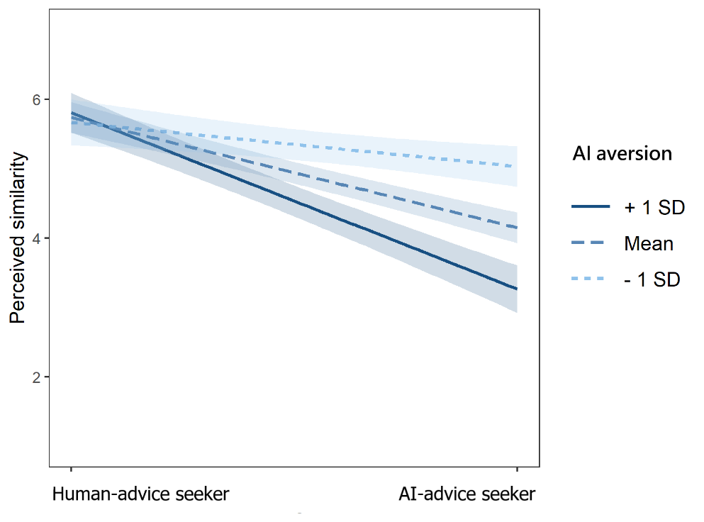
Discussion
Study S1 further supported Hypothesis 1, which posits that people deny humanness, especially human nature, to AI-advice (versus human-advice) seekers. Moreover, Study S1 explained this effect. In line with Hypothesis 2, the denial of humanness of AI-advice seekers is influenced by AI aversion. Specifically, participants with greater AI aversion perceived less similarity between themselves and AI-advice seekers and thus denied their humanness to a greater extent.

DESCRIPTIONS OF STUDY S2

Method
Participants
Study S2 employed a design similar to Study 3. Relying on the effect sizes obtained in Study 3, an a priori statistical analysis using the web-based Monte Carlo power analysis app (Schoemann et al., 2017) revealed that an N of 157 would provide 80% power to detect an indirect effect via humanness nature. Considering the possible indirect effects via human uniqueness, we recruited 300 participants via Credamo (121 men and 179 women; M_{age} = 28.78, SD = 6.98), paying each 2 CNY. No participants were excluded. They were randomly assigned into either the AI-advice seeker (n =148) or the human-advice seeker (n = 152) condition.
Materials and Procedure
Advice Seeker Manipulation. We asked participants to image an academic scenario, wherein a protagonist (called Zhang) read some materials to complete an essay. We depicted the protagonist as an AI-advice seeker [a human-advice seeker] by introducing that Zhang turned to ChatGPT [a professor] for recommended reading materials.
Humanness Attribution. Participants rated the protagonist on human nature (α = .77) and human uniqueness (α = .86) as in Studies 1–3.
Helping Intention. Participants indicated their willingness to help the protagonist as a classmate on three items (α = .90). An example item was “If Zhang would like to publish the essay in an academic journal, to what extent are you willing to help Zhang prepare the manuscript?” (1 = not at all, 7 = very much). Higher scores indicate stronger helping intention.
Transparency and Openness
We have made data for this study public at http://tinyurl.com/yc7k3dty (Dang, 2024). It was preregistered at http://tinyurl.com/2834wras. Stimulus materials is provided in the Supplemental Material (SM).
Results
Humanness Attribution to Advice Seekers
We conducted a Target (2) × Dimension (2) mixed ANOVA. The main effect of dimension was significant, F(1, 298) = 9.51, p = .002, η² = .031, 90% CI [0.007, 0.070], with participants attributing greater human uniqueness (M = 5.58, SD = 0.92) than human nature (M = 5.49, SD = 0.84) to advice seekers. Supporting Hypothesis 1, participants attributed less humanness to the AI-advice seeker (M = 5.32, SD = 0.86) than to the human-advice seeker (M = 5.75, SD = 0.76), F(1, 298) = 20.94, p < .001, η² = .066, 90% CI [0.027, 0.115]. The two-way interaction was significant, F(1, 298) = 16.86, p < .001, η² = .054, 90% CI [0.019, 0.100]. Simple effect analyses revealed that participants attributed less human nature to the AI-advice seeker (M = 5.22, SD = 0.85) than to the human-advice seeker (M = 5.76, SD = 0.72), F(1, 298) = 35.90, p < .001, η² = .108, 90% CI [0.058, 0.164]. They also attributed less human uniqueness to the AI-advice seeker (M = 5.42, SD = 0.95) than to the human-advice seeker (M = 5.73, SD = 0.85), F(1, 298) = 8.91, p = .003, η² = .029, 90% CI [0.006, 0.067]. The difference between humanness attributed to two advice seekers was larger in human nature than in human uniqueness.
Helping Intention Across Advice Seekers
An ANOVA on helping intention revealed that participants reported weaker intention to help the AI-advice seeker (M = 4.73, SD = 1.52) than the human-advice seeker (M = 5.17, SD = 1.24), F(1, 298) = 7.57, p = .006, η² = .025, 90% CI [0.005, 0.061].
Using Mplus 8.0, we examined a mediation model with human nature and human uniqueness as correlated mediators and helping intention as the dependent variable (Figure S3). Participants attributed less human nature (b = –0.55, 95% CI [–0.73, –0.37], SE = .09, p < .001, b* = –.32) and less human uniqueness (b = –0.31, 95% CI [–0.52, –0.11], SE = .10, p = .003, b* = –.17) to the AI-advice seeker than to the human-advice seeker. Both human nature (b = 0.68, 95% CI [0.40, 0.96], SE = .15, p < .001, b* = .41) and human uniqueness (b = 0.40, 95% CI [0.16, 0.65], SE = .13, p = .001, b* = .26) positively predicted helping intention. The direct effect of target on helping intention was not significant after controlling for human nature and human uniqueness, (b = 0.06, 95% CI [–0.21, 0.32], SE = .14, p = .672, b* = .02). Based on 5,000 bootstrap samples, both the indirect effect via human nature attribution (b = –0.37, 95% CI [–0.65, –0.17], SE = .12) and that via human uniqueness attribution (b = –0.13, 95% CI [–0.31, –0.02], SE = .07) were significant.

Figure S3
Humanness Attribution and Helping for Advice Seekers in Study S2
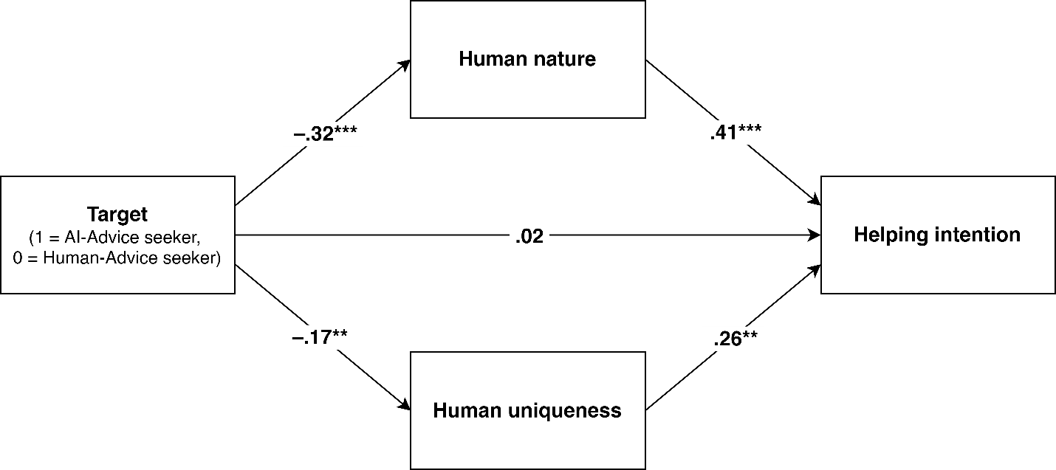
Note. The coefficients are standardized. To enhance clarity, we omitted the correlated residuals between the two mediators (b = 0.60, 95% CI [0.49, 0.70], SE = 0.05, p < .001, b* = .84). **p < .01, ***p < .001.

DESCRIPTIONS OF STUDY S3

Study S3 aimed to replicate and extend Studies 3 and S2, testing Hypothesis 1 in a medical context, specifically focusing on patients seeking advice from either medical algorithms or doctors.
Method
Participants
Study S3 employed a design similar to that of Study 3. The focus of interest in Study S3 was the mediating role of humanness attribution in helping intention toward AI-advice (versus human-advice) seekers. Therefore, we used an online Monte Carlo power analysis application (Schoemann et al., 2017) to calculate the required sample size. The smaller effect of Target on humanness nature and uniqueness attribution obtained in Study 2 was r = –.29. We specified medium-sized relationships between Target and Helping (r = –.30) and Humanness Attribution and Helping (r = .30); an N of 182 would provide 80% power to detect an indirect effect. Considering that we intended to test the indirect effects via both human nature and uniqueness, we recruited 300 participants via Credamo. Three participants failed the attention check and were excluded. The final sample included 297 participants (117 men and 180 women; M_{age} = 29.30, SD = 7.13), paying each 3 CNY. Participants were randomly assigned to either the AI- (n =146) or human-advice seeker (n = 151) condition.
Materials and Procedure
Advice Seeker Manipulation. We presented participants with a medical scenario in which a protagonist (Zhang) sought a medical diagnosis and advice for itchy skin and knee pain. We depicted the protagonist as an AI-advice seeker (a human-advice seeker) by stating that a medical AI algorithm (doctor)] examined Zhang’s information regarding ongoing treatment and medical test results.
Humanness Attribution. Participants rated the protagonist on human nature (α = .73) and human uniqueness (α = .70) traits as in Studies 1 and 2.
Helping Intention. Participants indicated their willingness to help the protagonist on three items (α = .64). An example item was, “If you were a staff member who handled medical insurance reimbursement at Zhang’s company, to what extent would you be willing to reimburse Zhang for medical fees at the highest rate?” (1 = not at all, 7 = very much). Higher scores indicated a stronger willingness to help.
Transparency and Openness
We have made data for this study public at http://tinyurl.com/yc7k3dty (Dang, 2024). It was preregistered at http://tinyurl.com/yewbxmtb. Stimulus materials is provided in the Supplemental Material (SM).
Results
Humanness Attribution to Advice Seekers
We conducted a 2 (Target) × 2 (Dimension) mixed ANOVA. The main effect of Dimension was significant, F(1, 295) = 36.21, p < .001, η² = .109, 90% CI [0.059, 0.167], with participants attributing greater human uniqueness (M = 5.73, SD = 0.56) than human nature (M = 5.65, SD = 0.61) to advice seekers. The main effect of Target was also significant, F(1, 295) = 6.26, p = .013, η² = .021, 90% CI [0.002, 0.055], with participants attributing less humanness to AI-advice seeker (M = 5.56, SD = 0.56) than to human-advice seeker (M = 5.72, SD = 0.49). Thus, Hypothesis 1 was supported. The two-way interaction was significant, F(1, 295) = 20.59, p < .001, η² = .065, 90% CI [0.027, 0.115]. Simple effect analyses revealed that participants attributed less human nature to the AI-advice seeker (M = 5.41, SD = 0.67) than to the human-advice seeker (M = 5.70, SD = 0.51), F(1, 295) = 16.57, p < .001, η² = .053, 90% CI [0.019, 0.100]; however, they attributed similar levels of human uniqueness to the AI- (M = 5.71, SD = 0.55) and human-advice seekers (M = 5.74, SD = 0.57), F(1, 295) = 0.13, p = .715, η² < .001. The difference between the levels of humanness attributed to the two advice seekers was larger for human nature than for human uniqueness.
Helping Intention Across Advice Seekers
An ANOVA on helping intention revealed that participants’ helping intention did not differ between the AI- (M = 5.31, SD = 0.81) and human-advice seekers (M = 5.24, SD = 0.77), F(1, 295) = 0.65, p = .420, η² = .002, 90% CI [0.000, 0.020]. As significant indirect effects can occur without significant total effects (Hayes, 2009; Rucker et al. 2011), we subsequently tested the mediating role of humanness attribution in helping intention.

Figure S4
Humanness Attribution and Helping Intention Toward Advice Seekers in Study S3
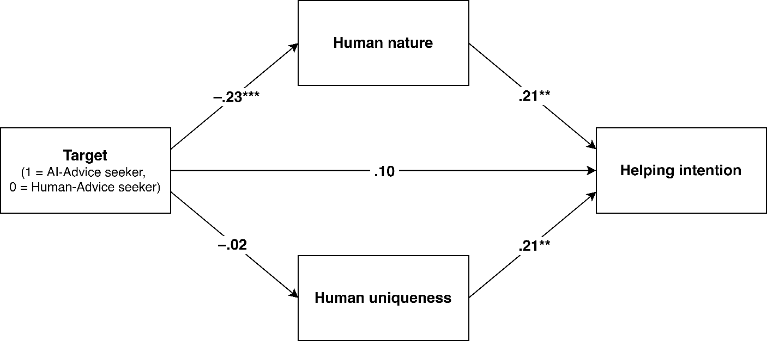
Note. The coefficients are standardized. To enhance clarity, we omitted the correlated residuals between the two mediators (b = 0.21, 95% CI [0.17, 0.26], SE = 0.02, p < .001, b* = .65). **p < .01, ***p < .001.

We used Mplus 8.0 to examine the mediating role of humanness attribution in helping intention toward different targets (Figure S4). Participants attributed less human nature to the AI-advice seeker than to the human-advice seeker (b = –0.28, 95% CI [–0.42, –0.15], SE = .07, p < .001, b* = –.23); however, human uniqueness ratings did not differ across targets (b = –0.02, 95% CI [–0.15, 0.10], SE = .07, p = .711, b* = –.02). Both human nature (b = 0.28, 95% CI [0.09, 0.46], SE = .09, p = .003, b* = .21) and uniqueness (b = 0.30, 95% CI [0.10, 0.49], SE = .10, p = .003, b* = .21) positively predicted helping intention. The direct effect of the target on helping intention was positive but not significant after controlling for human nature and uniqueness (b = 0.16, 95% CI [–0.01, 0.33], SE = .09, p = .072, b* = .10). Thus, the attribution of human nature (b = –0.08, 95% CI [–0.17, –0.02], SE = .04), but not human uniqueness (b = –0.01, 95% CI [–0.06, 0.03], SE = .02), mediated the difference in helping intention toward advice seekers.
Discussion
Study S3 provided further support for Hypothesis 1 in a medical context. Notably, the participants denied the human nature, but not the human uniqueness, of the medical AI user. A possible explanation is that medical diagnosis and therapy often involve a mechanistic approach, in which patients are viewed as mechanical systems with various components. Although this approach helps diagnose and treat patients, it can sometimes lead to the perception that patients lack emotions and interpersonal warmth (Haque & Waytz, 2012), which are fundamental aspects of human nature (Haslam, 2006). Study S3 also demonstrated that denying human nature to a medical AI user reduced participants’ intentions to help them.
References
Dang, J. (2024, August 6). (De)Humanization of AI recommendation seekers. Open Science Framework. Retrieved from https://osf.io/t9crk/
Fiske, S. T., Cuddy, A. J. C., & Glick, P. (2007). Universal dimensions of social cognition: Warmth and competence. Trends in Cognitive Sciences, 11, 77–83. https://doi.org/10.1016/j.tics.2006.11.005
Haque, O. S., & Waytz, A. (2012). Dehumanization in medicine: Causes, solutions, and functions. Perspectives on Psychological Science, 7(2), 176–186. https://doi.org/10.1177/1745691611429706
Haslam, N. (2006). Dehumanization: An integrative review. Personality and Social Psychology Review, 10(3), 252–264. https://doi.org/10.1207/s15327957pspr1003_4
Pietraszkiewicz, A., Formanowicz, M., Gustafsson Sendén, M., Boyd, R. L., Sikström, S.,& Sczesny, S. (2019). The big two dictionaries: Capturing agency and communion in natural language. European Journal of Social Psychology, 49(5), 871–887. https://doi.org/10.1002/ejsp.2561
Schoemann, A. M., Boulton, A. J., & Short, S. D. (2017). Determining power and sample size for simple and complex mediation models. Social Psychological & Personality Science, 8(4), 379–386. https://doi.org/10.1177/1948550617715068
Schweitzer, S., & Waytz, A. (2021). Language as a window into mind perception: How mental state language differentiates body and mind, human and nonhuman, and the self from others. Journal of Experimental Psychology: General, 150(8), 1642–1672. https://doi.org/10.1037/xge0001013

