Supplementary Material for:
Mutual cooperation gives you a stake in your partner’s welfare – especially if they’re irreplaceable
[author names & contact info removed for double-blind review]

Supplementary Materials include:

S.1. Supplementary Methods: Game Instructions
S.2. Supplementary Methods: Exit Surveys
S.3. Supplementary Results: Effects of Cooperative Partners are Bigger for Stake-Based Helping
S.4. Supplementary Results: Robustness Checks
- S.4.1 Robustness Check: Completely (Un)Cooperative Dyads
- S.4.2 Robustness Check: Including Hypothetical Decisions
- S.4.3 Robustness Check: Non-Binary Measurements of Mutual Cooperation
S.5. Supplementary Results: Helping Among First-Round Cooperators
S.6. Supplementary Results: Perceived Interdependence Correlates with Cooperation & Helping
- S.6.1 Perceived Interdependence Correlates with Cooperation in the Prisoner’s Dilemma
- S.6.2 Perceived Interdependence Correlates with a Willingness to Secretly Help a Partner
S.7. Screenshots from the Experimental Game

S.1. Supplementary Methods: Game Instructions

S.1.1 Instructions for the Prisoner’s Dilemma:
In this study, you will be randomly and anonymously paired with another participant. Each of you simultaneously and privately chooses whether you want to cooperate or defect. Your payoffs will be determined by the choices of both as below:
- If you cooperate and your partner cooperates you both gain 4 points
- If you cooperate and your partner defects you lose 2 points and your partner gains 8 points
- If you defect and your partner cooperates you gain 8 points and your partner loses 2 points
- If you defect and your partner defects 0 points are earned
1 point is equal to 1 cent.
You will begin the game with a 10-point endowment.

S.1.2 Instructions for the Asocial Condition (Experiments 2-3)
In this study, you will be randomly and anonymously paired to play the same session as another participant. However, the gambling task you play with be independent of one another. Each round you must select option ‘A’ or option ‘B’, and the computer will simultaneously randomly select ‘A’ or ‘B’. Your payoffs will be determined by the choices of both you and the computer as below:
- If you select ‘A’ and the computer randomly generates option ‘A’ you receive 10¢
- If you select option ‘A’ and the computer randomly generates option ‘B’ you lose 2¢
- If you select option ‘B’ and the computer randomly generates option ‘A’ you gain 4¢
- If you select option ‘B’ and the computer randomly generates option ‘B’ you gain 4¢

S.2. Supplementary Methods: Exit Surveys

S.2.1 Study 1 Exit Survey

What was good for my partner was good for me:
- Strongly Agree
- Agree
- Somewhat Agree
- Neutral
- Somewhat Disagree
- Disagree
- Strongly Disagree

What was good for my partner was bad for me:
- Strongly Agree
- Agree
- Somewhat Agree
- Neutral
- Somewhat Disagree
- Disagree
- Strongly Disagree

I depend on my partner:
- Strongly Agree
- Agree
- Somewhat Agree
- Neutral
- Somewhat Disagree
- Disagree
- Strongly Disagree

I benefit from having a partner
- Strongly Agree
- Agree
- Somewhat Agree
- Neutral
- Somewhat Disagree
- Disagree
- Strongly Disagree

Sex:
- Male
- Female
- Other

Age: [Participant enters a number]

[Comprehension Check]
In a given round if both you and your partner choose to cooperate how many points do you earn?
In a given round if you choose to defect and your partner chooses to cooperate how many points do you earn?
In a given round if both you and your partner choose to cooperate how many points do you earn?

[Hypothetical Help]
[This question only included for participants who did not get an opportunity to help in game]
In Control Condition: Imagine you had the opportunity to pay 3¢ to increase your partners final earnings by 7¢, would you?
In Interdependence Condition: Imagine you were still playing the game and your partner only had a 10% chance of surviving into the next round, but you could pay 3¢ to give them a 90% chance of surviving. If they survived, you would both continue to the next round. If they did not survive, then there would be no more rounds because you'd have no one to interact with. Would you have been willing to pay 3 cents to increase their probability of survival from 10% to 90%?

S.2.2 Study 2 Exit Survey

What is good for my partner is good for me:
- Strongly Agree
- Agree
- Somewhat Agree
- Neutral
- Somewhat Disagree
- Disagree
- Strongly Disagree

I feel that my partner’s gain is my gain:
- Strongly Agree
- Agree
- Somewhat Agree
- Neutral
- Somewhat Disagree
- Disagree
- Strongly Disagree

Honestly, I do not care whether my partner thrives or not:
- Strongly Agree
- Agree
- Somewhat Agree
- Neutral
- Somewhat Disagree
- Disagree
- Strongly Disagree

When my partner does well at something, I feel good.
- Strongly Agree
- Agree
- Somewhat Agree
- Neutral
- Somewhat Disagree
- Disagree
- Strongly Disagree

When my partner does poorly at something, I feel bad.
- Strongly Agree
- Agree
- Somewhat Agree
- Neutral
- Somewhat Disagree
- Disagree
- Strongly Disagree

My partner and I rise together.
- Strongly Agree
- Agree
- Somewhat Agree
- Neutral
- Somewhat Disagree
- Disagree
- Strongly Disagree

[Comprehension Check]
If in a given round both you and your partner choose to cooperate how many points do you earn?
If in a given round you choose to defect and your partner chooses to cooperate how many points do you earn?
If in a given round both you and your partner choose to defect how many points do you earn?

Age: [Participant enters a number]

Sex:
- Male
- Female
- Intersex
- Prefer not to respond

S.3. Supplementary Results:
The Effect of Cooperative Partners is Bigger for Stake-Based Helping

The main text showed that participants were more willing to help cooperative partners when doing so would affect the partner’s survival (Interdependence Condition) than when help only affected the partner’s earnings (Control Condition). It also showed that the experimental condition did not affect people’s willingness to help an uncooperative partner – participants only had a stake in cooperative partners. But was the effect of (un)cooperative partners bigger in the Interdependence Condition than the Control Condition? This cannot be tested with Fisher’s exact tests alone, so we used logistic regression to predict willingness to help based on the experimental condition and the number of rounds of mutual cooperation. More specifically, we tested whether there was an interaction between the experimental condition and the number of rounds of mutual cooperation, such that prior mutual cooperation had more effect in the Interdependence Condition.

In Experiment 1, prior mutual cooperation had a marginally significantly bigger effect in the Interdependence Condition than in the Control Condition (interaction: z = 1.83, two-tailed p = .07, one-tailed p = .035). Experiment 2 found very similar results (interaction: z = 1.63, two-tailed p = .10, one-tailed p = .05). Though neither of these was significant on its own with two-tailed tests, they were both marginally significant in the same direction, and the (significant) one-tailed tests are arguably justified because we had pre-registered these directional predictions in advance. To be sure, we conducted an internal meta-analysis by aggregating the z-scores across the two studies using Stouffer’s method, unweighted, and dividing by the square root of the number of z-scores (Whitlock, 2005). Here we find a highly significant interaction between the experimental condition and prior mutual cooperation on helping behavior: p = .007. This provides support for our hypothesis that engaging in reciprocity has a greater impact on helping behavior when help increases the probability of future interactions. Section S.4.1, S.4.2, and S.4.3 all present similar analyses of the same question, and the results are very similar.

S.4. Supplementary Results: Robustness Checks

S.4.1 Robustness Check: Completely (Un)Cooperative Dyads

The main text categorized dyads as either cooperative or uncooperative, depending on whether they had mutually cooperated in at least 3 of the 5 rounds before the opportunity to secretly help. As a robustness check, we show that the results are similar if we analyze only the dyads that cooperated in all or none of those 5 rounds. Dyads who mutually cooperated in all 5 rounds were more likely to help their partners in the Interdependence Condition relative to the Control Condition (Experiment 1: 82% vs. 53%, Fisher exact test p = .01, OR = 3.97, 95% CI [1.22, 14.55]; Experiment 2: 95% vs. 68%, Fisher exact test p = .003, OR = 9.05, 95% CI [1.89, 43.34]). By contrast, dyads who mutually defected in all five rounds did not help differently in the Interdependence vs. Control Conditions (Experiment 1: 39% vs. 33%, Fisher exact tests p = .78, OR = 1.29, 95% CI [.38, 4.52]; Experiment 2: 53% vs. 40%, Fisher exact test p = .086, OR = 1.71, 95% CI [0.59, 5.02]). See Tables S1-S2 for all comparisons. Even with this highly reduced sample, the effect of (un)cooperative partners is significantly or marginally significantly stronger in the Interdependence Condition than in the Control Condition, and is significant when Experiments 1 and 2 are combined meta-analytically (Experiment 1: z = 1.44, one-tailed p = .07; Experiment 2: z = 1.72, one-tailed p = .04; combined meta-analytically with Stouffer’s method: z = 2.23, one-tailed p = .01).

We can also compare completely (un)cooperative dyads in Experiment 2 with dyads in the Asocial Condition (Table S2). Completely cooperative dyads in the Interdependence Condition helped their partners more than did dyads in the Asocial Condition (95% vs. 69%, Fisher exact test p = .005, OR = 8.96, 95% CI [1.93, 41.49]). However, completely uncooperative dyads in the Interdependence Condition were not significantly different from dyads in the Asocial Condition, and if anything were less helpable (53% vs. 69%, Fisher exact test p = .17, OR = 0.53, 95% CI [0.21, 1.32]). These results also match those in the full analysis in the main text.

Table S1
Experiment 1: Proportion of Help Provided in Completely Cooperative and Defective Dyads
 | Interdependence | Control
Dyad Type | Proportion Help | Proportion Help | Odds Ratio [95% CI]
Completely Cooperative Dyads | 27/33  (82%) | 20/38  (53%) | 3.97*  [1.22, 14.55]
Completely Defecting Dyads | 11/28  (39%) | 9/27  (33%) | 1.29  [0.38, 4.52]
Odds Ratio [95% CI] | 6.70**  [1.91, 26.83] | 2.19  [0.72, 7.08]
Note: *p < .05, ** p < .01.

Table S2
Experiment 2: Proportion of Help Provided in Completely Cooperative and Defective Dyads
 | Interdependence | Control Condition |  | Asocial Condition
 | Proportion  Help | Proportion Help | Odds Ratio vs. Interdependence | Prop. Help | Odds Ratio vs. Interdependence
Cooperative Dyads | 39/41  (95%) | 28/41 (68%) | 9.05**  [1.89, 43.34] | 37/54 (69%) | 8.96**  [1.93, 41.49]
Uncooperative Dyads | 16/30  (53%) | 10/25 (40%) | 1.71  [0.59, 5.02] | 37/54 (69%) | 0.53  [0.21, 1.32]
Odds Ratio [95% CI] | 17.06***  [3.47, 83.82] | 3.23*  [1.15, 9.10]
Notes: Participants in the Asocial Condition had no opportunity to cooperate or defect, so the concept of “fully (un)cooperative” does not apply; this column is the same data as in main text. * p < .05, ** p < .01, ***p < .001.

S.4.2 Robustness Check: Including Hypothetical Decisions

The main text only analyzed helping decisions that cost money, which only half the participants had the chance to make. As a robustness check, we present here the results including the hypothetical helping decisions that the other participants made. Among cooperative dyads, there was more helping in the Interdependence Condition than the Control Condition (Experiment 1: 86% vs. 51%, Fisher’s exact test p < .001, OR = 6.02, 95% CI [3.07, 12.44]; Experiment 2: 91% vs. 58%, Fisher’s exact test p < .001, OR = 7.64, 95% CI [3.51, 18.20]). Among uncooperative dyads, there was also more helping behavior in the Interdependence Condition than in the Control Condition (Experiment 1: 61% vs. 40%, Fisher’s exact test p < .01, OR = 2.33, 95% CI [1.35, 4.04], Table S3; Experiment 2: 75% vs. 46%, Fisher’s exact test p < .001, OR = 3.49, 95% CI [2.0, 6.19], Table S4. However, as predicted, the effect of Interdependence vs. Control Condition was stronger among cooperative dyads than uncooperative dyads (Experiment 1: z = 2.26, one-tailed p = .012; Experiment 2: z = 1.68, one-tailed p = .047; combined meta-analytically with Stouffer’s method: z = 2.79, one-tailed p = .003). Table S3-S4 presents all comparisons with the data from the real and hypothetical decisions combined.
When comparing the Interdependence Condition with the Asocial Condition in Experiment 2, cooperative dyads helped more in Interdependence Condition than in the Asocial condition (91% vs. 75%, Fisher’s exact p = .001, OR = 3.40, 95% CI [1.50,8.31]. However, as predicted, there was no difference for uncooperative dyads (75% vs. 75%, Fisher’s exact p = 1.0, OR = 0.96, 95% CI [0.52-1.77]; and the effect size was significantly smaller (z = 2.29, p = .01).

Table S3
Experiment 1: Proportion of Help Provided in Cooperative and Uncooperative Dyads (Inclusive of Hypothetical Decisions)
 | Interdependence Condition | Control Condition
 | Proportion Help | Proportion Help | Odds Ratio [95% CI]
Cooperative Dyads | 94/109  (86%) | 64/126  (51%) | 6.02***  [3.07, 12.44]
Uncooperative Dyads | 80/131  (61%) | 45/112  (40%) | 2.33**  [1.35, 4.04]
Odds Ratio [95% CI] | 3.97***  [2.02, 8.21] | 1.53  [0.89, 2.66]
Note: ** p < .01, ***p < .001.

Table S4
Experiment 2: Proportion of Help Provided in Cooperative and Uncooperative Dyads (Inclusive of Hypothetical Decisions)
 | Interdependence | Control Condition |  | Asocial Condition
 | Proportion  Help | Proportion Help | Odds Ratio vs. Interdependence | Prop. Help | Odds Ratio vs. Interdependence
Cooperative Dyads | 105/115  (91%) | 64/111 (58%) | 7.64***  [3.51, 18.20] | 86/114 (75%) | 3.40**  [1.50, 8.31]
Uncooperative Dyads | 103/138  (75%) | 52/114 (46%) | 3.49***  [2.00, 6.19] | 86/114 (75%) | 0.96  [0.52, 1.77]
Odds Ratio [95% CI] | 3.55***  [1.62, 8.48] | 1.62  [0.93, 2.85]
Note: Dyads in the Asocial Condition cannot be classified as Cooperative or Uncooperative because there is no interaction. **p < .01, ***p < .001.

S.4.3 Robustness Check: Non-Binary Measurements of Mutual Cooperation

The main text and the above analysis both used a binary measure to code dyads as either cooperative or uncooperative. To check the robustness of this finding, we use a binary logistic regression (SPSS 29.0) to show that a continuous measure of mutual cooperation predicts participants’ willingness to secretly help a partner, but more so in the Interdependence Condition. Figure S1 shows the data for Experiment 1, and Figure S2 shows the data for Experiment 2.
In the Interdependence Condition, the more rounds of mutual cooperation that people experienced, the more likely they were to provide anonymous help for their partner (Experiment 1: b=2.16 ± s.e. 0.59, Wald(1)=13.53, N=119, p<.001; Experiment 2: b=0.44 ± s.e. 0.16, Wald(1) = 7.64, N=128, p=.006). In the Control Condition, this relationship was in the same direction but was not significant (Experiment 1: b=0.78 ± s.e. 0.47, Wald(1) = 2.73, N=119, p=.098; Experiment 2: b=0.143 ± s.e. 0.93, Wald(1) = 2.36, N=116, p=.12.
A comparison of slopes shows that the effect of mutual cooperation was stronger in the Interdependence Condition than in the Control condition (Experiment 1: t₂₃₄=1.83, two-tailed p=.069, one-tailed p=.035, Figure S1; Experiment 2: t₂₄₀=1.62, two-tailed p=.11, one-tailed p=.055, Figure S2). Though neither of these was significant on its own with two-tailed tests, they were both marginally significant in the same direction, and the (significant or nearly significant) one-tailed tests are arguably justified because we had pre-registered these directional predictions in advance. To be sure, we conducted an internal meta-analysis by aggregating the z-scores across the two studies using Stouffer’s method, unweighted, and dividing by the square root of the number of z-scores (Whitlock, 2005). Here we find a significant interaction between the experimental condition and prior mutual cooperation on helping behavior: p = .016. This provides support for our hypothesis that engaging in reciprocity has a greater impact on helping behavior when help increases the probability of future interactions. Section S.3 presents the same results with a different analysis, and the results are very similar.

Figure S1
Experiment 1: The effect of prior mutual cooperation on willingness to secretly help
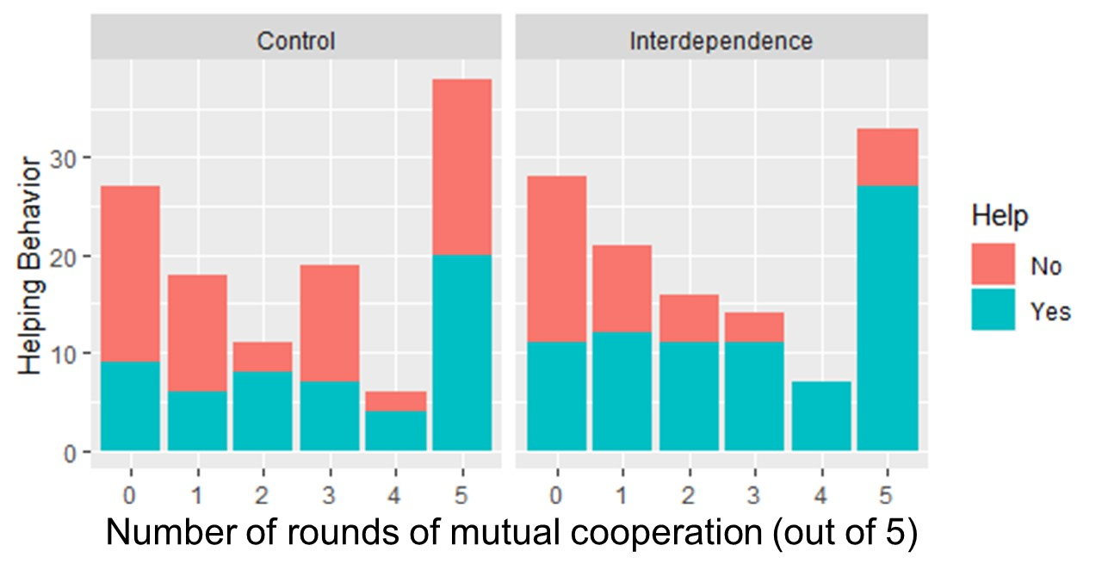

Figure S2
Experiment 2: The effect of prior mutual cooperation on willingness to secretly help
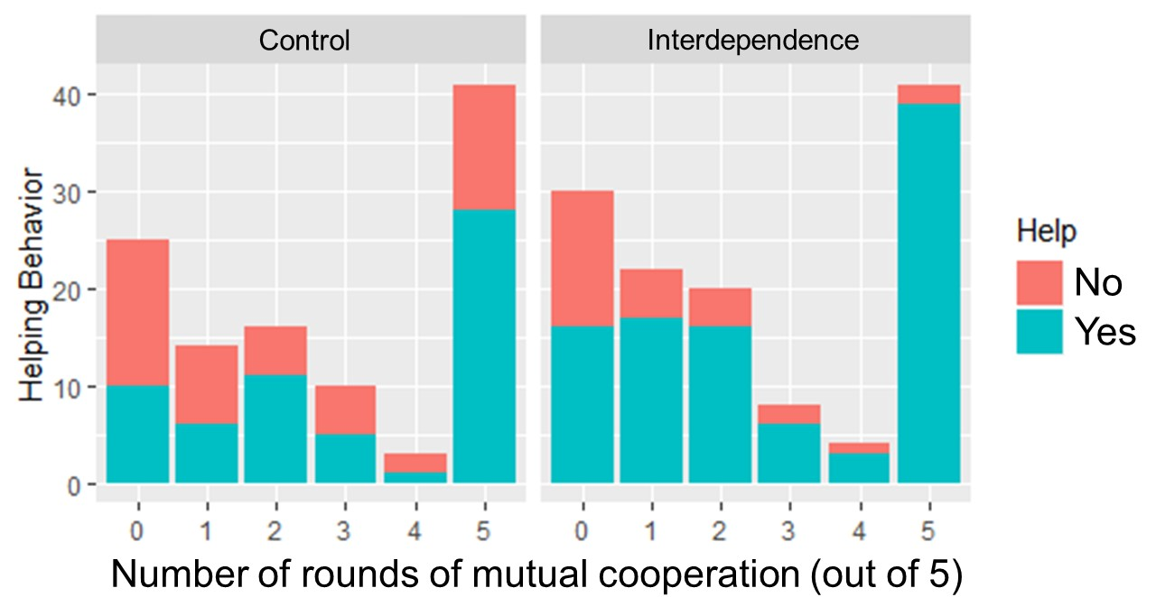
S.5 Supplementary Results: Helping Among First-Round Cooperators

Participants were randomly assigned to the experimental conditions, but were not randomly assigned to be in cooperative or uncooperative dyads. Instead, their dyad type is partly endogenous: a cooperative dyad requires that both members cooperate, so people who cooperate in the first round are more likely to end up in a cooperative dyad. As such, people in cooperative dyads almost certainly have a more “cooperative personality” (however defined) on average than people in uncooperative dyads. Therefore, any difference between the cooperative and uncooperative dyads could be caused by differing “cooperative personality profiles” (e.g., social preferences, heuristics, personality), rather than the state of being in a cooperative vs. uncooperative dyad. This does not limit the conclusions of our hypothesis, because we are more concerned with the differences between experimental conditions. If someone is in an uncooperative dyad – whether for endogenous or exogenous reasons – then they have less stake in their partner than someone in a cooperative dyad.

That being said, for those who are interested, there is a way to tease apart the reasons for someone being in a cooperative or uncooperative dyad, namely by looking at their Round 1 cooperation (i.e., before they were affected by their partner’s actions). Some people who cooperated in Round 1 had partners who defected, hence they ended up in uncooperative dyads, and vice versa (though this latter was rare). We analyzed “first-round cooperators” separately from the “first-round defectors”, which helps us to partially tease out the effects of a person’s preferences (i.e., being a first-round cooperator vs. first-round defector) from the effects of the situation (i.e., being in a cooperative vs. uncooperative dyad). These results replicate the results from the main text: “first-round cooperators” in cooperative dyads provided more secret help than “first-round cooperators” in uncooperative dyads, but only in the Interdependence Condition. Furthermore, the effect of dyad type was greater in the Interdependence condition than the Control condition – the interaction was significant in both Experiments 1 and 2 with one-tailed test (and with a two-tailed test when combined meta-analytically). Note: almost all “first-round defectors” ended up in uncooperative dyads, so we could not analyze them.

Table S5
Proportion of Help Provided by First-Round Cooperators in Cooperative and Uncooperative Dyads in Experiment 1
 | Interdependence Condition | Control Condition
 | Proportion Help | Proportion Help | Odds Ratio [95% CI]
Cooperative Dyads | 44/53  (83%) | 30/61  (49%) | 5.05***  [2.11, 12.12]
Uncooperative Dyads | 24/45  (53%) | 13/32  (41%) | 1.46  [0.58, 3.70]
Odds Ratio [95% CI] | 4.89***  [1.91, 12.49] | 1.41  [0.60, 3.36]
Note: ***p < .001. Interaction for the odds ratios: z = 1.90, 1-tailed p = .029, 2-tailed p = .057

Table S6
Proportion of Help Provided by First-Round Cooperators in Cooperative and Uncooperative Dyads in Experiment 2
 | Interdependence Condition | Control Condition
 | Proportion Help | Proportion Help | Odds Ratio [95% CI]
Cooperative Dyads | 47/52  (90%) | 34/53  (64%) | 5.25***  [1.78, 15.46]
Uncooperative Dyads | 32/51  (63%) | 20/38  (53%) | 1.52  [0.65, 3.56]
Odds Ratio [95% CI] | 5.58***  [1.89, 16.48] | 1.61  [0.69, 3.76]
Note: **p < .005. Interaction for the odds ratios: z = 1.77, 1-tailed p = .038, 2-tailed p = .077

Thus, in both Experiments 1 and 2, if we restrict our analysis to participants who cooperated in the first round, we see very similar effects to those in the main text, despite the smaller sample size. In the Interdependence Condition, cooperators who ended up in cooperative dyads were more likely to secretly help their partners than cooperators who ended up in uncooperative dyads, but in the Control Condition there was no effect of dyad types. This suggests that the higher helping in cooperative dyads in the Interdependence Condition was not just because “cooperative people” were more likely to end up in cooperative dyads – there is something about being in a cooperative dyad that makes people more likely to help in the Interdependence Condition (but not the Control Condition).

Furthermore, the effect of dyad type was stronger in the Interdependence Condition, as shown by the significant interaction of the odds ratios in both experiments. These are significant in both Experiments 1 and 2 with a one-tailed test, which is justified by our strong directional prediction. If we combine Experiments 1 and 2 with an internal meta-analysis using Stouffer’s method, then the interaction is highly significant with both one- and two-tailed tests (combined z = 2.60, one-tailed p = .004, two-tailed p = .009).

Note: most first-round defectors ended up in uncooperative dyads, which is hardly surprising, given that mutual cooperation requires that both partners cooperate. As such, we could not examine the effect of cooperative vs. uncooperative dyads among first-round defectors. However, for completeness, we present their helping rates among the uncooperative dyads, in case these data are useful for future researchers. In Experiment 1, helping rates by first-round defectors in uncooperative dyads were 10/24 (42%) in the Control Condition and 10/20 (50%) in the Interdependence Condition. There were barely any first-round defectors in cooperative dyads: only two in the Control Condition (one of whom helped) and one in the Interdependence Condition (who did help). In Experiment 2, helping rates by first-round defectors in uncooperative dyads were 17/17 (41%) in the Control Condition and 17/21 (81%) in the Interdependence Condition. There were barely any first-round defectors in cooperative dyads: one in the Control Condition (who did not help) and one in the Interdependence Condition (who did help).

S.6. Supplementary Results:
Perceived Interdependence Correlates with Cooperation & Helping

People are more likely to cooperate with others if they feel interdependent with them (e.g., Ayers, 2023). To test this, we conducted a secondary analysis on participants’ perceptions of their interdependence with their partners, which we had measured on the post-experimental survey using Ayers and colleagues’ 2023 interdependence scale (Experiments 2-3) or questions derived from it (Experiment 1, see main text). This analysis is tangential to our main focus, because it focuses on proximate mechanisms, whereas our main focus was the effect of the situation itself (not the psychological sensations that the situation triggers). However, we include this as a secondary analysis because it might interest some readers. The survey in Experiment 1 is the sum of 4 questions on a Likert scale with each question from -3 to +3; in Experiments 2 it is the sum of 6 questions on a 1-7 Likert scale.

S.6.1 Perceived Interdependence Correlates with Cooperation in the Prisoner’s Dilemma

As predicted, there was a strong correlation between participants’ perceptions of interdependence and the number of rounds in which they mutually cooperated, in both Experiment 1 and 2 (r₄₇₆ = .68 and, p < .001; r₄₇₆ = .56, p < .001; respectively).

However, the underlying causation is clear: does perceived interdependence cause cooperation, or does mutual cooperation cause perceived interdependence? These experiments were not designed to test this, but we can make steps at establishing causation by teasing out the effects of the situation (i.e., cooperative vs. uncooperative dyads) and the effects of a participant’s “cooperative type” (i.e., first-round cooperators vs. first-round defectors). If participant’s pre-experiment interdependence affects their mutual cooperation, then first-round cooperators should perceive higher interdependence when we control for dyad type. If the experience of mutual cooperation affects one’s perceived interdependence, then participants in a cooperative dyad should perceive higher interdependence when we control for their first-round cooperation. Very few first-round defectors ended up in cooperative dyads, so we cannot analyze them, but we can analyze the other three combinations of situation & type. To test this, we looked within first-round cooperators to compare the interdependence of those who ended up in cooperative vs. uncooperative dyads – this controls for “cooperative type”, to reveal the effects of being in a cooperative vs. uncooperative dyad. We can also look within uncooperative dyads to compare the interdependence of first-round cooperators and first-round defectors – this controls for the situation, to reveal the effects of one’s “cooperative type”.

Overall, the results on the next page are clear: first-round cooperators perceive much higher interdependence if they end up in cooperative dyads instead of uncooperative dyads (Cohen’s d ranging from 0.93 to 1.59), whereas there is little or no difference in perceived interdependence between first-round cooperators and first-round defectors within uncooperative dyads (Cohen’s d ranging from 0.05 to 0.51). Thus, it appears to be the type of dyad that drives perceived interdependence at the end of the experiment, not one’s “cooperative type. Future experiments should test this further.

Effect of dyads: first-round cooperators in cooperative vs. uncooperative dyads
- Experiment 1 (4 questions, range -3 to +3)
  - Control Condition (N = 61 vs. 32): M = 6.0 ± SD 3.9 vs. M = -0.8 ± SD 6.2
    - t_{44.4} = 5.67, p < .001, d = 1.42 [0.94, 1.89]
  - Interdep. Condition (N = 53 vs. 45): M = 6.5 ± SD 4.1 vs. M = -1.0 ± SD 5.3
    - t_{81.7} = 7.69, p < .001, d = 1.59 [1.13, 2.04]
- Experiment 2 (6 questions, range 1 to 7)
  - Control Condition (N = 53 vs. 38): M= 5.6 ± SD 1.1 vs. M = 4.1 ± SD 1.2
    - t₈₉ = 6.48, p < .001, d = 1.38 [0.91, 1.84]
  - Interdep. Condition (N = 52 vs. 51): M = 5.6 ± SD 0.9 vs. 4.7 ± SD 1.1
    - t_{95.3} = 4.71, p < .001, d = 0.93 [0.52, 1.33]

Effects of type: first-round cooperators vs. first-round defectors within uncooperative dyads
- Experiment 1 (4 questions, range -3 to +3)
  - Control Condition (N = 32 vs. 24): M = -0.8 ± SD 6.2 vs M = -1.1 ± 4.7
    - t₅₄ = 0.19, p = .85, d = 0.05 [-0.48, 0.58]
  - Interdep. Condition (N = 45 vs. 20): M = -1.0 ± SD 5.3 vs. M = -1.4 ± SD 6.5
    - t₆₃ = 0.24, p = .81, d = 0.07 [-0.46, 0.59]
- Experiment 2 (6 questions, range 1 to 7)
  - Control Condition (N = 38 vs. 17): M= 4.1 ± SD 1.2 vs. M = 3.6 ± SD 1.7
    - t₂₃ = 0.95, p = .35, d = 0.32 [-0.26, 0.89]
  - Interdep. Condition (N = 51 vs. 21): M = 4.7 ± SD 1.1 vs. 4.1 ± SD 1.2
    - T₇₀ = 1.97, p = .053, d = 0.51 [-0.01, 1.02]

S.6.2 Perceived Interdependence Correlates with a Willingness to Secretly Help a Partner

Do individuals who decide to help a partner report greater perceived interdependence? To address this question, we ran t-tests exploring group differences in perceived interdependence, comparing those that chose to help to those who did not. In Experiment 1, the participants who paid to help their partner reported greater perceived interdependence; this was true in the Control Condition t(117) = 4.42, p < .001, d = .81, 95% CI of d [.44, 1.19] and the Interdependence Condition t(117) = 3.01, p < .01, d = .58, 95% CI of d [.19, .97] (see Figure S3). We found the same pattern of results in Experiment 2: partners who paid to help reported greater interdependence in Control Condition (t(107) = 2.78, p < .01, d = . 54, 95% CI of d [.15, .92]), Interdependence Condition (t(123) = 3.48, p < .001, d = .75, 95% CI of d [.32, 1.18], and even the Asocial Condition (t(52) = 3.71, p < .001, d = 1.09, 95 CI of d [.47, 1.69], see Figure S4).

Figure S3
Experiment 1: Between Group Differences in Perceived Interdependence (with 95% CI)
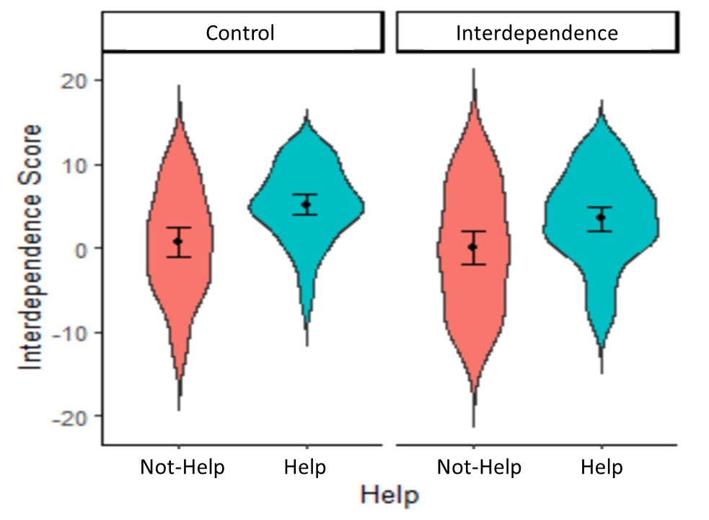
Figure S4
Experiment 2: Between Group Differences in Perceived Interdependence (with 95% CI)
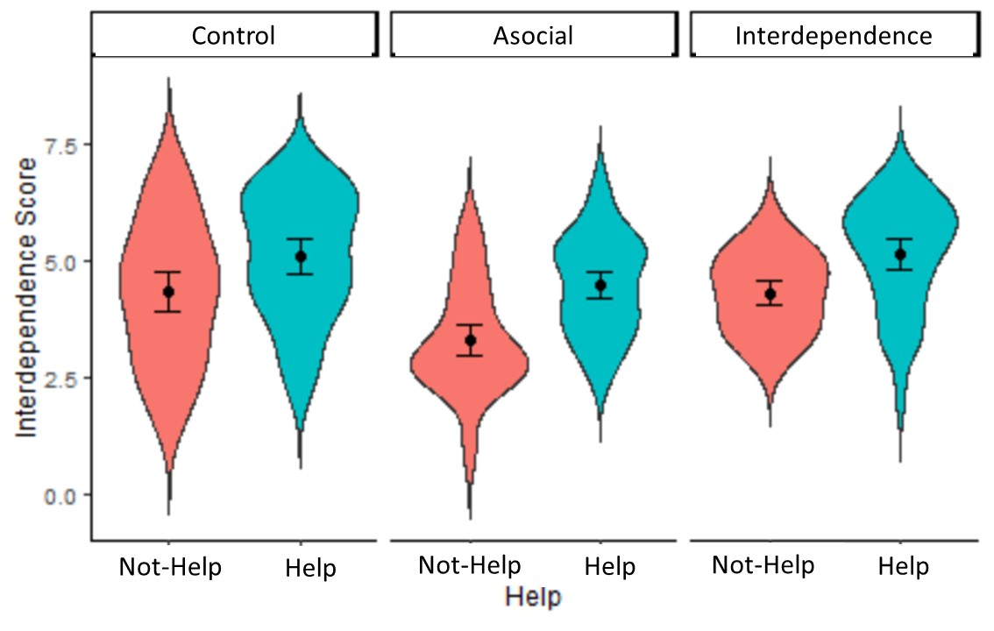

S.7 Screenshots from the Experimental Game

We first present the o-tree instructions and game screens from both the Control and Interdependence Conditions, because these conditions were the same until after five rounds of the game, whereupon participants were given the opportunity to anonymously help their partner. We then present the screens that differ between those conditions (i.e., the anonymous helping screen). We then present the instructions and game screen from the Asocial Condition, as this was different due to the asocial task. Finally, we present what participants in Experiment 3 saw.

COMMON TO CONTROL AND INTERDEPENDENCE CONDITIONS:
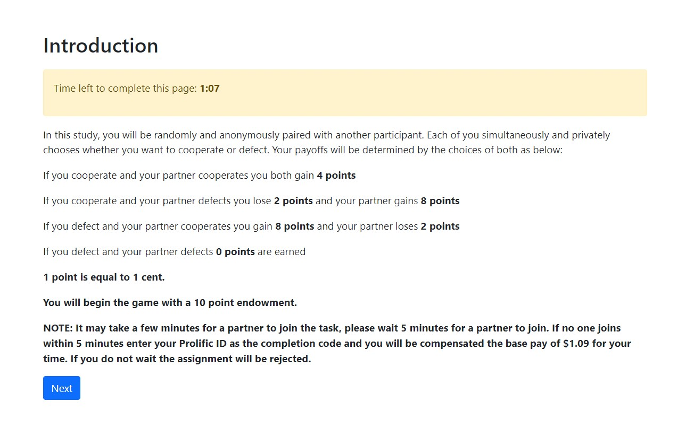


CONTROL CONDITION


INTERDEPENDENCE CONDITION


EXPERIMENT 2 ASOCIAL CONDITION


EXPERIEMENT 3
ALTERNATE PLAYER (PLAYER 3) ONE-SHOT GAME


EXAMPLE OF PLAYER 1 & 2 (INTERACTING DUO)

OPPORTUNITY TO HELP PRESENTED TO INTERACTING PLAYER (IN GOOD & BAD REPLACEMENT CONDITIONS)


