**Supplemental Materials for *Too Naïve to Lead: When Leaders Fall for Flattery***

All data, syntax, and materials are available through the Open Science Framework:<https://osf.io/wuc5k/?view_only=5839d24dea4b425186253b9f28dc2e8d>

Contents

**Scenario and Manipulation Texts for Studies** 2

**Study 1** 2

**Study 2** 3

**Study 4** 5

**Study 5** 8

**Study 6** 9

**Study 7** 11

**Supplementary Study 2** 12

**Supplementary Study 3** 13

**Supplementary Study 5** 14

**Supplementary Study 6** 15

**Supplementary Studies** 16

**Supplementary Study 1: Perceptions of Leader Naiveté** 16

**Supplementary Study 2: Reputational Consequences for Leaders and Non-Leaders** 18

**Supplementary Study 3: Comparing Explicitly and Non-Explicitly Requested Favors** 23

**Supplementary Study 4: Online Full-Measure Version of Study 3** 31

**Supplementary Study 5: Comparing New and Established Leaders** 35

**Supplementary Study 6: The Impact of Approacher and Leader Competence** 44

**Supplemental Analyses** 58

**Study 1** 58

**Study 2** 59

**Study 3** 62

**Study 4** 67

**Study 5** 73

**Study 6** 79

**Study 7** 82

**Supplemental References** 86

# **Scenario and Manipulation Texts for Studies**

## **Study 1**

As you know, every year various schools announce faculty searches and candidates apply for positions. Part of the academic job market involves informal networking between faculty and job candidates in academic conferences and elsewhere.

Imagine that you are in one of these academic conferences. During a break between the sessions, you observe several Ph.D. students who are having an informal conversation with a senior faculty member from a different school. You observe one particular Ph.D. student whom you know is on the job market this year commenting favorably on the senior faculty member’s published papers. The Ph.D. student goes on extolling praises and making a point to mention how much they admire the faculty member’s research.

You then hear the Ph.D. student ask whether the senior faculty member would be willing to read their research statement and give feedback on how it could be improved and tailored to the faculty member’s department. The Ph.D. student also asks whether the senior faculty would forward their C.V. and put in a good word to the hiring committee at the senior faculty’s school.

*Grant Favor Condition:* The senior faculty member agrees to do these favors for the Ph.D. student and gives their email to the student to connect later.

*Refuse Favor Condition:* The senior faculty member declines to do these favors for the Ph.D. student.

## **Study 2**

*Flattery and Grant-Favor Condition:*

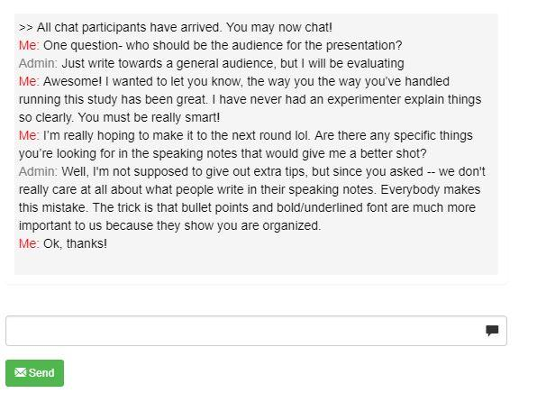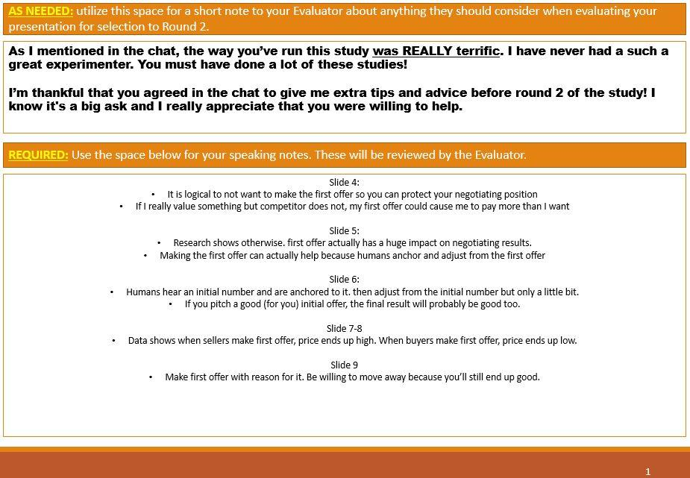

*Flattery and Refuse-Favor Condition:*

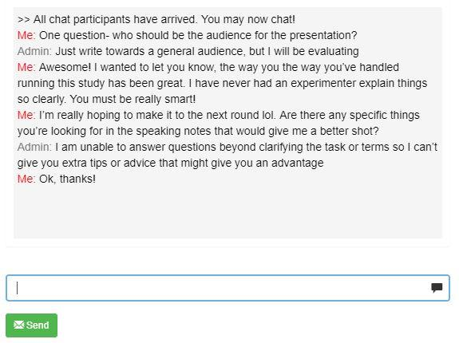

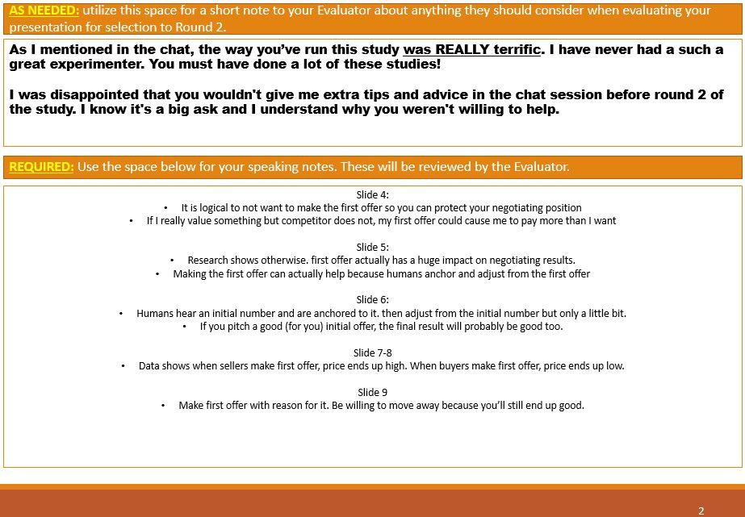

## **Study 4**

Imagine there is a new position opening up at your organization. You are not interested in this position, but you know that a lot of your coworkers would really like to get this new position as it represents a promotion for many of them. The same day the new position is announced, your organization happens to hold a company Happy Hour at a local restaurant. At the Happy Hour, you notice that (INITIALS) is in attendance.

*Condition 1: Flattery, Grant Favor*

You see someone in your organization approach (INITIALS) and act in an extremely fawning way towards them -- complimenting them on their work, buttering them up, and repeatedly mentioning how they admire (INITIALS)’s work.

A few moments later, you hear the approacher ask for a personal introduction to the manager hiring for the new position, whom (INITIALS) knows well. The approacher also asks if (INITIALS) would put in a good word to the hiring manager for the new position.

In response, (INITIALS) agrees to grant this favor and you witness them call over the hiring manager, highly recommend the approacher for the desirable position, and secure a personal meeting between the hiring manager and the approacher.

*Condition 2: Flattery, Refuse Favor*

You see someone in your organization approach (INITIALS) and act in an extremely fawning way towards them -- complimenting them on their work, buttering them up, and repeatedly mentioning how they admire (INITIALS)’s work.

A few moments later, you hear the approacher ask for a personal introduction to the manager hiring for the new position, whom (INITIALS) knows well. The approacher also asks if (INITIALS) would put in a good word to the hiring manager for the new position.

In response, (INITIALS) declines to grant this favor and does not speak to the hiring manager on the approacher’s behalf.

*Condition 3: Nepotism, Grant Favor*

You see someone in your organization approach (INITIALS). The approacher is (INITIALS)’s nephew who also works at the company. The two discuss a recent family gathering and it is apparent that they know each other well due to their family ties.

A few moments later, you hear the approacher ask for a personal introduction to the manager hiring for the new position, whom (INITIALS) knows well. The approacher also asks if (INITIALS) would put in a good word to the hiring manager for the new position.

In response, (INITIALS) agrees to grant this favor and you witness them call over the hiring manager, highly recommend the approacher for the desirable position, and secure a personal meeting between the hiring manager and the approacher.

*Condition 4: Nepotism, Refuse Favor*

You see someone in your organization approach (INITIALS). The approacher is (INITIALS)’s nephew who also works at the company. The two discuss a recent family gathering and it is apparent that they know each other well due to their family ties.

A few moments later, you hear the approacher ask for a personal introduction to the manager hiring for the new position, whom (INITIALS) knows well. The approacher also asks if (INITIALS) would put in a good word to the hiring manager for the new position.

In response, (INITIALS) declines to grant this favor and does not speak to the hiring manager on the approacher’s behalf.

*Condition 5: Meritocracy, Grant Favor*

You see someone in your organization approach (INITIALS). The approacher mentions that they are hoping to be promoted to the new position as their qualifications and experience make them a great fit. In particular, the approacher details their strong performance ratings, the time they spent shadowing others in the role and a technical certification they recently earned. You and (INITIALS) know that this information is factually true; the approacher did not exaggerate their qualifications.

A few moments later, you hear the approacher ask for a personal introduction to the manager hiring for the new position, whom (INITIALS) knows well. The approacher also asks if (INITIALS) would put in a good word to the hiring manager for the new position.

In response, (INITIALS) agrees to grant this favor and you witness them call over the hiring manager, highly recommend the approacher for the desirable position, and secure a personal meeting between the hiring manager and the approacher.

*Condition 6: Meritocracy, Refuse Favor*

You see someone in your organization approach (INITIALS). The approacher mentions that they are hoping to be promoted to the new position as their qualifications and experience make them a great fit. In particular, the approacher details their strong performance ratings, the time they spent shadowing others in the role and a technical certification they recently earned. You and (INITIALS) know that this information is factually true; the approacher did not exaggerate their qualifications.

A few moments later, you hear the approacher ask for a personal introduction to the manager hiring for the new position, whom (INITIALS) knows well. The approacher also asks if (INITIALS) would put in a good word to the hiring manager for the new position.

In response, (INITIALS) declines to grant this favor and does not speak to the hiring manager on the approacher’s behalf.

*Condition 7: Control, Grant Favor*

You see someone in your organization approach (INITIALS).

A few moments later, you hear the approacher ask for a personal introduction to the manager hiring for the new position, whom (INITIALS) knows well. The approacher also asks if (INITIALS) would put in a good word to the hiring manager for the new position.

In response, (INITIALS) agrees to grant this favor and you witness them call over the hiring manager, highly recommend the approacher for the desirable position, and secure a personal meeting between the hiring manager and the approacher.

*Condition 4: Control, Refuse Favor*

You see someone in your organization approach (INITIALS).

A few moments later, you hear the approacher ask for a personal introduction to the manager hiring for the new position, whom (INITIALS) knows well. The approacher also asks if (INITIALS) would put in a good word to the hiring manager for the new position.

In response, (INITIALS) declines to grant this favor and does not speak to the hiring manager on the approacher’s behalf.

## **Study 5**

Imagine there is a new position opening up at your organization. You are not interested in this position, but you know that a lot of your coworkers would really like to get this new position as it represents a promotion for many of them. The same day the new position is announced, your organization happens to hold a company Happy Hour at a local restaurant. At the Happy Hour, you notice that (your leader) is in attendance.

*Excessive Work-Related Flattery Condition:*

You see someone in your organization approach (your leader) and act in an extremely fawning way towards them -- complimenting them on their work, buttering them up, and repeatedly mentioning how they admire (your leader)’s work.

*Excessive Personal Characteristics-Related Flattery Condition*

You see someone in your organization approach (your leader) and act in an extremely fawning way towards them -- complimenting them on their outfit and repeatedly mentioning how they liked (your leader)'s new haircut.

*Merited Work-Related Flattery Condition*

You see someone in your organization approach (your leader). After an initial greeting, you hear the approacher compliment (your leader) on their work on a recent initiative and express their admiration for the project, which (your leader)was in charge of and was a big success for the organization.

*Control Condition:*

You see someone in your organization approach (your leader). After an initial greeting, you hear the approacher ask about how things were going that week and say to (your leader), “I hope you had a great day.”

A week later, you see the approacher ask (your leader) for a personal introduction to the manager hiring for the new position, whom (your leader) knows well. The approacher also asks if (your leader)would put in a good word to the hiring manager for the new position.

*Grant Favor Condition*

You subsequently find out that (your leader) agreed to grant this favor and placed a call to the hiring manager on behalf of the approacher, highly recommending them for the desirable position, and securing a personal meeting between the hiring manager and the approacher.

*Refuse Favor Condition*

You subsequently find out that (your leader) declined to grant this favor and did not speak to the hiring manager on the approacher’s behalf.

## **Study 6**

As a reminder, in Part 1 you completed a task called "Finding E's," in which you found instances of the letter "E" in 10 grids of letters. **Another MTurker (the “Evaluator") has now evaluated your work on that task.** There were two Evaluators assigned to evaluate participants in this study, with each taking half of the participants. The Evaluators reviewed your data for quality and **for potential nomination to a future Evaluator role for you.** Evaluators receive further study opportunities at a higher pay rate.

Prior to showing your results, you will review the evaluation of another participant for comparison and so that you can provide feedback on our role selection process.

*Favor-Harm Condition:*

You will be seeing information about another participant who was **evaluated by the same Evaluator as you**. Thus, the Evaluator's decision about the other participant **strongly impacts your potential nomination**, as Evaluators are only able to nominate one participant each study.

*No Harm Condition:*

You will be seeing information about another participant who was **evaluated by a different Evaluator than you**. As this participant was reviewed by a different Evaluator, their evaluation **had no impact on your potential nomination** for the advanced role.

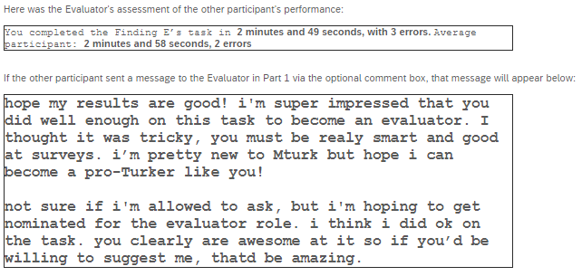

*Grant Favor Condition:*

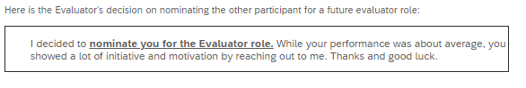

*Refuse Favor Condition*

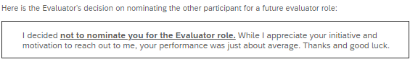

## **Study 7**

Now imagine that at a work event, you saw someone within your organization approach and act in an extremely fawning way towards (your leader) -- complimenting them on their work, buttering them up with flattery, and mentioning several times how admirable their achievements are.    
    
*Aware Condition:*

After speaking with the person, (your leader), turns to you and says, “Wow, that person never gave me the time of day before I was promoted to manager.”

*Unaware Condition:*

After speaking with the person, (your leader), turns to you and says, “Wow, that person seemed really interested in my work!”

*Grant Favor Condition:*

Later on, (your leader) informs you that the approacher also asked them for a major professional favor during their conversation.   
  
In response, (your leader) agreed to grant the favor.

*Refuse Favor Condition:*

Later on, (your leader) informs you that the approacher also asked them for a major professional favor during their conversation.   
  
In response, (your leader) refused to grant the favor.

## **Supplementary Study 2**

*Leader condition:*

First, please think about someone you know who has a lot of power, influence, and/or prestige in a professional field. This should be someone whom other people constantly and regularly seek out and approach for professional guidance, professional favors, and/or professional help. In other words, this should be someone with a great deal of power in a professional field.

*Non-Leader condition:*

First, please think about someone you know who has a low level of power, influence, and/or prestige in a professional field. This should be someone whom other people rarely if ever seek out or approach for professional guidance, professional favors, and/or professional help. In other words, this should be someone with a low level of power in a professional field.

Imagine that you saw someone approach (the leader)} and act in an extremely obsequious way towards them -- complimenting them on their work, buttering them up with flattery, and mentioning several times how admirable their achievements are.

You then hear this approacher ask (the leader) for a major professional favor.

*Grant Favor Condition:*

In response, (the leader) agrees to grant this person the favor.

*Refuse Favor Condition:*

In response, (the leader) refuses to grant this person the favor.

## **Supplementary Study 3**

Imagine there is a new position opening up at your organization. You are not interested in this position, but you know that a lot of your coworkers would really like to get this new position as it represents a promotion for many of them.

The same day the new position is announced, your organization happens to hold a company Happy Hour at a local restaurant. At the Happy Hour, you notice that (your leader) is in attendance. This new position is not on (your leader)'s team, but they do personally know the hiring manager for the position.   
  
You see someone in your organization approach (your leader) and act in an extremely fawning way towards them -- complimenting them on their work, buttering them up, and repeatedly mentioning how they admire (your leader)’s work.

*Explicit Request Condition:*

A week later, you see the approacher ask (your leader) for a personal introduction to the manager hiring for the new position, whom (your leader) knows well. The approacher also asks if (your leader) would put in a good word to the hiring manager for the new position.

*No Request Condition:* (no text)

*Grant Favor Condition*:

Several weeks later, you found out that (your leader) placed a call to the hiring manager on behalf of the person who approached at the Happy Hour, highly recommending them for the desirable position and secured a personal meeting between the two about the position.

*Refuse Favor Condition:*

Several weeks later, you found out that (your leader) did not reach out to the hiring manager to put in a good word for the person who approached at the Happy Hour or to help them secure a meeting with the hiring manager about the new position

## **Supplementary Study 5**

*New Leader Condition:*

In this study, we will ask you to imagine that your work team has been assigned a new leader, named Alex, who just joined from another organization. You are not very familiar with Alex but they hold a position with a great deal of control over resources and rewards. In other words, Alex is someone with a lot of power in your organization and has been working with your team for a few weeks at this point.

*Established Leader Condition:*

In this study, we will ask you a few questions about someone you know at work. First, please think about someone you know professionally within your work organization who holds a position with a **great deal of control over resources and rewards**. In other words, this should be someone with a lot of power in your organization. Please take a few moments to think about a person like this whom you know, and write down their first name (or initials) below

Imagine there is a new position opening up at your organization. You are not interested in this position, but you know that a lot of your coworkers would really like to get this new position as it represents a promotion for many of them. The same day the new position is announced, your organization happens to hold a company Happy Hour at a local restaurant. At the Happy Hour, you notice that (your leader) is in attendance.

You see someone in your organization approach (your leader) and act in an extremely fawning way towards them -- complimenting them on their work, buttering them up, and repeatedly mentioning how they admire (your leader)’s work.

A week later, you see the approacher ask (your leader) for a personal introduction to the manager hiring for the new position, whom (your leader) knows well. The approacher also asks if (your leader) would put in a good word to the hiring manager for the new position.

*Grant Favor Condition:*

You subsequently find out that (your leader) agreed to grant this favor and placed a call to the hiring manager on behalf of the approacher, highly recommending them for the desirable position, and securing a personal meeting between the hiring manager and the approacher.

*Refuse Favor Condition:*

You subsequently find out that (your leader) declined to grant this favor and did not speak to the hiring manager on the approacher’s behalf.

## **Supplementary Study 6**

Imagine there is a new position opening up at your organization. You are not interested in this position, but you know that a lot of your coworkers would really like to get this new position as it represents a promotion for many of them.   The same day the new position is announced, your organization happens to hold a company Happy Hour at a local restaurant. At the Happy Hour, you notice that (your leader) is in attendance.

*Incompetent Approacher Condition:*

You see someone in your organization approach (your leader). The approacher is known in the organization to be ***rather incompetent***, generally receiving low performance ratings and lacking the skills and capabilities to succeed in their work.

*Competent Approacher Condition:*

You see someone in your organization approach (your leader). The approacher is known in the organization to be ***extremely competent***, generally receiving high performance ratings and possessing the skills and capabilities to succeed in their work.

You see this approacher act in an extremely fawning way towards (your leader) -- complimenting them on their work, buttering them up, and repeatedly mentioning how they admire (your leader)’s work.

A week later, you see the approacher ask for a personal introduction to the manager hiring for the new position, whom (your leader) knows well. The approacher also asks if (your leader) would put in a good word to the hiring manager for the new position.

*Grant Favor Condition:*

You subsequently find out that (your leader) agreed to grant this favor and placed a call to the hiring manager on behalf of the approacher, highly recommending them for the desirable position, and securing a personal meeting between the hiring manager and the approacher.

*Refuse Favor Condition:*

You subsequently find out that (your leader) declined to grant this favor and did not speak to the hiring manager on the approacher’s behalf.

# 

# **Supplementary Studies**

## **Supplementary Study 1: Perceptions of Leader Naiveté**

Given the centrality of naiveté to our theorizing, it was important to understand how people generally view the naiveté of leaders to better contextualize the empirical findings in our studies. Thus, we had participants provide their general perceptions of naiveté for a leader as well as for a non-leader and an average person for comparison.

**Method**

***Participants.*** We recruited 193 adults for this study who agreed to complete an online survey associated with a university in France[1] in exchange for financial compensation. We excluded one participant who incorrectly responded to both attention checks and excluded two responses that were duplicates of each other, leaving a final usable sample of 190 (*M*age = 25.64 years, *SDage* = 4.73; 120 female, 66 male, four non-binary / third gender / self-identified)

***Design and procedure.*** All participants were asked to picture three types of individuals: a leader of an organization, a non-leader of an organization (e.g., a low-level employee with little power), and an “average person,” in counterbalanced order (see Online Materials for scenario text). For each type of individual, participants were asked to rate their perceptions of the individual’s general traits[2].

**Measures**

***Perceived naiveté.*** We used the same scale of naiveté as all other studies (αLeader = .72; αNonleader = .72; αAverage = .84).

**Results**

Results from a one-way repeated measures ANOVA showed that perceptions of naiveté were significantly different based on whether the referent individual was a leader, a non-leader, or an average person, *F*(2, 378) = 105.00, *p*< .001, *generalized eta squared* = .237. Post-hoc analyses with a Bonferroni adjustment revealed that all the pairwise differences between naiveté ratings were significantly different from each other (*p*s ≤ .003). Specifically, leaders were rated at the least naïve (*M* = 2.36, *SD* = 1.05) than both non-leaders (*M* = 3.49, *SD* = 1.23, *t*(189) = -9.28, *p* < .001) and the average person (*M* = 3.82, *SD* = 1.07; *t*(189) = 15.30, *p* < .001). Additionally non-leaders were rated as less naïve than the average person (*t*(189) = 3.36, *p* = .003). Thus, these results show that leaders are generally perceived to be low in naiveté and are thought to be significantly less naïve than lower-level employees and the average person.

**Discussion**

As revealed in this study, when people picture a leader of an organization in their mind, they typically think of someone who is quite low in naiveté, likely due to the expectations people hold of leaders to be adept at handling complex issues. These findings provide important context to the studies in our manuscript. As we note in the manuscript, results show that favor-granting leaders appear more naïve than those who refuse to grant favors, but the means of both ratings tend to be less than the midpoint of our scale. However, in light of these findings, we can more confidently claim that favor-granting leaders in our studies are indeed appearing naïve to observers, rather than simply more naïve than favor-refusers, since perceptions of leader naiveté are restricted to a limited range of values based on the leader’s status.

## **Supplementary Study 2: Reputational Consequences for Leaders and Non-Leaders**

In Supplementary Study 2, we examine whether the consequences of rewarding flattery apply to leaders and non-leaders alike. We have argued that being perceived to have fallen for flattery is particularly risky for organizational leaders because it is at odds with followers’ implicit expectations that leaders will resist influence and be adept decision-makers. In contrast, while non-leaders may also look naïve when rewarding flattery, observers may not judge them against the same standards, as suggested as suggested by Supplementary Study 1 referenced in Footnote 4 of the main manuscript, which showed that leaders are seen as less naïve than non-leaders and the general population. This difference in implicit expectations may lead observers to penalize non-leaders who reward flattery less. Supplementary Study 2 tests this possibility by manipulating the flattery recipient’s leadership status and measuring observers’ reactions to witnessing either leaders or non-leaders reward flattery.

**Method**

***Participants.*** We recruited 398 participants from Amazon Mechanical Turk (Mturk). Thirty-three participants were excluded from the analyses for failing one or more attention checks, resulting in a usable *N* = 365 (*Mage* = 33.67 years, *SDage* = 10.13; 39.18% female).[3]

***Design and procedure.*** For this study, we adapted the stimulus materials from Study 1 to be about a corporate setting (see page 12 for scenario text). We also modified the Study 1 materials to reflect a 2(leadership status: leader vs. non-leader) 🞨 2(recipient response: grant favor vs. refuse favor) between-subjects design. Participants were first asked to think of an individual in a professional field who was either a leader (e.g., “Think about someone you know who has a lot of power, influence, and/or prestige in a professional field.”) or not (e.g., “Think about someone you know who has a low level of power, influence, and/or prestige in a professional field.”). They then read a scenario in which this individual (the recipient) is approached by another person (the approacher), who flatters the recipient and then requests a professional favor, which the recipient either grants or refuses.

***Manipulation check.*** As a manipulation check, participants first rated whether the recipient was a powerful leader using three items (“To what extent does this person have control over others’ resources in their professional field”; “How much power does this person have in their professional field”; “To what extent does this person have control over others' outcomes in their professional field”; 1 = *not at all*, 7 = *very much;* α = .96)

***Evaluations of recipient.*** Next, participants evaluated the recipient using the same measures as Study 1: naiveté (α = .92), competence (α = .93), and warmth (α =.92). Additionally, for secondary analyses, participants rated how the recipient’s response impacted their overall impression of him or her (-3 = *became very negative*, +3 = *became very positive*).

**Results**

Supplemental Table 1 provides means for all dependent measures by condition.

**Supplemental Table 1**

*Descriptive Statistics for Measures in Supplementary Study 2.*

|  |  |  |  |  |  |  |  |  |
| --- | --- | --- | --- | --- | --- | --- | --- | --- |
|  | Leader | | | | Non-Leader | | | |
| Variable | Grant  Favor | Refuse Favor | *t*a | *p* | Grant  Favor | Refuse Favor | *t*b | *p* |
| **Perceived naiveté** | | | | |  | | | |
| Perceived Naiveté | 3.26  [2.89, 3.63] | 2.60  [2.30, 2.90] | 2.77 | .006 | 3.99  [3.67, 4.30] | 3.09  [2.72, 3.45] | 3.70 | <.001 |
|  |  |  | | |  |  | | |
| **Impression-management consequences** | | | | |  | | | |
| Perceived Competence | .49  [.20, .77] | 1.22  [1.00, 1.44] | -4.13 | <.001 | .67  [.42, .92] | .83  [.54, 1.12] | -0.84 | .400 |
| Perceived Warmth | 1.15  [.91, 1.40] | .49  [.23, .75] | 3.58 | <.001 | 1.16  [.95, 1.37] | .14  [-.23, .52] | 4.83 | <.001 |
| Overall Impression | .38  [.08, .68] | .90  [.62, 1.17] | -2.50 | .013 | .49  [.21, .77] | .59  [.21, .97] | -0.42 | .674 |
|  |  | | | |  | | | |

a *df* = 184*;* b *df* = 177; *Note.* The values in square brackets are 95% confidence intervals.

***Manipulation check.*** The manipulation check confirmed that participants in the leader condition thought of a more powerful leader than did those in the non-leader condition, *F*(1, 361) = 169.04, *p* < .001, $η_{p}^{2}$ = .319.

***Perceived naiveté.*** As expected, an ANOVA testing the effects of favor-granting and recipient power on perceived naiveté revealed significant effects for both the favor condition, *F*(1,361) = 7.64, *p* = .006, $η_{p}^{2}$ = .021, and the leadership status condition, *F*(1,361) = 8.70, *p* = .003, $η_{p}^{2}$ = .024, but no significant interaction, *F*(1,361) = 0.48, *p* = .489, $η_{p}^{2}$ = .001. As Supplemental Table 1 shows, favor grantors were perceived as more naïve than those who refused to grant the favor, regardless of leadership status, *t*s > 2.77, *p*s < .006, *d*s > 2.01.

***Impression-management consequences.*** As detailed below, consistent with Study 1, leaders who granted favors to flatterers were rated as less competent than those who refused. In contrast, for non-leader flattery recipients, these reputational costs were reduced.

Beginning with perceived competence, an ANOVA testing the effects of favor-granting and recipient leader status on perceived competence showed a significant effect of favor-granting, *F*(1, 361) = 16.05, *p* < .001, $η_{p}^{2}$ = 0.043, and a significant interaction, *F*(1, 361) = 4.83, *p* = .029, $η_{p}^{2}$ = 0.013. There was no significant effect of being a leader, *F*(1, 361) = 0.97, *p* = .326, $η_{p}^{2}$ = 0.003. As illustrated in Supplemental Figure 1A and Supplemental Table 1, leader recipients suffered a reputational cost from rewarding flattery as participants rated their competence lower when they granted favors, *t*(184) = -4.13, *p* = <.001, *d* = .49, while competence perceptions of non-leader recipients did not differ based on favor-granting, *t*(177) = -.42, *p* = .674, *d* = .23.

Second, for perceived warmth, an ANOVA testing the effects of favor granting and recipient leader status indicated a significant effect of favor-granting, *F*(1,361) = 11.36, *p* < .001, $η_{p}^{2}$ = 0.031, but no effect of being a leader, *F*(1, 361) = 0.00, *p* = .979, $η_{p}^{2}$ = 0.000, nor a significant interaction, *F*(1, 361) = 1.60, *p* = .207, $η_{p}^{2}$ = 0.004. Regardless of leader status, favor-granting increased perceived warmth, *t*s > 3.58, *p*s < .001, *d*s > .14, as shown in Supplemental Figure 1B. Thus, our results align with Study 1 in demonstrating a warmth benefit for granting favors to flatterers.

**Supplemental Figure 1A and 1B.**

*Supplementary Study 2: Competence and warmth ratings of recipient as a function of leader status condition (leader vs. non-leader) and favor condition (grant favor vs. refuse favor).*

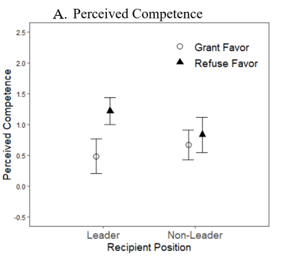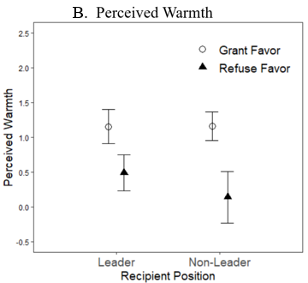

*Note*: Error bars represent 95% confidence intervals.

Finally, in terms of overall impression, an ANOVA testing the effects of favor granting and recipient power revealed a significant effect of favor-granting, *F*(1, 361 = 5.50, *p* = .020, $η_{p}^{2}$ = .015, but no effect of leadership status, *F*(1, 361) = 0.23, *p* = .635, $η_{p}^{2}$ = 0.001, and no interaction, *F*(1, 361) = 1.77, *p* = .184, $η_{p}^{2}$ = 0.005. Despite the non-significant interaction, secondary analyses demonstrated a similar pattern of results as perceived competence (see Supplemental Figure 2). As shown in Supplemental Table 1, granting favors led to a worse overall impression for leader recipients, *t*(184) = -2.50, *p* = .013, *d* = .22, but had no effect on the overall impression of non-leader recipients, *t*(177) = -.42, *p* = .674, *d* = .01.

**Supplemental Figure 2.**

*Supplementary Study 2: Overall impression ratings of recipient as a function of leader status condition (leader vs. non-leader) and favor condition (grant favor vs. refuse favor).*

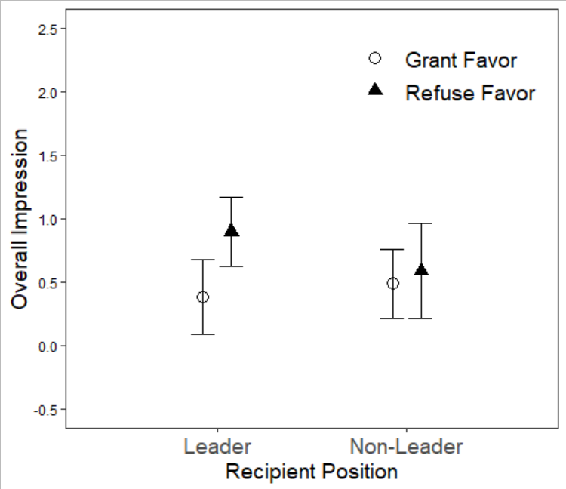

*Note*: Error bars represent 95% confidence intervals.

**Discussion**

This study suggests that being seen rewarding flattery is indeed worse for leaders than non-leaders. While all flattery recipients who reward flattery appear more naïve to observers, the flattery recipient’s leadership status impacts whether or not they suffer negative downstream reputational consequences as well. Participants rate leaders who fall for flattery as less competent and as worse overall than those who refuse favors after flattery but do not penalize non-leaders for the same behavior.

## **Supplementary Study 3: Comparing Explicitly and Non-Explicitly Requested Favors**

We preregistered our study <https://aspredicted.org/6C5_9XN>.

**Method**

***Participants.*** We recruited 404 employed adults from Amazon Mturk. Following our preregistered exclusion criteria, we excluded the data from 6 participants (who either answered both attention checks incorrectly or provided a nonsensical response to what they do for work), leaving a final sample of 398 (*Mage* = 40.56, *SD* = 11.12; 188 female, 205 male, two non-binary/third gender; three did not self-identify). Participants reported having worked with their leader for an average of 6.89 years (*SD* = 7.07).

***Design and procedure.*** Using a design similar to Studies 4 and 5, we first asked participants to recall a leader in their organization and to report the length of their relationship. Participants then read a scenario in which they observed another individual (the “approacher”) approach their organizational leader at an office social event and excessively flatter the leader. We used a 2(request explicitness: explicit request vs. no request) 🞨 2(leader response: grant favor vs. refuse favor) between-subjects design (see page 13 for scenario text).

In the *Explicit Request* condition, participants read the same protocol as Studies 6 and 7 in which they witnessed the approacher request a professional favor from the leader a week after the social event. In the *No Request* condition, the approacher did not make a request for a favor. As with Studies 4 and 5, participants read that they subsequently found out that the leader either provided a favor to the approacher (*Grant Favor*) or refused to do so (*Refuse Favor)*.

**Measures**

***Perceived naiveté and downstream impression-management and organizational consequences.*** We collected the same scales as Studies 4-5 of naiveté (α = .95), competence (α = .93), warmth (α = .91), overall impression (single item), commitment (α = .92), and organizational fairness *(*α = .97).

**Results**

Contrary to our preregistered predictions, the explicitness of the favor request had little impact on the effect of favor-granting on naiveté or our downstream outcomes, with the only exception being a significant interaction of favor-granting and request explicitness in predicting perceptions of warmth. Results by outcome are presented in Supplemental Table 2 and Supplemental Figures 3-5.

**Supplemental Table 2**

*Descriptive Statistics for All Measures in Supplementary Study 3*

|  |  |  |  |  |  |  |  |  |
| --- | --- | --- | --- | --- | --- | --- | --- | --- |
|  | Explicitly Requested Favor | | | | No Requested Favor | | | |
| Variable | Grant Favor | Refuse Favor | *t*a | *p* | Grant Favor | Refuse Favor | *t*b | *p* |
| **Perceived naiveté** | | | | |  | | | |
| Perceived Naiveté | 3.67  [3.34,4.00] | 1.96  [1.72,2.21] | 8.31 | <.001 | 3.95  [3.60, 4.31] | 2.02  [1.74,2.29] | 8.49 | <.001 |
|  |  |  | | |  |  | | |
| **Impression-management consequences** | | | | |  | | | |
| Perceived Competence | 0.03  [-0.18,0.24] | 1.26  [1.07,1.46] | -8.56 | <.001 | -0.28  [-0.51,-0.05] | 1.10  [0.89,1.32] | -8.82 | <.001 |
| Perceived Warmth | 0.63  [0.41,0.84] | 0.44  [0.22,0.66] | 1.19 | .235 | 0.12  [-0.11,0.36] | 0.40  [0.22,0.58] | -1.87 | .063 |
| Overall Impression | -0.33  [-0.58,-0.08] | 0.89  [0.63,1.16] | -6.67 | <.001 | -0.63  [-0.89,-0.37] | 0.94  [0.69,1.18] | -8.67 | <.001 |
| **Organizational consequences** | | | |  |  |  |  |  |
| Commitment to leader | 3.59  [3.31,3.87] | 4.25  [3.98,4.52] | -3.37 | <.001 | 3.24  [2.96,3.52] | 4.06  [3.82,4.30] | -4.33 | <.001 |
| Organizational Fairness | 3.22  [2.94,3.51] | 5.23  [4.98,5.48] | -10.50 | <.001 | 3.15  [2.86,3.45] | 5.19  [4.94,5.44] | -10.40 | <.001 |
|  |  | | | |  | | | |

a *df* = 198*;* b *df* = 196; *Note.* The values in square brackets are 95% confidence intervals.

***Manipulation checks.*** Participants were asked to what extent the leader performed a favor for the approacher and whether the approacher explicitly requested a favor from the leader (1 = *not at all*; 7 = *very much*). Participants in the grant-favor condition witnessed favor-granting to a stronger extent (*M* = 5.94, *SD* = 1.28) than did participants in the refuse-favor condition (*M* = 2.01, *SD* = 1.53; *t*(396) = 27.78, *p* < .001). Participants in the explicit request condition rated knowing the leader more (*M* = 5.74, *SD* = 1.34) as compared to participants in the incompetent approacher condition (*M* = 4.59, *SD* = 1.75; *t*(396) = 7.35, *p* < .001)[4].

***Perceived naiveté.*** Beginning with perceived naiveté, an ANOVA testing the effects of request explicitness and favor-granting revealed a significant effect of granting favors, *F*(1, 394) = 140.87, *p* < .001, $η_{p}^{2}$ = .263, but did not show a significant effect of request explicitness, *F*(1, 394) = 1.19, *p* = .276, $η_{p}^{2}$ = .003, or a significant interaction, *F*(1, 394) = 0.57, *p* = .449, $η_{p}^{2}$ = .001 show. As shown in Supplemental Table 2 and Supplemental Figure 3, results followed our predictions as favor-granting in response to flattery made leaders appear more naïve, regardless of whether a favor was explicitly requested or not.

**Supplemental Figure 3**

*Supplementary Study 3: Perceived leader naiveté as a function of request explicitness (explicit request vs. no request) and favor conditions (grant favor vs. refuse favor).*

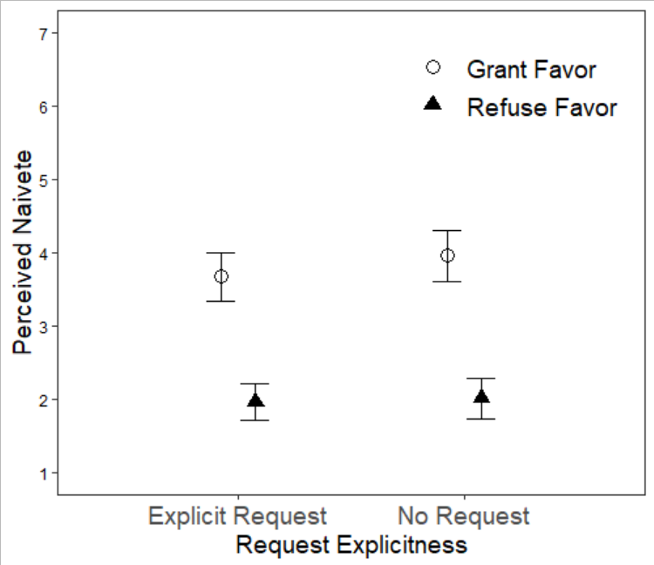

*Note*: Error bars represent 95% confidence intervals.

***Impression-management consequences***. ANOVA results indicated a significant effect of favor-granting, *F*(1, 394) = 150.88, *p* < .001, $η_{p}^{2}$ = .278, and a significant effect of request explicitness on perceptions of leader competence, *F*(1, 394) = 4.92, *p* = .027, $η_{p}^{2}$ = .012, but did not show a significant interaction, *F*(1, 394) = 0.51, *p*= .474, $η_{p}^{2}$ = .001. Supplemental Figure 4A and planned contrasts show that the effect of favor-granting on leader competence was negative regardless of request explicitness but showed that granting a non-explicitly requested favor causes leaders to appear even less competent (*M* = -.28, *SD* = 1.00) than doing so in response to an explicitly requested favor (*M* = 0.03, *SD* = 1.04), *t*(394) = -2.07, *p* = .039, in contrast to our predictions.

Moving next to perceptions of warmth, ANOVA results showed a significant effect of request explicitness, *F*(1, 394) = 6.13, *p* = .014, $η_{p}^{2}$ = .015 and a significant interaction, *F*(1, 394) = 4.64, *p* = .032, $η_{p}^{2}$ = .012, but did not show a significant effect of favor-granting, *F*(1, 394) = 0.18, *p* = .678, $η_{p}^{2}$ = .000. Despite the significant interaction, Supplemental Figure 4B and Supplemental Table 2 illustrate that granting a favor in response to flattery did not have a significant effect on warmth regardless of whether the favor was requested or not, although results were suggestive that granting a non-explicitly requested favor may reduce perceptions of warmth (*t* = -1.87, *p* = .063, *d* = .27), in contrast to our prediction. Planned contrasts further supported this possibility as non-explicitly requested favors resulted in lower warmth perceptions (*M* = 0.12, *SD* = 1.15) than doing so for an explicitly requested favor (*M* = 0.63, *SD* = 1.07, *t*(394) = -3.27, *p* = .001).

Finally for the impression-management outcomes, as depicted in Supplemental Figure 4C, an ANOVA on overall leader impression revealed a significant effect of favor-granting, *F*(1, 394) = 117.18, *p* < .001, $η_{p}^{2}$ = .229, but no significant effect of request explicitness, *F*(1, 394) = 0.93, *p* = .334, $η_{p}^{2}$ = .002, and a lack of interaction, *F*(1, 394) = 1.71, *p* = .191, $η_{p}^{2}$ = .004. As shown in Supplemental Table 2, favor-granting harmed overall impressions of leaders regardless of whether the favor was explicitly requested or not.

**Supplemental Figure 4A-C**

*Supplementary Study 3: Impression-management consequences (competence, warmth, overall impression) as a function of request explicitness (explicit request vs. no request) and favor conditions (grant favor vs. refuse favor).*

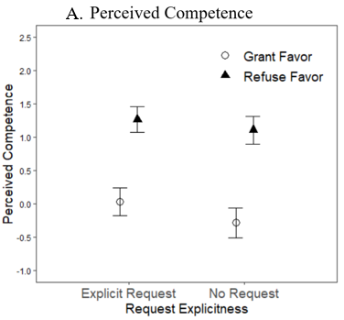 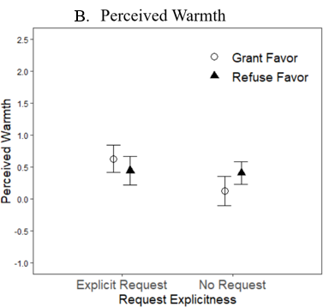

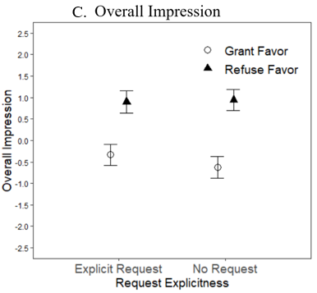

***Organizational consequences.*** As with the results for naiveté, competence, and overall impression, results for the organizational outcomes in Supplemental Table 2 and Supplemental Figures 5A and 5B showed consistent negative effects of favor-granting for both explicitly requested favors and non-explicitly requested favors. Beginning with commitment to the leader, an ANOVA showed a significant effect of favor-granting, *F*(1, 394) = 29.49, *p* < .001, $η_{p}^{2}$ = .070 and a significant effect of request explicitness, *F*(1, 394) = 3.87, *p* = .050, $η_{p}^{2}$ = .010, but did not show a significant interaction, *F*(1, 394) = 0.35, *p* = .556, $η_{p}^{2}$ = .001. For organizational fairness, ANOVA results showed a significant effect of favor-granting, *F*(1, 394) = 218.45, *p* < .001, $η_{p}^{2}$ = .357, but did not show a significant effect of request explicitness, *F*(1, 394) = 0.17, *p* = .679, $η_{p}^{2}$ = .000, nor an interaction, *F*(1, 394) = 0.01 *p* = .921, $η_{p}^{2}$ = .000. As shown in Supplemental Figures 5A and 5B, favor-granting decreased commitment to leaders and made the organization seem less fair to observers when the favor was explicitly requested as well as when it was not, but did not seem to show a large difference between explicit and non-explicitly requested favors as predicted.

**Supplemental Figure 5A and 5B**

*Supplementary Study 3: Organizational consequences (commitment to leader and organizational fairness) as a function of request explicitness (explicit request vs. no request) and favor conditions (grant favor vs. refuse favor).*

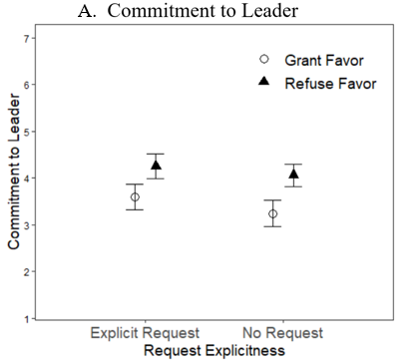 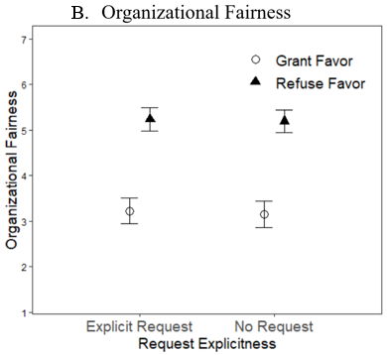

*Note*: Error bars represent 95% confidence intervals.

**Discussion**

This supplementary study explored an additional contextual factor that might differentiate real-world instances of flattery and favor-granting from the main paradigm we use in the manuscript, particularly whether a favor is seen to be explicitly requested after flattery or not. In contradiction to our predictions, the explicitness of the favor request did not meaningfully impact the effect of favor-granting in response to flattery, and to the extent it did, rewarding non-explicitly granted favors was judged as marginally worse (lower competence and warmth) by observers. However, the consistency of the effect of favor-granting across the request explicitness conditions suggests that observers do not care as much about whether a favor is requested or not, but primarily focus on whether flatterer’s receive favorable treatment.

## **Supplementary Study 4: Online Full-Measure Version of Study 3**

**Method**

***Participants.*** We recruited 150 participants from Amazon Mechanical Turk (MTurk) who were employed at an organization other than MTurk (i.e., not self-employed). Of the 150, 12 participants reported not having witnessed flattery and three participants provided nonsense responses to our survey prompt; they were thus excluded, leaving a final sample of 135 (*Mage* = 38.00, *SDage* = 9.99; 63 female, 72 male). The average work experience of the sample was 17.46 years (*SD* = 10.06) and, importantly, the average length of relationship with their supervisor was 5.79 years (*SD* = 4.91).

***Design and procedure.*** We first asked participants to think of their current or most recent supervisor and report the length and quality of their relationship with them. Next, we informed participants that we were interested in instances when they may have witnessed the supervisor receive flattery from subordinates or peers that appeared aimed at currying favor. Participants were asked to describe the event(s) in a few sentences before completing the measures.

**Measures.**

***Rewarding flattery.*** Participants were asked to what extent did their supervisor “reward flattery with some sort of preferential treatment or favors” (1 = *not at all*, 7 = *to a great extent*).

***Perceived naiveté.*** We asked how the leader’s response to flattery impacted perceptions of the leader’s naiveté using the same measure as in our other studies (α = .94; 1 = *not at all*, 7 = *extremely*; Barasch et al., 2016).

***Impression-management consequences.*** Participants assessed how their impression of the leader’s competence and warmth was affected by how the leader responded to flattery using four items each (αcompetence = .96, αwarmth = .96; -3 = *became much more negative*, 3 = *became much more positive*) from Cuddy, Fiske, and Glick (2008; competence: “how competent they are,” “how confident they are,” “how skillful they are,” and “how able they are”; warmth: “how warm they are,” “how nice they are,” “how friendly they are,” and “how sincere they are.”) Participants also evaluated how their impression of the leader changed using a single item (-3 = *became much more negative*, 3 = *became much more positive*). These are the same measures utilized in Studies 4 and 5 from the main manuscript.

***Organizational consequences.*** Participants also rated how the leader’s response to flattery impacted organizational consequences using the same measures as Studies 4 and 5.

***Commitment to the supervisor.*** Participants indicated how their commitment was impacted by the leader’s response to flattery using an adapted version of the five-item affective commitment measure in Grant, Dutton, & Rosso (2008; e.g., “I would be very happy to spend the rest of my career work with (the leader)”; 1 = *not at all*, 7 = *to a great extent*; α = .94).

***Organizational fairness.*** Participants assessed their perceptions of the organization when leaders reward flattery in terms of distributive fairness (e.g., “To what extent do you think that your organization awards promotions that reflect employees’ contributions at work?”; 1 = *not at all*, 7 = *to a great extent;* α = .97) and procedural fairness (e.g., “To what extent do you think that promotion decisions in your organization are made using procedures that are free of bias?”;α = .94). These scales consisted of three items each, adapted from Colquitt (2001). As the two scales were highly correlated (*r* = .84), we combined them into an overall scale of organizational fairness (α = .96)

**Results**

***Perceived naiveté.*** As predicted, the more accommodating the recalled supervisor was in rewarding flattery, the more participants viewed him or her as naïve (*b* = 0.53, *SE* = .07, *t*(133) = 7.07, *p* < .001).

***Impression-management consequences.*** As predicted, we found that the more supervisors were perceived as rewarding flattery, the less competent participants perceived them to be (*b* = -.22, *SE* = .07, *t*(120) = -3.20, p = .002). As with our prior study, we ran a mediation analysis with Supervisor’s Rewarding of Flattery as the independent variable, perceived naiveté as the mediator variable and perceived competence as the dependent variable. We found further support for our model, that perceived naiveté mediated the relationship between supervisors’ rewarding flattery and perceived competence (indirect effect = -.15, *SE* = .06, 95% CI[ -0.27, -0.04]).

In contrast to Study 1, Study 2, and Supplementary Study 2 where an unfamiliar leader was seen as more warm after rewarding flattery, results were consistent with the Study 3 results showing familiars leader did not gain such a warmth benefit from the same behavior. The relationship between perceived rewarding of flattery and leader warmth was significant but negative for familiar leaders in this study (*b* = -.15, *SE* = .07, *t*(133) = -1.85, *p* = .038). This effect was mediated by perceived naiveté (indirect effect = -.15, *SE* = .06, 95% CI [ -0.28, -0.05]).

We also found that participants who perceived supervisors to have rewarded flattery had worse overall impressions of them (*b* = -.34, *SE* = .07, *t*(133) = -5.16, *p* < .001, supporting our predictions. For our mediation analysis, we found that perceived naiveté mediated the effect of Supervisor’s Rewarding of Flattery on overall impressions of the supervisor (indirect effect = -.11, *SE* = .06, 95% CI[ -0.24, -0.01]), providing support for our predictions.

***Organizational consequences*.** As predicted, recollections of supervisors rewarding flattery were negatively associated with commitment to the supervisor (*b* = -.22, *SE* = .09, *t*(133) = -2.46, *p* = .015) and perceptions of organizational fairness (*b* = -.38, *SE* = .08, *t*(133) = -4.90, *p* < .001). We also assessed whether perceptions of naiveté mediated the effect of Supervisor’s Rewarding of Flattery on our organizational outcomes. In support of our predictions, perceived naiveté mediated the effect of supervisor’s rewarding flattery on commitment to the supervisor (indirect effect = -.16, *SE* = .07, 95% CIBC [ -0.32, -0.04]), as well as organizational fairness (indirect effect*­* = -.13, *SE* = .07, 95% CIBC [ -0.28, -0.03]).

## **Supplementary Study 5: Comparing New and Established Leaders**

We preregistered our study <https://aspredicted.org/JLW_5TW>.

**Method**

***Participants.*** We recruited 401 employed adults from Amazon Mturk. Following our preregistered exclusion criteria, we excluded the data from 3 participants (who either answered both attention checks incorrectly or provided a nonsensical response to what they do for work), leaving a final sample of 398 (*Mage* = 40.22, *SD* = 11.21; 173 female, 219 male, three non-binary/third gender; five did not self-identify).

***Design and procedure.*** Using a design similar to Studies 4 and 5, participants read that they observed another individual (the “approacher”) approach an organizational leader at an office social event, excessively flatter the leader, and then ask for a professional favor a week later. We used a 2(leader familiarity: new vs. established) 🞨 2(leader response: grant favor vs. refuse favor) between-subjects design (see page 14 for scenario text).

In the *New Leader* condition, participants were told that their work team had been assigned a new leader, Alex, who had just joined from another organization and had been working with the team for a few weeks at that point. Participants in the *Established Leader* condition followed the same protocol as Studies 4-5 and recalled a leader from their own organization and recorded how long they had known their leader. Participants in this condition reported having worked with their leader for an average of 6.61 years (*SD* = 7.39). As with Studies 4 and 5, participants read that they subsequently found out that the leader either provided a favor to the approacher (*Grant Favor*) or refused to do so (*Refuse Favor)*.

**Measures**

***Perceived naiveté and downstream impression-management and organizational consequences.*** We collected the same scales as Studies 4-5 of naiveté (α = .94), competence (α = .93), warmth (α = .89), overall impression (single item), commitment (α = .90), and organizational fairness *(*α = .96).

**Results**

Providing support for our overall predictions, the results demonstrated that leader familiarity impacted the effect of favor-granting on perceptions of leader’s warmth but did not have a meaningful impact on the effect of favor-granting for any of the other outcomes we measured. Results by outcome are presented in Supplemental Table 3 and Supplemental Figures 6-8.

**Supplemental Table 3**

*Descriptive Statistics for All Measures in Supplementary Study 5*

|  |  |  |  |  |  |  |  |  |
| --- | --- | --- | --- | --- | --- | --- | --- | --- |
|  | Established Leader | | | | New Leader | | | |
| Variable | Grant Favor | Refuse Favor | *t*a | *p* | Grant Favor | Refuse Favor | *t*b | *p* |
| **Perceived naiveté** | | | | |  | | | |
| Perceived Naiveté | 3.54  [3.24,3.83] | 1.60  [1.40,1.80] | 10.88 | <.001 | 3.69  [3.35,4.02] | 1.74  [1.52,1.95] | 9.81 | <.001 |
|  |  |  | | |  |  | | |
| **Impression-management consequences** | | | | |  | | | |
| Perceived Competence | 0.17  [-0.03,0.37] | 1.60  [1.39, 1.80] | -9.76 | <.001 | 0.05  [-0.16,0.25] | 1.13  [0.90,1.35] | -6.98 | <.001 |
| Perceived Warmth | 0.57  [0.39,0.76] | 0.57  [0.39,0.76] | 0.01 | .991 | 0.43  [0.20,0.66] | 0.05  [-0.22,0.32] | 2.14 | .034 |
| Overall Impression | -0.34  [-0.57,-0.10] | 1.39  [1.12,1.66] | -9.66 | <.001 | -0.67  [-0.96,-0.38] | 0.87  [0.53,1.22] | -6.78 | <.001 |
| **Organizational consequences** | | | |  |  |  |  |  |
| Commitment to leader | 3.59  [3.36,3.82] | 4.44  [4.20,4.68] | -5.02 | <.001 | 2.98  [2.75,3.20] | 3.41  [3.17,3.64] | -2.62 | .010 |
| Organizational Fairness | 3.25  [3.00,3.51] | 5.50  [5.26,5.73] | -12.88 | <.001 | 2.94  [2.66,3.23] | 4.76  [4.49,5.04] | -9.18 | <.001 |
|  |  | | | |  | | | |

a *df* = 196*;* b *df* = 198; *Note.* The values in square brackets are 95% confidence intervals.

***Manipulation checks.*** Participants were asked to what extent the leader performed a favor for the approacher and whether the leader in their scenario was someone they already knew professionally (1 = *not at all*; 7 = *very much*). Participants in the grant-favor condition witnessed favor-granting to a stronger extent (*M* = 6.16, *SD* = 1.00) than did participants in the refuse-favor condition (*M* = 1.60, *SD* = 1.28; *t*(396) = 39.62, *p* < .001)[5]. Participants in the established leader condition rated knowing the leader more (*M* = 5.95, *SD* = 1.43) as compared to participants in the incompetent approacher condition (*M* = 2.94, *SD* = 1.96; *t*(396) = 17.46, *p* < .001)[6].

***Perceived naiveté.*** Beginning with perceived naiveté, an ANOVA testing the effects of leader familiarity and favor-granting revealed a significant effect of granting favors, *F*(1, 394) = 212.05, *p* < .001, $η_{p}^{2}$ = .350, but did not show a significant effect of leader familiarity, *F*(1, 394) = 1.16, *p* = .282, $η_{p}^{2}$ = .003, or a significant interaction, *F*(1, 394) = 0.00, *p* = .979, $η_{p}^{2}$ = .000 show. As shown in Supplemental Table 3 and Supplemental Figure 6, results followed our predictions as favor-granting in response to flattery made leaders appear more naïve, regardless of whether they were new or established.

**Supplemental Figure 6**

*Supplementary Study 5: Perceived leader naiveté as a function of leader familiarity (established vs. new) and favor conditions (grant favor vs. refuse favor).*

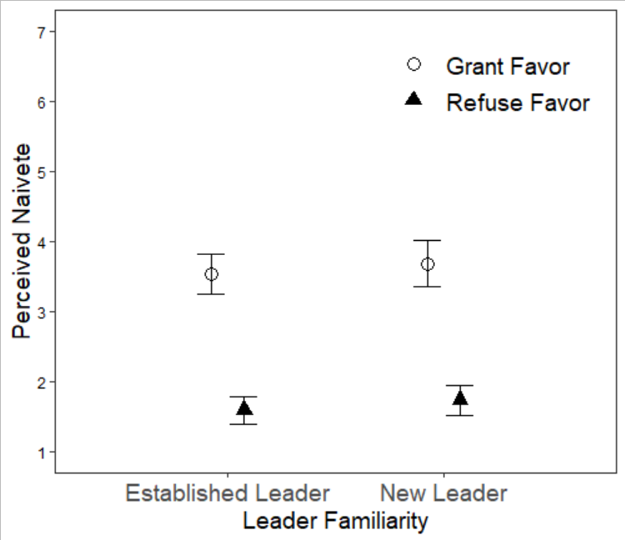

*Note*: Error bars represent 95% confidence intervals.

***Impression-management consequences***. Consistent with our predictions, favor-granting leaders were judged to be less competent regardless of how familiar they were to the observer. ANOVA results indicated a significant effect of favor-granting, *F*(1, 394) = 138.25, *p* < .001, $η_{p}^{2}$ = .260, and a significant effect of leader familiarity, *F*(1, 394) = 7.83, *p* = .005, $η_{p}^{2}$ = .019, but did not show a significant interaction, *F*(1, 394) = 2.62, *p*= .106, $η_{p}^{2}$ = .007. As with the naiveté results, Supplemental Figure 7A shows that the effect of favor-granting on leader competence was negative regardless of leader familiarity.

Results for perceived warmth were supportive of our prediction that new leaders would benefit from favor-granting by appearing more warm but established leaders would not. ANOVA results showed a significant effect of leader familiarity, *F*(1, 394) = 9.09, *p* = .003, $η_{p}^{2}$ = .023, but did not show a significant effect of favor-granting, *F*(1, 394) = 3.00, *p* = .084, $η_{p}^{2}$ = .008, or a significant interaction, *F*(1, 394) = 2.93, *p* = .088, $η_{p}^{2}$ = .007. While the interaction between favor-granting and leader familiarity was not significant at the *p* < .05 level, Supplemental Figure 7B and Supplemental Table 3 illustrate the predicted pattern of results. For new leaders, granting a favor led to higher perceptions of warmth (*M* = 0.43, *SD* = 1.14) compared to refusing to grant the favor (*M* = 0.05, *SD* = 1.37, *t*(198) = 2.13, *p* = .034). In contrast, for established leaders, perceptions of warmth for leaders who granted favors (*M* = 0.57, *SD* = 0.92) were almost identical to those who refused to grant (*M* = 0.57, *SD* = 0.92, *t*(196) = 0.01, *p* = .991). Thus, we see that the warmth results follow the pattern across our manuscript studies that suggest a warmth benefit for new leaders who grant favors in response to flattery but a lack of similar benefit for established leaders.

Finally for the impression-management outcomes, as depicted in Supplemental Figure 7C, an ANOVA on overall leader impression revealed a significant effect of favor-granting, *F*(1, 394) = 127.34, *p* < .001, $η_{p}^{2}$ = .224, and a significant effect of leader familiarity, *F*(1, 394) = 8.67, *p* = .003, $η_{p}^{2}$ = .022, but no interaction, *F*(1, 394) = 0.40, *p* = .528, $η_{p}^{2}$ = .001. Following our predictions, Supplemental Table 3 shows that favor-granting harmed overall impressions of leaders regardless of whether they were new or established.

**Supplemental Figure 7A-7C**

*Supplementary Study 5: Impression-management consequences (competence, warmth, overall impression) as a function of leader familiarity (established vs. new) and favor conditions (grant favor vs. refuse favor).*

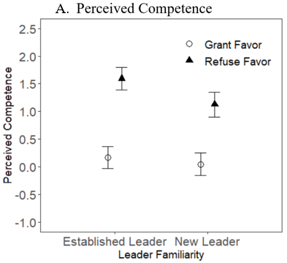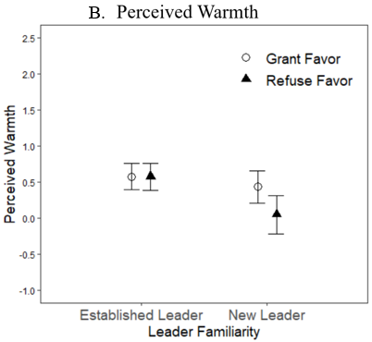

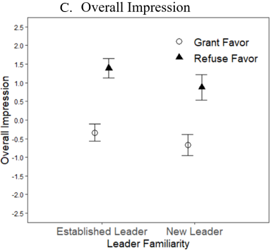

*Note*: Error bars represent 95% confidence intervals.

***Organizational consequences.*** As with the results for naiveté, competence, and overall impression, results for the organizational outcomes in Supplemental Table 3 and Supplemental Figures 8A-8B followed our predictions in showing consistent negative effects of favor-granting for both new and established leaders. Beginning with commitment to the leader, an ANOVA showed a significant effect of favor-granting, *F*(1, 394) = 29.40, *p* < .001, $η_{p}^{2}$ = .069 and a significant effect of leader familiarity, *F*(1, 394) = 49.42, *p* < .001, $η_{p}^{2}$ = .111, but did not show a significant interaction, *F*(1, 394) = 3.21, *p* = .074, $η_{p}^{2}$ = .008. While favor-granting decreased commitment for new and established leaders, the marginally significant interaction and results shown in Supplemental Figure 8A are suggestive that favor-granting does not harm commitment for new leaders as much as established leaders, although commitment to new leaders appears lower overall. For organizational fairness, results were similar with an ANOVA showing a significant effect of favor-granting, *F*(1, 394) = 236.55, *p* < .001, $η_{p}^{2}$ = .375 and a significant effect of leader familiarity, *F*(1, 394) = 15.87, *p* < .001, $η_{p}^{2}$ = .039, and a lack of interaction, *F*(1, 394) = 2.58, *p* = .109, $η_{p}^{2}$ = .006. As shown in Figure 8B, favor-granting made the organization seem less fair to observers for both new and established leaders.

**Supplemental Figure 8A and 8B**

*Supplementary Study 5: Organizational consequences (commitment to leader and organizational fairness) as a function of leader familiarity (established vs. new) and favor conditions (grant favor vs. refuse favor).*

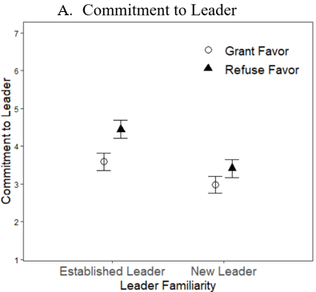 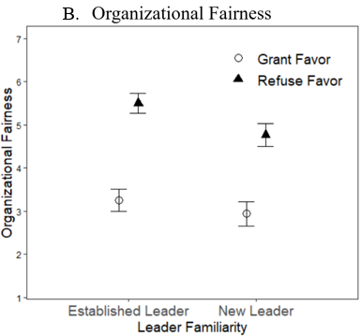

*Note*: Error bars represent 95% confidence intervals.

**Discussion**

This supplementary study provides a direct test of the ways in which falling for flattery differs between new and established leaders. As with the studies in the main manuscript, this study shows that favor-granting in response to flattery makes leaders, regardless of whether they are new or established, appear more naïve, less competent, and leads observers to be less committed and to see their organization as less fair. In terms of perceived warmth, the results of this study also mirror the results across studies in the manuscript by showing that new leaders are perceived to be more warm when rewarding flattery, but that established leaders do not receive the same reputational benefit. Thus, this study provides important support for our contention that perceptions of warmth, as they reflect how a leader treats others, are likely to be judged differently based on the existence or lack of prior leader-observer relationship. Absent an existing relationship, leaders who reward flattery look more warm as favor-granting reflect a positive social interaction. However, with an existing relationship, observers seem to judge favor-granting more holistically and see an unfairly offered favor as more damaging to themselves, and thus less warm.

## **Supplementary Study 6: The Impact of Approacher and Leader Competence**

When observing flattery, observers are likely to focus not only on the flattery itself but also on characteristics of the approacher and the leader. Results from the *Meritocracy* condition in Study 4, in which the approacher detailed their qualifications for the desired position instead of engaging in flattery, suggested that a competent approacher’s deservingness of the favor may limit negative reactions to a leader granting them a favor. We posit that if an observer witnesses an incompetent employee flatter a leader and receive a professional favor in return, this is likely to exacerbate the observer’s negative reaction because not only did the favor seem to result from ungenuine flattery, but it is aiding the career of an unqualified and undeserving employee.

We also explore the potential impact of how generally competent observers think their leader is, since this perception shapes how deserving the observer thinks their leader is of flattery and for the observer’s expectations of how the leader will handle a favor request after receiving flattery. The implications of how a leader’s general competence will impact attributions that they have fallen for flattery are not straightforward. On one hand, an observer may see flattery towards a generally competent leader as more valid and thus have less of a negative reaction to favor-granting in response. Alternatively, with high expectations for a generally competent leader’s ability to handle flatterers fairly, an observer may be even more surprised when they reward flattery, and thus react more strongly. We preregistered our study and analysis plan prior to data collection at <https://aspredicted.org/ZFB_1DX>.

**Method**

***Participants.*** We recruited 500 individuals from a sample of working professionals in Singapore. Following our preregistered exclusion criteria, we excluded data from 16 participants (who either answered both attention checks incorrectly or provided a nonsensical response to what they do for work), leaving a final sample of 484 (*Mage* = 31.41 years, *SDage* = 8.79; 279 female, 191 male, one non-binary/third gender; thirteen did not self-identify). These professionals had worked with their leader for an average of 3.08 years (*SD* = 3.85).

***Design and procedure.*** As with Studies 4-5, we asked participants to think of their existing leader in their organization and to report how long they had known the leader. We also asked participants to report how generally competent they believed their leader to be, based on their prior experiences with the leader. Next, using a design similar to Study 5, participants read that they observed an individual (the “approacher”) approach the leader at an office social event, excessively flatter the leader, and then ask for a professional favor a week later.

We used a 2(approacher competence: competent vs. incompetent) 🞨 2(leader response: grant favor vs. refuse favor) between-subjects design (see page 15 for scenario text). In the *Incompetent Approacher* condition, participants were told that the approacher was known to be incompetent with low performance ratings and lacking the skills and capabilities to succeed at work. Participants in the *Competent Approacher* condition read that the approacher was known to be extremely competent, receiving high ratings and possessing the skills to succeed. As with Study 5, participants read that they subsequently found out that the leader either provided a favor to the approacher (*Grant Favor*) or refused to do so (*Refuse Favor)*.

**Measures**

***Leader’s general competence.*** Before the scenario, participants rated their leader’s general competence using the competence scale from Studies 4 and 5, adapted to be about how the observer generally sees the leader (1 = *Not at all*, 7 = *Extremely*; α = .91).

***Perceived naiveté and downstream impression-management and organizational consequences.*** After the scenario, participants completed the scales from Studies 4 and 5 about how the scenario impacted their perceptions of the leader’s naiveté (α = .95), competence (α = .93), warmth (α = .90), overall impression (single-item), commitment (α = .87), and organizational fairness *(*α = .95).

**Results**

Providing support for our overall predictions, the results demonstrated significant interactions of approacher competence and favor-granting for all focal outcomes, with the exception of commitment to the leader. Results by outcome are presented in Supplemental Table 4 and Supplemental Figures 9-11, and discussed further below.

**Supplemental Table 4**

*Descriptive Statistics for All Measures in Supplementary Study 6.*

|  |  |  |  |  |  |  |  |  |
| --- | --- | --- | --- | --- | --- | --- | --- | --- |
|  | Competent Approacher | | | | Incompetent Approacher | | | |
| Variable | Grant Favor | Refuse Favor | *t*a | *p* | Grant Favor | Refuse Favor | *t*b | *p* |
| **Perceived naiveté** | | | | |  | | | |
| Perceived Naiveté | 3.41  [3.14, 3.68] | 2.08  [1.86, 2.30] | 7.66 | <.001 | 3.96  [3.69, 4.23] | 1.72  [1.53, 1.91] | 13.17 | <.001 |
|  |  |  | | |  |  | | |
| **Impression-management consequences** | | | | |  | | | |
| Perceived Competence | -0.01  [-0.20, 0.19] | 0.98  [0.79, 1.16] | -7.27 | <.001 | -0.38  [-0.56, -0.20] | 1.17  [0.99, 1.35] | -12.07 | <.001 |
| Perceived Warmth | 0.35  [0.15, 0.56] | 0.31  [0.12, 0.50] | 0.36 | .760 | 0.05  [-0.14, 0.24] | 0.52  [0.34, 0.70] | -3.48 | <.001 |
| Overall Impression | -0.47  [-0.70, -0.24] | 1.16  [0.93,1.39] | 9.90 | <.001 | -1.00  [-1.21,-0.79] | 1.46  [1.20,1.72] | 14.77 | <.001 |
| **Organizational consequences** | | | |  |  |  |  |  |
| Commitment to leader | 3.60  [3.40, 3.79] | 4.21  [3.99, 4.43] | -4.16 | <.001 | 3.33  [3.14, 3.53] | 4.22  [4.00, 4.44] | -6.06 | <.001 |
| Organizational Fairness | 3.23  [3.03, 3.43] | 4.61  [4.38, 4.84] | -8.98 | .006 | 3.10  [2.87, 3.32] | 4.95  [4.77, 5.13] | -12.66 | .857 |
|  |  | | | |  | | | |

a *df* = 243*;* b *df* = 237; *Note.* The values in square brackets are 95% confidence intervals.

***Manipulation checks.*** Participants were asked to what extent the leader performed a favor for the approacher and how competent the approacher was at their job (1 = *not at all*; 7 = *very much*). Participants in the grant-favor condition witnessed favor-granting to a stronger extent (*M* = 5.14, *SD* = 1.44) than did participants in the refuse-favor condition (*M* = 2.44, *SD* = 1.53; *t*(482) = 15.15, *p* < .001). Participants in the competent approacher condition perceived the approacher to be more competent (*M* = 4.33, *SD* = 1.56) as compared to participants in the incompetent approacher condition (*M* = 2.43, *SD* = 1.19; *t*(482) = 20.03, *p* < .001).

***Perceived naiveté.*** Beginning with perceived naiveté, an ANOVA testing the effects of approacher competence and favor-granting revealed a significant effect of granting favors, *F*(1, 480) = 213.95, *p* < .001, $η_{p}^{2}$ = .308, and a significant interaction, *F*(1, 480) = 13.89, *p* < .001, $η_{p}^{2}$ = .028, but did not show a significant effect of approacher competence, *F*(1, 480) = 0.56, *p* = .439, $η_{p}^{2}$ = .001. As shown in Supplemental Table 4 and Supplemental Figure 9, while favor-granting increased perceptions of leader naiveté regardless of the approacher’s competence, planned contrasts indicated that participants perceived leaders who granted a favor to an incompetent approacher as more naïve (*M* = 3.96, *SD* = 1.54) than leaders who did so for a competent approacher (*M* = 3.41, *SD* = 1.47), *t*(480) = 3.18, *p* = .002. In this way, the incompetence of the approacher seems to exacerbate perceptions that the leader is naively falling for flattery when they grant favors.

**Supplemental Figure 9**

*Supplementary Study 6: Perceived leader naiveté as a function of approacher competence (competent vs. incompetent) and favor conditions (grant favor vs. refuse favor).*

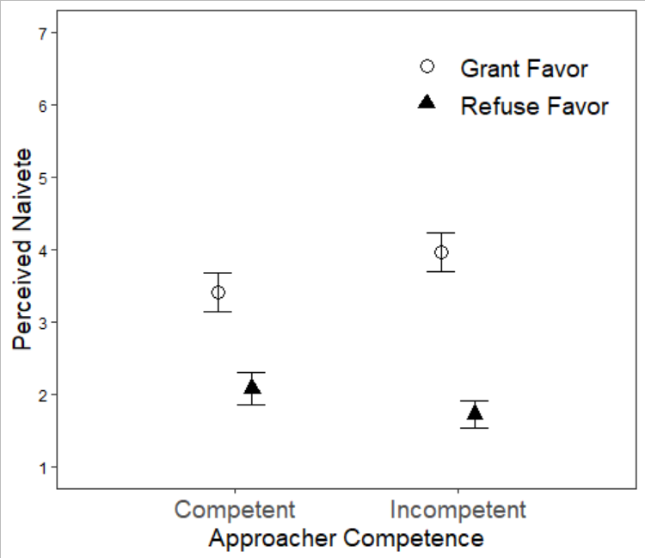

*Note*: Error bars represent 95% confidence intervals.

***Impression-management consequences***. Consistent with our predictions, the ANOVA results revealed significant interactions of approacher competence and favor-granting for both impression-management outcomes (*F*s > 6.80, *p*s < .009, $η_{p}^{2}s$ > .014). Beginning with perceived competence of the leader, the ANOVA results indicated a significant effect of favor-granting, *F*(1, 480) = 183.37, *p* < .001, $η_{p}^{2}$ = .276, and a significant interaction, *F*(1, 480) = 9.28, *p*= .002, $η_{p}^{2}$ = .019, but no effect of approacher competence, *F*(1, 480) = 0.93, *p*= .335, $η_{p}^{2}$ = .002. As with the naiveté, Supplemental Figure 10A shows that the effect of favor-granting on leader competence was negative regardless of the approacher’s competence, with planned contrasts revealing that rewarding an incompetent approacher negatively impacted leader competence (*M* = -0.38, *SD* = 1.00) more so than rewarding a competent approacher (*M* = -.01, *SD* = 1.06), *t*(480) = 2.83 *p* = .005.

As Supplemental Figure 10B shows, an ANOVA on perceptions of warmth revealed a significant effect of favor-granting, *F*(1, 480) = 4.54, *p* = .034, $η_{p}^{2}$ = .009, and a significant interaction, *F*(1, 480) = 6.80, *p* = .009, $η_{p}^{2}$ = .014. There was no significant effect of approacher competence, *F*(1, 480) = 0.25, *p* = .620, $η_{p}^{2}$ = .001. While favor-granting had no impact on warmth perceptions when the approacher was competent (*M*Grant = .35, *SD*Grant = 1.12; *M*Refuse = .31, *SD*Refuse = 1.10; *t*(243) = 0.36, *p* = .760), favor-granting (vs. refusing) decreased perceptions of warmth for an incompetent approacher (*M*Grant = .05, *SD*Grant = 1.09; *M*Refuse = .52, *SD*Refuse = 0.98; *t*(237) = 3.48, *p* < .001). Thus, we see that for leader competence and warmth perceptions, negative reactions to favor-granting were magnified when the approacher was incompetent.

Finally, for overall impression of the leader, ANOVA results indicated a significant effect of favor-granting, *F*(1, 480) = 303.62, *p* < .001, $η_{p}^{2}$ = .387, and a significant interaction, *F*(1, 480) = 12.61, *p* < .001, $η_{p}^{2}$ = .026, but no effect of approacher competence, *F*(1, 480) = 0.98, *p*= .324, $η_{p}^{2}$ = .002. As with the naiveté and competence results, Supplemental Figure 10C and Supplemental Table 4 show that the effect of favor-granting on leader impression was negative regardless of the approacher’s competence. Planned contrasts revealed that rewarding an incompetent approacher negatively impacted impressions of the leader (*M* = -1.00, *SD* = 1.15) more so than rewarding a competent approacher (*M* = -.47, *SD* = 1.26), *t*(480) = 3.21 *p* = .001.

**Supplemental Figure 10A-10C**

*Supplementary Study 6: Impression-management consequences (competence, warmth, and overall impression) as a function of approacher competence (competent vs. incompetent) and favor conditions (grant favor vs. refuse favor).*

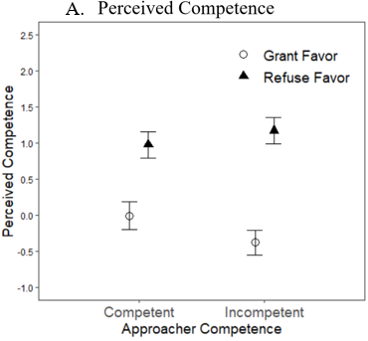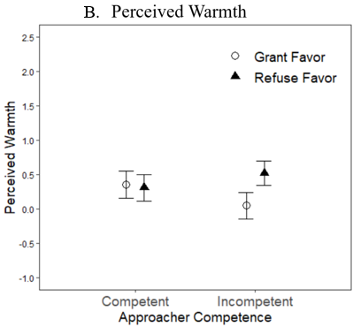

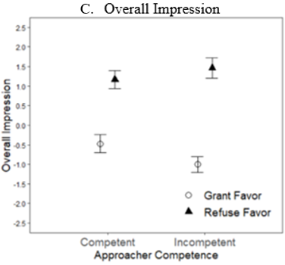

*Note*: Error bars represent 95% confidence intervals.

***Organizational consequences.*** Contrary to our predictions, an ANOVA on commitment to the leader did not show a significant interaction of approacher competence and favor-granting *F*(1, 480) = 1.76, *p* = .185, $η_{p}^{2}$ = .004. There was a significant effect of favor-granting, as expected, *F*(1, 480) = 51.95, *p* < .001, $η_{p}^{2}$ = .098, but no effect of approacher competence, *F*(1, 480) = 1.50, *p* = .222, $η_{p}^{2}$ = .003. As Supplemental Figure 11A illustrates, granting a favor harmed observer commitment regardless of approacher competence. However, planned contrasts were suggestive that, in line with our other outcomes, granting a favor to an incompetent approacher was marginally more detrimental to commitment (*M* = 3.33, *SD* = 1.09) than doing so for a competent approacher (*M* = 3.60, *SD* = 1.18), *t* = 1.80, *p* = .072.

Finally, the results followed our predictions for perceptions of organizational fairness, as an ANOVA showed a significant interaction of approacher competence and favor-granting *F*(1, 480) = 5.05, *p* = .025, $η_{p}^{2}$ = .010. There was a significant effect of favor-granting, as expected, *F*(1, 480) = 231.01, *p* < .001, $η_{p}^{2}$ = .325, but no effect of approacher competence, *F*(1, 480) = 0.87, *p* = .353, $η_{p}^{2}$ = .002. As Supplemental Figure 11B illustrates, granting a favor decreased organizational fairness perceptions regardless of approacher competence, but planned contrasts showed that leaders who refused to grant a favor to an incompetent flatterer were able to increase perceptions of organizational fairness (*M* = 4.95, *SD* = 0.98) compared to leaders who did the same for a competent flatterer (*M* = 4.61, *SD* = 1.28), *t*(480) = 2.25, *p* = .025.

**Supplemental Figure 11A and 11B**

*Supplementary Study 6: Organizational consequences (commitment to leader and organizational fairness) as a function of approacher competence (competent vs. incompetent) and favor conditions (grant favor vs. refuse favor).*

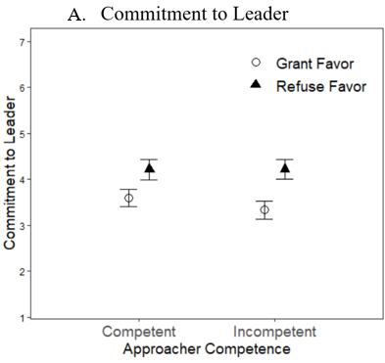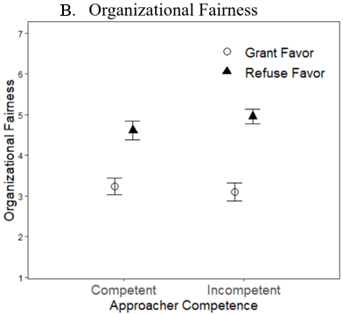

*Note*: Error bars represent 95% confidence intervals.

***Secondary analyses: Impact of leader’s general competence.*** As described in the study introduction. we conducted secondary analyses to test whether participants’ prior perceptions of their leader’s general competence, assessed before reading the scenarios, would impact their reactions to reading that the leader had rewarded flattery. As presented in Tables 5-10, an ANOVA testing the effects of approacher competence, favor-granting, and leader’s general competence did not demonstrate any significant three-way interactions for any of our focal outcomes (*F*s < 1.40, *p*s > .237, $η_{p}^{2}s$ < .003). Additionally, when we controlled for perceptions of the leader’s general competence in our focal analyses, the pattern or significance of our findings did not change, as shown in Tables 11-16. These results suggest that observers’ existing perceptions of their leader’s general level of competence do not have a strong impact on their reactions to witnessing the leader reward flattery.

**Discussion**

When reacting to witnessing a leader reward a flatterer, observers consider not only the flattery but also how competent, and thus deserving, the approacher is of the favor. When an incompetent flatterer is rewarded with a favor, observers’ negative reactions are magnified, leading them to view their leader as more naïve, less competent and warm, and the organization as less fair. On the other hand, observers do not seem to focus on prior perceptions of their leader’s general competence, which suggests that the salience of witnessing their leader rewarding flattery is sufficiently strong to impact perceptions of both incompetent and competent leaders.

**Supplemental Table 5**

*Secondary Analyses: ANOVA results for effects of favor condition, approacher competence condition, and perceptions of leader’s general competence on perceived naiveté*

|  |  |  |  |
| --- | --- | --- | --- |
|  | F-value | p-value | $$η_{p}^{2}$$ |
| Favor Condition | 224.83 | < .001 | 0.321 |
| Approacher Competence Condition | 0.94 | 0.334 | 0.002 |
| Perceptions of Leader’s General Competence | 21.63 | < .001 | 0.043 |
| Favor x Approacher Competence | 15.39 | < .001 | 0.031 |
| Favor x Perceptions of Leader’s General Competence | 0.01 | 0.927 | 0.000 |
| Approacher Competence x Perceptions of Leader’s General Competence | 4.80 | 0.029 | 0.010 |
| Favor x Approacher Competence x Perceptions of Leader’s General Competence | 0.31 | 0.578 | 0.001 |

**Supplemental Table 6**

*Secondary Analyses: ANOVA results for effects of favor condition, approacher competence condition, and perceptions of leader’s general competence on perceived competence*

|  |  |  |  |
| --- | --- | --- | --- |
|  | F-value | p-value | $$η_{p}^{2}$$ |
| Favor Condition | 194.24 | < .001 | 0.290 |
| Approacher Competence Condition | 1.31 | 0.254 | 0.003 |
| Perceptions of Leader’s General Competence | 22.89 | < .001 | 0.046 |
| Favor x Approacher Competence | 10.24 | 0.001 | 0.021 |
| Favor x Perceptions of Leader’s General Competence | 0.94 | 0.333 | 0.002 |
| Approacher Competence x Perceptions of Leader’s General Competence | 6.69 | 0.010 | 0.014 |
| Favor x Approacher Competence x Perceptions of Leader’s General Competence | 0.79 | 0.375 | 0.002 |

**Supplemental Table 7**

*Secondary Analyses: ANOVA results for effects of favor condition, approacher competence condition, and perceptions of leader’s general competence on perceived warmth*

|  |  |  |  |
| --- | --- | --- | --- |
|  | F-value | p-value | $$η_{p}^{2}$$ |
| Favor Condition | 5.36 | 0.021 | 0.011 |
| Approacher Competence Condition | 0.59 | 0.443 | 0.001 |
| Perceptions of Leader’s General Competence | 38.37 | < .001 | 0.075 |
| Favor x Approacher Competence | 8.42 | 0.004 | 0.017 |
| Favor x Perceptions of Leader’s General Competence | 0.05 | 0.832 | 0.000 |
| Approacher Competence x Perceptions of Leader’s General Competence | 3.29 | 0.070 | 0.007 |
| Favor x Approacher Competence x Perceptions of Leader’s General Competence | 0.11 | 0.744 | 0.000 |

**Supplemental Table 8**

*Secondary Analyses: ANOVA results for effects of favor condition, approacher competence condition, and perceptions of leader’s general competence on commitment to the leader*

|  |  |  |  |
| --- | --- | --- | --- |
|  | F-value | p-value | $$η_{p}^{2}$$ |
| Favor Condition | 59.19 | < .001 | 0.111 |
| Approacher Competence Condition | 2.26 | 0.133 | 0.005 |
| Perceptions of Leader’s General Competence | 47.11 | < .001 | 0.090 |
| Favor x Approacher Competence | 2.46 | 0.117 | 0.005 |
| Favor x Perceptions of Leader’s General Competence | 1.99 | 0.159 | 0.004 |
| Approacher Competence x Perceptions of Leader’s General Competence | 1.27 | 0.260 | 0.003 |
| Favor x Approacher Competence x Perceptions of Leader’s General Competence | 0.10 | 0.746 | 0.000 |

**Supplemental Table 9**

*Secondary Analyses: ANOVA results for effects of favor condition, approacher competence condition, and perceptions of leader’s general competence on perceived organizational fairness*

|  |  |  |  |
| --- | --- | --- | --- |
|  | F-value | p-value | $$η_{p}^{2}$$ |
| Favor Condition | 236.87 | < .001 | 0.332 |
| Approacher Competence Condition | 0.76 | 0.383 | 0.002 |
| Perceptions of Leader’s General Competence | 9.33 | 0.002 | 0.019 |
| Favor x Approacher Competence | 5.19 | 0.023 | 0.011 |
| Favor x Perceptions of Leader’s General Competence | 2.00 | 0.158 | 0.004 |
| Approacher Competence x Perceptions of Leader’s General Competence | 4.54 | 0.034 | 0.009 |
| Favor x Approacher Competence x Perceptions of Leader’s General Competence | 1.40 | 0.237 | 0.003 |

**Supplemental Table 10**

*Secondary Analyses: ANOVA results for effects of favor condition, approacher competence condition, and perceptions of leader’s general competence on overall impression of the leader*

|  |  |  |  |
| --- | --- | --- | --- |
|  | F-value | p-value | $$η_{p}^{2}$$ |
| Favor Condition | 320.61 | < .001 | 0.402 |
| Approacher Competence Condition | 1.36 | 0.244 | 0.003 |
| Perceptions of Leader’s General Competence | 22.93 | 0.000 | 0.046 |
| Favor x Approacher Competence | 13.84 | 0.000 | 0.028 |
| Favor x Perceptions of Leader’s General Competence | 0.84 | 0.360 | 0.002 |
| Approacher Competence x Perceptions of Leader’s General Competence | 6.20 | 0.013 | 0.013 |
| Favor x Approacher Competence x Perceptions of Leader’s General Competence | 0.13 | 0.724 | 0.000 |

**Supplemental Table 11**

*Secondary Analyses: ANOVA results for effects of favor condition and approacher competence on perceived naiveté, controlling for perceptions of leader’s general competence*

|  |  |  |  |
| --- | --- | --- | --- |
|  | F-value | p-value | $$η_{p}^{2}$$ |
| Favor Condition | 226.81 | < .001 | 0.321 |
| Approacher Competence Condition | 0.95 | 0.331 | 0.002 |
| Perceptions of Leader’s General Competence | 21.53 | < .001 | 0.043 |
| Favor-Granting x Approacher Competence | 15.88 | < .001 | 0.032 |

**Supplemental Table 12**

*Secondary Analyses: ANOVA results for effects of favor condition and approacher competence on perceived competence, controlling for perceptions of leader’s general competence*

|  |  |  |  |
| --- | --- | --- | --- |
|  | F-value | p-value | $$η_{p}^{2}$$ |
| Favor Condition | 195.21 | < .001 | 0.290 |
| Approacher Competence Condition | 1.38 | 0.241 | 0.003 |
| Perceptions of Leader’s General Competence | 22.64 | < .001 | 0.045 |
| Favor-Granting x Approacher Competence | 10.88 | 0.001 | 0.022 |

**Supplemental Table 13**

*Secondary Analyses: ANOVA results for effects of favor condition and approacher competence on perceived warmth, controlling for perceptions of leader’s general competence*

|  |  |  |  |
| --- | --- | --- | --- |
|  | F-value | p-value | $$η_{p}^{2}$$ |
| Favor Condition | 5.70 | 0.017 | 0.012 |
| Approacher Competence Condition | 0.58 | 0.446 | 0.001 |
| Perceptions of Leader’s General Competence | 38.33 | 0.000 | 0.074 |
| Favor-Granting x Approacher Competence | 8.69 | 0.003 | 0.018 |

**Supplemental Table 14**

*Secondary Analyses: ANOVA results for effects of favor condition and approacher competence on commitment to the leader controlling for perceptions of leader’s general competence*

|  |  |  |  |
| --- | --- | --- | --- |
|  | F-value | p-value | $$η_{p}^{2}$$ |
| Favor Condition | 59.91 | 0.000 | 0.111 |
| Approacher Competence Condition | 2.43 | 0.120 | 0.005 |
| Perceptions of Leader’s General Competence | 47.09 | 0.000 | 0.090 |
| Favor-Granting x Approacher Competence | 2.74 | 0.098 | 0.006 |

**Supplemental Table 15**

*Secondary Analyses: ANOVA results for effects of favor condition and approacher competence on perceived organizational fairness, controlling for perceptions of leader’s general competence*

|  |  |  |  |
| --- | --- | --- | --- |
|  | F-value | p-value | $$η_{p}^{2}$$ |
| Favor Condition | 237.40 | < 2.2e-16 | 0.331 |
| Approacher Competence Condition | 0.67 | 0.414 | 0.001 |
| Perceptions of Leader’s General Competence | 9.24 | 0.002 | 0.019 |
| Favor-Granting x Approacher Competence | 5.68 | 0.018 | 0.012 |

**Supplemental Table 16**

*Secondary Analyses: ANOVA results for effects of favor condition and approacher competence on overall impressions of the leader, controlling for perceptions of leader’s general competence*

|  |  |  |  |
| --- | --- | --- | --- |
|  | F-value | p-value | $$η_{p}^{2}$$ |
| Favor Condition | 321.90 | < 2.2e-16 | 0.402 |
| Approacher Competence Condition | 1.43 | 0.232 | 0.003 |
| Perceptions of Leader’s General Competence | 22.74 | 0.000 | 0.045 |
| Favor-Granting x Approacher Competence | 14.55 | 0.000 | 0.029 |

# **Supplemental Analyses**

## **Study 1**

**Study 1 Method and Results Supplement- Overall Impression**

After reading one of the two scenarios, participants also evaluated how their overall impression of the leader would change(-3 = *become much more negative*, +3 = *become much more positive;* single-item). We found a significant effect of Granting a Favor on overall impressions of the senior faculty, (*t*(175) = -2.17, *p* = .032, *d* = -.33), providing support for our predictions. Participants had worse overall impressions of favor-granting faculty (*M* = .01, *SD* = 1.20) as compared to those who refused (*M* = .40, *SD* = 1.16). We found that perceived naiveté mediated the effect of Granting a Favor on overall impressions of the senior faculty as the bias-corrected bootstrapped confidence interval for the size of the indirect effect excluded 0 (indirect effect = -.14, *SE* = .07, *95%CI* [-0.30, -0.04]), providing support for our predictions.

**Study 1 Method and Results Supplement- Ancillary Variables**

After reading one of the two scenarios, participants assessed how their evaluations of the senior faculty member’s fairness and of their overall impression of academia changed as a result of this information (both single items). Participants viewed the faculty member who granted the favor as less fair (*M =* -.62, *SD* = 1.25) than the faculty member who did not perform a favor (*M* = 1.09, *SD* = 1.35), *t*(177) = 8.75, *p* <.001*, d =* .33. Participants’ overall impression of academia did not significantly differ if they viewed the faculty member grant the favor (*M =* -.36, *SD* = 1.00) or refuse (*M* = -.13, *SD* = 1.09), *t*(179) = 1.44, *p* =.152*, d =* .21. These results suggest that, like other evaluations of the senior faculty member, being seen granting favors after flattery negatively impacts perceptions of fairness. However, this event was not impactful enough to significantly change overall perceptions of academia itself.

## **Study 2**

**Supplemental Table 17**

*Study 2: Bootstrapped Indirect Effects of Favor-Granting after Flattery on Downstream Outcomes, via Perceived Naiveté and Leader Fairness*

|  |  |  |  |
| --- | --- | --- | --- |
| ***Dependent Variable***  Mediator Variable | Effect | SE | Bias-Corrected Confidence Interval |
| **Impression-management consequences** | | |  |
| ***Perceived Competence*** |  |  |  |
| Perceived Naiveté | -.14 | .08 | [-0.34, -0.02] |
| Leader Fairness | -.67 | .14 | [-0.97, -0.43] |
| ***Perceived Warmth*** |  |  |  |
| Perceived Naiveté | .09 | .07 | [-0.02, 0.24] |
| Leader Fairness | -.53 | .12 | [-0.81, -0.33] |
| **Organizational consequences** |  |  |  |
| ***Commitment to Leader*** |  |  |  |
| Perceived Naiveté | -.19 | .10 | [-0.45, -0.04] |
| Leader Fairness | -.63 | .19 | [-1.08, -0.31] |
| ***Organizational Fairness*** |  |  |  |
| Perceived Naiveté | -.03 | .06 | [-0.17, 0.07] |
| Leader Fairness | -.64 | .15 | [-0.97, -0.38] |
|  |  |  |  |
| *Note*. Bootstrap (N) = 5,000 |  |  |  |

**Study 2 Method and Results Supplement- Overall Impression**

We collected the same measures of overall impression (-3 = *very negative*, +3 = *very positive*), as in Study 1.

Our results supported our predictions, as participants viewed lab experimenters who granted a favor after flattery as less favorable overall (*M* = 1.24, *SD =* 1.55) than experimenters who refused to grant a favor (*M* = 1.67, *SD* = 1.14), *t*(162) = -2.02, *p* = .045, *d* = .32. In terms of mediation, we again found that our proposed mechanism – perceived naiveté – mediated the effect of experimenter favor-granting on overall impression (indirect effect = -.30, *SE* = .11, *95%CI* [-0.54, -0.13]), providing further support for our predictions.

**Study 2 Method and Results Supplement- Ancillary Variables**

After reading the materials from their competitor, participants evaluated (1) the lab experimenter’s fairness (single item); (2) their overall impression of the lab (single item); (3) their overall impression of the competitor (single item); (4) the quality of their competitor’s work (-3 = *very poor*, +3 = *very good;* two items; e.g. “quality of work”; Farh, Hackett, Liang, 2007; α = .90); (5) their engagement during the task (1 = *strongly disagree*, 7 = *strongly agree*; 4 items; e.g. “while working on my speech, I felt bursting with energy”; Schaufeli, Bakker, & Salanova, 2006; α = .73); and (6) how helpful the RA was to the participant or their competitor (each single item). We also collected some controls that were not explored related to whether the RA was asked and resolved questions by others or the participant in the lab (all single items).

Participants viewed the lab experimenter who granted the favor as less fair (*M =* 4.01, *SD* = 1.87) than the experimenter who did not perform a favor (*M* = 5.63, *SD* = 1.30), *t*(162) = -6.48, *p* <.001*, d =* 1.01. Participants’ had a worse overall impression of the lab after seeing a favor granted (*M =* .84, *SD* = 1.55) than when it was refused (*M* = 1.73, *SD* = 1.21), *t*(162) = -4.12, *p* < .001*, d =* .64. Participants evaluated the quality of their competitor’s work as better when the competitor had a favor granted (*M =* 2.12, *SD* = 0.85) versus a favor refused (*M* = 1.54, *SD* = 1.33), *t*(162) = -3.29, *p* =.001*, d =* .51. Additionally, participants viewed the lab experimenter who granted the favor as being more helpful to the competitor (*M =* 6.03, *SD* = 1.08) than the experimenter who did not (*M* = 4.62, *SD* = 1.43), *t*(162) = 7.08, *p* <.001*, d =* 1.11.

There was no significant difference between conditions for the overall impression of the competitor (*t*(162) = -1.89, *p* = .061*, d =* .29), engagement on the task (*t*(162) = .24, *p* = .04*, d =* 1.11), or how helpful the RA seemed to the participant (*t*(162) = .34, *p* = .736*, d =* .05). Overall, these results suggest that granting a favor after flattery leads to negative perceptions for the recipient and the lab, although this does not impact perceptions of the recipient nor participants’ engagement with their work.

## **Study 3**

**Study 3 Method and Results Supplement- Flattery Frequency (One-Off vs. Recurring) Coding of Open-Ended Responses and Secondary Moderation Analysis**

Two coders who were blind to hypotheses individually rated participants’ responses for whether the described flattery was a one-off occurrence or whether it represented recurring instances of flattery over time. Coders were trained to look at time-referent language (e.g., “one-off,” “always,” “often”) as well as whether the participant utilized specific (versus general) language to describe a specific event, suggesting the flattery was an isolated occurrence. After an initial round of independent coding, the coders agreed on 88.7% of codes (κ = .77). Thus, they met to discuss and resolve remaining disagreements. The final code results showed 80 instances of recurring flattery, 36 instances of one-off flattery, and 8 responses that were unclear (most responses in this category focused solely on the response of the leader and did not describe the flattery itself). As an example, the following was coded as an instance of recurring flattery “AA was often told how much people liked working with him and treated him very friendly and comforting. Since he was the staffer of the team, every body [sic] wanted to be on his good side in order to be staffed on the right projects.” The following was coded as an instance of one-off flattery, “We were having drinks after the delivery of a recommendation for a client. A team member flattered H in his leadership capabilities to get the next client he wanted.” Thus, we can see from the qualitative coding that employee observe both types of flattery with established leaders, and often observe recurring instances of flattery from other employees over time.

As mentioned in the manuscript, we used these coder ratings of the frequency of flattery as a moderator to see if it impacted the relationship between favor-granting and our outcomes. We excluded the unclear coded responses from our analysis. As shown in Supplemental Tables 18-23 below, regression analyses revealed no significant interactions between favor-granting and flattery frequency, nor was flattery frequency a significant predictor, for any outcome. These results suggest that reactions to leaders falling for flattery are similar whether the flattery is isolated or recurring.

**Supplemental Table 18**

*Regression results – Perceived Naivete*

|  |  |  |  |
| --- | --- | --- | --- |
|  | *b* | *SE* | p-value |
| Favor-granting | 0.44 | 0.16 | 0.009 |
| Flattery Frequency | 0.03 | 0.74 | 0.970 |
| Reward x Flattery Frequency | 0.05 | 0.20 | 0.780 |

*Note: df* = 112

**Supplemental Table 19**

*Regression results – Perceived Competence*

|  |  |  |  |
| --- | --- | --- | --- |
|  | *b* | *SE* | p-value |
| Favor-granting | -0.46 | 0.14 | 0.001 |
| Flattery Frequency | -0.12 | 0.61 | 0.848 |
| Reward x Flattery Frequency | -0.02 | 0.16 | 0.884 |

*Note: df* = 112

**Supplemental Table 20**

*Regression results – Perceived Warmth*

|  |  |  |  |
| --- | --- | --- | --- |
|  | *b* | *SE* | p-value |
| Favor-granting | 0.05 | 0.15 | 0.752 |
| Flattery Frequency | 0.98 | 0.67 | 0.145 |
| Reward x Flattery Frequency | -0.27 | 0.18 | 0.124 |

*Note: df* = 112

**Supplemental Table 21**

*Regression results – Overall Impression*

|  |  |  |  |
| --- | --- | --- | --- |
|  | *b* | *SE* | p-value |
| Favor-granting | -0.26 | 0.15 | 0.082 |
| Flattery Frequency | 0.55 | 0.66 | 0.406 |
| Reward x Flattery Frequency | -0.14 | 0.17 | 0.424 |

*Note: df* = 112

**Supplemental Table 22**

*Regression results – Commitment to Leader*

|  |  |  |  |
| --- | --- | --- | --- |
|  | *b* | *SE* | p-value |
| Favor-granting | -0.67 | 0.17 | < .001 |
| Flattery Frequency | -0.53 | 0.79 | 0.500 |
| Reward x Flattery Frequency | 0.22 | 0.21 | 0.291 |

*Note: df* = 112

**Supplemental Table 23**

*Regression results – Organizational Fairness*

|  |  |  |  |
| --- | --- | --- | --- |
|  | *b* | *SE* | p-value |
| Favor-granting | -0.37 | 0.13 | 0.005 |
| Flattery Frequency | 0.27 | 0.59 | 0.652 |
| Reward x Flattery Frequency | -0.01 | 0.16 | 0.930 |

*Note: df* = 112

**Study 3 Method and Results Supplement- Secondary Analyses Controlling for Quality and Length of Leader-Observer Relationship**

As secondary analyses, we assessed the robustness of our findings when controlling for the length (in years) and quality of the observers’ relationship with their supervisor (e.g., “I would characterize my working relationship with (my supervisor) as extremely effective”; 1 = *strongly disagree*, 7 = *strongly agree*). First, we assessed whether relationship length or relationship quality interacted with our rewarding flattery variable in predicting any of our outcomes. There were no significant interactions, thus, the following analyses are presented including the two variables as non-interactive covariates. As Supplemental Table 24 shows, the inclusion of the relationship covariates did not change any of our substantive conclusions about the direct effect of rewarding flattery on our outcomes. When controlling for characteristics of the prior relationship. rewarding flattery was associated with increased perceptions of naiveté (*b =* .39, *SE*= .09, *t*(120) = 4.44, *p* < .001) and reduced perceptions of competence (*b =* -.40, *SE*= .07, *t*(120) = -5.81, *p* < .001), overall impression (*b =* -.24, *SE*= .07, *t*(120) = -3.31, *p* = .001), commitment to the supervisor (*b =* -.35, *SE* = .08, *t*(120) = 4.55, *p* < .001), and organizational fairness (*b =* -.28, *SE* = .07, *t*(120) = -4.09, *p* < .001). As with the results in our main manuscript, rewarding flattery was not a significant predictor for warmth (*b =* -.06, *SE* = .07, *t*(120) = -0.86, *p* = .392) Additionally, while relationship length was not a significant predictor for any outcome, relationship quality significantly predicted all outcomes, as shown in Supplemental Table 24.

**Supplemental Table 24.** Study 3: Regression Results including Relationship Covariates

|  |  |  |  |  |  |  |  |  |  |  |  |  |  |  |  |  |  |  |  |  |  |  |  |  |  |  |  |  |  |  |  |  |  |  |  |  |
| --- | --- | --- | --- | --- | --- | --- | --- | --- | --- | --- | --- | --- | --- | --- | --- | --- | --- | --- | --- | --- | --- | --- | --- | --- | --- | --- | --- | --- | --- | --- | --- | --- | --- | --- | --- | --- |
|  |  | | Naiveté | | | |  | | Competence | | | |  | | Warmth | | | |  | | Overall Impression | | | |  | | Commitment to Supervisor | | | |  | | Organizational Fairness | | | |
|  |  | | *b* | | *SE* | |  | | *b* | | *SE* | |  | | *b* | | *SE* | |  | | *b* | | *SE* | |  | | *b* | | *SE* | |  | | *b* | | *SE* | |
| Rewarding Flattery |  | | 0.39*** | | 0.09 | |  | | -0.40*** | | 0.07 | |  | | -0.06 | | 0.07 | |  | | -0.24** | | 0.07 | |  | | -0.35*** | | 0.08 | |  | | -0.28*** | | 0.07 | |
| Relationship Length |  | | 0.00 | | 0.04 | |  | | -0.03 | | 0.03 | |  | | 0.01 | | 0.04 | |  | | -0.02 | | 0.04 | |  | | 0.02 | | 0.04 | |  | | 0.01 | | 0.03 | |
| Relationship Quality |  | | -0.20* | | 0.09 | |  | | 0.27*** | | 0.07 | |  | | 0.34*** | | 0.07 | |  | | 0.35*** | | 0.07 | |  | | 0.59*** | | 0.08 | |  | | 0.30*** | | 0.07 | |
|  | |  | |  | |  | |  | |  | |  | |  | |  | |  | |  | |  | |  | |  | |  | |  | |  | |  | |  | |

*Note*. *df*= 120; * *p* < .05 level. ** *p* < .01 level. *** *p* < .001 level

**Study 3 Method and Results Supplement- Supervisor Fairness**

Participants also assessed how their evaluations of the supervisors’ fairness was impacted by the extent to which they rewarded flattery with favorable treatment (single item: 1 = *not at all*, 7 = *to a great extent*). Participants viewed leaders who strongly rewarded flattery as less fair (*b* = -0.61, *SE* = .08, *t*(122) = -7.89, *p* < .001). These results follow our previous study in showing that being seen granting favors after flattery negatively impacts perceptions of fairness.

**Study 3 Method and Results Supplement- Overall Impression**

Participants rated how the supervisor’s response impacted their overall impression of him or her (-3 = *became very negative*, +3 = *became very positive*).

We also found that participants who perceived supervisors to have rewarded flattery had worse overall impressions of them (*b* = -.32, *SE* = .08, *t*(120) = -4.18, *p* < .001), supporting our predictions. For our mediation analysis, we found that perceived naiveté mediated the effect of favor granting on overall impressions of the supervisor (indirect effect = -.10, *SE* = .06, 95% CIBC [ -0.25, -0.03]), providing support for our predictions.

## **Study 4**

**Study 4: Methods and Results Supplement- Manipulation Checks and Mediation Analyses Controlling for Relationship Length and Quality**

***Relationship length.*** Participants listed how long they had known the leader in years.

***Relationship quality***. Participants rated the quality of their relationship with the leader using nine items (α = .95) from Liden and Maslyn’s (1998) leader-member exchange scale[7]. Sample items include “I like (the leader) very much as a person” and “I admire (the leader’s) professional skills.”

***Manipulation Checks.*** The manipulation checks confirmed that participants in the grant-favor conditions observed favor granting to a greater extent than did participants in the refuse-favor conditions, *F*(1, 794) = 1365.53, *p* < .001.[8] Additionally, planned contrasts using Tukey adjustments confirmed that participants in the flattery condition observed flattery (*M* = 6.38, *SD* = 1.05) significantly more than did participants in the nepotism (*M* = 3.41, *SD* = 1.79, *t* = 17.56, *p* < .001), meritocracy (*M* = 3.25, *SD* = 1.88, *t* = 18.40, *p* < .001), or control condition (*M* = 3.15, *SD* = 1.92, *t* = 19.06, *p* < .001). Similarly, participants in the nepotism condition rated the approacher and leader as biologically related (*M* = 6.23, *SD* = 1.31) to a great extent than did participants in the flattery (*M* = 1.88, *SD* = 1.72, *t* = 26.85, *p* < .001), meritocracy (*M* = 2.12, *SD* = 1.78, *t* = 25.24, *p* < .001), or control condition (*M* = 1.96, *SD* = 1.68, *t* = 26.24, *p* < .001). Finally, participants in the meritocracy condition observed approachers detailing their qualifications to a greater extent (*M* = 5.71, *SD* = 1.46) than those in the flattery (*M* = 2.79, *SD* = 1.85, *t* = 16.52, *p* < .001), nepotism, (*M* = 2.60, *SD* = 1.84, *t* = 17.63, *p* < .001), or control condition (*M* = 2.62, *SD* = 1.87, *t* = 17.44, *p* < .001).

***Focal flattery condition analyses controlling for leader-observer relationship.*** We also used the flattery condition to test our core theoretical model and assess if our predictions would hold while controlling for an observer’s prior relationship (length and quality) with the leader. As predicted and in line with the results in the main manuscript, observing a leader granting a favor in response to flattery (vs. refusing) increased perceptions of naiveté (*t*(198) = 7.01, *p* <.001). Supporting our predictions, participants had diminished perceptions of the leader’s competence (*t*(198) = -7.75, *p* < .001), lower overall impressions (*t*(198) = -7.24, *p* < .001), were less committed to the leader (*t*(198) = -3.51, *p* = <.001), and thought the overall organization to be less fair (*t*(195) = -9.89, *p* < .001) when observing favor-granting (vs. refusing). This suggests that changes in perceptions of a leader resulting from witnessing falling for flattery occurs regardless of the strength or length of the prior relationship.

***Mediation Analyses.*** Results also mostly supported our mediation model as naiveté mediated the effect of favor granting for three of the four focal negative outcomes (reduced competence, overall impression, commitment, organizational fairness) while controlling for the length and quality of the observer’s relationship.[9] As shown in Supplemental Table 25 and generally supporting our predictions, bootstrapped analyses revealed that the bias-corrected confidence interval for the size of the indirect effect of granting a favor excluded 0 for competence (*Effect* = - .17, *SE* = .09, 95% CI [-0.365, -0.017]), overall impression (*Effect* = -.28, *SE* = .12, 95% CI [-0.564, -0.074]), and organizational fairness (*Effect* = -.30, *SE* = .11, 95% CI [ -0.543, -0.115]), but no indirect effect for commitment (*Effect* = -.10, *SE* = .09, 95% CI [-0.302, 0.051]). Overall, accounting for the prior relationship with the leader, naiveté appears to mediate the relationship between being observed falling for flattery and negative personal and organizational consequences.

In contrast, when assessing the mediation by naiveté in the other favor request contexts, we see that the effect of favor-granting is not mediated by naiveté for the nepotism, meritocracy, or control conditions. As shown in Supplemental Tables 26-28, there were no significant indirect effects for any of the focal negative outcomes across any of the other prequest contexts, as all of the 95% bias-corrected confidence intervals included 0. This provides further support for the uniqueness of the naiveté mechanism to the flattery context as these results show how the effect of favor-granting on outcomes only operates via naiveté in response to flattery and not other favor-granting reasons.

This study also provided insight into our research question about how warmth perceptions might differ in established (versus new) leader-subordinate relationships. In contrast to Studies 1, 2, and Supplementary Study 2, where unknown leaders were seen as more warm after granting favors, when participants imagined their own leader falling for flattery, they did not perceive that leader to be more warm (*t*(200) = -1.05, *p* = .297, *d* = -.15). This builds on newcomer-focused work by Foulk and Long (2016) by suggesting that the warmth benefit from receiving and rewarding flattery may be limited to employees without an established leader relationship.

**Supplemental Table 25**

*Study 4- Bootstrapped Indirect Effects of Favor-Granting on Downstream Outcomes for the Flattery Condition*

|  |  |  |  |
| --- | --- | --- | --- |
| Dependent Variable | Effect | SE | Bias-Corrected Confidence Interval |
| Perceived Competence | -.17 | .09 | [-0.365, -0.017] |
| Overall Impression | -.28 | .12 | [-0.564, -0.074] |
| Supervisor Commitment | -.10 | .09 | [-0.302, 0.051] |
| Organizational Fairness | -.30 | .11 | [-0.543, -0.115] |
|  |  |  |  |
| *Note*. Boot (N) = 5,000; Effects come from bootstrapped mediation analysis controlling for effect of leader-observer relationship quality and length | | | |

**Supplemental Table 26**

*Study 4- Bootstrapped Indirect Effects of Favor-Granting on Downstream Outcomes for the Nepotism Condition*

|  |  |  |  |
| --- | --- | --- | --- |
| Dependent Variable | Effect | SE | Bias-Corrected Confidence Interval |
| Perceived Competence | .02 | .03 | [-0.005, 0.103] |
| Overall Impression | .05 | .05 | [-0.010, 0.183] |
| Supervisor Commitment | .05 | .04 | [-0.011, 0.139] |
| Organizational Fairness | .01 | .03 | [-0.017, 0.110] |
|  |  |  |  |
| *Note*. Boot (N) = 5,000; Effects come from bootstrapped mediation analysis controlling for effect of leader-observer relationship quality and length | | | |

**Supplemental Table 27**

*Study 4- Bootstrapped Indirect Effects of Favor-Granting on Downstream Outcomes for the Meritocracy Condition*

|  |  |  |  |
| --- | --- | --- | --- |
| Dependent Variable | Effect | SE | Bias-Corrected Confidence Interval |
| Perceived Competence | .00 | .01 | [-0.058, 0.011] |
| Overall Impression | -.01 | .03 | [-0.102, 0.028] |
| Supervisor Commitment | -.02 | .05 | [-0.129, 0.061] |
| Organizational Fairness | .00 | .01 | [-0.013, 0.053] |
|  |  |  |  |
| *Note*. Boot (N) = 5,000; Effects come from bootstrapped mediation analysis controlling for effect of leader-observer relationship quality and length | | | |

**Supplemental Table 28**

*Study 4- Bootstrapped Indirect Effects of Favor-Granting on Downstream Outcomes for the Control Condition*

|  |  |  |  |
| --- | --- | --- | --- |
| Dependent Variable | Effect | SE | Bias-Corrected Confidence Interval |
| Perceived Competence | .01 | .04 | [-0.086, 0.082] |
| Overall Impression | .04 | .12 | [-0.065, 0.141] |
| Supervisor Commitment | .05 | .04 | [-0.014, 0.152] |
| Organizational Fairness | -.03 | .05 | [-0.147, 0.045] |
|  |  |  |  |
| *Note*. Boot (N) = 5,000; Effects come from bootstrapped mediation analysis controlling for effect of leader-observer relationship quality and length | | | |

**Study 4: Methods and Results Supplement- Overall Impression**

After reading the scenarios, participants evaluated how their impression of the leader would change using a single item (-3 = *become much more negative*, 3 = *become much more positive*)

An ANOVA on overall impression again indicated a significant main effect of favor granting, *F*(1, 794) = 41.10, *p* < .001, $η_{p}^{2}$ = .049, and a significant interaction, *F*(3, 794) = 30.47, *p* < .001, $η_{p}^{2}$ = .103, but no significant effect of request context, *F*(3, 794) = 0.71, *p* = .548, $η_{p}^{2}$ = .003. As shown in Supplemental Table 29 and Supplemental Figure 12, observers had worse impressions of leaders who granted favors after flattery and nepotism compared to refusing (*t*s < -7.03, *p*s < .001, *d*s > .99). However, observers in the meritocratic condition had better impressions of those who granted favors than refused (*t*(196) = 3.12, *p* = .002, *d* = .44), while granting favors in the control condition had no effect (*t*(197) = -0.24, *p* = .811). Planned contrasts revealed that favor-granting led to worse overall impressions in the flattery condition (*M* = -0.16, *SD* = 1.55) than the meritocracy (*M* = 0.97, *SD* = 1.22; *t*(395) = -5.701, *p* < .001) or control conditions (*M* = 0.52, *SD* = 1.27; *t*(395*)* = -3.39, *p* < .001), although it did not differ from favor-granting in the nepotism condition (*M* = -0.13, *SD* = 1.49; *t*(395) = -.17, *p* = .868). Thus, as compared to neutral or positive request contexts, favor-granting in response to flattery harmed leader impressions.

**Supplemental Table 29**

*Descriptive Statistics for Overall Impression in Study 4.*

|  |  |  |  |  |  |  |  |  |  |  |  |  |
| --- | --- | --- | --- | --- | --- | --- | --- | --- | --- | --- | --- | --- |
|  | Flattery | | | Nepotism | | | Meritocracy | | | Control | | |
| Variable | Grant Favor | Refuse Favor | *t*a | Grant Favor | Refuse Favor | *t*b | Grant Favor | Refuse Favor | *t*c | Grant Favor | Refuse Favor | *t*d |
| Overall Impression | *M* = -0.16  (*1.55*) | *M* = 1.20  (*1.19*) | -7.03  (*p* <.001) | *M* = -0.13  (*1.49*) | *M* = 1.47  (*1.24*) | -8.29  (*p* <.001) | *M* = 0.97  (*1.22*) | *M* = 0.38  (*1.46*) | 3.12  (*p* =.002) | *M* = 0.52  (*1.27*) | M = 0.56  (*1.31*) | -0.24  (*p* =.811) |

a *df* = 200*;* b *df* = 201; ­c *df* = 196; d*df* = 197 *Note.* The values in parentheses are standard deviations.

**Supplemental Figure 12**

*Study 4: Overall Impression as a function of request context (flattery vs. nepotism vs. meritocracy vs. control) and favor conditions (grant favor vs. refuse favor).*

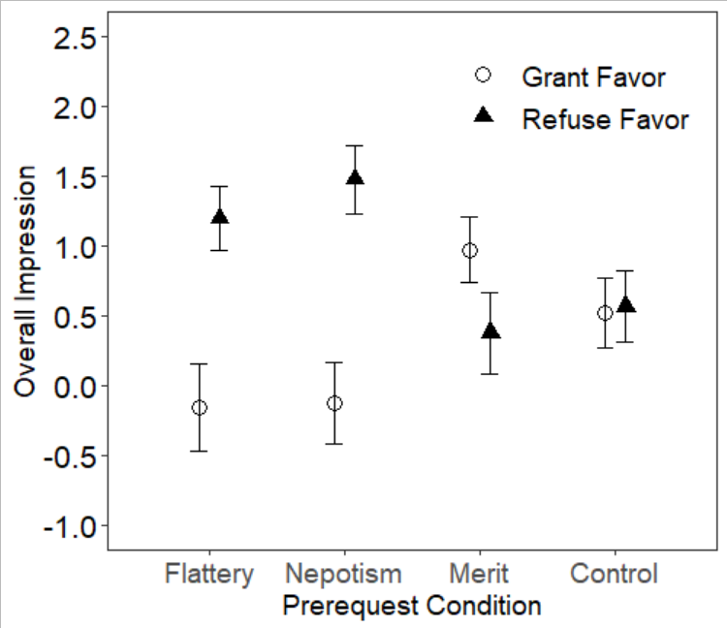

*Note*: Error bars represent 95% confidence intervals.

## **Study 5**

**Study 5: Methods and Results Supplement- Alternate Mediation Mechanisms**

As part of secondary analyses for Study 5 in the manuscript, we sought to provide a comprehensive test of potential alternate explanatory mechanisms for the effect of favor-granting on our downstream outcomes. In our review of potential alternate explanations, many seemed to overlap conceptually with naiveté (e.g., savviness, inexperience), which would make interpreting results conceptually difficult. Thus, as part of Supplementary Study 1 (see page 16 for description of the sample and procedure), we also collected measures related to perceptions of leaders for characteristics besides naiveté so that we could conduct an exploratory factor analysis. Through examining which factors the naiveté and other items load on, we can select alternate mechanisms to test that are sufficiently distinct in participants’ mind from naiveté (i.e., do not load onto the same factors as the naiveté items) while foregoing test of mechanisms that are too conceptually similar (i.e., load onto the same factors as the naiveté items.)

***Alternate mediation mechanisms.*** We collected a set of potential alternate explanatory mechanisms to naiveté for the effect of favor-granting on downstream outcomes to be used in secondary analyses for Study 5 (1 = *not at all*; 7 = *very much*). These alternate mechanisms included: how savvy the leader seems (single-item), how inexperienced (single-item) how unprepared (single-item), how need (single-item), how narcissistic (two-items: narcissistic and self-absorbed), and how critical (two items: critical and cynical).

**Results**

To assess which alternate mechanisms were empirically distinct from the naiveté measure, we conducted an Exploratory Factor Analysis using common factor analysis with principal axis factoring following the best practices outlined by Carpenter (2018). We first confirmed the factorability of our data. Results from the Bartlett’s test of sphericity (χ2(66) = 629.84, p <.001) indicated that the overall set of items were significantly correlated and the Kaiser-Meyer-Olkin (KMO) Measure of sampling adequacy of .76 was larger than the standard .60 cutoff. Thus, we concluded it was appropriate to factor analyze the present set of items. Results from parallel analysis (see Supplemental Figure 13) indicated that a three-factor structure best represented our data.

**Supplemental Figure 13**

*Scree Plot with Parallel Analysis of Factor Analysis for naiveté items and alternate mechanisms*

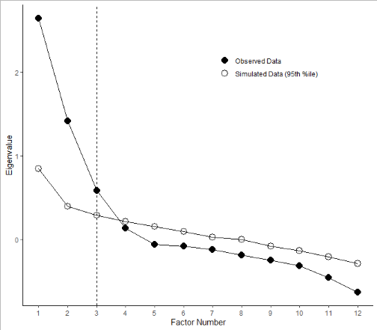

.

As we anticipated that the factors representing the various perceptions would correlate, we used an Oblique Promax rotation – which is robust and recommended for solutions with correlated factors. Using the standard cutoffs suggested by prior research (e.g., .40 by Reinard, 2006), we assessed which items loaded onto which factors. As shown in Supplemental Table 30, the naiveté items loaded onto two distinct factors, representing the gullibility and lack of awareness facets of the naiveté construct (e.g., Barasch et al., 2010). Several potential alternate mechanisms loaded onto the two naiveté factors: inexperience, unprepared, savvy and needy. This suggests that these items are not sufficiently empirically distinct from the facets of naiveté. In contrast, several items loaded onto a different factor: narcissistic, self-absorbed, cynical, and critical. Thus, we chose these four items, split into two constructs (self-absorption: narcissistic and self-absorbed; criticality: critical and cynical) to test as alternate mechanisms in Study 5.

**Supplemental Table 30**

*Oblique Promax Rotated Factor Loadings of a Principal Axis Factoring Analysis of Perceived Leader Naiveté and Other Alternative Characteristics*

|  |  |  |  |
| --- | --- | --- | --- |
| Please rate the extent to which the following traits apply to leaders of organizations. | Factor 1 | Factor 2 | Factor 3 |
| Naïve | 0.16 | 0.03 | **0.76** |
| Gullible | 0.13 | -0.03 | **0.64** |
| Ignorant | **0.63** | 0.08 | 0.17 |
| Unaware | **0.71** | 0.09 | 0.02 |
| Savvy | -0.42 | -0.07 | **0.43** |
| Inexperienced | **0.51** | -0.08 | 0.30 |
| Unprepared | **0.62** | 0.00 | 0.27 |
| Needy | 0.06 | -0.10 | **0.44** |
| Narcissistic | 0.06 | **0.78** | -0.02 |
| Self-absorbed | 0.01 | **0.75** | 0.03 |
| Cynical | 0.20 | **0.54** | -0.04 |
| Critical | -0.35 | **0.39** | 0.24 |

*Note.* Bolding of factor loadings for each scale item indicates onto which sub-factor the scale item loaded

The supplemental mediation tests for Study 5 are presented below (Supplemental Tables 31-34) illustrating that for all focal negative outcomes with the exception of commitment, perceived naiveté continued to be a significant mediator even when accounting for the alternate mediation mechanisms.

**Supplemental Table 31 – Indirect effects of Favor-granting on Perceived Competence**

|  |  |  |  |  |
| --- | --- | --- | --- | --- |
| Mediation Variable | Indirect Effect | SE | Bootstrapped 95% Confidence Interval | |
| Perceived Naiveté | -.36 | .12 | [-0.62, -0.16] | |
| Perceived Self-Absorption | -.18 | .08 | [-0.36, -0.05] | |
| Perceived Cynicality | .02 | .03 | [-0.03, 0.09] | |
|  |  |  |  | |
| *Note*. Boot (N) = 5,000; Indirect effects for Excessive Work-Related Flattery Condition. Warmth mediation not assessed due to lack of significant main effect of favor-granting. | | | |

**Supplemental Table 32 – Indirect effects of Favor-granting on Overall Impression**

|  |  |  |  |  |
| --- | --- | --- | --- | --- |
| Mediation Variable | Indirect Effect | SE | Bootstrapped 95% Confidence Interval | |
| Perceived Naiveté | -.25 | .10 | [-0.47, -0.06] | |
| Perceived Self-Absorption | -.39 | .12 | [-0.64, -0.18] | |
| Perceived Cynicality | -.02 | .03 | [-0.11, 0.03] | |
|  |  |  |  | |
| *Note*. Boot (N) = 5,000; Indirect effects for Excessive Work-Related Flattery Condition. Warmth mediation not assessed due to lack of significant main effect of favor-granting. | | | |

**Supplemental Table 33 – Indirect effects of Favor-granting on Commitment to Leader**

|  |  |  |  |  |
| --- | --- | --- | --- | --- |
| Mediation Variable | Indirect Effect | SE | Bootstrapped 95% Confidence Interval | |
| Perceived Naiveté | .02 | .11 | [-0.21, 0.23] | |
| Perceived Self-Absorption | -.38 | .12 | [-0.65, -0.16] | |
| Perceived Cynicality | -.02 | .04 | [-0.11, 0.04] | |
|  |  |  |  | |
| *Note*. Boot (N) = 5,000; Indirect effects for Excessive Work-Related Flattery Condition. Warmth mediation not assessed due to lack of significant main effect of favor-granting. | | | |

**Supplemental Table 34 – Indirect effects of Favor-granting on Organizational Fairness**

|  |  |  |  |  |
| --- | --- | --- | --- | --- |
| Mediation Variable | Indirect Effect | SE | Bootstrapped 95% Confidence Interval | |
| Perceived Naiveté | -.27 | .13 | [-0.55, -0.01] | |
| Perceived Self-Absorption | -.32 | .12 | [-0.59, -0.12] | |
| Perceived Cynicality | -.03 | .04 | [-0.14, 0.02] | |
|  |  |  |  | |
| *Note*. Boot (N) = 5,000; Indirect effects for Excessive Work-Related Flattery Condition. Warmth mediation not assessed due to lack of significant main effect of favor-granting. | | | |

**Study 5 Method and Results Supplement- Overall Impression**

Participants completed the same measure of overall impression (-3 = *very negative*, 3 = *very positive*) as other studies. An ANOVA on overall impression revealed a significant effect of favor-granting, *F*(1, 582) = 61.99, *p* < .001, $η_{p}^{2}$ = .096, a significant effect of favor impact, *F*(1, 582) = 3.62, *p* = .013, $η_{p}^{2}$ = .018), and a significant interaction, *F*(1, 582) = 20.13, *p* < .001, $η_{p}^{2}$ = .094. Supplemental Table 35 and Supplemental Figure 14 show that participants who witnessed favors granted for excessive work or personal characteristics had worse overall impressions of their leaders, while those who witnessed favors granted for merited work-related flattery or neutral platitudes did not change their impression of their leader.

**Supplemental Table 35**

*Descriptive Statistics for Overall Impression in Study 5.*

|  |  |  |  |  |  |  |  |  |  |  |  |  |
| --- | --- | --- | --- | --- | --- | --- | --- | --- | --- | --- | --- | --- |
|  | Excessive Work-Related | | | Merited Work-Related | | | Personal Characteristics-Related | | | Neutral Platitude | | |
| Variable | Grant Favor | Refuse Favor | *t*a | Grant Favor | Refuse Favor | *t*b | Grant Favor | Refuse Favor | *t*c | Grant Favor | Refuse Favor | *t*d |
| Perceived Naiveté | *M* = -0.60  [-.83,-.36] | *M* = 1.06  [.73,1.39] | 8.32  (*p* <.001) | *M* = 0.49  [.13,.86] | *M* = 0.71  [.40,1.02] | .90  (*p* =.367) | *M* = -0.35  [-.64,-.06] | *M* = 1.30  [.96,1.63] | 7.47  (*p* <.001) | *M* = 0.30  [-.00,.59] | M = .12  [-.12,.36] | 0.92  (*p* =.358) |

a *df* = 149*;* b *df* = 147; ­c *df* = 142; d*df* = 144; *Note.* The values in square brackets are 95% confidence interval.

**Supplemental Figure 14**

*Study 5: Perceived overall impression as a function of flattery type (excessive work-related vs. merited work-related vs. personal characteristics-related vs. neutral platitude) and favor conditions (grant favor vs. refuse favor).*

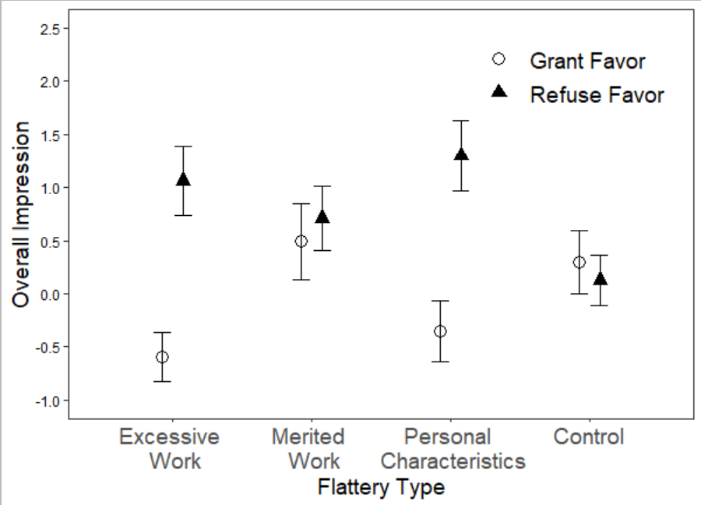

*Note*: Error bars represent 95% confidence intervals.

## **Study 6**

**Study 6: Method and Results Supplement- Overall Impression**

Participants completed the same measures of overall impression (-3 = *very negative*, 3 = *very positive*) as used in Study 5.

An ANOVA on overall impression also revealed a significant effect of favor-granting, *F*(1, 460) = 18.88, *p* < .001, $η_{p}^{2}$ = .040, and a significant interaction, *F*(1, 460) = 8.00, *p*= .005, $η_{p}^{2}$ = .017. There was no significant effect of favor impact, *F*(1, 460) = 0.42, *p* = .516, $η_{p}^{2}$ = .001). Supplemental Table 36 and Supplemental Figure 15 show that participants who were harmed by the favor provided lower overall impressions of evaluators who granted favors (*M* = 0.38, *SD* = 1.68) than evaluators who refused (*M* = 1.41, *SD* = 1.38; *t*(231) = -5.13, *p* < .001, *d* = -.67). In contrast, participants not harmed by the favor did not view evaluators who granted favors more negatively than evaluators who refused, *t(*229) = -1.05, *p* = .294, *d* = -.14.

**Supplemental Table 36:**

*Descriptive Statistics for Supplementary Measures in Study 6.*

|  |  |  |  |  |  |  |  |  |
| --- | --- | --- | --- | --- | --- | --- | --- | --- |
|  | Favor-Harm | | | | No Harm | | | |
| Variable | Grant Favor | Refuse Favor | *t*a | *p* | Grant Favor | Refuse Favor | *t*b | *p* |
|  | | | | |  | | | |
| Overall Impression | 0.38  [0.07, 0.69] | 1.41  [1.16, 1.66] | -5.13 | <.001 | 0.88  [0.59, 1.17] | 1.10  [0.81, 1.38] | -1.05 | .294 |
| Supervisor Fairness | 4.27  [3.96, 4.57] | 5.48  [5.30, 5.66] | -6.99 | <.001 | 4.98  [4.74, 5.22] | 5.19  [4.96, 5.42] | -1.26 | .211 |
|  |  |  | | |  |  | | |

a *df* = 231*;* b *df* = 229; *Note.* The values in square brackets are 95% confidence intervals.

**Supplemental Figure 15**

*Study 6: Perceived overall impression as a function of impact (favor-harm vs. no harm) and favor conditions (grant favor vs. refuse favor).*

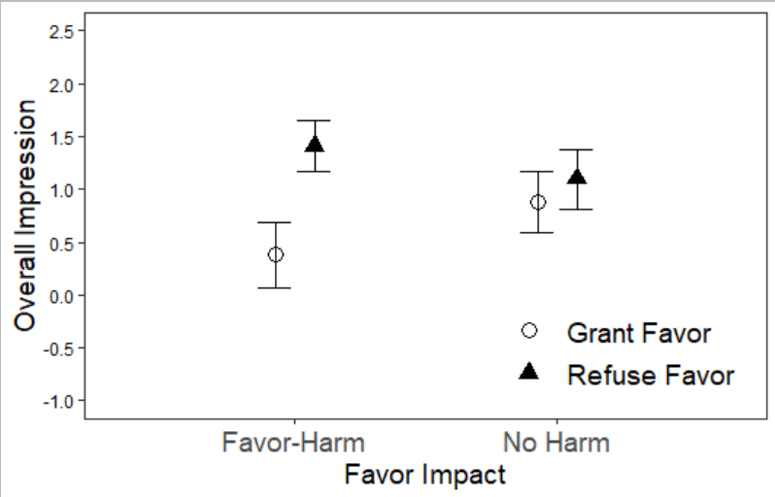

*Note*: Error bars represent 95% confidence intervals.

**Study 6: Method and Results Supplement- Ancillary Variables**

In addition to the variables in the main manuscript, we also collected for exploratory purposes the extent to which individuals thought the supervisor (as opposed to the organization) was unfair. We measured supervisor justice using Ambrose and Schminke’s (2009) three-item measure of general justice perceptions adapted to be about the supervisor (e.g. “Usually, the way things work around my supervisor are fair.”; α = .91).

As shown in Supplemental Table 36, favor impact and favor-granting interacted in predicting perceptions of supervisor fairness. An ANOVA on supervisor fairness demonstrated a significant effect of favor-granting, *F*(1, 460) = 34.96, *p* < .001, $η_{p}^{2}$ = .07, no effect of favor impact, *F*(1, 460) = 2.91, *p* = .089, $η_{p}^{2}$ = .01, and a significant interaction, *F*(1, 460) = 17.24, *p* < .001, $η_{p}^{2}$ = .04. In line with results in the main manuscript for overall impression and supervisor commitment, participants who were directly impacted by the favor had more negative reactions to favor granting (*t*(231) = -6.99, *p* < .001, *d* = .92), while favor-granting had no impact on non-impacted participants (*t*(229) = -1.26, *p* = .211, *d* = .17). Thus, we see that being impacted by the favor heightens reactions to favor-granting such that participants feel the evaluator was less fair.

## **Study 7**

**Study 7: Method and Results Supplement- Overall Impression**

Participants completed the same measures of overall impression (-3 = *my impression would become much more negative*, 3 = *my impression would become much more positive*) as used in other studies. An ANOVA on overall impression revealed a significant effect of favor-granting, *F*(1, 313) = 76.95, *p* < .001, $η_{p}^{2}$ = .197, but there was no significant effect of leader awareness, *F*(1, 313) = 1.88, *p* = .172, $η_{p}^{2}$ = .006), nor a significant interaction, *F*(1, 313) = 1.08, *p*= .300, $η_{p}^{2}$ = .003. Supplemental Table 37 and Supplemental Figure 16 show that granting a favor in response to flattery harms observers’ impressions of the leader regardless of whether they appear aware or unaware.

**Supplemental Table 37**

*Descriptive Statistics for Supplementary Measures in Study 7.*

|  |  |  |  |  |  |  |  |  |
| --- | --- | --- | --- | --- | --- | --- | --- | --- |
|  | Aware | | | | Not Aware | | | |
| Variable | Grant Favor | Refuse Favor | *t*a | *p* | Grant Favor | Refuse Favor | *t*b | *p* |
|  | | | | |  | | | |
| Overall Impression | -0.15  [-0.49,0.19] | 1.32  [1.07,1.58] | 6.92 | <.001 | -0.20  [-0.50,0.10] | 0.96  [0.67,1.26] | 5.52 | <.001 |
| Leader Fairness | 0.08  [-0.28,0.44] | 1.43  [1.14,1.71] | 5.85 | <.001 | -0.09  [-0.44,0.26] | 0.94  [0.61,1.27] | 4.24 | <.001 |
| Overall Impression of Organization | 0.10  [-0.22,0.43] | 0.79  [0.54,1.05] | 3.31 | .001 | -0.13  [-0.39,0.14] | 0.54  [0.21,0.54 | 3.10 | .002 |
|  |  |  | | |  |  | | |

a *df* = 153*;* b *df* = 160; *Note.* The values in square brackets are 95% confidence intervals.

**Supplemental Figure 16**

*Study 7: Perceived overall impression as a function of leader’s demonstrated awareness (aware vs. unaware) and favor conditions (grant favor vs. refuse favor).*

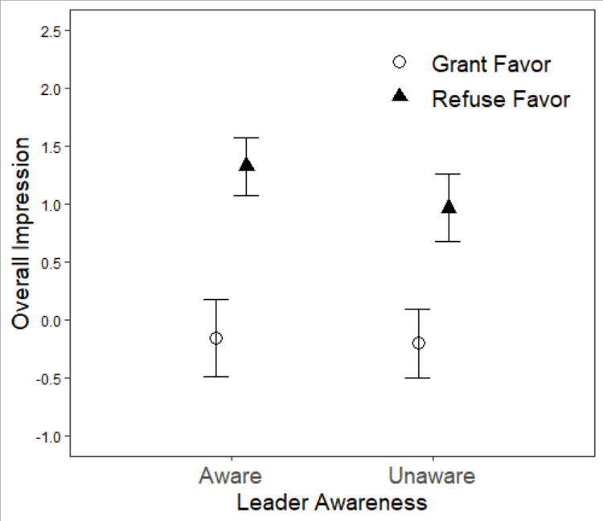

*Note*: Error bars represent 95% confidence intervals.

**Study 7: Method and Results Supplement- Ancillary Variables**

Participants also rated how fair they saw the leader and their overall impression of the organization (-3 = *my impression would become much more negative*, 3 = *my impression would become much more positive*). As with results for the overall leader impression, an ANOVA on leader fairness revealed a significant effect of favor-granting, *F*(1, 313) = 50.05, *p* < .001, $η_{p}^{2}$ = .138, but there was no significant effect of leader awareness, *F*(1, 313) = 3.84, *p* = .051, $η_{p}^{2}$ = .012), nor a significant interaction, *F*(1, 313) = 0.93, *p*= .336, $η_{p}^{2}$ = .003. Supplemental Table 37 and Supplemental Figure 17A show that granting a favor leads to reduced perceptions of leader fairness regardless of leader awareness. However, planned contrasts show that leaders who refuse to grant a favor and indicate awareness appear more fair (*M* = 1.43, *SD* = 1.25) than leaders who refuse but appear unaware (*M* = 0.94, *SD* = 1.52), *t*(313) = 2.07, *p* = .039.

Similarly, an ANOVA on impression of the organization revealed a significant effect of favor-granting, *F*(1, 313) = 20.44, *p* < .001, $η_{p}^{2}$ = .061, but there was no significant effect of leader awareness, *F*(1, 313) = 2.55, *p* = .111, $η_{p}^{2}$ = .008), nor a significant interaction, *F*(1, 313) = 0.00, *p*= .945, $η_{p}^{2}$ = .000. Whether the leader indicated awareness or not, granting a favor harmed perceptions of the overall organization as shown in Supplemental Figure 17B. The combined results for the two ancillary variables are aligned with results in the main manuscript showing that both favor-granting and awareness impact perceptions of the leader, but that awareness has less of an impact on perceptions of the overall organization.

**Supplemental Figure 17A and 17B**

*Study 7: Leader fairness and Overall Impression of Organization as a function of leader’s demonstrated awareness (aware vs. unaware) and favor conditions (grant favor vs. refuse favor).*

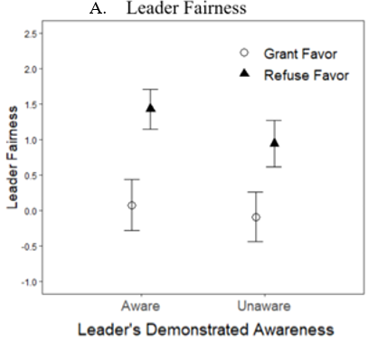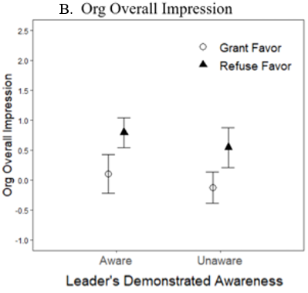

# **Supplemental References**

Ambrose, M. L., & Schminke, M. (2009). The Role of Overall Justice Judgments in Organizational Justice Research: A Test of Mediation. *Journal of Applied Psychology*, *94*(2), 491–500. https://doi.org/10.1037/a0013203

Barasch, A., Levine, E. E., & Schweitzer, M. E. (2016). Bliss is ignorance: How the magnitude of expressed happiness influences perceived naiveté and interpersonal exploitation. *Organizational Behavior and Human Decision Processes*, *137*, 184–206. https://doi.org/10.1016/j.obhdp.2016.05.006

Carpenter, S. (2018). Ten steps in scale development and reporting: A guide for researchers. *Communication Methods and Measures*, *12*(1), 25–44. <https://doi.org/10.1080/19312458.2017.1396583>

Colquitt, J. A. (2001). On the dimensionality of organizational justice: A construct validation of a measure. *Journal of Applied Psychology*, *86*(3), 386–400. https://doi.org/10.1037/0021-9010.86.3.386

Cuddy, A. J. C., Fiske, S. T., & Glick, P. (2008). Warmth and competence as universal dimensions of social perception: The stereotype content model and the BIAS map. In *Advances in Experimental Social Psychology* (Vol. 40, pp. 61–149). https://doi.org/10.1016/S0065-2601(07)00002-0

Farh, J. L., Hackett, R. D., & Liang, J. (2007). Individual-level cultural values as moderators of perceived organizational support–employee outcome relationships in China: Comparing the effects of power distance and traditionality. *Academy of management journal*, *50*(3), 715-729.

Foulk, T. A., & Long, D. M. (2016). Impressed by impression management: Newcomer reactions to ingratiated supervisors. *Journal of Applied Psychology*, *101*(10), 1487–1497. https://doi.org/10.1037/apl0000146

Grant, A. M., Dutton, J. E., & Rosso, B. D. (2008). Giving commitment: employee support programs and the prosocial sensemaking process. *Academy of Management Journal*, *51*(5), 898–918. https://doi.org/10.5465/amj.2008.34789652

Liden, R. C., & Maslyn, J. M. (1998). Multidimensionality of leader-member exchange: An empirical assessment through scale development. *Journal of management*, *24*(1), 43-72.

Reinard, J. C. (2006). *Communication research statistics*. Sage Publications, Inc.

Schaufeli, W. B., Bakker, A. B., & Salanova, M. (2006). The measurement of work engagement with a short questionnaire: A cross-national study. *Educational and psychological measurement*, *66*(4), 701-716.

1. Survey materials were translated into French. Both English and French versions of materials have been uploaded to the online repository.
2. To support secondary analyses for Study 5, we also collected an additional set of measures about perceptions of each individual (such as self-absorption, experience, and neediness) which we used in an exploratory factor analysis to identify empirically distinct alternate mechanisms. These measures and the exploratory factor analysis are detailed in the supplemental analyses for Study 5 in this document.
3. We also ran the analysis with inattentive participants and saw no change in the pattern or significance of results.
4. The effect of request explicitness was qualified by a significant interaction between favor granting and request explicitness, *F*(1, 394) = 12.05, p < .001, but post-hoc tests showed a significant effect of request explicitness whether the leader granted or refused a favor (*t*s > 2.86, *p*s ≤ .005).
5. This effect was qualified by a significant interaction between favor granting and leader familiarity, *F*(1, 394) = 3.87, p = .050, post-hoc tests showed a significant effect of favor-granting for both new and established leaders (*t*s > 24.10, *p*s < .001).
6. As with the favor-granting manipulation check, the effect of leader familiarity was qualified by a significant interaction between favor granting and leader familiarity, *F*(1, 394) = 5.17, p = .024, but post-hoc tests showed a significant effect of leader familiarity whether the leader granted or refused a favor (*t*s > 10.47, *p*s < .001).
7. Items from the contribution subscale (i.e., “I do work for (the leader) that goes beyond what is specified in my job description”) were not included as our context did not require the participant to have worked directly for the leader.
8. Although this effect was qualified by a significant interaction between favor granting and request context, *F*(3, 794) = 4.91, p = .002, post-hoc tests demonstrated significant effects of granting favor across all request context conditions: flattery (*t* = 20.03, *p* < .001), nepotism (*t* = 19.48, *p* < .001), meritocracy (*t* = 13.99, *p* < .001) and control (*t* = 20.99, *p* < .001).
9. Mediation results excluding the relationship length and quality covariates remained consistent with the exception of the indirect effect of favor-granting on competence via naiveté. The indirect effect was not significant but was in the predicted direction and the 95% bias-corrected confidence interval just included 0 (*Effect* = -.14, *SE* = .09, *CI* [-0.351, .003]).