Supplemental Material for

**Moderators of intergroup evaluation in disadvantaged groups: A comprehensive test of predictions from system justification theory**

# Correlational Analyses of SDO and RWA

Here, we report supplemental correlational analyses using two different measures, which have been interpreted as indexing system-justifying beliefs (Jost & Hunyady, 2005). These correlational analyses are based on a sub-sample of Project Implicit studies, which assessed these construct.

## Method

### Study Selection.

We included only studies which reported measures of SDO and / or RWA. The final number of datasets included in the present study was *n* = 24, yielding a total of *k* = 24 independent effect sizes.

### Measures.

#### Intergroup evaluation.

We used the same three dependent measures as reported in the main text.

#### Right-wing authoritarianism.

Right-wing authoritarianism (RWA) was assessed using a 15-item measure, adapted from Zakrisson (2005) (e.g., “Our country needs a powerful leader, in order to destroy the radical and immoral currents prevailing in society today”). Each participant responded to on average four randomly selected items from this measure, using a scale from 1 (*strongly disagree*) to 6 (*strongly agree*).

#### Social dominance orientation.

Social dominace orientation (SDO) was assessed using a 12-item measure, adapted from Pratto, Sidanius, Stallworth, and Malle (1994) (e.g., “Some people are just inferior to others”). Each participant responded to on average four randomly selected items from this measure, using a scale from 1 (*strongly disagree*) to 6 (*strongly agree*).

### Data analysis.

R scripts and RMarkdown scripts to reproduce data preparation, analyses, figures, and tables can be found at <https://osf.io/cxp9z/>.

## Results

### SDO.

To test the relationship between disadvantaged group members’ SDO and intergroup evaluation at the individual level, we calculated the correlation between SDO and the three measures of intergroup evaluation within each sample and fitted three separate random-effects models, weighting each correlation coefficient by its corresponding sample size.

#### IAT D Scores.

We observed an average effect of *r* = .06, *z* = 7.51, *p* < .001, 95% *CI* [0.05; 0.08], indicating that the correlation between SDO and IAT *D* Scores at the individual level was very small. The estimated amount of total heterogeneity was $τ^{2}$ = 0.0005, *Q*(22) = 183.94, *p* < .001, accounting for a large proportion of the total variability, *I*2 = 71.61%.

#### One-item preference scores.

We observed an average effect of *r* = .10, *z* = 5.95, *p* < .001, 95% *CI* [0.07; 0.13], indicating that the correlation between SDO and one-item preference scores at the individual level was small. The estimated amount of total heterogeneity was $τ^{2}$ = 0.00, *Q*(22) = 467.15, *p* < .001, accounting for a large proportion of the total variability, *I*2 = 95.96%.

#### Feeling thermometer difference scores.

We observed an average effect of *r* = .05, *z* = 4.02, *p* < .001, 95% *CI* [0.02; 0.07], indicating that the correlation between SDO and feeling thermometer difference scores at the individual-level was very small. The estimated amount of total heterogeneity was $τ^{2}$ = 0.00, *Q*(21) = 138.56, *p* < .001, accounting for a large proportion of the total variability, *I*2 = 83.08%.

Taken together, we observed positive but small correlations between SDO and intergroup evaluation: Members of disadvantaged groups displayed more favorable evaluations towards an advantaged outgroup relative to their disadvantaged ingroup the higher their self-reported SDO levels.

### RWA.

To test the relationship between disadvantaged group members’ RWA and intergroup evaluation at the individual level, we calculated the correlation between RWA and the three measures of intergroup evaluation within each sample and fitted three separate random-effects models, weighting each correlation coefficient by its corresponding sample size.

#### IAT D Scores.

We observed an average effect of *r* = -.01, *z* = -4.06, *p* = < .001, 95% *CI* [-0.02; -0.01], indicating that RWA and IAT *D* Scores were uncorrelated at the individual level. The estimated amount of total heterogeneity was $τ^{2}$ = 0.0000, *Q*(22) = 27.16, *p* .205, with *I*2 = 0.00%.

#### One-item preference scores.

We observed an average effect of *r* = .00, *z* = 0.11, *p* = .915, 95% *CI* [-0.02; 0.03], indicating RWA and one-item preference scores were uncorrelated at the individual level. The estimated amount of total heterogeneity was $τ^{2}$ = 0.00, *Q*(22) = 86.65, *p* < .001, with *I*2 = 84.91%.

#### Feeling thermometer difference scores.

We observed an average effect of *r* = .01, *z* = 0.67, *p* = .503, 95% *CI* [-0.01; 0.03], indicating that RWA and feeling thermometer difference scores were uncorrelated at the individual-level. The estimated amount of total heterogeneity was $τ^{2}$ = 0.00, *Q*(21) = 58.57, *p* < .001, with *I*2 = 80.19%.

Taken together, on average, correlational analyses with RWA yielded null effects across all three measures of intergroup evaluation: RWA levels among members of disadvantaged groups were unrelated to their intergroup evaluations.

## Discussion

We ran a series of individual-level analyses assessing the relationships between SDO, RWA, and intergroup evaluation in disadvantaged group members. Here, we observed small correlations between SDO and outgroup favoritism for all three dependent measures. However, another pattern emerged regarding RWA, where we observed correlations close to zero for all three dependent measures.

Two issues complicate clear interpretations of these findings. First, participants did not complete either the full SDO or RWA scales. Instead, each participant responded to few randomly-selected items from each scale. Consequently, the available individual-level data suffers from both relatively high measurement error and relatively low construct validity—which, in turn, implies a high risk of underestimating the true relationship between system justifying beliefs and outgroup favoritism at the individual level. Second, the SDO and RWA measures were only included in approximately one-third of the datasets examined in the main analyses. This subset of datasets is very selective, with all focusing on race- and ethnicity-related intergroup attitudes. Hence, analyses that relied on this subset of datasets are less suited to examine the generalizability of SJT’s predictions, and thus stand in contrast to our main meta-analytic findings across a wider variety of social groups.

## References

Jost, J. T., & Hunyady, O. (2005). Antecedents and consequences of system-justifying ideologies. *Current Directions in Psychological Science*, *14*(5), 260–265. <https://doi.org/10.1111/j.0963-7214.2005.00377.x>

Pratto, F., Sidanius, J., Stallworth, L. M., & Malle, B. F. (1994). Social dominance orientation: A personality variable predicting social and political attitudes. *Journal of Personality and Social Psychology*, *67*(4), 741–763. <https://doi.org/10.1037/0022-3514.67.4.741>

Zakrisson, I. (2005). Construction of a short version of the right-wing authoritarianism (rwa) scale. *Personality and Individual Differences*, *39*(5), 863–872. <https://doi.org/10.1016/j.paid.2005.02.026>

# Exploratory Moderator Analyses of Cultural Differences

To further explore whether societal aspects moderate intergroup evaluations among disadvantaged groups in a more quantitative fashion, we searched for indices of cultural difference that may be related to system-justifying beliefs. Specifically, we used Hofstede’s cultural value dimensions (Hofstede, Hofstede, & Minkov, 2010) that describe aggregate country differences, with the most well-established being collectivism-individualism, masculinity-femininity, uncertainty avoidance, and power-distance.

## Using Power Distance as Continuous Moderator

Hofstede’s power distance index would seem to be the most promising proxy for culture-level metrics of system-justifying beliefs, in that it reflects the degree to which the less powerful members of a society accept and expect that power is distributed unequally. As an index of societal inequality, this cultural value dimension appears to be conceptually most similar to system justification motives (Jost & Hunyady, 2005). Based on these data, we conducted a series of mixed-effects meta-regression analyses, but we did not observe significant moderation effects of the power distance index for IAT *D* Scores, *QM*(1) = 0.02, *p* = .880, one-item preference scores, *QM*(1) = 2.37, *p* = .124, or feeling thermometer difference scores, *QM*(1) = 0.03, *p* = .866.

## Using Four Cultural Dimensions Simultaneously

We also ran a series of meta-regression analyses, each time simultaneously using the first four Hofstede dimensions–individualism, power distance, masculinity, and uncertainty avoidance–as continuous moderators. Here, we also did not observe significant overall moderation effects for IAT *D* Scores, *QM*(4) = 1.35, *p* = .853, one-item preference scores, *QM*(4) = 8.45, *p* = .076, or feeling thermometer difference scores, *QM*(4) = 3.58, *p* = .465. These additional analyses suggest that cultural and societal differences–indexed by the Hofstede dimensions–do not seem to be reliably related to intergroup evaluations among disadvantaged groups. However, given the rather low power of these analyses (due to only *n* = countries), these are not strong tests of the relationship between country-level factors and outgroup favoritism in disadvantaged groups.

## References

Jost, J. T., & Hunyady, O. (2005). Antecedents and consequences of system-justifying ideologies. *Current Directions in Psychological Science*, *14*(5), 260–265. <https://doi.org/10.1111/j.0963-7214.2005.00377.x>

# Analyses with Advantaged Groups

Here, we report supplemental analyses using advantaged groups. Specifically, we examined overall effects of intergroup evaluation for all three measures of intergroup evaluation as well as relationships between conservatism and intergroup evaluations.

## Method

### Participants.

The total sample size was *N* = 4,757,009.

### Intergroup Domains.

Table S1 provides an overview of advantaged group samples, dependent measures, moderators, and descriptive statistics.

#### Old vs. Young.

From the *k* = 14 studies focusing on age-related group evaluations, we included only participants with a self-reported age of 54 years and younger (see Kite, Stockdale, Whitley, & Johnson, 2005; Neugarten, 1974).

#### Arab vs. French.

From the *k* = 1 study focusing on evaluations of Arab people relative to French people, we included only participants who reported being French or White and who self-categorized as Christian (e.g., Protestant; Catholic).

#### Disabled vs. Abled.

From the *k* = 1 study focusing on evaluations of disability relative to non-disability, we included only participants who indicated that they did not have a disability.

#### Black vs. White.

From the *k* = 11 studies focusing on evaluations of Black people relative to White people, we included only participants who self-categorized as White.

#### Religious groups.

From the *k* = 2 studies focusing on evaluations of religious groups, we included only participants who self-categorized as Christian, thus yielding 2 independent samples.

#### Gay vs. Straight.

From the *k* = 15 studies focusing on evaluations of Gay people relative to Straight people, we included only participants who self-categorized as heterosexual.

#### Dark-Skinned vs. Light-Skinned.

From the *k* = 13 studies focusing on evaluations of dark-skinned people relative to light-skinned people, we included only participants who self-categorized as somewhat somewhat light-skinned, light-skinned, or very light-skinned.

#### Overweight vs. Normal Weight.

From the *k* = 14 studies focusing on evaluations of overweight people relative to normal weight people, we included only participants who self-categorized as being neither underweight nor overweight, slightly, moderately, or very underweight.

Table S1

Overview of advantaged group samples, variables, and descriptive statistics.

|  |  |  |  |  |  |  |  |  |  |  |  |  |
| --- | --- | --- | --- | --- | --- | --- | --- | --- | --- | --- | --- | --- |
|  |  |  | IAT | |  | Preference | |  | Thermometer | |  |  |
| Group | Country |  | dz | N |  | dz | N |  | dz | N |  | Conservatism |
| Younger (<55) age | AUS |  | 1.16 | 16615 |  | 0.48 | 18332 |  | 0.19 | 18807 |  | -0.28 |
| Younger (<55) age | BEL |  | 1.44 | 1698 |  | 0.62 | 1711 |  | 0.38 | 1841 |  | -0.23 |
| Younger (<55) age | BRA |  | 1.01 | 4430 |  | 0.52 | 5152 |  | 0.26 | 5290 |  | -0.25 |
| Younger (<55) age | CAN (EN) |  | 1.09 | 21171 |  | 0.41 | 22560 |  | 0.12 | 23040 |  | -0.42 |
| Younger (<55) age | CAN (FR) |  | 1.27 | 1794 |  | 0.56 | 1816 |  | 0.29 | 1877 |  | -0.43 |
| Christian | CHN |  | 1.25 | 7912 |  | 0.70 | 8540 |  | -0.03 | 9077 |  | -0.45 |
| Younger (<55) age | DEU |  | 1.42 | 16162 |  | 0.58 | 16145 |  | 0.29 | 17135 |  | -0.51 |
| Younger (<55) age | ESP |  | 1.22 | 6913 |  | 0.52 | 7205 |  | 0.07 | 7468 |  | -0.53 |
| Younger (<55) age | FRA |  | 1.44 | 14136 |  | 0.62 | 14506 |  | 0.32 | 15109 |  | -0.35 |
| Younger (<55) age | GBR |  | 1.15 | 35603 |  | 0.39 | 39795 |  | 0.13 | 40662 |  | 0.01 |
| Younger (<55) age | KOR |  | 1.35 | 5911 |  | 1.16 | 6235 |  | -0.26 | 7046 |  | -0.33 |
| Younger (<55) age | NLD |  | 1.32 | 7512 |  | 0.62 | 8095 |  | 0.27 | 8422 |  | -0.56 |
| Younger (<55) age | SWE |  | 1.20 | 8689 |  | 0.47 | 8270 |  | 0.09 | 9097 |  | -0.04 |
| Younger (<55) age | USA |  | 1.10 | 711861 |  | 0.43 | 733460 |  | 0.09 | 757832 |  | -0.15 |
| Non-Arab / Non-Muslim | FRA |  | 1.17 | 10457 |  | 0.70 | 10642 |  | 0.54 | 1106 |  | -0.36 |
| Non-disabled participants | USA |  | 1.16 | 272975 |  | 0.54 | 285593 |  | 0.19 | 291482 |  | -0.26 |
| White participants | AUS |  | 0.99 | 8833 |  | 0.57 | 9701 |  | 0.40 | 9755 |  | -0.38 |
| White participants | BEL |  | 0.87 | 8817 |  | 0.64 | 9576 |  | 0.44 | 9984 |  | -0.29 |
| White participants | BRA |  | 0.99 | 4990 |  | 0.55 | 6431 |  | 0.31 | 6487 |  | -0.31 |
| White participants | CAN (EN) |  | 0.97 | 39599 |  | 0.50 | 41850 |  | 0.34 | 42615 |  | -0.47 |
| White participants | CAN (FR) |  | 1.09 | 2767 |  | 0.60 | 2825 |  | 0.43 | 2919 |  | -0.51 |
| White participants | DEU |  | 0.91 | 33528 |  | 0.52 | 34818 |  | 0.29 | 36254 |  | -0.57 |
| White participants | ESP |  | 1.05 | 7929 |  | 0.67 | 8451 |  | 0.41 | 8692 |  | -0.67 |
| White participants | FRA |  | 1.02 | 20146 |  | 0.51 | 21183 |  | 0.32 | 21790 |  | -0.21 |
| White participants | GBR |  | 0.93 | 78012 |  | 0.57 | 90927 |  | 0.40 | 92420 |  | -0.33 |
| White participants | SWE |  | 0.75 | 13898 |  | 0.58 | 13978 |  | 0.35 | 14821 |  | -0.07 |
| White participants | USA |  | 0.96 | 1597308 |  | 0.61 | 1559488 |  | 0.47 | 1637808 |  | -0.20 |
| Christian | USA |  | 1.17 | 8354 |  | 1.48 | 8146 |  | 0.86 | 8218 |  | 0.06 |
| Christian | USA |  | 1.37 | 8539 |  | 1.73 | 8321 |  | 1.09 | 8380 |  | 0.08 |
| Straight | AUS |  | 0.78 | 11012 |  | 0.62 | 13460 |  | 0.58 | 14162 |  | -0.34 |
| Straight | BEL |  | 0.77 | 2330 |  | 0.82 | 2471 |  | 0.79 | 2851 |  | -0.27 |
| Straight | BRA |  | 0.66 | 6812 |  | 0.89 | 8740 |  | 0.83 | 9143 |  | -0.25 |
| Straight | CAN (EN) |  | 0.74 | 16684 |  | 0.62 | 18234 |  | 0.58 | 19175 |  | -0.42 |
| Straight | CAN (FR) |  | 0.48 | 2044 |  | 0.62 | 1999 |  | 0.64 | 2256 |  | -0.50 |
| Christian | CHN |  | 0.45 | 14518 |  | 1.27 | 17979 |  | 0.93 | 18714 |  | -0.48 |
| Straight | DEU |  | 0.57 | 23868 |  | 0.76 | 23754 |  | 0.75 | 26778 |  | -0.52 |
| Straight | ESP |  | 0.74 | 8665 |  | 0.74 | 9614 |  | 0.64 | 10410 |  | -0.64 |
| Straight | FRA |  | 0.52 | 17878 |  | 0.66 | 18733 |  | 0.62 | 20749 |  | -0.37 |
| Straight | GBR |  | 0.81 | 30963 |  | 0.66 | 35388 |  | 0.64 | 36920 |  | -0.40 |
| Straight | KOR |  | 0.80 | 12973 |  | 1.05 | 18003 |  | 0.47 | 18651 |  | -0.52 |
| Straight | NLD |  | 0.93 | 5861 |  | 0.78 | 6847 |  | 0.80 | 7370 |  | -0.68 |
| Straight | RUS |  | 1.10 | 2596 |  | 1.48 | 2546 |  | 1.07 | 3071 |  | -0.02 |
| Straight | SWE |  | 0.49 | 12682 |  | 0.61 | 12603 |  | 0.62 | 14615 |  | -0.06 |
| Straight | USA |  | 0.87 | 767542 |  | 0.71 | 791703 |  | 0.69 | 824433 |  | -0.25 |
| Light-skinned | BEL |  | 0.79 | 2560 |  | 0.55 | 2832 |  | 0.32 | 3142 |  | -0.39 |
| Light-skinned | BRA |  | 0.95 | 4770 |  | 0.62 | 6878 |  | 0.41 | 7087 |  | -0.29 |
| Light-skinned | CAN (EN) |  | 0.92 | 8951 |  | 0.45 | 9842 |  | 0.30 | 10267 |  | -0.56 |
| Light-skinned | CAN (FR) |  | 1.15 | 1111 |  | 0.48 | 1147 |  | 0.39 | 1230 |  | -0.64 |
| Christian | CHN |  | 1.28 | 1832 |  | 0.95 | 2236 |  | 0.23 | 2330 |  | -0.48 |
| Light-skinned | DEU |  | 0.92 | 12637 |  | 0.53 | 13029 |  | 0.26 | 14216 |  | -0.68 |
| Light-skinned | ESP |  | 1.01 | 3564 |  | 0.63 | 4180 |  | 0.32 | 4324 |  | -0.65 |
| Light-skinned | FRA |  | 1.01 | 9239 |  | 0.41 | 9757 |  | 0.32 | 10461 |  | -0.43 |
| Light-skinned | GBR |  | 0.90 | 13139 |  | 0.45 | 14583 |  | 0.30 | 15327 |  | -0.57 |
| Light-skinned | KOR |  | 1.11 | 1460 |  | 0.97 | 1920 |  | -0.35 | 1985 |  | -0.45 |
| Light-skinned | NLD |  | 0.72 | 6432 |  | 0.60 | 7508 |  | 0.32 | 8104 |  | -0.73 |
| Light-skinned | SWE |  | 0.71 | 11711 |  | 0.57 | 12552 |  | 0.37 | 13534 |  | -0.12 |
| Light-skinned | USA |  | 0.91 | 558605 |  | 0.44 | 585443 |  | 0.31 | 315233 |  | -0.31 |
| Normal weight | AUS |  | 1.16 | 5592 |  | 1.11 | 6847 |  | 0.63 | 6989 |  | -0.35 |
| Normal weight | BEL |  | 1.06 | 1066 |  | 1.14 | 1240 |  | 0.58 | 1287 |  | -0.28 |
| Normal weight | BRA |  | 0.88 | 3513 |  | 1.09 | 4563 |  | 0.78 | 4610 |  | -0.28 |
| Normal weight | CAN (EN) |  | 1.08 | 9049 |  | 1.03 | 10111 |  | 0.58 | 10286 |  | -0.44 |
| Normal weight | CAN (FR) |  | 1.46 | 1075 |  | 1.29 | 1152 |  | 0.91 | 1196 |  | -0.46 |
| Christian | CHN |  | 0.26 | 3906 |  | 0.77 | 4798 |  | -0.29 | 4913 |  | -0.45 |
| Normal weight | DEU |  | 1.44 | 11310 |  | 0.96 | 12222 |  | 0.62 | 12781 |  | -0.56 |
| Normal weight | ESP |  | 1.10 | 3527 |  | 1.08 | 4047 |  | 0.39 | 4158 |  | -0.57 |
| Normal weight | FRA |  | 1.32 | 6714 |  | 1.21 | 7414 |  | 0.75 | 7621 |  | -0.39 |
| Normal weight | GBR |  | 1.02 | 11518 |  | 1.03 | 13113 |  | 0.59 | 13375 |  | -0.44 |
| Normal weight | KOR |  | 0.80 | 2640 |  | 1.52 | 3441 |  | -0.20 | 3550 |  | -0.35 |
| Normal weight | NLD |  | 1.08 | 4587 |  | 1.33 | 5535 |  | 0.66 | 5735 |  | -0.61 |
| Normal weight | SWE |  | 1.30 | 6594 |  | 1.12 | 7240 |  | 0.69 | 7611 |  | -0.04 |
| Normal weight | USA |  | 1.13 | 136920 |  | 1.12 | 139779 |  | 0.65 | 143990 |  | -0.25 |

*Note.* Top row of column labels refer to dependent measures: IAT = IAT; Preference = one-item preference measure; Thermometer = feeling thermometer difference score. Second row of column labels refer to Group = advantaged group examined in analyses; dz = Cohen’s *dz*, with positive scores indicating outgroup favoritism and negative scores indicating ingroup favoritism; N = sample size, Conservatism = sample-average of conservatism. Abbreviations in second column denote country codes: AUS = Australia, BEL = Belgium, BRA = Brazil, CAN (EN) = Canada (English), CAN (FR) = Canada (French), CHN = China, DEU = Germany, ESP = Spain, FRA = France, GBR = United Kingdom, KOR = Korea, NLD = The Netherlands, RUS = Russia, SWE = Sweden, USA = United States.

## Results

### Testing the predictions of SJT at the individual level.

#### Implicit versus explicit measures.

We fitted three separate random-effects models, using the three measures of intergroup evaluation as dependent variables.

##### IAT D Scores.

We observed a significant large mean effect of *dz* = 1.00, *z* = 32.49, *p* < .001, 95% *CI* [0.94; 1.06]. This medium-sized positive effect indicates that, on average, members of advantaged groups displayed ingroup favoritism on the IAT. The estimated amount of total heterogeneity was $τ^{2}$ = 0.07, *Q*(70) = 73,129.55, *p* < .001, accounting for a large proportion of the total variability. The percentage of the heterogeneity not attributable to sampling error was *I*2 = 99.97%.

##### One-item preference scores.

We also observed a large mean effect of *dz* = 0.77, *z* = 20.58, *p* = < .001, 95% *CI* [0.70; 0.84], indicating that, on average, members of advantaged groups displayed ingroup favoritism on the one-item preference measures. The estimated amount of total heterogeneity was $τ^{2}$ = 0.10, *Q*(70) = 133,992.31, *p* < .001, accounting for a large proportion of the total variability, and *I*2 = 99.97%, indicating high total heterogeneity.

##### Feeling thermometer difference scores.

We observed a medium-sized mean effect of *dz* = 0.43, *z* = 12.27, *p* < .001, 95% *CI* [0.36; 0.50], indicating that, on average, members of advantaged groups also displayed ingroup favoritism on feeling thermometer difference scores. The estimated amount of total heterogeneity was $τ^{2}$ = 0.09, *Q*(70) = 64,160.26, *p* < .001, and *I*2 = 99.95%, indicating high total heterogeneity.

Taken together, advantaged groups displayed large-to-medium effects of ingroup favoritism on implicit and explicit measures.

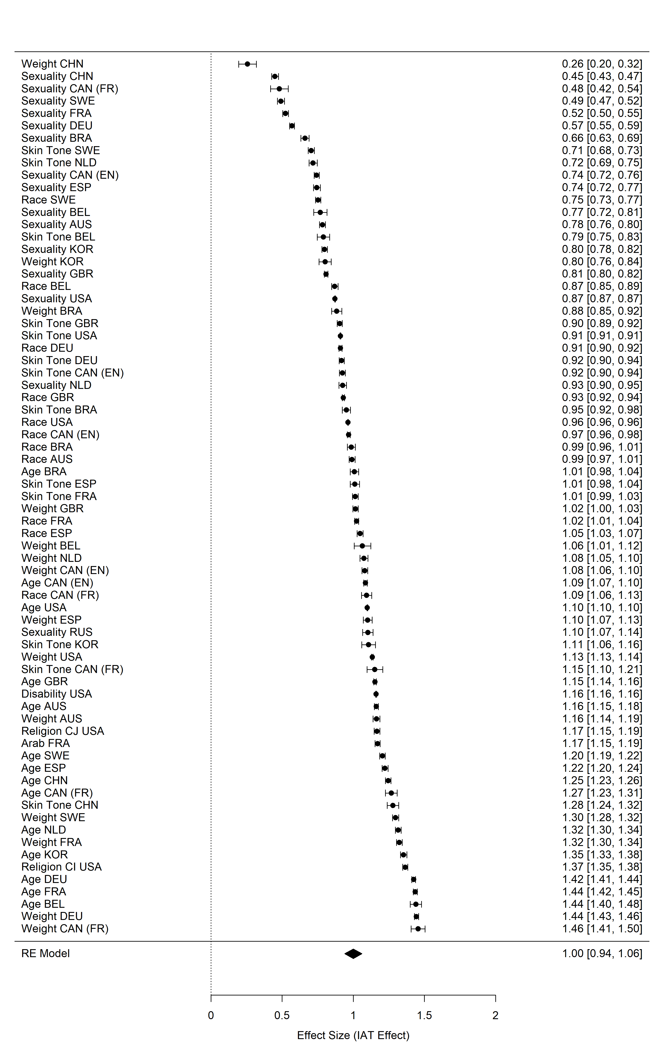

*Figure* *S1.* Caterpillar plot of random-effects meta-analysis of IAT effects (IAT *D* Scores) with study effects ordered by effect size. Positive scores indicate ingroup favoritism and negative scores indicate outgroup favoritism from the perspective of the advantaged groups. Error bars depict 95% confidence intervals and values in squared brackets indicate lower and upper bounds of confidence intervals. Dataset labels denote the intergroup domain for each study and the respective country. Abbreviations for religious groups: CH = Christian participants, CJ = Christianity vs. Judaism, CI = Christianity vs. Islam. Country codes: AUS = Australia, BEL = Belgium, BRA = Brazil, CAN (EN) = Canada (English), CAN (FR) = Canada (French), CHN = China, DEU = Germany, ESP = Spain, FRA = France, GBR = United Kingdom, KOR = Korea, NLD = The Netherlands, RUS = Russia, SWE = Sweden, USA = United States.

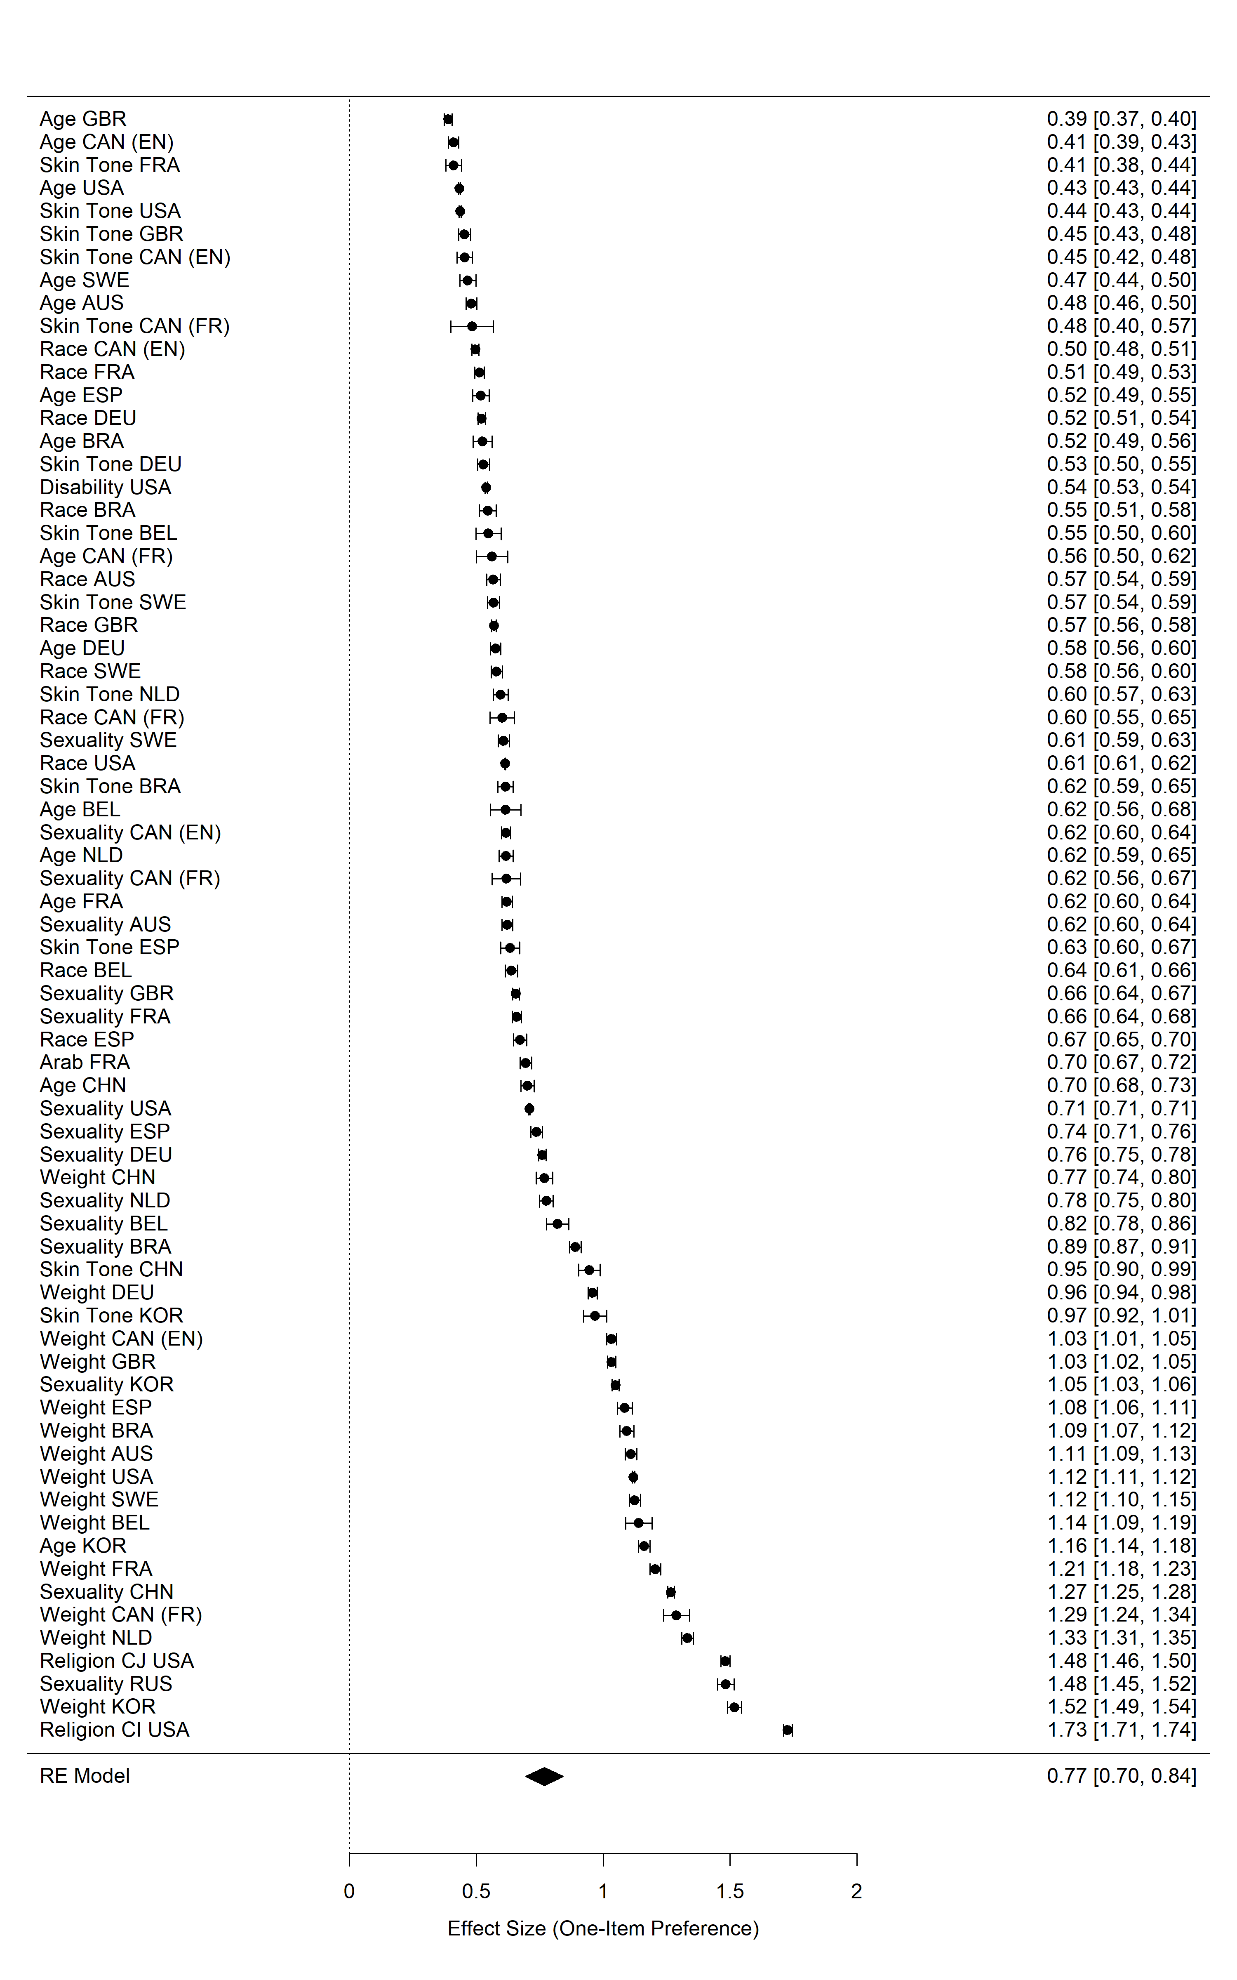

*Figure* *S2.* Caterpillar plot of random-effects meta-analysis of one-item preference scores with study effects ordered by effect size. Positive scores indicate ingroup favoritism and negative scores indicate outgroup favoritism from the perspective of the advantaged groups. Error bars depict 95% confidence intervals and values in squared brackets indicate lower and upper bounds of confidence intervals. Dataset labels denote the intergroup domain for each study and the respective country. Abbreviations for religious groups: CJ = Christianity vs. Judaism, CI = Christianity vs. Islam. Country codes: AUS = Australia, BEL = Belgium, BRA = Brazil, CAN (EN) = Canada (English), CAN (FR) = Canada (French), CHN = China, DEU = Germany, ESP = Spain, FRA = France, GBR = United Kingdom, KOR = Korea, NLD = The Netherlands, RUS = Russia, SWE = Sweden, USA = United States.

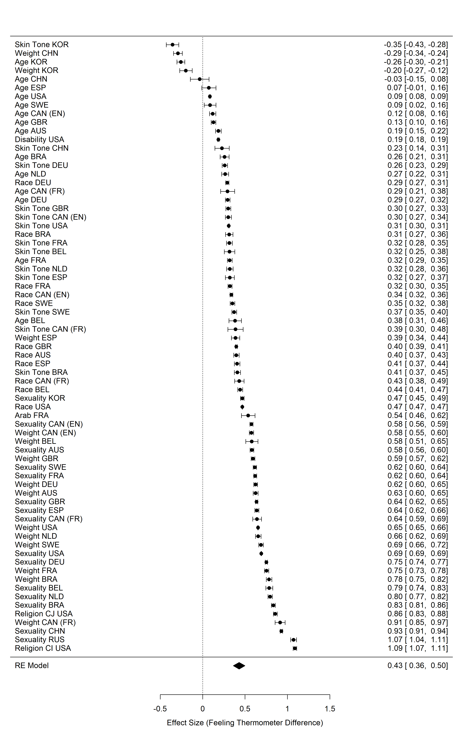

*Figure* *S3.* Caterpillar plot of random-effects meta-analysis of feeling thermometer (difference) scores with study effects ordered by effect size. Positive scores indicate ingroup favoritism and negative scores indicate outgroup favoritism from the perspective of the advantaged groups. Error bars depict 95% confidence intervals and values in squared brackets indicate lower and upper bounds of confidence intervals. Dataset labels denote the intergroup domain for each study and the respective country. Abbreviations for religious groups: CJ = Christianity vs. Judaism, CI = Christianity vs. Islam. Country codes: AUS = Australia, BEL = Belgium, BRA = Brazil, CAN (EN) = Canada (English), CAN (FR) = Canada (French), CHN = China, DEU = Germany, ESP = Spain, FRA = France, GBR = United Kingdom, KOR = Korea, NLD = The Netherlands, RUS = Russia, SWE = Sweden, USA = United States.

#### Conservatism.

To test the relationship between advantaged group members’ conservative beliefs and intergroup evaluation at the individual level, we followed the same procedure as detailed in the main text.

##### IAT D Scores.

We observed an average effect of *r* = .10, *z* = 13.51, *p* < .001, 95% *CI* [0.09; 0.12], indicating that the correlation between conservatism and IAT *D* Scores at the individual level was small. The estimated amount of total heterogeneity was $τ^{2}$ = 0.0039, *Q*(70) = 21,013.06, *p* < .001, accounting for a large proportion of the total variability, *I*2 = 99.53%.

##### One-item preference scores.

We observed an average effect of *r* = .15, *z* = 9.20, *p* < .001, 95% *CI* [0.12; 0.19], indicating that the correlation between conservatism and one-item preference scores at the individual level was small. The estimated amount of total heterogeneity was $τ^{2}$ = 0.02, *Q*(70) = 93,162.54, *p* < .001, accounting for a large proportion of the total variability, *I*2 = 99.91%.

##### Feeling thermometer difference scores.

We observed an average effect of *r* = .16, *z* = 9.82, *p* < .001, 95% *CI* [0.13; 0.19], indicating that the correlation between conservatism and feeling thermometer difference scores at the individual-level was small. The estimated amount of total heterogeneity was $τ^{2}$ = 0.02, *Q*(69) = 103,040.45, *p* < .001, accounting for a large proportion of the total variability, *I*2 = 99.91%.

Taken together, we observed positive but small correlations between conservatism and intergroup evaluation: Members of advantaged groups displayed more favorable evaluations towards their ingroup relative to an disadvantaged outgroup the more they described themselves as conservative.

### Examining relationships between conservatism and intergroup evaluation at the group level.

To test the relationship between advantaged groups’ conservative beliefs and intergroup evaluation at the group level, we fitted three separate mixed-effects meta-regression models with self-reported conservatism aggregated at the sample level as continuous moderators, and using advantaged groups’ IAT *D* Scores, one-item preference scores, and feeling thermometer difference scores as dependent variables.

#### IAT D Scores.

First, we fitted a mixed-effects model with group aggregates of self-reported conservatism as a continuous moderator, using advantaged groups’ IAT *D* Scores as dependent variable. We did not observe a significant moderating effect, *QM*(1) = 0.66, *p* = .417, $R^{2}$ = 0.00%. This indicates that group aggregates of self-reported conservatism were unrelated to group aggregates of implicit ingroup favoritism (see Figure C4, Panel A).

#### One-item preference scores.

Again, we fitted a mixed-effects model with group aggregates of self-reported conservatism as a continuous moderator, now using advantaged groups’ one-item preference scores as dependent variable. We did not observe a significant moderating effect, *QM*(1) = 2.55, *p* = .110, $R^{2}$ = 2.16%. This indicates that group aggregates of self-reported conservatism were unrelated to group aggregates of one-item preference scores (see Figure C4, Panel B).

#### Feeling thermometer difference scores.

Lastly, we fitted the same mixed-effects model with feeling thermometer difference scores as the dependent variable and self-reported conservatism as a continuous moderator. Here, we also did not observe a significant moderating effect, *QM*(1) = 1.87, *p* = .171, with conservatism accounting for only 1.23% of the heterogeneity in feeling thermometer difference scores. This indicates that that group aggregates of self-reported conservatism were unrelated to group aggregates of feeling thermometer difference scores (see Figure C4, Panel C).

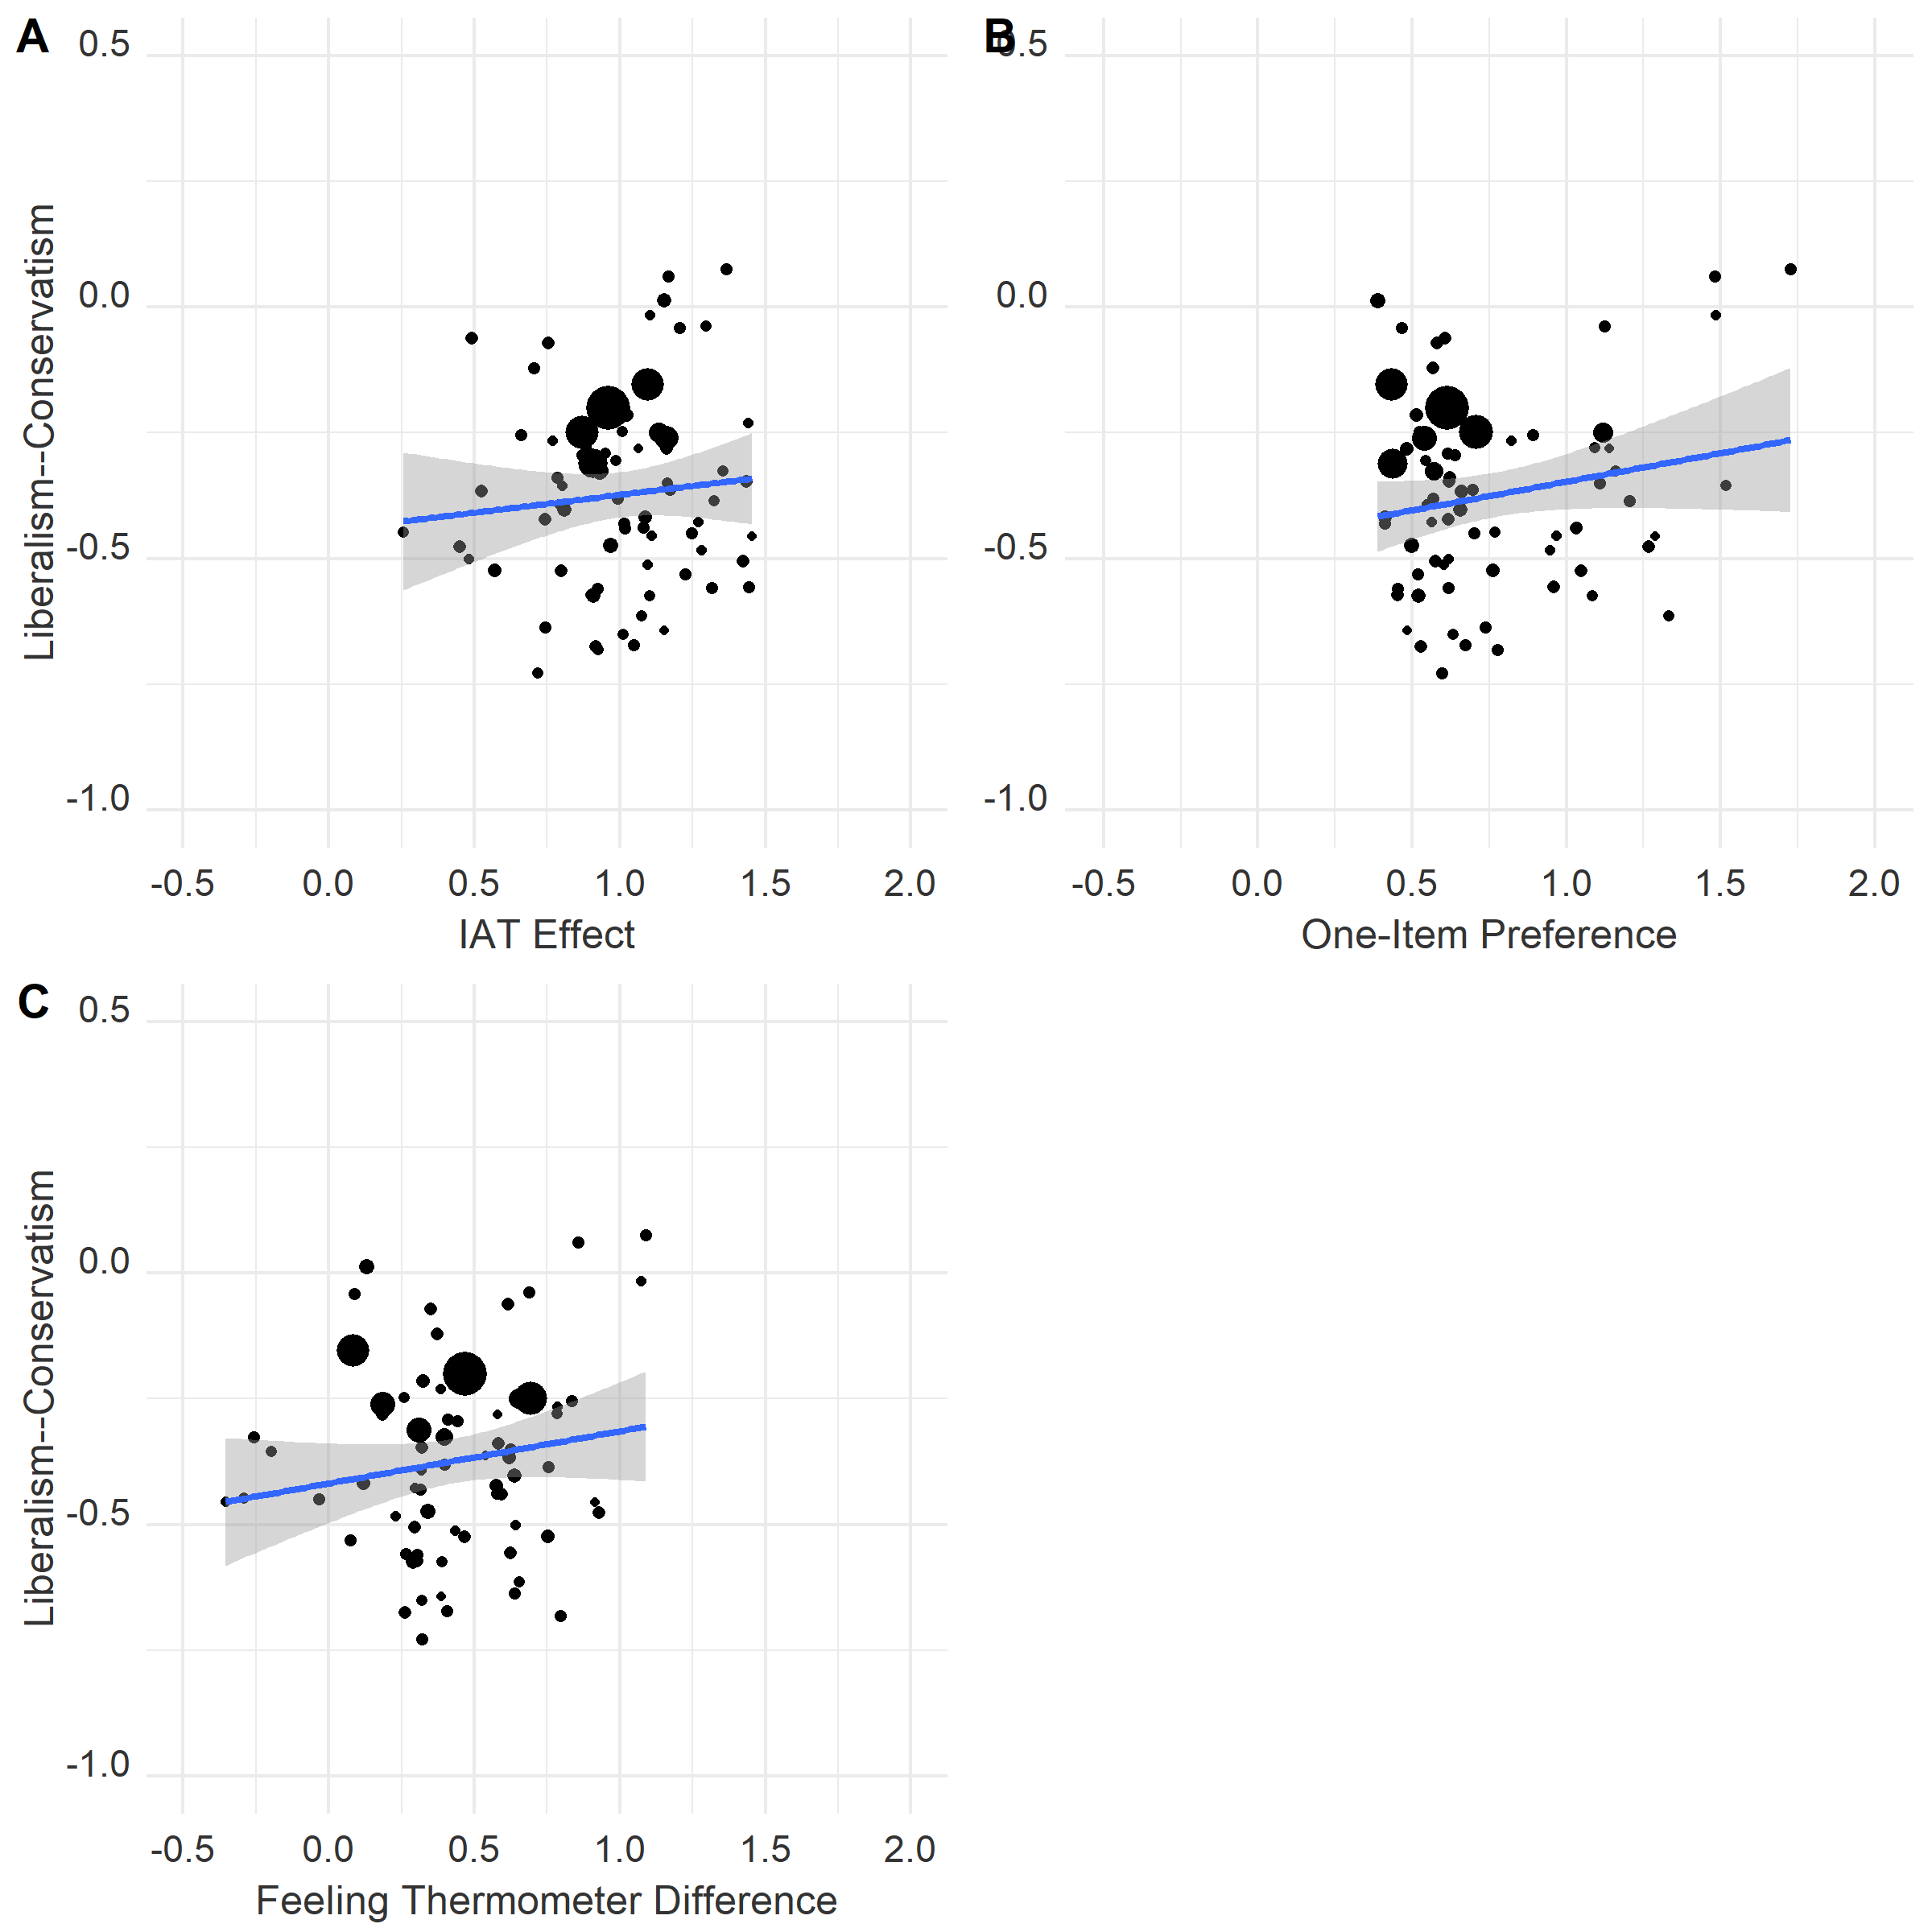

*Figure* *4.* Scatterplot depicting the relationship between conservatism and intergroup evaluations among advantaged groups. Y-axes reflect disadvantaged groups’ sample-level mean Cohen’s *dz* for conservatism, measured on a one-item 6- point and/or 7-point scale. X-axes reflect mean Cohen’s *dz* for IAT *D* Scores (Panel A), one-item preference scores (Panel B), and feeling thermometer difference scores (Panel C). Each circle corresponds to a different social group, with circle size reflecting sample size. Positive values on the y-axes indicate more conservative attitudes. Positive values on the x-axes indicate more favorable evaluations of the advantaged group relative to the disadvantaged group (i.e., ingroup favoritism for these samples).

## Discussion

Taken together, we examined the relationships between conservatism and intergroup evaluation in advantaged groups at both the individual and group levels in a series of additional moderator analyses. At the individual level, we observed small correlations for all three intergroup bias metrics, consistent with the hypothesis that members of advantaged groups display more ingroup favoritism the more they endorse conservative beliefs (Jost, Banaji, & Nosek, 2004). However, these effects were not replicated at the group level. Specifically, we did not observe significant moderation effect of conservatism for IAT *D* Scores, one-item preference scores, or feeling thermometer difference scores. In short, we found that the relationship between conservatism and intergroup evaluations in advantaged groups depended on the level of analysis, with small, but reliable, correlations at the individual level, but non-significant correlations at the group level.

## References

Jost, J. T., Banaji, M. R., & Nosek, B. A. (2004). A decade of system justification theory: Accumulated evidence of conscious and unconscious bolstering of the status quo. *Political Psychology*, *25*(6), 881–919. <https://doi.org/10.1111/j.1467-9221.2004.00402.x>

Kite, M. E., Stockdale, G. D., Whitley, B. E., & Johnson, B. T. (2005). Attitudes toward younger and older adults: An updated meta-analytic review. *Journal of Social Issues*, *61*(2), 241–266. <https://doi.org/10.1111/j.1540-4560.2005.00404.x>

Neugarten, B. L. (1974). Age groups in american society and the rise of the young-old. *The ANNALS of the American Academy of Political and Social Science*, *415*(1), 187–198. <https://doi.org/10.1177/000271627441500114>

# Additional Figures

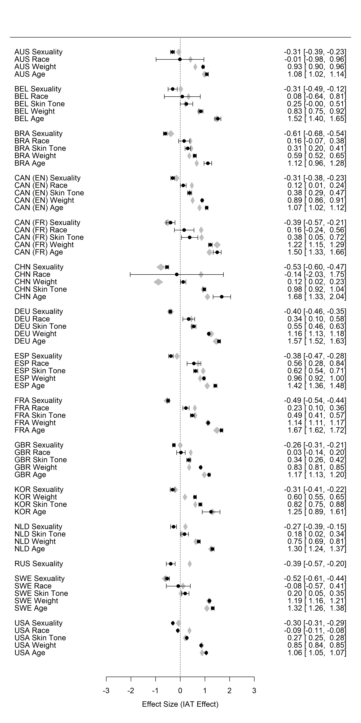

*Figure* *S5.* Forest plot of random-effects meta-analysis of disadvantaged groups’ IAT *D* Scores (black circles) and IAT *D* Score stigma as continuous moderator (gray polygons). Study effects are ordered by country *and* effect size of IAT *D* Scores. Positive scores of IAT *D* Scores indicate outgroup favoritism and negative scores indicate ingroup favoritism from the perspective of the disadvantaged groups. Positive scores of IAT *D* Score stigma indicate a preference for advantaged relative to disadvatanged groups; negative scores indicate a preference for disadvantaged groups relative to advantaged groups. Error bars for IAT *D* Scores depict 95% confidence intervals and values in squared brackets indicate lower and upper bounds of confidence intervals. Country codes: AUS = Australia, BRA = Brazil, CAN (EN) = Canada (English), CAN (FR) = Canada (French), CHN = China, FRA = France, DEU = Germany, KOR = Korea, NLD = The Netherlands, RUS = Russia, SPA = Spain, SWE = Sweden, GBR = United Kingdom, USA = United States.

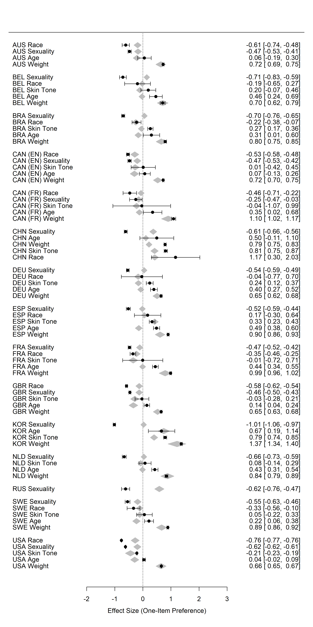

*Figure* *S6.* Forest plot of random-effects meta-analysis of disadvantaged groups’ one-item preference scores (black circles) and one-item preference score stigma as continuous moderator (gray polygons). Study effects are ordered by country *and* effect size of IAT *D* Scores. Positive scores of one-item preference scores indicate outgroup favoritism and negative scores indicate ingroup favoritism from the perspective of the disadvantaged groups. Positive scores of one-item preference score stigma indicate a preference for advantaged relative to disadvatanged groups; negative scores indicate a preference for disadvantaged groups relative to advantaged groups. Error bars for one-item preference scores depict 95% confidence intervals and values in squared brackets indicate lower and upper bounds of confidence intervals. Country codes: AUS = Australia, BRA = Brazil, CAN (EN) = Canada (English), CAN (FR) = Canada (French), CHN = China, FRA = France, DEU = Germany, KOR = Korea, NLD = The Netherlands, RUS = Russia, SPA = Spain, SWE = Sweden, GBR = United Kingdom, USA = United States.

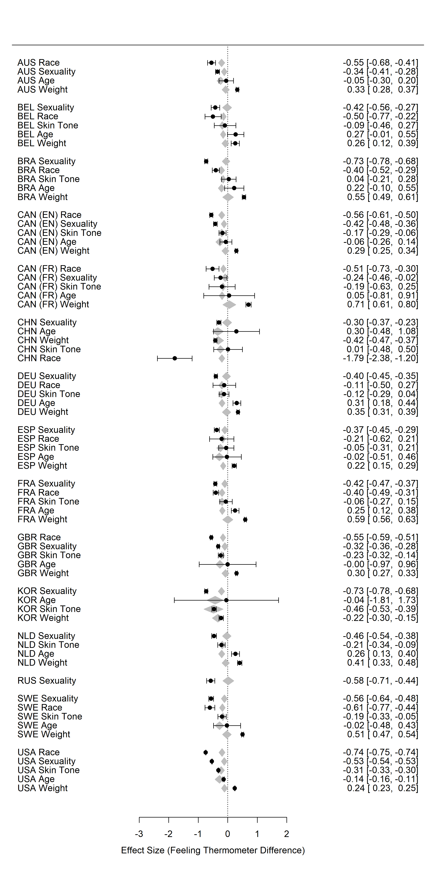

*Figure* *S7.* Forest plot of random-effects meta-analysis of disadvantaged groups’ feeling thermometer difference scores (black circles) and feeling thermometer difference score stigma as continuous moderator (gray polygons). Study effects are ordered by country *and* effect size of IAT *D* Scores. Positive scores of feeling thermometer difference scores indicate outgroup favoritism and negative scores indicate ingroup favoritism from the perspective of the disadvantaged groups. Positive scores of feeling thermometer difference score stigma indicate a preference for advantaged relative to disadvatanged groups; negative scores indicate a preference for disadvantaged groups relative to advantaged groups. Error bars for feeling thermometer difference scores depict 95% confidence intervals and values in squared brackets indicate lower and upper bounds of confidence intervals. Country codes: AUS = Australia, BRA = Brazil, CAN (EN) = Canada (English), CAN (FR) = Canada (French), CHN = China, FRA = France, DEU = Germany, KOR = Korea, NLD = The Netherlands, RUS = Russia, SPA = Spain, SWE = Sweden, GBR = United Kingdom, USA = United States.