Supplementary Material

Supplementary Material 1: AffectR Algorithm.
We implemented the affectR package to decode how dyads traverse linguistic mental state space based on the words they chose to say in the conversation. affectR allows us to measure the sentiment of words along the three mental state dimensions (rationality, social impact, and valence). The affectR package was created using ratings of mental state words on 16 psychological dimensions (Tamir et al., 2016). The ratings were collected from 1205 participants on Amazon Mechanical Turk, with aggregate values freely available online (https://osf.io/3qn47/). Principal component analysis (PCA) revealed that these 16 dimensions could be reduced to three mental state dimensions, which proved able to explain patterns of brain activity associated with thinking about others' mental states (Tamir et al., 2016). To expand the volume of the dictionary from 166 words to two million words, the fastText library (https://fasttext.cc/) was employed. A support vector regression (SVR) model with a radial basis function was used to predict the ratings of 166 mental state words along three principal component dimensions. This approach was feasible because these 166 words are part of the fastText corpus. The SVR model was then used to estimate 3D dimension scores for all 2 million words in the fastText corpus, resulting in the creation of a comprehensive weighted dictionary. This approach has been implemented in a previous neuroimaging study (Thornton & Tamir, 2020) to show that the 3D mind model does not only capture how mental states are represented in the brain but also in language. Further, in more recent studies, the same method was applied to study whether the 3D mind model characterizes how people understand mental states across modern and historical cultures (Thornton et al., 2022) and to explore what mental state trajectories lead to stronger social connections in affiliative conversations (Speer et al., 2024).

Supplementary Material 2: Topic Modeling Using BERTopic.
We applied topic modeling to explore how the neural and linguistic dynamics relate to the content of the conversations. Topic modeling is gaining popularity in psychology and social neuroscience. It has previously been successfully used in the domain of marketing on social media conversations to drive brand strategy (Resnik et al., 2015) and has been implemented in clinical psychology to differentiate between the language of depressed and non-depressed individuals (Putnick & Bornstein, 2016) and to detect self-injurious thoughts and behavior on online platforms (Franz et al., 2020). We employed BERTopic (https://maartengr.github.io/BERTopic/index.html), which is a topic modeling technique that leverages hugging-face (https://huggingface.co/) transformers and class-based term frequency-inverse document frequency (cTF-DF) to create dense clusters providing easily interpretable topics while keeping important words in the topic descriptions. The benefit of BERTopic, as opposed to more traditional algorithms, is that it selects the number of topics automatically and does not require the specification of the number of topics beforehand, which enables a purely data-driven exploration of topics. In addition, BERTopic does not only rely on word-level but also uses sentence-level embeddings, which has the advantage of considering the semantic relationship between words in a corpus, leading to more informative topics. Another advantage is that, due to the nature of the semantic embeddings, textual preprocessing (stemming, lemmatization, stopword removal, etc.) is not needed.

Supplementary Material 3: Correlation Between Exploration Across Modalities
To test whether there is internal consistency between the neural, linguistic, and topic exploration measures (novelty and divergence), we computed the Pearson correlation between all six measures. To obtain measures for neural, linguistic, and topic divergence, we extracted the random slopes for each participant from the three multilevel models depicted in Figure 3. That is, the multilevel model fit on the neural data, the linguistic data, and the topic modeling data. The correlation analysis revealed that the six measures of exploration are overall positively correlated, which suggests that our measures of exploration are internally consistent (see Supplementary Figure 1). All three measures of novelty were also strongly and significantly positively correlated. Further, the divergence measures showed a positive correlation. The observation that the neural and linguistic divergence are correlated was expected because these two measures exist in the same mental state space, and the observation that linguistic and topic divergence are correlated was anticipated because they are both based on linguistic data. As a result, the fact that the correlation between topic and neural divergence was not significant was expected to reveal the weakest correlation because the conceptual and methodological distance was the largest. We also observed significant correlations between topic novelty and linguistic and neural divergence, which was expected because topic novelty was also based on distances of individual data points, whereas neural and linguistic novelty were based on comparisons between distributions. We also observed a marginally significant correlation between linguistic divergence and neural and linguistic novelty. Together, these results suggest that our measures of exploration are internally consistent.
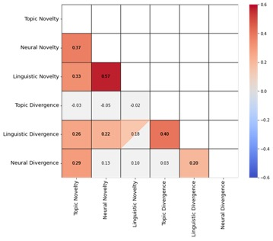
Supplementary Figure 1. Correlation between neural, linguistic and topic novelty and divergence. Colored squares are significant at p < 0.05. Squares that are filled with a triangle are marginally significant (p < 0.10). Grey squares are not significant.

Supplementary Material 4: Individual vs. Dyadic Exploration Across Modalities
We examined whether exploration is mostly driven by one of the partners being exploratory or whether there are synergistic effects of both partners exploring. To this end, we performed a model comparison where we fit a model with only individual exploration and a model with only dyadic exploration predicting agreement (while also controlling for the number of turns and the initial distance in opinions). Individual neural and linguistic exploration were computed the same way as the dyadic neural novelty, with the only difference that here we only focused on the turns of one of the participants at a time. For individual topic exploration, the mean distance between topics introduced by one participant at a time was computed. To compare the models, we used the Bayesian Information Criterion (BIC; lower values represent higher fit). The model comparison revealed that for all measures of exploration, except for topic exploration, dyadic exploration was a better predictor than the two individual partners’ exploration, suggesting that the combined dyadic exploration is greater than the sum of its parts and highlighting the synergistic effects of dyadic exploration.
This analysis also revealed that the dyadic neural and linguistic exploration models predict agreement equally well, whereas the topic exploration measure does a poorer job at predicting agreement. Further, these models explain different portions of the variance in agreement across dyads, as the composite measure of all three of these measures does substantially better in predicting agreement than each individual modality.
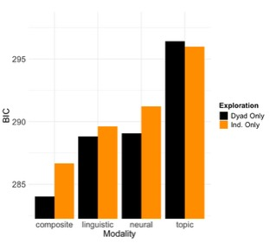
Supplementary Figure 2. Dyadic exploration is a better predictor than individual exploration. This graph shows the model fit (BIC; lower is better) for a model with both participants’ individual exploration or their dyadic exploration as a predictor of agreement across the 3 modalities and their composite.

Supplementary Material 5: Mediation Analyses Robustness Check
To test the robustness of our mediation analysis, we also conducted a mediation analysis with each individual measure of exploration in terms of novelty as the mediator. The analysis revealed a similar pattern as the findings in Supplementary Material 3: the mediation analysis revealed significant and marginally significant mediation effects for the linguistic and neural mental state exploration measures, respectively. No significant mediation was found for the topic exploration measure, where only the effect of social motive on exploration was significant (see Supplementary Figure 2). In addition, these analyses showed that these measures appear to capture different portions of variance in dyads' exploration behavior, as the composite measure performs best in predicting agreement and is the only one that fully mediates the effect of social motive on agreement. No significant mediation effects were found for the divergence measure of exploration.
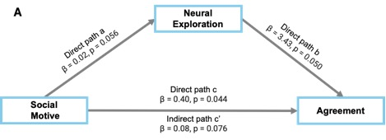
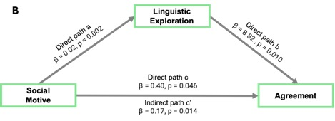
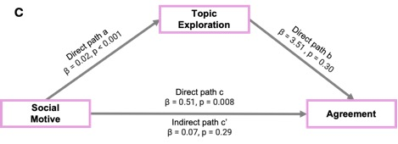
Supplementary Figure 3. Exploration mediates the positive effect of compromise on agreement. Mediation analyses for the neural A), linguistic B) and topic C) novelty measures.
Supplementary Material 6: Comparison Between Divergence and Novelty in Predicting Eventual Agreement
We also tested whether divergence or novelty is more important in predicting eventual agreement. We used the slopes of a multilevel model predicting distance between partners (in neural, linguistic, or topic space) from time as a measure of divergence. For each modality (neural, linguistic and topic), we then entered the divergence and novelty measures into a multilevel model predicting eventual agreement while controlling for initial agreement. For both neural (β_{novelty} = 4.05, 95% CI [1.81, 6.27], SE = 1.11, p < 0.001) and linguistic (β_{novelty} = 10.79, 95% CI [4.92, 16.66], SE = 2.92, p < 0.001) data, only the novelty measure significantly predicted eventual agreement. For the topic data (β_{novelty} = 5.97, 95% CI [-0.75, 12.69], SE = 3.34, p = 0.08) there was a marginally significant effect of novelty. In none of the models did divergence reach significance as a predictor of eventual agreement. In addition, divergence was not found to be a significant mediator of social motive on agreement. Further, also when entering divergence alone in a model, it did not emerge as a significant predictor of agreement. This suggests that novelty is more important in predicting agreement at the end of the conversation as opposed to divergence.

Supplementary Material 7: Validation of social motive manipulation
To verify that participants followed the assigned instructions, we administered a post­-task self‐report questionnaire for each topic (air pollution, cost of tuition), asking them to rate agreement with two statements (6-point Likert scale):
- “During this conversation, I tried to persuade the other participant of my opinion.”
- “During this conversation, I tried to find a compromise between our opinions.”
We then conducted two‐sample t‐tests for each statement and topic. In the persuade condition, participants reported significantly greater persuasion efforts than in the compromise condition (air: t = –3.15, p = 0.002; tuition: t = –3.60, p < 0.001). Conversely, in the compromise condition they indicated significantly more compromise‐seeking than in the persuade condition (air: t = 3.03, p = 0.003; tuition: t = 3.49, p = 0.001).
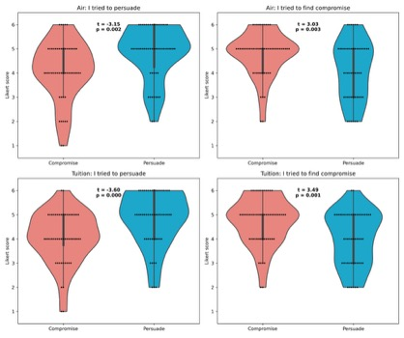
Supplementary Figure 4. Difference between conditions (persuade vs compromise) and topics (air vs tuition) in the self-reported motivation to persuade vs find compromise.

Supplementary Material 8: Dyads Who Agree More Before the Conversation Diverge More
To test whether our measures of exploration relate to the initial agreement, that is, the inverse distance in opinion at the start of the conversation, we computed the correlation between all six of our exploration measures (divergence & novelty for neural, linguistic, and topic data). We found a significant correlation between neural divergence and initial agreement (r = 0.22, p = 0.027) and a marginally significant correlation between topic divergence and initial agreement (r = 0.19, p = 0.062). No significant correlation was found between linguistic divergence and initial agreement. When combining the neural and topic divergence measures using their first principal component, a strong positive correlation was found (r = 0.30, p = 0.003). No significant correlations were found between the novelty measures and initial alignment. This suggests that dyads who enter the conversations with more aligned opinions are more inclined to diverge in mental state and topic space.
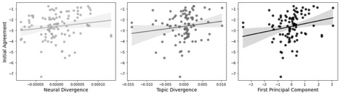
Supplementary Figure 5. Neural and topic divergence is positively correlated with agreement when entering the conversation.

Supplementary Material 9: Example sentences representing high and low levels of rationality, social impact and valence
Examples of high rationality sentences (>2SD above mean):
So I thought that obviously research would be the most important thing.
My rationale for that is I, I thought 10 million would go pretty far for financial planning.
Also another thought on the public education.
Examples for low rationality (<2SD below mean):
I'm so jealous, bro. I jealous.
And like, that's like frustrating.
Yeah wow that sounds really horrible.
Examples of high (positive) valence (>3SD above mean):
Especially with the abundance of scholarship opportunities available.
I'd love to read more about that.
Its kind of an opportunity for students to kind of use the talents they might have.
Examples of low (negative) valence (<3SD below mean):
Uh, my professor is literal insane.
Like it's so bad.
That shit was crazy.
Cause it's a systemic problem.
Examples of high social impact (>2SD above mean):
Like to actually change their behavior.
I'm so jealous.
But would love to hear your thoughts.
Examples of low social impact’
Actually I honestly can't remember.
Yeah, I would, I would definitely agree.
So I have been having a good day. Nice sleeping.
Supplementary Material 10: Example snippets representing high and low linguistic and topic divergence and novelty.

High novelty conversation example

Speaker 1: Yeah, I definitely agree that we should invest in education. Um I know I mentioned a little bit earlier investing in like education for students who are in school settings. But it's also useful to invest in education of adults and workers and employees. Especially those who do work at places that have a high carbon footprint and are buying up those government contracts to be allowed to pollute. Um if we can get those individuals who work there to be more conscious about their footprint and carbon emissions, not only as an individual, but working together to see the corporation and help lower the corporation's total emission I think that is a great place to go. So spending, I guess, a good amount of money on both childhood education in schools and also employee education at their businesses.

Speaker 2: I think another idea to reduce the amount of pollution is to give like tax breaks to the companies that don't have a lot of pollution. So maybe if they decrease their amount of pollution, then they wouldn't pay as much taxes. Just because I feel like the reason a lot of companies continue to pollute is because they want to make money. And so if you let them know like, hey you are not gonna lose out on that much money if you reduce your pollution, then maybe the companies will be more likely to reduce their pollution.

Low novelty conversation example

Speaker 1: Yeah Sorry I accidentally picked my mouse before. Um but yeah, I definitely am great. I think I would kind of focus on like empowering the kids and making them feel like they could really make a difference with every decision that they make. Because I do feel like sometimes climate change is kind of seen as this impossible thing to solve. So maybe just trying to like break it down into actionable, like steps that kids could do at, at any age. Um like I like the idea of educating them on like what you can recycle and stuff I feel like, you know, specific things like that could, could help. So yeah.

Speaker 2: Yeah I totally agree with you. Um like climate change is something that's always like something you think of as like super impossible. So giving kids that like empowerment is super important. Um yeah I don't really have much to add, but um. I think like my, my elementary school was like big on, on like reduced reuse, recycle, but like never made it really something that I was actively doing. Like, it was more just like a a phrase more of more than like something that I was actually doing. So I think if they had something more interactive for kids to do that made them actually feel like they were doing something, then that would be that be important.

High divergence conversation example

Speaker 1: Uh, yeah, I, yeah, I think that the government can only control public schools too. Um, but I feel like there should be, I dunno, options, like public options where you can go college for a very reduced amount or like even free, cuz I think even now, like, even though people, if you go to your in-school like you get um, a cheaper tuition, but I still think it's like a lot of money that could still put people in a lot of debt. So, um, yeah, I do think there's still room for the, for the federal government to step in and help with these things. And yeah. So now that I think about it, yeah. Lobbying is probably a good, uh, thing to do too.
Speaker 2: Yeah. Um, I'll talk about scholarships a little bit. Uh, scholarships are amazing and yeah, I think that there should always be scholarships, um, but right now in terms of this money, it hardly would be the most effective or appropriate to use it to create scholarships, uh, simply because that's like putting a bandaid on a bullet hole, like, that's not going to address the huge problem, it's, it's not going to figure out a way to make college more afforable to people. While it would really help those few individuals, um, I don't think it's a good optional overall.

Low divergence conversation example

Speaker 1: Oh, good question. I think I would donate everything to the transportation. Um just because it's something that would like make an impact immediately. Like of course education will educate people, but I don't know if, I don't know I feel like there's still gonna be like some problems there. And then lobbying, like, you know, you can lobby as much as you want. And then like, let's say there still wasn't like, let's say government still didn't wanna do it like It wouldn't happen
Speaker 2: Yeah I think I agree with you. I also think that transportation kind of takes both like the private and public corporation aspect of it, or like population aspect of it and unites them together. Because a lot of these like mass transits usually work with, you know, private corporations when they're taking pretty much like an entire city or an entire group of people and transporting them. So I feel like it would kind of be the equal balance between both of them. Which I guess is why I initially put a majority of my funds towards it cuz I like feel like it could kill two birds with one stone with that. Yeah.

Supplementary Material 11: Robustness analyses for agreement is associated with more mental state exploration
We conducted additional analyses controlling for condition to test the robustness of the finding that dyads who agree more explore more mental state space as compared to dyads who agree less. When adding condition (compromise vs persuade) as an additional regressor to the model predicting neural divergence from level of agreement and time, the interaction effect remains significant (β_{std} = 0.01, p = 0.003). So, this suggests that this analysis is not redundant with the analyses reporting that dyads instructed to compromise explore more than dyads who are instructed to persuade, because the agreement–exploration relationship holds above and beyond simple condition effects. In other words, even once we account for whether dyads were instructed to compromise or persuade, higher agreement still uniquely predicts greater exploration (βstd = 0.01, p = 0.003). This demonstrates that our analysis captures a genuine link between dyad-specific shifts in agreement and their exploratory trajectories, not just a reflection of the original experimental manipulation—thereby reinforcing the specificity and robustness of our mediation framework.

Supplementary Material 12: Relationship Between Divergence and Novelty
We also considered whether divergence is merely a by-product of novelty. When partners venture into unpredictable topics (high novelty), does this process inherently generate momentary divergence as one partner temporarily “pulls ahead” before the other catches up? This is especially relevant given that novelty, rather than divergence, ultimately predicts agreement.
Although related, the two measures are distinct. Divergence is computed as a pointwise Mahalanobis distance between partners’ mental state coordinates, while novelty quantifies the absolute degree of uncharted ground covered in a conversational turn using Kolmogorov–Smirnov distances. They correlate modestly (r ≈ .20) and both are shaped by compromise instructions, but they capture different aspects of exploration: divergence reflects relative distance, novelty the extent of new ground covered.
To test whether novelty predicts divergence, we fit a multilevel model with trials nested within dyads, predicting turn-by-turn divergence from novelty while controlling for the number of turns. Results revealed a significant effect (β = 3.02, p < .001), suggesting that novelty can indeed induce temporary divergence as partners adjust to new ideas.
We interpret these findings as evidence that novelty and divergence are complementary rather than redundant. Novelty may transiently drive divergence, but the two ultimately capture different mechanisms of exploration. We refrain from strong causal claims here, and future research will need to explore this avenue further.

Supplementary Material 12: Relationship Between Divergence and Novelty
We tested for, and did not find, any differences between same race/gender vs. different race/gender dyads on agreement before and after the conversation, and on exploration during the conversation:
We did not find any significant effect of being in a mixed-gender dyad on agreement after the conversation (t = -0.27, SE = 0.26, p = 0.78) or before the conversation (t = 0.87, SE = 0.27, p = 0.38). Similarly, being in a mixed-race dyad did not have a significant effect on agreement after the conversation (t = -1.03, SE = 0.29, p = 0.31) or before the conversation (t = 0.11, SE = 0.31, p = 0.92).
We did not find a significant effect of being in a mixed-gender dyad on neural exploration (t = -0.17, SE = 0.02, p = 0.86), topic exploration (t = -0.33, SE = 0.005, p = 0.73), or linguistic exploration (t = -0.25, SE = 0.007, p = 0.80). Similarly, being in a mixed-race dyad did not have a significant effect on neural exploration (t = -0.06, SE = 0.02, p = 0.95), topic exploration (t = -0.71, SE = 0.006, p = 0.48), or linguistic exploration (t = 0.18, SE = 0.008, p = 0.85).
The lack of significance effect could either be due to a lack of power, as the reviewer already alluded to, or could reflect the fact that the data was collected in a small college town where the similarities of attending the same universities may outweigh the difference in race or gender. Lastly, there is also the possibility that there simply aren’t any systematic differences between mixed-race vs same-race or mixed-gender vs same gender dyads. We have added these analyses to the Supplement.

References
Franz, P. J., Nook, E. C., Mair, P., & Nock, M. K. (2020). Using Topic Modeling to Detect and Describe Self‐Injurious and Related Content on a Large‐Scale Digital Platform. Suicide and Life-Threatening Behavior, 50(1), 5–18. https://doi.org/10.1111/sltb.12569
Putnick, D. L., & Bornstein, M. H. (2016). Measurement invariance conventions and reporting: The state of the art and future directions for psychological research. Developmental Review, 41, 71–90. https://doi.org/10.1016/j.dr.2016.06.004
Resnik, P., Armstrong, W., Claudino, L., Nguyen, T., Nguyen, V.-A., & Boyd-Graber, J. (2015). Beyond LDA: Exploring Supervised Topic Modeling for Depression-Related Language in Twitter. Proceedings of the 2nd Workshop on Computational Linguistics and Clinical Psychology: From Linguistic Signal to Clinical Reality, 99–107. https://doi.org/10.3115/v1/W15-1212
Speer, S. P. H., Mwilambwe-Tshilobo, L., Tsoi, L., Burns, S. M., Falk, E. B., & Tamir, D. I. (2024). Hyperscanning shows friends explore and strangers converge in conversation. Nature Communications, 15(1), 7781. https://doi.org/10.1038/s41467-024-51990-7
Tamir, D. I., Thornton, M. A., Contreras, J. M., & Mitchell, J. P. (2016). Neural evidence that three dimensions organize mental state representation: Rationality, social impact, and valence. Proceedings of the National Academy of Sciences, 113(1), 194–199. https://doi.org/10.1073/pnas.1511905112
Thornton, M. A., & Tamir, D. I. (2020). People represent mental states in terms of rationality, social impact, and valence: Validating the 3d Mind Model. Cortex, 125, 44–59. https://doi.org/10.1016/j.cortex.2019.12.012
Thornton, M. A., Wolf, S., Reilly, B. J., Slingerland, E. G., & Tamir, D. I. (2022). The 3d Mind Model Characterizes How People Understand Mental States Across Modern and Historical Cultures. Affective Science, 3(1), 93–104. https://doi.org/10.1007/s42761-021-00089-z

