Supplemental Materials
Supplemental Study A
This study extended on Study 1 in two ways. First, we sought to replicate the findings in a different country and with a non-university sample. Second, note the moral and immoral behaviors in Study 1 differed not only in their morality but in their behavioral context. For example, in Study 1, a decision to recycle (a moral behavior) did not have a matched decision not to recycle (as an immoral behavior). Although this subtle confound is common in better-than-average-effect studies, here we solved it by manipulating the framing of each behavior to take either the original frame or its inverse (e.g., the percentage of the time that a target does not engage in a behavior). This turns the originally framed moral and immoral behaviors into inversely framed immoral and moral behaviors, respectively.
Method
Participants and Design. Two hundred eighteen Americans (52.3% female, 46.3% male, 0.9% non-binary, 0.5% agender; M_{age} = 30.35, SD_{age} = 11.48) recruited through Prolific took part in the study. Participants were randomly assigned to one of six conditions in a 3 (target: self, others in the study, or moral threshold) X 2 (frame: original or inverse) full-factorial design. A third factor, morality, was measured within-participants. Note that the frame factor is primarily a counterbalancing factor that unconfounds the content of the behavior from its morality; thus, this can be better thought of as a three-condition study.
Procedure. Like in Study 1, participants considered 14 behaviors: 7 moral behaviors and 7 immoral behaviors. Those in the self condition indicated what percentage of the time they engage in each behavior. Those in the others in the study condition instead estimated what percentage of the time the other participants in the study engage in each behavior. Finally, those in the moral threshold condition identified the cutoff point for each behavioral base rate that would reflect morality as opposed to immorality.
Participants responded to the items using either the original frame (as used in Study 1) or the inverse frame. For the inverse frame, each moral behavior was actually the opposite of an original immoral behavior, whereas each immoral behavior was actually the opposite of an original moral behavior. For example, those in the original frame conditions still answered questions about—as two examples—the percentage of the time they washed their hands after using the restroom (moral behavior) and the percentage of the time they threw trash on the ground (immoral behavior). Those in the inverse frame instead indicated the percentage of the time they did not wash their hands after using the restroom (immoral behavior) and the percentage of the time they hold onto trash until they can dispose of it instead of throwing it on the ground (moral behavior).
Results
We again tested for evidence of self-positivity and other-negativity, this time using a design in which the behavioral contexts were unconfounded from their morality. We used a mixed model that predicted participants’ judgments. This model included a fixed effect of morality that indicated whether the behavior being judged was moral (+1) or immoral (-1). A fixed effect of frame differentiated those participants who considered the original (+1) set of behaviors (used in Study 1) from those who saw the inverse (-1) frame—i.e., the one in which the behavioral descriptions in the original frame were flipped so that the moral behaviors became immoral ones (and vice versa). In addition, target (self, others in the study, moral threshold) was included as a categorical variable. The full set of interaction terms that could be created from these fixed effects was added. Finally, the model included two random effects to account for non-independence in the data: one for participant (because each participant made 14 judgments) and one for the specific behavior being judged (because each of the 28 behaviors took the form of a self, others, or moral threshold judgment).
We observed a significant Morality X Target interaction, F(2, 2803.97) = 174.67, p < .001, indicating that the positivity of estimates varied by target. As in Study 1, we decomposed this interaction into a series of 2 X 2 interactions. We replicated our finding that participants thought they were more moral than others, B = 19.81, SE = 1.11, t(2803.97) = 17.77, p < .001. Of greater relevance was how self-judgments and others-judgments compared to the moral threshold. As in Study 1, we saw clear evidence of self-positivity: Participants reported easily exceeding the moral threshold, B = 14.46, SE = 1.07, t(2803.97) = 13.48, p < .001. Once again, we saw weaker evidence of other-negativity: The others in the study were believed to not quite live up to the moral standard reflected in the moral threshold, B = -5.35, SE = 1.13, t(2803.97) = -4.76, p < .001.
Unexpectedly, we also observed a Morality X Target X Frame interaction, F(2, 2803.97) = 14.48, p < .001. In light of this, we examined the robustness of self-positivity and other-negativity by analyzing moral behaviors and immoral behaviors separately for both the original and inverse frames. Speaking to the robustness of self-positivity, participants reported engaging in moral behaviors more frequently than the moral threshold and immoral behaviors less frequently than the moral threshold under both the original and inverse frame, ts > 2.99, ps < .003.
But like in Study 1, other-negativity was more finicky. In fact, it was only in one of four cases—when judging moral behaviors that took the inverse frame (i.e., how often one does not engage in an immoral behavior)—that evidence of other-negativity emerged, B = -14.26, SE = 2.55, t(507.72) = -5.59, p < .001. It is worth noting that other-negativity also emerged in Study 1 when judging these behaviors, but when they took their original frame (as
immoral behaviors). But for that combination (immoral—original frame) as well as the other two (moral—original frame, immoral—inverse frame) in the present study, judgments of the others in the study did not significantly differ from moral threshold, ts < 1.93, ps > .054 (see Table S1). In other words, the sporadic evidence for other-negativity—in contrast to the highly consistent evidence for self-positivity—seems not to identify a consistent, narrow context in which other-negativity emerges (given the inconsistencies in the Study 1 and
Table S1
Mean (SD) Behavioral Estimates by Target, Frame, and Morality of Behaviors (Supplemental Study A)
Frame  Morality | Self | Others in the Study | Moral Threshold
Original Frame
Moral Behaviors | 76.14_{a} (31.04) | 56.05_{b} (26.23) | 61.33_{b} (24.01)
Immoral Behaviors | 18.91_{a} (25.67) | 41.91_{b} (24.95) | 44.35_{b} (25.34)
Morality Composite | 57.23_{a} | 14.14_{b} | 16.98_{b}
Inverse Frame
Moral Behaviors | 71.07_{a} (32.50) | 49.43_{c} (25.37) | 63.70_{b} (25.41)
Immoral Behaviors | 28.23_{a} (34.87) | 42.76_{b} (24.34) | 38.45_{b} (26.14)
Morality Composite | 42.84_{a} | 6.67_{c} | 25.25_{b}
Overall
Moral Behaviors | 73.54_{a} (31.87) | 52.49_{c} (25.95) | 62.59_{b} (24.77)
Immoral Behaviors | 23.69_{a} (31.06) | 42.37_{b} (24.60) | 41.21_{b} (25.91)
Morality Composite | 49.85_{a} | 10.12_{c} | 21.38_{b}
Note. The morality composite reflects the moral behavior composite minus the immoral behavior composite. Means in the same row that do not share a subscript differ at the p < .05 level. Moral and immoral behaviors of the inverse frame are the opposite of immoral and moral behaviors of the original frame, respectively.
Supplemental Study A results), but instead reflects the relative flimsiness (and thus variability
when the traditional threshold of statistical significance is reached at these sample sizes) of these effects. Despite this variation, other-negativity did emerge in the aggregate (combining across moral and immoral behaviors, and, in Supplemental Study A, frames) in both studies.
The Frame manipulation, in Supplemental Study A, also permitted us to test whether, for each behavior, the frame itself had an effect on the behavioral estimates. Because there is not a reason to expect that the inverse frame would always lead to a higher or lower (implied) behavioral estimate of the original behavior (compared to when that original behavior was estimated directly), we conducted an analysis on each behavior separately. Each model included fixed effects of frame (+1 = original, -1 = inverse), target (categorical), and their interaction. A random effect of participant was included. We changed the target’s reference category so that we could get an estimate of frame for each target. Thirty-two of the 42 estimates (comparing the direct estimate to the implied estimate; see Table S2) did not differ. Of the 10 cases in which the direct and implied estimates differed, six did so in the direction that the direct estimate is more positive than the implied estimate, whereas four showed the reverse pattern. There is thus not consistent evidence of direct or implied estimates being systematically different.

Supplemental Study B
This study served as an exploratory Pilot Study to preregistered Study 2. It offered initial evidence that the dividing line that distinguishes targets’ position with respect to the moral threshold is whether or not the target is an individual. The two individual targets—individuated and non-individuated—were judged to be above the moral threshold. The two collective targets—others in the study and others in society—were judged to be below the
Table S2
Effect of Frame, per Behavior and Target (Supplemental Study A)
Behavior | Self | Others in the Study | Moral Threshold
1 | B = -3.63, SE = 3.11, t(212) = -1.17, p = .244 | B = -0.88, SE = 3.42, t(212) = -0.26, p = .797 | B = -2.22, SE = 3.18, t(212) = -0.70, p = .486
2 | B = 5.96, SE = 2.83, t(212) = 2.11, p = .036 | B = -0.30, SE = 3.11, t(212) = -0.10, p = .923 | B = 2.61, SE = 2.89, t(212) = 0.90, p = .367
3 | B = 1.06, SE = 2.77, t(212) = 0.39, p = .701 | B = 2.35, SE = 3.04, t(212) = 0.77, p = .441 | B = 5.51, SE = 2.83, t(212) = 1.95, p = .530
4 | B = 2.68, SE = 2.16, t(212) = 1.24, p = .215 | B = 5.02, SE = 2.37, t(212) = 2.12, p = .035 | B = 3.63, SE = 2.20, t(212) = 1.65, p = .101
5 | B = 2.54, SE = 3.25, t(212) = 0.78, p = .435 | B = 2.66, SE = 3.57, t(212) = 0.74, p = .458 | B = -4.59, SE = 3.32, t(212) = -1.38, p = .169
6 | B = 6.28, SE = 2.80, t(212) = 2.24, p = .026 | B = -8.94, SE = 3.08, t(212) = -2.91, p = .004 | B = -5.28, SE = 2.86, t(212) = -1.84, p = .067
7 | B = 0.39, SE = 3.66, t(212) = 0.11, p = .915 | B = -4.08, SE = 4.02, t(212) = -1.02, p = .311 | B = -0.41, SE = 3.74, t(212) = -0.11, p = .912
8 | B = -2.63, SE = 2.83, t(212) = -0.93, p = .354 | B = -5.22, SE = 3.10, t(212) = -1.68, p = .094 | B = 1.41, SE = 2.89, t(212) = 0.49, p = .625
9 | B = -0.89, SE = 2.35, t(212) = -0.38, p = .706 | B = -5.67, SE = 2.59, t(212) = -2.19, p = .030 | B = 1.16, SE = 2.41, t(212) = 0.48, p = .631
10 | B = -9.48, SE = 2.83, t(212) = -3.35, p < .001 | B = -3.33, SE = 3.11, t(212) = -1.07, p = .286 | B = 8.57, SE = 2.89, t(212) = 2.96, p = .003
11 | B = -4.46, SE = 2.87, t(212) = -1.56, p = .121 | B = -7.29, SE = 3.15, t(212) = -2.32, p = .022 | B = 2.23, SE = 2.93, t(212) = 0.76, p = .448
12 | B = -18.19, SE = 2.69, t(212) = -6.76, p < .001 | B = -4.19, SE = 2.96, t(212) = -1.42, p = .158 | B = 1.66, SE = 2.75, t(212) = 0.60, p = .547
13 | B = 3.05, SE = 3.00, t(212) = 1.02, p = .310 | B = 0.08, SE = 3.29, t(212) = 0.03, p = .980 | B = 7.52, SE = 3.06, t(212) = 2.46, p = .015
14 | B = -2.45, SE = 2.36, t(212) = -1.04, p = .301 | B = -4.68, SE = 2.59, t(212) = -1.81, p = .073 | B = 5.62, SE = 2.41, t(212) = 2.33, p = .021
Note. Behavior numbers correspond to those in Appendix A in the main manuscript. Behaviors 1-7 are moral behaviors in their original frame, whereas behaviors 8-14 are immoral behaviors in their original frame. In each tested model, frame is coded as +1 (original frame) or -1 (inverse frame). Non-italicized bolded effects are those in which the implied behavioral estimate is less moral (or more immoral) than the direct behavioral estimate. Italicized bolded effects are those in which the implied behavioral estimate is more moral (or less immoral) than the direct behavioral estimate.

moral threshold. Study 2 replicated these effects with a better-powered sample and included additional (ideal and ought) threshold measures.
Method
Participants and Design. Three hundred eighty-nine Americans (60.9% female, 38.8% male, 0.3% genderfluid; M_{age} = 38.95, SD_{age} = 12.81) recruited through Amazon’s Mechanical Turk (AMT) took part in the study in exchange for nominal payment. Participants considered three of six possible targets. Two judgments were equivalent for everyone: self and moral threshold. In addition, participants were randomly assigned to also make judgments about a social target that took one of four forms: individuated individual, non-individuated individual, others in the study, or others in society.
Procedure. The procedure was similar to that of Study 2, with two differences. First, participants considered only the self, one of the four social targets, and the moral threshold—that is, we did not include in this study the ought and ideal thresholds. Second, although the behaviors depicted largely the same situations, the wording used to describe them was slightly different from that used in Studies 2 and Studies 4a-4b (see “Moral and Immoral Behaviors, Supplemental Study B” section below).
Results
We entered participants’ estimates into a mixed model with two fixed-effects predictors as well as their interaction: morality of the particular behavior (+1 = moral, -1 = immoral) and target as a categorical variable (self, moral threshold, individuated individual, non-individuated individual, others in the study, others in society). Finally, to account for the non-independence of participants’ judgments as well as different participants’ ratings of the same behavior, we included participant and behavior as random factors.
We observed a significant Morality X Target interaction, F(5, 11262.20) = 104.28, p < .001 (see Table S3), suggesting that at least some targets departed from each other. Indeed, participants showed a better-than-others effect regardless of the nature of the other, ts > 5.13, ps < .001. Participants also displayed self-positivity: The 2(Morality) X 2(Target: self or moral threshold) interaction was significant, t(11262.20) = 15.39, p < .001.
Next, we examined whether participants displayed evidence of other-negativity, or even other-positivity, depending on how that other was described. As with Study 2, when people considered others as a collective—whether others in the study or others in society—participants displayed other-negativity: Participants estimated that the behavior of both others in the study, B = -4.83, SE = 0.88, t(11262.20) = -5.48, p < .001, and others in society more generally, B = -6.99, SE = 0.88, t(11262.20) = -7.96, p < .001, fell short of the moral threshold. When participants instead considered an individual—whether individuated or not—the target was believed to exceed the moral threshold: Both an individuated individual, B = 4.27, SE = 0.88, t(11262.19) = 4.86, p < .001, and a non-individuated individual, B = 2.05, SE = 0.99, t(11262.19) = 2.07, p = .038, were estimated to be better than the moral threshold. Unlike in Study 2, the two targets that described collectives (others in the study, others in society) were only marginally significantly different, B = 2.16, SE = 1.11, t(11262.20) = 1.96, p = .051, as were the two targets described as individuals, B = 2.22, SE = 1.19, t(11262.20) = 1.86, p = .062. Note that Study 2 offered a larger sample size (and thus greater statistical power) for these tests.

Table S3
Mean (SD) Behavioral Estimates by Target and Morality of Behaviors (Supplemental Study B)
Morality | Self | Moral Threshold | Social
Morality | Self | Moral Threshold | Individuated Individual | Non-individuated Individual | Others in the Study | Others in Society
Moral Behaviors | 63.85_{a} (31.83) | 61.40_{b} (26.69) | 61.98_{ab} (28.12) | 58.32_{c} (28.23) | 52.40_{d} (25.73) | 50.55_{d} (26.77)
Immoral Behaviors | 22.43_{a} (28.71) | 37.54_{c} (30.87) | 29.57_{b} (29.43) | 30.36_{b} (28.39) | 38.20_{cd} (26.87) | 40.67_{d} (28.31)
Morality Composite | 41.42_{a} | 23.86_{c} | 32.41_{b} | 27.96_{b} | 14.20_{d} | 9.88_{d}
Note. The morality composite reflects the moral behavior composite minus the immoral behavior composite. Means in the same row that do not share the same subscript differ at the p < .05 level.

Moral and Immoral Behaviors, Supplemental Study B
Self
- Return a lost item (e.g., by tracking down the owner, to a "lost and found") when you find one (worth $20 or more)
- Volunteer to give up your own seat so others can sit together (when you see two people struggling to find seats together)
- Return excess change to a cashier (when you are in this situation as a costumer)
- Help a stranger who dropped possessions s/he was carrying to retrieve them (when you see this happen)
- Help someone cross the street (e.g., elderly person, visually impaired person), when you observe such a person in need
- Share with someone else a secret that you were asked to keep (thereby going against the person's wishes)
- Make a racist joke (in what percentage of months?)
- Knowingly lie on your tax returns (in what percentage of years?)
- Make fun of someone in front of other people (in what percentage of months?)
- Pretend not to hear when you heard someone calling for help

Others in the Study / Moral Thresholds
- Return a lost item (e.g., by tracking down the owner, to a “lost and found”) when they find one (worth $20 or more)
- Volunteer to give up their own seat so others can sit together (when they see two people struggling to find seats together)
- Return excess change to a cashier (when they are in this situation as a costumer)
- Help a stranger who dropped possessions s/he was carrying to retrieve them (when they see this happen)
- Help someone cross the street (e.g., elderly person, visually impaired person), when they observe such a person in need
- Share with someone else a secret that they were asked to keep (thereby going against the person's wishes)
- Make a racist joke (in what percentage of months?)
- Knowingly lie on their tax returns (in what percentage of years?)
- Make fun of someone in front of other people (in what percentage of months?)
- Pretend not to hear when they heard someone calling for help

Within-Participants Moral Threshold Comparisons (Studies 2-3, Supplemental Study B)
One strength of the within-participants design used in Studies 2-3 and Supplemental Study B is that it also lets us consider, within-participants, how each of the self and social targets fared against the moral threshold. For each study (and in total), we calculated the percentage of target judgments that were above, at, or below that same participant’s corresponding moral threshold (see Table S4).

Table S4
Percentage of Behavioral Estimates That Were Above, At, or Below That Participant’s Moral Threshold, by Target and Study (Studies 2-3 and Supplemental Study B)
 | Self | Individuated Individual | Non-individuated Individual | Others in the Study | Others in Society
Study 2
Above | 70.4 | 65.3 | 57.9 | 46.2 | 39.2
At | 4.3 | 3.6 | 3.2 | 4.3 | 3.1
Below | 25.3 | 31.1 | 38.9 | 49.5 | 57.7
Study 3
Above | 69.3 | - | 53.1 | 45.9 | -
At | 4.1 | - | 4.8 | 3.3 | -
Below | 26.6 | - | 42.1 | 50.8 | -
Supplemental Study B
Above | 57.8 | 50.1 | 53.3 | 43.7 | 36.3
At | 9.8 | 7.6 | 7.3 | 4.8 | 5.6
Below | 32.4 | 42.3 | 39.4 | 51.5 | 58.1
Overall
Above | 67.0 | 59.6 | 54.8 | 45.6 | 38.1
At | 5.5 | 5.1 | 4.6 | 3.9 | 4.1
Below | 27.5 | 35.3 | 40.6 | 50.5 | 57.8
Note. “Overall” reflects the percentages across the three studies.

Pre-study Screening and Memory-based Attention Checks (Studies 2-4b)
Pre-study screening. To qualify for participation in Studies 2-4b, potential participants were required to pass a captcha and answer correctly the following question: “How often have you personally suffered a fatal heart attack?” The response options to the screening question were presented in a random order: “Never,” “Daily,” “Weekly,” “Monthly,” “Annually.” Only those who answered “Never” were allowed to begin the study. This served to minimize the likelihood that bots, inattentive respondents, or potential participants who lacked English-language ability were able even qualify to begin the study.
Memory-based attention checks. In addition, all participants in Studies 2-4b were required to answer a memory-based attention check at the end of the study. As preregistered, the responses from participants who failed the memory-based attention checks were removed from all analyses. Below we detail each study’s memory-based attention check. For all questions, response options were presented in random order. In other words, the letters that precede the answer choices shown below were not shown to participants:
Study 2. “In this HIT, you considered a set of 10 behaviors and made 5 different judgments about each of them. Which of the following was one of the behaviors you considered? a) returning excess change to a cashier; b) participating in a Christian ceremony; c) flying on an airplane; d) shaking someone’s hand; e) riding in a classic car” (correct response: a).
Study 3. “In this HIT, you indicated how often you yourself engage in various behaviors, but also how often _____ engage(s) in various behaviors... a) a randomly chosen person in this study with the following participant code: 33A9p607; b) others in this study, on average; c) people in society in general; d) your best friend” (correct response: a or b, depending on the social target condition).
Study 4a and pretest for Study 4b. “In this HIT, you were asked to anticipate how you would feel upon learning: a) you had overestimated or underestimated the prevalence of a behavior; b) a municipal corruption ring was finally disbanded; c) a favored or disfavored politician quietly aided the January 6th insurrection; d) that your hometown’s baseball team won an important match” (correct response: a).
Study 4b. “In this study, you were asked to reflect on why people: a) may or may not feel guilt for overestimating how immoral others are; b) have varying views on marijuana policy; c) might refrain from voting in important elections; d) might choose to support a non-local football team” (correct response: a).

Distribution of Moral Thresholds, by Behavior (Study 2)
In what follows, we present histograms that summarize the frequencies of participants’ different ranges of numeric responses to the moral, ideal, and ought thresholds for each behavior in Study 2 (Figures S1-S10). This is potentially informative for three reasons. First, we can test whether the moral thresholds simply cluster around 0% and 100%. If so, this could reflect that moral thresholds are more commentaries that people should always (or never) engage in a behavior, or (inversely) that it is morally notable if people ever (or ever do not) engage in a behavior. As can be seen in the histograms below, there is little evidence of bimodality either for individual behaviors in isolation or when considered in the aggregate. For example, only 21.69% of moral thresholds were under 20%, and 18.80% of moral thresholds were over 80%. Second, we can ask whether many participants might have simply indicated 50% as a middle response reflecting that they did not know how to select a moral threshold. This occurred in only 3.30% of cases. Third, we wanted to test whether there was indeed systematic variability among behaviors in the identified moral thresholds. And indeed, a model with a fixed effect (instead of a random effect) of behavior revealed a very large main effect of behavior F(9, 6156) = 89.89, p < .001.

Figure S1
Distribution of Thresholds—Moral (A), Ideal (B), and Ought (C)—for the Moral Behavior “When people encounter a lost item (worth 20$ or more), they try to return it (e.g., by tracking down the owner, to a "lost and found"), as opposed to ignoring it and letting someone else take it or deal with it.” (Study 2)
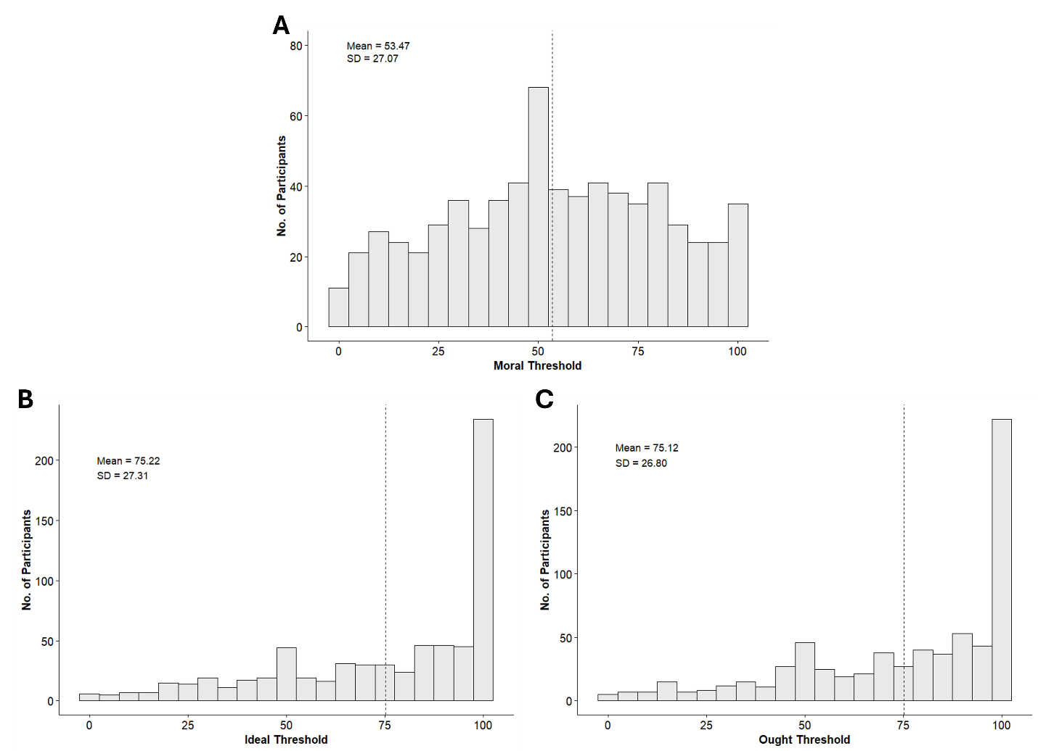

Figure S2
Distribution of Thresholds—Moral (A), Ideal (B), and Ought (C)—for the Moral Behavior “When people see two people struggling to find seats together, they volunteer to give up their own seat so others can sit together, as opposed to staying seated in their own seat.” (Study 2)
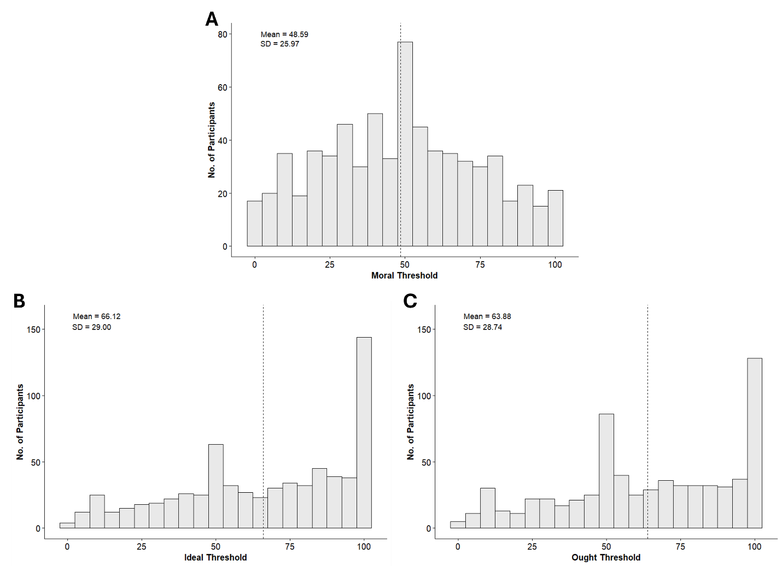

Figure S3
Distribution of Thresholds—Moral (A), Ideal (B), and Ought (C)—for the Moral Behavior “When, as a customer, people receive excess change from a cashier, they return the excess change to the cashier, as opposed to keeping the excess change.” (Study 2)
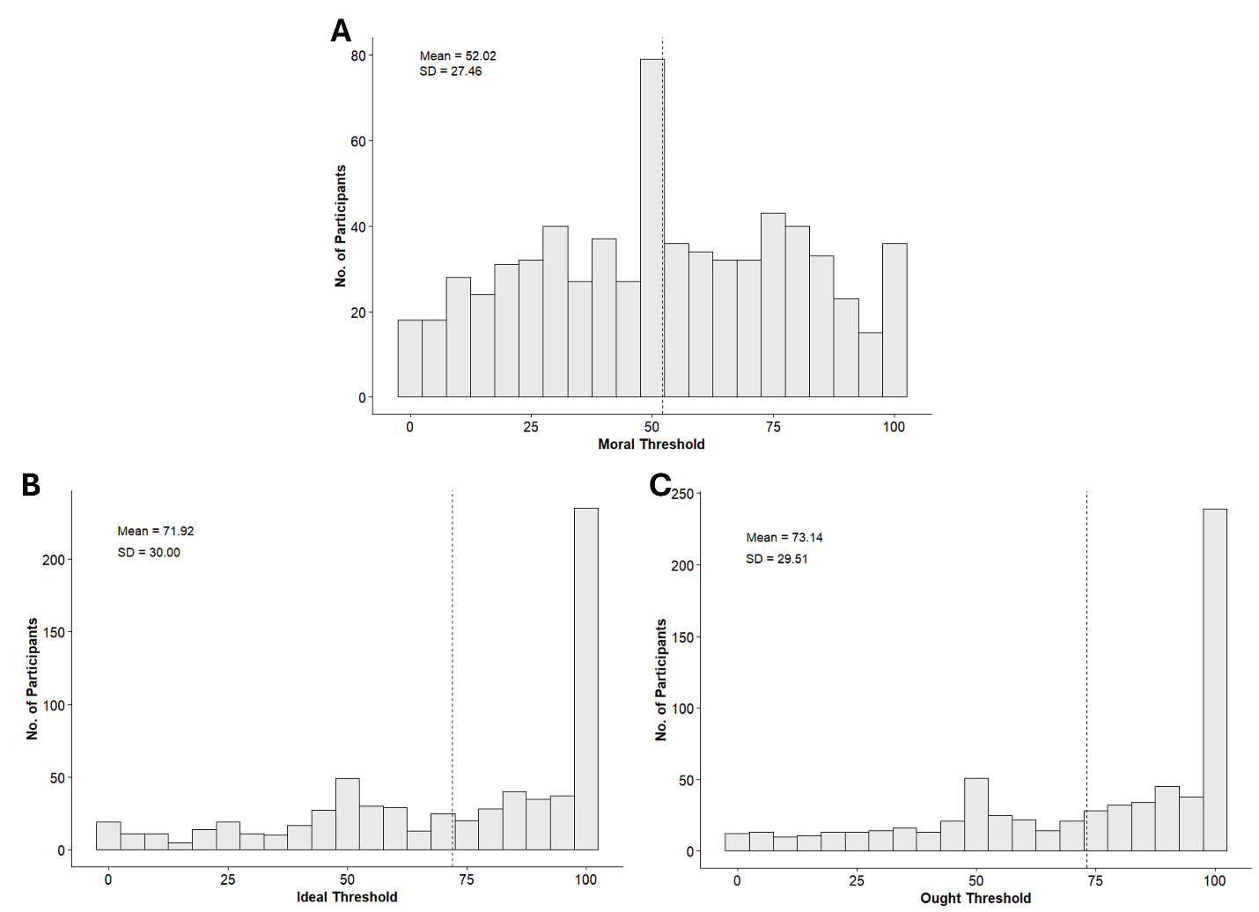

Figure S4
Distribution of Thresholds—Moral (A), Ideal (B), and Ought (C)—for the Moral Behavior “When people see a stranger nearby drop their possessions, they stop to help the stranger retrieve the possessions, as opposed to ignoring the stranger and letting them deal with it.” (Study 2)
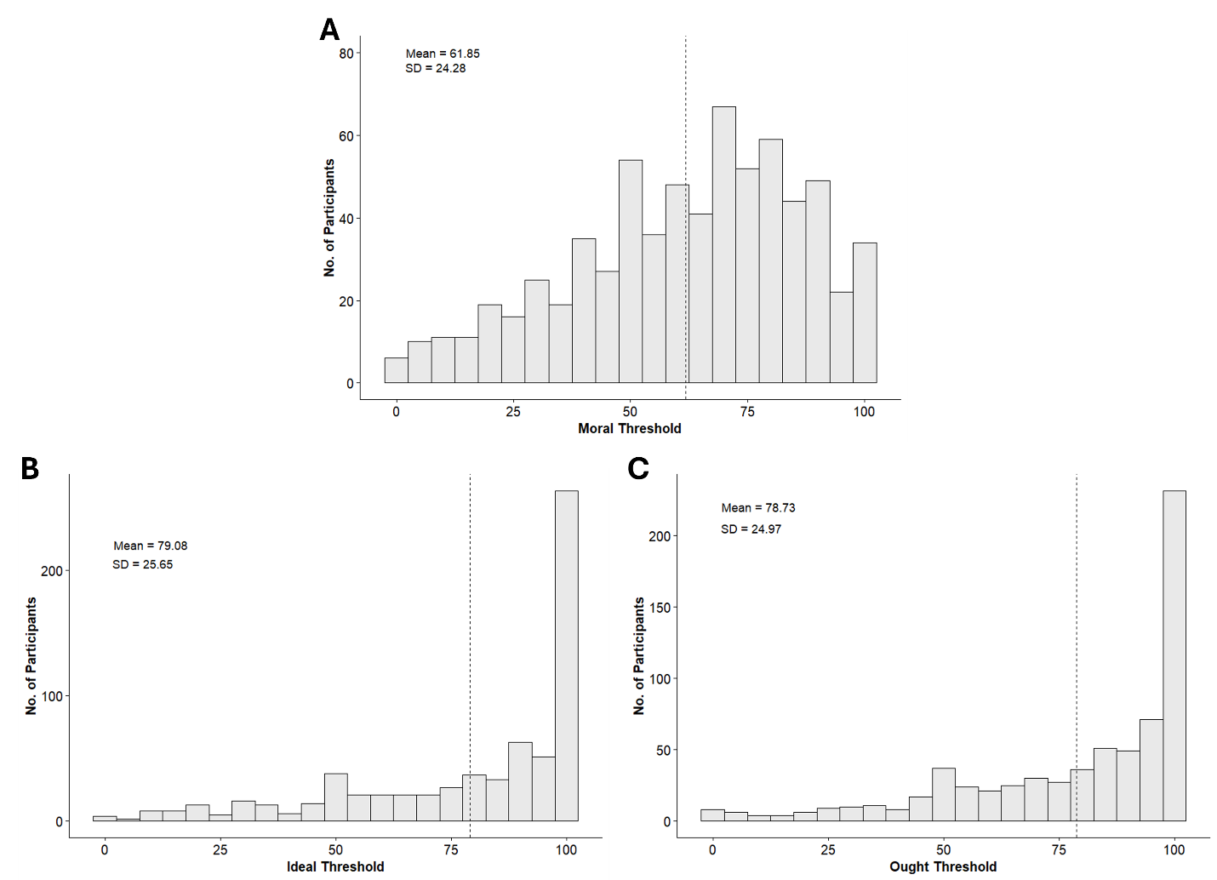

Figure S5
Distribution of Thresholds—Moral (A), Ideal (B), and Ought (C)—for the Moral Behavior “When people see a vulnerable person (e.g., an elderly person, a visually impaired person) approaching an intersection on foot, they offer to help the vulnerable person cross the street, as opposed to ignoring the vulnerable person.” (Study 2)
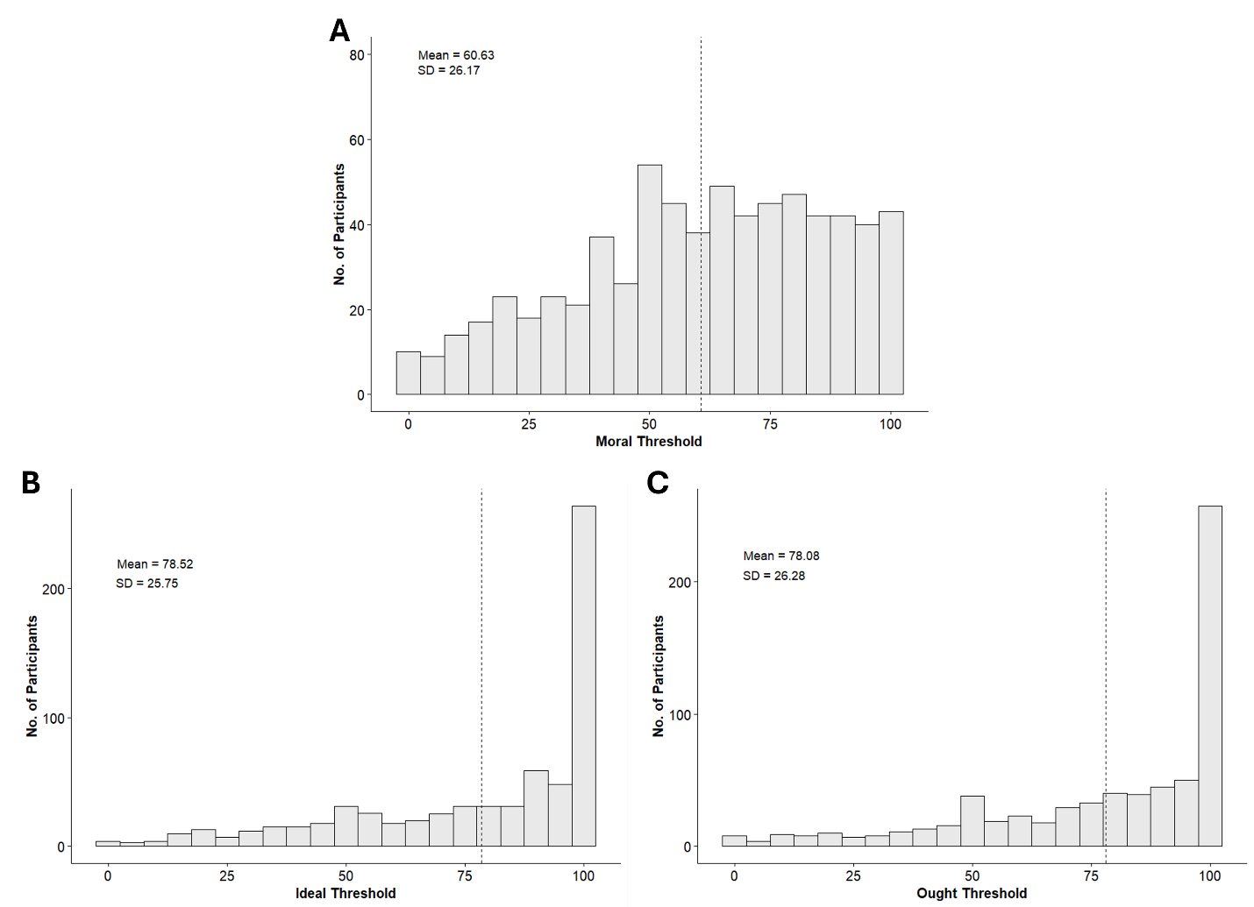

Figure S6
Distribution of Thresholds—Moral (A), Ideal (B), and Ought (C)—for the Immoral Behavior “When people are asked to keep a secret, they share the secret with someone else (thereby going against the person's wishes), as opposed to keeping the secret (thereby respecting the person's wishes).” (Study 2)
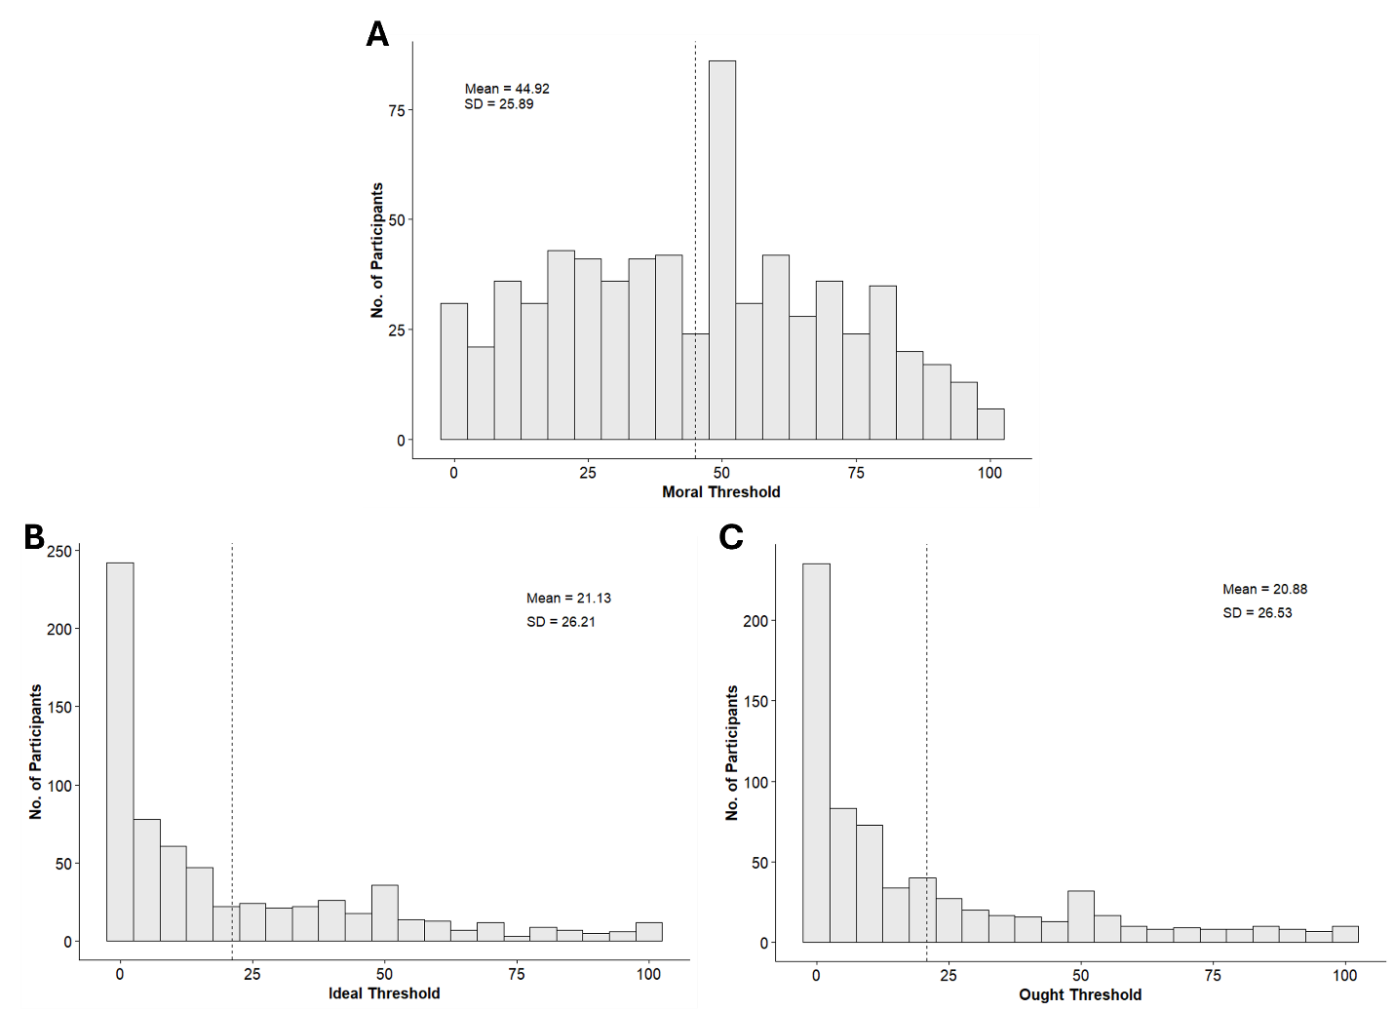

Figure S7
Distribution of Thresholds—Moral (A), Ideal (B), and Ought (C)—for the Immoral Behavior “When people listen to someone else tell a racist joke, they laugh or smile, as opposed to signaling their disapproval.” (Study 2)
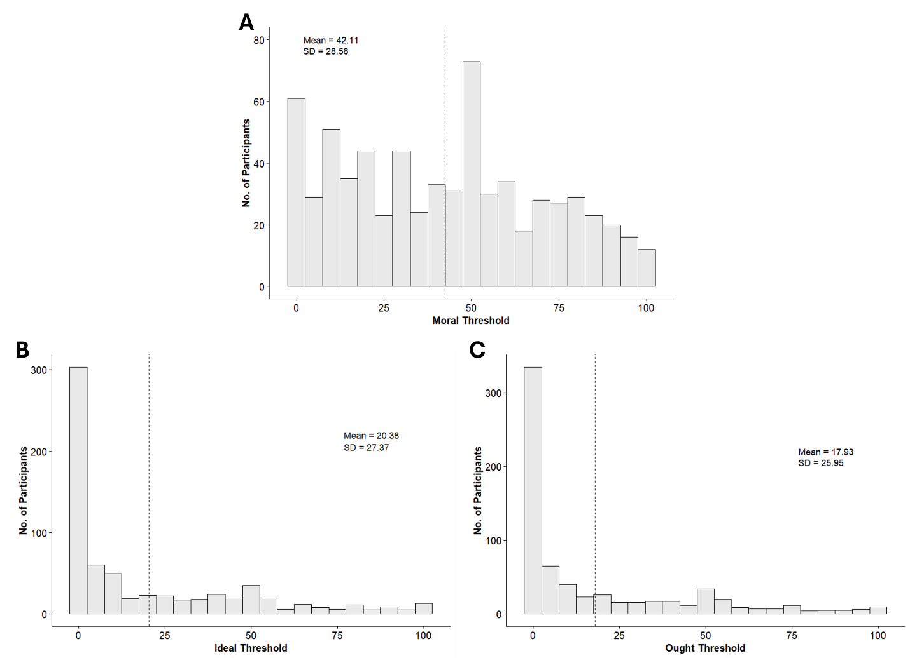

Figure S8
Distribution of Thresholds—Moral (A), Ideal (B), and Ought (C)—for the Immoral Behavior “When people are completing their annual tax returns, they knowingly lie on the returns, as opposed to reporting everything accurately to the best of their ability.” (Study 2)
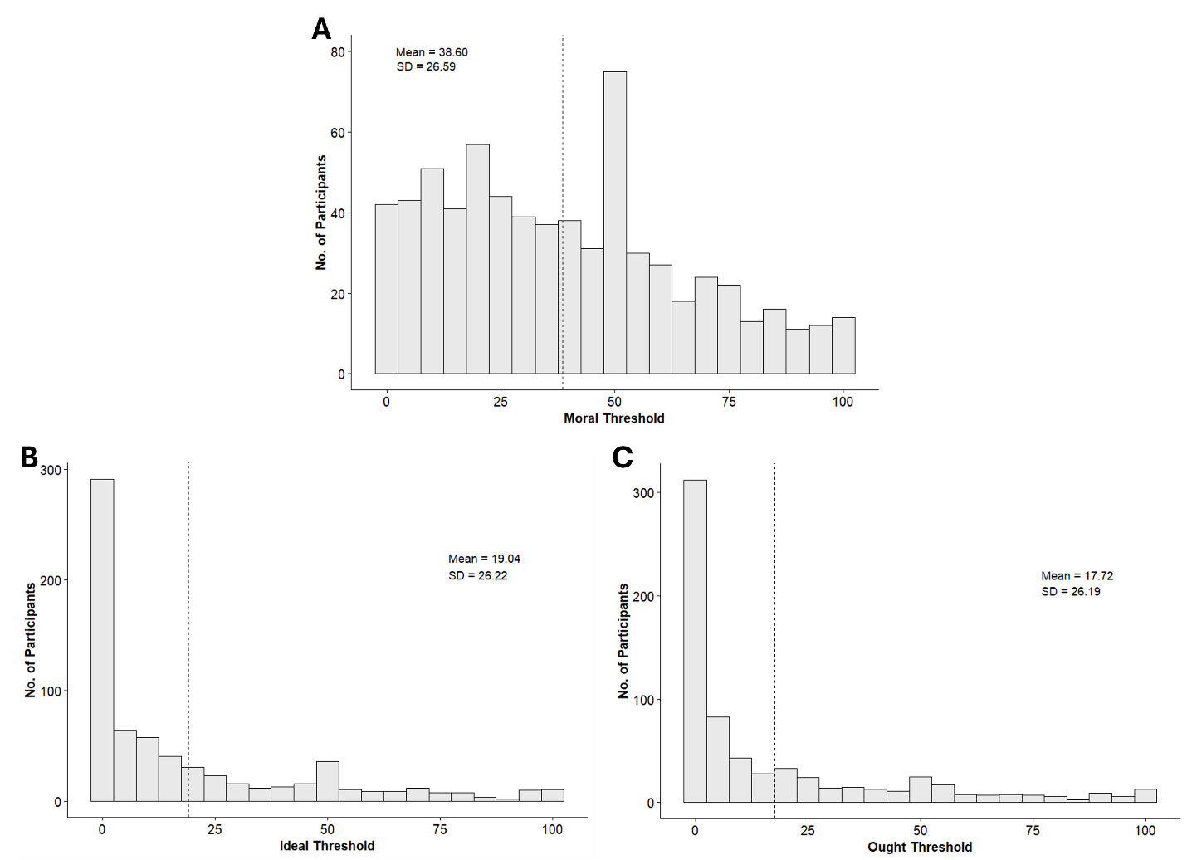

Figure S9
Distribution of Thresholds—Moral (A), Ideal (B), and Ought (C)—for the Immoral Behavior “When people are talking with others about those who aren't present, they make fun of those people behind their backs, as opposed to speaking respectfully about those people.” (Study 2)
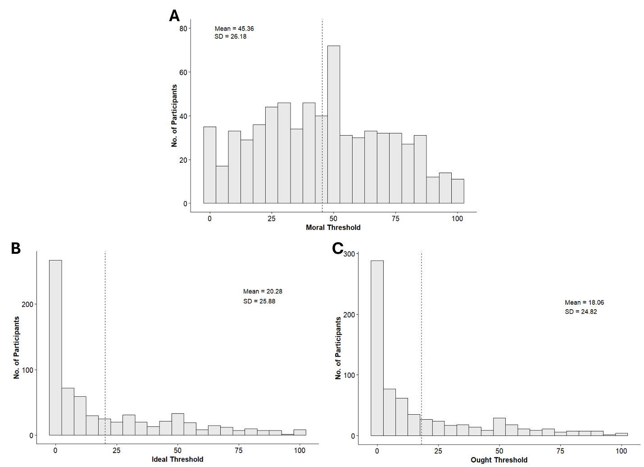

Figure S10
Distribution of Thresholds—Moral (A), Ideal (B), and Ought (C)—for the Immoral Behavior “When people hear someone else calling out for help, they ignore or pretend not to hear the person in need, as opposed to offering help to the person in need.” (Study 2)
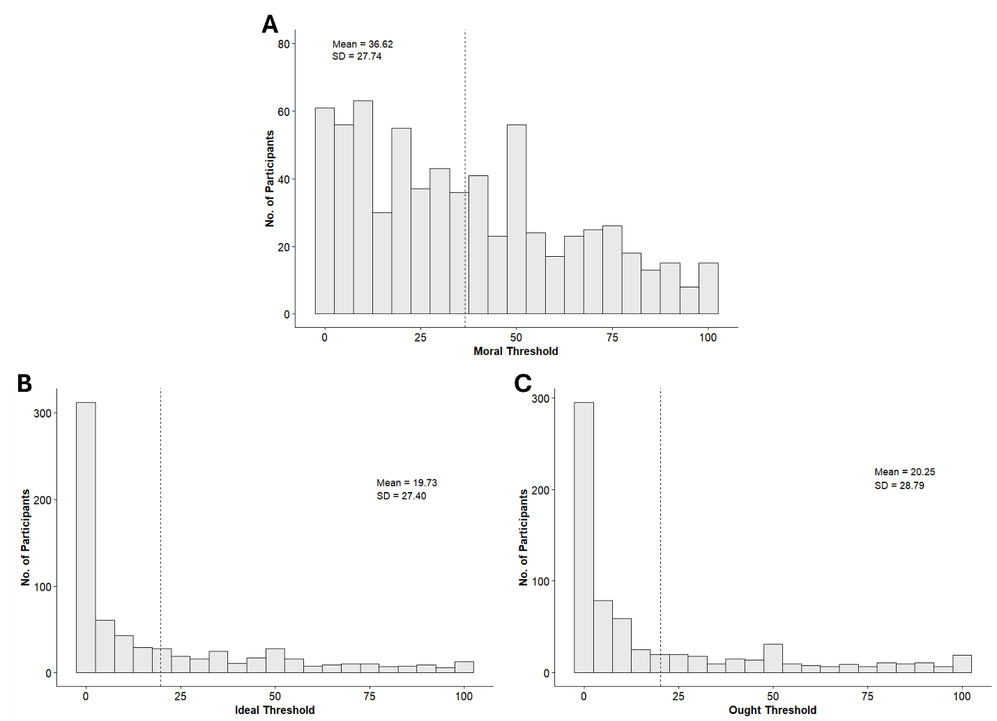

Correlations between Self, Social, and Moral Threshold Judgments
Here, we report the correlations between self, social, and moral threshold judgments. Studies 2-3 and Supplemental Study B permit these tests. Because some behaviors may simply invite higher (or lower) judgments (across all three targets)—for example, because they are more unusual or rarer—we first standardized the estimates within target and behavior. In other words, we calculated the mean and standard deviation of the judgments for each target (self, social, and moral threshold) and behavior and used those to Z-score each individual judgment. This meant that the mean and standard deviation across all judgments for a specific target and behavior were 0 and 1, respectively. Below, we provide the correlations between the moral threshold and the various targets for Studies 2-3 and Supplemental Study B. For each study, we first provide the overall correlations (i.e., Tables S5, S8, and S11), and then segregate them between moral and immoral behaviors (Tables S6, S9, and S12, and Tables S7, S10, and S13, respectively).

Table S5
Correlations Between Target Judgments (Study 2)
Target | Moral Threshold | Individuated Individual | Non-individuated Individual | Others in the Study | Others in Society
Self | .26*** | .31*** | .41*** | .35*** | .32***
Moral Threshold | - | .22*** | .32*** | .33*** | .35***
Note. ***p < .001.

Table S6
Correlations Between Target Judgments, for Moral Behaviors (Study 2)
Target | Moral Threshold | Individuated Individual | Non-individuated Individual | Others in the Study | Others in Society
Self | .31*** | .39*** | .48*** | .39*** | .38***
Moral Threshold | - | .24*** | .35*** | .34*** | .35***
Note. ***p < .001.

Table S7
Correlations Between Target Judgments, for Immoral Behaviors (Study 2)
Target | Moral Threshold | Individuated Individual | Non-individuated Individual | Others in the Study | Others in Society
Self | .20*** | .23*** | .34*** | .31*** | .26***
Moral Threshold | - | .19*** | .28*** | .33*** | .34***
Note. ***p < .001.

Table S8
Correlations Between Target Judgments (Study 3)
Target | Moral Threshold | Individual | Collective
Self | .32*** | .51*** | .44***
Moral Threshold | - | .41*** | .39***
Note. ***p < .001.

Table S9
Correlations Between Target Judgments, for Moral Behaviors (Study 3)
Target | Moral Threshold | Individual | Collective
Self | .36*** | .51*** | .46***
Moral Threshold | - | .46*** | .40***
Note. ***p < .001.

Table S10
Correlations Between Target Judgments, for Immoral Behaviors (Study 3)
Target | Moral Threshold | Individual | Collective
Self | .27*** | .50*** | .41***
Moral Threshold | - | .37*** | .39***
Note. ***p < .001.

Table S11
Correlations Between Target Judgments (Supplemental Study B)
Target | Moral Threshold | Individuated Individual | Non-individuated Individual | Others in the Study | Others in Society
Self | .41*** | .46*** | .51*** | .45*** | .43***
Moral Threshold | - | .35*** | .49*** | .43*** | .45***
Note. ***p < .001.

Table S12
Correlations Between Target Judgments, for Moral Behaviors (Supplemental Study B)
Target | Moral Threshold | Individuated Individual | Non-individuated Individual | Others in the Study | Others in Society
Self | .40*** | .36*** | .40*** | .51*** | .57***
Moral Threshold | - | .28*** | .40*** | .38*** | .47***
Note. ***p < .001.

Table S13
Correlations Between Target Judgments, for Immoral Behaviors (Supplemental Study B)
Target | Moral Threshold | Individuated Individual | Non-individuated Individual | Others in the Study | Others in Society
Self | .48*** | .57*** | .67*** | .57*** | .49***
Moral Threshold | - | .42*** | .60*** | .46*** | .45***
Note. ***p < .001.

Effect Sizes, by Study and Behavior
As our linear mixed models include random effects in their specifications, they do not lend themselves to a traditional effect-size estimate like Cohen’s d. Instead, we report effect sizes by analyzing each behavior separately, thereby obviating the need to use a mixed model. For each study, we computed effect sizes (Cohen’s d) for all appropriate tests at the behavior level and then averaged across behaviors (Tables S14-S20) as an interpretable index of average effect size.

Table S14
Cohen’s d Estimates for Each Comparison Between Pairs of Targets (Study 1)
Behavior | Self vs. Others in the Study | Self vs. Moral Threshold | Moral Threshold vs. Others in the Study
1 | 0.31 | 0.28 | 0.01
2 | 3.00 | 2.11 | -0.06
3 | 0.81 | 1.26 | -0.59
4 | 1.10 | 1.68 | -0.43
5 | 0.77 | 0.64 | 0.12
6 | 1.09 | 0.69 | 0.35
7 | 1.25 | 0.89 | 0.40
8 | 1.70 | 1.44 | 0.30
9 | 2.73 | 1.80 | 0.33
10 | 1.76 | 1.20 | 0.36
11 | 1.83 | 0.97 | 0.76
12 | 1.18 | 1.35 | -0.12
13 | 1.10 | -0.19 | 1.31
14 | 2.68 | 1.88 | 0.35
Average | 1.52 | 1.14 | 0.22
Note. For each “A vs. B” column, positive effect sizes reflect that A is greater than B for the moral behaviors (1-7) and that A is less than B for the immoral behaviors (8-14). Behavior numbers correspond to those in Appendix A in the main manuscript.

Table S15
Cohen’s d Estimates for Each Comparison Between Pairs of Targets (Study 2)
Behavior | Self vs. Moral Threshold | Individuated Individual vs. Moral Threshold | Non-individuated Individual vs. Moral Threshold | Moral Threshold vs. Others in the Study | Moral Threshold vs. Others in Society | Ideal Threshold vs. Moral Threshold | Ought Threshold vs. Moral Threshold
1 | 0.50 | 0.29 | 0.03 | 0.19 | 0.30 | 0.80 | 0.80
2 | 0.28 | 0.33 | -0.05 | 0.24 | 0.39 | 0.64 | 0.56
3 | 0.48 | 0.29 | 0.03 | 0.14 | 0.35 | 0.69 | 0.74
4 | 0.63 | 0.16 | 0.05 | 0.05 | 0.22 | 0.69 | 0.69
5 | 0.15 | 0.10 | -0.16 | 0.29 | 0.44 | 0.69 | 0.67
6 | 0.82 | 0.63 | 0.44 | 0.05 | 0.17 | 0.91 | 0.92
7 | 0.69 | 0.57 | 0.37 | -0.04 | 0.08 | 0.78 | 0.89
8 | 1.10 | 0.74 | 0.46 | -0.25 | -0.02 | 0.74 | 0.79
9 | 1.04 | 0.77 | 0.44 | 0.05 | 0.17 | 0.96 | 1.07
10 | 0.56 | 0.46 | 0.33 | 0.04 | 0.12 | 0.61 | 0.58
Average | 0.63 | 0.44 | 0.19 | 0.08 | 0.22 | 0.75 | 0.77
Note. For each “A vs. B” column, positive effect sizes reflect that A is greater than B for the moral behaviors (1-5) and that A is less than B for the immoral behaviors (6-10). Behavior numbers correspond to those in the Appendix B in the main manuscript.

Table S16
Cohen’s d Estimates for Each Comparison Between Pairs of Targets (Study 2)
Behavior | Individuated Individual vs. Non-individuated Individual | Non-individuated Individual vs. Others in the Study | Others in the Study vs. Others in Society
1 | 0.27 | 0.24 | 0.10
2 | 0.37 | 0.18 | 0.17
3 | 0.27 | 0.17 | 0.22
4 | 0.11 | 0.09 | 0.17
5 | 0.24 | 0.13 | 0.15
6 | 0.22 | 0.49 | 0.12
7 | 0.23 | 0.35 | 0.13
8 | 0.27 | 0.23 | 0.24
9 | 0.36 | 0.51 | 0.12
10 | 0.15 | 0.40 | 0.08
Average | 0.25 | 0.28 | 0.15
Note. For each “A vs. B” column, positive effect sizes reflect that A is greater than B for the moral behaviors (1-5) and that A is less than B for the immoral behaviors (6-10). Behavior numbers correspond to those in the Appendix B in the main manuscript.

Table S17
Cohen’s d Estimates for Each Comparison Between Pairs of Targets (Study 3)
Behavior | Self vs. Moral Threshold | Non-individuated Individual vs. Moral Threshold | Moral Threshold vs. Others in the Study | Non-individuated Individual vs. Others in the Study
1 | -0.15 | -0.31 | 0.57 | 0.25
2 | 0.45 | -0.15 | 0.35 | 0.19
3 | -0.61 | -0.40 | 0.56 | 0.15
4 | 0.48 | -0.01 | 0.25 | 0.23
5 | 0.50 | 0.01 | 0.28 | 0.28
6 | 0.70 | 0.33 | -0.04 | 0.29
7 | 0.97 | 0.56 | -0.39 | 0.20
8 | 1.04 | 0.54 | -0.33 | 0.26
9 | 1.10 | 0.40 | -0.23 | 0.19
10 | 1.08 | 0.41 | -0.15 | 0.28
Average | 0.56 | 0.14 | 0.09 | 0.23
Note. For each “A vs. B” column, positive effect sizes reflect that A is greater than B for the moral behaviors (1-5) and that A is less than B for the immoral behaviors (6-10). Behavior numbers correspond to those in the Appendix C in the main manuscript.

Table S18
Cohen’s d Estimates of Target on Anticipated Positive and Negative Feelings, Between Frames (Study 4a)
Behavior | Positive Feelings | Negative Feelings
Original Frame
1 | 0.38 | 0.03
2 | -0.56 | -0.01
3 | -0.15 | 0.31
4 | 0.29 | 0.66
5 | -0.09 | 0.54
6 | -0.03 | 0.16
7 | -0.23 | 0.68
8 | -0.22 | 0.15
9 | -0.05 | 0.00
10 | 0.22 | 0.25
Inverse Frame
1 | 0.08 | 0.24
2 | -0.13 | 0.05
3 | 0.24 | 0.53
4 | 0.06 | 0.05
5 | -0.26 | -0.06
6 | -0.04 | 0.62
7 | 0.04 | 0.38
8 | -0.08 | -0.26
9 | 0.01 | 0.19
10 | 0.30 | 0.02
Average | -0.01 | 0.23
Note. Positive effect sizes reflect greater anticipated feelings in the individual (vs. collective) target condition. Behavior numbers correspond to those in Appendix B in the main manuscript.

Table S19
Cohen’s d Estimates of the Guilt Manipulation and Target on Anticipated Negative Feelings (Study 4b Pretest)
Behavior | Guilt | Target
1 | 0.32 | -0.05
2 | 0.18 | 0.38
3 | 0.19 | 0.59
4 | 0.29 | 0.78
5 | 0.19 | 0.06
6 | 0.34 | 0.05
7 | 0.02 | 0.36
8 | 0.45 | -0.03
9 | 0.56 | 0.15
10 | 0.20 | 0.07
Average | 0.27 | 0.24
Note. Positive effect sizes reflect greater anticipated feelings in the underestimated (vs. overestimated) guilt condition and the individual (vs. collective) target conditions. Behavior numbers correspond to those in Appendix B in the main manuscript.

Table S20
Cohen’s d Estimates of the Guilt Manipulation and Target on Behavioral Estimates (Study 4b)
Behavior | Guilt | Target
1 | 0.19 | 0.19
2 | 0.19 | 0.22
3 | 0.21 | 0.18
4 | 0.20 | 0.16
5 | 0.23 | 0.18
6 | 0.04 | 0.23
7 | 0.04 | 0.31
8 | 0.01 | 0.17
9 | 0.08 | 0.46
10 | 0.15 | 0.40
Mean | 0.13 | 0.25
Note. Positive effect sizes reflect more evaluatively positive behavioral estimates in the underestimated (vs. overestimated) guilt condition and the individual (vs. collective) target conditions. Behavior numbers correspond to those in Appendix B in the main manuscript. Behaviors 1-5 are moral behaviors; behaviors 6-10, immoral behaviors.

As might be guessed from this use of “match,” the creator of this foil is more familiar with soccer than with baseball.

