Online supplementary material

Table of Contents
Study 1: Creating Harmonious Goals 2
Mediation analysis 2
Study 2a: Health-Finance Multifinality 3
Mediation analysis 3
Study 2b: Work-Leisure Multifinality 4
Mediation analysis 4
Study 3a: US-China Difference in Harmony 5
Additional analysis 5
Study 3b: Culture Difference in Harmony 6
Additional analysis 6
Study 4: Gender Effects on Perceived Work-Family Harmony 7
Mediation analysis 7
Study 5: Harmony Increases Helping Behaviors 8
Mediation analysis 8
Additional analysis 8
Study 6: Harmony Promotes Generosity 10
Mediation analysis 10
Study 7a: Harmony Promotes Health 11
Mediation analysis 11
Study 8: Longitudinal Implications 12
Additional analysis 12

Study 1: Creating Harmonious Goals

Mediation analysis

Figure S1: Indirect effect from connect vs. conflict condition to motivation (on the left) and well-being (on the right) through perceived harmony
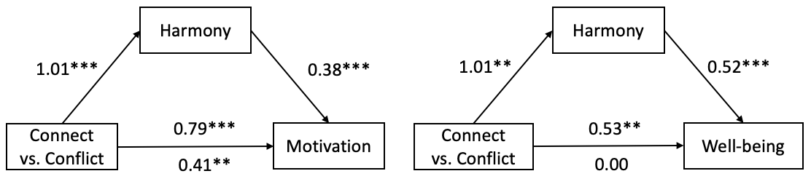

Table S1: Mediation model (Connect vs. Conflict Condition Social Harmony Motivation)
Path | Point estimate | SE | t | p
a | 1.01 | 0.18 | 5.77 | < .001
b | 0.38 | 0.05 | 7.23 | < .001
c | 0.79 | 0.14 | 5.47 | < .001
c’ | 0.41 | 0.14 | 2.93 | .004

Table S2: Mediation model (Connect vs. conflict condition Harmony Well-being)
Path | Point estimate | SE | t | p
a | 1.01 | 0.18 | 5.77 | < .001
b | 0.52 | 0.05 | 9.86 | < .001
c | 0.53 | 0.16 | 3.34 | .001
c’ | 0.00 | 0.14 | 0.02 | .982

Study 2a: Health-Finance Multifinality

Mediation analysis

Figure S2: Indirect effect from connect vs. control condition to motivation through perceived harmony
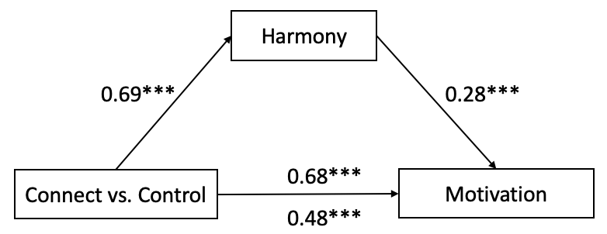
Table S3: Mediation model (Connect vs. Control Condition Harmony Motivation)
Path | Point estimate | SE | t | p
a | 0.69 | 0.12 | 5.65 | < .001
b | 0.28 | 0.06 | 4.74 | < .001
c | 0.68 | 0.13 | 5.39 | < .001
c’ | 0.48 | 0.13 | 3.76 | < .001

Study 2b: Work-Leisure Multifinality

Mediation analysis

Figure S3: Indirect effect from connect vs. control condition to motivation through perceived harmony
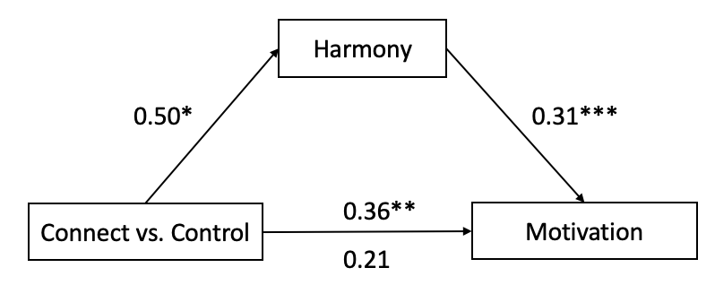
Table S4: Mediation model (Connect vs. Control Condition Harmony Motivation)
Path | Point estimate | SE | t | p
a | 0.50 | 0.20 | 2.54 | .011
b | 0.31 | 0.04 | 8.63 | < .001
c | 0.36 | 0.14 | 2.68 | .008
c’ | 0.21 | 0.12 | 1.70 | .091

Study 3a: US-China Difference in Harmony

Additional analysis
Correlation results on specific items of motivation:

Harmony in U.S. participants’ goal systems positively predicted their motivation, r(174) = .23, p < .001, and feeling energized to pursue their goals, r(174) = .25, p < .001. In China, harmony similarly positively predicted motivation, r(174) = .24, p < .001, and feeling energized to pursue goals, r(174) = .43, p < .001.

Country | Correlation between Harmony and Motivation Item 1: I feel motivated to pursue each of these goals |  | Correlation between Harmony and Motivation Item 2: I feel energized to pursue each of these goals
Country | r | p | r | p
US | .23 | .003 | .25 | < .001
China | .24 | .001 | .43 | < .001

Detailed Results of Harmony, Motivation and Wellbeing across two countries:

Country | Harmony |  | Motivation |  | Well-being
Country | Mean | SD | Mean | SD | Mean | SD
US | 5.26 | 1.29 | 5.69 | 0.99 | 4.40 | 1.01
China | 5.95 | 0.61 | 6.31 | 0.56 | 5.82 | 0.70

Study 3b: Culture Difference in Harmony

Additional analysis
Number of participants and demographics across eight countries:

Country | Number of Participants | Demographics
Netherlands | 148 | M_{age} = 30.09, SD_{age} = 8.72, 47% women
Germany | 147 | M_{age} = 30.10, SD_{age} = 8.75, 48% women
Australia | 148 | M_{age} = 37.51, SD_{age} = 12.03, 50% women
UK | 149 | M_{age} = 42.42, SD_{age} = 13.98, 70% women
Egypt | 113 | M_{age} = 26.58, SD_{age} = 6.87, 30% women
Mexico | 132 | M_{age} = 30.63, SD_{age} = 8.69, 28% women
Indonesia | 134 | M_{age} = 31.34, SD_{age} = 8.35, 49% women
India | 108 | M_{age} = 32.48, SD_{age} = 10.53, 19% women

Detailed Results of Harmony, Motivation and Wellbeing across eight countries:

Country | Harmony |  | Motivation |  | Well-being
Country | Mean | SD | Mean | SD | Mean | SD
Netherlands | 5.05 | 1.09 | 5.58 | 0.98 | 4.26 | 0.98
Germany | 5.06 | 1.08 | 5.58 | 0.98 | 4.27 | 0.99
Australia | 5.25 | 1.21 | 5.67 | 0.94 | 4.29 | 1.01
UK | 5.30 | 1.21 | 5.60 | 1.06 | 4.44 | 1.12
Egypt | 5.32 | 1.44 | 5.44 | 1.33 | 4.11 | 0.80
Mexico | 5.54 | 1.35 | 5.70 | 1.19 | 4.23 | 1.07
Indonesia | 5.58 | 1.16 | 5.79 | 1.01 | 4.54 | 1.04
India | 5.71 | 1.26 | 6.26 | 0.76 | 4.85 | 0.96

Study 4: Gender Effects on Perceived Work-Family Harmony

Mediation analysis

Figure S4. Indirect effect from gender to work-family harmony through family goal perception
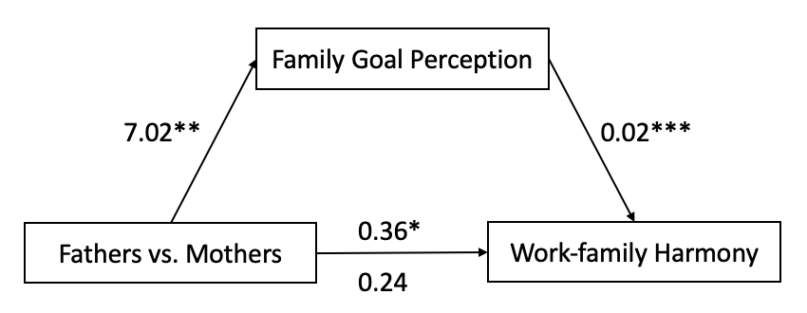

Table S5: Mediation model (Gender Family Goal Perception Work-family Harmony)
Path | Point estimate | SE | t | p
a | 7.02 | 2.69 | 2.61 | .009
b | 0.02 | 0.00 | 6.99 | < .001
c | 0.36 | 0.14 | 2.46 | .014
c’ | 0.24 | 0.14 | 1.75 | .081

Study 5: Harmony Increases Helping Behaviors

Mediation analysis

Figure S5. Indirect effect from connect vs. conflict condition to prosocial task performance through perceived harmony
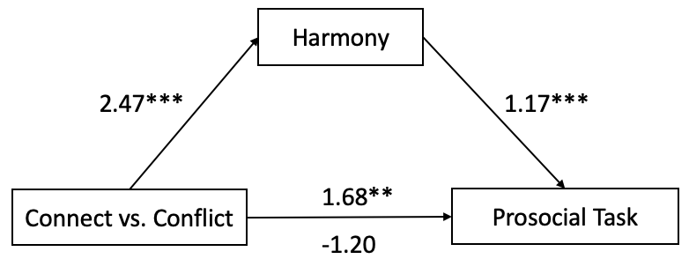

Table S6: Mediation model (Connect vs. Conflict Condition Harmony Prosocial Task)
Path | Point estimate | SE | t | p
a | 2.47 | 0.13 | 19.36 | < .001
b | 1.17 | 0.19 | 6.19 | < .001
c | 1.68 | 0.54 | 3.14 | .002
c’ | -1.20 | 0.70 | 1.72 | .086

Additional analysis

Results with no data exclusions:

As we predicted, participants in the Connect condition perceived more harmony between helping another person and benefiting themselves (M = 5.52, SD = 1.30) than those in the Conflict condition (M = 3.43, SD = 1.65), t(597) = 17.13, p < .001, d = 1.40.
Moving to task performance, we counted the number of completed CAPTCHA trails. Per our preregistration, if participants miswrote more than one character, the CAPTCHA was excluded. As predicted, when helping another person, participants in the Connect condition transcribed more CAPTCHAs (M = 11.37, SD = 5.45) than those in Conflict conditions (M = 10.03, SD = 5.98), t(596) = 2.86, p = .004, d = 0.23. There was no significant difference in task performance when benefiting themselves between the Connect condition (M = 14.11, SD = 3.00) and Conflict condition (M = 13.96, SD = 3.25), t(597) = 0.59, p = .553.
We next calculated the correlations between the number of CAPTCHAs transcribed in the other-benefiting task and the self-benefiting task, within each condition. As predicted, performance on the pro-social task predicted performance on the self-benefiting task when the goals were connected, r = 0.43, p < .001, more than when they were conflicting, r = 0.14, p = .015, z = 3.98, p < .001.
Additionally, we fit a mediation model to test whether harmony explains the positive effect of Connect condition on performance on the prosocial task. The connect manipulation positively predicted perceived harmony and perceived harmony positively predicted performance on the prosocial task. Monte Carlo resampling (5,000 iterations) estimated the 95% confidence interval (CI) of the indirect effect, which was positive and did not include zero, 95% CI [1.66, 3.01]. This pattern of results confirms that perceived goal harmony mediated the effect of the connecting manipulation on performance on the prosocial task.

Study 6: Harmony Promotes Generosity

Mediation analysis

Figure S6. Indirect effect from connect vs. conflict condition to gift-giving behaviors through perceived harmony
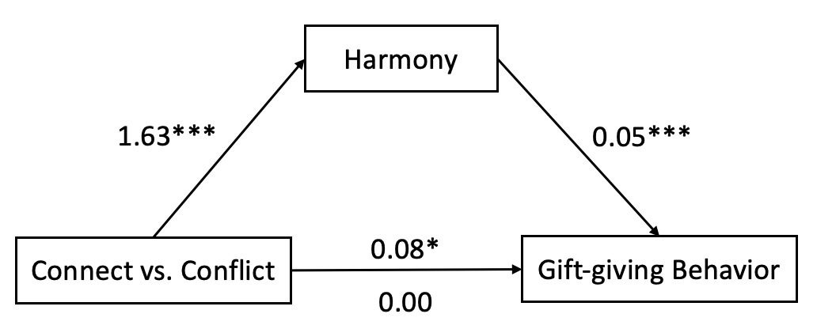

Table S7: Mediation model (Connect vs. Conflict Condition Harmony Gift-giving Behavior)
Path | Point estimate | SE | t | p
a | 1.63 | 0.19 | 8.74 | < .001
b | 0.05 | 0.01 | 4.32 | < .001
c | 0.08 | 0.03 | 2.36 | .019
c’ | 0.00 | 0.04 | 0.08 | .939

Study 7a: Harmony Promotes Health

Mediation analysis

Figure S7. Indirect effect from connect vs. control condition to healthy restaurant preference through perceived harmony
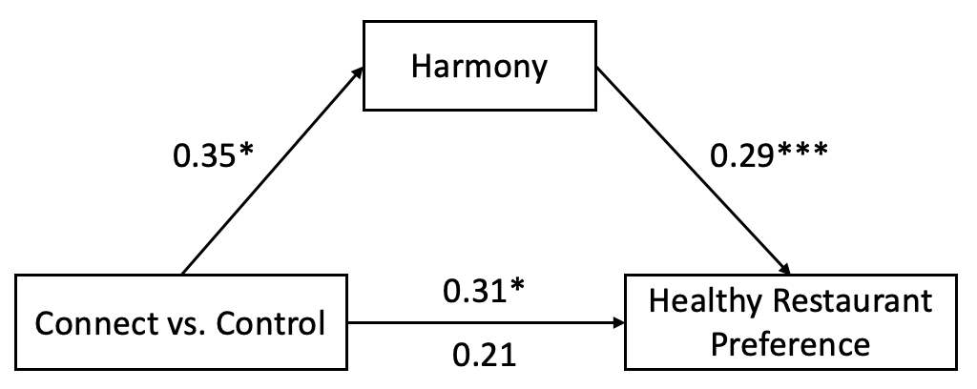

Table S8: Mediation model (Connect vs. Control Condition Harmony Healthy Restaurant Preference)
Path | Point estimate | SE | t | p
a | 0.35 | 0.17 | 2.03 | .043
b | 0.29 | 0.04 | 6.66 | < .001
c | 0.31 | 0.14 | 2.24 | .026
c’ | 0.21 | 0.13 | 1.60 | .111

Study 8: Longitudinal Implications

Additional analysis

Mixed effect regression model

We regressed goal persistence (in Time 2 and Time 3) on the harmony index measured in Time 1, and included a random intercept to control for repeated observations from participants and a fixed effect for the survey wave:

Path | Est. | S.E. | t val. | d.f. | p
(Intercept) | 4.10 | 0.33 | 12.59 | 343 | < .001
Goal harmony (Time 1) | 0.08 | 0.06 | 1.42 | 338 | .158
Study wave | -0.00 | 0.05 | -0.02 | 339 | .986

