Creative Ideation Activates Disinhibited Reward-Seeking and Indulgent Choices
Supplemental Material

Pilot Study 1: Perceived Tastiness and Healthfulness of Burgers

We ran the following study on Prolific and allowed participants from the US and UK to take part. One hundred and eighty one participants (58.2% female, Mage = 37.86 years) out of two hundred and one passed the attention check and indicated that they eat beef (which is what people generally associate with burgers). We asked participants to indicate whether they agreed that burgers are tasty, yummy, and appealing on a scale from 1 (strongly disagree) to 7 (strongly agree). Given the high Cronbach’s α (0.93), we created a composite score for tastiness. We also asked participants to indicate whether they agreed that burgers are healthy and good for heart healthy on a scale from 1 (extremely) to 7 (not at all). Given the high Cronbach’s α (0.90), we created a composite score for healthy. Next, we asked “From a health perspective, should you limit your consumption of burgers? On a scale from 1 (not at all, can have a burger daily) to 7 (very much, should only have a burger very rarely or not at all). Last, we asked demographic information and whether the participants eat beef (yes/no). A one-sample t-test comparing the average tastiness to the mid-point on the scale (4), showed that participants thought burgers were very tasty (M=6.2, SD = 0.8), p < .001, d = 2.75. Similarly, a one-sample t-test comparing the average healthiness of burgers to the mid-point on the scale (4), showed that participants thought burgers were unhealthy (M=4.7, SD=1.4), p < .001, d = .50. Last, a one-sample t-test comparing how much people thought they should limit their burger consumption given its health properties compared to the mid-point on the scale (4), showed that people thought they should limit their burger consumption (M=4.8, SD=1.0), p < .001, d = .80. We thus conclude that burgers are generally perceived as tasty but unhealthy and their consumption should be limited.
Studies S1 and S2

In study S1, we tested whether fatigue, entitlement, and/or liberation would mediate the effect. In Study S2, we again tested liberation and also tested variety seeking as possible mechanisms.
Participants who engage in a creative idea generation task might continue to be creative on any task that follows it (Shalley, 1991). Thus, creative idea generators might create more creative burgers by including more unusual ingredients, which might also contain more calories. We thus removed all unusual ingredients in Study S2.
Method

Participants and Design
In study S1, participants were from a large U.S. university and were paid $5 in exchange for their participation. For Study S2, participants were recruited using Amazon Mechanical Turk (Mturk) and were paid $2. To be eligible to complete study S2, participants had to be located in the United States and have a 95% approval rate. Study S1 had 134 participants (44.0% male; Mage = 20.7 years) with the sample size determined by the number of participants who wanted to take part within the week that the study was conducted. For the next study, we set the sample size to 100 participants per condition. Study S2 had 297 participants (55.6% male; Mage = 35.05 years; one person did not provide age or gender information). Three hundred and fifty participants were recruited. Three hundred and fifty-two participants started the study, and 297 participants completed the study and passed the attention checks for a completion rate of 84.4%. In study S1, participants were randomly assigned to one of two conditions (Idea generation: creative versus practical). In study S2, participants were randomly assigned to one of three conditions (Idea generation: creative versus practical, control condition).
Procedure
For study S1, participants entered the laboratory and were led to individual cubicles by a research assistant who was blind to the conditions and hypotheses of the study. For study S2, participants completed the study virtually. If they met the eligibility requirements for the study, they were able to accept the task and complete the study through an online survey platform. Participants first completed an idea generation task based on the task used by Goncalo and Staw (2006). Participants were randomly assigned to receive instructions to generate solutions to a problem that were either creative or practical by substituting the appropriate words in the following communication to participants:
“A store has recently gone bankrupt, and there is now an empty space where the store used to be. Please generate as many (creative, original and novel)/(practical, logical and useful) ideas for uses of that space as you can. You have 7 minutes to do so. The survey will automatically move you forward after 7 minutes.”
In study S2, we wanted to provide a more rigorous test of our hypothesis by including an additional control condition in which participants did not engage in any form of idea generation in order to ensure that people who engage in a creative idea generation task indeed create more calorie-rich burgers rather than that people who engage in a practical idea generation task create less calorie-rich burgers than people would usually do. We thus included an additional control condition in Study S2, which asked participants to complete a standard reflection task—to write about their day yesterday.
After generating ideas (or writing about their day yesterday), participants engaged in a task in which they were asked to build their perfect burger. This task was designed to measure indulgent choices. Participants were provided with pictures of 14 (seven in S2) different types of buns (including sesame seed bun, lettuce wrap, and naan bread), nine (five in S2) different types of patties (including beef patties, grilled chicken, and veggie patties), 13 (six in S2) different types of cheese (including American cheese, blue cheese, and brie as well as an additional no cheese option), and 72 (29 in S2) choices of burger toppings (including ketchup, bacon, and peanut butter). See Appendix A for all choices. Participants were instructed as follows:
“For the next study, we will ask you to build a burger that you would love to eat. You can select any and all ingredients to make your perfect burger. At the end, you can name your burger.”
In study S1, participants filled in the survey with the potential mediator variables in between the idea generation manipulation and the burger task. In study S2 the potential mediator and indulgence scales were positioned after the burger task.
Dependent Variables
The main dependent measure was the number of calories in the burger (calculated using data from myfooddiary.com), with higher calorie content indicating more indulgent choices. We created a second dependent variable for Study S1. Here, we also counted the number of unhealthy burger components because a participant might put together a healthy grilled chicken and avocado whole wheat burger, which contains the same amount of calories as a beef burger on a white bun, which is not considered as healthy. Every component that was high in saturated fat, high in added sugar or was highly processed was categorized as unhealthy. All vegetables, fruit, and complex carbohydrate components (e.g. whole wheat) that were also minimally processed were categorized as healthy. See the material on our OSF cite for the health rating of each component. For example, while onions were categorized as healthy, onion rings were categorized as unhealthy. Given the very high correlation between the calories in the burgers and the number of unhealthy components, r = 0.87, p < .001 in Study S1, we decided not to use the number of unhealthy components measure in the remainder of the studies because the number of calories in the burgers seemed sufficient to demonstrate how unhealthy the burgers are.
In the real world, restaurants have begun to make calorie counts available to help people make healthier choices which, in fact, seems to work (Lim, Penrod, Ha, Brudge, & Bruce, 2018). Thus, to enhance the realism and generalizability of the task and to test whether or not individuals deliberately make unhealthy choices even when calorie counts are known, we listed the number of calories for each burger component easily visible next to each component in study S2.
In study S2, we also included a self-reported indulgence measure to test whether participants admit to feeling indulgent. Specifically, following the unhealthy choices measure, participants completed a survey which included a slightly modified version of the six-item measure of hyperopia, which measures an aversion to indulgence, by Haws & Poynor (2008). We adapted the scale to focus on indulgence. The original scale’s items were all framed negatively, e.g. “It is hard for me to make myself indulge.” We kept two items that were negatively worded and changed the other four to be positively worded. Two of the positively worded items are: “I love to pamper myself” and “I always enjoy the luxuries life has to offer.” The items were on a seven-point scale ranging from 1 (“Strongly disagree”) to 7 (“Strongly Agree”). The original and modified scales can be found in Appendix C.
Potential Mechanisms
In Study S1, participants completed a survey in between the idea generation task and the burger task which included three exploratory measures of plausible mediator variables: 1) a liberation scale (Goncalo et al., 2015), 2) an entitlement scale (Jehn & Bezrukova, 2010) and 3) a fatigue scale, which we created, that asked participants to indicate whether they felt tired, exhausted, fatigued, and had a lot of energy (reverse scored). Each of these three scales were from 1 = strongly disagree to 7 = strongly agree.
In study S2, following the indulgent choices measure, participants completed a survey which included two potential mechanisms: 1) the same liberation measure as in Study 1a (Goncalo et al., 2015), and a variety seeking scale (Van Trijp et al., 1996, see Appendix C for the full, modified scale). Each of these scales were from 1 = strongly disagree to 7 = strongly agree.
Additional Measures
At the end of each of the two studies, we collected information on ethnicity, gender, age, whether participants are currently on a calorie restricting diet (yes/no), and how hungry participants currently are (on a scale from 1 (not at all hungry) to 10 (extremely hungry)). Participants were also asked how hungry they were before engaging in the burger task.
Unusualness of Burger Components
In order to show that the unusualness of the burger components did not influence the effect of creative idea generation on unhealthy choices, we restricted the burger component choices by excluding all unusual options such as peanut butter in Study S2 to rule out this alternative explanation of our results.
Manipulation Checks
As a manipulation check, participants responded to the question “how creative were the ideas that you generated during the idea generation task” on a five-item scale from 1 (“not at all”) to 5 (“a great deal”). Additionally, two independent raters who were blind to condition rated the creativity of the ideas generated on a 5-point scale from 1 = not at all creative to 5 = very creative. The interrater reliability (LeBreton & Senter, 2008) between the two raters for study S1 was ICC(2) = 0.70, and for study S2 was ICC(2) = 0.83. These were acceptable, and, thus, we averaged the two raters’ creativity ratings in each study.
Results
Manipulation Check Results
Independent samples t-tests demonstrated that the participants in the creative condition (Study S1: M = 3.42; SD = 1.08; Study S2: M = 3.28; SD = 1.00) indicated that the ideas they generated were significantly more creative than those in the practical condition (Study S1: M = 2.74; SD = 0.92; Study S2: M = 2.82; SD = 1.03), Study S1: t(130.87) = -3.94, p < 0.001, d = .68; Study S2: t(201) = -3.22, p = .001, d = .45) in both studies. Equal variance was not assumed in Study S1 given that the Levene’s test was significant, p = .04. Furthermore, independent samples t-tests demonstrated that participants in the creative condition (Study S1: M = 2.04; SD = 0.28; Study S2: M = 2.41; SD = 0.55) generated significantly more creative ideas than those in the practical condition (Study S1: M = 1.84; SD = 0.25; Study S2: M = 1.99; SD = 0.44), Study S1: t(132) = -4.31, p < .001, d = .75; Study S2: t(173.52) = -5.76, p < .001, d = .84 in both studies. Equal variance was not assumed in Study S2 because the Levene’s tests were significant, p = .015. Together, these results indicate that the manipulations were successful in that participants who were instructed to be creative not only believed they were creative but independent coding of their ideas also indicated that they followed the instructions and thus were more creative.
Calorie Results
As predicted, the results of an independent samples t-test in study S1 revealed a significant effect of type of idea generation task (creative versus practical) on the number of calories in the burger, with the participants in the creative idea generation condition (M_{kcal} = 1418.26; SD_{kcal} = 546.53), creating significantly more calorie-rich burgers than the participants in the practical idea generation condition (M_{kcal} = 1180.58; SD_{kcal} = 487.72), t(132) = -2.65, p = .009, d = .46.
As predicted, in Study S2, a one-way ANOVA revealed a significant effect of condition (type of idea generation task, creative or practical, or control condition) on the number of calories in the burger, F(2, 294) = 6.90, p = .001, η² = .045. Planned contrasts revealed that participants in the creative condition (M_{kcal} = 1440.41; SD_{kcal} = 930.01) built burgers that contained significantly more calories than participants in the practical condition (M_{kcal} = 1140.10; SD_{kcal} = 467.78), p = .001, d = .41 and participants in the control condition (M_{kcal} = 1128.19; SD_{kcal} = 510.55), p = .001, d = .42. The calories in the burger of participants in the practical and control conditions did not differ from each other, p = .90.
Number of Unhealthy Components Results in Study S1
As predicted, the results of an independent samples t-test in study S1 revealed a significant effect of type of idea generation task (creative versus practical) on the number of unhealthy burger components, with the participants in the creative idea generation condition (M = 7.77; SD = 3.17) putting significantly more unhealthy components on their burgers than the participants in the practical idea generation condition (M = 6.12; SD = 3.24), t(132) = -2.97, p = .004, d = .52.
Indulgence Results for Study S2
As predicted, in study S2, a one-way ANOVA revealed a significant effect of condition on indulgence, F(2, 294) = 26.88, p < .001. In particular, participants in the creative idea generation condition (M = 5.15; SD = 0.95) indicated feeling significantly more indulgent than participants in the practical idea generation condition (M = 4.36; SD = 1.30), p < .001, d = .69 and participants in the control condition (M = 3.91; SD = 1.24), p < .001, d = 1.12. The participants in the practical idea generation condition also indicated feeling significantly more indulgent than participants in the control condition, p < .007.
Potential Mechanisms:
We tested for mediation by liberation, entitlement, and fatigue in Study S1 and by liberation and variety seeking in study S2 by running separate mediation procedures (Model 4) on PROCESS in SPSS as recommended by Hayes (2017). For all of these, we used calories in the burger as our dependent variable. In study S1, the indirect effects through liberation, entitlement, and fatigue were not significant as the 95% CIs contained zero [-90.27, 40.91], [-72.63, 24.59], and [-25.81, 21.28] respectively. In study S2, the indirect effects through liberation and variety seeking were not significant as the 95% CIs contained zero, liberation: [-16.01, 9.86], variety seeking: [-8.58, 26.10]. We thus did not find support that these potential mechanisms explained the relationship between creative idea generation and indulgent choices.
Additional Results
When excluding the outliers in each of the studies, the main effects and mediation results remain the same. When controlling for being on a calorie restricting diet and/or when controlling for hunger, all results remain the same. See below for the detailed analyses.

Additional Results for Studies S1, 1a (in the main text), and S2

When not controlling for the unusualness of the burger components in Study 1a in the main text, the results of an independent samples t-test revealed a significant effect of type of idea generation task (creative versus practical) on the number of calories in the burger, with the participants in the creative idea generation condition (M_{kcal} = 1727.34; SD_{kcal} = 1481.00), creating significantly more calorie-rich burgers than the participants in the practical idea generation condition (M_{kcal} = 1258.75; SD_{kcal} = 584.94), t = 2.98, p = .003.
Results with outliers removed (using Tukey’s method to detect outliers)
In Study S1, four outliers whose calories in the burger were extremely high were removed. The results of an independent samples t-test in study S1 revealed a significant effect of type of idea generation task (creative versus practical) on the number of calories in the burger, with the participants in the creative idea generation condition (M_{kcal} = 1345.92; SD_{kcal} = 435.52), creating significantly more calorie-rich burgers than the participants in the practical idea generation condition (M_{kcal} = 1154.33; SD_{kcal} = 442.91), t(128) = -2.49, p = .014.
In Study S1, two outliers who added an extremely large number of unhealthy burger components were removed. The results of an independent samples t-test in study S1 revealed a significant effect of type of idea generation task (creative versus practical) on the number of unhealthy burger components, with the participants in the creative idea generation condition (M = 7.46; SD = 2.66) putting significantly more unhealthy components on their burgers than the participants in the practical idea generation condition (M = 5.94; SD = 2.89), t(129) = -3.14, p = .002.
In Study 1a in the main text, ten outliers whose calories in the burger were extremely high were removed. The results of an ANCOVA revealed a significant effect of type of idea generation task (creative versus practical) on the number of calories in the burger when controlling for the unusualness of the burger components, with the participants in the creative idea generation condition (M_{kcal} = 1368.49; SD_{kcal} = 468.67), creating significantly more calorie-rich burgers than the participants in the practical idea generation condition (M_{kcal} = 1230.90; SD_{kcal} = 514.66), F(1, 188) = 4.05, p = .046.
In Study S2, 16 outliers were removed. A one-way ANOVA revealed a significant effect of condition (type of idea generation task, creative or practical, or control condition) on the number of calories in the burger, F(2, 278) = 3.25, p = .04, η² = .023. Planned contrasts revealed that participants in the creative condition (M_{kcal} = 1198.27; SD_{kcal} = 414.56) built burgers that contained significantly more calories than participants in the practical condition (M_{kcal} = 1088.23; SD_{kcal} = 346.43), p = .04, and participants in the control condition (M_{kcal} = 1063.40; SD_{kcal} = 362.88), p = .02. The calories in the burger of participants in the practical and control conditions did not differ from each other, p = .64.
We tested for mediation by liberation, entitlement, and fatigue in Study S1 and by liberation and variety seeking in studies 1a in the main text and S2 by running separate mediation procedures (Model 4) on PROCESS in SPSS as recommended by Hayes (2017) excluding the outliers. For all of these, we used calories in the burger as our dependent variable. In study S1, the indirect effects through liberation, entitlement, and fatigue were not significant as the 95% CIs contained zero [-38.51, 59.99], [-71.29, 17.86], and [-17.17, 27.31] respectively. In study 1a and S2, the indirect effects through liberation and variety seeking were not significant as the 95% CIs contained zero (study 1a liberation: [-44.12, 156.74], variety seeking: [-18.08, 106.49]; study S2 liberation: [-19.05, 10.42], variety seeking: [-18.02, 6.31]).
Neither Study 1a in the main text nor Study S2 had any outliers on the indulgence scale.
Results when controlling for being on a calorie restricting diet
The results of an ANCOVA in study S1 revealed a significant effect of type of idea generation task (creative versus practical) on the number of calories in the burger when controlling for being on a calorie restricting diet (yes/no question) with the participants in the creative idea generation condition (M_{kcal} = 1418.26; SD_{kcal} = 546.53), creating significantly more calorie-rich burgers than the participants in the practical idea generation condition (M_{kcal} = 1180.58; SD_{kcal} = 487.72), F(1, 131) = 6.98, p = .009.
The results of an ANCOVA in study S1 revealed a significant effect of type of idea generation task (creative versus practical) on the number of unhealthy components in the burger when controlling for being on a calorie restricting diet (yes/no question) with the participants in the creative idea generation condition (M = 7.46; SD = 2.66), creating significantly more calorie-rich burgers than the participants in the practical idea generation condition (M = 5.94; SD = 2.89), F(1, 128) = 9.81, p = .002.
The results of an ANCOVA in study 1a in the main text revealed a significant effect of type of idea generation task (creative versus practical) on the number of calories in the burger when controlling for the unusualness of the burger components as well as being on a calorie restricting diet, with the participants in the creative idea generation condition (M_{kcal} = 1727.34; SD_{kcal} = 1481.00), creating significantly more calorie-rich burgers than the participants in the practical idea generation condition (M_{kcal} = 1258.75; SD_{kcal} = 584.94), F(1, 196) = 5.63, p = .019.
The results of an ANCOVA in study 1a in the main text revealed a significant effect of type of idea generation task (creative versus practical) on the indulgence measure when controlling for the unusualness of the burger components as well as being on a calorie restricting diet, with the participants in the creative idea generation condition (M = 4.91; SD = 1.05), feeling significantly more indulgent than the participants in the practical idea generation condition (M = 3.97; SD = 1.14), F(1, 196) = 30.35, p < .001.
In Study S2, a one-way ANCOVA revealed a significant effect of condition (type of idea generation task, creative or practical, or control condition) on the number of calories in the burger when controlling for being on a calorie restricting diet, F(2, 292) = 6.52, p = .002, η² = .043. Planned contrasts revealed that participants in the creative condition (M_{kcal} = 1440.41; SD_{kcal} = 930.01) built burgers that contained significantly more calories than participants in the practical condition (M_{kcal} = 1138.65; SD_{kcal} = 469.74), p = .002, and participants in the control condition (M_{kcal} = 1128.19; SD_{kcal} = 510.55), p = .002. The calories in the burger of participants in the practical and control conditions did not differ from each other, p = .88.
In study S2, an ANCOVA controlling for being on a calorie restricting diet revealed a significant effect of condition on indulgence, F(2, 292) = 26.60, p < .001. In particular, participants in the creative idea generation condition (M = 5.15; SD = 0.95) indicated feeling significantly more indulgent than participants in the practical idea generation condition (M = 4.36; SD = 1.30), p < .001, and participants in the control condition (M = 3.91; SD = 1.24), p < .001. The participants in the practical idea generation condition also indicated feeling significantly more indulgent than participants in the control condition, p < .007.
Results when controlling for hunger
The results of an ANCOVA in study S1 revealed a significant effect of type of idea generation task (creative versus practical) on the number of calories in the burger when controlling for how hungry participants indicated they were before engaging in the burger task with the participants in the creative idea generation condition (M_{kcal} = 1418.26; SD_{kcal} = 546.53), creating significantly more calorie-rich burgers than the participants in the practical idea generation condition (M_{kcal} = 1180.58; SD_{kcal} = 487.72), F(1, 131) = 8.14, p = .005.
The results of an ANCOVA in study S1 revealed a significant effect of type of idea generation task (creative versus practical) on the number of unhealthy components in the burger when controlling for how hungry participants indicated they were before engaging in the burger task with the participants in the creative idea generation condition (M = 7.46; SD = 2.66), creating significantly more calorie-rich burgers than the participants in the practical idea generation condition (M = 5.94; SD = 2.89), F(1, 128) = 11.12, p = .001.
The results of an ANCOVA in study 1a in the main text revealed a significant effect of type of idea generation task (creative versus practical) on the number of calories in the burger when controlling for the unusualness of the burger components as well as how hungry participants indicated they were before engaging in the burger task, with the participants in the creative idea generation condition (M_{kcal} = 1727.34; SD_{kcal} = 1481.00), creating significantly more calorie-rich burgers than the participants in the practical idea generation condition (M_{kcal} = 1258.75; SD_{kcal} = 584.94), F(1, 196) = 5.05, p = .026.
The results of an ANCOVA in study 1a in the main text revealed a significant effect of type of idea generation task (creative versus practical) on the indulgence measure when controlling for the unusualness of the burger components as well as how hungry participants indicated they were before engaging in the burger task, with the participants in the creative idea generation condition (M = 4.91; SD = 1.05), feeling significantly more indulgent than the participants in the practical idea generation condition (M = 3.97; SD = 1.14), F(1, 196) = 30.61, p < .001.
In Study S2, a one-way ANCOVA revealed a significant effect of condition (type of idea generation task, creative or practical, or control condition) on the number of calories in the burger when controlling for how hungry participants indicated they were before engaging in the burger task, F(2, 293) = 6.2052, p = .002, η² = .041. Planned contrasts revealed that participants in the creative condition (M_{kcal} = 1440.41; SD_{kcal} = 930.01) built burgers that contained significantly more calories than participants in the practical condition (M_{kcal} = 1140.10; SD_{kcal} = 467.78), p = .002, and participants in the control condition (M_{kcal} = 1128.19; SD_{kcal} = 510.55), p = .003. The calories in the burger of participants in the practical and control conditions did not differ from each other, p = .95.
In study S2, an ANCOVA controlling for how hungry participants indicated they were before engaging in the burger task revealed a significant effect of condition on indulgence, F(2, 293) = 26.49, p < .001. In particular, participants in the creative idea generation condition (M = 5.15; SD = 0.95) indicated feeling significantly more indulgent than participants in the practical idea generation condition (M = 4.36; SD = 1.30), p < .001, and participants in the control condition (M = 3.91; SD = 1.24), p < .001. The participants in the practical idea generation condition also indicated feeling significantly more indulgent than participants in the control condition, p < .007.
Study S3: Self vs. Other
Generally, people make more indulgent choices for others than for themselves (Laran, 2010). For example, when asked to choose between healthy and unhealthy snack options for a friend or oneself, people tend to choose the unhealthy, indulgent snacks for their friend more often than for themselves because they believe that their friend has a pleasure-seeking goal (Laran, 2010). However, we believe the opposite will happen for people who have engaged in a creative idea generation task because creative idea generators are likely to focus on rewarding themselves, not others. We expect people to experience a desire to indulge the self and choices that reflect this desire for the self, but not expect people to believe that others deserve to indulge in treats. Creative idea generators are likely to feel like they themselves have earned a reward and therefore they should deserve a reward, not somebody else. In other words, after engaging in a creative idea generation task, individuals may believe that they deserve a special reward such as a decadent burger but that other people do not. Thus, the desire to indulge and reward oneself should be focused on the self rather than an indiscriminate impulse to create indulgent products or experiences. We thus predict that creative idea generators will feel indulgent and make more indulgent choices for themselves, but notably this effect should not extend to choices made for others.
To test this hypothesis, we manipulated whether participants created a burger for themselves or for someone else. We did so to test whether our proposed effect is about self-indulgence and thus relating only to the self rather than a general impulse for indiscriminate decadence or lack of control. We predicted that the effect would only hold if participants created a burger for themselves, but not when they did so for another person. We again included the indulgence scale (Haws & Poynor, 2008). We also again tested liberation and variety seeking as potential mechanisms in this study. We wanted to ensure that variety seeking was not a confound for the expected results, and wanted to ensure again that liberation was not a mediator.
Method
Participants and design
Three hundred participants from MTurk (58% male; M_{age} = 49.56 years) participated for $2. Our sample size was set a priori to 50 per condition. We requested 350 participants to account for expected attrition. 362 participants opened the survey with 300 participants completing the study and passing the attention checks for a completion rate of 82.9%. Participants were randomly assigned to one of six conditions: 3 (condition: creative/practical idea generation, or control) x 2 (burger for self vs. other).
Procedure
Participants were randomly assigned to the control condition in which they were asked to write about their day yesterday or to one of the two idea generation tasks from the previous studies.
Participants then engaged in the same burger task described in study 1a. However, participants were randomly assigned to build the burger for themselves or for another person. The instructions for the self (someone else) were as follows:
“For the next study, we will ask you to build a burger that you (you think someone else) would love to eat. You can select any and all ingredients to make your (the) perfect burger (for someone else). At the end, you can name the burger.”
Last, participants filled out a survey with the indulgence scale, potential mechanisms, and demographics.
Dependent variables
The dependent measure was, following experiments 1a-c, the number of calories in the burger. Participants were provided with the same pictures of buns, patties, cheese, and burger toppings as in Study 1b. Each of the choices also included the number of calories that the item contained. We also included the indulgence scale (Haws & Poynor, 2008), as in previous studies.
Potential Mechanisms
The survey further included the same liberation and variety seeking scales as before.
Additional variables
The survey further included ethnicity, gender, age, whether participants are currently on a calorie restricting diet, and how hungry participants currently are before putting together the burger.
Manipulation Checks
We asked the same manipulation check question as in previous studies. Additionally, as before, we had two independent raters who were blind to condition rate the creativity of the ideas. The interrater reliability (LeBreton & Senter, 2008) between the two raters was high, ICC(2) = 0.81. We thus averaged the two raters’ creativity ratings.
Results
Manipulation Check results
A 2 (creative vs. practical) x 2 (self vs. other) ANOVA revealed a significant main effect of idea generation condition on the creative manipulation check question F(1, 197) = 19.83, p < .001, η² = 0.09, but no main effect of self vs. other, F(1, 197) = 0.60, p = .44, η² = 0.003, and no interaction, F(1, 197) = 0.07, p = .80, η² < 0.001. Participants in the creative condition (M = 3.51; SD = 1.04) indicated that the ideas they generated were significantly more creative than those in the practical condition (M =2.85; SD = 1.07), F(1, 197) = 19.83, p < .001, η² = 0.09. Furthermore, a 2 (creative vs. practical) x 2 (self vs. other) ANOVA revealed a significant main effect of idea generation condition on the creativity of the ideas, F(1, 198) = 16.45, p < .001, η² = 0.08, but no main effect of self vs. other, F(1, 198) = 0.15, p = .70, η² = 0.001, and no interaction, F(1, 198) = 0.76, p = 0.38, η² = 0.004. Participants in the creative condition (M = 2.36; SD = 0.44) generated significantly more creative ideas than those in the practical condition (M = 2.14; SD = 0.31), F(1, 197) = 19.83, p < .001, η² = 0.08.
Calorie and Self-reported Indulgence Results
A 3 (condition: creative/practical idea generation, or control) x 2 (burger for self vs. other) ANOVA revealed a significant main effect of condition on the number of calories in the burger, F(2, 294) = 6.22, p = .002, η² = 0.041, a non-significant main effect of self vs. other, F(1, 294) = 1.64, p = .20, η² =0.006, and a significant interaction, F(2, 294) = 3.42, p = .034, η² = 0.023. As predicted, planned contrasts showed a significant effect of condition when participants created the burger for themselves, F(2, 294) = 9.56, p < .001, η² = 0.06, but not when participants created the burger for someone else, F(2, 294) = 0.21, p = .81, η² = 0.001. In particular and as can be seen in Figure 2, when creating the burger for themselves, participants who engaged in the creative idea generation task (M_{kcal} = 2264.81; SD_{kcal} = 2491.96) built burgers that contained significantly more calories than those who engaged in the practical idea generation task (M_{kcal} = 1273.97; SD_{kcal} = 629.78), p < .001, as well as those who wrote about their day yesterday (M_{kcal} = 1243.38; SD_{kcal} = 796.91), p < .001. In contrast, when creating the burger for another person, participants who engaged in the creative idea generation task (M_{kcal} = 1493.04; SD_{kcal} = 1104.67) built burgers that contained similar calories than those who engaged in the practical idea generation task (M_{kcal} = 1361.56; SD_{kcal} = 839.55), p = .62, as well as those who wrote about their day yesterday (M_{kcal} = 1327.02; SD_{kcal} = 1207.65), p = .54.
Figure S1
Interaction Between Condition (Creative/Practical/Control) and for Whom the Burger Was Created (Self/Other) in Study S3.

Note. Error Bars Represent +/- 1 Standard Error.

Furthermore, as predicted, a 3 (condition: creative/practical idea generation, or control) x 2 (burger for self vs. other) ANOVA revealed a significant main effect of condition on the self-reported indulgence measure, F(2, 294) = 13.82, p < .001, η² =0.086, a significant main effect of self vs. other, F(1, 294) = 11.96, p = .001, η² = 0.039, and a significant interaction, F(2, 294) = 9.75, p < .001, η² = 0.062. Planned contrasts showed a significant effect of condition when participants created the burger for themselves, F(2, 294) = 23.44, p < .001, η² = 0.14, but not when participants created the burger for someone else, F(2, 294) = 0.53, p = .59, η² = 0.004. In particular, when creating the burger for themselves, participants who engaged in the creative idea generation task (M = 5.57; SD = 0.62) felt significantly more indulgent than those who engaged in the practical idea generation (M = 4.37; SD = 1.29), p < .001, d=1.19, as well as those in the control condition (M = 4.24; SD = 0.88), p < .001, d = 1.74. In contrast, when creating the burger for someone else, participants who engaged in the creative idea generation task (M = 4.37; SD = 1.21) felt similarly indulgent as those who engaged in the practical idea generation (M = 4.16; SD = 1.16), p = .33, as well as those in the control condition (M = 4.33; SD = 1.24), p = .86.
Additional results
We tested for moderated mediation by including liberation and variety seeking as mediators in separate mediation procedures (Model 8) on PROCESS in SPSS as recommended by Hayes (2017). The index of moderated mediation for liberation and variety seeking were not significant as the 95% CIs contained zero [-103.17, 53.81] and [-34.61, 133.61] respectively. We thus again did not find support for these potential mechanisms explaining the relationship between creative idea generation and unhealthy choices in the condition in which participants created the burgers for themselves.
Discussion
In this study, we extend the findings of the previous studies by demonstrating that people who work on a creative idea generation task make more indulgent choices by creating more calorie-rich burgers for themselves, but not for others. Thus, the desire to indulge does not extend indiscriminately to another person but rather is focused on oneself. This suggests that asking an individual to be creative as opposed to practical, fundamentally shifts how they perceive both the task and themselves. The nature of the task as creative caused an awareness of one’s indulgence, and led to more indulgent choices for oneself but not for others. Although the data did not replicate previous findings (Laran, 2010) that people tend to make indulgent choices for others in the control conditions to a statistically significant degree, nevertheless, participants in the control conditions did create burgers that contained on average approximately 75 more calories for others than for themselves.
In some cases, the calories on the burger were very excessive. The participants in the creative idea generation condition created burgers for themselves that contained a rather large number of calories. One might thus wonder if it is even feasible to consume food in one meal that has 2264 kcal, as the average burger created by these participants had, particularly because the daily calorie needs of an average man are 2400 kcal and of an average woman 2000 kcal if they are moderately active (https://health.gov/dietaryguidelines/2015/guidelines/appendix-2/). However, there are a number of days on the American calendar (the country from which our participants were drawn) that make a 2264 kcal burger look rather ordinary: the average American consumes 2400 calories on Super Bowl Sunday during the game alone (Calorie Control Council, 2020a) and 3000 kcal during Thanksgiving dinner (Calorie Control Council, 2020b). Making the 2264 kcal burger look even smaller is a report by The Food and Agriculture Organization stating that the average American eats an average of 3600 kcal a day (Renee, 2018). While 2264 kcal in a single burger contains approximately twice the amount of calories that most high-calorie burgers at fast food restaurants contain (e.g. Burger King’s most calorie-laden burger has 1250kcal [Nutrition Charts, 2019]), it is clearly not inconceivable to consume two of those.
Study S4: Cocktails
We ran an identical study to Study 1b presented in the main text on 304 participants from Mturk (57.2% male; M_{age} = 36.07 years) without restricting the amount of alcohol participants could add to the cocktail. In this study, outlier analysis identified 53 outliers who created cocktails that contained more than 496 ABV. To put this into perspective, this much alcohol is in 11 tequila shots, which if consumed within one hour by an average woman is close to a lethal blood alcohol level (Heatley & Crane, 1990). The most extreme outlier was someone who created a cocktail that had 4791 ABV, which corresponds to 106 tequila shots. When removing these outliers, the results of a one-way ANOVA revealed a significant effect of condition on the amount of alcohol (ABV) in the cocktail, F(2, 248) = 8.02, p < .001, η² = 0.061. The participants in the creative idea generation condition (M_{ABV} = 134.67; SD_{ABV} = 96.77) created cocktails that contained significantly more alcohol than the participants in the practical idea generation condition (M_{ABV} = 95.37; SD_{ABV} = 58.85), p = .001 and the participants in the control condition (M_{ABV} = 91.91; SD_{ABV} = 65.76), p < .001. The alcohol content of the participants in the practical and control conditions did not differ from each other, p = .76.
When including all 53 outliers in the analysis, the results of a one-way ANOVA revealed a non-significant effect of condition on the amount of alcohol (ABV) in the cocktail, F(2, 301) = 1.43, p = .24, η² = 0.009. The participants in the creative idea generation condition (M_{ABV} = 516.14; SD_{ABV} = 807.39) created cocktails that contained more alcohol than the participants in the practical idea generation condition (M_{ABV} = 348.52; SD_{ABV} = 668.34), p = .12 and than the participants in the control condition (M_{ABV} = 371.23; SD_{ABV} = 794.61), p = .18. The alcohol content of the participants in the practical and control conditions did not differ from each other, p = .83.
Study 1b (in main text): Cocktails
Results with outliers removed (using Tukey’s method to detect outliers)
Eleven outliers were removed because their ABVs in the cocktail were extremely high. The results of a one-way ANOVA revealed a significant effect of condition on the amount of alcohol (ABV) in the cocktail, F(2, 345) = 27.07, p < .001, η² = 0.14. The participants in the creative idea generation condition (M_{ABV} = 132.98; SD_{ABV} = 76.04), created cocktails that contained significantly more alcohol than the participants in the practical idea generation condition (M_{ABV} = 86.20; SD_{ABV} = 65.78), p < .001 and the participants in the control condition (M_{ABV} = 76.45; SD_{ABV} = 40.62), p < .001. The alcohol content of the participants in the practical and control conditions did not differ from each other, p = .21.
We removed three outliers who had extremely low scores on the indulgence measure. The results of a one-way ANOVA revealed a significant effect of condition on indulgence, F(2, 353) = 90.91, p < .001, η² = 0.34. Pairwise comparisons showed that participants in the creative idea generation condition (M = 5.37; SD = 0.84) indicated feeling significantly more indulgent than participants in the practical idea generation condition (M = 4.00; SD = 0.81), p < .001, as well as the control condition (M = 4.00; SD = 0.98), p < .001. The practical idea generation condition and the control condition did not differ from one another, p = .99.
Thirty outliers were removed because the calories in the cocktails were extremely high. A one-way ANOVA using the calories in the cocktails as our dependent variable revealed a significant effect of condition on the number of calories in the cocktails, F(2, 326) = 26.92, p < .001, η² = 0.14. Pairwise comparisons showed that participants in the creative idea generation condition (M = 937.55; SD = 568.25) added significantly more calories than participants in the practical idea generation condition (M = 589.36; SD = 380.86), p < .001. Notably, the participants in the control condition (M = 1086.17; SD = 605.13) added significantly more calories than the participants in the creative condition, p = .04, as well as in the practical idea generation condition, p < .001. It seems that participants in the control condition added calories via other means than alcohol such as via juices.
Results when controlling for being on a calorie restricting diet
The results of an ANCOVA revealed a significant effect of condition on the amount of alcohol (ABV) in the cocktail when controlling for being on a calorie restricting diet, F(2, 355) = 34.70, p < .001, η² = 0.16. The participants in the creative idea generation condition (M_{ABV} = 150.01; SD_{ABV} = 94.09), created cocktails that contained significantly more alcohol than the participants in the practical idea generation condition (M_{ABV} = 90.73; SD_{ABV} = 73.75), p < .001 and the participants in the control condition (M_{ABV} = 76.45; SD_{ABV} = 40.62), p < .001. The alcohol content of the participants in the practical and control conditions did not differ from each other, p = .08.
Results when controlling for hunger
The results of an ANCOVA revealed a significant effect of condition on the amount of alcohol (ABV) in the cocktail when controlling for how hungry participants indicated being before creating the cocktail task, F(2, 354) = 35.17, p < .001, η² = 0.16. The participants in the creative idea generation condition (M_{ABV} = 150.16; SD_{ABV} = 94.51), created cocktails that contained significantly more alcohol than the participants in the practical idea generation condition (M_{ABV} = 90.73; SD_{ABV} = 73.75), p < .001 and the participants in the control condition (M_{ABV} = 76.45; SD_{ABV} = 40.62), p < .001. The alcohol content of the participants in the practical and control conditions did not differ from each other, p = .12.
Results when controlling for thirst
The results of an ANCOVA revealed a significant effect of condition on the amount of alcohol (ABV) in the cocktail when controlling for how thirsty participants indicated being before creating the cocktail task, F(2, 354) = 34.49, p < .001, η² = 0.16. The participants in the creative idea generation condition (M_{ABV} = 150.01; SD_{ABV} = 94.09), created cocktails that contained significantly more alcohol than the participants in the practical idea generation condition (M_{ABV} = 90.73; SD_{ABV} = 73.75), p < .001 and the participants in the control condition (M_{ABV} = 76.60; SD_{ABV} = 40.73), p < .001. The alcohol content of the participants in the practical and control conditions did not differ from each other, p = .12.
Results when controlling for the number of alcoholic drinks usually consumed within a week
The results of an ANCOVA revealed a significant effect of condition on the amount of alcohol (ABV) in the cocktail when controlling for how many alcoholic beverages participants usually drink on a weekly basis, F(2, 354) = 34.49, p < .001, η² = 0.16. The participants in the creative idea generation condition (M_{ABV} = 150.01; SD_{ABV} = 94.09), created cocktails that contained significantly more alcohol than the participants in the practical idea generation condition (M_{ABV} = 90.73; SD_{ABV} = 73.75), p < .001 and the participants in the control condition (M_{ABV} = 76.38; SD_{ABV} = 40.76), p < .001. The alcohol content of the participants in the practical and control conditions did not differ from each other, p = .12.
Results when controlling for the calories in the cocktail
The results of an ANCOVA revealed a significant effect of condition on the amount of alcohol (ABV) in the cocktail when controlling for the calories in the cocktail, F(2, 355) = 30.94, p < .001, η² = 0.15. The participants in the creative idea generation condition (M_{ABV} = 150.01; SD_{ABV} = 94.09), created cocktails that contained significantly more alcohol than the participants in the practical idea generation condition (M_{ABV} = 90.73; SD_{ABV} = 73.75), p < .001 and the participants in the control condition (M_{ABV} = 76.45; SD_{ABV} = 40.62), p < .001. The alcohol content of the participants in the practical and control conditions differed marginally from each other, p = .06.
Interaction results between condition and dieting status
There was no significant interaction between condition and dieting status, F(2, 353) = .35, p = .71.
Interaction results between condition and hunger
As a PROCESS Model 1 moderation analysis shows, there was a significant interaction between condition (coded as 1=creative condition and 0= practical and control conditions) and hunger, F(5, 352) = -7.01, p = .03. However, those in the creative condition had significantly higher ABVs than those in the other two conditions at each level of hunger. When hunger was low (1 out of 10), participants in the creative condition (M_{ABV} = 176.3) put significantly more alcohol into their cocktails than participants in the practical condition (M_{ABV} = 77.4) and control condition (M_{ABV} = 76.9), p > .001. When hunger was medium (4 out of 10), participants in the creative condition (M_{ABV} = 154.8) put significantly more alcohol into their cocktails than participants in the practical condition (M_{ABV} = 90.2) and control condition (M_{ABV} = 76.5), p > .001. When hunger was high (8 out of 10), participants in the creative condition (M_{ABV} = 126.2) put significantly more alcohol into their cocktails than participants in the practical condition (M_{ABV} = 107.3) and control condition (M_{ABV} = 75.9), p > .001.
Interaction results between condition and thirst
As a PROCESS Model 1 moderation analysis shows, there was no significant interaction between condition (coded as 1=creative condition and 0= practical and control conditions) and thirst, F(5. 352) = -1.3, p = .71.
Interaction results between condition and number of weekly alcoholic drinks consumed
As a PROCESS Model 1 moderation analysis shows, there was no significant interaction between condition (coded as 1=creative condition and 0= practical and control conditions) and number of weekly alcoholic drinks consumed, F(5. 352) = -.29, p = .93.
Study 1c (in main text): Create a Workout
There were no outliers in this data set.
Results when controlling for being on a calorie restricting diet
The results of an ANCOVA revealed a significant effect of type of idea generation task (creative vs. practical) on the number of calories burnt in the exercise regimen when controlling for being on a calorie restricting diet, with the participants in the creative idea generation condition (M_{kcal} = 1882.8; SD_{kcal} = 1161.31), burning significantly fewer calories in their exercise regimen than the participants in the practical idea generation condition (M_{kcal} = 2399.18; SD_{kcal} = 974.44), F (1, 104) = 5.99, p = .02.
Results when controlling for weight
The results of an ANCOVA revealed a significant effect of type of idea generation task (creative vs. practical) on the number of calories burnt in the exercise regimen when controlling for participants’ weight, with the participants in the creative idea generation condition (M_{kcal} = 1917.39; SD_{kcal} = 1143.26), burning significantly fewer calories in their exercise regimen than the participants in the practical idea generation condition (M_{kcal} = 2399.18; SD_{kcal} = 974.44), F (1, 103) = 4.79, p = .03.
Results when controlling for usual number of hours exercised in a week
The results of an ANCOVA revealed a significant effect of type of idea generation task (creative vs. practical) on the number of calories burnt in the exercise regimen when controlling for participants’ usual number of hours exercised in a week, with the participants in the creative idea generation condition (M_{kcal} = 1882.80; SD_{kcal} = 1161.31), burning significantly fewer calories in their exercise regimen than the participants in the practical idea generation condition (M_{kcal} = 2399.18; SD_{kcal} = 974.44), F (1, 104) = 6.09, p = .02.

Study 2 (in main text): Candy consumption
Results when not controlling for starting weight
The results of a one-way ANOVA revealed a significant effect of condition on the amount of candy eaten, F(2, 129) = 7.92, p < .001. The participants in the creative idea generation condition (M_{oz} = 0.58; SD = 0.39), ate significantly more candy than the participants in the practical idea generation condition (M_{oz} = 0.36; SD = 0.35), p = .003, and the participants in the control condition (M_{oz} = 0.30; SD = 0.32), p < .001 d = .79. The candy eaten by participants in the practical and control conditions did not differ from each other, p = .46.
Results when using individual BAS subscales.
The results of a one-way ANOVA revealed a significant effect of condition on the BAS reward subscale, F(2, 129) = 7.10, p = .001. As predicted, the participants in the creative idea generation condition (M = 5.25; SD = 1.37), scored significantly higher than the participants in the practical idea generation condition (M = 4.30; SD = 1.41), p = .001, and the participants in the control condition (M = 4.30; SD = 1.25), p = .001. The BAS reward score by participants in the practical and control conditions did not differ from each other, p = .99. Based on bootstrapping 5,000 resamples, and controlling for starting weight, the indirect effect through the BAS reward subscale was not significant at p < 0.05 (indirect effect = 0.04; SE = 0.03) as the 95% CI included zero [-.002, 0.09]. However, relative to participants in the practical and control conditions, participants who engaged in creative ideation reported significantly higher BAS reward scores (effect = 1.00, SE = 0.28, p < .001, 95% CI (0.45, 1.55)), which translated into marginally increased consumption of candy (effect = 0.04, SE = 0.02, p = .06, 95% CI (-0.002, 0.08)).
The results of a one-way ANOVA revealed a significant effect of condition on the BAS drive subscale, F(2, 129) = 11.37, p < .001. As predicted, the participants in the creative idea generation condition (M = 4.48; SD = 1.32), scored significantly higher than the participants in the practical idea generation condition (M = 3.49; SD = 1.28), p < .001, and the participants in the control condition (M = 3.33; SD = 1.10), p < .001. The BAS drive score by participants in the practical and control conditions did not differ from each other, p = .54. Based on bootstrapping 5,000 resamples, and controlling for starting weight, the indirect effect through the BAS drive was not significant at p < 0.05 (indirect effect = 0.04; SE = 0.03) as the 95% CI included zero [-.01, 0.00]. However, relative to participants in the practical and control conditions, participants who engaged in creative ideation reported significantly higher BAS drive scores (effect = 1.21, SE = 0.25, p < .001, 95% CI (0.70, 1.71)), which translated into a non-significant increase in consumption of candy (effect = 0.03, SE = 0.02, p = .14, 95% CI (-0.01, 0.08)).
The results of a one-way ANOVA revealed a significant effect of condition on the BAS fun subscale, F(2, 129) = 12.48, p < .001. As predicted, the participants in the creative idea generation condition (M = 4.84; SD = 1.14), scored significantly higher than the participants in the practical idea generation condition (M = 3.96; SD = 1.17), p < .001, and the participants in the control condition (M = 3.67; SD = 1.13), p < .001. The BAS fun score by participants in the practical and control conditions did not differ from each other, p = .24. Based on bootstrapping 5,000 resamples, and controlling for starting weight, the indirect effect through the BAS fun was not significant at p < 0.05 (indirect effect = 0.05; SE = 0.03) as the 95% CI included zero [-.01, 0.11]. However, relative to participants in the practical and control conditions, participants who engaged in creative ideation reported significantly higher BAS fun scores (effect = 1.21, SE = 0.24, p < .001, 95% CI (0.74, 1.68)), which translated into marginally increased consumption of candy (effect = 0.04, SE = 0.02, p = .10, 95% CI (-0.008, 0.09)).
Condition by dieting status interaction results for all studies
In Study S1, there was a significant interaction between condition (creative/practical) and dieting status (yes/no), F(1, 130) = 4.84, p = .03. Among the 14 participants who indicated being on a calorie restricting diet, the seven participants in the creative idea generation condition (M_{kcal} = 1724.34; SD_{kcal} = 656.44), created significantly more calorie-rich burgers than the seven participants in the practical idea generation condition (M_{kcal} = 915.12; SD_{kcal} = 411.42), F(1, 130) = 8.70, p = .004. Among the 120 participants who indicated not being on a calorie restricting diet, the 62 participants in the creative idea generation condition (M_{kcal} = 1383.70; SD_{kcal} = 527.85), created marginally significantly more calorie-rich burgers than the 65 participants in the practical idea generation condition (M_{kcal} = 1212.61; SD_{kcal} = 489.46), F(1, 130) = 3.33, p = .07.
In Study 1a in the main text, there was no significant interaction condition (creative/practical) and dieting status (yes/no), F(1. 196) = 0.017, p = .90.
In Study S2, an ANOVA revealed that there was a significant interaction between condition (creative/practical/control) and dieting status, F(1, 290) = 3.67, p = .027. Among the 75 participants who were on a diet, the 27 participants in the creative idea generation condition (M_{kcal} = 1885.67; SD_{kcal} = 1520.31), created significantly more calorie-rich burgers than the 25 participants in the practical idea generation condition (M_{kcal} = 1205.08; SD_{kcal} = 648.64), p < .001, and than the 23 participants in the control condition (M_{kcal} = 1278.38; SD_{kcal} = 407.85), p = .001. There was no difference between the control and practical conditions, p = .69. Among the 221 participants who were not on a diet, the 68 participants in the creative idea generation condition (M_{kcal} = 1263.62; SD_{kcal} = 452.68), created more calorie-rich burgers than the 82 participants in the practical idea generation condition (M_{kcal} = 1118.40; SD_{kcal} = 402.89), p = .17, and than the 71 participants in the control condition (M_{kcal} = 1079.38; SD_{kcal} = 407.85), p = .09. Albeit these differences were at best marginally significant. There was no difference between the control and practical conditions, p = .71.
In Study 1b in the main text, an ANOVA revealed that there was a significant interaction between condition (creative/practical/control) and dieting status on the calories in the cocktail, F(1, 353) = 4.98, p = .007. Among the 115 participants who were on a diet, the 22 participants in the creative idea generation condition (M_{kcal} = 4652.18; SD_{kcal} = 7968.46), created significantly more calorie-rich cocktails than the 21 participants in the practical idea generation condition (M_{kcal} = 627.82; SD_{kcal} = 464.59), p < .001, and than the 72 participants in the control condition (M_{kcal} = 1364.84; SD_{kcal} = 1154.89), p = .001. There was no difference between the control and practical conditions, p = .37. Among the 244 participants who were not on a diet, the 89 participants in the creative idea generation condition (M_{kcal} = 1790.42; SD_{kcal} = 5089.61), created significantly more calorie-rich cocktails than the 93 participants in the practical idea generation condition (M_{kcal} = 684.17; SD_{kcal} = 1061.68), p = .03, but not than the 62 participants in the control condition (M_{kcal} = 1392.17; SD_{kcal} = 1133.42), p = .47. There was no difference between the control and practical conditions, p = .19.
In Study 1b in the main text, there was no significant interaction of condition (creative/practical/control) and dieting status (yes/no) on ABV, F( 353) = 0.35, p = .71.
In Study 1c in the main text, there was no significant interaction of condition (creative/practical/control) and dieting status (yes/no) on Calories Burned, F(2, 103) = 1.00, p = .32.
In Study 1d in the main text, there was no significant interaction of condition (creative/practical) and dieting status (yes/no) on Candy, F(1, 174) = .04, p = .84.
In Study 2 in the main text, there was no significant interaction of condition (creative/practical/control) and dieting status (yes/no) on Candy Consumed when controlling for starting weight, F(2, 125) = 2.18, p = .12.
In Study 3a in the main text, there was no significant interaction of condition (creative/practical/control) and dieting status (yes/no) on Burger Calories, F(2, 300) = .74, p = .48.
In Study 3b in the main text, there was no significant interaction of condition (creative/practical/control) and dieting status (yes/no) on Burger Calories, F(2, 299) = 1.29, p = .28.
In Study 3c in the main text, there was no significant interaction of condition (creative/practical/control) and dieting status (yes/no) on Burger Calories, F(2, 301) = .21, p = .81.
In Study 4 in the main text, there was no significant interaction of condition (creative/practical/control) and dieting status (yes/no) on Burger Calories, F(1, 345) = 1.54, p = .22.
In Study S3, an ANOVA revealed that there was a significant three-way interaction between condition (creative/practical/control), for whom the burger was assembled (self vs. other), and dieting status on the Burger Calories, F(2, 288) = 4.53, p = .01. For those who were on a diet and created the burger for themselves, those in the creative idea generation condition (M_{kcal} = 3798.26; SD_{kcal} = 3429.46), created significantly more calorie-rich burgers than those in the practical idea generation condition (M_{kcal} = 1268.48; SD_{kcal} = 1051.45), p < .001, and than those in the control condition (M_{kcal} = 1825.67; SD_{kcal} = 1294.74), p = .001. There was no difference between the control and practical conditions, p = .26. No other comparisons were statistically significant different, all ps > .22.
In Study S4, there was no significant interaction of condition (creative/practical/control) and dieting status (yes/no) on cocktail ABV, F(2, 245) = .47, p = .63 and no significant difference on Cocktail Calories, F(2, 245) = .27, p = .76.
Condition by healthy eating goals interaction results for Study 5
We tested whether healthy eating goals would moderate the effect of condition on candy consumed by running the moderation procedure (Model 1) on PROCESS in SPSS as recommended by Hayes (2017). The results show that there is no significant interaction between condition and healthy eating goals on candy consumed (b = .07, 95% CI [-.10, .24], t = .83, p = .41).
We also tested whether healthy eating goals would moderate the effect of condition on calories in the burger by running the moderation procedure (Model 1) on PROCESS in SPSS as recommended by Hayes (2017). The results show that there is a marginally significant interaction between condition and healthy eating goals on calories in the burger (b = -357.82, 95% CI [-716.01, .37], t = -1.98, p = .0502).

Violin Plots for All Studies
Figure S2a: Study 1a Violin Plot of Burger Calories by Condition
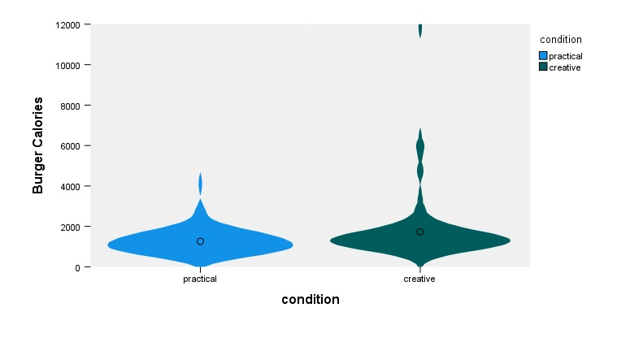
Figure S2b: Study 1a Violin Plot of Indulgence Scale by Condition
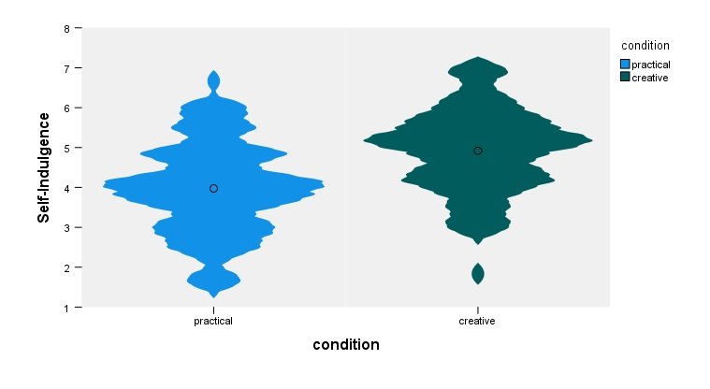

Figure S3a: Study 1b Violin Plot of ABV by Condition
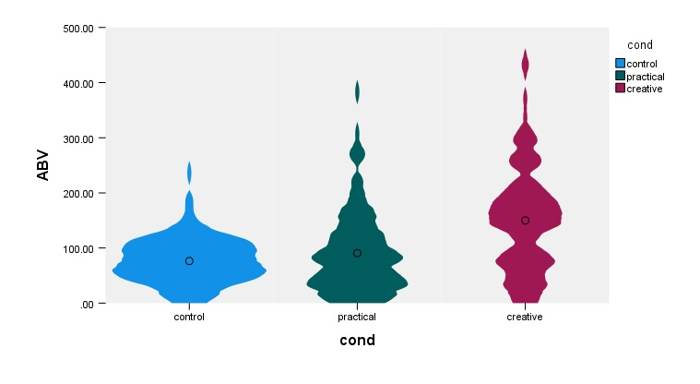
Figure S3b: Study 1b Violin Plot of Cocktail Calories by Condition
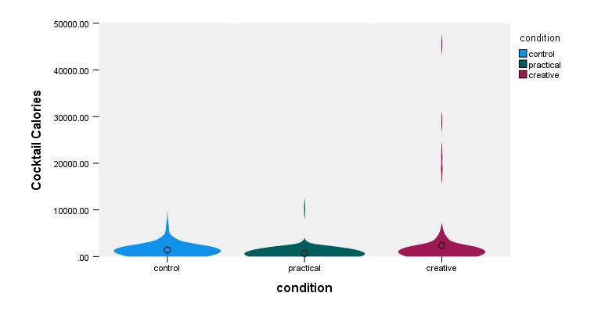

Figure S3c: Study 1b Violin Plot of Indulgence Scale by Condition
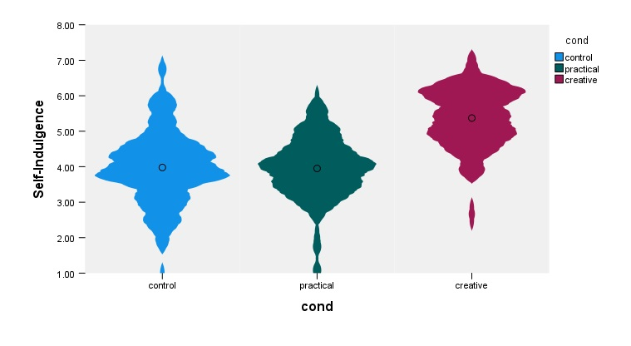
Figure S4a: Study 1c Violin Plot of Calories Burnt in Workout by Condition
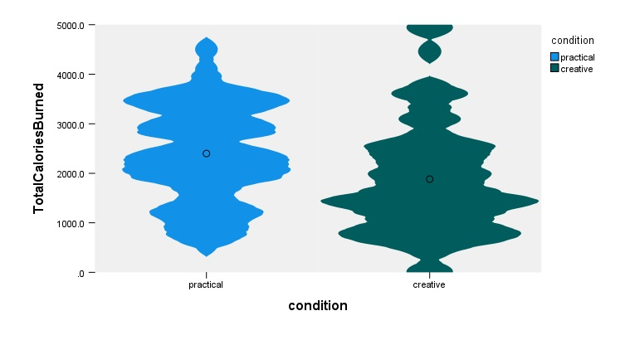

Figure S4b: Study 1c Violin Plot of Indulgence Scale by Condition
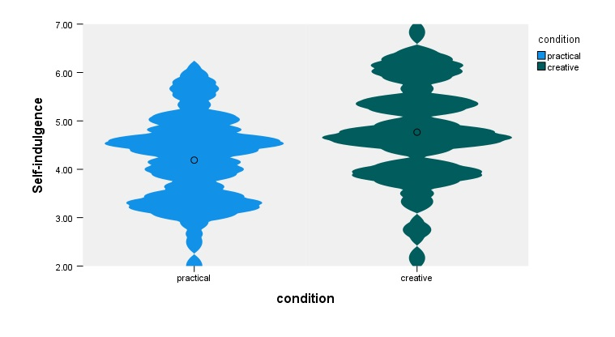
Figure S5: Study 1d Violin Plot of Indulgence Scale by Condition
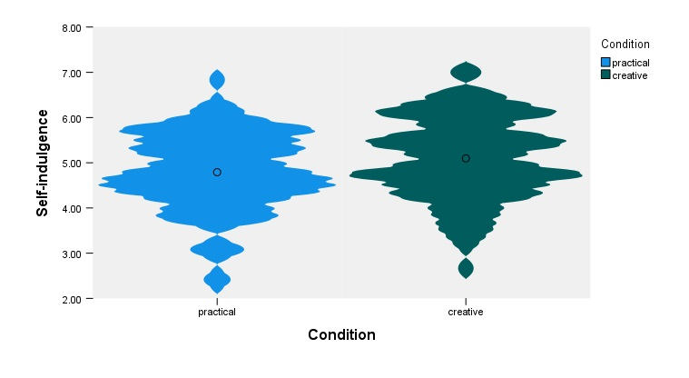

Figure S6a: Study 2 Violin Plot of Candy Consumed by Condition
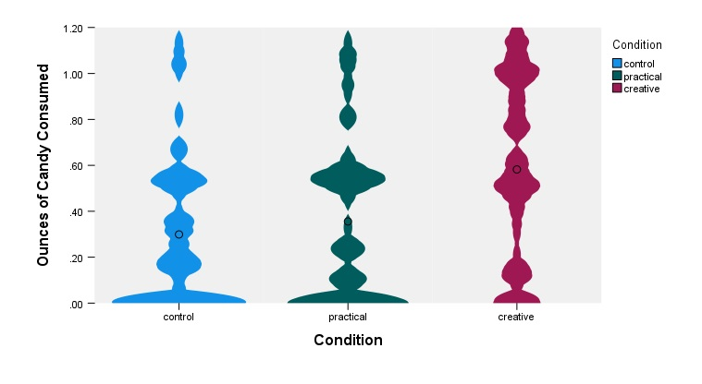
Figure S6b: Study 2 Violin Plot of Indulgence Scale by Condition
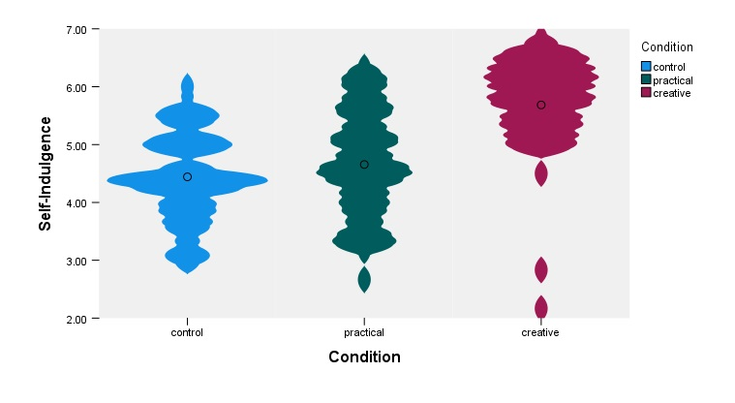

Figure S7: Study 3a Violin Plot of Burger Calories by Condition
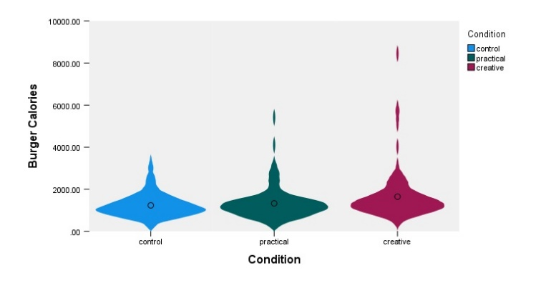
Figure S8: Study 3b Violin Plot of Burger Calories by Condition
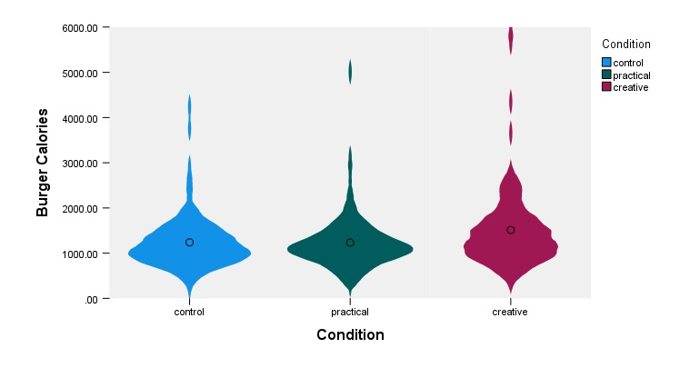

Figure S9a: Study 3c Violin Plot of Burger Calories by Condition
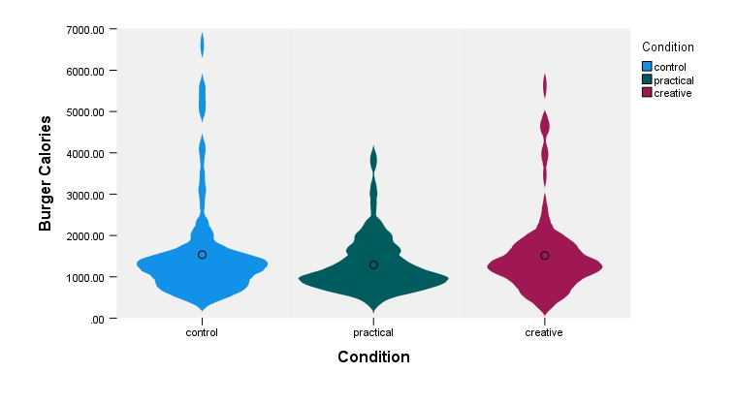
Figure S9b: Study 3c Violin Plot of Indulgence Scale by Condition
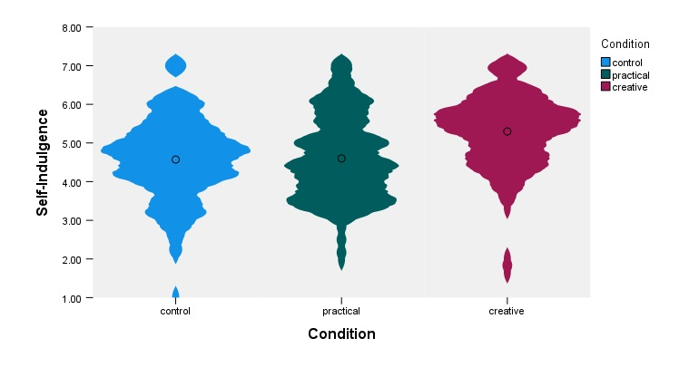

Figure S10: Study 4 Violin Plot of Burger Calories by Condition
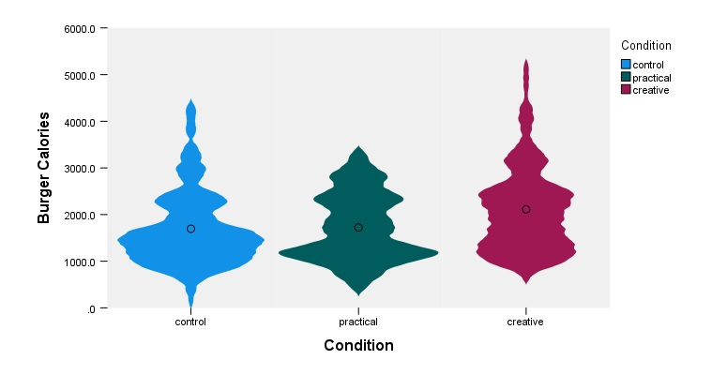

Figure S11a: Study 5 Violin Plot of Burger Calories by Condition
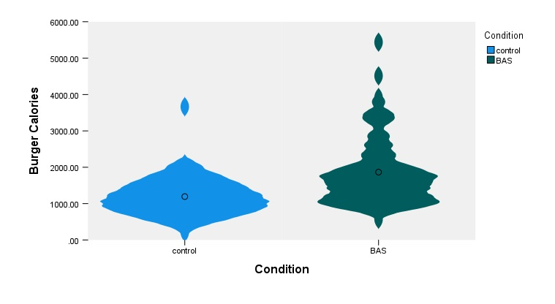

Figure S11b: Study 5 Violin Plot of Candy Consumed by Condition
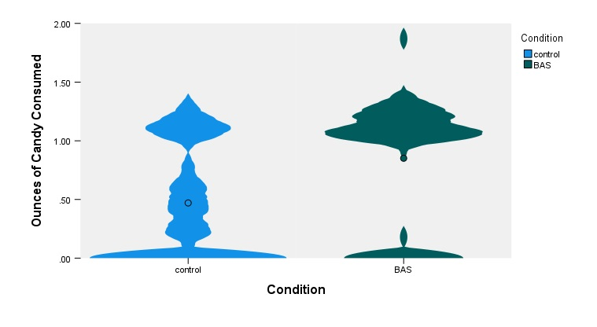

Figure S12: Study S1 Violin Plot of Burger Calories by Condition
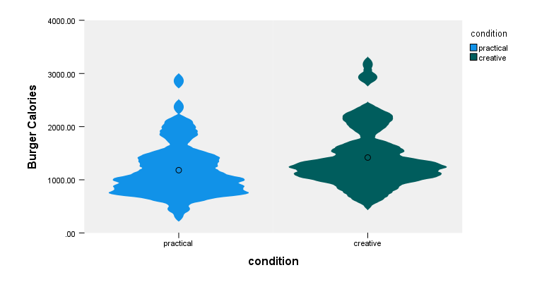

Figure S13: Study S2 Violin Plot of Burger Calories by Condition

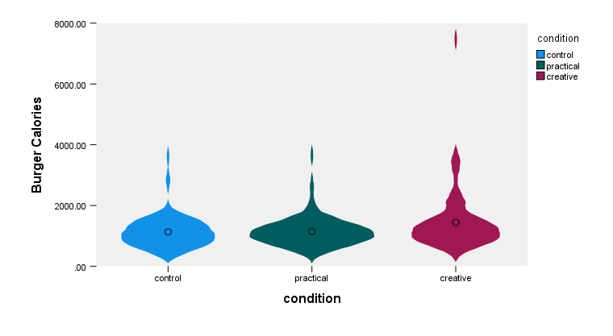

Figure S14: Study S3 Violin Plot of Burger Calories by Creativity and Self/Other Conditions

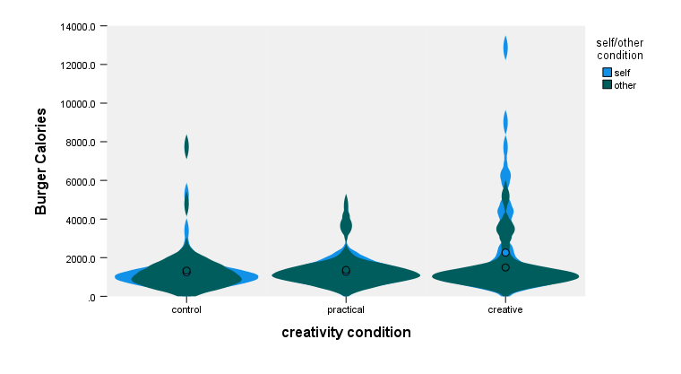

Figure S15a: Study S4 Violin Plot of Cocktail ABV by Condition

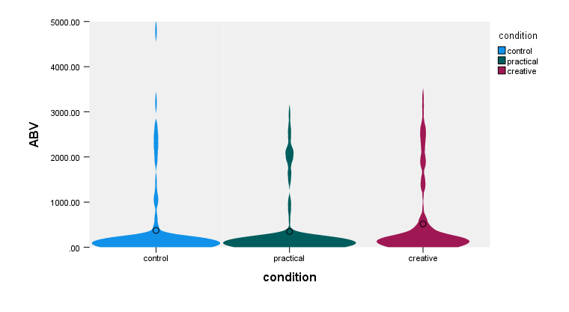
Figure S15b: Study S4 Violin Plot of Cocktail Calories by Condition

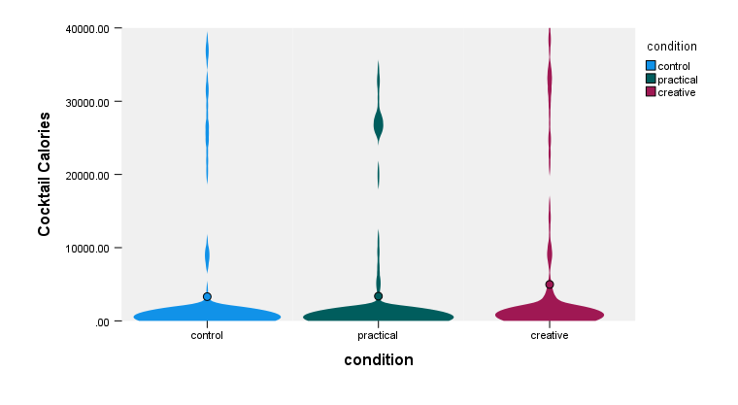

In study S2, participants were given five minutes instead of seven.

