SUPPLEMENTARY MATERIAL

More Than a Barrier:
Nostalgia Inhibits, but Also Promotes, Favorable Responses to Innovative Technology

STUDY 1A 2
STUDY S1 5
STUDY S2 10
STUDY 1B 12
STUDY 2 15
STUDY 3 18
STUDY 4 21

STUDY 1A

1. Stimulus Materials
Social Connectedness Manipulation (Kumashiro & Sedikides, 2005)
Social Connectedness Condition
Please think of a person to whom you turn when you feel distressed or worried. You may feel comfortable depending on this person, and you will not worry about being abandoned by this person. Please list six central traits that describe this person. Also, please recall a specific situation in which this person actually comforted and helped you when you were feeling distressed or worried. Please list several traits of that person and write a brief description of that situation.
Control Condition
Please think of a person you know but with whom you do not have a close relationship. You know this person casually. You will not consider the person to be your close friend and turn to the person for help. Please list six central traits that describe this person. Then please recall a specific situation in which you interacted with this person. Please list several traits of that person and write a brief description of that situation.
Manipulation Check
Recalling this person makes me feel loved.
Recalling this person makes me feel protected.
Recalling this person makes me feel connected to loved ones.
Recalling this person makes me feel supported.
Recalling this person makes me feel warm.

Quality of Humans—AI Robots Relationship (Adapted from Riketta, 2005)
In general, the relationship between humans and AI robots is harmonious.
Humans and AI robots easily get to like each other.
Humans and AI robots compete with each other. (reverse-scored)
Humans and AI robots easily get to dislike each other. (reverse-scored)

2. Parallel Analyses and Exploratory Factor Analyses
Social Connectedness Manipulation Check. Parallel analysis extracted a single factor (Eigenvalue = 3.27), whereas an exploratory factor analysis indicated that all items loaded on a single factor accounting for 80.91% of the variance (factor loadings > .861).
Quality of Human–AI Robot Relationship. Parallel analysis extracted a single factor (Eigenvalue = 2.31), which, according to an exploratory factor analysis, accounted for 57.81% of the variance (factor loadings > .710).
Positive Affect (PA) (see below). Parallel analysis extracted a single factor (Eigenvalue = 2.41), which, according to an exploratory factor analysis, accounted for 80.42% of the variance (factor loadings > .887).

3. Descriptive Statistics and Correlations
Variable | M (SD) | 2
1. Connectedness manipulation check | 5.02 (1.48) | .29***
2. Quality of humans-AI robots relationship | 4.67 (0.95)
***p < .001.

4. The Role of Affect
Given that nostalgia consistently induces positive affect (PA), and sometimes may also induce negative affect (NA; Frankenbach et al., 2021; Leunissen et al., 2021), we controlled for PA or NA across studies to test the unique effects of nostalgia. Here, we only assessed PA as a covariate. Following the stem “Recalling this person makes me feel …”, participants responded to three items (Kochanska, 2001; Mikulincer & Shaver, 2019; Wildschut et al., 2006): “happy,” “in a good mood,” “joyful” (1 = strongly disagree, 7 = strongly agree; α = .88).
Participants in the high social connectedness condition (M = 4.83, SD = 0.93) reported more PA than those in the low social connectedness condition (M = 4.02, SD = 1.12), F(1, 139) = 21.69, p < .001, η² = .14, 90% CI [0.06, 0.22]. We controlled for PA in an Analysis of Covariance. The effect of social connectedness on the quality of human–AI robot relationship remained significant, F(1, 138) = 10.22, p = .002, η² = .07, 90% CI [0.02, 0.14].
We followed-up with a mediation analysis via Process macro (Hayes, 2014, Model 4, 5000 bootstrap resamples). Social connectedness increased PA (b = 0.81, 95% CI [0.46, 1.15], SE = 0.17, t = 4.66, p < .001, b* = .73), which did not predict the quality of human–AI robot relationship (b = –0.06, 95% CI [–0.21, 0.09], SE = 0.08, t = –0.84, p = .401, b* = –.07). The indirect effect of social connectedness on the quality of human–AI robot relationship via PA was not significant, ab = –.05, SE = 0.07, bootstrap 95% CI [–0.19, 0.07]. PA did not account for the effect of social connectedness on the quality of human–AI robot relationship.

References
Kochanska, G. (2001). Emotional development in children with different attachment histories: The first three years. Child Development, 72(2), 474–490. https://doi.org/10.1111/1467-8624.00291

STUDY S1

1. Stimulus Materials
Social Connectedness Manipulation (adapted from Wildschut et al., 2006, Study 4)
“The Social Connectedness scale has been administered to a large number of participants over the last five years. Based on the responses of over 1,200 participants, we have developed a way of scoring your answers. This allows us to provide you with valid and detailed feedback regarding your level of social connectedness.”
High Connectedness Condition
I always feel distant from people.
I always don’t feel related to most people.
I always feel like an outsider.
I always see myself as a loner.
I always feel disconnected from the world around me.
I always don’t feel I participate with anyone or any group.
I always don’t feel close to people.
I am always not able to relate to my peers.
I always catch myself losing a sense of connectedness with society.
I am always not able to connect with other people.
Feedback: “You are on the 67th percentile of the social connectedness distribution. Compared to other participants, you are high on social connectedness.”
Low Connectedness Condition
I sometimes feel distant from people.
I sometimes don’t feel related to most people.
I sometimes feel like an outsider.
I sometimes see myself as a loner.
I sometimes feel disconnected from the world around me.
I sometimes don’t feel I participate with anyone or any group.
I sometimes don’t feel close to people.
I am sometimes not able to relate to my peers.
I sometimes catch myself losing a sense of connectedness with society.
I am sometimes not able to connect with other people.
Feedback: “You are on the 33rd percentile of the social connectedness distribution. Compared to other participants, you are low on social connectedness.”
Manipulation Check
At this moment, I feel loved.
At this moment, I feel protected.
At this moment, I feel connected to others.

Psychological Closeness with AI Robots (Aron et al., 1992)
“Please choose the diagram that best represented your relationship with AI robots.”
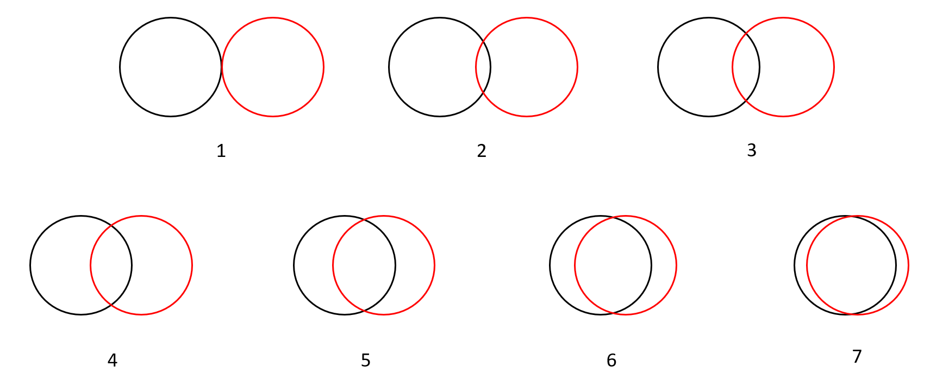

2. Description of Study S1
In Study S1, we tested the replicability of Study 1A: Does social connectedness improve responses to AI technology? We used a different manipulation of social connectedness (i.e., test feedback) and a different measure of responses to AI technology (i.e., psychological closeness with AI robots).
We recruited 206 Chinese participants on ePanel for 10 CNY (1.54 USD) each. Five of them quite the study. The final sample consisted of 201 participants (112 men, 89 women; M_{age} = 38.19 years, SD_{age} = 8.43 years). We randomly assigned them to the high social connectedness (n = 101) or low social connectedness (n = 100) condition.
We manipulated social connectedness similar to Wildschut et al. (2006, Study 4). Participants completed a 10-item social disconnectedness scale adapted from Lee et al. (2001). In the high social connectedness condition, we phrased each item so as to elicit disagreement (e.g., “I always feel disconnected from the world around me”; 1 = strongly disagree, 7 = strongly agree), whereas, in the low social connectedness condition, we phrased each item so as to elicit agreement (e.g., “I sometimes feel disconnected from the world around me”; 1 = strongly disagree, 7 = strongly agree). As intended, participants in the high social connectedness condition (M = 2.31, SD = 1.20) reported less agreement with the items than those in the low social connectedness condition (M = 3.28, SD = 1.39, F(1, 199) = 28.00, p < .001, η² = .12, 90% CI [0.06, 0.20]. Subsequently, participants received bogus feedback that their social connectedness score was either in the 67th percentile (high social connectedness condition) or 33rd percentile (low social connectedness condition) among their peers. As a manipulation check, they responded to three items (preceded by the stem “At this moment, I feel…”): “ loved,” “protected,” “connected to others” (1 = strongly disagree, 7 = strongly agree). The internal reliability of the manipulation check measure was good (α = .79). Parallel analysis extracted only one factor (Eigenvalue = 2.13). Further, exploratory factor analyses revealed that all items loaded on a single factor accounting for 71.04% of the variance (factor loadings > .823).
We measured perceived psychological closeness with AI robots with an adapted version of the Inclusion of Others in the Self (IOS) scale (Aron et al., 1992). We presented participants with seven diagrams, each depicting two circles (one representing humans, the other representing AI robots) with varying degrees of overlap. Participants chose the diagram that best represented humans’ relationship with AI robots; the greater the overlap between the two circles, the higher the psychological closeness.
Participants in the high social connectedness condition (M = 5.17, SD = 0.90) reported greater social connectedness than those in the low social connectedness condition (M = 4.39, SD = 1.32), F(1, 199) = 24.23, p < .001, η² = .11, 90% CI [0.05, 0.18], attesting to the effectiveness of the manipulation.
Participants in the high social connectedness condition (M = 4.94, SD = 1.16) reported greater psychological closeness with robots than those in the low social connectedness condition (M = 4.24, SD = 1.44), F(1, 199) = 14.44, p < .001, η² = .07, 90% CI [0.02, 0.13]. In replication of Study 1A findings, social connectedness enhanced responses to AI technology.

3. Descriptive Statistics and Correlations
Variable | M (SD) | 2
1. Connectedness manipulation check | 4.78 (1.19) | .19**
2. Psychological closeness with AI robots | 4.59 (1.35)
**p < .01.

4. The Role of Affect
We assessed PA with the items “happy,” “in a good mood,” and NA with the items “unhappy,” “sad” (Wildschut et al., 2006; “1 = strongly disagree, 7 = strongly agree), all preceded by the stem “Thinking about this event makes me feel …”. We averaged responses to create PA (r [199] = .88) and NA (r [199] = .85) indices.
Participants in the high social connectedness condition (M = 5.11, SD = 1.59) reported more PA than those in the low social connectedness condition (M = 3.97, SD = 1.56), F(1, 199) = 6.85, p = .010, η² = .03, 90% CI [0.005, 0.08]. However, participants in the high social connectedness condition (M = 2.60, SD = 1.66) reported equivalent NA to those in the low social connectedness condition (M = 2.61, SD = 1.65), F(1, 199) = 1.84, p = .177, η² = .01, 90% CI [0.00, 0.04].
Next, we conducted an Analysis of Covariance with PA as a covariate. The effect of social connectedness on psychological closeness with AI robots remained significant, F(1, 198) = 11.70, p = .001, η² = .06, 90% CI [0.02, 0.11]. We conducted a similar Analysis of Covariance with NA as a covariate. Again, the effect of social connectedness on psychological closeness with AI robots remained significant, F(1, 198) = 11.84, p = .001, η² = .06, 90% CI [0.02, 0.12].
Finally, we tested a mediation model on psychological closeness with AI robots, with PA and NA as mediators. Nostalgia increased PA (b = 0.49, 95% CI [0.12, 0.85], SE = 0.19, t = 2.62, p = .010, b* = .18) and decreased NA (b = –0.40, 95% CI [–0.75, –0.04], SE = 0.18, t = –2.19, p = .030, b* = –.15). Neither PA (b = –0.17, 95% CI [–0.27, 0.23], SE = 0.13, t = 0.13, p = .894, b* = –.02) nor NA (b = –0.18, 95% CI [–0.44, 0.08], SE = 0.13, t = –1.38, p = .171, b* = –.17) predicted support for research on companion robots. Therefore, the indirect effects of nostalgia on support for research on companion robots via PA (ab = –.01, SE = 0.07, bootstrap 95% CI [–0.16, 0.12]) and NA (ab = .07, SE = 0.07, bootstrap 95% CI [–0.03, 0.21]) were not significant. The analyses rule out the possibility that PA or NA accounted for the effect of social connectedness on psychological closeness with AI robots.

STUDY S2

1. Description of Study S2
In Study S2, we tested the replicability of findings from Study 1A and Study S1. We used the same social connectedness manipulation as in Study 1A (Mikulincer et al., 2005), and the same measure of responses to AI technology as in Study S2 (i.e., psychological closeness with AI robots). Further, we test participants from a different cultural group (i.e., USA).
We recruited 207 U.S. participants on Prolific Academic. We excluded nine because they quit the study. The final sample comprised 198 participants (127 women, 70 men, 1 unreported, M_{age} = 35.66 years, SD_{age} = 12.14 years). We randomly assigned participants to the high social connectedness (n = 100) or low social connectedness (n = 98) condition, remunerating each with 1.50 USD.
We manipulated social connectedness with the relationship visualization task (Mikulincer et al., 2005), as in Study 1A. We also used the same manipulation check items (α = .96). Parallel analysis extracted a single factor (Eigenvalue = 3.59), and exploratory factor analyses indicated that all items loaded on a single factor accounting for 89.65% of the variance (factor loadings > .937). We measured perceived psychological closeness with AI Robots using the IOS scale (Aron et al., 1992), as in Study S1.
Participants in the high social connectedness condition (M = 6.14, SD = 0.96) felt greater social connectedness than those in the low social connectedness condition (M = 3.31, SD = 1.62), F(1, 196) = 223.30, p < .001, η² = .53, 90% CI [0.46, 0.59]. The manipulation was successful.
In addition, participants in the high social connectedness condition (M = 2.87, SD = 1.57) reported greater psychological closeness with AI robots than those in the low social connectedness condition (M = 2.37, SD = 1.03), F(1, 198) = 7.04, p = .009, η² = .04, 90% CI [0.01, 0.09]. In replication of Studies 1A and S1, social connectedness increased psychological closeness with AI robots, this time among U.S. participants.

2. Descriptive Statistics and Correlations
Variable | M (SD) | 2
1. Connectedness manipulation check | 4.74 (1.95) | .16*
2. Psychological closeness with AI robots | 2.62 (1.35)
*p < .05.

STUDY 1B

1. Stimulus Materials
Manipulation of Skepticism About Change
Please indicate your agreement or disagreement with the “Skepticism Scale”, an internationally validated measure of attitudes toward change.
Low Skepticism Condition
I always fear change, because of the uncertainty it brings.
Change always makes me unhappy.
I always fear change, because I worry that I might lose something valuable.
I always view change as disruptive.
I always think that change is as a threat to stability.
I always avoid change.
I always fear that after change, I will have lost something meaningful to me.
I always find change unmanageable.
We will now have your responses to the “Skepticism Scale” scored via the computer. Next, we will give you feedback on your level of skepticism (i.e., attitudes toward change).
[The next page should show something like: SCORING IN PROCESS. PLEASE WAIT. This could last 10 seconds.]
The “Skepticism Scale” has been administered to a large number of participants in the last five years. Based on the responses of over 1,200 participants, we have developed a way of scoring your answers. This allows us to provide you with valid and detailed feedback about your level of skepticism (i.e., attitudes toward change).
Feedback: “You are on the 32nd percentile of the skepticism about change distribution. Compared to other participants, you are below average on skepticism. That is, your attitudes toward change are positive. You endorse change fairly strongly”.
Please explain why you are low on skepticism about change. Why are your attitudes toward change positive? Take at least 2 minutes to do so, although you can take as much time as you need.
High Skepticism Condition
I sometimes fear change, because of the uncertainty it brings.
Change sometimes makes me unhappy.
I sometimes fear change, because I worry that I might lose something valuable.
I sometimes view change as disruptive.
I sometimes think that change is as a threat to stability.
I sometimes avoid change.
I sometimes fear that after change, I will have lost something meaningful to me.
I sometimes find change unmanageable.
We will now have your responses to the “Skepticism Scale” scored via the computer. Next, we will give you feedback on your level of skepticism (i.e., attitudes toward change).
[The next page should show something like: SCORING IN PROCESS. PLEASE WAIT. This could last 10 seconds.]
The “Skepticism Scale” has been administered to a large number of participants in the last five years. Based on the responses of over 1,200 participants, we have developed a way of scoring your answers. This allows us to provide you with valid and detailed feedback about your level of skepticism (i.e., attitudes toward change).
Feedback: “You are on the 68th percentile of the skepticism about change distribution. Compared to other participants, you are above average on skepticism. That is, your attitudes toward change are somewhat negative. You do not endorse change strongly”.
Please explain why you are high on skepticism about change. Why are your attitudes toward change negative? Take at least 2 minutes to do so, although you can take as much time as you need.
Manipulation Check
Right now, I am feeling quite skeptical about change.
Right now, I am having skeptical feelings about change.
I feel skeptical about change at the moment.

Support for Research on Innovative Technologies
AI Technology
To what extent do you support research on AI technology?
To what extent do you support the use of taxpayer money for research on AI technology?
5G Technology
To what extent do you support research on 5G technology?
To what extent do you support the use of taxpayer money for research on 5G technology?

Behavioral Support for Innovative Technologies (adapted from Venus et al., 2019, Study 2)
We describe this dependent measure in the main text.

2. Descriptive Statistics and Correlations
Variable | M (SD) | 2 | 3 | 4
1. Skepticism manipulation check | 4.42 (1.65) | –.26*** | –.14* | –.25***
2. Support for research on innovative technology | 5.36 (1.08) |  | .17* | .15*
3. Behavioral support: Words | 47.34 (50.99) |  |  | .62***
4. Behavioral support: Time | 138.32 (119.52)
*p < .05, ***p < .001.

STUDY 2

1. Stimulus Materials
Southampton Nostalgia Scale (Sedikides et al., 2015)
According to the Oxford Dictionary, ‘nostalgia’ is defined as a ‘sentimental longing for the past.’
1. How valuable is nostalgia for you?
1 | 2 | 3 | 4 | 5 | 6 | 7
Not at all |  |  |  |  |  | Very much
2. How important is it for you to bring to mind nostalgic experiences?
1 | 2 | 3 | 4 | 5 | 6 | 7
Not at all |  |  |  |  |  | Very much
3. How significant is it for you to feel nostalgic?
1 | 2 | 3 | 4 | 5 | 6 | 7
Not at all |  |  |  |  |  | Very much
4. How prone are you to feeling nostalgic?
1 | 2 | 3 | 4 | 5 | 6 | 7
Not at all |  |  |  |  |  | Very much
5. How often do you experience nostalgia?
1 | 2 | 3 | 4 | 5 | 6 |  | 7
Very rarely |  |  |  |  |  | Very frequently
6. Generally speaking, how often do you bring to mind nostalgic experiences?
1 | 2 | 3 | 4 | 5 | 6 |  | 7
Very rarely |  |  |  |  |  | Very frequently
7. Specifically, how often do you bring to mind nostalgic experiences? (Please check one.)
-----Once or twice a year
-----Once every couple of months
-----Once or twice a month
-----Approximately twice a week
-----Approximately once a week
-----Three to four times a week
-----At least once a day

Social Connectedness
In general, I feel loved.
In general, I feel protected.
In general, I feel connected to loved ones.
In general, I feel that I can trust others.

Skepticism about Change
I am not sure change is good.
Change can lead you to places you don’t want to go.
Change can be tricky.
I am skeptical about change.

Support for Research on Innovative Technologies
AI Technology
To what extent do you support research on AI technology?
To what extent do you support the use of taxpayer money for research on AI technology?
To what extent do you support increasing state funding for research on AI technology?
5G Technology
To what extent do you support research on 5G technology?
To what extent do you support the use of taxpayer money for research on 5G technology?
To what extent do you support increasing state funding for research on 5G technology?

2. Parallel Analyses and Exploratory Factor Analyses
Nostalgia. Parallel analysis extracted only one factor (Eigenvalue = 5.01). Exploratory factor analyses revealed that all items loaded on a single factor accounting for 71.51% of the variance (factor loadings > .744).
Social Connectedness. Parallel analysis extracted only one factor (Eigenvalue = 2.63). Exploratory factor analyses revealed that all items loaded on a single factor accounting for 65.84% of the variance (factor loadings > .711).
Skepticism About Change. Parallel analysis extracted only one factor (Eigenvalue = 2.46). Exploratory factor analyses showed that four items loaded on one factor accounting for 61.48% of the variance (factor loadings > .741).
Support for Research on Innovative Technologies. For AI items, parallel analysis extracted only one factor (Eigenvalue = 2.54), which accounted for 84.79% of the variance (factor loadings > .867). For 5G items, parallel analysis extracted only one factor (Eigenvalue = 2.52), which accounted for 83.89% of the variance (factor loadings > .865).

STUDY 3

1. Stimulus Materials
Nostalgia Manipulation (Event Reflection Task; Sedikides et al., 2015)
Nostalgia Condition
Nostalgia is defined as a sentimental longing for one’s past or as feeling sentimental about a fond and valued memory from one’s personal past (e.g., childhood, close relationship, momentous events). Please think of a nostalgic event in your life. Specifically, try to think of a past event that makes you feel most nostalgic. Bring this nostalgic experience to mind. Immerse yourself in this nostalgic experience for a couple of minutes and think about how it makes you feel. … Now please list four keywords that summarize the gist of the event you recalled. … Now please describe this event in no more than 150 words.
Control Condition
Please think of an ordinary event in your life. Specifically, try to think of a past event that is ordinary and normal. Bring this ordinary experience to mind, immerse yourself in the ordinary experience for a couple of minutes, and think about how it makes you feel. … Now please list four keywords that summarize the gist of the event you recalled. … Now please describe this event in no more than 150 words.
Manipulation Check
Right now, I am feeling quite nostalgic.
Right now, I am having nostalgic thoughts.
I feel nostalgic at the moment.

Social Connectedness
Thinking about this event makes me feel loved.
Thinking about this event makes me feel protected.
Thinking about this event makes me feel connected to loved ones.
Thinking about this event makes me feel that I can trust others.

Skepticism about Change
I am not sure change is good.
Change can lead you to places you don’t want to go.
Change can be tricky.
I am skeptical about change.

Support for Research on Innovative Technologies
AI Technology
To what extent do you support research on AI technology?
To what extent do you support the use of taxpayer money for research on AI technology?
5G Technology
To what extent do you support research on 5G technology?
To what extent do you support the use of taxpayer money for research on 5G technology?

Participation in Research on Innovative Technologies
We describe this dependent measure in the main text.

2. Parameters Used in Sample Size Planning
The parameters we used in the analysis are:
b* (X-M1): .19
b* (X-M2): .22
b* (X-Y): –.15
b* (M1-M2): –.05
b* (M1-Y): .21
b* (M2-Y): –.27
Standard Deviations of X, M1, M2, and Y are: 1.27, 1.17, 1.28, 1.14

3. Parallel Analyses and Exploratory Factor Analyses for all Measures
Nostalgia Manipulation Check. Parallel analysis extracted only one factor (Eigenvalue = 2.72). Exploratory factor analyses revealed that all items loaded on a single factor accounting for 90.73% of the variance (factor loadings > .949).
Social Connectedness. Parallel analysis extracted only one factor (Eigenvalue = 2.63). Exploratory factor analyses revealed that all items loaded on a single factor accounting for 65.70% of the variance (factor loadings > .716).
Skepticism about Change. Parallel analysis extracted only one factor (Eigenvalue = 2.65). Exploratory factor analyses revealed that all items loaded on a single factor accounting for 66.28% of the variance (factor loadings > .723).
Support for Research on Innovative Technologies. For AI items, parallel analysis extracted only one factor (Eigenvalue = 1.66), which accounted for 83.15% of the variance (factor loadings > .912). For 5G items, parallel analysis extracted only one factor (Eigenvalue = 1.51), which accounted for 75.50% of the variance (factor loadings > .869).

4. Descriptive Statistics and Correlations
Variable | M (SD) | 2 | 3 | 4 | 5 | 6 | 7
1. Nostalgia manipulation check | 4.42 (1.65) | .38*** | .15** | .07 | .08 | .08 | .10†
2. Social connectedness | 5.20 (0.97) |  | –.03 | .18** | .15** | .20*** | .22***
3. Skepticism about change | 4.23 (1.21) |  |  | –.34*** | –.21*** | –.14* | –.10†
4. Support for research on AI | 5.36 (1.08) |  |  |  | .70*** | .34*** | .27***
5. Support for research on 5G | 5.78 (0.94) |  |  |  |  | .22*** | .33***
6. Participation in AI research | 0.71 (0.45) |  |  |  |  |  | .64***
7. Participation in 5G research | 0.69 (0.46)
†p < .10, *p < .05, **p < .01, ***p < .001.

STUDY 4

1. Stimulus Materials
Nostalgia Manipulation
Nostalgia Condition
Pictures (nostalgic pictures/objects: adapted from Oba et al., 2015; Yang et al., 2021)
Twenty objects are depicted in the pictures below. Please indicate whether you are familiar with each object (1 = familiar, 0 = unfamiliar).
[Show each of 20 pictures once at a time]
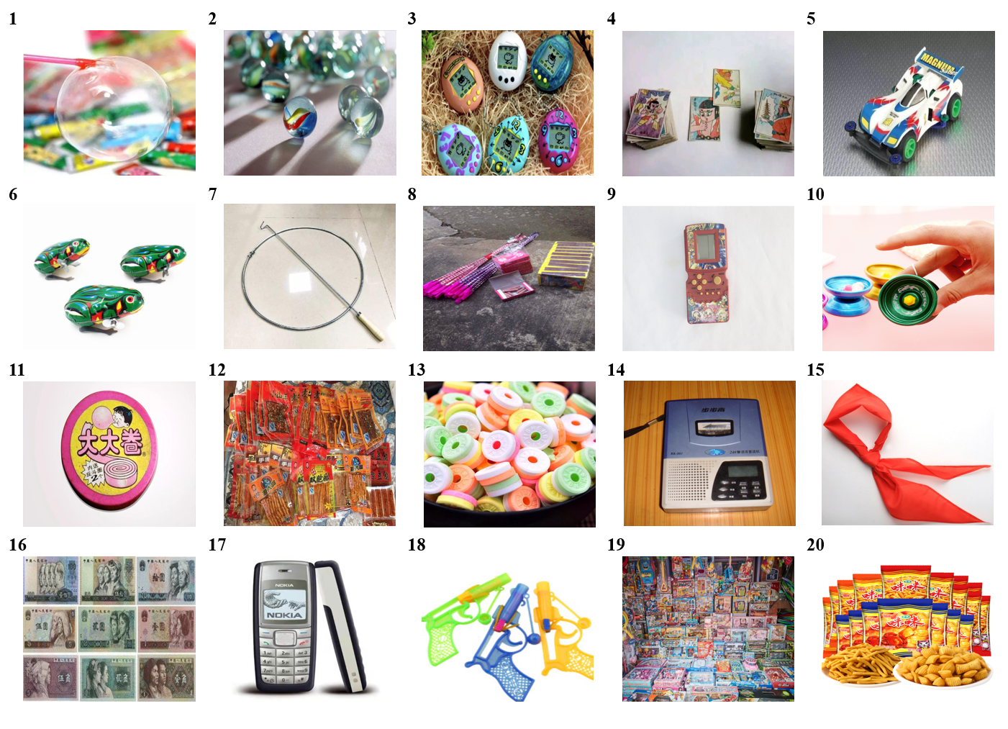
1 = balloon glue, 2 = marble, 3 = cyberpet, 4 = cards, 5 = four-drive toy vehicle, 6 = clockwork frog, 7 = hoop rolling, 8 = hand-held fireworks, 9 = Tetris game, 10 = YOYO, 11 = tata bubble gum, 12 = spicy gluten, 13 = whistling candy, 14 = BBK repeater, 15 = red scarf, 16 = antique editions of RMB paper currency, 17 = NOKIA mobile phone, 18 = popgun, 19 = assembled toy suit, 20 = prawn crackers.
Prototype (central features: adapted from Hepper et al., 2012)
Step 1
Below are listed 12 features that might describe or characterize experiences and memories that we have in our lives. Please read these features carefully.
[Show simultaneously the 12 features here]
rose-colored memories | keepsakes | reliving | familiar smells
reminiscing | Longing | familiar tastes | fond memories
feeling happy | childhood/youth | emotions | personal meaning
Step 2
Now please bring to mind an event in your life that (1) is relevant to at least one of the 20 objects depicted in the pictures you just saw, and (b) is characterized by at least five of the 12 features above. Specifically, try to think of a past event whereby at least one object and five features were part of it and/or describe your current experience as you think about it. This event can be recent or refer back to earlier years of your life.
Step 3
[Show 20 pictures and 12 features again here]
Please select the objects (at least one) and features (at least five) that are relevant to this event.
Step 4
Now we would like you to spend five minutes imagining that you are back at this event. Try and immerse yourself into this event, trying to remember exactly what happened at the time.
We will time you while you do this, and tell you when you can stop imagining yourself experiencing the event.
Step 5
Now in the space below please take at least five minutes to recall and write a brief description of (a) the event, and (b) your experience as you remember the event.
____________________________________________________________________________________________________________________________________________________________
Step 6
The following statements refer to how you feel right now. Please indicate your agreement or disagreement by placing a number in the blank space preceding each statement. The number should be anywhere from 1 to 7, according to the following scale.
1 | 2 | 3 | 4 | 5 | 6 | 7
Strongly disagree | Moderately disagree | Slightly disagree | Not sure | Slightly  agree | Moderately agree | Strongly  agree
___ Right now, I am feeling quite nostalgic.
___ Right now, I am having nostalgic feelings
___ I feel nostalgic at the moment.

Control Condition
Pictures (neutral pictures/objects: adapted from Oba et al., 2015; Yang et al., 2021)
Several objects are depicted in the pictures below. Please indicate whether you are familiar with each object (1 = familiar, 0 = unfamiliar).
[Show each of 20 pictures once at a time]
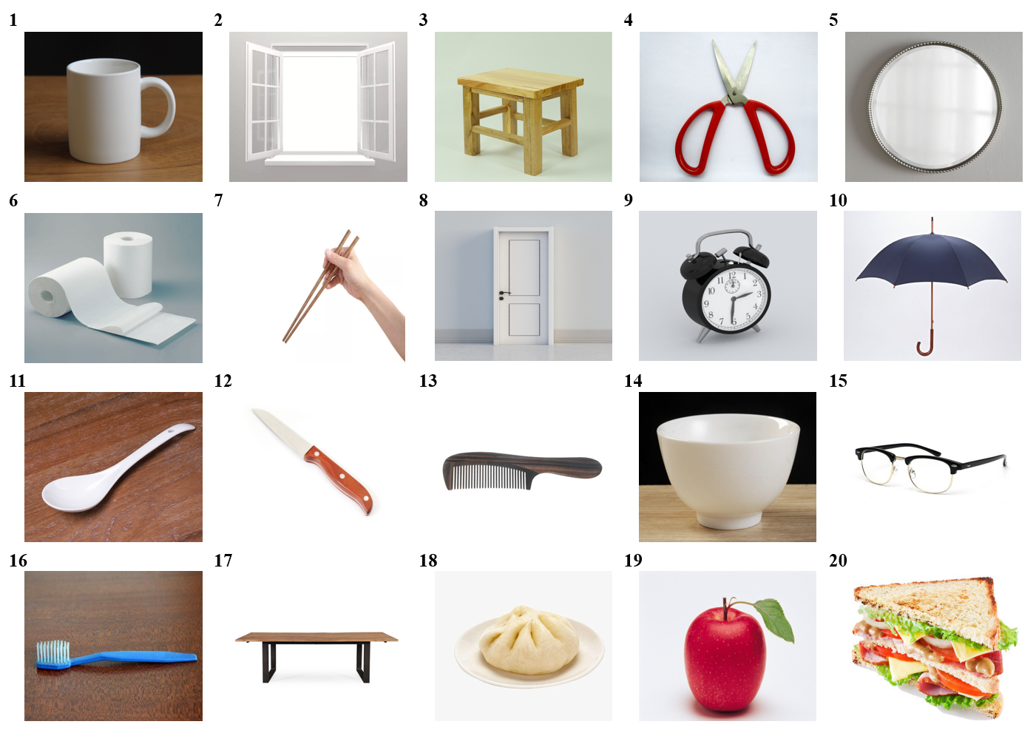
1 = cup, 2 = window, 3 = stool, 4 = scissors, 5 = mirror, 6 = rolled toilet paper, 7 = chopsticks, 8 = door, 9 = clock, 10 = umbrella, 11 = porcelain spoon, 12 = knife, 14 = bowl, 15 = glasses, 16 = toothbrush, 17 = bench, 18 = steamed stuffed bun, 19 = apple, 20 = sandwich.

Prototype (Peripheral features; adapted from Hepper et al., 2012)
Step 1
Below are listed 12 features that might describe or characterize experiences and memories that we have in our lives. Please read these features carefully.
[Show simultaneously the 12 features here]
feeling warm/comforted | anxiety/pain | wishing | achievements
regret | Daydreaming | laziness | bittersweet
feeling sad | change | ageing | bad memories
Step 2
Now please bring to mind an event in your life that (1) is relevant to at least one of the 20 objects depicted in the pictures you just saw, and (b) is characterized by at least five of the 12 features above. Specifically, try to think of a past event whereby at least one object and five features were part of it and/or describe your current experience as you think about it. This event can be recent or refer back to earlier years of your life.
Step 3
[Show 20 pictures and 12 features again here]
Please select the objects (at least one) and features (at least five) that are relevant to this event.
Step 4
Now we would like you to spend five minutes imagining that you are back at this event. Try and immerse yourself into this event, trying to remember exactly what happened at the time.
We will time you while you do this, and tell you when you can stop imagining yourself experiencing the event.
Step 5
Now in the space below please take at least five minutes to recall and write a brief description of (a) the event, and (b) your experience as you remember the event.
____________________________________________________________________________________________________________________________________________________________
Step 6
The following statements refer to how you feel right now. Please indicate your agreement or disagreement by placing a number in the blank space preceding each statement. The number should be anywhere from 1 to 7, according to the following scale.
1 | 2 | 3 | 4 | 5 | 6 | 7
Strongly disagree | Moderately disagree | Slightly disagree | Not sure | Slightly  agree | Moderately agree | Strongly  agree

Manipulation Check
___ Right now, I am feeling quite nostalgic.
___ Right now, I am having nostalgic feelings
___ I feel nostalgic at the moment.

Social Connectedness
Thinking about this event makes me feel loved.
Thinking about this event makes me feel protected.
Thinking about this event makes me feel connected to loved ones.
Thinking about this event makes me feel that I can trust others.

Skepticism about Change
I am not sure change is good.
Change can lead you to places you don’t want to go.
Change can be tricky.
I am skeptical about change.

Support for Research on Companion Robots
To what extent do you support research on companion robots?
To what extent do you support the use of taxpayer money for research on companion robots?
To what extent do you support increasing state funding for research on companion robots?

Adoption of Companion Robots
Would you like to use companion robots or real pets in the following situation?
1. If you’re a child’s parent, would you prefer to let a companion robot or a real pet play with your child?
2. If you’re a nursing home manager, would you prefer companion robots or real pets living with residents with dementia?
3. If you’re a doctor, would you prefer to use a companion robot or a real pet to calm delirious patients?
4. If you’re a social worker at a retirement center, would you prefer to let a companion robot or a real pet live with older people?
5. If you’re a therapist, would you prefer to put companion robots or real pets as play partners for children with autism?
6. If you’re a volunteer in the community, would you recommend that socially isolated young adults have a companion robot or a real pet?

2. Parameters Used in Sample Size Planning
r (X-M1): .30 (.23)
r (X-M2): .26 (.21)
r (X-Y): .03 (.02)
r (M1-M2): –.03 (–.03)
r (M1-Y): .20 (.19)
r (M2-Y): –.23 (–.20)
SD (X): 0.50
SD (M1): 0.97
SD (M2): 1.21
SD (Y): 0.73
Correlations involving the outcome variable (Y) are average correlations across the four measures of responses to innovative technology in Study 3 (i.e., support for, and participation in, research on AI and 5G technology). Small discrepancies with (average) point-biserial correlations reported in Table 3 (see above, in parentheses) arise because sample size planning inadvertently used biserial correlations. Repeating the power analysis with point-biserial correlations yielded a requisite sample size of 278 to achieve 80% power, which we exceeded (Study 4 N = 300).

3. Parallel Analyses and Exploratory Factor Analyses for all Measures
Nostalgia Manipulation Check. Parallel analysis extracted only one factor (Eigenvalue = 2.61). Exploratory factor analyses revealed that all items loaded on a single factor accounting for 86.95% of the variance (factor loadings > .917).
Social Connectedness. Parallel analysis extracted only one factor (Eigenvalue = 3.07). Exploratory factor analyses revealed that all items loaded on a single factor accounting for 76.71% of the variance (factor loadings > .832).
Skepticism about Change. Parallel analysis extracted only one factor (Eigenvalue = 2.24). Exploratory factor analyses revealed that all items loaded on a single factor accounting for 56.03% of the variance (factor loadings > .717).
Support for Research on Companion Robots. Parallel analysis extracted only one factor (Eigenvalue = 2.41). Exploratory factor analyses revealed that all items loaded on a single factor accounting for 80.37% of the variance (factor loadings > .858).

4. Descriptive Statistics and Correlations
Variable | M (SD) | 2 | 3 | 4 | 5
1. Nostalgia manipulation check | 4.66 (1.92) | .44*** | .17** | .20*** | .01
2. Social connectedness | 4.19 (1.81) |  | .05 | .42*** | .29***
3. Skepticism about change | 3.87 (1.28) |  |  | –.14* | –.17**
4. Support for research on companion robots | 4.41 (1.22) |  |  |  | .36***
5. Adoption of companion robots | 2.16 (1.41)
*p < .05, **p < .01, ***p < .001.

5. The Role of Affect
We measured PA (r [298] = .90) and NA (r [298] = .69) as in Study 3. Nostalgic compared to control participants reported higher PA (M = 5.31, SD = 1.48 vs. M = 3.60, SD = 1.96; F(1, 298) = 72.86, p < .001, η² = .20, 90% CI [0.13, 0.26]) and lower NA (M = 2.44, SD = 1.48 vs. M = 3.46, SD = 1.90; F(1, 298) = 26.81, p < .001, η² = .08, 90% CI [0.04, 0.14]).
Support for Research on Companion Robots
In mediation analyses with PA as a covariate, nostalgic (compared to control) participants reported higher social connectedness (b = 1.18, 95% CI [0.79, 1.57], SE = 0.20, t = 5.91, p < .001, b* = .33), which, in turn, predicted improved support for research on companion robots (b = 0.28, 95% CI [0.20, 0.36], SE = 0.04, t = 6.79, p < .001, b* = .42). Nostalgic (compared to control) participants reported higher skepticism about change (b = 0.80, 95% CI [0.48, 1.11], SE = 0.16, t = 4.95, p < .001, b* = .31), which, in turn, negative predicted support for research on companion robots (b = –0.15, 95% CI [–0.25, –0.05], SE = 0.05, t = –2.91, p = .004, b* = –.16). The indirect effects of nostalgia on support for research on companion robots via social connectedness (ab = .33, SE = 0.08, bootstrap 95% CI [0.19, 0.49]) and skepticism about change (ab = –.12, SE = 0.05, bootstrap 95% CI [–0.23, –0.03]) were significant.
In similar mediation analyses with NA as a covariate, nostalgic (compared to control) participants reported higher social connectedness (b = 1.41, 95% CI [1.05, 1.77], SE = 0.18, t = 7.62, p < .001, b* = .39), which, in turn, predicted improved support for research on companion robots (b = 0.29, 95% CI [0.20, 0.37], SE = 0.04, t = 6.88, p < .001, b* = .42). Nostalgic (compared to control) participants reported higher skepticism about change (b = 0.76, 95% CI [0.47, 1.04], SE = 0.15, t = 5.17, p < .001, b* = .30), which, in turn, negative predicted support for research on companion robots (b = –0.15, 95% CI [–0.26, –0.05], SE = 0.05, t = –2.90, p = .004, b* = –.16). The indirect effects of nostalgia on support for research on companion robots via social connectedness (ab = .40, SE = 0.08, bootstrap 95% CI [0.27, 0.56]) and skepticism about change (ab = –.11, SE = 0.05, bootstrap 95% CI [–0.22, –0.03]) were significant.
Next, we tested a mediation model on support for research on companion robots, with PA and NA as mediators. Nostalgia increased PA (b = 1.79, 95% CI [1.40, 2.18], SE = 0.20, z = 9.07, p < .001, b* = .46) and decreased NA (b = –1.02, 95% CI [–1.41, –0.63], SE = 0.20, z = –5.20, p < .001, b* = –.29). Neither PA (b = 0.07, 95% CI [0.17, –0.03], SE = 0.05, z = 1.39, p = .166, b* = .11) nor NA (b = –0.06, 95% CI [–0.16, 0.04], SE = 0.05, z = –1.28, p = .201, b* = –.09) predicted support for research on companion robots. Therefore, the indirect effects of nostalgia on support for research on companion robots via PA (ab = .12, SE = 0.09, bootstrap 95% CI [–0.08, 0.34]) and NA (ab = .07, SE = 0.05, bootstrap 95% CI [–0.05, 0.20]) were not significant.
Adoption of Companion Robot Adoption
In mediation analyses with PA as a covariate, nostalgic (compared to control) participants reported higher social connectedness (b = 1.69, 95% CI [1.33, 2.05], SE = 0.18, z = 9.17, p < .001), which, in turn, predicted improved companion robot adoption (b = 0.28, 95% CI [0.18, 0.37], SE = 0.05, z = 5.86, p < .001). Nostalgic (compared to control) participants reported higher skepticism about change (b = 0.58, 95% CI [0.29, 0.86], SE = 0.14, z = 4.00, p < .001), which, in turn, negatively predicted companion robot adoption (b = –0.19, 95% CI [–0.32, –0.07], SE = 0.06, z = –3.11, p = .002). The indirect effects of nostalgia on companion robot via social connectedness (ab = .47, SE = 0.09, bootstrap 95% CI [0.30, 0.67]) and via skepticism about change (ab = –.11, SE = 0.04, bootstrap 95% CI [–0.21, –0.04]) were significant.
In similar mediation analyses with NA as a covariate, nostalgic (compared to control) participants reported higher social connectedness (b = 1.69, 95% CI [1.33, 2.05], SE = 0.18, z = 9.17, p < .001), which, in turn, predicted improved companion robot adoption (b = 0.28, 95% CI [0.18, 0.37], SE = 0.05, z = 5.66, p < .001). Nostalgic (compared to control) participants reported higher skepticism about change (b = 0.58, 95% CI [0.29, 0.86], SE = 0.14, z = 4.00, p < .001), which, in turn, negatively predicted companion robot adoption (b = –0.20, 95% CI [–0.32, –0.08], SE = 0.06, z = –3.15, p = .002). The indirect effects of nostalgia on companion robot via social connectedness (ab = .47, SE = 0.10, bootstrap 95% CI [0.30, 0.68]) and via skepticism about change (ab = –.11, SE = 0.04, bootstrap 95% CI [–0.22, –0.04]) were significant.
Next, we tested a mediation model on adoption of companion robot adoption, with PA and NA as mediators. Nostalgia increased PA (b = 1.79, 95% CI [1.40, 2.18], SE = 0.20, z = 9.07, p < .001, b* = .46) and decreased NA (b = –1.02, 95% CI [–1.41, –0.63], SE = 0.20, z = –5.20, p < .001, b* = –.29). Neither PA (b = 0.05, 95% CI [–0.17, 0.16], SE = 0.06, z = 0.77, p = .442, b* = .06) nor NA (b = –0.04, 95% CI [–0.16, 0.07], SE = 0.04, z = –0.74, p = .462, b* = –.06) predicted support for research on companion robots. Therefore, the indirect effects of nostalgia on support for research on companion robots via PA (ab = .08, SE = 0.11, bootstrap 95% CI [–0.13, 0.29]) and NA (ab = .05, SE = 0.06, bootstrap 95% CI [–0.07, 0.18]) were not significant.
In ancillary analyses, we specified a Poisson distribution for adoption of companion robots, using the COUNT option in Mplus. Results of these analyses were essentially identical to those reported above.

