Supplementary Materials

Study 1R—supplemental replication

Method
In Study 1R we recruited an increased sample of 200 participants. We pre-registered this experiment on Open Science Framework: [https://osf.io/g842u]. We aimed to recruit at least 200 advisers based on recommendations to conduct studies with large samples (Simmons et al., 2011).
Participants were randomly assigned to a intact configural vs. impared configural processing condition.
Stimuli.



Design and procedure. The target in the photo is looking toward a book on the right of the table from the participant’s perspective, but from the target’s perspective, the individual is looking toward the left. To measure perspective taking, participants were asked the question, “On what side of the table is the book?” and were given the options either “left” or “right.” Participants who answered “left” were categorized as having adopted the perspective of the individual in the photograph.

Results
In the configural processing condition, a greater percentage of participants (75%, 81/108) took the target’s perspective than in the featural processing condition (46%, 43/92), χ² = 16.84, p < .001.

Study 3
Stimuli

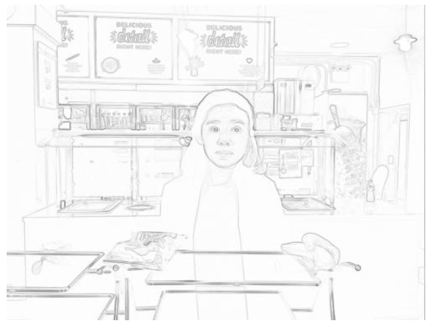

Not conflicted

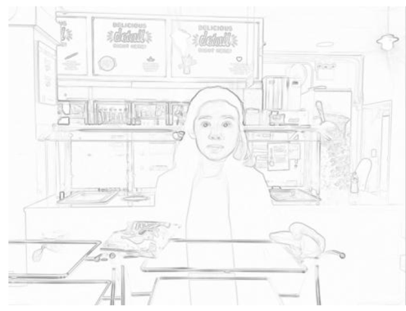

Featural Processing Condition

Configural Processing Condition

Conflicted

Additional Dependent Measures
Participants also indicated what snack they thought the target would select (banana or chips) and the extent to which the person wanted each item (1=not at all to 7=extremely).
Results

Table S1. Perceptions of Target by Condition (Study 3)

 |  | Prediction |  | Perception (1=not at all; 7=extremely)
 |  | Wants unhealthy choice | Selects unhealthy choice | Wants unhealthy option | Wants  healthy option | Feels Conflicted
Configural | Gaze at unhealthy  (Conflict condition) | 60%  (61/101) | 39%  (39/101) | 4.93  [4.61, 5.25] | 4.08  [3.77, 4.39] | 4.50  [4.17, 4.82]
 | Gaze at healthy  (No conflict condition) | 36%  (36/101) | 22%  (22/101) | 3.91  [3.59, 4.23] | 4.65  [4.35, 4.96] | 4.02  [3.69, 4.35]
Featural | Gaze at unhealthy  (Conflict condition) | 50%  (50/100) | 43%  (43/100) | 4.83  [4.51, 5.15] | 4.45  [4.14, 4.76] | 4.32  [3.99, 4.65]
 | Gaze at healthy  (No conflict condition) | 45%  (45/99) | 35%  (35/99) | 4.74  [4.41, 5.06] | 4.53  [4.22, 4.84] | 4.62  [4.28, 4.95]
Frequencies are reported in parentheses for binary variables, and standard deviations are reported in brackets for continuous variables.

Predicted selection. As predicted, a logistic regression with perceptions of what choice the individual would ultimately select did not reveal an interaction between processing style and conflict, Wald χ² = 1.32, p = .25.
Using an ANOVA with the predicted likelihood of the individual selecting the healthy option as the dependent variable (on a seven-point scale), and processing style, conflict, and their interaction as the independent variables, we also did not find an interaction between processing style and conflict, F(1, 397) = 1.60, p = .21, η_{p}² = .004. We found a significant main effect of conflict such that participants thought the target would be less likely to have the chips in the conflict condition (M = 4.64, SD = 1.80) than in the control (M = 5.03, SD = 1.74), F(1, 397) = 4.90, p = .03, η_{p}² = .01. Additionally, we found another main effect of processing style such that participants thought the target would be more likely to have a banana more in the configural condition (M = 5.00, SD = 1.76) than in the featural condition (M = 4.65, SD = 1.78), F(1, 397) = 4.08, p = .04, η_{p}² = .01.
Want (continuous measure). We found a significant main effect of conflict such that participants thought the target wanted the banana less in the conflict condition (M = 4.26, SD = 1.64) than in the control (M = 4.59, SD = 1.49), F(1, 397) = 4.30, p = .04, η_{p}² = .01. additionally, a similar interaction emerged. In particular, we found an interaction between the processing style and conflict conditions on perceptions of how much the target wanted the unhealthy option, F(1, 397) = 21.54, p = .005, η_{p}² = .02, but not on how much the target wanted the healthy option, F(1, 397) = 2.54, p = .11, η_{p}² = .006. This pattern suggests that participants’ inferences about what the target wanted were driven by perceived desire for the unhealthy option.

