Supplementary Materials

Table S1. Overview of all predictor variables assessed at each time point in each study
 |  | Push |  | Pull
 |  | Moral Emotions | Moral Cognitions | Hedonic Motivations | Rationalizing Cognitions
Study 1 | Time 1 | Meat Emotions,  Animal Emotions | Suffering | Tastiness | --
 | Time 2 | Meat Emotions,  Animal Emotions | Suffering,  Moral Piggybacking | Tastiness | --
 | Time 3 | Meat Emotions,  Animal Emotions | Suffering,  Moral Piggybacking | Tastiness | --
Study 2 | Time 1 | Meat Emotions,  Animal Emotions | Suffering | Tastiness | --
 | Time 2 | Meat Emotions,  Animal Emotions | Moral Piggybacking | -- | --
 | Time 3 | Meat Emotions,  Animal Emotions | Moral Piggybacking | -- | --
 | Time 4 | Meat Emotions,  Animal Emotions | Suffering | Tastiness | --
Study 3 | Time 1 | Meat Emotions,  Animal Emotions | Suffering,  Moral Piggybacking,  Animals-Humans Similar | Tastiness | Natural,  Necessary,  Life Impossible,  Social Pressures,  Personal Choice
 | Time 2 | Meat Emotions,  Animal Emotions | Suffering,  Moral Piggybacking,  Animals-Humans Similar | Tastiness | Natural,  Necessary,  Life Impossible,  Social Pressures,  Personal Choice
 | Time 3 | Meat Emotions,  Animal Emotions | Suffering,  Moral Piggybacking,  Animals-Humans Similar | Tastiness | Natural,  Necessary,  Life Impossible,  Social Pressures,  Personal Choice
 | Time 4 | Meat Emotions,  Animal Emotions | Suffering,  Moral Piggybacking,  Animals-Humans Similar | Tastiness | Natural,  Necessary,  Life Impossible,  Social Pressures,  Personal Choice

Study 1

Method

Demographic Information

The average age of the participants was 18.80 (SD = 3.29), and they reported the following ethnicities: African Canadian/Carribean/Black = 6%, Caucasian/White = 11%, East Asian (e.g., Chinese, Korean, Vietnamese, etc.) = 24%, Latino/Hispanic = 2%, Middle Eastern/North African = 5%, South Asian (e.g., Indian, Sri Lankan, Pakistani, etc.) = 32%, and Multi-racial/Other = 20%.

Exploratory items

Meat Attitudes
“When you think about what you personally eat, what is your attitude toward eating meat?”
“When you think about what people in general eat, what is your attitude toward eating meat?”
Response Scale:
- Strongly opposed to eating meat
- Somewhat opposed to eating meat
- Slightly opposed to eating meat
- Not at all opposed to eating meat
Correlations between the two items were:
Time 1: r = .71***
Time 2: r = .75***
Time 3: r = .76***
Meat Attitudes means and standard deviations were:
Time 1: 3.47 (.80)
Time 2: 3.25 (.89)
Time 3: 3.10 (.92)
Meat Attitudes correlations with moralization:
Time 1: -.54***
Time 2: -.59***
Time 3: -.59***

Vegetarianism Attitudes
“In general how do you feel about the idea of vegetarianism?”
Response Scale:
- Strongly in Favor
- Somewhat in Favor
- Neutral
- Somewhat Opposed
- Strongly Opposed
Vegetarian Attitudes means and standard deviations were:
Time 1: 3.33 (1.02)
Time 2: 2.64 (.86)
Time 3: 2.56 (.84)
Vegetarian Attitudes correlations with moralization:
Time 1: -.36**
Time 2: -.43***
Time 3: -.45***

Meat Health Attitudes
“How much do you believe eating meat is important for maintaining good health?
Response Scale:
- Not at all
- Slightly
- Moderately
- Much
- Very Much
Meat Health Attitudes means and standard deviations were:
Time 1: 3.38 (1.11)
Time 2: 3.13 (1.13)
Time 3: 3.06 (1.11)
Meat Health Attitudes correlations with moralization:
Time 1: -.28***
Time 2: -.21***
Time 3: -.09

Meat Environment Attitudes
“How much do you believe eating meat has harmful effects on the environment?”
Response Scale:
- Not at all
- Slightly
- Moderately
- Much
- Very Much
Meat Environment Attitudes means and standard deviations were:
Time 1: 2.97 (1.14)
Time 2: 3.29 (1.14)
Time 3: 3.45 (1.08)
Meat Environment Attitudes correlations with moralization:
Time 1: .42***
Time 2: .39***
Time 3: .32***

Classification as a Meat Eater
We asked participants to classify themselves as one of the following: “Daily meat-eater (eat meat most everyday)”, “Occasional meat-eater (eat meat some days but not all)”, “Rare meat-eater (eat meat, but rarely)”, “Pescatarian (never eat meat except for fish)”, “Vegetarian (never eat meat, but do eat eggs, dairy, and other foods produced by animals)”, “Vegan (never eat meat or anything produced by animals).”

Results

Table S2. Means, standard deviations, and correlations for all variables collected at each time point. (Study 1)
 | Time | Means (SD) | Meat Emotions | Animal Emotions | Suffering | Tastiness | Moral Piggybacking
Moralization | 1  2  3 | 2.26 (1.02)  2.45 (1.00)  2.65 (1.06) | .67  .59  .61 | .43  .47  .52 | .34  .34  .38 | -.38  -.42  -.50 | --  .53  .57
Meat Emotions | 1  2  3 | 1.56 (.91)  1.58 (.85)  1.74 (.98) | -- | .56  .53  .62 | .36  .37  .44 | -.46  -.50  -.58 | --  .49  .57
Animal Emotions | 1  2  3 | 2.51 (1.21)  2.64 (1.33)  2.79 (1.32) |  | -- | .43  .59  .58 | -.31  -.40  -.43 | --  .59  .62
Suffering | 1  2  3 | 3.62 (1.21)  3.66 (1.22)  3.75 (1.18) |  |  | -- | -.22  -.34  -.29 | --  .40  .35
Tastiness | 1  2  3 | 3.93 (1.13)  4.16 (1.07)  4.04 (1.14) |  |  |  | -- | --  -.35  -.38
Moral Piggybacking | 1  2  3 | --  2.91 (1.01)  2.99 (1.08) |  |  |  |  | --
Note: All correlations are significant at p < .001

Cross-Lagged SEM Path Models for each Predictor

Figure S1. Cross-lagged model for meat emotions and moralization

Moralization₁
Moralization₂
Moralization₃
Emotions₁
Emotions₂
Emotions₃
.30***
.45***
.59***
.80***
.15*
.05
.30**
.36***
.63***
.20***
.11**

Figure S2. Cross-lagged model for moral piggybacking (measured at Time 2 and 3) and moralization
Moralization₂
Moralization₃
MoralPiggybacking₂
.58***
.53***
.15
.21*
.53***
.34***

†

MoralPiggybacking₃
Figure S3. Cross-lagged model for animal emotions and moralization
Moralization₁
Moralization₂
Moralization₃
Animal Emotions₁
Animal Emotions₂
Animal Emotions₃
.47***
.61***
.67***
.68***
.05
.20*
.17**
.14*
.52***
.17*
.19**

Figure S4. Cross-lagged model for tastiness and moralization
Moralization₁
Moralization₂
Moralization₃
Taste₁
Taste₂
Taste₃
.49***
.61***
.80***
.84***
-.16**
-.06
-.14*
-.14*
-.34**
-.16***
-.11**

Figure S5. Cross-lagged model for suffering and moralization

†
†
Moralization₁
Moralization₂
Moralization₃
Suffering₁
Suffering₂
Suffering₃
.50***
.64***
.62***
.76***
-.03
.05
.10
.08
.45***
.22***
.09

Details on Cluster Analysis Procedure

We submitted participants’ raw moralization scores to an agglomerative hierarchical cluster analysis, making no assumptions about the number of clusters a priori. The distance between clusters was established using the Dynamic Time Wrapping measure, aligning individual time trajectories to minimize the between-series differences (see Liao, 2005). The observations were further combined using the Ward’s clustering method, which minimized the within-cluster variance (see Ward, 1963). We examined the agglomerative schedule to determine an optimal number of clusters and assigned the observations to clusters. In all cases, only complete observations were used.

Figure S6. Cluster analysis scree plot
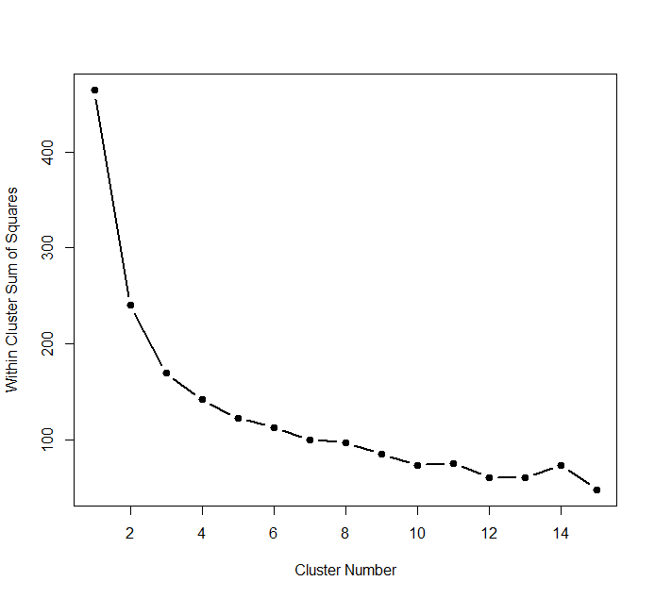

Figure S7. Dendrogram for cluster analysis
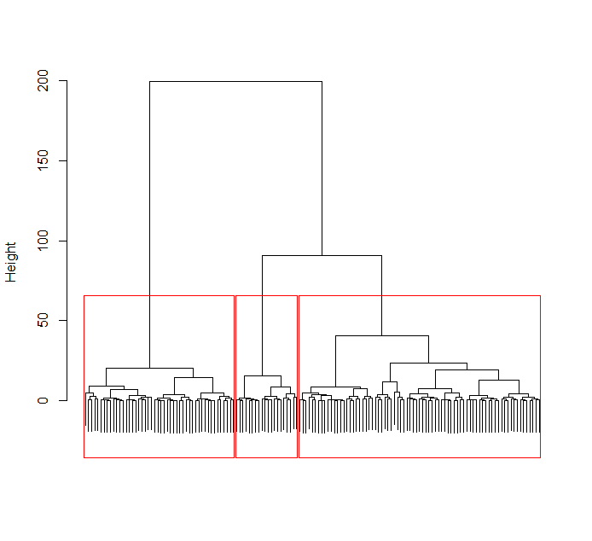
Table S3. Exploratory results when all significant predictors are entered simultaneously.

Linear Mixed Model Regression Statistics
Predicting Moralization
Meat Emotions | b=.47, SE=.05, df =583.26,  p <.001, 95% CI [.37, .56]
Moral Piggybacking | b=.21, SE=.04, df =383.47,  p <.001, 95% CI [.13, .28]
Animal Emotions | b=.03, SE=.03, df =344.33,  p =.277, 95% CI [-.03, .10]
Suffering | b=.02, SE=.03, df =370.67,  p =.483, 95% CI [-.04, .08]
Tastiness | b=-.05, SE=.04, df =269.44,  p =.194, 95% CI [-.13, .03]

Additional Analyses Regarding the Shape of Moralization

We also conducted model comparisons between the linear model and the curvilinear model by calculating the -2 restricted log likelihood for each model. The statistic is a measure of model fit, with smaller values indicating a better model fit. For the linear model, the -2 restricted log likelihood was 257.93, whereas the curvilinear model’s -2 restricted log likelihood was 258.27. A chi-square test comparing the difference between these two models (.34) yielded a non-significant result, p = .560. In such cases, the rule of thumb is to select the more parsimonious model since adding a new predictor does nothing to improve the model. Thus, we further conclude that the linear model fits the data best.

Study 2

Method

Demographic Information

The average participant age was 54.18 (SD = 11.30), and they reported the following ethnicities: White = 89%, Black = 1%, Asian = 5%, Latino = 2%, Multi-Racial or Other = 3%.

Discussion of Sample Selection

Reasoning for only recruiting those who completed previous session to next session. Since every-other session involved presenting participants with additional stimuli regarding the morality of eating meat, we considered it paramount that only those participants who had been presented with the stimuli be recruited for the next session. Participants who were not exposed to these stimuli posed a problem since we expected the repeated sessions to serve as continuous reinforcement of the previous ones. If participants missed a video session and then showed a drop in moralization (or no increase when others increased) we would have no way of disentangling whether these participants’ movement (or lack thereof) was due to the pull mechanisms or simply a lack of reinforcement (or a combination of the two).
In addition, due to the high cost of collecting data from a panel company, we chose to limit our invitations to subsequent sessions only to those participants who we knew had taken part in previous sessions, as we considered these participants far more reliable and worth investing money in than those who failed to take part in the previous session.

Further discussion of why we removed non-meat-eaters. It is possible that of the 8 participants excluded for being vegetarian, some had not already moralized the issue of eating meat. However, even if these individuals were vegetarian for non-moral reasons, they would likely be much easier to get to moralize than meat-eaters because pull mechanisms, like the tastiness of meat, would be irrelevant for them. If this is the case, by including them, our results might overweight the impact of the push mechanisms while discounting the ability to overcome pull mechanisms that likely deter meat eaters from moralizing. Conversely, if these vegetarians resisted moralizing for non-meat eating reasons (i.e., not because of the taste of meat), then it may lead us to underweight the importance of things like the taste of meat as a pull mechanism. All in all, this small number of vegetarians could have obscured our results.
Sample size selection. Our sample size selection for Study 2 was originally based on the results we found from Study 1 using only those participants who completed all 3 questionnaire sessions since, in line with the above, in Study 2 we planned to conduct analyses only using participants who completed all sessions. In Study 1, we found that 135 participants completed all 3 sessions and all predictors included in the study were significant. For details regarding these results, please contact the corresponding author.

Video Coding and Selection
Two research assistants searched the internet for videos that presented an argument against killing animals so humans could eat them. The research assistants compiled videos that were short (< 10 minutes) and did not specifically attack a single company (e.g., Walmart, Tyson, McDonalds), which could be problematic if brand loyalty affected moralization. In total, the research assistants compiled a total of 113 videos, the vast majority of which were hosted on youtube.com. Then, 4 other research assistants coded each video on whether or not the video’s argument was moral in nature, and how morally evocative (i.e., how intensely they felt the arguments appealed to moral concerns) they found the video to be. Coders also rated whether or not each video fit into the following argument categories, which were developed based on the two initial research assistants’ recommendations after having watched the videos: eating meat means animals will suffer, eating meat harms the environment, eating meat causes health problems in humans, eating meat is unnatural for humans, becoming vegetarian is what many others, including celebrities, are doing. Reliabilities among coders was moderate-to-high, so we averaged scores together for each coded variable (α_{moral} = .76, α_{moral_intensity} =.85, α_{suffer} =.84, α_{environment} = .90, α_{health} = .82, α_{unnatural} = .62, α_{everyone_is_doing} = .63).
To select the videos to use as stimuli, we first selected videos that the raters unanimously coded as being moral in nature (n = 82). Then, we decided to choose a single argument category that all video stimuli in our study would speak to, because we feared that mixing argument categories could introduce confusion and muddle the overarching argument against eating animals. To determine which category made the most sense, we ran correlation analyses between ratings of moral intensity and each of the argument categories. Results yielded a very strong correlation between moral intensity and the suffering argument category, r = .57, while the other categories also correlated with moral intensity but not as strongly, with rs ranging from .18 to .39. We then ranked all videos that were rated as being moral in nature and were in the suffering argument category in terms of their moral intensity ratings from most intense to least intense. Then we grouped together the most morally intense videos into 3 groups so that they would form separate compilations each lasting approximately 10 minutes. These 3 groups served as the stimuli for our 3 video sessions (see below for links to each video). Which video participants watched during each video session was randomly determined.

Links to videos used

https://www.youtube.com/watch?v=zF7Ega_TpZE
https://www.youtube.com/watch?v=CKeE_SPSbio
https://www.youtube.com/watch?time_continue=1&v=_yzKjHQ8ofo
https://www.youtube.com/watch?v=jBR4FlrWVk4
https://www.youtube.com/watch?v=Z-cor1uZ2AM
https://www.youtube.com/watch?v=QKWKUU0XQ8U

Moral Piggybacking Items

Participants responded on a scale from 1(not at all) to 5(very much) to the following 4 items: “When you think about eating meat, to what extent does it lead you to think about morality in general (i.e., what is or is not morally appropriate behavior in various contexts)?”, “When you think about eating meat, to what extent does it lead you to think about what it means to be a moral individual?”, “When you think about eating meat, to what extent does it lead you to think about moral values that you personally hold?”, and “When you think about eating meat, to what extent does it lead you to think about your identity as a moral person?”.

Exploratory items

The same exploratory items were collected as in Study 1, but only at Time 1 and Time 4.
Meat Attitudes means and standard deviations were:
Time 1: 3.89 (.34)
Time 4: 3.65 (.63)
Meat Attitudes correlations with moralization:
Time 1: -.34***
Time 4: -.72***
Vegetarian Attitudes means and standard deviations were:
Time 1: 3.03 (.75)
Time 4: 2.84 (.77)
Vegetarian Attitudes correlations with moralization:
Time 1: -.08
Time 4: -.35***
Meat Health Attitudes means and standard deviations were:
Time 1: 3.46 (1.03)
Time 4: 3.12 (1.09)
Meat Health Attitudes correlations with moralization:
Time 1: .06
Time 4: -.29***
Meat Environment Attitudes means and standard deviations were:
Time 1: 1.82 (.92)
Time 4: 2.03 (.99)
Meat Environment Attitudes correlations with moralization:
Time 1: .19***
Time 4: .47***

Results

Table S4. Means, standard deviations, and correlations for all variables collected at each time point. (Study 2)
 | Time | Means (SD) | Meat Emotions | Animal Emotions | Suffering | Tastiness | Moral Piggybacking
Moralization | 1  2  3  4 | 1.56 (.67)  1.63 (.79)  1.72 (.87)  1.79 (.97) | .43***  .62***  .71***  .76*** | .35***  44***  .57***  .65*** | .14*  --  --  .45*** | -.03  --  --  -.48*** | --  .64***  .73***  --
Meat Emotions | 1  2  3  4 | 1.14 (.43)  1.26 (.61)  1.37 (.73)  1.57 (.95) | -- | .42***  .53***  .66***  .65*** | .35***  --  --  .53*** | -.25***  --  --  -.50*** | --  .59***  .75***  --
Animal Emotions | 1  2  3  4 | 1.84 (.99)  2.11 (1.17)  2.19 (1.16)  2.61 (1.36) |  | -- | .47***  --  --  .70*** | -.20**  --  --  -.46*** | --  .46***  .60***  --
Suffering | 1  2  3  4 | 2.50 (1.13)  --  --  3.14 (1.18) |  |  | -- | -.22***  --  --  -.39*** | --
Tastiness | 1  2  3  4 | 4.57 (.60)  --  --  4.37 (.76) |  |  |  | -- | --
Moral Piggybacking | 1  2  3  4 | --  1.68 (.90)  1.80 (1.00)  -- |  |  |  |  | --
Note: *p < .05, **p < .01, ***p < .001.

Attrition Rates

In all, 293 completed questionnaires at Time 2, 257 completed questionnaires at Time 3, and 239 completed questionnaires at Time 4.

Results when including all participants (regardless of number of sessions completed)

Table S5. Results of linear mixed model regressions and cross-lagged analyses examining the impact of the predictor variables on moralization when including all participants (not just those who completed all sessions).

 | Linear Mixed Model Regression Statistics  Predicting Moralization |  | Cross-Lagged Analyses
 | Grand-Mean Centered | Time 1-Person Centered (Top)  & Aggregate (Bottom) | Predicting  Time 2 Moralization | Predicting  Time 3  Moralization | Predicting  Time 4  Moralization
Meat Emotions | b=.76, SE=.04,  df =55.89,  p <.001  95% CI [.67, .85] | b=.58, SE=.05, df =48.10,  p <.001, 95% CI [.47, .69]  b=.64, SE=.05, df =454.65,  p <.001, 95% CI [.54, .73] | b=.49, SE = .10  p < .001  95% CI [.29, .69] | b=.31, SE = .08  p < .001  95% CI [.15, .44] | b=.36, SE = .08  p < .001  95% CI [.20, .52]
Animal Emotions | b=.30, SE=.02,  df =319.78,  p <.001  95% CI [.25, .34] | b=.21, SE=.03, df =176.36,  p <.001, 95% CI [.15, .27]  b=.32, SE=.04, df =423.76,  p <.001, 95% CI [.27, .37] | b=.27, SE = .04  p < .001  95% CI [.19, .35] | b=.07, SE = .04  p = .043  95% CI [.00, .15] | b=.17, SE = .04  p < .001  95% CI [.09, .25]
Moral Piggybacking | b=.53, SE=.04,  df =181.03,  p <.001  95% CI [.46, .61] | b=.30, SE=.05, df =25.27,  p <.001, 95% CI [.21, .39]  b=.59, SE=.04, df =281.13,  p <.001, 95% CI [.51, .66] | -- | b=.18, SE = .05  p = .001  95% CI [.08, .28] | --
Suffering | b=.19, SE=.03,  df =283.82,  p <.001  95% CI [.14, .25] | b=.28, SE=.05, df =91.51,  p <.001, 95% CI [.18, .37]  b=.17, SE=.03, df =433.30,  p <.001, 95% CI [.12, .22] | -- | -- | b=.16, SE = .05  p < .001  95% CI [.06, .26]
Tastiness | b=-.23, SE=.05,  df =309.65,  p <.001  95% CI [-.34, -.13] | b=-.57, SE=.11, df =61.16,  p <.001, 95% CI [-.78, -.36]  b=-.18, SE=.05, df =430.70,  p <.001, 95% CI [-.27, -.08] | -- | -- | b=-.28, SE = .10  p = .004  95% CI [-.48, -.08]

Note: Time 1-Person Centered involves the first time point collected for each variable. Thus, if a variable was not collected during session 1, then its session 2 value (when it was first collected) serves as its first time point.
Note: Cross-lagged analyses are identical to those presented in the main manuscript because cross-lagged analyses can only be conducted on participants who have complete data.

Table S6. Analyses exploring what predicted attrition

 | Logistic Regressions
 | Predicting Dropout After Time 1 (not doing questionnaire session 2, n = 36)  b (SE) | Predicting Dropout After Time 2 (not doing questionnaire session 3, n = 35)  b (SE) | Predicting Dropout After Time 3 (not doing questionnaire session 4, n = 17)  b (SE)
Suffering | .04 (.09), p = .683 | -- | --
Tastiness | -.21 (.16), p = .199 | -- | --
Moralization | -.07 (.16), p = .674 | .20 (.21), p = .352 | .02 (.29), p = .953
Meat Emotions | .45 (.23), p = .047 | -.09 (.33), p = .781 | -1.17 (.86), p = .173
Animal Emotions | .08 (.10), p = .454 | -.11 (.17), p = .502 | .01 (.22), p = .967
Moral Piggybacking | -- | .19 (.18), p = .298 | .06 (.17), p = .715

Note: gaps are due to us not having measured the variable in the prior round.

Conclusion: there is no clear pattern that predicts dropping out in subsequent rounds. This seems to suggest that the reason why participants dropped out of the study was independent of these key predictors of the moralization process, as well as moralization itself.

Table S7. Exploratory results when all significant predictors are entered simultaneously.

Linear Mixed Model Regression Statistics
Predicting Moralization
 | Model 1 | Model 2
Meat Emotions | b=.39, SE=.08, df =66.91,  p <.001, 95% CI [.24, .54] | b=.57, SE=.06, df =81.61,  p <.001, 95% CI [.45, .69]
Moral Piggybacking | b=.35, SE=.04, df =172.50,  p <.001, 95% CI [.27, .43] | --
Animal Emotions | b=.06, SE=.03, df =100.57,  p =.038, 95% CI [.00, .12] | b=.18, SE=.03, df =228.11,  p <.001, 95% CI [.11, .24]
Suffering | -- | b=-.06, SE=.03, df =547.54,  p =.044, 95% CI [-.13, .00]
Tastiness | -- | b=-.02, SE=.05, df =205.49,  p =.659, 95% CI [-.12, .0307]

Note: Since moral piggybacking was never measured at the same time as suffering and tastiness, we fit separate models for the moral piggybacking and the latter two predictors. Model 1 included moral piggybacking, meat emotions, and animal emotions, whereas Model 2 included suffering, tastiness, meat emotions, and animal emotions.

Cross-Lagged SEM Path Models for each Predictor

Figure S8. Cross-lagged model for meat emotions and moralization
Moralization₁
Moralization₂
Moralization₃
MeatEmotions₁
MeatEmotions₂
MeatEmotions₃
.54***
.57***
.75***
.74***
.15**
.11*
.49***
.31***
.13***
.13***
.11***
Moralization₄
MeatEmotions₄
.15**
.44***
1.04 ***
.20***
.28***
.36***
.04
.36***
.04

Figure S9. Cross-lagged model for animal emotions and moralization
Moralization₁
Moralization₂
Moralization₃
Animal Emotions₁
Animal Emotions₂
Animal Emotions₃
.54***
.67***
.81***
.45***
-.08
.28***
.27***
.07*
.23***
.12***
.16***
Moralization₄
Animal Emotions₄
.21**
.53***
.64***
.19**
.27***
.27***
.27***
.17***
.16*

Figure S10. Cross-lagged model for suffering (measured at Time 1 and 4) and moralization

Moralization₁
Moralization₄
Suffering₁
Suffering₄
.54***
.65***
.00
.16***
.10*
.34*

Figure S11. Cross-lagged model for moral piggybacking (measured at Time 2 and 3) and moralization

Moralization₂
Moralization₃
Piggybacking₂
Piggybacking₃
.68***
.66***
.26***
.18***
.45***
.20***

Figure S12. Cross-lagged model for tastiness (measured at Time 1 and 4) and moralization

Moralization₁
Moralization₄
Taste₁
Taste₄
.57***
.72***
-.10
-.28**
-.01
-.25***

Figure S13. Cluster Analysis Scree Plot
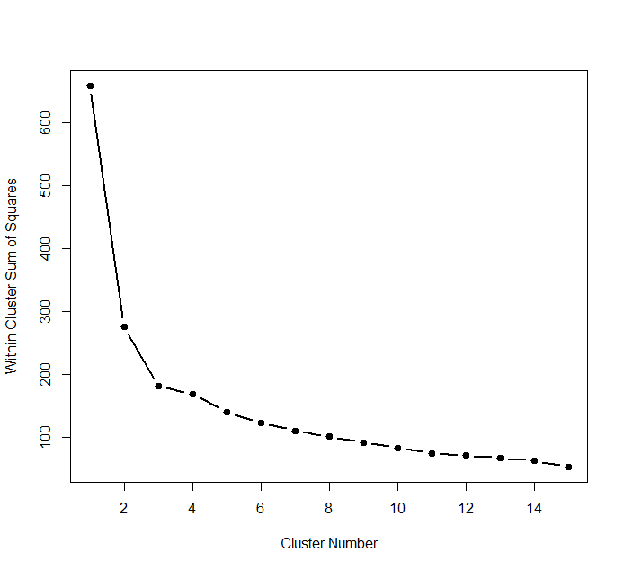

Figure S14. Dendrogram for Cluster Analysis
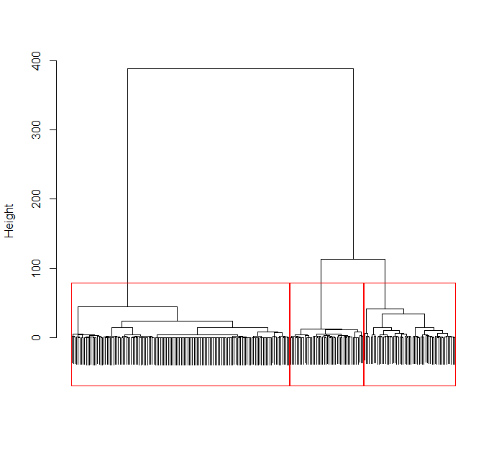
Additional Analyses Regarding the Shape of Moralization

We also conducted model comparisons between the linear model and the curvilinear model by calculating the -2 restricted log likelihood for each model. For the linear model, the -2 restricted log likelihood was 488.20, whereas the curvilinear model’s -2 restricted log likelihood was 492.81. A chi-square test comparing the difference between these two models (4.61) yielded a significant result, p = .032, indicating that the linear model was the better of the two models.

Study 3

Method
Demographic Information

The average age of the participants was 39.48 (SD = 11.94), and they indicated the following ethnicities: White = 44%, Black = 7%, Asian = 8%, Latino = 38%, Multi-Racial or Other = 3%.

Reliability Measures for All Composites not Reported

Moralization: .76
Meat Emotions: .96
Animal Emotions: .92
Moral Piggybacking: .93

Suffering Composite

This composite consisted of the same item used in Studies 1 and 2 (“How much do you believe eating meat causes suffering to animals?”), along with the following two items: “When thinking about animals that become meat humans eat, to what extent do you think about them suffering?”, and “To what extent do you think the animals raised for human consumption experience pain and suffering?”, as well as three items that asked “To what extent do you think each of the following animals has the capacity to suffer?” followed by “cows”, “pigs”, and “chickens”. Participants responded to the first three items using a scale from 1(not at all) to 5(very much), and the second set of items on a scale from 1(no capacity to suffer at all) to 5(very large capacity to suffer).

Personal Choice Items

We asked 2 items assessing how much participants believed eating meat was a personal choice as opposed to something they had no control over: “I really do not have any other choice but to eat meat”, and “Eating meat is a personal choice I make – If I wanted to, I could choose to not eat meat.” with this second item being reverse scored. Participants responded to both items on a scale ranging from 1(strongly disagree) to 5(strongly agree). Reliabilities for this composite at each time point were high so we averaged them together to form a personal choice composite (α_{time1}=.74, α_{time2}=.76, α_{time3}=.73, α_{time4}=.75).

Impossible Item

“My life would be impossible to live if I did not eat meat.”

Natural

“Eating meat is just a natural thing that humans do.”

Necessary

“Eating meat is a necessary thing for me to do for my physical survival.”

Exploratory items

The same exploratory items were collected as in Studies 1-2.

Meat Attitudes means and standard deviations were:
Time 1: 3.94 (.25)
Time 2: 3.81 (.41)
Time 3: 3.74 (.50)
Time 4: 3.72 (.52)
Meat Attitudes correlations with moralization:
Time 1: -.10
Time 2: -.31***
Time 3: -.49***
Time 4: -.52***
Vegetarian Attitudes means and standard deviations were:
Time 1: 2.83 (.71)
Time 2: 2.75 (.75)
Time 3: 2.63 (.80)
Time 4: 2.62 (.82)
Vegetarian Attitudes correlations with moralization:
Time 1: -.002
Time 2: -.20***
Time 3: -.23***
Time 4: -.30***
Meat Health Attitudes means and standard deviations were:
Time 1: 3.16 (1.06)
Time 2: 3.11 (1.08)
Time 3: 3.05 (1.14)
Time 4: 2.96 (1.13)
Meat Health Attitudes correlations with moralization:
Time 1: .10
Time 2: .02
Time 3: -.08
Time 4: -.14**
Meat Environment Attitudes means and standard deviations were:
Time 1: 2.26 (1.06)
Time 2: 2.38 (1.09)
Time 3: 2.56 (1.15)
Time 4: 2.61 (1.14)
Meat Environment Attitudes correlations with moralization:
Time 1: .07
Time 2: .23***
Time 3: .29***
Time 4: .27***

Results

Table S8. Means, standard deviations, and correlations for all variables collected at each time point. (Study 3)
 | Time | Means (SD) | 1. | 2. | 3. | 4. | 5. | 6. | 7. | 8. | 9. | 10. | 11.
1. Moralization | 1  2  3  4 | 1.43 (.54)  1.51 (.58)  1.55 (.70)  1.56 (.70) | .18  .25  .54  .57 | .13  .35  .36  .36 | .43  .54  .71  .78 | .14  .24  .34  .31 | -.02  -.03  -.12  -.06 | .04  -.02  -.10  -.04 | .10  .16  .16  .22 | .05  -.01  -.08  -.04 | .15  -.01  .03  .01 | -.01  -.06  -.12  -.23 | .04  .14  .24  .22
2. Meat Emotions | 1  2  3  4 | 1.08 (.20)  1.18 (.35)  1.30 (.55)  1.36 (.61) | -- | .40  .51  .48  .56 | .35  .36  .50  .56 | .21  .36  .42  .42 | .03  -.01  -.07  -.08 | -.09  -.04  -.13  -.08 | .15  .08  .18  .16 | -.10  -.15  -.18  -.14 | .00  -.07  -.08  -.13 | -.14  -.31  -.33  -.30 | .07  .27  .24  .31
3. Animal Emotions | 1  2  3  4 | 1.98 (1.10)  2.25 (1.15)  2.50 (1.21)  2.61 (1.28) |  | -- | .33  .35  .37  .37 | .54  .62  .62  .65 | -.08  -.15  -.10  -.15 | -.17  -.14  -.15  -.15 | .05  -.01  -.05  .05 | -.11  -.13  -.18  -.08 | -.08  -.04  -.15  -11 | -.08  -.10  -.19  -.18 | .32  .45  .44  .48
4. Moral Piggybacking | 1  2  3  4 | 1.35 (.64)  1.43 (.68)  1.50 (.76)  1.57 (.81) |  |  | -- | .21  .30  .37  .33 | -.01  -.05  -.05  -.06 | .00  -.05  .03  -.01 | .35  .28  .28  .29 | .02  .00  -.02  -.05 | .13  .08  .08  .05 | -.19  -.19  -.13  -.17 | .18  .20  .30  .31
5. Suffering | 1  2  3  4 | 3.13 (.84)  3.30 (.96)  3.42 (.98)  3.52 (1.02) |  |  |  | -- | -.12  -.22  -.23  -.20 | -.18  -.21  -.23  -.22 | -.05  -.01  -.09  -.04 | -.04  -.14  -.18  -.15 | -.06  -.08  -.16  -.17 | -.07  -.09  -.18  -.10 | .47  .52  .55  .61
6. Personal Choice | 1  2  3  4 | 1.89 (.84)  2.03 (.92)  2.05 (.85)  2.06 (.94) |  |  |  |  | -- | .61  .73  .72  -.72 | .12  .08  .18  .15 | .03  .09  .10  .08 | .41  .46  .49  .48 | .03  .04  .11  .07 | .00  -.02  -.10  -.13
7. Impossible | 1  2  3  4 | 2.41 (1.20)  2.38 (1.12)  2.34 (1.12)  2.28 (1.17) |  |  |  |  |  | -- | .20  .21  .23  .22 | .21  .24  .26  .26 | .58  .55  .61  .63 | .16  .12  .18  .18 | -.05  -.03  -.05  -.13
8. Social Pressures | 1  2  3  4 | 1.41 (.76)  1.35 (.68)  1.38 (.71)  1.42 (.73) |  |  |  |  |  |  | -- | .22  .23  .17  .11 | .24  .20  .23  .21 | -.07  -.10  -.03  -.04 | -.06  -.04  -.07  .01
9. Natural | 1  2  3  4 | 3.57 (1.27)  3.52 (1.26)  3.45 (1.27)  3.47 (1.27) |  |  |  |  |  |  |  | -- | .38  .49  .47  .41 | .18  .23  .34  .27 | -.04  -.11  -.11  -.04
10. Necessary | 1  2  3  4 | 2.60 (1.35)  2.64 (1.32)  2.55 (1.33)  2.56 (1.33) |  |  |  |  |  |  |  |  | -- | .16  .22  .21  .21 | .05  -.02  -.03  -.06
11. Tastiness | 1  2  3  4 | 4.59 (.56)  4.57 (.62)  4.51 (.63)  4.53 (.66) |  |  |  |  |  |  |  |  |  | -- | -.05  -.08  -.13  -.10
12. Animals-Humans Similar | 1  2  3  4 | 3.28 (1.10)  3.33 (1.08)  3.45 (1.11)  3.51 (1.14) |  |  |  |  |  |  |  |  |  |  | --
All values greater than .11 or less than -.11 are significant at p < .05.

Attrition Rates

In all, 440 completed session 2, 414 completed session 3, 391 completed session 4, 383 completed session 5, 355 completed session 6, and 350 completed session 7.

Results when including all participants (regardless of number of sessions completed)

Table S9. Results of linear mixed model regressions and cross-lagged analyses examining the impact of the predictor variables on moralization when including all participants (not just those who completed all sessions).

 | Linear Mixed Model Regression Statistics  Predicting Moralization |  | Cross-Lagged Analyses
 | Grand-Mean Centered | Time 1-Person Centered (Top)  & Aggregate (Bottom) | Predicting  Time 2 Moralization | Predicting  Time 3  Moralization | Predicting  Time 4  Moralization
Meat Emotions | b=.74, SE=.03,  df =222.46, p <.001  95% CI [.67, .80] | b=.28, SE=.05, df =87.86,  p <.001, 95% CI [.19, .37]  b=.78, SE=.03, df =1527.42,  p <.001, 95% CI [.73, .84] | b=.22, SE = .13  p = .091  95% CI [-.03, .48] | b=.41, SE = .08  p < .001  95% CI [.25, .57] | b=.19, SE = .06  p = .001  95% CI [.07, .31]
Animal Emotions | b=.31, SE=.02,  df =956.29, p <.001  95% CI [.28, .34] | b=.06, SE=.02, df =245.77,  p =.001, 95% CI [.02, .10]  b=.41, SE=.02, df =1384.36,  p <.001, 95% CI [.38, .44] | b=.08, SE = .02  p = .001  95% CI [.04, .12] | b=.13, SE = .02  p < .001  95% CI [.09, .17] | b=.05, SE = .02  p = .045  95% CI [.01, .09]
Moral Piggybacking | b=.67, SE=.02,  df =715.00, p <.001  95% CI [.64, .71] | b=.34, SE=.03, df =145.57,  p <.001, 95% CI [.28, .40]  b=.75, SE=.02, df =1478.89,  p <.001, 95% CI [.72, .78] | b=.07, SE = .05  p = .114  95% CI [-.03, .17] | b=.20, SE = .05  p < .001  95% CI [.10, .30] | b=.12, SE = .05  p = .014  95% CI [.02, .22]
Suffering Composite | b=.40, SE=.02,  df =901.49, p <.001  95% CI [.35, .44] | b=.14, SE=.04, df =280.30,  p < .001, 95% CI [.07, .21]  b=.46, SE=.02, df =1278.28,  p <.001, 95% CI [.41, .50] | b=.10, SE = .03  p = .001  95% CI [.04, .16] | b=.11, SE = .03  p < .001  95% CI [.05, .17] | b=.07, SE = .03  p = .023  95% CI [.01, .13]
Personal Choice | b= .01, SE=.02,  df =153.34, p =.577  95% CI [-.03, .05] | b=.00, SE=.02, df =1150.05,  p =.972, 95% CI [-.05, .05]  b=.00, SE=.03, df =1165.73,  p =.948, 95% CI[-.05, .05] | b=-.02, SE = .02  p = .265  95% CI [-.06, .02] | b=-.03, SE = .02  p = .030  95% CI [-.07, .00] | b=.00, SE = .02  p = .996  95% CI [-.04, .04]
Impossible | b= -.07, SE=.02,  df =244.06, p < .001  95% CI [-.10, -.04] | b=.01, SE=.02, df =1271.62,  p =.661, 95% CI [-.03, .05]  b=-.11, SE=.02, df =1184.33,  p < .001, 95% CI[-.15, -.07] | b=-.04, SE = .02  p = .042  95% CI [-.08, .00] | b=-.03, SE = .02  p = .206  95% CI [-.07, .01] | b=.00, SE = .02  p = .862  95% CI [-.04, .04]
Social Pressures | b=.17, SE=.02,  df =348.85, p <.001  95% CI [.12, .22] | b=.06, SE=.04, df =111.21,  p =.155, 95% CI [-.02, .14]  b=.19, SE=.03 df =1318.52,  p <.001, 95% CI [.14, .24] | b=.07, SE = .04  p = .060  95% CI [-.01, .15] | b=.04, SE = .04  p = .369  95% CI [-.04, .12] | b=.03, SE = .04  p = .464  95% CI [-.05, .11]
Natural | b= -.11, SE=.01,  df =600.07, p <.001  95% CI [-.13, -.08] | b=-.03, SE=.02, df =93.01,  p =.062, 95% CI[-.06, .00]  b= -.13, SE=.02 df =1208.38,  p < .001, 95% CI [-.16, -.10] | b=.01, SE = .02  p = .743  95% CI [-.03, .05] | b=-.02, SE = .02  p = .429  95% CI [-.06, .02] | b=-.03, SE = .02  p = .136  95% CI [-.07, .01]
Necessary | b= -.02, SE=.01,  df =662.07, p =.127  95% CI [-.05, .01] | b=-.01, SE=.02, df =229.55,  p =.662, 95% CI[-.05, .03]  b= -.02, SE=.02, df =1116.56,  p =.173, 95% CI[-.05, .01] | b=.02, SE = .02  p = .374  95% CI [-.02, .06] | b=-.03, SE = .02  p = .126  95% CI [-.07, .01] | b=-.01, SE = .02  p = .636  95% CI [-.05, .03]
Tastiness | b= -.30, SE=.03,  df =616.87, p < .001  95% CI [-.35, -.25] | b=-.08, SE=.04, df=125.20,  p=.062, 95%CI[-.16, .00]  b=-.44, SE=.02 df =1483.18,  p<.001, 95%CI[-.49, -.39] | b=-.03, SE = .05  p =.585  95% CI [-.13, .07] | b=-.06, SE = .04  p =.193  95% CI [-.14, .02] | b=-.12, SE = .04  p =.003  95% CI [-.20, -.04]
Animals-Humans Similar | b=.21, SE=.02,  df =552.34, p <.001  95% CI [.17, .25] | b= .07 SE=.02, df =215.25,  p =.003, 95% CI [.03, .12]  b= .23, SE=.02 df =1120.96,  p < .001, 95% CI [.19, .27] | b=.03, SE = .02  p =.193  95% CI [-.01, .07] | b=.08, SE = .03  p =.001  95% CI [.02, .14] | b=.01, SE = .03  p = .830  95% CI [-.05, .07]

Note: Cross-lagged analyses are identical to those presented in the main manuscript because cross-lagged analyses can only be conducted on participants who have complete data.

Table S10. Analyses exploring what predicted attrition

 | Logistic Regressions
 | Predicting Dropout After Time 1 (not doing questionnaire session 2, n = 515)  b (SE) | Predicting Dropout After Time 2 (not doing questionnaire session 3, n = 29)  b (SE) | Predicting Dropout After Time 3 (not doing questionnaire session 4, n = 30)  b (SE)
Suffering | -.08 (.08), p =.344 | -.16(21), p = .443 | -.05(.20), p = .798
Tastiness | -.14 (.12), p = .225 | .42(.38), p =.262 | .09(.32), p = .771
Moralization | -.20 (.13), p = .124 | -.15(.34), p = .657 | -.16(.30), p = .595
Meat Emotions | .29 (.28), p = .302 | .54(.38), p = .155 | .14(.32), p = .670
Animal Emotions | -.08 (.07), p = .200 | -.01(.17), p = .932 | .03(.16), p = .851
Moral Piggybacking | -.01 (.11), p = .951 | .04(.27), p = .885 | .08(.23), p = .716
Social Pressures | .16 (.09), p = .055 | .47 (.21), p = .027 | -.01(.27), p = .960
Life Impossible | .03(.06), p = .562 | .003(.17), p = .987 | .002(.17), p = .990
Animals-Humans Similar | .03 (.06), p = .603 | .09(.18), p = .608 | .001(.17), p = .995
Natural | -.09(.05), p = .092 | -.06(.15), p = .710 | -.11(.15), p = .479
Necessary | .02(.05), p = .728 | -.03(.15), p = .856 | -.04(.15), p = .788
Choice | .08(.08), p = .332 | .04(.21), p = .859 | -.43(.27), p = .114

As in Study 2, there appears to be no clear pattern that predicts dropping out in subsequent rounds.

Cognitive Dissonance Reduction
Many of the potential deterrents of moralization that we included in Study 3 did not turn out to be significant negative predictors of moralization. Some of the variables, such as the personal choice composite, showed no relationship with moralization, whereas other variables, such as social pressures and necessary were found to be positively associated with moralization. This unexpected result led us to conclude that these variables were unlikely to be deterrents of moralization. Yet, they still could play a role in the larger process, however, instead of deterring moralization, they may be used as tools for breaking the link between moralization and not eating meat any longer (Bastian & Loughnan, 2017). If individuals feel compelled to believe that killing animals for their meat is immoral, but also do not wish to stop eating meat, then from a cognitive dissonance perspective, individuals might convince themselves that they cannot or should not stop eating meat, regardless of the morality of the issue, for various reasons.
If such cognitive dissonance reduction was occurring, we might expect some of the pull mechanisms to significantly interact with moralization in predicting becoming a vegetarian. Specifically, we would expect that the link between moralization and becoming a vegetarian would be greatly diminished (or entirely broken) for those showing high levels of endorsement on the rationalizing cognition. For instance, if individuals felt compelled to moralize the issue, but were motivated to continue to eat meat, they might rationalize eating meat by relying on social conformity pressures as a way of convincing themselves that it is still okay to eat meat even though it feels immoral. If so, those who show signs of moralization but also score high on social pressures would be less likely to become a vegetarian than someone who shows signs of moralization and does not score high on social pressures.
To examine such a possibility, we conducted a series of exploratory regression analyses using data from the final time point (Time 4) when participants had completed the mini-course and when we asked participants how likely they were to become a vegetarian. For each regression, we entered a potential deterrent that did not negatively predict moralization, as well as participants’ moralization score, and these variables’ interaction as predictors, and participants’ likelihood of becoming a vegetarian as the outcome measure. In addition, although we found that perceived suffering was a significant predictor of increased moralization, we decided to also include it here since past research and theorizing suggest that individuals might feel that eating meat is acceptable if they determine that animals are unable to suffer or feel pain (see Bastian & Loughnan, 2017). The interaction results, along with simple slope analyses for significant interactions, are presented in Table S11. These results, especially those we found for necessary, impossible, and suffering, indicate that even if our mini-course compelled participants to view killing animals for their meat as immoral, many participants were still unlikely to become vegetarians because they minimized or broke the link between moralization and becoming a vegetarian via dissonance reduction cognitions that helped absolve them of responsibility or helped convince them that minimal harm was being done. Why these particular mechanisms interacted with moralization and social pressures and choice did not is unclear, and something we hope future research might explore.

Table S11. Interaction and simple slope results of regression analyses examining the role necessary to survive, life impossible, social pressures, personal choice, and suffering had in breaking the link between moralization and the likelihood of becoming a vegetarian.

 | Interaction with Moralization | Simple Slopes
Necessary to Survive | b=-.16, SE =.04, p < .001 | Low: b = .66, SE = .08, p < .001  High: b = .24, SE = .08, p = .003
Life Impossible | b=-.14, SE =.05, p = .006 | Low: b = .59, SE = .08, p < .001  High: b = .26, SE = .09, p = .003
Social Pressures | b=-.09, SE =.08, p = .226 | --
Personal Choice | b= .01, SE =.07, p = .927 | --
Suffering | b=.15, SE =.06, p = .009 | Low: b = .16, SE = .10, p = .122  High: b = .47, SE = .07, p < .001

Cross-Lagged SEM Path Models for each Predictor

Figure S15. Cross-lagged model for meat emotions and moralization

Moralization₁
Moralization₂
Moralization₃
MeatEmotions₁
MeatEmotions₂
MeatEmotions₃
.53***
.63***
.69***
.97***
-.002
.14***
.41***
.02***
.04***
.09***
Moralization₄
MeatEmotions₄
.04***
.51***
.69***
.25**
.19***
.12***
.33***
.19***
.14***
.22
†

Figure S16. Cross-lagged model for animal emotions and moralization

Moralization₁
Moralization₂
Moralization₃
Animal Emotions₁
Animal Emotions₂
Animal Emotions₃
.54***
.63***
.63***
.57***
.15
-.03
.08***
.13***
.08*
.13***
.07**
Moralization₄
Animal Emotions₄
.05*
.60***
.53***
.18***
.14*
.25***
.25***
.05*
.16*

Figure S17. Cross-lagged model for moral piggybacking and moralization

Moralization₁
Moralization₂
Moralization₃
MoralPiggyback₁
MoralPiggyback₂
MoralPiggyback₃
.53***
.63***
.50***
.44***
.24***
.22***
.07
.20***
.15***
.12***
.17***
Moralization₄
MoralPiggyback₄
.16**
.52***
.47***
.12*
.22***
.11*
.16**
.29***
.25***

Figure S18. Cross-lagged model for suffering and moralization

Moralization₁
Moralization₂
Moralization₃
Suffering₁
Suffering₂
Suffering₃
.54***
.67***
.95***
.79***
.01
-.01
.10***
.11***
.06**
.03*
.06***
Moralization₄
Suffering₄
.02
.59***
.71***
.07*
.20***
.14*
.15**
.25***

Figure S19. Cross-lagged model for tastiness and moralization

Moralization₁
Moralization₂
Moralization₃
Tasty₁
Tasty₂
Tasty₃
.56***
.72***
.71***
.55***
-.02
-.05
-.03
-.06
.00
-.01
-.02*
Moralization₄
Tasty₄
-.02*
.62***
.46***
-.12**
.18**
.14*
.31***
.46***
-.01

Figure S20. Cross-lagged model for animals-humans similar and moralization
Moralization₁
Moralization₂
Moralization₃
Similar₁
Similar₂
Similar₃
.55***
.70***
.66***
.59***
-.04
.03
.03
.08***
.02
.06**
.06***
Moralization₄
Similar₄
.04*
.63***
.62***
.01
.19***
.12*
.30***
.29***
.06

Figure S21. Cross-lagged model for natural and moralization
Moralization₁
Moralization₂
Moralization₃
Natural₁
Natural₂
Natural₃
.55***
.72***
.66***
.55***
.10
-.06
.01
-.02
.03
-.04
-.04*
Moralization₄
Natural₄
.00
.61***
.50***
-.03
.18***
.13*
.27***
.37***
.01

Figure S22. Cross-lagged model for choice and moralization

Moralization₁
Moralization₂
Moralization₃
Choice₁
Choice₂
Choice₃
.56***
.73***
.71***
.46***
.05
-.12
-.02
-.03*
-.02
-.02
-.02
Moralization₄
Choice₄
.01
.63***
.69***
.00
.16**
.14*
.36***
.21***
-.02

Figure S23. Cross-lagged model for social pressures and moralization

Moralization₁
Moralization₂
Moralization₃
SocialPressures₁
SocialPressures₂
SocialPressures₃
.54***
.73***
.61***
.58***
.10*
.04
.07
.04
.04
.01
.00
Moralization₄
SocialPressures₄
.03**
.62***
.49***
.03
.16**
.13*
.28***
.40***
.03
†

Figure S24. Cross-lagged model for necessary and moralization

Moralization₁
Moralization₂
Moralization₃
Necessary₁
Necessary₂
Necessary₃
.54***
.74***
.69***
.58***
.16
-.03
.02
-.03
.11**
.01
.01
Moralization₄
Necessary₄
-.02
.62***
.43***
-.01
.17**
.14*
.28***
.42***
.03
†

Figure S25. Cross-lagged model for impossible and moralization

Moralization₁
Moralization₂
Moralization₃
LifeImpossible₁
LifeImpossible₂
LifeImpossible₃
.55***
.73***
.65***
.58***
-.01
-.03
-.05*
-.03
.03
.02
-.03
Moralization₄
LifeImpossible₄
.00
.63***
.68***
.00
.17**
.13*
.29***
.27***
.06

Figure S26. Cluster Analysis Scree Plot
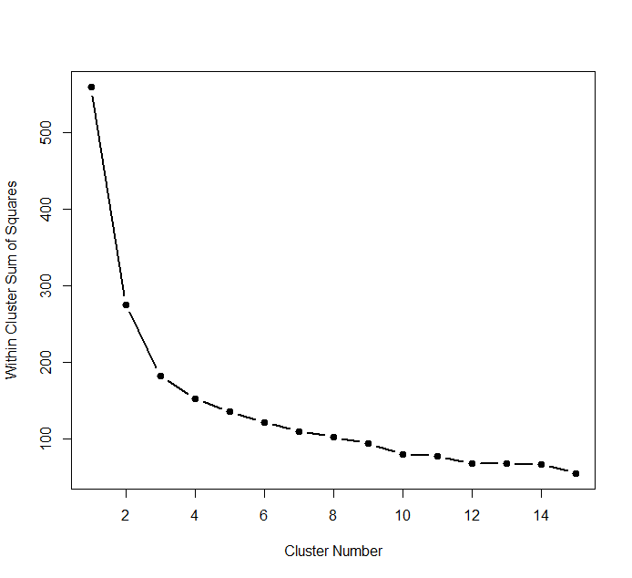

Figure S27. Dendrogram for Cluster Analysis
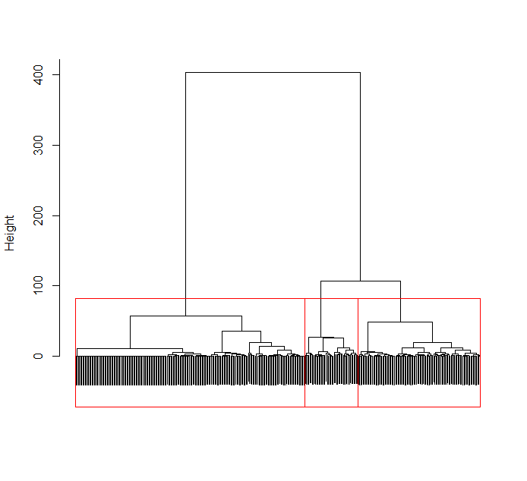
Additional Analyses Regarding the Shape of Moralization

We also conducted model comparisons between the linear model and the curvilinear model by calculating the -2 restricted log likelihood for each model. For the linear model, the -2 restricted log likelihood was 359.52, whereas the curvilinear model’s -2 restricted log likelihood was 492.81. A chi-square test comparing the difference between these two models (3.12) yielded a marginally significant result, p = .077, suggesting that the linear model was the better of the two models.

The Moderating Role of Moral Identity and the Harm-Care Moral Foundation

We ran a series of linear mixed model regressions entering each of the predictors (grand-mean centered for all variables except natural, and person-centered for natural) separately and interacting them with each of the individual difference measures when predicting moralization scores. The interaction results, along with simple slope analyses for significant interactions, are presented below in Table S12.

Table S12. Results of linear mixed model regression analyses examining the moderating influence of moral internalization, moral symbolization, and the harm-care moral foundation on each predictor’s influence on moralization.

 | Moral Internalization as a moderator | Simple slopes at different values of  Moral Internalization | Moral Symbolization as a moderator | Simple slopes at different values of  Moral Symbolization | Harm Care as a moderator | Simple slopes at different values of Harm-Care
Moral Piggybacking | b = .13, SE =.06  df = 163.22  p = .018  95% CI [.02, .24] | Low:  b=.42, SE=.04, p<.001  95% CI [.34, .50]  Hi:  b=.56, SE=.04, p<.001  95% CI [.48, .64] | b = -.01, SE =.03  df = 179.09  p = .789  95% CI[-.07, .05] | -- | b = .06, SE =.04  df = 211.75  p = .115  95% CI[-.01, .13] | --
Suffering | b = .06, SE =.05  df = 274.50  p = .219  95% CI [-.04, .16] | -- | b = .06, SE =.03  df = 264.07  p = .049  95% CI [.00, .11] | Low:  b=.13, SE=.04, p<.001  95% CI [.05, .21]  Hi:  b=.23, SE=.04, p<.001  95% CI [.15, .31] | b = .06, SE =.03  df = 230.80  p = .031  95% CI [.01, .12] | Low:  b= -.05, SE=.04, p=.173  95% CI [-.13, .03]  Hi:  b=.06, SE=.05, p=.176  95% CI [-.03, .16]
Animals-Humans Similar | b = .07, SE =.04  df = 245.81  p = .047  95% CI [.00, .15] | Low:  b=.05, SE=.03, p=.103  95% CI [-.01, .11]  Hi:  b = .12, SE=.03, p<.001  95% CI [.06, .18] | b = .04, SE =.02  df = 233.01  p = .055  95% CI [.00, .08] | Low:  b=.05, SE=.03, p=.074  95% CI [-.01, .11]  Hi:  b=.12, SE=.03, p<.001  95% CI [.06, .18] | b = .03, SE =.02  df = 224.22  p = .111  95% CI[-.01, .08] | --
Animal Emotions | b = -.01, SE =.03  df = 301.72  p = .862  95% CI [-.07, .06] | -- | b = .02, SE =.02  df = 255.80  p = .222  95% CI[-.01, .06] | -- | b =-.002, SE =.02  df = 317.39  p = .894  95% CI[-.05, .04] | --
Tastiness | b = -.01, SE =.07  df = 173.76  95% CI [-.14, .12]  p = .912 | -- | b = -.12, SE =.04  df = 243.89  p = .003  95%CI[-.20, -.04] | Low:  b=.07, SE=.06, p=.219  95% CI[-.05, .19]  Hi:  b=-.16, SE=.05, p< .001  95% CI[-.26, -.06] | b = -.06, SE =.04  df = 254.71  p = .161  95% CI[-.15, .03] | --
Meat Emotions | b = .14, SE =.10  df = 73.63  95% CI [-.05, .33]  p = .153 | -- | b = -.05, SE =.06  df = 76.12  p = .348  95% CI[-.16, .06] | -- | b = .06, SE =.06  df = 87.09  p = .318  95% CI[-.06, .19] | --
Natural | b = -.04, SE =.04  df = 125.96  p = .278  95% CI [-.11, .03] | -- | b = .04, SE =.02  df = 97.80  p = .047  95% CI [.00, .08] | Low:  b=-.08, SE=.03, p=.005  95% CI [-.13, .-.02]  Hi:  b=.00, SE=.03, p=.998  95% CI [-.06, .06] | b = .01, SE =.02  df = 109.66  p = .548  95% CI[-.03, .06] | --

General Discussion

Table S13. Linear mixed model regression analyses entering moralization as the dependent variable, meat attitudes composite as a covariate, and each of the significant predictor variables from Studies 1-3 as separate predictors.

bs, SEs, dfs, and p-values
(when controlling for meat attitudes)
Study 1
Meat Emotions | b=.53, SE=.06, df =282.41, p <.001 95% CI [.42, .64]
Animal Emotions | b=.15, SE=.05, df =1747.82, p =.001 95% CI [.06, .24]
Moral Piggybacking | b=.35, SE=.05, df =98.55, p <.001 95% CI [.25, .44]
Suffering | b=.16, SE=.04, df =364.57, p <.001 95% CI [.08, .24]
Tastiness | b=-.11, SE=.05, df =209.77, p =.029 95% CI [-.22, -.01]
Study 2
Meat Emotions | b=.52, SE=.06, df =69.39, p <.001 95% CI [.41, .64]
Animal Emotions | b=.26, SE=.03, df =514.95, p =.001 95% CI [.20, .31]
Moral Piggybacking | --
Suffering | b=.09, SE=.03, df =602.46, p =.002 95% CI [.03, .15]
Tastiness | b=-.13, SE=.06, df =233.18, p =.019 95% CI [-.24, -.02]
Study 3
Meat Emotions | b=.36, SE=.05, df =201.92, p <.001 95% CI [.27, .45]
Animal Emotions | b=.08, SE=.02, df =491.36, p <.001 95% CI [.04, .11]
Moral Piggybacking | b=.43, SE=.02, df =260.77, p <.001 95% CI [.39, .49]
Suffering | b=.11, SE=.02, df =894.18, p <.001 95% CI [.07, .16]
Tastiness | b=-.03, SE=.03, df =741.28, p =.302 95% CI [-.08, .03]
Animals-Humans Similar | b=.06, SE=.02, df =1071.99, p <.001 95% CI [.03, .09]

Note: Values for Moral Piggybacking in Study 2 could not be calculated because this variable was only measured at Times 2 and 3 while Meat Attitudes was only measured at Times 1 and 4.

Table S14. Regression analyses examining moralization scores at time 4 as predictors of each behavioral measure, controlling for time 4 meat attitudes.

bs, SEs, dfs, and p-values for Moralization as predictor
(when controlling for meat attitudes at Time 4)
Study 2
Become Vegetarian | b=.45, SE=.07, df =238, p <.001 95% CI [.32, .59]
Limit Meat | b=.50, SE=.12, df =238, p <.001 95% CI [.28, .73]
Limit Factory Farm Meat | b=.43, SE=.13, df =238, p <.001 95% CI [.18, .67]
Study 3
Become Vegetarian | b=.18, SE=.07, df =349, p =.008 95% CI [.05, .31]
Limit Meat | b=.34, SE=.11, df =349, p =.002 95% CI [.13, .55]
Limit Factory Farm Meat | b=.27, SE=.11, df =349, p =.013 95% CI [.06, .49]
Protest | b=.34, SE=.08, df =349, p <.001 95% CI [.19, .49]
Volunteer Time | b= .40, SE=.09, df =349, p <.001 95% CI [.23, .57]
Donate Money | b=.49, SE=.12, df =349, p <.001 95% CI [.24, .73]
Contact Gov. Rep. | b=.57, SE=.11, df =349, p <.001 95% CI [.34, .79]

The Possibility of Moral Ambivalence

An interesting question, highly relevant to the present investigation, is whether individuals can experience moral ambivalence, such that they moralize the same issue in opposite directions. For instance, it may be possible that individuals simultaneously moralize the issue of eating meat as both moral and immoral. We believe, however, that such moral ambivalence is unlikely to exist. According to the moral psychology literature, when we hold something as a moral conviction, we experience that conviction as essentially factual – in the same way we just know that a triangle has three sides, we know something is morally right or wrong. With this in mind, it would appear theoretically impossible to simultaneously hold two moral convictions, one in favor and one against, on the exact same issue. It would be tantamount to believing that a triangle has three sides and a triangle has four sides at the same time.

If such moral ambivalence does exist, we believe it would could still be explained by the PPMM. If people can moralize in two directions at the same time, such ambivalence could be represented by two separate push-pull models happening at the same time in a person’s head. The two models could, in theory, even be kept independent of one another in the person’s head, only applying the model that is salient depending on the situation. Alternatively, the two separate models might both exist at the same time and interfere with each other, leading the individual to be in a state of moral flux. This moral flux might be resolved by either one of the models overcoming the other (thereby ending the moral ambivalence), or by compartmentalizing one while the other is salient. In all, although our research is an initial examination of the process of moralization, we hope it inspires future research that aims to tackle important questions such as whether moral ambivalence exists, and if so, how it relates to the PPMM.

