Supplemental Materials
Overconfidence Among Beginners: Is a Little Learning a Dangerous Thing?
by C. Sanchez & D. Dunning, 2017, Journal of Personality and Social Psychology
http://dx.doi.org/10.1037/pspa0000102

In Studies 1–4, participants on an average displayed a cubic trend in the time course of their confidence. It is unlikely, but possible, for this trend to appear on average even though few individual participants displayed it. The trend could be a phenomenon that emerges in the aggregate but not at the individual participant level. For example, if roughly half our participants showed a strict linear rise in confidence and the other half signs of an inverted-U, that would give rise to a cubic function in the average that would never be evident for any individual participant.
So we decided to classify individual participants according to the apparent trend in their data, classifying participants into those descriptively showing a cubic trend, a quadratic one, or a linear one—noting which direction, positive or negative, that trend took on. Note that our general purpose was to see what proportion of participants showed confidence trends consistent with a “beginner’s bubble” pattern, which would be produced either by a positive cubic trend or a negative quadratic trend.
We began the classification procedure by noting that |t| = 1. Thus, we took any trend above that number to indicate a trend was present at the individual participant level. To begin, if a participants revealed a cubic trend of t > 1, we classified that participant as having a positive
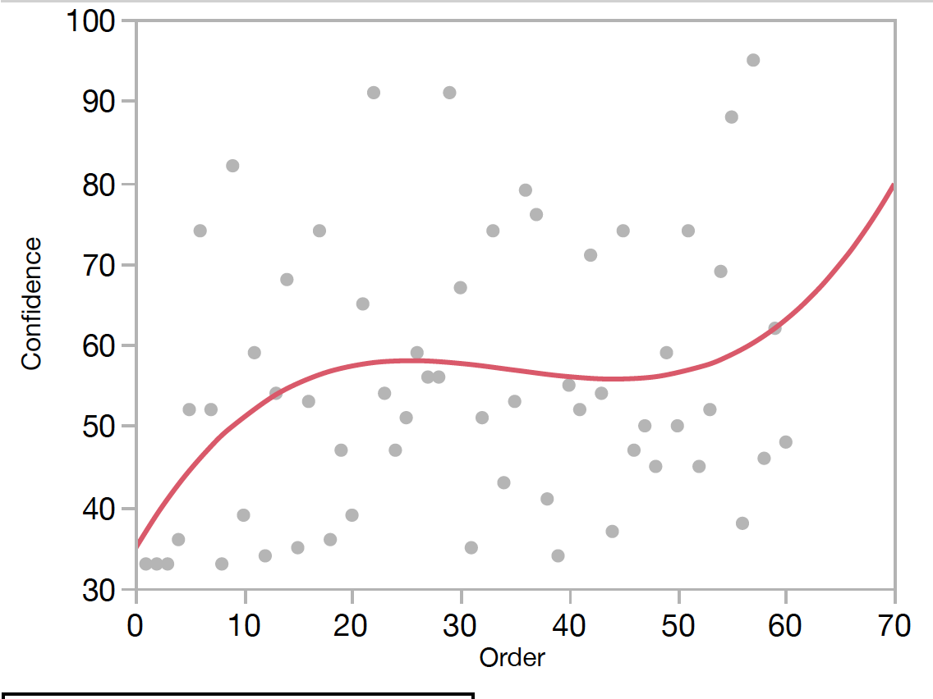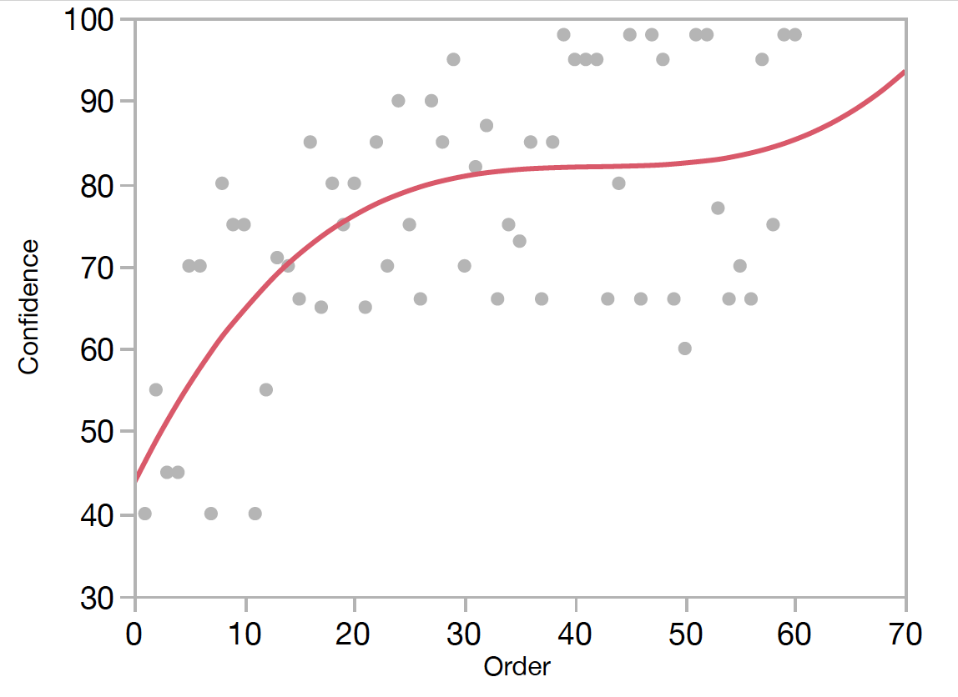
Figure S1. Two examples of individual confidence trends classified as upward cubic. T-value associated with the cubic trend to the left curve is 1.31, for the right curve it is 1.26.
If t < -1, we classified the participant as having a negative cubic trend. Figure S1 shows two examples of participants showing a positive cubic trend a t above 1.
Otherwise, we then moved to the quadratic component and asked the same question of it. Classifying a person as having an upward quadratic trend if t > 1 and negative if t < -1. See Figure S2, which shows two examples of participants showing a negative quadratic trend (cubic trend absent) with t < -1. If a participant did not show a quadratic trend, we moved to the linear component and asked the same question of it. If no component produced any |t| > 1, we labeled the participant as having no trend.
This system, to our eye, appeared to successfully capture participants who visually are displaying cubic, quadratic, and linear trends in their individual data. Table S1 shows the number of participants in each study sorted into each category we coded for.

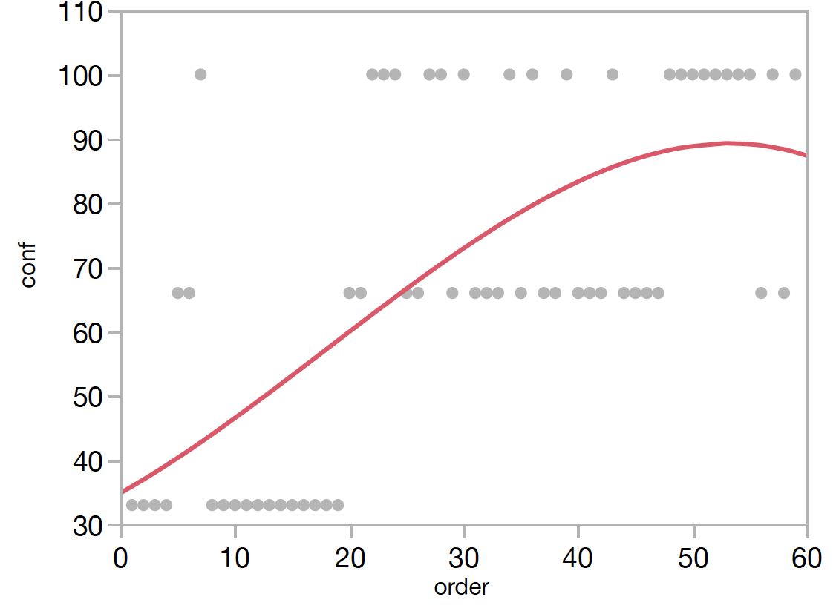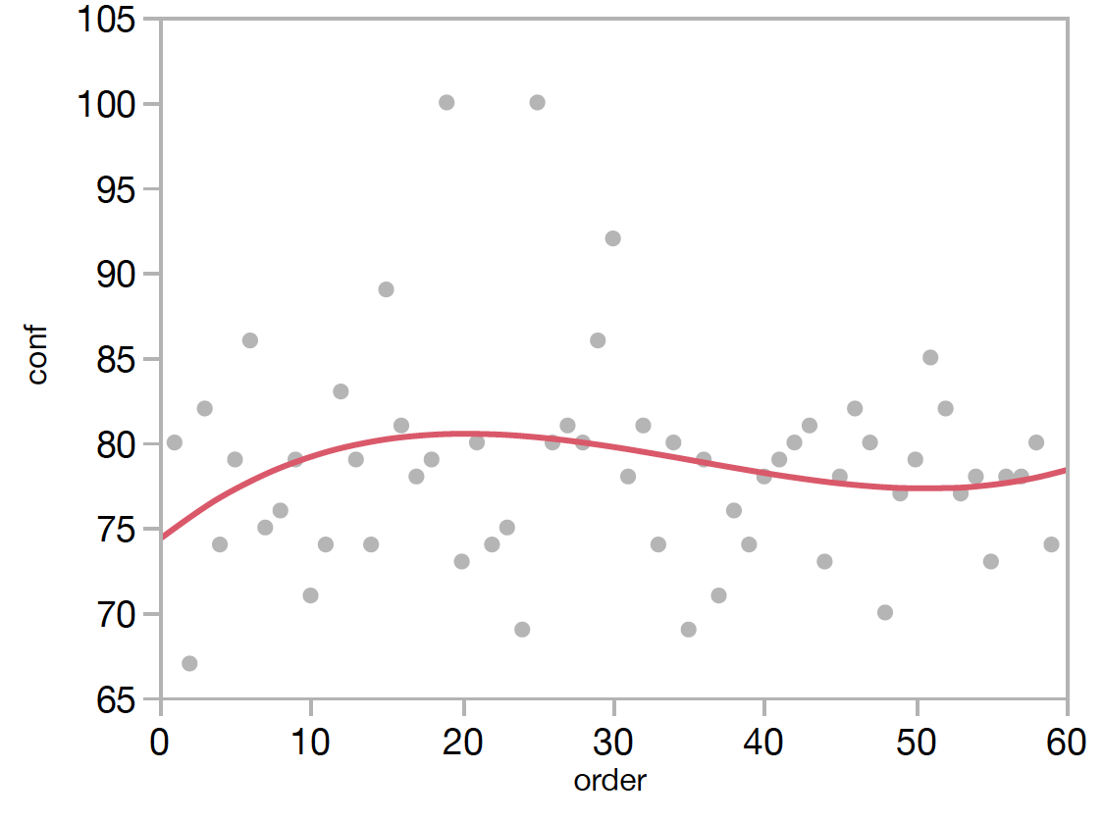
Figure S2. Two examples of individual confidence trends classified as downward quadratic. T-value associated with the left curve is -1.29, for the right curve it is -1.21.

According to this system, an upward cubic trend is the most prevalent pattern we see in individual data, with 49% showing it. The next most prevalent pattern is downward quadratic (23%). Note that both of these patterns (displayed by 72% of participants in total) are consistent with our main prediction of a “beginner’s bubble” in confidence. There is a positive rise of confidence early on which diminishes or flattens (and, occasionally, deflates) while accuracy incrementally catches up.
The flip of the cubic tail frequently seen at the end of the experimental session was unpredicted but has been unfailingly replicated from our first pilot study to follow-ups after the series reported in this manuscript. (And it’s presence is suggested by the percentage of upward linear, upward cubic, and upward quadratic patterns seen; 60% of total.)

Table S1. Classification of individual patterns of confidence into linear, quadratic, and cubic trends.
 | Linear |  | Quadratic |  | Cubic
Study | Positive | Negative | Positive | Negative* | Positive* | Negative | No Trend | n
1 | 2 | 0 | 2 | 14 | 18 | 2 | 0 | 38
2 | 7 | 1 | 1 | 11 | 24 | 1 | 1 | 50
3 | 2 | 0 | 2 | 11 | 25 | 8 | 0 | 50
4 | 3 | 0 | 1 | 7 | 24 | 8 | 5 | 47
Total | 14 | 1 | 6 | 43 | 91 | 19 | 6 | 185
% | 7.6 | 0.5 | 3.2 | 23.2 | 49.2 | 10.3 | 3.2
*consistent with "beginner's bubble" hypothesis

This is important to remember: The presence of the cubic trend is not essential for our treatment of beginner’s confidence, but the presence of some sort of bubble (non-linearity) is. The rise in confidence seen at the end of our series appears to be an “unanticipated” bonus finding, always there, that is worthy of further research.

