**MEASURES TAKEN**

The list below includes all measures taken during the studies reported in this paper. A solid circle indicates measures reported in the manuscript. An unfilled circle denotes measures taken, but not reported on in the manuscript. These measures mostly assess subjective experience of time, objective and subjective memory, demographics and control variables.

1. **Study 1: The Effect of Photo-taking on Enjoyment of a Real-Life Bus Tour**

* Overall, how much did you enjoy your bus tour experience? [1 (Not at all) to 15 (Extremely)]
* Overall, to what extent did you feel immersed in your bus tour experience? [1 (Not at all) to 15 (Extremely)]
* Overall, how much do you feel like you learned during your bus tour experience? [1 (Nothing at all) to 15 (A great deal)]
* Would you recommend a similar [xxx] bus tour experience to a friend? [1 (Not at all) to 15 (Extremely)]
* How old are you?
* What is your gender? [Male, Female]

1. **Study 2: The Effect of Photo-taking on Enjoyment of an Eating Experience**

* How much did you enjoy your eating experience at [xxx]? [1 (Not at all) to 15 (Extremely)]
* To what extent did you feel immersed in your eating experience at [xxx]? [1 (Not at all) to 15 (Extremely)]
* Did you take any photos during your eating experience? [Yes, No] If so, approximately how many?
* How many people did you visit [xxx] with today?
* Taking pictures during an experience ruins the experience itself. [1 (Strongly disagree) to 7 (Strongly agree)]
* Without taking pictures, you will not remember the experience you have. [1 (Strongly disagree) to 7 (Strongly agree)]
* Please estimate how many photos you took over the past week.
* How old are you?
* What is your gender? [Male, Female]

1. **Study 3: The Effect of Photo-taking Under Controlled Conditions**
2. Time 1 (immediately following their bus tour experience; online in the lab)

* How much did you enjoy the tour experience? [1 (Did not enjoy at all) to 7 (Enjoyed very much)]
* How quickly did time seem to pass while you were experiencing the tour? [slider scale; 0 (Very slowly) to 100 (Very quickly)]
* How long did this tour experience seem to last? [slider scale; 0 (Very short) to 100 (Very long)]
* Please estimate how long the entire tour experience lasted across both cities. [1 to 20 minutes]
* To what extent did you feel you were really part of the tour experience? [slider; 0 (Felt I was not at all part of the experience) to 100 (Felt I was entirely part of the experience)]
* To what extent did you feel immersed in the tour experience? [1 (not at all) to 7 (extremely)]
* Did you notice that the videos had a timer? [Yes, No]
* Have you ever been to London before? [Yes, No]
* Have you ever been to Hollywood before? [Yes, No]
* How old are you?
* What is your gender? [Male, Female, Prefer not to disclose]
* Please describe your experience with this study. In particular, how did you experience the movie and the interface? Is there anything in the instructions or the interface that you would change?

1. Time 2 (30 minutes after bus tour experience; online in the lab)

* How much did you enjoy the tour experience? [1 (Did not enjoy at all) to 7 (Enjoyed very much)]
* Thinking back to the entire experience, how well do you remember the tour you experienced? [1 (Not at all), 2 (Barely at all), 3 (Not so well), 4 (Fairly well), 5 (Very well), 6 (Almost perfectly), 7 (Perfectly)]
* How do we know if the Queen is in London? [There is a flag flying outside the palace, There are two guards outside the palace, Traffic is blocked outside the palace]
* What is the name of the only club Prince Charles is a member of? [Royal Club, Alpine Club, Brook’s Club, White’s Club]
* What palace was built for Henry VIII and was the home of Prince Charles and his sons? [Sir James Palace, Whitehall Palace, Buckingham Palace, Lambeth Palace]
* Which queen was married at the palace they passed? [Queen Elizabeth I, Queen Elizabeth II, Queen Mary, Queen Victoria, Queen Anne]
* Who was the first lady to be admitted to the all men’s club the bus tour passed? [Justine Roberts, Millicent Fawcett, Margaret Thatcher, Leona Lewis, Virginia Woolf]
* What does the J and B stand for in the wine merchant they pass? [Jokowi & Brooks, Jim Beam, James Brown, Justerini & Brooks]
* Which of the following images WAS part of your bus tour experience? [4 images]
* What is the silver gazebo which features four silver statues of screen actresses called? [Welcome to Hollywood, Gateway to Hollywood, Hollywood Gazebo, Hollywood Gate]
* The famous theater at the beginning of the tour that opened with the premiere of “The King of Kings” is called the: [Egyptian Theater, Kodak Theater, Chinese Theater, Directors’ Guilt Theater, Hollywood Theater]
* The building of the Director’s Guild of America has how many theaters for directors to screen their movies? [1,2,3,4,5,6]
* In her statue on top of the spire, which movie is Marilyn Monroe depicted in? [Some Like it Hot, Gentlemen Prefer Blondes, Seven Year Itch, How to Marry a Millionaire]
* What was one of the actresses depicted in the statues featuring 4 successful races in Hollywood? [Dorothy Dandridge, Halle Berry, Debbie Allen, Diahann Carroll]
* Which of the following images WAS NOT part of your tour experience? [4 images]

1. Time 3 (1 week after bus tour experience; online via email)

* How much did you enjoy the tour experience? [1 (Did not enjoy at all) to 7 (Enjoyed very much)]
* Thinking back to the entire experience, how well do you remember the tour you experienced? [1 (Not at all), 2 (Barely at all), 3 (Not so well), 4 (Fairly well), 5 (Very well), 6 (Almost perfectly), 7 (Perfectly)]
* What is the first site the tour bus visits? [Kensington Square, Piccadilly Circus, Trafalgar Square, Parliament Square]
* Who was a member of the Literary Club the tour bus passed? [Mark Twain, Thomas Hardy, Lewis Carroll, Jonathan Swift, Ernest Hemingway]
* What hotel does the tour bus pass at the end? [The Dorchester, The Ritz, Claridge, Duke’s Hotel]
* When there are flyovers in London, which arch do the planes fly over? [Marble Arch, Wellington Arch, Admiralty Arch, Thistle Arch]
* Which Greek goddess was depicted in the golden figure the bus tour passed? [Athena, Diana, Aphrodite, Hestia]
* Who recently had a hat made at the world famous hatters the bus tour passed? [Jude Law, Robert Pattinson, Johnny Depp, Hugh Grant]
* Which of the following images WAS NOT part of your bus tour experience? [4 images]
* Who died in one of the private bungalows at the Chateau Marmont? [ Joaquin Phoenix, Marilyn Monroe, John Belushi, Heath Ledger, Whitney Houston]
* Where does the tour start? [Sunset Boulevard, Sunset Strip, Hollywood Boulevard, Rodeo Drive, La Brea Avenue]
* The standup comedy club feature on the tour is the: [Groundlings, Comedy Store, Comedy Union, Laugh Factory, Upright Citizens Brigade]
* Who performed at the comedy club featured on the tour? [Robin Williams, Ellen DeGeneres, Rosie O’Donnell, Adam Sandler, Dave Chappelle, Jim Carey]
* Which of the following images WAS part of your bus tour experience? [4 images]

1. **Study 4: How Photo-taking Affects More or Less Visually Homogeneous Experiences**
2. Time 1 (immediately following their bus tour [concert] experience; online in the lab)

* How much did you enjoy the tour [concert] experience? [1 (Did not enjoy at all) to 7 (Enjoyed very much)]
* How quickly did time seem to pass while you were experiencing the tour [concert]? [slider scale; 0 (Very slowly) to 100 (Very quickly)]
* How long did this tour [concert] experience seem to last? [slider scale; 0 (very short) to 100 (very long)]
* Please estimate how long the entire tour [concert] experience lasted across both cities. [1 to 20 minutes]
* To what extent did you feel you were really part of the tour [concert] experience? [slider; 0 (Felt I was not at all part of the experience) to 100 (Felt I was entirely part of the experience)]
* To what extent did you feel immersed in the tour [concert] experience? [1 (not at all) to 7 (extremely)]
* Did you notice that the videos had a timer? [Yes, No]
* How old are you?
* What is your gender? [Male, Female, Prefer not to disclose]

1. Time 2 (30 minutes after bus tour experience; online in the lab)

* How much did you enjoy the tour [concert] experience? [1 (Did not enjoy at all) to 7 (Enjoyed very much)]

1. Time 3 (1 week after experience; online via email)

* How much did you enjoy the tour experience? [1 (Did not enjoy at all) to 7 (Enjoyed very much)]

1. **Study 5: The Effect of Taking Photos vs. Planning to Take Photos**

* How much did you enjoy the tour experience? [1 (Did not enjoy at all) to 7 (Enjoyed very much)]
* To what extent did you feel you were really part of the tour experience? [slider; 0 (Felt I was not at all part of the experience) to 100 (Felt I was entirely part of the experience)]
* To what extent did you feel immersed in the tour experience? [1 (not at all) to 7 (extremely)]
* Have you ever been to London before? [Yes, No]
* How old are you?
* What is your gender? [Male, Female, Prefer not to disclose]

1. **Study 6: The Effect of Photo-taking on Visual Attention in a Natural Setting**

* How much did you enjoy your experience in the Japan exhibit? [1 (Not at all) to 7 (Extremely)]
* How much do you feel like you learned while visiting this exhibit? [1 (Nothing at all) to 7 (A lot)]
* To what extent did you feel immersed in your exhibit experience? [1 (Not at all) to 7 (Extremely)]
* Would you recommend this exhibit to a friend? [1 (Definitely not) to 7 (Definitely would)]
* How old are you?
* What is your gender? [Male, Female]

1. **Study 7: The Effect of Photo-taking When Photo-taking Gets in the Way**
2. Time 1 (immediately following their bus tour experience; online in the lab)

* How much did you enjoy the tour experience? [1 (Did not enjoy at all) to 7 (Enjoyed very much)]
* How quickly did time seem to pass while you were experiencing the tour? [slider scale; 0 (Very slowly) to 100 (Very quickly)]
* How long did this tour experience seem to last? [slider scale; 0 (very short) to 100 (very long)]
* Please estimate how long the entire tour experience lasted across both cities. [1 to 20 minutes]
* To what extent did you feel you were really part of the tour experience? [slider; 0 (Felt I was not at all part of the experience) to 100 (Felt I was entirely part of the experience)]
* To what extent did you feel immersed in the tour experience? [1 (not at all) to 7 (extremely)]
* Did you notice that the videos had a timer? [Yes, No]
* How much did you feel like you were missing out on the tour experience while you were using the photo interface? [1 (Not very much) to 7 (Very much)]
* Using the photo interface really disrupted my tour experience. [1 (Strongly disagree) to 7 (Strongly agree)]
* Have you ever been to London before? [Yes, No]
* Have you ever been to Hollywood before? [Yes, No]
* Have you ever been to Paris before? [Yes, No]
* How old are you?
* What is your gender? [Male, Female, Prefer not to disclose]
* Please describe your experience with this study. In particular, how did you experience the movie and the interface? Is there anything in the instructions or the interface that you would change?

1. Time 2 (30 minutes after bus tour experience; online in the lab)

* How much did you enjoy the tour experience? [1 (Did not enjoy at all) to 7 (Enjoyed very much)]
* Thinking back to the entire experience, how well do you remember the tour you experienced? [1 (Not at all), 2 (Barely at all), 3 (Not so well), 4 (Fairly well), 5 (Very well), 6 (Almost perfectly), 7 (Perfectly)]
* How do we know if the Queen is in London? [There is a flag flying outside the palace, There are two guards outside the palace, Traffic is blocked outside the palace]
* What is the name of the only club Prince Charles is a member of? [Royal Club, Alpine Club, Brook’s Club, White’s Club]
* What palace was built for Henry VIII and was the home of Prince Charles and his sons? [Sir James Palace, Whitehall Palace, Buckingham Palace, Lambeth Palace]
* Which queen was married at the palace they passed? [Queen Elizabeth I, Queen Elizabeth II, Queen Mary, Queen Victoria, Queen Anne]
* Who was the first lady to be admitted to the all men’s club the bus tour passed? [Justine Roberts, Millicent Fawcett, Margaret Thatcher, Leona Lewis, Virginia Woolf]
* What does the J and B stand for in the wine merchant they pass? [Jokowi & Brooks, Jim Beam, James Brown, Justerini & Brooks]
* Which of the following images WAS part of your bus tour experience? [4 images]
* What is the silver gazebo which features four silver statues of screen actresses called? [Welcome to Hollywood, Gateway to Hollywood, Hollywood Gazebo, Hollywood Gate]
* The famous theater at the beginning of the tour that opened with the premiere of “The King of Kings” is called the: [Egyptian Theater, Kodak Theater, Chinese Theater, Directors’ Guilt Theater, Hollywood Theater]
* The building of the Director’s Guild of America has how many theaters for directors to screen their movies? [1, 2, 3, 4, 5, 6]
* In her statue on top of the spire, which movie is Marilyn Monroe depicted in? [Some Like it Hot, Gentlemen Prefer Blondes, Seven Year Itch, How to Marry a Millionaire]
* What was one of the actresses depicted in the statues featuring 4 successful races in Hollywood? [Dorothy Dandridge, Halle Berry, Debbie Allen, Diahann Carroll]
* Which of the following images WAS NOT part of your tour experience? [4 images]
* What were the book stalls on the river called? [Livre Marchand, Roman marche, Marche, Bouquinistes]
* What was the architect of the Louvre glass pyramid from? [Japan, China, Korea, America, Great Britain]
* How many statues of Joan of Arc are there in Paris? [2, 3, 4, 5, 6]

1. Time 3 (1 week after experience; online via email)

* How much did you enjoy the tour experience? [1 (Did not enjoy at all) to 7 (Enjoyed very much)]
* Thinking back to the entire experience, how well do you remember the tour you experienced? [1 (Not at all), 2 (Barely at all), 3 (Not so well), 4 (Fairly well), 5 (Very well), 6 (Almost perfectly), 7 (Perfectly)]
* To what extent did you feel you were really part of the tour experience? [slider; 0 (Felt I was not at all part of the experience) to 100 (Felt I was entirely part of the experience)]
* To what extent did you feel immersed in the tour experience? [1 (not at all) to 7 (extremely)]
* What is the first site the tour bus visits? [Kensington Square, Piccadilly Circus, Trafalgar Square, Parliament Square]
* Who was a member of the Literary Club the tour bus passed? [Mark Twain, Thomas Hardy, Lewis Carroll, Jonathan Swift, Ernest Hemingway]
* What hotel does the tour bus pass at the end? [The Dorchester, The Ritz, Claridge, Duke’s Hotel]
* When there are flyovers in London, which arch do the planes fly over? [Marble Arch, Wellington Arch, Admiralty Arch, Thistle Arch]
* Which Greek goddess was depicted in the golden figure the bus tour passed? [Athena, Diana, Aphrodite, Hestia]
* Who recently had a hat made at the world famous hatters the bus tour passed? [Jude Law, Robert Pattinson, Johnny Depp, Hugh Grant]
* Which of the following images WAS NOT part of your bus tour experience? [4 images]
* Who died in one of the private bungalows at the Chateau Marmont? [ Joaquin Phoenix, Marilyn Monroe, John Belushi, Heath Ledger, Whitney Houston]
* Where does the tour start? [Sunset Boulevard, Sunset Strip, Hollywood Boulevard, Rodeo Drive, La Brea Avenue]
* The standup comedy club feature on the tour is the: [Groundlings, Comedy Store, Comedy Union, Laugh Factory, Upright Citizens Brigade]
* Who performed at the comedy club featured on the tour? [Robin Williams, Ellen DeGeneres, Rosie O’Donnell, Adam Sandler, Dave Chappelle, Jim Carey]
* Which of the following images WAS part of your bus tour experience? [4 images]
* Flow questionnaire
  + My mind isn’t wandering. I am not thinking of something else. I am totally involved in what I am doing. My body feels good. I don’t seem to hear anything. The world seems to be cut off from me. I am less aware of myself and my problems…..Please indicate whether you have ever had a similar experience to the one described above [Yes, No]
  + My concentration is like breathing. I never think of it. I am really quite oblivious to my surroundings after I really get going. I think that the phone could ring, and the doorbell could ring, or the house could burn down or something like that. When I start, I really do shut out the whole world. Once I stop, I can let it back in again.…..Please indicate whether you have ever had a similar experience to the one described above [Yes, No]
  + I am so involved in what I am doing. I don’t see myself as separate from what I am doing.…..Please indicate whether you have ever had a similar experience to the one described above [Yes, No]

1. **Study 8: The Effect of Photo-taking When the Activity is Actively Engaging**

* How much did you enjoy the craft experience? [1 (Did not enjoy at all) to 7 (Enjoyed very much)]
* To what extent did you feel you were really part of the craft experience? [slider; 0 (Felt I was not at all part of the experience) to 100 (Felt I was entirely part of the experience)]
* To what extent did you feel immersed in the craft experience? [1 (Not at all immersed) to 7 (Extremely immersed)]
* How crowded was the craft experience? [1 (Not at all crowded) to 7 (Extremely crowded)]
* How frustrated did you feel during the craft experience? [1 (Not at all frustrated) to 7 (Extremely frustrated)]
* How unusual was the craft experience compared to other craft experiences you have done in the past? [1 (Definitely not) to 7 (Definitely would)]
* How novel was the craft experience compared to other craft experiences you have done in the past? [1 (Definitely not) to 7 (Definitely would)]
* Did you take photos during the craft experience? If they answered yes to previous question:
  + How many photos did you take during the craft experience? Please look back at your photo-taking device to get the exact count, and then enter the total number of photos you took.
  + How much did you feel like you were missing out on the craft experience while you were taking photos? [1 (Not very much) to 7 (Very much)]
  + Taking photos really disrupted my craft experience. [1 (Strongly disagree) to 7 (Strongly agree)]
  + How distracted did you feel by taking photos during the craft experience? [1 (Not at all distracted) to 7 (Extremely distracted)]
* Please estimate how many photos you took over the past week, NOT including any photos you took today in the lab. Please only write a number. If you did not take any photos over the past week, write "0".
* Taking pictures during an experience ruins the experience itself. [1 (Strongly disagree) to 7 (Strongly agree)]
* Without taking pictures, you will not remember the experiences you have. [1 (Strongly disagree) to 7 (Strongly agree)]
* In general, how much do you enjoy arts-and-crafts projects? [1 (Not at all) to 7 (A great deal)]
* How much experience do you have with arts-and-crafts projects like the one you engaged in today? [1 (No experience at all) to 7 (A great deal of experience)]
* Which craft did you engage in today? [Wafer Eiffel Tower, Spaghetti and Marshmallow Tower]
* Are you planning to take your craft home? [Yes, No]
* How old are you?
* What is your gender? [Male, Female, Prefer not to disclose]
* Please describe your experience with this study. Is there anything in the instructions or activity that you would change?

1. **Study 9: Taking Photos of Positive versus Negative Experiences**

* How much did you enjoy the safari experience? [1 (Did not enjoy at all) to 7 (Enjoyed very much)]
* To what extent did you feel you were really part of the safari experience? [slider; 0 (Felt I was not at all part of the experience) to 100 (Felt I was entirely part of the experience)]
* To what extent did you feel immersed in the safari experience? [1 (not at all) to 7 (extremely)]
* How quickly did time seem to pass while you were experiencing the safari? [slider scale; 0 (Very slowly) to 100 (Very quickly)]
* How long did this safari experience seem to last? [slider scale; 0 (very short) to 100 (very long)]
* How old are you?
* What is your gender? [Male, Female, Prefer not to disclose]

Study 4: 3-way interaction of stimulus by condition by time interaction graphed separately by stimulus, condition, and time

By stimulus:

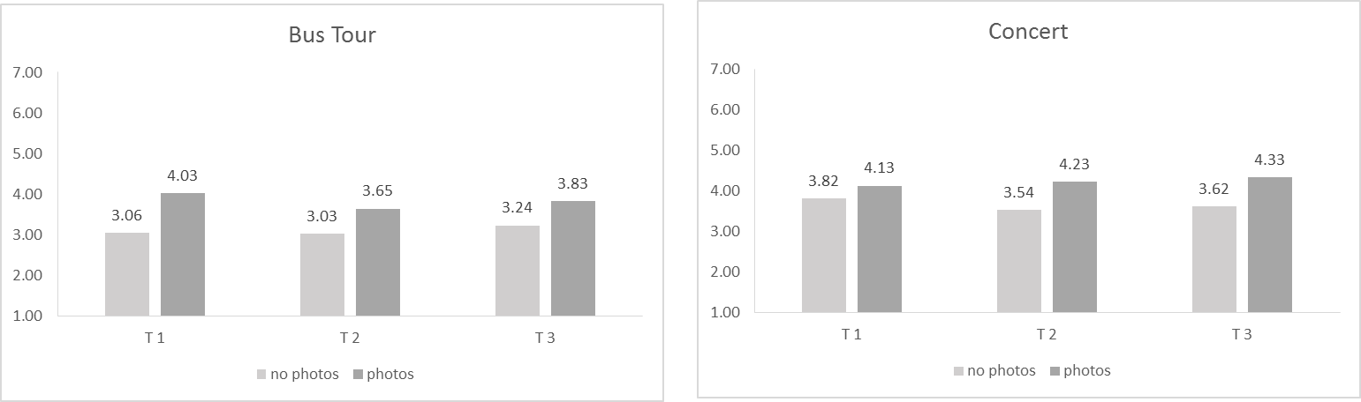

By condition:

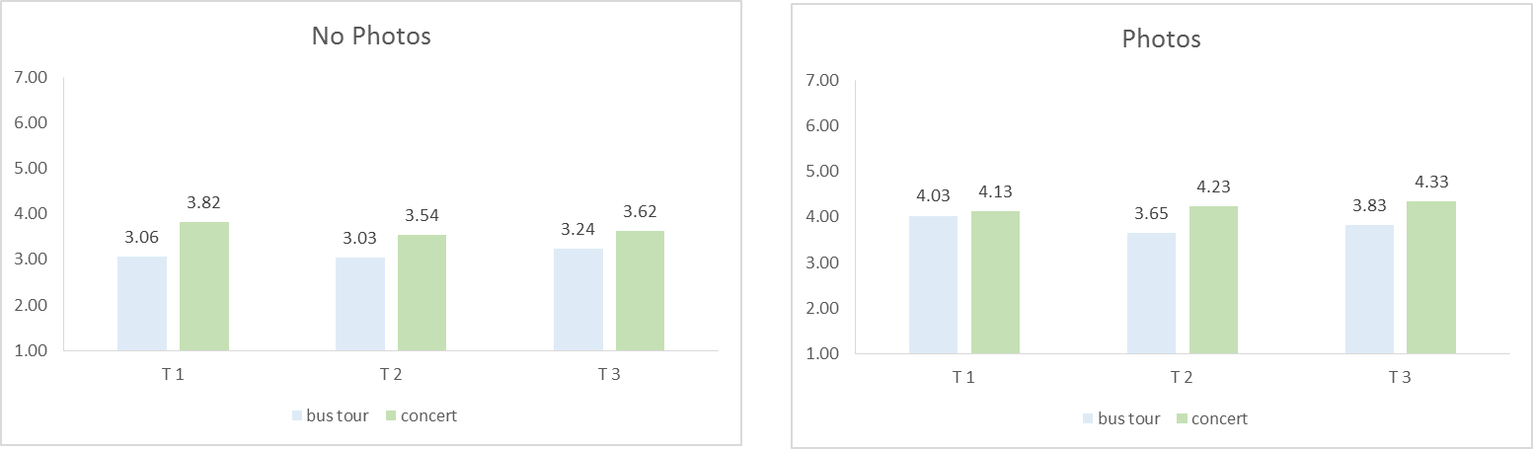

By time:

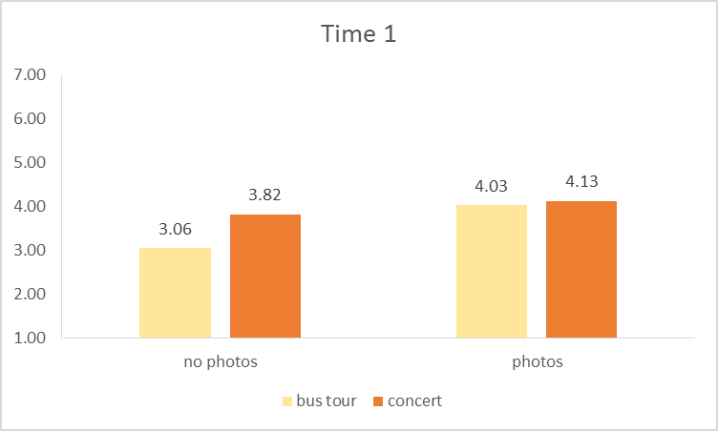 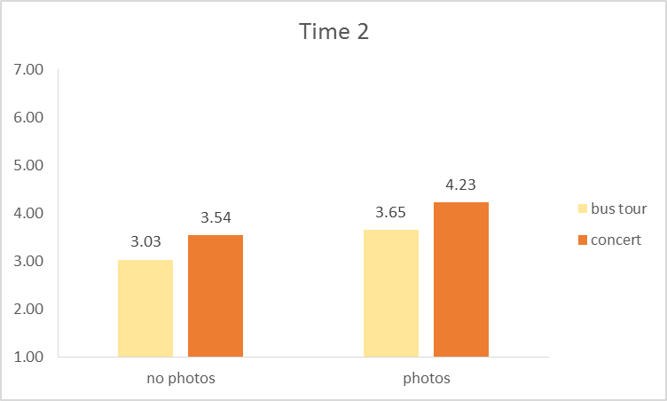

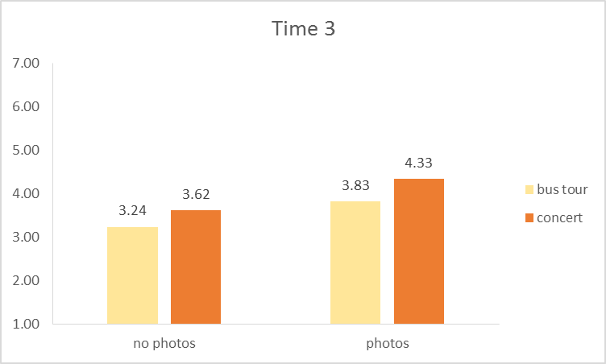

Instructions – Study 6

NO PHOTO CONDITION

**Museum Study Instructions**

Thank you for agreeing to participate in our study!

Please read these instructions carefully:

You will go on a self-guided tour of an exhibit today. View the exhibit as you normally would when visiting a museum exhibit.

While you view the exhibit, you will be wearing mobile eye-tracking glasses that will record a video of your surroundings and your eye fixations.

* Walk up the stairs to the second floor and walk straight ahead to enter the Japan exhibit. This is the focus of our study today.
* In the Japan exhibit, please view the artifacts in a **clockwise** pattern, starting with the displays **on your left** as soon as you enter the room (see map on the back of this sheet).
* Do NOT enter the China exhibit (the circular room) or view other exhibits during this study.
* When you have completed your visit, please return to this station to answer a few questions about your experience.
* **Please put on the mobile eye-tracking glasses now, and do not take them off until you return to this location.**

PHOTO CONDITION

**Museum Study Instructions**

Thank you for agreeing to participate in our study!

Please read these instructions carefully:

You will go on a self-guided tour of an exhibit today. View the exhibit as you normally would when visiting a museum exhibit.

While you view the exhibit, you will be wearing mobile eye-tracking glasses that will record a video of your surroundings and your eye fixations.

You also have a camera to take pictures of anything in the exhibit while wearing the mobile eye-tracking glasses. While you view the exhibit, please take photos as you normally would in this context. Please take at least 10 photos.

* Walk up the stairs to the second floor and walk straight ahead to enter the Japan exhibit. This is the focus of our study today.
* In the Japan exhibit, please view the artifacts in a **clockwise** pattern, starting with the displays **on your left** as soon as you enter the room (see map on the back of this sheet).
* Do NOT enter the China exhibit (the circular room) or view other exhibits during this study.
* When you have completed your visit, please return to this station to answer a few questions about your experience.
* **Please put on the mobile eye-tracking glasses now, and do not take them off until you return to this location.**

12

10

13

11

China Exhibit  
(Do Not Enter)

Entrance

9

4

Japan Exhibit Map

**LEGEND:**

= main

display

area

**please view the exhibit clockwise from the entrance, following the numbers**

8

7

6

5

3

1

2

Study 8 Task Selection Instructions

Builder Condition [Observer Condition in brackets]

Behavioral Lab ID:_______________________

Many people engage in arts and craft activities. We are interested in people’s experiences with such activities. In this study, you will engage in an arts-and-crafts project of your choice. This will involve using [watching someone use] food materials to build a tower from scratch.

You will get to choose the arts-and-crafts project that you want to [watch someone] do. The two options are shown below:

1. Wafer Eiffel Tower

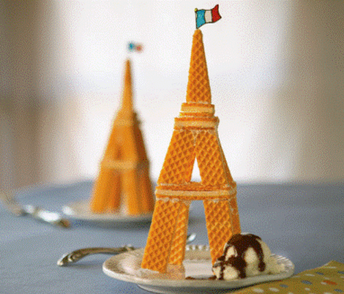

1. Spaghetti and Marshmallow Tower

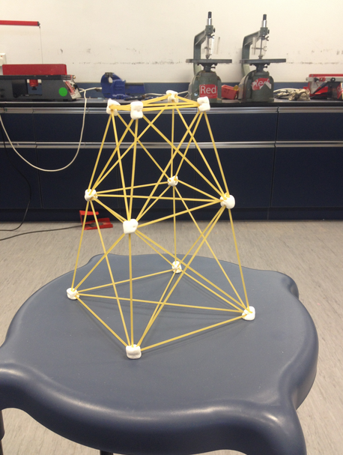

Once you have decided which arts-and-crafts project you would like to [watch someone] do, **please circle it above**. Then, raise your hand for the experimenter to collect this sheet and give you further instructions.

Sceenshots of more positive video used in study 9

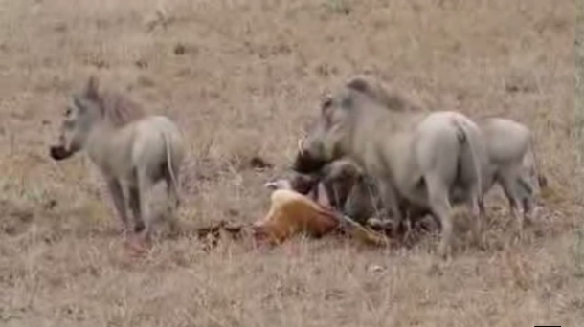 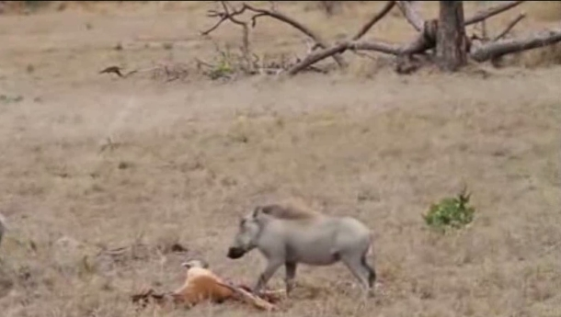

0 seconds (Start) 15 seconds

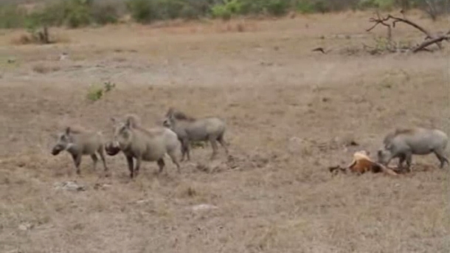 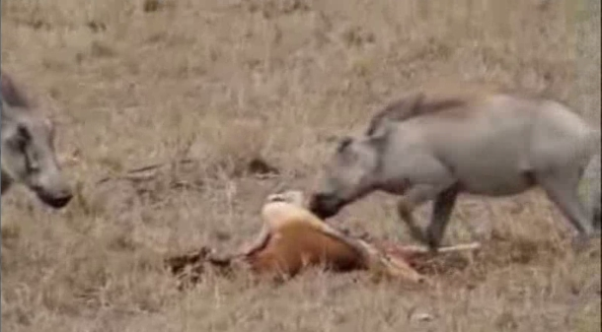

30 seconds 45 seconds

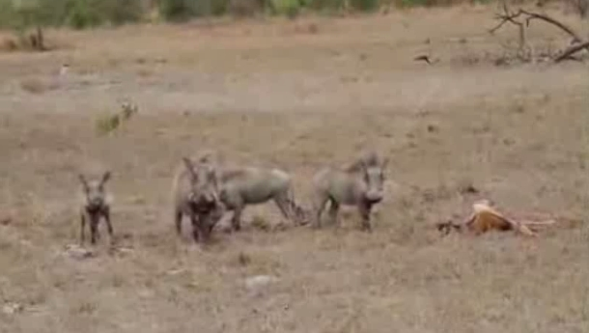 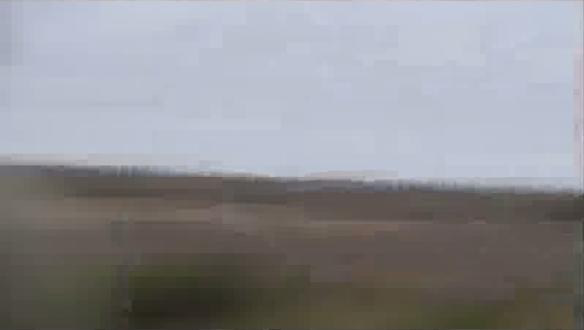

1 minute 1 minute 15 seconds

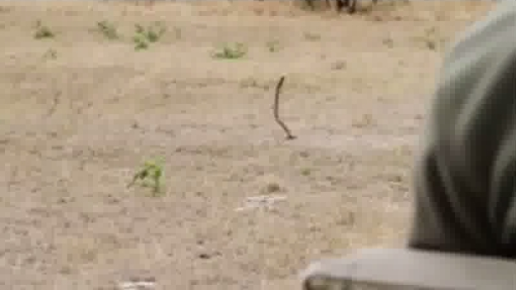 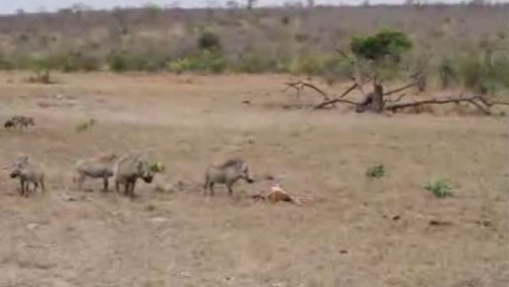

1 min 30 seconds 1 min 45 seconds

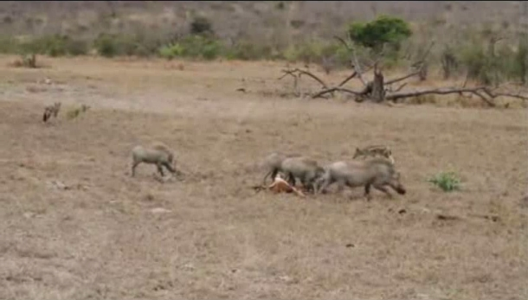 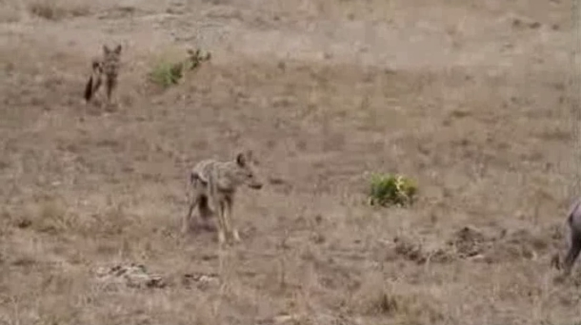

2 minutes 2 minutes 15 seconds

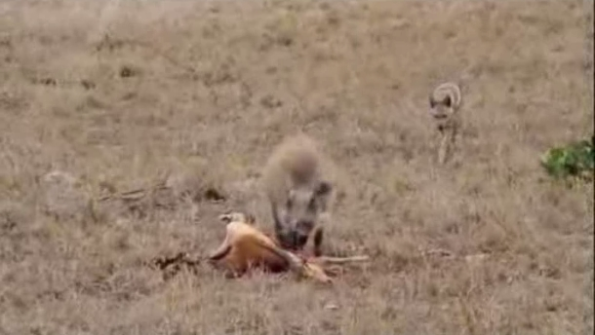 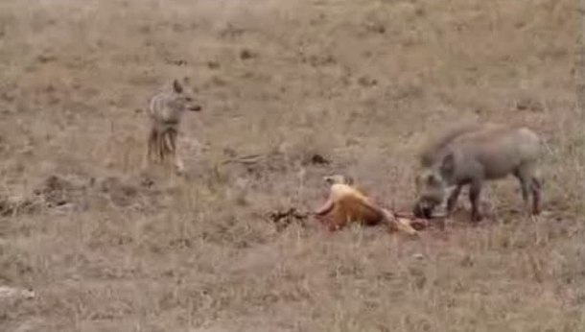

2 minutes 30 seconds 2 mintues 45 seconds

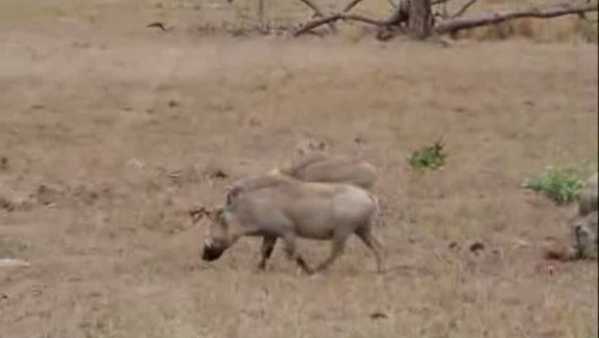

3 minutes (End)

Sceenshots of more negative video used in study 9

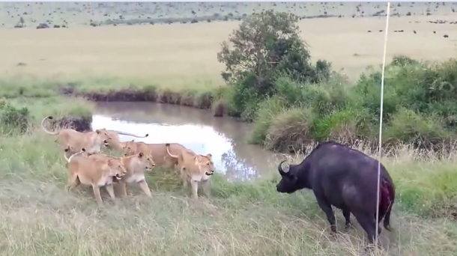 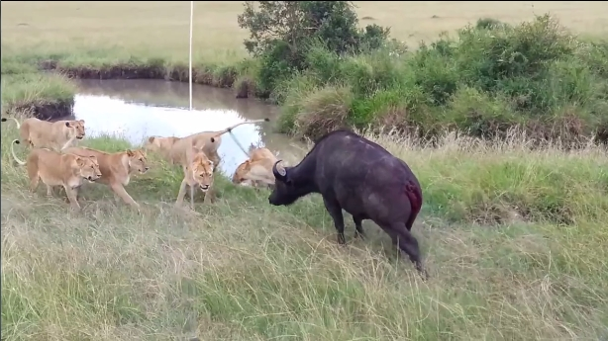

0 seconds (Start) 15 seconds

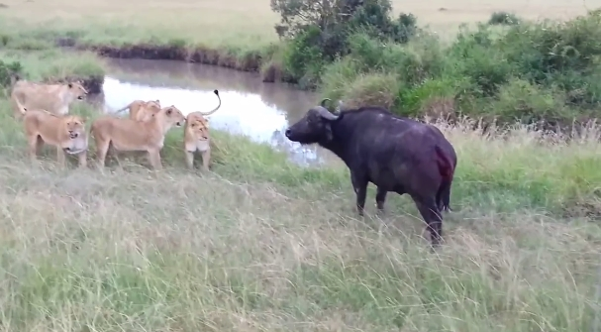 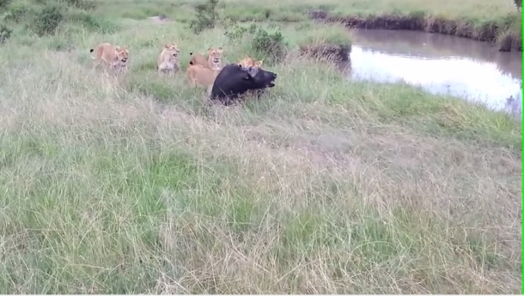

30 seconds 45 seconds

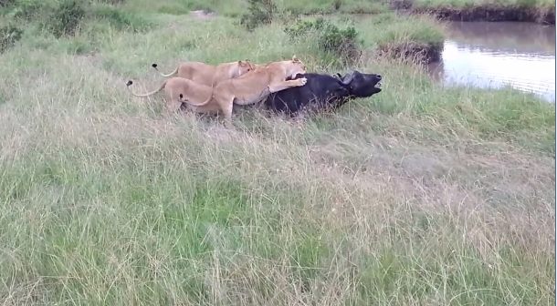 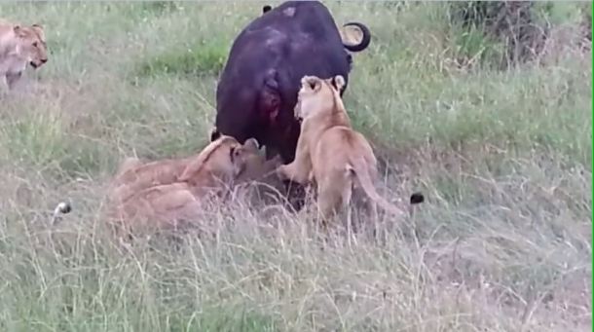

1 min 1 min 15 seconds

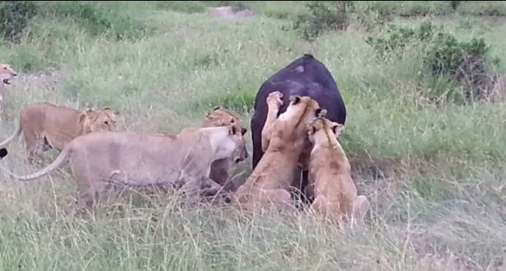 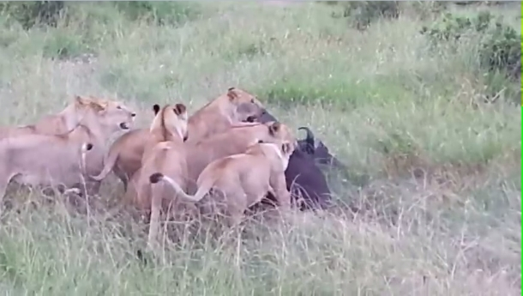

1 min 30 seconds 1 min 45 seconds

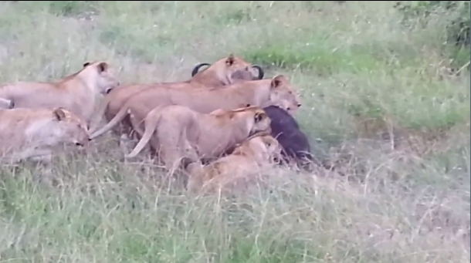 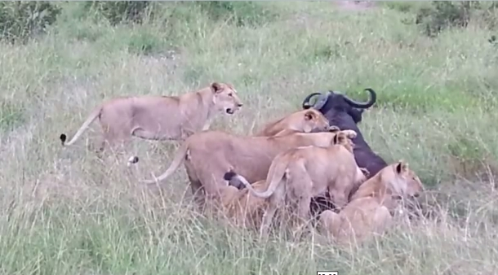

2 min 2 min 15 seconds

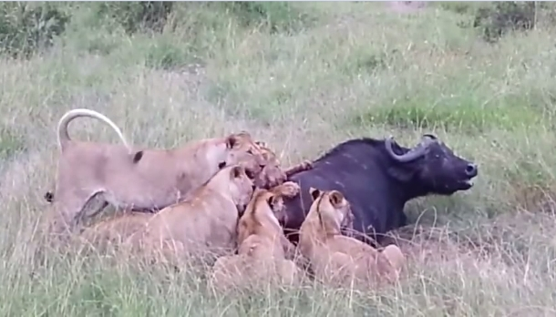 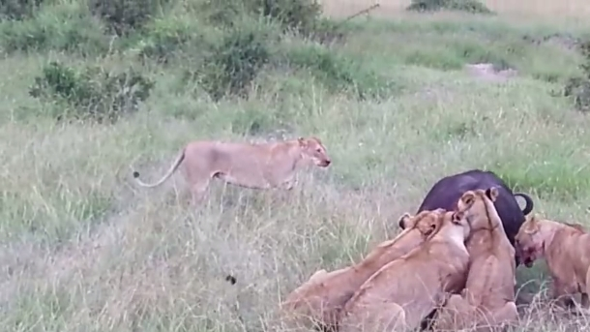

2 min 30 seconds 2 min 45 seconds

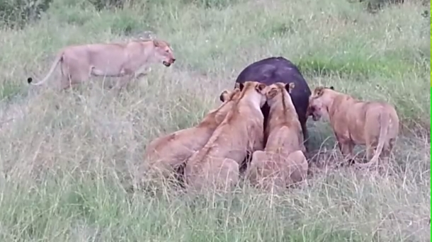

3 min (End)