Figure S1
The Therapist Office Virtual Environment in Facing the Fear VR
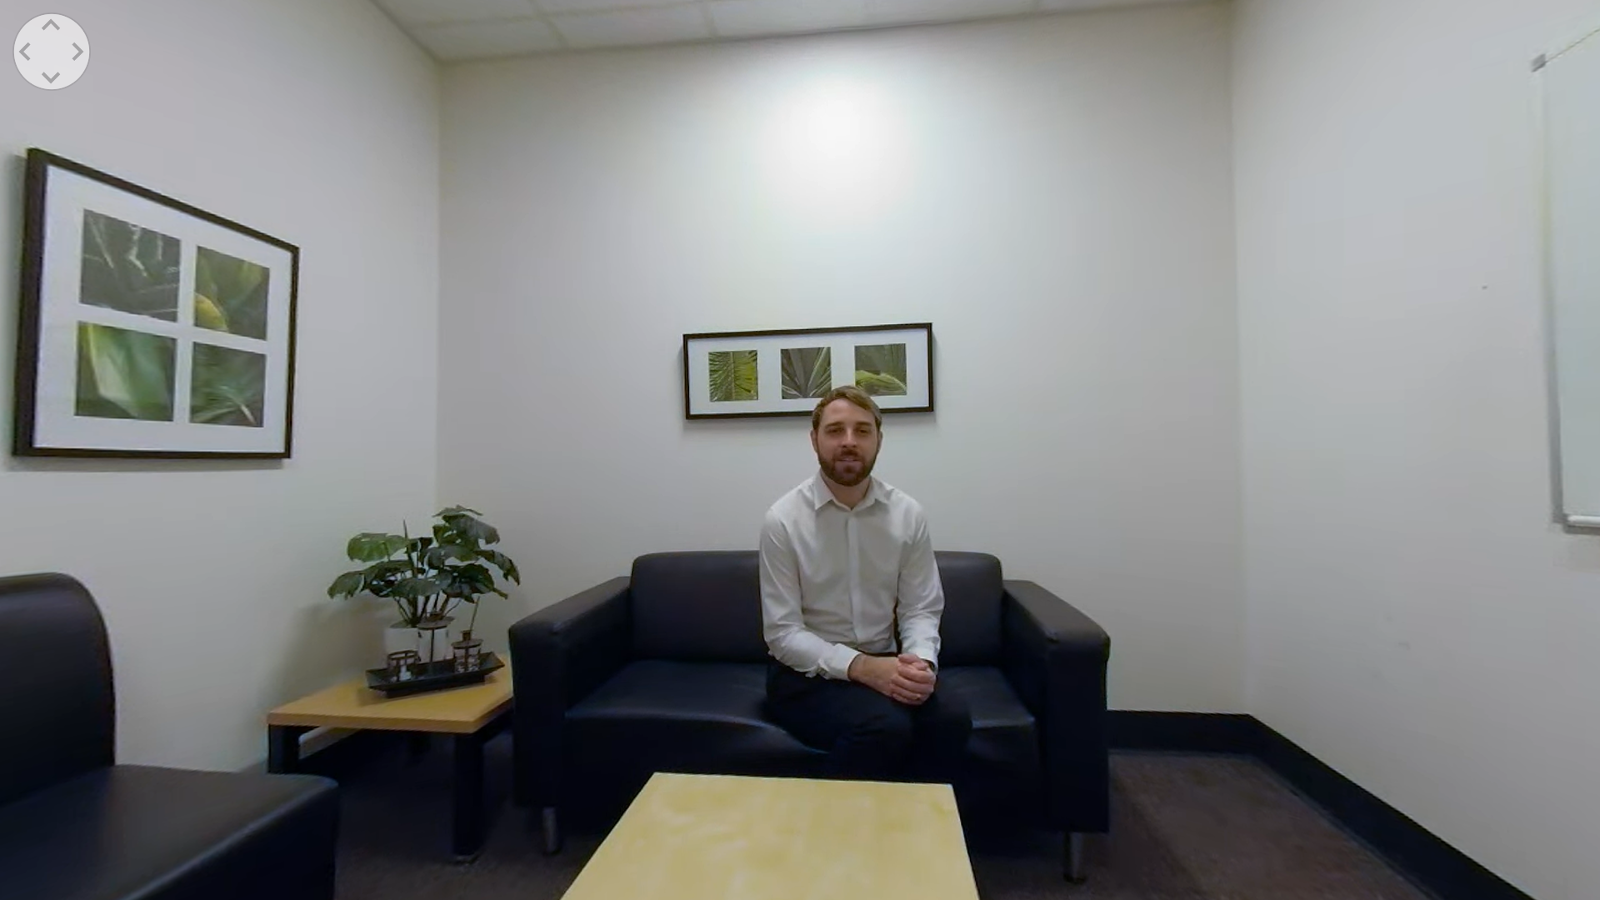
Figure S2
The Forest Virtual Environment in Facing the Fear VR
