**Supplemental Figure 1**

*Minority Stress Processes and Affirmative Therapy with Transgender and Gender Diverse Clients*

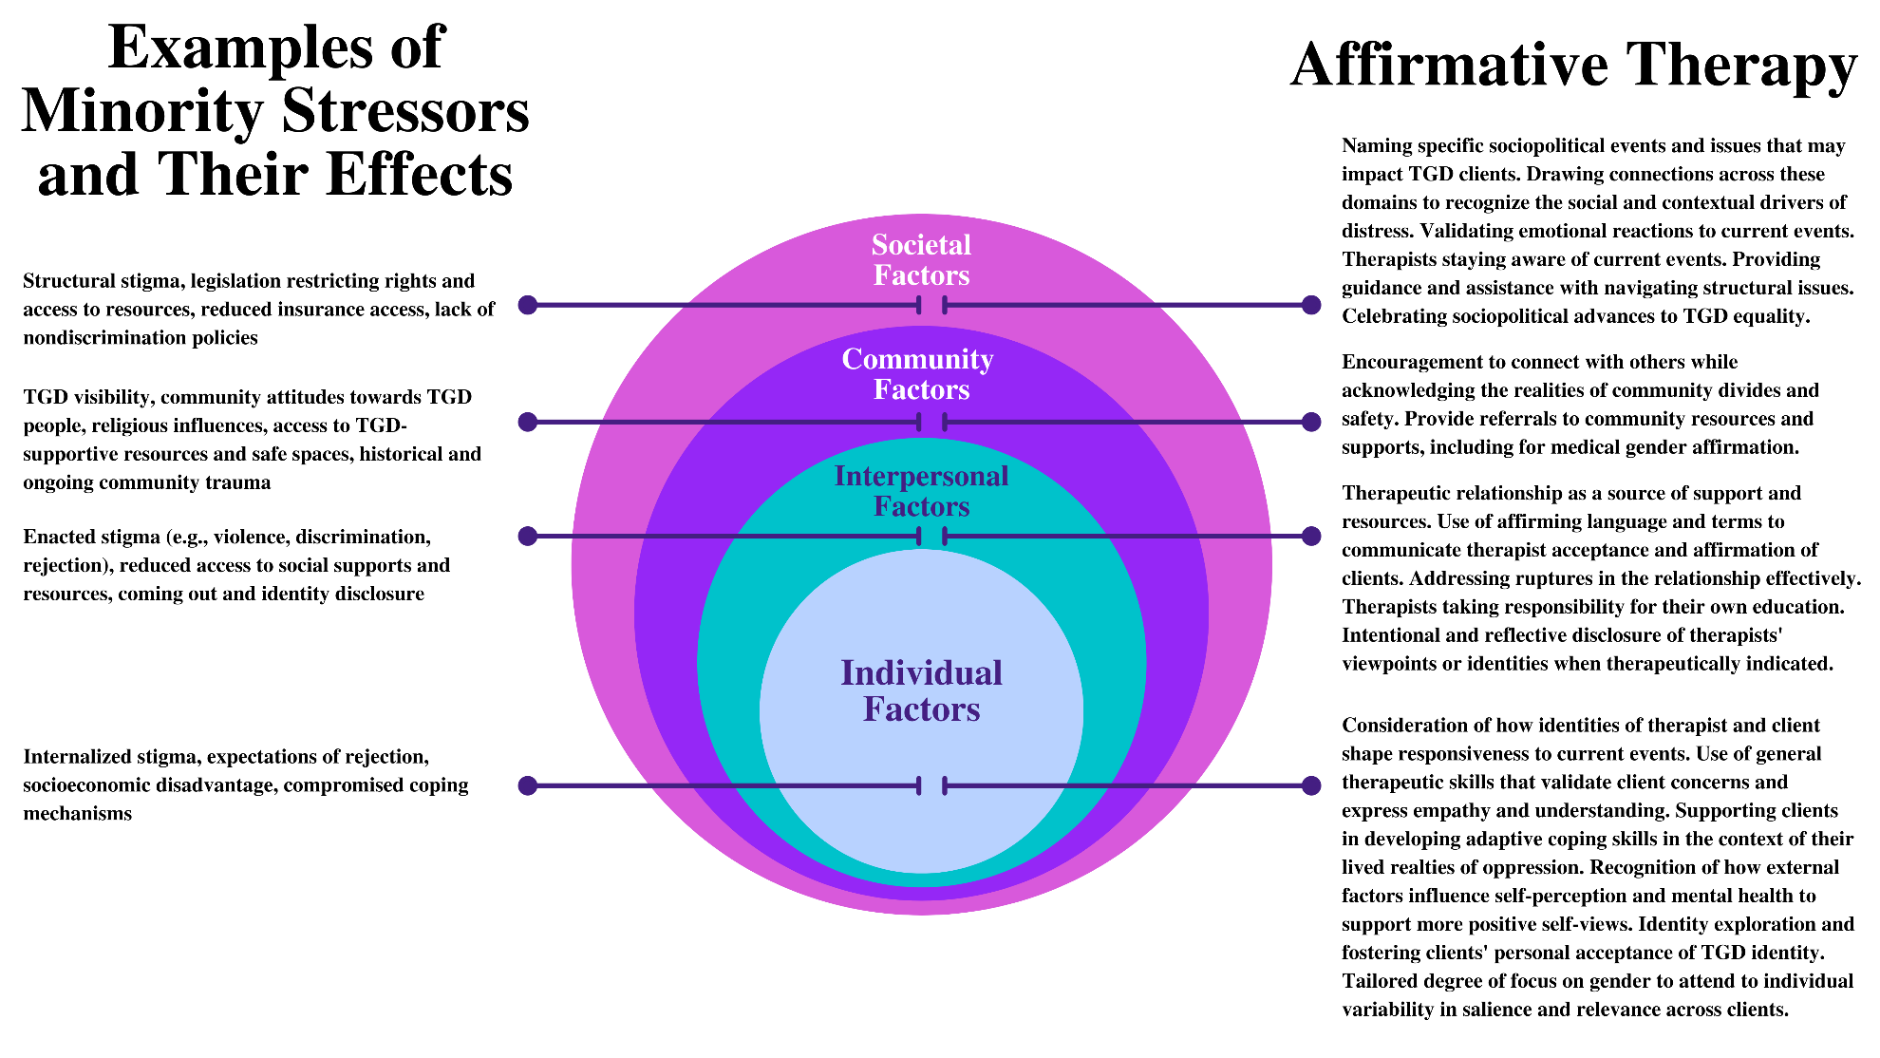

*Note.* This figureprovides an overview of the findings in our current analyses and how these may span across levels of the socioecological model, contrasted with examples of minority stressors. This portrayal of findings was inspired by the Sexual and Gender Minority Health Disparities Research Framework (NIMHD, 2021). TGD = transgender and gender diverse.