Supplemental Materials

Supplemental Table 1.
Supplemental Table 1. Participant demographic and baseline substance-use characteristics by cannabis-use frequency group.
Characteristics | Total Sample (N=20) | Infrequent Use (n=6) | Frequent Use (N=14)
Age, years, mean (SD) | 33.1 (10.8) | 39.3 (11.2) | 30.4 (9.8)
BMI, kg/m2, mean (SD) | 27.5 (4.6) | 28.7 (3.8) | 26.9 (4.9)
Sex, n (%)
Female | 9 (45.0%) | 2 (33.3%) | 7 (50.0%)
Male | 9 (45.0%) | 3 (50.0%) | 6 (42.9%)
Other | 2 (10.0%) | 1 (16.7%) | 1 (7.1%)
Race
Asian | 2 (10.0%) | 0 (0.0%) | 2 (14.3%)
Black/African American | 6 (30.0%) | 3 (50.0%) | 3 (21.4%)
White | 12 (60.0%) | 3 (50.0%) | 9 (64.3%)
Hispanic Origin, n (%)
No | 20 (100%) | 6 (100.0%) | 14 (100%)
Nicotine/Tobacco-Use, n (%)
Cigarette-predominant | 7 (35.0%) | 3 (50.0%) | 4 (28.6%)
Dual cigarette/e-cigarette use | 8 (40.0%) | 1 (16.7%) | 7 (50.0%)
E-cigarette-predominant | 5 (25.0%) | 2 (33.3%) | 3 (21.4%)
Past 30-day cigarette use, mean (SD) | 5.5 (6.3) | 6.3 (7.1) | 5.1 (6.2)
Past 30-day e-cigarette use, mean (SD) | 3.3 (6.0) | 1.5 (1.6) | 4.1 (7.1)
Past 30-day cannabis use, mean (SD) | 18.6 (11.9) | 3.3 (2.1) | 25.1 (7.1)
Note: THC dose was assigned based on cannabis-use frequency. Participants who used cannabis infrequently received 10 mg THC, and participants who used cannabis frequently received 25 mg THC. Past 30-day cigarette use, e-cigarette use, and cannabis use are presented as mean number of use days or use episodes as assessed at screening.

Supplemental Figure 1.


Supplemental Figure 2.
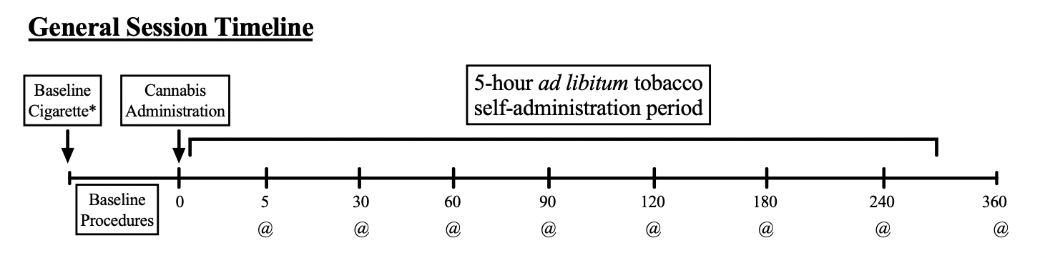
Supplemental Figure 3.
