Supplemental Table 1
Treatment Emergent Adverse Events by System Organ Class
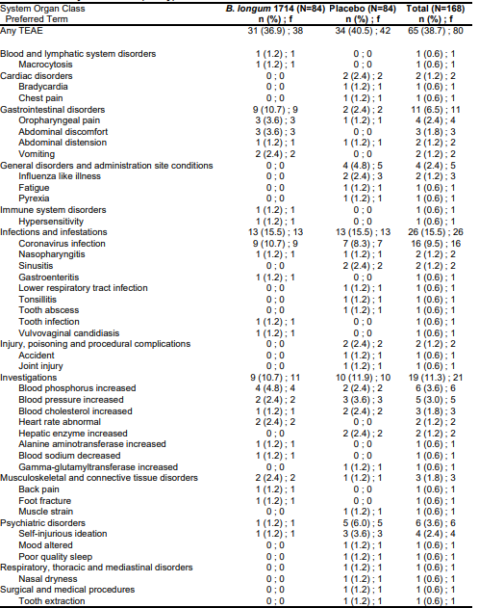
Abbreviations: B. longum = Bifidobacterium longum; n = number; TEAE = Treatment Emergent Adverse Event.

