Figure S1
Post-resolution Proportion of Events Related to Drinking Episodes and Pre-resolution Proportional DPS Scores by Factorized Life Health Domain
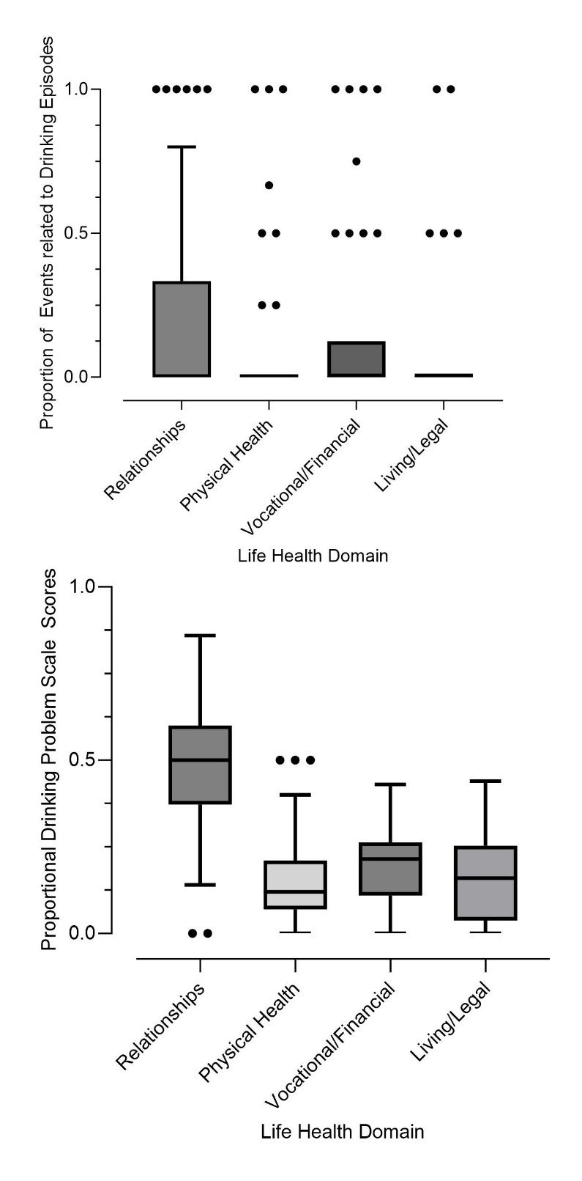
Note. Box plots using Tukey’s method show the distribution of the proportion of life events related to post-resolution drinking episode data for each factorized life-health domain (upper panel) and the proportional Drinking Problems Scale scores for each factorized life-health domain (lower panel). In the plots, the solid horizontal line is the median; the shaded area is the Interquartile Range (IQR) (Q3 – Q1); the upper whisker extends to Q3 + 1.5xIQR; the lower whisker extends to Q1 - 1.5xIQR; outliers are individual data points less than Q1 – 3xIQR and greater than Q3 + 3xIQR.

