Supplementary Material
Table S1: Sample description
 | N
N | 231
Sex  (N men/women/divers) | 26/191/14
Education  1 no school leaving certificate  2 lower secondary school  3 intermediate secondary school  4 general/subject-specific university entrance qualification  5 completed university degree  6 unspecified | 8  26  65  76  50  6
Comorbidities (%)  PTSD  Affective disorder  Anxiety disorder  OCD  Addiction  Eating disorder | 47 (20.3)  123 (53.2)  82 (35.5)  17 (7.4)  54 (23.4)  26 (11.3)
Note: N: number of cases, PTSD: Post traumatic stress disorder, OCD: Obsessive compulsive disorder

Figure S1: Distribution of mean suicidal urges and hopelessness across participants.
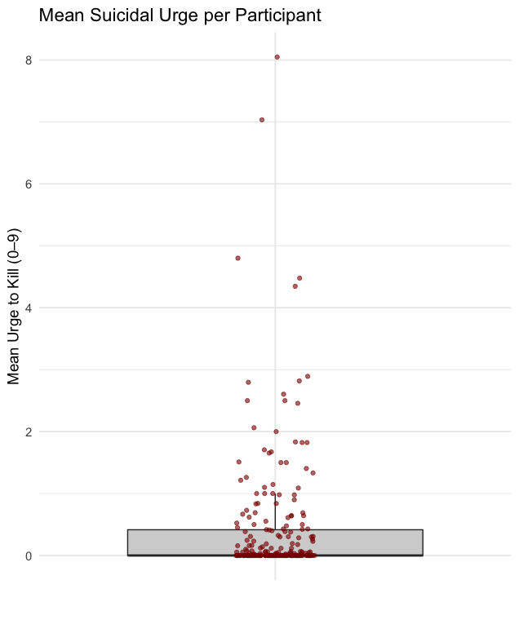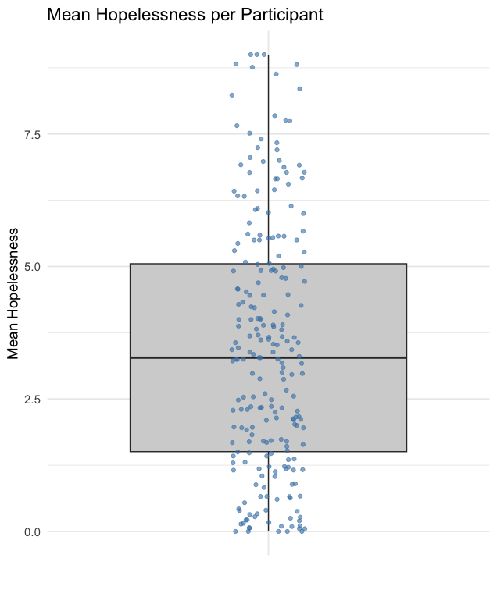
Notes. While most individuals reported very low mean suicidal urges, a few participants exhibited consistently elevated levels. For hopelessness, most individuals reported moderate mean levels of hopelessness, several individuals also exhibited lower or persistently high levels (mean ≥ 7).
Figure S2: Mean suicidal urge scores by assessment hour within the 09:00–21:00 sampling window, with 95% confidence intervals

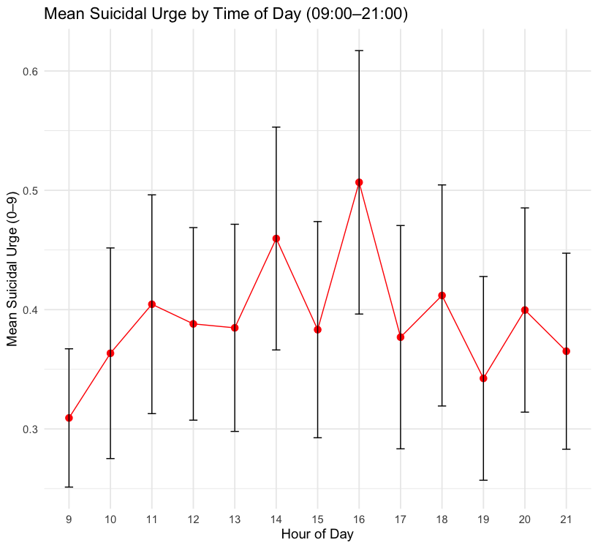

Figure S3: Participant Level Scatterplots for same-time and lagged hopelessness

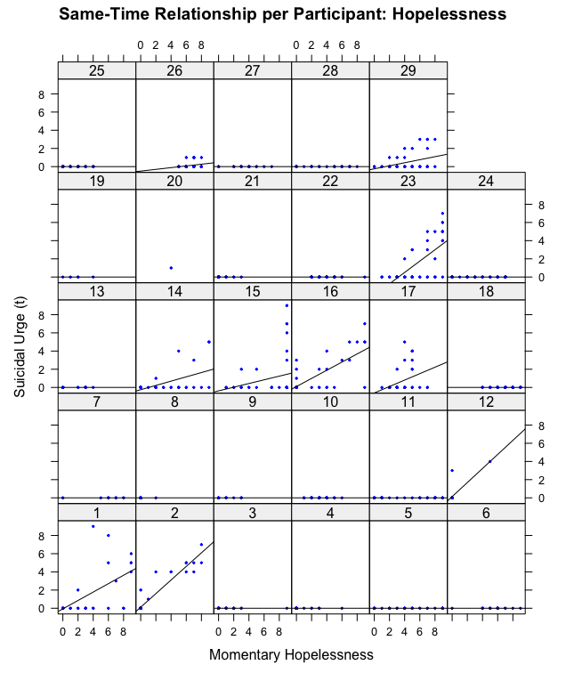
Panel A. Notes. Each plot represents an individual participant, displaying the relationship between momentary hopelessness (x-axis) and momentary suicidal urges (y-axis) across all AA prompts. Black lines represent participant-specific regression lines, while blue dots depict individual data points, illustrating the heterogeneity of within-person associations between lagged hopelessness and suicidal urges in daily life among participants.

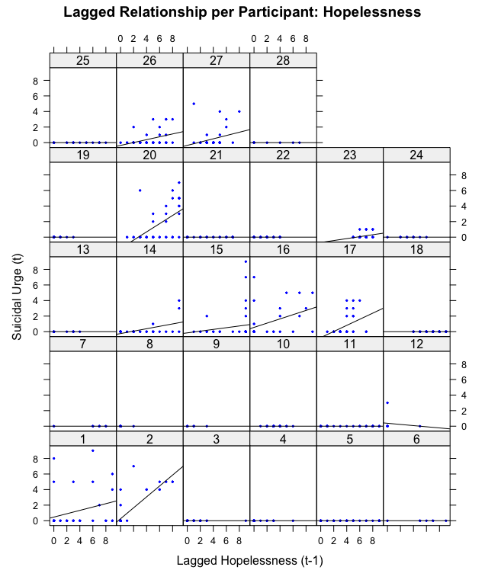
Panel B. Notes. Each plot represents an individual participant, displaying the relationship between lagged hopelessness (x-axis) and momentary suicidal urges (y-axis) across all AA prompts. Black lines represent participant-specific regression lines, while blue dots depict individual data points, illustrating the heterogeneity of within-person associations between lagged hopelessness and suicidal urges among participants.
Figure S4: Barplots of beta parameters for each participant

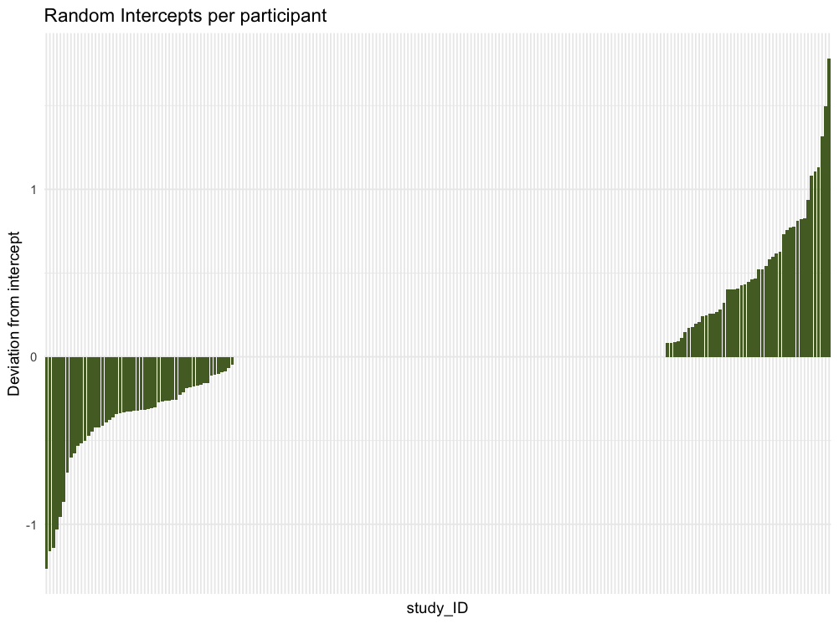

Figure S5. Forest Plots für hurdle mixed model results
Figure 5a. Results of the lagged model M1: Prediction of suicidal urges by lagged hopelessness, controlled for age, gender and autoregressive effect of lagged suicidal urges
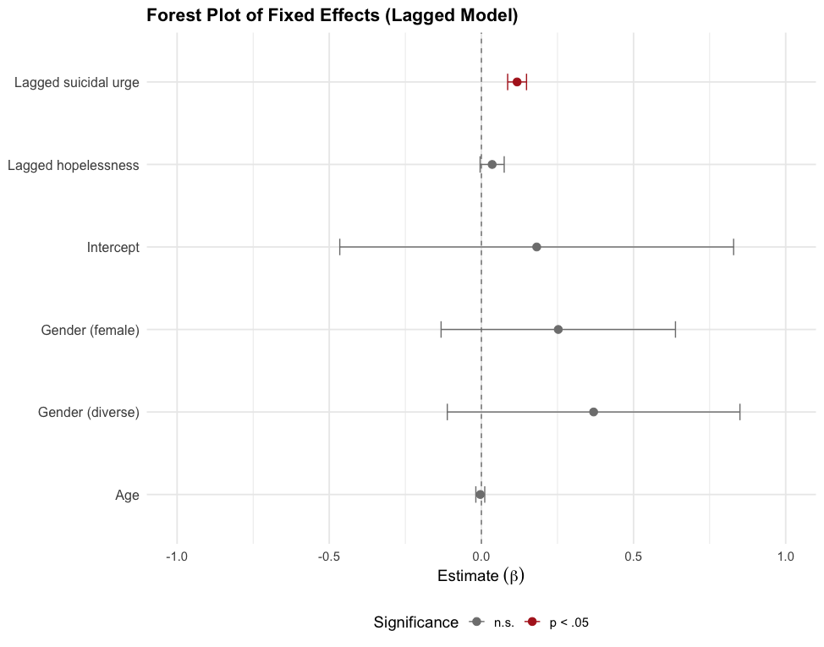
Figure 5b. Results of the combined model M2, including momentary effects of hopelessness

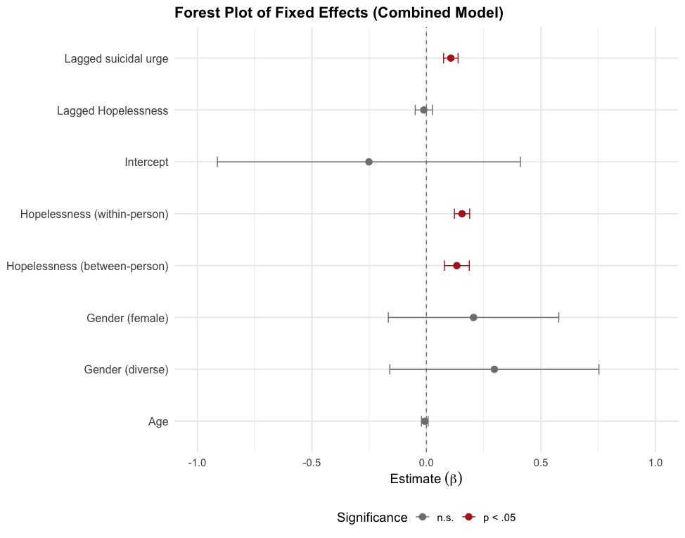
Figure 5c. Results of the sensitivity model M3, including negative affect as a covariate
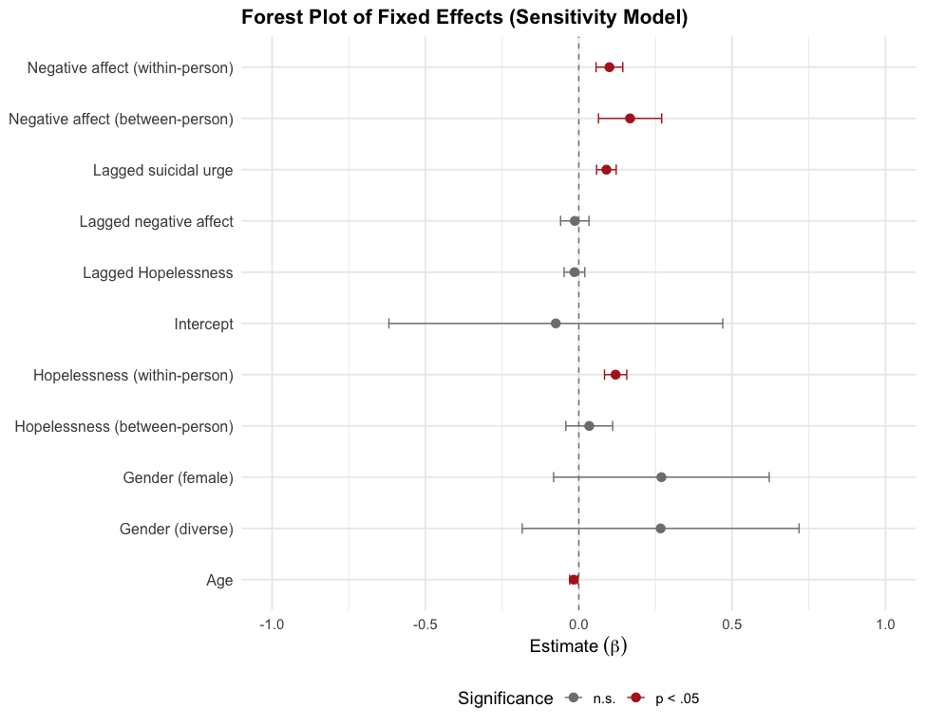
Figure 5d. Results of the moderation model M4b, including ASAD score as a moderator for hopelessness
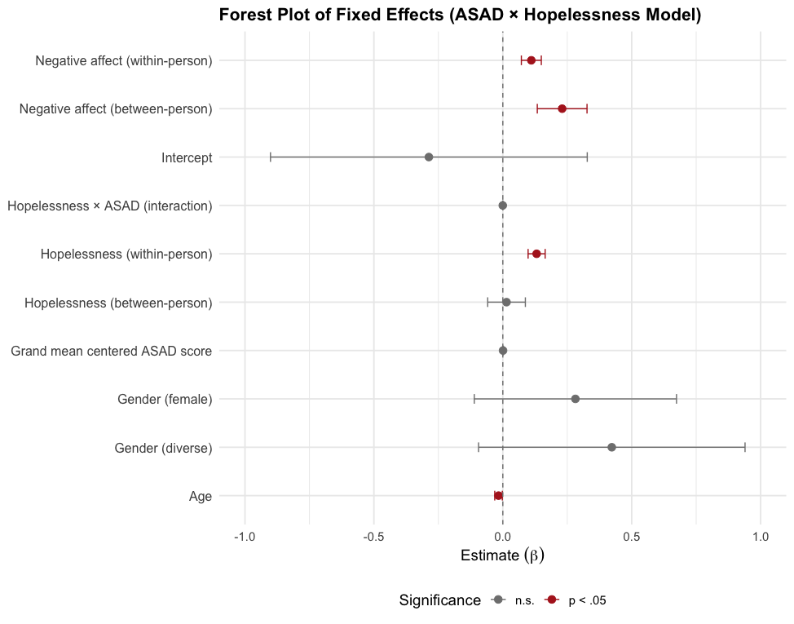

Statement of Ethics
All patients were informed about the aims and voluntary nature of their participation in the study and gave their written consent. The responsible ethics committee gave a positive ethics vote (Central Institute of Mental Health, Mannheim: DRKS00031808).

Conflicts of Interest
The authors declare that there is no conflict of interest that could have influenced the content presented here.

Funding
The DBT main study, from which the AA data were derived, was funded by the Luda, Gerhorst, and Betuva Foundations (to Dr. Bohus). The funders had no role in study design, data collection, analysis, decision to publish, or manuscript preparation. Publication fees were supported by Ruhr-Universität Bochum.

Data Availability Statement
The preregistration, anonymized dataset and analysis syntax supporting the findings of this study will be made publicly available on the Open Science Framework.

Declaration of generative AI and AI-assisted technologies in the writing process.
During the preparation of this manuscript, the authors used DeepL and ChatGPT to improve readability and phrasing. After using these tools, the authors reviewed and edited the content as needed and take full responsibility for the content of the published article.

