Supplementary Materials
Case Vignettes

 | System Used
 | Description only | DSM-5 | AMPD
BPD (Jamie, 27) | 1A | 1B | 1C
OCPD (Chris, 49) | 2A | 2B | 2C
STPD (Sam, 38) | 3A | 3B | 3C
Depression w/ Subclinical BPD Features (Alex, 45) | 4A | 4B | 4C

Note. The coloured text presented in the vignettes below indicates the diagnostic information that differs between diagnostic systems. All text presented to participants was in black, and the wordcount for each vignette was omitted.

1A) Borderline Personality Disorder – description only

Jamie is 27 years of age and presented to your clinic for relationship difficulties, and a general sense of feeling “lost” in terms of who they are and what they want out of life and other people.

Jamie reported a long history of unsuccessful romantic relationships since Jamie was fifteen years old. These relationships were characterised by a pervasive worry that the person would leave Jamie for something or someone else. Jamie described previous relationships as tending to run hot or cold, so that there were periods of being “madly in love” or fighting excessively. Jamie noted often “going crazy” with thoughts of the partner cheating. These concerns are greater when Jamie is overwhelmed with other areas of life, such as occupational commitments or familial interactions. Jamie describes their family of origin as “dysfunctional” and thinks that this may be why relationships are so difficult. When Jamie feels as though a relationship may end, Jamie experiences frequent angry outbursts, comprised of screaming and throwing objects towards the partner.

Whenever it has seemed that a relationship might end in the past, Jamie noted experiencing a three-to-four day period of feeling depressed. When Jamie feels depressed, Jamie stays home and isolates from friends and family, and drinks alcohol until “blacking out.” Jamie often loses control when eating comforting foods to the extent that Jamie might finish 1.5L of ice-cream in a single sitting. Jamie is unable to work and has often lost employment as a result of these intense depressive periods. The regular occurrence of these “low” periods have also led to Jamie’s close friends from school to no longer extend invitations to social events. As a result, Jamie reports feeling empty inside most of the time.

Wordcount: 285

1B) Borderline Personality Disorder with DSM-5 information

Jamie is 27 years of age and presented to your clinic for relationship difficulties, and a general sense of feeling “lost” in terms of who they are and what they want out of life and other people. At interview, you identify these feelings as consistent with persistent identity disturbance.

Jamie reported a long history of unsuccessful romantic relationships since Jamie was fifteen years old. These relationships were characterised by a pervasive worry that the person would leave Jamie for something or someone else. Jamie described previous relationships as tending to run hot or cold, so that there were periods of being “madly in love” or fighting excessively. Jamie noted often “going crazy” with thoughts of the partner cheating. These concerns are greater when Jamie is overwhelmed with other areas of life, such as occupational commitments or familial interactions. Jamie describes their family of origin as “dysfunctional” and thinks that this may be why relationships are so difficult. When Jamie feels as though a relationship may end, Jamie experiences frequent angry outbursts, comprised of screaming and throwing objects towards the partner. Jamie meets the criteria of a pattern of unstable interpersonal relationships and frantic efforts to avoid real or imagined abandonment.

Whenever it has seemed that a relationship might end in the past, Jamie noted experiencing a three-to-four day period of feeling depressed. These intense mood swings meet the criteria for affective instability. When Jamie feels depressed, Jamie stays home and isolates from friends and family, and drinks alcohol until “blacking out.” Jamie often loses control when eating comforting foods to the extent that Jamie might finish 1.5L of ice-cream in a single sitting. These behaviours meet the criterion of impulsivity in at least two areas (alcohol use and eating). Jamie is unable to work and has often lost employment as a result of these intense depressive periods. The regular occurrence of these “low” periods have also led to Jamie’s close friends from school to no longer extend invitations to social events. As a result, Jamie reports feeling empty inside most of the time. You are able to establish that these feelings of emptiness meet the criterion for chronic feelings of emptiness.

On the basis of your assessment, Jamie meets criteria for Borderline Personality Disorder (refer to the Figure below).
Wordcount: 379

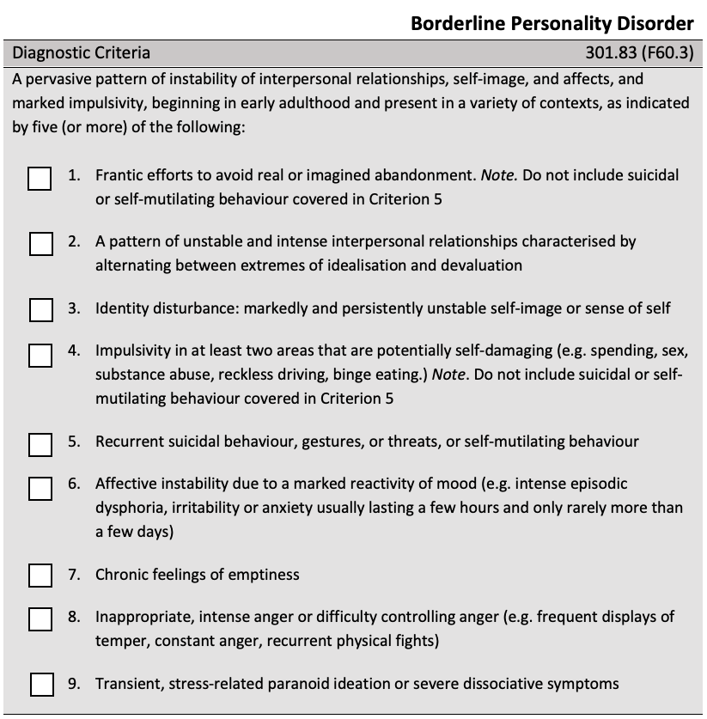

1C) Borderline Personality Disorder with AMPD information

Jamie is 27 years of age and presented to your clinic for relationship difficulties, and a general sense of feeling “lost” in terms of who they are and what they want out of life and other people. At interview, you consider Jamie’s level of impairment in terms of identity to be severely impaired. You consider Jamie’s self-direction to be moderately impaired.

Jamie reported a long history of unsuccessful romantic relationships since Jamie was fifteen years old. These relationships were characterised by a pervasive worry that the person would leave Jamie for something or someone else. Jamie described previous relationships as tending to run hot or cold, so that there were periods of being “madly in love” or fighting excessively. Jamie noted often “going crazy” with thoughts of the partner cheating. These concerns are greater when Jamie is overwhelmed with other areas of life, such as occupational commitments or familial interactions. Jamie describes their family of origin as “dysfunctional” and thinks that this may be why relationships are so difficult. When Jamie feels as though a relationship may end, Jamie experiences frequent angry outbursts, comprised of screaming and throwing objects towards the partner. You consider Jamie’s interpersonal functioning to be severely impaired in both areas of empathy and intimacy.

Whenever it has seemed that a relationship might end in the past, Jamie noted experiencing a three-to-four day period of feeling depressed. When Jamie feels depressed, Jamie stays home and isolates from friends and family, and drinks alcohol until “blacking out.” Jamie often loses control when eating comforting foods to the extent that Jamie might finish 1.5L of ice-cream in a single sitting. Jamie is unable to work and has often lost employment as a result of these intense depressive periods. The regular occurrence of these “low” periods have also led to Jamie’s close friends from school to no longer extend invitations to social events. As a result, Jamie reports feeling empty inside most of the time.

You administer the Personality Inventory for the DSM-5 (PID-5) to identify any maladaptive personality traits. The PID-5 reveals that Jamie is particularly high in emotional lability, depressivity, impulsivity and hostility. On the basis of your assessment and Jamie’s PID-5 results, Jamie meets criteria for Borderline Personality Disorder (refer to the Figure below).
Wordcount: 377
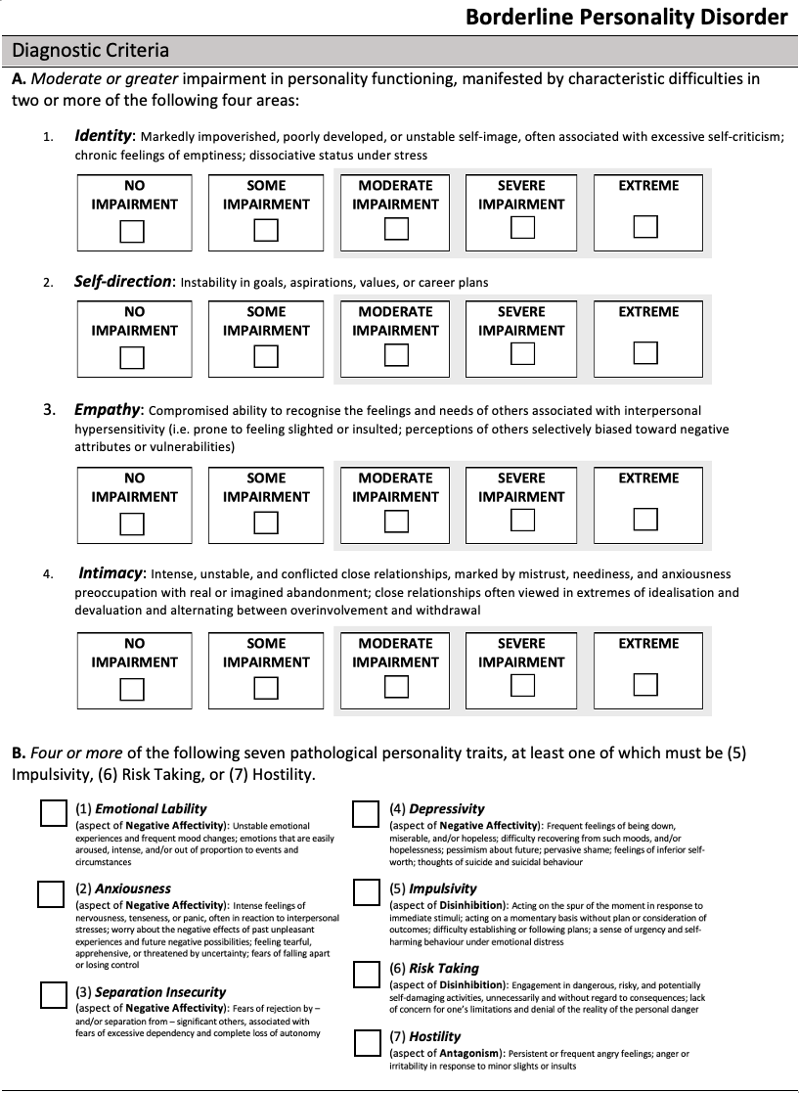

2A) Obsessive Compulsive Personality Disorder – description only

Chris is 49 years of age and presented to your clinic for assistance in managing frustration at work, specifically in the context of relationships with their colleagues. Chris’ affect was somewhat flattened and constricted.

Chris detailed a history of excelling academically and occupationally, and attributed their various successes to the fact that they are more hard-working, organised and disciplined than other people. Chris noted always liking things done a particular way; the right way, which has caused some “tension” over the years with work colleagues. Chris’ colleagues tend to “prefer a quick-fix,” often compromising on Chris’ “vision.” Chris struggles with trusting colleagues at work with any shared tasks, even when Chris has been instructed by management to do so. More recently, two of Chris’ colleagues had made complaints to their Manager about Chris being challenging to work with due to time-wasting tendencies and “pig-headedness”. This often makes shared tasks extremely difficult to complete on-time. Chris noted being subsequently denied a promotion due to these complaints.

Chris reflected on missing out on the recent promotion opportunity as “perplexing” given Chris’ long-standing devotion to work, even to the extent of “losing touch” with previous friendships due to working so diligently over the years. Chris admitted romantic relationships have also been difficult to initiate and maintain. Chris reported that it is easier not to put themselves “out there” as others often misconstrue Chris’ conscientiousness as stubbornness. Chris could not identify any hobbies outside of work. Despite money not being a reported issue, Chris’ shoes were notably scuffed and had a number of holes. Chris noted that the shoes were “lucky” and that the majority of their income is put into savings in the event of ever having to get married. Chris has not been on a holiday or taken a single sick-day from work in over twenty-five years.

Wordcount: 305

2A) Obsessive Compulsive Personality Disorder – DSM-5

Chris is 49 years of age and presented to your clinic for assistance in managing frustration at work, specifically in the context of relationships with their colleagues. Chris’ affect was somewhat flattened and constricted.

Chris detailed a history of excelling academically and occupationally, and attributed their various successes to the fact that they are more hard-working, organised and disciplined than other people. Chris noted always liking things done a particular way; the right way, which has caused some “tension” over the years with work colleagues. Chris’ colleagues tend to “prefer a quick-fix,” often compromising on Chris’ “vision.” Chris struggles with trusting colleagues at work with any shared tasks, even when Chris has been instructed by management to do so. More recently, two of Chris’ colleagues had made complaints to their Manager about Chris being challenging to work with due to time-wasting tendencies and “pig-headedness”. This often makes shared tasks extremely difficult to complete on-time. Chris noted being subsequently denied a promotion due to these complaints. Chris meets the criteria of perfectionism that interferes with task completion, as well as a reluctance to delegate tasks or to work with others unless they submit to exactly his or her way of doing things.

Chris reflected on missing out on the recent promotion opportunity as “perplexing” given Chris’ long-standing devotion to work, even to the extent of “losing touch” with previous friendships due to working so diligently over the years. Chris admitted romantic relationships have also been difficult to initiate and maintain. Chris reported that it is easier not to put themselves “out there” as others often misconstrue Chris’ conscientiousness as stubbornness. Chris could not identify any hobbies outside of work. This exclusion of leisurely activities and relationships meets criteria for an excessive devotion to work and productivity. Despite money not being a reported issue, Chris’ shoes were notably scuffed and had a number of holes. Chris noted that the shoes were “lucky” and that the majority of their income is put into savings in the event of ever having to get married. This meets criteria for a miserly spending style. Chris has not been on a holiday or taken a single sick-day from work in over twenty-five years.

On the basis of your assessment, Chris meets criteria for Obsessive Compulsive Personality Disorder (refer to the Figure below).
Wordcount: 385
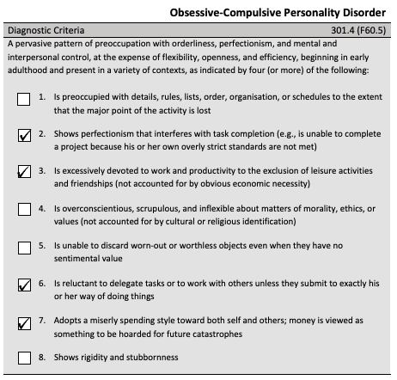

2C) Obsessive Compulsive Personality Disorder – AMPD

Chris is 49 years of age and presented to your clinic for assistance in managing frustration at work, specifically in the context of relationships with their colleagues. Chris’ affect was somewhat flattened and constricted.

Chris detailed a history of excelling academically and occupationally, and attributed their various successes to the fact that they are more hard-working, organised and disciplined than other people. Chris noted always liking things done a particular way; the right way, which has caused some “tension” over the years with work colleagues. Chris’ colleagues tend to “prefer a quick-fix,” often compromising on Chris’ “vision.” Chris struggles with trusting colleagues at work with any shared tasks, even when Chris has been instructed by management to do so. More recently, two of Chris’ colleagues had made complaints to their Manager about Chris being challenging to work with due to time-wasting tendencies and “pig-headedness”. This often makes shared tasks extremely difficult to complete on-time. Chris noted being subsequently denied a promotion due to these complaints. You consider Chris’ level of impairment in terms of identity to be severely impaired. You consider Chris’ self-direction to be moderately impaired.

Chris reflected on missing out on the recent promotion opportunity as “perplexing” given Chris’ long-standing devotion to work, even to the extent of “losing touch” with previous friendships due to working so diligently over the years. Chris admitted romantic relationships have also been difficult to initiate and maintain. Chris reported that it is easier not to put themselves “out there” as others often misconstrue Chris’ conscientiousness as stubbornness. You consider Chris’ level of interpersonal functioning in areas of empathy and intimacy to be extremely impaired. Chris could not identify any hobbies outside of work. Despite money not being a reported issue, Chris’ shoes were notably scuffed and had a number of holes. Chris noted that the shoes were “lucky” and that the majority of their income is put into savings in the event of ever having to get married. Chris has not been on a holiday or taken a single sick-day from work in over twenty-five years.

You administer the Personality Inventory for the DSM-5 (PID-5) to identify any maladaptive personality traits. The PID-5 reveals that Chris is particularly high in rigid perfectionism, intimacy avoidance and restricted affectivity. On the basis of your assessment and Chris’ PID-5 results, Chris meets criteria for Obsessive-Compulsive Personality Disorder (refer to the Figure below).
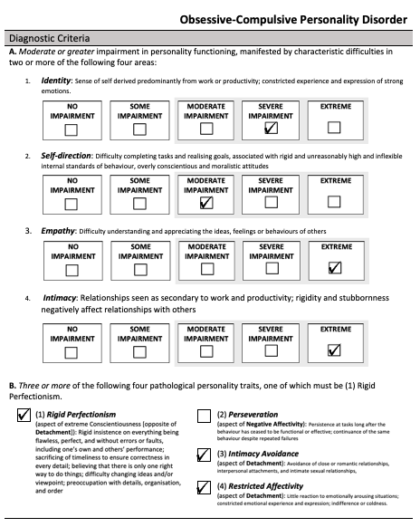
Wordcount: 397
3A) Schizotypal Personality Disorder – description only

Sam is 38 years of age and presented to your clinic for reported long standing difficulties with social anxiety. Sam presented as somewhat unkept, regularly clicking and patting their legs, and often spoke in a vague and metaphorical way that was at times difficult to understand. Sam’s affect was flat and constricted, and Sam was often emotionally inhibited.

Sam’s elderly parents are reportedly Sam’s primary confidants, and Sam noted feeling like a “loner” for much of their life. Sam reported historically wanting to establish friendships and even romantic relationships; though always feels “paralysed” with an intense discomfort that does not seem to subside regardless of how much time is spent trying to get to know someone. Other than this acute discomfort in social situations, Sam reflected on feeling “nothingness” the rest of the time. Sam disclosed that to feel something, as opposed to numbness, Sam sometimes scrapes their thigh with an open pair of scissors to the extent that blood is drawn. Sam reported no intention of dying.

Sam enjoys working as a laboratory technician, as the work primarily occurs in isolation. Sam noted being particularly good at the job as Sam has a special ability to distinguish between specific viruses before the pathology results even come back. On occasions when Sam has had to share the laboratory with another colleague, Sam becomes distressed and makes silly mistakes. Sam swears that this is because Sam can hear the other colleague’s thoughts; that they are critiquing Sam’s every move and questioning Sam’s ability to perform the role. Sam is often overly cautious of others’ intentions, as they always seem to be out to get Sam or to take advantage of Sam in some way.

Wordcount: 283

3B) Schizotypal Personality Disorder – DSM-5

Sam is 38 years of age and presented to your clinic for reported long standing difficulties with social anxiety. Sam presented as somewhat unkept, regularly clicking and patting their legs, and often spoke in a vague and metaphorical way that was at times difficult to understand. Sam’s affect was flat and constricted, and Sam was often emotionally inhibited.
You identify that Sam’s thinking and speech were odd, and Sam’s affect was constricted and emotionally-incongruent.

Sam’s elderly parents are reportedly Sam’s primary confidants, and Sam noted feeling like a “loner” for much of their life. This meets criteria for a lack of close friends other than first-degree relatives. Sam reported historically wanting to establish friendships and even romantic relationships; though always feels “paralysed” with an intense discomfort that does not seem to subside regardless of how much time is spent trying to get to know someone. You note this meets criteria for excessive social anxiety despite familiarity. Other than this acute discomfort in social situations, Sam reflected on feeling “nothingness” the rest of the time. Sam disclosed that to feel something, as opposed to numbness, Sam sometimes scrapes her thigh with an open pair of scissors to the extent that blood is drawn. Sam reported no intention of dying.

Sam enjoys working as a laboratory technician, as the work primarily occurs in isolation. Sam noted being particularly good at the job as Sam has a special ability to distinguish between specific viruses before the pathology results even come back. On occasions when Sam has had to share the laboratory with another colleague, Sam becomes distressed and makes silly mistakes. Sam swears that this is because Sam can hear the other colleague’s thoughts; that they are critiquing Sam’s every move and questioning Sam’s ability to perform the role. You note this telepathy is consistent with magical thinking that influences behaviour. Sam is often overly cautious of others’ intentions, as they always seem to be out to get Sam or to take advantage of Sam in some way. This ideation meets criteria for paranoia and suspiciousness.

On the basis of your assessment, Sam meets criteria for Schizotypal Personality Disorder (refer to the Figure below).
Wordcount: 361
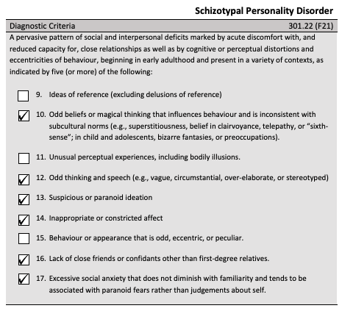

3C) Schizotypal Personality Disorder – AMPD

Sam is 38 years of age and presented to your clinic for reported long standing difficulties with social anxiety. Sam presented as somewhat unkept, regularly clicking and patting their legs, and often spoke in a vague and metaphorical way that was at times difficult to understand. Sam’s affect was flat and constricted, and Sam was often emotionally inhibited.
At interview, you consider Sam’s level of impairment in terms of identity to be moderately impaired.

Sam’s elderly parents are reportedly Sam’s primary confidants, and Sam noted feeling like a “loner” for much of their life. Sam reported historically wanting to establish friendships and even romantic relationships; though always feels “paralysed” with an intense discomfort that does not seem to subside regardless of how much time is spent trying to get to know someone. Other than this acute discomfort in social situations, Sam reflected on feeling “nothingness” the rest of the time. Sam disclosed that to feel something, as opposed to numbness, Sam sometimes scrapes her thigh with an open pair of scissors to the extent that blood is drawn. Sam reported no intention of dying.

Sam enjoys working as a laboratory technician, as the work primarily occurs in isolation. You deem Sam’s self-direction to have some impairment. Sam noted being particularly good at the job as Sam has a special ability to distinguish between specific viruses before the pathology results even come back. On occasions when Sam has had to share the laboratory with another colleague, Sam becomes distressed and makes silly mistakes. Sam swears that this is because Sam can hear the other colleague’s thoughts; that they are critiquing Sam’s every move and questioning Sam’s ability to perform the role. Sam is often overly cautious of others’ intentions, as they always seem to be out to get Sam or to take advantage of Sam in some way. Overall, you consider Sam’s interpersonal functioning to be severely impaired in areas of empathy and intimacy.

You administer the Personality Inventory for the DSM-5 (PID-5) to identify any maladaptive personality traits. The PID-5 reveals that Sam is particularly high in cognitive and perceptual dysregulation; unusual beliefs and experiences; restricted affectivity; withdrawal; and suspiciousness. On the basis of your assessment and Sam’s PID-5 results, Sam meets criteria for Schizotypal Personality Disorder (refer to the Figure below).
Wordcount: 382
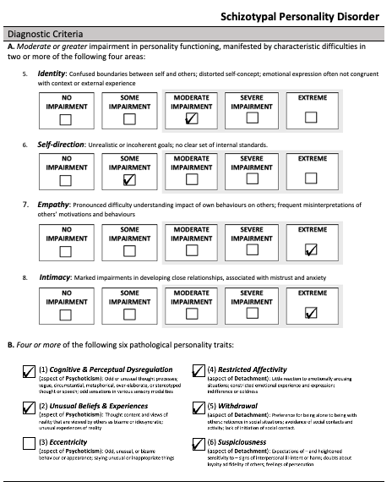
4A) Depression with Subclinical BPD Features – Description only

Alex is 45 years of age and presented to your clinic with depressed mood in the context of relationship breakdown. Alex presented as hunched over with a flattened and restricted affect, often fidgeting with their hands and looking down towards the floor.

Alex and Alex’s partner of 20 years separated six months ago. Since this time, Alex reported experiencing low mood and feelings of emptiness for the majority of each day. Alex noted finding it difficult to engage in, and enjoy, previously enjoyable hobbies such as rock climbing and socialising with friends due to trouble concentrating and a perceived lack of energy despite adequate sleep. Alex reported a loss of 9kg in the last six months. Alex reported struggling with who they are as a person and what Alex wants out of life since the separation. Alex has attempted to take their own life on three separate occasions over the last six months when the sense of worthlessness and emptiness became overwhelming. Alex does not wish to die at present despite recurrent ideation that things would be “easier” that way.

Sometimes Alex can get so angry and frustrated with these feelings that Alex will burn the skin on Alex’s forearms with cigarette butts and will throw and break items of great value at home. Alex reported that during these times excessive amounts of money are spent, more money than he earns, to replace the broken item with a more expensive version. Alex reported sometimes driving very fast, much faster than the speed limit, to “let off some steam.” Alex reported strong social supports, though has not wished to draw upon them to date.

Wordcount: 273

4B) Depression with Subclinical BPD Features – DSM-5

Alex is 45 years of age and presented to your clinic with depressed mood in the context of relationship breakdown. Alex presented as hunched over with a flattened and restricted affect, often fidgeting with their hands and looking down towards the floor.

Alex and Alex’s partner of 20 years separated six months ago. Since this time, Alex reported experiencing low mood and feelings of emptiness for the majority of each day. Alex noted finding it difficult to engage in, and enjoy, previously enjoyable hobbies such as rock climbing and socialising with friends due to trouble concentrating and a perceived lack of energy despite adequate sleep. Alex reported a loss of 9kg in the last six months. Alex reported struggling with who they are as a person and what Alex wants out of life since the separation. Alex has attempted to take their own life on three separate occasions over the last six months when the sense of worthlessness and emptiness became overwhelming. Alex’s suicide attempts meet criteria for recurrent suicidal behaviour. Alex does not wish to die at present despite recurrent ideation that things would be “easier” that way.

Sometimes Alex can get so angry and frustrated with these feelings that Alex will burn the skin on Alex’s forearms with cigarette butts and will throw and break items of great value at home. This behaviour meets criteria for intense anger and difficulty controlling anger. Alex reported that during these times excessive amounts of money are spent, more money than he earns, to replace the broken item with a more expensive version. Alex reported sometimes driving very fast, much faster than the speed limit, to “let off some steam.” Alex’s impulsivity in spending and reckless driving behaviour meets criteria for impulsivity in at least two areas of potentially self-damaging behaviour. Alex reported strong social supports, though has not wished to draw upon them to date.

On the basis of your assessment, Alex has some features consistent with Borderline Personality Disorder, though does not meet the full criteria for diagnosis (refer to the Figure below).

Wordcount: 338

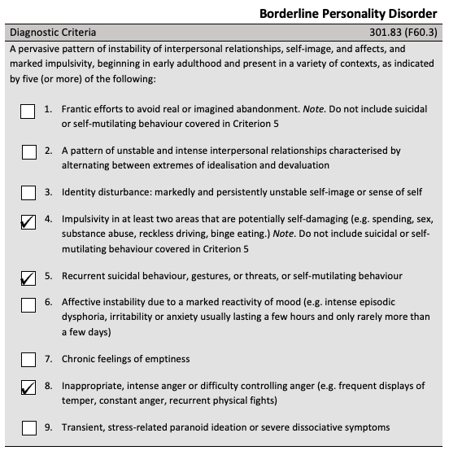

4C) Depression with Subclinical BPD Features – AMPD

Alex is 45 years of age and presented to your clinic with depressed mood in the context of relationship breakdown. Alex presented as hunched over with a flattened and restricted affect, often fidgeting with their hands and looking down towards the floor.

Alex and Alex’s partner of 20 years separated six months ago. Since this time, Alex reported experiencing low mood and feelings of emptiness for the majority of each day. Alex noted finding it difficult to engage in, and enjoy, previously enjoyable hobbies such as rock climbing and socialising with friends due to trouble concentrating and a perceived lack of energy despite adequate sleep. Alex reported a loss of 9kg in the last six months. Alex reported struggling with who they are as a person and what Alex wants out of life since the separation. You determine that Alex’s self-functioning in terms of identity and self-direction has some impairment. Alex has attempted to take their own life on three separate occasions over the last six months when the sense of worthlessness and emptiness became overwhelming. Alex does not wish to die at present despite recurrent ideation that things would be “easier” that way.

Sometimes Alex can get so angry and frustrated with these feelings that Alex will burn the skin on Alex’s forearms with cigarette butts and will throw and break items of great value at home. Alex reported that during these times excessive amounts of money are spent, more money than he earns, to replace the broken item with a more expensive version. Alex reported sometimes driving very fast, much faster than the speed limit, to “let off some steam.” Alex reported strong social supports, though has not wished to draw upon them to date. You consider Alex’s interpersonal functioning in terms of empathy and intimacy to be minimally impaired.

You administer the Personality Inventory for the DSM-5 (PID-5) to identify any maladaptive personality traits. The PID-5 reveals that Alex is particularly high in Depressivity; Impulsivity; and Risk Taking. On the basis of your assessment and Alex’s PID-5 results, Alex has some features consistent with Borderline Personality disorder, though does not meet the full criteria for diagnosis (refer to the Figure below).

Wordcount: 363

