**Supplemental Materials**

**Reduced Sensitivity to Affiliation and Psychopathic Traits**

Rebecca Waller, Natalie Corbett, Adrian Raine. Nicholas J. Wagner, Alexis Broussard, Donnisa Edmonds, Sonia Reardon, Callie Jones, Maya Itkin-Ofer, Tiffany Schell, & Craig S. Neumann

**Supplemental Methods**

**Measures**

**Psychopathic Traits.** Although we use summed total and subscale scores for our main analyses, we initially examined the factor structure of the SRP-SF-IV items to establish its underlying dimensionality. We used confirmatory factor analysis in Mplus vs 7.2 and mean and variance adjusted weighted least squares estimation (WLSMV) to test a four-correlated and four-bifactor model where items of the SRP were loaded on the four hypothesized dimensions of psychopathy. For the four-bifactor model, items were also specified to simultaneously load onto a general factor representing an overarching psychopathy construct that can be disambiguated even after modeling variance in the specific dimensions of psychopathy. Model fit was evaluated using the comparative fit index (CFI), Tucker-Lewis index (TLI), and root mean square error of approximation (RMSEA). RMSEA values less than or equal to .08, CFI values greater than .95, and TLI values greater than or equal to .95 were used to indicate a good fit to the data. Consistent with previous results (Dotterer et al., 2017; Waller, McCabe, Dotterer, Neumann, & Hyde, 2018), a four bifactor model demonstrated excellent model fit (χ2=608.15, df=297, p<.001; CFI=.98, TLI=.98; RMSEA=.05) with high loadings of all items on the general psychopathy factor (**Supplemental Figure 1**). The model fit for a four-correlated factor model also demonstrated excellent model fit (χ2= 1043.82, df=318, p<.001; CFI=.95, TLI=.95 RMSEA =.08) (**Supplemental Figure 2**). These model results indicate, consistent with prior efforts, that there are complexities posed by heterogeneity in the psychopathy construct and an examination of both specific psychopathy dimensions (i.e., affective, interpersonal, lifestyle, and antisocial facets) and general psychopathy (i.e., total scores) is warranted.

|  |  |  |
| --- | --- | --- |
| **Supplemental Table 1. Frequency that participants in our study correctly chose which of two images depicted affection and social closeness from 16 image pairs and frequency with which they indicated they would prefer to watch that image if it were a video** | | |
| **Correct choice of affiliation image** | **Number of participants** | **% of participants** |
| 16 | 328 | 80.6 |
| 15 | 54 | 13.3 |
| 14 | 11 | 2.7 |
| 13 | 3 | 0.7 |
| 12 | 4 | 1 |
| 11 | 1 | 0.2 |
| 10 | 3 | 0.7 |
| 9 | 0 | 0 |
| 8 | 0 | 0 |
| 7 | 2 | 0.5 |
| 6 | 0 | 0.0 |
| 5 | 0 | 0.0 |
| 4 | 0 | 0.0 |
| 3 | 0 | 0.0 |
| 2 | 0 | 0.0 |
| 1 | 1 | 0.2 |
| **Chose to watch affiliation image** | **Number of participants** | **% of participants** |
| 16 | 177 | 43.5 |
| 15 | 60 | 14.7 |
| 14 | 39 | 9.6 |
| 13 | 34 | 8.4 |
| 12 | 28 | 6.9 |
| 11 | 21 | 5.2 |
| 10 | 8 | 2.0 |
| 9 | 17 | 4.2 |
| 8 | 12 | 2.9 |
| 7 | 11 | 2.7 |

**Note**. For subsequent modeling purposes, we excluded videos that all participants chose to watch (*n=*7, 43.5%)

|  |  |  |
| --- | --- | --- |
| **Supplemental Table 2.** Mean ratings for pleasant interpersonal touch scenarios that were described in advance to evoke intended touch expressions | | |
| **Interpersonal touch scenario (from Masson & de Beeck, 2018)** | **Action** | ***M (SD) p*leasantness ratings in our sample** |
| 1. You are in the airport. You and your partner have not seen each other for 6 months. You hug each other as soon as you see each other. | Hug | 6.31 (.72) |
| 1. Your partner looks somehow lovelier today. You want to give a hug to express how much you love this person | Hug | 6.16 (.88) |
| 1. Your sibling just ended a long-term relationship. You want to console him/her by hugging. | Hug | 5.91 (1.03) |
| 1. You want to flirt with him/her by stroking his/her arm with intimacy | Stroke | 5.51 (1.07) |
| 1. Your friend is crying. You want to console him/her by stroking his/her arm(s) | Stroke | 5.11 (.96) |
| 1. You hold the hands of your partner with affection | Hold | 5.59 (1.09) |  |
| **Combined across all pleasant interpersonal touch scenarios** | | **5.77 (.71)** |  |

*Note.* We randomly selected two videos from three that were available for each pleasant interpersonal touch scenario. Table presents mean scores across ratings for the two videos per scenario. Ratings for SATED videos were made on a 7-point Likert scale: 1=very unpleasant, 2=moderately unpleasant, 3=somewhat unpleasant; 4=neutral, 5=somewhat pleasant, 6=moderately pleasant; 7=very pleasant

**Supplemental Table 3:** Standardized factor loadings of items from CAVE, SATED, CASES, and PATS on a “general” sensitivity to factor and “specific” domain factors.

|  |  |  |  |  |  |
| --- | --- | --- | --- | --- | --- |
| *Item level indicators* | **“General” sensitivity to affiliation factor** | **“specific” sensitivity to positive touch (SATED)** | **“specific” preference for affiliative videos (CAVE)** | **“specific” sensitivity to positive affective cues (CASES)** | **“specific” sensitivity to physical touch (PATS)** |
| **SATED interpersonal touch videos** | | | | | |
| Hug 1, ex1 | .25*** | .84*** |  |  |  |
| Hug 1, ex2 | .29*** | .84*** |  |  |  |
| Hug 2, ex1 | .48*** | .71*** |  |  |  |
| Hug 2, ex2 | .39*** | .77*** |  |  |  |
| Hug 3, ex1 | .33*** | .82*** |  |  |  |
| Hug 3, ex2 | .20** | .88*** |  |  |  |
| Stroke 1, ex1 | .07*ns* | .78*** |  |  |  |
| Stroke 1, ex2 | .08*ns* | .83*** |  |  |  |
| Stroke 2, ex1 | .08*ns* | .79*** |  |  |  |
| Stroke 2, ex2 | .18** | .80*** |  |  |  |
| Hold 1, ex 1 | .22*** | .78*** |  |  |  |
| Hold 1, ex 2 | .28*** | .80*** |  |  |  |
| **CAVE affiliation vs. neutral pair choice** | | | | | |
| #3 | .52*** |  | .48*** |  |  |
| #6 | .55*** |  | .56*** |  |  |
| #8 | .53*** |  | .69*** |  |  |
| #9 | .63*** |  | .60*** |  |  |
| #10 | .54*** |  | .72*** |  |  |
| #11 | .56*** |  | .55*** |  |  |
| #13 | .71*** |  | .53*** |  |  |
| #14 | .34*** |  | .63*** |  |  |
| #16 | .60*** |  | .61*** |  |  |
| **CASES questionnaire – item numbers (see Supplemental Figure 4 for item details)** | | | | | |
| #5 | .51*** |  |  | .38*** |  |
| #8 | .41*** |  |  | .45*** |  |
| #13 | .40*** |  |  | .36*** |  |
| #22 | .38*** |  |  | .51*** |  |
| #25 | .40*** |  |  | .50*** |  |
| #3 | .34*** |  |  | .42*** |  |
| #11 | .68*** |  |  | .43*** |  |
| #15 | .53*** |  |  | .47*** |  |
| #20 | .54*** |  |  | .68*** |  |
| #30 | .57*** |  |  | .71*** |  |
| **PATS questionnaire – item numbers (see Supplemental Figure 4 for item details)** | | | | | |
| #1 | .51*** |  |  |  | .33*** |
| #2 | .61*** |  |  |  | .33*** |
| #3 | .39*** |  |  |  | .18* |
| #4 | .31*** |  |  |  | .27*** |
| #5 | .58*** |  |  |  | .48*** |
| #6 | .65*** |  |  |  | .51*** |
| #7 | .60*** |  |  |  | .58*** |
| #8 | .48*** |  |  |  | .12*ns* |
| #9 | .61*** |  |  |  | .68*** |
| #10 | .54*** |  |  |  | .46*** |
| *Note.* \*\*\**p<.*001, \*\**p<*.01, *p<*.05. Model fit statistics: χ2= 1251.56, df=738, p<.001; CFI=.97, TLI=.97 RMSEA =.04. | | | | | |

**Supplemental Table 4. Multi-group modeling using Chi-Square using the MLR estimator in Mplus with a Satorra-Bentler scaling correction to compare pathways between lower sensitivity to affiliation and psychopathy for males versus females.**

|  |  |  |  |  |  |  |  |  |  |
| --- | --- | --- | --- | --- | --- | --- | --- | --- | --- |
|  | **Pathway tested** | **Scaling factor for model with freed pathway** | **Scaling factor for fully fixed morel** | ***df* for model with freed pathway** | ***df* for fully fixed model** | **χ2 for model with freed pathway** | **χ2 for fully fixed model** | **Satorra-Bentler Scaled χ2** | ***p*** |
| **Females (*n=*240) vs. males (*n=*162)** | Lower sensitivity to affiliation 🡪 Total psychopathy scores | 1.12 | 1.12 | 17 | 18 | 23.90 | 24.64 | 0.81 | 0.37 |
| Lower sensitivity to affiliation 🡪 Interpersonal-affective scores (Factor 1) | 1.11 | 1.11 | 25 | 26 | 30.73 | 31.82 | 1.08 | 0.30 |
| Lower sensitivity to affiliation 🡪 Affective facet scores | 1.11 | 1.12 | 44 | 45 | 60.18 | 59.96 | 0.02 | 0.89 |
| Lower sensitivity to affiliation 🡪 CU traits | 1.08 | 1.08 | 17 | 18 | 18.05 | 18.16 | 0.06 | 0.81 |

**Supplemental Table 5.** Regression model results exploring unique associations between sensitivity to affiliation factor scores and individual item ratings from the affective items on the SRP-SF, controlling for ratings on the other items

|  |  |  |  |
| --- | --- | --- | --- |
| *Dependent variable*  **Individual item ratings for SRP-SF items on the affective facet** | *Predictor*  **Sensitivity to affiliation (modeled as a latent factor)** | | |
| **B (SE)** | **β** | ***p*** |
| **3. Most people are wimps.** | -.05 (.06) | -.04 | .43 |
| **8. I like to see fist-fights.** | .002 (.06) | .001 | .98 |
| **13. I don't bother to keep in touch with my family** | **-.23 (.08)** | **-.20** | **.007** |
| **16. People sometimes say that I'm cold-hearted.** | **-.25 (.06)** | **-.22** | **<.001** |
| **18.** **I love violent sports and movies.** | -.06 (.07) | -.04 | .45 |
| **24. I never feel guilty over hurting others.** | .01 (.07) | .01 | .85 |
| **28. I dump friends that I don't need any more.** | .05 (.07) | .04 | .45 |
| *Note.* \*\*\**p<*.001, \*\**p<*.01, \**p<*.05. We examined separate regression models in Mplus with MLR estimation testing each affective facet item as a dependent variable with sensitivity to affiliation (modeled as a latent factor) and ratings on all other items as predictors. Both significant findings detailed above survive a Bonferroni multiple comparisons correction for the 7 models tested (i.e., adjusted *p=.*007). | | | |

**Supplemental Figure 1. Four-bifactor model of SRP-SF items**

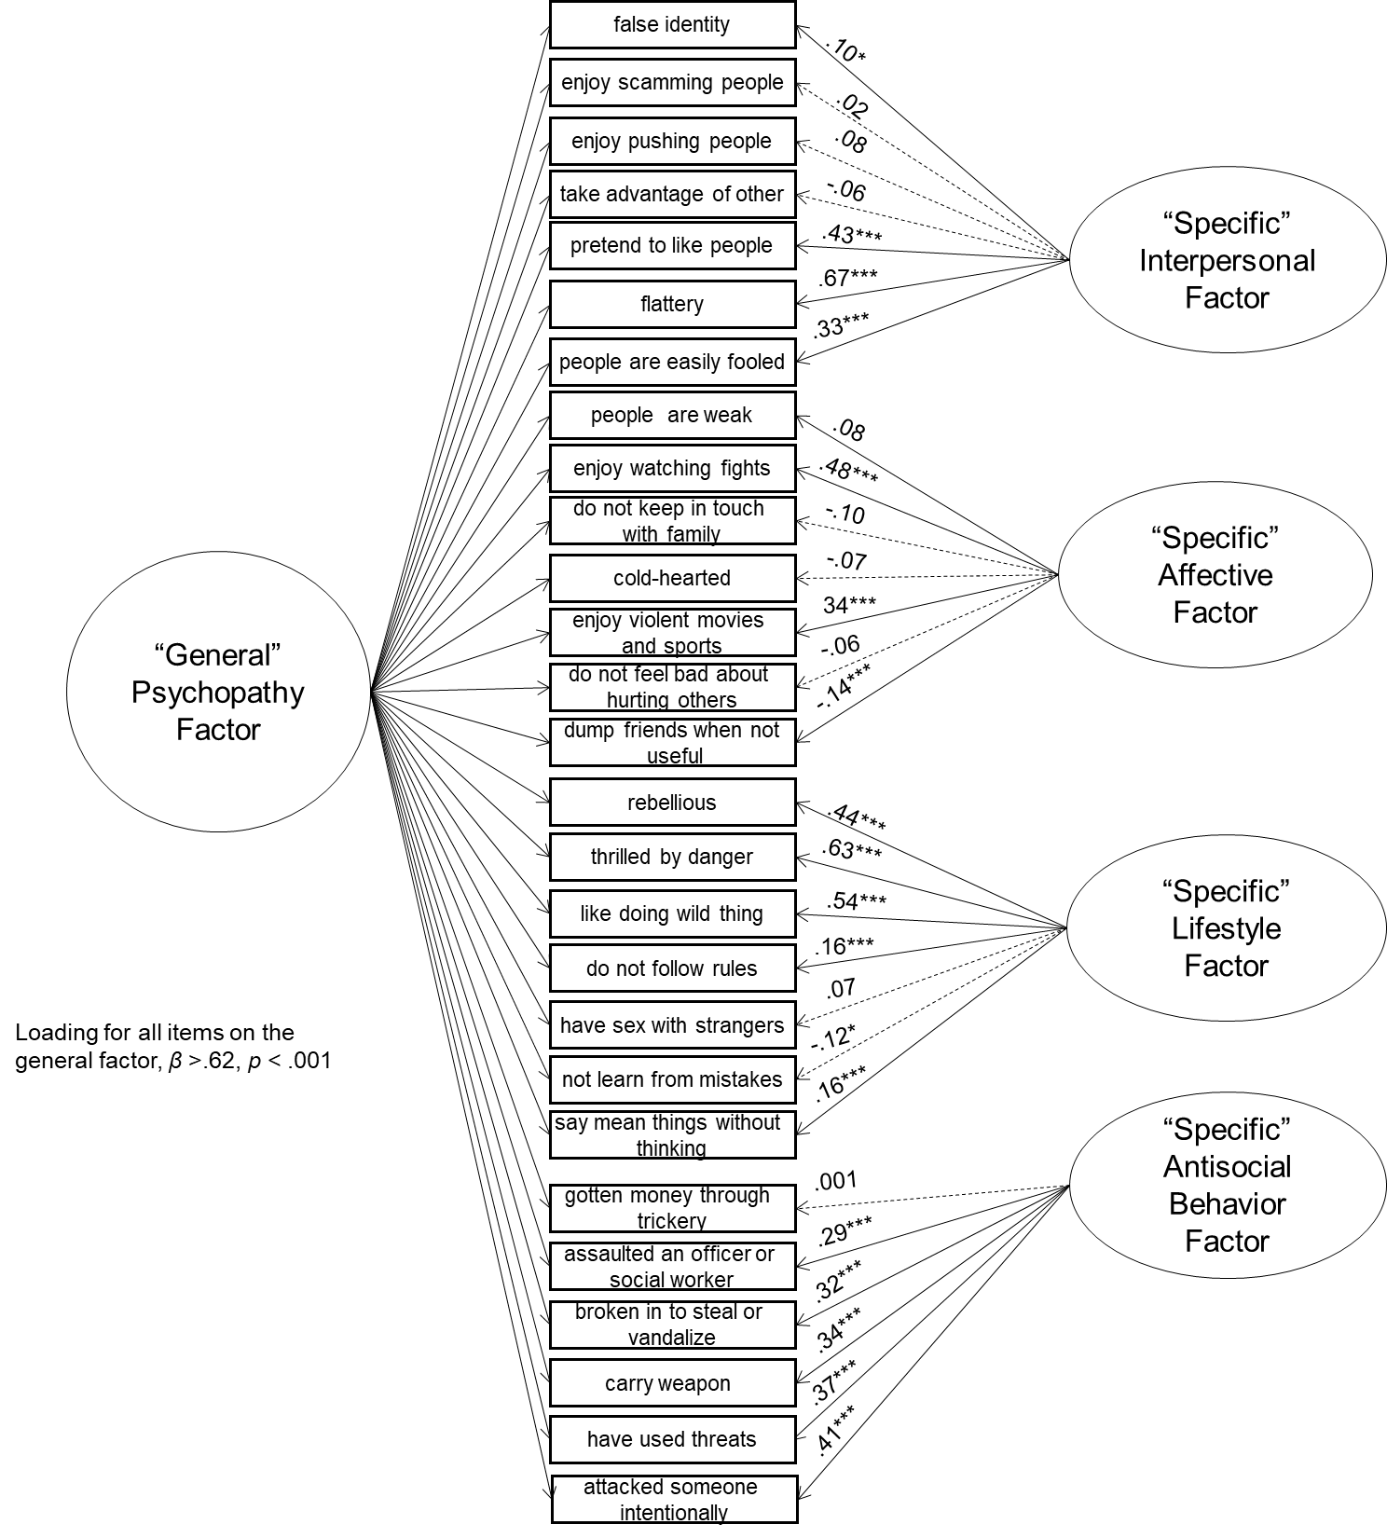

***Note.***\*\*\**p<.*001, \*\**p<*.01, \**p<.*05. Model presents standardized factor loadings (β). Due to copyright issues, paraphrased indicators of item content are presented. Model fit statistics: χ2=608.15, df=297, p<.001; CFI=.98, TLI=.98; RMSEA=.05.

**Supplemental Figure 2. Correlated four-factor model of the SRP-SF**

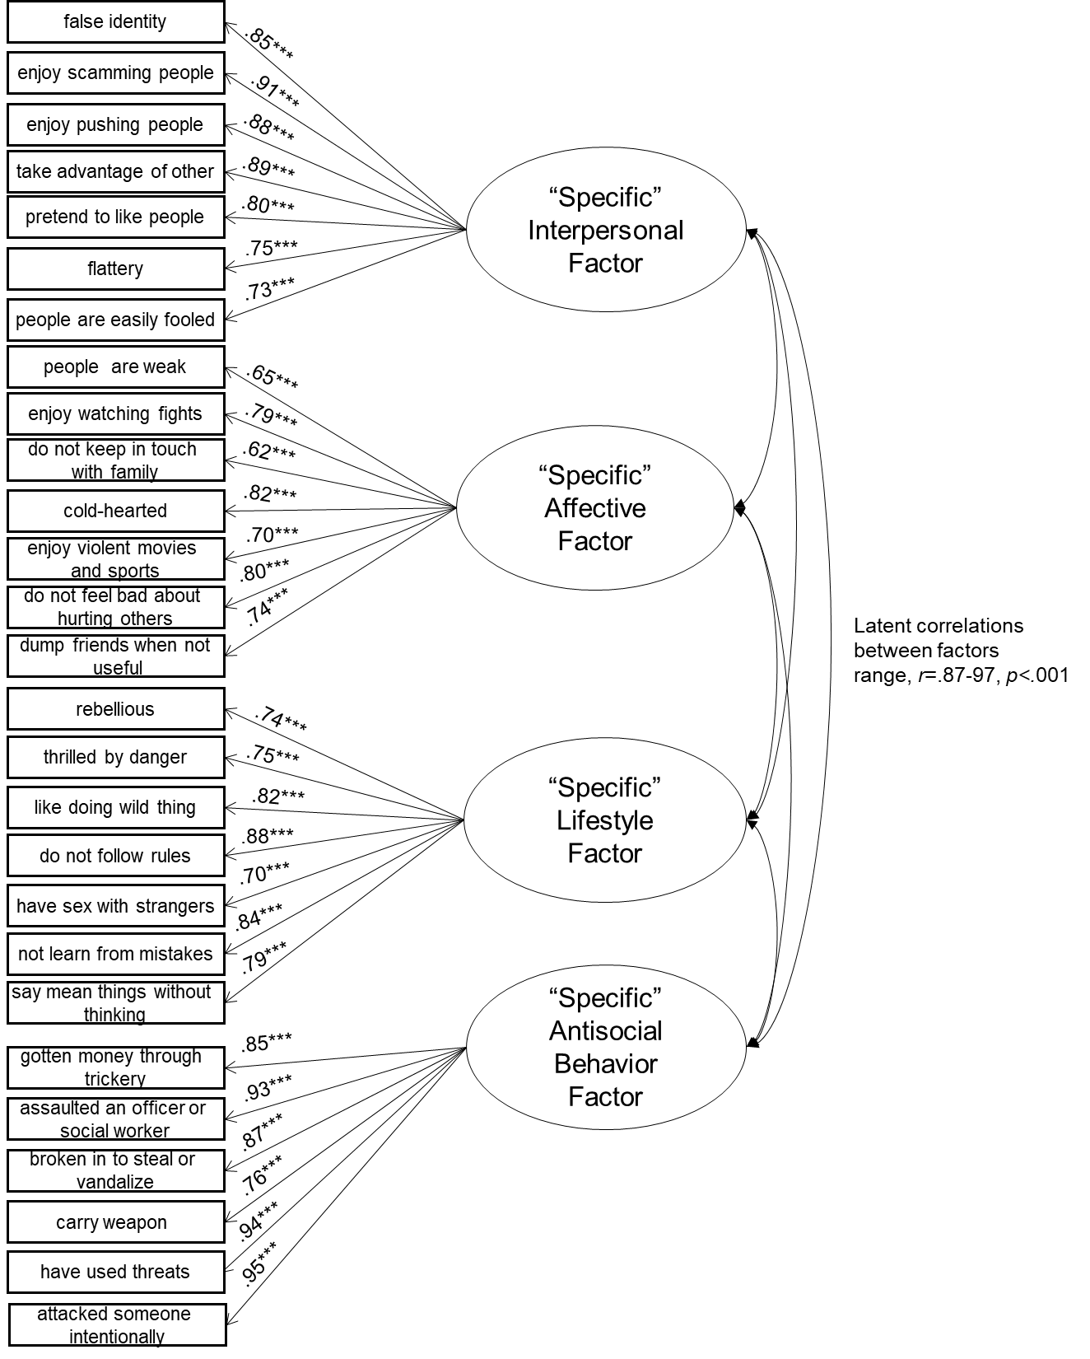

***Note.***\*\*\**p<.*001, \*\**p<*.01, \**p<.*05. Model presents standardized factor loadings (β). Due to copyright issues, paraphrased indicators of item content are presented. Model fit statistics: χ2= 1043.82, df=318, p<.001; CFI=.95, TLI=.95 RMSEA =.08.

**Supplemental Figure 3. Distribution of SRP-SF scores assessing psychopathic traits among our MTurk community sample**

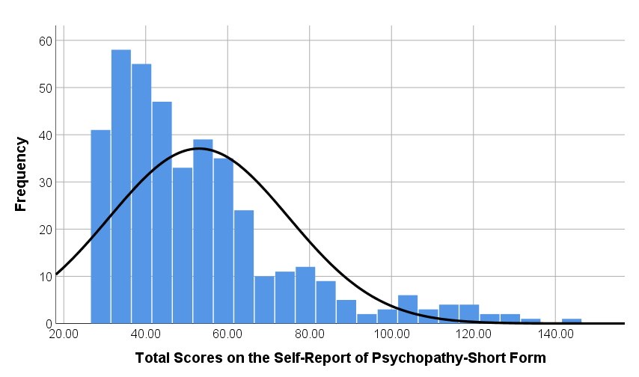

**Note.** Total Scores on the Self-Report of Psychopathy-Short Form (N=407). M=53.00, SD=21.90, range=29.00-145.00, Skewness=1.53, Kurtosis=2.37. Notably, despite this not being a forensic sample, a significant proportion of the sample (n=68, 17%) had “elevated” scores of ≥70 on the SRP, suggesting that we were assessing psychopathic traits across the full dimensional range.

**Supplemental Figure 4.** Bifactor model to assess a multi-measure, multi-method, multi-domain measure of sensitivity to affiliation

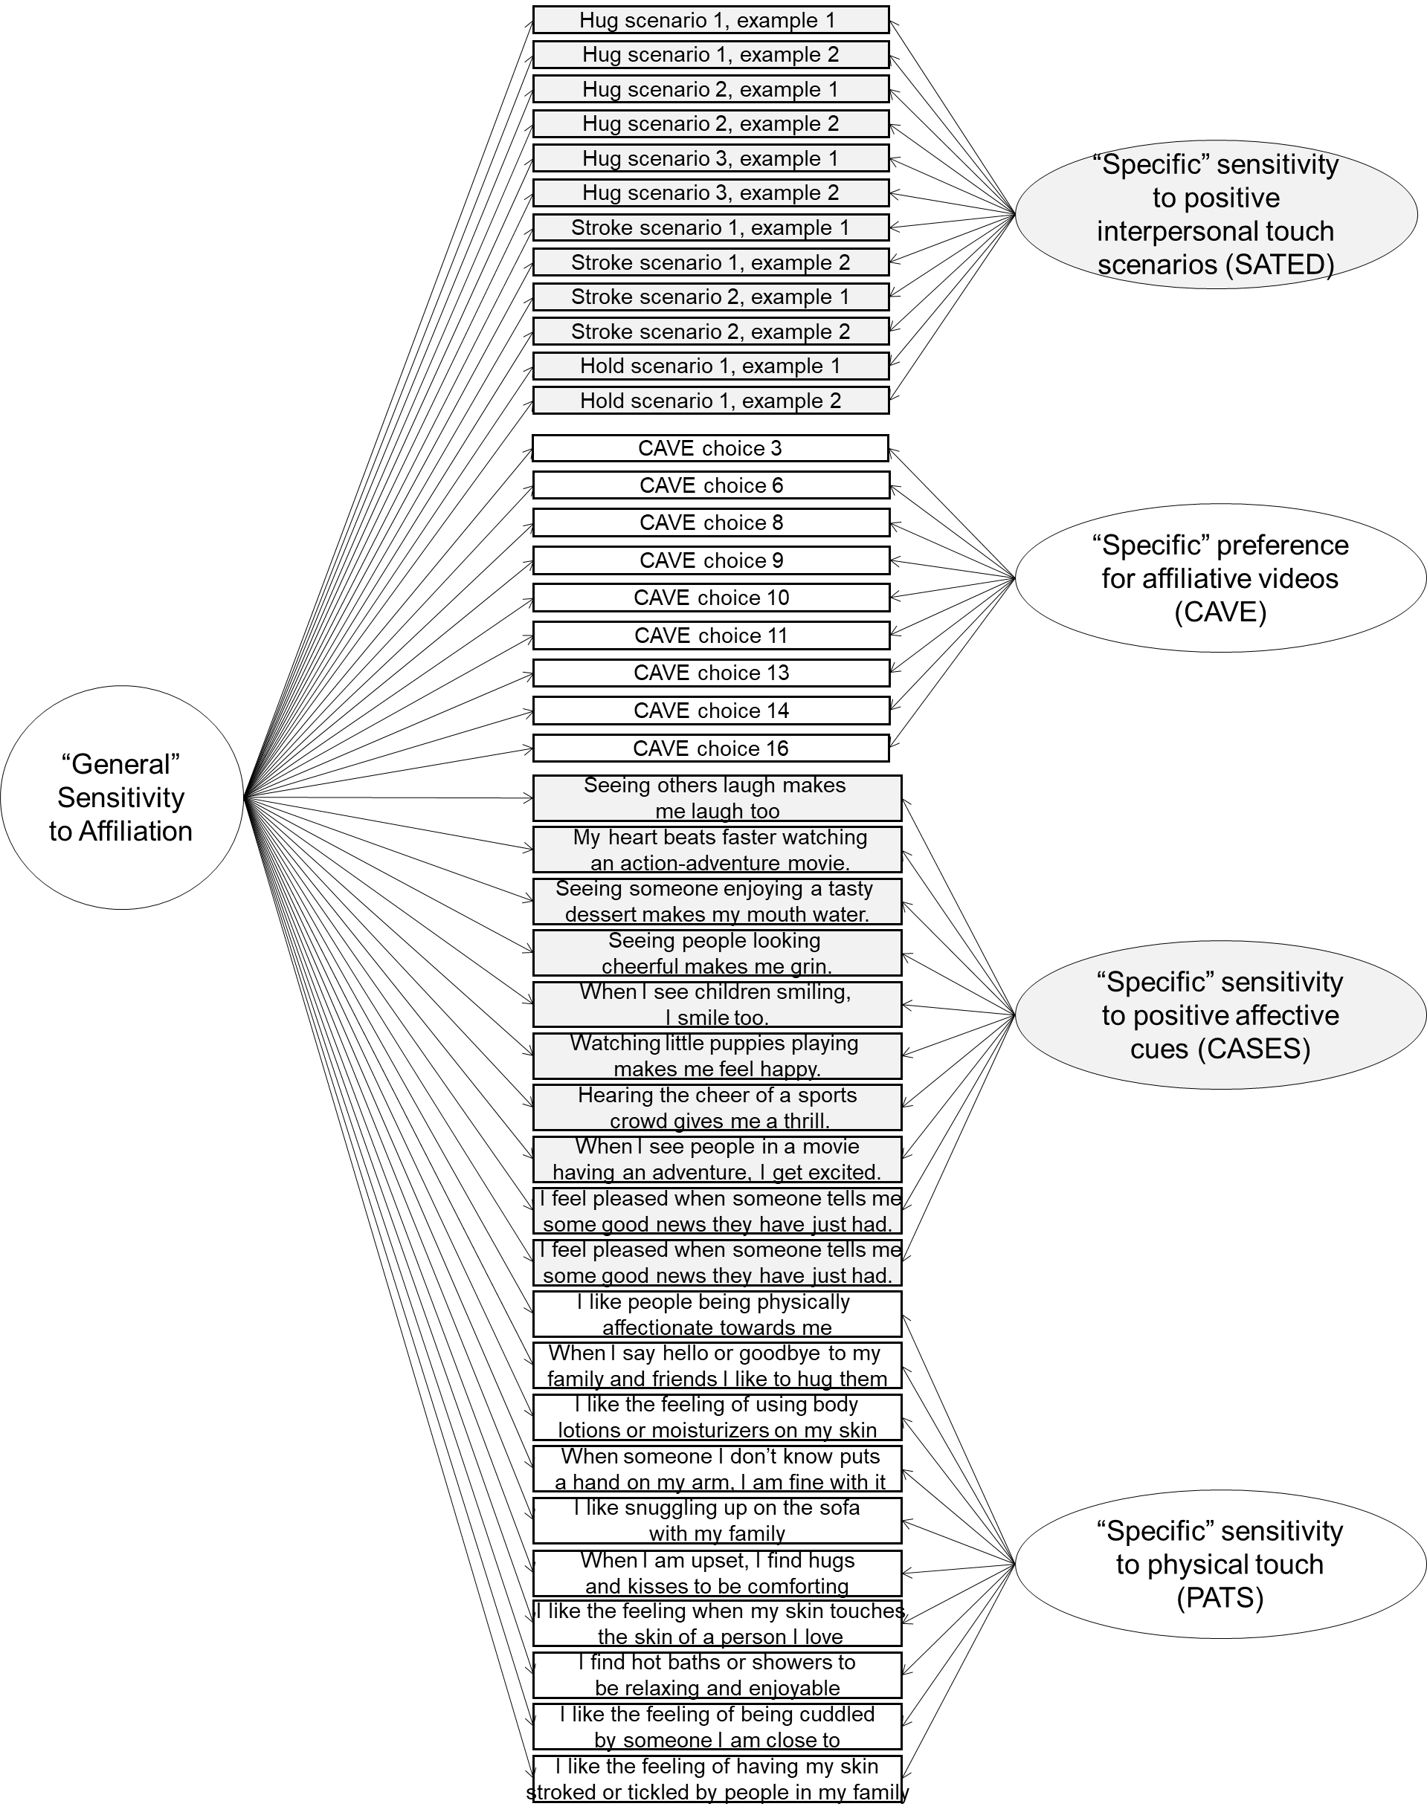

**References**

Dotterer, H. L., Waller, R., Neumann, C. S., Shaw, D. S., Forbes, E. E., Hariri, A. R., & Hyde, L. W. (2017). Examining the factor structure of the Self-Report of Psychopathy Short-Form across four young adult samples. *Assessment, 24*(8), 1062-1079.

Waller, R., McCabe, H. K., Dotterer, H. L., Neumann, C. S., & Hyde, L. W. (2018). Unique and interactive associations between maltreatment and complex emotion recognition deficits and psychopathic traits in an undergraduate sample. *Journal of personality disorders, 32*(4), 543-561.