**Supplement S1 – Recruitment strategy**

Recruitment had two phases, to ensure we were able to obtain a wide range of psychopathic-trait levels.

One phase included the broad population of undergraduates. Flyers made no mention of psychopathy-relevant traits or behaviours (describing the study as simply about face expressions and personality). This phase recruited a mix of paid participants (who were potentially from across the campus) and specifically psychology undergraduates participating for course credit; note psychology students are likely to have lower-than-average levels of psychopathic traits (Litten, Roberts, Ladyshewsky, Castell, & Kane, 2018).

The other phase was targeted at recruiting individuals at the higher end of psychopathic traits. First, flyers referred to psychopathy-relevant traits and behaviours, specifically: “Wanted: adventurous, fearless, charming and carefree people who’ve led exciting lives!” and “Are you good at looking out for number one as well as handling other people?”. Note the wording of these was designed to sound attractive to individuals high on psychopathy; for example, we could not realistically expect to get participants to sign up if we targeted psychopathy-relevant traits that are clearly socially unacceptable (e.g., "Do you enjoy hurting others"). Second, locations in which flyers were posted included the business school, given that business students are likely to have higher-than-average levels of psychopathic traits (Litten, Roberts, Ladyshewsky, Castell, & Kane, 2018).

Note that the experimenter testing the participants was blind as to which recruitment method had led the participant to sign up, and also that the psychopathy questionnaires were not scored until after the session had been completed. This ensured the experimenter remained blind to the participant's trait level while conducting the testing.

**Reference:**

Litten, V., Roberts, L. D., Ladyshewsky, R. K., Castell, E., & Kane, R. (2018). The influence of academic discipline on empathy and psychopathic personality traits in undergraduate students. *Personality and Individual Differences*, *123*, 145-150.

**Supplement S2 – Genuine and posed distress stimuli**

Facial expression stimuli for the rating tasks were from Dawel et al.’s (2017) final sets (i.e., the “perceived-as-genuine” and “perceived-as-fake” sets validated in Experiments 3 and 4 of that article, referred to here as “genuine” and “posed”). Details of the fear and sad stimuli (18 genuine distress items, 18 posed distress items) are given in Table S1. For neutral and non-distress emotions (happy, anger, disgust), Dawel et al. (2017) Supplement S3 provides the same details; note that, for happy, we did not use one of the genuine-posed stimulus pairs because it failed final verification checks in Experiment 3 of that article, leaving 15 genuine and 15 posed happy items, plus the full 6 genuine and 6 posed for anger and 10 genuine and 10 posed for disgust.

Table S1

*Distress expression stimulus items, including stimulus code from original source database*

|  |  |  |  |  |  |  |  |  |
| --- | --- | --- | --- | --- | --- | --- | --- | --- |
|  |  |  |  | **Genuine stimulus item** | |  | **Posed stimulus items, matched to each genuine**  **stimulus item for sex-of-face and viewpoint** | |
| **Exp.** | **Sex** | **View** |  | **Source** | **Stimulus code** |  | **Source** | **Stimulus code** |
| Fear | F | 3Q |  | FacePlace | CF0015_1110_FE |  | KDEF | AF16AFHR |
| Fear | F | FR |  | GUR-M | 134_F22_004 |  | RaFD | Rafd090_08_Caucasian_female_frontal |
| Fear | F | FR |  | GUR-M | 026_F1_015 |  | RaFD | Rafd090_19_Caucasian_female_fearful_frontal |
| Fear | F | FR |  | GUR-M | 049_F1_019 |  | RaFD | Rafd090_04_Caucasian_female_fearful_frontal |
| Fear | F | FR |  | GUR-M | 219_F15_004 |  | McLellan | F009_fea_POS |
| Fear | F | FR |  | GUR-M | 219_F13_004 |  | RaFD | Rafd090_02_Caucasian_female_fearful_frontal |
| Sad | F | 3Q |  | FacePlace | CF0042_1100_SA |  | KDEF | BF20SAHR |
| Sad | F | 3Q |  | FacePlace | CF0033_1100_SA |  | KDEF | AF19SAHR |
| Sad | F | 3Q |  | FacePlace | CF0002_1100_SA |  | KDEF | AF32SAHR |
| Sad | F | 3Q |  | FacePlace | CF0056_1110_SA |  | KDEF | AF28SAHR |
| Sad | F | 3Q |  | FacePlace | CF0043_1100_SA |  | KDEF | AF11SAHR |
| Sad | F | 3Q |  | FacePlace | CF0036_1100_SA |  | RaFD | Rafd045_12_Caucasian_female_sad_frontal |
| Sad | F | FR |  | GUR-M | 999_S3_022 |  | RaFD | Rafd090_08_Caucasian_female_sad_frontal |
| Sad | F | FR |  | GUR-M | 133_S1_024 |  | RaFD | Rafd090_04_Caucasian_female_sad_frontal |
| Sad | F | FR |  | GUR-M | 102_S4_026 |  | RaFD | Rafd090_02_Caucasian_female_sad_frontal |
| Sad | F | FR |  | GUR-M | 234_S5_034 |  | RaFD | Rafd090_16_Caucasian_female_sad_frontal |
| Sad | F | FR |  | GUR-M | 023_S2_025 |  | RaFD | Rafd090_01_Caucasian_female_sad_frontal |
| Sad | F | FR |  | GUR-M | 015_S3_022 |  | RaFD | Rafd090_14_Caucasian_female_sad_frontal |

*Note.* Exp. = expression. F = female. FR = frontal viewpoint. 3Q = three-quarter viewpoint. FacePlace = from Righi, Peissig, & Tarr (2012). GUR-M = method-acted (evoked) expressions from Gur et al. (2002). KDEF = Karolinska Directed Emotional Faces (Lundqvist et al., 1998). RaFD = Radboud Faces Database (Langner et al., 2010). McLellan = from McLellan et al. (2010).

**Supplement S3 – Instructions for rating intent-to-help**

For the intent-to-help rating task, we developed the following context and written instructions:

We want you to imagine that each person is someone you know (e.g. a colleague at university or work) and they have just had something bad happen to them.

For each face, please rate **how much you would want to be able to help this person** using the following scale:

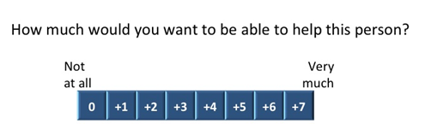

**0** means that would not want to be able to help this person at all

**+7** means that you would very much want to be able to help this person

**Supplement S4 – Instructions and scoring for arousal rating using SAM**

For the arousal rating task, participants were given detailed written instructions (adapted for our task from Bradley & Lang, 1994) explaining what to rate as follows:

In this task you will see the faces of different people, one at a time, showing different facial expressions.

We want you to **focus on how each facial expression makes you feel** at the time you are viewing it

The following scale will appear below each face, after a few seconds. Please use this scale to rate how **aroused** each facial expression makes you feel

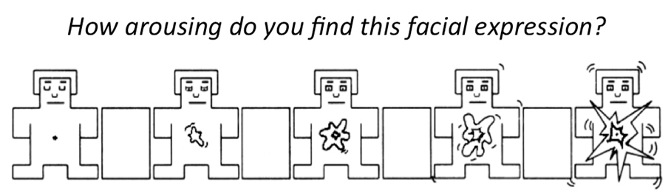[1]

|  |  |  |  |  |  |  |  |  |  |
| --- | --- | --- | --- | --- | --- | --- | --- | --- | --- |
| *Our scoring: (not shown to participants)* | *0* | *1* | *2* | *3* | *4* | *5* | *6* | *7* | *8* |

The scale represents feeling unaroused (on the left) versus feeling aroused (on the right).

The left extreme of the scale means you felt completely relaxed, calm, sluggish, dull, sleepy, **unaroused.** You can indicate you felt completely unaroused by clicking on the figure at the left of the row.

On the other hand, the right extreme of the scale means you felt stimulated, excited, frenzied, jittery, wide-awake, **aroused**. If you felt completely aroused while viewing the picture, click on the figure at the right of the row.

If you are not at all excited nor at all calm, click on the figure in the middle of the row.

You can also represent intermediate levels by clicking on any of the figures, or on the blocks between the figures.

High levels of arousal can be either unpleasant or unpleasant. We want you to **ignore how pleasant/unpleasant you feel**, and just focus on your feelings of arousal.

Your rating of each face should reflect your immediate personal experience of arousal, and no more.

Also, some of the faces may prompt emotional experiences; others may seem relatively neutral. There are no right or wrong answers. Please just rate how YOU ACTUALLY FELT WHILE YOU LOOKED AT THE FACE.

**Supplement S5 – Instructions and instruction-check for rating perceived genuineness**

For rating the genuineness of the emotion displayed in each face, participants were given the same task and instructions as in Dawel et al. (2017; note that article includes verification of the task, including choice of terms 'genuine' and 'fake' as the endpoints, plus stability of ratings across item sets, and high correlation with previous authenticity-rating scales). Detailed written instructions were given, explaining the concept of emotional genuineness and what we wanted the participant to rate, as follows:

Sometimes people show facial expressions of emotions they genuinely feel, and sometimes they display expressions that are faked or posed (e.g., to be polite or because they are acting).

An example of a genuine expression is when somebody smiles and they really feel happy, like when they get a present or see something funny.

An example of a faked expression is when somebody smiles for a school photo, without feeling any emotion. Or a parent playing a game with their child may put on a ‘scared’ face to pretend fear, but is not actually feel the emotion displayed.

Your task is to decide whether faces are showing genuinely felt expressions or faked/posed/acted expressions.

All the expressions you will see were photographed in laboratories, but some of them are genuine and some are faked.

In **genuine expressions**, emotions were induced by showing people video clips, pictures or sounds, or by asking them to remember an emotional event. For example, some people showing genuine happy expressions were photographed while watching a funny video. Others showing genuine fear were photographed while watching a scary film.

In **faked expressions**, people were simply instructed to act different emotions. For example, some people showing faked happy expressions were photographed when instructed to pose for a photo. Others showing faked fear were photographed when instructed to ‘look scared’ or to

move specific face muscles.

You will rate each face using the following scale:

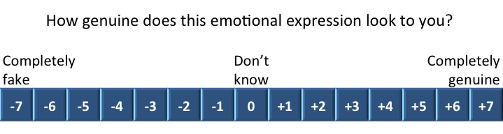

* **–7** means you think the expression is completely faked/posed/acted, and that the person does not feel the displayed emotion at all.
* **+7** means you think the expression is completely genuine, and that the person really feels the displayed emotion.
* **0** means that you can’t tell at all, and are just guessing.

Please don’t assume that half the faces you see will be genuine and half faked—this is not true of the face set you will see. We just want to know how genuine or fake you think the expressions are.

If you think that more of the faces you see are at the genuine end of the scale, please use this end more.

If you think that more of the faces you see are at the fake end of the scale, please use this end more.

If you think that they are spread across the scale, then please use the full length of the scale.

A final point: we want you to ***ignore the strength*** of the expressions when you rate how genuine or fake each expression is.

For example, an expression of sadness may be very subtle but be completely genuinely felt. Such an expression should be rated as completely genuine.

On the other hand, an expression of sadness may be very strong but be completely faked/posed/acted.

Such an expression should be rated as completely faked.

At the end of the study, participants were given two post-test questions about the emotional genuineness rating task instructions. They were required to choose a or b to two instruction check questions:

• “An example of a GENUINE expression is: (a) when somebody smiles and they really feel happy (e.g., like when they get a present they like) [correct answer], or (b) when somebody smiles without feeling any emotion (e.g., for a school photo)”

• “An example of a FAKED expression is: (a) when someone shows a fearful expression and they really feel afraid (e.g., when watching a scary film or hearing a creepy noise in the dark), or (b) when someone shows a fearful expression without feeling any emotion, or when feeling a different emotion to fear (e.g., a parent playing ‘tigers’ with their child might pretend a fearful expression, but feel no emotion or feel happy playing with their child) [correct answer].”

All the *N* = 140 participants included in analyses answered both questions correctly. We also tested an additional seven participants who were excluded from analyses because they incorrectly answered at least one of these questions.

**Supplement S6 – Results for emotion labelling accuracy**

Emotion labelling refers to the basic categorisation of the emotion displayed (6-way choice as anger, disgust, fear, happy, sad, neutral), not to whether the emotion is then perceived as genuine or not. Labelling results for our study are shown in Table S6 below. In terms of mean labelling accuracy, our finding that fear is labelled less accurately than other emotion stimuli replicates standard findings from multiple other databases indicating fear is the most difficult of Ekman's (1975) 'basic emotions' to recognise (for example, cf. 60-91% correct for posed expressions in Pictures of Facial Affect (Russell, 1994) and RaFD (e.g., Langner et al., 2010 had 83% for fear). In terms of correlations with psychopathic trait measures, these are reported as Spearman's *rho* rather than Pearson's *r* due to substantially skewed labelling accuracy (i.e., many participants labelled all or nearly all the expressions perfectly). Note the ceiling effect also implies correlations will have been underestimated in strength, particularly for sad (mean accuracy 88%-90%).

Table S6

*Mean labelling accuracy for each expression type, and bivariate correlations (Spearman’s ρ) between labelling accuracy and psychopathy questionnaire subscales (N = 140)*

|  |  |  |  |  |  |  |  |  |  |  |  |
| --- | --- | --- | --- | --- | --- | --- | --- | --- | --- | --- | --- |
|  | |  |  | **Affective psychopathy** | | | |  | **Other psychopathy** | | |
| Expression | | % accuracy *M* (*SD*) |  | LSRPS-F1 | TriPM-mean | ICU | Affective combined1 |  | LSRPS-F2 | TriPM-disinhibit | TriPM-bold |
| **Fear** | |  |  |  |  |  |  |  |  |  |  |
|  | Genuine | 71 (21.4) |  | -.104 | -.141 | -.083 | -.121 |  | -.107 | -.113 | -.010 |
|  | Posed | 83 (20.7) |  | -.076 | -.128 | **-.232\*\*** | **-.178\*** |  | -.129 | -.061 | -.062 |
| **Sad** | |  |  |  |  |  |  |  |  |  |  |
|  | Genuine | 88 (12.1) |  | -.114 | .027 | -.034 | -.051 |  | -.014 | -.130 | .043 |
|  | Posed | 90 (10.1) |  | -.029 | -.066 | -.128 | -.083 |  | -.133 | -.069 | -.017 |
| **Distress (average of all fear and sad expressions)** | | | | | | | | | | | |
|  | Genuine | 82 (10.6) |  | -.131 | -.056 | -.098 | -.098 |  | -.113 | **-.181\*** | .062 |
|  | Posed | 88 (10.5) |  | -.089 | -.135 | **-.249\*\*** | **-.188\*** |  | **-.183\*** | -.076 | -.006 |
| **Happy** | |  |  |  |  |  |  |  |  |  |  |
|  | Genuine | 97 (3.8) |  | **-.222\*\*** | -.115 | **-.191\*** | **-.195\*** |  | -.090 | **-.192\*** | -.023 |
|  | Posed | 93 (8.4) |  | -.140 | -.112 | -.103 | -.143 |  | -.012 | -.108 | -.054 |
| **Anger** | |  |  |  |  |  |  |  |  |  |  |
|  | Genuine | 80 (15.2) |  | -.022 | -.107 | -.083 | -.097 |  | -.063 | -.041 | -.132 |
|  | Posed | 91 (13.6) |  | -.055 | -.014 | -.117 | -.076 |  | -.006 | .023 | .029 |
| **Disgust** | |  |  |  |  |  |  |  |  |  |  |
|  | Genuine | 75 (17.4) |  | -.060 | -.006 | .026 | .002 |  | .080 | -.025 | -.097 |
|  | Posed | 89 (12.3) |  | -.108 | -.132 | -.118 | -.137 |  | .087 | -.003 | -.060 |
| **Neutral** | | 86 (13.7) |  | -.045 | .038 | -.013 | .004 |  | .012 | .016 | .022 |

*Note.* 1Affective psychopathy combined scores = (*z*LSRPS-F1 + *z*TriPM-mean + *z*ICU)/3). \*\**p* < .01. \**p* < .05.

**Supplement S7 – Bivariate correlations between all questionnaire measures**

Table S7

*Bivariate correlations between all questionnaire measures (N = 140)*

|  |  |  |  |  |  |  |  |  |  |  |
| --- | --- | --- | --- | --- | --- | --- | --- | --- | --- | --- |
|  | **Affective psychopathy** | | | | **Other psychopathy** | | | **Covariates** | | |
| Measure | LSRPS-F1 | | TriPM-mean2 | ICU | LSRPS-F2 | TriPM-disinhibit | TriPM-bold | STAI-state | STAI-trait | DASS-depress2 |
| **Affective psychopathy subscales** | | | | | | | | | | |
| Affective  combined1 | **.832\*\*\*** | | **.890\*\*\*** | **.818\*\*\*** | **.481\*\*\*** | **.561\*\*\*** | **.238\*\*** | .112 | **.236\*\*** | **.297\*\*\*** |
| LSRPS-F1 |  | | **.647\*\*\*** | **.447\*\*\*** | **.305\*\*\*** | **.475\*\*\*** | **.320\*\*\*** | .017 | .050 | .113 |
| TriPM-  meanness2 |  | |  | **.634\*\*\*** | **.449\*\*\*** | **.491\*\*\*** | **.250\*\*** | .136 | **.167\*** | **.227\*\*** |
| ICU |  | |  |  | **.478\*\*\*** | **.422\*\*\*** | -.030 | .127 | **.371\*\*\*** | **.396\*\*\*** |
| **Other psychopathy subscales** | | | | | | | | | | |
| LSRPS-F2 |  |  | |  |  | **.611\*\*\*** | **-.177\*** | **.391\*\*\*** | **.513\*\*** | **.441\*\*\*** |
| TriPM-  disinhibition |  |  | |  |  |  | .144 | **.271\*\*** | **.313\*\*\*** | **.226\*\*** |
| TriPM-  boldness |  |  | |  |  |  |  | **.305\*\*\*** | **-.498\*\*\*** | **-.355\*\*\*** |
| **Covariate questionnaire measures** | | | | | | | | | | |
| STAI-state |  |  | |  |  |  |  |  | **.671\*\*\*** | **.520\*\*\*** |
| STAI-trait |  |  | |  |  |  |  |  |  | **.723\*\*\*** |

*Note.* 1Affective psychopathy combined scores = (*z*LSRPS-F1 + *z*TriPM-mean + *z*ICU)/3). 2Spearman’s *ρ* is used for correlations involving TriPM-meanness and DASS-depression because these measures were non-normally distributed; all other correlations are Pearson’s *r*. \**p* < .05. \*\**p* < .01. \*\*\**p* < .001.

**Supplement S8 – Bivariate correlations for fear and sad expressions separately**

Table S8a

*Bivariate correlations between psychopathy subscales and intent-to-help ratings (N = 140)*

|  |  |  |  |  |  |  |  |  |  |  |
| --- | --- | --- | --- | --- | --- | --- | --- | --- | --- | --- |
| **Expression** | |  | **Affective psychopathy subscales** | | | |  | **Other psychopathy subscales** | | |
| LSRPS-F1 | TriPM-mean2 | ICU | Affective combined |  | LSRPS-F2 | TriPM-disinhibit | TriPM-bold |
| **Fear** | | | | | | | | | | |
|  | Genuine |  | **-.215\*** | **-.302\*\*\*** | **-.231\*\*** | **-.299\*\*\*** |  | -.132 | **-.207\*** | -.013 |
| Posed |  | **-.206\*** | -.144 | -.077 | **-.180\*** |  | -.121 | -.135 | -.067 |
| *z*1 |  | -.12 | 1.93 | **1.97\*** | 1.55 |  | .14 | .92 | .68 |
| **Sad** | | | | | | | | | | |
|  | Genuine |  | **-.393\*\*\*** | **-.451\*\*\*** | **-.383\*\*\*** | **-.486\*\*\*** |  | **-.232\*\*** | **-.318\*\*\*** | -.075 |
|  | Posed |  | **-.216\*** | **-.207\*** | -.061 | **-.213\*** |  | -.086 | **-.207\*** | -.122 |
|  | *z*1 |  | **2.12\*** | **2.18\*\*** | **3.77\*\*\*** | **3.36\*\*\*** |  | 1.67 | 1.33 | 0.53 |
| **Distress (average taken from all fear and sad expressions)** | | | | | | | | | | |
|  | Genuine |  | **-.366\*\*\*** | **-.448\*\*\*** | **-.366\*\*\*** | **-.467\*\*\*** |  | **-.218\*\*** | **-.310\*\*\*** | -.058 |
|  | Posed |  | **-.227\*\*** | **-.201\*** | -.071 | **-.215\*** |  | -.105 | **-.194\*** | -.109 |
|  | *z*1 |  | 1.87 | **3.09\*\*** | **3.89\*\*\*** | **3.24\*\*\*** |  | 1.44 | 1.53 | .65 |
| **Neutral** | |  | **-.192\*** | **-.225\*\*** | -.074 | **-.191\*** |  | -.155 | **-.223\*\*** | -.075 |

*Note.* 1Steiger's *z*-test for the difference between dependent correlations (<http://www.psychmike.com/dependent_correlations.php)> was used to establish whether each correlation for genuine expressions differed significantly from that for posed expressions (e.g., for affective combined, correlation of -.299 for genuine fear vs. correlation of -.180 for posed fear). 2Spearman’s *ρ* is used for correlations with TriPM-meanness because this measure was non-normally distributed; all other correlations are Pearson’s *r*. \**p* < .05. \*\**p* < .01. \*\*\**p* < .001.

Table S8b

*Bivariate correlations between psychopathy subscales and SAM arousal ratings (N = 140)*

|  |  |  |  |  |  |  |  |  |  |  |
| --- | --- | --- | --- | --- | --- | --- | --- | --- | --- | --- |
| **Expression** | |  | **Affective psychopathy subscales** | | | |  | **Other psychopathy subscales** | | |
| LSRPS-F1 | TriPM-mean2 | ICU | Affective combined |  | LSRPS-F2 | TriPM-disinhibit | TriPM-bold |
| **Fear** | | | | | | | | | | |
|  | Genuine |  | -.119 | -.135 | -.140 | **-.166\*** |  | .028 | .043 | -.104 |
| Posed |  | .023 | .019 | -.010 | -.009 |  | **.183\*** | .098 | -.157 |
| *z*1 |  | 1.81 | 1.93 | 1.66 | **2.01\*** |  | **1.99\*** | .70 | .68 |
| **Sad** | | | | | | | | | | |
|  | Genuine |  | -.122 | **-.175\*** | -.127 | -.160 |  | .011 | -.002 | -.135 |
|  | Posed |  | -.017 | -.045 | .032 | -.028 |  | .091 | .042 | **-.180\*** |
|  | *z*1 |  | 1.24 | 1.47 | 1.88 | 1.57 |  | .95 | .52 | -.54 |
| **Distress (average taken from all fear and sad expressions)** | | | | | | | | | | |
|  | Genuine |  | -.131 | **-.169\*** | -.142 | **-.176\*** |  | .019 | .015 | -.134 |
|  | Posed |  | -.003 | -.045 | .018 | -.022 |  | .132 | .067 | **-.182\*** |
|  | *z*1 |  | 1.63 | 1.52 | **2.04\*** | **1.97\*** |  | 1.44 | .66 | .62 |
| **Neutral** *(ρ)* | |  | -.031 | -.101 | -.045 | -.080 |  | <.001 | -.021 | **-.180\*\*** |

*Note.* 1Steiger's *z*-test for the difference between dependent correlations (<http://www.psychmike.com/dependent_correlations.php)> was used to establish whether each correlation for genuine expressions differed significantly from that for posed expressions (e.g., for affective combined, correlation of -.166 for genuine fear vs. correlation of -.009 for posed fear). 2Spearman’s *ρ* is used for correlations with TriPM-meanness because this measure was non-normally distributed; all other correlations are Pearson’s *r.*  \**p* < .05. \*\**p* < .01.

Table S8c

*Bivariate correlations between psychopathy subscales and genuineness discrimination scores*1 *(N = 140)*

|  |  |  |  |  |  |  |  |  |  |  |
| --- | --- | --- | --- | --- | --- | --- | --- | --- | --- | --- |
| **Expression** | |  | **Affective psychopathy subscales** | | | |  | **Other psychopathy subscales** | | |
| LSRPS-F1 | TriPM-mean2 | ICU | Affective combined |  | LSRPS-F2 | TriPM-disinhibit | TriPM-bold |
|  | **Fear** |  | **-.176\*** | -.153 | **-.208\*** | **-.203\*** |  | -.114 | -.078 | .038 |
| **Sad** |  | **-.191\*** | -.150 | **-.179\*** | **-.192\*** |  | -.034 | -.041 | -.094 |
| **Distress** |  | **-.206\*** | **-.168\*** | **-.211\*** | **-.216\*** |  | -.060 | -.058 | -.056 |

*Note.* 1Genuineness discrimination scores were calculated by subtracting each participant’s mean genuineness rating for all posed distress items from their mean genuineness rating for all genuine distress items. 2Spearman’s *ρ* is used for correlations with TriPM-meanness because this measure was non-normally distributed; all other correlations are Pearson’s *r*. \**p* < .05.

Table S8d

*Bivariate correlations between psychopathy subscales and genuineness ratings (N = 140)*

|  |  |  |  |  |  |  |  |  |  |  |
| --- | --- | --- | --- | --- | --- | --- | --- | --- | --- | --- |
| **Expression** | |  | **Affective psychopathy subscales** | | | |  | **Other psychopathy subscales** | | |
| LSRPS-F1 | TriPM-mean2 | ICU | Affective combined |  | LSRPS-F2 | TriPM-disinhibit | TriPM-bold |
| **Fear** | | | | | | | | | | |
|  | Genuine |  | -.116 | **-.203\*** | **-.208\*** | **-.188\*** |  | -.121 | -.101 | -.025 |
| Posed |  | .134 | .035 | .071 | .088 |  | .030 | -.001 | -.091 |
| *z*1 |  | **2.10\*** | **2.03\*** | **2.35\*** | **2.32\*** |  | 1.26 | .84 | .55 |
| **Sad** | | | | | | | | | | |
|  | Genuine2 |  | **-.176\*** | -.131 | **-.177\*** | **-.186\*** |  | -.002 | -.064 | **-.226\*\*** |
|  | Posed2 |  | .147 | .106 | .106 | .133 |  | -.006 | .043 | -.014 |
|  | *z*1 |  | **2.45\*** | 1.79 | **2.14\*** | **2.42\*** |  | .03 | .81 | 1.62 |
| **Distress (average taken from all fear and sad expressions)** | | | | | | | | | | |
|  | Genuine |  | -.136 | **-.185\*** | **-.170\*** | -.157 |  | -.045 | -.050 | **-.170\*** |
|  | Posed |  | **.171\*** | .086 | .141 | .163 |  | .044 | .034 | -.101 |
|  | *z*1 |  | **2.45\*** | **2.15\*** | **2.48\*** | **2.56\*** |  | .71 | .67 | .55 |

*Note.* 1Steiger's *z*-test for the difference between dependent correlations (<http://www.psychmike.com/dependent_correlations.php)> was used to establish whether each correlation for genuine expressions differed significantly from that for posed expressions (e.g., for affective combined, correlation of -.188 for genuine fear vs. correlation of -.088 for posed fear). 2Spearman’s *ρ* is used for correlations with TriPM-meanness because this measure was non-normally distributed; all other correlations are Pearson’s *r.*  \**p* < .05. \*\**p* < .01.

**Supplement S9 – Viewpoint analyses**

We had no *a priori* theoretical interest in viewpoint effects, but checked correlations separately for different viewpoints. Table S9 shows that, as expected, there was no evidence that the association between affective psychopathy and prosocial behaviour was any different depending on whether person shown was facing the camera or away from the camera. Also note that the difference in correlation strength between genuine and posed expressions (see main paper, plus Table S9) cannot be attributed to viewpoint, or to face sex, because both of these variables were matched across the genuine and posed stimuli.

Table S9

*Bivariate correlations with intent-to-help ratings for genuine and posed expressions across viewpoints (N = 140)*

|  |  |  |  |  |  |  |  |
| --- | --- | --- | --- | --- | --- | --- | --- |
|  |  | Frontal view faces | | |  | Three-quarter view faces3 | |
|  |  | Fear  (5 items) | Sad  (6 items) | Distress  (11 items) |  | Sad  (6 items) | Distress  (7 items) |
| **Genuine** | | | | | | | |
|  | Affective combined1 | **-.282\*\*** | **-.454\*\*\*** | **-.451\*\*\*** |  | **-.328\*\*\*** | **-.340\*\*\*** |
|  | LSRPS-F1 | **-.205\*** | **-.349\*\*\*** | **-.341\*\*\*** |  | **-.286\*\*** | **-.288\*\*** |
|  | TriPM-meanness2 | **-.269\*\*** | **-.392\*\*\*** | **-.438\*\*\*** |  | **-.298\*\*\*** | **-.318\*\*\*** |
|  | ICU | **-.228\*\*** | **-.390\*\*\*** | **-.381\*\*\*** |  | **-.220\*\*** | **-.225\*\*** |
| **Posed** | |  |  |  |  |  |  |
|  | Affective combined1 | -.131 | -.205 | **-.183\*** |  | **-.200\*** | **-.242\*\*** |
|  | LSRPS-F1 | **-.169\*** | **-.217\*** | **-.209\*** |  | **-.194\*** | **-.230\*\*** |
|  | TriPM-meanness2 | -.109 | **-.190\*** | **-.168\*** |  | **-.210\*** | **-.233\*\*** |
|  | ICU | -.032 | -.061 | -.051 |  | -.054 | -.095 |

*Note.* 1Affective psychopathy combined scores = (*z*LSRPS-F1 + *z*TriPM-mean + *z*ICU)/3). 2Spearman’s *ρ* is used for correlations with TriPM-meanness because this measure was non-normally distributed; all other correlations are Pearson’s *r.* 3Fear not presented separately for three-quarter view faces as there was only 1 fear item in this view.\**p* < .05. \*\**p* < .01. \*\*\**p* < .001.

**Supplement S10 – Tests of specificity to distress emotions: Results for the three non-distress emotions separately (Happy, Anger, Disgust)**

TableS10a

*Pearson’s r correlations between Affective Psychopathy Combined scores1 and arousal ratings for all emotions (N = 140)*

|  |  |  |  |  |  |
| --- | --- | --- | --- | --- | --- |
|  | Happy | Anger | Disgust | Fear | Sad |
| Genuine | .093 | .014 | .065 | **-.166\*** | -.160 |
| Posed | -.041 | .082 | .162 | -.009 | -.028 |

*Note.* 1Affective psychopathy combined scores = (*z*LSRPS-F1 + *z*TriPM-mean + *z*ICU)/3). \**p* < .05.

Table S10b

*Pearson’s r correlations between Affective Psychopathy Combined scores1 and genuineness discrimination scores2 for all emotions (N = 140)*

|  |  |  |  |  |
| --- | --- | --- | --- | --- |
| Happy | Anger | Disgust | Fear | Sad |
| -.042 | -.138 | -.058 | **-.203\*** | **-.192\*** |

*Note.* 1Affective psychopathy combined scores = (*z*LSRPS-F1 + *z*TriPM-mean + *z*ICU)/3). 2 Genuineness discrimination scores were calculated by subtracting each participant’s mean genuineness rating for all posed items from their mean genuineness rating for all genuine items. \**p* < .05.

Note, for the intent-to-help rating task the only non-distress expression tested was neutral expressions, for which results are reported in the main article.

**Supplement S11 – Mediation by authenticity discrimination ability**

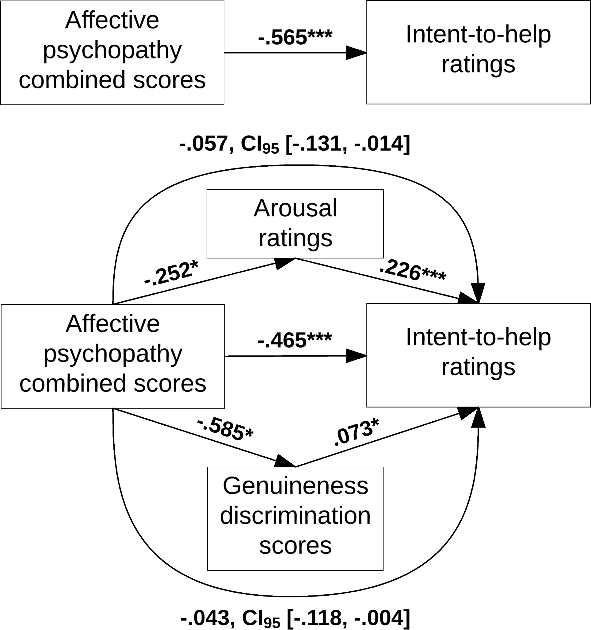

**Supplemental Figure**  **S11.** Mediation-model tests of whether the relationship between affective psychopathy combined scores and intent-to-help is mediated independently by ability to perceive the authenticity of distress emotions (genuineness discrimination) and by arousal. Model results are from the Preacher and Hayes’ (2013) PROCESS method. Path strength coefficients are the unstandardised weights. For direct paths, \**p* < .05, \*\**p* < .01, \*\*\**p* < .001. For the indirect mediation path, the bootstrapping method does not produce an exact *p*-value; instead, the indirect path is taken as significant if the bootstrapped 95% confidence intervals do not cross zero. All significant paths are bolded.

Note, in our above mediation model, we framed genuineness discrimination and arousal as separate, independent mediators of the association between affective psychopathy and prosociality. Theoretically however, more complex interrelationships might be involved. In the present study, we also found a direct, bivariate association between arousal to genuine distress and genuineness discrimination ability for distress emotions, r = .273, p =.001. The direction of causality in this relationship is of course unknown but, speculatively, there could perhaps be a causal relationship in either direction: it might be that consciously perceiving a distress expression as showing genuine emotion is one factor causing increased arousal to that expression, and/or it might be that increased arousal from a subcortical route (e.g., amygdala) is one factor that helps an observer to then consciously perceive the stimulus as showing genuine emotion. If either of these is the case, there might also be other, more complicated, causal routes linking affective psychopathy to reduced prosocial behaviour (e.g., higher affective psychopathy causes reduced subcortical arousal to others’ distress, which leads to reduced prosocial behaviour both directly and also by an indirect route via reduced cortical percepts of authenticity).

1. SELF ASSESSMENT MANIKIN © Peter J. Lang 1994.