Supplemental Appendix 1. Association Between Recoded C-SSRS-SV Factor Scores and Relevant Criteria

Measures
Suicide Risk Classification. The VA Suicide Risk Classification summarizes the yes-no responses on the Columbia-Suicide Severity Rating Scale Screen Version (C-SSRS-SV; Posner et al., 2011) and classifies participants into suicide risk categories. Participants can be classified into the following categories: no risk, low risk, moderate risk, or high risk.
Depression Symptom Severity. The Patient Health Questionnaire-9 (PHQ-9; α = .66; Kroenke et al., 2002) assesses depression symptom severity. Each of the nine symptom items are scored on a 4-point Likert scale ranging from 0 (not at all) to 3 (nearly every day) with higher total scores indicating greater depression symptom severity.
Suicidal and Self-Injurious Thoughts Severity. PHQ-9 Item 9 (Kroenke et al., 2002) was used as single-item measurement of wishing one was dead or thoughts of hurting oneself. This item is rated a 4-point Likert scale ranging from 0 (not at all) to 3 (nearly every day) with higher total scores indicating greater severity of suicidal and self-injurious thoughts.
Anxiety Symptom Severity. The Generalized Anxiety Disorder-7 (GAD-7; α = .84; Spitzer et al., 2006) assesses anxiety symptom severity. Each of the seven symptom items are scored on a 4-point Likert scale ranging from 0 (not at all) to 3 (nearly every day) with higher total scores indicating greater anxiety symptom severity.
Posttraumatic Stress Disorder (PTSD) Symptom Severity. The PTSD Checklist for the Diagnostic and Statistical Manual for Mental Disorders, Fifth Edition (PCL-5; α = .93; Weathers et al., 2013) assesses PTSD symptom severity. Each of the twenty symptom items are scored on a 5-point Likert scale ranging from 0 (not at all) to 4 (extremely) with higher total scores indicating greater PTSD symptom severity.

Data analysis
The full longitudinal configural model was estimated using the method described in the main text of the manuscript (i.e., WLSMV estimation, pairwise deletion, delta parameterization). Factor scores for each of the latent variables were predicted from the resulting model using the Empirical Bayes Model approach. Factor scores for the baseline suicide risk factor were correlated with the available suicide related criteria.

Results and Discussion
The resulting correlations are presented in Supplemental Table 1. All correlations are statistically significant and in the expected direction. Factor scores from the recoded C-SSRS-SV had their strongest associations with the suicide risk determination based on C-SSRS-SV responses and the PHQ-9 item 9, which assesses self-injurious thoughts. This offers preliminary convergent validity and supports construct validity for our face-valid recoding of the C-SSRS-SV measure.

Supplemental Table 1. Correlations for Factor Scores and Clinical Characteristics
 | N | 1 | 2 | 3 | 4 | 5 | 6
- C-SSRS-SV Factor Scores | 1,388 | —
- VA Suicide Risk Classification | 1,193 | .81** | —
- PHQ-9 Item 9 | 1,388 | .67** | .53** | —
- PHQ-9 Total Score | 1,388 | .34** | .25** | .46** | —
- GAD-7 Total Score | 1,388 | .20** | .16** | .24** | .53** | —
- PCL-5 Total Score | 1,154 | .24** | .18** | .26** | .46** | .52** | —
Note. C-SSRS-SV = Columbia-Suicide Severity Rating Scale Screen Version; GAD-7 = Generalized Anxiety Disorder-7; PHQ-9 = Patient Health Questionnaire-9; PCL-5 = Posttraumatic Stress Disorder Checklist for Diagnostic and Statistical Manual of Mental Disorders, 5th Edition.
**p < .01.

References
Kroenke, K., & Spitzer, R. L. (2002). The PHQ-9: A new depression diagnostic and severity measure. Psychiatric Annals, 32(9), 509–515. https://doi.org/10.3928/0048-5713-20020901-06
Posner, K., Brown, G. K., Stanley, B., Brent, D. A., Yershova, K. V., Oquendo, M. A., Currier, G. W., Melvin, G. A., Greenhill, L., & Shen, S. (2011). The Columbia–Suicide Severity Rating Scale: Initial validity and internal consistency findings from three multisite studies with adolescents and adults. American Journal of Psychiatry, 168(12), 1266–1277. https://doi.org/10.1176/appi.ajp.2011.10111704
Spitzer, R. L., Kroenke, K., Williams, J. B., & Löwe, B. (2006). A brief measure for assessing generalized anxiety disorder: The GAD-7. Archives of Internal Medicine, 166(10), 1092–1097. https://doi.org/10.1001/archinte.166.10.1092
Weathers, F. W., Litz, B. T., Keane, T. M., Palmieri, P. A., Marx, B. P., & Schnurr, P. P. (2013). The PTSD Checklist for DSM-5 (PCL-5). Scale available from the National Center for PTSD at www.ptsd.va.gov.

Supplemental Appendix 2. Results After Managing Missing Data with Multiple Imputation.
Multiple Imputation Procedure
We replicated our primary analyses using multiple imputation to manage missing data rather than pairwise deletion. Imputations were generated using the mice package (version 3.19.0; Buuren & Groothuis-Oudshoorn, 2011) in R.
Rather than imputing the recoded C-SSRS-SV composite variables directly, we imputed the raw dichotomous C-SSRS-SV item responses (Items 1, 2, 3, 4, 5, 5a, 6, and 6a) at each of the six assessment waves and then derived the recoded active suicidal ideation and suicidal behavior composites within each completed dataset. Prior to recoding, the skip-out logic of the original C-SSRS-SV was reimposed deterministically (e.g., Items 3–5a were set to 0 if Item 2 was 0; Item 6a was set to 0 if Item 6 was 0) to preserve the structural dependencies built into the measure. This approach ensured that the composite scores derived from the imputed data retained the same logical structure as those derived from the observed data.
Predictive mean matching (PMM) was used as the imputation method for all C-SSRS-SV items. Although logistic regression is a more conventional choice for binary outcomes, several C-SSRS-SV items had very low base rates of endorsement, and PMM produced imputed distributions that more closely matched the observed empirical response distributions (see bar plots, Figures S1–S3). PMM was also used for all continuous auxiliary variables while logistic regression was used for other dichotomous auxiliaries, and polytomous regression was used for nominal auxiliaries.
Auxiliary variables were selected to include theoretically relevant predictors of suicide risk, depression severity, and missingness. These included repeated measures of depression, anxiety, posttraumatic stress, and health-related quality of life symptoms; substance use indicators (alcohol, drug, and tobacco use); treatment-related variables (medication adherence, side effects, treatment satisfaction, and treatment confidence); and study-design and demographic covariates (site, randomization group, age, sex, race, ethnicity, marital status, employment, military service variables, provider characteristics, and a COVID-era indicator). A complete list of auxiliary variables is available in the analytic code provided with the supplemental material.
Because the full set of analysis and auxiliary variables across all assessment waves yielded a predictor matrix that was computationally intractable, we constrained the predictor matrix so that variables measured only at baseline (e.g., demographics, study site, randomization group) predicted variables at all waves, and variables measured repeatedly predicted other variables measured at the same wave. This restriction limited the size of the prediction set for any given variable while preserving the auxiliary information most likely to be relevant to that variable's imputation.
A total of 25 imputed datasets were generated using 20 iterations each. Convergence was inspected via trace plots of imputation chain means and variances, and plausibility of imputed values was inspected via bar plots comparing the proportion of responses in each category across observed and imputed data for each C-SSRS-SV item at each wave (Figures S1–S3). No convergence concerns were identified, and imputed distributions closely tracked observed distributions across waves.
Longitudinal measurement invariance models were re-estimated on the imputed data using the same model specifications described in the main text. Subgroup analyses (sex, race) could not be reliably re-estimated on the imputed data because the combination of low base rates for several C-SSRS-SV items and reduced subgroup sample sizes produced sparse or empty response categories in many of the imputed datasets. We therefore present multiple-imputation results for the full sample only.

Results and Discussion
We re-estimated the longitudinal measurement invariance models on the 25 multiply imputed datasets. Test statistics and parameter estimates were pooled across imputations and likelihood ratio tests for nested model comparisons were pooled using the D2 method (Li et al., 1991; Rubin, 1987).
Results were broadly consistent with the pairwise-deletion analyses presented in the main text but slightly more favorable for the C-SSRS-SV. The configural model fit the data well (χ² = 73.73, df = 75, CFI = 1.000, RMSEA = 0.00, SRMR = .031) and the RMSEA_{D} statistic suggested that none of the threshold, metric, or scalar constraints resulted in meaningful degradation in model fit (Table S2). These analyses therefore support full scalar invariance, without the need to free the suicidal behavior intercept at baseline. That said, the ΔCFI of -.015 when imposing scalar invariance constraints does exceeds the conventional ΔCFI < -.01 cutoff (Cheung & Rensvold, 2002). Modification indices identified the suicidal behavior item at baseline as the greatest source of misfit in the scalar invariance model. When we ran a model freeing the suicidal behavior item intercept at baseline the magnitude of the intercept difference was comparable to that observed in the pairwise analyses: ν = -.41, p < .001

References
Buuren, S. V., & Groothuis-Oudshoorn, K. (2011). mice: Multivariate Imputation by Chained Equations in R. Journal of Statistical Software, 45(3). https://doi.org/10.18637/jss.v045.i03
Cheung, G. W., & Rensvold, R. B. (2002). Evaluating goodness-of-fit indexes for testing measurement invariance. Structural Equation Modeling: A Multidisciplinary Journal, 9(2), 233–255. https://doi.org/10.1207/S15328007SEM0902_5
Li, K.-H., Meng, X.-L., Raghunathan, T. E., & Rubin, D. B. (1991). Significance levels from repeated p-values with multiply imputed data. Statistica Sinica, 1(1), 65–92.
Rubin, D. B. (1987). Multiple imputation for nonresponse in surveys (1st ed.). Wiley. https://doi.org/10.1002/9780470316696

Figure S1. Comparing Observed and Imputed Item 1 Distributions
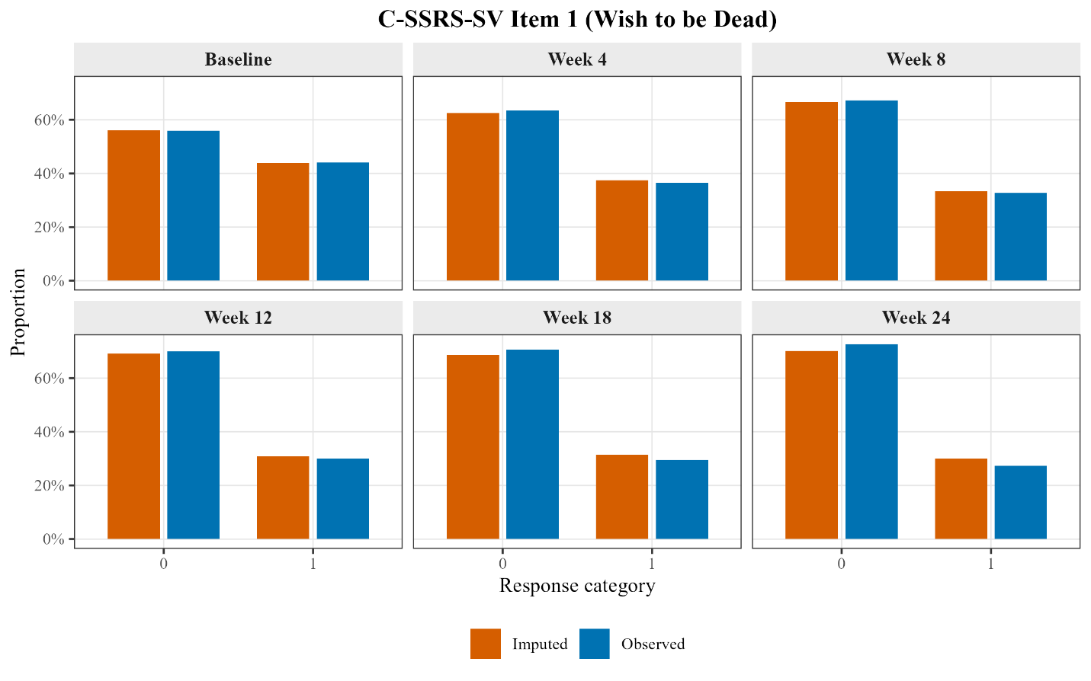

Figure S2. Comparing Observed and Imputed Suicidal Ideation Item Distributions
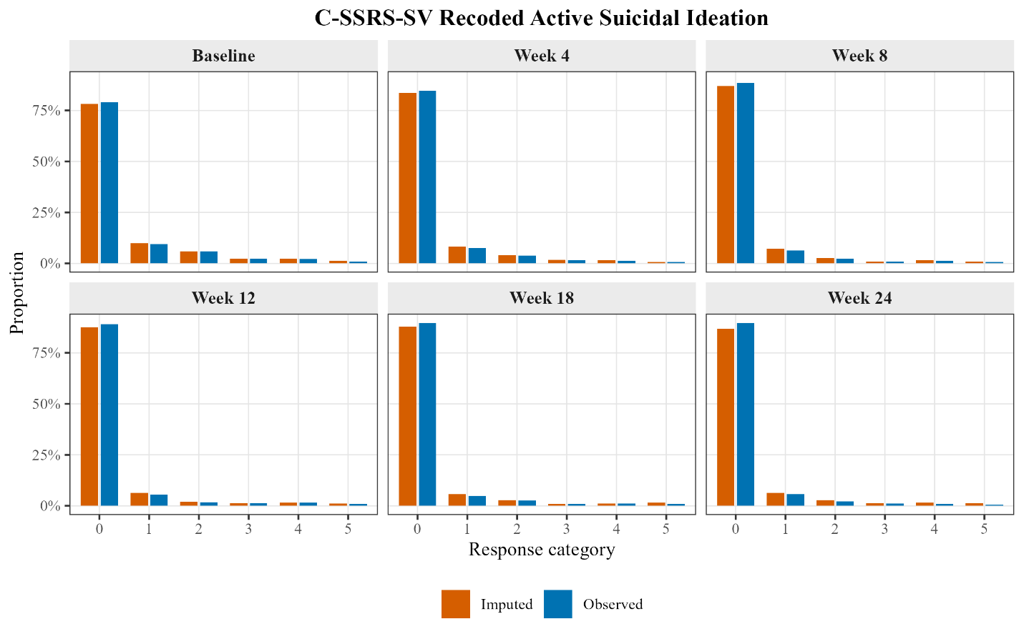

Figure S3. Comparing Observed and Imputed Suicidal Behavior Item Distributions
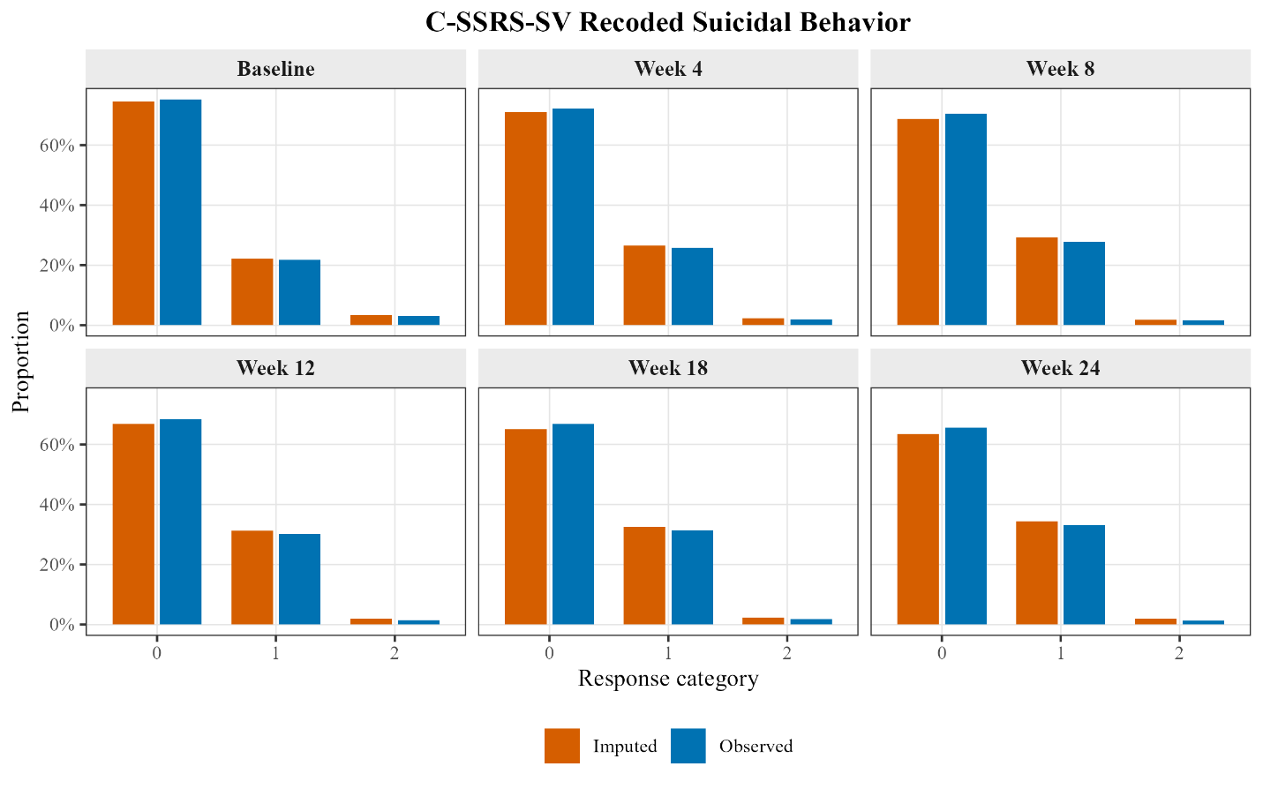

Supplemental Table 2.

Tests of C-SSRS-SV Measurement Invariance Across Full Sample Using Multiply Imputed Data (N = 1,388)

Model | χ^{2†} | df | CFI† | RMSEA† | SRMR | Test | Δχ^{2†} | Δdf | p | ΔCFI | RMSEA_{D} | RMSEA_{D} CI | Conclusion
1. Configural Invariance | 73.73 | 75 | 1.00 | .000 | .031 |  |  |  |  |  |  |  | Accept
2. Threshold Invariance | 86.97 | 90 | 1.00 | .000 | .031 | 2 vs. 1 | 3.15 | 15 | .999 | .000 | .000 |  | Accept
3. Metric Invariance | 99.61 | 95 | .996 | .006 | .031 | 3 vs. 2 | 14.97 | 5 | .011 | .000 | .029 | [—, .053] | Accept
4. Scalar Invariance | 205.58 | 105 | .904 | .026 | .033 | 4 vs. 3 | 95.42 | 10 | .000 | -.015 | .073 | [.059, .088] | Reject
Note. CFI = comparative fit index; CI = Confidence Interval; df = degrees of freedom; RMSEA = root-mean-square error of approximation; SRMR = standardized root-mean-square residual
†Scaled metric

Supplemental Appendix 3. Results of Group × Time Invariance Analyses.

Data Analysis
We extended the longitudinal invariance analyses presented in the main text by examining whether the measurement properties of the C-SSRS-SV were invariant across both time and demographic subgroups simultaneously. Two sets of group × time invariance analyses were conducted: one comparing White (n = 949) and non-White (n = 439) participants, and one comparing male (n = 1,044) and female (n = 344) participants. Non-White participants included those who self-identified as Black or African American, American Indian or Alaska Native, Asian, Pacific Islander or Native Hawaiian, or Other/Mixed. In the sex × time model, as with the primary analyses, the week 8 and 18 time points were dropped from the analyses due to missing response categories in the female subgroup.
The general analytic approach mirrored the longitudinal invariance analyses described in the main text. Models were estimated using the diagonally weighted least squares estimator with robust standard errors and mean- and variance-adjusted test statistics (WLSMV). Missing data were managed using pairwise deletion, and the scale of the latent response variables was fixed using delta parameterization. Acceptable fit of the configural model was defined by meeting at least two of the following criteria (Hu & Bentler, 1999): SRMR ≤ .08, CFI ≥ .95, RMSEA ≤ .06. Nested model comparisons were evaluated using the RMSEA_{D} metric (Savalei et al., 2024), with non-degradation in model fit accepted when the upper bound of the RMSEAD 90% confidence interval fell below .10. When an imposed constraint produced significant degradation in model fit, exploratory analyses were used to identify local sources of misfit and, where possible, establish partial invariance by freeing specific non-invariant parameters.
The key difference between these models and those presented in the main text is that each level of constraint was imposed across both groups and time points simultaneously. That is, the threshold invariance model required item thresholds to be equal across the two demographic groups and across the six assessment waves, metric invariance model required factor loadings to be equal across groups and waves, etc.
Identification of the group × time models followed the same logic described by Wu and Estabrook (2016). The general step-wise procedure was as follows. Unless otherwise noted, all constraints were retained when proceeding from one model to the next.
In the configural model, latent response item intercepts and latent variable means were fixed to 0, and the delta scaling parameter and latent variable variances were fixed to 1 at all time points in both groups. These are necessary identification conditions and consistent with a baseline configural model (Wu & Estabrook, 2016). In the threshold invariance model, item thresholds were constrained equal across groups and time, and minimal constraints were placed on latent response variable intercepts and delta scaling parameters. In the metric invariance model, loadings were constrained equal across groups and time in addition to the threshold constraints. At this step in the procedure, we were able to free the remaining constraints on item intercepts, scaling parameters, and latent variable variances, except those in the reference group at baseline, which were necessary to maintain identification conditions for the latent response variables and general latent variables. In the scalar invariance model, item intercepts were constrained to 0 across groups and time, and all latent factor means were freed except the reference group at baseline. As in the main analyses, residual covariances were allowed between repeated measurements of the same item across waves. Consistent with the main text, strict invariance (i.e., invariance of residual variances) was not tested. See provided R syntax for additional details on the constraints at each level.

Results
Results of the race × time and sex × time invariance models are presented in Supplemental Tables 3 and 4, respectively.

Race × Time Invariance
The configural model fit the data well (χ² = 276.92, df = 150, CFI = .997, RMSEA = .035, SRMR = .049), and imposition of threshold and metric invariance constraints did not produce meaningful degradation in model fit. The scalar invariance model produced a significant degradation in fit (RMSEA_{D} = .087, 90% CI [.074, .101]). Examination of modification indices indicated that the two largest sources of misfit were the suicidal behavior item intercepts at baseline in the White and non-White groups. We therefore freed the longitudinal scalar invariance constraint for the suicidal behavior intercept at baseline while retaining the cross-group equality constraint (i.e., the baseline intercept was allowed to differ from intercepts at subsequent waves, but was constrained to equality across racial groups). This modification was sufficient to support partial longitudinal scalar invariance but full cross-group scalar invariance (RMSEA_{D} = .059, 90% CI [.044, .074]). The freed intercept (ν = -.413, p < .001) was very similar in magnitude to the corresponding intercept observed in the full-sample longitudinal invariance model (ν = -.408) and the within-group analyses (White ν = -.391, non-White ν =
-.434). Participants in both racial groups reported less lifetime suicidal behavior at baseline than would be expected at their level of latent suicide risk based on subsequent assessments.

Sex × Time Invariance
The configural, threshold, and metric invariance models fit the data well, with no meaningful degradation in fit through the imposition of metric constraints. The scalar invariance model produced a significant degradation in fit (RMSEA_{D} = .100, 90% CI [.083, .117]). The solution also contained a negative residual variance for a latent response variable, which raises questions regarding the interpretability of the scalar invariance model. Despite this, in the interest of being thorough, we attempted to establish partial scalar invariance using the same approach applied in the race × time analysis (i.e., freeing the longitudinal scalar invariance constraint on the suicidal behavior intercept at baseline while retaining the cross-group constraint). This modification eliminated the negative residual variance and was sufficient to meet the RMSEA_{D} criterion for non-degradation (RMSEAD = .067, 90% CI [.049, .086]).

Discussion
Several factors warrant caution in interpreting the group × time invariance results. First, both analyses involve unbalanced subgroup sample sizes. Yoon and Lai (2018) demonstrated that multiple-group factorial invariance testing is sensitive to sample size imbalance because the multiple-group fit function is weighted by group size. As a result, parameter estimates are pulled toward the structure of the larger group, and violations of invariance localized to the smaller group can be masked. Although the magnitude of sample size imbalance for these analyses is small relative to the ratios examined by Yoon and Lai (2018), the potential effect of that imbalance should be acknowledged. Second, both analyses involve the simultaneous imposition of constraints across groups and time at each step. It can therefore be difficult to localize the source of misfit when constraints are violated. In the present analyses, modification indices in the race × time scalar model clearly identified the baseline suicidal behavior intercept as the primary source of misfit, mirroring the pattern observed in the full-sample longitudinal analysis. In the sex × time scalar model, the source of misfit was less clear, and the partial scalar solution should be interpreted accordingly. Third, the C-SSRS-SV items have low base rates of endorsement, which compounds the challenges introduced by both the sample-size imbalance and the simultaneous group × time constraint structure. The combination of sparse data in the smaller subgroups and the demanding model structure likely contributed to the estimation difficulties observed in the sex × time scalar model.
These results provide preliminary evidence that the measurement structure of the C-SSRS-SV is largely invariant across racial groups and sex over time. As in the full sample, the caveat to longitudinal invariance was the suicidal behavior intercept at baseline, which suggests participants might under-report past suicidal behaviors at the initial assessment. These results provide preliminary support for full scalar invariance across race and sex, suggesting that previous epidemiological for differing rates of suicide risk across these groups is not just a measurement artifact. These cross-group invariance results should be taken as preliminary though. The limited number of non-White participants in the sample required us to collapse across racial groups, which may obscure non-invariance across smaller subgroups. In addition, the low base rate of endorsement for some items resulted in very small cell counts for the smaller subgroups. We had to drop some time points entirely in the sex × time model because some response options went entirely unendorsed among females. These sparse cells contain little information for estimating model parameters so the resulting models can be prone to estimation problems (as we saw in the sex × time model) and may not replicate consistently. Future work using a larger sample is needed to test these joint group × time invariance models more definitively.

References
Hu, L., & Bentler, P. M. (1999). Cutoff criteria for fit indexes in covariance structure analysis: Conventional criteria versus new alternatives. Structural Equation Modeling: A Multidisciplinary Journal, 6(1), 1–55. https://doi.org/10.1080/10705519909540118
Savalei, V., Brace, J. C., & Fouladi, R. T. (2024). We need to change how we compute RMSEA for nested model comparisons in structural equation modeling. Psychological Methods, 29(3), 480–493. (2023-35925-001). https://doi.org/10.1037/met0000537
Wu, H., & Estabrook, R. (2016). Identification of confirmatory factor analysis models of different levels of invariance for ordered categorical outcomes. Psychometrika, 81(4), 1014–1045. https://doi.org/10.1007/s11336-016-9506-0
Yoon, M., & Lai, M. H. C. (2018). Testing factorial invariance with unbalanced samples. Structural Equation Modeling: A Multidisciplinary Journal, 25(2), 201–213. https://doi.org/10.1080/10705511.2017.1387859
Supplemental Table 3.

C-SSRS-SV Race × Time Measurement Invariance Model (White n = 949, non-White n = 439)

Model | χ^{2†} | df | CFI† | RMSEA† | SRMR | Test | Δχ^{2†} | Δdf | p | ΔCFI | RMSEA_{D} | RMSEA_{D} CI | Conclusion
1. Configural Invariance | 276.92 | 150 | .997 | .035 | .049 |  |  |  |  |  |  |  | Accept
2. Threshold Invariance | 316.77 | 183 | .997 | .032 | .049 | 2 vs. 1 | 31.18 | 33 | .558 | .000 | .000 |  | Accept
3. Metric Invariance | 335.05 | 194 | .997 | .032 | .050 | 3 vs. 2 | 22.36 | 11 | .022 | .000 | .049 | [.028, .071] | Accept
4. Scalar Invariance | 430.64 | 216 | .995 | .038 | .054 | 4 vs. 3 | 86.79 | 22 | .000 | -.001 | .087 | [.074, .101] | Reject
5. Partial Scalar Invariance | 372.55 | 215 | .997 | .033 | .054 | 5 vs. 3 | 48.21 | 21 | .001 | .000 | .059 | [.044, .074] | Accept
Item 6v = -.413, p < .001
Note. CFI = comparative fit index; CI = Confidence Interval; df = degrees of freedom; RMSEA = root-mean-square error of approximation; SRMR = standardized root-mean-square residual.
†Scaled metric

Supplemental Table 4.

C-SSRS-SV Sex × Time Measurement Invariance Model (White n = 1,042, non-White n = 344)

Model | χ^{2†} | df | CFI† | RMSEA† | SRMR | Test | Δχ^{2†} | Δdf | p | ΔCFI | RMSEA_{D} | RMSEA_{D} CI | Conclusion
1. Configural Invariance | 99.21 | 60 | .998 | .031 | .044 |  |  |  |  |  |  |  | Accept
2. Threshold Invariance | 120.63 | 81 | .998 | .027 | .044 | 2 vs. 1 | 14.27 | 21 | .858 | .000 | .000 |  | Accept
3. Metric Invariance | 137.42 | 88 | .998 | .028 | .047 | 3 vs. 2 | 15.72 | 7 | .028 | .000 | .048 | [.022, .076] | Accept
4. Scalar Invariance | 248.18 | 102 | .993 | .046 | .045 | 4 vs. 3 | 93.19 | 14 | .000 | -.002 | .100 | [.083, .117] | Rejectª
5. Partial Scalar Invariance | 187.16 | 101 | .996 | .035 | .046 | 5 vs. 3 | 46.16 | 13 | .000 | -.001 | .067 | [.049, .086] | Accept
Item 6v = -.394, p < .001
Note. CFI = comparative fit index; CI = Confidence Interval; df = degrees of freedom; RMSEA = root-mean-square error of approximation; SRMR = standardized root-mean-square residual.
†Scaled metric
ªModel included a negative residual variance

Supplemental Appendix 4. Results of Randomization Group × Time Invariance Analyses.

Data Analysis
We examined invariance across randomization groups (n₁ = 696, n₂ = 692) and across time in a group × time model. The methods of the analysis were consistent with that described in Supplemental Appendix 3.

Results
See Supplemental Table 5 for full results. Note that there was a consistent improper solution (negative latent response variable residual variance) that persisted through the threshold invariance model. Model inspection revealed that the negative residual variance was limited to the delayed results subgroup. The metric invariance constraints resolved this estimation issue.
Supplemental Table 5.

C-SSRS-SV Randomization Group × Time Measurement Invariance Model (Delayed results n = 696, Immediate results n = 692)

Model | χ^{2†} | df | CFI† | RMSEA† | SRMR | Test | Δχ^{2†} | Δdf | p | ΔCFI | RMSEA_{D} | RMSEA_{D} CI | Conclusion
1. Configural Invariance | 215.28 | 150 | .999 | .025 | .041 |  |  |  |  |  |  |  | Acceptª
2. Threshold Invariance | 253.53 | 183 | .998 | .024 | .041 | 2 vs. 1 | 36.03 | 33 | .329 | .000 | .000 |  | Acceptª
3. Metric Invariance | 290.36 | 194 | .998 | .027 | .043 | 3 vs. 2 | 30.19 | 11 | .001 | .000 | .063 | [.043, .084] | Accept
4. Scalar Invariance | 407.41 | 216 | .996 | .036 | .048 | 4 vs. 3 | 94.26 | 22 | .000 | -.001 | .091 | [.077, .105] | Reject
5. Partial Scalar Invariance | 343.82 | 215 | .997 | .029 | .048 | 5 vs. 3 | 52.69 | 21 | .000 | .000 | .062 | [.048, .078] | Accept
Item 6v = -.391, p < .001
Note. CFI = comparative fit index; CI = Confidence Interval; df = degrees of freedom; RMSEA = root-mean-square error of approximation; SRMR = standardized root-mean-square residual.
†Scaled metric
ªModel included a negative residual variance

Supplemental Table 6.

Percent of Sample Endorsing Each Recoded C-SSRS-SV Item Response Across Study

Response Category | Baseline  (N = 1,193) | Week 4  (N = 1,118) | Week 8  (N = 1,062) | Week 12  (N = 1,075) | Week 18  (N = 1,063) | Week 24  (N = 1,140)
Item 1 (Wish to be dead)
0 (No wish to be dead) | 667 (55.91%) | 710 (63.51%) | 715 (67.33%) | 752 (69.95%) | 750 (70.56%) | 829 (72.72%)
1 (Wish to be dead) | 526 (44.09%) | 408 (36.49%) | 347 (32.67%) | 323 (30.05%) | 313 (29.44%) | 311 (27.28%)
Recoded Active Suicidal Ideation (Items 2–5a)
0 (No active SI) | 942 (79.03%) | 946 (84.62%) | 938 (88.32%) | 957 (89.02%) | 954 (89.75%) | 1022 (89.65%)
1 (Non-specific active SI) | 112 (9.40%) | 86 (7.69%) | 67 (6.31%) | 59 (5.49%) | 51 (4.80%) | 65 (5.70%)
2 (Active SI with method, no plan) | 71 (5.96%) | 44 (3.94%) | 25 (2.35%) | 19 (1.77%) | 27 (2.54%) | 24 (2.11%)
3 (Active SI with some intent, no plan) | 29 (2.43%) | 18 (1.61%) | 10 (0.94%) | 14 (1.30%) | 10 (0.94%) | 12 (1.05%)
4 (Active SI with specific plan) | 27 (2.27%) | 16 (1.43%) | 14 (1.32%) | 16 (1.49%) | 12 (1.13%) | 11 (0.96%)
5 (Active SI with specific plan and intent) | 11 (0.92%) | 8 (0.72%) | 8 (0.75%) | 10 (0.93%) | 9 (0.85%) | 6 (0.53%)
Recoded Suicidal Behavior (Items 6 and 6a)
0 (No history of suicidal behavior) | 898 (75.27%) | 805 (72.20%) | 748 (70.50%) | 730 (68.35%) | 709 (66.76%) | 745 (65.64%)
1 (Lifetime history of suicidal behavior) | 259 (21.71%) | 288 (25.83%) | 295 (27.80%) | 322 (30.15%) | 334 (31.45%) | 376 (33.13%)
2 (Suicidal behavior in past 3 months) | 36 (3.02%) | 22 (1.97%) | 18 (1.70%) | 16 (1.50%) | 19 (1.79%) | 14 (1.23%)
Note. SI = suicidal ideation.

