Emotion Regulation Difficulties in Daily Life:
Assessment, Dynamics, and Links to Stress-Affective States and Traits

Supplements

Exploratory Structural Equation Modelling Approach
S-DERS covariance matrices were calculated for the within- and between-person level using the decomposition by (Muthén, 1994). Next, EFA was conducted on these covariance matrices using principal axis factoring and promax rotation, as in the original English S-DERS construction (Lavender et al., 2017). Then, referent items were determined using the esemComp package (Silvestrin & de Beer, 2022), have maximal loadings on a single latent factor and minimal loadings on the remaining factors. Lastly, CFA models were fitted using the EFA loadings as starting values and fixing the referent loadings (Prokofieva et al., 2023). For the ESEM model with cross-level invariance, loadings from either the within- or between-person covariance matrix can be used. We used the between-person loadings as starting points, as multilevel CFA by design already puts more weight on within-person fit (Hsu et al., 2015; Muthén, 1994).

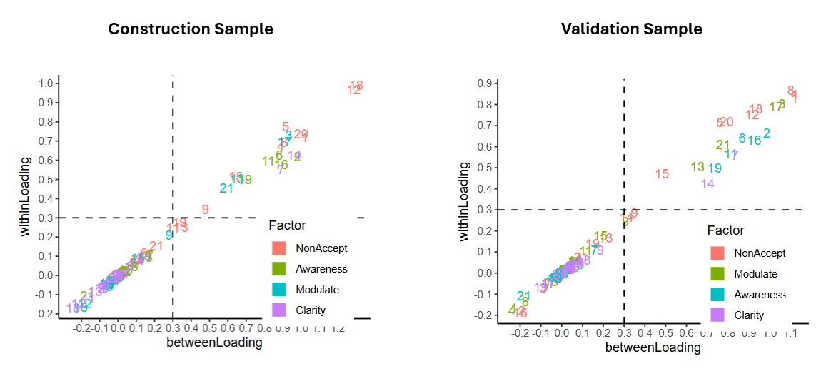
Figure S1. Visualizations of within-/between-person loadings in the construction and validation sample. Colours indicate the scale membership according to the original S-DERS. Scattered numbers indicate the item number.
Table S1

Means, standard deviations, and correlations

Variable | M | SD | 1 | 2 | 3 | 4 | 5 | 6 | 7 | 8 | 9 | 10
1. DERS | 2.25 | 0.60
2. Neuroticism | 1.96 | 0.69 | .70**
3. DASS | 0.69 | 0.53 | .61** | .67**
4. S-DERS: Global | 1.91 | 0.44 | .67** | .56** | .60**
5. S-DERS: Non-Acceptance | 1.43 | 0.52 | .59** | .55** | .60** | .86**
6. S-DERS: Modulate | 1.41 | 0.49 | .47** | .44** | .53** | .74** | .77**
7. S-DERS: Awareness | 3.06 | 0.75 | .48** | .32** | .32** | .68** | .28** | .13*
8. S-DERS: Clarity | 1.69 | 0.59 | .48** | .36** | .37** | .71** | .59** | .52** | .36**
9. Affect: Valence | 5.98 | 1.05 | -.31** | -.29** | -.20** | -.41** | -.35** | -.37** | -.25** | -.28**
10. Affect: Arousal | 5.75 | 1.16 | -.35** | -.33** | -.24** | -.40** | -.34** | -.20** | -.31** | -.33** | .43**
11. Stressors | 1.77 | 0.63 | .20** | .23** | .28** | .27** | .33** | .45** | -.01 | .13* | -.25** | -.07

Note. Descriptives are based on mean scores (in contrast to sum scores) with the following response ranges: DERS = Difficulties in Emotion Regulation Scale [1-5], Neuroticism [0-4], DASS = Depression, Anxiety and Stress Scale [0-3], S-DERS = State-DERS [1-5], Affect [1-10], Stressors [1-7]
* indicates p < .05.
** indicates p < .01
Table S2
Multilevel factor loadings for the validation sample
 | Non-Acceptance | Modulate | Awareness | Clarity
Item 8 | 0.87 (1.10) | -0.13 (-0.17) | -0.02 (-0.03) | 0.01 (0.01)
Item 4 | 0.85 (1.12) | -0.18 (-0.24) | -0.03 (-0.05) | 0.02 (0.04)
Item 1 | 0.83 (1.12) | -0.17 (-0.23) | -0.01 (-0.02) | 0.05 (0.09)
Item 5 | 0.72 (0.76) | 0.03 (0.03) | 0.03 (0.04) | 0.03 (0.04)
Item 12 | 0.75 (0.92) | 0.02 (0.02) | -0.02 (-0.04) | 0.02 (0.03)
Item 20 | 0.72 (0.79) | 0.02 (0.02) | 0.00 (0.00) | 0.03 (0.05)
Item 18 | 0.78 (0.93) | -0.04 (-0.05) | -0.00 (-0.00) | 0.06 (0.11)
Item 13 | 0.17 (0.21) | 0.51 (0.65) | 0.04 (0.07) | 0.03 (0.05)
Item 17 | -0.05 (-0.06) | 0.79 (1.03) | -0.00 (-0.01) | 0.02 (0.03)
Item 3 | -0.07 (-0.09) | 0.81 (1.06) | 0.00 (0.00) | -0.00 (-0.00)
Item 15 | 0.47 (0.48) | 0.18 (0.19) | 0.03 (0.04) | 0.05 (0.07)
Item 21 | 0.07 (0.09) | 0.61 (0.78) | -0.11 (-0.18) | -0.01 (-0.01)
Item 9 | 0.29 (0.35) | 0.25 (0.31) | 0.02 (0.03) | 0.11 (0.19)
Item 6 | -0.02 (-0.02) | 0.06 (0.06) | 0.64 (0.87) | 0.03 (0.05)
Item 11 | -0.02 (-0.02) | 0.11 (0.11) | 0.57 (0.81) | -0.05 (-0.07)
Item 2 | -0.18 (-0.19) | 0.03 (0.04) | 0.67 (0.99) | 0.03 (0.04)
Item 19 | 0.14 (0.15) | 0.02 (0.02) | 0.50 (0.73) | -0.07 (-0.10)
Item 16 | -0.19 (-0.20) | 0.06 (0.06) | 0.63 (0.93) | 0.04 (0.05)
Item 14 | 0.27 (0.31) | 0.05 (0.06) | -0.02 (-0.03) | 0.43 (0.70)
Item 7 | 0.07 (0.08) | -0.07 (-0.08) | 0.11 (0.16) | 0.56 (0.83)
Note. Main entries represent within-person loadings; entries in parentheses between-person loadings. Loadings > .40 are highlighted in bold. Horizontal section lines mark items belonging to the same scale according to the original S-DERS.
Short Form Construction
First, we inspected the factor loadings in the validation sample (Figure S1, Table S2). The final 4- and 8-item versions are marked in Table S3.
For the Non-Acceptance scale, creating a short form is most complex, as all items of the original S-DERS scale are good candidates from a statistical standpoint. Item 5 is the only item that did not belong to the non-acceptance scale in the trait DERS and we therefore eliminated this item from the short-version pool. All remaining items capture meta-affective processes, i.e., how a person feels about their emotions. Item 12 and 18 showed the highest loadings and could therefore be preferable from a statistical standpoint. Also, for psychological reasons, we suggest that the best 4-item measure of this scale might be item 18 (“I am irritated with myself for feeling this way”), as “irritation” is more likely to capture general negative affective components, while other items target more specific emotions (e.g., guilt [item 1], embarrassment [item 4], shame [item 8], anger [12]). We additionally suggest item 12 for the 8-item scale, as it has a similar loading pattern as item 18, which should lead to higher reliability.
For the modulate scale, only items 3 and 17 showed good loadings on the factor, as well as very low cross-loadings (|all| < .10) and good face validity. Hence, we suggest them for the 8-item version. For a 4-item version, both are possible, but we prefer the phrasing of item 17, as it is a little more specific and might be easier understood (e.g., in younger clinical samples).
For the awareness scale, all but item 19 are similarly sufficient candidates from a statistical standpoint. Item 16 might be suboptimal for momentary assessment settings, as “taking time to figure out what I am really feeling” might sometimes just not be possible in daily life for purely practical reasons and therefore introduce more complex context dependency. Item 2 is our suggestion for the 4-item scale, as it has the best loadings and captures the psychological construct of “awareness” with most face validity. Item 11 expresses more of a valuation than awareness. Therefore, we suggest item 6 as the second item for the 8-item version.
For the clarity scale, we suggest item 7 for the 4-item version, as item 14 had a considerable cross-loading on the non-acceptance factor in the laboratory validation (Sicorello et al., 2025). For an 8-item version, of course, both items must be used.

Table S3
Assignment of items to the three daily life versions
Scale | Item# | Original Item (English version) | v18 | v8 | v4
Non-  Acceptance | 8 | I feel ashamed with myself for feeling this way. | ✓
Non-  Acceptance | 4 | I am embarrassed for feeling this way. | ✓
Non-  Acceptance | 1 | I feel guilty for feeling this way. | ✓
Non-  Acceptance | 5 | I am feeling very bad about myself. | ✓
Non-  Acceptance | 12 | I am angry with myself for feeling this way. | ✓ | ✓
Non-  Acceptance | 20 | I feel like I’m a weak person for feeling this way. | ✓
Non-  Acceptance | 18 | I am irritated with myself for feeling this way. | ✓ | ✓ | ✓
Modulate | 13 | I am having difficulty controlling my behaviors. | ✓
Modulate | 17 | My emotions feel out of control. | ✓ | ✓ | ✓
Modulate | 10 | I believe that I will continue feeling this way for a long time.
Modulate | 3 | I feel out of control. | ✓ | ✓
Modulate | 15 | I believe that I am going to end up feeling very depressed.
Modulate | 21 | My emotions feel overwhelming. | ✓
Modulate | 9 | I am having difficulty doing the things I need to do right now.
Awareness | 6 | I am acknowledging my emotions. | ✓ | ✓
Awareness | 11 | I care about what I am feeling. | ✓
Awareness | 2 | I am paying attention to how I feel. | ✓ | ✓ | ✓
Awareness | 19 | I believe that my feelings are valid and important. | ✓
Awareness | 16 | I am taking time to figure out what I am really feeling. | ✓
Clarity | 14 | I am confused about how I feel. | ✓ | ✓
Clarity | 7 | I have no idea how I am feeling. | ✓ | ✓ | ✓

Table S4
Correlations between latent factors
 | Non-Acceptance | Modulate | Awareness | Clarity
Non-Acceptance | 1.00 (1.00) | 0.78 (0.79) | 0.11 (0.14) | 0.24 (0.46)
Modulate | 0.78 (0.79) | 1.00 (1.00) | -0.05 (0.04) | 0.33 (0.42)
Awareness | 0.11 (0.14) | -0.05 (0.04) | 1.00 (1.00) | 0.02 (0.32)
Clarity | 0.24 (0.46) | 0.33 (0.42) | 0.02 (0.32) | 1.00 (1.00)
Note. Main entries represent within-person correlations; entries in parentheses represent between-person correlations.

Table S5
Correlations between observed sum scores and latent factors
 |  | Latent factors
 |  | Non-Acceptance | Modulate | Awareness | Clarity
Observed scores | Non-Acceptance | 0.95 (0.99) | 0.71 (0.75) | 0.11 (0.14) | 0.26 (0.49)
Observed scores | Modulate | 0.71 (0.79) | 0.90 (0.98) | -0.06 (0.02) | 0.31 (0.42)
Observed scores | Awareness | 0.08 (0.12) | -0.03 (0.05) | 0.86 (0.97) | 0.02 (0.30)
Observed scores | Clarity | 0.36 (0.59) | 0.35 (0.50) | 0.09 (0.36) | 0.66 (0.93)
Note. Main entries represent within-person correlations; entries in parentheses represent between-person correlations. Observed scores refer to unit-weighted composite scores (e.g., sum or mean values) as they are most commonly used in questionnaire scaling. Correlations between these observed scores and their latent factors are calculated from the factor loadings of the confirmatory factor analysis model in the validation sample.

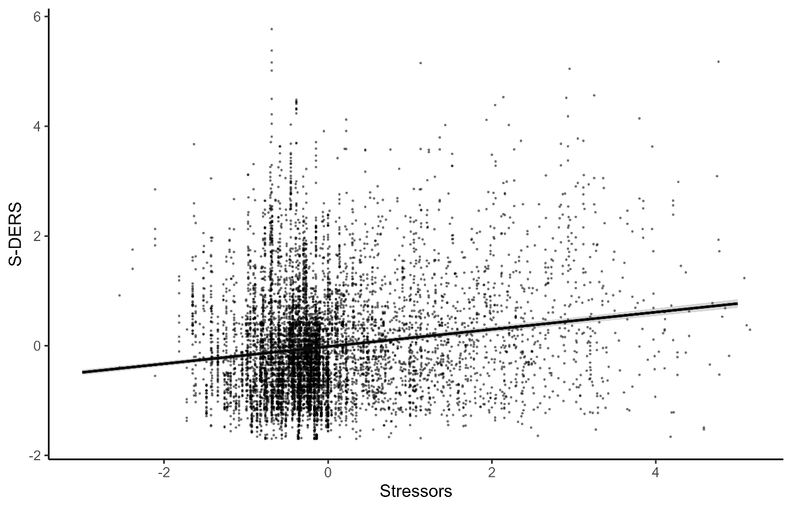
Figure S2. Associations between preceding stressors and momentary S-DERS values.

Table S6
Linear mixed model results predicting S-DERS from affective valence and arousal
Term | β | 95% CI | t | df | p
Within-person effects
Valence | -0.14 | [-0.17, -0.12] | -10.69 | 6616 | < .001***
Arousal | -0.19 | [-0.21, -0.16] | -12.41 | 6616 | < .001***
Valence² | 0.04 | [0.03, 0.05] | 6.57 | 6616 | < .001***
Arousal × Valence | 0.01 | [-0.01, 0.02] | 0.94 | 6616 | .347
Arousal² | 0.03 | [0.01, 0.04] | 4.13 | 6616 | < .001***
Between-person effects
Valence | -0.14 | [-0.24, -0.04] | -2.71 | 221 | .007**
Arousal | -0.19 | [-0.28, -0.11] | -4.36 | 221 | < .001***
Valence² | 0.13 | [0.02, 0.24] | 2.29 | 221 | .023*
Arousal × Valence | 0.05 | [-0.06, 0.16] | 0.88 | 221 | .379
Arousal² | -0.12 | [-0.20, -0.04] | -2.97 | 221 | .003**
* indicates p < .05. ** indicates p < .01. *** indicates p < .001.

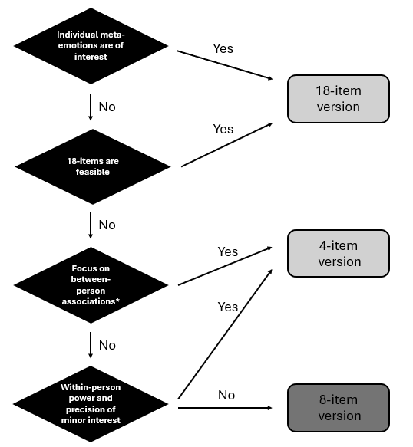
Figure S3. Decision diagram for the use of the three questionnaire versions. *Considering the necessary number of prompts shown in Figure 1D.

References
Hsu, H. Y., Kwok, O. man, Lin, J. H., & Acosta, S. (2015). Detecting Misspecified Multilevel Structural Equation Models with Common Fit Indices: A Monte Carlo Study. Multivariate Behavioral Research, 50(2), 197–215. https://doi.org/10.1080/00273171.2014.977429
Lavender, J. M., Tull, M. T., DiLillo, D., Messman-Moore, T., & Gratz, K. L. (2017). Development and Validation of a State-Based Measure of Emotion Dysregulation. Assessment, 24(2), 197–209. https://doi.org/10.1177/1073191115601218
Muthén, B. O. (1994). Multilevel Covariance Structure Analysis. Sociological Methods & Research, 22(3), 376–398. https://doi.org/10.1177/0049124194022003006
Prokofieva, M., Zarate, D., Parker, A., Palikara, O., & Stavropoulos, V. (2023). Exploratory structural equation modeling: A streamlined step by step approach using the R Project software. BMC Psychiatry, 23(1), 546. https://doi.org/10.1186/s12888-023-05028-9
Sicorello, M., Elsaesser, M., & Kolar, D. R. (2025). Translation, validation and extended factor models of the German State Difficulties in Emotion Regulation Scale (S-DERS). Borderline Personality Disorder and Emotion Dysregulation, 12(1). https://doi.org/10.1186/s40479-025-00299-y
Silvestrin, M., T., & de Beer, L. (2022). esemComp: ESEM-within-CFA syntax composer [Computer software]. https://mateuspsi.github.io/esemComp

