Additional Information
Model Prompting and Fine-Tuning
We set the system prompt to be the default for GPT-3.5-Turbo: “You are a helpful assistant.” For in-context learning, we prompted both GPT-3.5-Turbo and Flan-T5-large models to give numerical ratings from 1 to 5 for participants’ hostility and aggression responses to AIHQ scenarios:
“Read the following written responses people give regarding why they thought the person in the scene before acted toward them the way they did. Your task is to rate the hostility of the attributed intent. A rating of 1 would be given if someone perceived the situation as an accident. A rating of 5 would be given if someone thought the person in the scene did this on purpose and wanted to harm them. A rating of 3 might be given if the person thought the person in the scene did this on purpose to some degree, but did not intend to harm them. Please output a single numeric number from 1 to 5, do not include anything other than the number in the output.”

“Read the following behavioral responses people give toward the social situation above. Your task is to rate the presence of aggression in the behavioral response. A rating of 1 is given for a passive response or one in which the participant says that she/he would do nothing. A rating of 5 would be given for physical retaliation. Other examples of ratings include: 2 (the participant reports that he /she would ask why the other person acted toward them in that way), 3 (the participant would tell the other person not to act that way again), and 4 (the participant would yell at the other person). Please output a single numeric number from 1 to 5, do not include anything other than the number in the output.”

To further improve the models’ performance, we randomly subsampled half of the TBI participants (n = 42) and half of the non-TBI participants (n = 42), and used their responses to all 15 AIHQ scenarios as training data (Figure 1). The training dataset is reformatted into the conversational chat format to fine tune GPT-3.5-Turbo and the user-question format to fine tune Flan-T5-Large. We then give the same prompt to the two fine-tuned models to rate the hostility and aggression responses to AIHQ scenarios given by participants not in the training dataset.
Fine-tuning GPT-3.5-Turbo aimed to enhance its ability to rate responses in a way that closely aligns with trained human raters. Following OpenAI’s fine-tuning guidelines, the model was trained using a conversational chat format consistent with its actual application. The training examples incorporated the exact prompts the model would encounter in the rating task, with the responses structured as single numerical ratings. This approach helped the model learn to accurately identify and differentiate varying levels of hostility and aggression from the training data, refining its ability to provide appropriate ratings. By aligning the training data with the intended use case, the fine-tuned GPT-3.5-Turbo demonstrated improved proficiency in producing ratings that resemble those given by human raters.

Table A1. Participant demographics (Dataset 1)

Variables | Training dataset |  | Testing dataset
Variables | TBI subjects  (n = 42) | non-TBI subjects  (n = 42) | TBI subjects  (n = 43) | non-TBI subjects  (n = 43)
Age, mean (SD) | 40.4 (14.2) | 39.9 (15.8) | 39.7 (12.6) | 41.2 (14.6)
Sex, n (%)  Male  Female | 22 (52.4%)  20 (47.6%) | 20 (47.6%)  22 (52.4%) | 25 (58.1%)  18 (41.9%) | 23 (53.5%)  20 (46.5%)
Race, n (%)  White  Asian  Black  Native American  Other | 32 (76.2%)  0 (0%)  9 (21.4%)  1 (2.38%)  0 (0%) | 33 (78.6%)  0 (0%)  8 (19.0%)  1 (2.38%)  0 (0%) | 33 (76.7%)  1 (2.32%)  8 (18.6%)  0 (0%)  2 (4.65%) | 31 (72.1%)  0 (0%)  11 (25.6%)  0 (0%)  1 (2.33%)

Table A2. Participant demographics (Dataset 2)

N | 144
Age, mean (SD) | 22.5 (5.84)
Sex, n (%)  Male  Female | 27 (18.75%)  117 (81.25%)
Race, n (%)  White | 103 (73.05%)
Note. Detailed breakdown of race information was not available

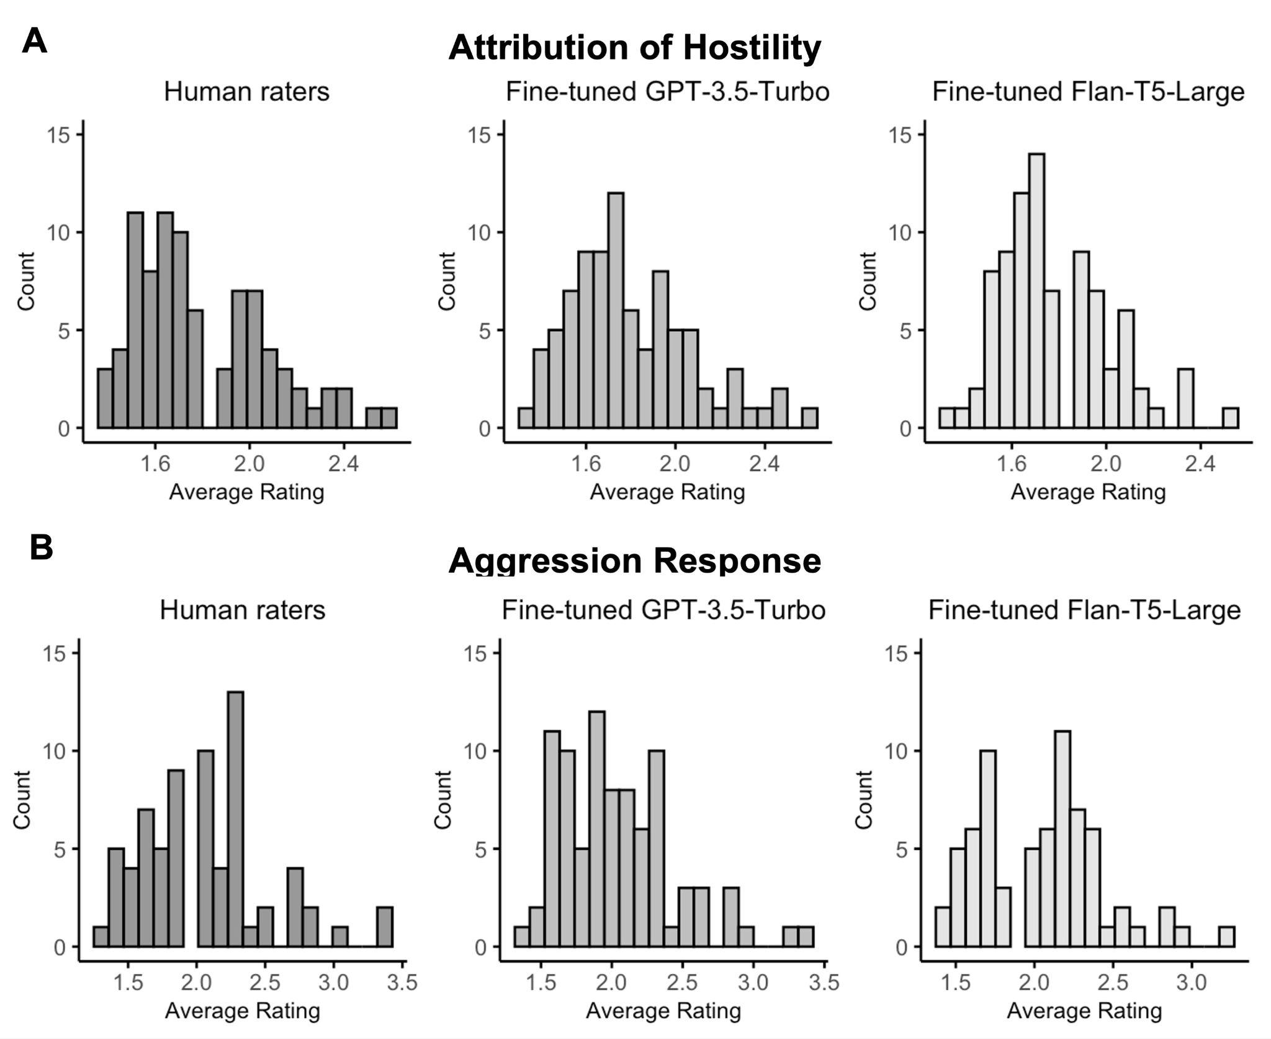
Figure A1. Distribution of average ratings for attribution of hostility and aggression response. A. Attribution of hostility: Each histogram shows the distribution of participants’ average attribution of hostility scores. The left panel shows average score given by the two human raters, the middle panel shows scores generated by fine-tuned GPT-3.5-Turbo, and the right panel shows scores from fine-tuned Flan-T5-Large. B. Aggression response: Same as A, but for aggression response ratings.
Table A3. Example ratings by human raters, fine-tuned GPT-3.5-Turbo, and fine-tuned Flan-T5-Large to responses for attribution of hostility (why the character acted the way they did in the scenario)
Scenario | Attribution of hostility | Ratings
Scenario | Attribution of hostility | Human raters | Fine-tuned GPT-3.5-  Turbo | Fine-tuned Flan-T5-  Large
You are dancing at a club and someone bumps into you from behind. | Drunk. | 1 | 1 | 1
You've been at a new job for three weeks. One day, you see one of your new co-workers on the street. You start to walk up to this person and start to say hello, but she/he passes by you without saying hello. | They might not have been able to see you or there was a lot of commotion on the street, or you were in a fairly dimly lit area. They could have also been distracted by their phone or maybe they were with other people. | 1 | 1 | 1
You've been at a new job for three weeks. One day, you see one of your new co-workers on the street. You start to walk up to this person and start to say hello, but she/he passes by you without saying hello. | Jealous. | 3 | 3 | 3
Your neighbors are playing loud music. You knock on the door and ask them to turn it down. Fifteen minutes later, the music is loud again. | They probably made the music loud again just to annoy me and I doubt they lost a controller, or somebody else in the party turned it up because they turned it down | 3 | 3 | 3
You walk past a bunch of teenagers at a mall and your hear them start to laugh. | They were laughing at me. | 5 | 4 | 4
You have been looking for a parking spot for awhile, when you see one up ahead. You put your signal on, proceed toward the spot, but someone passes your car and takes the parking space. | They're a butt hole and they just wanted to take it ahead of me. | 4 | 4 | 4

Table A4. Example ratings by human raters, fine-tuned GPT-3.5-Turbo, and fine-tuned Flan-T5-Large to responses for aggression response (how the participant would respond to the scenario)

Scenario | Response for Aggression Response | Ratings
Scenario | Response for Aggression Response | Human raters | Fine-tuned GPT-3.5-  Turbo | Fine-tuned Flan-T5-  Large
A day before meeting someone for a date, she/he calls to cancel. This is the third straight time they’ve done that. | Let them go. | 1 | 1 | 1
While walking outside during the rain, a car swerves to avoid hitting a cat, and drives into a puddle, splashing water onto you. | Well, it's already happened, so there's not much I can do about it but maybe try to prevent it in the future by not being so close to the curb. | 1 | 1 | 1
You are supposed to meet a new friend for lunch at a restaurant but she/he never shows up. | I would try to call their cell phone before I left the restaurant. Next time I talk to them, I would try to get the story and feel it out from there on whether we should make arrangements for another lunch. | 2 | 2 | 2
Someone jumps in front of you on the grocery line and says, I'm in a rush. | Confront him and then probably try to confront someone that is employed at the place wherever it is I happen to be at. | 3 | 3 | 3
While driving, the person in the car behind you honks their horn and then cuts you off. | I would probably tail gate him, ride his ass. If he got out of his car, I would politely get out of my car. If he was violent, I would be violent back. | 5 | 5 | 4
You are on a bus sitting in an aisle seat. A person gets on the bus at the next stop, begins walking as the bus moves, and steps on your foot. | Hit him with my shoe. | 5 | 5 | 5

Table A5. Intraclass correlation coefficients between model-generated and human-generated ratings for fine-tuned and pre-trained versions of GPT-3.5-Turbo and Flan-T5-Large.
 | Attribution of Hostility  ICC score | Aggression Response  ICC score
GPT-3.5-Turbo (Fine-tuned) | 0.935 | 0.962
GPT-3.5-Turbo (pre-trained) | 0.393 | 0.694
Flan-T5-Large (Fine-tuned) | 0.858 | 0.913
Flan-T5-Large (Pre-trained) | 0.203 | 0.788

Table A6. Correlation between the ratings given by human raters and ratings given by fine-tuned Flan-T5-Large on half of TBI group data and half of non-TBI group data.

Variable | Fine-tuned Flan-T5-Large |  | Inter-Rater Correlation
Variable | TBI Group  (n = 43) | non-TBI Group  (n = 43) | TBI Group  (n = 43) | non-TBI Group  (n = 43)
Attributions of hostility
All scenarios | 0.897 | 0.795 | 0.897 | 0.801
Ambiguous scenarios | 0.849 | 0.806 | 0.916 | 0.802
Intentional Scenarios | 0.782 | 0.814 | 0.758 | 0.730
Accidental scenarios | 0.768 | 0.515 | 0.936 | 0.716
AIHQ aggression response
All scenarios | 0.944 | 0.864 | 0.940 | 0.906
Ambiguous scenarios | 0.906 | 0.737 | 0.908 | 0.726
Intentional Scenarios | 0.894 | 0.851 | 0.914 | 0.921
Accidental scenarios | 0.868 | 0.832 | 0.912 | 0.881
Note. All correlations were significant at p < .001.

Table A7. Testing for the differences in the means of 2 groups for attribution of hostility and aggression response.

 | Human rated |  |  | Fine-tuned Flan-T5-Large rated
Variable | TBI  (n=43) | non-TBI  (n=43) | TBI > non-TBI  p value | TBI  (n = 43) | non-TBI  (n = 43) | TBI > non-TBI  p value
Attributions of hostility
All scenarios | 1.90 | 1.71 | .005** | 1.84 | 1.73 | .039*
Ambiguous scenarios | 1.97 | 1.69 | .017* | 1.97 | 1.72 | .015*
Intentional Scenarios | 2.42 | 2.35 | .357 | 2.42 | 2.38 | .958
Accidental scenarios | 1.29 | 1.11 | .005** | 1.29 | 1.11 | .115
AIHQ aggression response
All scenarios | 2.17 | 1.91 | .005** | 2.12 | 1.90 | .006**
Ambiguous scenarios | 2.07 | 1.84 | <.001*** | 2.04 | 1.82 | < .001***
Intentional Scenarios | 2.45 | 2.21 | .064 | 2.42 | 2.31 | .307
Accidental scenarios | 1.99 | 1.68 | .023* | 1.91 | 1.58 | .006**
Note. Average ratings given by large language models trained on 50% of data are significantly higher for the TBI compared to the non-TBI group, reproducing results obtained with human raters. * p < 0.05. ** p < 0.01, *** p < 0.001
Table A8. Correlations of AIHQ intent, attribution of hostility, and blame scales with AIHQ anger and aggression scales for TBI group (n = 85)

 | Fine-tuned Flan-T5-Large |  | Trained human raters
 | Attributions of hostility r  (p value) | Aggression response r  (p value) | Attributions of hostility r (p value) | Aggression response r  (p value)
Attributions of intent
All scenarios | 0.503*** | 0.503*** | 0.637*** | 0.507***
Ambiguous scenarios | 0.597*** | 0.362* | 0.684*** | 0.389*
Intentional Scenarios | 0.105 | 0.212 | 0.173 | 0.198
Accidental scenarios | 0.539*** | 0.30* | 0.783*** | 0.429**
AIHQ anger response
All scenarios | 0.340* | 0.659*** | 0.230 | 0.663***
Ambiguous scenarios | 0.433** | 0.430** | 0.474** | 0.506***
Intentional Scenarios | 0.143 | 0.545*** | 0.079 | 0.573***
Accidental scenarios | 0.320* | 0.585*** | 0.295 | 0.658***
Attributions of blame
All scenarios | 0.544*** | 0.463** | 0.504*** | 0.459**
Ambiguous scenarios | 0.625*** | 0.301 | 0.695*** | 0.368*
Intentional Scenarios | 0.184 | 0.469** | 0.227 | 0.434**
Accidental scenarios | 0.504*** | 0.307* | 0.499*** | 0.428**
Note. * p < 0.05. ** p < 0.01, *** p < 0.001

Table A9. Correlations of AIHQ intent, attribution of hostility, and blame scales with AIHQ anger and aggression scales on the new dataset.

 | Fine-tuned GPT-3.5-Turbo |  | Trained human raters
 | Attributions of hostility r  (p value) | Aggression response r  (p value) | Attributions of hostility r (p value) | Aggression response r  (p value)
Attributions of intent
All scenarios | 0.485*** | 0.323*** | 0.486*** | 0.311***
Ambiguous scenarios | 0.616*** | 0.227** | 0.594*** | 0.178*
Intentional Scenarios | 0.314*** | 0.234** | 0.304*** | 0.242**
Accidental scenarios | 0.249** | 0.384*** | 0.344*** | 0.374***
AIHQ anger response
All scenarios | 0.426*** | 0.448*** | 0.408*** | 0.492***
Ambiguous scenarios | 0.466*** | 0.396*** | 0.459*** | 0.358***
Intentional Scenarios | 0.373*** | 0.428*** | 0.386*** | 0.462***
Accidental scenarios | 0.303*** | 0.516*** | 0.363*** | 0.532***
Attributions of blame
All scenarios | 0.396*** | 0.453*** | 0.379*** | 0.464***
Ambiguous scenarios | 0.502*** | 0.322*** | 0.462*** | 0.260***
Intentional Scenarios | 0.352*** | 0.388*** | 0.334*** | 0.381***
Accidental scenarios | 0.206* | 0.486*** | 0.304*** | 0.521***
Note. * p < 0.05. ** p < 0.01, *** p < 0.001

Table A10. Correlations of AIHQ intent, attribution of hostility, and blame scales with AIHQ anger and aggression scales on the new dataset.

 | Fine-tuned Flan-T5-Large |  | Trained human raters
 | Attributions of hostility r  (p value) | Aggression response r  (p value) | Attributions of hostility r (p value) | Aggression response r  (p value)
Attributions of intent
All scenarios | 0.456*** | 0.311*** | 0.486*** | 0.311***
Ambiguous scenarios | 0.593*** | 0.324*** | 0.594*** | 0.178*
Intentional Scenarios | 0.233** | 0.212* | 0.304*** | 0.242**
Accidental scenarios | 0.321*** | 0.330*** | 0.344*** | 0.374***
AIHQ anger response
All scenarios | 0.399*** | 0.448*** | 0.408*** | 0.492***
Ambiguous scenarios | 0.496*** | 0.429*** | 0.459*** | 0.358***
Intentional Scenarios | 0.275*** | 0.411*** | 0.386*** | 0.462***
Accidental scenarios | 0.308*** | 0.437*** | 0.363*** | 0.532***
Attributions of blame
All scenarios | 0.371*** | 0.411*** | 0.379*** | 0.464***
Ambiguous scenarios | 0.506*** | 0.344*** | 0.462*** | 0.260***
Intentional Scenarios | 0.276*** | 0.341*** | 0.334*** | 0.381***
Accidental scenarios | 0.223** | 0.436*** | 0.304*** | 0.521***
Note. * p < 0.05. ** p < 0.01, *** p < 0.001

