Description of Each Comparison Metric
Pairwise model comparisons were conducted to evaluate the performance of the HADS total score, subscales, and individual item models in accounting for variance in the clinically important variables, using a combination of the Bayesian Information Criterion (BIC), Bayes Factor (BF), and Vuong’s closeness test. BIC assesses model fit while penalising complexity, with a difference of >2 points indicating a better fit for the model with the lower BIC (Burnham & Anderson, 2002; Lorah & Womack, 2019). BF quantifies the relative likelihood of the observed data under two competing models, with values of ≥3 interpreted as evidence in favour of the second model over the first (Schmalz et al., 2023). Lastly, Vuong’s closeness test compares non-nested models using a likelihood ratio test; a p-value <.05 indicates a significant difference in model fit (Vuong, 1989). When significant, post-hoc tests determine which model fits better. Model comparisons were synthesised across all three indicators (i.e., BIC, BF, and Vuong’s test) to identify the strongest model for each outcome. Where models were indistinguishable (e.g., ∆BIC <2), the simpler model was favoured, prioritising the HADS-T over the subscales, and the subscales over the individual items.

Table S1
Comparison of Participants with Non-Participants
 | Included  (n=402) | Invited but not included (n=107) | p
Sex – n (%)
Male | 291 (72.39%) | 84 (78.50%) | .249
Female | 111 (27.61%) | 23 (21.50%) | .249
Age at injury (years) – M (SD) | 36.28 (15.71) | 34.13 (15.20) | .198
Time-post injury (years) – M (SD) | 12.62 (9.03) | 13.36 (9.38) | .472
Education level at injury (years) – M (SD) | 12.62 (2.44) | 11.85 (2.36) | .004
Any mental health treatment preinjury – n (%) | 67 (16.67%) | 19 (17.92%) | .872
PTA duration (days) – M (SD) | 25.84 (25.06) | 21.69 (22.12) | .098
Worst 24-h GCS score – M (SD) | 8.27 (4.34) | 8.58 (4.56) | .542
Abnormality found on CT – n (%)
Yes | 355 (88.75%) | 97 (90.65%) | .698
No | 45 (11.25%) | 10 (9.35%) | .698
Comorbid orthopaedic injury – n (%) | 304 (75.62%) | 80 (74.77%) | .955
Spine | 142 (35.32%) | 42 (39.25%) | .523
Chest | 192 (48.00%) | 50 (46.73%) | .901
Abdomen | 101 (25.12%) | 22 (20.56%) | .394
Limb | 230 (57.21%) | 67 (62.62%) | .370
Face | 130 (32.34%) | 49 (45.79%) | .013
Note. For the included group, there was complete data for education level at injury (n=389/402), employment status (n=400/402), PTA duration (n=392/402), worst 24-h GCS score (n=375/402). and abnormality on CT scan (n=400/402). For the excluded group, there was complete data for education level at injury (n=101/107), preinjury mental health treatment (n=106/107), PTA duration (n=106/107), and worst 24-h GSC score (n=100/107). PTA = post-traumatic amnesia; GCS = Glasgow Coma Scale; CT = computed tomography; TBI = traumatic brain injury. Orthopaedic injuries refer to fractures or injuries requiring surgery, excluding abrasions or bruising.
Table S2
Statistical Results for Regression Models and Comparisons
Outcome | R² | BIC | BF | Vuong’s
Functional disability
Total | .34 | 2622.6 | Subscales better than total (BF=9.02)  Items better than total (BF=3.14)  Subscales equivalent to or better than items (BF<0.001) | Subscales better than total (p=.004)  Items better than total (p<.001)  Items better than subscales (p<.001)
Subscales | .38 | 2598.7
Items | .46 | 2620.3
Life satisfaction
Total | .30 | 2590.0 | Subscales better than total (BF>1000)  Total equivalent to or better than items (BF<0.001)  Subscales equivalent to or better than items (BF<0.001) | Total equivalent to subscale* (p=.920 and .080)  Items better than total (p=.004)  Subscales equivalent to items (p=.141)
Subscales | .32 | 2585.6
Items | .36 | 2636.8
Suicidal ideation
Total | .20 | 335.9 | Total equivalent to or better than subscales (BF=0.086)  Total equivalent to or better than items (BF<0.001)  Subscales equivalent to or better than items (BF<0.001) | Total equivalent to subscale (p=.274)  Items better than total (p=.005)  Items better than subscale (p=.006)
Subscales | .20 | 340.8
Items | .27 | 386.2

Table S2 (continued)
Outcome | R² | BIC | BF | Vuong’s
Self-harm
Total | .05 | 142.1 | Total equivalent to or better than subscales (BF=1.89)  Total equivalent to or better than items (BF<0.001)  Subscales equivalent to or better than items (BF<0.001) | Total equivalent to subscale* (p=.926 and .074)  Total equivalent to items (p=.068)  Subscales equivalent to items (p=.071)
Subscales | .08 | 140.9
Items | .27 | 184.8
Mental health treatment
Total | .05 | 503.6 | Total equivalent to or better than subscales (BF=0.095)  Total equivalent to or better than items (BF<0.001)  Subscales equivalent to or better than items (BF<0.001) | Total equivalent to subscale (p=.264)  Total equivalent to items (p=.527)  Subscales equivalent to items (p=.565)
Subscales | .06 | 508.3
Items | .08 | 568.1
Note. BIC = Bayesian Information Criterion; BF = Bayes Factor
*Where two p-values are reported, this indicates that the overall Vuong’s test was significant, but both post-hoc comparisons (model 1 > model 2 or model 2 > model 1) were non-significant.

Table S3
HADS Total and Subscale Regression Parameters for All Clinically Important Outcomes
Model | HADS-T | HADS-A | HADS-D
Functional disability | 0.584  (p<.001) | 0.126  (p=.171) | 1.017  (p<.001)
Life satisfaction | -0.540  (p<.001) | -0.264  (p=.005) | -0.800  (p<.001)
Suicidal ideation | 0.150  (p<.001) | 0.185  (p<.001) | 0.119  (p<.001)
Self-harm | 0.122  (p<.001) | 0.282  (p<.001) | -0.040  (p=.580)
Mental health treatment | 0.064  (p<.001) | 0.032  (p=.311) | 0.094  (p=.002)
Note. Bolded values indicate significant predictors.

Table S4
HADS Individual Item Regression Results for All Clinically Important Outcomes
HADS item | Functional disability | Life satisfaction | Suicidal ideation | Self-harm | Mental health treatment
Intercept | 13.66  (p<.001) | 28.18  (p<.001) | -3.82  (p<.001) | -6.43  (p<.001) | -1.43  (p<.001)
Item 1 | 1.01  (p=.058) | 0.15  (p=.791) | 0.02  (p=.933) | -0.11  (p=.812) | 0.07  (p=.716)
Item 2 | 1.74  (p<.001) | -0.99  (p=0.049) | 0.44  (p=.039) | 0.13  (p=.745) | 0.13  (p=.447)
Item 3 | 0.25  (p=.622) | -0.81  (p=.132) | 0.25  (p=.257) | -1.03  (p=.017) | 0.27  (p=.146)
Item 4 | 1.12  (p=.034) | -0.34  (p=.558) | -0.48  (p=.066) | -1.43  (p=.014) | 0.12  (p=.526)
Item 5 | 0.08  (p=.865) | -1.13  (p=.022) | 0.29  (p=.183) | 1.47  (p=.001) | -0.05  (p=.768)
Item 6 | 0.07  (p=.902) | -1.41  (p=.014) | 1.12  (p<.001) | 0.78  (p=.090) | -0.26  (p=.190)
Item 7 | -0.07  (p=.896) | -1.18  (p=.044) | 0.37  (p=.180) | 0.07  (p=.900) | -0.00  (p=.992)
Item 8 | 2.89  (p<.001) | -0.82  (p=.036) | 0.12  (p=.490) | -0.86  (p=.028) | 0.22  (p=.105)
Item 9 | -0.17  (p=.765) | 0.50  (p=.421) | 0.46  (p=.064) | 0.92  (p=.029) | -0.30  (p=.164)
Item 10 | 0.32  (p=.400) | -0.35  (p=.385) | -0.17  (p=.366) | 0.14  (p=.664) | 0.22  (p=.105)
Item 11 | -1.12  (p=.006) | 0.80  (p=.066) | -0.06  (p=.784) | 0.87  (p=.037) | -0.11  (p=.481)
Item 12 | 0.10  (p=.853) | -1.10  (p=.051) | -0.13  (p=.573) | 0.07  (p=.885) | 0.26  (p=.165)
Item 13 | 1.00  (p=.107) | 0.05  (p=.943) | 0.08  (p=.787) | 0.61  (p=.254) | 0.20  (p=.372)
Item 14 | 0.75  (p=.089) | 0.11  (p=.813) | -0.11  (p=.607) | 0.24  (p=.512) | -0.08  (p=.623)
Note. Bolded values indicate items that are uniquely significant predictors in the same direction as the total/subscale scores.

Figure S1
Regression Tree Diagrams for the Total Score for All Clinically Important Outcomes

Note. HADS = Hospital Anxiety and Depression Scale; WHODAS 2.0 = 12-item World Health Organization Disability Assessment Schedule 2.0; SWLS = Satisfaction With Life Scale; IDAS-II = Inventory of Depression and Anxiety Symptoms – Expanded Version. Suicidal Ideation (IDAS-II Item 13) and self-harm (IDAS-II Item 38) were coded as present (yes/no) if participants responded with at least “A little bit”. Mental health treatment was similarly dichotomised as ‘yes’ or ‘no’ if the participant responded ‘yes’ to currently receiving any type of treatment (i.e., counselling, medication, and/or past-year psychiatric hospitalisation) for their mental health.
Figure S2
Regression Tree Diagrams for the Anxiety Subscale Score for All Clinically Important Outcomes

Note. H HADS = Hospital Anxiety and Depression Scale; WHODAS 2.0 = 12-item World Health Organization Disability Assessment Schedule 2.0; SWLS = Satisfaction With Life Scale; IDAS-II = Inventory of Depression and Anxiety Symptoms – Expanded Version. Suicidal Ideation (IDAS-II Item 13) and self-harm (IDAS-II Item 38) were coded as present (yes/no) if participants responded with at least “A little bit”. Mental health treatment was similarly dichotomised as ‘yes’ or ‘no’ if the participant responded ‘yes’ to currently receiving any type of treatment (i.e., counselling, medication, and/or past-year psychiatric hospitalisation) for their mental health.
Figure S3
Regression Tree Diagrams for the Depression Subscale Score for All Clinically Important Outcomes

Note. HADS = Hospital Anxiety and Depression Scale; WHODAS 2.0 = 12-item World Health Organization Disability Assessment Schedule 2.0; SWLS = Satisfaction With Life Scale; IDAS-II = Inventory of Depression and Anxiety Symptoms – Expanded Version. Suicidal Ideation (IDAS-II Item 13) and self-harm (IDAS-II Item 38) were coded as present (yes/no) if participants responded with at least “A little bit”. Mental health treatment was similarly dichotomised as ‘yes’ or ‘no’ if the participant responded ‘yes’ to currently receiving any type of treatment (i.e., counselling, medication, and/or past-year psychiatric hospitalisation) for their mental health.
Deriving Cut-Offs on the HADS-A
As shown in Figure S3, the regression tree analyses for the HADS-A identified different optimal cut-offs depending on the clinical outcome. For example, the functional disability model identified four cut-offs, dividing participants into five groups based on their HADS-A scores (0–1, 2–7, 8–10, 11–12, and 13–21).
Following these analyses, the research team collaboratively reviewed the results to establish a single set of uniform cut-offs for the HADS-A (Figure S4). Three cut-offs were selected as the most clinically useful and tractable, creating four severity groups: ‘normal’ (0–7), ‘mild’ (8–10), ‘moderate’ (11–14), and ‘severe’ (15–21). The first cut-off, distinguishing the normal group from the mildly distressed group, was set at 8, as any lower empirical cut-offs identified by the regression tree analyses were not considered clinically meaningful (e.g., a score of 3 on a scale from 0–21). The highest cut-off, separating moderate from severe distress, was set at 15, as no empirical cut-offs from the regression tree analyses exceeded this threshold. The middle cut-off (11), differentiating mild from moderate distress, approximated the average of the empirical cut-offs identified between 8–15 (see Figure S2). Figure S5 illustrates the distribution of participants across these anxiety groups.

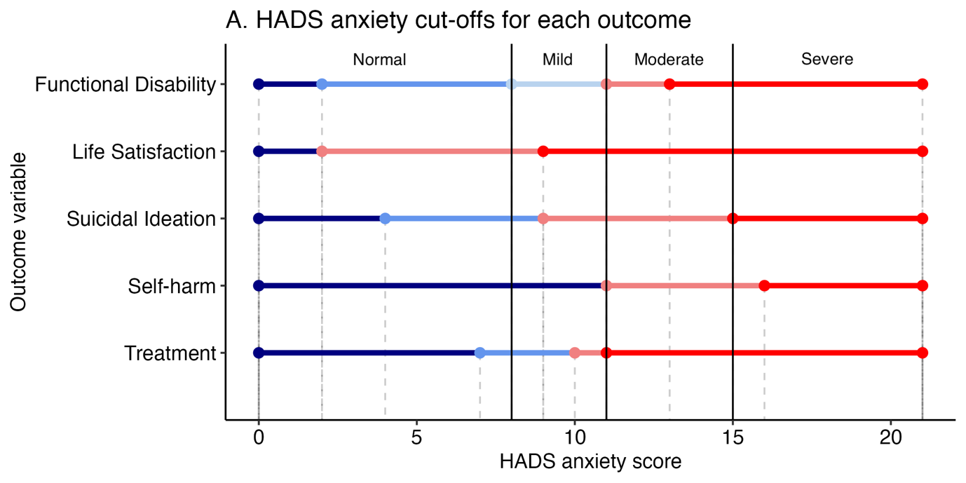
Figure S4
HADS Anxiety Score Regression Tree Analysis Results for All Outcomes

Note. Treatment refers to current mental health treatment. Each dot and dashed line is the cut-off from the regression tree analysis. The bold black lines are the uniform cut-offs decided by the research team. Blue indicates a less severe HADS anxiety score and red indicates a more? severe HADS anxiety score.

Figure S5
Distribution of Individuals in Each HADS-A Category
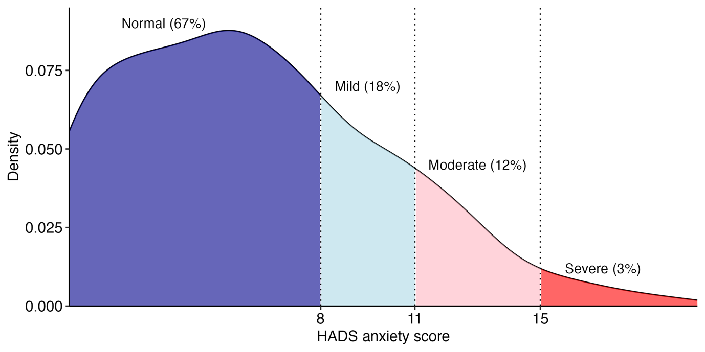
Assessing the Performance of the Uniform HADS-A Cut-Offs
While the regression tree analyses identified optimal cut-offs for each outcome separately, our uniform cut-offs necessarily deviated from outcome-specific cut-offs. We therefore wanted to evaluate the effectiveness of this single set of cut-offs in differentiating the five clinical outcomes. ANOVA and chi-squared results confirmed significant differences between the groups defined by the uniform HADS-A cut-offs across all outcome variables. Post-hoc analyses were conducted to further examine pairwise group differences, showing that participants in more distressed groups generally had worse clinical outcomes (p<.05). The uniform cut-offs showed significant group differences in 5/6 pairwise comparisons for functional disability and suicidal ideation, 4/6 for life satisfaction and self-harm, but only 1/6 pairwise comparisons showed a significant difference for mental health treatment (see Figure S6 for details on group comparisons).

Figure S6
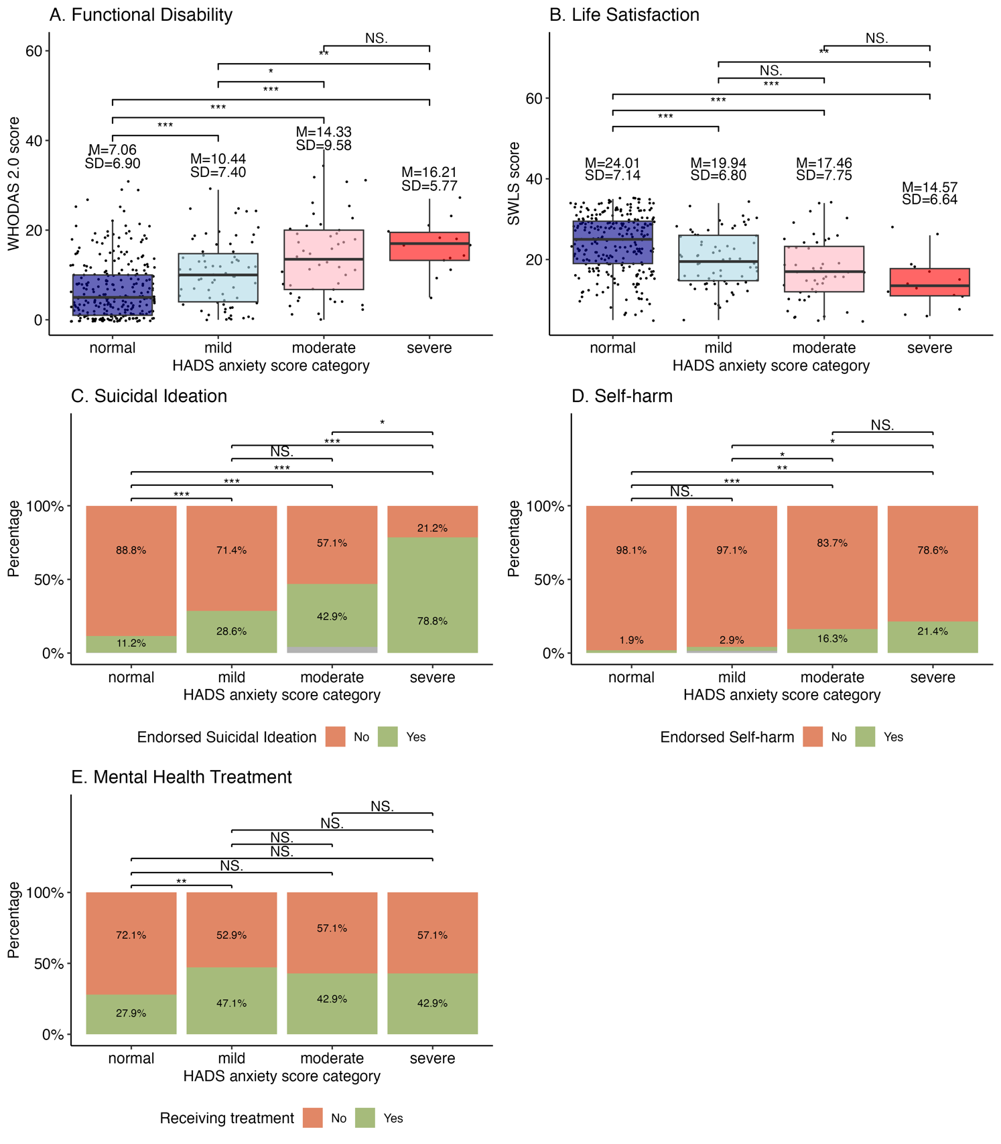
Comparison of HADS Anxiety Score Categories for Each Clinically Important Outcome
Note. Normal group = on average, no to mild difficulties with everyday activities on the WHODAS 2.0 and slight satisfaction with life on the SWLS. Mild group = on average, mild difficulties with everyday activities and were slight dissatisfaction with life. Moderate group = on average, mild to moderate difficulties with everyday activities and slight dissatisfaction with life. Severe group = on average, mild to moderate difficulties with everyday activities and were dissatisfied with life. Asterisks indicate statistical significance: non-significant (NS), p<.05 (*), p<.01 (**), and p<.001 (***).
For clinical outcomes such as suicidal ideation and self-harm, using the above four HADS-A severity groups may be less practical when binary (yes/no) decisions are needed. This is particularly the case in research contexts, such as online surveys, where the HADS may be the only available tool to indicate to further inquiry about suicidality or self-harm. In these situations, a single cut-off may be more useful. As seen in Figure S4, both suicidal ideation self-harm have empirical cut-offs identified by regression tree analysis occurring around a HADS-A score of 11. Thus, a cut-off of ≥11 on the HADS-A, distinguishing moderate from mild distress, was selected as a potentially useful threshold for clinicians or researchers to inquire about suicidal ideation or self-harm. We calculated sensitivity, specificity, positive predictive value, and negative predictive value analyses using this cut-off, with the results shown in Table S5. In practical terms, 39% of individuals with moderate-severe TBI who endorsed suicidal ideation and 61% who endorsed self-harm were correctly identified. Conversely, 91% and 86% of those who did not report suicidal ideation or self-harm were correctly classified as low risk. The positive predictive value shows that 52% of those flagged as at risk reported suicidal ideation, while only 17% reported self-harm. The negative predictive value indicates that 85% and 98% of individuals scoring below the cut-off did not report suicidal ideation or self-harm, respectively.

Table S5
HADS-A Sensitivity, Specificity, Positive Predictive Value and Negative Predictive Values for Suicidal ideation and Self-Harm
Metric | Suicidal ideation | Self-harm
Sensitivity | .39 | .61
Specificity | .91 | .86
PPV | .52 | .17
NPV | .85 | .98
Note. PPV = positive predictive value; NPV = negative predictive value.
Deriving Cut-Offs on the HADS-D
As shown in Figure S7, the regression tree analyses for the HADS-D identified different optimal cut-offs depending on the clinical outcome. For example, the functional disability model identified five cut-offs, dividing participants into six groups based on their HADS-D scores (0–1, 2–3, 4–5, 6–9, 10–13 and 14–21).
Following these analyses, the research team collaboratively reviewed the results to establish a single set of uniform cut-offs for the HADS-D (Figure S7). Three cut-offs were selected as the most clinically useful and tractable, creating four severity groups: ‘normal’ (0–4), ‘mild’ (5–10), ‘moderate’ (11–15), and ‘severe’ (16–21). The first cut-off, distinguishing the normal group from the mildly distressed group, was set at 5, as any lower empirical cut-offs identified by the regression tree analyses were not considered clinically meaningful (e.g., a score of 2 on a scale from 0–21). The highest cut-off, separating moderate from severe distress, was set at 16, as no empirical cut-offs from the regression tree analyses exceeded this threshold. The middle cut-off (11), differentiating mild from moderate distress, approximated the average of the empirical cut-offs identified between 5–16 (see Figure S2). Figure S8 illustrates the distribution of participants across these depression groups.

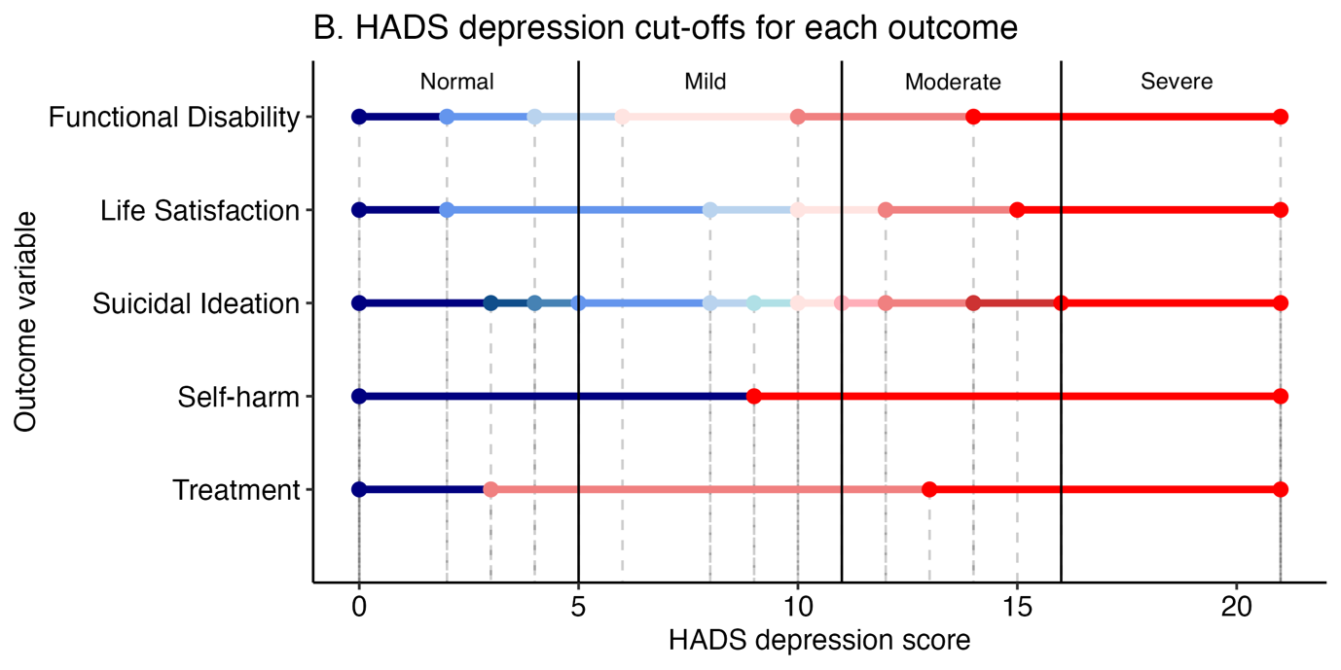
Figure S7
HADS Depression Score Regression Tree Analysis Results for All Outcomes

Note. Treatment refers to current mental health treatment. Each dot and dashed line is the cut-off from the regression tree analysis. The bold black lines are the uniform cut-offs decided by the research team. Blue indicates a less severe HADS depression score and red indicates a more severe HADS depression score.

Figure S8
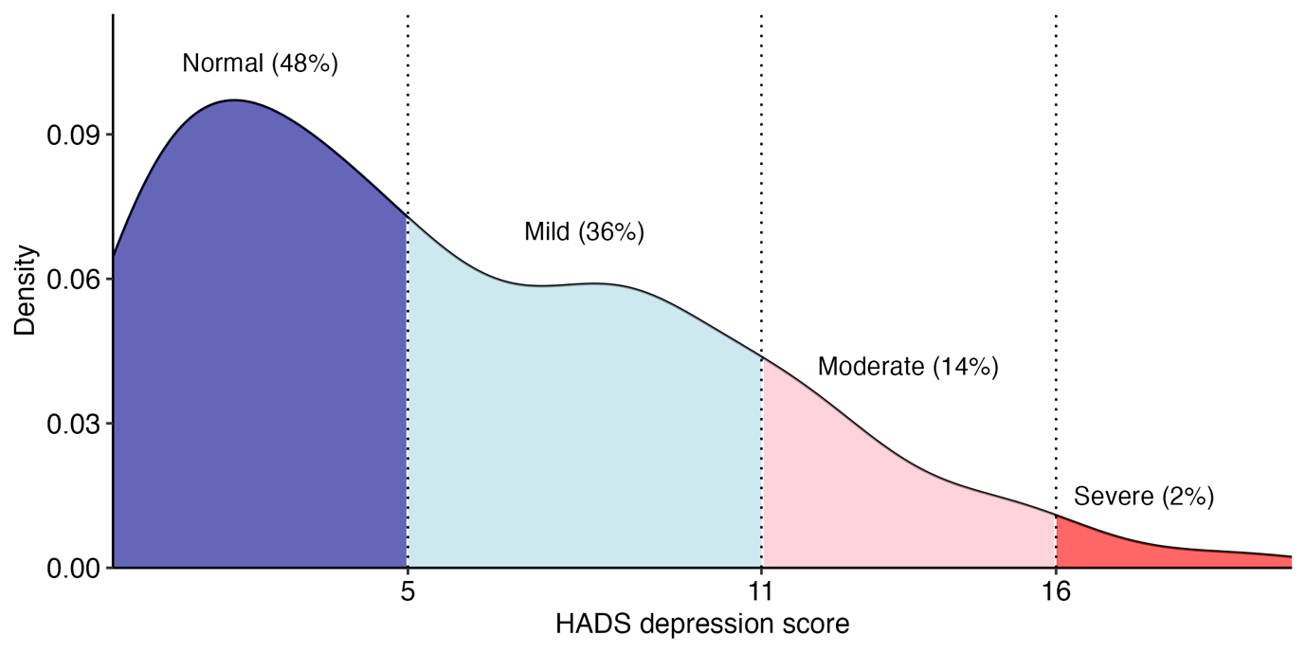
Distribution of Individuals in Each HADS-D Category

Assessing the Performance of the Uniform HADS-A Cut-Offs
While the regression tree analyses identified optimal cut-offs for each outcome separately, our uniform cut-offs necessarily deviated from outcome-specific cut-offs. We therefore wanted to evaluate the effectiveness of this single set of cut-offs in differentiating the five clinical outcomes. ANOVA and chi-squared results confirmed significant differences between the groups defined by the uniform HADS-A cut-offs across all outcome variables. Post-hoc analyses were conducted to further examine pairwise group differences, showing that participants in more distressed groups generally had worse clinical outcomes (p<.05). The uniform cut-offs showed significant group differences in all 6 pairwise comparisons for functional disability, 5/6 for life satisfaction, 3/6 for suicidal ideation and mental health treatment, but only 1/6 pairwise comparisons showed a significant difference for self-harm (see Figure S9 for details on group comparisons).

Figure S9
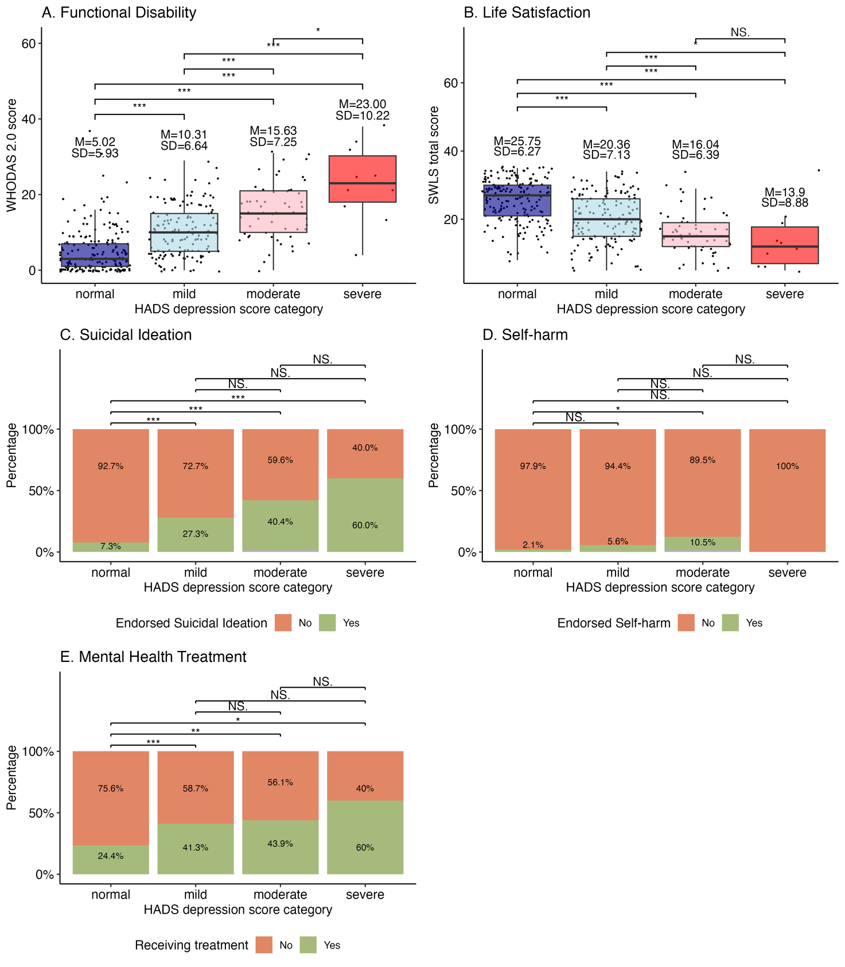
Comparison of HADS Depression Score Categories for Each Clinically Important Outcome
Note. Normal group = on average, no to mild difficulties with everyday activities on the WHODAS 2.0 and were satisfied with life on the SWLS. Mild group = on average, mild difficulties with everyday activities and slight satisfaction with life. Moderate group = on average, mild to moderate difficulties with everyday activities and slight dissatisfaction with life. Severe group = on average, moderate difficulties with everyday activities and were dissatisfied with life. Asterisks indicate statistical significance: non-significant (NS), p<.05 (*), p<.01 (**), and p<.001 (***).
For clinical outcomes such as suicidal ideation and self-harm, using the above four HADS-D severity groups may be less practical when binary (yes/no) decisions are needed. This is particularly the case in research contexts, such as online surveys, where the HADS may serve as the sole indicator of whether to inquire about suicidality or self-harm in participants. In these situations, a single cut-off may be more useful. As seen in Figure S7, both suicidal ideation self-harm have empirical cut-offs identified by regression tree analysis occurring around a HADS-D score of 11. Thus, a cut-off of ≥11 on the HADS-D, distinguishing moderate from mild distress, was selected as a potentially useful threshold for clinicians or researchers to inquire about suicidal ideation or self-harm. We calculated sensitivity, specificity, positive predictive value, and negative predictive value analyses using this cut-off, with the results shown in Table S6. In practical terms, 35% of individuals with moderate-severe TBI who endorsed suicidal ideation and 33% who endorsed self-harm were correctly identified. Conversely, 88% and 84% of those who did not report suicidal ideation or self-harm were correctly classified as low risk. The positive predictive value shows that 44% of those flagged as at risk reported suicidal ideation, while only 9% reported self-harm. The negative predictive value indicates that 84% and 96% of individuals scoring below the cut-off did not report suicidal ideation or self-harm, respectively.

Table S6
HADS-D Sensitivity, Specificity, Positive Predictive Value and Negative Predictive Values for Suicidal Ideation and Self-Harm
Metric | Suicidal ideation | Self-harm
Sensitivity | .35 | .33
Specificity | .88 | .84
PPV | .44 | .09
NPV | .84 | .96
Note. PPV = positive predictive value; NPV = negative predictive value.
Supplementary References
Burnham, K. P., & Anderson, D. R. (2002). Model Selection and Inference: A Practical Information-Theoretic Approach (2nd edition). Springer.
Lorah, J., Womack, A. (2019). Value of sample size for computation of the Bayesian information criterion (BIC) in multilevel modeling. Behaviour Research Methods, 51, 440–450. https://doi.org/10.3758/s13428-018-1188-3
Schmalz, X., Biurrun Manresa, J., & Zhang, L. (2023). What is a Bayes Factor? Psychological Methods, 28(3), 705–718. https://doi.org/10.1037/met0000421
Vuong, Q. H. (1989). Likelihood Ratio Tests for Model Selection and Non-Nested Hypotheses. Econometrica, 57(2), 307–333. https://doi.org/10.2307/1912557

