Table S1. Descriptive statistics on price-level and full-task completion times and number of prices administered for the alcohol purchase task overall and in each sample
 | Overall (N = 1313) |  |  |  |  | Hamilton sample (N = 725) |  |  |  |  | Memphis sample (N = 588)
 | M | SD | Min. | Med. | Max. | M | SD | Min. | Med. | Max. | M | SD | Min. | Med. | Max.
Average time per price (seconds) | 6.85 | 5.38 | 1.80 | 5.73 | 119.93 | 6.74 | 5.98 | 1.96 | 5.70 | 119.93 | 6.98 | 4.55 | 1.80 | 5.80 | 41.4
Average time per price (minutes) | 0.11 | 0.09 | 0.03 | 0.10 | 2.00 | 0.11 | 0.10 | 0.03 | 0.10 | 2.00 | 0.12 | 0.08 | 0.03 | 0.10 | 0.69
Full-task completion time (seconds) | 124.71 | 75.83 | 43 | 111 | 1799 | 124.35 | 91.32 | 45 | 110 | 1799 | 125.14 | 51.13 | 43 | 114 | 471
Full-task completion time (minutes) | 2.08 | 1.26 | 0.72 | 1.85 | 29.98 | 2.07 | 1.52 | 0.75 | 1.83 | 29.98 | 2.09 | 0.85 | 0.72 | 1.90 | 7.85
Prices administered | 20.00 | 5.30 | 5 | 20 | 30 | 19.89 | 4.99 | 5 | 20 | 30 | 20.14 | 5.67 | 5 | 20 | 30

Table S2. Internal consistency of YAACQ subscales in each sample
 | Hamilton sample | Memphis sample
Subscale | a | a
Social/interpersonal | 0.66 | 0.71
Impaired control | 0.73 | 0.76
Self-perception | 0.76 | 0.78
Self-care | 0.77 | 0.80
Risky behaviour | 0.71 | 0.68
Academic/occupational | 0.67 | 0.66
Dependence | 0.50 | 0.55
Blackout drinking | 0.76 | 0.76
Note. YAACQ = Young Adult Alcohol Consequences Questionnaire; a = Cronbach’s alpha.

Table S3. Frequencies of select response patterns on the full-length and brief Alcohol Purchase Tasks in each sample
 | Hamilton sample (N = 725) |  |  |  | Memphis sample (N = 588)
 | APT_{full} |  | APT_{brief.} |  | APT_{full} |  | APT_{brief.}
 | n | % | n | % | n | % | n | %
Constant demand (ΔQ < 0.025) | 1 | 0.14 | 1 | 0.14 | 0 | 0.00 | 0 | 0.00
Bounce violations at >10% of price increments | 1 | 0.14 | 2 | 0.28 | 3 | 0.51 | 1 | 0.17
One or more reversals | 2 | 0.28 | 1 | 0.14 | 4 | 0.68 | 0 | 0.00
One or more signs of non-systematic responding (constant demand, bounce violations, and/or reversals) | 3 | 0.41 | 2 | 0.28 | 7 | 1.19 | 1 | 0.17
Reported non-zero consumption only when alcohol was freeª | 0 | 0.00 | 0 | 0.00 | 1 | 0.17 | 1 | 0.17
Reported zero consumption across all pricesª | 0 | 0.00 | 0 | 0.00 | 0 | 0.00 | 0 | 0.00
Did not reach breakpoint (i.e., reported non-zero consumption at highest price) | 30 | 4.14 | 30 | 4.14 | 33 | 5.61 | 34 | 5.78
Note. APT_{full} = full-length Alcohol Purchase Task; APT_{brief} = brief Alcohol Purchase Task. ªResponse pattern precluding the estimation of elasticity.

Table S4. Results of regression models examining associations of demand indices from the full-length and brief Alcohol Purchase Tasks with alcohol use in each sample
 |  | Hamilton sample
 |  | DV: Number of drinking days per typical weekª |  |  | DV: Number of HDD per typical week^{b} |  |  | DV: Number of standard drinks per typical week^{b}
 |  | RR | Est. | 95% CI | RR | Est. | 95% CI | RR | Est. | 95% CI
IV of interest: Int.
 | Int. | 1.06 | 0.06 | 0.02 – 0.09 | 1.28 | 0.25 | 0.17 – 0.34 | 1.46 | 0.38 | 0.32 – 0.45
 | Age | 1.05 | 0.05 | 0.01 – 0.08 | 0.95 | -0.05 | -0.11 – 0.01 | 1.01 | 0.01 | -0.03 – 0.05
 | Subj. fin. | 0.93 | -0.07 | -0.12 – -0.02 | 0.92 | -0.08 | -0.16 – 0.00 | 0.93 | -0.07 | -0.12 – -0.01
 | Sex | 0.89 | -0.12 | -0.20 – -0.03 | 1.00 | 0.00 | -0.15 – 0.15 | 0.81 | -0.21 | -0.31 – -0.12
 | Race | 1.08 | 0.08 | -0.02 – 0.17 | 1.09 | 0.09 | -0.07 – 0.26 | 1.13 | 0.12 | 0.02 – 0.23
IV of interest: Int. (br.)
 | Int. (br.) | 1.06 | 0.06 | 0.02 – 0.09 | 1.28 | 0.25 | 0.17 – 0.33 | 1.46 | 0.38 | 0.32 – 0.45
 | Age | 1.05 | 0.05 | 0.01 – 0.08 | 0.95 | -0.05 | -0.11 – 0.01 | 1.01 | 0.01 | -0.03 – 0.05
 | Subj. fin. | 0.93 | -0.07 | -0.12 – -0.02 | 0.92 | -0.08 | -0.16 – 0.00 | 0.93 | -0.07 | -0.12 – -0.02
 | Sex | 0.89 | -0.12 | -0.20 – -0.03 | 1.00 | 0.00 | -0.15 – 0.15 | 0.81 | -0.21 | -0.31 – -0.12
 | Race | 1.08 | 0.08 | -0.02 – 0.17 | 1.09 | 0.09 | -0.07 – 0.26 | 1.13 | 0.12 | 0.02 – 0.23
IV of interest: Omax
 | Omax | 1.07 | 0.07 | 0.04 – 0.10 | 1.26 | 0.23 | 0.16 – 0.31 | 1.40 | 0.34 | 0.28 – 0.40
 | Age | 1.05 | 0.05 | 0.02 – 0.09 | 0.96 | -0.04 | -0.11 – 0.02 | 0.99 | -0.01 | -0.05 – 0.03
 | Subj. fin. | 0.92 | -0.08 | -0.13 – -0.03 | 0.89 | -0.12 | -0.20 – -0.03 | 0.90 | -0.10 | -0.16 – -0.05
 | Sex | 0.89 | -0.12 | -0.20 – -0.03 | 1.00 | 0.00 | -0.14 – 0.15 | 0.80 | -0.22 | -0.32 – -0.13
 | Race | 1.08 | 0.08 | -0.01 – 0.17 | 1.12 | 0.11 | -0.06 – 0.27 | 1.13 | 0.12 | 0.02 – 0.23
IV of interest: Omax (br.)
 | Omax (br.) | 1.06 | 0.06 | 0.03 – 0.10 | 1.22 | 0.20 | 0.13 – 0.27 | 1.35 | 0.30 | 0.24 – 0.37
 | Age | 1.05 | 0.05 | 0.02 – 0.09 | 0.96 | -0.04 | -0.10 – 0.02 | 1.01 | 0.01 | -0.04 – 0.05
 | Subj. fin. | 0.92 | -0.08 | -0.13 – -0.03 | 0.89 | -0.12 | -0.20 – -0.04 | 0.90 | -0.10 | -0.16 – -0.05
 | Sex | 0.89 | -0.12 | -0.20 – -0.04 | 0.99 | -0.01 | -0.15 – 0.14 | 0.79 | -0.23 | -0.33 – -0.13
 | Race | 1.08 | 0.08 | -0.01 – 0.18 | 1.13 | 0.12 | -0.04 – 0.29 | 1.17 | 0.16 | 0.05 – 0.26
IV of interest: BP
 | BP | 1.11 | 0.10 | 0.06 – 0.14 | 1.19 | 0.17 | 0.11 – 0.23 | 1.21 | 0.19 | 0.14 – 0.24
 | Age | 1.05 | 0.05 | 0.01 – 0.08 | 0.95 | -0.05 | -0.11 – 0.01 | 1.00 | 0.00 | -0.05 – 0.04
 | Subj. fin. | 0.92 | -0.08 | -0.13 – -0.04 | 0.88 | -0.13 | -0.21 – -0.04 | 0.90 | -0.11 | -0.17 – -0.06
 | Sex | 0.87 | -0.14 | -0.23 – -0.06 | 0.92 | -0.08 | -0.22 – 0.07 | 0.74 | -0.30 | -0.40 – -0.20
 | Race | 1.08 | 0.08 | -0.01 – 0.18 | 1.15 | 0.14 | -0.02 – 0.30 | 1.22 | 0.20 | 0.09 – 0.31
IV of interest: BP (br.)
 | BP (br.) | 1.11 | 0.10 | 0.06 – 0.14 | 1.19 | 0.17 | 0.11 – 0.23 | 1.21 | 0.19 | 0.14 – 0.24
 | Age | 1.05 | 0.05 | 0.01 – 0.08 | 0.95 | -0.05 | -0.11 – 0.01 | 1.00 | 0.00 | -0.05 – 0.04
 | Subj. fin. | 0.92 | -0.08 | -0.13 – -0.04 | 0.89 | -0.12 | -0.21 – -0.04 | 0.90 | -0.11 | -0.17 – -0.06
 | Sex | 0.87 | -0.14 | -0.23 – -0.06 | 0.92 | -0.08 | -0.22 – 0.07 | 0.74 | -0.30 | -0.40 – -0.20
 | Race | 1.08 | 0.08 | -0.01 – 0.18 | 1.15 | 0.14 | -0.02 – 0.30 | 1.22 | 0.20 | 0.09 – 0.31
IV of interest: a
 | a | 0.86 | -0.15 | -0.24 – -0.06 | 0.47 | -0.75 | -0.96 – -0.54 | 0.76 | -0.28 | -0.39 – -0.17
 | Age | 1.04 | 0.04 | 0.01 – 0.08 | 0.93 | -0.07 | -0.13 – -0.01 | 0.98 | -0.02 | -0.06 – 0.02
 | Subj. fin. | 0.92 | -0.08 | -0.13 – -0.03 | 0.90 | -0.11 | -0.19 – -0.04 | 0.90 | -0.10 | -0.16 – -0.05
 | Sex | 0.89 | -0.12 | -0.20 – -0.03 | 1.02 | 0.02 | -0.12 – 0.16 | 0.79 | -0.24 | -0.33 – -0.14
 | Race | 1.07 | 0.07 | -0.02 – 0.17 | 1.06 | 0.06 | -0.09 – 0.22 | 1.20 | 0.18 | 0.07 – 0.29
IV of interest: a (br.)
 | a (br.) | 0.87 | -0.14 | -0.20 – -0.09 | 0.58 | -0.55 | -0.66 – -0.44 | 0.73 | -0.31 | -0.37 – -0.26
 | Age | 1.04 | 0.04 | 0.01 – 0.08 | 0.93 | -0.07 | -0.13 – -0.01 | 0.98 | -0.02 | -0.06 – 0.02
 | Subj. fin. | 0.92 | -0.08 | -0.12 – -0.03 | 0.90 | -0.10 | -0.18 – -0.03 | 0.91 | -0.09 | -0.15 – -0.04
 | Sex | 0.90 | -0.11 | -0.19 – -0.03 | 1.03 | 0.03 | -0.11 – 0.16 | 0.80 | -0.22 | -0.32 – -0.13
 | Race | 1.06 | 0.06 | -0.04 – 0.15 | 1.03 | 0.03 | -0.12 – 0.18 | 1.15 | 0.14 | 0.03 – 0.24
 |  | Memphis sample
 |  | DV: Number of drinking days per typical weekª |  |  | DV: Number of HDD per typical week^{b} |  |  | DV: Number of standard drinks per typical week^{b}
 |  | RR | Est. | 95% CI | RR | Est. | 95% CI | RR | Est. | 95% CI
IV of interest: Int.
 | Int. | 1.08 | 0.08 | 0.05 – 0.12 | 1.38 | 0.32 | 0.26 – 0.39 | 1.48 | 0.39 | 0.34 – 0.44
 | Age | 1.03 | 0.03 | -0.01 – 0.07 | 1.03 | 0.03 | -0.04 – 0.11 | 1.04 | 0.04 | -0.00 – 0.09
 | Subj. fin. | 0.95 | -0.05 | -0.10 – -0.01 | 0.85 | -0.16 | -0.24 – -0.07 | 0.91 | -0.09 | -0.14 – -0.04
 | Sex | 0.96 | -0.04 | -0.13 – 0.04 | 0.90 | -0.10 | -0.26 – 0.06 | 0.79 | -0.23 | -0.34 – -0.13
 | Race | 1.03 | 0.03 | -0.06 – 0.11 | 1.15 | 0.14 | -0.02 – 0.30 | 1.05 | 0.05 | -0.05 – 0.15
IV of interest: Int. (br.)
 | Int. (br.) | 1.08 | 0.08 | 0.05 – 0.12 | 1.38 | 0.32 | 0.25 – 0.38 | 1.46 | 0.38 | 0.33 – 0.44
 | Age | 1.03 | 0.03 | -0.01 – 0.07 | 1.03 | 0.03 | -0.05 – 0.10 | 1.04 | 0.04 | -0.00 – 0.09
 | Subj. fin. | 0.95 | -0.05 | -0.09 – -0.01 | 0.86 | -0.15 | -0.24 – -0.07 | 0.91 | -0.09 | -0.14 – -0.04
 | Sex | 0.96 | -0.04 | -0.13 – 0.04 | 0.91 | -0.09 | -0.25 – 0.07 | 0.79 | -0.23 | -0.33 – -0.13
 | Race | 1.03 | 0.03 | -0.06 – 0.11 | 1.15 | 0.14 | -0.02 – 0.30 | 1.06 | 0.06 | -0.04 – 0.15
IV of interest: Omax
 | Omax | 1.07 | 0.07 | 0.04 – 0.11 | 1.31 | 0.27 | 0.19 – 0.35 | 1.38 | 0.32 | 0.26 – 0.38
 | Age | 1.02 | 0.02 | -0.02 – 0.06 | 0.97 | -0.03 | -0.11 – 0.05 | 0.98 | -0.02 | -0.07 – 0.03
 | Subj. fin. | 0.94 | -0.06 | -0.11 – -0.02 | 0.83 | -0.19 | -0.28 – -0.11 | 0.87 | -0.14 | -0.19 – -0.08
 | Sex | 0.95 | -0.05 | -0.13 – 0.04 | 0.87 | -0.14 | -0.30 – 0.03 | 0.74 | -0.30 | -0.40 – -0.19
 | Race | 1.02 | 0.02 | -0.06 – 0.11 | 1.11 | 0.10 | -0.07 – 0.26 | 1.01 | 0.01 | -0.10 – 0.12
IV of interest: Omax (br.)
 | Omax (br.) | 1.06 | 0.06 | 0.03 – 0.09 | 1.25 | 0.22 | 0.15 – 0.29 | 1.28 | 0.25 | 0.19 – 0.31
 | Age | 1.02 | 0.02 | -0.02 – 0.06 | 0.98 | -0.02 | -0.10 – 0.05 | 0.99 | -0.01 | -0.06 – 0.04
 | Subj. fin. | 0.94 | -0.06 | -0.10 – -0.01 | 0.84 | -0.18 | -0.27 – -0.10 | 0.89 | -0.12 | -0.17 – -0.06
 | Sex | 0.95 | -0.05 | -0.14 – 0.03 | 0.87 | -0.14 | -0.31 – 0.02 | 0.73 | -0.31 | -0.42 – -0.19
 | Race | 1.02 | 0.02 | -0.06 – 0.11 | 1.13 | 0.12 | -0.05 – 0.28 | 1.03 | 0.03 | -0.08 – 0.14
IV of interest: BP
 | BP | 1.08 | 0.08 | 0.04 – 0.11 | 1.17 | 0.16 | 0.09 – 0.23 | 1.17 | 0.16 | 0.10 – 0.21
 | Age | 1.02 | 0.02 | -0.02 – 0.06 | 0.98 | -0.02 | -0.10 – 0.06 | 0.99 | -0.01 | -0.07 – 0.04
 | Subj. fin. | 0.93 | -0.07 | -0.11 – -0.02 | 0.82 | -0.20 | -0.29 – -0.11 | 0.88 | -0.13 | -0.19 – -0.07
 | Sex | 0.93 | -0.07 | -0.16 – 0.01 | 0.81 | -0.21 | -0.38 – -0.05 | 0.69 | -0.37 | -0.49 – -0.25
 | Race | 1.03 | 0.03 | -0.05 – 0.12 | 1.15 | 0.14 | -0.03 – 0.31 | 1.05 | 0.05 | -0.07 – 0.16
IV of interest: BP (br.)
 | BP (br.) | 1.08 | 0.08 | 0.04 – 0.11 | 1.17 | 0.16 | 0.09 – 0.24 | 1.17 | 0.16 | 0.10 – 0.21
 | Age | 1.02 | 0.02 | -0.02 – 0.06 | 0.98 | -0.02 | -0.10 – 0.05 | 0.99 | -0.01 | -0.07 – 0.04
 | Subj. fin. | 0.94 | -0.06 | -0.11 – -0.02 | 0.83 | -0.19 | -0.28 – -0.11 | 0.88 | -0.13 | -0.19 – -0.07
 | Sex | 0.93 | -0.07 | -0.16 – 0.01 | 0.81 | -0.21 | -0.37 – -0.04 | 0.69 | -0.37 | -0.48 – -0.25
 | Race | 1.03 | 0.03 | -0.05 – 0.11 | 1.15 | 0.14 | -0.03 – 0.30 | 1.05 | 0.05 | -0.07 – 0.16
IV of interest: a
 | a | 0.90 | -0.11 | -0.16 – -0.06 | 0.60 | -0.51 | -0.66 – -0.36 | 0.78 | -0.25 | -0.30 – -0.20
 | Age | 1.02 | 0.02 | -0.02 – 0.06 | 0.97 | -0.03 | -0.11 – 0.04 | 0.99 | -0.01 | -0.06 – 0.04
 | Subj. fin. | 0.92 | -0.08 | -0.12 – -0.03 | 0.79 | -0.23 | -0.31 – -0.14 | 0.85 | -0.16 | -0.22 – -0.10
 | Sex | 0.93 | -0.07 | -0.16 – 0.01 | 0.81 | -0.21 | -0.36 – -0.05 | 0.69 | -0.37 | -0.48 – -0.26
 | Race | 0.99 | -0.01 | -0.09 – 0.08 | 1.00 | 0.00 | -0.16 – 0.16 | 0.96 | -0.04 | -0.16 – 0.07
IV of interest: a (br.)
 | a (br.) | 0.89 | -0.12 | -0.17 – -0.07 | 0.59 | -0.52 | -0.67 – -0.36 | 0.78 | -0.25 | -0.30 – -0.20
 | Age | 1.02 | 0.02 | -0.02 – 0.06 | 0.97 | -0.03 | -0.10 – 0.04 | 1.00 | 0.00 | -0.05 – 0.05
 | Subj. fin. | 0.93 | -0.07 | -0.11 – -0.03 | 0.81 | -0.21 | -0.29 – -0.13 | 0.86 | -0.15 | -0.21 – -0.09
 | Sex | 0.93 | -0.07 | -0.16 – 0.01 | 0.82 | -0.20 | -0.36 – -0.04 | 0.69 | -0.37 | -0.48 – -0.26
 | Race | 1.00 | 0.00 | -0.09 – 0.08 | 1.04 | 0.04 | -0.12 – 0.20 | 0.98 | -0.02 | -0.13 – 0.09
Note. DV = dependent variable; IV = independent variable; RR = rate ratio; est. = estimate; CI = confidence interval; IV = independent variable; DV = dependent variable; HDD = heavy drinking days; AUD = alcohol use disorder; br. brief Alcohol Purchase Task; int. = intensity; BP = breakpoint; α = elasticity; subj. fin. = subjective financial situation. All demand indices were standardized prior to estimating models, such that estimates should be interpreted as log-unit changes in the dependent variable corresponding to a one-standard-deviation change in the demand index. Sex was coded as 0 = male, 1 = female; and race was coded as 0 = non-White, 1 = White. ªModelled as a count outcome using a Poisson distribution. ^{b}Modelled as a count outcome using a negative binomial distribution.

Table S5. Results of regression models examining associations of demand indices from the full-length and brief Alcohol Purchase Tasks with alcohol problems in each sample
 |  | Hamilton sample
 |  | DV: Number of alcohol consequencesª |  |  | DV: Number of AUD symptomsª |  |  | DV: Likelihood of AUD (vs. no AUD)^{b}
 |  | RR | Est. | 95% CI | RR | Est. | 95% CI | OR | Est. | 95% CI
IV of interest: Int.
 | Int. | 1.26 | 0.23 | 0.16 – 0.30 | 1.35 | 0.30 | 0.19 – 0.42 | 1.53 | 0.43 | 0.232 – 0.640
 | Age | 0.98 | -0.02 | -0.06 – 0.03 | 0.98 | -0.02 | -0.10 – 0.06 | 0.95 | -0.05 | -0.189 – 0.080
 | Subj. fin. | 0.86 | -0.15 | -0.21 – -0.09 | 0.75 | -0.29 | -0.39 – -0.19 | 0.70 | -0.36 | -0.539 – -0.174
 | Sex | 0.90 | -0.11 | -0.22 – -0.00 | 0.87 | -0.14 | -0.32 – 0.05 | 0.77 | -0.25 | -0.575 – 0.064
 | Race | 1.06 | 0.06 | -0.06 – 0.18 | 1.12 | 0.11 | -0.10 – 0.31 | 1.16 | 0.15 | -0.197 – 0.508
IV of interest: Int. (br.)
 | Int. (br.) | 1.26 | 0.23 | 0.16 – 0.30 | 1.36 | 0.31 | 0.19 – 0.42 | 1.54 | 0.43 | 0.233 – 0.641
 | Age | 0.98 | -0.02 | -0.06 – 0.03 | 0.98 | -0.02 | -0.10 – 0.06 | 0.95 | -0.06 | -0.191 – 0.079
 | Subj. fin. | 0.86 | -0.15 | -0.21 – -0.09 | 0.75 | -0.29 | -0.40 – -0.19 | 0.70 | -0.36 | -0.541 – -0.176
 | Sex | 0.90 | -0.11 | -0.22 – -0.00 | 0.87 | -0.14 | -0.32 – 0.05 | 0.77 | -0.26 | -0.578 – 0.062
 | Race | 1.06 | 0.06 | -0.06 – 0.18 | 1.11 | 0.10 | -0.10 – 0.31 | 1.16 | 0.15 | -0.198 – 0.506
IV of interest: Omax
 | Omax | 1.23 | 0.21 | 0.14 – 0.27 | 1.35 | 0.30 | 0.19 – 0.40 | 1.71 | 0.54 | 0.329 – 0.760
 | Age | 0.97 | -0.03 | -0.07 – 0.02 | 0.98 | -0.02 | -0.10 – 0.06 | 0.95 | -0.06 | -0.191 – 0.080
 | Subj. fin. | 0.84 | -0.17 | -0.23 – -0.10 | 0.74 | -0.30 | -0.40 – -0.20 | 0.68 | -0.39 | -0.571 – -0.205
 | Sex | 0.89 | -0.12 | -0.22 – -0.01 | 0.89 | -0.12 | -0.30 – 0.07 | 0.78 | -0.25 | -0.570 – 0.072
 | Race | 1.05 | 0.05 | -0.06 – 0.17 | 1.07 | 0.07 | -0.13 – 0.28 | 1.13 | 0.12 | -0.236 – 0.478
IV of interest: Omax (br.)
 | Omax (br.) | 1.20 | 0.18 | 0.11 – 0.25 | 1.34 | 0.29 | 0.18 – 0.40 | 1.67 | 0.51 | 0.295 – 0.748
 | Age | 0.98 | -0.02 | -0.06 – 0.03 | 0.99 | -0.01 | -0.09 – 0.07 | 0.96 | -0.05 | -0.180 – 0.090
 | Subj. fin. | 0.85 | -0.16 | -0.22 – -0.10 | 0.75 | -0.29 | -0.40 – -0.19 | 0.68 | -0.39 | -0.574 – -0.209
 | Sex | 0.89 | -0.12 | -0.23 – -0.01 | 0.88 | -0.13 | -0.31 – 0.06 | 0.77 | -0.27 | -0.587 – 0.052
 | Race | 1.07 | 0.07 | -0.05 – 0.19 | 1.09 | 0.09 | -0.11 – 0.30 | 1.16 | 0.15 | -0.201 – 0.508
IV of interest: BP
 | BP | 1.14 | 0.13 | 0.07 – 0.18 | 1.25 | 0.22 | 0.13 – 0.30 | 1.36 | 0.30 | 0.151 – 0.461
 | Age | 0.98 | -0.02 | -0.07 – 0.03 | 0.98 | -0.02 | -0.10 – 0.06 | 0.95 | -0.05 | -0.187 – 0.081
 | Subj. fin. | 0.84 | -0.17 | -0.23 – -0.11 | 0.74 | -0.30 | -0.40 – -0.20 | 0.67 | -0.40 | -0.587 – -0.223
 | Sex | 0.85 | -0.16 | -0.27 – -0.05 | 0.82 | -0.20 | -0.39 – -0.02 | 0.69 | -0.37 | -0.689 – -0.052
 | Race | 1.09 | 0.09 | -0.03 – 0.21 | 1.13 | 0.12 | -0.08 – 0.33 | 1.24 | 0.22 | -0.130 – 0.568
IV of interest: BP (br.)
 | BP (br.) | 1.14 | 0.13 | 0.07 – 0.18 | 1.25 | 0.22 | 0.14 – 0.30 | 1.36 | 0.31 | 0.153 – 0.463
 | Age | 0.98 | -0.02 | -0.07 – 0.03 | 0.98 | -0.02 | -0.10 – 0.06 | 0.95 | -0.05 | -0.188 – 0.080
 | Subj. fin. | 0.84 | -0.17 | -0.23 – -0.11 | 0.74 | -0.30 | -0.40 – -0.20 | 0.67 | -0.41 | -0.589 – -0.225
 | Sex | 0.85 | -0.16 | -0.27 – -0.05 | 0.82 | -0.20 | -0.39 – -0.02 | 0.69 | -0.37 | -0.691 – -0.055
 | Race | 1.09 | 0.09 | -0.03 – 0.21 | 1.13 | 0.12 | -0.08 – 0.33 | 1.24 | 0.21 | -0.132 – 0.567
IV of interest: a
 | a | 0.84 | -0.18 | -0.27 – -0.10 | 0.67 | -0.40 | -0.60 – -0.19 | 0.49 | -0.72 | -1.157 – -0.318
 | Age | 0.97 | -0.03 | -0.08 – 0.01 | 0.96 | -0.04 | -0.12 – 0.04 | 0.93 | -0.07 | -0.206 – 0.063
 | Subj. fin. | 0.85 | -0.16 | -0.22 – -0.10 | 0.74 | -0.30 | -0.40 – -0.19 | 0.68 | -0.39 | -0.571 – -0.208
 | Sex | 0.89 | -0.12 | -0.23 – -0.02 | 0.88 | -0.13 | -0.31 – 0.06 | 0.77 | -0.26 | -0.582 – 0.055
 | Race | 1.09 | 0.09 | -0.03 – 0.21 | 1.12 | 0.11 | -0.10 – 0.32 | 1.16 | 0.15 | -0.204 – 0.501
IV of interest: a (br.)
 | a (br.) | 0.82 | -0.20 | -0.25 – -0.14 | 0.70 | -0.35 | -0.47 – -0.23 | 0.58 | -0.55 | -0.797 – -0.316
 | Age | 0.96 | -0.04 | -0.08 – 0.01 | 0.96 | -0.04 | -0.12 – 0.04 | 0.93 | -0.07 | -0.210 – 0.061
 | Subj. fin. | 0.85 | -0.16 | -0.22 – -0.10 | 0.75 | -0.29 | -0.39 – -0.19 | 0.68 | -0.39 | -0.571 – -0.205
 | Sex | 0.89 | -0.12 | -0.23 – -0.02 | 0.88 | -0.13 | -0.31 – 0.06 | 0.77 | -0.26 | -0.583 – 0.057
 | Race | 1.07 | 0.07 | -0.05 – 0.19 | 1.07 | 0.07 | -0.13 – 0.28 | 1.11 | 0.11 | -0.245 – 0.466
 |  | Memphis sample
 |  | DV: Number of alcohol consequencesª |  |  | DV: Number of AUD symptomsª |  |  | DV: Likelihood of AUD (vs. no AUD)^{b}
 |  | RR | Est. | 95% CI | RR | Est. | 95% CI | OR | Est. | 95% CI
IV of interest: Int.
 | Int. | 1.25 | 0.22 | 0.15 – 0.29 | 1.38 | 0.32 | 0.21 – 0.43 | 1.61 | 0.48 | 0.287 – 0.684
 | Age | 0.99 | -0.01 | -0.07 – 0.06 | 1.00 | 0.00 | -0.10 – 0.10 | 1.01 | 0.01 | -0.164 – 0.177
 | Subj. fin. | 0.89 | -0.12 | -0.18 – -0.05 | 0.90 | -0.10 | -0.21 – 0.01 | 0.99 | -0.01 | -0.196 – 0.181
 | Sex | 0.93 | -0.07 | -0.20 – 0.07 | 0.97 | -0.03 | -0.25 – 0.18 | 1.02 | 0.02 | -0.342 – 0.384
 | Race | 1.21 | 0.19 | 0.06 – 0.32 | 1.15 | 0.14 | -0.07 – 0.36 | 1.15 | 0.14 | -0.217 – 0.501
IV of interest: Int. (br.)
 | Int. (br.) | 1.25 | 0.22 | 0.15 – 0.29 | 1.36 | 0.31 | 0.20 – 0.42 | 1.56 | 0.45 | 0.260 – 0.648
 | Age | 0.99 | -0.01 | -0.07 – 0.05 | 1.00 | 0.00 | -0.10 – 0.10 | 1.00 | 0.00 | -0.170 – 0.170
 | Subj. fin. | 0.89 | -0.12 | -0.19 – -0.05 | 0.90 | -0.11 | -0.22 – -0.00 | 0.98 | -0.02 | -0.205 – 0.168
 | Sex | 0.94 | -0.06 | -0.19 – 0.07 | 0.97 | -0.03 | -0.24 – 0.19 | 1.02 | 0.02 | -0.336 – 0.387
 | Race | 1.21 | 0.19 | 0.06 – 0.32 | 1.16 | 0.15 | -0.07 – 0.36 | 1.17 | 0.16 | -0.200 – 0.515
IV of interest: Omax
 | Omax | 1.17 | 0.16 | 0.08 – 0.24 | 1.26 | 0.23 | 0.12 – 0.35 | 1.46 | 0.38 | 0.182 – 0.591
 | Age | 0.97 | -0.03 | -0.10 – 0.03 | 0.96 | -0.04 | -0.14 – 0.06 | 0.96 | -0.04 | -0.212 – 0.125
 | Subj. fin. | 0.88 | -0.13 | -0.20 – -0.06 | 0.88 | -0.13 | -0.24 – -0.02 | 0.93 | -0.07 | -0.255 – 0.116
 | Sex | 0.90 | -0.10 | -0.24 – 0.04 | 0.93 | -0.07 | -0.28 – 0.15 | 0.94 | -0.07 | -0.422 – 0.289
 | Race | 1.19 | 0.17 | 0.04 – 0.30 | 1.15 | 0.14 | -0.08 – 0.36 | 1.10 | 0.09 | -0.262 – 0.449
IV of interest: Omax (br.)
 | Omax (br.) | 1.13 | 0.12 | 0.05 – 0.20 | 1.22 | 0.20 | 0.08 – 0.31 | 1.35 | 0.30 | 0.116 – 0.508
 | Age | 0.97 | -0.03 | -0.09 – 0.03 | 0.97 | -0.03 | -0.13 – 0.07 | 0.96 | -0.04 | -0.208 – 0.126
 | Subj. fin. | 0.88 | -0.13 | -0.20 – -0.06 | 0.88 | -0.13 | -0.24 – -0.02 | 0.94 | -0.06 | -0.246 – 0.12
 | Sex | 0.90 | -0.11 | -0.24 – 0.03 | 0.92 | -0.08 | -0.29 – 0.14 | 0.93 | -0.07 | -0.424 – 0.281
 | Race | 1.20 | 0.18 | 0.04 – 0.31 | 1.17 | 0.16 | -0.06 – 0.37 | 1.14 | 0.13 | -0.220 – 0.484
IV of interest: BP
 | BP | 1.09 | 0.09 | 0.02 – 0.16 | 1.13 | 0.12 | 0.01 – 0.22 | 1.19 | 0.17 | 0.008 – 0.340
 | Age | 0.97 | -0.03 | -0.09 – 0.04 | 0.98 | -0.02 | -0.13 – 0.08 | 0.97 | -0.03 | -0.198 – 0.135
 | Subj. fin. | 0.87 | -0.14 | -0.21 – -0.07 | 0.88 | -0.13 | -0.24 – -0.02 | 0.93 | -0.07 | -0.254 – 0.113
 | Sex | 0.87 | -0.14 | -0.28 – -0.00 | 0.88 | -0.13 | -0.35 – 0.09 | 0.87 | -0.14 | -0.490 – 0.212
 | Race | 1.21 | 0.19 | 0.06 – 0.33 | 1.20 | 0.18 | -0.04 – 0.40 | 1.16 | 0.15 | -0.206 – 0.497
IV of interest: BP (br.)
 | BP (br.) | 1.09 | 0.09 | 0.02 – 0.15 | 1.13 | 0.12 | 0.02 – 0.23 | 1.20 | 0.18 | 0.019 – 0.350
 | Age | 0.97 | -0.03 | -0.09 – 0.04 | 0.97 | -0.03 | -0.13 – 0.08 | 0.97 | -0.03 | -0.201 – 0.132
 | Subj. fin. | 0.87 | -0.14 | -0.20 – -0.07 | 0.87 | -0.14 | -0.25 – -0.03 | 0.93 | -0.08 | -0.259 – 0.105
 | Sex | 0.87 | -0.14 | -0.27 – -0.00 | 0.88 | -0.13 | -0.34 – 0.09 | 0.87 | -0.13 | -0.484 – 0.215
 | Race | 1.21 | 0.19 | 0.06 – 0.33 | 1.20 | 0.18 | -0.03 – 0.40 | 1.17 | 0.16 | -0.194 – 0.507
IV of interest: a
 | a | 0.82 | -0.20 | -0.26 – -0.13 | 0.76 | -0.28 | -0.41 – -0.15 | 0.58 | -0.55 | -0.879 – -0.274
 | Age | 0.96 | -0.04 | -0.10 – 0.03 | 0.96 | -0.04 | -0.14 – 0.06 | 0.95 | -0.05 | -0.220 – 0.119
 | Subj. fin. | 0.86 | -0.15 | -0.22 – -0.08 | 0.87 | -0.14 | -0.25 – -0.03 | 0.90 | -0.11 | -0.296 – 0.077
 | Sex | 0.87 | -0.14 | -0.27 – -0.00 | 0.87 | -0.14 | -0.35 – 0.08 | 0.87 | -0.14 | -0.492 – 0.221
 | Race | 1.14 | 0.13 | -0.01 – 0.26 | 1.09 | 0.09 | -0.13 – 0.31 | 0.99 | -0.01 | -0.369 – 0.348
IV of interest: a (br.)
 | a (br.) | 0.81 | -0.21 | -0.28 – -0.15 | 0.74 | -0.30 | -0.44 – -0.17 | 0.58 | -0.55 | -0.877 – -0.269
 | Age | 0.97 | -0.03 | -0.09 – 0.03 | 0.96 | -0.04 | -0.14 – 0.06 | 0.95 | -0.05 | -0.216 – 0.122
 | Subj. fin. | 0.87 | -0.14 | -0.21 – -0.07 | 0.87 | -0.14 | -0.25 – -0.03 | 0.90 | -0.10 | -0.288 – 0.081
 | Sex | 0.88 | -0.13 | -0.26 – -0.00 | 0.87 | -0.14 | -0.35 – 0.08 | 0.87 | -0.14 | -0.491 – 0.220
 | Race | 1.15 | 0.14 | 0.01 – 0.28 | 1.12 | 0.11 | -0.11 – 0.33 | 1.05 | 0.05 | -0.307 – 0.402
Note. DV = dependent variable; IV = independent variable; RR = rate ratio; OR = odds ratio; est. = estimate; CI = confidence interval; IV = independent variable; DV = dependent variable; HDD = heavy drinking days; AUD = alcohol use disorder; br. brief Alcohol Purchase Task; int. = intensity; BP = breakpoint; α = elasticity; subj. fin. = subjective financial situation. All demand indices were standardized prior to estimating models, such that estimates should be interpreted as log-unit changes in the dependent variable corresponding to a one-standard-deviation change in the demand index. Sex was coded as 0 = male, 1 = female; and race was coded as 0 = non-White, 1 = White. ªModelled as a count outcome using a negative binomial distribution. ^{b}Modelled as a binary outcome using a binomial distribution.

Table S6. Associations of demand indices from the full-length and brief Alcohol Purchase Tasks with each alcohol consequence subscale in each sample, controlling for age, subjective financial status, sex, and race
 | Hamilton Sample
 | RR | Est. | 95% CI | RR | Est. | 95% CI | RR | Est. | 95% CI | RR | Est. | 95% CI
 | DV: Social/interpersonalª |  |  | DV: Impaired control^{b} |  |  | DV: Self-perception^{b} |  |  | DV: Self-care^{b}
O_{max} | 1.11 | 0.10 | 0.06 – 0.14 | 1.17 | 0.16 | 0.10 – 0.23 | 1.16 | 0.15 | 0.03 – 0.28 | 1.23 | 0.21 | 0.11 – 0.30
O_{max} (br.) | 1.08 | 0.08 | 0.04 – 0.12 | 1.15 | 0.14 | 0.08 – 0.21 | 1.19 | 0.17 | 0.04 – 0.29 | 1.22 | 0.20 | 0.10 – 0.29
a | 0.85 | -0.16 | -0.27 – -0.04 | 0.68 | -0.39 | -0.56 – -0.23 | 0.81 | -0.21 | -0.43 – 0.02 | 0.67 | -0.40 | -0.59 – -0.22
a (br.) | 0.86 | -0.15 | -0.22 – -0.08 | 0.76 | -0.27 | -0.37 – -0.18 | 0.83 | -0.19 | -0.33 – -0.06 | 0.76 | -0.27 | -0.37 – -0.17
 | DV: Risky behaviour^{b} |  |  | DV: Academic/occupational^{b} |  |  | DV: Dependence^{b} |  |  | DV: Blackout drinking^{b}
 | RR | Est. | 95% CI | RR | Est. | 95% CI | RR | Est. | 95% CI | RR | Est. | 95% CI
O_{max} | 1.28 | 0.25 | 0.14 – 0.36 | 1.26 | 0.23 | 0.09 – 0.36 | 1.31 | 0.27 | 0.15 – 0.38 | 1.12 | 0.11 | 0.06 – 0.15
O_{max} (br.) | 1.23 | 0.21 | 0.10 – 0.32 | 1.23 | 0.21 | 0.07 – 0.35 | 1.28 | 0.25 | 0.14 – 0.37 | 1.08 | 0.08 | 0.03 – 0.12
a | 0.54 | -0.62 | -0.87 – -0.38 | 0.64 | -0.45 | -0.75 – -0.15 | 0.39 | -0.95 | -1.33 – -0.57 | 0.79 | -0.24 | -0.36 – -0.13
a (br.) | 0.64 | -0.44 | -0.58 – -0.31 | 0.70 | -0.35 | -0.53 – -0.18 | 0.56 | -0.58 | -0.78 – -0.38 | 0.84 | -0.18 | -0.24 – -0.12
 | Memphis Sample
 | RR | Est. | 95% CI | RR | Est. | 95% CI | RR | Est. | 95% CI | RR | Est. | 95% CI
 | DV: Social/interpersonalª |  |  | DV: Impaired control^{b} |  |  | DV: Self-perception^{b} |  |  | DV: Self-care^{b}
O_{max} | 1.09 | 0.09 | 0.04 – 0.14 | 1.14 | 0.13 | 0.06 – 0.21 | 1.03 | 0.03 | -0.11 – 0.18 | 1.14 | 0.13 | 0.02 – 0.24
O_{max} (br.) | 1.08 | 0.08 | 0.03 – 0.13 | 1.11 | 0.10 | 0.03 – 0.17 | 1.05 | 0.05 | -0.10 – 0.20 | 1.07 | 0.07 | -0.04 – 0.18
a | 0.79 | -0.24 | -0.34 – -0.14 | 0.79 | -0.23 | -0.33 – -0.13 | 0.93 | -0.07 | -0.22 – 0.08 | 0.84 | -0.18 | -0.30 – -0.07
a (br.) | 0.76 | -0.28 | -0.38 – -0.17 | 0.76 | -0.27 | -0.37 – -0.16 | 0.91 | -0.09 | -0.24 – 0.07 | 0.85 | -0.16 | -0.28 – -0.05
 | DV: Risky behaviour^{b} |  |  | DV: Academic/occupational^{b} |  |  | DV: Dependence^{b} |  |  | DV: Blackout drinking^{b}
 | RR | Est. | 95% CI | RR | Est. | 95% CI | RR | Est. | 95% CI | RR | Est. | 95% CI
O_{max} | 1.23 | 0.21 | 0.11 – 0.31 | 1.15 | 0.14 | -0.03 – 0.31 | 1.22 | 0.20 | 0.09 – 0.31 | 1.12 | 0.11 | 0.05 – 0.18
O_{max} (br.) | 1.21 | 0.19 | 0.09 – 0.29 | 1.08 | 0.08 | -0.09 – 0.25 | 1.15 | 0.14 | 0.03 – 0.25 | 1.08 | 0.08 | 0.02 – 0.14
a | 0.72 | -0.33 | -0.47 – -0.19 | 0.68 | -0.39 | -0.65 – -0.13 | 0.67 | -0.40 | -0.61 – -0.20 | 0.83 | -0.19 | -0.27 – -0.11
a (br.) | 0.66 | -0.41 | -0.57 – -0.26 | 0.66 | -0.41 | -0.67 – -0.14 | 0.62 | -0.48 | -0.71 – -0.26 | 0.81 | -0.21 | -0.30 – -0.13
Note. DV = dependent variable; RR = rate ratio; est. = estimate; CI = confidence interval; HDD = heavy drinking days; AUD = alcohol use disorder; br. = brief APT; α = elasticity. All demand indices were standardized prior to estimating models, such that estimates should be interpreted as log-unit changes in the dependent variable corresponding to a one-standard-deviation change in the demand index. Each row represents a separate model examining the association of a demand index with an alcohol use outcome, controlling for covariates (age, subjective financial status, sex, race). Bolding denotes statistical significance at α = 0.05. ªModelled as a count outcome using a Poisson distribution. ^{b}Modelled as a count outcome using a negative binomial distribution.

Figure S1. Mean aggregate demand curves for each permutation of the brief Alcohol Purchase Task in the Hamilton sample
Permutation 1 (n = 30) | Permutation 2 (n = 8)
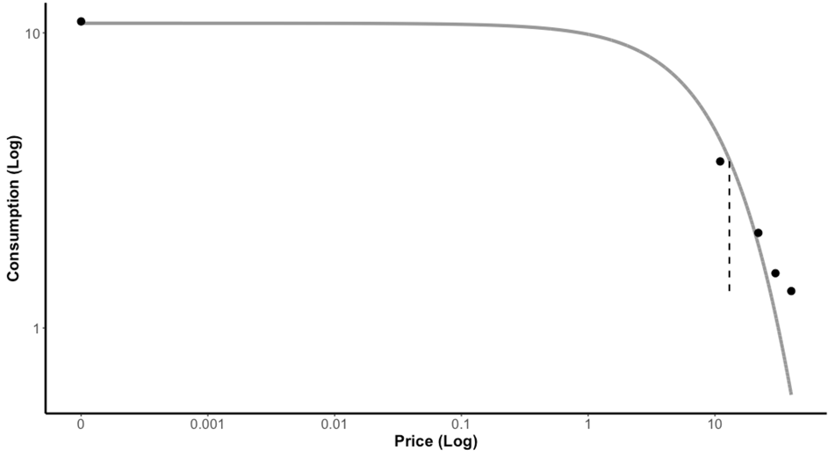 | 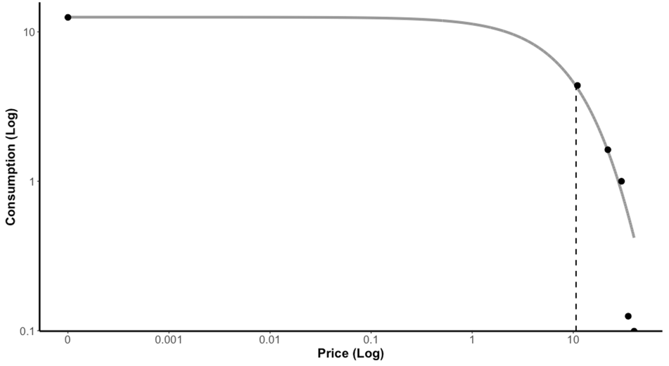
Permutation 3 (n = 4) | Permutation 4 (n = 27)
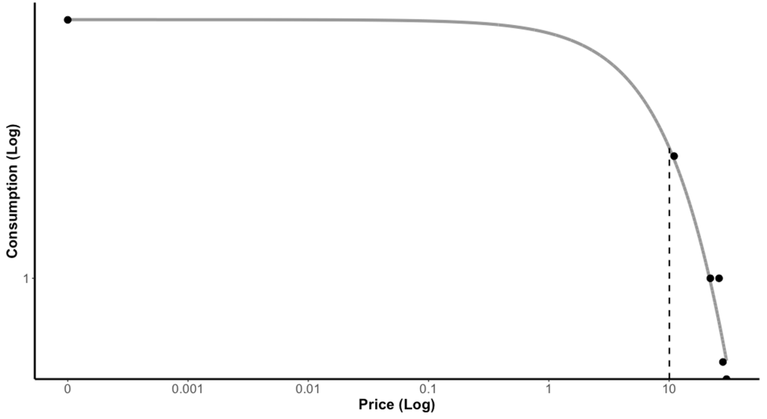 | 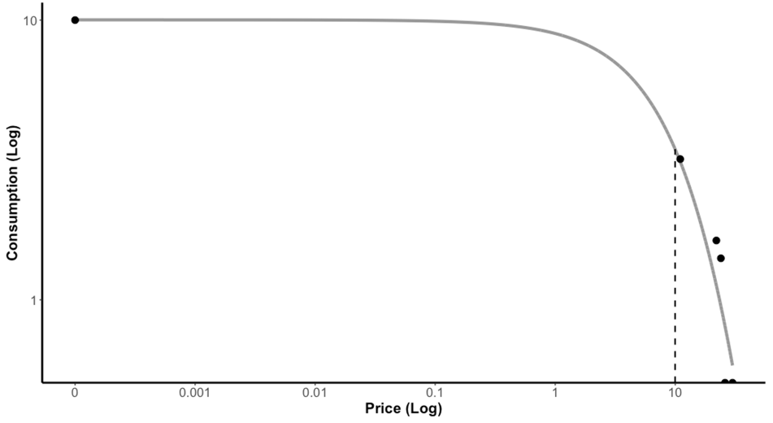
Permutation 5 (n = 51) | Permutation 6 (n = 76)
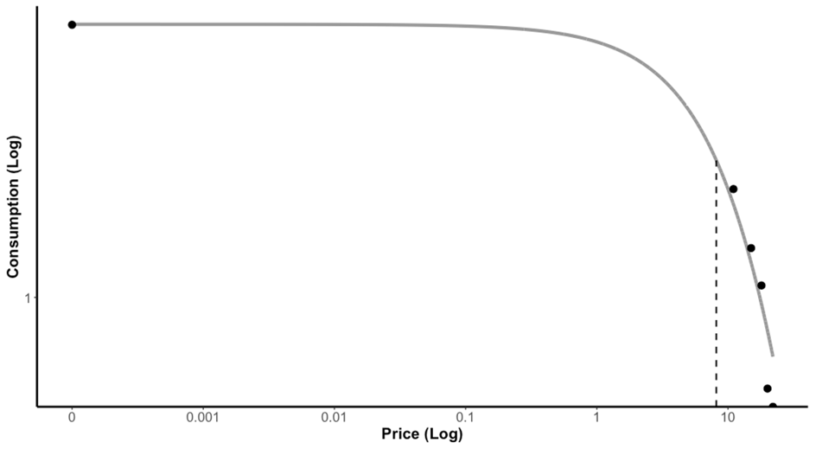 | 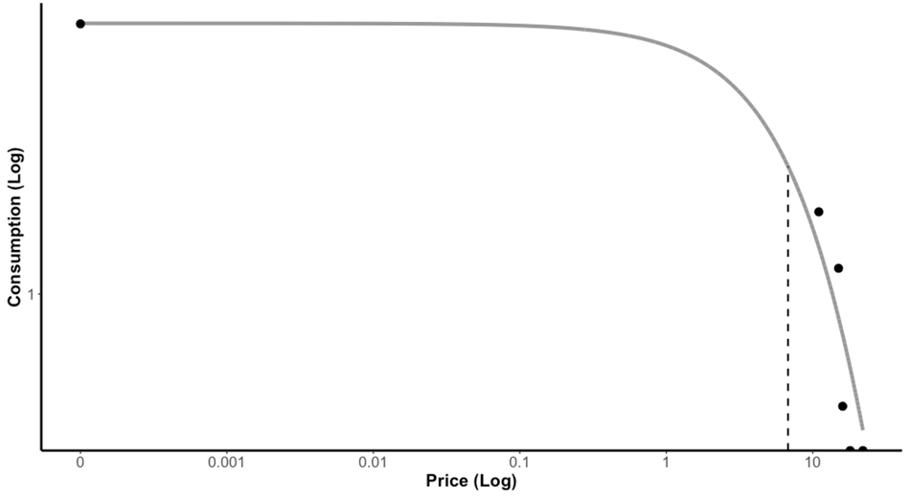
Permutation 7 (n = 60) | Permutation 8 (n = 149)
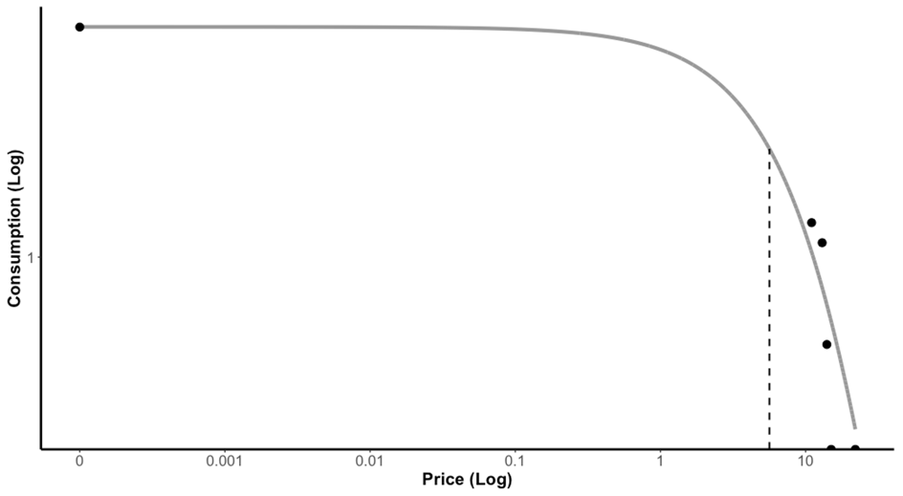 | 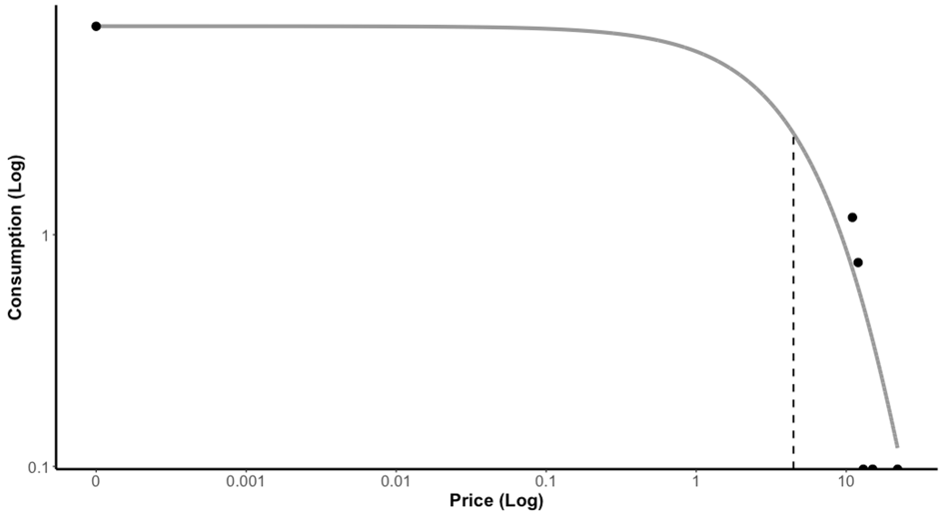
Permutation 9 (n = 103) | Permutation 10 (n = 133)
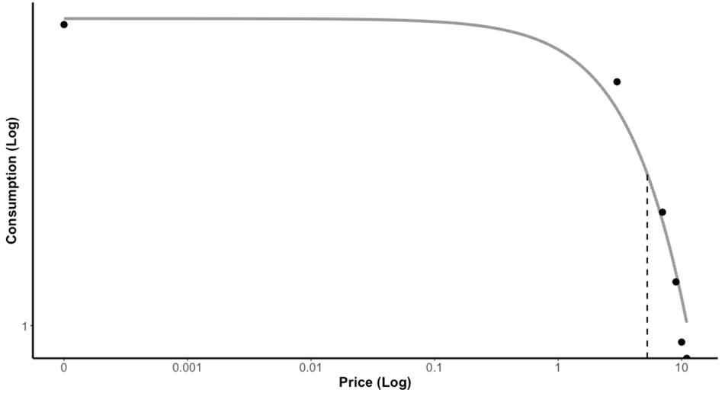 | 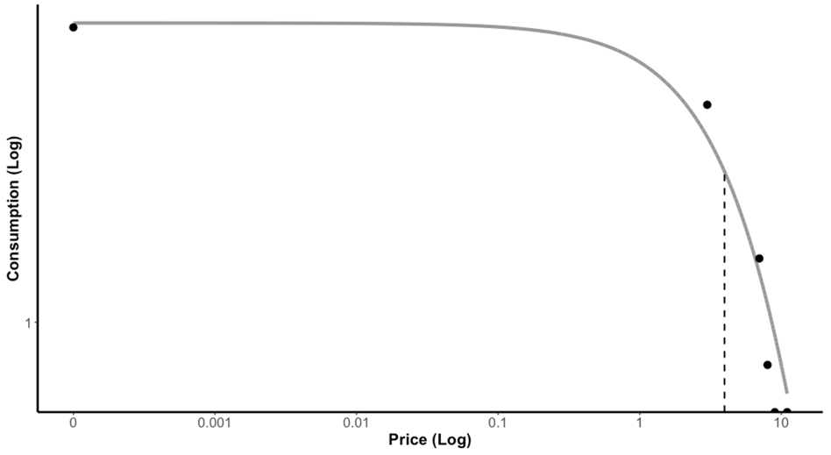
Permutation 11 (n = 57) | Permutation 12 (n = 20)
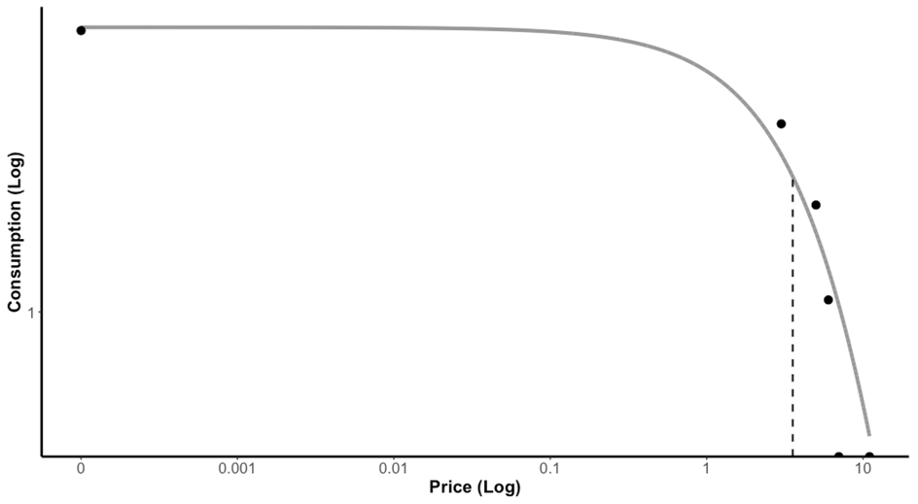 | 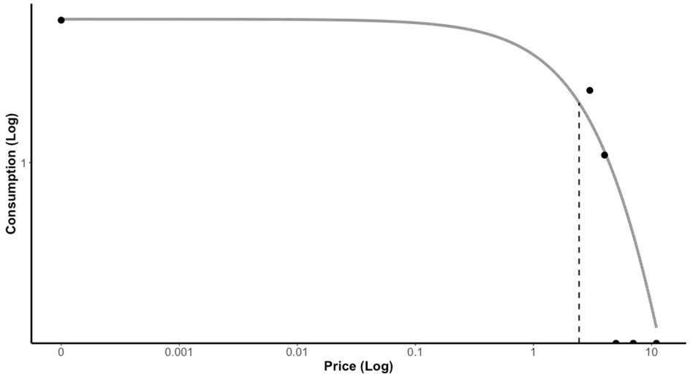
Permutation 13 (n = 4) | Permutation 14 (n = 3)
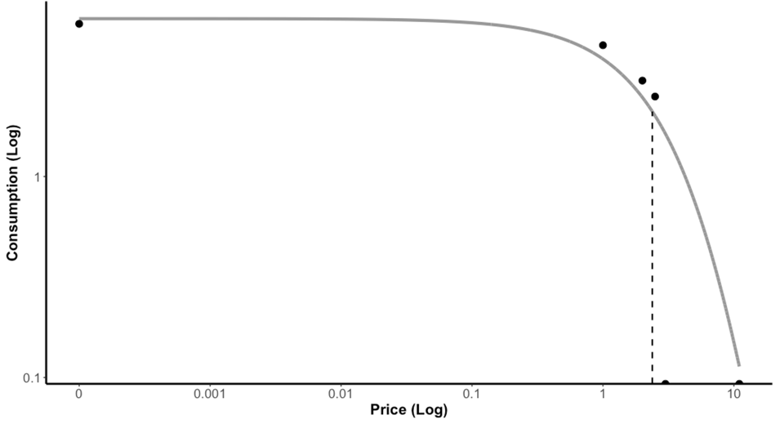 | 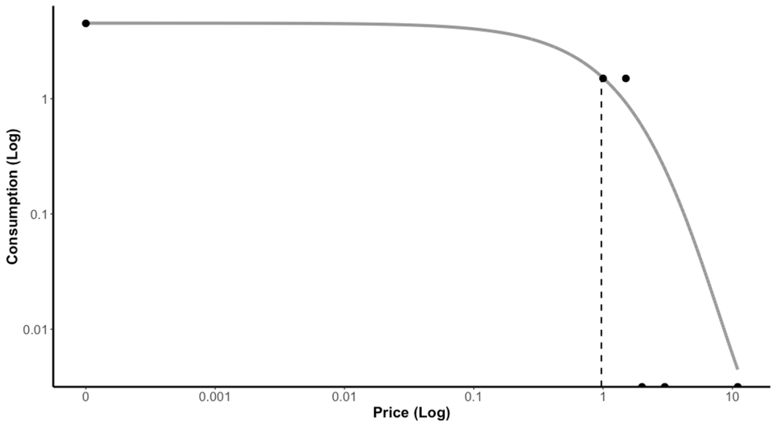
Note. No participants in the Hamilton sample would have been administered the 15th or 16th permutations of the brief alcohol purchase task.

Figure S2. Mean aggregate demand curves for each version of the brief Alcohol Purchase Task in the Memphis sample
Permutation 1 (n = 35) | Permutation 2 (n = 9)
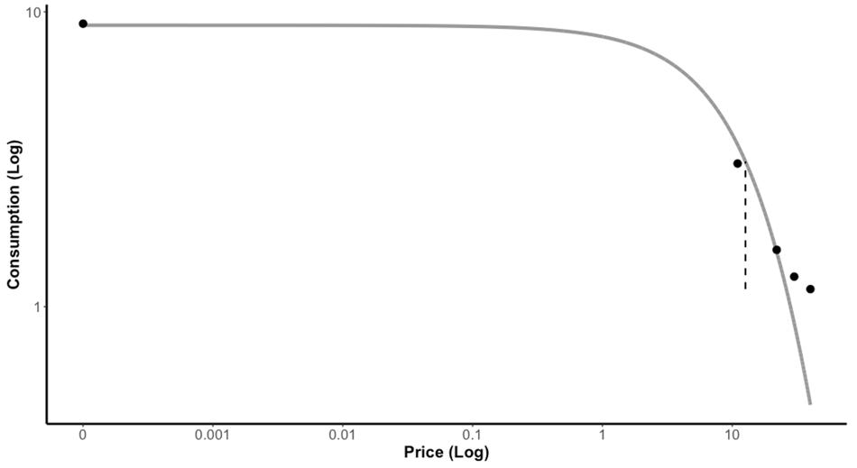 | 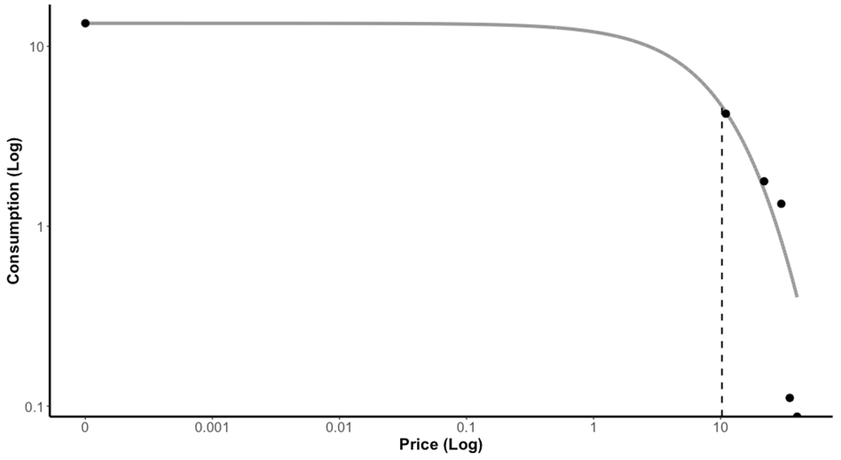
Permutation 3 (n = 10) | Permutation 4 (n = 19)
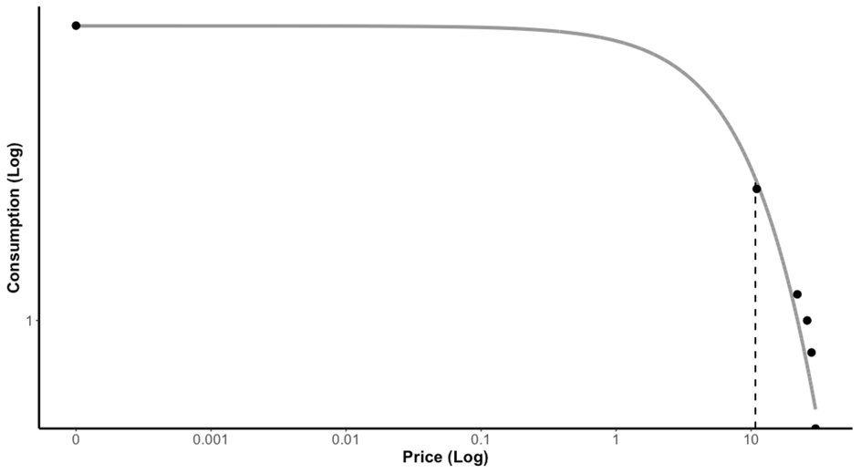 | 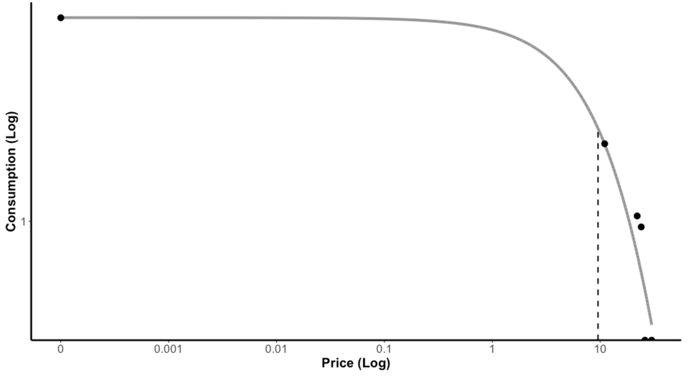
Permutation 5 (n = 44) | Permutation 6 (n = 76)
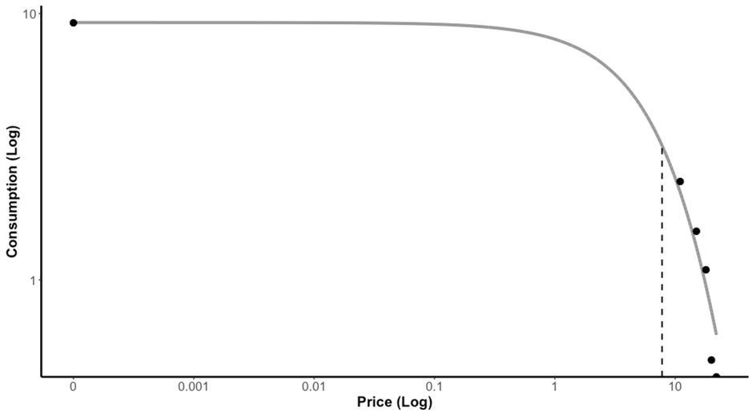 | 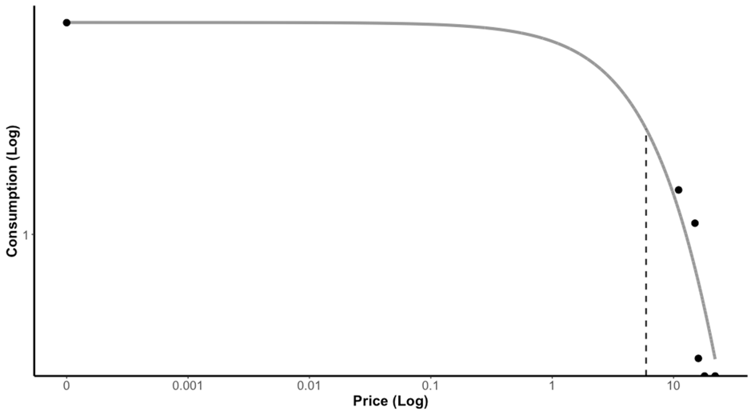
Permutation 7 (n = 35) | Permutation 8 (n = 89)
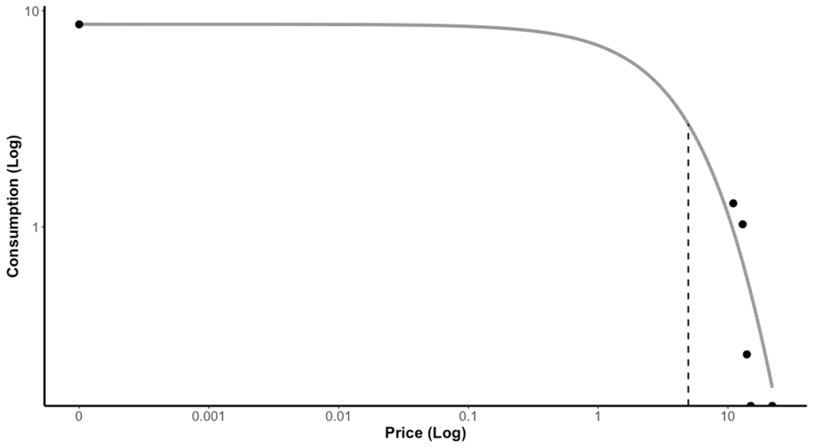 | 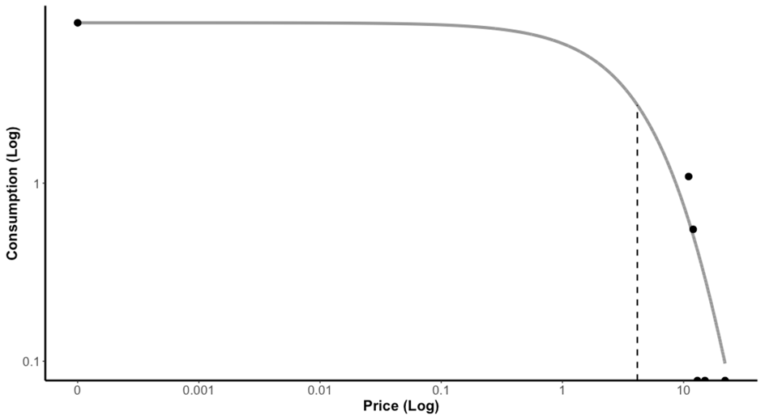
Permutation 9 (n = 100) | Permutation 10 (n = 85)
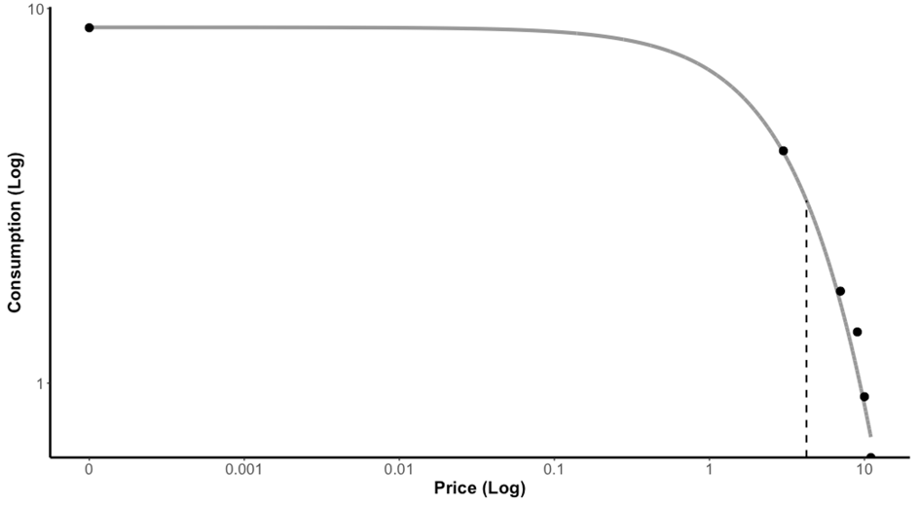 | 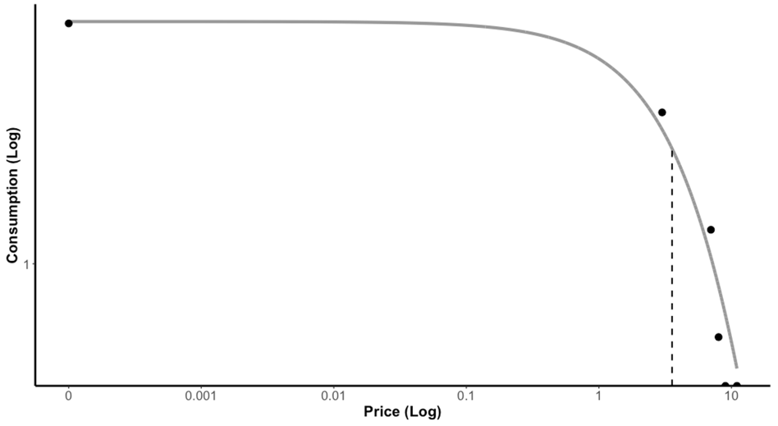
Permutation 11 (n = 51) | Permutation 12 (n = 18)
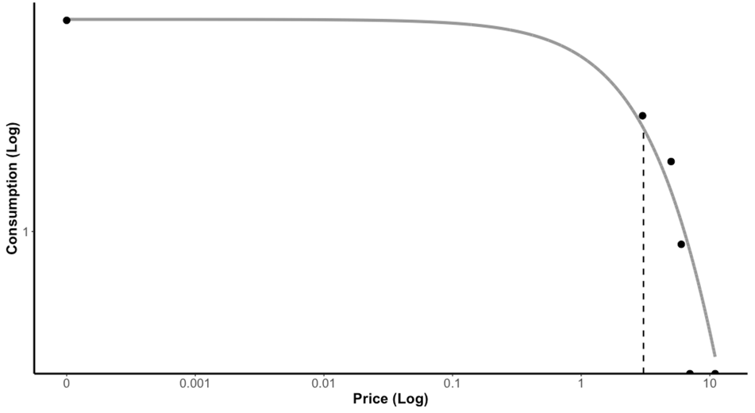 | 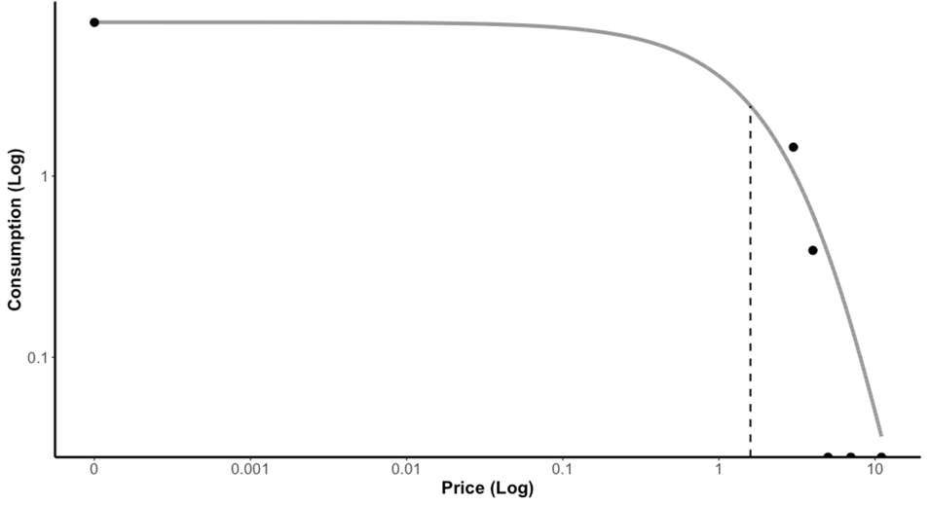
Permutation 13 (n = 6) | Permutation 14 (n = 9)
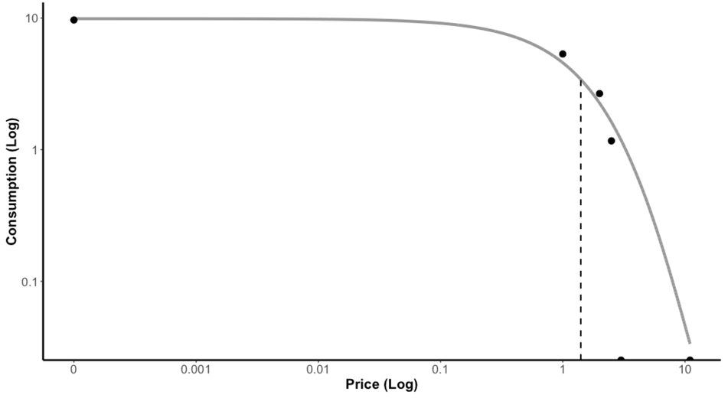 | 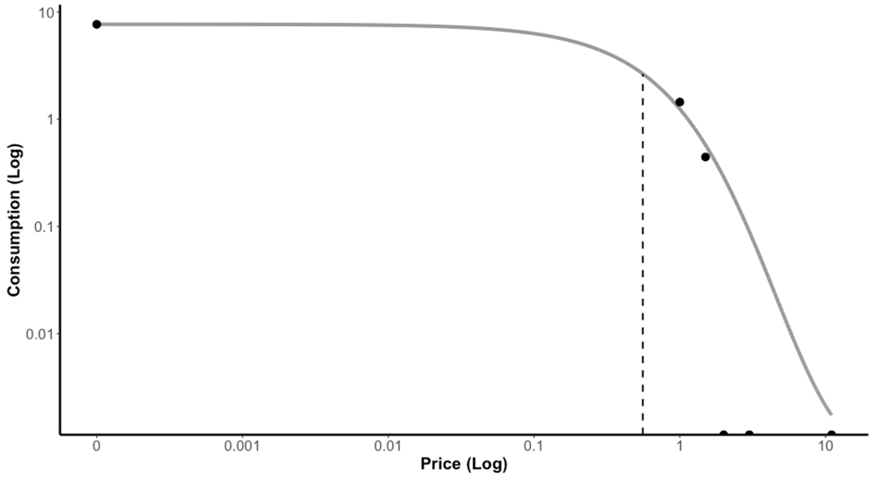
Permutation 15 (n = 1) | Permutation 16 (n = 1)
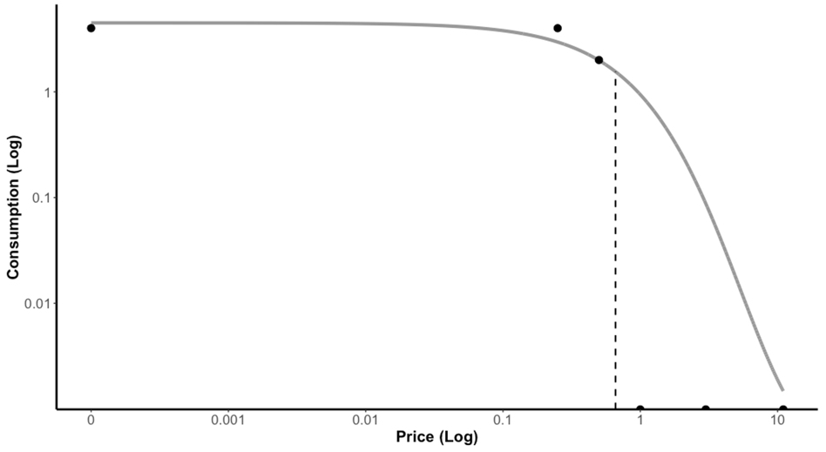 | 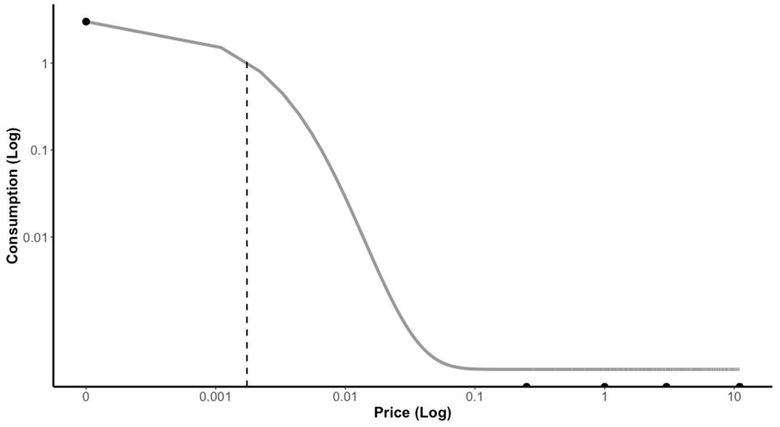

Alcohol Purchase Task (Murphy & MacKillop, 2006)

Instructions for the Alcohol Purchase Task were as follows: “Please respond to these questions as if you were actually in a TYPICAL SITUATION when you drink alcohol. Imagine where you typically drink, what you typically drink, and who you typically drink with, if anyone. The available drinks are standard size beer (12 oz.), wine (5 oz.), shots of hard liquor (1.5 oz.), or mixed drinks containing one shot of liquor. Assume that you did not drink alcohol before you are making these decisions, and will not have an opportunity to drink elsewhere after making these decisions. In addition, assume that you would consume every drink you request; that is, you cannot stockpile drinks for a later date or bring drinks home with you.”

Participants were presented with 30 different prices, administered in the following order: $0, $0.25, $0.5, $1, $1.5, $2, $2.5, $3, $4, $5, $6, $7, $8, $9, $10, $11, $12, $13, $14, $15, $16, $18, $20, $22, $24, $26, $28, $30, $35, $40).

