SUPPLEMENTARY MATERIALS
Kłosowska et al., Development, psychometric properties and cut-off scores of the Polish Version of the 20-item Pain Anxiety Symptoms Scale (PASS-20) in a Chronic Pain Sample. Psychological Assessment.

Table of contents:

Supplementary Table A 2
Supplementary Table B 5
Supplementary Table C 9
Supplementary Table D 11
Supplementary Table E 13
Supplementary Table F 15
Supplementary Figure A 17
Supplementary Figure B 18
Supplementary Figure C 19
Supplementary Figure D 20
Polish translation of PASS-20 scale 21

Supplementary Table A
Sociodemographic and pain characteristics – online sample
Study variables | Number of  participants | Mean ± Standard Deviation  or Percentage
Demographic variables
Age (years) | 418 | 49.37 ± 15.20
Gender
Female | 249 | 59.6%
Male | 168 | 40.2%
Other | 1 | 0.2%
Race
White | 417 | 99.8%
Latino/a | 1 | 0.2%
Education
Primary school | 2 | 0.5%
Secondary school | 162 | 38.8%
Vocational | 51 | 12.2%
Higher | 202 | 48.3%
Other | 1 | 0.2%
Job situation
Student | 6
Full-time job | 232
Part-time job | 28
Unemployed | 35
Retired | 124
Income | 258
Less than 2,000 PLN | 11 | 2.6%
2,000 – 3,999 PLN | 112 | 26.8%
4,000 – 5,999 PLN | 62 | 14.8%
6,000 – 9,999 PLN | 32 | 7.7%
More than 10,000 PLN | 9 | 2.2%
Prefer not to say | 32 | 7.7%
Marital status
Married | 257 | 61.5%
Domestic partnership | 63 | 15.1%
Single | 47 | 11.2%
Divorced | 35 | 8.4%
Widowed | 16 | 3.8%
Residence
Village | 88 | 21.1%
City up to 20,000 residents | 46 | 11.0%
City of 20,000 – 50,000 residents | 60 | 14.4%
City of 50,000 – 100,0000 residents | 60 | 14.4%
City of 100,000 – 200,000 residents | 41 | 9.8%
City of 200,000 – 500,000 residents | 58 | 13.9%
City over 500,000 residents | 65 | 15.5%
Pain-related variables
Sick leave
Yes | 47 | 51.4%
No | 215 | 11.2%
Retirement due to pain
Yes | 19 | 4.5%
No | 2 | 0.5%
Duration of chronic pain
3–6 months | 24 | 5.7%
6–12 months | 38 | 9.1%
1–3 years | 100 | 23.9%
3–5 years | 72 | 17.2%
>5 years | 184 | 44.0%
Treatment of chronic pain
<3 months | 18 | 4.3%
3–6 months | 29 | 6.9%
6–12 months | 38 | 9.1%
1–3 years | 72 | 17.2%
3–5 years | 54 | 12.9%
>5 years | 119 | 28.5%
Pain location
Lumbar-sacral area | 251
Legs | 115
Knees | 107
Neck | 94
Shoulder girdle | 77
Pelvis | 57
Head | 76
Other | 54
Pain management
Pharmacotherapy | 268
Blockades | 47
Surgical | 44
Physiotherapy | 217
Psychotherapy | 27
Unconventional medicine | 38
Other | 9
Frequency of medical pain management appointments | 418 | 5.16 ± 9.06
Use of painkillers
Yes | 354 | 84.7%
No | 64 | 15.3%
Frequency of painkillers intake
Never | 1 | 0.2%
Several Times a year | 28 | 6.7%
Several Times a month | 129 | 30.9%
Several Times a week | 104 | 24.9%
Once a day | 55 | 13.2%
Several Times a day | 37 | 8.9%
Painkillers intake in last week
Yes | 299 | 71.5%
No | 55 | 13.2%
Not taking painkillers despite pain
Yes | 255 | 61.0%
No | 99 | 23.7%
Previous pain management therapy
Yes | 47 | 11.2%
No | 52 | 12.4%
Pain at the moment | 418 | 4.94 ± 2.27
Pain in the last week | 418 | 5.66 ± 2.08
The highest pain in the last week | 418 | 6.59 ± 2.21
Resting during the day due to pain
<1 hour | 181 | 43.3%
1–3 hours | 158 | 37.8%
>3 hours | 79 | 18.9%
Given up work/school due to pain
Yes | 185 | 44.3%
No | 233 | 55.7%
Cessation or limitation of activities due to pain
Yes | 329 | 78.7%
No | 89 | 21.3%
Type of limited activities
Work | 137
Education | 23
Hobby | 146
Trips | 143
Sport | 207
Social Meetings | 125
Other | 11

Supplementary Table B
Sociodemographic and pain characteristics – hospital sample
Study variables | Number of  participants | Mean ± Standard Deviation  or Percentage
Demographic variables
Age (years) | 110 | 56.56±16.31
Missing | 38
Gender
Female | 114 | 77%
Male | 33 | 22.3%
Missing | 1 | 0.7%
Race
White | 147 | 99.3%
Missing | 1 | 0.7%
Education
Primary school | 3 | 2.0%
Middle school | 1 | 0.7%
Secondary school | 54 | 36.5%
Vocational | 25 | 16.9%
Higher | 59 | 39.9%
Other | 2 | 1.4%
Missing | 4 | 2.7%
* Job situation
Student | 6 | 3.8%
Full-time job | 51 | 32.7%
Part-time job | 7 | 4.5%
Unemployed | 8 | 5.1%
Retired | 82 | 55.4%
Missing | 2 | 1.3%
Income
Less than 2,000 PLN | 29 | 19.6%
2,000 – 3,999 PLN | 56 | 37.8%
4,000 – 5,999 PLN | 26 | 17.6%
6,000 – 9,999 PLN | 9 | 6.1%
More than 10,000 PLN | 3 | 2.0%
Prefer not to say | 12 | 8.1%
Missing | 13 | 8.8%
Marital status
Married | 76 | 51.4%
Domestic partnership | 8 | 5.4%
Single | 25 | 16.9%
Divorced | 14 | 9.5%
Widowed | 24 | 16.2%
Missing | 1 | 0.7%
Residence
Village | 35 | 23.6%
City up to 20,000 residents | 7 | 4.7%
City of 20,000 – 50,000 residents | 6 | 4.1%
City of 50,000 – 100,0000 residents | 8 | 5.4%
City of 100,000 – 200,000 residents | 6 | 4.1%
City of 200,000 – 500,000 residents | 8 | 5.4%
City over 500,000 residents | 75 | 50.7%
Missing | 3 | 2.0%
Pain-related variables
Sick leave
Yes | 13 | 8.8%
No | 124 | 83.8%
Missing | 11 | 7.4%
Retirement due to pain
Yes | 14 | 9.5%
No | 14 | 9.5%
Missing | 120 | 81,1%
Duration of chronic pain
3–6 months | 4 | 2.7%
6–12 months | 9 | 6.1%
1–3 years | 22 | 14.9%
3–5 years | 23 | 15.5%
>5 years | 90 | 60.8%
Treatment of chronic pain
<3 months | 5 | 3.4%
3–6 months | 7 | 4.7%
6–12 months | 15 | 10.1%
1–3 years | 30 | 20.3%
3–5 years | 23 | 15.5%
>5 years | 62 | 41.9%
Missing | 6 | 4.1%
* Pain location
Lumbar-sacral area | 102 | 20.0%
Legs | 62 | 12.2%
Knees | 41 | 8.1%
Neck | 46 | 9.0%
Shoulder girdle | 54 | 10.6%
Pelvis | 53 | 10.4%
Head | 48 | 9.4%
Other | 98 | 19.3%
Missing | 5 | 1.0%
* Pain management
Pharmacotherapy | 127 | 25.2%
Blockades | 81 | 16.1%
Surgical | 26 | 5.2%
Physiotherapy | 113 | 22.5%
Psychotherapy | 32 | 6.4%
Unconventional medicine | 72 | 14.3%
Other | 48 | 9.5%
Missing | 4 | 0.8%
Use of painkillers
Yes | 137 | 92.6%
No | 8 | 5.4%
Missing | 3 | 2.0%
Frequency of painkillers intake
Several Times a year | 17 | 11.5%
Several Times a month | 31 | 20.9%
Several Times a week | 21 | 14.2%
Once a day | 23 | 15.5%
Several Times a day | 44 | 29.7%
Missing | 12 | 8.1%
Painkillers intake in the last week
Yes | 112 | 75.7%
No | 26 | 17.6%
Missing | 10 | 6.8%
Not taking painkillers despite pain
Yes | 92 | 62.2%
No | 45 | 30.4%
Missing | 11 | 7.4%
Previous pain management therapy
Yes | 59 | 39.9%
No | 83 | 56.1%
Missing | 6 | 4.1%
Pain at the moment | 141 | 5.65±2.54
Pain in the last week | 141 | 6.35±2.36
The highest pain in the last week | 142 | 7.11±.94
Resting during the day due to pain
<1 hour | 60 | 40.6%
1–3 hours | 50 | 33.8%
>3 hours | 33 | 22.3%
Missing | 5 | 3.4%
Given up work/school due to pain
Yes | 76 | 51.4%
No | 64 | 43.2%
Missing | 8 | 5.4%
Cessation or limitation of activities due to pain
Yes | 122 | 82.4%
No | 22 | 14.9%
Missing | 4 | 2.7%
* Type of limited activities
Work | 70 | 17.3%
Education | 20 | 5.0%
Hobby | 56 | 13.9%
Trips | 75 | 18.6%
Sport | 68 | 16.8%
Social Meetings | 63 | 16.6%
Other | 31 | 7.7%
Missing | 21 | 5.2%
Note: *Multiple Choice Questions

Supplementary Table C
Descriptive statistics of the Polish PASS-20 - online sample
PASS-20 scale/item | Measurement 1 |  |  |  |  |  | Measurement 2
PASS-20 scale/item | Mean (SD) | Women/Men | Md | S | K | Range | Mean (SD) | Women/Men | Md | S | K | Range
PASS-20 total | 47.22(21.11) | 49.59(19.99)/43.85(22.26) | 48 | 0.15 | -0.04 | 0-100 | 45.00(20.14) | 47.22(18.87)/42.13(21.39) | 47 | -0.06 | -0.40 | 0-100
PASS-20 avoidance | 13.08(5.15) | 13.42(5.16)/12.60(5.11) | 13 | 0.01 | -0.15 | 0-25 | 12.46(4.84) | 12.79(4.77)/12.04(4.93) | 13 | -0.21 | 0.02 | 0-25
PASS-20 fearful thinking | 11.88(5.91) | 12.42(5.76)/11.12(6.03) | 12 | 0.04 | -0.56 | 0-25 | 11.28(5.78) | 11.90(5.60)/10.48(5.94) | 12 | -0.04 | -0.69 | 0-25
PASS-20 cognitive anxiety | 13.20(6.01) | 14.10(5.72)/11.90(6.22) | 13 | -0.01 | -0.56 | 0-25 | 12.59(5.74) | 13.42(5.46)/11.53(5.93) | 13 | -0.10 | -0.52 | 0-25
PASS-20 physiological responses | 9.06(6.42) | 9.65(6.29)/8.23(6.53) | 9 | 0.39 | -0.71 | 0-25 | 8.66(5.93) | 9.11(5.71)/8.08(6.17) | 9 | 0.24 | -0.86 | 0-25
PASS item 1 | 2.53(1.25) | 2.63(1.25)/2.40(1.23) | 3 | -0.15 | -0.44 | 0-5 | 2.36(1.28) | 2.34(1.30)/2.38(1.25) | 3 | -0.18 | -0.56 | 0-5
PASS item 2 | 2.63(1.36) | 2.75(1.37)/2.46(1.33) | 3 | -0.25 | -0.70 | 0-5 | 2.39(1.37) | 2.55(1.32)/2.19(1.41) | 3 | -0.08 | -0.80 | 0-5
PASS item 3 | 2.25(1.36) | 2.41(1.38)/2.02(1.31) | 2 | 0.18 | -0.71 | 0-5 | 2.04(1.29) | 2.12(1.26)/1.93(1.33) | 2 | 0.29 | -0.51 | 0-5
PASS item 4 | 1.80(1.45) | 1.86(1.49)/1.73(1.39) | 2 | 0.44 | -0.72 | 0-5 | 1.72(1.32) | 1.73(1.29)/1.71(1.37) | 2 | 0.37 | -0.67 | 0-5
PASS item 5 | 2.46(1.43) | 2.65(1.40)/2.18(1.45) | 3 | -0.01 | -0.80 | 0-5 | 2.23(1.32) | 2.29(1.27)/2.15(1.39) | 2 | 0.01 | -0.85 | 0-5
PASS item 6 | 2.01(1.36) | 2.05(1.33)/1.96(1.41) | 2 | 0.29 | -0.67 | 0-5 | 1.88(1.30) | 1.85(1.30)/1.93(1.31) | 2 | 0.22 | -0.71 | 0-5
PASS item 7 | 1.97(1.53) | 2.06(1.33)/1.84(1.53) | 2 | 0.22 | -1.05 | 0-5 | 1.80(1.39) | 1.83(1.37)/1.76(1.43) | 2 | 0.30 | -0.92 | 0-5
PASS item 8 | 2.73(1.42) | 2.77(1.41)/2.67(1.42) | 3 | -0.06 | -0.82 | 0-5 | 2.85(1.38) | 2.91(1.40)/2.76(1.36) | 3 | -0.13 | -0.83 | 0-5
PASS item 9 | 2.20(1.41) | 2.22(1.41)/2.18(1.40) | 2 | 0.04 | -0.86 | 0-5 | 2.17(1.32) | 2.24(1.29)/2.08(1.35) | 2 | 0.08 | -0.76 | 0-5
PASS item 10 | 2.59(1.43) | 2.76(1.38)/2.36(1.47) | 3 | -0.05 | -0.84 | 0-5 | 2.52(1.28) | 2.68(1.25)/2.30(1.29) | 3 | 0.00 | -0.63 | 0-5
PASS item 11 | 2.86(1.33) | 2.94(1.33)/2.76(1.32) | 3 | -0.26 | -0.56 | 0-5 | 2.67(1.29) | 2.81(1.26)/2.49(1.30) | 3 | -0.24 | -0.59 | 0-5
PASS item 12 | 1.59(1.54) | 1.69(1.55)/1.44(1.52) | 1 | 0.60 | -0.81 | 0-5 | 1.55(1.45) | 1.66(1.46)/1.40(1.43) | 1 | 0.55 | -0.90 | 0-5
PASS item 13 | 2.33(1.57) | 2.52(1.54)/2.05(1.59) | 2 | 0.09 | -1.03 | 0-5 | 2.36(1.53) | 2.68(1.45)/1.94(1.53) | 2 | 0.09 | -0.95 | 0-5
PASS item 14 | 2.50(1.51) | 2.73(1.49)/2.15(1.47) | 3 | 0.08 | -1.06 | 0-5 | 2.38(1.39) | 2.62(1.36)/2.06(1.35) | 2 | 0.15 | -0.77 | 0-5
PASS item 15 | 1.64(1.55) | 1.87(1.54)/1.31(1.51) | 1 | 0.50 | -0.94 | 0-5 | 1.60(1.40) | 1.82(1.44)/1.33(1.30) | 1 | 0.46 | -0.82 | 0-5
PASS item 16 | 2.18(1.61) | 2.31(1.62)/2.01(1.59) | 2 | 0.15 | -1.16 | 0-5 | 2.00(1.53) | 2.09(1.55)/1.88(1.50) | 2 | 0.22 | -1.05 | 0-5
PASS item 17 | 2.72(1.40) | 2.87(1.31)/2.49(1.49) | 3 | -0.20 | -0.65 | 0-5 | 2.64(1.33) | 2.84(1.26)/2.38(1.37) | 3 | -0.21 | -0.67 | 0-5
PASS item 18 | 2.06(1.47) | 2.16(1.44)/1.92(1.51) | 2 | 0.28 | -0.86 | 0-5 | 1.99(1.38) | 2.07(1.36)/1.88(1.39) | 2 | 0.12 | -0.95 | 0-5
PASS item 19 | 2.94(1.40) | 3.10(1.41)/2.72(1.36) | 3 | -0.26 | -0.75 | 0-5 | 2.84(1.38) | 2.98(1.32)/2.65(1.44) | 3 | -0.22 | -0.76 | 0-5
PASS item 20 | 3.23(1.31) | 3.25(1.33)/3.19(1.27) | 3 | -0.42 | -0.56 | 0-5 | 3.02(1.26) | 3.10(1.25)/2.93(1.27) | 3 | -0.35 | -0.37 | 0-5
DASS-21 depression | 8.31(5.20) | 8.63(5.11)/7.80(5.30) | 8 | 0.28 | -0.67 | 0-21 | - | - | - | - | - | -
DASS-21 anxiety | 7.09(5.16) | 7.37(5.05)/6.66(5.32) | 7 | 0.45 | -0.64 | 0-21 | - | - | - | - | - | -
DASS-21 stress | 9.21(4.89) | 9.51(4.89)/8.77(4.90) | 9 | 0.12 | -0.50 | 0-21 | - | - | - | - | - | -
STAI Trait | 7.09(5.16) | 49.62(8.64)/45.70(9.08) | 48 | 0.02 | -0.07 | 23-77 | - | - | - | - | - | -
CSQ Catastrophizing | 15.51(7.92) | 16.45(7.70)/14.19(8.06) | 16 | -0.02 | -0.42 | 0-36 | - | - | - | - | - | -
Note: Md – median K – kurtosis, S – skewness, Range – observed range, N=418 for measurement 1, N=330 for measurement 2; PASS-20 – Pain Anxiety Symptom Scale 20-item version; DASS-21 – Depression Anxiety Stress Scales 21-item version; STAI Trait – The State-Trait Anxiety Inventory: Trait form; CSQ Catastrophizing – Catastrophizing subscale of Coping Strategies Questionnaire
Supplementary Table D
Descriptive statics of the Polish PASS-20 – hospital sample
PASS-20 scale/item | Mean (SD) | Women/Men | Md | S | K | Range
Total scale | 46.30(21.66) | 47.28(21.44)/42.90(22.81) | 48.00 | -0.02 | -0.62 | 0–100
Avoidance | 13.16(5.89) | 13.28(5.77)/12.68(6.47) | 13.00 | 0.02 | -0.47 | 0–25
Fearful thinking | 10.45(6.62) | 10.56(6.78)/10.13(6.25) | 10.00 | 0.28 | -0.85 | 0–25
Cognitive anxiety | 14.24(6.38) | 14.60(6.20)/12.87(6.97) | 15.00 | -0.39 | -0.76 | 0–25
Physiological responses | 8.45(5.97) | 8.84(6.09)/7.23(5.51) | 8.00 | 0.33 | -0.61 | 0–25
Item 1 | 2.11(1.58) | 2.09(1.60)/2.26(1.53) | 2.00 | 0.11 | -1.15 | 0–5
Item 2 | 2.17(1.69) | 2.29(1.72)/2.93(1.60) | 2.00 | 0.20 | -1.18 | 0–5
Item 3 | 2.23(1.67) | 2.22(1.72)/2.23(1.52) | 2.00 | 0.39 | -1.11 | 0–5
Item 4 | 1.38(1.51) | 1.37(1.53)/1.42(1.48) | 1.00 | 0.85 | -0.39 | 0–5
Item 5 | 2.42(1.62) | 2.51(1.62)/2.10(1.67) | 3.00 | -0.04 | -1.14 | 0–5
Item 6 | 1.92(1.58) | 1.95(1.60)/1.84(1.57) | 2.00 | 0.46 | -0.90 | 0–5
Item 7 | 1.85(1.60) | 1.92(1.63)/1.68(1.47) | 2.00 | 0.37 | -1.07 | 0–5
Item 8 | 2.85(1.73) | 2.86(1.77)/2.84(1.64) | 3.00 | -0.14 | -1.34 | 0–5
Item 9 | 1.79(1.59) | 1.84(1.64)/1.58(1.43) | 1.00 | 0.62 | -0.63 | 0–5
Item 10 | 3.03(1.63) | 3.08(1.59)/2.77(1.78) | 3.00 | -0.41 | -1.11 | 0–5
Item 11 | 2.97(1.73) | 2.98(1.71)/2.90(1.83) | 3.00 | -0.39 | -1.14 | 0–5
Item 12 | 1.54(1.52) | 1.61(1.59)/1.32(1.40) | 1.00 | 0.64 | -0.84 | 0–5
Item 13 | 2.21(1.70) | 2.20(1.72)/2.23(1.69) | 2.00 | 0.15 | -1.21 | 0–5
Item 14 | 2.75(1.60) | 2.80(1.62)/2.55(1.57) | 3.00 | -0.18 | -1.23 | 0–5
Item 15 | 1.61(1.63) | 1.81(1.72)/0.90(1.08) | 1.00 | 0.63 | -1.01 | 0–5
Item 16 | 2.22(1.81) | 2.27(1.83)/2.03(1.78) | 2.00 | 0.24 | -1.40 | 0–5
Item 17 | 3.06(1.52) | 3.17(1.48)/2.61(1.56) | 3.00 | -0.45 | -0.84 | 0–5
Item 18 | 2.09(1.59) | 2.17(1.59)/1.90(1.58) | 2.00 | 0.24 | -1.08 | 0–5
Item 19 | 3.09(1.65) | 3.16(1.63)/2.90(1.72) | 3.00 | -0.33 | -1.16 | 0–5
Item 20 | 3.24(1.57) | 3.36(1.55)/2.87(1.63) | 4.00 | -0.68 | -0.59 | 0–5
Note: PASS-20 – Pain Anxiety Symptom Scale 20-item version; Md – median; K – kurtosis; S – skewness, Range – observed range

Supplementary Table E
Item reliability statistics – online sample
 |  | Measurement 1 (N=418) |  |  |  |  |  | Measurement 2 (N=330)
PASS-20 | Item | Cronbach’s Alpha  If Item Dropped | Item-rest  Correlation | Cronbach’s Alpha |  |  |  | Cronbach’s Alpha  If Item Dropped | Item-rest Correlation | Cronbach’s Alpha
Avoidance |  |  |  | 0.82 |  |  |  |  |  | 0.80
 | Item 3 | 0.78 | 0.62 |  |  |  |  | 0.75 | 0.60
 | Item 6 | 0.76 | 0.67 |  |  |  |  | 0.71 | 0.74
 | Item 8 | 0.78 | 0.60 |  |  |  |  | 0.80 | 0.45
 | Item 11 | 0.76 | 0.69 |  |  |  |  | 0.75 | 0.61
 | Item 20 | 0.82 | 0.46 |  |  |  |  | 0.78 | 0.52
Fearful thinking |  |  |  | 0.88 |  |  |  |  |  | 0.88
 | Item 1 | 0.86 | 0.64 |  |  |  |  | 0.87 | 0.64
 | Item 2 | 0.84 | 0.74 |  |  |  |  | 0.84 | 0.79
 | Item 9 | 0.84 | 0.76 |  |  |  |  | 0.85 | 0.72
 | Item 13 | 0.85 | 0.72 |  |  |  |  | 0.86 | 0.70
 | Item 16 | 0.86 | 0.69 |  |  |  |  | 0.85 | 0.72
Cognitive anxiety |  |  |  | 0.84 |  |  |  |  |  | 0.91
 | Item 5 | 0.88 | 0.71 |  |  |  |  | 0.90 | 0.71
 | Item 10 | 0.86 | 0.78 |  |  |  |  | 0.88 | 0.80
 | Item 14 | 0.86 | 0.78 |  |  |  |  | 0.88 | 0.81
 | Item 17 | 0.86 | 0.78 |  |  |  |  | 0.88 | 0.80
 | Item 19 | 0.89 | 0.66 |  |  |  |  | 0.90 | 0.74
Physiological responses |  |  |  | 0.91 |  |  |  |  |  | 0.91
 | Item 4 | 0.90 | 0.71 |  |  |  |  | 0.89 | 0.76
 | Item 7 | 0.88 | 0.78 |  |  |  |  | 0.89 | 0.78
 | Item 12 | 0.88 | 0.78 |  |  |  |  | 0.89 | 0.76
 | Item 15 | 0.88 | 0.78 |  |  |  |  | 0.89 | 0.76
 | Item 18 | 0.88 | 0.76 |  |  |  |  | 0.89 | 0.78
Total scale |  |  |  | 0.96 |  |  |  |  |  | 0.96
 | Item 1 | 0.95 | 0.61 |  |  |  |  | 0.96 | 0.60
 | Item 2 | 0.95 | 0.69 |  |  |  |  | 0.95 | 0.74
 | Item 3 | 0.95 | 0.64 |  |  |  |  | 0.96 | 0.61
 | Item 4 | 0.95 | 0.71 |  |  |  |  | 0.95 | 0.75
 | Item 5 | 0.95 | 0.76 |  |  |  |  | 0.95 | 0.77
 | Item 6 | 0.95 | 0.77 |  |  |  |  | 0.95 | 0.75
 | Item 7 | 0.95 | 0.78 |  |  |  |  | 0.95 | 0.72
 | Item 8 | 0.96 | 0.55 |  |  |  |  | 0.96 | 0.47
 | Item 9 | 0.95 | 0.74 |  |  |  |  | 0.95 | 0.77
 | Item 10 | 0.95 | 0.80 |  |  |  |  | 0.95 | 0.80
 | Item 11 | 0.95 | 0.70 |  |  |  |  | 0.96 | 0.69
 | Item 12 | 0.95 | 0.68 |  |  |  |  | 0.96 | 0.65
 | Item 13 | 0.95 | 0.78 |  |  |  |  | 0.95 | 0.77
 | Item 14 | 0.95 | 0.78 |  |  |  |  | 0.95 | 0.80
 | Item 15 | 0.95 | 0.68 |  |  |  |  | 0.96 | 0.66
 | Item 16 | 0.95 | 0.71 |  |  |  |  | 0.95 | 0.75
 | Item 17 | 0.95 | 0.75 |  |  |  |  | 0.95 | 0.77
 | Item 18 | 0.95 | 0.81 |  |  |  |  | 0.95 | 0.82
 | Item 19 | 0.95 | 0.66 |  |  |  |  | 0.95 | 0.73
 | Item 20 | 0.96 | 0.43 |  |  |  |  | 0.96 | 0.53
Note: PASS-20 – Pain Anxiety Symptom Scale 20-item version
Supplementary Table F
Item reliability statistics – hospital sample
Pain Anxiety Symptom Scale 20-item version | Item | Cronbach’s Alpha  If Item Dropped | Item–rest  Correlation | Cronbach’s Alpha
Avoidance |  |  |  | 0.76
 | Item 3 | 0.72 | 0.51
 | Item 6 | 0.66 | 0.68
 | Item 8 | 0.77 | 0.38
 | Item 11 | 0.66 | 0.68
 | Item 20 | 0.75 | 0.42
Fearful thinking |  |  |  | 0.85
 | Item 1 | 0.84 | 0.60
 | Item 2 | 0.81 | 0.70
 | Item 9 | 0.81 | 0.70
 | Item 13 | 0.82 | 0.65
 | Item 16 | 0.82 | 0.69
Cognitive anxiety |  |  |  | 0.86
 | Item 5 | 0.83 | 0.66
 | Item 10 | 0.81 | 0.74
 | Item 14 | 0.84 | 0.63
 | Item 17 | 0.81 | 0.75
 | Item 19 | 0.85 | 0.60
Physiological responses |  |  |  | 0.82
 | Item 4 | 0.79 | 0.59
 | Item 7 | 0.78 | 0.62
 | Item 12 | 0.77 | 0.64
 | Item 15 | 0.81 | 0.52
 | Item 18 | 0.76 | 0.67
Total |  |  |  | 0.94
 | Item 1 | 0.93 | 0.52
 | Item 2 | 0.93 | 0.63
 | Item 3 | 0.93 | 0.52
 | Item 4 | 0.93 | 0.61
 | Item 5 | 0.93 | 0.73
 | Item 6 | 0.93 | 0.75
 | Item 7 | 0.93 | 0.64
 | Item 8 | 0.94 | 0.35
 | Item 9 | 0.93 | 0.70
 | Item 10 | 0.93 | 0.72
 | Item 11 | 0.93 | 0.70
 | Item 12 | 0.93 | 0.62
 | Item 13 | 0.93 | 0.73
 | Item 14 | 0.93 | 0.57
 | Item 15 | 0.93 | 0.48
 | Item 16 | 0.93 | 0.71
 | Item 17 | 0.93 | 0.74
 | Item 18 | 0.93 | 0.76
 | Item 19 | 0.93 | 0.63
 | Item 20 | 0.94 | 0.44

Supplementary Figure A
Recruitment flowchart – online study
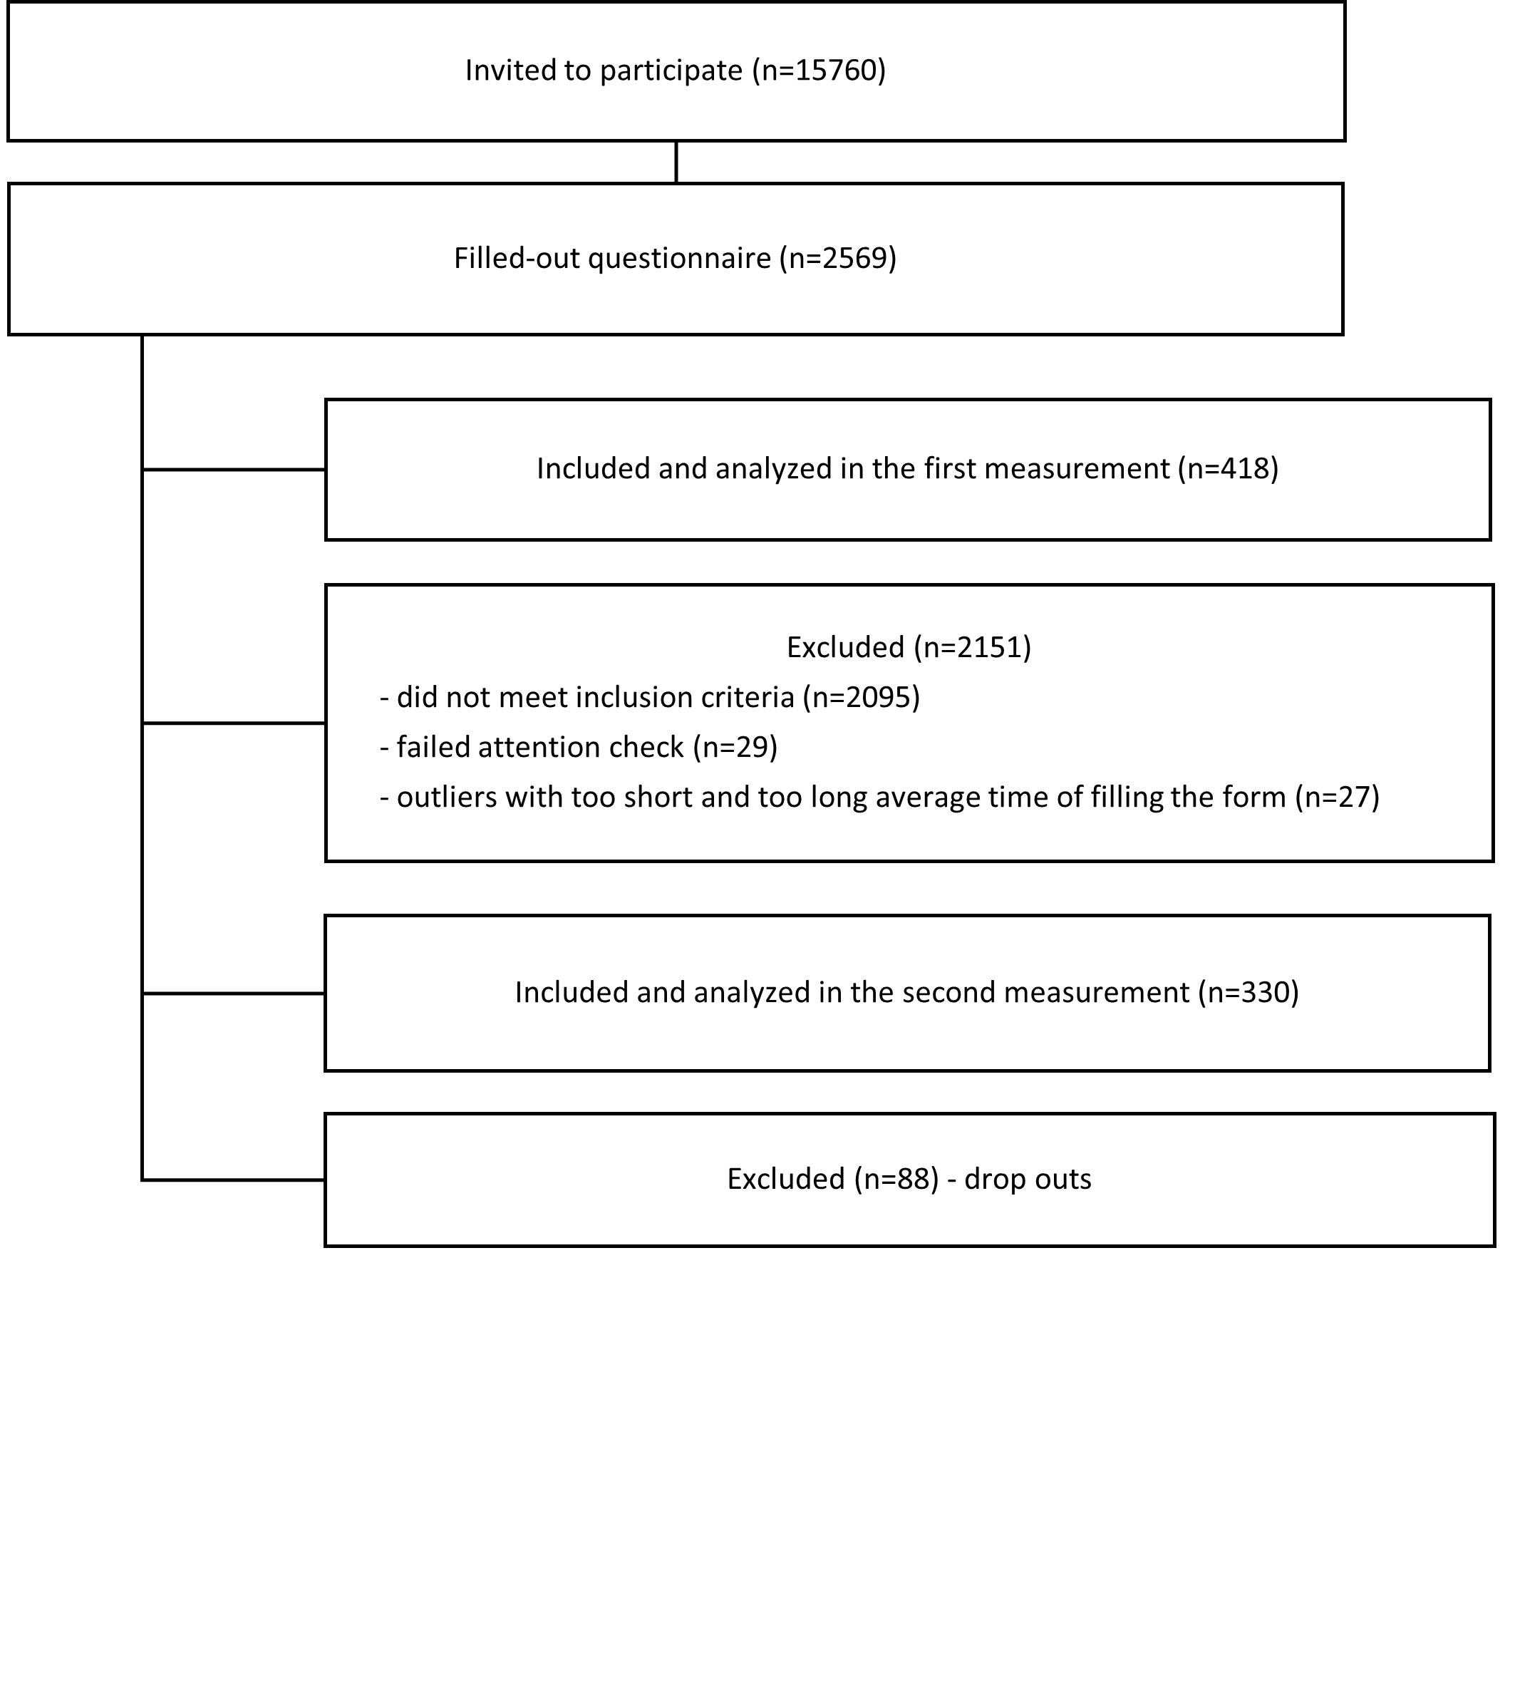

Supplementary Figure B
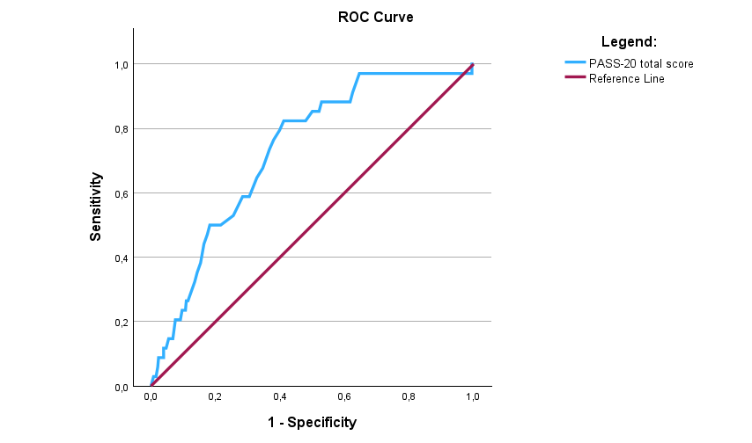
ROC curve for the PASS-20 total score (individuals with high disability level vs. individuals with low disability level) – online study.
Supplementary Figure C
Correlation matrix showing associations of the Polish PASS-20 scores with other questionnaires measuring similar constructs – online study.
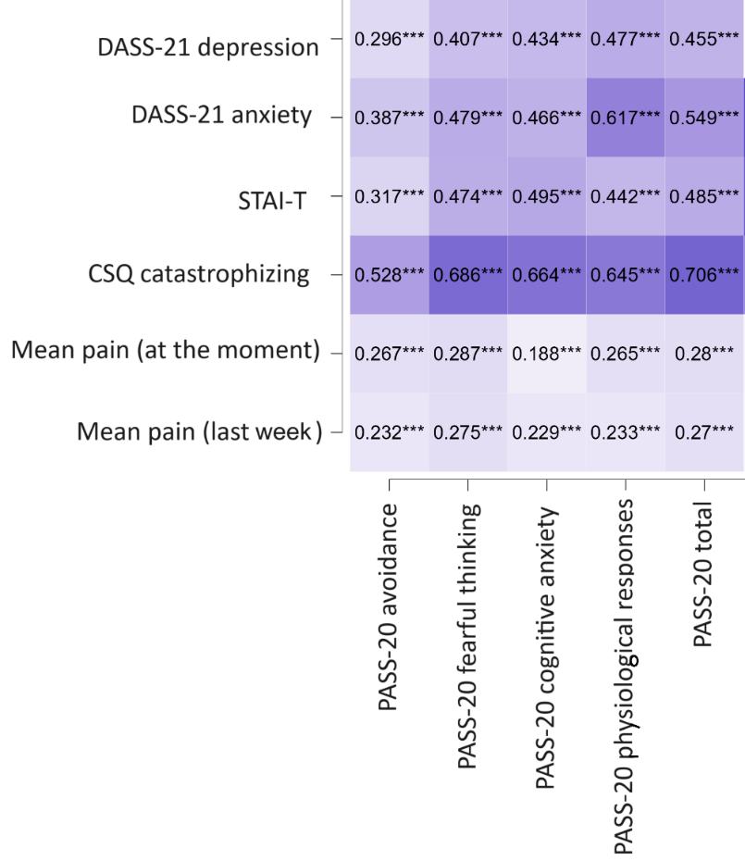
Note: PASS-20 – Pain Anxiety Symptom Scale 20-item version; DASS-21 – Depression Anxiety Stress Scales 21-item version; STAI-T – The State-Trait Anxiety Inventory – Trait form; CSQ catastrophizing – Catastrophizing subscale of Coping Strategies Questionnaire; positive correlations are marked in blue; density represents strength of the associations
***p<0.001

Supplementary Figure D
Factor Loadings for the Four Correlated Factors Model (A) and Higher-Order Model (B), including covariates between items 12 and 15 in the hospital-recruited sample
Note: N=136; Standardized coefficients are presented. Statistically significant paths (all p<0.001) are depicted with solid lines.

Polish translation of PASS-20 scale

Polska wersja: 20-item Pain Anxiety Symptoms Scale (PASS-20)
Doświadczając bólu, różne osoby różnie na niego reagują. Chcielibyśmy dowiedzieć się, co Pan/Pani robi i o czym myśli, kiedy odczuwa ból. Za pomocą poniższej skali prosimy wskazać, jak często zdarzają się Panu/Pani wymienione myśli lub działania. W każdym punkcie prosimy zakreślić właściwą cyfrę od 0 (NIGDY) do 5 (ZAWSZE).

1. Myślę, że jeśli ból zbytnio się nasili, to już nigdy nie osłabnie 0 1 2 3 4 5
2. Kiedy odczuwam ból, boję się, że stanie się coś strasznego 0 1 2 3 4 5
3. Kiedy czuję silny ból, od razu kładę się do łóżka 0 1 2 3 4 5
4. Zaczynam się trząść, kiedy robię coś, co wzmaga ból 0 1 2 3 4 5
5. Kiedy czuję ból, nie jestem w stanie myśleć racjonalnie 0 1 2 3 4 5
6. Kiedy tylko poczuję, że zbliża się ból, rzucam wszystko 0 1 2 3 4 5
7. Ból sprawia, że łomocze mi serce 0 1 2 3 4 5
8. Kiedy tylko nadchodzi ból, biorę leki, by go złagodzić 0 1 2 3 4 5
9. Kiedy czuję ból, zaczynam się obawiać, że to ciężka choroba 0 1 2 3 4 5
10. Podczas ataków bólu trudno mi myśleć o czymkolwiek innym 0 1 2 3 4 5
11. Kiedy mnie boli, unikam ważnych czynności 0 1 2 3 4 5
12. Kiedy czuję ból, mam zawroty głowy albo mdleję 0 1 2 3 4 5
13. Ból mnie przeraża 0 1 2 3 4 5
14. Kiedy mnie boli, bez przerwy o tym myślę 0 1 2 3 4 5
15. Ból powoduje u mnie mdłości 0 1 2 3 4 5
16. Kiedy czuję silny ból, obawiam się, że ulegnę paraliżowi albo
zwiększy się moja niepełnosprawność 0 1 2 3 4 5
17. Kiedy mnie boli, mam trudności z koncentracją 0 1 2 3 4 5
18. Po epizodzie bólu trudno mi uspokoić swoje ciało 0 1 2 3 4 5
19. Martwię się, kiedy czuję ból 0 1 2 3 4 5
20. Staram się nie robić rzeczy, które powodują ból 0 1 2 3 4 5

Adapted from “A Short Version of the Pain Anxiety Symptoms Scale (PASS-20): Preliminary Development and Validity” by L.M. McCracken and L. Dhingra, 2002, Pain Research and Management, 7(1), p. 47 (https://doi.org/10.1155/2002/517163). CC BY.

