Supplemental Table 1
The Gambling Disorder Test (GDT)

Instructions: The questions below are about your gambling activity† during the past year (i.e., last 12 months). Note that gambling here refers to any activity where you bet money on an unknown outcome (e.g., a game or sporting event) for the chance to win money.

Item | Never | Rarely | Sometimes | Often | Very often
1. I have had difficulties controlling my gambling activity | 1 | 2 | 3 | 4 | 5
2. I have given increasing priority to gambling over other life interests and daily activities | 1 | 2 | 3 | 4 | 5
3. I have continued gambling despite the occurrence of negative consequences | 1 | 2 | 3 | 4 | 5
4. I have experienced significant problems in life (e.g., personal, family, social, education, occupational) due to the severity of my gambling behavior | 1 | 2 | 3 | 4 | 5
†These instructions are for the broad assessment of Gambling Disorder symptoms, regardless of where it takes place. However, if the intention to use the GDT is to assess Gambling Disorder in the context of online gambling activities only, then the following set of instructions is recommended: ‘The questions below are about your online gambling activity (as opposed to land-based / offline gambling) during the past year (i.e., last 12 months). Note that online gambling here refers only online gambling activities where you bet money on an unknown outcome (e.g., a game or sporting event) for the chance to win money using any internet-connected device.’.
Note. Scoring information: Total scores are obtained by totaling up participant’s responses to all items of the GDT (range 4 to 20 points), with higher scores suggesting greater levels of disordered gambling symptoms. If necessary, disordered gambling gamblers may be identified by inspecting if participants endorsed all four items of the GDT (i.e., answering 4: Often or 5: Very Often to all four items).

Supplemental Table 2
Sample Structure and Splitting Information
Sample | Size (n) | Mean age (SD) | Age range† | Gender (n, %)
Complete | 1,028 | 46.54 (15.71) | 18-87 | Female (524, 50.97%)
 |  |  |  | Male (495, 48.15%)
 |  |  |  | Other (9, 0.88%)
1 | 514 | 45.50 (15.79) | 18-87 | Female (267, 51.95%)
 |  |  |  | Male (242, 47.08%)
 |  |  |  | Other (5, 0.97%)
2 | 514 | 47.58 (15.58) | 18-80 | Female (257, 50%)
 |  |  |  | Male (253, 49.22%)
 |  |  |  | Other (4, 0.78%)
Abbreviations. SD = Standard deviation
†: Age ranges from Sample 1 and Sample 2 do not match because only one participant reported an age of 87, with a total of four participants reporting being aged between 80 to 87 years.

Supplemental Analysis: Item Response Theory (IRT)
As requested by the reviewer, a Graded Response Model (GRM) was applied to evaluate the psychometric properties of the GDT. The GRM is a type of Item Response Theory (IRT) model specifically suited for items with ordered categorical responses, such as Likert-type scales. It estimates both discrimination (how well items distinguish between individuals with different levels of the latent trait) and threshold parameters (difficulty levels at which individuals are likely to endorse each response category) for each item. This approach allows for an evaluation of item performance across varying levels of GD severity, making it particularly suitable for clinical and psychological assessments where symptom severity is graded.
The analysis was conducted in R version 4.4.1 “Race for Your Life” using the package mirt (v 1.42), a robust tool for IRT analysis that allows for flexible modeling of both unidimensional and multidimensional traits. Data were then analyzed using the GRM function (itemtype = "graded" in mirt). This model was chosen to capture the ordered nature of the WHO-GDT responses while allowing each item to vary in its discrimination ability.
After fitting the GRM, Item Information Curves (IICs) and the Test Information Curve (TIC) were generated to visually assess the precision of each item and the overall test across levels of GD severity (latent trait θ). The IICs provide information about where each item is most informative (i.e., where it has the lowest measurement error) across the latent trait continuum, while the TIC combines information from all items to show the precision of the entire scale. To complement the TIC, the Standard Error (SE) was calculated as the inverse of the square root of the test information and was plotted alongside the TIC, offering a clear visualization of the test’s reliability across GD severity levels.

The results of this analysis provided strong evidence supporting the GDT’s psychometric properties. The model converged after 64 iterations with a log-likelihood of -1312.016, indicating a stable solution. The factor loadings for each item were substantial, ranging from .954 to .982, with high communalities (h²) between .910 and .964 (see Supplemental Table 3).
Supplemental Table 3
Factor Loadings and Communalities for the GDT Items in the Graded Response Model (GRM)
Item | Factor Loading (Factor 1) | Communality (h²)
1 | .982 | .964
2 | .968 | .937
3 | .960 | .922
4 | .954 | .910
Note. Sum of Squared Loadings = 3.733; Proportion of Variance Explained = .933.

These values suggest that each item is strongly related to the underlying latent trait, which in this case is Gambling Disorder (GD). The single-factor structure explained 93.3% of the total variance, supporting the unidimensionality of the GDT.
As can be seen in Supplemental Figure 1, the Item Information Curves (IICs) show that each item contributes the most information at moderate-to-high levels of GD, with GDT Item 1 providing the highest peak of information. This indicates that the GDT items are well-suited to measure individuals with moderate to severe levels of GD but may be less informative for individuals with low GD severity.
As shown in Supplemental Figure 2, the Test Information Curve (TIC) further confirms this pattern, with the test providing maximal information and, therefore, greatest measurement precision at moderate-to-high levels of GD. The Standard Error (SE) curve, plotted alongside the TIC, shows that SE is lowest at these levels, signifying high reliability in this range. However, at low levels of GD severity, the SE increases, reflecting reduced measurement precision. Overall, these findings suggest that the GDT is a robust tool for assessing GD, particularly among individuals with clinically significant symptoms, and is less sensitive at detecting minimal or early-stage gambling issues.
Supplemental Figure 1
Item Information Curves for all four items of the GDT (N = 1,028)

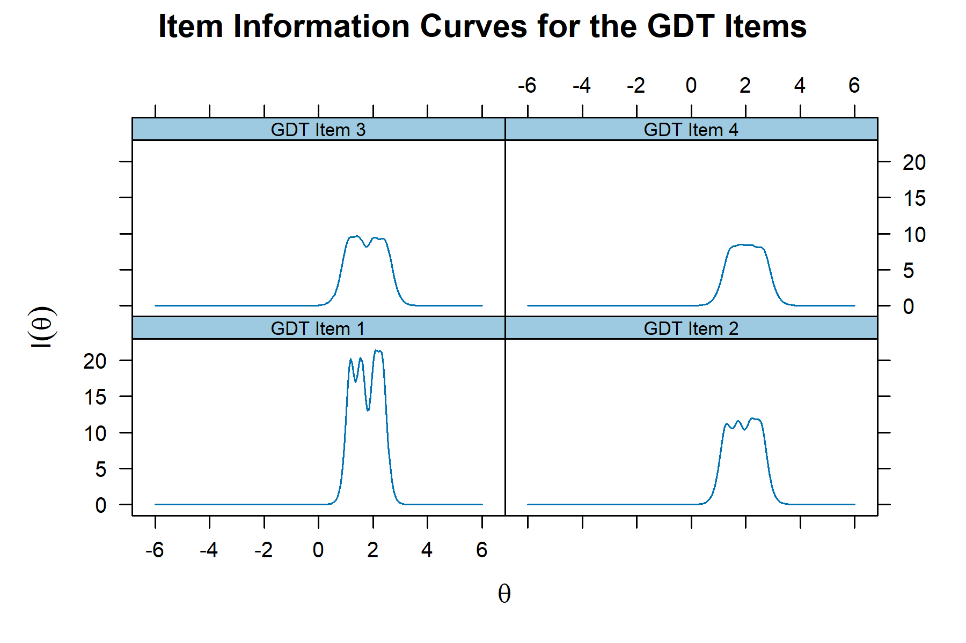

Supplemental Figure 2
Test Information Curve with Standard Error for all four items of the GDT (N = 1,028)
