Supplemental Analyses
We explored additional aspects of the sample in terms of age. Age was unrelated to ICSS scores (r = .03, p = .322) and the frequency of viewing pornography over the past 14 days (r = .04, p = .131), but positively related to the number of sexual partners over the lifetime (r = .24, p < .001). Additionally, the CloudResearch sample scores significantly higher than the undergraduate sample in terms of ICSS scores (F[1, 1305] = 20.01, p < .001), frequency of viewing pornography over the past 14 days (F[1, 1386] = 9.78, p = .002), and the number of sexual partners over the lifetime (F[1, 997] = 42.06, p < .001).

Initial Index of Consensual Sexual Sadism (ICSS) Item Set
Below is a list of behaviors that individuals may engage in alone or with a consenting sexual partner. If you do not have prior experience with a sexual partner, please imagine how you would respond if you did have a sexual partner. Please indicate agreement with each statement below.

1 = Strongly disagree; 7 = Strongly agree

Vicarious Sexual Sadism
1. Fantasizing about dominating my partner is sexually arousing.
2. I fantasize about tying up or confining my partner and/or watch pornography depicting bondage.
3. I enjoy watching rough or violent pornography and/or fantasize about rough or violent sex.
4. I fantasize about and/or watch pornography involving spanking, hitting, and/or whipping.
5. Fantasizing about and/or watching pornography involving others’ pain is sexually arousing.
6. I fantasize about humiliating my partner and/or watch pornography involving humiliation for sexual pleasure.
7. I fantasize about strangling or suffocating my partner and/or watch pornography involving strangulation or suffocation.
8. I fantasize about forcing my partner to ingest my bodily fluids and/or watch pornography that involves ingesting bodily fluids.
9. I fantasize about blindfolding my partner and/or watch pornography involving blindfolding.

Direct Sexual Sadism
10. Dominating my partner is sexually arousing.
11. I enjoy tying up or confining my partner.
12. I enjoy having rough or violent sex with my partner.
13. Spanking, hitting, and/or whipping my partner is pleasurable.
14. Causing pain to my partner is sexually arousing.
15. I humiliate my partner for sexual pleasure.
16. I enjoy strangling or suffocating my partner.
17. I enjoy getting my partner to ingest my bodily fluids.
18. I enjoy blindfolding my partner.

Note. Bolded statements are included in the final scale.

Supplemental Table 1
Exploratory Factor Analysis of 18 ICSS Items per Sample
 | Undergraduate |  | CloudResearch
 | Factor |  | Factor
 | 1 | 2 | 1 | 2
ICSS-vicarious
1. Fantasizing about dominating my partner is sexually arousing. | .75 |  | .91
2. I fantasize about tying up or confining my partner and/or watch pornography depicting bondage. |  | .70 |  | .78
3. I enjoy watching rough or violent pornography and/or fantasize about rough or violent sex. | .33 | .48 | .46 | .41
4. I fantasize about and/or watch pornography involving spanking, hitting, and/or whipping. | .37 | .48 |  | .70
5. Fantasizing about and/or watching pornography involving others’ pain is sexually arousing. | .67 |  | .68
6. I fantasize about humiliating my partner and/or watch pornography involving humiliation for sexual pleasure. | .80 |  | .72
7. I fantasize about strangling or suffocating my partner and/or watch pornography involving strangulation or suffocation. | .72 |  | .81
8. I fantasize about forcing my partner to ingest my bodily fluids and/or watch pornography that involves ingesting bodily fluids. | .64 |  | .82
9. I fantasize about blindfolding my partner and/or watch pornography involving blindfolding. |  | .94 |  | .93
ICSS-direct
10. Dominating my partner is sexually arousing. |  | .70 |  | .73
11. I enjoy tying up or confining my partner. |  | .83 |  | .81
12. I enjoy having rough or violent sex with my partner. |  | .61 | .32 | .49
13. Spanking, hitting, and/or whipping my partner is pleasurable. | .55 |  |  | .62
14. Causing pain to my partner is sexually arousing. | .85 |  | .91
15. I humiliate my partner for sexual pleasure. | .79 |  | .79
16. I enjoy strangling or suffocating my partner. | .72 |  | .81
17. I enjoy getting my partner to ingest my bodily fluids. | .51 |  | .71
18. I enjoy blindfolding my partner. |  | .90 |  | .97

Supplemental Table 2
Exploratory Factor Analysis of Nine ICSS-Vicarious Items per Sample
 | Undergraduate | CloudResearch
 | Factor | Factor
 | 1 | 1
1. Fantasizing about dominating my partner is sexually arousing. | .67 | .78
2. I fantasize about tying up or confining my partner and/or watch pornography depicting bondage. | .82 | .79
3. I enjoy watching rough or violent pornography and/or fantasize about rough or violent sex. | .83 | .85
4. I fantasize about and/or watch pornography involving spanking, hitting, and/or whipping. | .86 | .84
5. Fantasizing about and/or watching pornography involving others’ pain is sexually arousing. | .82 | .89
6. I fantasize about humiliating my partner and/or watch pornography involving humiliation for sexual pleasure. | .71 | .81
7. I fantasize about strangling or suffocating my partner and/or watch pornography involving strangulation or suffocation. | .73 | .78
8. I fantasize about forcing my partner to ingest my bodily fluids and/or watch pornography that involves ingesting bodily fluids. | .62 | .72
9. I fantasize about blindfolding my partner and/or watch pornography involving blindfolding. | .74 | .73

Supplemental Table 3
Exploratory Factor Analysis of Nine ICSS-Direct Items per Sample
 | Undergraduate | CloudResearch
 | Factor | Factor
 | 1 | 1
10. Dominating my partner is sexually arousing. | .73 | .83
11. I enjoy tying up or confining my partner. | .82 | .87
12. I enjoy having rough or violent sex with my partner. | .69 | .74
13. Spanking, hitting, and/or whipping my partner is pleasurable. | .80 | .80
14. Causing pain to my partner is sexually arousing. | .77 | .81
15. I humiliate my partner for sexual pleasure. | .60 | .72
16. I enjoy strangling or suffocating my partner. | .77 | .71
17. I enjoy getting my partner to ingest my bodily fluids. | .63 | .62
18. I enjoy blindfolding my partner. | .79 | .77

Supplemental Table 4
Item Response Theory Parameters for ICSS Items per Sample
 | Undergraduate |  |  |  |  |  |  | CloudResearch
Item | a | b₁ | b₂ | b₃ | b₄ | b₅ | b₆ | a | b₁ | b₂ | b₃ | b₄ | b₅ | b₆
ICSS-vicarious
1 | 3.51 | 1.17 | 1.57 | 1.72 | 2.13 | 2.46 | 2.55 | 4.20 | 1.01 | 1.28 | 1.38 | 1.55 | 1.90 | 2.17
2 | 4.29 | .92 | 1.20 | 1.35 | 1.52 | 1.91 | 2.13 | 4.26 | .67 | .97 | 1.12 | 1.21 | 1.50 | 1.89
3 | 3.62 | .88 | 1.11 | 1.28 | 1.47 | 1.85 | 2.22 | 3.95 | .69 | .91 | 1.06 | 1.20 | 1.62 | 1.95
4 | 4.36 | .93 | 1.20 | 1.35 | 1.53 | 1.89 | 2.23 | 4.06 | .65 | .99 | 1.13 | 1.26 | 1.52 | 1.94
5 | 4.85 | 1.18 | 1.44 | 1.60 | 1.85 | 2.09 | 2.43 | 5.31 | .90 | 1.18 | 1.32 | 1.50 | 1.68 | 1.99
6 | 4.02 | 1.38 | 1.70 | 1.88 | 2.20 | 2.50 | 2.59 | 4.96 | 1.02 | 1.33 | 1.43 | 1.54 | 1.87 | 2.03
7 | 5.17 | 1.25 | 1.53 | 1.60 | 1.76 | 2.10 | 2.42 | 4.96 | 1.05 | 1.36 | 1.51 | 1.65 | 2.03 | 2.13
8 | 3.56 | 1.35 | 1.59 | 1.68 | 1.90 | 2.23 | 2.52 | 3.36 | 1.12 | 1.40 | 1.52 | 1.70 | 2.09 | 2.41
9 | 3.84 | .91 | 1.12 | 1.26 | 1.41 | 1.78 | 2.17 | 3.38 | .67 | .86 | .99 | 1.18 | 1.61 | 2.05
ICSS-direct
10 | 2.66 | .49 | .74 | .92 | 1.23 | 1.71 | 2.12 | 3.50 | .38 | .64 | .77 | 1.01 | 1.38 | 1.85
11 | 3.99 | .90 | 1.16 | 1.25 | 1.50 | 1.83 | 2.16 | 4.33 | .63 | .88 | 1.02 | 1.24 | 1.60 | 2.05
12 | 2.91 | .52 | .75 | 1.00 | 1.31 | 1.72 | 2.09 | 3.20 | .47 | .88 | 1.02 | 1.22 | 1.63 | 2.04
13 | 4.04 | 1.06 | 1.37 | 1.50 | 1.71 | 2.09 | 2.28 | 3.21 | .56 | .86 | 1.07 | 1.34 | 1.80 | 2.06
14 | 5.08 | 1.28 | 1.48 | 1.60 | 1.92 | 2.32 | -- | 6.76 | 1.00 | 1.21 | 1.34 | 1.65 | 1.81 | 2.05
15 | 3.87 | 1.50 | 1.82 | 1.92 | 2.24 | 2.88 | -- | 4.72 | 1.12 | 1.43 | 1.55 | 1.72 | 1.99 | 2.09
16 | 5.13 | 1.30 | 1.51 | 1.58 | 1.77 | 2.09 | 2.32 | 4.07 | 1.10 | 1.41 | 1.53 | 1.73 | 1.94 | 2.20
17 | 2.69 | 1.23 | 1.46 | 1.60 | 1.87 | 2.22 | 2.62 | 2.36 | 1.13 | 1.44 | 1.51 | 1.77 | 2.09 | 2.61
18 | 3.72 | .92 | 1.13 | 1.26 | 1.54 | 1.89 | 2.20 | 2.91 | .56 | .76 | .88 | 1.18 | 1.69 | 2.20

Supplemental Table 5
Exploratory Factor Analysis of the ICSS per Sample
 | Sample
 | Undergraduate | CloudResearch
1. Fantasizing about dominating my partner is sexually arousing. | .74 | .88
2. I fantasize about tying up or confining my partner and/or watch pornography depicting bondage. | .74 | .72
3. I enjoy watching rough or violent pornography and/or fantasize about rough or violent sex. | .70 | .76
7. I fantasize about strangling or suffocating my partner and/or watch pornography involving strangulation or suffocation. | .78 | .82
8. I fantasize about forcing my partner to ingest my bodily fluids and/or watch pornography that involves ingesting bodily fluids. | .63 | .75
13. Spanking, hitting, and/or whipping my partner is pleasurable. | .77 | .70
14. Causing pain to my partner is sexually arousing. | .81 | .92
15. I humiliate my partner for sexual pleasure. | .64 | .79
18. I enjoy blindfolding my partner. | .70 | .60

Supplemental Table 6
Model Fit Indicators for Sex per Sample
Group | n | RMSEA | CFI | SRMR | $χ$²(df)
Undergraduate
Male | 219 | .150 | .898 | .055 | 160.042 (27)
Female | 688 | .178 | .815 | .072 | 612.916 (27)
CloudResearch
Male | 199 | .175 | .885 | .073 | 192.381 (27)
Female | 201 | .199 | .847 | .075 | 242.810 (27)
Note. Age analyses included only CloudResearch participants. Age groups were based on median split (Mdn = 35.00). Younger = 35 and younger; Older = older than 35.

Supplemental Table 7
ICSS Score Descriptive Statistics for Each Sample by Sex and/or Age
Sample | Group |  | n | M (SD) | Min | Max
CloudResearch |  |  | 400 | 1.67 (1.14) | 1.00 | 6.78
 | Sex
 |  | Male | 199 | 1.77 (1.21) | 1.00 | 6.78
 |  | Female | 201 | 1.58 (1.05) | 1.00 | 6.22
 | Age
 |  | Younger | 201 | 1.80 (1.17) | 1.00 | 6.78
 |  | Older | 199 | 1.54 (1.09) | 1.00 | 6.22
Undergraduate Student |  |  | 907
 | Sex
 |  | Male | 219 | 1.71 (1.07) | 1.00 | 5.78
 |  | Female | 688 | 1.33 (.71) | 1.00 | 5.22
Note. Scores are based on the nine-item ICSS. Age groups for the community adult sample were based on median split (Mdn = 35.00). Younger = less than or equal to 35; Older = greater than 35.
Supplemental Table 8
Bivariate Correlations between the ICSS and Outcomes per Sample
Outcome | ICSS
 | Undergraduate | CloudResearch
Sadistic pleasure
Pleasure in sexual contexts | .64ª | .79^{g}
Pleasure in nonsexual contexts | .14ª | .41^{g}
Normal personality
Openness | .07^{b} | .01^{g}
Honesty-Humility | -.08^{b} | -.23^{g}
Emotionality | -.07^{b} | .02^{g}
Conscientiousness | -.14^{b} | -.24^{g}
Agreeableness | -.07^{b} | -.16^{g}
Extraversion | -.06^{b} | -.15^{g}
Personality disorder traits
Antagonism | .25^{c} | .45^{g}
Negative Affect | .08^{c} | .25^{g}
Detachment | .18^{c} | .21^{g}
Disinhibition | .21^{c} | .37^{g}
Psychoticism | .17^{c} | .40^{g}
Antagonistic personality features
Everyday sadism
VAST | .39^{b} | .51^{g}
SSIS | .34^{d} | .51^{g}
ASP | .31e | .49^{g}
Psychopathy | .27^{b} | .40^{g}
Machiavellianism | .21^{b} | .32^{g}
Narcissism | .05^{b} | .26^{g}
Chronic aggression | .23^{c} | .39^{g}
Sexual cognition
Frequency of sadistic sexual fantasies | .68e | .83^{g}
Relationship satisfaction
Romantic relationship satisfaction | -.08^{f} | -.10^{h}
Note. Bolded values are significant at p < .05. ªn = 907; ^{b}n = 826; ^{c}n = 821; ^{d}n = 831; ^{e}n = 823; ^{f}n = 653; ^{g}n = 400; ^{h}n = 358.

Supplemental Table 9
Differences in the Relations between ICSS and Everyday Sadism and Outcomes per Sample
 | Undergraduate |  |  |  |  |  | CloudResearch
Outcome | ICSS | Everyday sadism |  | Steiger t-test |  |  | ICSS | Everyday sadism |  | Steiger t-test
 | r | r | |r_{difference}| | t | df | p | r | r | |r_{difference}| | t | df | p
Sadistic pleasure
Sadistic pleasure in sexual contexts | .64ª | .36^{g} | .28 | 8.95 | 747 | <.001 | .79^{g} | .53^{l} | .26 | 8.82 | 397 | <.001
Sadistic pleasure in nonsexual contexts | .14ª | .47^{g} | .33 | -9.27 | 747 | <.001 | .41^{g} | .59^{l} | .18 | -4.71 | 397 | <.001
Normal personality
Openness | .07^{b} | -.13^{h} | .20 | 4.80 | 666 | <.001 | .01^{g} | -.07^{l} | .08 | 1.71 | 397 | .088
Honesty-Humility | -.08^{b} | -.34^{h} | .26 | 6.51 | 666 | <.001 | -.23^{g} | -.42^{l} | .19 | 4.43 | 397 | <.001
Emotionality | -.07^{b} | -.26^{h} | .19 | 4.63 | 666 | <.001 | .02^{g} | -.02^{l} | .04 | .85 | 397 | .396
Conscientiousness | -.14^{b} | -.24^{h} | .10 | 2.42 | 666 | .016 | -.24^{g} | -.38^{l} | .14 | 3.21 | 397 | .001
Agreeableness | -.07^{b} | -.29^{h} | .22 | 5.41 | 666 | <.001 | -.16^{g} | -.30^{l} | .14 | 3.11 | 397 | .002
Extraversion | -.06^{b} | .01^{h} | .07 | -1.65 | 666 | .099 | -.15^{g} | -.15^{l} | 0 | 0 | 397 | 1.000
Personality disorder traits
Antagonism | .25^{c} | .62^{i} | .37 | -10.86 | .661 | <.001 | .45^{g} | .73^{l} | .28 | -8.53 | 397 | <.001
Negative Affect | .08^{c} | .01^{i} | .07 | 1.65 | 661 | .099 | .25^{g} | .27^{l} | .02 | -.44 | 397 | .660
Detachment | .18^{c} | .33^{i} | .15 | -3.72 | 661 | <.001 | .21^{g} | .35^{l} | .14 | -3.17 | 397 | .002
Disinhibition | .21^{c} | .41^{i} | .20 | -5.12 | 661 | <.001 | .37^{g} | .53^{l} | .16 | -3.99 | 397 | <.001
Psychoticism | .17^{c} | .29^{i} | .12 | -2.94 | 661 | .003 | .40^{g} | .50^{l} | .10 | -2.47 | 397 | .014
Antagonistic personality features
Psychopathy | .27^{b} | .69^{h} | .42 | -13.30 | 666 | <.001 | .40^{g} | .72^{l} | .32 | -9.60 | 397 | <.001
Machiavellianism | .21^{b} | .39^{h} | .18 | -4.58 | 666 | <.001 | .32^{g} | .48^{l} | .16 | -3.86 | 397 | <.001
Narcissism | .05^{b} | .21^{h} | .16 | -3.85 | 666 | <.001 | .26^{g} | .42^{l} | .16 | -3.73 | 397 | <.001
Chronic aggression | .23^{c} | .52^{i} | .29 | -7.87 | 661 | <.001 | .39^{g} | .61^{l} | .22 | -5.84 | 397 | <.001
Sexual cognition
Frequency of sadistic sexual fantasies | .68e | .39^{j} | .29 | 9.13 | 663 | <.001 | .83^{g} | .60^{l} | .23 | 8.22 | 355 | <.001
Relationship satisfaction
Romantic relationship satisfaction | -.08^{f} | -.21^{k} | .13 | 2.79 | 529 | .005 | -.10^{h} | -.17^{m} | .07 | 1.43 | 355 | .154
Note. Bolded values are significant at p < .05. ªn = 907; ^{b}n = 826; ^{c}n = 821; ^{d}n = 831; ^{e}n = 823; ^{f}n = 653; ^{g}n = 750; ^{h}n = 669; ^{i}n = 664; ^{j}n = 666; ^{k}n = 532; ^{l}n = 400; ^{m}n = 358.

Supplemental Table 10
Exploratory Factor Analysis of 18 UASSS Items
 | Factor
 | 1 | 2
ICSS-vicarious
1. Fantasizing about dominating my partner is sexually arousing. | .82 | -.03
2. I fantasize about tying up or confining my partner and/or watch pornography depicting bondage. | .15 | .73
3. I enjoy watching rough or violent pornography and/or fantasize about rough or violent sex. | .37 | .46
4. I fantasize about and/or watch pornography involving spanking, hitting, and/or whipping. | .29 | .57
5. Fantasizing about and/or watching pornography involving others’ pain is sexually arousing. | .70 | .15
6. I fantasize about humiliating my partner and/or watch pornography involving humiliation for sexual pleasure. | .81 | -.02
7. I fantasize about strangling or suffocating my partner and/or watch pornography involving strangulation or suffocation. | .74 | .09
8. I fantasize about forcing my partner to ingest my bodily fluids and/or watch pornography that involves ingesting bodily fluids. | .71 | .01
9. I fantasize about blindfolding my partner and/or watch pornography involving blindfolding. | -.08 | .94
ICSS-direct
10. Dominating my partner is sexually arousing. | .05 | .72
11. I enjoy tying up or confining my partner. | .07 | .83
12. I enjoy having rough or violent sex with my partner. | .20 | .58
13. Spanking, hitting, and/or whipping my partner is pleasurable. | .38 | .42
14. Causing pain to my partner is sexually arousing. | .87 | -.01
15. I humiliate my partner for sexual pleasure. | .83 | -.09
16. I enjoy strangling or suffocating my partner. | .72 | .07
17. I enjoy getting my partner to ingest my bodily fluids. | .57 | .07
18. I enjoy blindfolding my partner. | -.11 | .93

Supplemental Table 11
Exploratory Factor Analysis of Nine ICSS-Vicarious Items
 | Factor
 | 1
1. Fantasizing about dominating my partner is sexually arousing. | .72
2. I fantasize about tying up or confining my partner and/or watch pornography depicting bondage. | .81
3. I enjoy watching rough or violent pornography and/or fantasize about rough or violent sex. | .83
4. I fantasize about and/or watch pornography involving spanking, hitting, and/or whipping. | .85
5. Fantasizing about and/or watching pornography involving others’ pain is sexually arousing. | .85
6. I fantasize about humiliating my partner and/or watch pornography involving humiliation for sexual pleasure. | .76
7. I fantasize about strangling or suffocating my partner and/or watch pornography involving strangulation or suffocation. | .75
8. I fantasize about forcing my partner to ingest my bodily fluids and/or watch pornography that involves ingesting bodily fluids. | .66
9. I fantasize about blindfolding my partner and/or watch pornography involving blindfolding. | .74

Supplemental Table 12
Exploratory Factor Analysis of Nine ICSS-Direct Items
 | Factor
 | 1
10. Dominating my partner is sexually arousing. | .77
11. I enjoy tying up or confining my partner. | .84
12. I enjoy having rough or violent sex with my partner. | .70
13. Spanking, hitting, and/or whipping my partner is pleasurable. | .79
14. Causing pain to my partner is sexually arousing. | .78
15. I humiliate my partner for sexual pleasure. | .65
16. I enjoy strangling or suffocating my partner. | .74
17. I enjoy getting my partner to ingest my bodily fluids. | .63
18. I enjoy blindfolding my partner. | .78

Supplemental Table 13
Model Fit Indicators for Each Sample, Sex, and Age
Group | n | RMSEA | CFI | SRMR | $χ$²(df)
Sample
CloudResearch | 400 | .177 | .877 | .070 | 364.958 (27)
Undergraduate student | 907 | .166 | .854 | .063 | 703.871 (27)
Sex
Male | 418 | .155 | .899 | .055 | 296.836 (27)
Female | 889 | .171 | .848 | .066 | 726.108 (27)
Age
Younger | 201 | .186 | .854 | .074 | 215.253 (27)
Older | 199 | .170 | .897 | .070 | 181.654 (27)
Note. Age analyses included only CloudResearch participants. Age groups were based on median split (Mdn = 35.00). Younger = 35 and younger; Older = older than 35.

Supplemental Table 14
Measurement Invariance Models and Model Fit Indices
Model | RMSEA | CFI | SRMR | $∆$RMSEA | $∆$CFI | $∆$SRMR
Sample
Configural | .170 | .863 | .060 | - | - | -
Metric | .165 | .850 | .083 | -.004 | -.012 | .023
Scalar | .158 | .846 | .085 | -.007 | -.004 | .002
Sex
Configural | .166 | .867 | .057 | - | - | -
Metric | .158 | .861 | .072 | -.008 | -.006 | .015
Scalar | .152 | .855 | .076 | -.006 | -.006 | .004
Age
Configural | .178 | .877 | .066 | - | - | -
Metric | .167 | .877 | .072 | -.012 | .000 | .006
Scalar | .159 | .873 | .074 | -.007 | -.004 | .002
Note. Age analyses included only community adult participants. Age groups were based on median split (Mdn = 35.00). Younger = 35 and younger; Older = older than 35.

Supplemental Table 15
Proportion of Participants Choosing Strongly Disagree or Other Responses for Each Item
Item | Strongly disagree |  | Other responses
 | % | n | % | n
15 | 89.7 | 1172 | 10.3 | 135
8 | 87.1 | 1138 | 12.9 | 169
7 | 86.7 | 1133 | 13.3 | 174
14 | 86.6 | 1132 | 13.4 | 175
1 | 83.6 | 1093 | 16.4 | 214
13 | 77.2 | 1009 | 22.8 | 298
2 | 76.3 | 997 | 23.7 | 310
3 | 75.1 | 982 | 24.9 | 325
18 | 74.4 | 972 | 25.6 | 335
Note. N = 1307.

Supplemental Figure 1
Item Response Category Characteristic Curves
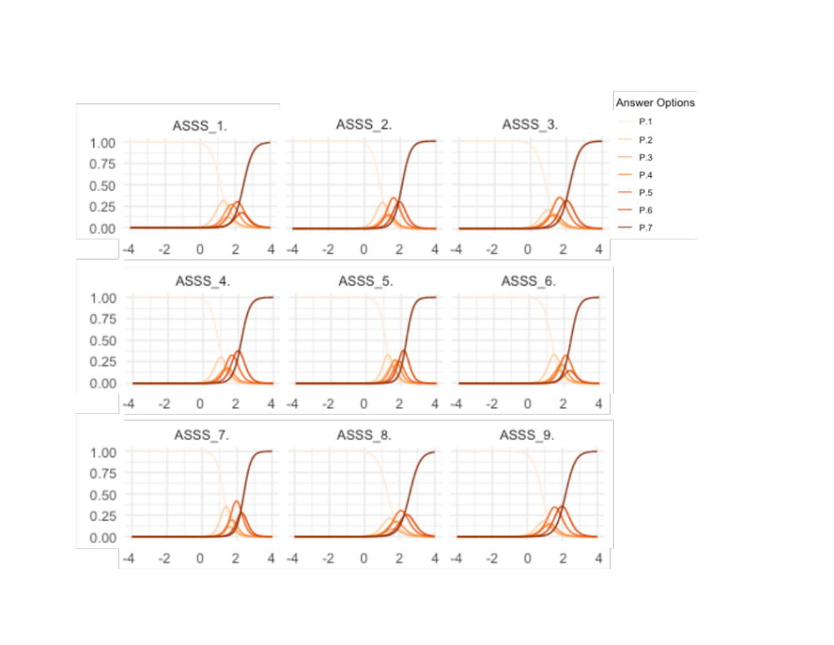
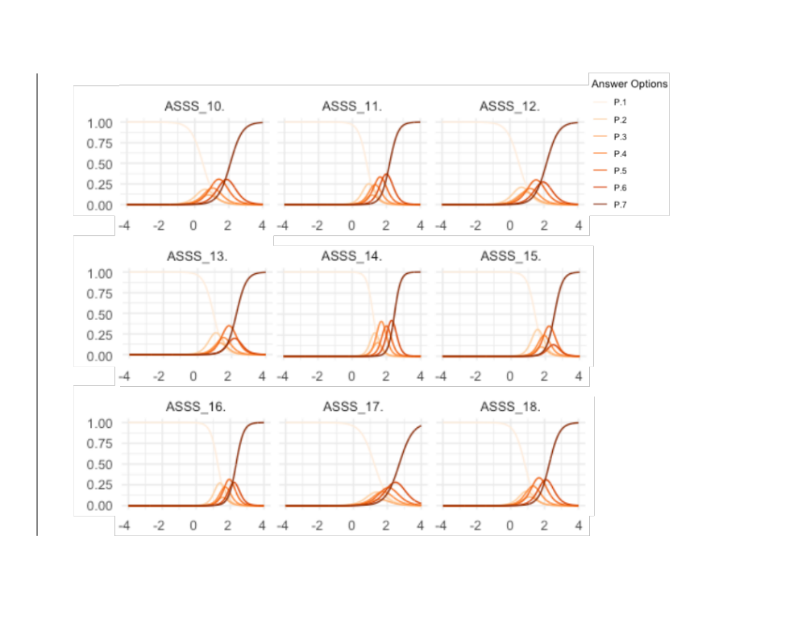
Note. x-axis displays levels of latent subclinical sexual sadism ($θ$); y-axis displays the probability of endorsing a response category.

Supplemental Figure 2
Item Response Information Curves
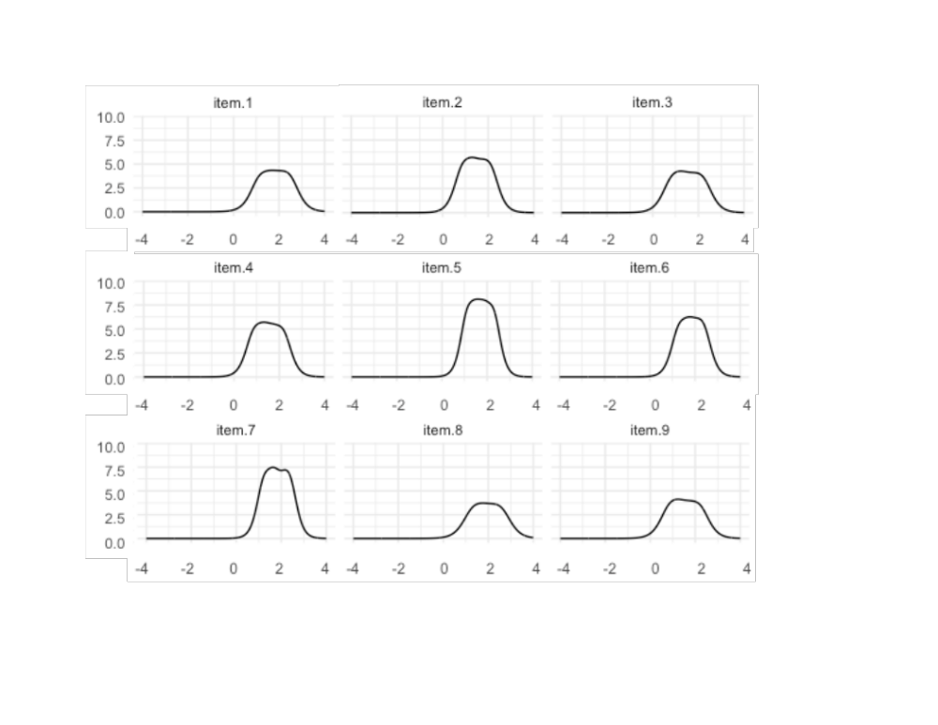
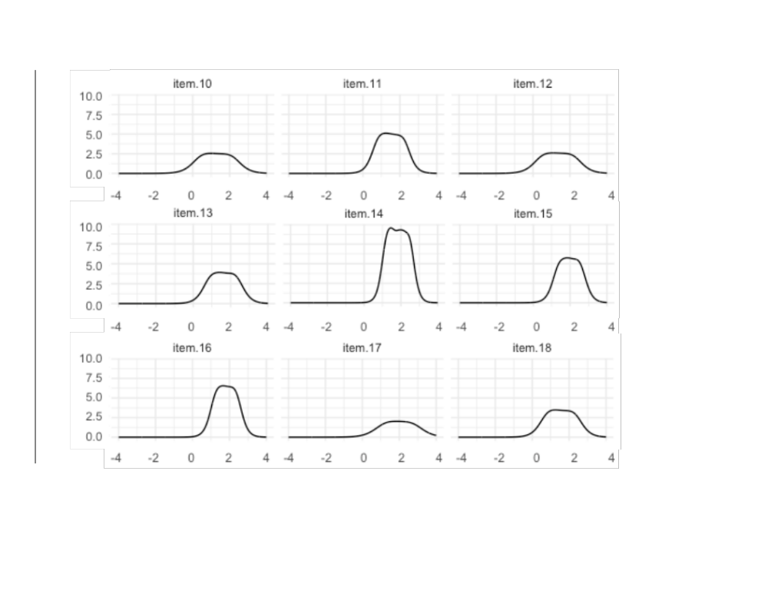
Note. x-axis displays levels of latent subclinical sexual sadism ($θ$); y-axis displays item information.

Supplemental Figure 3
Test Information Curve
