Supplemental Materials for
Development and Validation of the Parental Affection Warmth Scale (PAWS) in a Sample of Parents of 2- to- 8-Year-Olds

Results
Exploratory Factor Analysis
Data Diagnostics
Sample Size. Before conducting exploratory factor analysis (EFA), we evaluated several criteria recommended in the literature to determine the suitability of the data for EFA using full information maximum likelihood estimation (Costello & Osborne, 2005; Watkins, 2018; Yong & Pearce, 2013). We tested whether (a) the sample size was large enough to ensure generalisability and replicability, (b) test items were sufficiently correlated with each other, and (c) the pattern of missing data was missing completely at random or missing at random. First, the sample of 450 met best practice recommendations to have at least 300 participants for EFA (Tabachnick & Fidell, 2013).
Factorability. Second, we assessed the factorability of the correlation matrix (i.e., test items are correlated with each other) using Bartlett’s (1954) Test of Sphericity and Kaiser-Meyer-Olkin (KMO) Measure of Sampling Adequacy statistic (Kaiser, 1974). Bartlett’s Test of Sphericity indicated that the correlation matrix was factorable, χ2 (1378) = 33947.54, p < .001, and the KMO statistic was above the minimum value of .50 required for factor analysis (KMO = .76).
Missing Data. Third, we examined the pattern of missing data on PAWS variables. Responses on 1.92% of PAWS variables were missing. Little’s (1988) Missing Completely at Random Test indicated that missingness was completely at random, χ2 (2565) = 329.84, p < 1.00.
Linear Regression Models
Data Diagnostics
To determine whether regression analyses were appropriate for the data, we tested for (a) linearity in the parameters, (b) independence of errors, (c) homoscedasticity of errors, (d) the absence of problematic univariate and multivariate outliers, (e) the absence of multicollinearity, and (f) normal distribution of errors (Tabachnick & Fidell, 2001). Less emphasis was placed on the normal distribution of errors as results from linear regression analyses are robust to this statistical violation when the sample size is large (i.e., N > 500; Nemes et al., 2009; Williams et al., 2013). Ordinary least squares (OLS) estimation method was used for regression models when assumptions are met (Ernst & Albers, 2017; Williams et al., 2013).
Data were examined for violations of linear regression assumptions. First, the residual plots for all models were randomly scattered rather than curved, indicating that the assumption of linearity was met (Tabachnick & Fidell, 2001). Second, to test the independence of errors, cases were sorted in order of when they completed the survey, and the Durbin-Watson (1950) statistic was calculated for all models. All models had a Durbin-Watson statistic close to 2, suggesting independence of errors. Third, the residual plots of most regression models showed that the variance of residuals was uniform along the predicted dependent variable score, suggesting homoscedasticity of errors (Tabachnick & Fidell, 2001). However, some models showed slight heteroscedasticity, indicated by the non-uniform variance of residuals along the predicted dependent variable. Nevertheless, because the independence of errors assumption was already met, OLS estimates can remain unbiased despite violations of the homoscedasticity assumption (Weisberg, 2005). Fourth, univariate outliers were identified in the residuals plot as cases with standardised residuals above 3.3, and multivariate outliers were identified as cases exceeding the Mahalanobis (1936) distance critical value. However, outliers were retained as there were no justifiable grounds to remove them – the outliers did not represent data entry errors nor were they observations from a member outside of the target population (Williams et al., 2013). Finally, variance inflation factor (VIF) values were less than 10 for all regression models, suggesting an absence of multicollinearity (Tabachnick & Fidell, 2001). As the assumptions of OLS were met, the data were suitable for regression analyses.
Demographic Covariates for Linear Regression Models. The following correlations were observed for parent demographics. As parent age increased, PFQ Positivity scores significantly increased whereas PAWS Toddler-oriented Interaction, PAWS Play-based Interaction, APQ-PR Negative, PFQ Negativity, ECBI Intensity, and ICU scores significantly decreased. Parent ethnicity was uncorrelated with any main study variables. Parents who were married or in a de-facto relationship had significantly higher PAWS Toddler-oriented Interaction, APQ-PR Negative, PFQ Negativity, ECBI Intensity and ICU scores and significantly lower PFQ Positivity scores than single parents. As parents’ level of educational attainment increased, PAWS Toddler-oriented Interaction, APQ-PR Negative, PFQ Negativity, ECBI Intensity, ECBI Problem and ICU scores significantly increased whereas PAWS Warmth, APQ-PR Positive, PFQ Positivity, and MEEC scores significantly decreased. Parents who were employed had significantly higher PAWS Toddler-oriented Interaction, APQ-PR Negative, PFQ Negativity, ECBI Intensity and ICU scores and significantly lower PAWS Warmth, PAWS Total, APQ-PR Positive, PFQ Positivity, and MEEC scores than parents who were unemployed. As parents’ household income increased, APQ-PR Positive, PFQ Positivity, and MEEC scores significantly increased and PFQ Negativity, ECBI Intensity, ECBI Problem and ICU scores significantly decreased. Mothers had significantly higher PAWS Warmth, PAWS Total, APQ-PR Positive, PFQ Positivity, and MEEC scores and significantly lower APQ-PR Negative, ECBI Intensity and ICU scores than fathers. Parents who lived mostly with their child had significantly lower PAWS Warmth, PAWS Total, and APQ-PR Positive scores than parents who did not live mostly with their child. Parent demographics were uncorrelated with the remaining variables.

Supplementary Table 1
Summary of Questionnaire Measures Used to Assess the Convergent, Discriminant and Concurrent Validity of Parental Affection Warmth Scale (PAWS) Scores
 | Construct | Measure
Criterion Validity
 | Positive Parenting | 12-item Positive subscale of the Alabama Parenting Questionnaire Preschool-Revision
 | Positive Feelings | 11-item Positivity subscale of the Parent Feelings Questionnaire
Discriminant Validity
 | Negative Parenting | 7-item Negative/Inconsistent and 2-item Punitive Parenting subscales of the Alabama Parenting Questionnaire Preschool-Revision
 | Negative Feelings | 13-item PFQ Negativity subscale of the Parent Feelings Questionnaire
Concurrent Validity
 | Child Empathy | Measure of Empathy in Early Childhood
 | Child Conduct Problems | Eyberg Child Behavior Inventory
 | Child Callous Unemotional Traits | Inventory of Callous-Unemotional Traits

Supplementary Table 2
Refined Pool of Parental Affection Warmth Scale (PAWS) Items Following Expert Review Process (n = 53), by Category
WACS-II Category | PAWS Item
Tone/Pitch of Voice | I use a positive tone of voice when I talk to my child.
Tone/Pitch of Voice | I use my tone of voice to show my child I'm interested in what they're doing.
Tone/Pitch of Voice | I use baby talk with my child.
Tone/Pitch of Voice | I use a musical voice when I talk to my child.
Tone/Pitch of Voice | I use a sing-song tone when I talk to my child.
Tone/Pitch of Voice | I talk enthusiastically with my child.
Vocally Expressed Affection | I tell my child when they are doing something good.
Vocally Expressed Affection | I tell my child what I love about them.
Vocally Expressed Affection | I tell my child when I am having fun with them.
Vocally Expressed Affection | I talk to my child about happy memories together.
Vocally Expressed Affection | I tell my child that I like what they have created.
Vocally Expressed Affection | I talk to my child about their feelings.
Vocally Expressed Affection | I tell my child that I enjoy playing together.
Vocally Expressed Affection | I tell my child that I have missed them.
Vocally Expressed Affection | I use pet names with my child (e.g. sweetie, baby).
Vocally Expressed Affection | I call my child a special nickname.
Vocally Expressed Affection | I sing to my child.
Vocally Expressed Affection | I tell my child that I love them.
Vocally Expressed Affection | My child and I talk about our feelings together
Facial Expression | I use animated facial expressions towards my child to convey my enthusiasm or interest (e.g., big smile, raise my eyebrows, nod my head, widen my eyes).
Facial Expression | I smile or laugh with my child.
Facial Expression | I mirror my child's positive facial expressions.
Facial Expression | I use my facial expressions to show my child I approve of what they're doing.
Facial Expression | I use my facial expressions to show my child that I care for them.
Physical Touch | I am physically affectionate with my child.
Physical Touch | I hug my child.
Physical Touch | I pat my child on their head/shoulder/leg/back.
Physical Touch | I kiss my child.
Physical Touch | I tickle my child.
Physical Touch | I place my child on my lap.
Physical Touch | I ruffle/stroke my child's hair.
Physical Touch | I adjust my child's clothing/hair etc. in a loving way.
Physical Touch | I put my arm around my child when we're sitting close together.
Action | I join in on my child's games.
Action | I play games with my child (e.g., peekaboo, hide-and-seek, board games).
Action | I dance with my child.
Action | I play wrestle with my child.
Action | I high-five my child.
Action | I do things to make my child laugh.
Action | I show my child how to do new things.
Action | I physically guide my child in learning new skills.
Action | I help my child when they're struggling to do something.
Action | I imitate my child's play.
Action | I read to my child.
Eye Contact | I look my child in the eyes when we talk.
Eye Contact | I look my child in the eyes when we play.
Eye Contact | When something unexpected happens my child and I look at each other.
Body Posture | I face my child when they talk to me.
Body Posture | I face towards my child when we play.
Body Posture | I sit close to my child when we are playing or doing activities.
Body Posture | My body language is relaxed when I'm around my child.
Body Posture | I lean in towards my child to show them I am interested.
Body Posture | I let my child lead when we play together.
Note. WACS-II = Warmth/Affection Coding System Version 2.

Supplementary Table 3
Four-Factor Solution of the Refined 53-Item PAWS
 | F1 | F2 | F3 | F4
PAWS10 - I use my facial expressions to show my child that I care for them. | .76 |  |  | -.13
PAWS8 - I tell my child that I love them. | .73 |  | .11 | -.23
PAWS4 - I tell my child when I am having fun with them. | .70 |  | -.18
PAWS2 - I tell my child what I love about them. | .63 | .18
PAWS48 - I tell my child when they are doing something good. | .62 | -.14
PAWS11 - I show my child how to do new things. | .61 |  | -.21 | .22
PAWS38 - I tell my child that I like what they have created. | .60 | -.15 | .22
PAWS40 - I talk to my child about happy memories together. | .59 | .11
PAWS35 - I use my facial expressions to show my child I approve of what they're doing. | .58 | -.11 | .11
PAWS33 - I face towards my child when we play. | .54 | -.13 | .12
PAWS42 - I use a positive tone of voice when I talk to my child. | .53 |  |  | .24
PAWS6 - I let my child lead when we play together. | .49 | .14 | .19 | -.19
PAWS1 - I tell my child that I enjoy playing together. | .49 | .21 | -.18 | .23
PAWS30 - I talk enthusiastically with my child. | .48 | .11 | .13
PAWS27 - I smile or laugh with my child. | .48 | -.22 | .20 | .11
PAWS16 - I face my child when they talk to me. | .46 | -.17 | .11 | .11
PAWS43 - I read to my child. | .45 | .27 | -.19 | .19
PAWS13 - My child and I talk about our feelings together. | .45 | .26
PAWS46 - I talk to my child about their feelings. | .44 |  | .15
PAWS50 - I look my child in the eyes when we talk. | .43 | -.21 | .21 | .12
PAWS52 - I use my tone of voice to show my child I'm interested in what they're doing. | .42 |  |  | .25
PAWS23 - I tell my child that I have missed them. | .42 |  | .17
PAWS5 - I physically guide my child in learning new skills. | .42 | .17 | -.13 | .27
PAWS39 - I use animated facial expressions towards my child to convey my enthusiasm or interest (e.g., big smile, raise my eyebrows, nod my head, widen my eyes). | .41 |  | .14
PAWS7 - I sit close to my child when we are playing or doing activities. | .40 |  | .15 | .20
PAWS37 - I look my child in the eyes when we play. | .37 |  | .22 | .11
PAWS22 - I lean in towards my child to show them I am interested. | .35 |  | .12 | .20
PAWS3 - I mirror my child's positive facial expressions. | .34 | .31
PAWS51 - My body language is relaxed when I'm around my child. | .34 |  |  | .21
PAWS26 - I use a sing-song tone when I talk to my child. | -.16 | .88 | .15
PAWS31 - I use a musical voice when I talk to my child. |  | .86
PAWS21 - I use baby talk with my child. | -.23 | .77 |  | .11
PAWS12 - I sing to my child. |  | .54 | .23
PAWS9 - I dance with my child. |  | .47 |  | .14
PAWS18 - I tickle my child. | -.12 | .34 | .29 | .27
PAWS25 - I put my arm around my child when we're sitting close together. |  |  | .54 | .10
PAWS44 - I use pet names with my child (e.g. sweetie, baby). | .18 | .20 | .53 | -.16
PAWS34 - I kiss my child. | .13 | .12 | .53
PAWS29 - I ruffle/stroke my child's hair. |  | .18 | .48
PAWS45 - I am physically affectionate with my child. | .13 |  | .48 | .15
PAWS32 - I call my child a special nickname. | .19 | .19 | .39 | -.10
PAWS36 - I adjust my child's clothing/hair etc. in a loving way. | .26 | .16 | .38
PAWS15 - I pat my child on their head/shoulder/leg/back. |  | .11 | .37 | .23
PAWS41 - I place my child on my lap. |  | .31 | .33 | .22
PAWS14 - I help my child when they're struggling to do something. | .20 | -.11 | .16 | .32
PAWS49 - I join in on my child's games. |  | .20 |  | .65
PAWS24 - I play games with my child (e.g., peekaboo, hide-and-seek, board games). | .12 | .19 |  | .58
PAWS53 - I high-five my child. | .12 | .16 | .10 | .36
PAWS20 - I hug my child. | .43 |  | .37
PAWS47 - I play wrestle with my child. | -.29 | .43 |  | .43
PAWS28 - I imitate my child's play. |  | .37 |  | .41
PAWS19 - I do things to make my child laugh. | .31 |  |  | .27
PAWS17 - When something unexpected happens my child and I look at each other. | .21 |  | .11 | .19
Sum of Squared Loadings | 7.63 | 4.32 | 2.08 | 1.89
Proportion Variance | .14 | .08 | .04 | .04
Cumulative Variance | .14 | .23 | .27 | .30
Note. PAWS = Parental Affection Warmth Scale; F1 = Factor 1; F2 = Factor 2; F3 = Factor 3; F4 = Factor 4.

Supplementary Table 4
Five-Factor Solution of the Refined 53-Item PAWS
 | F1 |  | F2 |  | F3 |  |  | F4 |  |  | F5
PAWS10 - I use my facial expressions to show my child that I care for them. | .78 |  |  |  | -.18 |  |  |  |  |  | .16
PAWS4 - I tell my child when I am having fun with them. | .68 |  |  |  |  |  |  | -.15
PAWS2 - I tell my child what I love about them. | .61 |  | .17
PAWS35 - I use my facial expressions to show my child I approve of what they're doing. | .59 |  | -.13 |  |  |  |  |  |  |  | .20
PAWS33 - I face towards my child when we play. | .55 |  | -.15 |  |  |  |  |  |  |  | .20
PAWS48 - I tell my child when they are doing something good. | .55 |  | -.12 |  |  |  |  | .22 |  |  | -.11
PAWS11 - I show my child how to do new things. | .54 |  | .11 |  | .30 |  |  |  |  |  | -.22
PAWS38 - I tell my child that I like what they have created. | .54 |  | -.14 |  |  |  |  | .26
PAWS40 - I talk to my child about happy memories together. | .53 |  | .12 |  | .11 |  |  |  |  |  | -.11
PAWS30 - I talk enthusiastically with my child. | .49 |  |  |  |  |  |  |  |  |  | .19
PAWS42 - I use a positive tone of voice when I talk to my child. | .49 |  |  |  | .24
PAWS6 - I let my child lead when we play together. | .48 |  | .14 |  | -.19 |  |  | .12 |  |  | .11
PAWS1 - I tell my child that I enjoy playing together. | .48 |  | .20 |  | .19 |  |  | -.17
PAWS43 - I read to my child. | .44 |  | .28 |  | .19 |  |  | -.12
PAWS27 - I smile or laugh with my child. | .44 |  | -.22 |  | .12 |  |  | .17 |  |  | .12
PAWS16 - I face my child when they talk to me. | .43 |  | -.17 |  | .12
PAWS23 - I tell my child that I have missed them. | .43 |  |  |  |  |  |  |  |  |  | .22
PAWS52 - I use my tone of voice to show my child I'm interested in what they're doing. | .42 |  |  |  | .20 |  |  |  |  |  | .19
PAWS50 - I look my child in the eyes when we talk. | .41 |  | -.22 |  | .11 |  |  | .13 |  |  | .18
PAWS46 - I talk to my child about their feelings. | .40 |  |  |  |  |  |  | .13
PAWS13 - My child and I talk about our feelings together. | .40 |  | .27 |  |  |  |  | .11 |  |  | -.10
PAWS37 - I look my child in the eyes when we play. | .38 |  |  |  |  |  |  |  |  |  | .28
PAWS5 - I physically guide my child in learning new skills. | .37 |  | .19 |  | .31 |  |  |  |  |  | -.13
PAWS3 - I mirror my child's positive facial expressions. | .36 |  | .30 |  |  |  |  |  |  |  | .15
PAWS22 - I lean in towards my child to show them I am interested. | .33 |  |  |  | .19 |  |  |  |  |  | .11
PAWS26 - I use a sing-song tone when I talk to my child. | -.13 |  | .90 |  | -.10
PAWS31 - I use a musical voice when I talk to my child. |  | .88 |  | -.11
PAWS21 - I use baby talk with my child. | -.22 |  | .80 |  | .11
PAWS12 - I sing to my child. |  |  | .57 |  |  |  |  | .21
PAWS9 - I dance with my child. |  |  | .48 |  | .13
PAWS28 - I imitate my child's play. |  |  | .38 |  | .30 |  |  | -.11 |  |  | .18
PAWS18 - I tickle my child. | -.12 |  | .36 |  | .23 |  |  | .20 |  |  | .16
PAWS41 - I place my child on my lap. | -.12 |  | .34 |  | .22 |  |  | .29
PAWS49 - I join in on my child's games. |  |  | .22 |  | .60
PAWS24 - I play games with my child (e.g., peekaboo,  hide-and-seek, board games). |  | .21 |  | .58
PAWS14 - I help my child when they're struggling to do something. | .12 |  |  |  | .39 |  |  | .26
PAWS34 - I kiss my child. |  |  | .16 |  |  |  |  | .61
PAWS45 - I am physically affectionate with my child. |  |  |  |  | .18 |  |  | .44 |  |  | .17
PAWS44 - I use pet names with my child (e.g. sweetie, baby). | .16 |  | .21 |  | -.16 |  |  | .37 |  |  | .24
PAWS36 - I adjust my child's clothing/hair etc. in a loving way. | .22 |  | .18 |  |  |  |  | .33
PAWS29 - I ruffle/stroke my child's hair. |  |  | .18 |  |  |  |  | .21 |  |  | .41
PAWS15 - I pat my child on their head/shoulder/leg/back. |  | .10 |  | .12 |  |  | .13 |  |  | .40
PAWS25 - I put my arm around my child when we're sitting  close together. |  |  |  |  |  | .30 |  |  | .40
PAWS8 - I tell my child that I love them. | .64 |  |  |  |  |  |  | .32 |  |  | -.24
PAWS39 - I use animated facial expressions towards my child to convey my enthusiasm or interest (e.g., big smile, raise my eyebrows, nod my head, widen my eyes). | .47 |  |  |  |  |  |  |  |  |  | .36
PAWS7 - I sit close to my child when we are playing or doing activities. | .43 |  | -.11 |  | .10 |  |  |  |  |  | .34
PAWS20 - I hug my child. | .35 |  |  |  |  |  |  | .41
PAWS47 - I play wrestle with my child. | -.24 |  | .44 |  | .32 |  |  |  |  |  | .19
PAWS32 - I call my child a special nickname. | .20 |  | .19 |  | -.13 |  |  | .23 |  |  | .23
PAWS17 - When something unexpected happens my child and I look at each other. | .23 |  |  |  | .10 |  |  |  |  |  | .25
PAWS53 - I high-five my child. | .12 |  | .17 |  | .31 |  |  |  |  |  | .14
PAWS19 - I do things to make my child laugh. | .27 |  |  |  | .29 |  |  | .11
PAWS51 - My body language is relaxed when I'm around my child. | .30 |  |  |  | .22
Sum of Squared Loadings | 8.38 |  | 4.07 |  | 2.83 |  |  | 2.40 |  |  | 8.38
Proportion Variance | .16 |  | .08 |  | .05 |  |  | .05 |  |  | .16
Cumulative Variance | .16 |  | .24 |  | .29 |  |  | .33 |  |  | .16
Note. PAWS = Parental Affection Warmth Scale; F1 = Factor 1; F2 = Factor 2; F3 = Factor 3; F4 = Factor 4; F5 = Factor 5.

Supplementary Table 5
Zero-order Correlations Between Demographic and Main Variables
Main Variables | Parent Demographics |  |  |  |  |  |  |  | Child Demographics
Main Variables | Age | Ethnicity | Marital Status | Education | Employment | Household Income | Relationship to Child | Living Mostly with Child |  | Age | Sex
PAWS Warmth | .00 | -.03 | -.02 | -.14** | .14** | .06 | -.17** | .09** |  | .00 | .08*
PAWS Toddler-oriented Interaction | -.15** | .01 | .09** | .12** | -.08* | -.04 | -.02 | .02 |  | -.25** | .03
PAWS Play-based Interaction | -.07* | .01 | .06 | .04 | -.01 | .05 | .02 | .04 |  | -.16** | .00
PAWS Total | -.05 | -.02 | .02 | -.06 | .08* | .04 | -.12** | .08* |  | -.10** | .06
APQ-PR Positive | .01 | .01 | -.02 | -.11** | .17** | .09** | -.13** | .07* |  | .09** | .08*
PFQ Positivity | .07* | -.01 | -.09* | -.22** | .21** | .12** | -.13** | .04 |  | .08* | .09**
APQ-PR Negative | -.16** | .04 | .12** | .24** | -.21** | -.05 | .13** | .01 |  | -.09** | -.10**
PFQ Negativity | -.08* | -.01 | .07* | .21** | -.13** | -.07* | .05 | .01 |  | -.05 | -.11**
MEEC | .02 | -.04 | -.02 | -.08* | .10** | .07* | -.14** | -.03 |  | .07* | .14**
ECBI Intensity | -.08* | -.04 | .10** | .18** | -.11** | -.07* | .07* | -.03 |  | -.09** | -.11**
ECBI Problem | -.06 | .05 | .06 | .08* | -.06 | -.09** | .01 | .02 |  | .01 | -.08*
ICU | -.12** | -.01 | .10** | .23** | -.21** | -.12** | .15** | -.03 |  | -.12** | -.17**
Note. PAWS = Parental Affection Warmth Scale; APQ-PR = Alabama Parenting Questionnaire Preschool-Revision; PFQ = Positive Feelings Questionnaire; MEEC = Measure of Empathy in Early Childhood; ECBI = Eyberg Child Behavior Inventory; ICU = Inventory of Callous-Unemotional Traits. Parent Ethnicity: 1 = White, 2 = Non-white; Marital status: 1 = Single, 2 = Married/De-facto; Education: 1 = Some high school, 2 = High school graduate or GED, 3 = Bachelor's degree, 4 = Master's or higher degree; Employment: 1 = Employed, 2 = Not employed; Household income: 1 = Less than $25,000, 2 = $25,000 - $49,999, 3 = $50,000 - $99,999, 4 = $100,000 - $149,999, 5 = More than $150,000; Relationship to Child: 1 = Mother, 2 = Father; Living Mostly with Child: 1 = Yes, 2 = No; Sex of child: 1 = Male, 2 = Female.
*p < .05. **p < .01.

Supplementary Table 6
Standardised Betas for Regression Models with Simultaneous Entry of PAWS Subscale Scores Predicting Child Empathy and CU Traits for Parents of Children Aged 4-8 Years-Old
Variables | MEEC | ICU
Model 1:
PAWS Warmth | .36** | -.57**
PAWS Toddler-oriented Interaction | -.08 | .53**
PAWS Play-based Interaction | .04 | -.06
Model R² | .13** | .37**

Note. PAWS = Parental Affection Warmth Scale; MEEC = Measure of Empathy in Early Childhood; ICU = Inventory of Callous-Unemotional Traits. *p < .05. **p < .001.

Supplementary Figure 1
Scree Plot
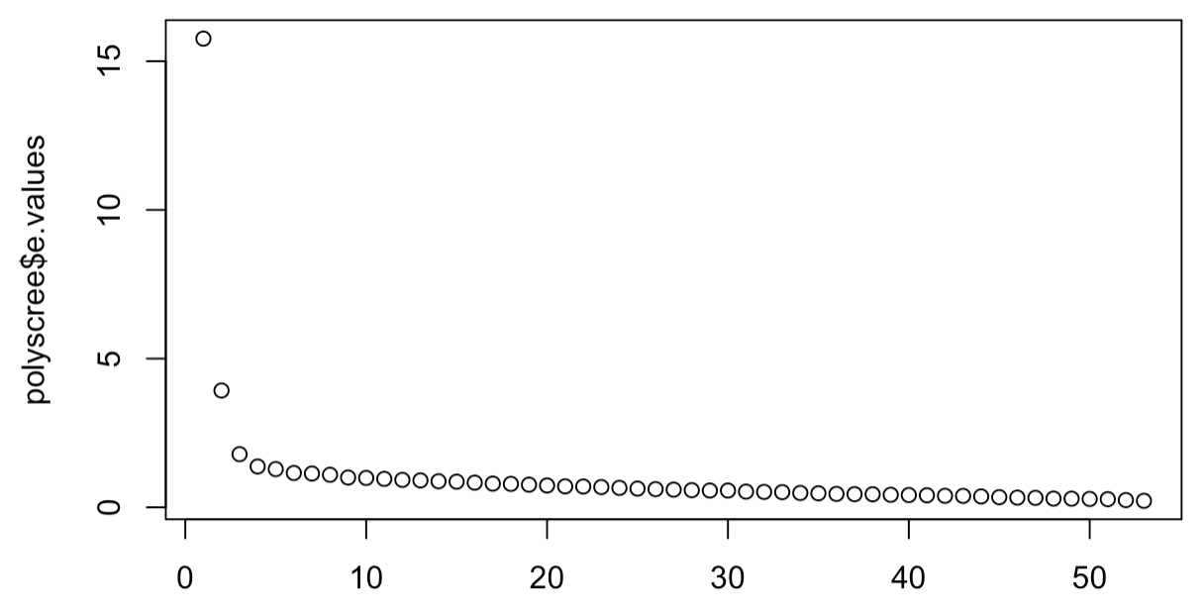
Note. The number of factors to retain is determined by the number of data points above the point of inflexion in scree plots (Costello & Osborne, 2005). There are three data points above the point of inflexion in this scree plot.

Supplementary Figure 2
Parallel Analysis
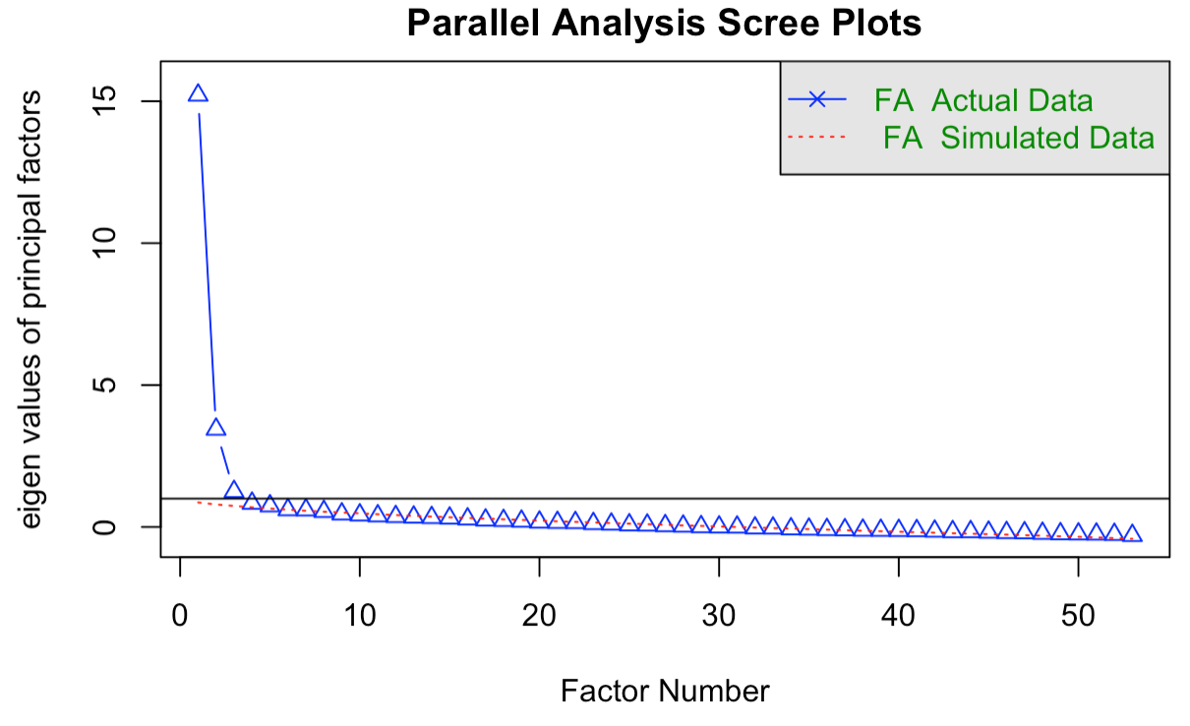
Note. Factors are retained if their actual eigenvalues exceed simulated eigenvalues in parallel analysis (Williams et al., 2010). There are five factors exceeding simulated data in this parallel analysis scree plot.


Supplementary Material 1
Parental Affection Warmth Scale (PAWS)
PAWS
Child’s Name: Child’s Date of Birth: / /
Completed by: Mother Father Other:
Date Completed: / /
Instructions: Please rate how frequently you do each of the following behaviours in an average week. Mark your answer by circling one appropriate number for each statement. Please answer to the best of your ability and do not leave any statement unrated.
 |  | Never or rarely | Sometimes | Often | Very Often
1 | I help my child when they're struggling to do something. | 1 | 2 | 3 | 4
2 | I look my child in the eyes when we play. | 1 | 2 | 3 | 4
3 | I tell my child when they are doing something good. | 1 | 2 | 3 | 4
4 | I lean in towards my child to show them I am interested. | 1 | 2 | 3 | 4
5 | I hug my child. | 1 | 2 | 3 | 4
6 | I adjust my child's clothing/hair etc. in a loving way. | 1 | 2 | 3 | 4
7 | I tell my child that I love them. | 1 | 2 | 3 | 4
8 | I talk to my child about happy memories together. | 1 | 2 | 3 | 4
9 | I kiss my child. | 1 | 2 | 3 | 4
10 | I talk enthusiastically with my child. | 1 | 2 | 3 | 4
11 | I smile or laugh with my child. | 1 | 2 | 3 | 4
12 | I do things to make my child laugh. | 1 | 2 | 3 | 4
13 | I let my child lead when we play together. | 1 | 2 | 3 | 4
14 | I use my facial expressions to show my child I approve of what they're doing. | 1 | 2 | 3 | 4
15 | I use animated facial expressions towards my child to convey my enthusiasm or interest (e.g., big smile, raise my eyebrows, nod my head, widen my eyes). | 1 | 2 | 3 | 4
16 | I tell my child that I have missed them. | 1 | 2 | 3 | 4
17 | I face my child when they talk to me. | 1 | 2 | 3 | 4
18 | I tell my child that I like what they have created. | 1 | 2 | 3 | 4
19 | I tell my child what I love about them. | 1 | 2 | 3 | 4
20 | I face towards my child when we play. | 1 | 2 | 3 | 4
21 | I sit close to my child when we are playing or doing activities. | 1 | 2 | 3 | 4
22 | I use my tone of voice to show my child I'm interested in what they're doing. | 1 | 2 | 3 | 4
23 | I am physically affectionate with my child. | 1 | 2 | 3 | 4
24 | I talk to my child about their feelings. | 1 | 2 | 3 | 4
25 | I put my arm around my child when we're sitting close together. | 1 | 2 | 3 | 4
26 | I tell my child when I am having fun with them. | 1 | 2 | 3 | 4
27 | I use my facial expressions to show my child that I care for them. | 1 | 2 | 3 | 4
28 | I look my child in the eyes when we talk. | 1 | 2 | 3 | 4
29 | My body language is relaxed when I'm around my child. | 1 | 2 | 3 | 4

Supplementary Material 2
PAWS Scoring Information
Description. The 29-item Parental Affection Warmth Scale (PAWS) measures parental warmth.
Scoring. Sum the raw scores. No reverse coding necessary.

References
Bartlett, M. S. (1954). Significance test for sphericity of a normal n-variate distribution. Journal of the Royal Statistical Society, 16, 296-298.
Costello, A. B., & Osborne, J. (2005). Best practices in exploratory factor analysis: Four recommendations for getting the most from your analysis. Research, and Evaluation Practical Assessment, Research, and Evaluation, 10, 7. https://doi.org/10.7275/jyj1-4868
Durbin, J., & Watson, G. S. (1950). Testing for serial correlation in least squares regression: I. Biometrika, 37(3/4), 409. https://doi.org/10.2307/2332391
Ernst, A. F., & Albers, C. J. (2017). Regression assumptions in clinical psychology research practice-a systematic review of common misconceptions. PeerJ, 2017(5). https://doi.org/10.7717/peerj.3323
Kaiser, H. (1974). An index of factorial simplicity. Psychometrika, 39, 31–36. https://doi.org/10.1007/BF02291575
Little, R. J. (1988). A test of missing completely at random for multivariate data with missing values. Journal of the American Statistical Association, 83(404), 1198–1202. https://doi.org/10.1080/01621459.1988.10478722
Mahalanobis, P. C. (1936). On the generalized distances in statistics: Mahalanobis distance. J. Soc. Bengal, 26, 541-588.
Nemes S., Jonasson J. M., Genell A. & Steineck, G. (2009) Bias in odds ratios by logistic regression modelling and sample size. BMC Med Res Methodol. 2009;9:56. doi: 10.1186/1471-2288-9-56.
Tabachnick, B. G., & Fidell, L. S. (2001). Using multivariate statistics (4th ed.). Allyn and Bacon.
Tabachnick, B. G., & Fidell, L. S. (2013). Using multivariate statistics (6th ed.). Pearson Education Inc.
Watkins, M. W. (2018). Exploratory factor analysis: A guide to best practice. Journal of Black Psychology, 44(3), 219–246. https://doi.org/10.1177/0095798418771807
Weisberg, S. (2005). Applied linear regression (Vol. 528). John Wiley & Sons.
Williams, M. N., Grajales, C. A. G., & Kurkiewicz, D. (2013). Assumptions of multiple regression: Correcting two misconceptions. Practical Assessment, Research, and Evaluation, 18(1), 11. https://doi.org/10.7275/55hn-wk47
Williams, B., Onsman, A., & Brown, T. (2010). Exploratory factor analysis: A five-step guide for novices. Australasian Journal of Paramedicine, 8(3). https://doi.org/10.33151/ajp.8.3.93
Yong, A. G., & Pearce, S. (2013). A beginner’s guide to factor analysis: Focusing on exploratory factor analysis. Tutorials in Quantitative Methods for Psychology, 9(2), 79–94. https://doi.org/10.20982/tqmp.09.2.p079

