Supplementary Material 1
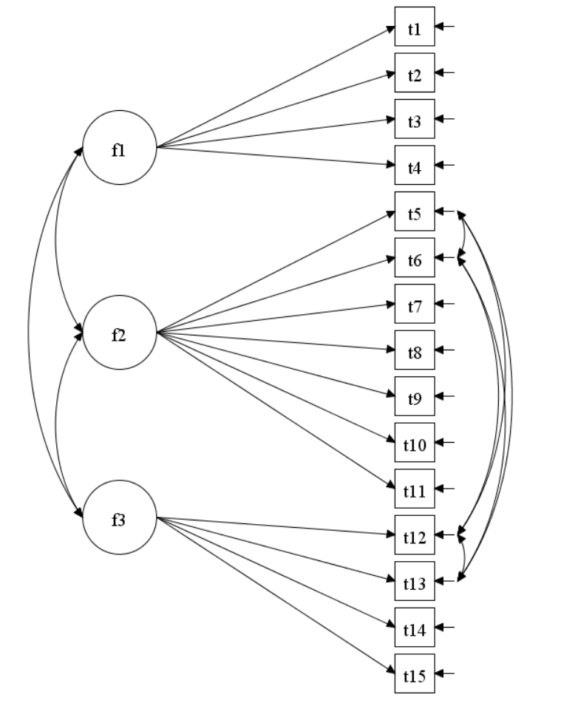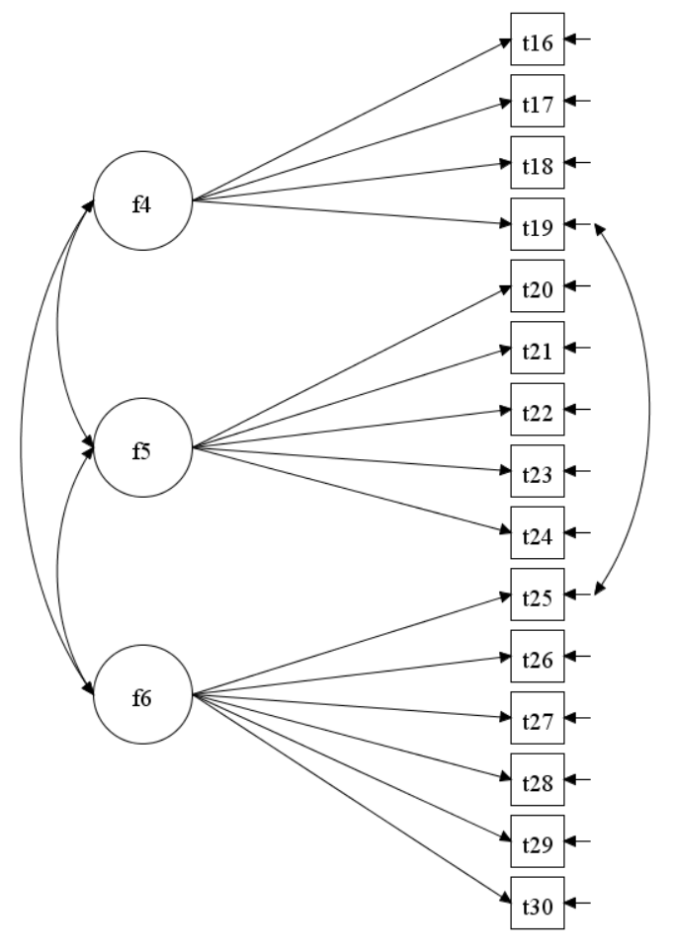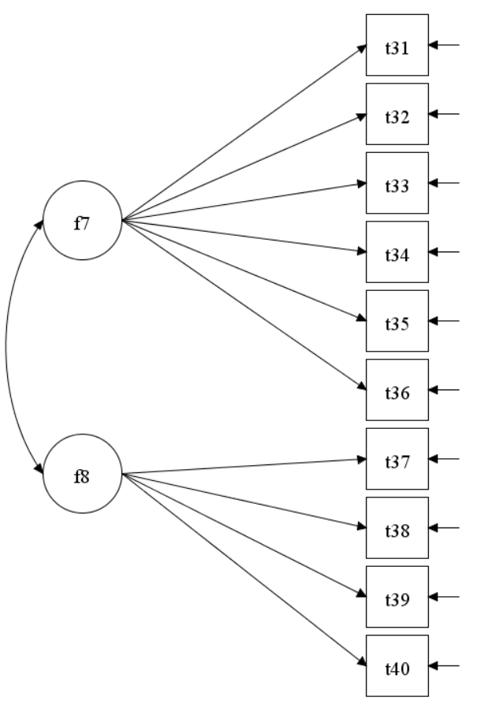
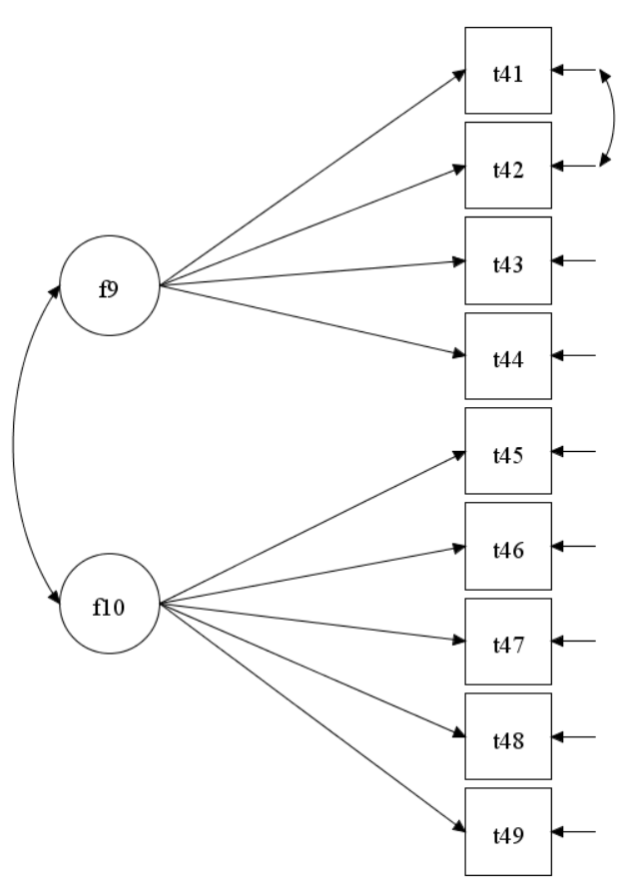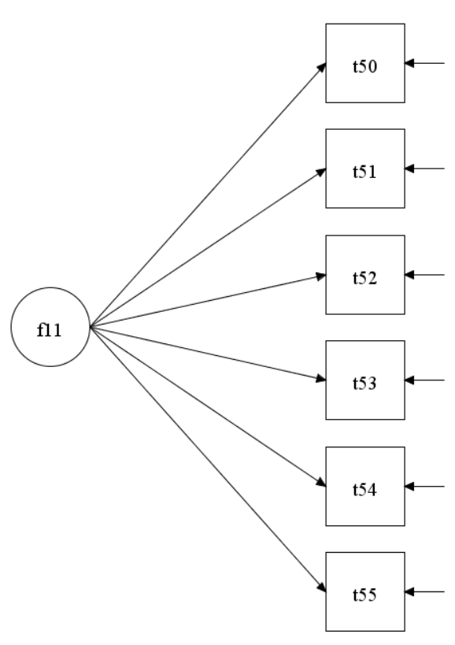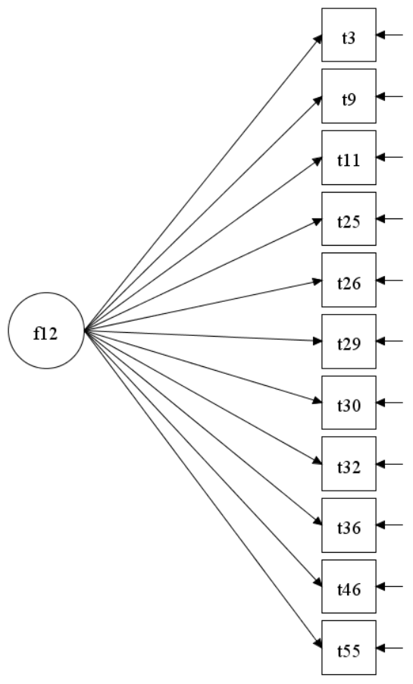
f1: Capacity to Invest f2: Sense of Self f3: Representation of Other
f4: Interpersonal Relationships f5: Sec and Intimacy f6: Internal Investments in Others
f7: Lower-level Defenses f8: Higher-Level Defenses f9: Self-directed Aggression
f10: Other-directed Aggression f11: Moral Values f12: Narcissism
Figure S1. The confirmatory factor analysis for the six dimensions of STIPO-R.

