Details of exploratory analysis of clinical spider-phobic vs. subclinical spider-fearful individuals
To explore potential differences between individuals who meet all criteria for spider phobia according to DSM and those who only meet some criteria, we conducted additional exploratory analyses with these two subgroups of our spider-fearful sample. In this section, we will refer to those individuals who do not meet all criteria of spider phobia as “subclinical spider-fearful” individuals, while those who meet all criteria are referred to as “clinical spider-phobic” individuals. We performed the same analyses as described above when comparing the entire spider-fearful sample with the non-fearful sample. This included mixed ANOVA models to examine whether rl-BAT and vBATon resulted in differences in the number of steps completed and average / max anxiety / disgust ratings. Additionally, we employed the TOST procedure to determine whether the number of steps / ratings in response to both BATs could be considered equal between the spider-fearful and the phobic subgroups.
Of our 31 individuals classified as spider-fearful, 9 met all diagnostic criteria for spider phobia, leaving us with a subsample of 22 spider-fearful individuals. Compared to individuals in the spider-phobic sample, the spider-fearful subsample on average met M = 5.27 (SD = 0.7) DSM criteria. Detailed information regarding the specific criteria fulfilled within the spider-fearful subsample can be found in the online supplement (see Table S2). It is important to exercise caution when interpreting the results reported in this section for two main reasons: (1) the differences in sample size between the two groups and (2) the relatively small sample sizes of both groups. Additionally, it is crucial to note that all analyses reported in this section are exploratory in nature.
The mixed ANOVA models calculated included the factors Phobia Level (subclinical vs. clinical), BAT-Type (rl-BAT vs. vBATon) and BAT Presentation Sequence (vBATon/rl-BAT vs. rl-BAT/vBATon). Regarding the steps completed in both BATs, we found a significant main effect for Phobia Level (F(1, 28) = 7.23, p = .012, η_{p}² = 0.21), indicating that clinical spider-phobic individuals (M = 6.17, SD = 1.82) completed fewer steps compared to those with subclinical spider-fearful (M = 7.73, SD = 1.56). In terms of average / max anxiety ratings, we found a significant main effect of BAT-Type on average anxiety ratings (F(1, 28) = 6.90, p = .014, ηp2 = 0.20). This finding reveals that, similar to our main analysis, the rl-BAT (M = 5.12, SD = 2.21) lead to higher average anxiety ratings than the vBATon (M = 3.98, SD = 1.61) in both groups. No significant effects were found for average / maximum disgust ratings. All other effects not reported here were non-significant and can be found in detail in the online supplement (see Table S3).
The TOST procedures were calculated with equivalence bounds set to ±2 BAT steps completed and anxiety / disgust SUDs. Equivalence was tested for rl-BAT and vBATon in both groups separately. The TOST procedure indicated equivalence of BAT steps completed for the clinical spider-phobic (t(8) = -2.29, p = .028, unstandardized mean difference = 0.56, Hedges’ g = 0.27) and the subclinical spider-fearful (t(21) = -5.36, p < .001, unstandardized mean difference = 0.36, Hedges’ g = 0.25) samples. In contrast, the equivalence hypothesis was not supported for either anxiety rating in the clinical spider-phobic (avgAnx: t(8) = -1.81, p = .054, unstandardized mean difference = 0.56, Hedges’ g = 0.23; maxAnx: t(8) = 1.28, p = .118, unstandardized mean difference = -0.44, Hedges’ g = -0.12) and the subclinical spider-fearful (avgAnx: t(21) = -1.48, p = .077, unstandardized mean difference = 1.38, Hedges’ g = 0.70; maxAnx: t(21) = -1.43, p = .084, unstandardized mean difference = 1.27, Hedges’ g = 0.52) group. This suggests that ratings potentially differed between both BATs within each group, although it needs to be noted that the unstandardized mean differences are below our equivalence bounds. Thus, this result is more likely due to the small samples. Regarding disgust SUDs, equivalence in the clinical spider-phobic group was indicated for average disgust (t(8) = -2.68, p = .014, unstandardized mean difference = 0.31, Hedges’ g = 0.16) but not maximum disgust SUDs (t(8) = 1.05, p = .163, unstandardized mean difference = -0.89, Hedges’ g = -0.27). In the subclinical spider-fearful group, we found equivalence for both average disgust SUDs (avgDisg: t(21) = -2.55, p = .009, unstandardized mean difference = 0.81, Hedges’ g = 0.36) and maximum disgust SUDs (maxDisg: t(21) = -2.65, p = .007, unstandardized mean difference = 0.73, Hedges’ g = 0.32). It is important to note that these results are most likely underpowered, especially in the clinical spider-phobic group. However, the equivalence tests between rl-BAT and vBATon yielded comparable results in both groups for all outcomes except the maximum disgust ratings.
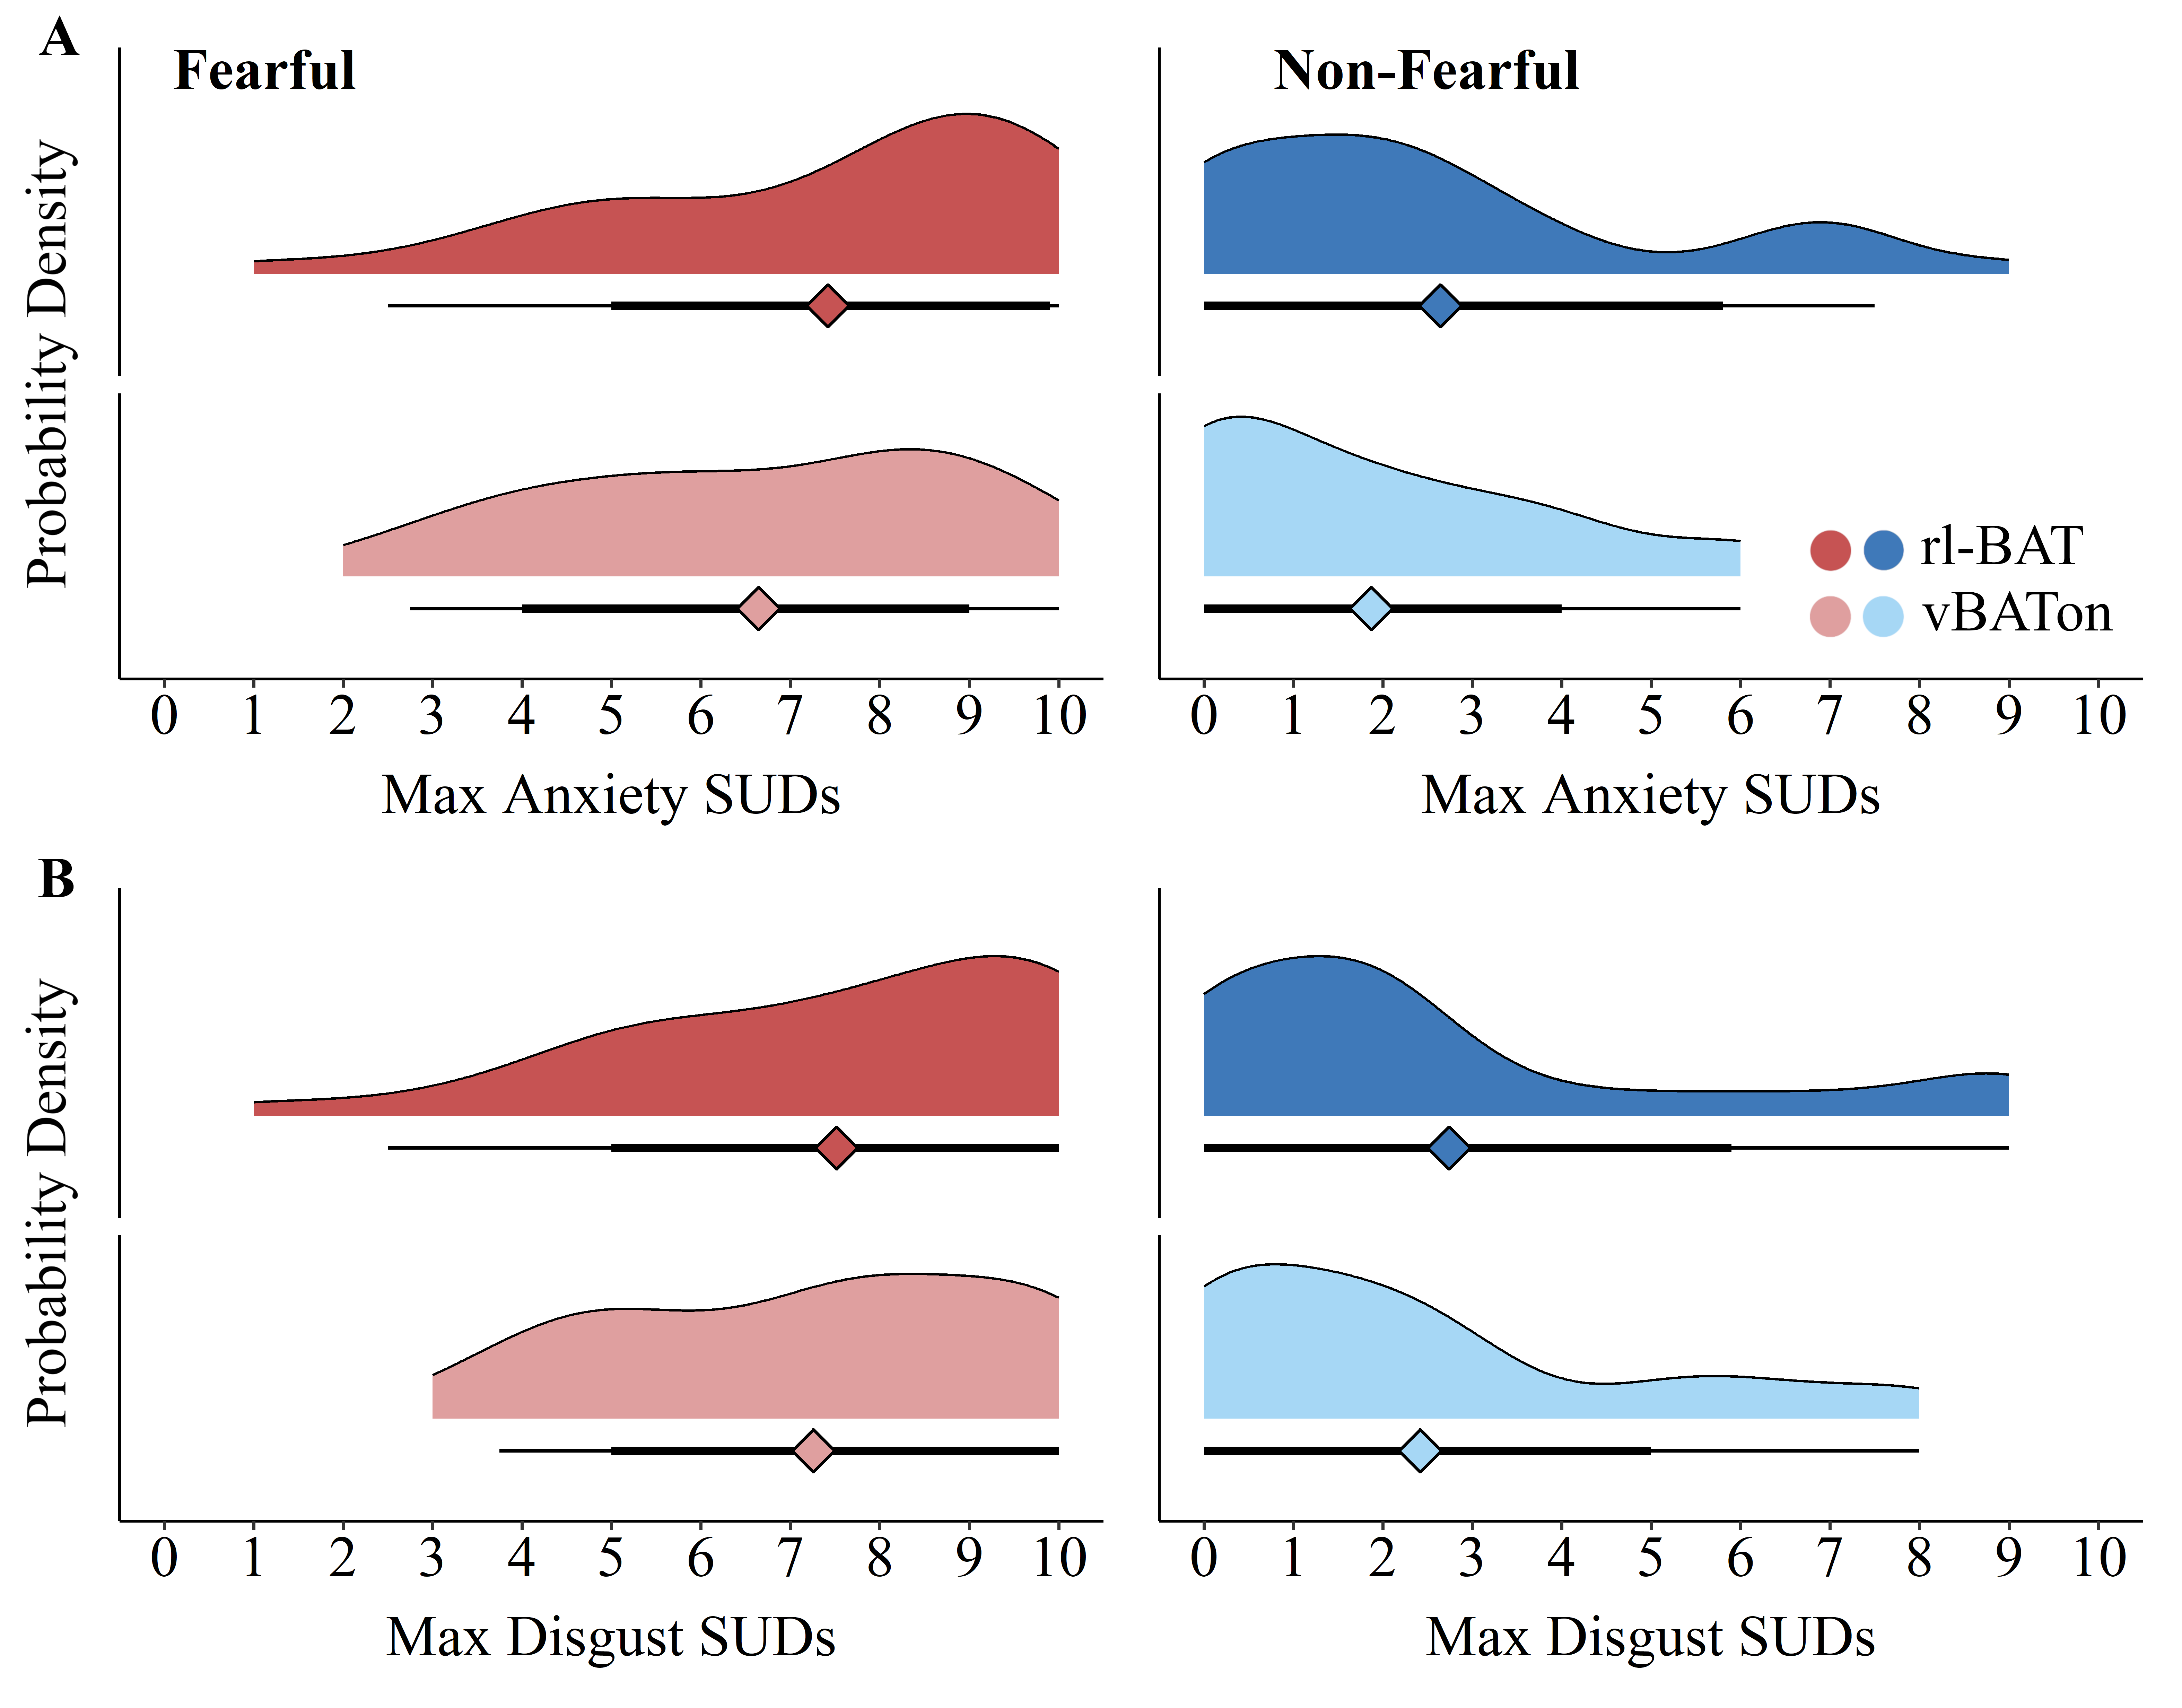
Figure S1. Mean values and probability densities of max anxiety / disgust SUDs for rl-BAT and vBATon in the spider-fearful and non-fearful group. Diamonds represent group means for vBATon and rl-BAT, respectively. Horizontal bars represent quantile intervals.
Table S2. Pearson correlations of BAT outcome variables and questionnaire scores across spider-fearful and non-fearful
individuals.
 | Variable | 1 | 2 | 3 | 4 | 5 | 6 | 7 | 8 | 9 | 10 | 11
rl-BAT | 1. Mean Anxiety
rl-BAT | 2. Mean Disgust | .95**
rl-BAT | 3. Maximum Anxiety | .95** | .91**
rl-BAT | 4. Maximum Disgust | .93** | .93** | .95**
rl-BAT | 5. Steps | -.44** | -.39** | -.49** | -.49**
vBATon | 6. Mean Anxiety | .77** | .72** | .77** | .74** | -.53**
vBATon | 7. Mean Disgust | .74** | .74** | .73** | .75** | -.48** | .92**
vBATon | 8. Maximum Anxiety | .68** | .63** | .72** | .70** | -.54** | .94** | .88**
vBATon | 9. Maximum Disgust | .69** | .68** | .71** | .73** | -.52** | .87** | .93** | .91**
vBATon | 10. Steps | -.50** | -.49** | -.53** | -.54** | .87** | -.63** | -.62** | -.64** | -.67**
 | 11. SPQ Score | .67** | .65** | .64** | .63** | -.79** | .76** | .72** | .73** | .72** | -.85**
 | 12. FSQ Score | .60** | .57** | .57** | .55** | -.71** | .71** | .65** | .68** | .64** | -.76** | .92**
Note. SPQ = Spider Phobia Questionnaire. FSQ = Fear of Spiders Questionnaire. ** = p < .001

Table S3. Details of spider phobia criteria fulfilled / not fulfilled by subclinical spider-fearful individuals.
Criterion | Subclinical spider-fearful, n fulfilled (overall N = 22)
A: Excessive fear | 22
B: Immediate anxiety response | 12
C: Avoidance or extreme distress | 10
D: Disproportionate fear level | 17
E: Duration > 6 months | 22
F: Clinically relevant impact on life | 11
G: Not caused by other disorder | 22

Table S4. Detailed ANOVA results for the exploratory analyses of our main outcomes including the effects of Phobia Level (clinical spider phobic vs. subclinical spider-fearful), BAT Type (rl-BAT vs. vBATon), BAT Presentation Sequence (vBATon/rl-BAT vs. rl-BAT/vBATon) and the Phobia Level x BAT Type interaction.
Outcome | Effect | F (1, 28) | p | η_{p}²
BAT Steps Completed
 | Phobia Level | 7.23 | .012 | .21
 | BAT Type | 1.91 | .178 | .06
 | BAT Presentation Sequence | 0.40 | .533 | .01
 | Phobia Level x BAT Type | 0.09 | .526 | .02
Average Anxiety
 | Phobia Level | 0.02 | .893 | <.01
 | BAT Type | 6.90 | .014 | .20
 | BAT Presentation Sequence | 0.43 | .517 | .02
 | Phobia Level x BAT Type | 1.04 | .317 | .04
Maximum Anxiety
 | Phobia Level | 0.46 | .503 | .02
 | BAT Type | 0.99 | .328 | .03
 | BAT Presentation Sequence | 0.58 | .452 | .02
 | Phobia Level x BAT Type | 2.66 | .114 | .09
Average Disgust
 | Phobia Level | 0.20 | .655 | .01
 | BAT Type | 2.32 | .139 | .08
 | BAT Presentation Sequence | 1.21 | .281 | .04
 | Phobia Level x BAT Type | 0.37 | .551 | .01
Maximum Disgust
 | Phobia Level | 0.26 | .617 | .01
 | BAT Type | 0.01 | .979 | <.01
 | BAT Presentation Sequence | 1.55 | .224 | .05
 | Phobia Level x BAT Type | 2.65 | .115 | .09
Note. Bold F-values denote results with p < .05.

Table S5. Means and standard deviations of BAT steps and anxiety / disgust SUD ratings for vBATon and rl-BAT in the clinical spider-phobic and subclinical spider-fearful groups.
 | Clinical Spider Phobic |  |  | Subclinical Spider-Fearful
 | rl-BAT | vBATon | rl-BAT |  | vBATon
BAT Steps | 6.44 (2.07) | 5.89 (1.62) | 7.91 (1.66) |  | 7.55 (1.47)
Average Anxiety | 4.77 (2.79) | 4.20 (1.81) | 5.27 (1.99) |  | 3.89 (1.56)
Maximum Anxiety | 6.44 (3.00) | 6.89 (2.57) | 7.82 (2.06) |  | 6.55 (2.24)
Average Disgust | 4.32 (2.94) | 4.01 (2.06) | 4.89 (1.84) |  | 4.08 (1.78)
Maximum Disgust | 6.67 (3.24) | 7.56 (2.24) | 7.86 (1.96) |  | 7.14 (2.21)
Note. SUD = Subjective Units of Distress. Average ratings of participants indicate their average rating across all steps. Maximum ratings indicate their highest rating given across all steps.

