Table S1
Fit Measures for Confirmatory Factor Analytic Models in Study 3 (n = 193)
Invariance type | χ² (scaled) | df | Robust CFI | Robust TLI |  | Robust RMSEA |  | SRMR
 | Aggregate CFA (all one-month responses)
N/A | 384.166 | 118 | 0.963 | 0.957 |  | 0.064 |  | 0.077
 | Randomization group (SCR card group / waitlist control)
Configural | 480.826 | 236 | 0.965 | 0.959 |  | 0.064 |  | 0.086
Metric | 454.387 | 251 | 0.962 | 0.958 |  | 0.064 |  | 0.096
Δ (Configural Metric) | -26.439 | 15 | -0.003 | -0.001 |  | 0.000 |  | 0.010
Scalar invariance | 469.903 | 266 | 0.961 | 0.96 |  | 0.063 |  | 0.097
Δ (Metric Scalar) | 15.516 | 15 | -0.001 | 0.002 |  | -0.001 |  | 0.001
 | Age (18–25 years / 26–65 years)
Configural | 533.849 | 236 | 0.963 | 0.958 |  | 0.068 |  | 0.086
Metric | 462.579 | 251 | 0.964 | 0.961 |  | 0.065 |  | 0.095
Δ (Configural Metric) | -71.27 | 15 | 0.001 | 0.003 |  | -0.003 |  | 0.009
Scalar invariance | 498.03 | 266 | 0.961 | 0.96 |  | 0.066 |  | 0.097
Δ (Metric Scalar) | 35.451 | 15 | -0.003 | -0.001 |  | 0.001 |  | 0.002
 | Sex
Configural | 536.321 | 236 | 0.961 |  | 0.955 |  | 0.07 |  | 0.087
Metric | 509.964 | 251 | 0.956 |  | 0.952 |  | 0.072 |  | 0.097
Δ (Configural Metric) | -26.357 | 15 | -0.005 |  | -0.003 |  | 0.002 |  | 0.010
Scalar invariance | 534.299 | 266 | 0.954 |  | 0.953 |  | 0.072 |  | 0.099
Δ (Metric Scalar) | 24.335 | 15 | -0.002 |  | 0.001 |  | 0.000 |  | 0.002
 | Longitudinal invariance (baseline visit / one-month visit)
Configural | 1181.018 | 504 | 0.975 |  | 0.972 |  | 0.052 |  | 0.071
Metric | 1042.507 | 521 | 0.977 |  | 0.975 |  | 0.049 |  | 0.073
Δ (Configural Metric) | -138.511 | 17 | 0.002 |  | 0.003 |  | -0.003 |  | 0.002
Scalar invariance | 1134.576 | 538 | 0.974 |  | 0.973 |  | 0.051 |  | 0.075
Δ (Metric Scalar) | 92.069 | 17 | -0.003 |  | -0.002 |  | 0.002 |  | 0.002
Note. For nested models used for invariance testing, changes (Δ) in fit measures between successive levels of invariance are italicized, and the fit measures used to determine whether invariance was achieved are bolded. df = degrees of freedom; CFI = comparative fit index; TLI = Tucker-Lewis index; RMSEA = root mean square error of approximation; SRMR = standardized root mean square residual; CFA = confirmatory factor analysis; SCR = state cannabis registration.
Table S2
Interval | Outcome | Robust CFI | Robust TLI | Robust RMSEA | SRMR
Baseline to three months (n = 187) | Cannabis use (≥ or < once weekly) | 0.923 | 0.935 | 0.074 | 0.092
Baseline to three months (n = 187) | Pain (BPI pain severity) | 0.938 | 0.935 | 0.068 | 0.090
Baseline to three months (n = 187) | Insomnia (AIS) | 0.943 | 0.940 | 0.065 | 0.089
Baseline to three months (n = 187) | Anxiety (HADS) | 0.939 | 0.936 | 0.068 | 0.090
Baseline to three months (n = 187) | Depression (HADS) | 0.941 | 0.938 | 0.066 | 0.089
Baseline to three months (n = 187) | Physical well-being (SF-12) | 0.935 | 0.932 | 0.070 | 0.091
Baseline to three months (n = 187) | Mental well-being (SF-12) | 0.940 | 0.937 | 0.067 | 0.090
Baseline to twelve months (n = 161) | Cannabis use (≥ or < once weekly) | 0.942 | 0.948 | 0.065 | 0.086
Baseline to twelve months (n = 161) | Pain (BPI pain severity) | 0.953 | 0.951 | 0.057 | 0.085
Baseline to twelve months (n = 161) | Insomnia (AIS) | 0.958 | 0.956 | 0.053 | 0.084
Baseline to twelve months (n = 161) | Anxiety (HADS) | 0.957 | 0.955 | 0.054 | 0.084
Baseline to twelve months (n = 161) | Depression (HADS) | 0.954 | 0.951 | 0.056 | 0.085
Baseline to twelve months (n = 161) | Physical well-being (SF-12) | 0.950 | 0.947 | 0.059 | 0.086
Baseline to twelve months (n = 161) | Mental well-being (SF-12) | 0.954 | 0.952 | 0.056 | 0.085
Fit Measures for Cross-Lagged Panel Models in Study 4
Note. CFI = comparative fit index; TLI = Tucker-Lewis index; RMSEA = root mean square error of approximation; SRMR = standardized root mean square residual; BPI = Brief Pain Inventory; AIS = Athens Insomnia Scale; HADS = Hospital Anxiety and Depression Scale; SF-12 = Short-Form Health Survey.
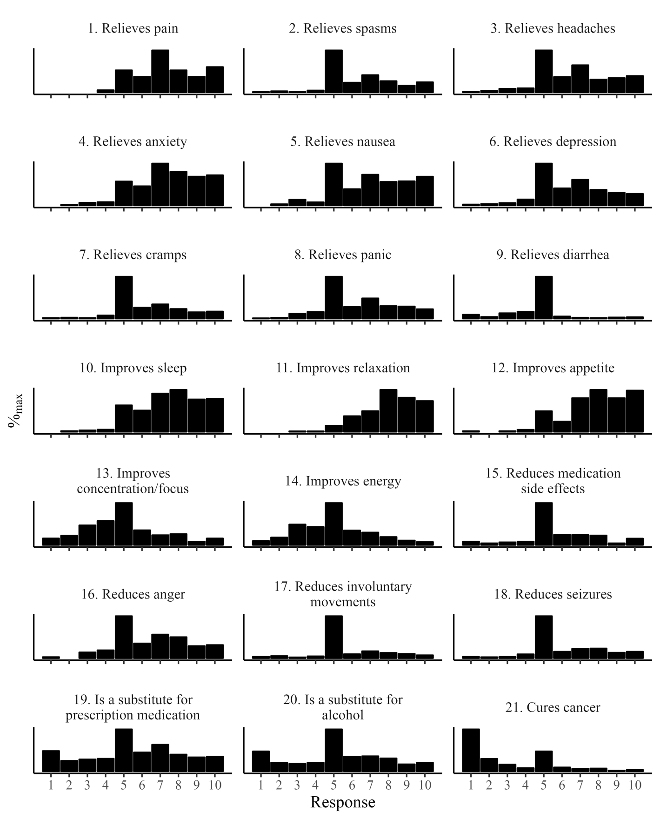
Figure S1
100%
0%
100%
0%
100%
0%
100%
0%
100%
0%
100%
0%
100%
0%
Strongly disagree
Strongly agree
St. d.
St. a.
St. d.
St. a.
CEEQ–M Responses at the Screening Timepoint (n = 269)
Note. “St. d.” = Strongly disagree; “St. a.” = Strongly agree.
Figure S2
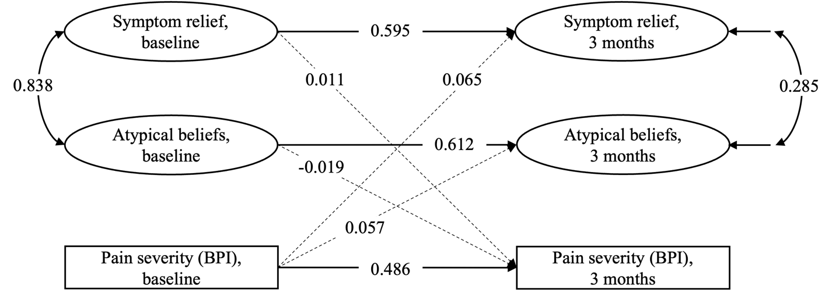
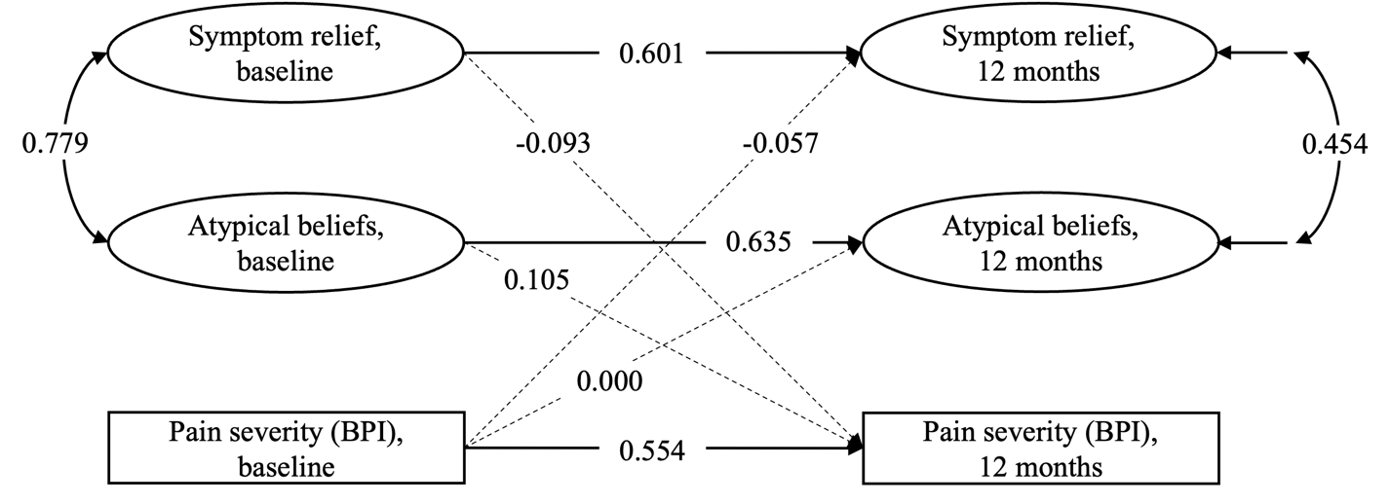
Cross-Lagged Panel Models of CEEQ–M-Measured Latent Variables and Pain Severity in the Past 24 Hours, as Measured by the Brief Pain Inventory (BPI), Between (A) Baseline and Three-Month Timepoints and (B) Baseline and Twelve-Month Timepoints
A
B
Note. Higher BPI scores indicate higher levels of pain. Numeric values correspond to the standardized model solution. Age and sex were included as predictors of three-month and twelve-month variables (paths not shown).
Solid paths are significant (p < 0.05); dashed paths are nonsignificant (p ≥ 0.05).
Figure S3
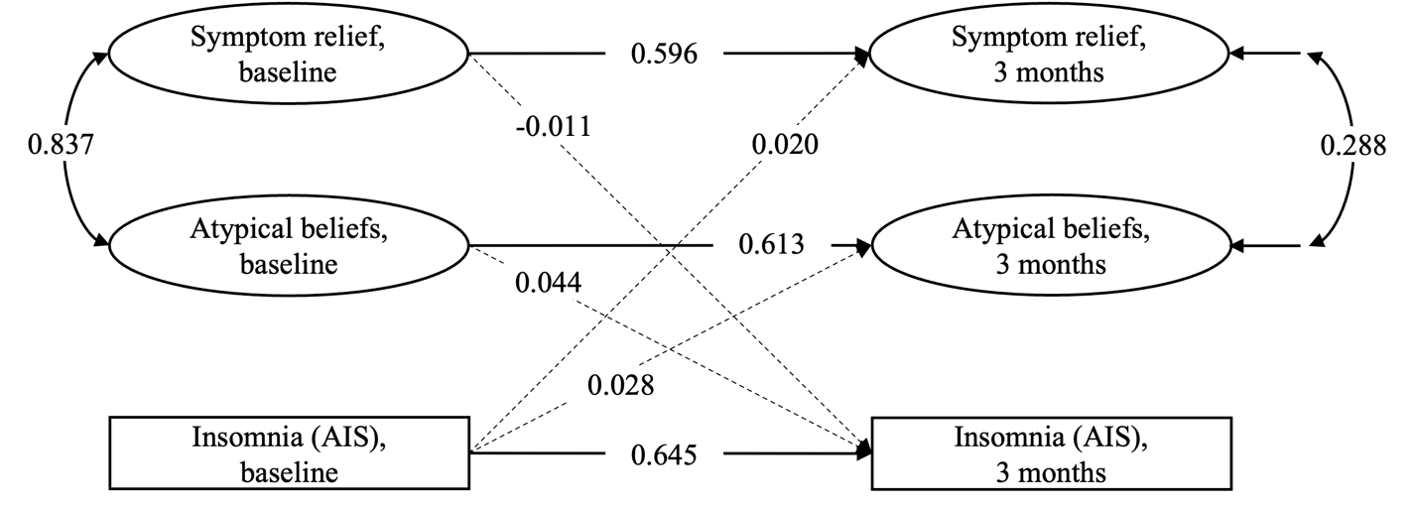
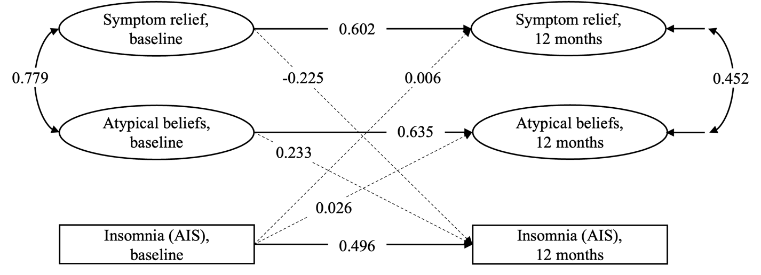
Cross-Lagged Panel Models of CEEQ–M-Measured Latent Variables and Insomnia, as Measured by the Athens Insomnia Scale (AIS), Between (A) Baseline and Three-Month Timepoints and (B) Baseline and Twelve-Month Timepoints
A
B
Note. Higher AIS scores indicate higher levels of insomnia. Numeric values correspond to the standardized model solution. Age and sex were included as predictors of three-month and twelve-month variables (paths not shown).
Solid paths are significant (p < 0.05); dashed paths are nonsignificant (p ≥ 0.05).
Figure S4
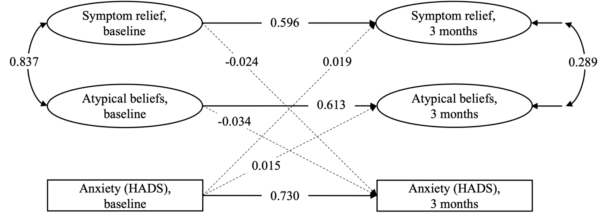
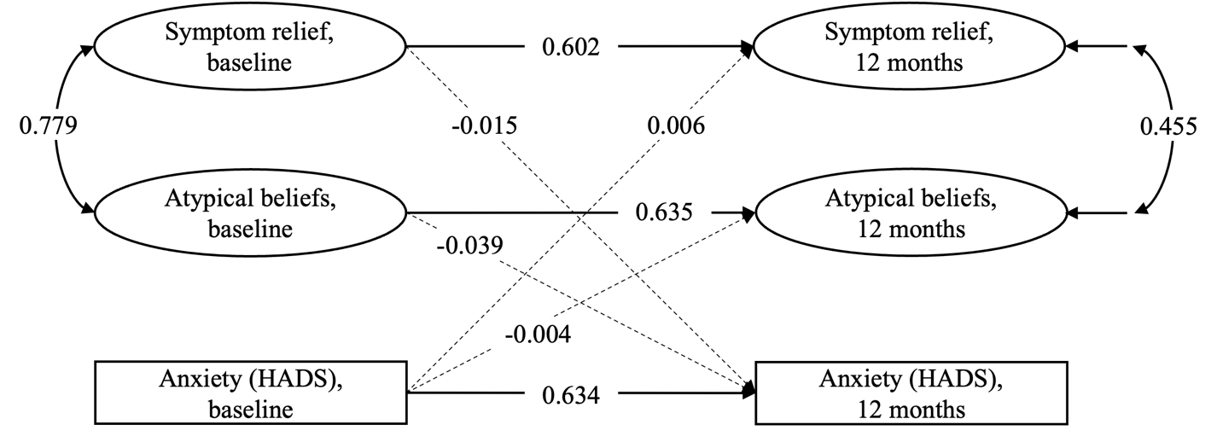
Cross-Lagged Panel Models of CEEQ–M-Measured Latent Variables and Symptoms of Anxiety, as Measured by the Hospital Anxiety and Depression Scale (HADS), Between (A) Baseline and Three-Month Timepoints and (B) Baseline and Twelve-Month Timepoints
A
B
Note. Higher HADS scores indicate a higher degree of symptoms. Numeric values correspond to the standardized model solution. Age and sex were included as predictors of three-month and twelve-month variables (paths not shown).
Solid paths are significant (p < 0.05); dashed paths are nonsignificant (p ≥ 0.05).
Figure S5
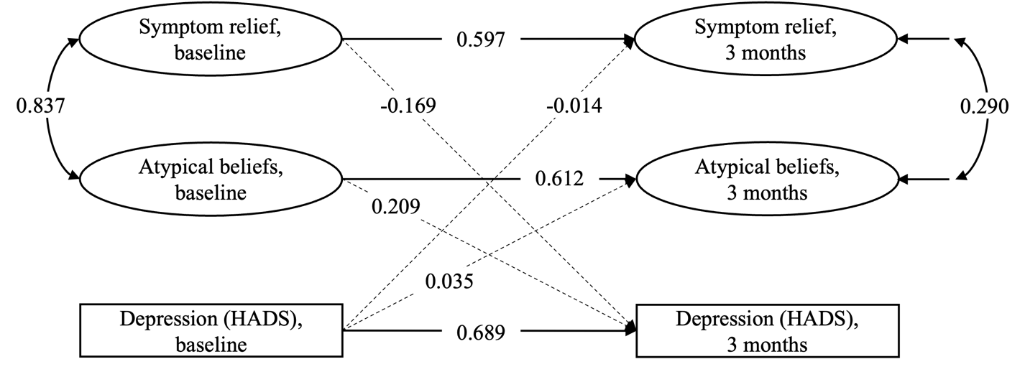
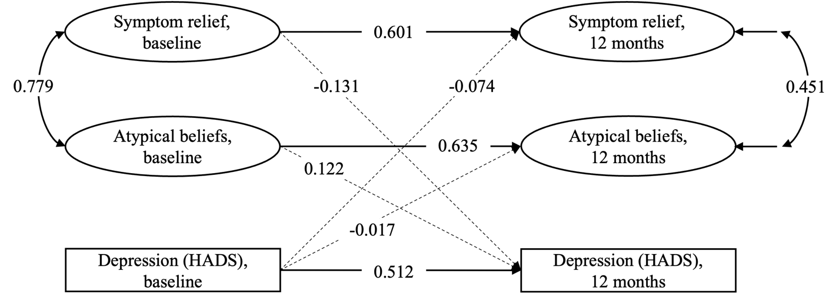
Cross-Lagged Panel Models of CEEQ–M-Measured Latent Variables and Depressive Symptoms, as Measured by the Hospital Anxiety and Depression Scale (HADS), Between (A) Baseline and Three-Month Timepoints and (B) Baseline and Twelve-Month Timepoints
A
B
Note. Higher HADS scores indicate a higher degree of symptoms. Numeric values correspond to the standardized model solution. Age and sex were included as predictors of three-month and twelve-month variables (paths not shown).
Solid paths are significant (p < 0.05); dashed paths are nonsignificant (p ≥ 0.05).
Figure S6
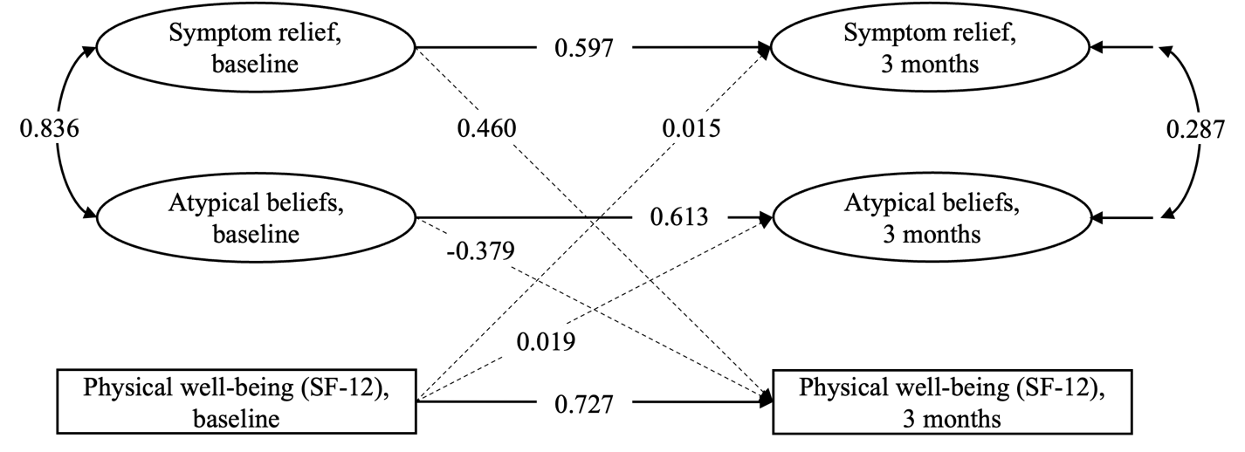
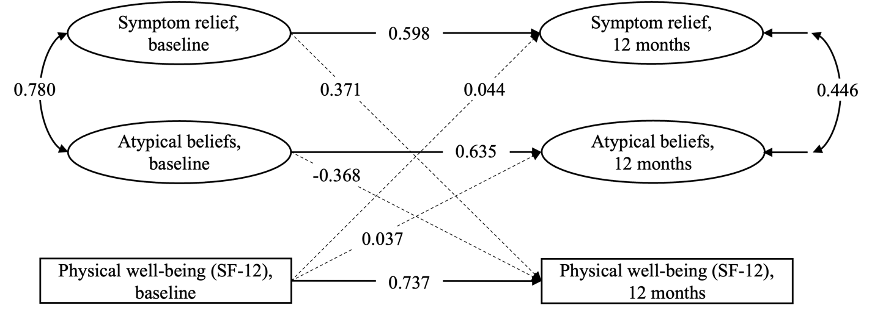
Cross-Lagged Panel Models of CEEQ–M-measured Latent Variables and General Physical Well-Being, as Measured by the 12-Item Short-Form Health Survey (SF-12), Between (A) Baseline and Three-Month Timepoints and (B) Baseline and Twelve-Month Timepoints
A
B
Note. Higher SF-12 scores indicate greater well-being. Numeric values correspond to the standardized model solution. Age and sex were included as predictors of three-month and twelve-month variables (paths not shown).
Solid paths are significant (p < 0.05); dashed paths are nonsignificant (p ≥ 0.05).
Figure S7
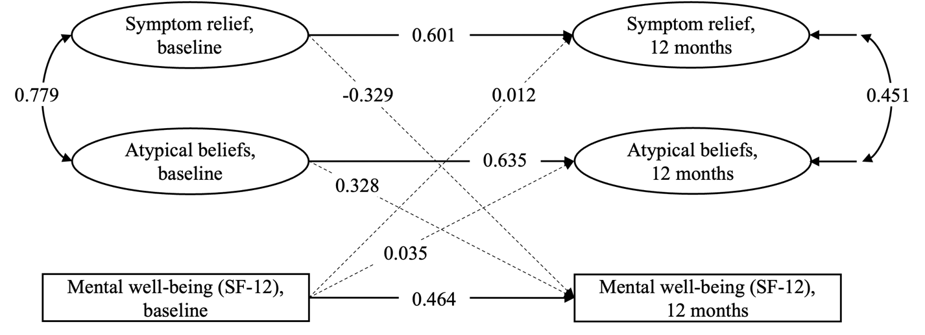
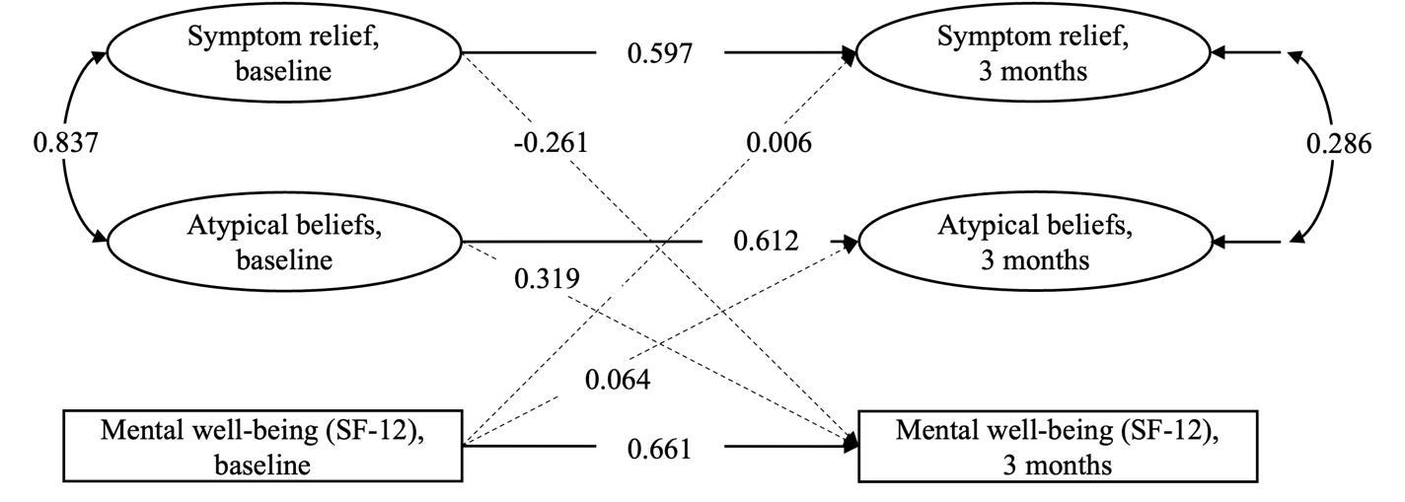
Cross-Lagged Panel Models of CEEQ–M-measured Latent Variables and General Mental Well-Being, as Measured by the 12-Item Short-Form Health Survey (SF-12), Between (A) Baseline and Three-Month Timepoints and (B) Baseline and Twelve-Month Timepoints
A
B
Note. Higher SF-12 scores indicate greater well-being. Numeric values correspond to the standardized model solution. Age and sex were included as predictors of three-month and twelve-month variables (paths not shown).
Solid paths are significant (p < 0.05); dashed paths are nonsignificant (p ≥ 0.05).

Appendix

The Cannabis Effects Expectancy Questionnaire–Medical (CEEQ–M)
Author’s note: The original version of this instrument used the term “marijuana” instead of “cannabis,” which latter we suggest as the more appropriate term for future administrations of this instrument, as shown here.

The following questions ask about some ways in which cannabis may affect people. Read each question carefully and respond according to your own personal beliefs about cannabis. There are no right or wrong answers. Please be honest. Remember, your answers are confidential.
 | Strongly disagree |  | Disagree |  | Neutral |  | Agree |  | Strongly agree
 | 1 | 2 | 3 | 4 | 5 | 6 | 7 | 8 | 9 | 10
Cannabis relieves pain
Cannabis relieves muscle spasms
Cannabis relieves headaches
Cannabis relieves anxiety
Cannabis relieves nausea
Cannabis relieves depression
Cannabis relieves cramps
Cannabis relieves panic attacks
Cannabis relieves diarrhea
Cannabis improves sleep
Cannabis improves relaxation
Cannabis improves appetite
Cannabis improves concentration/focus
Cannabis improves energy
Cannabis reduces medication side effects
Cannabis reduces anger
Cannabis reduces involuntary movements
Cannabis reduces seizures
Cannabis is a substitute for prescription medication
Cannabis is a substitute for alcohol
Cannabis cures cancer

Place an x in the box that shows how much you agree or disagree with each item:

