 | Wave 1  (N = 7364) | Wave 2  (N = 6716) | Wave 3  (N = 6019) | Wave 4  (N = 4997) | Wave 5  (N = 4497) | Wave 6  (N = 3335) | Wave 7  (N = 3305) | Wave 8  (N = 3856) | Wave 9  (N = 3915) | Wave 10  (N = 4085)
Age, mean (sd) | 10.65 (0.26) | 12.81(0.23) | 13.84 (0.21) | 16.68 (0.24) | 17.84 (0.40) | 18.65 (0.49) | 21.95 (0.52) | 22.88 (0.53) | 23.80 (0.52) | 25.76 (0.51)
Sex  Male  Female | 3621 (49%)  3731 (51%) | 3281 (49%)  3421 (51%) | 2963 (49%)  3075 (51%) | 2019 (40%)  2968 (59%) | 1905 (42%)  2587 (58%) | 1178 (35%)  2151 (64%) | 1168 (35%)  2132 (65%) | 1334 (35%)  2467 (64%) | 1331 (34%)  2561 (65%) | 1335 (33%)  2681 (66%)
Ethnicity M  White  Non-White | 5814 (79%)  114 (2%) | 5334 (79%)  102 (2%) | 4867 (81%)  88 (1%) | 4138 (83%)  80 (2%) | 4574 (80%)  69 (2%) | 2777 (83%)  54 (2%) | 2723 (82%)  52 (2%) | 3070 (80%)  55 (1%) | 3096 (80%)  58 (1%) | 3058 (75%)  50 (1%)
Qualification M  University  None  Other | 1168 (16%)  159 (2%)  1064 (14%) | 1117 (17%)  126 (2%)  1002 (15%) | 1052 (17%)  105 (2%)  914 (15%) | 1010 (20%)  95 (2%)  798 (16%) | 877 (20%)  76 (2%)  763 (17%) | 743 (22%)  55 (2%)  544 (16%) | 702 (21%)  50 (2%)  512 (15%) | 759 (20%)  60 (2%)  607 (16%) | 750 (19%)  63 (2%)  602 (15%) | 755 (18%)  65 (2%)  591 (15%)
Financial diff.  Yes | 360 (4%) | 330 (5%) | 300 (5%) | 235 (5%) | 200 (4%) | 145 (4%) | 148 (4%) | 171 (4%) | 193 (5%) | 175 (4%)
Supplemental Material
Table s1. Demographic characteristics for each wave (with percentages)

Note. Ethnicity M= Maternal reported ethnicity when the child was 8.7 years, Qualification M = Maternal Qualification; Maternal ethnicity does not add up to 100% because of missing values.

Table s2. Missingness
 | Data available | No data available | p
Wave 2 (12.81y)
Sex
Male | 2941 | 680 | .056
Female | 3095 | 636
Ethnicity Mother 8.1y
White | 94 | 20 | .392
Non-white | 4985 | 829
SMFQ 11y | 4.30 (3.71) | 3.99 (3.47) | .005
Family income 8.1y
˂ £100 | 70 | 27 | ˂.001
£100 - £199 | 362 | 69
£200 - £299 | 728 | 140
£300 - £399 | 955 | 173
˃ £399 | 2502 | 362
Family income 11.1y
˂ £100 | 24 | 78 | ˂.001
£120 - £189 | 47 | 198
£190 - £239 | 40 | 226
£240 - £289 | 67 | 304
£290 - £359 | 94 | 505
£360 - £429 | 77 | 490
£430 - £479 | 48 | 344
£480 - £559 | 93 | 733
£560 - £799 | 111 | 1025
˃ £800 | 83 | 667
Age mother | 38.14 (4.40) | 37.37 (4.72) | ˂.001
Maternal depression
Yes, recently | 159 | 36 | ˂.001
Yes, in the past | 329 | 75
No, never | 4745 | 707
Temperament 57m | 12.79 (3.31) | 12.84 (3.38) | .678
Mother-child conflict 6.5y | 2.85 (0.82) | 2.90 (0.83) | .106
School ability 9.7y | 3.52 (1.08) | 3.40 (1.11) | .003
School enjoyment 11.2y | 1.98 (0.71) | 2.04 (0.81) | .034
SDQ 6.9y | 7.23 (4.65) | 8.03 (5.01) | ˂.001
SDQ 11.8y | 6.31 (4.77) | 7.30 (5.35) | ˂.001
Wave 3 (13.84y)
Sex
Male | 2649 | 972 | .030
Female | 2813 | 918
Ethnicity Mother 8.1y
White | 4560 | 34 | .045
Non-white | 80 | 1254
SMFQ 11y | 4.00 (3.48) | 4.16 (3.59) | .087
SMFQ 13y | 3.90 (3.77) | 3.86 (3.90) | .784
Family income 8.1y
˂ £100 | 60 | 37 | ˂.001
£100 - £199 | 310 | 121
£200 - £299 | 650 | 218
£300 - £399 | 847 | 281
˃ £399 | 2350 | 514
Family income 11.1y
˂ £100 | 66 | 36 | ˂.001
£120 - £189 | 173 | 72
£190 - £239 | 198 | 68
£240 - £289 | 277 | 94
£290 - £359 | 465 | 134
£360 - £429 | 447 | 120
£430 - £479 | 314 | 78
£480 - £559 | 680 | 146
£560 - £799 | 927 | 209
˃ £800 | 632 | 118
Maternal depression
Yes, recently | 146 | 49 | .10
Yes, in the past | 307 | 97
No, never | 4236 | 1126
Temperament 57m | 12.78 (3.32) | 12.89 (3.32) | .284
Mother-child conflict 6.5y | 2.84 (0.82) | 2.92 (0.83) | .004
School ability 9.7y | 3.52 (1.08) | 3.42 (1.09) | .001
School enjoyment 11.2y | 1.98 (0.71) | 2.03 (0.77) | .027
SDQ 6.9y | 7.19 (4.61) | 7.89 (5.01) | ˂.001
SDQ 11.8y | 6.29 (4.76) | 6.98 (5.21) | ˂.001
SDQ 13.1y | 6.52 (4.80) | 7.31 (5.22) | ˂.001
Wave 4 (16.68y)
Sex
Male | 1669 | 1952 | ˂.001
Female | 2383 | 1348
Ethnicity Mother 8.1y
White | 3502 | 2312 | .683
Non-white | 66 | 48
SMFQ 11y | 3.93 (3.43) | 4.18 (3.61) | .002
SMFQ 13y | 3.96 (3.82) | 3.74 (3.74) | .085
SMFQ 14y | 4.86 (4.40) | 4.89 (4.56) | .792
Family income 8.1y
˂ £100 | 38 | 59 | ˂.001
£100 - £199 | 214 | 217
£200 - £299 | 482 | 386
£300 - £399 | 630 | 498
˃ £399 | 1901 | 963
Family income 11.1y
˂ £100 | 51 | 51 | ˂.001
£120 - £189 | 119 | 126
£190 - £239 | 136 | 130
£240 - £289 | 215 | 156
£290 - £359 | 333 | 266
£360 - £429 | 323 | 244
£430 - £479 | 239 | 153
£480 - £559 | 505 | 321
£560 - £799 | 742 | 394
˃ £800 | 563 | 187
Maternal depression
Yes, recently | 107 | 88 | .019
Yes, in the past | 225 | 179
No, never | 3344 | 2108
Temperament 57m | 12.82 (3.28) | 12.78 (3.38) | .645
Mother-child conflict 6.5y | 2.83 (0.82) | 2.90 (0.83) | .003
School ability 9.7y | 3.53 (1.07) | 3.45 (1.10) | .011
School enjoyment 11.2y | 1.94 (0.69) | 2.06 (0.77) | ˂.001
School enjoyment 14.1y | 2.75 (1.81) | 2.88 (1.82) | .031
SDQ 6.9y | 6.98 (4.48) | 7.88 (4.99) | ˂.001
SDQ 11.8y | 6.00 (4.54) | 7.12 (5.27) | ˂.001
SDQ 13.1y | 6.19 (4.56) | 7.47 (5.30) | ˂.001
Wave 5 (17.84y)
Sex
Male | 1645 | 2152 | ˂.001
Female | 1976 | 1645
Ethnicity Mother 8.1y
White | 3221 | 2593 | .904
Non-white | 62 | 52
SMFQ 11y | 3.90 (3.40) | 4.20 (3.63) | ˂.001
SMFQ 13y | 3.93 (3.80) | 3.84 (3.78) | .345
SMFQ 14y | 4.87 (4.41) | 4.86 (4.54) | .897
SMFQ 16y | 5.72 (5.39) | 6.05 (5.91) | .098
Family income 8.1y
˂ £100 | 37 | 60 | ˂.001
£100 - £199 | 181 | 250
£200 - £299 | 455 | 413
£300 - £399 | 595 | 533
˃ £399 | 1732 | 1132
Family income 11.1y
˂ £100 | 41 | 61 | ˂.001
£120 - £189 | 97 | 148
£190 - £239 | 127 | 139
£240 - £289 | 192 | 179
£290 - £359 | 317 | 282
£360 - £429 | 299 | 268
£430 - £479 | 217 | 175
£480 - £559 | 496 | 330
£560 - £799 | 671 | 465
˃ £800 | 486 | 286
Maternal depression
Yes, recently | 95 | 100 | .122
Yes, in the past | 219 | 219
No, never | 3046 | 2406
Temperament 57m | 12.84 (3.33) | 12.76 (3.32) | .400
Mother-child conflict 6.5y | 2.83 (0.83) | 2.89 (0.81) | .012
School ability 9.7y | 3.53 (1.06) | 3.46 (1.10) | .016
School enjoyment 11.2y | 1.95 (0.67) | 2.05 (0.78) | ˂.001
School enjoyment 14.1y | 2.73 (1.79) | 2.89 (1.85) | .004
SDQ 6.9y | 7.07 (4.55) | 7.68 (4.88) | ˂.001
SDQ 11.8y | 6.03 (4.61) | 6.94 (5.12) | ˂.001
SDQ 13.1y | 6.27 (4.61) | 7.18 (5.17) | ˂.001
Relationship parents 14.1y | 8.10 (3.30) | 8.80 (3.71) | ˂.001
Psychotic symptoms 16.6y | 8.84 (1.62) | 8.95 (1.79) | .086
Wave 6 (18.65y)
Sex
Male | 993 | 2628 | ˂.001
Female | 1766 | 1965
Ethnicity Mother 8.1y
White | 2405 | 3409 | .415
Non-white | 52 | 62
SMFQ 11y | 3.88 (3.40) | 4.14 (3.58) | .002
SMFQ 13y | 4.03 (3.82) | 3.80 (3.77) | .017
SMFQ 14y | 5.05 (4.53) | 4.73 (4.39) | .009
SMFQ 16y | 5.77 (5.37) | 5.88 (5.37) | .553
SMFQ 18y | 6.21 (5.01) | 6.79 (5.35) | ˂.001
Family income 8.1y
˂ £100 | 33 | 64 | ˂.001
£100 - £199 | 153 | 278
£200 - £299 | 319 | 549
£300 - £399 | 442 | 696
˃ £399 | 1294 | 1570
Family income 11.1y
˂ £100 | 37 | 65 | ˂.001
£120 - £189 | 73 | 172
£190 - £239 | 86 | 180
£240 - £289 | 138 | 233
£290 - £359 | 222 | 377
£360 - £429 | 228 | 339
£430 - £479 | 166 | 226
£480 - £559 | 340 | 486
£560 - £799 | 509 | 627
˃ £800 | 388 | 362
Maternal depression
Yes, recently | 86 | 127 | .031
Yes, in the past | 152 | 252
No, never | 2298 | 3154
Temperament 57m | 12.85 (3.28) | 12.77 (3.35) | .312
Mother-child conflict 6.5y | 2.82 (.083) | 2.89 (0.82) | ˂.001
School ability 9.7y | 3.54 (1.06) | 3.47 (1.10) | .006
School enjoyment 11.2y | 1.94 (0.66) | 2.03 (0.76) | ˂.001
School enjoyment 14.1y | 2.73 (1.80) | 2.84 (1.82) | .039
SDQ 6.9y | 6.69 (4.51) | 7.61 (4.83) | ˂.001
SDQ 11.8y | 5.96 (4.55) | 6.77 (5.04) | ˂.001
SDQ 13.1y | 6.09 (4.59) | 7.09 (5.05) | ˂.001
Relationship parents 14.1y | 8.11 (3.32) | 8.61 (3.60) | ˂.001
Psychotic symptoms 16.6y | 8.85 (1.63) | 8.92 (1.72) | .189
Wave 7 (21.95y)
Sex
Male | 994 | 2627 | ˂.001
Female | 1719 | 2012
Ethnicity Mother 8.1y
White | 2355 | 3459 | .999
Non-white | 46 | 68
SMFQ 11y | 3.88 (3.38) | 4.14 (3.59) | .002
SMFQ 13y | 3.87 (3.68) | 3.91 (3.87) | .708
SMFQ 14y | 4.91 (4.49) | 4.83 (4.43) | .518
SMFQ 16y | 5.94 (5.54) | 5.67 (5.56) | .122
SMFQ 18y | 6.31 (5.05) | 6.65 (5.31) | .047
SMFQ 19y | 6.70 (5.79) | 6.54 (5.91) | .501
Family income 8.1y
˂ £100 | 19 | 78 | ˂.001
£100 - £199 | 136 | 295
£200 - £299 | 306 | 562
£300 - £399 | 438 | 690
˃ £399 | 1292 | 1572
Family income 11.1y
˂ £100 | 26 | 76
£120 - £189 | 66 | 179
£190 - £239 | 78 | 188
£240 - £289 | 135 | 236
£290 - £359 | 218 | 381
£360 - £429 | 225 | 342
£430 - £479 | 169 | 223
£480 - £559 | 353 | 473
£560 - £799 | 514 | 622
˃ £800 | 364 | 386
Maternal depression
Yes, recently | 71 | 124 | .403
Yes, in the past | 159 | 245
No, never | 2227 | 3225
Temperament 57m | 12.83 (3.32) | 12.79 (3.32) | .583
Mother-child conflict 6.5y | 2.81 (0.83) | 2.89 (0.81) | .001
School ability 9.7y | 3.55 (1.06) | 3.45 (1.10) | .002
School enjoyment 11.2y | 1.93 (0.67) | 2.03 (0.75) | ˂.001
School enjoyment 14.1y | 2.72 (1.79) | 2.85 (1.83) | .012
SDQ 6.9y | 6.72 (4.41) | 7.76 (4.86) | ˂.001
SDQ 11.8y | 5.85 (4.55) | 6.84 (5.02) | ˂.001
SDQ 13.1y | 6.04 (4.43) | 7.10 (5.14) | ˂.001
Relationship parents 14.1y | 8.08 (3.30) | 8.62 (3.61) | ˂.001
Psychotic symptoms 16.6y | 8.85 (1.60) | 8.90 (1.76) | .392
General health 18.7y | 2.30 (0.97) | 2.40 (0.98) | .007
Wave 8 (22.88y)
Sex
Male | 1099 | 2522 | ˂.001
Female | 1991 | 1740
Ethnicity Mother 8.1y
White | 2648 | 3166 | .653
Non-white | 49 | 65
SMFQ 11y | 3.77 (3.32) | 4.24 (3.36) | ˂.001
SMFQ 13y | 3.88 (3.71) | 3.91 (3.86) | .742
SMFQ 14y | 5.00 (4.53) | 4.74 (4.38) | .031
SMFQ 16y | 5.93 (5.52) | 5.64 (5.59) | .094
SMFQ 18y | 6.27 (5.01) | 6.77 (5.40) | .004
SMFQ 19y | 6.66 (5.82) | 6.61 (5.83) | .861
SMFQ 22y | 5.63 (5.57) | 5.62 (5.40) | .961
Family income 8.1y
˂ £100 | 23 | 74 | ˂.001
£100 - £199 | 172 | 259
£200 - £299 | 350 | 518
£300 - £399 | 491 | 637
˃ £399 | 1442 | 1422
Family income 11.1y
˂ £100 | 36 | 66 | ˂.001
£120 - £189 | 69 | 176
£190 - £239 | 100 | 166
£240 - £289 | 156 | 215
£290 - £359 | 239 | 360
£360 - £429 | 256 | 311
£430 - £479 | 193 | 199
£480 - £559 | 406 | 420
£560 - £799 | 556 | 580
˃ £800 | 407 | 343
Maternal depression
Yes, recently | 78 | 117 | .262
Yes, in the past | 186 | 218
No, never | 2504 | 2948
Temperament 57m | 12.86 (3.32) | 12.75 (3.31) | .194
Mother-child conflict 6.5y | 2.83 (0.83) | 2.88 (0.81) | .019
School ability 9.7y | 3.53 (1.07) | 3.47 (1.09) | .016
School enjoyment 11.2y | 1.93 (0.67) | 2.04 (0.76) | ˂.001
School enjoyment 14.1y | 2.75 (1.82) | 2.83 (1.80) | .104
SDQ 6.9y | 6.92 (4.57) | 7.69 (4.80) | ˂.001
SDQ 11.8y | 5.91 (4.57) | 6.87 (5.05) | ˂.001
SDQ 13.1y | 6.19 (4.57) | 7.07 (5.10) | ˂.001
Relationship parents 14.1y | 8.12 (3.36) | 8.64 (3.58) | ˂.001
Psychotic symptoms 16.6y | 8.86 (1.62) | 8.90 (1.75) | .573
General health 18.7y | 2.30 (0.96) | 2.42 (1.01) | .002
General health 21y | 2.40 (0.95) | 2.44 (0.95) | .303
Wave 9 (23.80y)
Sex
Male | 1116 | 2505 | ˂.001
Female | 2020 | 1711
Ethnicity Mother 8.1y
White | 2662 | 3152 | .956
Non-white | 53 | 61
SMFQ 11y | 3.83 (3.37) | 4.20 (3.61) | ˂.001
SMFQ 13y | 3.86 (3.70) | 3.93 (3.87) | .512
SMFQ 14y | 4.89 (4.45) | 4.85 (4.47) | .761
SMFQ 16y | 5.87 (5.48) | 5.74 (5.66) | .499
SMFQ 18y | 6.31 (5.08) | 6.71 (5.31) | .019
SMFQ 19y | 6.67 (5.84) | 6.59 (5.79) | .762
SMFQ 22y | 5.60 (5.55) | 5.72 (5.50) | .629
SMFQ 23y | 6.08 (5.48) | 6.29 (5.43) | .380
Family income 8.1y
˂ £100 | 33 | 64 | ˂.001
£100 - £199 | 162 | 269
£200 - £299 | 356 | 512
£300 - £399 | 490 | 638
˃ £399 | 1438 | 1462
Family income 11.1y
˂ £100 | 41 | 61 | ˂.001
£120 - £189 | 85 | 160
£190 - £239 | 105 | 161
£240 - £289 | 154 | 217
£290 - £359 | 239 | 360
£360 - £429 | 267 | 300
£430 - £479 | 192 | 200
£480 - £559 | 411 | 415
£560 - £799 | 571 | 565
˃ £800 | 377 | 373
Maternal depression
Yes, recently | 74 | 121 | .049
Yes, in the past | 195 | 209
No, never | 2520 | 2931
Temperament 57m | 12.93 (3.29) | 12.70 (3.34) | .008
Mother-child conflict 6.5y | 2.82 (0.82) | 2.89 (0.82) | ˂.001
School ability 9.7y | 3.55 (1.06) | 3.45 (1.10) | ˂.001
School enjoyment 11.2y | 1.93 (0.68) | 2.05 (0.76) | ˂.001
School enjoyment 14.1y | 2.71 (1.77) | 2.88 (1.85) | .002
SDQ 6.9y | 6.95 (4.50) | 7.67 (4.86) | ˂.001
SDQ 11.8y | 5.94 (4.56) | 6.86 (5.07) | ˂.001
SDQ 13.1y | 6.16 (4.58) | 7.10 (5.10) | ˂.001
Relationship parents 14.1y | 8.16 (3.35) | 8.59 (3.59) | ˂.001
Psychotic symptoms 16.6y | 9.87 (1.65) | 8.88 (1.70) | .951
General health 18.7y | 2.30 (0.96) | 2.40 (1.01) | .023
General health 21y | 2.40 (0.95) | 2.42 (0.96) | .730
General health 22y | 2.16 (0.85) | 2.25 (0.85) | .022
Anxiety 22y | 11.46 (4.48) | 11.57 (4.51) | .565
Wave 10 (23.80y)
Sex
Male | 1075 | 2546 | ˂.001
Female | 2016 | 1715
Ethnicity Mother 8.1y
White | 2598 | 3216 | .311
Non-white | 45 | 69
SMFQ 11y | 3.78 (3.36) | 4.23 (3.61) | ˂.001
SMFQ 13y | 3.91 (3.73) | 3.88 (3.84) | .739
SMFQ 14y | 5.04 (4.55) | 4.71 (4.36) | .008
SMFQ 16y | 5.61 (5.56) | 5.96 (5.54) | .044
SMFQ 18y | 6.38 (5.11) | 6.59 (5.26) | .220
SMFQ 19y | 6.61 (5.75) | 6.73 (6.00) | .617
SMFQ 22y | 5.56 (5.48) | 5.80 (5.68) | .338
SMFQ 23y | 6.00 (5.29) | 6.47 (5.92) | .046
SMFQ 24y | 6.83 (5.89) | 6.87 (6.07) | .867
Family income 8.1y
˂ £100 | 32 | 65 | ˂.001
£100 - £199 | 152 | 279
£200 - £299 | 330 | 538
£300 - £399 | 509 | 619
˃ £399 | 1412 | 1452
Family income 11.1y
˂ £100 | 39 | 63 | ˂.001
£120 - £189 | 76 | 169
£190 - £239 | 91 | 175
£240 - £289 | 148 | 223
£290 - £359 | 244 | 355
£360 - £429 | 251 | 316
£430 - £479 | 188 | 204
£480 - £559 | 397 | 429
£560 - £799 | 557 | 579
˃ £800 | 390 | 360
Maternal depression 6.1y
Yes, recently | 79 | 116 | .377
Yes, in the past | 177 | 227
No, never | 2467 | 2985
Temperament 57m | 12.92 (3.30) | 12.71 (3.33) | .015
Mother-child conflict 6.5y | 2.89 (0.82) | 2.82 (0.82) | ˂.001
School ability 9.7y | 3.55 (1.05) | 3.45 (1.11) | ˂.001
School enjoyment 11.2y | 1.94 (0.67) | 2.04 (0.76) | ˂.001
School enjoyment 14.1y | 2.68 (1.71) | 2.91 (1.91) | ˂.001
SDQ 6.9y | 6.89 (4.47) | 7.71 (4.87) | ˂.001
SDQ 11.8y | 5.86 (4.48) | 6.90 (5.10) | ˂.001
SDQ 13.1y | 6.15 (4.54) | 7.12 (5.12) | ˂.001
Relationship parents 14.1y | 8.16 (3.38) | 8.58 (3.55) | ˂.001
Psychotic symptoms 16.6y | 8.87 (1.65) | 8.88 (1.70) | .983
General health 18.7y | 2.32 (0.96) | 2.37 (1.01) | .199
General health 21y | 2.37 (0.93) | 2.50 (1.00) | .004
General health 22y | 2.16 (0.84) | 2.22 (0.88) | .097
Anxiety 22y | 11.42 (4.46) | 11.67 (4.55) | .200

Figure s1. Histogram of all items at wave 1.

Figure s2. Histogram of all items at wave 2.

Figure s3. Histogram of all items at wave 3.

Figure s4. Histogram of all items at wave 4.

Figure s5. Histogram of all items at wave 5.

Figure s6. Histogram of all items at wave 6.

Figure s7. Histogram of all items at wave 7.

Figure s8. Histogram of all items at wave 8.

Figure s9. Histogram of all items at wave 9.

Figure s10. Histogram of all items at wave 10.

Table s3. Exploratory Factor Analysis

 | T1 | T2 | T3 | T4 | T5 | T6 | T7 | T8 | T9 | T10
Highest Eigenvalue | 5.40 | 6.47 | 6.75 | 7.85 | 7.41 | 7.81 | 8.27 | 7.86 | 8.04 | 8.24
Explained variance | .42 | .50 | .52 | .60 | .57 | .60 | .64 | .60 | .62 | .63
EFA factor loadings | $$λ_{k1}$$ | $$λ_{k2}$$ | $$λ_{k3}$$ | $$λ_{k4}$$ | $$λ_{k5}$$ | $$λ_{k6}$$ | $$λ_{k7}$$ | $$λ_{k8}$$ | $$λ_{k9}$$ | $$λ_{k10}$$
1. Miserable/unhappy | .60 | .67 | .72 | .79 | .75 | .77 | .82 | .81 | .81 | .79
2. Did not enjoy anything | .48 | .51 | .54 | .73 | .74 | .78 | .82 | .84 | .85 | .78
3. Felt tired | .45 | .45 | .41 | .55 | .54 | .54 | .62 | .52 | .56 | .57
4. Restless | .31 | .43 | .40 | .56 | .52 | .52 | .59 | .54 | .60 | .59
5. I was no good anymore | .82 | .87 | .88 | .92 | .89 | .91 | .91 | .92 | .93 | .91
6. Cried a lot | .61 | .73 | .74 | .71 | .70 | .72 | .69 | .70 | .70 | .74
7. Hard to concentrate | .56 | .60 | .59 | .62 | .56 | .65 | .75 | .66 | .68 | .72
8. I hated myself | .82 | .89 | .89 | .89 | .86 | .91 | .91 | .93 | .92 | .89
9. I was a bad person | .55 | .61 | .69 | .82 | .81 | .82 | .82 | .85 | .85 | .85
10. Felt lonely | .73 | .79 | .81 | .81 | .78 | .76 | .80 | .74 | .76 | .80
11. Nobody really loved me | .80 | .85 | .85 | .85 | .84 | .85 | .83 | .81 | .82 | .86
12. Not as good as other kids | .72 | .79 | .79 | .83 | .81 | .84 | .85 | .80 | .81 | .85
13. Did everything wrong | .70 | .77 | .82 | .89 | .87 | .88 | .89 | .85 | .85 | .90

Wave 1 – Age 11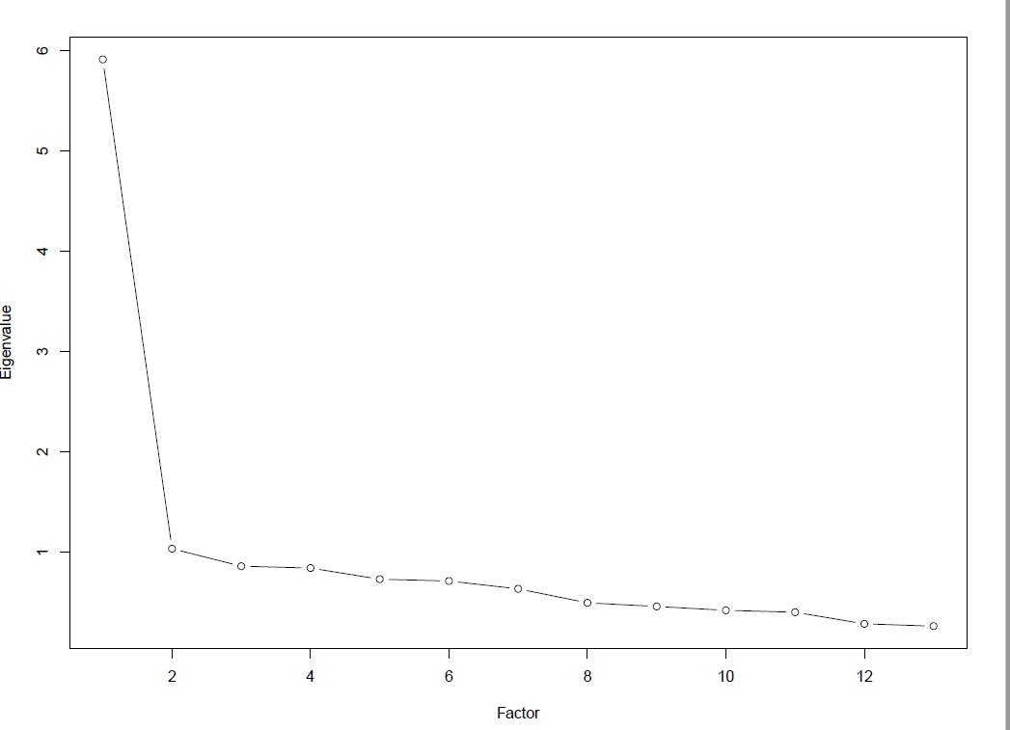 | Wave 2 – Age 13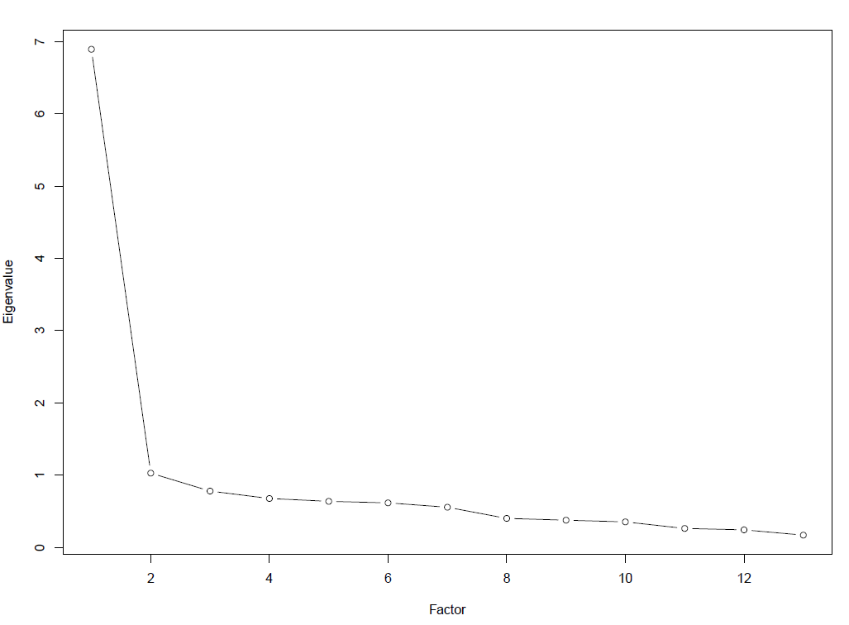 | Wave 3 – Age 14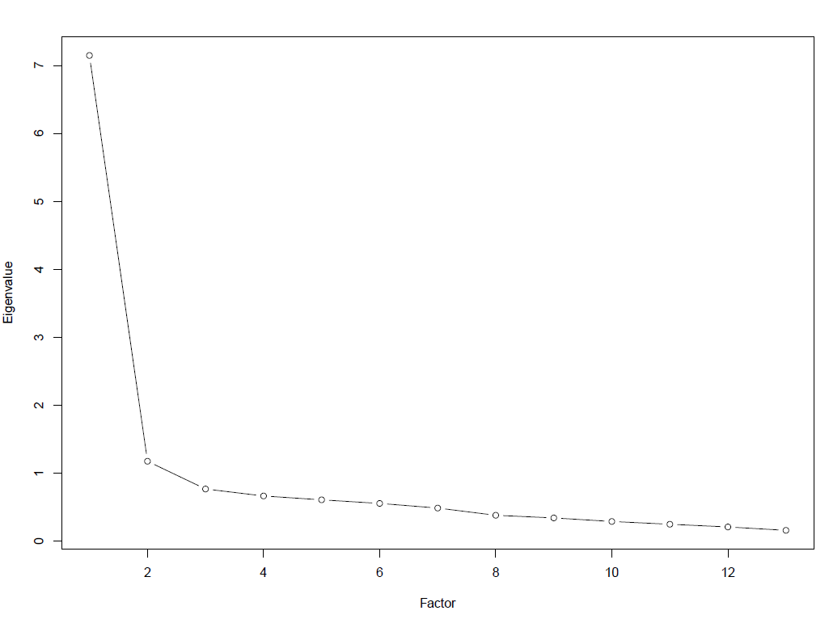 | Wave 4- Age 17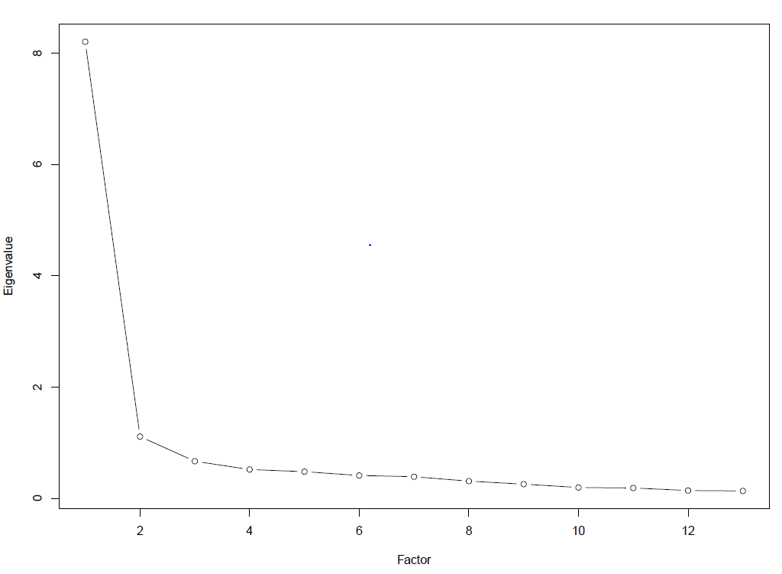 | Wave 5 –Age 18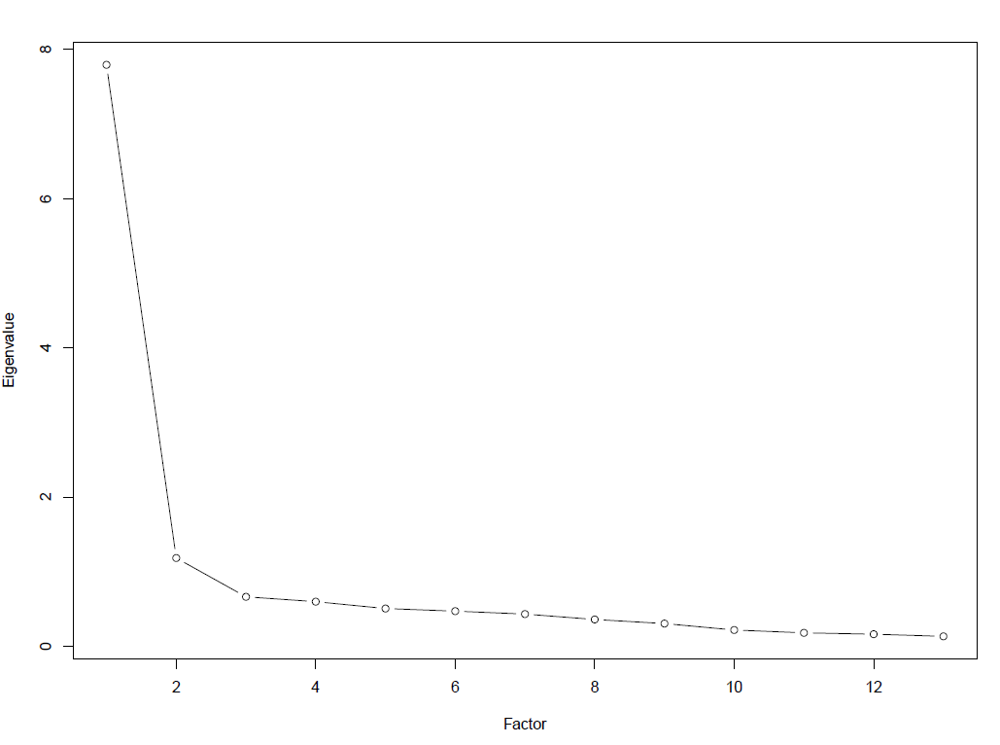
Wave 6 – Age 19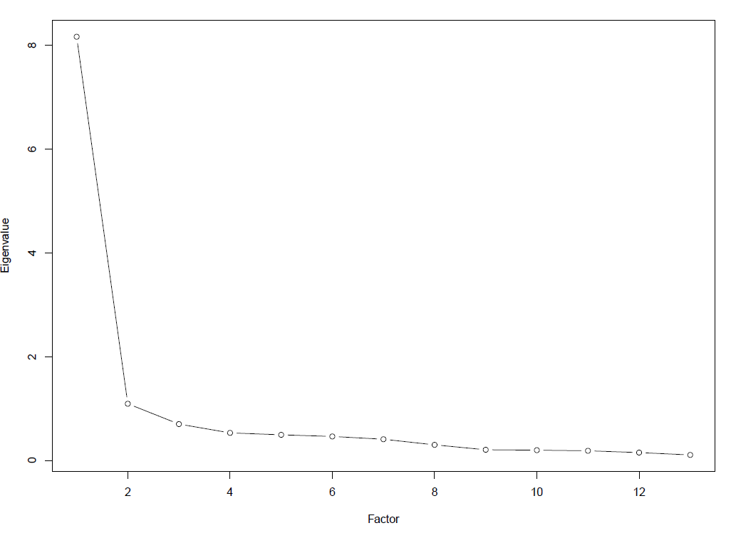 | Wave 7 – Age 22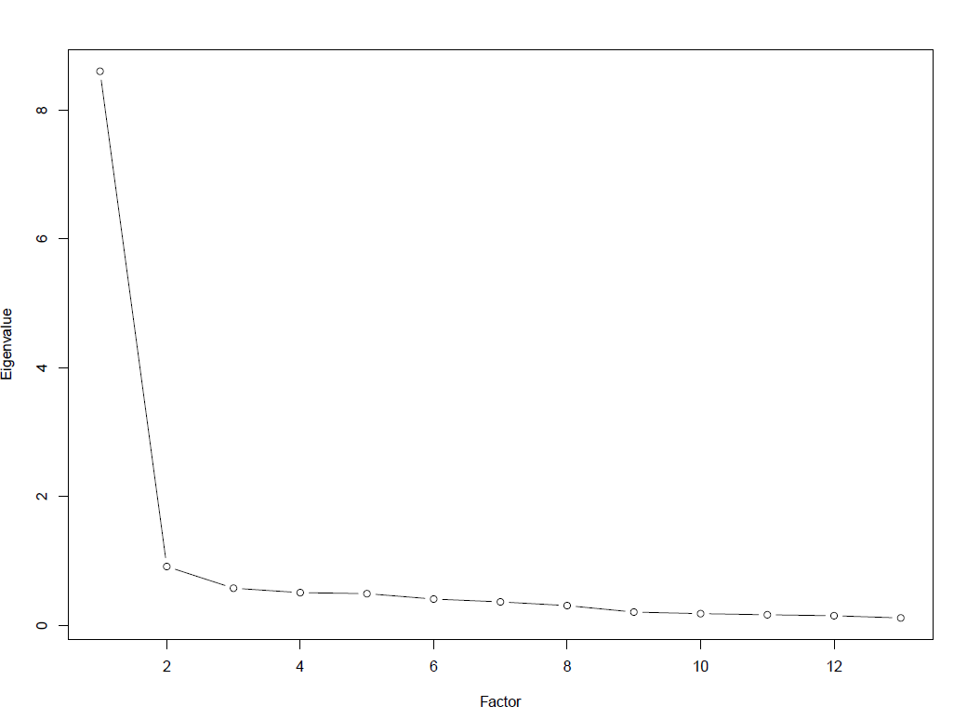 | Wave 8 – Age 23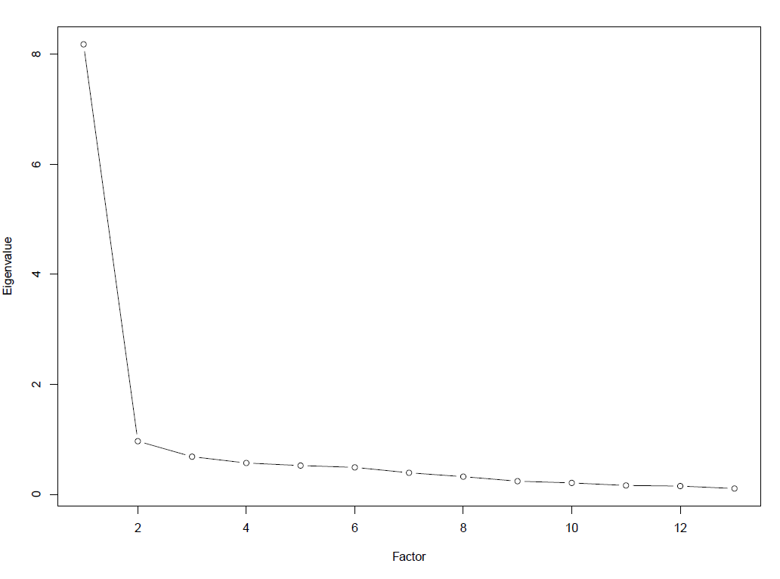 | Wave 9 – Age 24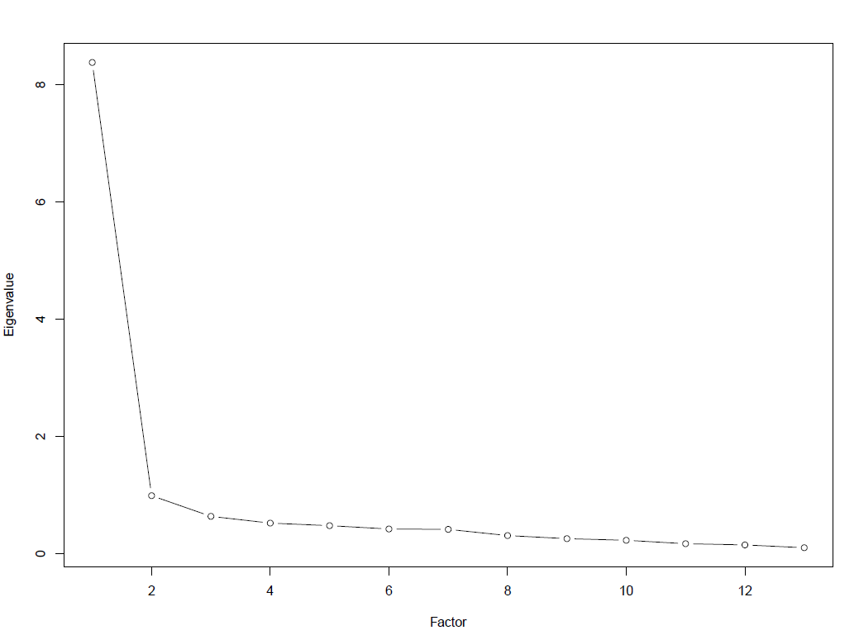 | Wave 10 – Age 26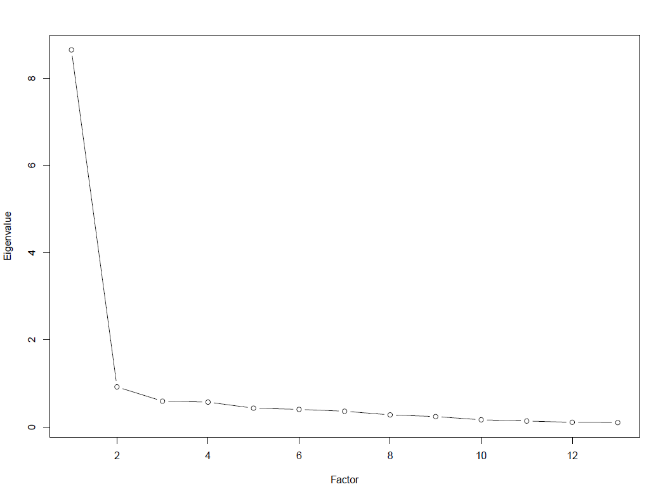
Figure s11. Scree plot for all waves

 | $$χ^{2}(df)$$ | CFI | RMSEA | ∆CFI | ∆RMSEA
Wave 1 (11y)
Configural | 523 (130) | .980 | .031
Scalar | 934 (154) | .968 | .037 | .012 | .006
Scalarpartial¹ | 807 (151) | .972 | .034 | .008 | .003
Strictpartial | 902 (164) | .971 | .035 | .001 | .001
Wave 2 (13y)
Configural | 426 (130) | .984 | .030
Scalar | 787 (154) | .974 | .036 | .010 | .006
Strict | 938 (167) | .973 | .039 | .001 | .003
Wave 3 (14y)
Configural | 732 (130) | .975 | .041
Scalar | 1221 (154) | .967 | .050 | .008 | .009
Scalarpartial² | 1055 (153) | .971 | .047 | .004 | .006
Strictpartial | 1197 (166) | .971 | .048 | .000 | .001
Wave 4 (16y)
Configural | 1037 (130) | .970 | .058
Scalar | 1494 (154) | .965 | .065 | .005 | .007
Strict | 1558 (167) | .970 | .064 | .005 | .001
Wave 5 (18y)
Configural | 1186 (130) | .963 | .065
Scalar | 1577 (154) | .958 | .069 | .005 | .004
Strict | 1706 (167) | .964 | .069 | .006 | .000
Wave 6 (19y)
Configural | 795 (130) | .970 | .060
Scalar | 1084 (154) | .965 | .066 | .005 | .006
Strict | 1167 (167) | .971 | .065 | .006 | .001
Wave 7 (22y)
Configural | 553 (130) | .981 | .048
Scalar | 836 (154) | .977 | .057 | .004 | .009
Scalarpartial² | 668 (153) | .981 | .049 | .000 | .001
Strictpartial | 793 (166) | .982 | .052 | .001 | .003
Wave 8 (23y)
Configural | 721 (130) | .978 | .054
Scalar | 1016 (154) | .971 | .060 | .006 | .006
Strict8 | 1269 (167) | .976 | .058 | .005 | .002
Wave 9 (24y)
Configural | 797 (130) | .975 | .057
Scalar | (154) | .969 | .064 | .006 | .007
Strict | 1181 (167) | .978 | .062 | .009 | .002
Wave 10 (26y)
Configural | 673 (130) | .984 | .051
Scalar | 979 (154) | .981 | .058 | .003 | .007
Strict | 1034 (167) | .985 | .057 | .004 | .001
Table s4. Sex measurement invariance cross-sectional waves
¹ factor loading of “I cried a lot” and thresholds of “feeling restless” were freed
² factor loading of “I cried a lot” was freed
CFI = Comparative Fit-Index; RMSEA = Root Mean Square Error of Approximation; df = degrees of freedom
ΔCFI ≥ .010 and ΔRMSEA ≥ .007 indicate substantial deterioration in model fit (Neufeld et al, 2022). Bolded numbers indicate non-invariance.
Table s5. Confidence intervals for Table 4 in the main manuscript
 | Sex  (male=1) | Psychotic  16.6y | Anxiety  21y | Health  18.7y
Wave 1 (11 yrs) | [.01; .06] [-.05; .02] [-.05; .02] | [.12; .19] [.13; .21] [.13; .21] | [.13; .20] [.17; .26] [.17; .26] | [.09; .16] [.13; .22] [.13; .22]
Wave 2 (13 yrs) | [-.13; -.08] [-.18: -.10] [-.18: -.10] | [.19; .25] [.20; .27] [.20; .27] | [.21; .28] [.24; .32] [.24; .32] | [.15; .22] [.17; .26] [.17; .26]
Wave 3 (14 yrs) | [-.20; -.15] [-.24: -.16] [-.24: -.16] | [.17; .24] [.19; .26] [.19; .26] | [.23; .30] [.26; .35] [.26; .35] | [.19; .27] [.24; .32] [.24; .32]
Wave 4 (17 yrs) | [-.13; -.08] [-.28: -.21] [-.28: -.21] | [.32; .37] [.29; .36] [.29; .36] | [.34; .41] [.34; .42] [.34; .42] | [.25; .32] [.27; .36] [.27; .36]
Wave 5 (18 yrs) | [-.26; -.21] [-.20: -.13] [-.20: -.13] | [.22; .29] [.12; .30] [.22; .30] | [.33; .40] [.35; .43] [.35; .43] | [.26; .33] [.26; .35] [.26; .35]
Wave 6 (19 yrs) | [-.19; -.13] [-.21; -.10] [-.21; -.10] | [.20; .27] [.16; .27] [.16; .27] | [.32; .40] [.39; .48] [.39; .48] | [.31; .37] [.33; .43] [.33; .43]
Wave 7 (22 yrs) | [-.14; -.08] [-.18; -.07] [-.18; -.07] | [.20; .28] [.18; .29] [.18; .29] | [.70; .74] [.67; .73] [.67; .73] | [.24; .31] [.27; .37] [.27; .37]
Wave 8 (23 yrs) | [-.14; -.08] [-.18; -.08] [-.18; -.08] | [.16; .24] [.19; .30] [.19; .30] | [.49; .54] [.54; .61] [.54; .61] | [.22; .29] [.26; .37] [.26; .37]
Wave 9 (24 yrs) | [-.13; -.07] [-.17; -.07] [-.17; -.07] | [.15; .22] [.15; .27] [.15; .27] | [.47; .53] [.51; .58] [.51; .58] | [.23; .31] [.25; .35] [.25; .35]
Wave10 (26 yrs) | [-.19; -.13] [-.19; -.08] [-.19; -.08] | [.18; .26] [.17; .28] [.17; .28] | [.43; .59] [.47; .55] [.47; .55] | [.23; .31] [.24; .39] [.24; .39]
 | Health 21y | Health 22y | SDQ¹ 11.8y | SDQE¹ 11.8y
Wave 1 (11 yrs) | [.09; .17] [.12; .21] [.12; .21] | [.13; .19] [.13; .22] [.13; .22] | [.26; .31] [.26; .33] [.26; .33] | [.18; .22] [.19; .26] [.19; .26]
Wave 2 (13 yrs) | [.13; .20] [.17; .26] [.17; .26] | [.12; .19] [.14; .23] [.14; .23] | [.15; .20] [.18; .25] [.18; .25] | [.14; .19] [.14; .22] [.14; .22]
Wave 3 (14 yrs) | [.15; .23] [.19; .28] [.19; .28] | [.13; .20] [.17; .26] [.17; .26] | [.14; .20] [.17; .25] [.12; .25] | [.13; .18] [.14; .22] [.14; .22]
Wave 4 (17 yrs) | [.21; .28] [.22; .31] [.22; .31] | [.19; .26] [.21; .29] [.21; .29] | [.13; .19] [.15; .23] [.15; .23] | [.15; .21] [.14; .22] [.14; .22]
Wave 5 (18 yrs) | [.20; .27] [.23; .31] [.23; .31] | [.16; .24] [.20; .28] [.20; .28] | [.14; .20] [.15; .23] [.15; .23] | [.13; .19] [.15; .21] [.15; .21]
Wave 6 (19 yrs) | [.20; .28] [.23; .34] [.23; .34] | [.17; .24] [.18; .28] [.18; .28] | [.15; .22] [.14; .25] [.14; .25] | [.17; .24] [.16; .27] [.16; .27]
Wave 7 (22 yrs) | [.34; .40] [.35; .44] [.35; .44] | [.29; .36] [.28; .38] [.28; .38] | [.14; .21] [.14; .25] [.14; .25] | [.15; .22] [.16; .27] [.16; .27]
Wave 8 (23 yrs) | [.18; .35] [.30; .40] [.30; .40] | [.31; .37] [.29; .39] [.29; .39] | [.13; .20] [.14; .25] [.14; .25] | [.14; .21] [.15; .26] [.15; .26]
Wave 9 (24 yrs) | [.27; .34] [.28; .38] [.28; .38] | [.26; .33] [.27; .37] [.27; .37] | [.14; .20] [.15; .26] [.15; .26] | [.13; .20] [.15; .26] [.15; .26]
Wave10 (26 yrs) | [.26; .33] [.28; .38] [.28; .38] | [.26; .32] [.27; .37] [.27; .37] | [.15; .21] [.17; .27] [.17; .27] | [.14; .21] [.15; .26] [.15; .26]
 | SDQ¹ 13.1y | SDQE1 13.1y | LE s12y
Wave 1 (11 yrs) | [.26; .30] [.27; .34] [.27; .34] | [.17; .22] [.19; .26] [.19; .26] | [.07; .15] [.09; .19] [.09; .19]
Wave 2 (13 yrs) | [.20; .25] [.24; .32] [.24; .32] | [.19; .24] [.21; .28] [.21; .28] | [.15; .23] [.14; .24] [.14; .24]
Wave 3 (14 yrs) | [.15; .23] [.21; .29] [.21; .29] | [.19; .24] [.20; .28] [.20; .28] | [.11; .19] [.15; .24] [.15; .24]
Wave 4 (17 yrs) | [.15; .21] [.18; .25] [.18; .25] | [.18; .24] [.19; .26] [.19; .26] | [.19; .26] [.19; .28] [.19; .28]
Wave 5 (18 yrs) | [.17; .23] [.18; .25] [.18; .25] | [.16; .22] [.17; .25] [.17; .25] | [.08; .17] [.11; .21] [.11; .21]
Wave 6 (19 yrs) | [.17; .24] [.16; .27] [.16; .27] | [.19; .26] [.18; .29] [.18; .29] | [.09; .18] [.07; .20] [.07; .20]
Wave 7 (22 yrs) | [.16; .24] [.17; .28] [.17; .28] | [.16; .24] [.18; .29] [.18; .29] | [.09; .18] [.14; .27] [.14; .27]
Wave 8 (23 yrs) | [.17; .24] [.17; .28] [.17; .28] | [.16; .23] [.17; .28] [.17; .28] | [.07; .16] [.09; .22] [.09; .22]
Wave 9 (24 yrs) | [.16; .23] [.16; .28] [.16; .28] | [.15; .22] [.15; .26] [.15; .26] | [.06; .15] [.08; .21] [.08; .21]
Wave10 (26 yrs) | [.18; .25] [.18; .29] [.18; .29] | [.15; .22] [.16; .26] [.16; .26] | [.10; .19] [.16; .26] [.11; .24]

External variable correlations with sum scores / factor scores derived from configural MI model / factor scores derived from strict MI model
¹ Strengths and Difficulties Questionnaire (SDQ) rated by the mother. SDQE refers to the emotional subscale of the SDQ
² non-significant; all other p-values ˂ .001; LE = Life events

Table s6. Correlations of sum and factor scores at the same time-point. Factor scores 1 refers to the configural MI model and factor scores 2 to the strict longitudinal MI model
 | r_{factorscores1, sum scores} | r_{factorscores2, sum scores} | r_{factorscores1, factorscores2}
Wave1 (11 yrs) | .94 | .94 | .95
Wave2 (13 yrs) | .92 | .93 | .94
Wave3 (14 yrs) | .94 | .94 | .94
Wave4 (17 yrs) | .94 | .94 | .94
Wave5 (18 yrs) | .95 | .94 | .95
Wave6 (19 yrs) | .94 | .94 | .96
Wave7 (22 yrs) | .93 | .93 | .98
Wave8 (23 yrs) | .94 | .94 | .98
Wave9 (14 yrs) | .94 | .94 | .99
Wave10 (26 yrs) | .95 | .95 | .99

