Supplemental File: Raw VRS Output

Table of Contents

- Raw VRS Output for Table 1 Violence Risk Scale (VRS) Sample Characteristics and Recidivism Information…………………………………………………………………………………………………………… p. 3

- Raw VRS Output for Table 2 Predictive Validity of VRS Risk and Change Scores for Violent and General Recidivism at 2, 3, and 5 Years Fixed Follow-up (N = 472)………………………………………………………………………………………………………………………. p. 16

- Raw VRS Output for Table 3: Logistic Regression Models for VRS Calculator in the Generation of Recidivism Estimates Over Defined Follow-ups………………………………………………………………………………………………………………………... p. 35

- Raw VRS Output for Table 4 Cox Regression Survival Analysis for VRS Scores in the Prediction of Violent and General Recidivism……………………………………………………………………………………………………………… p. 45

- Raw VRS Output for Table 5: Evidence Based Risk Categories for VRS Scores……….… p. 50

- Raw VRS Output for Table 6: Construct Validity Indicators for VRS Common Language Risk Levels ……………………………………………………………………………………………………………………………… p. 56

- Raw VRS Output Table 7: Construct Validity Indicators: Spearman’s Ranked Correlation (r_{s}) between VRS Common Language Risk Levels with Structured Professional Judgment (SPJ) Measures……………………………………………………………………………………………………… p. 64

- Raw VRS Output for Logistic Regression Sample Moderator Analyses…………………… p. 68

- Raw VRS Output for VRS Cox and Logistic Regression Analyses Minus Pueblo (CMHIP) Data………………………………………………………………………………………………………………………. p. 77

Raw VRS Output for Table 1 Violence Risk Scale (VRS) Sample Characteristics and Recidivism Information

Oneway (For Table 1 Violence Risk Scale (VRS) Sample Characteristics and Recidivism Information)
All Assessments (N = 1,100)
 |  | N | Mean | Std. Deviation
Follow up time yrs | Lewis et al. (2013) | 150 | 4.897 | 2.6275
Follow up time yrs | Coupland & Olver (2018) | 155 | 9.732 | 2.6076
Follow up time yrs | Hogan & Olver (2019) | 66 | 7.674 | 2.9869
Follow up time yrs | Higgs et al. (2020) | 139 | 7.172 | 1.8798
Follow up time yrs | Eggert et al. (2020) | 133 | 7.726 | 4.9689
Follow up time yrs | Wong & Gordon (2006) | 455 | 2.153 | 1.3829
Follow up time yrs | Total | 1098 | 5.240 | 3.8763
yes-no violent recidivism | Lewis et al. (2013) | 152 | .48 | .501
yes-no violent recidivism | Coupland & Olver (2018) | 155 | .61 | .490
yes-no violent recidivism | Hogan & Olver (2019) | 66 | .12 | .329
yes-no violent recidivism | Higgs et al. (2020) | 139 | .40 | .492
yes-no violent recidivism | Eggert et al. (2020) | 133 | .08 | .265
yes-no violent recidivism | Wong & Gordon (2006) | 455 | .09 | .280
yes-no violent recidivism | Total | 1100 | .25 | .436
yes-no general recidivism | Lewis et al. (2013) | 152 | .63 | .486
yes-no general recidivism | Coupland & Olver (2018) | 155 | .79 | .411
yes-no general recidivism | Hogan & Olver (2019) | 66 | .23 | .422
yes-no general recidivism | Higgs et al. (2020) | 139 | .68 | .467
yes-no general recidivism | Eggert et al. (2020) | 133 | .17 | .373
yes-no general recidivism | Wong & Gordon (2006) | 455 | .22 | .417
yes-no general recidivism | Total | 1100 | .41 | .492
VRS static | Lewis et al. (2013) | 152 | 13.855 | 3.1400
VRS static | Coupland & Olver (2018) | 155 | 13.062 | 3.9505
VRS static | Hogan & Olver (2019) | 65 | 6.966 | 4.2564
VRS static | Higgs et al. (2020) | 139 | 13.122 | 2.9129
VRS static | Eggert et al. (2020) | 133 | 7.579 | 4.0287
VRS static | Wong & Gordon (2006) | 455 | 9.639 | 4.3786
VRS static | Total | 1099 | 10.738 | 4.5743
VRS dynamic pre | Lewis et al. (2013) | 152 | 46.507 | 7.1853
VRS dynamic pre | Coupland & Olver (2018) | 155 | 45.388 | 6.8817
VRS dynamic pre | Hogan & Olver (2019) | 66 | 29.996 | 10.8632
VRS dynamic pre | Higgs et al. (2020) | 139 | 44.330 | 7.9499
VRS dynamic pre | Eggert et al. (2020) | 133 | 31.132 | 8.5957
VRS dynamic pre | Wong & Gordon (2006) | 455 | 24.818 | 11.9698
VRS dynamic pre | Total | 1100 | 34.253 | 13.6723
VRS total pre | Lewis et al. (2013) | 152 | 61.477 | 8.4861
VRS total pre | Coupland & Olver (2018) | 155 | 58.452 | 9.8261
VRS total pre | Hogan & Olver (2019) | 66 | 36.790 | 14.1328
VRS total pre | Higgs et al. (2020) | 139 | 57.452 | 8.9592
VRS total pre | Eggert et al. (2020) | 133 | 38.947 | 11.2041
VRS total pre | Wong & Gordon (2006) | 455 | 33.441 | 15.0473
VRS total pre | Total | 1100 | 44.740 | 17.3305

ANOVA
 |  | Sum of Squares | df | Mean Square | F | Sig.
Follow up time yrs | Between Groups | 9212.760 | 5 | 1842.552 | 276.737 | .000
Follow up time yrs | Within Groups | 7270.684 | 1092 | 6.658
Follow up time yrs | Total | 16483.444 | 1097
yes-no violent recidivism | Between Groups | 48.419 | 5 | 9.684 | 66.085 | .000
yes-no violent recidivism | Within Groups | 160.309 | 1094 | .147
yes-no violent recidivism | Total | 208.727 | 1099
yes-no general recidivism | Between Groups | 65.333 | 5 | 13.067 | 71.205 | .000
yes-no general recidivism | Within Groups | 200.757 | 1094 | .184
yes-no general recidivism | Total | 266.090 | 1099
VRS static | Between Groups | 5906.020 | 5 | 1181.204 | 75.637 | .000
VRS static | Within Groups | 17069.150 | 1093 | 15.617
VRS static | Total | 22975.170 | 1098
VRS dynamic pre | Between Groups | 99156.508 | 5 | 19831.302 | 204.132 | .000
VRS dynamic pre | Within Groups | 106281.648 | 1094 | 97.150
VRS dynamic pre | Total | 205438.157 | 1099
VRS total pre | Between Groups | 160910.826 | 5 | 32182.165 | 208.119 | .000
VRS total pre | Within Groups | 169169.007 | 1094 | 154.633
VRS total pre | Total | 330079.833 | 1099

Post Hoc Tests

Homogeneous Subsets

Follow up time yrs
Tukey B^{a,b}
VRS sample | N | Subset for alpha = 0.05
VRS sample | N | 1 | 2 | 3 | 4
Wong & Gordon (2006) | 455 | 2.153
Lewis et al. (2013) | 150 |  | 4.897
Higgs et al. (2020) | 139 |  |  | 7.172
Hogan & Olver (2019) | 66 |  |  | 7.674
Eggert et al. (2020) | 133 |  |  | 7.726
Coupland & Olver (2018) | 155 |  |  |  | 9.732
Means for groups in homogeneous subsets are displayed.
a. Uses Harmonic Mean Sample Size = 132.800.
b. The group sizes are unequal. The harmonic mean of the group sizes is used. Type I error levels are not guaranteed.

yes-no violent recidivism
Tukey B^{a,b}
VRS sample | N | Subset for alpha = 0.05
VRS sample | N | 1 | 2 | 3
Eggert et al. (2020) | 133 | .08
Wong & Gordon (2006) | 455 | .09
Hogan & Olver (2019) | 66 | .12
Higgs et al. (2020) | 139 |  | .40
Lewis et al. (2013) | 152 |  | .48
Coupland & Olver (2018) | 155 |  |  | .61
Means for groups in homogeneous subsets are displayed.
a. Uses Harmonic Mean Sample Size = 133.059.
b. The group sizes are unequal. The harmonic mean of the group sizes is used. Type I error levels are not guaranteed.

yes-no general recidivism
Tukey B^{a,b}
VRS sample | N | Subset for alpha = 0.05
VRS sample | N | 1 | 2 | 3
Eggert et al. (2020) | 133 | .17
Wong & Gordon (2006) | 455 | .22
Hogan & Olver (2019) | 66 | .23
Lewis et al. (2013) | 152 |  | .63
Higgs et al. (2020) | 139 |  | .68 | .68
Coupland & Olver (2018) | 155 |  |  | .79
Means for groups in homogeneous subsets are displayed.
a. Uses Harmonic Mean Sample Size = 133.059.
b. The group sizes are unequal. The harmonic mean of the group sizes is used. Type I error levels are not guaranteed.

VRS static
Tukey B^{a,b}
VRS sample | N | Subset for alpha = 0.05
VRS sample | N | 1 | 2 | 3
Hogan & Olver (2019) | 65 | 6.966
Eggert et al. (2020) | 133 | 7.579
Wong & Gordon (2006) | 455 |  | 9.639
Coupland & Olver (2018) | 155 |  |  | 13.062
Higgs et al. (2020) | 139 |  |  | 13.122
Lewis et al. (2013) | 152 |  |  | 13.855
Means for groups in homogeneous subsets are displayed.
a. Uses Harmonic Mean Sample Size = 132.374.
b. The group sizes are unequal. The harmonic mean of the group sizes is used. Type I error levels are not guaranteed.

VRS dynamic pre
Tukey B^{a,b}
VRS sample | N | Subset for alpha = 0.05
VRS sample | N | 1 | 2 | 3
Wong & Gordon (2006) | 455 | 24.818
Hogan & Olver (2019) | 66 |  | 29.996
Eggert et al. (2020) | 133 |  | 31.132
Higgs et al. (2020) | 139 |  |  | 44.330
Coupland & Olver (2018) | 155 |  |  | 45.388
Lewis et al. (2013) | 152 |  |  | 46.507
Means for groups in homogeneous subsets are displayed.
a. Uses Harmonic Mean Sample Size = 133.059.
b. The group sizes are unequal. The harmonic mean of the group sizes is used. Type I error levels are not guaranteed.

VRS total pre
Tukey B^{a,b}
VRS sample | N | Subset for alpha = 0.05
VRS sample | N | 1 | 2 | 3 | 4
Wong & Gordon (2006) | 455 | 33.441
Hogan & Olver (2019) | 66 | 36.790 | 36.790
Eggert et al. (2020) | 133 |  | 38.947
Higgs et al. (2020) | 139 |  |  | 57.452
Coupland & Olver (2018) | 155 |  |  | 58.452 | 58.452
Lewis et al. (2013) | 152 |  |  |  | 61.477
Means for groups in homogeneous subsets are displayed.
a. Uses Harmonic Mean Sample Size = 133.059.
b. The group sizes are unequal. The harmonic mean of the group sizes is used. Type I error levels are not guaranteed.

Table 1 (All Assessments, post measures, N = 635)
 |  | N | Mean | Std. Deviation
VRS dynamic post | Lewis et al. (2013) | 152 | 42.095 | 7.2278
VRS dynamic post | Coupland & Olver (2018) | 155 | 40.795 | 7.0411
VRS dynamic post | Hogan & Olver (2019) | 62 | 28.949 | 11.1004
VRS dynamic post | Higgs et al. (2020) | 133 | 36.744 | 7.1744
VRS dynamic post | Eggert et al. (2020) | 133 | 26.978 | 8.5250
VRS dynamic post | Total | 635 | 36.207 | 9.9362
VRS total post | Lewis et al. (2013) | 152 | 56.765 | 9.1316
VRS total post | Coupland & Olver (2018) | 155 | 53.513 | 10.2469
VRS total post | Hogan & Olver (2019) | 62 | 35.504 | 14.2025
VRS total post | Higgs et al. (2020) | 133 | 49.910 | 8.2118
VRS total post | Eggert et al. (2020) | 133 | 34.792 | 11.0381
VRS total post | Total | 635 | 47.857 | 13.5144
VRS change | Lewis et al. (2013) | 152 | 4.7117 | 2.97873
VRS change | Coupland & Olver (2018) | 155 | 4.6258 | 2.95008
VRS change | Hogan & Olver (2019) | 62 | 1.0193 | 1.21268
VRS change | Higgs et al. (2020) | 133 | 7.6407 | 4.12326
VRS change | Eggert et al. (2020) | 133 | 4.1543 | 4.82931
VRS change | Total | 635 | 4.8270 | 3.99385

ANOVA
 |  | Sum of Squares | df | Mean Square | F | Sig.
VRS dynamic post | Between Groups | 23165.987 | 4 | 5791.497 | 92.541 | .000
VRS dynamic post | Within Groups | 39427.117 | 630 | 62.583
VRS dynamic post | Total | 62593.104 | 634
VRS total post | Between Groups | 49744.265 | 4 | 12436.066 | 118.619 | .000
VRS total post | Within Groups | 66049.548 | 630 | 104.841
VRS total post | Total | 115793.813 | 634
VRS change | Between Groups | 2020.352 | 4 | 505.088 | 39.321 | .000
VRS change | Within Groups | 8092.467 | 630 | 12.845
VRS change | Total | 10112.819 | 634

Post Hoc Tests

Homogeneous Subsets
VRS dynamic post
Tukey B^{a,b}
VRS sample | N | Subset for alpha = 0.05
VRS sample | N | 1 | 2 | 3
Eggert et al. (2020) | 133 | 26.978
Hogan & Olver (2019) | 62 | 28.949
Higgs et al. (2020) | 133 |  | 36.744
Coupland & Olver (2018) | 155 |  |  | 40.795
Lewis et al. (2013) | 152 |  |  | 42.095
Means for groups in homogeneous subsets are displayed.
a. Uses Harmonic Mean Sample Size = 113.129.
b. The group sizes are unequal. The harmonic mean of the group sizes is used. Type I error levels are not guaranteed.

VRS total post
Tukey B^{a,b}
VRS sample | N | Subset for alpha = 0.05
VRS sample | N | 1 | 2 | 3 | 4
Eggert et al. (2020) | 133 | 34.792
Hogan & Olver (2019) | 62 | 35.504
Higgs et al. (2020) | 133 |  | 49.910
Coupland & Olver (2018) | 155 |  |  | 53.513
Lewis et al. (2013) | 152 |  |  |  | 56.765
Means for groups in homogeneous subsets are displayed.
a. Uses Harmonic Mean Sample Size = 113.129.
b. The group sizes are unequal. The harmonic mean of the group sizes is used. Type I error levels are not guaranteed.

VRS change
Tukey B^{a,b}
VRS sample | N | Subset for alpha = 0.05
VRS sample | N | 1 | 2 | 3
Hogan & Olver (2019) | 62 | 1.0193
Eggert et al. (2020) | 133 |  | 4.1543
Coupland & Olver (2018) | 155 |  | 4.6258
Lewis et al. (2013) | 152 |  | 4.7117
Higgs et al. (2020) | 133 |  |  | 7.6407
Means for groups in homogeneous subsets are displayed.
a. Uses Harmonic Mean Sample Size = 113.129.
b. The group sizes are unequal. The harmonic mean of the group sizes is used. Type I error levels are not guaranteed.

Table 1 Oneway (Fixed 5-year follow-up sample N = 472)
 |  | N | Mean | Std. Deviation
Follow up time yrs | Lewis et al. (2013) | 82 | 6.989 | 1.1576
Follow up time yrs | Coupland & Olver (2018) | 145 | 10.224 | 1.8315
Follow up time yrs | Hogan & Olver (2019) | 44 | 9.221 | 1.7216
Follow up time yrs | Higgs et al. (2020) | 119 | 7.620 | 1.3124
Follow up time yrs | Eggert et al. (2020) | 82 | 11.011 | 3.2518
Follow up time yrs | Total | 472 | 9.049 | 2.4755
5-yr violent recidivism | Lewis et al. (2013) | 82 | .55 | .501
5-yr violent recidivism | Coupland & Olver (2018) | 145 | .52 | .501
5-yr violent recidivism | Hogan & Olver (2019) | 44 | .14 | .347
5-yr violent recidivism | Higgs et al. (2020) | 119 | .36 | .482
5-yr violent recidivism | Eggert et al. (2020) | 82 | .09 | .281
5-yr violent recidivism | Total | 472 | .37 | .484
5-yr general recidivism | Lewis et al. (2013) | 82 | .80 | .399
5-yr general recidivism | Coupland & Olver (2018) | 145 | .74 | .441
5-yr general recidivism | Hogan & Olver (2019) | 44 | .27 | .451
5-yr general recidivism | Higgs et al. (2020) | 119 | .66 | .474
5-yr general recidivism | Eggert et al. (2020) | 82 | .18 | .389
5-yr general recidivism | Total | 472 | .59 | .492
VRS static | Lewis et al. (2013) | 82 | 14.134 | 2.9763
VRS static | Coupland & Olver (2018) | 145 | 13.039 | 3.9456
VRS static | Hogan & Olver (2019) | 43 | 5.991 | 4.1125
VRS static | Higgs et al. (2020) | 119 | 13.000 | 2.8224
VRS static | Eggert et al. (2020) | 82 | 8.171 | 3.8387
VRS static | Total | 471 | 11.729 | 4.4177
VRS dynamic pre | Lewis et al. (2013) | 82 | 46.744 | 7.0603
VRS dynamic pre | Coupland & Olver (2018) | 145 | 45.266 | 6.8246
VRS dynamic pre | Hogan & Olver (2019) | 44 | 28.415 | 10.4188
VRS dynamic pre | Higgs et al. (2020) | 119 | 44.568 | 7.8596
VRS dynamic pre | Eggert et al. (2020) | 82 | 30.909 | 8.9626
VRS dynamic pre | Total | 472 | 41.281 | 10.4413
VRS dynamic post | Lewis et al. (2013) | 82 | 42.299 | 6.9805
VRS dynamic post | Coupland & Olver (2018) | 145 | 40.751 | 7.0238
VRS dynamic post | Hogan & Olver (2019) | 44 | 27.590 | 10.5763
VRS dynamic post | Higgs et al. (2020) | 119 | 36.746 | 7.0391
VRS dynamic post | Eggert et al. (2020) | 82 | 27.432 | 9.1885
VRS dynamic post | Total | 472 | 36.469 | 9.6836
VRS total pre | Lewis et al. (2013) | 82 | 62.011 | 7.3541
VRS total pre | Coupland & Olver (2018) | 145 | 58.306 | 9.7519
VRS total pre | Hogan & Olver (2019) | 44 | 34.192 | 13.5735
VRS total pre | Higgs et al. (2020) | 119 | 57.568 | 8.9538
VRS total pre | Eggert et al. (2020) | 82 | 39.332 | 11.3364
VRS total pre | Total | 472 | 53.219 | 13.8194
VRS total post | Lewis et al. (2013) | 82 | 57.099 | 8.5525
VRS total post | Coupland & Olver (2018) | 145 | 53.420 | 10.2586
VRS total post | Hogan & Olver (2019) | 44 | 33.331 | 13.5998
VRS total post | Higgs et al. (2020) | 119 | 49.713 | 8.1372
VRS total post | Eggert et al. (2020) | 82 | 35.856 | 11.5675
VRS total post | Total | 472 | 48.200 | 13.0835
VRS change | Lewis et al. (2013) | 82 | 4.9116 | 3.09239
VRS change | Coupland & Olver (2018) | 145 | 4.5483 | 2.98973
VRS change | Hogan & Olver (2019) | 44 | .8616 | .93459
VRS change | Higgs et al. (2020) | 119 | 7.8553 | 4.18804
VRS change | Eggert et al. (2020) | 82 | 3.4765 | 5.28412
VRS change | Total | 472 | 4.9153 | 4.21593

ANOVA
 |  | Sum of Squares | df | Mean Square | F | Sig.
Follow up time yrs | Between Groups | 1107.608 | 4 | 276.902 | 72.698 | .000
Follow up time yrs | Within Groups | 1778.761 | 467 | 3.809
Follow up time yrs | Total | 2886.369 | 471
5-yr violent recidivism | Between Groups | 14.815 | 4 | 3.704 | 18.100 | .000
5-yr violent recidivism | Within Groups | 95.558 | 467 | .205
5-yr violent recidivism | Total | 110.373 | 471
5-yr general recidivism | Between Groups | 25.625 | 4 | 6.406 | 33.821 | .000
5-yr general recidivism | Within Groups | 88.457 | 467 | .189
5-yr general recidivism | Total | 114.083 | 471
VRS static | Between Groups | 3369.409 | 4 | 842.352 | 67.641 | .000
VRS static | Within Groups | 5803.234 | 466 | 12.453
VRS static | Total | 9172.643 | 470
VRS dynamic pre | Between Groups | 22141.129 | 4 | 5535.282 | 88.503 | .000
VRS dynamic pre | Within Groups | 29207.820 | 467 | 62.544
VRS dynamic pre | Total | 51348.948 | 471
VRS dynamic post | Between Groups | 15619.957 | 4 | 3904.989 | 63.883 | .000
VRS dynamic post | Within Groups | 28546.516 | 467 | 61.127
VRS dynamic post | Total | 44166.473 | 471
VRS total pre | Between Groups | 44082.855 | 4 | 11020.714 | 112.209 | .000
VRS total pre | Within Groups | 45866.984 | 467 | 98.216
VRS total pre | Total | 89949.839 | 471
VRS total post | Between Groups | 32940.373 | 4 | 8235.093 | 80.652 | .000
VRS total post | Within Groups | 47683.941 | 467 | 102.107
VRS total post | Total | 80624.314 | 471
VRS change | Between Groups | 1940.932 | 4 | 485.233 | 35.238 | .000
VRS change | Within Groups | 6430.654 | 467 | 13.770
VRS change | Total | 8371.585 | 471

Post Hoc Tests

Homogeneous Subsets

Follow up time yrs
Tukey B^{a,b}
VRS sample | N | Subset for alpha = 0.05
VRS sample | N | 1 | 2 | 3 | 4
Lewis et al. (2013) | 82 | 6.989
Higgs et al. (2020) | 119 | 7.620
Hogan & Olver (2019) | 44 |  | 9.221
Coupland & Olver (2018) | 145 |  |  | 10.224
Eggert et al. (2020) | 82 |  |  |  | 11.011
Means for groups in homogeneous subsets are displayed.
a. Uses Harmonic Mean Sample Size = 80.106.
b. The group sizes are unequal. The harmonic mean of the group sizes is used. Type I error levels are not guaranteed.

5-yr violent recidivism
Tukey B^{a,b}
VRS sample | N | Subset for alpha = 0.05
VRS sample | N | 1 | 2 | 3
Eggert et al. (2020) | 82 | .09
Hogan & Olver (2019) | 44 | .14
Higgs et al. (2020) | 119 |  | .36
Coupland & Olver (2018) | 145 |  | .52 | .52
Lewis et al. (2013) | 82 |  |  | .55
Means for groups in homogeneous subsets are displayed.
a. Uses Harmonic Mean Sample Size = 80.106.
b. The group sizes are unequal. The harmonic mean of the group sizes is used. Type I error levels are not guaranteed.

5-yr general recidivism
Tukey B^{a,b}
VRS sample | N | Subset for alpha = 0.05
VRS sample | N | 1 | 2
Eggert et al. (2020) | 82 | .18
Hogan & Olver (2019) | 44 | .27
Higgs et al. (2020) | 119 |  | .66
Coupland & Olver (2018) | 145 |  | .74
Lewis et al. (2013) | 82 |  | .80
Means for groups in homogeneous subsets are displayed.
a. Uses Harmonic Mean Sample Size = 80.106.
b. The group sizes are unequal. The harmonic mean of the group sizes is used. Type I error levels are not guaranteed.

VRS static
Tukey B^{a,b}
VRS sample | N | Subset for alpha = 0.05
VRS sample | N | 1 | 2 | 3
Hogan & Olver (2019) | 43 | 5.991
Eggert et al. (2020) | 82 |  | 8.171
Higgs et al. (2020) | 119 |  |  | 13.000
Coupland & Olver (2018) | 145 |  |  | 13.039
Lewis et al. (2013) | 82 |  |  | 14.134
Means for groups in homogeneous subsets are displayed.
a. Uses Harmonic Mean Sample Size = 79.433.
b. The group sizes are unequal. The harmonic mean of the group sizes is used. Type I error levels are not guaranteed.

VRS dynamic pre
Tukey B^{a,b}
VRS sample | N | Subset for alpha = 0.05
VRS sample | N | 1 | 2
Hogan & Olver (2019) | 44 | 28.415
Eggert et al. (2020) | 82 | 30.909
Higgs et al. (2020) | 119 |  | 44.568
Coupland & Olver (2018) | 145 |  | 45.266
Lewis et al. (2013) | 82 |  | 46.744
Means for groups in homogeneous subsets are displayed.
a. Uses Harmonic Mean Sample Size = 80.106.
b. The group sizes are unequal. The harmonic mean of the group sizes is used. Type I error levels are not guaranteed.

VRS dynamic post
Tukey B^{a,b}
VRS sample | N | Subset for alpha = 0.05
VRS sample | N | 1 | 2 | 3
Eggert et al. (2020) | 82 | 27.432
Hogan & Olver (2019) | 44 | 27.590
Higgs et al. (2020) | 119 |  | 36.746
Coupland & Olver (2018) | 145 |  |  | 40.751
Lewis et al. (2013) | 82 |  |  | 42.299
Means for groups in homogeneous subsets are displayed.
a. Uses Harmonic Mean Sample Size = 80.106.
b. The group sizes are unequal. The harmonic mean of the group sizes is used. Type I error levels are not guaranteed.

VRS total pre
Tukey B^{a,b}
VRS sample | N | Subset for alpha = 0.05
VRS sample | N | 1 | 2 | 3 | 4
Hogan & Olver (2019) | 44 | 34.192
Eggert et al. (2020) | 82 |  | 39.332
Higgs et al. (2020) | 119 |  |  | 57.568
Coupland & Olver (2018) | 145 |  |  | 58.306
Lewis et al. (2013) | 82 |  |  |  | 62.011
Means for groups in homogeneous subsets are displayed.
a. Uses Harmonic Mean Sample Size = 80.106.
b. The group sizes are unequal. The harmonic mean of the group sizes is used. Type I error levels are not guaranteed.

VRS total post
Tukey B^{a,b}
VRS sample | N | Subset for alpha = 0.05
VRS sample | N | 1 | 2 | 3
Hogan & Olver (2019) | 44 | 33.331
Eggert et al. (2020) | 82 | 35.856
Higgs et al. (2020) | 119 |  | 49.713
Coupland & Olver (2018) | 145 |  | 53.420 | 53.420
Lewis et al. (2013) | 82 |  |  | 57.099
Means for groups in homogeneous subsets are displayed.
a. Uses Harmonic Mean Sample Size = 80.106.
b. The group sizes are unequal. The harmonic mean of the group sizes is used. Type I error levels are not guaranteed.

VRS change
Tukey B^{a,b}
VRS sample | N | Subset for alpha = 0.05
VRS sample | N | 1 | 2 | 3
Hogan & Olver (2019) | 44 | .8616
Eggert et al. (2020) | 82 |  | 3.4765
Coupland & Olver (2018) | 145 |  | 4.5483
Lewis et al. (2013) | 82 |  | 4.9116
Higgs et al. (2020) | 119 |  |  | 7.8553
Means for groups in homogeneous subsets are displayed.
a. Uses Harmonic Mean Sample Size = 80.106.
b. The group sizes are unequal. The harmonic mean of the group sizes is used. Type I error levels are not guaranteed.

Descriptives

Descriptive Statistics (All Assessments)
 | N | Minimum | Maximum | Mean | Std. Deviation
VRS dynamic (all assessments) | 1100 | 1.1 | 55.0 | 32.886 | 12.8041
VRS total (all assessments) | 1100 | 2.5 | 74.6 | 43.325 | 16.4696
Valid N (listwise) | 1100

Raw VRS Output for Table 2 Predictive Validity of VRS Risk and Change Scores for Violent and General Recidivism at 2, 3, and 5 Years Fixed Follow-up (N = 472)

Raw output Table 2: Predictive Validity of VRS Risk and Change Scores for Violent and General Recidivism at 2, 3, and 5 Years Fixed Follow-up (N = 472)

ROC Curves
Case Processing Summary
2-yr violent recidivismª | Valid N (listwise)
Positive^{b} | 81
Negative | 391

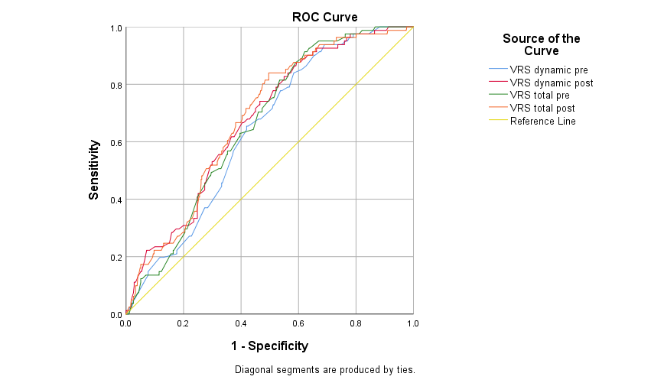

Area Under the Curve
Test Result Variable(s) | Area | Std. Errorª | Asymptotic Sig.^{b} | Asymptotic 95% Confidence Interval
 |  |  |  | Lower Bound | Upper Bound
VRS dynamic pre | .639 | .029 | .000 | .581 | .697
VRS dynamic post | .674 | .030 | .000 | .616 | .732
VRS total pre | .661 | .028 | .000 | .605 | .716
VRS total post | .681 | .029 | .000 | .624 | .738

ROC Curve

Case Processing Summary
3-yr violent recidivismª | Valid N (listwise)
Positive^{b} | 111
Negative | 361

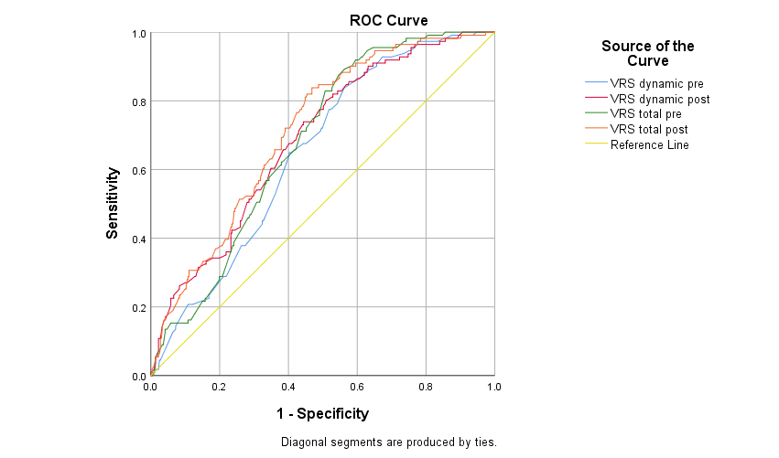

Area Under the Curve
Test Result Variable(s) | Area | Std. Errorª | Asymptotic Sig.^{b} | Asymptotic 95% Confidence Interval
 |  |  |  | Lower Bound | Upper Bound
VRS dynamic pre | .649 | .027 | .000 | .596 | .701
VRS dynamic post | .688 | .027 | .000 | .635 | .741
VRS total pre | .679 | .025 | .000 | .629 | .729
VRS total post | .712 | .026 | .000 | .662 | .762

ROC Curve
Case Processing Summary
5-yr violent recidivismª | Valid N (listwise)
Positive^{b} | 176
Negative | 296

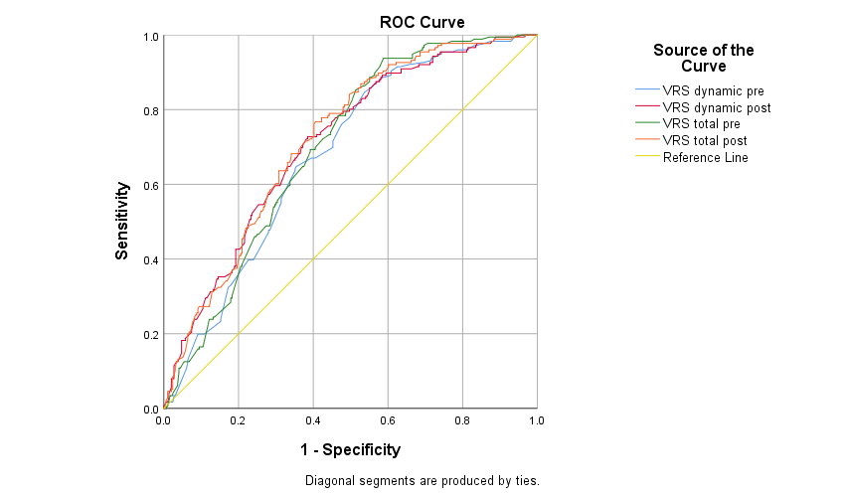

Area Under the Curve
Test Result Variable(s) | Area | Std. Errorª | Asymptotic Sig.^{b} | Asymptotic 95% Confidence Interval
 |  |  |  | Lower Bound | Upper Bound
VRS dynamic pre | .680 | .024 | .000 | .632 | .728
VRS dynamic post | .712 | .024 | .000 | .665 | .759
VRS total pre | .697 | .024 | .000 | .651 | .744
VRS total post | .720 | .023 | .000 | .675 | .766

ROC Curve

Case Processing Summary
2-yr general recidivismª | Valid N (listwise)
Positive^{b} | 170
Negative | 302

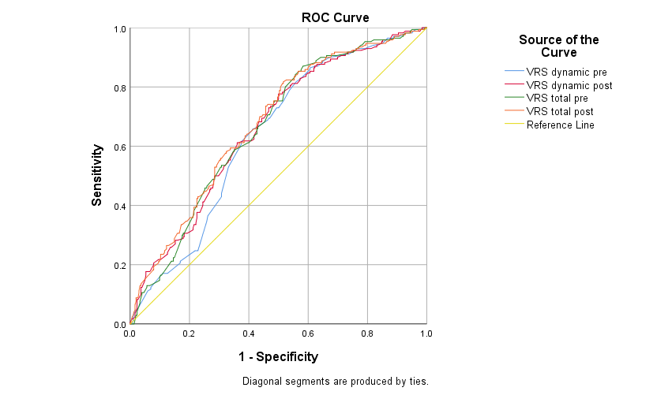

Area Under the Curve
Test Result Variable(s) | Area | Std. Errorª | Asymptotic Sig.^{b} | Asymptotic 95% Confidence Interval
 |  |  |  | Lower Bound | Upper Bound
VRS dynamic pre | .638 | .026 | .000 | .588 | .688
VRS dynamic post | .662 | .025 | .000 | .612 | .712
VRS total pre | .662 | .025 | .000 | .613 | .711
VRS total post | .676 | .025 | .000 | .627 | .725

ROC Curve

Case Processing Summary
3-yr general recidivismª | Valid N (listwise)
Positive^{b} | 215
Negative | 257

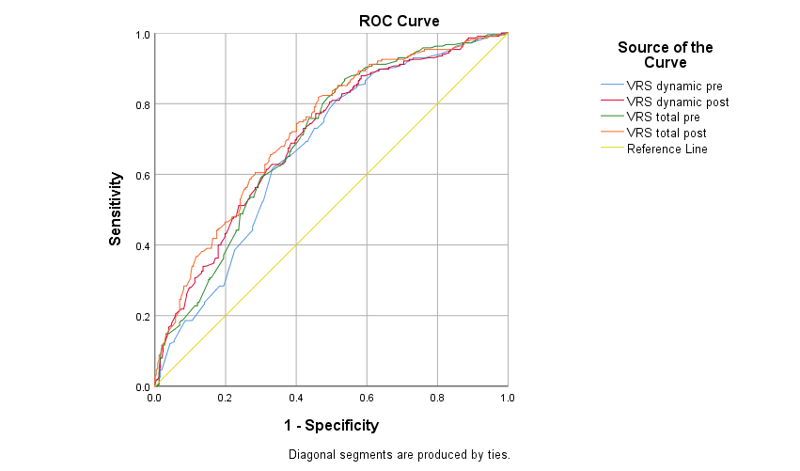

Area Under the Curve
Test Result Variable(s) | Area | Std. Errorª | Asymptotic Sig.^{b} | Asymptotic 95% Confidence Interval
 |  |  |  | Lower Bound | Upper Bound
VRS dynamic pre | .671 | .025 | .000 | .623 | .719
VRS dynamic post | .702 | .024 | .000 | .656 | .749
VRS total pre | .700 | .024 | .000 | .653 | .747
VRS total post | .725 | .023 | .000 | .680 | .771

ROC Curve

Case Processing Summary
5-yr general recidivismª | Valid N (listwise)
Positive^{b} | 279
Negative | 193

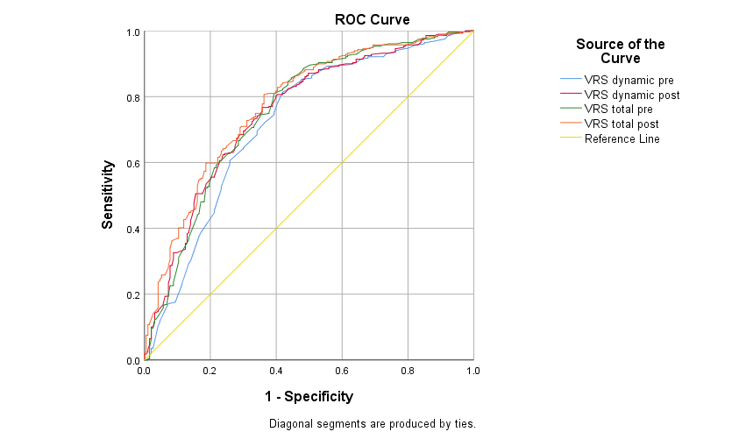

Area Under the Curve
Test Result Variable(s) | Area | Std. Errorª | Asymptotic Sig.^{b} | Asymptotic 95% Confidence Interval
 |  |  |  | Lower Bound | Upper Bound
VRS dynamic pre | .719 | .025 | .000 | .671 | .768
VRS dynamic post | .751 | .023 | .000 | .706 | .796
VRS total pre | .753 | .023 | .000 | .708 | .799
VRS total post | .774 | .022 | .000 | .731 | .817

ROC Curve

Case Processing Summary
2-yr violent recidivismª | Valid N (listwise)
Positive^{b} | 391
Negative | 81

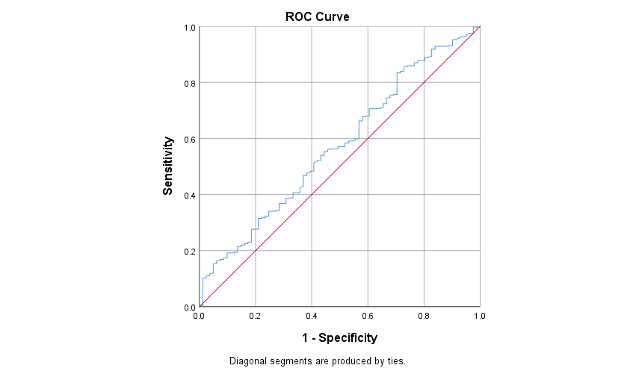

Area Under the Curve
Test Result Variable(s): VRS change res
Area | Std. Errorª | Asymptotic Sig.^{b} | Asymptotic 95% Confidence Interval
Area | Std. Errorª | Asymptotic Sig.^{b} | Lower Bound | Upper Bound
.572 | .035 | .042 | .504 | .640

ROC Curve

Case Processing Summary
3-yr violent recidivismª | Valid N (listwise)
Positive^{b} | 361
Negative | 111
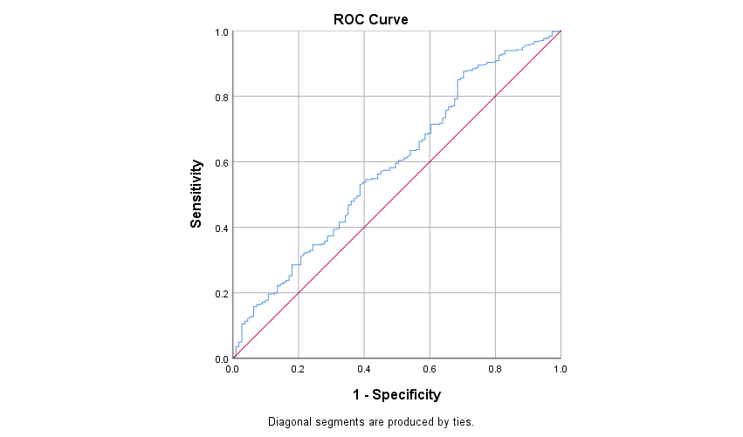

Area Under the Curve
Test Result Variable(s): VRS change res
Area | Std. Errorª | Asymptotic Sig.^{b} | Asymptotic 95% Confidence Interval
Area | Std. Errorª | Asymptotic Sig.^{b} | Lower Bound | Upper Bound
.589 | .031 | .005 | .528 | .650

ROC Curve

Case Processing Summary
5-yr violent recidivismª | Valid N (listwise)
Positive^{b} | 296
Negative | 176

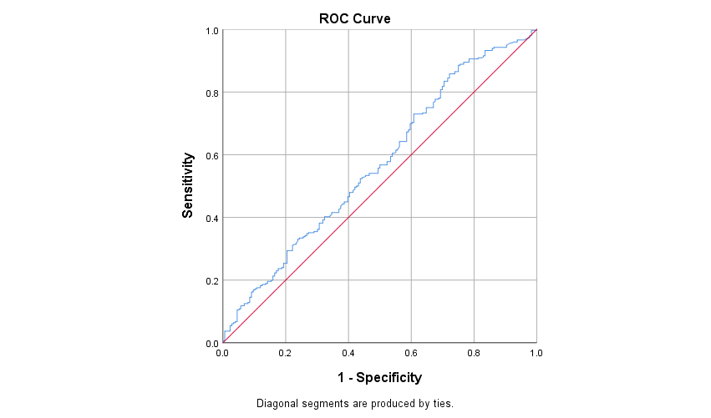

Area Under the Curve
Test Result Variable(s): VRS change res
Area | Std. Errorª | Asymptotic Sig.^{b} | Asymptotic 95% Confidence Interval
Area | Std. Errorª | Asymptotic Sig.^{b} | Lower Bound | Upper Bound
.569 | .027 | .013 | .515 | .622

ROC Curve
Case Processing Summary
2-yr general recidivismª | Valid N (listwise)
Positive^{b} | 302
Negative | 170

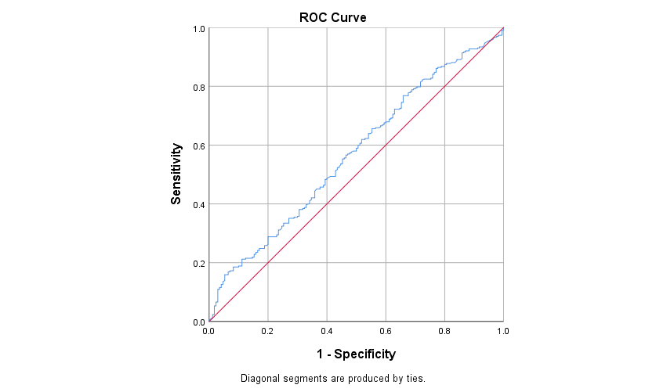

Area Under the Curve
Test Result Variable(s): VRS change res
Area | Std. Errorª | Asymptotic Sig.^{b} | Asymptotic 95% Confidence Interval
Area | Std. Errorª | Asymptotic Sig.^{b} | Lower Bound | Upper Bound
.568 | .027 | .014 | .515 | .622

ROC Curve

Case Processing Summary
3-yr general recidivismª | Valid N (listwise)
Positive^{b} | 257
Negative | 215

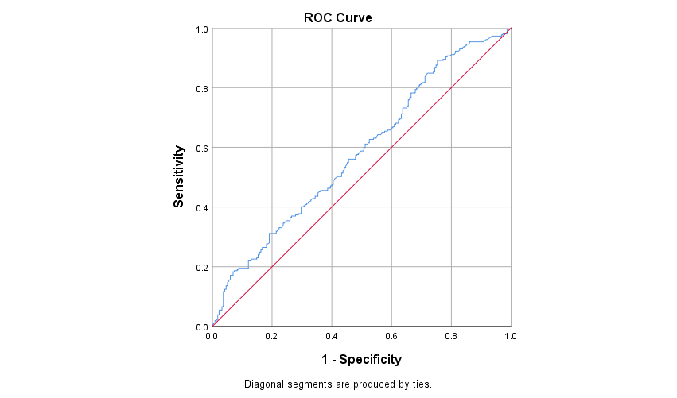

Area Under the Curve
Test Result Variable(s): VRS change res
Area | Std. Errorª | Asymptotic Sig.^{b} | Asymptotic 95% Confidence Interval
Area | Std. Errorª | Asymptotic Sig.^{b} | Lower Bound | Upper Bound
.583 | .026 | .002 | .532 | .635

ROC Curve

Case Processing Summary
5-yr general recidivismª | Valid N (listwise)
Positive^{b} | 193
Negative | 279

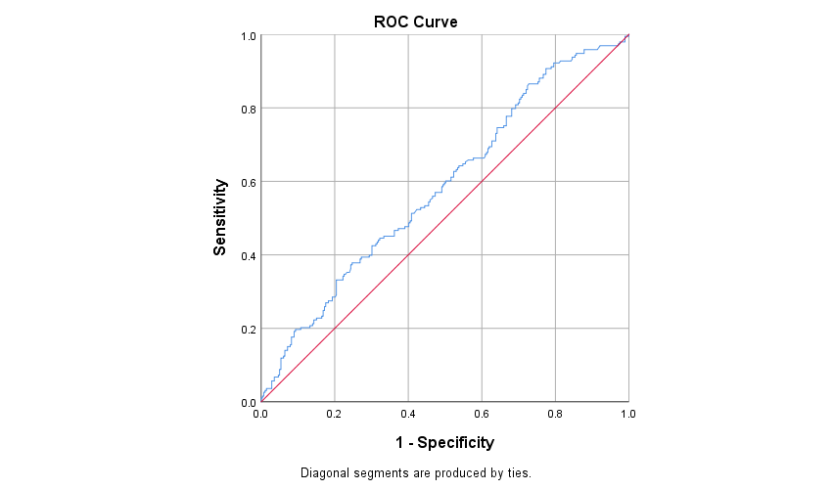

Area Under the Curve
Test Result Variable(s): VRS change res
Area | Std. Errorª | Asymptotic Sig.^{b} | Asymptotic 95% Confidence Interval
Area | Std. Errorª | Asymptotic Sig.^{b} | Lower Bound | Upper Bound
.585 | .026 | .002 | .533 | .637

ROC Curve

Case Processing Summary
2-yr violent recidivismª | Valid N (listwise)
Positive^{b} | 81
Negative | 390
Missing | 1

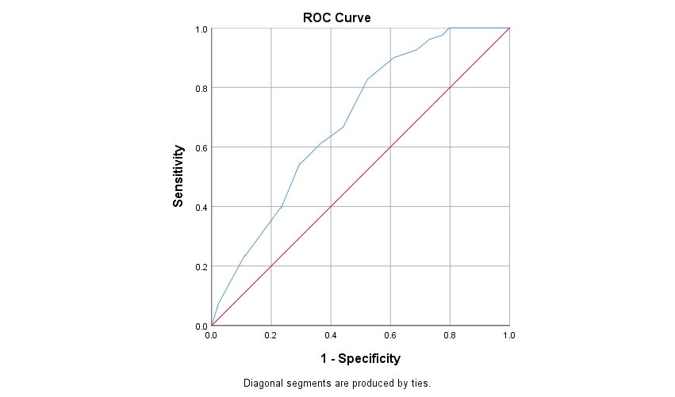

Area Under the Curve
Test Result Variable(s): VRS static
Area | Std. Errorª | Asymptotic Sig.^{b} | Asymptotic 95% Confidence Interval
Area | Std. Errorª | Asymptotic Sig.^{b} | Lower Bound | Upper Bound
.686 | .029 | .000 | .630 | .742

ROC Curve

Case Processing Summary
3-yr violent recidivismª | Valid N (listwise)
Positive^{b} | 111
Negative | 360
Missing | 1

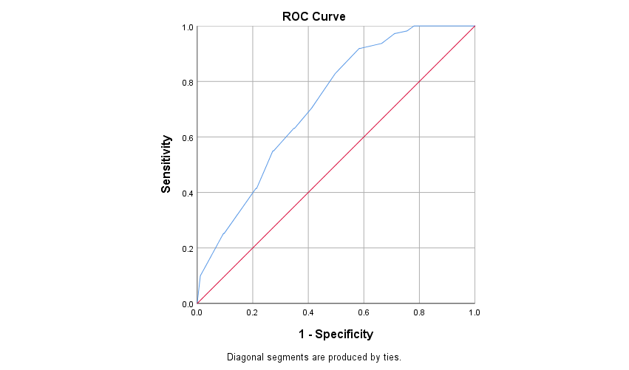

Area Under the Curve
Test Result Variable(s): VRS static
Area | Std. Errorª | Asymptotic Sig.^{b} | Asymptotic 95% Confidence Interval
Area | Std. Errorª | Asymptotic Sig.^{b} | Lower Bound | Upper Bound
.718 | .025 | .000 | .669 | .767

ROC Curve

Case Processing Summary
5-yr violent recidivismª | Valid N (listwise)
Positive^{b} | 175
Negative | 296
Missing | 1

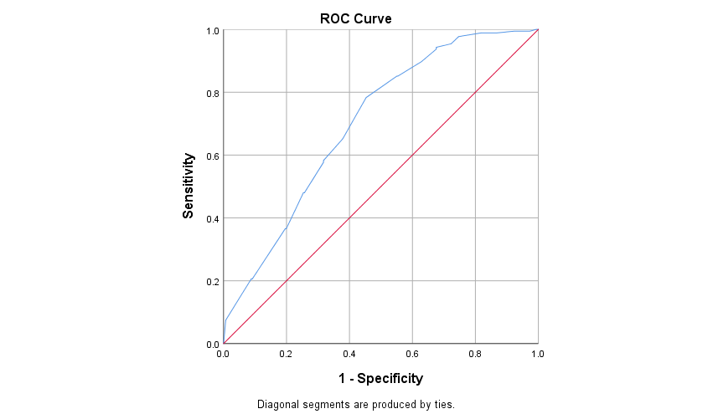

Area Under the Curve
Test Result Variable(s): VRS static
Area | Std. Errorª | Asymptotic Sig.^{b} | Asymptotic 95% Confidence Interval
Area | Std. Errorª | Asymptotic Sig.^{b} | Lower Bound | Upper Bound
.701 | .024 | .000 | .654 | .747

ROC Curve

Case Processing Summary
2-yr general recidivismª | Valid N (listwise)
Positive^{b} | 170
Negative | 301
Missing | 1

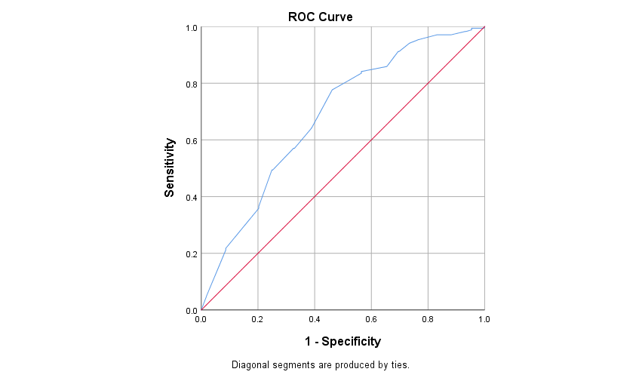

Area Under the Curve
Test Result Variable(s): VRS static
Area | Std. Errorª | Asymptotic Sig.^{b} | Asymptotic 95% Confidence Interval
Area | Std. Errorª | Asymptotic Sig.^{b} | Lower Bound | Upper Bound
.683 | .025 | .000 | .635 | .732

ROC Curve

Case Processing Summary
3-yr general recidivismª | Valid N (listwise)
Positive^{b} | 215
Negative | 256
Missing | 1

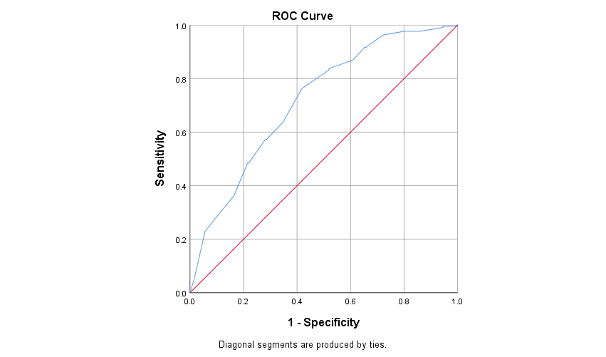

Area Under the Curve
Test Result Variable(s): VRS static
Area | Std. Errorª | Asymptotic Sig.^{b} | Asymptotic 95% Confidence Interval
Area | Std. Errorª | Asymptotic Sig.^{b} | Lower Bound | Upper Bound
.718 | .023 | .000 | .672 | .763

ROC Curve

Case Processing Summary
5-yr general recidivismª | Valid N (listwise)
Positive^{b} | 278
Negative | 193
Missing | 1

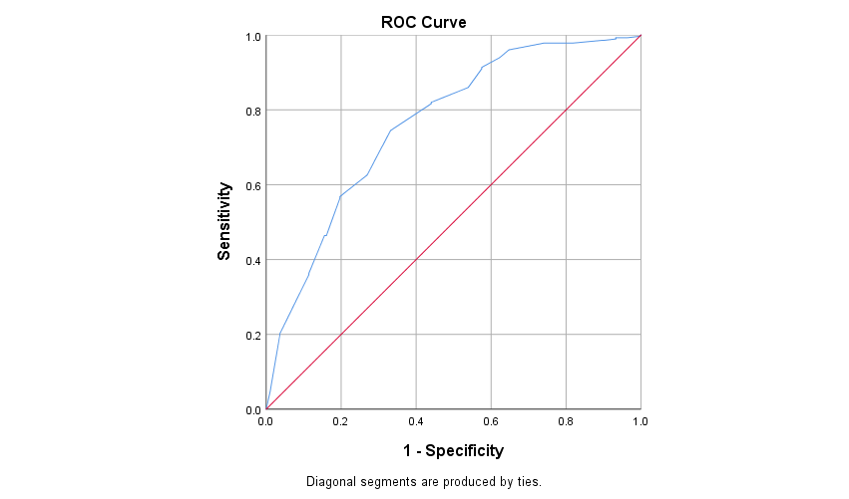

Area Under the Curve
Test Result Variable(s): VRS static
Area | Std. Errorª | Asymptotic Sig.^{b} | Asymptotic 95% Confidence Interval
Area | Std. Errorª | Asymptotic Sig.^{b} | Lower Bound | Upper Bound
.762 | .022 | .000 | .718 | .806

Raw VRS Output for Table 3: Logistic Regression Models for VRS Calculator in the Generation of Recidivism Estimates Over Defined Follow-ups

Table 3: Logistic Regression Models for VRS Calculator in the Generation of Recidivism Estimates Over Defined Follow-ups

Logistic Regression

Case Processing Summary
Unweighted Casesª |  |  |  | N |  | Percent
Selected Cases |  | Included in Analysis |  | 472 |  | 100.0
 |  | Missing Cases |  | 0 |  | .0
 |  | Total |  | 472 |  | 100.0
Unselected Cases |  |  |  | 0 |  | .0
Total |  |  |  | 472 |  | 100.0
a. If weight is in effect, see classification table for the total number of cases.
Model Summary
Step | -2 Log likelihood |  | Cox & Snell R Square |  | Nagelkerke R Square
1 | 396.905ª |  | .073 |  | .122
a. Estimation terminated at iteration number 6 because parameter estimates changed by less than .001.

Hosmer and Lemeshow Test
Step | Chi-square | df | Sig.
1 | 9.092 | 8 | .335

Contingency Table for Hosmer and Lemeshow Test
 |  | 2-yr violent recidivism = 0 |  | 2-yr violent recidivism = 1 |  | Total
 |  | Observed | Expected | Observed | Expected | Total
Step 1 | 1 | 45 | 44.665 | 1 | 1.335 | 46
Step 1 | 2 | 46 | 44.353 | 1 | 2.647 | 47
Step 1 | 3 | 42 | 42.869 | 5 | 4.131 | 47
Step 1 | 4 | 43 | 41.599 | 4 | 5.401 | 47
Step 1 | 5 | 39 | 40.224 | 8 | 6.776 | 47
Step 1 | 6 | 36 | 37.959 | 10 | 8.041 | 46
Step 1 | 7 | 34 | 37.323 | 13 | 9.677 | 47
Step 1 | 8 | 32 | 35.679 | 15 | 11.321 | 47
Step 1 | 9 | 39 | 33.641 | 8 | 13.359 | 47
Step 1 | 10 | 35 | 32.687 | 16 | 18.313 | 51

Classification Tableª
 | Observed |  | Predicted
 |  |  | 2-yr violent recidivism |  | Percentage Correct
 |  |  | 0 | 1 | Percentage Correct
Step 1 | 2-yr violent recidivism | 0 | 391 | 0 | 100.0
Step 1 | 2-yr violent recidivism | 1 | 81 | 0 | .0
Step 1 | Overall Percentage |  |  |  | 82.8
a. The cut value is .500

Variables in the Equation
 |  | B | S.E. | Wald | df | Sig. | Exp(B) | 95% C.I.for EXP(B)
 |  |  |  |  |  |  |  | Lower | Upper
Step 1ª | VRS total pre | .067 | .013 | 26.124 | 1 | .000 | 1.070 | 1.042 | 1.098
Step 1ª | VRS change | -.080 | .031 | 6.549 | 1 | .010 | .923 | .868 | .981
Step 1ª | Constant | -4.993 | .770 | 42.039 | 1 | .000 | .007
a. Variable(s) entered on step 1: VRS total pre, VRS change.

Logistic Regression
Case Processing Summary
Unweighted Casesª |  | N | Percent
Selected Cases | Included in Analysis | 472 | 100.0
Selected Cases | Missing Cases | 0 | .0
Selected Cases | Total | 472 | 100.0
Unselected Cases |  | 0 | .0
Total |  | 472 | 100.0
a. If weight is in effect, see classification table for the total number of cases.

Model Summary
Step | -2 Log likelihood | Cox & Snell R Square | Nagelkerke R Square
1 | 456.046ª | .117 | .177
a. Estimation terminated at iteration number 5 because parameter estimates changed by less than .001.

Hosmer and Lemeshow Test
Step | Chi-square | df | Sig.
1 | 8.893 | 8 | .351

Contingency Table for Hosmer and Lemeshow Test
 |  | 3-yr violent recidivism = 0 |  | 3-yr violent recidivism = 1 |  | Total
 |  | Observed | Expected | Observed | Expected | Total
Step 1 | 1 | 45 | 44.503 | 1 | 1.497 | 46
Step 1 | 2 | 45 | 43.758 | 2 | 3.242 | 47
Step 1 | 3 | 40 | 41.670 | 7 | 5.330 | 47
Step 1 | 4 | 41 | 39.843 | 6 | 7.157 | 47
Step 1 | 5 | 39 | 37.868 | 8 | 9.132 | 47
Step 1 | 6 | 30 | 35.703 | 17 | 11.297 | 47
Step 1 | 7 | 32 | 33.522 | 15 | 13.478 | 47
Step 1 | 8 | 30 | 31.114 | 17 | 15.886 | 47
Step 1 | 9 | 34 | 28.104 | 13 | 18.896 | 47
Step 1 | 10 | 25 | 24.915 | 25 | 25.085 | 50

Classification Tableª
 | Observed |  | Predicted
 |  |  | 3-yr violent recidivism |  | Percentage Correct
 |  |  | 0 | 1 | Percentage Correct
Step 1 | 3-yr violent recidivism | 0 | 351 | 10 | 97.2
Step 1 | 3-yr violent recidivism | 1 | 99 | 12 | 10.8
Step 1 | Overall Percentage |  |  |  | 76.9
a. The cut value is .500

Variables in the Equation
 |  | B | S.E. | Wald | df | Sig. | Exp(B) | 95% C.I.for EXP(B)
 |  |  |  |  |  |  |  | Lower | Upper
Step 1ª | VRS total pre | .078 | .012 | 40.796 | 1 | .000 | 1.081 | 1.056 | 1.107
Step 1ª | VRS change | -.100 | .029 | 11.907 | 1 | .001 | .905 | .856 | .958
Step 1ª | Constant | -5.093 | .706 | 52.013 | 1 | .000 | .006
a. Variable(s) entered on step 1: VRS total pre, VRS change.

Logistic Regression

Case Processing Summary
Unweighted Casesª |  | N | Percent
Selected Cases | Included in Analysis | 472 | 100.0
Selected Cases | Missing Cases | 0 | .0
Selected Cases | Total | 472 | 100.0
Unselected Cases |  | 0 | .0
Total |  | 472 | 100.0
a. If weight is in effect, see classification table for the total number of cases.

Model Summary
Step | -2 Log likelihood | Cox & Snell R Square | Nagelkerke R Square
1 | 544.589ª | .154 | .210
a. Estimation terminated at iteration number 5 because parameter estimates changed by less than .001.

Hosmer and Lemeshow Test
Step | Chi-square | df | Sig.
1 | 4.155 | 8 | .843

Contingency Table for Hosmer and Lemeshow Test
 |  | 5-yr violent recidivism = 0 |  | 5-yr violent recidivism = 1 |  | Total
 |  | Observed | Expected | Observed | Expected | Total
Step 1 | 1 | 44 | 43.899 | 3 | 3.101 | 47
Step 1 | 2 | 43 | 40.560 | 4 | 6.440 | 47
Step 1 | 3 | 36 | 36.834 | 11 | 10.166 | 47
Step 1 | 4 | 31 | 33.657 | 16 | 13.343 | 47
Step 1 | 5 | 31 | 30.524 | 16 | 16.476 | 47
Step 1 | 6 | 26 | 28.133 | 22 | 19.867 | 48
Step 1 | 7 | 22 | 24.898 | 25 | 22.102 | 47
Step 1 | 8 | 23 | 22.260 | 24 | 24.740 | 47
Step 1 | 9 | 21 | 19.083 | 25 | 26.917 | 46
Step 1 | 10 | 19 | 16.152 | 30 | 32.848 | 49

Classification Tableª
 | Observed |  | Predicted
 |  |  | 5-yr violent recidivism |  | Percentage Correct
 |  |  | 0 | 1 | Percentage Correct
Step 1 | 5-yr violent recidivism | 0 | 234 | 62 | 79.1
Step 1 | 5-yr violent recidivism | 1 | 99 | 77 | 43.8
Step 1 | Overall Percentage |  |  |  | 65.9
a. The cut value is .500

Variables in the Equation
 |  | B | S.E. | Wald | df | Sig. | Exp(B) | 95% C.I.for EXP(B)
 |  |  |  |  |  |  |  | Lower | Upper
Step 1ª | VRS total pre | .078 | .010 | 58.122 | 1 | .000 | 1.081 | 1.060 | 1.103
Step 1ª | VRS change | -.082 | .026 | 10.024 | 1 | .002 | .922 | .876 | .969
Step 1ª | Constant | -4.423 | .569 | 60.430 | 1 | .000 | .012
a. Variable(s) entered on step 1: VRS total pre, VRS change.

Logistic Regression

Case Processing Summary
Unweighted Casesª |  | N | Percent
Selected Cases | Included in Analysis | 472 | 100.0
Selected Cases | Missing Cases | 0 | .0
Selected Cases | Total | 472 | 100.0
Unselected Cases |  | 0 | .0
Total |  | 472 | 100.0
a. If weight is in effect, see classification table for the total number of cases.

Model Summary
Step | -2 Log likelihood | Cox & Snell R Square | Nagelkerke R Square
1 | 569.742ª | .095 | .130
a. Estimation terminated at iteration number 4 because parameter estimates changed by less than .001.

Hosmer and Lemeshow Test
Step | Chi-square | df | Sig.
1 | 5.909 | 8 | .657

Contingency Table for Hosmer and Lemeshow Test
 |  | 2-yr general recidivism = 0 |  | 2-yr general recidivism = 1 |  | Total
 |  | Observed | Expected | Observed | Expected | Total
Step 1 | 1 | 39 | 41.051 | 7 | 4.949 | 46
Step 1 | 2 | 41 | 38.588 | 6 | 8.412 | 47
Step 1 | 3 | 37 | 35.398 | 10 | 11.602 | 47
Step 1 | 4 | 35 | 33.044 | 12 | 13.956 | 47
Step 1 | 5 | 26 | 30.783 | 21 | 16.217 | 47
Step 1 | 6 | 28 | 28.069 | 18 | 17.931 | 46
Step 1 | 7 | 24 | 26.747 | 23 | 20.253 | 47
Step 1 | 8 | 26 | 24.778 | 21 | 22.222 | 47
Step 1 | 9 | 25 | 22.595 | 22 | 24.405 | 47
Step 1 | 10 | 21 | 20.947 | 30 | 30.053 | 51

Classification Tableª
 | Observed |  | Predicted
 |  |  | 2-yr general recidivism |  | Percentage Correct
 |  |  | 0 | 1 | Percentage Correct
Step 1 | 2-yr general recidivism | 0 | 260 | 42 | 86.1
Step 1 | 2-yr general recidivism | 1 | 123 | 47 | 27.6
Step 1 | Overall Percentage |  |  |  | 65.0
a. The cut value is .500

Variables in the Equation
 |  | B | S.E. | Wald | df | Sig. | Exp(B) | 95% C.I.for EXP(B)
 |  |  |  |  |  |  |  | Lower | Upper
Step 1ª | VRS total pre | .057 | .009 | 38.625 | 1 | .000 | 1.059 | 1.040 | 1.078
Step 1ª | VRS change | -.066 | .025 | 6.941 | 1 | .008 | .936 | .891 | .983
Step 1ª | Constant | -3.359 | .502 | 44.786 | 1 | .000 | .035
a. Variable(s) entered on step 1: VRS total pre, VRS change.

Logistic Regression

Case Processing Summary
Unweighted Casesª |  | N | Percent
Selected Cases | Included in Analysis | 472 | 100.0
Selected Cases | Missing Cases | 0 | .0
Selected Cases | Total | 472 | 100.0
Unselected Cases |  | 0 | .0
Total |  | 472 | 100.0
a. If weight is in effect, see classification table for the total number of cases.

Model Summary
Step | -2 Log likelihood | Cox & Snell R Square | Nagelkerke R Square
1 | 568.517ª | .160 | .213
a. Estimation terminated at iteration number 4 because parameter estimates changed by less than .001.

Hosmer and Lemeshow Test
Step | Chi-square | df | Sig.
1 | 4.741 | 8 | .785

Contingency Table for Hosmer and Lemeshow Test
 |  | 3-yr general recidivism = 0 |  | 3-yr general recidivism = 1 |  | Total
 |  | Observed | Expected | Observed | Expected | Total
Step 1 | 1 | 38 | 41.004 | 8 | 4.996 | 46
Step 1 | 2 | 40 | 37.386 | 7 | 9.614 | 47
Step 1 | 3 | 33 | 32.865 | 14 | 14.135 | 47
Step 1 | 4 | 31 | 29.604 | 16 | 17.396 | 47
Step 1 | 5 | 27 | 26.421 | 20 | 20.579 | 47
Step 1 | 6 | 20 | 23.425 | 27 | 23.575 | 47
Step 1 | 7 | 22 | 20.750 | 25 | 26.250 | 47
Step 1 | 8 | 18 | 18.103 | 29 | 28.897 | 47
Step 1 | 9 | 14 | 15.206 | 33 | 31.794 | 47
Step 1 | 10 | 14 | 12.236 | 36 | 37.764 | 50

Classification Tableª
 | Observed |  | Predicted
 |  |  | 3-yr general recidivism |  | Percentage Correct
 |  |  | 0 | 1 | Percentage Correct
Step 1 | 3-yr general recidivism | 0 | 181 | 76 | 70.4
Step 1 | 3-yr general recidivism | 1 | 77 | 138 | 64.2
Step 1 | Overall Percentage |  |  |  | 67.6
a. The cut value is .500

Variables in the Equation
 |  | B | S.E. | Wald | df | Sig. | Exp(B) | 95% C.I.for EXP(B)
 |  |  |  |  |  |  |  | Lower | Upper
Step 1ª | VRS total pre | .074 | .009 | 62.506 | 1 | .000 | 1.077 | 1.057 | 1.097
Step 1ª | VRS change | -.100 | .026 | 15.097 | 1 | .000 | .905 | .860 | .952
Step 1ª | Constant | -3.682 | .497 | 54.888 | 1 | .000 | .025
a. Variable(s) entered on step 1: VRS total pre, VRS change.

Logistic Regression

Case Processing Summary
Unweighted Casesª |  | N | Percent
Selected Cases | Included in Analysis | 472 | 100.0
Selected Cases | Missing Cases | 0 | .0
Selected Cases | Total | 472 | 100.0
Unselected Cases |  | 0 | .0
Total |  | 472 | 100.0
a. If weight is in effect, see classification table for the total number of cases.

Model Summary
Step | -2 Log likelihood | Cox & Snell R Square | Nagelkerke R Square
1 | 520.781ª | .221 | .298
a. Estimation terminated at iteration number 4 because parameter estimates changed by less than .001.

Hosmer and Lemeshow Test
Step | Chi-square | df | Sig.
1 | 9.379 | 8 | .311

Contingency Table for Hosmer and Lemeshow Test
 |  | 5-yr general recidivism = 0 |  | 5-yr general recidivism = 1 |  | Total
 |  | Observed | Expected | Observed | Expected | Total
Step 1 | 1 | 36 | 39.892 | 10 | 6.108 | 46
Step 1 | 2 | 38 | 33.951 | 9 | 13.049 | 47
Step 1 | 3 | 27 | 27.150 | 20 | 19.850 | 47
Step 1 | 4 | 24 | 22.504 | 23 | 24.496 | 47
Step 1 | 5 | 18 | 18.498 | 29 | 28.502 | 47
Step 1 | 6 | 17 | 14.823 | 29 | 31.177 | 46
Step 1 | 7 | 7 | 12.443 | 40 | 34.557 | 47
Step 1 | 8 | 12 | 10.098 | 35 | 36.902 | 47
Step 1 | 9 | 7 | 7.855 | 40 | 39.145 | 47
Step 1 | 10 | 7 | 5.786 | 44 | 45.214 | 51

Classification Tableª
 | Observed |  |  |  |  | Predicted
 |  |  |  |  |  | 5-yr general recidivism |  |  |  | Percentage Correct
 |  |  |  |  |  | 0 |  | 1
Step 1 | 5-yr general recidivism |  |  | 0 |  | 110 |  | 83 |  | 57.0
Step 1 |  |  |  | 1 |  | 45 |  | 234 |  | 83.9
Step 1 | Overall Percentage |  |  |  |  |  |  |  |  | 72.9
a. The cut value is .500
Variables in the Equation
 |  |  | B |  | S.E. |  | Wald |  | df |  | Sig. | Exp(B) |  | 95% C.I.for EXP(B)
 |  |  |  |  |  |  |  |  |  |  |  |  |  | Lower | Upper
Step 1ª |  | VRS total pre | .091 |  | .010 |  | 85.430 |  | 1 |  | .000 | 1.095 |  | 1.074 | 1.117
 |  | VRS change | -.113 |  | .028 |  | 16.513 |  | 1 |  | .000 | .893 |  | .846 | .943
 |  | Constant | -3.866 |  | .491 |  | 61.979 |  | 1 |  | .000 | .021
a. Variable(s) entered on step 1: VRS total pre, VRS change.

Raw VRS Output for Table 4 Cox Regression Survival Analysis for VRS Scores in the Prediction of Violent and General Recidivism

Table 4: Cox Regression Survival Analysis for VRS Scores in the Prediction of Violent and General Recidivism

Cox Regression
Case Processing Summary
 |  | N | Percent
Cases available in analysis | Eventª | 238 | 37.5%
Cases available in analysis | Censored | 397 | 62.5%
Cases available in analysis | Total | 635 | 100.0%
Cases dropped | Cases with missing values | 0 | 0.0%
Cases dropped | Cases with negative time | 0 | 0.0%
Cases dropped | Censored cases before the earliest event in a stratum | 0 | 0.0%
Cases dropped | Total | 0 | 0.0%
Total |  | 635 | 100.0%
a. Dependent Variable: violent recidivism survival time

Block 0: Beginning Block

Omnibus Tests of Model Coefficients
-2 Log Likelihood
2857.562

Block 1: Method = Enter

Omnibus Tests of Model Coefficientsª
-2 Log Likelihood | Overall (score) |  |  | Change From Previous Step |  |  | Change From Previous Block
-2 Log Likelihood | Chi-square | df | Sig. | Chi-square | df | Sig. | Chi-square | df | Sig.
2727.536 | 112.867 | 2 | .000 | 130.027 | 2 | .000 | 130.027 | 2 | .000
a. Beginning Block Number 1. Method = Enter

Variables in the Equation
 | B | SE | Wald | df | Sig. | Exp(B) | 95.0% CI for Exp(B)
 |  |  |  |  |  |  | Lower | Upper
VRS total pre | .065 | .007 | 99.540 | 1 | .000 | 1.068 | 1.054 | 1.081
VRS change | -.057 | .016 | 12.862 | 1 | .000 | .944 | .915 | .974

Cox Regression
Case Processing Summary
 |  | N | Percent
Cases available in analysis | Eventª | 344 | 54.2%
Cases available in analysis | Censored | 291 | 45.8%
Cases available in analysis | Total | 635 | 100.0%
Cases dropped | Cases with missing values | 0 | 0.0%
Cases dropped | Cases with negative time | 0 | 0.0%
Cases dropped | Censored cases before the earliest event in a stratum | 0 | 0.0%
Cases dropped | Total | 0 | 0.0%
Total |  | 635 | 100.0%
a. Dependent Variable: general recidivism survival time

Block 0: Beginning Block

Omnibus Tests of Model Coefficients
-2 Log Likelihood
4023.149

Block 1: Method = Enter

Omnibus Tests of Model Coefficientsª
-2 Log Likelihood | Overall (score) |  |  | Change From Previous Step |  |  | Change From Previous Block
-2 Log Likelihood | Chi-square | df | Sig. | Chi-square | df | Sig. | Chi-square | df | Sig.
3845.249 | 154.357 | 2 | .000 | 177.900 | 2 | .000 | 177.900 | 2 | .000
a. Beginning Block Number 1. Method = Enter

Variables in the Equation
 | B | SE | Wald | df | Sig. | Exp(B) | 95.0% CI for Exp(B)
 |  |  |  |  |  |  | Lower | Upper
VRS total pre | .063 | .005 | 140.626 | 1 | .000 | 1.065 | 1.054 | 1.076
VRS change | -.045 | .012 | 12.706 | 1 | .000 | .956 | .933 | .980

Cox Regression

Case Processing Summary
 |  | N | Percent
Cases available in analysis | Eventª | 280 | 25.5%
Cases available in analysis | Censored | 820 | 74.5%
Cases available in analysis | Total | 1100 | 100.0%
Cases dropped | Cases with missing values | 0 | 0.0%
Cases dropped | Cases with negative time | 0 | 0.0%
Cases dropped | Censored cases before the earliest event in a stratum | 0 | 0.0%
Cases dropped | Total | 0 | 0.0%
Total |  | 1100 | 100.0%
a. Dependent Variable: violent recidivism survival time

Block 0: Beginning Block

Omnibus Tests of Model Coefficients
-2 Log Likelihood
3551.595

Block 1: Method = Enter

Omnibus Tests of Model Coefficientsª
-2 Log Likelihood | Overall (score) |  |  | Change From Previous Step |  |  | Change From Previous Block
-2 Log Likelihood | Chi-square | df | Sig. | Chi-square | df | Sig. | Chi-square | df | Sig.
3379.292 | 146.065 | 1 | .000 | 172.303 | 1 | .000 | 172.303 | 1 | .000
a. Beginning Block Number 1. Method = Enter

Variables in the Equation
 | B | SE | Wald | df | Sig. | Exp(B) | 95.0% CI for Exp(B)
 |  |  |  |  |  |  | Lower | Upper
VRS total (all assessments) | .061 | .005 | 130.543 | 1 | .000 | 1.063 | 1.052 | 1.074

Cox Regression
Case Processing Summary
 |  | N | Percent
Cases available in analysis | Eventª | 451 | 41.0%
Cases available in analysis | Censored | 649 | 59.0%
Cases available in analysis | Total | 1100 | 100.0%
Cases dropped | Cases with missing values | 0 | 0.0%
Cases dropped | Cases with negative time | 0 | 0.0%
Cases dropped | Censored cases before the earliest event in a stratum | 0 | 0.0%
Cases dropped | Total | 0 | 0.0%
Total |  | 1100 | 100.0%
a. Dependent Variable: general recidivism survival time

Block 0: Beginning Block

Omnibus Tests of Model Coefficients
-2 Log Likelihood
5687.361

Block 1: Method = Enter

Omnibus Tests of Model Coefficientsª
-2 Log Likelihood | Overall (score) |  |  | Change From Previous Step |  |  | Change From Previous Block
-2 Log Likelihood | Chi-square | df | Sig. | Chi-square | df | Sig. | Chi-square | df | Sig.
5465.118 | 196.902 | 1 | .000 | 222.243 | 1 | .000 | 222.243 | 1 | .000
a. Beginning Block Number 1. Method = Enter

Variables in the Equation
 | B | SE | Wald | df | Sig. | Exp(B) | 95.0% CI for Exp(B)
 |  |  |  |  |  |  | Lower | Upper
VRS total (all assessments) | .051 | .004 | 180.676 | 1 | .000 | 1.052 | 1.044 | 1.060

Raw VRS Output for Table 5: Evidence Based Risk Categories for VRS Scores

Table 5: Evidence Based Risk Categories for VRS Scores

 |  | N | Mean | Std. Deviation
VRS static | Level I | 136 | 3.891 | 2.2970
VRS static | Level II | 280 | 6.582 | 3.2700
VRS static | Level III | 397 | 10.156 | 3.3126
VRS static | Level IV | 306 | 12.795 | 2.8811
VRS static | Level V | 216 | 15.509 | 1.8425
VRS static | Total | 1335 | 10.239 | 4.6245
VRS dynamic (all assessments) | Level I | 136 | 10.046 | 4.1050
VRS dynamic (all assessments) | Level II | 280 | 21.829 | 4.5196
VRS dynamic (all assessments) | Level III | 400 | 32.518 | 4.6231
VRS dynamic (all assessments) | Level IV | 306 | 42.116 | 3.3266
VRS dynamic (all assessments) | Level V | 216 | 48.388 | 3.4726
VRS dynamic (all assessments) | Total | 1338 | 32.754 | 12.4025
VRS total (all assessments) | Level I | 136 | 13.532 | 4.3989
VRS total (all assessments) | Level II | 280 | 27.973 | 4.1450
VRS total (all assessments) | Level III | 400 | 42.349 | 4.2767
VRS total (all assessments) | Level IV | 306 | 54.903 | 2.8933
VRS total (all assessments) | Level V | 216 | 64.273 | 3.0493
VRS total (all assessments) | Total | 1338 | 42.822 | 15.9893
VRS change | Level I | 19 | 1.5811 | 1.89424
VRS change | Level II | 107 | 2.8767 | 3.71621
VRS change | Level III | 215 | 4.3641 | 3.90310
VRS change | Level IV | 224 | 6.0546 | 3.97723
VRS change | Level V | 196 | 4.6208 | 3.69583
VRS change | Total | 761 | 4.6492 | 3.96609

 |  | N VRS scores | Mean (x 100 = %)
VRS_2YRvio0 | Level I | 20 | .0136
VRS_2YRvio0 | Level II | 15 | .0413
VRS_2YRvio0 | Level III | 15 | .1047
VRS_2YRvio0 | Level IV | 10 | .2090
VRS_2YRvio0 | Level V | 19 | .4114
VRS_2YRvio0 | Total | 79 | .1566
VRS_2YRvio2.5 | Level I | 20 | .0112
VRS_2YRvio2.5 | Level II | 15 | .0341
VRS_2YRvio2.5 | Level III | 15 | .0875
VRS_2YRvio2.5 | Level IV | 10 | .1781
VRS_2YRvio2.5 | Level V | 19 | .3654
VRS_2YRvio2.5 | Total | 79 | .1363
VRS_2YRvio5 | Level I | 20 | .0092
VRS_2YRvio5 | Level II | 15 | .0281
VRS_2YRvio5 | Level III | 15 | .0729
VRS_2YRvio5 | Level IV | 10 | .1508
VRS_2YRvio5 | Level V | 19 | .3217
VRS_2YRvio5 | Total | 79 | .1179
VRS_2YRvio9 | Level I | 20 | .0067
VRS_2YRvio9 | Level II | 15 | .0205
VRS_2YRvio9 | Level III | 15 | .0541
VRS_2YRvio9 | Level IV | 10 | .1143
VRS_2YRvio9 | Level V | 19 | .2578
VRS_2YRvio9 | Total | 79 | .0923
VRS_3YRvio0 | Level I | 20 | .013987
VRS_3YRvio0 | Level II | 15 | .050381
VRS_3YRvio0 | Level III | 15 | .144676
VRS_3YRvio0 | Level IV | 10 | .303191
VRS_3YRvio0 | Level V | 19 | .568706
VRS_3YRvio0 | Total | 79 | .215733
VRS_3YRvio2.5 | Level I | 20 | .0109
VRS_3YRvio2.5 | Level II | 15 | .0397
VRS_3YRvio2.5 | Level III | 15 | .1167
VRS_3YRvio2.5 | Level IV | 10 | .2536
VRS_3YRvio2.5 | Level V | 19 | .5093
VRS_3YRvio2.5 | Total | 79 | .1871
VRS_3YRvio5 | Level I | 20 | .008539
VRS_3YRvio5 | Level II | 15 | .031240
VRS_3YRvio5 | Level III | 15 | .093531
VRS_3YRvio5 | Level IV | 10 | .209578
VRS_3YRvio5 | Level V | 19 | .449696
VRS_3YRvio5 | Total | 79 | .160536
VRS_3YRvio9 | Level I | 20 | .005743
VRS_3YRvio9 | Level II | 15 | .021182
VRS_3YRvio9 | Level III | 15 | .064884
VRS_3YRvio9 | Level IV | 10 | .151285
VRS_3YRvio9 | Level V | 19 | .357719
VRS_3YRvio9 | Total | 79 | .122979
VRS_5YRvio0 | Level I | 20 | .0269
VRS_5YRvio0 | Level II | 15 | .0935
VRS_5YRvio0 | Level III | 15 | .2463
VRS_5YRvio0 | Level IV | 10 | .4576
VRS_5YRvio0 | Level V | 19 | .7151
VRS_5YRvio0 | Total | 79 | .3012
VRS_5YRvio2.5 | Level I | 20 | .0221
VRS_5YRvio2.5 | Level II | 15 | .0777
VRS_5YRvio2.5 | Level III | 15 | .2109
VRS_5YRvio2.5 | Level IV | 10 | .4080
VRS_5YRvio2.5 | Level V | 19 | .6732
VRS_5YRvio2.5 | Total | 79 | .2739
VRS_5YRvio5 | Level I | 20 | .0181
VRS_5YRvio5 | Level II | 15 | .0643
VRS_5YRvio5 | Level III | 15 | .1793
VRS_5YRvio5 | Level IV | 10 | .3601
VRS_5YRvio5 | Level V | 19 | .6285
VRS_5YRvio5 | Total | 79 | .2476
VRS_5YRvio9 | Level I | 20 | .0131
VRS_5YRvio9 | Level II | 15 | .0472
VRS_5YRvio9 | Level III | 15 | .1366
VRS_5YRvio9 | Level IV | 10 | .2892
VRS_5YRvio9 | Level V | 19 | .5527
VRS_5YRvio9 | Total | 79 | .2077
VRS_2YRgen0 | Level I | 20 | .0590
VRS_2YRgen0 | Level II | 15 | .1420
VRS_2YRgen0 | Level III | 15 | .2786
VRS_2YRgen0 | Level IV | 10 | .4376
VRS_2YRgen0 | Level V | 19 | .6366
VRS_2YRgen0 | Total | 79 | .3033
VRS_2YRgen2.5 | Level I | 20 | .0505
VRS_2YRgen2.5 | Level II | 15 | .1232
VRS_2YRgen2.5 | Level III | 15 | .2470
VRS_2YRgen2.5 | Level IV | 10 | .3978
VRS_2YRgen2.5 | Level V | 19 | .5986
VRS_2YRgen2.5 | Total | 79 | .2774
VRS_2YRgen5 | Level I | 20 | .0432
VRS_2YRgen5 | Level II | 15 | .1066
VRS_2YRgen5 | Level III | 15 | .2179
VRS_2YRgen5 | Level IV | 10 | .3592
VRS_2YRgen5 | Level V | 19 | .5593
VRS_2YRgen5 | Total | 79 | .2525
VRS_2YRgen9 | Level I | 20 | .0335
VRS_2YRgen9 | Level II | 15 | .0840
VRS_2YRgen9 | Level III | 15 | .1766
VRS_2YRgen9 | Level IV | 10 | .3013
VRS_2YRgen9 | Level V | 19 | .4951
VRS_2YRgen9 | Total | 79 | .2152
VRS_3YRgen0 | Level I | 20 | .0522
VRS_3YRgen0 | Level II | 15 | .1612
VRS_3YRgen0 | Level III | 15 | .3635
VRS_3YRgen0 | Level IV | 10 | .5859
VRS_3YRgen0 | Level V | 19 | .7983
VRS_3YRgen0 | Total | 79 | .3790
VRS_3YRgen2.5 | Level I | 20 | .0412
VRS_3YRgen2.5 | Level II | 15 | .1305
VRS_3YRgen2.5 | Level III | 15 | .3090
VRS_3YRgen2.5 | Level IV | 10 | .5249
VRS_3YRgen2.5 | Level V | 19 | .7563
VRS_3YRgen2.5 | Total | 79 | .3422
VRS_3YRgen5 | Level I | 20 | .0324
VRS_3YRgen5 | Level II | 15 | .1049
VRS_3YRgen5 | Level III | 15 | .2593
VRS_3YRgen5 | Level IV | 10 | .4632
VRS_3YRgen5 | Level V | 19 | .7089
VRS_3YRgen5 | Total | 79 | .3065
VRS_3YRgen9 | Level I | 20 | .0220
VRS_3YRgen9 | Level II | 15 | .0731
VRS_3YRgen9 | Level III | 15 | .1911
VRS_3YRgen9 | Level IV | 10 | .3675
VRS_3YRgen9 | Level V | 19 | .6234
VRS_3YRgen9 | Total | 79 | .2522
VRS_5YRgen0 | Level I | 20 | .0531
VRS_5YRgen0 | Level II | 15 | .2036
VRS_5YRgen0 | Level III | 15 | .4894
VRS_5YRgen0 | Level IV | 10 | .7459
VRS_5YRgen0 | Level V | 19 | .9100
VRS_5YRgen0 | Total | 79 | .4583
VRS_5YRgen2.5 | Level I | 20 | .0407
VRS_5YRgen2.5 | Level II | 15 | .1625
VRS_5YRgen2.5 | Level III | 15 | .4220
VRS_5YRgen2.5 | Level IV | 10 | .6896
VRS_5YRgen2.5 | Level V | 19 | .8846
VRS_5YRgen2.5 | Total | 79 | .4213
VRS_5YRgen9 | Level I | 20 | .0200
VRS_5YRgen9 | Level II | 15 | .0861
VRS_5YRgen9 | Level III | 15 | .2641
VRS_5YRgen9 | Level IV | 10 | .5188
VRS_5YRgen9 | Level V | 19 | .7900
VRS_5YRgen9 | Total | 79 | .3272
VRS_5YRgen5 | Level I | 20 | .0311
VRS_5YRgen5 | Level II | 15 | .1282
VRS_5YRgen5 | Level III | 15 | .3573
VRS_5YRgen5 | Level IV | 10 | .6271
VRS_5YRgen5 | Level V | 19 | .8534
VRS_5YRgen5 | Total | 79 | .3847

Raw VRS Output for Table 6: Construct Validity Indicators for VRS Common Language Risk Levels

Table 6: Construct Validity Indicators for VRS Common Language Risk Levels

Oneway
 |  | N | Mean | Std. Deviation
facet1_pcl | Level I | 108 | .59 | 1.119
facet1_pcl | Level II | 168 | 1.23 | 1.818
facet1_pcl | Level III | 187 | 1.80 | 1.870
facet1_pcl | Level IV | 134 | 2.88 | 2.142
facet1_pcl | Level V | 109 | 3.75 | 1.867
facet1_pcl | Total | 706 | 1.99 | 2.091
facet2_pcl | Level I | 108 | 1.02 | 1.434
facet2_pcl | Level II | 168 | 2.23 | 1.973
facet2_pcl | Level III | 187 | 3.66 | 1.872
facet2_pcl | Level IV | 134 | 4.95 | 1.877
facet2_pcl | Level V | 109 | 6.13 | 1.441
facet2_pcl | Total | 706 | 3.54 | 2.437
facet3_pcl | Level I | 108 | 2.01 | 1.759
facet3_pcl | Level II | 167 | 3.66 | 2.265
facet3_pcl | Level III | 186 | 5.34 | 2.182
facet3_pcl | Level IV | 133 | 6.88 | 1.563
facet3_pcl | Level V | 106 | 7.51 | 1.278
facet3_pcl | Total | 700 | 5.05 | 2.670
facet4_pcl | Level I | 107 | 1.20 | 1.557
facet4_pcl | Level II | 165 | 3.25 | 1.866
facet4_pcl | Level III | 186 | 5.30 | 1.667
facet4_pcl | Level IV | 132 | 7.12 | 1.494
facet4_pcl | Level V | 108 | 8.56 | 1.263
facet4_pcl | Total | 698 | 5.04 | 2.891
PCL Factor 1 | Level I | 108 | 1.60 | 2.234
PCL Factor 1 | Level II | 168 | 3.45 | 3.378
PCL Factor 1 | Level III | 188 | 5.46 | 3.230
PCL Factor 1 | Level IV | 135 | 7.83 | 3.477
PCL Factor 1 | Level V | 110 | 9.86 | 2.791
PCL Factor 1 | Total | 709 | 5.53 | 4.123
PCL Factor 2 | Level I | 108 | 2.78 | 2.236
PCL Factor 2 | Level II | 168 | 6.01 | 3.014
PCL Factor 2 | Level III | 188 | 9.31 | 2.973
PCL Factor 2 | Level IV | 135 | 12.40 | 2.102
PCL Factor 2 | Level V | 110 | 14.29 | 1.788
PCL Factor 2 | Total | 709 | 8.89 | 4.598
PCL TOTAL | Level I | 108 | 5.178 | 3.7981
PCL TOTAL | Level II | 167 | 11.152 | 5.3064
PCL TOTAL | Level III | 193 | 17.069 | 5.4183
PCL TOTAL | Level IV | 151 | 23.990 | 4.9791
PCL TOTAL | Level V | 126 | 27.809 | 4.2418
PCL TOTAL | Total | 745 | 17.238 | 9.0313
SIR total score | Level I | 94 | 5.4255 | 10.59467
SIR total score | Level II | 129 | -.7519 | 9.06145
SIR total score | Level III | 129 | -4.6512 | 9.53747
SIR total score | Level IV | 58 | -7.0690 | 8.95772
SIR total score | Level V | 15 | -12.2000 | 7.82122
SIR total score | Total | 425 | -1.8353 | 10.56789

ANOVA
 |  | Sum of Squares | df | Mean Square | F | Sig.
facet1_pcl | Between Groups | 759.158 | 4 | 189.790 | 57.279 | .000
facet1_pcl | Within Groups | 2322.700 | 701 | 3.313
facet1_pcl | Total | 3081.858 | 705
facet2_pcl | Between Groups | 1972.467 | 4 | 493.117 | 156.072 | .000
facet2_pcl | Within Groups | 2214.842 | 701 | 3.160
facet2_pcl | Total | 4187.309 | 705
facet3_pcl | Between Groups | 2424.160 | 4 | 606.040 | 164.704 | .000
facet3_pcl | Within Groups | 2557.295 | 695 | 3.680
facet3_pcl | Total | 4981.454 | 699
facet4_pcl | Between Groups | 4021.355 | 4 | 1005.339 | 386.063 | .000
facet4_pcl | Within Groups | 1804.629 | 693 | 2.604
facet4_pcl | Total | 5825.984 | 697
PCL Factor 1 | Between Groups | 5175.022 | 4 | 1293.755 | 132.777 | .000
PCL Factor 1 | Within Groups | 6859.636 | 704 | 9.744
PCL Factor 1 | Total | 12034.657 | 708
PCL Factor 2 | Between Groups | 10323.930 | 4 | 2580.982 | 391.099 | .000
PCL Factor 2 | Within Groups | 4645.907 | 704 | 6.599
PCL Factor 2 | Total | 14969.837 | 708
PCL TOTAL | Between Groups | 42862.126 | 4 | 10715.532 | 444.924 | .000
PCL TOTAL | Within Groups | 17822.150 | 740 | 24.084
PCL TOTAL | Total | 60684.276 | 744
SIR total score | Between Groups | 9330.003 | 4 | 2332.501 | 25.765 | .000
SIR total score | Within Groups | 38022.467 | 420 | 90.530
SIR total score | Total | 47352.471 | 424

Post Hoc Tests

Homogeneous Subsets

facet1_pcl
Tukey B^{a,b}
VRS CL Risk Level | N | Subset for alpha = 0.05
VRS CL Risk Level | N | 1 | 2 | 3 | 4 | 5
Level I | 108 | .59
Level II | 168 |  | 1.23
Level III | 187 |  |  | 1.80
Level IV | 134 |  |  |  | 2.88
Level V | 109 |  |  |  |  | 3.75
Means for groups in homogeneous subsets are displayed.
a. Uses Harmonic Mean Sample Size = 134.422.
b. The group sizes are unequal. The harmonic mean of the group sizes is used. Type I error levels are not guaranteed.

facet2_pcl
Tukey B^{a,b}
VRS CL Risk Level | N | Subset for alpha = 0.05
VRS CL Risk Level | N | 1 | 2 | 3 | 4 | 5
Level I | 108 | 1.02
Level II | 168 |  | 2.23
Level III | 187 |  |  | 3.66
Level IV | 134 |  |  |  | 4.95
Level V | 109 |  |  |  |  | 6.13
Means for groups in homogeneous subsets are displayed.
a. Uses Harmonic Mean Sample Size = 134.422.
b. The group sizes are unequal. The harmonic mean of the group sizes is used. Type I error levels are not guaranteed.

facet3_pcl
Tukey B^{a,b}
VRS CL Risk Level | N | Subset for alpha = 0.05
VRS CL Risk Level | N | 1 | 2 | 3 | 4 | 5
Level I | 108 | 2.01
Level II | 167 |  | 3.66
Level III | 186 |  |  | 5.34
Level IV | 133 |  |  |  | 6.88
Level V | 106 |  |  |  |  | 7.51
Means for groups in homogeneous subsets are displayed.
a. Uses Harmonic Mean Sample Size = 133.062.
b. The group sizes are unequal. The harmonic mean of the group sizes is used. Type I error levels are not guaranteed.

facet4_pcl
Tukey B^{a,b}
VRS CL Risk Level | N | Subset for alpha = 0.05
VRS CL Risk Level | N | 1 | 2 | 3 | 4 | 5
Level I | 107 | 1.20
Level II | 165 |  | 3.25
Level III | 186 |  |  | 5.30
Level IV | 132 |  |  |  | 7.12
Level V | 108 |  |  |  |  | 8.56
Means for groups in homogeneous subsets are displayed.
a. Uses Harmonic Mean Sample Size = 132.916.
b. The group sizes are unequal. The harmonic mean of the group sizes is used. Type I error levels are not guaranteed.

PCL Factor 1
Tukey B^{a,b}
VRS CL Risk Level | N | Subset for alpha = 0.05
VRS CL Risk Level | N | 1 | 2 | 3 | 4 | 5
Level I | 108 | 1.60
Level II | 168 |  | 3.45
Level III | 188 |  |  | 5.46
Level IV | 135 |  |  |  | 7.83
Level V | 110 |  |  |  |  | 9.86
Means for groups in homogeneous subsets are displayed.
a. Uses Harmonic Mean Sample Size = 135.029.
b. The group sizes are unequal. The harmonic mean of the group sizes is used. Type I error levels are not guaranteed.

PCL Factor 2
Tukey B^{a,b}
VRS CL Risk Level | N | Subset for alpha = 0.05
VRS CL Risk Level | N | 1 | 2 | 3 | 4 | 5
Level I | 108 | 2.78
Level II | 168 |  | 6.01
Level III | 188 |  |  | 9.31
Level IV | 135 |  |  |  | 12.40
Level V | 110 |  |  |  |  | 14.29
Means for groups in homogeneous subsets are displayed.
a. Uses Harmonic Mean Sample Size = 135.029.
b. The group sizes are unequal. The harmonic mean of the group sizes is used. Type I error levels are not guaranteed.

PCL TOTAL
Tukey B^{a,b}
VRS CL Risk Level | N | Subset for alpha = 0.05
VRS CL Risk Level | N | 1 | 2 | 3 | 4 | 5
Level I | 108 | 5.178
Level II | 167 |  | 11.152
Level III | 193 |  |  | 17.069
Level IV | 151 |  |  |  | 23.990
Level V | 126 |  |  |  |  | 27.809
Means for groups in homogeneous subsets are displayed.
a. Uses Harmonic Mean Sample Size = 142.908.
b. The group sizes are unequal. The harmonic mean of the group sizes is used. Type I error levels are not guaranteed.

SIR total score
Tukey B^{a,b}
VRS CL Risk Level | N | Subset for alpha = 0.05
VRS CL Risk Level | N | 1 | 2 | 3 | 4
Level V | 15 | -12.2000
Level IV | 58 |  | -7.0690
Level III | 129 |  | -4.6512 | -4.6512
Level II | 129 |  |  | -.7519
Level I | 94 |  |  |  | 5.4255
Means for groups in homogeneous subsets are displayed.
a. Uses Harmonic Mean Sample Size = 45.434.
b. The group sizes are unequal. The harmonic mean of the group sizes is used. Type I error levels are not guaranteed.

Crosstabs

VRS CL Risk Level * pcl25

Crosstab
 |  |  | pcl25 |  | Total
 |  |  | PCL-R < 25 | PCL-R 25+ | Total
VRS CL Risk Level | Level I | Count | 108 | 0 | 108
VRS CL Risk Level | Level I | % within VRS CL Risk Level | 100.0% | 0.0% | 100.0%
VRS CL Risk Level | Level II | Count | 163 | 4 | 167
VRS CL Risk Level | Level II | % within VRS CL Risk Level | 97.6% | 2.4% | 100.0%
VRS CL Risk Level | Level III | Count | 171 | 22 | 193
VRS CL Risk Level | Level III | % within VRS CL Risk Level | 88.6% | 11.4% | 100.0%
VRS CL Risk Level | Level IV | Count | 83 | 68 | 151
VRS CL Risk Level | Level IV | % within VRS CL Risk Level | 55.0% | 45.0% | 100.0%
VRS CL Risk Level | Level V | Count | 29 | 97 | 126
VRS CL Risk Level | Level V | % within VRS CL Risk Level | 23.0% | 77.0% | 100.0%
Total |  | Count | 554 | 191 | 745
 |  | % within VRS CL Risk Level | 74.4% | 25.6% | 100.0%

Chi-Square Tests
 | Value | df | Asymptotic Significance (2-sided)
Pearson Chi-Square | 309.120ª | 4 | .000
Likelihood Ratio | 329.671 | 4 | .000
Linear-by-Linear Association | 267.225 | 1 | .000
N of Valid Cases | 745
a. 0 cells (0.0%) have expected count less than 5. The minimum expected count is 27.69.

Symmetric Measures
 |  | Value | Approximate Significance
Nominal by Nominal | Phi | .644 | .000
Nominal by Nominal | Cramer's V | .644 | .000
Nominal by Nominal | Contingency Coefficient | .542 | .000
N of Valid Cases |  | 745

VRS CL Risk Level * pcl30

Crosstab
 |  |  | pcl30 |  | Total
 |  |  | PCL-R < 30 | PCL-R 30+ | Total
VRS CL Risk Level | Level I | Count | 108 | 0 | 108
VRS CL Risk Level | Level I | % within VRS CL Risk Level | 100.0% | 0.0% | 100.0%
VRS CL Risk Level | Level II | Count | 166 | 1 | 167
VRS CL Risk Level | Level II | % within VRS CL Risk Level | 99.4% | 0.6% | 100.0%
VRS CL Risk Level | Level III | Count | 191 | 2 | 193
VRS CL Risk Level | Level III | % within VRS CL Risk Level | 99.0% | 1.0% | 100.0%
VRS CL Risk Level | Level IV | Count | 127 | 24 | 151
VRS CL Risk Level | Level IV | % within VRS CL Risk Level | 84.1% | 15.9% | 100.0%
VRS CL Risk Level | Level V | Count | 77 | 49 | 126
VRS CL Risk Level | Level V | % within VRS CL Risk Level | 61.1% | 38.9% | 100.0%
Total |  | Count | 669 | 76 | 745
 |  | % within VRS CL Risk Level | 89.8% | 10.2% | 100.0%

Chi-Square Tests
 | Value | df | Asymptotic Significance (2-sided)
Pearson Chi-Square | 165.313ª | 4 | .000
Likelihood Ratio | 155.798 | 4 | .000
Linear-by-Linear Association | 123.077 | 1 | .000
N of Valid Cases | 745
a. 0 cells (0.0%) have expected count less than 5. The minimum expected count is 11.02.

Symmetric Measures
 |  | Value | Approximate Significance
Nominal by Nominal | Phi | .471 | .000
Nominal by Nominal | Cramer's V | .471 | .000
Nominal by Nominal | Contingency Coefficient | .426 | .000
N of Valid Cases |  | 745

Raw VRS Output Table 7: Construct Validity Indicators: Spearman’s Ranked Correlation (r_{s}) between VRS Common Language Risk Levels with Structured Professional Judgment (SPJ) Measures

Table 7: Construct Validity Indicators: Spearman’s Ranked Correlation (r_{s}) between VRS Common Language Risk Levels with Structured Professional Judgment (SPJ) Measures

Nonparametric Correlations (Spearman’s rho)

Correlations
 |  |  | VRS CL Risk Level
Spearman's rho | VRS CL Risk Level | Correlation Coefficient | 1.000
Spearman's rho | VRS CL Risk Level | Sig. (2-tailed) | .
Spearman's rho | VRS CL Risk Level | N | 1338
Spearman's rho | HCR-20 H | Correlation Coefficient | .673
Spearman's rho | HCR-20 H | Sig. (2-tailed) | .000
Spearman's rho | HCR-20 H | N | 256
Spearman's rho | HCR-20 C pre | Correlation Coefficient | .458
Spearman's rho | HCR-20 C pre | Sig. (2-tailed) | .000
Spearman's rho | HCR-20 C pre | N | 256
Spearman's rho | HCR-20 R pre | Correlation Coefficient | .451
Spearman's rho | HCR-20 R pre | Sig. (2-tailed) | .000
Spearman's rho | HCR-20 R pre | N | 255
Spearman's rho | HCR-20 total pre | Correlation Coefficient | .682
Spearman's rho | HCR-20 total pre | Sig. (2-tailed) | .000
Spearman's rho | HCR-20 total pre | N | 256
Spearman's rho | HCR-20 C post | Correlation Coefficient | .539
Spearman's rho | HCR-20 C post | Sig. (2-tailed) | .000
Spearman's rho | HCR-20 C post | N | 253
Spearman's rho | HCR-20 R post | Correlation Coefficient | .413
Spearman's rho | HCR-20 R post | Sig. (2-tailed) | .000
Spearman's rho | HCR-20 R post | N | 253
Spearman's rho | HCR-20 total post | Correlation Coefficient | .688
Spearman's rho | HCR-20 total post | Sig. (2-tailed) | .000
Spearman's rho | HCR-20 total post | N | 253
Spearman's rho | HCR-20 change | Correlation Coefficient | -.020
Spearman's rho | HCR-20 change | Sig. (2-tailed) | .753
Spearman's rho | HCR-20 change | N | 253
Spearman's rho | SAPROF Internal pre | Correlation Coefficient | -.387
Spearman's rho | SAPROF Internal pre | Sig. (2-tailed) | .000
Spearman's rho | SAPROF Internal pre | N | 178
Spearman's rho | SAPROF Motivational pre | Correlation Coefficient | -.444
Spearman's rho | SAPROF Motivational pre | Sig. (2-tailed) | .000
Spearman's rho | SAPROF Motivational pre | N | 178
Spearman's rho | SAPROF External pre | Correlation Coefficient | -.150
Spearman's rho | SAPROF External pre | Sig. (2-tailed) | .046
Spearman's rho | SAPROF External pre | N | 178
Spearman's rho | SAPROF total pre | Correlation Coefficient | -.381
Spearman's rho | SAPROF total pre | Sig. (2-tailed) | .000
Spearman's rho | SAPROF total pre | N | 178
Spearman's rho | SAPROF Internal post | Correlation Coefficient | -.430
Spearman's rho | SAPROF Internal post | Sig. (2-tailed) | .000
Spearman's rho | SAPROF Internal post | N | 178
Spearman's rho | SAPROF Internal pre-post change | Correlation Coefficient | -.101
Spearman's rho | SAPROF Internal pre-post change | Sig. (2-tailed) | .178
Spearman's rho | SAPROF Internal pre-post change | N | 178
Spearman's rho | SAPROF Motivational post | Correlation Coefficient | -.452
Spearman's rho | SAPROF Motivational post | Sig. (2-tailed) | .000
Spearman's rho | SAPROF Motivational post | N | 178
Spearman's rho | SAPROF Motivational pre-post change | Correlation Coefficient | .002
Spearman's rho | SAPROF Motivational pre-post change | Sig. (2-tailed) | .976
Spearman's rho | SAPROF Motivational pre-post change | N | 178
Spearman's rho | SAPROF External post | Correlation Coefficient | -.127
Spearman's rho | SAPROF External post | Sig. (2-tailed) | .092
Spearman's rho | SAPROF External post | N | 178
Spearman's rho | SAPROF External pre-post change | Correlation Coefficient | .054
Spearman's rho | SAPROF External pre-post change | Sig. (2-tailed) | .473
Spearman's rho | SAPROF External pre-post change | N | 178
Spearman's rho | SAPROF total post | Correlation Coefficient | -.383
Spearman's rho | SAPROF total post | Sig. (2-tailed) | .000
Spearman's rho | SAPROF total post | N | 178
Spearman's rho | SAPROF total pre-post change | Correlation Coefficient | -.036
Spearman's rho | SAPROF total pre-post change | Sig. (2-tailed) | .634
Spearman's rho | SAPROF total pre-post change | N | 178
Spearman's rho | SAPROF Internal prerelease | Correlation Coefficient | -.429
Spearman's rho | SAPROF Internal prerelease | Sig. (2-tailed) | .000
Spearman's rho | SAPROF Internal prerelease | N | 178
Spearman's rho | SAPROF Internal pre-prerelease change | Correlation Coefficient | -.147
Spearman's rho | SAPROF Internal pre-prerelease change | Sig. (2-tailed) | .050
Spearman's rho | SAPROF Internal pre-prerelease change | N | 178
Spearman's rho | SAPROF Motivational prerelease | Correlation Coefficient | -.393
Spearman's rho | SAPROF Motivational prerelease | Sig. (2-tailed) | .000
Spearman's rho | SAPROF Motivational prerelease | N | 178
Spearman's rho | SAPROF Motivational pre-prerelease change | Correlation Coefficient | .016
Spearman's rho | SAPROF Motivational pre-prerelease change | Sig. (2-tailed) | .832
Spearman's rho | SAPROF Motivational pre-prerelease change | N | 178
Spearman's rho | SAPROF External prerelease | Correlation Coefficient | -.127
Spearman's rho | SAPROF External prerelease | Sig. (2-tailed) | .091
Spearman's rho | SAPROF External prerelease | N | 178
Spearman's rho | SAPROF External pre-prerelease change | Correlation Coefficient | .027
Spearman's rho | SAPROF External pre-prerelease change | Sig. (2-tailed) | .716
Spearman's rho | SAPROF External pre-prerelease change | N | 178
Spearman's rho | SAPROF total prerelease | Correlation Coefficient | -.368
Spearman's rho | SAPROF total prerelease | Sig. (2-tailed) | .000
Spearman's rho | SAPROF total prerelease | N | 178
Spearman's rho | SAPROF total pre-prerelease change | Correlation Coefficient | -.071
Spearman's rho | SAPROF total pre-prerelease change | Sig. (2-tailed) | .348
Spearman's rho | SAPROF total pre-prerelease change | N | 178

Raw VRS Output for Logistic Regression Sample Moderator Analyses

Logistic Regression Sample Moderator Analyses

Logistic Regression

Case Processing Summary
Unweighted Casesª |  | N | Percent
Selected Cases | Included in Analysis | 472 | 100.0
Selected Cases | Missing Cases | 0 | .0
Selected Cases | Total | 472 | 100.0
Unselected Cases |  | 0 | .0
Total |  | 472 | 100.0
a. If weight is in effect, see classification table for the total number of cases.

Categorical Variables Codings
 |  | Frequency | Parameter coding
 |  | Frequency | (1) | (2) | (3) | (4)
VRS sample | Lewis et al. (2013) | 82 | .000 | .000 | .000 | .000
VRS sample | Coupland & Olver (2018) | 145 | 1.000 | .000 | .000 | .000
VRS sample | Hogan & Olver (2019) | 44 | .000 | 1.000 | .000 | .000
VRS sample | Higgs et al. (2020) | 119 | .000 | .000 | 1.000 | .000
VRS sample | Eggert et al. (2020) | 82 | .000 | .000 | .000 | 1.000

Block 1: Method = Enter

Model Summary
Step | -2 Log likelihood |  | Cox & Snell R Square |  | Nagelkerke R Square
1 | 475.247ª |  | .081 |  | .121
a. Estimation terminated at iteration number 5 because parameter estimates changed by less than .001.
Classification Tableª
 |  | Observed |  |  |  | Predicted
 |  |  |  |  |  | 3-yr violent recidivism |  |  | Percentage Correct
 |  |  |  |  |  | 0 | 1 |  | Percentage Correct
Step 1 |  | 3-yr violent recidivism |  | 0 |  | 361 | 0 |  | 100.0
 |  |  |  | 1 |  | 111 | 0 |  | .0
 |  | Overall Percentage |  |  |  |  |  |  | 76.5
a. The cut value is .500

Variables in the Equation
 |  | B | S.E. | Wald | df | Sig. | Exp(B) | 95% C.I.for EXP(B)
 |  |  |  |  |  |  |  | Lower | Upper
Step 1ª | VRS sample |  |  | 28.633 | 4 | .000
Step 1ª | VRS sample(1) | .070 | .293 | .057 | 1 | .812 | 1.072 | .604 | 1.903
Step 1ª | VRS sample(2) | -1.903 | .643 | 8.774 | 1 | .003 | .149 | .042 | .525
Step 1ª | VRS sample(3) | -.563 | .323 | 3.035 | 1 | .081 | .569 | .302 | 1.073
Step 1ª | VRS sample(4) | -2.023 | .518 | 15.257 | 1 | .000 | .132 | .048 | .365
Step 1ª | Constant | -.711 | .235 | 9.168 | 1 | .002 | .491
a. Variable(s) entered on step 1: VRS sample.

Block 2: Method = Enter

Model Summary
Step | -2 Log likelihood | Cox & Snell R Square | Nagelkerke R Square
1 | 447.945ª | .132 | .199
a. Estimation terminated at iteration number 6 because parameter estimates changed by less than .001.

Classification Tableª
 | Observed |  | Predicted
 |  |  | 3-yr violent recidivism |  | Percentage Correct
 |  |  | 0 | 1 | Percentage Correct
Step 1 | 3-yr violent recidivism | 0 | 350 | 11 | 97.0
Step 1 | 3-yr violent recidivism | 1 | 99 | 12 | 10.8
Step 1 | Overall Percentage |  |  |  | 76.7
a. The cut value is .500

Variables in the Equation
 |  | B | S.E. | Wald | df | Sig. | Exp(B) | 95% C.I.for EXP(B)
 |  |  |  |  |  |  |  | Lower | Upper
Step 1ª | VRS sample |  |  | 7.377 | 4 | .117
Step 1ª | VRS sample(1) | .244 | .307 | .630 | 1 | .427 | 1.276 | .699 | 2.329
Step 1ª | VRS sample(2) | -.957 | .726 | 1.741 | 1 | .187 | .384 | .093 | 1.592
Step 1ª | VRS sample(3) | .014 | .353 | .002 | 1 | .967 | 1.015 | .508 | 2.027
Step 1ª | VRS sample(4) | -1.112 | .605 | 3.371 | 1 | .066 | .329 | .100 | 1.078
Step 1ª | VRS total pre | .058 | .014 | 16.124 | 1 | .000 | 1.060 | 1.030 | 1.090
Step 1ª | VRS change | -.114 | .033 | 11.754 | 1 | .001 | .892 | .836 | .952
Step 1ª | Constant | -3.817 | .942 | 16.431 | 1 | .000 | .022
a. Variable(s) entered on step 1: VRS total pre, VRS change.

Logistic Regression

Case Processing Summary
Unweighted Casesª |  | N | Percent
Selected Cases | Included in Analysis | 472 | 100.0
Selected Cases | Missing Cases | 0 | .0
Selected Cases | Total | 472 | 100.0
Unselected Cases |  | 0 | .0
Total |  | 472 | 100.0
a. If weight is in effect, see classification table for the total number of cases.

Categorical Variables Codings
 |  | Frequency | Parameter coding
 |  | Frequency | (1) | (2) | (3) | (4)
VRS sample | Lewis et al. (2013) | 82 | .000 | .000 | .000 | .000
VRS sample | Coupland & Olver (2018) | 145 | 1.000 | .000 | .000 | .000
VRS sample | Hogan & Olver (2019) | 44 | .000 | 1.000 | .000 | .000
VRS sample | Higgs et al. (2020) | 119 | .000 | .000 | 1.000 | .000
VRS sample | Eggert et al. (2020) | 82 | .000 | .000 | .000 | 1.000

Block 1: Method = Enter

Model Summary
Step | -2 Log likelihood |  | Cox & Snell R Square |  | Nagelkerke R Square
1 | 552.318ª |  | .140 |  | .191
a. Estimation terminated at iteration number 5 because parameter estimates changed by less than .001.
Classification Tableª
 |  | Observed |  |  |  | Predicted
 |  |  |  |  |  | 5-yr violent recidivism |  |  | Percentage Correct
 |  |  |  |  |  | 0 | 1 |  | Percentage Correct
Step 1 |  | 5-yr violent recidivism |  | 0 |  | 189 | 107 |  | 63.9
 |  |  |  | 1 |  | 56 | 120 |  | 68.2
 |  | Overall Percentage |  |  |  |  |  |  | 65.5
a. The cut value is .500

Variables in the Equation
 |  | B | S.E. | Wald | df | Sig. | Exp(B) | 95% C.I.for EXP(B)
 |  |  |  |  |  |  |  | Lower | Upper
Step 1ª | VRS sample |  |  | 51.485 | 4 | .000
Step 1ª | VRS sample(1) | -.127 | .277 | .209 | 1 | .648 | .881 | .512 | 1.517
Step 1ª | VRS sample(2) | -2.042 | .492 | 17.207 | 1 | .000 | .130 | .049 | .341
Step 1ª | VRS sample(3) | -.765 | .293 | 6.837 | 1 | .009 | .465 | .262 | .826
Step 1ª | VRS sample(4) | -2.567 | .453 | 32.083 | 1 | .000 | .077 | .032 | .187
Step 1ª | Constant | .196 | .222 | .778 | 1 | .378 | 1.216
a. Variable(s) entered on step 1: VRS sample.

Block 2: Method = Enter

Model Summary
Step | -2 Log likelihood |  | Cox & Snell R Square |  | Nagelkerke R Square
1 | 526.580ª |  | .186 |  | .253
a. Estimation terminated at iteration number 5 because parameter estimates changed by less than .001.
Classification Tableª
 |  | Observed |  |  |  | Predicted
 |  |  |  |  |  | 5-yr violent recidivism |  |  | Percentage Correct
 |  |  |  |  |  | 0 | 1 |  | Percentage Correct
Step 1 |  | 5-yr violent recidivism |  | 0 |  | 235 | 61 |  | 79.4
 |  |  |  | 1 |  | 82 | 94 |  | 53.4
 |  | Overall Percentage |  |  |  |  |  |  | 69.7
a. The cut value is .500

Variables in the Equation
 |  | B | S.E. | Wald | df | Sig. | Exp(B) | 95% C.I.for EXP(B)
 |  |  |  |  |  |  |  | Lower | Upper
Step 1ª | VRS sample |  |  | 15.884 | 4 | .003
Step 1ª | VRS sample(1) | .017 | .289 | .003 | 1 | .953 | 1.017 | .578 | 1.791
Step 1ª | VRS sample(2) | -1.173 | .574 | 4.174 | 1 | .041 | .309 | .100 | .953
Step 1ª | VRS sample(3) | -.301 | .316 | .910 | 1 | .340 | .740 | .398 | 1.374
Step 1ª | VRS sample(4) | -1.750 | .518 | 11.393 | 1 | .001 | .174 | .063 | .480
Step 1ª | VRS total pre | .051 | .012 | 18.137 | 1 | .000 | 1.053 | 1.028 | 1.078
Step 1ª | VRS change | -.093 | .030 | 9.456 | 1 | .002 | .911 | .859 | .967
Step 1ª | Constant | -2.514 | .770 | 10.655 | 1 | .001 | .081
a. Variable(s) entered on step 1: VRS total pre, VRS change.

Logistic Regression

Case Processing Summary
Unweighted Casesª |  | N | Percent
Selected Cases | Included in Analysis | 472 | 100.0
Selected Cases | Missing Cases | 0 | .0
Selected Cases | Total | 472 | 100.0
Unselected Cases |  | 0 | .0
Total |  | 472 | 100.0
a. If weight is in effect, see classification table for the total number of cases.

Categorical Variables Codings
 |  | Frequency | Parameter coding
 |  | Frequency | (1) | (2) | (3) | (4)
VRS sample | Lewis et al. (2013) | 82 | .000 | .000 | .000 | .000
VRS sample | Coupland & Olver (2018) | 145 | 1.000 | .000 | .000 | .000
VRS sample | Hogan & Olver (2019) | 44 | .000 | 1.000 | .000 | .000
VRS sample | Higgs et al. (2020) | 119 | .000 | .000 | 1.000 | .000
VRS sample | Eggert et al. (2020) | 82 | .000 | .000 | .000 | 1.000

Block 1: Method = Enter

Model Summary
Step | -2 Log likelihood | Cox & Snell R Square | Nagelkerke R Square
1 | 580.440ª | .138 | .185
a. Estimation terminated at iteration number 4 because parameter estimates changed by less than .001.

Classification Tableª
 | Observed |  | Predicted
 |  |  | 3-yr general recidivism |  | Percentage Correct
 |  |  | 0 | 1 | Percentage Correct
Step 1 | 3-yr general recidivism | 0 | 106 | 151 | 41.2
Step 1 | 3-yr general recidivism | 1 | 20 | 195 | 90.7
Step 1 | Overall Percentage |  |  |  | 63.8
a. The cut value is .500

Variables in the Equation
 |  | B | S.E. | Wald | df | Sig. | Exp(B) | 95% C.I.for EXP(B)
 |  |  |  |  |  |  |  | Lower | Upper
Step 1ª | VRS sample |  |  | 54.240 | 4 | .000
Step 1ª | VRS sample(1) | .139 | .281 | .247 | 1 | .619 | 1.150 | .663 | 1.993
Step 1ª | VRS sample(2) | -1.653 | .435 | 14.415 | 1 | .000 | .191 | .082 | .449
Step 1ª | VRS sample(3) | -.278 | .289 | .926 | 1 | .336 | .757 | .430 | 1.334
Step 1ª | VRS sample(4) | -2.160 | .393 | 30.120 | 1 | .000 | .115 | .053 | .249
Step 1ª | Constant | .295 | .223 | 1.743 | 1 | .187 | 1.343
a. Variable(s) entered on step 1: VRS sample.

Block 2: Method = Enter
Model Summary
Step | -2 Log likelihood |  | Cox & Snell R Square |  | Nagelkerke R Square
1 | 545.330ª |  | .200 |  | .267
a. Estimation terminated at iteration number 5 because parameter estimates changed by less than .001.
Classification Tableª
 |  | Observed |  |  |  | Predicted
 |  |  |  |  |  | 3-yr general recidivism |  |  | Percentage Correct
 |  |  |  |  |  | 0 | 1 |  | Percentage Correct
Step 1 |  | 3-yr general recidivism |  | 0 |  | 170 | 87 |  | 66.1
 |  |  |  | 1 |  | 62 | 153 |  | 71.2
 |  | Overall Percentage |  |  |  |  |  |  | 68.4
a. The cut value is .500

Variables in the Equation
 |  | B | S.E. | Wald | df | Sig. | Exp(B) | 95% C.I.for EXP(B)
 |  |  |  |  |  |  |  | Lower | Upper
Step 1ª | VRS sample |  |  | 20.633 | 4 | .000
Step 1ª | VRS sample(1) | .279 | .295 | .896 | 1 | .344 | 1.322 | .742 | 2.355
Step 1ª | VRS sample(2) | -.978 | .523 | 3.496 | 1 | .062 | .376 | .135 | 1.048
Step 1ª | VRS sample(3) | .308 | .317 | .948 | 1 | .330 | 1.361 | .732 | 2.533
Step 1ª | VRS sample(4) | -1.496 | .470 | 10.140 | 1 | .001 | .224 | .089 | .563
Step 1ª | VRS total pre | .049 | .011 | 18.984 | 1 | .000 | 1.050 | 1.027 | 1.074
Step 1ª | VRS change | -.133 | .030 | 19.819 | 1 | .000 | .876 | .826 | .928
Step 1ª | Constant | -2.064 | .717 | 8.273 | 1 | .004 | .127
a. Variable(s) entered on step 1: VRS total pre, VRS change.

Logistic Regression

Case Processing Summary
Unweighted Casesª |  | N | Percent
Selected Cases | Included in Analysis | 472 | 100.0
Selected Cases | Missing Cases | 0 | .0
Selected Cases | Total | 472 | 100.0
Unselected Cases |  | 0 | .0
Total |  | 472 | 100.0
a. If weight is in effect, see classification table for the total number of cases.

Categorical Variables Codings
 |  | Frequency | Parameter coding
 |  | Frequency | (1) | (2) | (3) | (4)
VRS sample | Lewis et al. (2013) | 82 | .000 | .000 | .000 | .000
VRS sample | Coupland & Olver (2018) | 145 | 1.000 | .000 | .000 | .000
VRS sample | Hogan & Olver (2019) | 44 | .000 | 1.000 | .000 | .000
VRS sample | Higgs et al. (2020) | 119 | .000 | .000 | 1.000 | .000
VRS sample | Eggert et al. (2020) | 82 | .000 | .000 | .000 | 1.000

Block 1: Method = Enter

Model Summary
Step | -2 Log likelihood | Cox & Snell R Square | Nagelkerke R Square
1 | 529.299ª | .207 | .279
a. Estimation terminated at iteration number 4 because parameter estimates changed by less than .001.

Classification Tableª
 | Observed |  | Predicted
 |  |  | 5-yr general recidivism |  | Percentage Correct
 |  |  | 0 | 1 | Percentage Correct
Step 1 | 5-yr general recidivism | 0 | 99 | 94 | 51.3
Step 1 | 5-yr general recidivism | 1 | 27 | 252 | 90.3
Step 1 | Overall Percentage |  |  |  | 74.4
a. The cut value is .500

Variables in the Equation
 |  | B | S.E. | Wald | df | Sig. | Exp(B) | 95% C.I.for EXP(B)
 |  |  |  |  |  |  |  | Lower | Upper
Step 1ª | VRS sample |  |  | 87.350 | 4 | .000
Step 1ª | VRS sample(1) | -.382 | .337 | 1.287 | 1 | .257 | .683 | .353 | 1.320
Step 1ª | VRS sample(2) | -2.398 | .438 | 29.911 | 1 | .000 | .091 | .038 | .215
Step 1ª | VRS sample(3) | -.736 | .340 | 4.704 | 1 | .030 | .479 | .246 | .932
Step 1ª | VRS sample(4) | -2.914 | .399 | 53.313 | 1 | .000 | .054 | .025 | .119
Step 1ª | Constant | 1.417 | .279 | 25.860 | 1 | .000 | 4.125
a. Variable(s) entered on step 1: VRS sample.

Block 2: Method = Enter
Model Summary
Step | -2 Log likelihood | Cox & Snell R Square | Nagelkerke R Square
1 | 487.215ª | .274 | .370
a. Estimation terminated at iteration number 5 because parameter estimates changed by less than .001.

Classification Tableª
 | Observed |  | Predicted
 |  |  | 5-yr general recidivism |  | Percentage Correct
 |  |  | 0 | 1 | Percentage Correct
Step 1 | 5-yr general recidivism | 0 | 107 | 86 | 55.4
Step 1 | 5-yr general recidivism | 1 | 33 | 246 | 88.2
Step 1 | Overall Percentage |  |  |  | 74.8
a. The cut value is .500

Variables in the Equation
 |  | B | S.E. | Wald | df | Sig. | Exp(B) | 95% C.I.for EXP(B)
 |  |  |  |  |  |  |  | Lower | Upper
Step 1ª | VRS sample |  |  | 30.092 | 4 | .000
Step 1ª | VRS sample(1) | -.262 | .352 | .555 | 1 | .456 | .769 | .386 | 1.534
Step 1ª | VRS sample(2) | -1.658 | .530 | 9.790 | 1 | .002 | .191 | .067 | .538
Step 1ª | VRS sample(3) | -.112 | .365 | .094 | 1 | .759 | .894 | .437 | 1.829
Step 1ª | VRS sample(4) | -2.190 | .472 | 21.496 | 1 | .000 | .112 | .044 | .283
Step 1ª | VRS total pre | .058 | .012 | 25.206 | 1 | .000 | 1.060 | 1.036 | 1.084
Step 1ª | VRS change | -.150 | .032 | 21.875 | 1 | .000 | .861 | .808 | .916
Step 1ª | Constant | -1.302 | .726 | 3.211 | 1 | .073 | .272
a. Variable(s) entered on step 1: VRS total pre, VRS change.

Raw VRS Output for VRS Cox and Logistic Regression Analyses Minus Pueblo (CMHIP) data

VRS Cox and Logistic Regression Analyses Minus Pueblo (CMHIP) data

Logistic Regression

Case Processing Summary
Unweighted Casesª |  | N | Percent
Selected Cases | Included in Analysis | 390 | 100.0
Selected Cases | Missing Cases | 0 | .0
Selected Cases | Total | 390 | 100.0
Unselected Cases |  | 0 | .0
Total |  | 390 | 100.0
a. If weight is in effect, see classification table for the total number of cases.

Block 1: Method = Enter

Model Summary
Step | -2 Log likelihood | Cox & Snell R Square | Nagelkerke R Square
1 | 362.916ª | .054 | .087
a. Estimation terminated at iteration number 5 because parameter estimates changed by less than .001.

Hosmer and Lemeshow Test
Step | Chi-square | df | Sig.
1 | 9.533 | 8 | .299

Contingency Table for Hosmer and Lemeshow Test
 |  | 2-yr violent recidivism = 0 |  | 2-yr violent recidivism = 1 |  | Total
 |  | Observed | Expected | Observed | Expected | Total
Step 1 | 1 | 39 | 37.117 | 0 | 1.883 | 39
Step 1 | 2 | 34 | 35.299 | 5 | 3.701 | 39
Step 1 | 3 | 35 | 34.040 | 4 | 4.960 | 39
Step 1 | 4 | 33 | 33.006 | 6 | 5.994 | 39
Step 1 | 5 | 29 | 32.065 | 10 | 6.935 | 39
Step 1 | 6 | 30 | 31.026 | 9 | 7.974 | 39
Step 1 | 7 | 27 | 30.074 | 12 | 8.926 | 39
Step 1 | 8 | 30 | 28.974 | 9 | 10.026 | 39
Step 1 | 9 | 32 | 26.763 | 6 | 11.237 | 38
Step 1 | 10 | 25 | 25.637 | 15 | 14.363 | 40

Classification Tableª
 | Observed |  | Predicted
 |  |  | 2-yr violent recidivism |  | Percentage Correct
 |  |  | 0 | 1 | Percentage Correct
Step 1 | 2-yr violent recidivism | 0 | 314 | 0 | 100.0
Step 1 | 2-yr violent recidivism | 1 | 76 | 0 | .0
Step 1 | Overall Percentage |  |  |  | 80.5
a. The cut value is .500

Variables in the Equation
 |  | B | S.E. | Wald | df | Sig. | Exp(B) | 95% C.I.for EXP(B)
 |  |  |  |  |  |  |  | Lower | Upper
Step 1ª | VRS total pre | .060 | .015 | 15.960 | 1 | .000 | 1.061 | 1.031 | 1.093
Step 1ª | VRS change | -.073 | .035 | 4.246 | 1 | .039 | .930 | .868 | .996
Step 1ª | Constant | -4.524 | .896 | 25.520 | 1 | .000 | .011
a. Variable(s) entered on step 1: VRS total pre, VRS change.

Logistic Regression

Case Processing Summary
Unweighted Casesª |  | N | Percent
Selected Cases | Included in Analysis | 390 | 100.0
Selected Cases | Missing Cases | 0 | .0
Selected Cases | Total | 390 | 100.0
Unselected Cases |  | 0 | .0
Total |  | 390 | 100.0
a. If weight is in effect, see classification table for the total number of cases.

Block 1: Method = Enter

Model Summary
Step | -2 Log likelihood | Cox & Snell R Square | Nagelkerke R Square
1 | 419.475ª | .090 | .131
a. Estimation terminated at iteration number 5 because parameter estimates changed by less than .001.

Hosmer and Lemeshow Test
Step | Chi-square | df | Sig.
1 | 10.772 | 8 | .215

Contingency Table for Hosmer and Lemeshow Test
 |  | 3-yr violent recidivism = 0 |  | 3-yr violent recidivism = 1 |  | Total
 |  | Observed | Expected | Observed | Expected | Total
Step 1 | 1 | 38 | 36.472 | 1 | 2.528 | 39
Step 1 | 2 | 33 | 34.112 | 6 | 4.888 | 39
Step 1 | 3 | 32 | 32.432 | 7 | 6.568 | 39
Step 1 | 4 | 34 | 31.610 | 6 | 8.390 | 40
Step 1 | 5 | 23 | 29.414 | 16 | 9.586 | 39
Step 1 | 6 | 29 | 27.952 | 10 | 11.048 | 39
Step 1 | 7 | 24 | 26.462 | 15 | 12.538 | 39
Step 1 | 8 | 29 | 24.773 | 10 | 14.227 | 39
Step 1 | 9 | 23 | 22.455 | 16 | 16.545 | 39
Step 1 | 10 | 19 | 18.318 | 19 | 19.682 | 38

Classification Tableª
 | Observed |  | Predicted
 |  |  | 3-yr violent recidivism |  | Percentage Correct
 |  |  | 0 | 1 | Percentage Correct
Step 1 | 3-yr violent recidivism | 0 | 273 | 11 | 96.1
Step 1 | 3-yr violent recidivism | 1 | 94 | 12 | 11.3
Step 1 | Overall Percentage |  |  |  | 73.1
a. The cut value is .500

Variables in the Equation
 |  | B | S.E. | Wald | df | Sig. | Exp(B) | 95% C.I.for EXP(B)
 |  |  |  |  |  |  |  | Lower | Upper
Step 1ª | VRS total pre | .067 | .013 | 25.407 | 1 | .000 | 1.070 | 1.042 | 1.098
Step 1ª | VRS change | -.103 | .033 | 9.826 | 1 | .002 | .902 | .846 | .962
Step 1ª | Constant | -4.369 | .791 | 30.540 | 1 | .000 | .013
a. Variable(s) entered on step 1: VRS total pre, VRS change.

Logistic Regression
Case Processing Summary
Unweighted Casesª |  | N | Percent
Selected Cases | Included in Analysis | 390 | 100.0
Selected Cases | Missing Cases | 0 | .0
Selected Cases | Total | 390 | 100.0
Unselected Cases |  | 0 | .0
Total |  | 390 | 100.0
a. If weight is in effect, see classification table for the total number of cases.

Block 1: Method = Enter

Model Summary
Step | -2 Log likelihood | Cox & Snell R Square | Nagelkerke R Square
1 | 487.630ª | .111 | .149
a. Estimation terminated at iteration number 4 because parameter estimates changed by less than .001.

Hosmer and Lemeshow Test
Step | Chi-square | df | Sig.
1 | 10.595 | 8 | .226

Contingency Table for Hosmer and Lemeshow Test
 |  | 5-yr violent recidivism = 0 |  | 5-yr violent recidivism = 1 |  | Total
 |  | Observed | Expected | Observed | Expected | Total
Step 1 | 1 | 37 | 33.970 | 2 | 5.030 | 39
Step 1 | 2 | 27 | 29.415 | 12 | 9.585 | 39
Step 1 | 3 | 24 | 26.596 | 15 | 12.404 | 39
Step 1 | 4 | 28 | 24.363 | 11 | 14.637 | 39
Step 1 | 5 | 18 | 22.491 | 21 | 16.509 | 39
Step 1 | 6 | 21 | 20.634 | 18 | 18.366 | 39
Step 1 | 7 | 16 | 18.993 | 23 | 20.007 | 39
Step 1 | 8 | 22 | 17.289 | 17 | 21.711 | 39
Step 1 | 9 | 16 | 15.094 | 23 | 23.906 | 39
Step 1 | 10 | 12 | 12.155 | 27 | 26.845 | 39

Classification Tableª
 | Observed |  | Predicted
 |  |  | 5-yr violent recidivism |  | Percentage Correct
 |  |  | 0 | 1 | Percentage Correct
Step 1 | 5-yr violent recidivism | 0 | 158 | 63 | 71.5
Step 1 | 5-yr violent recidivism | 1 | 86 | 83 | 49.1
Step 1 | Overall Percentage |  |  |  | 61.8
a. The cut value is .500

Variables in the Equation
 |  | B | S.E. | Wald | df | Sig. | Exp(B) | 95% C.I.for EXP(B)
 |  |  |  |  |  |  |  | Lower | Upper
Step 1ª | VRS total pre | .067 | .011 | 35.422 | 1 | .000 | 1.069 | 1.046 | 1.093
Step 1ª | VRS change | -.089 | .030 | 8.904 | 1 | .003 | .915 | .863 | .970
Step 1ª | Constant | -3.625 | .638 | 32.315 | 1 | .000 | .027
a. Variable(s) entered on step 1: VRS total pre, VRS change.

Logistic Regression

Case Processing Summary
Unweighted Casesª |  | N | Percent
Selected Cases | Included in Analysis | 390 | 100.0
Selected Cases | Missing Cases | 0 | .0
Selected Cases | Total | 390 | 100.0
Unselected Cases |  | 0 | .0
Total |  | 390 | 100.0
a. If weight is in effect, see classification table for the total number of cases.

Block 1: Method = Enter

Model Summary
Step | -2 Log likelihood | Cox & Snell R Square | Nagelkerke R Square
1 | 504.022ª | .066 | .089
a. Estimation terminated at iteration number 4 because parameter estimates changed by less than .001.

Hosmer and Lemeshow Test
Step | Chi-square |  |  | df |  | Sig.
1 | 7.719 |  |  | 8 |  | .461
Contingency Table for Hosmer and Lemeshow Test
 |  |  | 2-yr general recidivism = 0 |  |  |  |  | 2-yr general recidivism = 1 |  | Total
 |  |  | Observed |  | Expected |  |  | Observed | Expected | Total
Step 1 |  | 1 | 32 |  | 31.467 |  |  | 7 | 7.533 | 39
 |  | 2 | 30 |  | 28.812 |  |  | 10 | 11.188 | 40
 |  | 3 | 28 |  | 26.058 |  |  | 11 | 12.942 | 39
 |  | 4 | 19 |  | 24.938 |  |  | 21 | 15.062 | 40
 |  | 5 | 23 |  | 22.931 |  |  | 16 | 16.069 | 39
 |  | 6 | 20 |  | 21.686 |  |  | 19 | 17.314 | 39
 |  | 7 | 25 |  | 20.365 |  |  | 14 | 18.635 | 39
 |  | 8 | 17 |  | 18.950 |  |  | 22 | 20.050 | 39
 |  | 9 | 19 |  | 17.137 |  |  | 20 | 21.863 | 39
 |  | 10 | 13 |  | 13.657 |  |  | 24 | 23.343 | 37

Classification Tableª
 | Observed |  | Predicted
 |  |  | 2-yr general recidivism |  | Percentage Correct
 |  |  | 0 | 1 | Percentage Correct
Step 1 | 2-yr general recidivism | 0 | 179 | 47 | 79.2
Step 1 | 2-yr general recidivism | 1 | 101 | 63 | 38.4
Step 1 | Overall Percentage |  |  |  | 62.1
a. The cut value is .500

Variables in the Equation
 |  | B | S.E. | Wald | df | Sig. | Exp(B) | 95% C.I.for EXP(B)
 |  |  |  |  |  |  |  | Lower | Upper
Step 1ª | VRS total pre | .047 | .010 | 21.650 | 1 | .000 | 1.048 | 1.028 | 1.069
Step 1ª | VRS change | -.082 | .029 | 7.905 | 1 | .005 | .921 | .869 | .975
Step 1ª | Constant | -2.564 | .565 | 20.559 | 1 | .000 | .077
a. Variable(s) entered on step 1: VRS total pre, VRS change.

Logistic Regression

Case Processing Summary
Unweighted Casesª |  | N | Percent
Selected Cases | Included in Analysis | 390 | 100.0
Selected Cases | Missing Cases | 0 | .0
Selected Cases | Total | 390 | 100.0
Unselected Cases |  | 0 | .0
Total |  | 390 | 100.0
a. If weight is in effect, see classification table for the total number of cases.

Block 1: Method = Enter

Model Summary
Step | -2 Log likelihood |  | Cox & Snell R Square |  | Nagelkerke R Square
1 | 489.431ª |  | .121 |  | .162
a. Estimation terminated at iteration number 4 because parameter estimates changed by less than .001.
Hosmer and Lemeshow Test
Step | Chi-square | df |  | Sig.
1 | 6.802 | 8 |  | .558

Contingency Table for Hosmer and Lemeshow Test
 |  | 3-yr general recidivism = 0 |  | 3-yr general recidivism = 1 |  | Total
 |  | Observed | Expected | Observed | Expected | Total
Step 1 | 1 | 32 | 31.400 | 7 | 7.600 | 39
Step 1 | 2 | 25 | 26.445 | 14 | 12.555 | 39
Step 1 | 3 | 26 | 23.387 | 13 | 15.613 | 39
Step 1 | 4 | 16 | 20.788 | 23 | 18.212 | 39
Step 1 | 5 | 19 | 18.778 | 20 | 20.222 | 39
Step 1 | 6 | 17 | 16.979 | 22 | 22.021 | 39
Step 1 | 7 | 19 | 15.212 | 20 | 23.788 | 39
Step 1 | 8 | 16 | 13.718 | 24 | 26.282 | 40
Step 1 | 9 | 8 | 11.191 | 31 | 27.809 | 39
Step 1 | 10 | 8 | 8.102 | 30 | 29.898 | 38

Classification Tableª
 | Observed |  | Predicted
 |  |  | 3-yr general recidivism |  | Percentage Correct
 |  |  | 0 | 1 | Percentage Correct
Step 1 | 3-yr general recidivism | 0 | 100 | 86 | 53.8
Step 1 | 3-yr general recidivism | 1 | 57 | 147 | 72.1
Step 1 | Overall Percentage |  |  |  | 63.3
a. The cut value is .500

Variables in the Equation
 |  | B | S.E. | Wald | df | Sig. | Exp(B) | 95% C.I.for EXP(B)
 |  |  |  |  |  |  |  | Lower | Upper
Step 1ª | VRS total pre | .066 | .011 | 39.150 | 1 | .000 | 1.068 | 1.046 | 1.091
Step 1ª | VRS change | -.113 | .030 | 13.828 | 1 | .000 | .893 | .841 | .948
Step 1ª | Constant | -3.033 | .574 | 27.900 | 1 | .000 | .048
a. Variable(s) entered on step 1: VRS total pre, VRS change.

Logistic Regression
Case Processing Summary
Unweighted Casesª |  | N | Percent
Selected Cases | Included in Analysis | 390 | 100.0
Selected Cases | Missing Cases | 0 | .0
Selected Cases | Total | 390 | 100.0
Unselected Cases |  | 0 | .0
Total |  | 390 | 100.0
a. If weight is in effect, see classification table for the total number of cases.

Block 1: Method = Enter

Model Summary
Step | -2 Log likelihood | Cox & Snell R Square | Nagelkerke R Square
1 | 419.257ª | .167 | .234
a. Estimation terminated at iteration number 4 because parameter estimates changed by less than .001.

Hosmer and Lemeshow Test
Step | Chi-square | df | Sig.
1 | 7.814 | 8 | .452

Contingency Table for Hosmer and Lemeshow Test
 |  | 5-yr general recidivism = 0 |  | 5-yr general recidivism = 1 |  | Total
 |  | Observed | Expected | Observed | Expected | Total
Step 1 | 1 | 30 | 29.339 | 9 | 9.661 | 39
Step 1 | 2 | 17 | 21.259 | 22 | 17.741 | 39
Step 1 | 3 | 21 | 16.954 | 18 | 22.046 | 39
Step 1 | 4 | 12 | 13.799 | 27 | 25.201 | 39
Step 1 | 5 | 13 | 11.593 | 26 | 27.407 | 39
Step 1 | 6 | 9 | 9.919 | 31 | 30.081 | 40
Step 1 | 7 | 9 | 8.094 | 30 | 30.906 | 39
Step 1 | 8 | 9 | 6.647 | 30 | 32.353 | 39
Step 1 | 9 | 2 | 5.092 | 37 | 33.908 | 39
Step 1 | 10 | 4 | 3.305 | 34 | 34.695 | 38

Classification Tableª
 | Observed |  | Predicted
 |  |  | 5-yr general recidivism |  | Percentage Correct
 |  |  | 0 | 1 | Percentage Correct
Step 1 | 5-yr general recidivism | 0 | 44 | 82 | 34.9
Step 1 | 5-yr general recidivism | 1 | 21 | 243 | 92.0
Step 1 | Overall Percentage |  |  |  | 73.6
a. The cut value is .500

Variables in the Equation
 |  | B | S.E. | Wald | df | Sig. | Exp(B) | 95% C.I.for EXP(B)
 |  |  |  |  |  |  |  | Lower | Upper
Step 1ª | VRS total pre | .085 | .011 | 55.141 | 1 | .000 | 1.089 | 1.065 | 1.114
Step 1ª | VRS change | -.130 | .034 | 14.575 | 1 | .000 | .878 | .822 | .939
Step 1ª | Constant | -3.246 | .579 | 31.453 | 1 | .000 | .039
a. Variable(s) entered on step 1: VRS total pre, VRS change.

Cox Regression
Case Processing Summary
 |  | N | Percent
Cases available in analysis | Eventª | 228 | 45.4%
Cases available in analysis | Censored | 274 | 54.6%
Cases available in analysis | Total | 502 | 100.0%
Cases dropped | Cases with missing values | 0 | 0.0%
Cases dropped | Cases with negative time | 0 | 0.0%
Cases dropped | Censored cases before the earliest event in a stratum | 0 | 0.0%
Cases dropped | Total | 0 | 0.0%
Total |  | 502 | 100.0%
a. Dependent Variable: violent recidivism survival time

Block 0: Beginning Block

Omnibus Tests of Model Coefficients
-2 Log Likelihood
2615.447

Block 1: Method = Enter

Omnibus Tests of Model Coefficientsª
-2 Log Likelihood | Overall (score) |  |  | Change From Previous Step |  |  | Change From Previous Block
-2 Log Likelihood | Chi-square | df | Sig. | Chi-square | df | Sig. | Chi-square | df | Sig.
2541.438 | 65.155 | 2 | .000 | 74.009 | 2 | .000 | 74.009 | 2 | .000
a. Beginning Block Number 1. Method = Enter

Variables in the Equation
 | B | SE | Wald | df | Sig. | Exp(B) | 95.0% CI for Exp(B)
 |  |  |  |  |  |  | Lower | Upper
VRS total pre | .055 | .007 | 57.623 | 1 | .000 | 1.056 | 1.041 | 1.071
VRS change | -.059 | .018 | 11.166 | 1 | .001 | .942 | .910 | .976

Cox Regression

Case Processing Summary
 |  | N | Percent
Cases available in analysis | Eventª | 322 | 64.1%
Cases available in analysis | Censored | 180 | 35.9%
Cases available in analysis | Total | 502 | 100.0%
Cases dropped | Cases with missing values | 0 | 0.0%
Cases dropped | Cases with negative time | 0 | 0.0%
Cases dropped | Censored cases before the earliest event in a stratum | 0 | 0.0%
Cases dropped | Total | 0 | 0.0%
Total |  | 502 | 100.0%
a. Dependent Variable: general recidivism survival time

Block 0: Beginning Block

Omnibus Tests of Model Coefficients
-2 Log Likelihood
3614.391

Block 1: Method = Enter

Omnibus Tests of Model Coefficientsª
-2 Log Likelihood | Overall (score) |  |  | Change From Previous Step |  |  | Change From Previous Block
-2 Log Likelihood | Chi-square | df | Sig. | Chi-square | df | Sig. | Chi-square | df | Sig.
3519.475 | 84.193 | 2 | .000 | 94.916 | 2 | .000 | 94.916 | 2 | .000
a. Beginning Block Number 1. Method = Enter

Variables in the Equation
 | B | SE | Wald | df | Sig. | Exp(B) | 95.0% CI for Exp(B)
 |  |  |  |  |  |  | Lower | Upper
VRS total pre | .051 | .006 | 78.037 | 1 | .000 | 1.052 | 1.040 | 1.064
VRS change | -.057 | .015 | 14.313 | 1 | .000 | .945 | .917 | .973

Cox Regression

Case Processing Summary
 |  | N | Percent
Cases available in analysis | Eventª | 270 | 27.9%
Cases available in analysis | Censored | 697 | 72.1%
Cases available in analysis | Total | 967 | 100.0%
Cases dropped | Cases with missing values | 0 | 0.0%
Cases dropped | Cases with negative time | 0 | 0.0%
Cases dropped | Censored cases before the earliest event in a stratum | 0 | 0.0%
Cases dropped | Total | 0 | 0.0%
Total |  | 967 | 100.0%
a. Dependent Variable: violent recidivism survival time

Block 0: Beginning Block

Omnibus Tests of Model Coefficients
-2 Log Likelihood
3319.410

Block 1: Method = Enter

Omnibus Tests of Model Coefficientsª
-2 Log Likelihood | Overall (score) |  |  | Change From Previous Step |  |  | Change From Previous Block
-2 Log Likelihood | Chi-square | df | Sig. | Chi-square | df | Sig. | Chi-square | df | Sig.
3189.334 | 107.101 | 1 | .000 | 130.076 | 1 | .000 | 130.076 | 1 | .000
a. Beginning Block Number 1. Method = Enter

Variables in the Equation
 | B | SE | Wald | df | Sig. | Exp(B) | 95.0% CI for Exp(B)
 |  |  |  |  |  |  | Lower | Upper
VRS total (all assessments) | .055 | .006 | 96.902 | 1 | .000 | 1.056 | 1.045 | 1.068

Cox Regression

Case Processing Summary
 |  | N | Percent
Cases available in analysis | Eventª | 429 | 44.4%
Cases available in analysis | Censored | 538 | 55.6%
Cases available in analysis | Total | 967 | 100.0%
Cases dropped | Cases with missing values | 0 | 0.0%
Cases dropped | Cases with negative time | 0 | 0.0%
Cases dropped | Censored cases before the earliest event in a stratum | 0 | 0.0%
Cases dropped | Total | 0 | 0.0%
Total |  | 967 | 100.0%
a. Dependent Variable: general recidivism survival time

Block 0: Beginning Block

Omnibus Tests of Model Coefficients
-2 Log Likelihood
5295.653

Block 1: Method = Enter

Omnibus Tests of Model Coefficientsª
-2 Log Likelihood | Overall (score) |  |  | Change From Previous Step |  |  | Change From Previous Block
-2 Log Likelihood | Chi-square | df | Sig. | Chi-square | df | Sig. | Chi-square | df | Sig.
5123.585 | 149.583 | 1 | .000 | 172.068 | 1 | .000 | 172.068 | 1 | .000
a. Beginning Block Number 1. Method = Enter

Variables in the Equation
 | B | SE | Wald | df | Sig. | Exp(B) | 95.0% CI for Exp(B)
 |  |  |  |  |  |  | Lower | Upper
VRS total (all assessments) | .045 | .004 | 137.558 | 1 | .000 | 1.046 | 1.038 | 1.054

