Supplemental Materials
Does the Five Facet Mindfulness Questionnaire Measure What We Think It Does? Construct Validity Evidence From an Active Controlled Randomized Clinical Trial
by S. B. Goldberg et al., 2015, Psychological Assessment
http://dx.doi.org/10.1037/pas0000233

Table S1
Baseline Correlations Between FFMQ Total Score and Subscales With Measures of Psychological Symptoms and Well-Being

FFMQ Subscale | SCL-90R GSI | PWB Total
Act Aware | -.18^{t} | .43***
Describe | -.02 | .41***
Non-judge | -.36*** | .33***
Non-react | -.11 | .23*
Observe | .02 | .31***
Total | -.23** | .50***
Note: FFMQ = Five Facet Mindfulness Questionnaire (Baer et al., 2006); SCL-90R = Symptom Checklist 90R (Derogatis, 1994); PWB = Psychological Well-being (Ryff, 1989). n = 125

^{t} < .10, * < .05, ** < .01, *** < .001

Table S2
Pre-Post Means, Standard Deviations, and Within-Group Paired t-Test Results

 | MBSR (n = 34) |  |  |  | HEP (n = 36) |  |  |  | WL (n = 36)
FFMQ Subscale | pre | post | t | d | pre | post | t | d | pre | post | t | d
Act Aware | 26.85 (4.12) | 28.85 (4.79) | 2.68* | 0.45 | 28.39 (5.21) | 30.81 (4.57) | 3.77** | 0.49 | 27.92 (5.62) | 28.83 (6.09) | 1.38 | 0.16
Describe | 26.71 (5.74) | 28.53 (5.46) | 2.82** | 0.33 | 29.28 (5.85) | 30.92 (5.60) | 4.03*** | 0.29 | 26.75 (5.95) | 27.08 (5.12) | 0.65 | 0.06
Non-judge | 30.21 (5.84) | 32.88 (6.03) | 2.67* | 0.45 | 32.06 (5.75) | 35.39 (4.85) | 4.99*** | 0.63 | 29.36 (4.13) | 32.19 (5.05) | 3.83** | 0.61
Non-react | 23.71 (4.17) | 25.41 (4.55) | 2.48* | 0.39 | 23.67 (4.33) | 24.69 (4.10) | 1.84^{t} | 0.24 | 23.28 (3.76) | 22.75 (4.94) | -0.69 | -0.12
Observe | 27.65 (4.72) | 29.18 (5.00) | 2.05* | 0.32 | 27.89 (5.31) | 28.69 (5.23) | 1.30 | 0.15 | 26.83 (5.10) | 26.14 (5.73) | -1.14 | -0.13
Total | 107.47 (14.07) | 115.68 (16.2) | 3.32** | 0.54 | 113.39 (14.47) | 121.81 (10.93) | 5.25*** | 0.66 | 107.31 (14.00) | 110.86 (15.15) | 2.42* | 0.24
Note: FFMQ = Five Facet Mindfulness Questionnaire (Baer et al., 2006); t = t-value from within-group paired t-test; d = Within-group Cohen’s (1988) d computed as post – pre / pooled standard deviation.

^{t} < .10, * < .05, ** < .01, *** < .001

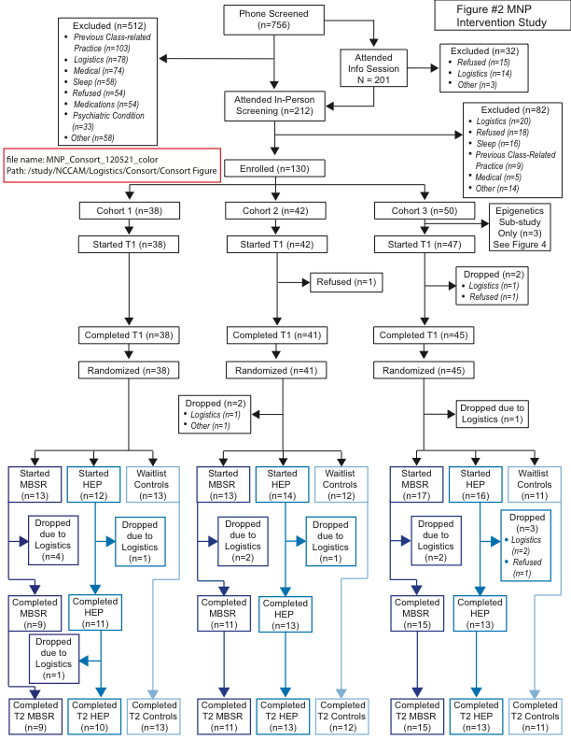
Figure S1. Consort Diagram.

Figure S2. Changes in FFMQ scores in MBSR group relative to HEP group. ns = p-value from analysis of covariance (ANCOVA) models was not significant (ps > .10). Cohen’s ds ranged from -0.13 to 0.18. Error bars reflect two standard errors on each side.

