Response Inhibition Task Specific Exclusion Criteria
For the response inhibition tasks, participants’ data was removed from further analysis based on task-specific exclusion criteria or missing data. For the go/no-go task, participants whose mean go RT was beyond +/- 3 SD were removed and participants whose false alarm rate was > 0.5 or hit rate < 0.5 were also removed (three young and two old; Jun & Lee, 2021; Liu et al., 2022). For the stop-signal task, participants were removed based on the recommendations made by Verbruggen et al. (2019) and included, participants whose: (1) unsuccessful stop RTs were longer than go RTs, violating the independent race model assumption, (2) probability of responding on stop trials fell outside of the 0.25-0.75 range, and (3) SSRT was less than 100 ms (four young and five old; Congdon et al., 2012; Hall et al., 2022). Participants’ data for the response inhibition tasks were excluded only from the tasks where they violated inclusion criteria or had missing data, resulting in task specific samples for the Go/No-Go task (91 older and 96 younger adults) and for the Stop-Signal (88 older and 95 younger adults).
Stop-Signal Reaction Time (SSRT) Analysis
For the Stop-Signal task, the primary dependent measure was stop-signal reaction time (SSRT), which was estimated using the integration method (Verbruggen et al., 2008). This method is preferred to other methods because it does not assume P(“response” | “stop-signal”) = .50 and is less affected by the go RT distribution (Verbruggen et al., 2019). This approach uses the participant’s own go-trial RT distribution, which is rank ordered from slowest to fastest. Then, the Nth RT is calculated where N = total number of RTs in the distribution, which is then multiplied by the probability of responding on stop signal trials, p(“response” | “stop-signal”). The Nth RT is thought to represent the finishing time of the stop-signal process (i.e., how fast a participant can cancel their response). The Nth RT is then subtracted from the mean stop-signal delay (SSD; i.e., the interval between onset of the go stimulus and the stop-signal) to obtain the SSRT, which represents how long a participant needs to inhibit a response after the stop signal appears. For example, in the present task there were 216 go trials. If a participant’s p(“response” | “stop-signal”) was 0.44, the corresponding Nth ranked RT in their go trial distribution would be 95 (216 x 0.44 = 95.04). If the 95th fastest go RT was 300 ms, then SSRT would be calculated by subtracting the mean-stop signal delay for this person (e.g., 120 ms) from this value, yielding an SSRT of 180 ms (300 – 120 = 180).
GradCPT Trial Assignment Algorithm
Due to the gradual onset of stimuli in the gradCPT, responses must be assigned to trials using an algorithm that accounts for stimulus coherence. To do this, we followed procedures previously established by Esterman et al. (2013). Responses were first categorized as either unambiguous or ambiguous. Unambiguous responses were those occurring after the nth image reached 70% coherence (560 ms) and before it dropped below 60% coherence (image N + 1, 1120 ms or 320 ms into image N + 1), and these responses were attributed directly to the nth image. In our dataset, 89% of older adults’ and 87% of younger adults’ responses fell into this category. Next, ambiguous responses were assigned according to specific rules: ambiguous responses were assigned to an adjacent trial if one of the two trials had no response. If both adjacent trials had no response, the press was assigned to the closest trial, unless that trial was a no-go trial, in which case participants were given the benefit of the doubt and the response was assigned to the go trial. If both adjacent trials were of the same type (both go or no-go), the response was instead assigned to whichever was temporally closer. Finally, in cases where a single trial contained multiple responses, only the fastest response was retained.
GradCPT: Response Bias
As in Jun and Lee, we also examined response bias using Grier’s B”, which ranges from -1 to 1. Negative values indicate a bias towards making a “go” response whereas positive values indicate a bias against making a response. When responses are difficult to withhold, it can lead to a negative B”, as we would expect in the 90% response condition. When responses are infrequent, they are sometimes missed and it can lead to a positive B”, as we would expect in the 10% response condition (Jun & Lee, 2021).
B” was was entered into a mixed model ANOVA, 2 (Age: young, old) x 2 (Response rate: 90%, 10%) x 2 (Block: first, second) x 2 (Time bin: 1, 2), with all variables but age as within-subjects factors.
As expected, there was a significant main effect of response rate, F(1, 190) = 262.71, p < .001, η_{p}² = .58, with more negative scores (i.e., liberal responding) in the 90% condition (see Figure S.1). There was also a main effect of age, F(1, 190) = 12.99, p < .001, η_{p}² = .06, but this was qualified by a significant interaction between age and response rate, F(1, 190) = 62.41, p < .001, η_{p}² = .25. There was also an interaction between response rate and time bin, F(1, 190) = 12.73, p < .001, η_{p}² = .06. There was no main effect of block or interaction between block and other variables, p’s > 0.1.
As can be seen in Figure S.1, both younger and older adults showed evidence of a negative bias in the 90% condition (i.e., a bias to respond). Post hoc analyses showed that younger adults had a more negative bias than older adults in this condition; t(190) = 3.58, p < .001, d = 0.26. Across time bins, both age groups showed a more negative bias as the time on the task increased (i.e., they became more liberal in their responding); t(191) = 2.16, p = .03, d = 0.16 suggesting that both age groups adjusted their response bias and responded more carelessly as the task went on.
In the 10% condition, young adults showed a positive bias against making a response (M = 0.41, SD = 0.06). Whereas older adults (M = -0.13, SD = 0.06) showed a unique pattern of starting out with a negative bias towards making a response in time bin 1 (more so within the first block) that trended towards zero by time bin 2 (see Figure S.1), suggesting that older adults made more commission errors at the start of the 10% condition which decreased over time with more practice (see Table 2).
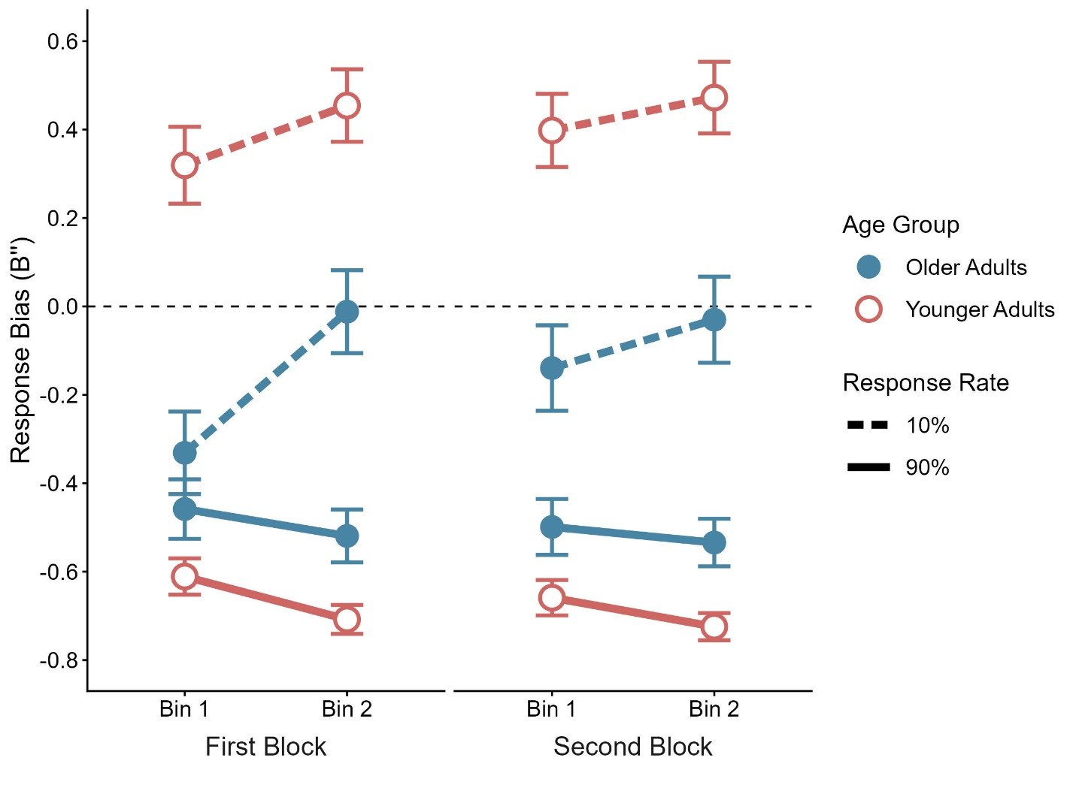

Figure S.1. Mean B” (response bias) by age group and response rate (90% and 10%) across blocks and time bins. Errors bars represent ±1 standard error. B” ranges from -1 to 1, with negative values reflecting a liberal bias and positive values indicating a conservative bias.
Reliability of gradCPT, vigilance decline, go/no-go and stop-signal reaction time.
We examined the split-half reliability of each measure included in the correlation analyses. GradCPT A’ was calculated with a Spearman-Brown corrected split-half correlation comparing average performance of odd-numbered task bins to average performance of even-numbered task bins (i.e., the start and end of each block) for each response rate separately. A’ reliability was 0.81 in the 90% condition and 0.68 in the 10% condition. Vigilance decline (bin 1 A’ minus bin 2 A’) was less reliable (calculated as the correlation between vigilance decline in block 1 with that from block 2): 0.27 in the 90% condition and 0.30 in the 10% condition. This is not surprising, as difference scores tend to be less reliable and one might expect vigilance decline to asymptote at some point during the task and thus, be less consistent over time. Nevertheless, caution should be exercised in interpreting any correlations (or lack thereof) with vigilance decline given its low reliability. Finally, due to the adaptive tracking procedure of the stop-signal task, split-half reliability could not be calculated for SSRT; however, reliability (first and second half) for the Nth RT and SSD (used to calculate SSRT) were very high at 0.93 and 0.94, respectively. Go/no-go first and second half reliability for D’ was also high at 0.86.
We also examined age differences in mean performance on the go/no-go and SSRT tasks themselves. On the go/no-go task, older adults had higher d-prime scores (M = 4.83, SD = 0.48) than younger adults (M = 4.62, SD = 0.58), t(185) = 2.66, p = .008, d = 0.20. This effect was driven by older adults making fewer false alarms than younger adults, t(185) = 2.37, p = .02, d = 0.17. On the stop signal task, older adults had longer SSRTs (M = 244.22, SD = 56.05) than younger adults (M = 227.34, SD = 48.20), t(181) = 2.19, p = .03, d = 0.16, suggesting they required more time to stop a response once initiated. Performance on the go/no-go task and stop-signal were not significantly correlated across all participants r = -0.12, p = .09, nor in either group separately (see Figure 6 for correlation matrices for young and older adults). Potential ceiling effects in the go/no-go task might have reduced the variability captured within this relationship, as previous work has found both tasks load onto the same latent response inhibition variable (Bender et al., 2016). Alternatively, the lack of significant relationship may be explained by the assertion that each task is thought to tap into a different type of response inhibition (action restraint on the go/no-go and action cancellation on the stop-signal (Verbruggen & Logan, 2008; Raud et al., 2020).

