Supplementary
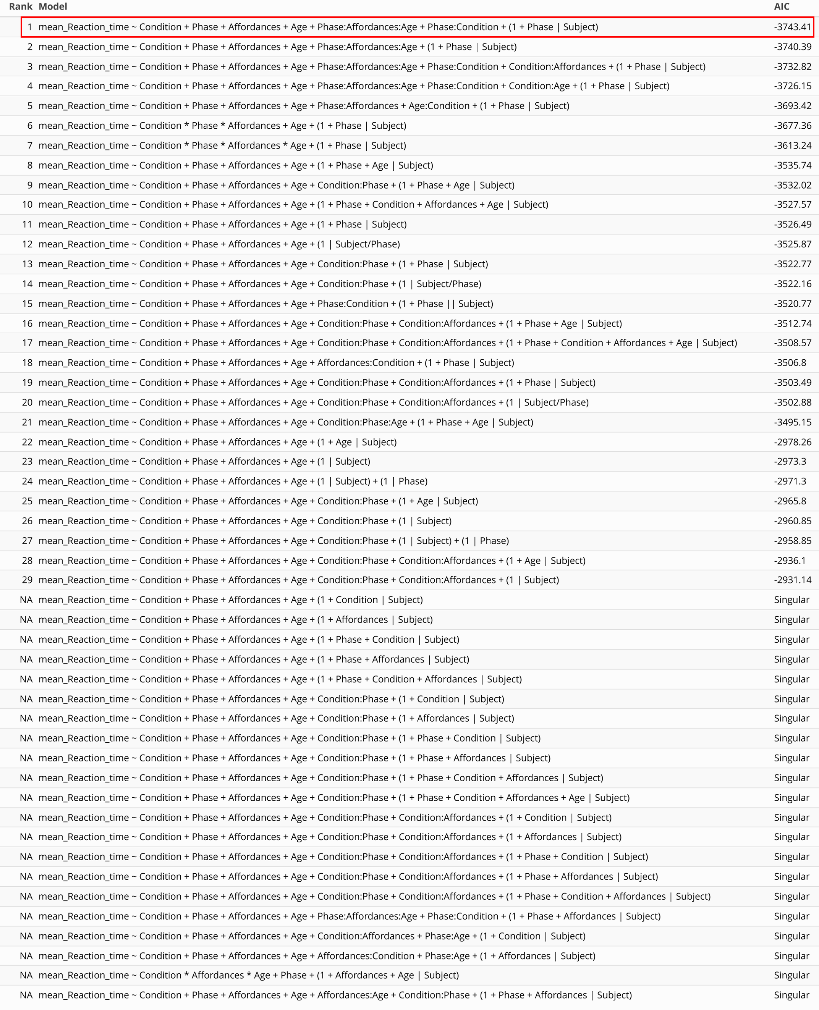
Supplementary Table 1. Comparison of the different statistical models and their associated AIC values. The model highlighted in red was selected based on the lowest AIC, with the additional criterion of normally distributed residuals.
Supplementary 2
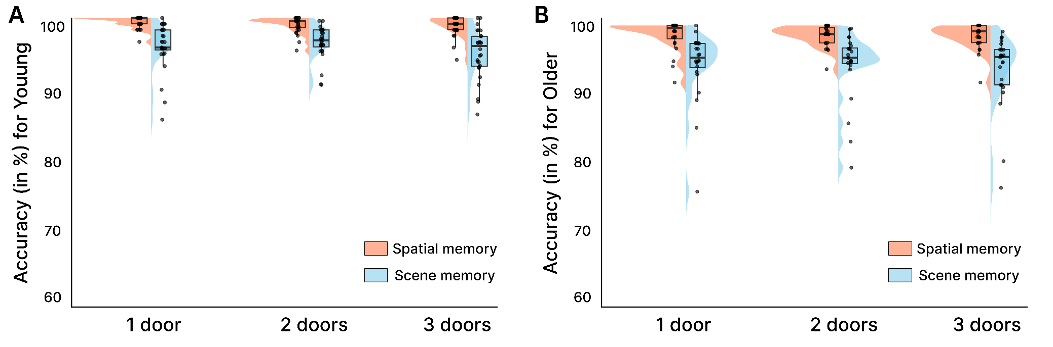
In this supplementary analysis we investigated the accuracy, using a generalized linear mixed-effects model due to ceiling effects of this metric (see Supplementary figure 1). Results of the GLMM indicated only an effect for the phase (χ²₍₁₎ = 22.82, p < .001) with more errors made during the scene memory phase. There was no effect for the age (χ²₍₁₎ = 0.20, p = .66), the eccentricity (χ²₍₂₎ = 1.51, p = .47), or the affordances (χ²₍₁₎ = 1.82, p = .40), and no other interactions (all p > .078). This lack of effects on accuracy is likely attributable to the pronounced ceiling of performance, reflecting the relative ease of the task and the relatively long response window of 2000ms. As stated in the Method section, this design choice was intentional, as it maximized the number of correct responses while minimizing speed–accuracy trade-offs, thereby preserving sensitivity to the reaction time effects that constituted the primary focus of the study.
Supplementary figure 1. Presentation of the mean values for the accuracy, across phase (scene memory vs spatial memory) and affordances. A. For young adults B. For older adults

Supplementary 3
To mitigate eye strain and fatigue, the protocol was divided into five blocks with self-paced breaks between them. While main analyses aggregated data across blocks to enhance statistical stability, potential learning effects could nonetheless influence reaction times and reported interactions. We therefore ran an additional analysis using a linear mixed model with block order entered as a continuous predictor to directly assess any systematic learning effect on reaction time
First, regarding reaction time we found a main effect of order (F_{(1, 4540.9)} = 39.31, p < .001), with a phase × order interaction (F_{(1, 4540.9)} = 9.77, p = .002). Linear-trend tests on the estimated marginal slope of reaction time across order revealed that reaction times decreased significantly across the session in every phase × age combination, with a steeper decline in older than in younger participants and in the scene-memory than in the spatial-memory phase (Supp. Fig. 1.A) suggesting a possible learning effect:
- Older adults in spatial memory: β = - 12.06 ms/run, t₍₄₅₀₆₎ = - 8.82, p < .001;
- Older adults in scene memory: β = - 26.91 ms/run, t₍₄₅₀₆₎ = - 19.71, p < .001;
- Younger adults in spatial memory: β = - 4.23 ms/run, t₍₄₅₀₅₎ = - 3.38, p < .001;
- Younger adults in scene memory: β = - 14.70 s/run, t₍₄₅₀₅₎ = - 11.73, p < .001
Second, we tested if the reported modulation of the reaction time by the number of affordances could be influenced by this reported learning effect. Results indicate that the resulting affordance slopes (Supp. Fig. 1.B) did not change across run order (F_{(8, 4540.9)} = 0.53, p = .834), as confirmed by the linear change in the affordance slope per run that was not significantly different from zero in any of the four age x phase level :
- Older adults in spatial memory: β = - 1.45 ms, t₍₄₅₁₅₎ = 1.08, p = .279;
- Older adults in scene memory: β = - 1.54 ms, t₍₄₅₁₅₎ = −1.15, p = .249;
- Younger adults in spatial memory: β = + 1.08 ms, t₍₄₅₁₅₎ = +0.85, p = .397;
- Younger adults in scene memory: β = + 2.01 ms, t₍₄₅₁₅₎ = +1.57, p = .117).
Together, these analyses show that reaction time decreased across the five experimental runs, reflecting a learning effect that was steeper in older adults and specifically in the scene memory phase (the more complex task), but that this practice-related effect did not modify the interaction between affordances and the phase reported in the main analysis.
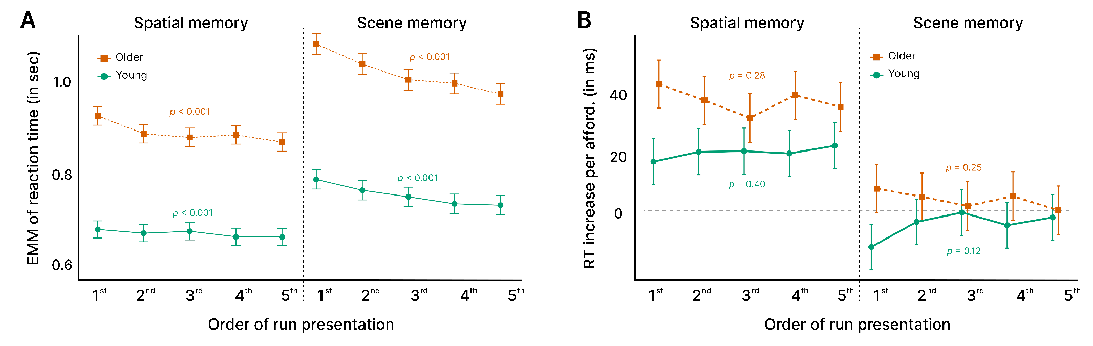
Supplementary figure 1. Presentation of the results for the analyses including the effect of run order.
(A) Estimated reaction time marginal means and (B) slopes of increase in reaction time per affordance, shown by age group and phase across run presentation order (between 1 and 5). While run order is plotted categorically for visualization here, reported statistics and p-values are derived from models treating run order as a continuous variable.

