Supplemental Materials

Supplemental Table 1

Factor Loadings for the Modified Social Impact Scale (mSIS)

Item  No. | Item | Factor 1 Loading
1 | People act like I am less competent. | 0.7856
2 | Feel I been treated with less respect. | 0.7719
3 | Feel others are concerned they could catch my AD risk. | 0.3456
4 | Feel others avoid me. | 0.7220
5 | Family members have rejected me. | 0.5245
6 | Some friends have rejected me. | 0.7271
7 | Encounter embarrassing situations. | 0.8188
8 | Others feel awkward and tense around me. | 0.8339
9 | Experienced financial hardship that has affected how I feel about myself. | 0.7273
10 | Job security has been affected. | 0.7452
11 | Experienced financial hardship that has affected my relationship with others. | 0.7688
12 | Feel others think I am to blame for my AD risk. | 0.7053
13 | Employer/ co-workers have discriminated against me. | 0.7030
14 | Feel less competent than I did before. | 0.7403
15 | Fear someone telling others about my AD risk without my permission. | 0.7586
16 | Feed I need to keep my risk a secret. | 0.6753
17 | Do not feel I can be open with others about my risk. | 0.6849
18 | Feel I am at least partially to blame for my risk | 0.3384
19 | Feel set apart from others who are well. | 0.8890
20 | Have a greater need than usual for reassurance. | 0.8038
21 | Feel lonely more often than usual. | 0.8932
22 | Have a sense of being unequal in my relationships. | 0.8898
23 | Feel useless due to my risk for AD dementia. | 0.8153

Note. For the full wording of all items, see the Appendix.

Supplemental Table 2

Reliability Coefficients for the Modified Social Impact Scale (mSIS) by Scoring Method and Study Group

Scale | Cronbach’s α  (95% CI)
mSIS Scores ª
Experiential Group | 0.95 (.90 to .99)
Hypothetical Group | 0.93 (.91 to .96)
mSIS Percent Agreement Scores ^{b}
Experiential Group | 0.91 (.50 to .99)
Hypothetical Group Agreement Percentage | 0.87 (.83 to .92)

ª Mean of mSIS item ratings on the full 1-4 response scale (1 = strongly disagree, 4 = strongly agree).
^{b} Mean of mSIS items after responses were binarized as disagree (0) or agree (1).

Supplemental Table 3
Percentages of Participants Agreeing with Modified Social Impact Scale (mSIS) Statements in the Hypothetical Group and Experiential Group at Time 1

 | Experiential Group |  |  | Hypothetical Group  (n=180)  % (95%CI) | p-valueª | p-value^{b}
 | All  (n=111)  % (95%CI) | ε4 Carriers (n=65)  % (95%CI) | ε4 Non-Carriers (n=46)  % (95%CI) | Hypothetical Group  (n=180)  % (95%CI) | p-valueª
mSIS Scale Score (Total) | 2.3  (1.1 to 3.6) | 2.3  (0.1 to 3.8) | 2.4  (0.1 to 4.6) | 26.1  (23.0 to 29.1) | <0.001^{z} | <0.001^{z}
mSIS Scale Items

People act like I am less competent. | 2.6  (-0.3 to 5.6) | 3.1  (-1.1 to 7.3) | 2.2  (-2.1 to 6.5) | 65.6  (58.6 to 72.5) | <0.001^{z} | <0.001^{z}
Have a greater need than usual for reassurance. | 5.3  (1.2 to 9.4) | 4.6  (-0.5 to 9.7) | 6.7  (-0.6 to 14.0) | 46.7  (39.4 to 54.0) | <0.001^{z} | <0.001^{z}
Feel less competent than I did before. | 8.8  (3.6 to 14.0) | 7.7  (1.2 to 14.2) | 8.9  (0.6 to 17.2) | 42.2  (35.0 to 49.4) | <0.001^{z} | <0.001^{z}
Feel set apart from others who are well. | 1.8  (-0.7 to 4.2) | 3.1  (-1.1 to 7.3) | 0.0  (0.0 to 0.0) | 41.1  (33.9 to 48.3) | <0.001^{z} | <0.001^{z}
Encounter embarrassing situations. | 2.6  (-0.3 to 5.6) | 1.5  (-1.5 to 4.5) | 2.2  (-2.1 to 6.5) | 40.6  (33.4 to 47.7) | <0.001^{z} | <0.001^{z}
Fear someone telling others about my AD risk without my permission. | 2.6  (-0.3 to 5.6) | 3.1  (-1.1 to 7.3) | 2.2  (-2.1 to 6.5) | 39.4  (32.3 to 46.6) | <0.001^{z} | <0.001^{z}
Feel I been treated with less respect. | 0.9  (-0.8 to 2.6) | 0.0  (0.0 to 0.0) | 2.2  (-2.1 to 6.5) | 38.9  (31.8 to 46.0) | <0.001^{z} | <0.001^{z}
Feel lonely more often than usual. | 2.6  (-0.3 to 5.6) | 1.5  (-1.5 to 4.5) | 4.4  (-1.6 to 10.5) | 36.7  (29.6 to 43.7) | <0.001^{z} | <0.001^{z}
Have a sense of being unequal in my relationships. | 2.6  (-0.3 to 5.6) | 3.1  (-1.1 to 7.3) | 2.2  (-2.1 to 6.5) | 35.0  (29.6 to 42.0) | <0.001^{z} | <0.001^{z}
Do not feel I can be open with others about my risk. | 7.0  (2.3 to 11.7) | 7.7  (1.2 to 14.2) | 6.7  (-0.6 to 14.0) | 29.1  (22.4 to 35.7) | <0.001^{z} | <0.001^{z}
Others feel awkward and tense around me. | 0.0  (0.0 to 0.0) | 0.0  (0.0 to 0.0) | 0.0  (0.0 to 0.0) | 28.3  (21.7 to 34.9) | <0.001^{z} | <0.001^{z}
Feed I need to keep my risk a secret. | 7.1  (2.4 to 11.8) | 7.8  (1.2 to 14.4) | 6.7  (-0.6 to 14.0) | 26.7  (20.2 to 33.1) | <0.001^{z} | 0.003^{y}
Feel useless due to my risk for AD dementia. | 1.8  (-0.7 to 4.2) | 1.6  (-1.5 to 4.6) | 2.2  (-2.1 to 6.5) | 26.3  (19.8 to 32.7) | <0.001 ^{z} | <0.001^{z}
Experienced financial hardship that has affected how I feel about myself. | 3.5  (0.1 to 6.9) | 4.6  (-0.5 to 9.7) | 2.2  (-2.1 to 6.5) | 22.8  (16.7 to 28.9) | <0.001 ^{z} | 0.002^{y}
Job security has been affected. | 2.6  (-0.3 to 5.6) | 1.5  (-1.5 to 4.5) | 4.4  (-1.6 to 10.5) | 20.0  (14.2 to 25.8) | <0.001^{z} | <0.001^{z}
Experienced financial hardship that has affected my relationship with others. | 0.9  (-0.8 to 2.6) | 1.5  (-1.5 to 4.5) | 0.0  (0.0 to 0.0) | 15.6  (10.3 to 21.0) | <0.001^{z} | 0.006^{y}
Employer/ co-workers have discriminated against me. | 0.9  (-0.8 to 2.6) | 0.0  (0.0 to 0.0) | 2.2  (-2.1 to 6.5) | 12.3  (7.5 to 17.1) | <0.001^{z} | 0.007^{y}
Some friends have rejected me. | 0.0  (0.0 to 0.0) | 0.0  (0.0 to 0.0) | 0.0  (0.0 to 0.0) | 10.7  (6.1 to 15.2) | <0.001^{z} | 0.01^{x}
Feel others avoid me. | 0.0  (0.0 to 0.0) | 0.0  (0.0 to 0.0) | 0.0  (0.0 to 0.0) | 9.4  (5.2 to 13.7) | 0.002^{y} | 0.02^{x}
Family members have rejected me. | 0.0  (0.0 to 0.0) | 0.0  (0.0 to 0.0) | 0.0  (0.0 to 0.0) | 6.1  (2.6 to 9.6) | 0.02^{x} | 0.09
Feel others think I am to blame for my AD risk. | 0.0  (0.0 to 0.0) | 0.0  (0.0 to 0.0) | 0.0  (0.0 to 0.0) | 5.0  (1.8 to 8.2) | 0.04^{x} | 0.15
Feel I am at least partially to blame for my risk. | 0.0  (0.0 to 0.0) | 0.0  (0.0 to 0.0) | 0.0  (0.0 to 0.0) | 4.4  (1.4 to 7.4) | 0.06 | 0.19
Feel others are concerned they could catch my AD risk. | 0.0  (0.0 to 0.0) | 0.0  (0.0 to 0.0) | 0.0  (0.0 to 0.0) | 2.2  (0.1 to 4.4) | 0.28 | 0.52
ªp-value for experiential vs hypothetical group
^{b}p-value for ε4 carriers vs hypothetical group
Note. 95%CI = 95% confidence interval. AD = Alzheimer’s disease. The experiential group includes those who reported knowing their APOE test result, and responses are tabled separately by APOE ε4 carrier status. The hypothetical group includes participants who underwent APOE testing but did not know their APOE ε4 carrier status. The mSIS items are listed here in descending order from highest to lowest agreement in the hypothetical group.

Supplemental Figure 1
Percentages of Participants Endorsing Agreement on Modified Social Impact Scale (mSIS) Statements by Study Group (ε4 Carrier Experiential versus Hypothetical Groups) at Time 1 (N = 245).
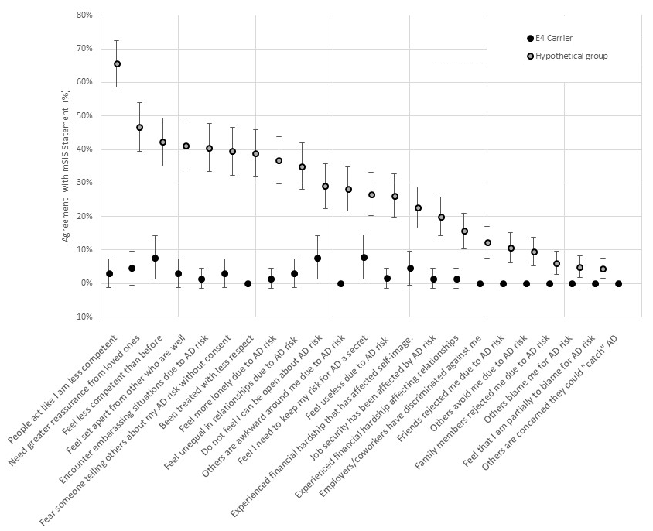
Note. The experiential group of APOE ε4 carriers includes participants who knew their APOE test result and were APOE ε4 carriers. The hypothetical group includes participants who underwent APOE testing but did not know their APOE test result. Values reflect dichotomized data (percent of participants endorsing agreement with each statement). Error bars represent normal 95% confidence intervals. For items with 0% reported, no participants endorsed agreement.

Supplemental Table 4

Percent Agreement Scores on the Modified Social Impact Scale (mSIS) at Time 1 and Within-Group Change from Time 1 to Time 2 by Study Group, Sex, and Age
Study Group | mSIS Percent Agreement Scores  Time 1  % (95%CI) | Change in mSIS Agreement Rating  from Time 1 to Time 2  Paired Mean Difference (95%CI)
Sex
Female
Experiential Group (n=31) | 1.11 (1.05 to 1.17) | -0.11 (-0.19 to -0.03)
ε4 Carriers (n=20) | 1.14 (1.06 to 1.23) | 0.12 (-0.22 to -0.01)
ε4 Non-Carriers (n=11) | 1.05 (-0.98 to 1.11) | -0.09 (-0.25 to 0.07)
Hypothetical Group (n=36)ª | 1.92 (1.78 to 2.06) | -0.13 (-0.28 to 0.03)
HG to EG Convertors (n=13) | 1.89 (1.59 to 2.20) | -0.68 (-0.99 to -0.37)
Male
Experiential Group (n=32) | 1.15 (1.05 to 1.25) | -0.06 (-0.14 to 0.02)
ε4 Carriers (n=16) | 1.14 (0.96 to 1.33) | -0.10 (-0.25 to 0.05)
ε4 Non-Carriers (n=16) | 3.5 (-3.1 to 10.2) | 0.01 (0.08 to 0.05)
Hypothetical Group (n=27)ª | 1.80 (1.66 to 1.95) | -0.10 (-0.25 to 0.06)
HG to EG Convertors (n=6) | 1.89 (1.37 to 2.41) | -0.46 (-0.92 to -0.01)
Age
Below median age of 69 years
Experiential Group (n=34) | 1.11 (1.01 to 1.21) | -0.10 (-0.19 to -0.02)
ε4 Carriers (n=18) | 1.09 (1.01 to 1.17) | -0.10 (-0.19 to 0.003)
ε4 Non-Carriers (n=16) | 1.13 (0.94 to 1.32) | -0.11 (-0.27 to 0.04)
Hypothetical Group (n=38) | 1.97 (1.80 to 2.14) | -0.06 (-0.23 to 0.12)
HG to EG Convertors (n=6) | 1.87 (1.31 to 2.43) | -0.80 (-1.35 to -0.25)
At and above median age of 69 years
Experiential Group (n=29) | 1.15 (1.08 to 1.22) | -0.06 (-0.14 to 0.01)
ε4 Carriers (n=18) | 1.19 (1.09 to 1.28) | -0.11 (-0.21 to -0.003)
ε4 Non-Carriers (n=11) | 1.08 (0.96 to 1.19) | 0.03 (-0.06 to 0.11)
Hypothetical Group (n=27) | 1.81 (1.68 to 1.93) | -0.16 (-0.28 to -0.03)
HG to EG Convertors (n=13) | 1.90 (1.61 to 2.20) | -0.52 (-0.81 to -0.24)
Note. Results are shown separately by study group, stratified by sex (female, male) and age (below vs. at/above the median age of 69 years). The experiential group (EG) includes those who knew their APOE test result. The hypothetical group (HG) includes those who did not know their APOE test result.

ª Two participants in the HG did not report sex

