Cognitive Functioning in Perimenopause: An Updated Systematic Review and Meta-Analysis
Supplementary Materials
Table S1
Definitions and Example Measures of Cognitive Domains Included in Meta-Analysis
Cognitive Domain | Definition | Example Measures
Attention | The ability to concentrate on specific stimuli or tasks and sustain that focus over time. | PASAT, Vigilance, Counting Backwards
Cognitive Flexibility | The capacity to adapt cognitive processing strategies to face new and unexpected conditions in the environment. | TMT-B, TMT (B-A), Verbal Fluency, COWAT
Global Cognition | An overall measure of cognitive function, incorporating various domains. | MMSE, MoCA, BADDS (total), ACE-III, Planning
Inhibitory Control | The ability to control automatic or dominant responses to perform goal-directed behaviours. | Stroop task
Language | The capacity for language comprehension, production, and verbal communication. | NART, WAIS-Vocabulary, Object Naming, Boston Naming Test, Similarities
Memory | The ability to encode, store, and retrieve information over short and long periods of time. | RAVLT, Logical Memory, Paired Associates, Verbal Recall, BVR, RCFT recall
Processing Speed | The ability to perform simple or complex tasks quickly and efficiently, often under time constraints. | TMT-A, Digit Symbol, Search Speed, SRT
Visuospatial | The ability to understand and mentally manipulate visual and spatial information. | Block Design, Visuospatial Ability
Working Memory | The capacity to hold and manipulate information in mind over short periods for complex tasks. | Digit Span, Subtraction, Verification

Table S2
Summary of Study Characteristics and Findings for Studies Included in Review
Study Characteristics |  | Assessment of Perimenopause |  | Findings and Methodological Quality
Authors,  Study Location | Sample Description | Criteria for Perimenopause | Cognitive Measure(s) | Key Findings | MMAT (/5)
Berent-Spillson et al. (2012), USA | 67 women across pre/peri/post (M_{age} = 52.66, SD = 3.43, range = 42-61 yrs) | Other criteria (hormonal biomarkers) | Cognitive flexibility (TMT-B, phonetic fluency, semantic fluency), processing speed (TMT-A, letter comparison, pattern comparison), memory (verbal recall, verbal retention, visual recall, visual retention) | •Peri and Post < Pre on most cognitive flexibility tasks.  •No group differences on all other tasks. | 4
Dorador-González (2021), Mexico | 59 women across pre/peri/post (M_{age} = 48.00, SD = 2.73, range = 39-59 yrs) | STRAW+10 (self-reported menstrual pattern) | Verbal working memory (digit span backward), visual working memory (Rey-Osterrieth Complex Figure, immediate figure choice task, delayed figure reproduction with interference), global cognition (MoCA), subjective memory complaints (memory failures questionnaire) | •No group differences in global cognition, verbal working memory, or immediate visual working memory.  •Pre > Post > Peri in delayed visual working memory and Rey-Osterrieth Complex Figure.  •Peri > Post and Pre in subjective memory complaints. | 4
Fuh et al. (2005), China | 495 women across pre/peri (M_{age} = 47.10, SD = 3.00, range = 40-54 yrs) | Other criteria (self-reported menstrual pattern) | Memory (Rey Auditory-Verbal Learning Test, continuous recognition paradigm), cognitive flexibility (verbal fluency, TMT-B), working memory (digit span) | •No group differences in memory, cognitive flexibility, or working memory.  •Peri < Pre in cognitive flexibility (verbal fluency). | 5
Greendale et al. (2009), USA | 2,362 women across pre/peri/post (M_{age} = 45.86, SD = 2.67, range = 42-52 yrs) | Other criteria (self-reported menstrual pattern) | Processing speed (symbol digit modalities test), memory (East Boston Memory Test – immediate & delayed), working memory (digit span backward) | •Late Peri < Early Peri, Pre, Post in processing speed.  •Peri < Pre and Post in delayed memory recall.  •No group differences in immediate memory recall or working memory. | 5
He et al. (2021), China | 57 women across pre/peri (M_{age} = 51.60, SD = 1.63, range = 45-55 yrs) | STRAW+10 (self-reported menstrual pattern) | Global cognition (MMSE) | •Peri < Pre in global cognition. | 4
Herlitz et al. (2007), Sweden | 242 women across pre/peri/post (M_{age} = 51.60, SD = 3.10, range = 45-55 yrs) | Other criteria (self-reported menstrual pattern) | Episodic memory (word recall & recognition tasks), semantic memory (vocabulary synonym selection), cognitive flexibility (verbal fluency), visuospatial (block design) | •No group differences on any task. | 4
Jacobs et al. (2016), USA | 194 women across pre/peri/post (M_{age} = 49.80, SD = 1.90, range = 45-55 yrs) | STRAW+10 (self-reported menstrual pattern + hormone biomarkers) | Global cognition (verbal IQ) | •No group differences. | 4
Kaur & Kaur (2022), India | 404 women across pre/peri/post (M_{age} = 46.39, SD = 4.31, range = 40-65 yrs) | Other criteria (self-reported menstrual pattern) | Global cognition (MMSE) | • Pre > Peri > Early Post > Late Post in global cognition. | 4
Kok et al. (2006), UK | 1,261 women across pre/peri/post (M_{age} = 53.00, range = 53-53 yrs) | Other criteria (self-reported menstrual pattern) | Language (NART), verbal memory (word learning & recall), processing speed (visual search task) | •Pre > Peri > Post in processing speed and language (though no significant differences in language after adjusting for childhood cognition and education).  •No group differences in verbal memory. | 5
Liu et al. (2021), China | 50 women across pre/peri (M_{age} = 53.19, SD = 3.82, range = 45-55 yrs) | STRAW+10 (self-reported menstrual pattern + hormone biomarkers) | Inhibitory control (Stroop task) | •Peri > Pre in reaction time (poorer performance).  •No group differences in accuracy. | 3
Martino et al. (2022), Argentina | 100 women across pre/peri/post (M_{age} = 50.06, SD = 3.60, range = 18-79 yrs) | STRAW+10 (self-reported menstrual pattern) | Working memory (digit span backwards), cognitive flexibility (fluency tasks, TMT-B), inhibitory control (Stroop task), planning (Porteus Labyrinth) | •No group differences in any task. | 4
Metcalf et al. (2022), USA | 167 women across pre/peri/post (M_{age} = 44.65, SD = 3.95, range = 35-47 yrs) | STRAW+10 (self-reported menstrual pattern) | Verbal memory (Buschke Selective Reminding Test) | •Pre > Peri and Post in verbal memory. | 3
Mosconi et al. (2017), USA | 62 women across pre/peri/post (M_{age} = 50.00, SD = 6.00, range = 40-60 yrs) | STRAW+10 (self-reported menstrual pattern) | Memory (immediate & delayed recall), processing speed (digit symbol substitution), language (object naming test, WAIS vocabulary), visuospatial (block design), global cognition (MMSE) | •Pre > Peri > Post in memory tasks.  •Pre and Peri > Post in processing speed.  •No group differences in language, visuospatial ability, and global cognition. | 5
Mosconi et al. (2024), USA | 60 women across pre/peri/post (M_{age} = 50.00, SD = 4.00, range = 40-65 yrs) | STRAW+10 (self-reported menstrual pattern) | Verbal memory (immediate & delayed recall tasks), cognitive flexibility (TMT-B, verbal fluency tasks), language (object naming task) | •No group differences in any task. | 5
Nagda et al. (2023), India | 105 women across peri/post (range = 45-55 yrs) | Other criteria | Global cognition  (Addenbrooke’s Cognitive Examination) | •No group differences in global cognition. | 2
Page et al. (2023), USA | 1,971 women across pre/peri/post (M_{age} = 49.00, SD = 4.40, range = 35-65 yrs) | STRAW+10 (self-reported menstrual pattern) | Global cognition (Brown Attention Deficit Disorder Scale) – self-report | •Peri < Pre and Post in global cognition. | 4
Raggio (2015), USA | 45 women across pre/peri/post (M_{age} = 53.60, SD = 6.60, range = 40-63 yrs) | Other criteria (self-reported menstrual pattern) | Global cognition (MoCA), memory  (Buschke Selective Reminding Test),  working memory (digit span, n-back), processing speed (TMT-A), cognitive flexibility (TMT-B, controlled word association test) | •Early Post < Peri and Late Post in memory.  •No group differences in any other task. | 4
Rentz et al. (2017), USA | 105 women across pre/peri/post (M_{age} = 49.80, SD = 2.00, range = 45-55 yrs) | STRAW+10 (self-reported menstrual pattern + hormonal biomarkers) | Memory (face-name associative memory exam, selective reminding test), working memory (digit span backward), cognitive flexibility (controlled oral word fluency test), language (NART) | •Pre and Peri > Post in memory.  •No group differences in any other task. | 4
Schaafsma et al. (2010), Australia | 120 women across pre/peri/post (range = 45-60 yrs) | STRAW+10 (self-reported menstrual pattern) | Memory (immediate & delayed verbal memory, Benton Visual Performance test), cognitive flexibility (controlled oral word association test), processing speed (digit symbol coding test), attention (CalCAP computerized reaction time tests) | •Peri < Pre in delayed memory recall and attention.  •No group differences in visual memory, cognitive flexibility, or processing speed. | 4
Schelbaum et al. (2021), USA | 137 women across pre/peri/post (M_{age} = 52.00, SD = 6.00, range = 40-65 yrs) | STRAW+10 (self-reported menstrual pattern + hormonal biomarkers) | Memory (Rey Auditory Verbal Learning Test, logical memory delayed recall tests), cognitive flexibility (TMT-B, FAS), language (object naming test) | •No group differences in any task. | 4
Tirkkonen et al. (2022), Finland | 342 women across early/late peri and post (M_{age} = 51.20, SD = 1.90) | Other criteria (self-reported menstrual pattern + hormonal biomarkers) | Processing speed (TMT-A), cognitive flexibility (TMT-B, verbal fluency test), working memory (digit span, word list test), memory (family pictures) | •No changes in cognitive flexibility (verbal fluency) or working memory (digit span).  •Post > Peri (early and late) in processing speed (TMT-A), memory (word lists).  •Post > Peri (late) cognitive flexibility (TMT-B), memory (family pictures). | 3
Tuomisto et al. (2012), Finland | 48 women across peri/post (M_{age} = 47.70, SD = 2.30, range = 43-71 yrs) | Other criteria (self-reported menstrual pattern + hormonal biomarkers) | Memory (Rey Auditory-Verbal Learning Test, Benton Visual Retention Test), attention (PASAT, vigilance), processing speed (digit symbol, simple reaction time, choice reaction time), visuospatial (block design), working memory (digit span, subtraction, verification), language (similarities), inhibitory control (Stroop) | •Peri > Post in visuospatial, processing speed, attention, inhibitory control, and some memory tasks.  •No group differences in language, working memory, and verbal memory (Rey Auditory-Verbal Learning Test). | 4
Unkenstein et al. (2016), Australia | 130 women across pre/peri/post (M_{age} = 49.89, SD = 4.19, range = 40-60 yrs) | STRAW+10 (self-reported menstrual pattern) | Memory (immediate & delayed recall tasks), working memory (digit span), cognitive flexibility (TMT-B, fluency tasks), processing speed (digit symbol), inhibitory control (Stroop), language (Boston Naming Test), global cognition (Visual Elevator Time) | •No group differences in any task. | 4
Weber et al. (2013), USA | 117 women across pre/peri/post (M_{age} = 48.72, SD = 4.06, range = 40-60 yrs) | STRAW+10 (self-reported menstrual pattern) | Attention (D2 Test of Attention), working memory (digit span, letter-number sequencing), cognitive flexibility (controlled oral word association test, fluency tasks), visuospatial (Hooper visual organization test), memory (Rey Auditory Verbal Learning Test) | •Post < Peri and Pre in attention, working memory, memory.  •No group differences in cognitive flexibility and visuospatial ability. | 3
Woods et al. (2000), USA | 205 women across peri/post (M_{age} = 46.7, SD = 4.4, range = 41-60 yrs) | Other criteria (self-reported menstrual pattern) | Memory (perceived memory functioning) – self-report | •Peri > Post subjective memory complaints. | 4
Zhu et al. (2023), Australia | 417 women across pre/peri/post (M_{age} = 50.77, SD = 3.52, range = 40-60 yrs) | STRAW+10 (self-reported menstrual pattern) | Memory (Everyday Memory Questionnaire) | •Peri > Pre and Post subjective memory complaints. | 4

Table S3
Summary of Effect Sizes for Cognitive Domain Subgroups – Pre-Peri Comparison
Domain | k | g | SE | 95% CI (lower) | 95% CI (upper) | p-value
Attention | 3 | -0.67 | 0.57 | -1.80 | 0.45 | .242
Cognitive Flexibility | 6 | 0.40 | 0.44 | -0.47 | 1.27 | .365
Global Cognition | 11 | -0.97 | 0.75 | -2.43 | 0.49 | .192
Inhibitory Control | 4 | -0.39 | 0.28 | -0.94 | 0.16 | .166
Language | 5 | 0.05 | 0.15 | -0.24 | 0.34 | .743
Memory | 14 | -0.15 | 0.11 | -0.37 | 0.07 | .182
Processing Speed | 6 | 0.05 | 0.03 | -0.01 | 0.11 | .119
Visuospatial | 3 | 0.69 | 0.84 | -0.96 | 2.34 | .413
Working Memory | 4 | -0.15 | 0.11 | -0.38 | 0.07 | .187

Table S4
Summary of Effect Sizes for Cognitive Domain Subgroups – Peri-Post Comparison
Domain | k | g | SE | 95% CI (lower) | 95% CI (upper) | p-value
Attention | 4 | 0.00 | 0.24 | -0.46 | 0.46 | .994
Cognitive Flexibility | 7 | 0.60 | 0.31 | -0.01 | 1.21 | .053
Global Cognition | 11 | -0.17 | 0.27 | -0.70 | 0.36 | .530
Inhibitory Control | 4 | 0.78 | 0.46 | -0.12 | 1.68 | .088
Language | 6 | 0.19 | 0.11 | -0.02 | 0.41 | .078
Memory | 15 | 0.13 | 0.07 | 0.00 | 0.26 | .055
Processing Speed | 8 | 0.17 | 0.06 | 0.06 | 0.28 | .003
Visuospatial | 4 | 0.81 | 0.13 | 0.55 | 1.07 | < .001
Working Memory | 6 | 0.12 | 0.07 | -0.02 | 0.26 | .101

Figure S1
Funnel Plot of Effect Sizes for Peri-Pre Comparison Studies
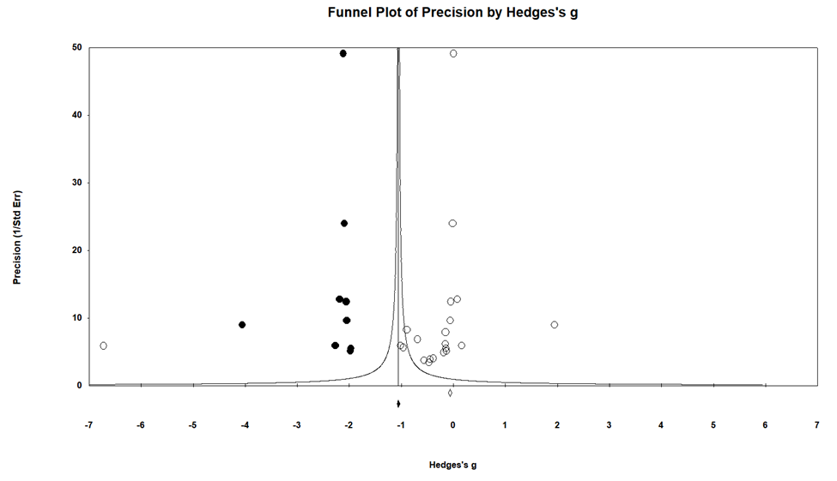
Note. Blank (white) circles represent studies included in the review. Filled (black) circles represent studies imputed by the trim-and-fill analysis. The blank diamond below the plot represents the unadjusted effect size. The filled diamond below the plot represents the estimated effect size adjusted for bias.
Figure S2
Funnel Plot of Effect Sizes for Peri-Post Comparison Studies
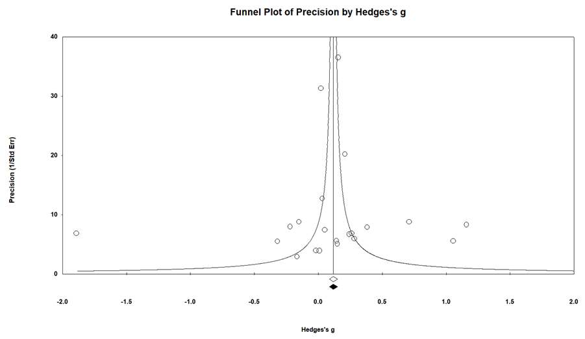
Note. Blank (white) circles represent studies included in the review. The blank diamond below the plot represents the unadjusted effect size. The filled (black) diamond below the plot represents the estimated effect size adjusted for bias.

