Supplementary Analysis

Chance performance
Teleportation in virtual reality is a mechanism previously used to disorient participants in spatial memory studies (Cherep et al., 2020), causing the concern older adults might merely guess their responses. Therefore, we conducted a specific analysis to empirically determine the guessing level for the Queen Square task and to verify if the performances of both groups were statistically above this chance level.
Chance levels were calculated using a bootstrap method which was applied separately to young and older groups, and further broken down by movement condition. The method involved pooling all the targets and responses together, shuffling the responses while keeping the targets static, and then recalculating the displacement error. This process was repeated one thousand times (Field & Wilcox, 2017) to generate a distribution of average errors as if the true object locations and the responses were completely unrelated.
To compare this chance distribution with the actual data from the Queen Square task, we needed to infer the population of average errors from the empirical data. This was achieved by resampling the empirical distribution of displacement errors one thousand times using bootstrap sampling. The resulting distributions were then compared using t-tests.
This analysis was conducted specifically for the displacement errors from one object configuration to minimize variance that could arise from averaging across trials with multiple objects. We particularly focused on performance the shifted-viewpoint (teleport) condition for one object replacement, which is critical for assessing the impact of potential disorientation.

Object location memory performance

Learning rate between blocks
A mixed ANOVA design evaluated the potential learning trends within the task, particularly focusing on how participants adjusted to the shifted-viewpoint (teleport) condition as they became accustomed to the immersive virtual reality experience. The analysis involved three within-subject factors: block number, movement condition, and object configuration; and one between-subject factor: age group (young and older). The primary focus was on the main effect of block number, which would indicate a general learning curve across participants, as well as interaction effects between block number and other factors, such as age group, movement condition, and object configuration. These interactions would help reveal if the learning rates differed not only by age but also by type of movement and object arrangement. To further explore the learning effects between consecutive blocks, post-hoc tests were conducted using a repeated coding method with Bonferroni correction. This approach assessed whether significant learning occurred from one block to the next.

Assessment of ceiling performance
Given that error in our task is measured as distance from the correct object location, a ceiling effect would manifest as a floor effect — where performance is artificially constrained by the lower theoretical minimum (0m displacement). To determine whether participants' low displacement errors were constrained by a floor effect, we analyzed the distribution of error values across movement conditions within each group, using Shapiro-Wilk test to assess deviations from normality and assessing skewness using Fisher's moment coefficient, which quantifies asymmetry in the distribution and indicates whether errors were disproportionately concentrated at lower values. We used a conservative alpha level of 0.01 for the Shapiro-Wilk tests to identify only substantial deviations from normality that might impact our primary analyses. To formally assess whether participants' performance was constrained by floor effects, we conducted one-sample t-tests comparing each group's mean error against the theoretical minimum of zero. We quantified the distance from the theoretical floor (0m) in standard deviation (SD) units, which measures how far the mean error deviates from the absolute minimum possible displacement (Uttl, 2005). A larger SD distance indicates greater variability and less constraint by a floor effect. We also examined the proportion of error values within one standard deviation of 0m, which serves as an indicator of clustering near the floor (Wang et al., 2008). A high proportion suggests that a substantial number of trials are near the minimum error limit, whereas a lower proportion indicates greater spread in performance and reduced risk of artificial constraints on condition comparisons.

Log-Transformed ANOVA Analysis
To ensure the robustness of our statistical analyses and account for potential floor effects, we applied a natural log transformation to displacement errors before re-running the mixed ANOVA. This transformation is specifically recommended for positively skewed data with a lower bound at zero, as is common in spatial error measurements (Šimkovic & Träuble, 2019). By amplifying distinctions among these smaller values, the log transformation ensures that variability within low-error conditions is preserved, allowing for more precise statistical comparisons across movement conditions and age groups. The log transformation enhances the resolution of small differences in the lower error ranges by expanding the scale where data is compressed, making it particularly valuable for our analysis where younger participants exhibited clustering toward lower displacement errors.

Viewpoint shift directionality and directional errors
To assess whether memory errors were systematically aligned with the direction of the viewpoint shift, and whether this effect was influenced by age (Segen et al., 2021), we conducted a supplementary analysis focusing on directional errors in the shifted-viewpoint conditions (both walking and teleport). To compute projected directional errors, we first calculated the viewpoint shift direction as the normalized vector difference between the retrieval (shifted-viewpoint) and encoding (same-viewpoint) locations. For each object, the displacement vector was defined as the difference between the target and response locations. We then projected this displacement vector onto the corresponding viewpoint shift direction using a dot product, yielding a signed scalar value. Positive values indicate errors in the direction of the viewpoint shift, negative values indicate errors in the opposite direction.
We fitted a linear mixed-effects model to examine how projected directional errors were influenced by age group, shift direction (left, right), movement condition (walking, teleport), and configuration type. The shift direction variable captured whether the retrieval viewpoint was located to the left or right of the encoding viewpoint. Specifically, “left” trials involved a clockwise shift from the short to the long arm of the platform, while “right” trials involved a counterclockwise shift from the long to the short arm (figure 1). We included two-way interactions to test whether the effect of shift direction on projected errors varied as a function of age group or movement condition, reflecting potential age-related differences in perspective taking and modulation by self-motion cues. Additionally, we included the three-way interaction (age group x shift direction x movement condition) to assess whether age-related differences in directional bias were specifically influenced by the availability of self-motion cues during viewpoint shifts and by the type of shifted viewpoint direction. Participant id was included as a random intercept to account for inter-individual variability. ANOVAs were conducted on the model outputs to evaluate the contribution of each factor to projected directional error, and resulting p-values were corrected for multiple comparisons using the Benjamini–Hochberg false discovery rate procedure.

Retrieval time
The retrieval time for the four-object configuration was first averaged across all objects within the configuration before further processing. To compare retrieval times between young and older participants, we applied a two-sample t-test on bootstrapped distributions of mean retrieval times generated through 1000 resampling iterations. An explorative analysis was performed by fitting a linear model with the average displacement error per participant as the dependent variable and the retrieval time as the independent variable. A longer retrieval time may indicate difficulties from the participants on remembering the location of the objects, thus leading to an increased displacement error.

Supplementary Results

Young and older adults exceed chance performance
We applied bootstrap methods to determine whether young and older groups performed significantly above chance in replacing objects.
For the younger group, the population of inferred average chance error across all movement conditions was statistically higher (M = 5.20m, 95% CI = [4.90, 5.49]m) compared to the average error inferred from the data (M = 0.70m, 95% CI = [0.63, 0.80]m; t(1,1998) = 910.85, p < 0.001). Similarly, in the older adults, the inferred average chance error across movement conditions (M = 5.28m, 95% CI = [4.98, 5.57]m) was also significantly higher than the average displacement error from the data (M = 1.28m, 95% CI = [1.13, 1.47]m; t(1,1998) = 749.89, p < 0.001); figure s1a).
When focusing solely on the shifted-viewpoint (teleport) condition, the results remained consistent. For the younger group, the population of inferred average chance error (M = 4.71m, 95% CI = [4.19, 5.23]m) was statistically higher than the average displacement error (M = 0.83m, 95% CI = [0.70, 0.99]m; t(1,1998) = 447.59, p < 0.001), and for the older adults, the inferred average chance error (M = 4.95m, 95% CI = [4.43, 5.47]m) exceeded the average displacement error (M = 1.97m, 95% CI = [1.64, 2.47]m; t(1,1998) = 284.98, p < 0.001), figure s1b). These findings confirm that both groups' performances were well above chance levels.
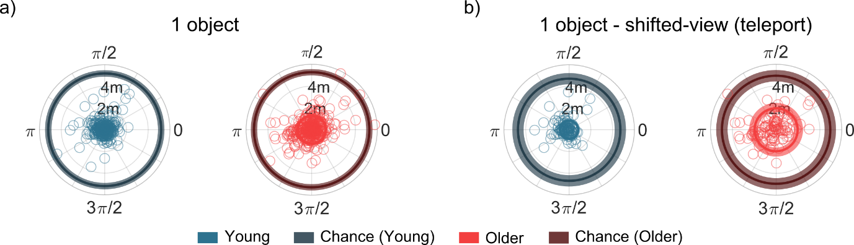
Figure s1: Chance performance analysis. A bootstrap method was used to infer chance performance separately for young and older participants. a) Polar plots show the individual responses for replaced objects in the one-object configuration across movement conditions. b) Polar plots depicts the shifted-viewpoint (teleport) condition only for one object configuration. In each plot, the origin $(0,0)$ represents the true object location, transparent circles indicate individual responses, solid circles indicate the mean and the mean confidence intervals for the observed population from the data sample (light blue/red for young/older) and the inferred chance population (dark blue/red for young/older). Both groups performed well above the chance level.

Performance stability across blocks
The mixed ANOVA on average displacement error suggested a non-significant trend toward a main effect of block number [F(2,41) = 3.084, p = 0.53, η_{p}² = 0.07, Greenhouse-Geisser correction applied; figure s2a]. Post hoc comparisons with repeated contrasts (Bonferroni corrected) revealed no significant differences between the first and second blocks, nor between the second and third blocks across age groups (p > 0.05). Note the average displacement error in the third block was numerically lower (M = 1.17m, SD = 0.10m) than the second (M = 1.31m, SD = 0.11m) and first blocks (M = 1.29m, SD = 0.09m).
Further analysis revealed no significant interaction between block number and participant group [F(2,41) = 0.27, p > 0.05] and no interaction was found between block number and object configuration [F(2,41) = 0.98, p > 0.05], suggesting any learning effect was consistent between groups and regardless of the increased complexity of the four-objects configurations.
No interaction between block number and movement condition [F(4,39) = 2.42, p = 0.06, η_{p}² = 0.05, Greenhouse-Geisser correction applied] was found. Planned contrasts showed an improvement from the second to third block in the shifted-viewpoint (teleport) condition [F(1,43) = 3.75, p_{not_adjusted} = 0.03, η_{p}² = 0.10 ; figure s2b], which did not survive multiple comparisons correction. No significant differences were found in the shifted-viewpoint (walking) condition or between the first and second blocks. No significant differences emerged in comparisons between the same-view and combined shifted-viewpoint conditions for any blocks. No trend was found in the triple interaction among block number, movement condition, and age group, indicating that the observed trend in performance improvement was consistent across both age groups.
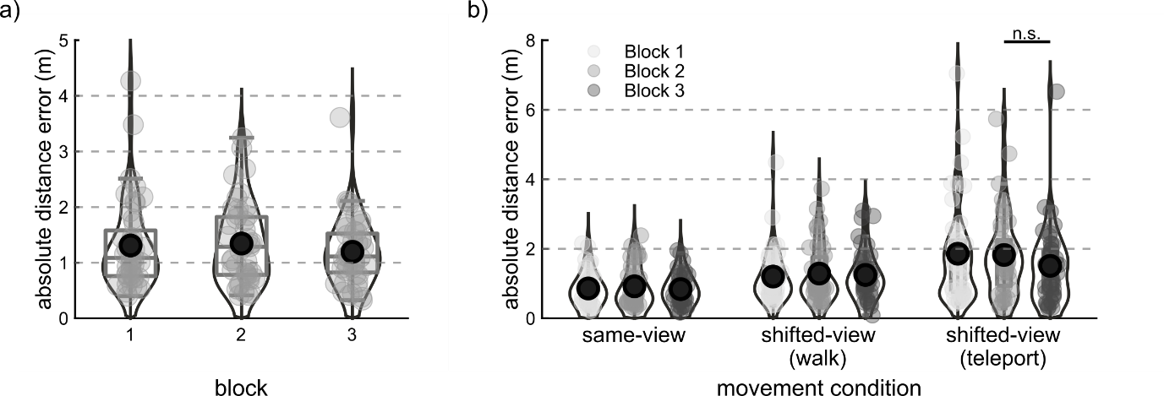
Figure s2: Performance between blocks – learning effect. a) Participant performance (absolute error distance) by experimental block averaged across age groups, object configurations and movement conditions. b) Participant performance (absolute error distance) by experimental block and movement condition averaged across age groups and object configurations. Each violin plot was generated using kernel density estimation to show the probability density of the data at different values. Light grey circles represent the mean absolute distance error for each participant. In each box, the large black dot marks the overall mean, and the dark grey bars mark the median and the 25th and 75th percentiles. Observations beyond the whisker length are outliers. A mixed ANOVA revealed no main effect of block and no interaction between block and participant group. A trend was found between block and movement conditions, with planned contrasts revealing a non-significant improvement from the second and the third block in the shifted-viewpoint (teleport) condition (p_{not_adjusted} = 0.03).

Direct assessment of ceiling performance
Direct assessment of potential floor effects revealed important distributional characteristics across age groups and conditions. All groups showed performance significantly above floor level when comparing each distribution against the lower theoretical minimum (0m; all p’s < .001). Both groups exhibited positive skewness (figure s3a; young adults: 1.35-1.88; older adults in shifted-viewpoint conditions: 1.16-2.13) with the exception of the same-view condition in the older group (skewness = 0.28). Deviations from normality were observed in most conditions (Shapiro-Wilk p < 0.01), except for the older adults' same-view condition (p = 0.39) and shifted-viewpoint walking condition (p = 0.015). The distance from floor metrics indicate that young adults' means were approximately 1.8-1.9 standard deviations above zero, providing sufficient room for potential improvement below observed performance levels (figure s3b). Furthermore, only a modest percentage (figure s3b; 9.5-19%) of young adults' values fell within one standard deviation of zero, suggesting most participants were not performing at floor. Together, these distributional characteristics suggest some clustering toward lower values, particularly in the young adult group, rather than severe floor effects that would invalidate statistical comparisons.

Log- transformed averaged displacement error mixed ANOVA
The log transformation normalized our data (Shapiro Wilk all p’s > 0.10). This transformation particularly benefited the young adult group, where skewness values were reduced from the original range of 1.35-1.88 to a more moderate 0.20-0.50. The overall dataset also demonstrated excellent normality (Shapiro-Wilk p = 0.81, skewness = 0.20).
The main effects of both age group [F(1,42) = 25.83, p < 0.001], object configuration [F(1,42) = 132.13, p < 0.001, η_{p}² = 0.76] and movement condition [F(2,41) = 63.63, p < 0.001] remained highly significant, with effect sizes strengthening after transformation (age group: partial η² increased from 0.30 to 0.38; movement condition: partial η² increased from 0.45 to 0.60). This confirms that the core findings regarding age-related differences and movement condition effects are robust and not artifacts of the data distribution.
Notably, the analysis confirmed the interaction between age group and movement condition [F(2,41) = 13.03, p < 0.001, η_{p}² = 0.24]. Planned contrasts revealed that both age groups showed significant differences between same-view and shifted-viewpoint conditions (figure s3c; all p < 0.01). However, a difference emerged in the comparison between walking and teleportation: only older adults showed a significant difference between these conditions [t(22) = - 10.06, p < .001, η_{p}² = 0. 82], while young adults did not (figure s3c; p = 0.159).
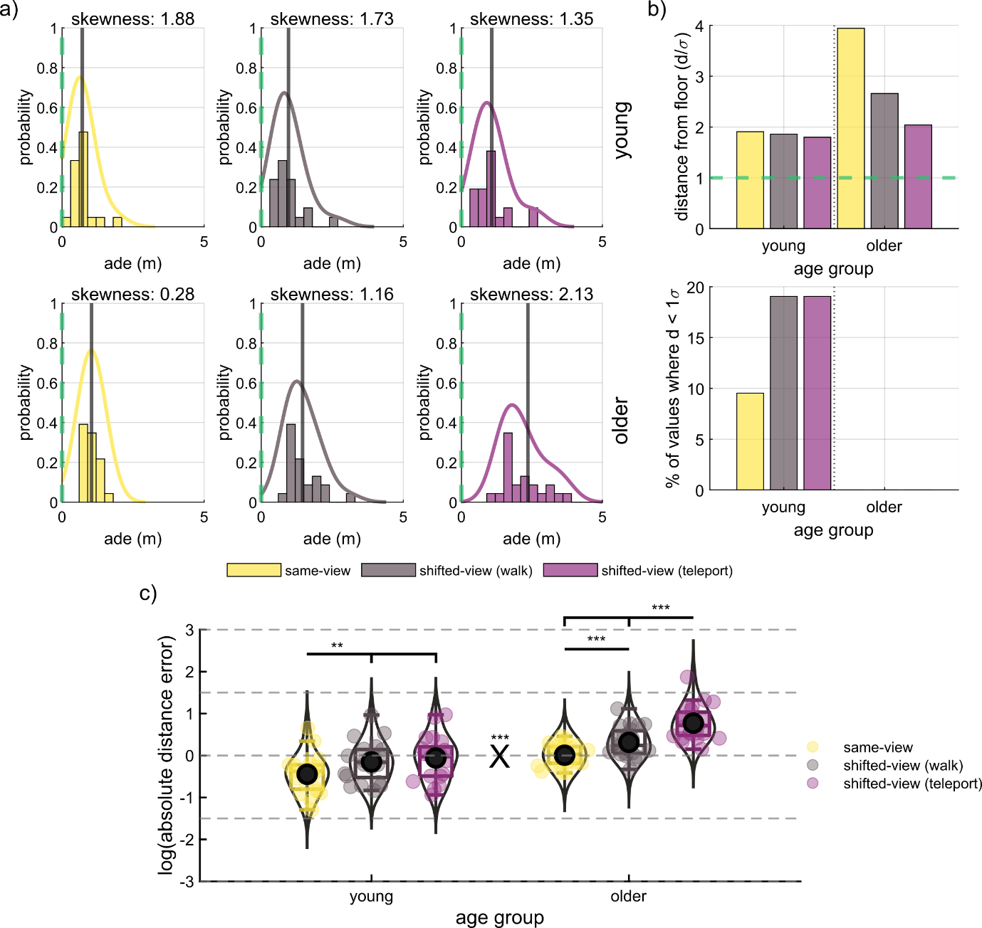
Figure s3: a) Histograms with kernel density estimation (KDE) overlays illustrate the distribution of averaged displacement error for each movement condition, shown separately for young (top row) and older (bottom row). The vertical black line represents the group mean for each condition, while the dashed green line indicates the theoretical floor (minimum possible error). b) Top: bar plots display the distance of the averaged displacement error from the theoretical minimum in standard deviation (SD) units. The dashed green line represents the 1 SD distance. Bottom: bar plots show the proportion of averaged displacement error falling within 1 SD of the theoretical, indicating potential flooring effects. c) Participant performance (log-transformed displacement error) by age group and movement condition, averaged across object configurations. Each violin plot was generated using kernel density estimation to show the probability density of the data at different values. Each circle represents the averaged displacement error for each participant. In each box, the large black dot marks the overall mean, and the dark grey bars mark the median and the 25th and 75th percentiles. Observations beyond the whisker length are outliers. A mixed ANOVA revealed a main effect of interaction between age group and movement condition remained significant (X symbol). Young and older groups performed best in the same-view condition, but only older showed better performance in the shifted-viewpoint when walking instead of teleporting. ∗p < 0.05, ∗∗p < 0.01, and ∗∗∗p < 0.001

No significant effects on projected directional errors
The linear mixed-effects model revealed no significant main effects or two-way interactions on projected directional errors after correction for multiple comparisons (all FDR-corrected p > 0.25; see table S1). The three-way interaction between age group, shift direction, and movement condition reached uncorrected significance (p = 0.015), but did not survive false discovery rate correction (p_{FDR} = 0.132). Visual inspection (figure s4) suggests that the interaction may reflect increased directional errors in older adults during leftward shift trials under teleportation.
Effect | Estimate (95% CI) | F | p-value (FDR)
Intercept | -0.081 (-0.397, 0.236) | 0.250 | 0.799
Configuration Type | -0.023 (-0.089, 0.043) | 0.464 | 0.799
Age Group | -0.161 (-0.465, 0.143) | 1.074 | 0.675
Shift Direction | 0.024 (-0.298, 0.345) | 0.021 | 0.886
Movement Type | -0.072 (-0.388, 0.244) | 0.200 | 0.799
Age Group × Shift Direction | 0.438 (-0.011, 0.886) | 3.663 | 0.251
Age Group × Movement | 0.293 (-0.137, 0.722) | 1.788 | 0.544
Shift Direction × Movement | -0.086 (-0.543, 0.370) | 0.138 | 0.799
Age Group × Shift Direction × Movement | -0.791 (-1.426, -0.156) | 5.963 | 0.132
Table s1: Linear mixed effects model results for projected directional errors. Fixed effects estimate from the linear mixed effects model examining the influence of age group, shift direction, movement type, configuration type, explorative two-way interactions and triple interaction on projected directional errors. Shift direction indicates whether participants moved from the long side to the short side of the L-shaped room (right shift) or from the short side to the long side (left shift). The model included participant id as a random effect. CI = confidence interval. P values are corrected for false discovery rate (FDR). The triple interaction trended towards significance but did not survive correction (p_{uncorrected} = 0.015).
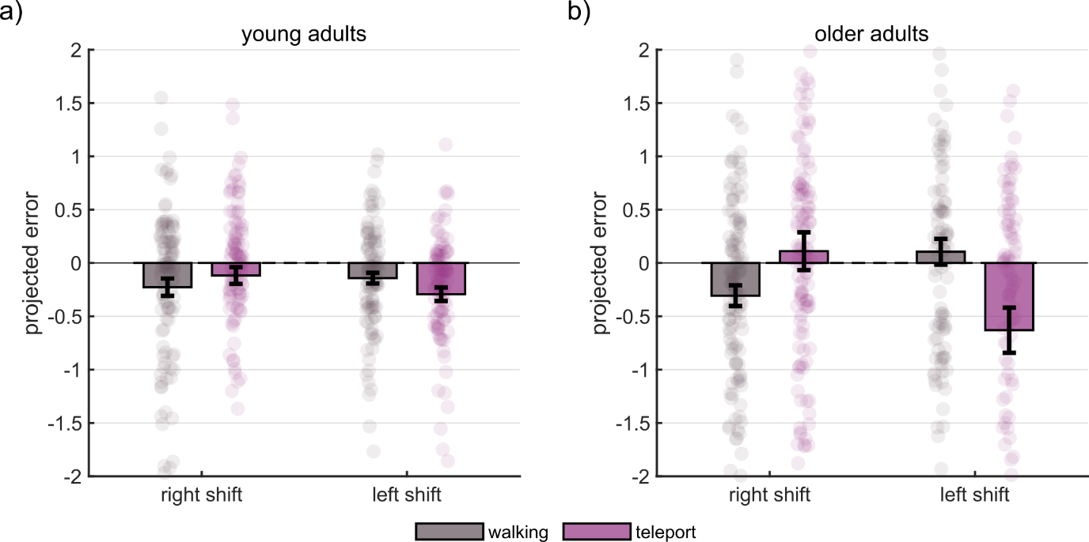Figure s4: Object displacement vectors projected along the viewpoint shift direction. All trials belonging to the same-viewpoint conditions were excluded. For each participant the viewpoint shift direction was calculated as normalized vector difference between the location of the shifted viewpoint and the same-view viewpoint. For each object, projected errors were calculated using the dot product of object displacement vector (from placed to target location) with directional shifted viewpoint direction. Positive values indicate errors in the direction of the viewpoint shift; negative values indicate errors opposite to it. Group means are shown as bars, with thin black lines indicating standard error of the mean (SEM), and participants’ individual trials data points as transparent dots. Projected errors are grouped by movement condition and shift direction plotted separately for young (a) and older participants (b).

Retrieval time association with displacement error
The retrieval time for the young group (M_{bootstrap} = 5.20s, SD_{bootstrap} = 0.14s) was significantly higher than for the older group (M_{bootstrap} = 6.51s, SD_{bootstrap} = 0.22s, t_{bootstrap} (998) = -114.30, p < 0.001, 95% CI [-1.35, -1.30], figure s3a). A linear regression was calculated to predict average displacement error across movement conditions and object configurations based on retrieval time. The regression was not statistically significant for the young [F(1, 19) = 2.91, p = 0.10; figure s3b] nor for the older adults [F(1, 21) = 3.61, p = 0.07; figure s3b].
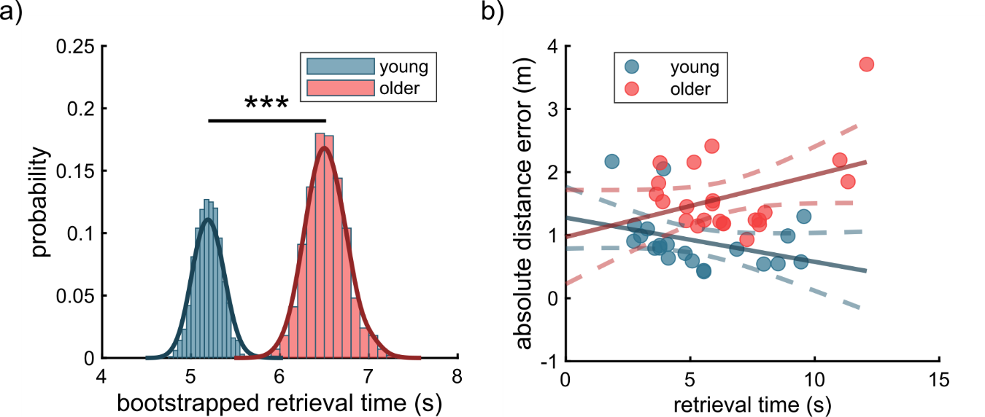
Figure s5: Retrieval time analysis. a) Probability distributions of bootstrapped mean retrieval times for young (blue) and older (red) participants, visualized with histograms and kernel density estimation. Bootstrapping was conducted with 1000 iterations, and group differences were assessed using a two-sample t-test (*** p < 0.001), indicating a significant difference in retrieval times between the two age groups. The black bar represents the significant difference between groups. Retrieval times were averaged across multiple movement conditions and object configurations. b) Linear regression models examining the relationship between retrieval time (x-axis) and absolute distance error (y-axis) for both young (blue) and older (red) participants. Circles represent individual participants’ data averaged across movement conditions and object configurations. The solid lines represent the fitted regression lines, and the dashed lines show the 95% confidence intervals for the slopes.

References
Cherep, L. A., Lim, A. F., Kelly, J. W., Acharya, D., Velasco, A., Bustamante, E., … Gilbert, S. B. (2020). Spatial Cognitive Implications of Teleporting Through Virtual Environments. Journal of Experimental Psychology: Applied. https://doi.org/10.1037/xap0000263
Field, A. P., & Wilcox, R. R. (2017). Robust statistical methods: A primer for clinical psychology and experimental psychopathology researchers. Behaviour Research and Therapy, 98, 19–38. https://doi.org/10.1016/j.brat.2017.05.013
Segen, V., Colombo, G., Avraamides, M., Slattery, T., & Wiener, J. M. (2021). Perspective taking and systematic biases in object location memory. Attention, Perception, and Psychophysics, 83(5), 2033–2051. https://doi.org/10.3758/S13414-021-02243-Y/FIGURES/6
Šimkovic, M., & Träuble, B. (2019). Robustness of statistical methods when measure is affected by ceiling and/or floor effect. PLOS ONE, 14(8), e0220889. https://doi.org/10.1371/JOURNAL.PONE.0220889
Uttl, B. (2005). Measurement of Individual Differences: Lessons From Memory Assessment in Research and Clinical Practice. Psychological Science, 16(6), 460-467. https://doi.org/10.1111/j.0956-7976.2005.01557.x
Wang, L., Zhang, Z., McArdle, J. J., & Salthouse, T. A. (2008). Investigating Ceiling Effects in Longitudinal Data Analysis. Multivariate Behavioral Research, 43(3), 476–496. https://doi.org/10.1080/00273170802285941

